Air Quality Analysis Report

Abstract
The data analyzed was a monitoring of hourly data on air-pollution over about one year on such indicators as carbon-monoxide (CO), nitrogen dioxide (NO2), nitrogen oxides (NOx), benzene, temperature, relative humidity and absolute humidity. Exploratory plots revealed that CO and NOx were unquestionably skewed to the right whereas temperature and relative humidity were more evenly distributed and this immediately indicated a later inferential analysis could not be done when off the target. Time-series plots revealed high short-term volatility as well as more the seasonal structure, and hourly profiles revealed a single evening peak at about 19:00 of the CO and NO2, though with minimum in early morning. The correlation heatmap and scatterplots demonstrated that the variables associated with combustion moved together with each other, especially those with CO namely CO, NOx and those with NO2 and NOx namely NOx, NO2, however temperature and relative humidity exhibited the opposite correlation (r = -0.56). To test the two conditions of comparison (low humidity and high humidity) of the NO2 concentrations in the conditions, the Wilcoxon-Mann-Whitney test was carried out, the outcome of which is non-negligible (U = 7,696,814.5, p < 0.001), but the effect size is relatively small. The seasonal comparison was done on NO2 in winter, spring, summer and autumn using the Kruskal-Wallis test and the results were found to have strong seasonal effects (H = 955.64, p < 0.001) with maximum levels in winter and minimum levels in summers. Combined, these findings indicate that a mixture of co-emission, atmospheric dispersion and seasonal meteorology cause pollutant behaviour within this urban series, as can be seen by more recent open-access air-quality literature.

Introduction and analytical context
The factors that normally influence data on air-pollution in the urban areas include traffic activity, sources of combustion, atmospheric chemistry, and dispersion by meteorological factors. This also renders time-series exploration particularly significant, as the results of a single pollutant may change irregularly throughout the hours, days and seasons due to different but intersecting causes. Current public-health instructions still rely on the theme that air pollution is one of the key risks on an international level and that health benefits are achieved by reducing concentrations throughout the entire exposure profile and not at severe hotspots only (Hoffmann et al. 2021). This is why exploratory analysis is not only descriptive in nature, but also the phase where distributional form, temporal framework and potential meteorological constraints can be seen clear enough to make justifiable statistical decisions.
The current data set was pre-processed to transform the coded -200 missing value to a missing data and retrieveing the individual date field and time field into a new variable that is datetimely. The file uploaded had 9,471 hourly records stretching back to the month of March 2004 up to the period of early April of 2005. Missings were also notable with several variables, namely NMHC where approximately 90.3 of the values were missing and CO, NO2 and NOx where the presence of missings was nearly a fifth of the series. As compared to that, core meteorological variables of temperature, relative and absolute humidity were unavailable only in an approximate of 5.1 per cent of cases. Based on it the analysis focused on CO, NO2, NOx, benzene, temperature, relative humidity and absolute humidity, as they provide sufficient coverage of data but also reflect a direct interpreting value.

Exploratory visualisation of distributions and time trends
The histograms were the initial ICP group of plots, due to the fact that a histogram provides a visual description of skewness, spread and tail behaviour at a glance. This was necessary in this case in particular since the inferential part of the assignment involved making decisions regarding appropriate statistical tests. The histograms revealed that CO and NOx were highly skewed to right with long upper tails and a high proportion of lesser and mean values. NO2 had a lower right tail but it was still noticeable. The temperature was a bit more related to broad and unimodal form, whereas relative humidity behaved the most harmonious among the variables depicted. This trend has analytical significance since it suggests that not all the variables of pollutants act as Gaussian data and thus it was wise to give preference to rank-based tests in which the distributional assumptions were questionable.
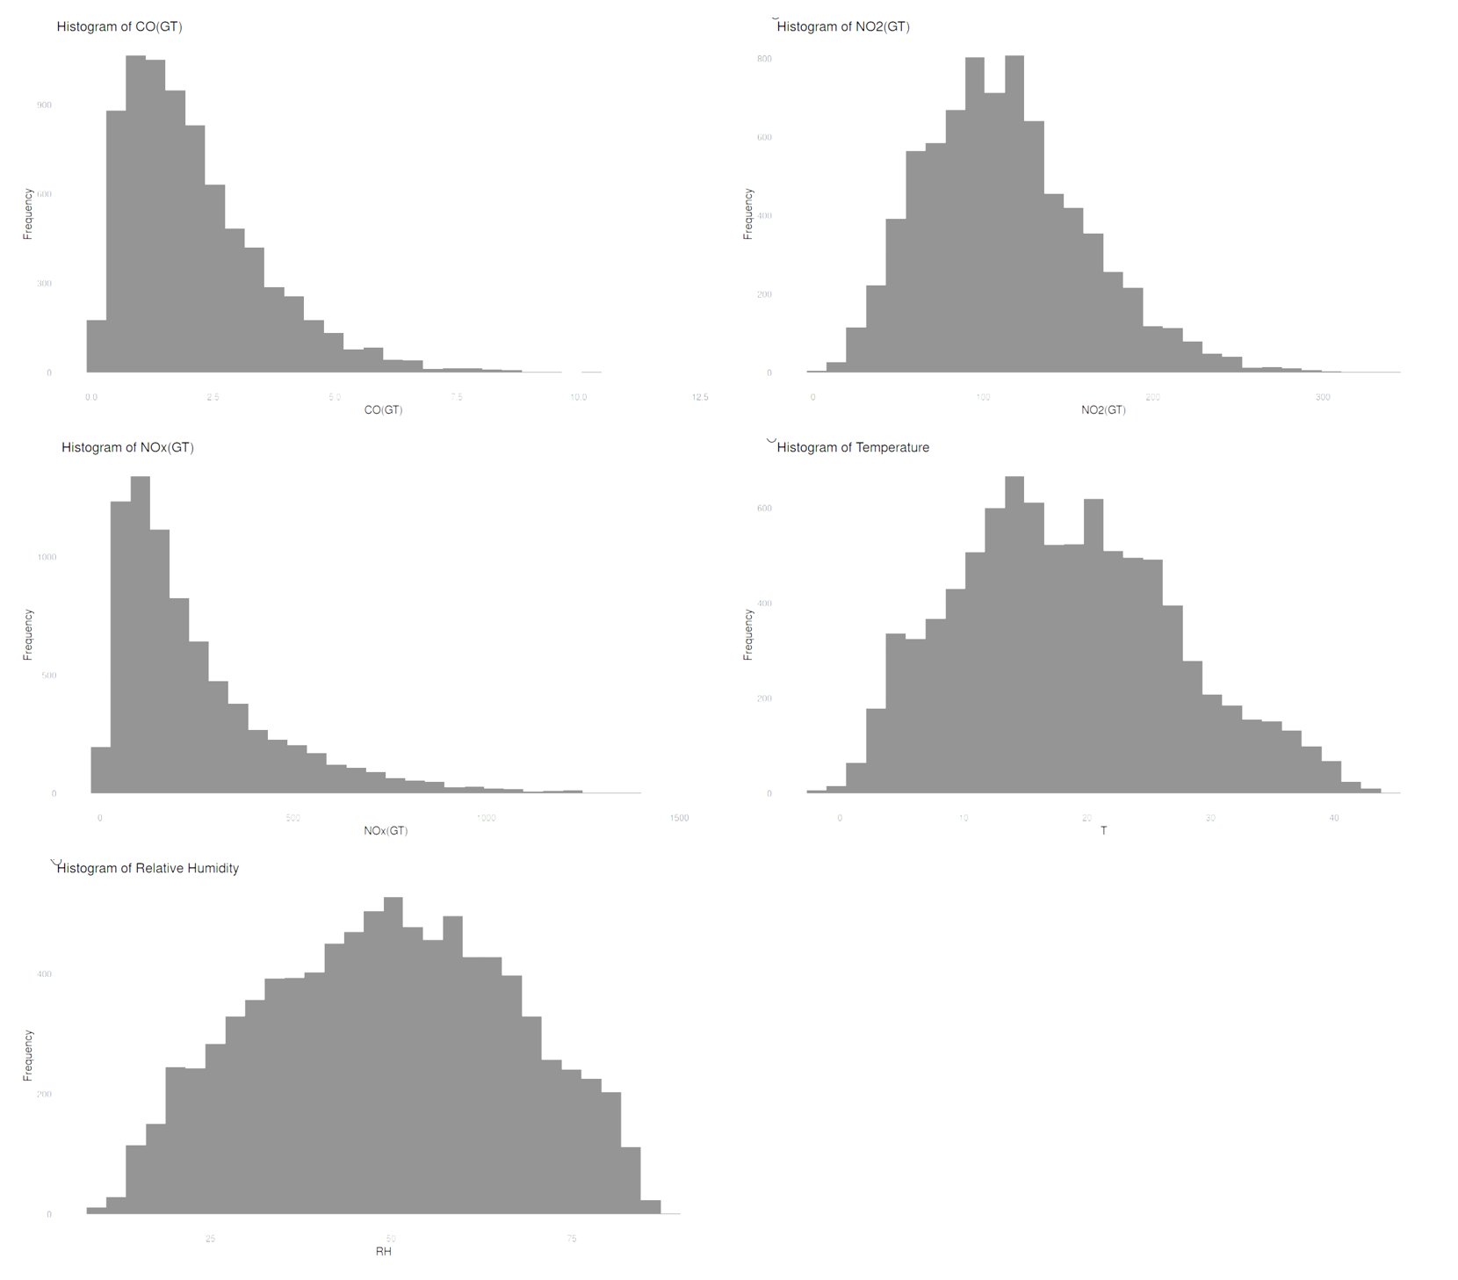
Figure 1. Distributional overview of the principal pollutant and meteorological variables derived from the supplied R output.
The time plots were another source of knowledge. The short-run volatility in the line graphs of the CO and NO2 showed that there was high volatility of the two gases during the year, but it also indicated bigger structure. The summer part of the series was relatively a quieter one whereas late autumn and winter had more and more high frequency of peaks, particularly of NO2. This pronounced seasonal difference is also in line with the recent literature that indicates that NO2 is often elevated during winter because favorable conditions of dispersion are sometimes exerted with the help of less developed boundary layers, lower temperatures, and domestic or traffic emissions (Rus et al. 2024; Chatoutsidou, Kandonouri and Lazaridis 2025). The two-pollutant panel was also beneficial as it demonstrated that CO and NO2 did not follow exactly the same pattern when moving, yet their further deviations tended to appear in the same timeframe, which is a visual indication, firstly, that some common sources or common conditions of the atmosphere are at play.
That was enhanced by the hourly mean profiles. CO and NO2 had their lowest mean at the early mornings, the minimum CO value of 05:00 (around 04:00) and the minimum NO2 value of 04:00 (around 03: 00) and then increased throughout the morning until they hit their maximum values in the day around 19:00. This evening domination indicates a blend of commuter traffic, combustion activity and unfavourable dispersion towards the end of the day. Diurnal measurements of nitrogen dioxide have also found organized daily patterns associated with rush-hour emissions and second-order transformation which are particularly found in urban and suburban monitoring measurements (Li et al. 2021, pp. 11133-11134; Chatoutsidou, Kondonouri and Lazaridis 2025).
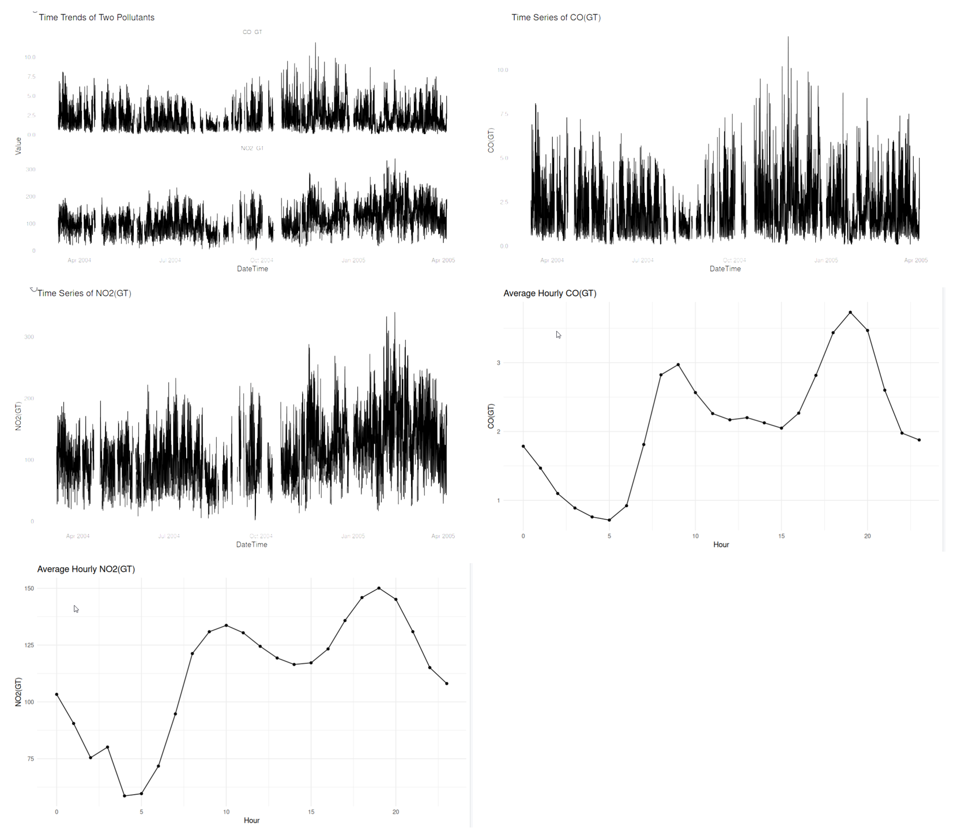
Figure 2. Temporal behaviour of CO and NO2, including annual traces and hourly mean profiles.

Relationships between pollutants and meteorological variables
The reasons behind the choice of scatterplots in testing the relationship between the pollutants and meteorological variables were the fact that the scatterplots do not smear out individual observations and thus it becomes simpler to observe weak timbers, clustering, scarcity of heteroscedasticity and outliers. CO vs temperature plot indicated a shallow and positive fitted line which was in line with the insignificant linear relationship between these variables subsequently. The NO2 against the relative humidity curve had a weak negative slope whereas the one of NOx against temperature in the curve was more evident with a negative inclination. In each of the three scatterplots, the error around the fitted line was also large and hence meteorology is only partly explaining the observed variation and the influence of the source strength, the atmospheric chemistry and time-of-day effects equally.
This discussion agrees with the recent open-access literature that demonstrates that meteorology may actually have a significant influence on the levels of pollutants, although not necessarily in a one-factor fashion. Wang et al. (2022) demonstrate that the elevated concentrations of NO2 and CO can be correlated with unfavourable diffusion circumstances and extended air at residence times and major traffic-related contaminants are frequently transported jointly and incline to reduce with improved meteorological circumstances, as explained by Sun et al. (2024) and Wang et al. (2025). Meanwhile, Alejo Sanchez et al. (2024) also prove that monitoring NO2 alone is subject to the factors of temperature and humidity and that it serves as a good reminder of the fact that the correlation between air quality and meteorology is both physical and measurement-related.
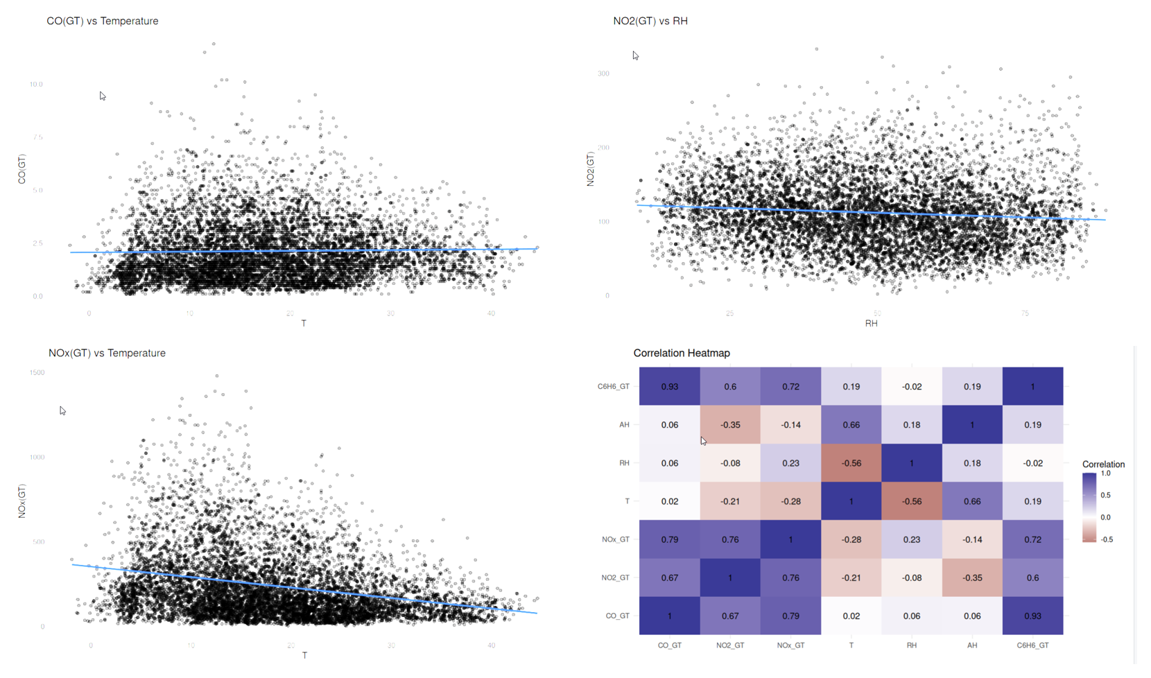
Figure 3. Scatterplots linking pollutants with weather-related variables, alongside the correlation heatmap.

Correlation analysis
The pairwise relationships were represented through the correlation heatmap that provided the view of the relationships as a system and not as a comparison. There were three findings that were significant. To begin with, the CO and benzene had the most positive relationship in the matrix with r = 0.93. This correlation is very high and indicates that these two variables tend to react to the same combination of emissions but this is plausible in urban combustion and traffic sources. Secondly, CO and NOx were also, strongly correlated with a r of 0.79 and also NO2 and NOx were strongly correlated with a r of 0.76. These values combined suggest that the gaseous pollutant cluster is coherent itself and not a collection of signals that are not related to one another. Thirdly, temperature and relative humidity showed a moderately negative correlation and the r = -0.56 and temperature and absolute humidity were positively correlated with a r = 0.66 that confirms that the organised structure of the meteorological background also occurred.
There are other lesser correlations that are also so educative. The relationship between CO and temperature was essentially null at r = 0.02 which coincides with the flat fit line in the scatterplot and indicates that there is an indirect or context-dependent influence of temperature on CO. Associations of NO2 with temperature and absolute humidity had negative coefficients, with significance of r = -0.21 and = -0.35 respectively. There was a small negative correlation between NOx and temperature with the correlation of -0.28 and a small positive correlation between NOx and relative humidity with the correlation of 0.23. Recent studies have also reported that pollutants related to combustion are frequently positively correlated with each other many times and may be negatively related to temperature or more favorable dispersion conditions, despite having an incorrect magnitude across different sites (Sun et al. 2024; Wang et al. 2025). The primary advantage of the current heatmap, thus, is that it does not confuse the associations of the sources and the background meteorological associations but creates a distinction between them.

Two-condition hypothesis test
In the case of two-condition hypothesis test, it was decided to use nitrogen dioxide as the response variable since it displayed obvious temporal change, obvious separation over years in the boxplots and had conceivable relationship to relative humidity in the scatterplot. In the uploaded data, wind variables were not presented, and the comparison was conducted on the relative humidity divided by the median that was 49.6. The null hypothesis was that the only difference in the distribution of NO 2 was related to low and high-humidity conditions. The second hypothesis was that there are differences in the occurrence of NO2 in the water under the two levels of humidity.
The evidence of the histogram and scatter plot showed that the NO2 data were not the best to be tested by a classical two-sample t-test without doing additional assumptions validation. Owing to this, the test of Wilcoxon-Mann-Whitney test was used as stronger non-parametric alternative to compare the two independent groups. The value was also statistically significant, U = 7,696,814.5, and p < 0.001. The mean NO 2 concentration of the low-humidity group was greater than that of the highhumidity group, namely, 116.35 and 107. 96, respectively, and the medians of 114.0 and 102.0, respectively. Though it was rather low at about r = 0.11, the trend was obvious: at the lower the humidity, the higher NO2 was likely to be. This is in line with the weak negative slope which is already evident in the scatterplot, and generally in line with what the recent literature suggests, specifically that humidity can be weakly positively correlated with nitrogen dioxide under certain urban environments (Sun et al. 2024; Wang et al. 2025).
Substantively, the outcome is not supposed to be exaggerated. The large sample size was helpful to achieve its statistical significance and the cloud of points on the scatterplot indicates that relative humidity cannot explain a significant part of the total variation. However, the test has some merits in it as it establishes the fact that the visual pattern is not entirely anecdotal. The working reading is thus tentative: humidity is seen to possess a non-illusory but weak relationship with the levels of NO2 in this sequence.

Seasonal group comparison
The seasonal comparison was on NO 2 since the boxplots presented a particularly distinct difference during the winter, spring, summer and autumn seasons. The null hypothesis was that the distributions of NO2 seasonally are equal. The second hypothesis was that there is at least one season that will dissimilar to the rest. Once again, the shapes of the boxplot and the previous histogram indicated that the non-parametric test suited better than the one-way ANOVA and therefore there was the use of Kruskal-Wallis test.
The statistical finding was overwhelming. Krushal-Wallis test provided H = 955.64 and p = 0.001 which means that seasonal variations in NO2 are strongly present. The mean NO2 concentration was the highest in winter (139.94) as well as the mode (135.0) and lowest in summer (91.46) and (88.5). Autumn and spring took an intermediate place, and had very similar centres. Analytic effects On the one hand, it represents an estimated medium effect size of an environmental time series one, and the epsilon-squared of about 0.124 is moderate. The post hoc pair wise testing with Benjamini-Hochberg adjustment revealed that all comparisons of the seasons were statistically significant except autumn versus spring which supports the visual impression created by the box plots that the two seasons are more likely to overlap than the rest.
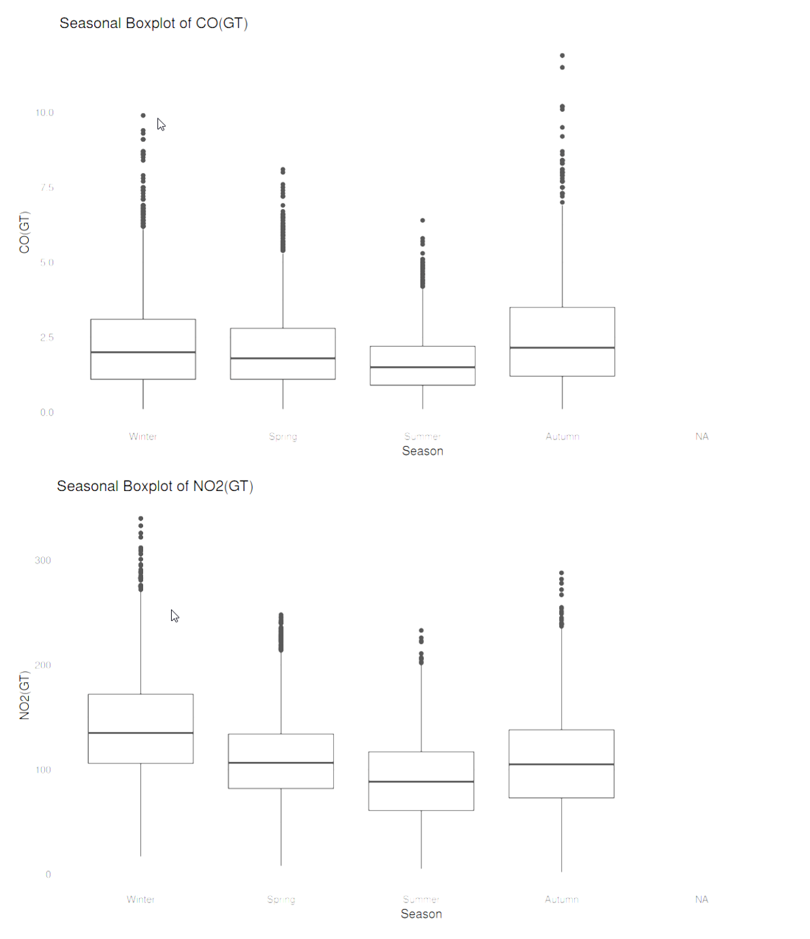
Figure 4. Seasonal boxplots showing that CO and especially NO2 vary systematically across the four seasons.

Reflective summary
The greatest experience of this work was that successful statistical programming can also start with a visual judgement and not with automatic choice of tests. Initially, it would have been easy to proceed to hypothesis testing at the beginning of the exercise, but the provided plots indicated why it would have been bad analytical behavior. It was immediately obvious on the histograms that many variables of pollutants were very right-skewed and time-series plots depicted significant volatility, sporadic peaks and seasonal concentration. Due to this reason, the subsequent decision to use non-parametric procedures was not generic but rather the decision based on the visual evidence. The visualisations thus served as the mediator between the unprocessed data and the statistical case.
The analysis also led to a better bewaking on the types of plot that were to be use. Annual traces of the pollution were best represented as you have data that are ordered in time and the idea was to exhibit continuity, spikes and the larger trends by season. Effectively, the semantically hidden R language of such a step was the known trick of extrapolating time to the x-axis and pollutant concentration to a y-axis by calling ggplot(AirQuality, aes(x = DateTime, y = NO2GT)) + geomline). The pollutant-meteorology relationships were best represented with scatterplots due to the fact they retained the individual observations and allowed one to view the trend that was fitted as well as the level of dispersion about the same. The heatmap was particularly handy since it condensed the entire correlation matrix to a single understandable image and communicating the distinction between strong source-related relationships and a weaker relationship between meteorological variables became significantly simpler.
There was a major challenge of data quality and formatting. AirQualityUCI file contained a coded missing of -200 which in case it had been counted as a real value this would have significantly altered the distributions, the correlations as well as the group tests. There was the practical issue as well in coding since the initial import strategy supposed the very type of delimiters, and as a result, at first the variable names appeared not to be detected with the needed accuracy. Fixing the file import and changing -200 to missing values were thus not house keeping issues, as they have a significant impact on whether the statistical outcome could be trusted. A second difficulty was the disproportion of the variables in the completeness. NMHC was too rough to be relied upon as a part of the overall inferential discussion, and this demanded selective as opposed to automatic availing of the available columns.
The inferential level extended my knowledge on the reasons why the visual evidence and numbers testing ought to have been read jointly. The Wilcoxon-Mann-Whitney value between the low and the high humidity was found to be having a statistically significant difference in NO2 but when the scatterplot acted as a reminder to me, that the difference was still small as far as practicality about the difference was concerned. Similarly, the Kruskal-Wallis seasonal comparison had a high significance, but the boxplots were able to add additional detail to the finding that autumn and spring were far more similar to one another than either of them was to winter or summer. This balance between figures and tests was likely the most helpful aspect of the assignment, which showed that statistical significance and substantive importance are the notions, to which the relationship is not absolute.
Conclusion
As indicated by the report, the provided AirQualityUCI results can be used to uphold a sensible environmental interpretation. CO, NO2 and NOx are considered as a similar group of pollutants with combustion nature, and they have positive strong relationships between themselves and benzene, but weaker and conditional ones with meteorological variables. The time plots not only indicate the short-term fluctuations, but also indicate the seasonal organisation, and the profiles of the hourly resolution indicate that the evening concentrations are more significant than the early-morning concentrations of both CO and NO2. The inferential testing proves that the wealth of NO2 under the low and high-humidity condition differs significantly and the more significantly under various seasons with winter turned out the most polluted season and the summer the least polluted one. As a combination, however, the visual and statistical evidence offer a possibility, that pollutant concentrations in this series are conditioned by source co-emission, patterns of daily activity and seasonally difference dispersion in the atmosphere.

Bibliography
Alejo Sánchez, D., Schalm, O., Álvarez Cruz, A., Hernández Rodríguez, E., Martínez Laguardia, A., Kairuz Cabrera, D. and Morales Pérez, M.C. (2024) ‘Enhancing the reliability of NO2 monitoring using low-cost sensors by compensating for temperature and humidity effects’, Atmosphere, 15(11), 1365. Available at: https://doi.org/10.3390/atmos15111365.
Chatoutsidou, S.E., Kordonouri, I. and Lazaridis, M. (2025) ‘An air-quality-based analysis of NO, NO2, and O3 at a suburban Mediterranean site’, Atmosphere, 17(1), 7. Available at: https://doi.org/10.3390/atmos17010007.
Hoffmann, B., Boogaard, H., de Nazelle, A., Andersen, Z.J., Abramson, M., Brauer, M., Brunekreef, B., Forastiere, F., Huang, W., Kan, H., Kaufman, J.D., Katsouyanni, K., Krzyzanowski, M., Kuenzli, N., Laden, F., Nieuwenhuijsen, M., Mustapha, A., Powell, P., Rice, M., Roca-Barceló, A., Roscoe, C.J., Soares, A., Straif, K. and Thurston, G. (2021) ‘WHO Air Quality Guidelines 2021—Aiming for healthier air for all: A joint statement by medical, public health, scientific societies and patient representative organisations’, International Journal of Public Health, 66, 1604465. Available at: https://doi.org/10.3389/ijph.2021.1604465.
Li, J., Wang, Y., Zhang, R., Smeltzer, C., Weinheimer, A., Herman, J., Boersma, K.F., Celarier, E.A., Long, R.W., Szykman, J.J., Delgado, R., Thompson, A.M., Knepp, T.N., Lamsal, L.N., Janz, S.J., Kowalewski, M.G., Liu, X. and Nowlan, C.R. (2021) ‘Comprehensive evaluations of diurnal NO2 measurements during DISCOVER-AQ 2011: effects of resolution-dependent representation of NOx emissions’, Atmospheric Chemistry and Physics, 21, pp. 11133–11160. Available at: https://doi.org/10.5194/acp-21-11133-2021.
Rus, A.A., Şoşdean, R., Lazăr, M., Simonescu, M., Luca, S., Dima, C.N., Frişan, A., Gaiţă, D. and Mornoş, C. (2024) ‘Seasonal variation in short-term ambient air pollutants and ST-elevation myocardial infarction admissions: an innovative exploration of air pollution’s health consequences’, Atmosphere, 15(5), 590. Available at: https://doi.org/10.3390/atmos15050590.
Sun, F., Gong, X., Wei, L., Zhang, Y., Ge, M. and Xiong, L. (2024) ‘Assessing the impact of short-term ozone exposure on excess deaths from cardiovascular disease: a multi-pollutant model in Nanjing, China’s Yangtze River Delta’, Frontiers in Public Health, 12, 1353384. Available at: https://doi.org/10.3389/fpubh.2024.1353384.
Wang, T., Du, H., Cheng, W., Zhao, Z., Zhang, J. and Zhou, C. (2022) ‘Influence of meteorological conditions on the air quality during the 2022 Winter Olympics in Beijing’, Frontiers in Environmental Science, 10, 987272. Available at: https://doi.org/10.3389/fenvs.2022.987272.
Wang, Y., Qu, S., Li, T., Chen, L. and Yang, L. (2025) ‘Association between ambient air pollution and outpatient visits of cardiovascular diseases in Zibo, China: a time series analysis’, Frontiers in Public Health, 12, 1492056. Available at: https://doi.org/10.3389/fpubh.2024.1492056.
World Health Organization (2021) WHO global air quality guidelines: particulate matter (PM2.5 and PM10), ozone, nitrogen dioxide, sulfur dioxide and carbon monoxide. Geneva: WHO. Available at: https://www.who.int/publications/i/item/9789240034228.

