Kyle Lovell
1802143@student.uwtsd.ac.uk
Graphics and games programming

Design of the program
In order to implement the graphical side of their project, the author used the Graphics Template that was provided by their lecturer, which uses OpenGL 3.
In order to load the obj, the author created their own obj loader that would store all the information in the relevant vectors stored in the cObj class.

User Guide
When the user launches the program, the first thing they will see is the console window, which shows the user how to play the game, and what buttons to press. The following image shows this:
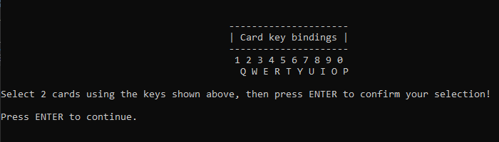

Test Schedule

Launching the Application
Upon launching the application using the Local Windows Debugger button (shown below), the program should open the console window, which will show the user guide.

Before
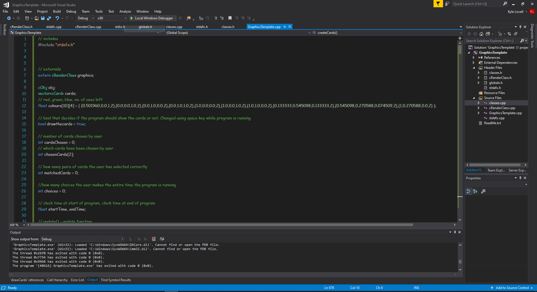

After
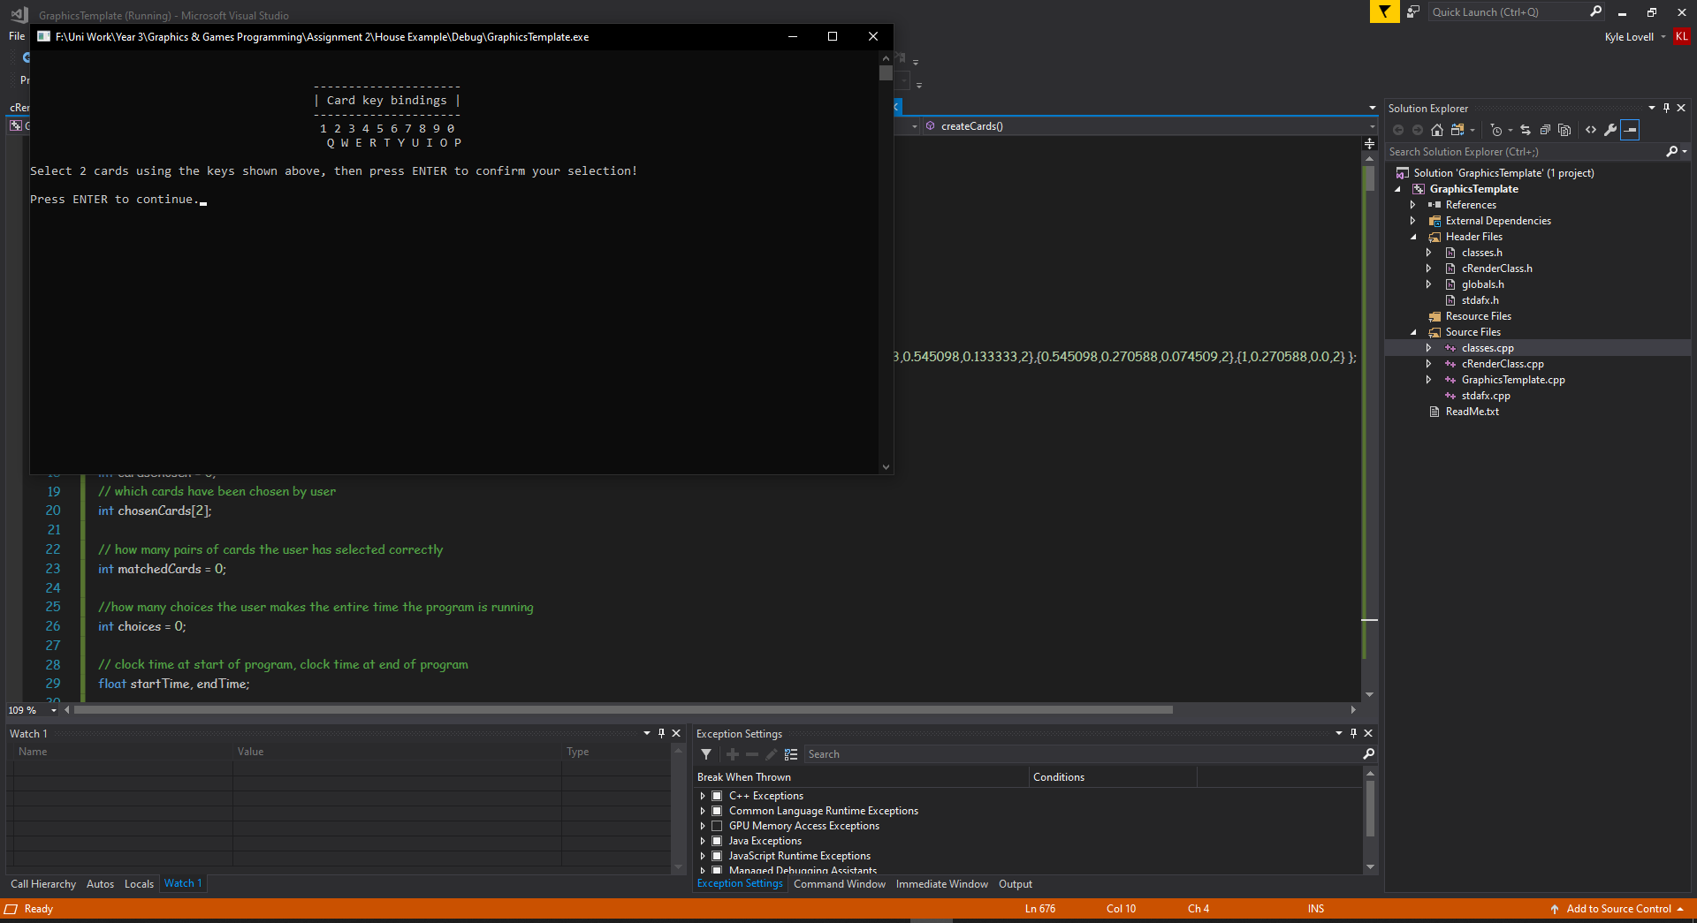
As you can see from these screenshots, the program launches the application correctly.

Opening the Game
After launching the application, the user must press ENTER to open the game.

Before

After
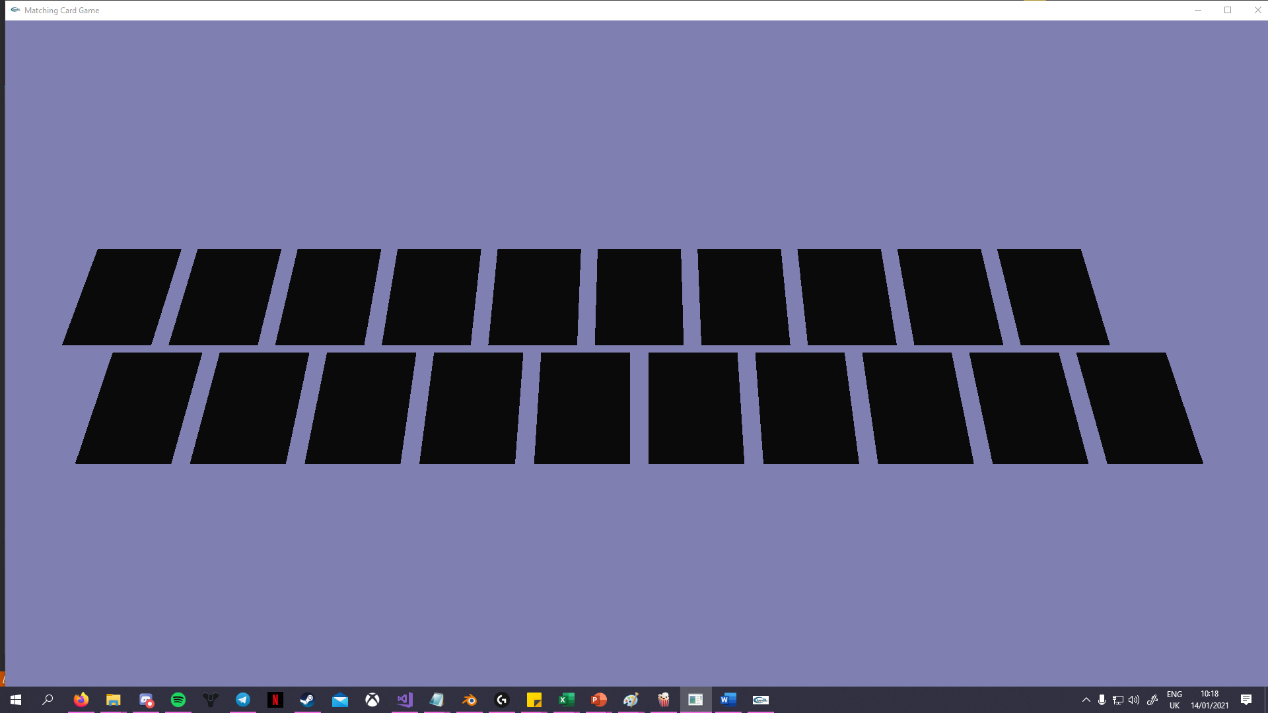

Selecting a Card
In order to select a card, the user must press one of the keys shown in the user guide. Once they have pressed this key, the program will flip this card, showing the true colour of the card. The user will be pressing the ‘r’ key, which should flip the fourth card from the left on the bottom row, revealing that it is green.

Before

After
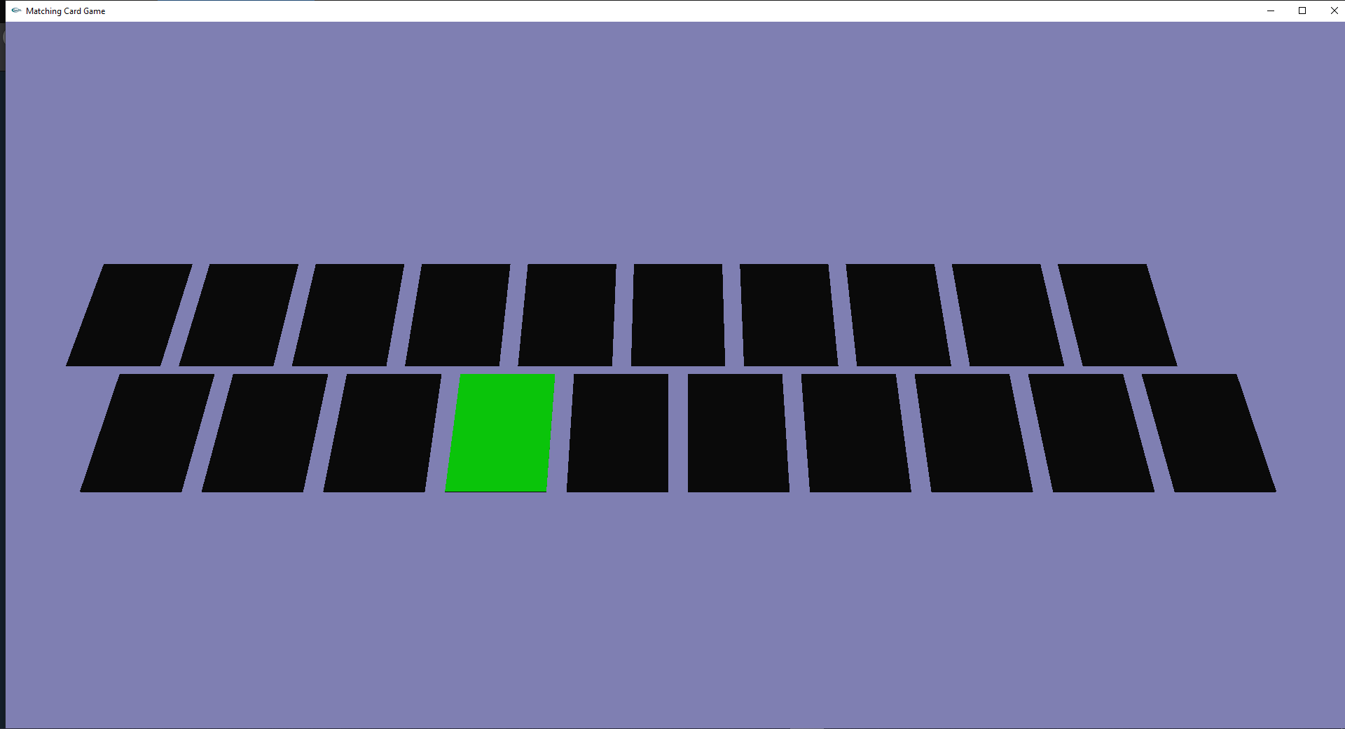

Selecting a Second Card
In order to make a pair, the user must select a second card. This code works in the same way as selecting the first card. The user will be pressing the ‘0’ key, which should flip the tenth card from the left on the top row, revealing that it is pink.

Before

After
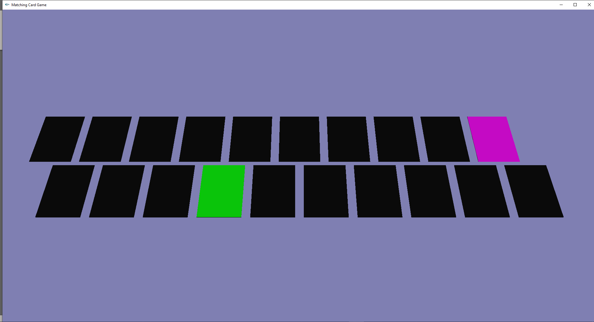

Confirming Selection (Non-Matching Pair)
Once the user has selected two cards, they must press ENTER to confirm their selection. In this case, the cards the user has selected are a non-matching pair and so, when the user presses ENTER, the cards will flip back over, and the user will be able to choose two more cards.

Before

After
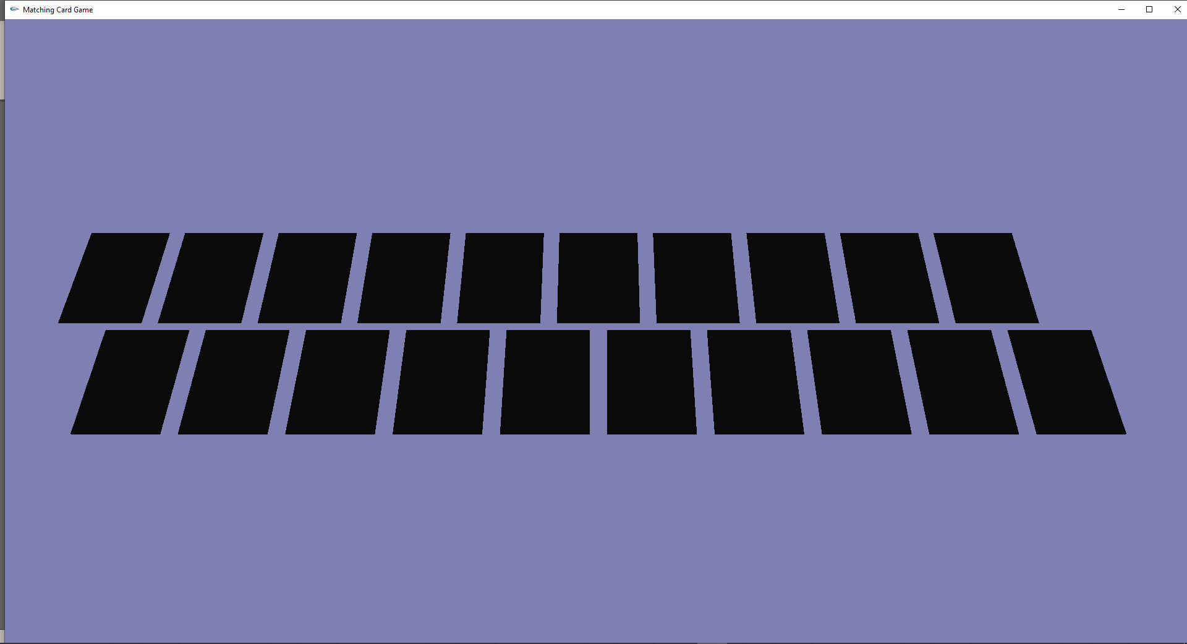

Confirming Selection (Matching Pair)
Once the user has selected two cards, they must press ENTER to confirm their selection. In this case, the cards the user has selected are a matching pair and so, when the user presses ENTER, the cards will become white, and the user will be able to choose two more cards.

Before
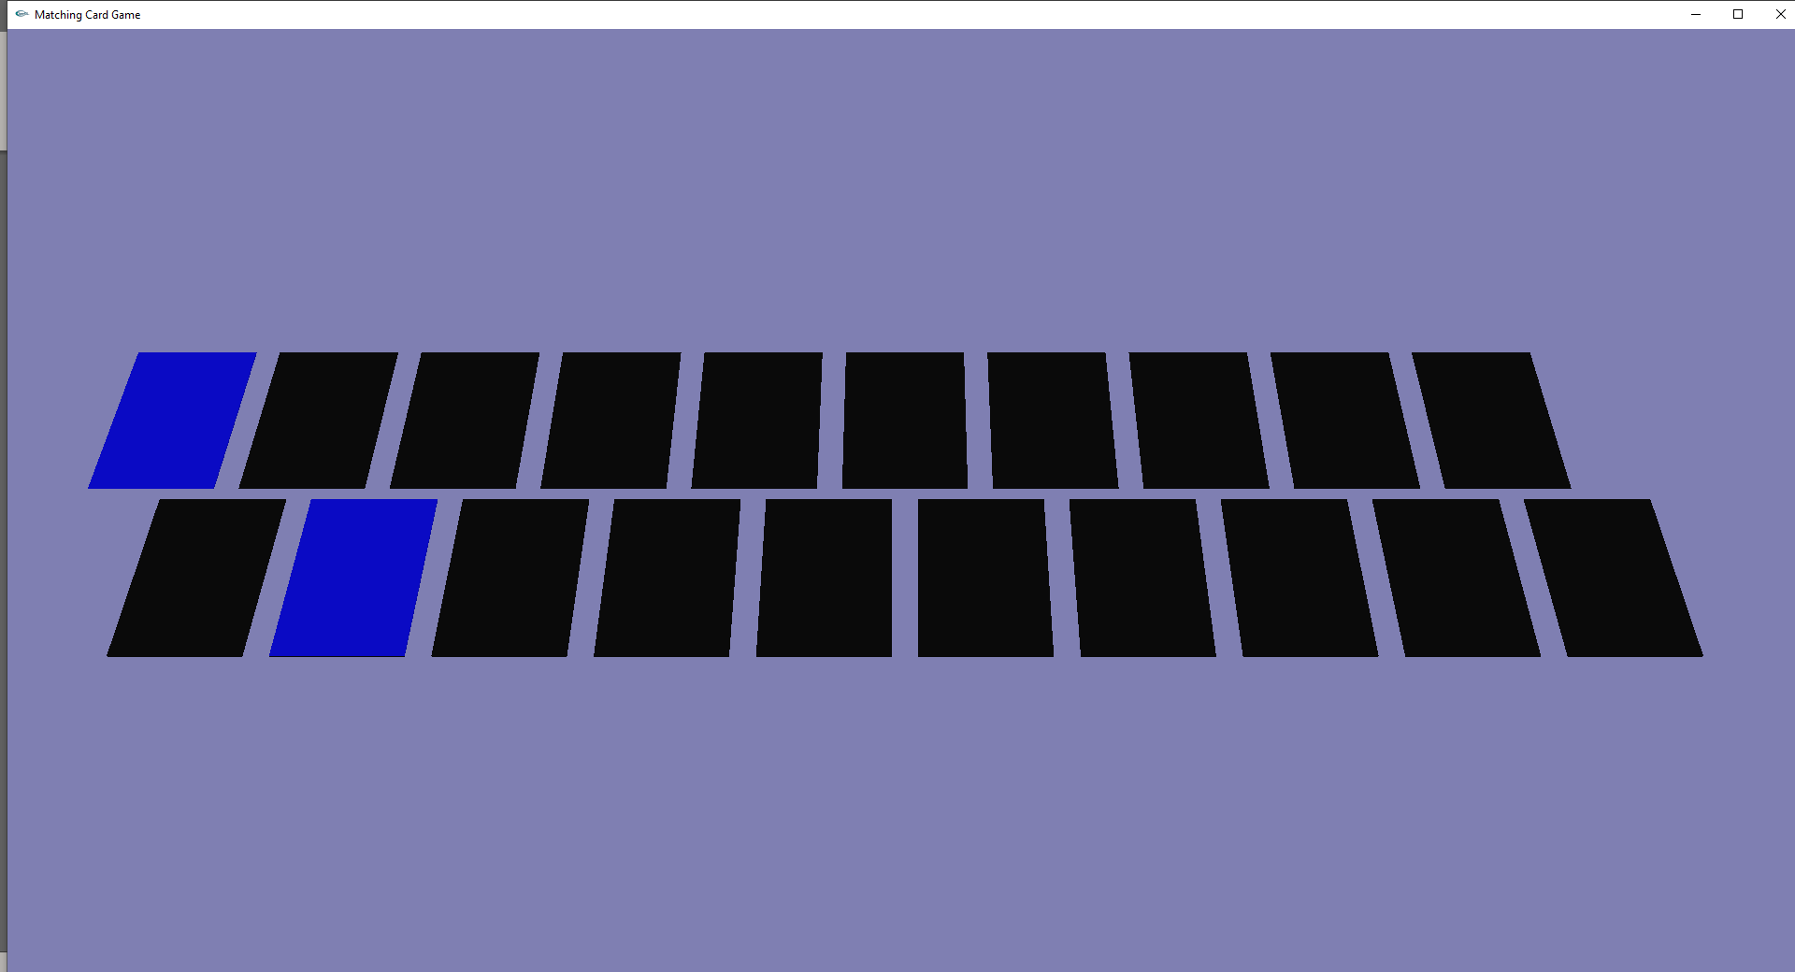

After
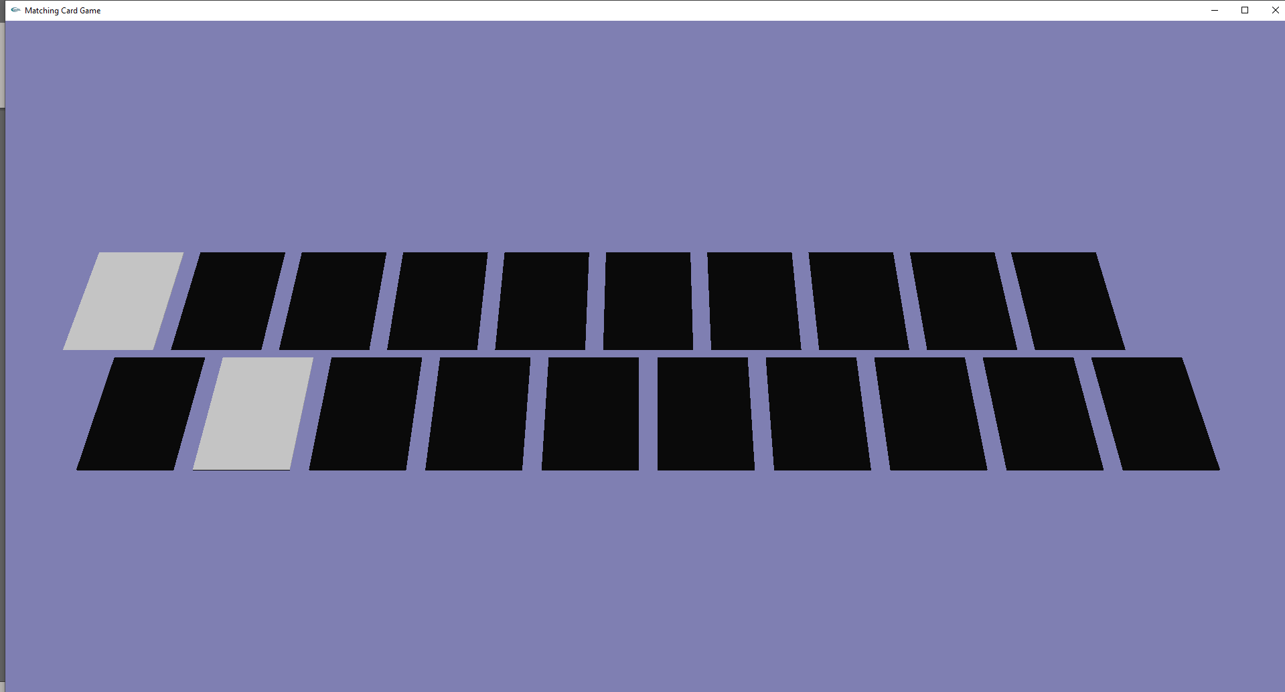

Selecting the final pair
Once the user selects the final matching pair, the game will close, and the user will be shown the victory screen via the console window. The console window will also show the user how long it took them to beat the game, and how many attempts they made.

Before
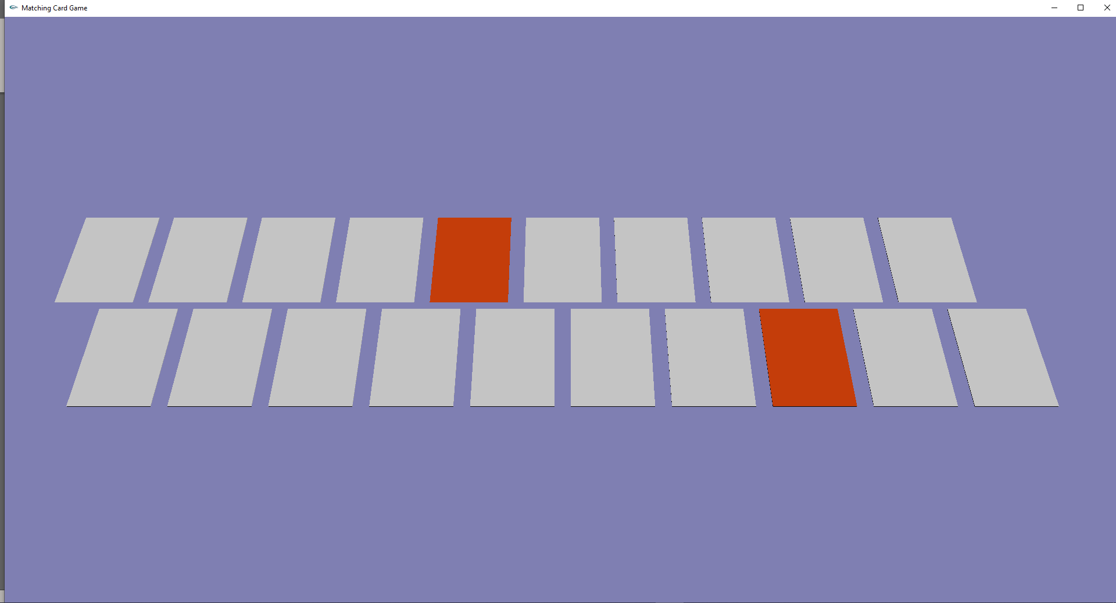

After
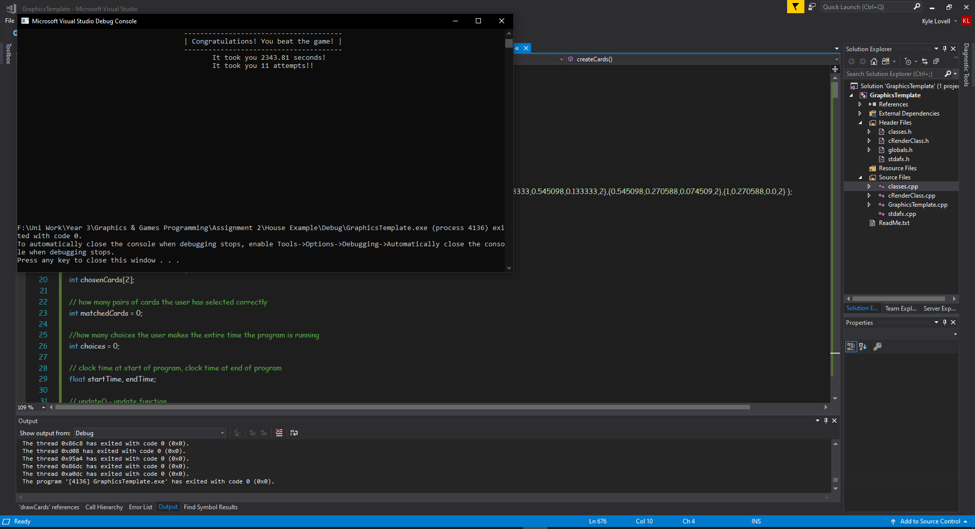

Improvements
The following are all improvements that the author felt they could have made with the project, had they had enough time to do so:
- Allowing the user to select cards with different inputs (keys, mouse etc.)
- Allowing the user to change the keys to flip the cards.
- Including animations when flipping the cards
The author was also not able to include textures in their program.

Appendix
The code included is only the code of the files the author actually worked on. Not all of the code belongs to the author, some was taken from examples given to them by lecturers.

GraphicsTemplate.cpp
// includes
#include "stdafx.h"

// externals
extern cRenderClass graphics;

cObj obj;
vector<cCard> cards;
// red, green, blue, no. of uses left
float colours[10][4] = { {0.501960,0.0,1,2},{0.0,0.0,1.0,2},{0.0,1.0,0.0,2},{0.0,1.0,1.0,2},{1.0,0.0,0.0,2},{1.0,0.0,1.0,2},{1.0,1.0,0.0,2},{0.133333,0.545098,0.133333,2},{0.545098,0.270588,0.074509,2},{1,0.270588,0.0,2} };

bool drawthecards = true;

int yTheta = 1;

int cardsChosen = 0;
int chosenCards[2];

int matchedCards = 0;
int choices = 0;

float startTime, endTime;

// update() - update function
void update()
{
// always re-render the scene..
renderScene();
}

void renderScene()
{
// set a colour
graphics.setColour(1, 1, 1);

// set pixel size..
graphics.setPointSize(4);

// draw to an off screen buffer
graphics.drawPixel(250, 250);

// render the scene
graphics.render();

}

///////////////////////////////////////////////
// Start of student's code
///////////////////////////////////////////////
void readFile()
{
string section;
int secNum = 0;
string values[3];

string line;
ifstream myfile("Card.obj");

cVector3 vec3;
cVector2 vec2;
cFVector fVec;
cFace face;

if (myfile.is_open())
{
int count = 0;
while (getline(myfile, line))
{
// found a vertex, separate line into 3 floats, store in cVector3 vec3
// will then pass into cObj
if (line[0] == 'v' && line[1] == ' ')
{
for (int i = 2; i < line.length(); i++)
{
if (line[i] != ' ')
section += line[i];
else
{
values[secNum] = section;
secNum++;
section = "";
}
}
values[secNum] = section;
secNum = 0;
section = "";

vec3.setValues(values);
obj.addV(vec3);
}

// found a texture coordinate, separate line into 2 floats, store in cVector2 vec2
// will then pass into cObj
if (line[0] == 'v' && line[1] == 't')
{
for (int i = 3; i < line.length(); i++)
{
if (line[i] != ' ')
section += line[i];
else
{
values[secNum] = section;
secNum++;
section = "";
}
}
values[secNum] = section;
secNum = 0;
section = "";

vec2.setValues(values);
obj.addVt(vec2);
}

// found a vertex normal, separate line into 3 floats, store in cVector3 vec3
// will then pass into cObj
if (line[0] == 'v' && line[1] == 'n')
{
for (int i = 3; i < line.length(); i++)
{
if (line[i] != ' ')
section += line[i];
else
{
values[secNum] = section;
secNum++;
section = "";
}
}
values[secNum] = section;
secNum = 0;
section = "";

vec3.setValues(values);
obj.addVn(vec3);
}

// found a face, separate line into 4 sets of 3 floats, store in cVector3 vec3
if (line[0] == 'f')
{
for (int i = 2; i < line.length(); i++)
{
if (line[i] != ' ' && line[i] != '/')
section += line[i];
else if (line[i] == '/')
{
values[secNum] = section;
secNum++;
section = "";
}
else
{
values[secNum] = section;
secNum = 0;
section = "";

fVec.setValues(values);
face.addFV(fVec);
}
}
values[secNum] = section;
secNum = 0;
section = "";

fVec.setValues(values);
face.addFV(fVec);
obj.addF(face);
face.clear();
}
}
}
// put break point here - testing purposes
}

int theta = 0;

void init(void);
void display(void);
void keyboardButton(unsigned char key, int x, int y);

//GLfloat mat_specular[] = { 0.256777, 0.137622, 0.086014, 1.0 };
GLfloat mat_diffuse[] = { 1, 0, /*0.0828*/ 1.0, 1.0 };
//GLfloat mat_ambient[] = { 0.19125, 0.0735, 0.0225, 1.0 };
GLfloat mat_shininess[] = { 12.8 };

GLfloat mat_specular2[] = { 0.256777, 0.137622, 0.086014, 1.0 };
GLfloat mat_diffuse2[] = { 0.7083, 0.27048, /*0.0828*/ 1.0, 1.0 };
GLfloat mat_ambient2[] = { 0.19125, 0.0735, 0.0225, 1.0 };
GLfloat mat_shininess2[] = { 12.8 };

void init(void)
{
GLfloat mat_specular[] = { 1.0, 1.0, 1.0, 1.0 };
GLfloat mat_shininess[] = { 50.0 };
GLfloat light_position[] = /*{ 1.0, 1.0, 1.0, 0.0 }*/{ 1.0, 1.0, 1.0, 0.0 };

glShadeModel(GL_SMOOTH);

//glMaterialfv(GL_FRONT, GL_AMBIENT, mat_ambient);
glMaterialfv(GL_FRONT, GL_DIFFUSE, mat_diffuse);
//glMaterialfv(GL_FRONT, GL_SPECULAR, mat_specular);
glMaterialfv(GL_FRONT, GL_SHININESS, mat_shininess);
glLightfv(GL_LIGHT0, GL_POSITION, light_position);

glEnable(GL_LIGHTING);
glEnable(GL_LIGHT0);
glEnable(GL_DEPTH_TEST);

glClearColor(0.5, 0.5, 0.7, 0.0);
/*glShadeModel(GL_FLAT);*/ //uses GL_SMOOTH or GL_FLAT
glutInitDisplayMode(GLUT_DEPTH);
glEnable(GL_DEPTH_TEST);

}

void drawCard(int index)
{
cVector3 vec;

int vIndex;

//glBindTexture(GL_TEXTURE_2D, texnum[0]);
glBegin(GL_QUADS);

GLfloat mat_diffuse[] = { 0.0, 0.0, 0.0, 1.0 };
glMaterialfv(GL_FRONT, GL_DIFFUSE, mat_diffuse);

for (int i = 0; i < obj.getFaceSize(); i++)
{
vec = obj.getNormal(i);
glNormal3f(vec.getX(), vec.getY(), vec.getZ());

if (vec.getY() == -1)
{
GLfloat mat_diffuse[] = { cards.at(index).getColour().getR(), cards.at(index).getColour().getG(), cards.at(index).getColour().getB(), 1.0 };

glMaterialfv(GL_FRONT, GL_DIFFUSE, mat_diffuse);
}

for (int j = 0; j < 4; j++)
{
vIndex = obj.getVectorIndex(i, j);
vec = obj.getVector(vIndex);
glVertex3f(vec.getX(), vec.getY(), vec.getZ());
}
}

glEnd();

}

void drawCards()
{
cVector3 vec;
cRGB colour;

//glLoadIdentity();
//glTranslatef(-6, 5, 0);
if (drawthecards)
{
for (int i = 0; i < 2; i++)
{
for (int j = 0; j < 10; j++)
{
colour = cards.at((i * 10) + j).getColour();
vec = cards.at((i * 10) + j).getPosition();

glTranslatef(vec.getX(), 5, vec.getZ());

if (cards.at((i * 10) + j).getRotate())
{
glRotatef(180, 0, 0, 1);
}
drawCard((i * 10) + j);
if (cards.at((i * 10) + j).getRotate())
{
glRotatef(180, 0, 0, 1);
}

glTranslatef(-vec.getX(), -5, -vec.getZ());

/*if (cards.at((i * 10) + j).getIsRotate())
{
cards.at((i * 10) + j).addRotate(15);
cout << cards.at((i * 10) + j).getRotate();
glRotatef(cards.at((i * 10) + j).getRotate(), 0, 0, 1);

if (cards.at((i * 10) + j).getRotate() == 180)
{
cards.at((i * 10) + j).setRotate(false);
}
}
drawCard((i * 10) + j);
if (cards.at((i * 10) + j).getIsRotate())
{
glRotatef(-cards.at((i * 10) + j).getRotate(), 0, 0, 1);
}
glTranslatef(-vec.getX(), -5, -vec.getZ());*/
}

}
}
}

void display(void)
{
//select clearing background colour
//if you don't do this then OGL will display
//whatever was last drawn in the buffer
//make it black
glClear(GL_COLOR_BUFFER_BIT | GL_DEPTH_BUFFER_BIT);
glColor3f(1.0, 1.0, 1.0);
glLoadIdentity();//reset transformation (of modelview matrix)

gluLookAt(5 * sin(float(theta)*0.0175), 15 * cos(float(yTheta)*0.0175), 5 * cos(float(theta)*0.0175), 0.0, 0.0, 0.0, 0.0, 1.0, 0.0);

// 5,5,5 - place camera ; 0,0,0 - aim lens towards 0,0,0;
// 0,1,0 - the up vector defines an unique orientation
//drawHouse();

/*glTranslatef(2.0, 0.0, 0.0);
glColor3f(0.0, 1.0, 0.0);
glRotatef(90.0, 0.0, 1.0, 0.0);
drawHouse();*/

drawCards();

glFlush();
}

void reshape(int w, int h)
{
glViewport(0, 0, w, h);
glMatrixMode(GL_PROJECTION);
glLoadIdentity();
glFrustum(-1.0, 1.0, -1.0, 1.0, 1.5, 20.0);
// l,r,bot,top,near,far

glMatrixMode(GL_MODELVIEW);
}

void checkCards()
{
cRGB col1 = cards.at(chosenCards[0]).getColour(), col2 = cards.at(chosenCards[1]).getColour();

if (col1.getR() == col2.getR() && col1.getG() == col2.getG() && col1.getB() == col2.getB())
{
// Match

cards.at(chosenCards[0]).setMatched(true);
cards.at(chosenCards[1]).setMatched(true);

matchedCards++;
}
else
{
// Not a match

cards.at(chosenCards[0]).setRotate(false);
cards.at(chosenCards[1]).setRotate(false);

}

choices++;
cardsChosen = 0;
glutPostRedisplay();

if (matchedCards == 10)
{
glutDestroyWindow(1);
cout << string(50, '\n');
cout << "\t \t \t \t \t ---------------------------------------";
cout << endl << "\t \t \t \t \t | Congratulations! You beat the game! |";
cout << endl << "\t \t \t \t \t ---------------------------------------" << endl;
endTime = GetTickCount();
cout << "\t \t \t \t \t \tIt took you " << (endTime - startTime) / 1000 << " seconds!" << endl;
cout << "\t \t \t \t \t \tIt took you " << choices << " attempts!!";
cout << string(19, '\n');
exit(0);
}
}

void turnCard(int cardIndex, bool flip, int chosenInc)
{
if (!(cards.at(cardIndex).getColour().getR() == 1 && cards.at(cardIndex).getColour().getG() == 1 && cards.at(cardIndex).getColour().getB() == 1) && cardsChosen < 2)
{
cards.at(cardIndex).setRotate(flip);
glutPostRedisplay();
cardsChosen += chosenInc;
chosenCards[cardsChosen - 1] = cardIndex;
}
}

void keyboardButton(unsigned char key, int x, int y)
{
switch (key) {
case 'd':
theta = (theta + 10) % 360;
glutPostRedisplay();
//cout << theta << endl;
break;
case 'a':
theta = (theta - 10) % 360;
glutPostRedisplay();
break;
case 'c':
yTheta = (yTheta + 10) % 360;
}

int cardIndex;

switch (key)
{
case '1':
// Choose 1st card
cardIndex = 0;

if (!cards.at(cardIndex).getRotate())
{
turnCard(cardIndex, true, 1);
}

break;
case '2':
// Choose 2nd card
cardIndex = 1;

if (!cards.at(cardIndex).getRotate())
{
turnCard(cardIndex, true, 1);
}

break;
case '3':
// Choose 3rd card
cardIndex = 2;

if (!cards.at(cardIndex).getRotate())
{
turnCard(cardIndex, true, 1);
}

break;
case '4':
// Choose 4th card
cardIndex = 3;

if (!cards.at(cardIndex).getRotate())
{
turnCard(cardIndex, true, 1);
}

break;
case '5':
// Choose 5th card
cardIndex = 4;

if (!cards.at(cardIndex).getRotate())
{
turnCard(cardIndex, true, 1);
}

break;
case '6':
// Choose 6th card
cardIndex = 5;

if (!cards.at(cardIndex).getRotate())
{
turnCard(cardIndex, true, 1);
}

break;
case '7':
// Choose 7th card
cardIndex = 6;

if (!cards.at(cardIndex).getRotate())
{
turnCard(cardIndex, true, 1);
}

break;
case '8':
// Choose 8th card
cardIndex = 7;

if (!cards.at(cardIndex).getRotate())
{
turnCard(cardIndex, true, 1);
}

break;
case '9':
// Choose 9th card
cardIndex = 8;

if (!cards.at(cardIndex).getRotate())
{
turnCard(cardIndex, true, 1);
}

break;
case '0':
// Choose 10th card
cardIndex = 9;

if (!cards.at(cardIndex).getRotate())
{
turnCard(cardIndex, true, 1);
}

break;

case 'q':
// Choose 11th card
cardIndex = 10;

if (!cards.at(cardIndex).getRotate())
{
turnCard(cardIndex, true, 1);
}

break;
case 'w':
// Choose 12th card
cardIndex = 11;

if (!cards.at(cardIndex).getRotate())
{
turnCard(cardIndex, true, 1);
}

break;
case 'e':
// Choose 13th card
cardIndex = 12;

if (!cards.at(cardIndex).getRotate())
{
turnCard(cardIndex, true, 1);
}

break;
case 'r':
// Choose 14th card
cardIndex = 13;

if (!cards.at(cardIndex).getRotate())
{
turnCard(cardIndex, true, 1);
}

break;
case 't':
// Choose 15th card
cardIndex = 14;

if (!cards.at(cardIndex).getRotate())
{
turnCard(cardIndex, true, 1);
}

break;
case 'y':
// Choose 16th card
cardIndex = 15;

if (!cards.at(cardIndex).getRotate())
{
turnCard(cardIndex, true, 1);
}

break;
case 'u':
// Choose 17th card
cardIndex = 16;

if (!cards.at(cardIndex).getRotate())
{
turnCard(cardIndex, true, 1);
}

break;
case 'i':
// Choose 18th card
cardIndex = 17;

if (!cards.at(cardIndex).getRotate())
{
turnCard(cardIndex, true, 1);
}

break;
case 'o':
// Choose 19th card
cardIndex = 18;

if (!cards.at(cardIndex).getRotate())
{
turnCard(cardIndex, true, 1);
}

break;
case 'p':
// Choose 20th card
cardIndex = 19;

if (!cards.at(cardIndex).getRotate())
{
turnCard(cardIndex, true, 1);
}

break;
case 13:
// Presses Enter
if (cardsChosen > 1)
{
checkCards();
}
break;
case 32:
// Presses Space
drawthecards = !drawthecards;
glutPostRedisplay();
default:

break;
}
}

void createCards()
{
cCard card;
float x = -6;
float y = 5;
float z = 0;
int randCol;

for (int i = 0; i < 2; i++)
{
for (int j = 0; j < 10; j++)
{
card.setPosition(x, y, z);

do
{
randCol = rand() % 10;
} while (colours[randCol][3] == 0);

colours[randCol][3]--;

card.setColour(colours[randCol][0], colours[randCol][1], colours[randCol][2]);

cards.push_back(card);
x += 1.2;
}
x = -5.4;
z += 2.4;
}
// break point here - for testing purposes
}

int main(int argc, char** argv)
{
createCards();

cout << endl << endl << "\t \t \t \t \t---------------------" << endl;
cout << "\t \t \t \t \t| Card key bindings |" << endl
<< "\t \t \t \t \t---------------------" << endl <<
"\t \t \t \t \t 1 2 3 4 5 6 7 8 9 0" << endl <<
"\t \t \t \t \t Q W E R T Y U I O P" << endl << endl;

cout << "Select 2 cards, then press ENTER to confirm your selection!" << endl << endl;
cout << "Press ENTER to continue.";
cin.get();
startTime = GetTickCount();

glutInit(&argc, argv);
glutInitDisplayMode(GLUT_SINGLE | GLUT_RGB);
glutInitWindowSize(1920, 1080);
glutInitWindowPosition(0, 0);
glutCreateWindow("Matching Card Game");

/*glMaterialfv(GL_FRONT, GL_SPECULAR, mat_specular);
glMaterialfv(GL_FRONT, GL_SHININESS, mat_shininess);
glMaterialfv(GL_FRONT, GL_DIFFUSE, mat_diffuse);
glMaterialfv(GL_FRONT, GL_AMBIENT, mat_ambient);*/

init();
glutReshapeFunc(reshape);
glutDisplayFunc(display);
glutKeyboardFunc(keyboardButton);
//glutIdleFunc(update);
readFile();

glutMainLoop();

return 0;
}

Classes.h
#pragma once
#include "stdafx.h"

// used to define colour of card
class cRGB
{
public:
cRGB();
~cRGB();

float getR();
float getG();
float getB();

void setColour(float ir, float ig, float ib);

private:
// floats between 0 and 1
float r, g, b;
};

class cVector3
{
public:
cVector3();
~cVector3();

void setValues(string values[3]);
float getX();
float getY();
float getZ();

private:
float x, y, z;
};

class cVector2
{
public:
cVector2();
~cVector2();

void setValues(string values[2]);

private:
float x, y;
};

class cFVector
{
public:
cFVector();
~cFVector();

void setValues(string values[3]);
int getVector();
int getTexture();
int getNormal();

private:
int v;
int vt;
int vn;
};

class cFace
{
public:
cFace();
~cFace();

void addFV(cFVector fVector);
void clear();
int getNormal();
int getVertex(int faceVectorIndex);

private:
vector<cFVector> fVectors;
};

class cObj
{
public:
cObj();
~cObj();

void addV(cVector3 cPos);
void addVt(cVector2 cPos);
void addVn(cVector3 cPos);
void addF(cFace face);

int getFaceSize();
cVector3 getNormal(int index);
cVector3 getVector(int index);
int getVectorIndex(int faceIndex, int faceVectorIndex);

private:
vector<cVector3> vertexPositions;
vector<cVector2> textureCoordinates;
vector<cVector3> vertexNormals;
vector<cFace> faces;
};

class cCard
{
public:
cCard();
~cCard();

void setPosition(float x, float y, float z);
cVector3 getPosition();
cRGB getColour();
void setColour(float ir, float ig, float ib);
void setRotate(bool value);
bool getRotate();
bool getMatched();
void setMatched(bool value);

private:
// colour of card
cRGB colour;

// if user finds matching pair, matched is set to true. Stops user from choosing this card again
bool isMatched;

// position of card
cVector3 position;

bool isRotate;
};

Classes.cpp
#include "stdafx.h"
#include "classes.h"

cRGB::cRGB()
{
r = 1.0, g = 1.0, b = 1.0;
}
cRGB::~cRGB()
{
}
float cRGB::getR()
{
return r;
}
float cRGB::getG()
{
return g;
}
float cRGB::getB()
{
return b;
}
void cRGB::setColour(float ir, float ig, float ib)
{
r = ir;
g = ig;
b = ib;
}

cVector3::cVector3()
{
x = 0, y = 0, z = 0;
}
cVector3::~cVector3()
{
}
void cVector3::setValues(string values[3])
{
stringstream(values[0]) >> x;
stringstream(values[1]) >> y;
stringstream(values[2]) >> z;
}
float cVector3::getX()
{
return x;
}
float cVector3::getY()
{
return y;
}
float cVector3::getZ()
{
return z;
}
cVector2::cVector2()
{
x = 0, y = 0;
}
cVector2::~cVector2()
{
}
void cVector2::setValues(string values[2])
{
stringstream(values[0]) >> x;
stringstream(values[1]) >> y;
}

cFVector::cFVector()
{
v = 0;
vt = 0;
vn = 0;
}
cFVector::~cFVector()
{
}
void cFVector::setValues(string values[3])
{
stringstream(values[0]) >> v;
stringstream(values[1]) >> vt;
stringstream(values[2]) >> vn;
}
int cFVector::getVector()
{
return v;
}
int cFVector::getTexture()
{
return 0;
}
int cFVector::getNormal()
{
return vn;
}

cFace::cFace()
{
}
cFace::~cFace()
{
}
void cFace::addFV(cFVector fVector)
{
fVectors.push_back(fVector);
}
void cFace::clear()
{
fVectors.clear();
}
int cFace::getNormal()
{
return fVectors.at(0).getNormal();
}
int cFace::getVertex(int faceVectorIndex)
{
return fVectors.at(faceVectorIndex).getVector();
}

cObj::cObj()
{
/*
vertexPositions.push_back(0.69);
vertexPositions.push_back(0.666);
vertexPositions.insert(vertexPositions.begin() + 1, 420);
vertexPositions.erase(vertexPositions.begin());
vertexPositions.clear();
*/
}
cObj::~cObj()
{
}
void cObj::addV(cVector3 cPos)
{
vertexPositions.push_back(cPos);
}
void cObj::addVt(cVector2 cPos)
{
textureCoordinates.push_back(cPos);
}
void cObj::addVn(cVector3 cPos)
{
vertexNormals.push_back(cPos);
}
void cObj::addF(cFace face)
{
faces.push_back(face);
}
int cObj::getFaceSize()
{
return faces.size();
}
cVector3 cObj::getNormal(int index)
{
int nIndex = faces.at(index).getNormal();
return vertexNormals.at(nIndex - 1);
}
cVector3 cObj::getVector(int index)
{
return vertexPositions.at(index - 1);
}
int cObj::getVectorIndex(int faceIndex, int faceVectorIndex)
{
return faces.at(faceIndex).getVertex(faceVectorIndex);
}

cCard::cCard()
{
isMatched = false;
isRotate = false;
}
cCard::~cCard()
{
}
void cCard::setPosition(float x, float y, float z)
{
string values[3] = { to_string(x),to_string(y),to_string(z) };
position.setValues(values);
}
cVector3 cCard::getPosition()
{
return position;
}
cRGB cCard::getColour()
{
return colour;
}
void cCard::setColour(float ir, float ig, float ib)
{
colour.setColour(ir, ig, ib);
}
bool cCard::getRotate()
{
return isRotate;
}
bool cCard::getMatched()
{
return isMatched;
}
void cCard::setMatched(bool value)
{
isMatched = value;
setColour(1, 1, 1);
}
void cCard::setRotate(bool value)
{
isRotate = value;
}

