Software Development
Adam Horton (1702203)

Decloration
The Person writting this assignment, Adam Horton,states that all work below unless stated otherwise is by himself and by his own accord.
Exercise 1
The problems
The problems that the writter had to face are as follows below in the table:
Problem Number 1 was trying to storing the numbers in a list- its difficulty was Easy
Solution - When the user types in the numbers, they are stored in a list that can hold 7 numbers
Problem number 2 was clearing the screen so player 2 couldnt see what player 1 had entered. The diffuculty was a medium and the solution for this was to create a loop that would continue to print blank lines to the screen.
Problem number 3 was to carry on looping if player 2’s guess was correct and to exit the loop if the guess was wrong. The difficulty for this was a Hard but it seemed easier than expected and the solution was to use multiple IF functions to ask them to guess and then check if the answer was right or wrong and if it is correct it wouldnt take a life off and would carry on looping but if the answer was incorrect it would deduct a life and cause the program to exit the loop and display a Game Over message to the screen.
The final problem the user faced was the validation of weither they had entered a whole number isntead of a letter / char or a double / decimal point number. The difficulty for this was hard due to multiple attempts to ensure that the code didnt say that their was an error in the code when a whole number was entered into the system. The solution for this was to implament multiple checks to make sure that the value passed in by the player didnt fall into the catagories of a double nor a string, other wise the player would have to re-type their input into the system again.
Testing
This is the part where the user has tested the code, shown and explained the outcome and then what the code should have been like / is like to date.
Test 1- clearing the screen
Origninally the plan was to open up a new GUI once the 1st player had entered their numbers, but due to the fact of the user doesn’t know how to do that,they decided to cout new lines to ensure that player 2 couldnt cheat.
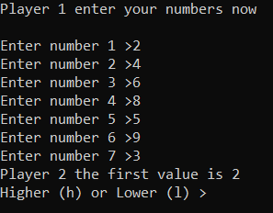
After testing this, it is clear that more lines were needed to make enough space so that player 2 can’t see the numbers that player 1 has entered.
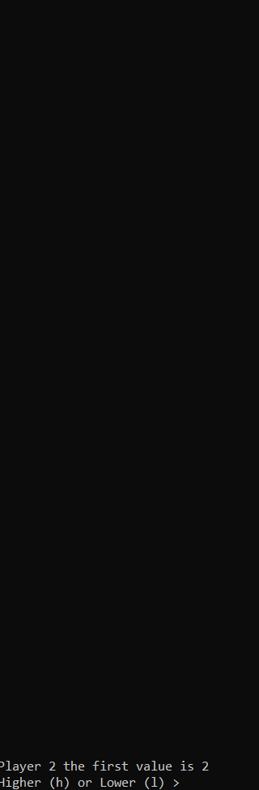
As you can see the new implamented function now prints to the screen 100 new lines so player 2 cannot see what values player 1 has entered before hand. The user believes that this test was a success due to it has done its job to the letter and allows the game to be played fairly and allows for endless combinations of numbers, both positive and negitive.

Exercise 2
The problems
below are a list of problems the user had when trying to do this section of the assignment,
problem number 1 and 2 was storing the treasure and players 2 guesses into a suitable valriable so that when they are being comparied they would show an accurate reading. The difficulty was easy due to the multiple amount of ways that it could be stored. The solution for both of these has been to store each 1 in a list which would contain 2 variables, the X and Y co-ordinates. For emaple the 1st treasure would be stored as Treasure1[2] where [0] is X and [1] is the Y co-ordinate.
The 3rd problem was setting and printing to the screen the map of where the treasure would be palced and where player 2 could guess where they are. The difficulty for this was hard due to the fact of the user tried to use multiple cout lines to just display the map and forgot about the X for when the treasure is found and N for if their is nothing there on the map. The solution for this was to store the map as a string list and save each element in the string list using multiple lines to ensure that each element was set to its unique placement.
The 4th problem the user faced was placing the treasure / guesses into the correct co-ordinates as a list starts at 0 and would have ment that location [1,5] would be [0,4] on the map. The difficulty for this was also hard but after looking at it from multiple angles. The solution for this was incrementing each treasure location entered by 1 so that[1,1] would become [2,2] on the map which would show [1,1] on the map.
The final problem is showing the map with either an X or a N on the correct co-ordinates. This was a hard task to complete however by using the knowledge the user had learnt from the previousn problem, it hadm simplified the solution for it. The solution is to set either X or N to an incromented possition, just like the previous problem, and show it to the screen so it does apear in the correct possition.

Testing
This portion of the assignment will show the testing done on the problems above and their outcomes.
Test 1- printing the map out.
Originally the map was going to be in a seperate function which would be called to display itself and show weather the treasure was found or not. The map origignally looked like:
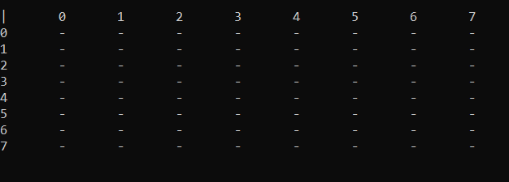
But was later changed to look like:
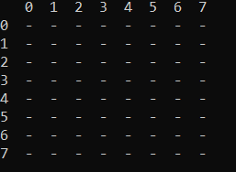
As this version allowed the map and the player more space to see and was also easier to code due to it. This outcome did appeal more to the user as it didnt fill the whole screen and was also easier to follow when it came to showing the X for any treasures found and a N for where there was nothing.
Test 2- showing the X and the N for the treasure
Coding this part of the map was also tricky due to the cordinates were of by 1 on each axis, X and Y, due to each list starts at 0. The original test was a fail due to its positioning on the map which was in the wrong place. The treasures are stored in [1,1],[2.2] and [3,3].
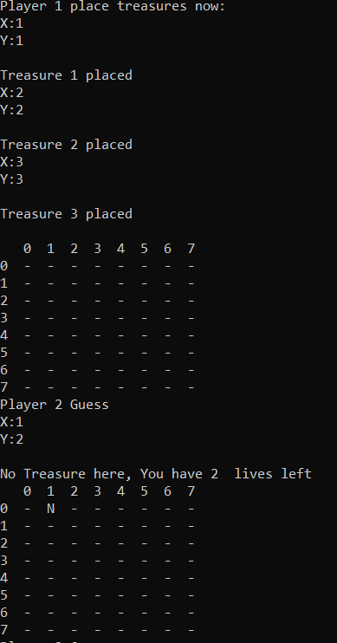
To combat this problem, the user decided to inplament a function that would allow the X and Y to be placed on the corrct pannels by incrementing each X and Y axis by 1 as shown below:
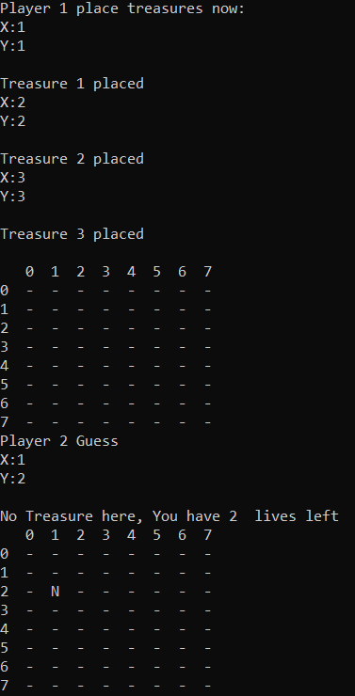
This test was a success due to it allowes the user to see where they have guessed and shows the N or X for that location correctly aswell. This is the evidence of the X being placed before the code was finished and after.
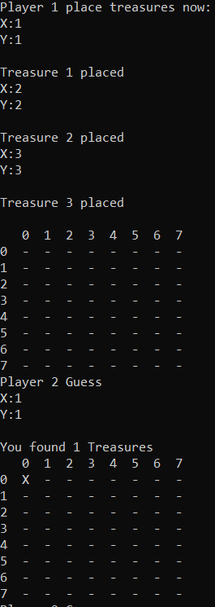
and this is the after:
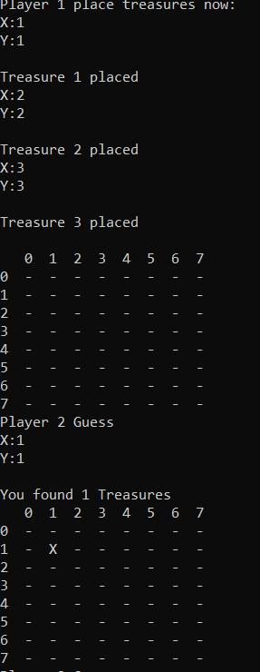
overall the user is happy with these results due to they accuratly place the X and / or N in the correct place on the board and allowes other players to see where they have guessed and weither they were right or wrong.
Exercise 3
The problems
The user did atempt this part of the assignment on paper but realised that in order to do some of the specific specifications of this section would require additional time and thinking which would have been after the deadline / due date. However, the user has included the information of an attempt on paper below, to ensure that marks are given when marks are some what due.

Apendix
EXERCISE 1 (assignment.sln)
#include <stdio.h>
#include <string>
#include <iostream>
#include <sstream>
using namespace std;
int main(int argc, char** argv[])
{
int numbers[7]; //this creates an array for the numbers
int loopNumb = 0;
string player2Guess;
cout << "Player 1 enter your numbers now" << endl << endl;

for (loopNumb = 0; loopNumb < 7; loopNumb++) //this loop causes the user (player 1 ) to enter the values that the 2nd user ( player 2 ) would guess.
{
cout << "Enter number " << loopNumb + 1 << " >";
string input = "";
stringstream stream;
getline(cin, input);
stream.str(input);
stream >> numbers[loopNumb];
stream.clear();
}
for (int I = 0; I < 100; I++)
{
cout << endl;
}
loopNumb = 0;
cout << "Player 2 the first value is " << numbers[loopNumb] << endl;

string answer;
for (loopNumb = 0; loopNumb < 6; loopNumb++)
{
cout << "Higher (h) or Lower (l) > ";
getline(cin, player2Guess);
if (player2Guess == "h")
{
if (numbers[loopNumb] < numbers[loopNumb + 1])
{
cout << "Correct,the next value is " << numbers[loopNumb + 1] << endl;
}
else
{
answer = "wrong";
cout << "You said higher, you were wrong.Sorry player 2 but player 1 wins " << endl;
break;
}
}
else if (player2Guess == "l")
{
if (numbers[loopNumb] > numbers[loopNumb + 1])
{
cout << "Correct,the next value is " << numbers[loopNumb + 1] << endl;
}
else
{
answer = "wrong";
cout << "Incorrect answer, sorry player 2 but player 1 wins " << endl;
break;
}
}
else
{
cout << "Please enter either h or l" << endl;
loopNumb--;

}
}
if (loopNumb == 6)
{
cout << "Congratulations player 2 on Beating player 1 with a score of " << loopNumb + 1 << " out of 7" << endl;
}

//pause
cin.get();
return 0;
}
EXERCISE 2(tester.sln)
#include <stdio.h>
#include <string>
#include <iostream>
#include <sstream>
using namespace std;

int main(int argc, char** argv[])
{
int foundTreasure = 0;
int lives = 3;

int looper;
int X;
int Y;
int treasure1[2];
int treasure2[2];
int treasure3[2];

// if treasure is found put a X on the -
// if treasure is not found put a N and take a life off( has 3 lives )

cout << "Player 1 place treasures now:" << endl;

for (looper = 0; looper < 3; looper++)
{
cout << "X:";
string input = "";
stringstream stream;
getline(cin, input);
stream.str(input);
stream >> X;
stream.clear();

cout << "Y:";
getline(cin, input);
stream.str(input);
stream >> Y;
stream.clear();

cout << endl;

if (X >= 8 || Y >= 8)
{
cout << "Please type in a number between 0 and 8 for both the X Axis and The Y Axis" << endl << endl;
looper = looper - 1;

}

if (looper == 0 && X > 0 && X < 8 && Y > 0 && Y < 8)
{
treasure1[0] = X;
treasure1[1] = Y;// 1st treasure location
}
else if (looper == 1 && X > 0 && X < 8 && Y > 0 && Y < 8)
{
treasure2[0] = X;
treasure2[1] = Y;// 2nd treasure location
}
else if (looper==2 && X > 0 && X < 8 && Y > 0 && Y < 8)
{
treasure3[0] = X;
treasure3[1] = Y;// 3rd treasure location
}

cout << "Treasure " << looper + 1 << " placed" << endl;

}

cout << endl;
int looper2 = 0;
int x2;
int y2;
int Player2Guess[2];
string map[9][9] = {
{" ","0","1","2","3","4","5","6","7"},
{"0","-","-","-","-","-","-","-","-"},
{"1","-","-","-","-","-","-","-","-"},
{"2","-","-","-","-","-","-","-","-"},
{"3","-","-","-","-","-","-","-","-"},
{"4","-","-","-","-","-","-","-","-"},
{"5","-","-","-","-","-","-","-","-"},
{"6","-","-","-","-","-","-","-","-"},
{"7","-","-","-","-","-","-","-","-"},
};

// X on a - is where player 2 has found a treasure
// and an N on a - is where player 2 has not found a treasure and has lost a life

for (int y = 0; y < 9; y++) {
for (int x = 0; x < 9; x++) {
cout << map[y][x] << " ";
}
cout << endl;
}

while (lives > 0 && foundTreasure < 3)
{
cout << "Player 2 Guess" << endl;

cout << "X:";
string input = "";
stringstream stream;
getline(cin, input);
stream.str(input);
stream >> x2;
stream.clear();

cout << "Y:";
getline(cin, input);
stream.str(input);
stream >> y2;
stream.clear();
cout << endl;

Player2Guess[0] = x2;
Player2Guess[1] = y2;

int P2GuessX = Player2Guess[1] + 1;
int P2GuessY = Player2Guess[0] + 1;

if (Player2Guess[0] == treasure1[0] && Player2Guess[1] == treasure1[1] || Player2Guess[0] == treasure2[0] && Player2Guess[1] == treasure2[1] || Player2Guess[0] == treasure3[0] && Player2Guess[1] == treasure3[1])
{
map[P2GuessX][P2GuessY] = "X";

foundTreasure = foundTreasure + 1;

cout << "You found " << foundTreasure << " Treasures" << endl;

for (int y = 0; y < 9; y++)
{
for (int x = 0; x < 9; x++)
{
cout << map[y][x] << " ";
}
cout << endl;
}
}
else
{
lives = lives - 1;

cout << "No Treasure here, You have " << lives << " lives left" << endl;

map[P2GuessX][P2GuessY] = "N";

for (int y = 0; y < 9; y++)
{
for (int x = 0; x < 9; x++)
{
cout << map[y][x] << " ";
}
cout << endl;
}
}
}

if (lives == 0 )
{
cout << "Player 2 you have " << lives << " lives and found " << foundTreasure << " out of 3 treasures. Player 1 Wins" << endl;
}

if (foundTreasure == 3)
{
cout << "Player 2 you found all 3 treasures.Player 2 wins" << endl;
}

//pause
cin.get();
return 0;
}

