Reflective essay
Teaching aims and Lesson Objectives:
lesson plans
Math:
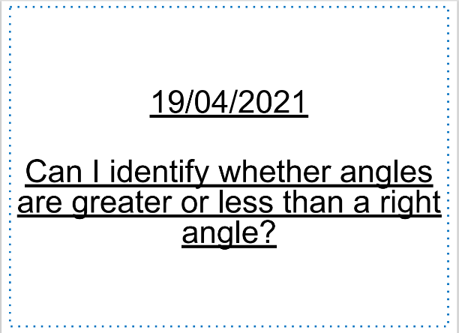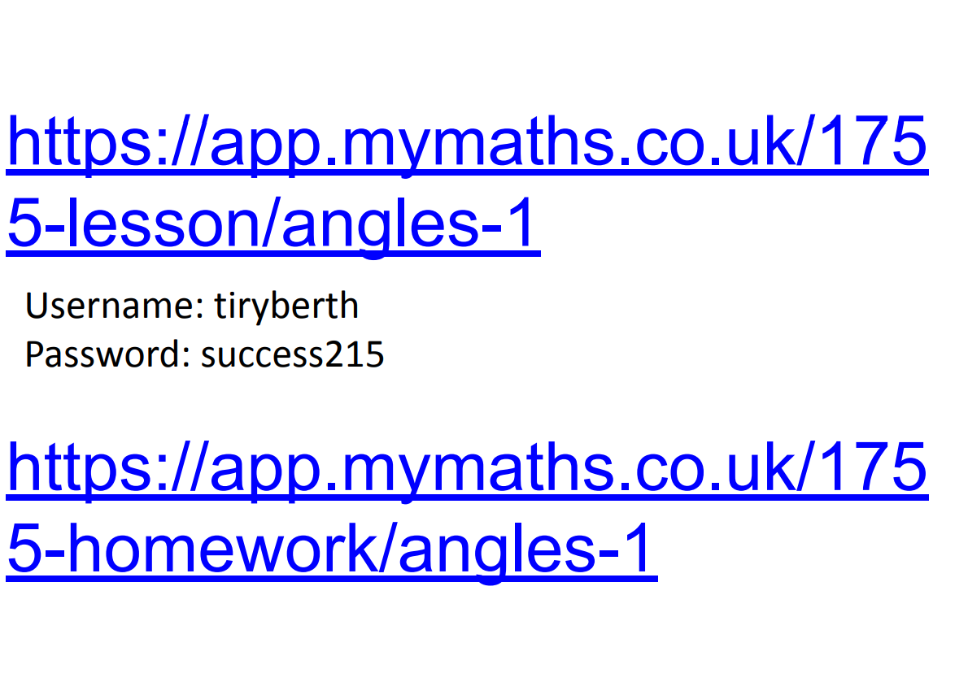
(figure 1. Lesson plan for numeracy, Mr D. Farmer, 2021)
Literacy:
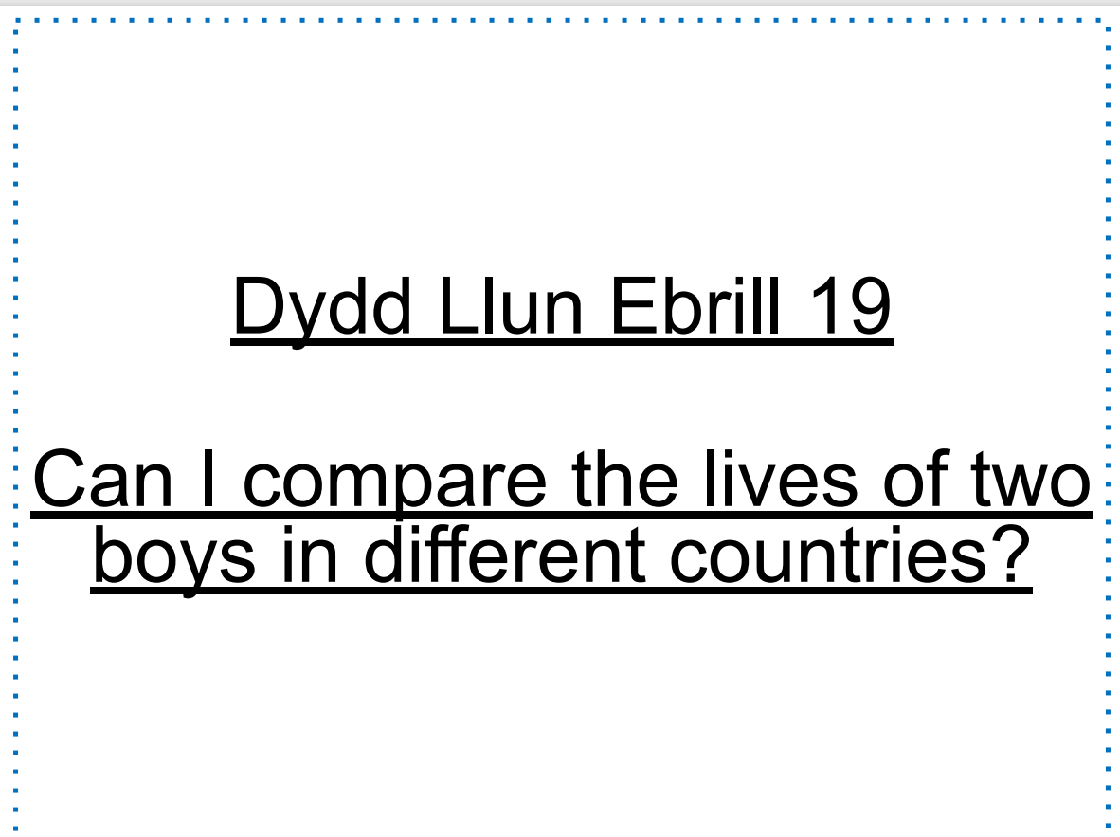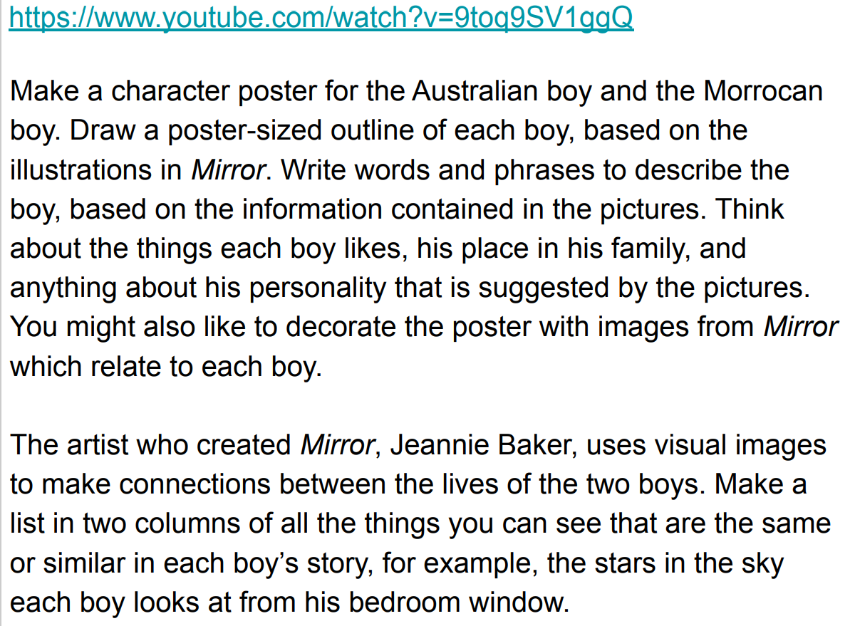
(figure 2. Lesson plan for literacy class, Mr D. Farmer, 2021)
Gibbs reflective cycle:
The Gibbs reflective style is a way of evaluating successfully what one has learnt and felt internally during an event. In this instance I will be using the Gibbs reflective cycle to provide an in-depth evaluation about my placement experience.
Description
For the placement section of this module, I observed the year 6 class in a local Primary school, on the 19th of April 2021. The classes were taken by Mr D. F and teaching assistant Mrs L. W. The focus of the classes I observed were mathematics and literacy; during this class, the learners were taught angles. The learning objective for this lesson was to see if learners could identify whether angles are greater or less than a right angle. By the end of this lesson the learners were able to identify angles greater or lesser than a right angle, furthermore the learners were able to give examples of right angles from around the classroom.
Feelings
During this placement I felt very welcomed by the school and settled comfortably into the setting. At the time I did not know what to expect from the learners or the class environment, however as the classes progressed, I was becoming more involved with the learners and the lesson. I began to feel comfortable enough to talk and engage with them whilst they were working and out in the playground during breaks. After learning about the Steiner schools and the methods of pupil-based learning I was conflicted when I began to observe this class, as it was heavily teacher-led learning. However, when choosing a literacy book the learners were tasked with creating a PowerPoint based on the novel they wanted to study, then that PowerPoint was presented to the class and the class collectively chose what book they wanted to study. I believe this is a successful way of involving the learners as it allows them to have a voice within their studies. I got the impression that the learners were questioning what my role was within the class, but once they were told I was just here to observe and learn I began to blend into the classroom setting. After the class it became apparent that this style of teaching is what interested the learners most: when they were tasked with something that they took the lead upon over the teacher they appeared to become more driven, and goal orientated in comparison to the teacher-led learning activities.
Evaluation
Overall, my experience at this placement was successful as I have gained further knowledge of the school and classroom environment and I have been able to view the different learning styles and techniques in action towards the learners. It was beneficial to be able to understand what I had learnt within the lectures about learning styles and the way in which children learn, and then to be able to observe that theory in a physical example such as; observing the kinaesthetic way of teaching and the social and solitary way of learning. However, as this was a real classroom observation, I was also distracted at times from understanding what sections of the class were useful in comparison to what was just normal children’s behaviour. For example, there were many times when the class was disrupted due to learners misbehaving and ignoring instruction. This often led to the teacher having to correct misbehaving students which took time out of classroom learning and at times having to reiterate what the tasks were to some learners as they were not listening and retaining focus. My role for this class was to observe, however when the class had their arts and crafts activity, they were tasked with writing their name in Chinese and learning how to say it, and due to my prior knowledge, I was able to contribute and teach some of the higher ability learners how to say ‘hello’ and ‘thank you’ in Chinese as well as their name.
The one altercation I witnessed was between CD and AD. They were being too rough to each other when out on break, and as a result the TA Mrs L W told the boys they must stand against the wall for the rest of their break. Mr D F saw that the boys were being punished and in turn told them they must come inside and write down the rules of how to keep safe in the break yard. I believe this was a successful punishment as both pupils were not in another altercation for the rest of that week.
Analysis
I believe the main reason as to why most of the classes were successful is down to the teaching style of Mr D.F. His main teaching style involves a lot of pupil-based learning where learners are given the authority to choose their own studies, for example with the literacy lesson where learners were able to choose their class book based upon the other learner’s power points. The learning style that took the lead during Mr D. F’s class was kinaesthetic and social learning. Due to the choice of learning styles used I believe this is what made Mr D. F’s classes successful and contributed to what helped learners remain entertained with the lesson and enthusiastic to learn. It is this style of teaching that relates closely with some aspects of Steiner Waldorf learning: in that it is the learners who choose the topic for the teacher to teach to them. This can be applied to Mr D. F’s class as it was the students that decided on what book to study based on the PowerPoints from their peers. Another theory I picked up on during my placement was the use of bloom’s Taxonomy. In the delivery of Mr. D. F’s Mathematics lesson he uses the chronological approach of blooms taxonomy. I believe this was successful as it provided depth to the topic and it was evident that the learners understood the topic as they were able to provide examples of right angles without having to take too much time to think. This type of learning also supports the ideas of Jerome Burner that argues that “suggests it is effective when faced with new material to follow a progression from enactive to iconic to symbolic representation; this holds true even for adult learners.”
To gain a deeper insight to the learners I could have involved myself further by talking with them and helping them through their work. I believe a different style of attention grabbers may have helped the situations where learners started to become restless and distracted. Mr D.F was using a clapping sequence to get the learners attention that they would then repeat. I think Mr D.F could have used tik tok attention grabbers as that is more current with the learners and would catch their attention faster, as it is something they take interest in.
Conclusion
I have discovered that it is more difficult to keep learners engaged with learning and class activities, especially if the activities are more mandatory like literacy and numeracy. From watching this example, I have acquired different techniques and have gained further understanding as to what ways are effective in helping learners remain entertained and what is unsuccessful. To handle these situations better it would be useful to have background knowledge on what types of learning styles the learners prefer, and try to then cater the lessons to that, to retain maximum engagement.
Action plan
I have observed various teaching resources in effective use, such as:
- MyMaths.co.uk: this platform was used for their math activity when finding angles. The learners used chrome books and protractors. This was an example of logical learning styles, although this type of teaching did poorly at keeping the learners engaged with the work. However, it then changed into the social type of learning as the learners were put in pairs where they could work together to discover the angles. This type of learning style seemed to better suit the learners as they were able to work with friends and this helped them stay motivated and engaged. This is something that is also emphasises by Vygotsky as he argues there should be more emphasis put on social learning as it can be believed that is contributes to cognitive development.
From this I will be able to use the different learning techniques I have viewed, as I have seen the positives and negatives of the platforms used. When I come to teach, I will try to include as much teacher/learner interaction as possible and keep activities social and adopt a kinaesthetic learning style as this seems to be the most successful in keeping learners engaged with their activities. If I were to do this observation again, I think I would try to be more engaging with the class and ask them how they enjoy their learning and what they believe is most effective, to get their opinion rather than just base it from my observation. I would also try to have more of a presence within the classroom by walking around to help learners and being in their area, to show that I am part of their learning experiences just as much as they are a part of mine.

Bibliography

Dr Saul McLeod, Burner – learning theory in Education (2019) <https://www.simplypsychology.org/bruner.html > [accessed 27.04.21].

Gibbs. G, Learning by doing, (Oxford: Oxford Brookes University, 1988)

Independent School Parent, Steiner School’s: an alternative education system. (2021) https://www.independentschoolparent.com/school/steiner-schools-an-alternative-educational-system/ [accessed 27.04.21].

Graham Gibbs, Learning by doing, (Oxford: Oxford Brookes University, 1988)
Independent School Parent, Steiner School’s: an alternative education system. (2021) https://www.independentschoolparent.com/school/steiner-schools-an-alternative-educational-system/ [accessed 27.04.21].
Dr Saul McLeod, Burner – learning theory in Education (2019) <https://www.simplypsychology.org/bruner.html > [accessed 27.04.21].

