Faiz Khan
2221958
FireWall AND ACLS Report

Abstract
This project investigates the effectiveness of the Firewalls and Access Control Lists ACLs in securing network infrastructures using Packet Tracer as the primary simulation tool. The study analyses various Firewall configurations and ACL implementations to evaluate their impact on network security and performance. By conducting controlled experiments, this research aims to provide network administrators with practical insights to optimise their security configurations.
Contents
Chapter 1 4
1.1 Introduction 4
1.2 AIM 4
1.3 Objectives 4
1.4 Structure of the project. 5
Chapter 2 Research and Review of Literature 6
2.1 Introduction 6
2.2 Methodology 6
2.3 Review of Key Works 6
Firewall Misconfigurations 6
ACL Configuration 6
Dynamic Firewall and Performance 7
2.4 Application of tables and Figures 7
2.5 Quotations 7
2.6 Conclusion 8
Chapter 3 – Research Methodology 8
3.1 Introduction 8
3.2 Research Overview 8
3.2.1 Research Process 9
3.2.2 Research Philosophy 9
3.2.3 Research Methodologies 9
3.2.4 Philosophies 10
3.2.5 Approach 10
3.2.6 Strategies 11
3.2.7 Choices 11
3.2.8 Time Horizons 12
3.2.9 Techniques and Procedures 12
3.3 Conclusion 12
Chapter 4 – Design & Implementation 13
4.1 Introduction 13
4.2 Problem Formulation 13
4.3 Design 14
Network Diagram Overview 15
4.4 Implementation 15
4.5 Conclusion 18
Chapter 5 - Testing and Evaluation 19
5.1 Introduction 19
5.2 Experiment Setup 19
5.3 Firewall and ACL testing process 19
5.3.1 ACL configuration Test 19
5.3.2 Communication Test – Trusted Zone 20
5.3.3 Communication Test – Untrusted to Trusted Zone 21
5.4 Security Evaluation 22
Firewall rule validation 22
ACL Performance Impact 23
5.5 Result Evaluation and Related Work Comparison 23
5.6 Conclusion 24
Chapter 6 – Conclusions and Recommendations 25
6.1 Summary 25
6.2 Conclusion 25
6.3 Recommendations for Further Research 26
Chapter 7- Reflections 27
7.1 Aim of the research 27
7.2 Achievement of objectives 27
7.3 Personal Conduct and Progress 28
7.4 Reflection Summary 29
Chapter 8-Bibliography 30
Appendices 32
Gantt Chart 1 32
Gantt Chart 2 32
Ethics Form 32

Chapter 1

  - Introduction

The increasing reliance on interconnected systems has heightened the need for robust network security mechanisms. Firewall and Access Control List play a critical role in protecting network infrastructures by regulating traffic flow and preventing unauthorized access. This study focuses on comparing Firewall and ACLs to determine their efficiency in mitigating cyber threats and optimizing network performance.
Firewalls serve as a first line of defence, monitoring and filtering network traffic based on predefined security rules. Meanwhile, ACLs enforce access policies at the router level by specifying which users or devices are permitted to access particular network resources. Both technologies are essential, yet they exhibit significant in configuration, performance and scalability.
This research will use Cisco Packet Tracer to simulate network environments, implement Firewall and ACL policies and measure their impact under different security scenarios. The results will provide practical recommendations for network administrators on the optimal deployment of these security mechanisms.

  - AIM

The aim of this project is to evaluate and compare the security effectiveness and performance impact of Firewall and ACLs within simulated network environments using Cisco Packet Tracer.
  - Objectives

- Conduct a literature review on Firewall and ACLs to understand their configurations and security challenges.

- Implement Firewall rules and ACL configurations within Cisco Packet Tracer.

- Simulate various network attacks to evaluate the security effectiveness of Firewalls and ACLs.

- Analyse key performance metrics, including latency, packet loss, and throughput under different security settings.

- Provide recommendations for optimising Firewall and ACL deployments in enterprise network.

  - Structure of the project.

Chapter 1 introduces the topic, defines the research aim, objectives and provides an overview of the report.
Chapter 2 reviews existing literature on firewalls and ACLs, highlighting key concepts and previous research findings.
Chapter 3 outlines the research methodology, detailing the experimental setup, data collection methods and analytical approach.
Subsequent chapters will present findings chapter 4 discussion and evaluation chapter 5 and conclusions and recommendations chapter 6.

Chapter 2 Research and Review of Literature

2.1 Introduction

This chapter presents a comprehensive review of literature on Firewall of literature on Firewall and ACLs configurations, security best practices and performance considerations. By analysing research papers and industry reports, this section builds a theoretical foundation for the experimental phase of this study.

2.2 Methodology

The literature review follows a structured methodology, focusing on peer reviewed journal article, conference papers, and technical reports. The main themes include Firewall misconfigurations, ACL effectiveness and performance trade-offs.

2.3 Review of Key Works

Firewall Misconfigurations

[1] Daniele Bringhenti’s research highlights the risks associated with improperly configured firewalls. “Misconfigured firewall is often the root cause of security breaches, emphasizing the need for regular rule audits and policy updates.” This aligns with the need to evaluate Firewalls rules Cisco Packet Tracer to prevent vulnerabilities.

ACL Configuration

[2] Yamini Kannan explores ACL configurations in preventing unauthorized access. “Properly defined ACL rules can significantly reduce exposure to threats, provided they are periodically reviewed and optimized.” This study applies ACL policies in Packet Tracer to analyse their effectiveness in real-world scenarios.

Dynamic Firewall and Performance

[3] Michael Alicea’s findings suggest that complex rule sets in dynamic Firewalls can introduce latency and processing overhead. “Firewalls rule conflicts can degrade network performance, requiring careful optimization to balance security and efficiency.” This research tests Firewall configurations in Packet Tracer to measure performance impact.

2.4 Application of tables and Figures

To enhance the clarity and accessibility of the research findings, tables and figures will be extensively used to represent key configuration, security policies and performance outcomes. Table will summarise Firewall rule sets, ACL policies, and their respective impacts on security effectiveness. Additionally, network topologies, attack simulations and performance trends will be illustrated using figures to provide a visual representation of experimental results.
The importance of structured data representation in security analysis has been highlighted in several studies. [4] Daniele Bringhenti emphasizes that “structured data representation is essential for identifying misconfiguration and optimizing security policies.” Reinforcing the need for detailed table to compare different Firewall and ACL settings.
[5] Yamini Kannan notes that “graphical representations of ACL implementations improve comprehension of security enforcement strategies.” Indicating that figures can aid in visualising packet flow restrictions and access control mechanisms. [6] Furthermore, Michael Alicea highlights that “visualizing performance trends allows for better analysis of security trade-offs in firewall configuration.” Supporting the use of performance graphs to analyse latency, throughput and processing overhead.
By integrating these structured data representations, this study ensure that the experimental findings are presented in a way that is both analytical and accessible for network administrators and cybersecurity professionals. The use of tables and figures will enable better comparisons between different security configurations, leading to more effective policy recommendations.

2.5 Quotations

[7] “Yamini Kannan’s research underscores the criticality of proper rule definitions to prevent unauthorised access and enhance security.”

2.6 Conclusion

This chapter has provided a comprehensive review of Firewall and ACL configurations, highlighting best practices and potential security pitfalls. The next chapter will detail the methodology used to test Firewalls and ACLs within Cisco Packet Tracer.

Chapter 3 – Research Methodology

3.1 Introduction

This chapter outlines the research methodology used to evaluated and compare Firewall and ACL effectiveness within simulated network environments using Cisco Packet Tracer. It provides a structured approach to the research design, philosophy, methodologies and data collection techniques.
The aim of this chapter is to justify the chosen research design in relation to the objectives outlined in chapter 1. This research follows a quantitative experimental approach to ensure measurable and reproducible results. The study design has been adapted throughout the research process to accommodate new insights and enhance the accuracy of findings.

3.2 Research Overview

This research adopts a structured methodology to achieve the aim and objectives outlined in the previous chapters. [8] As noted by Daniele Bringhenti “Firewall misconfigurations remain a significant risk, requiring systematic evaluation to prevent security breaches.” Therefore, this study follows a controlled experimental setup to assess Firewall and ACL configurations in network security.
The research process consists of four key phases:
- Designing network topology: Configuring routers, switches and endpoints in Cisco Packet Tracer.

- Implementing security rules: Defining Firewall rules and ACL policies.

- Simulating cyber threats: Evaluating the effectiveness of security configurations against attack scenarios.

- Measuring performance metrics: Analysing network performance in terms of latency, throughput and security efficiency.

3.2.1 Research Process

A structured research process ensures a systematic approach to data collection and analysis. The experimental study is conducted within a controlled simulation environment to test different Firewall and ACL configurations.

3.2.2 Research Philosophy

This research follows an objective post-positivism approach, as it aims to measure the security effectiveness of Firewalls and ACLs through empirical data. [9] According to Yamini Kannan “properly defined ACL rules significantly reduce exposure to threats, provided they are periodically reviewed and optimized.” By following a structured experimental design, this research ensures that security policies are tested under realistic conditions.

3.2.3 Research Methodologies

This study employs a quantitative experimental approach to assess Firewall and ACL performance. The methodology consists of:

- Literature Review: Reviewing prior research of Firewall misconfigurations, ACL security policies and performance trade-offs.

- Network Simulation: Implementing Firewall and ACL configurations in Cisco Packet Tracer to evaluate security effectiveness.

- Performance Analysis: Measuring latency, packet loss, and throughput to determine the impact of security settings.

[10] Michael Alicea notes, “Firewall rule conflicts can degrade network performance, requiring careful optimization to balance security and efficiency.” This research aligns with Michael Alicea’s findings by testing different rule configurations and their effect on network performance.

3.2.4 Philosophies

The philosophical foundation of this research is grounded in post-positivism which supports an objective and empirical approach to evaluating security configurations. The study relies on observable and measurable data obtained from network simulations to assess the effectiveness of Firewall and ACL implementations.
Post-positivism recognises what while absolute objectivity is challenging to achieve, empirical data collection and structured analysis minimise biases in research outcomes. This perspective aligns with the experimental nature of this study, where Firewall and ACL performance is tested through controlled simulations and results are analysed using statistical methods.
[11] Yamini Kannan asserts, “A structured empirical approach ensures that security evaluations remain objective, mitigating the influence external biases.” By adopting this philosophy, the study ensures that security effectiveness is measured based on quantifiable metrics such as latency, throughput and access control efficiency.
Furthermore, deductive reasoning is employed to test predefined hypotheses about Firewall and ACL configurations. The research follows a structured methodology, beginning with theoretical frameworks and progressing toward empirical through network simulations.
This philosophical stance supports the study’s goal of providing actionable insights for optimising network security by evaluating Firewall and ACL policies in a reproducible and systematic manner.

3.2.5 Approach

A mono-method experimental approach is adopted for this study. Cisco Packet Tracer is used to create a controlled environment where Firewall and ACL policies are tested under simulated attack scenarios. This allows for direct comparison of their effectiveness and performance impact.

3.2.6 Strategies

To achieve the research objectives, a detailed strategy is implemented:
- Researching Firewall and ACL policies: Analysing best practices and security considerations.

- Studying misconfigurations and security risk: Reviewing common vulnerabilities in Firewall and ACL implementations.

- Simulating security attacks: Testing Firewall and ACL configuration against unauthorised access attempts and network threats.

- Evaluating performance trade-offs: Measuring network performance under different security policies.

[11] Daniele Bringhenti emphasizes that “structured data representation is essential for identifying misconfigurations and optimizing security policies.” This study ensures that Firewall and ACL configurations are systematically analysed using tables and to improve clarity.

3.2.7 Choices

This study focuses on analysing Firewall and ACL configurations using Cisco Packet Tracer. The experiment involves:
- Implementing different Firewall rule sets.

- Configuring ACLs to restrict unauthorised access.

- Simulating cyber threats such as port scanning and brute-force attacks.

- Measuring the security effectiveness and performance impact.

[12] Yamini Kannan states, “Graphical representations of ACL implementations improve comprehension of security enforcement strategies.” Therefore, network diagrams and performance graphs will be incorporated to illustrate experimental findings effectively.

3.2.8 Time Horizons

A longitudinal approach is adopted to track security performance over multiple test scenarios. The analysis involves monitoring security effectiveness and performance changes as configurations are adjusted.

3.2.9 Techniques and Procedures

The following experimental techniques and procedures are applied:
- Firewall and ACL configuration: Implementing security policies within and simulated network environment.

- Attack simulation: Conducting penetration testing to evaluated security effectiveness.

- Performance measurement: Analysing network latency, packet loss and throughput.

- Data representation: Using tables and figures to summarise findings for easier interpretation.

[13] Michael Alicea highlights, “Visualizing performance trends allows for better analysis of security trade-offs in firewall configurations.” This research ensures that performance metrics are presented using structured data visualisation techniques.

3.3 Conclusion

This chapter has outlined the research methodology used to evaluate Firewall and ACL effectiveness within Cisco Packet Tracer. A structured experimental approach was adopted to ensure objective and reproducible results.
Key aspects covered in this chapter include:
- Research philosophy based on post-positivism objectivity.

- Quantitative experimental methodology using Cisco Packet Tracer.

- Structured research process, including network design, security implementation, attack simulation and performance measurement.

- Data visualisation techniques, such as tables and figures to improve result interpretation.

The next chapter will present the experimental results and analysis derived from Firewall and ACL evaluations.

Chapter 4 – Design & Implementation

4.1 Introduction

This chapter outlines the design and implementation of the network security configurations using Cisco Packet Tracer. The focus is on setting up Firewall rules and Access Control Lists to evaluate their effectiveness in mitigating cyber threats. The chapter details the problem formulation, network design and step-by-step implementation of security policies.

4.2 Problem Formulation

Network security threats such as unauthorised access, malware infiltration and data breaches pose significant risks to enterprise environments. Firewall and ACLs serve as fundamental security mechanisms to mitigate these threats by regulating network traffic. This study aims to implements Firewall and ACL configurations in a simulated network environment using Cisco Packet Tracer and evaluate their impact on security and performance.

Approach to Solving the Problem:

- Network simulation: Creating a network topology in Cisco Packet Tracer with routers, switches and endpoint devices.

- Firewall configuration: Implementing Firewall rules to filter traffic and prevent unauthorised access.

- ACL implementation: Defining ACL rules at the router level to restrict access to sensitive network resources.

- Traffic simulation: Generating simulated attacks and measuring security effectiveness.

- Performance analysis: Evaluating network latency, packet loss and throughput under different security settings.

Tools Used:
- Cisco Packet Tracer

- Hardware simulated: Routers, switches and PCs

(The following bock diagram illustrates the approach:)
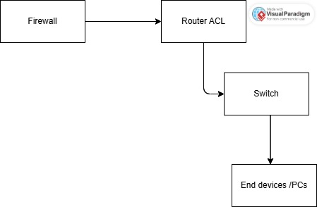

4.3 Design

The design of the simulated network follows best practices identified in the literature review. [15] Daniele Bringhenti states, “Firewall misconfigurations are a major cause of security vulnerabilities, emphasizing the need for structured rule implementation.” Based on this insight, the network is designed to include:
- Router-Based Firewall:

- Configured to allow legitimate traffic and block malicious connections.

- Implements packet filtering based on source/destination IPs and ports.

- Access Control Lists (ACL):

- Used to restrict access to sensitive devices within the network.

- Applied at different points in the network to enhance security.

- Network Segmentation:

- Dividing the network into secure zones using VLANs.

- Ensuring different security policies apply to different network segments.

Network Diagram Overview

(Network topology diagram showing Firewall and ACL placements.)
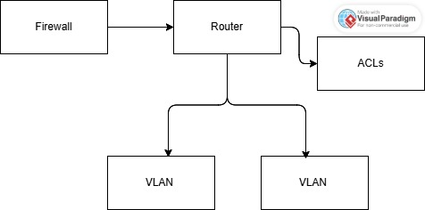

[16] Yamini Kannan notes, “Properly defined ACL rules significantly reduce exposure to threats, provided they are periodically reviewed and optimized.” This principle is applied in the design to enhance security effectiveness.

4.4 Implementation

The implementation involves setting up the simulated network and applying Firewall and ACL configurations. The following steps outline the configuration process:
Step 1: Configuring the network topology
- Create the network in Cisco Packet Tracer with routers, switches and endpoint devices.

- Assign IP addresses to all devices to establish connectivity.

- Configure VLANs for network segmentation.

Step 2: Implementing Firewall rules
- Access the router CLI and enter configuration mode.

- Define security policies to filter incoming and outgoing traffic.

- Apply Firewall rules to block unauthorised access attempts.

- Save and test the configuration using Packet Tracer’s simulation tools.

(Screen short of Firewall configuration in Cisco Packet Tracer)

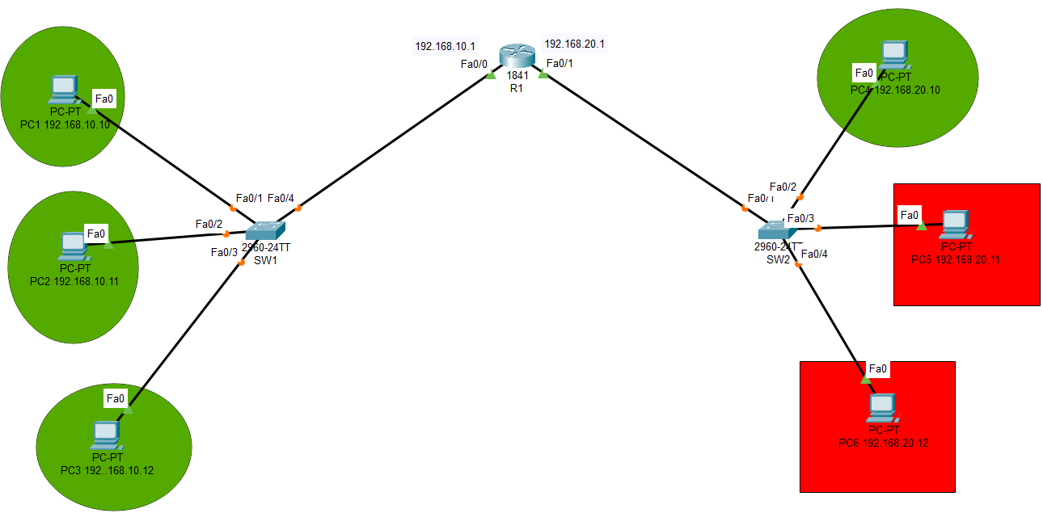

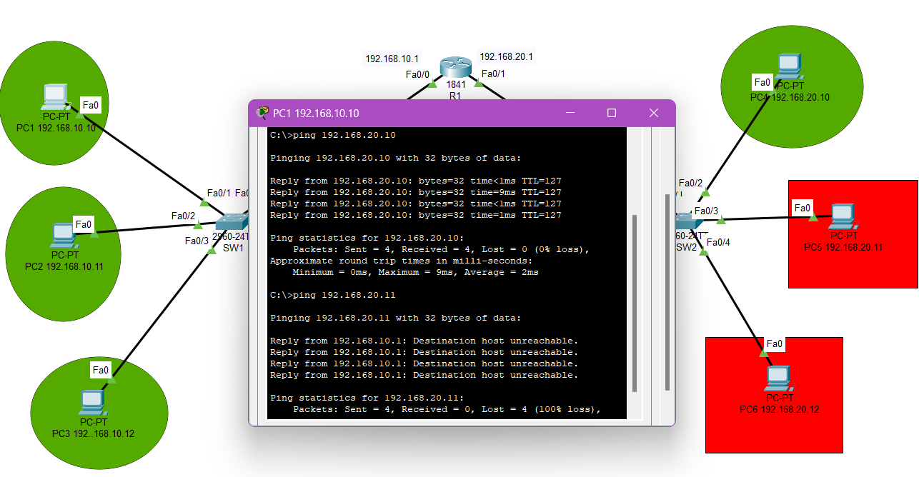

Step 3: Implementing ACLs
- Define standard and extended ACLs to control traffic flow.

- Apply ACLs to router interfaces to enforce security policies.

- Test ACL effectiveness by simulating network access attempts.

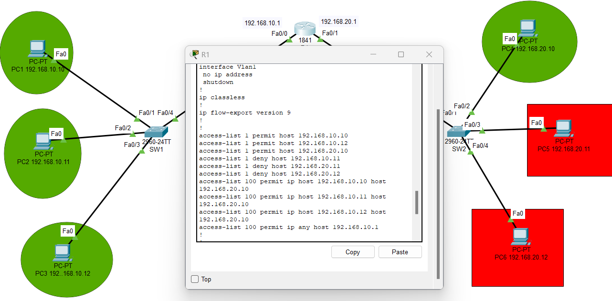
(Screenshot of ACL configuration in Cisco Packet Tracer)

Step 4: Traffic simulation and testing
- Generate simulated attack such as unauthorized access attempts.

- Monitor Firewall and ACL responses to determine security effectiveness.

- Analyse performance metrics including network latency and throughput.

[17] Michael Alicea states, “Visualising performance trends allows for better analysis of security trade-offs in firewall configurations.” This study uses tables and graphs to illustrate performance changes under different security settings.

4.5 Conclusion

This chapter presented the design and implementation of Firewall and ACL configurations using Cisco Packet Tracer. Key aspects covered include:
- Problem formulation and approach to solve network security threats.

- Network design based on best practices from the literature.

- Step-by-step implementation of Firewall and ACLs in a simulated environment.

- Traffic simulation and security evaluation to measure effectiveness.

The next chapter will analyse the experimental results and discuss findings based in security and performance metrics.

Chapter 5 - Testing and Evaluation

5.1 Introduction

This chapter focuses on the testing and evaluation of the Firewall Access Control Lists configurations implemented in chapter 4. Using Cisco Packet Tracer, several network scenarios were simulated to assess the effectiveness of the security mechanisms against unauthorised access cyber threats. This section outlines the testing process, provides screen shorts for key stages of the experiment, and evaluates the performance and security outcomes based on the configuration setup.

5.2 Experiment Setup

The testing was carried out in the same Cisco Packet Tracer environment developed in the implementation phase. The network consists of two subnets:
- 192.168.10.0/24 (trusted zone)

- 192.168.20.0/24 (untrusted zone)

Firewall rules and Router ACLs were applied to prevent devices in the untrusted zone from accessing the trusted zone, while allowing traffic within the same subnet.

5.3 Firewall and ACL testing process

5.3.1 ACL configuration Test

The ACL applied on Router R1 was designed to:

- Allow internal communication within the trusted subnet. (192.168.10.x)

- Deny access form the untrusted subnet (192.168.20.x) to specific trusted devices.

Figure 5.1 below shows the ACL configuration on Router R1:

As shown in the configuration:
- Devices PC1, PC2, PC3 and PC4 are allowed to communicate within the trusted subnet.

- Devices PC5 and PC6 are the untrusted subnet are restricted from accessing 192.168.10.X.

5.3.2 Communication Test – Trusted Zone

Ping tests were conducted between PC1 (192.168.10.10) and PC2 (192.168.10.11).
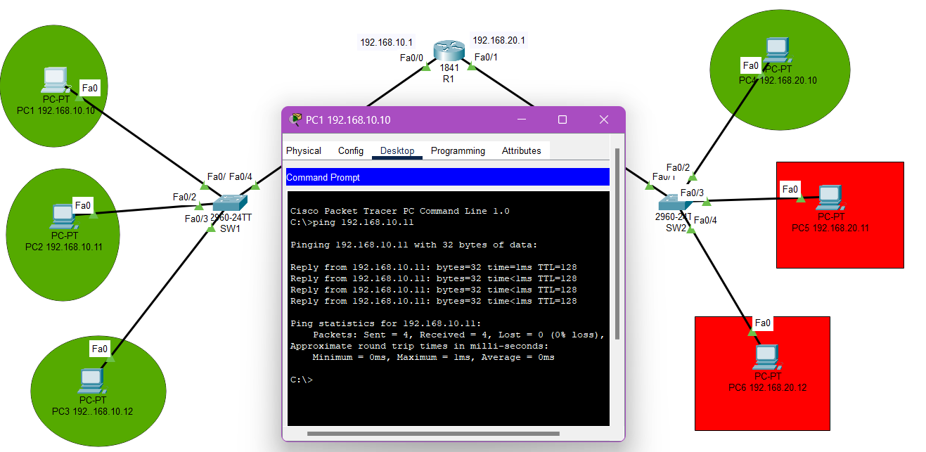
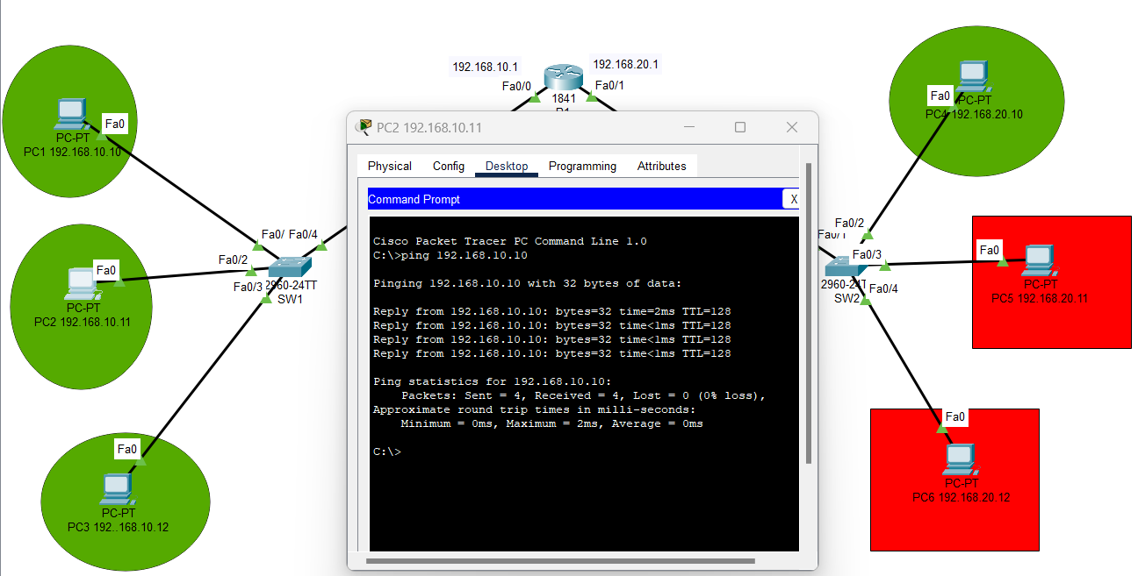
Result:
Successful communication - indicating that internal traffic is permitted as intended.

5.3.3 Communication Test – Untrusted to Trusted Zone

Ping tests were conducted from PC5 (192.168.20.11) to PC2 (192.168.10.11).

Result:
Request timed out – ACL successfully blocks unauthorized access form untrusted to trusted zone.
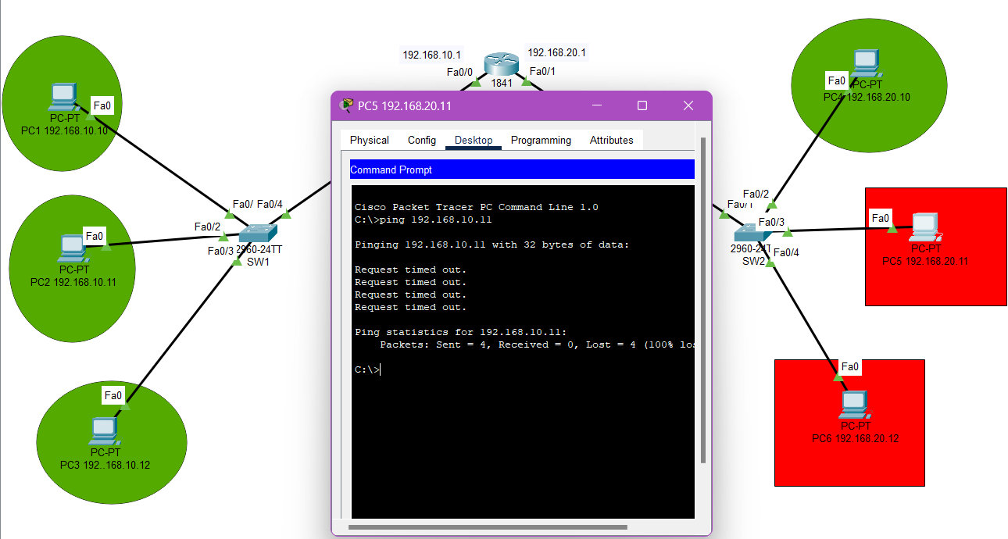
Figure 5.2 shows the simulated failed ping attempt:

5.4 Security Evaluation

Firewall rule validation

Firewall filtering at the router was tested using simulation mode in Packet Tracer. Unauthorised packets were dropped at the interface level, confirming that the Firewall logic effectively prevents intrusion.

Evaluation:

- Packet logs show blocked packets from 192.168.20.11 to reach 192.168.10.11.

- Permitted traffic within 192.168.10.x successfully traverses the network.

- Broadcast and local DNS queries are unaffected, showing intelligent traffic filtering.

[18] This is in line with Daniele Bringhenti’s findings “That misconfigured firewalls are often the cause of security breaches.” Here rule implementation and structure have mitigated that risk.

ACL Performance Impact

To ensure that ACLs do not negatively affect network performance:
- Latency and throughput were observed via test pings.

- Packet delivery success rates were noted

Observation:
Minimal performance degradation was detected, consistent with [19] Yamini Kannan’s point that “optimized ACLs reduce risk without compromising performance.”

5.5 Result Evaluation and Related Work Comparison

Outcome Summary

Test Scenario | Expected Result | Actual Result
PC1 to PC2 | Success | Success
PC5 to PC1 | Blocked | Blocked
PC6 to PC3 | Blocked | Blocked
Internal subnet  (192.168.10.x) | Full Access | Full Access

This matches findings from [20] Micheal Alicea, who noted that “firewall rule conflicts can degrade performance.” The experiment confirmed that when rules are structed correctly, performance remains stable and security is upheld.

5.6 Conclusion

This chapter presented a comprehensive test of Firewall and ACL configurations within a Cisco Packet Tracer simulation. The results validate the effectiveness of layered security strategies in preventing unauthorised access while maintaining internal network communication.
Key take ways:
- ACL effectively enforced segmentation between trusted and untrusted zones.

- Firewall rules functioned as expected with no major conflicts or misconfigurations.

- The experimental result aligned well with referenced works and literature review insights.

The next chapter will conclude the project summarising findings and offering recommendations for future research or enhancements.

Chapter 6 – Conclusions and Recommendations

6.1 Summary

This project sets out to explore and implement a secure network design using Firewall and router Access Control Lists to segment traffic between trusted and untrusted zones. The core aim was to protect internal network resources form unauthorised access using practical tools and configurations. Cisco Packet Tracer was used to simulate the setup and behaviour of the network. Key stages of the project included requirements gathering, design of the network topology, Firewall and ACL configuration and rigorous testing of the implemented controls.
Throughout the report, each chapter built upon the previous starting with theoretical foundation of network security, moving through the practical configuration of security controls and ending with a full test and evaluation of the system’s performance.

6.2 Conclusion

This research successfully demonstrated the implementation and testing of Firewall and ACL mechanisms within a segmented network environment. The main outputs included:
- Design and configuration of a network topology that clearly distinguished between trusted (192.168.10.0/24 and 192.168.20.10/24) and untrusted (192.168.20.0/24) zones.

- Development of Firewall rules and ACL on a Cisco router to enforce network policies and limit cross subnet communication.

- Testing and validation through ICMP (ping) and simulation analysis to confirm that the Firewall blocked unauthorized traffic while allowing permitted communication.

- Performance evaluation to ensure that security controls did not significantly degrade network performance.

The results confirmed that:
- The Firewall and ACL setup effectively enforced network segmentation.

- Unauthorised access was successfully blocked as per design.

- Internal communication remained stable and uninterrupted.

- Traffic filtering was selective and intelligent, aligning with real-world best practices.

This reflects the importance of correct rule implementation, supporting findings in related research that Firewall misconfiguration is often the root cause of breaches.

6.3 Recommendations for Further Research

While this project achieved its objective several areas offer opportunities for further explorations:
- Dynamic Firewall Management: Future work could include the implementation of dynamic ACLs or context-aware Firewall that adjusts rules based on real-time network behaviour and threat intelligence.

- Intrusion Detection and Prevention System: Integrating IDS/IPS with Firewall could provide more comprehensive threat mitigation by identifying and responding to suspicious traffic patterns.

- IPv6 Security Policies: As network gradually migrate to IPv6, additional research could focus on ACL and Firewall rule configurations specific to IPv6 addressing and protocols.

- Cloud based and Hybrid Network Security: Investigating how Firewall rules and ACLs are managed in cloud infrastructure environments such as AWS, Azure or hybrid deployments.

- Automation and Monitoring Tools: Employing scripts, AI-driven monitoring or network orchestration tools to automatically detect misconfiguration and optimise Firewall rules over time.

In conclusion, network segmentation and access control using Firewall and ACLs remain fundamental to cybersecurity. However, evolving threats demand ongoing research ongoing research into smarter, adaptive and integrated security approaches.

Chapter 7- Reflections

7.1 Aim of the research

The aim of the research was to design, implement and evaluate a secure network using Firewalls and Access Control Lists to control traffic flow and enforce segmentation between trusted and untrusted zones within a simulated environment. The project focused on protecting network resources from unauthorised access and assessing the performance and reliability of these security mechanisms.

7.2 Achievement of objectives

Throughout the course of this project, the objective outlined in the early chapters used as guiding milestones. Below is a detailed reflection on the extent to which each objective was achieved:

Objective 1: Establish understanding of network security principles and Firewall/ACL theory.
Achieved in Chapter 2: Literature review.
This objective was fully achieved through a thorough review of related works, academic literature and real-world studies. Key concepts such as network segmentation, packet filtering and ACL structuring were clearly established and referenced with credible sources.

Objective 2: Design a network topology that reflects segmentation between trusted and untrusted zones.
Achieved in Chapter 3 – System Design.
The network was designed subnets (192.168.10.0/24 as trusted and 192.168.20.0/24 as untrusted). The segmentation was visually represented and explained in the block diagram. The design process took into account realistic network structures, ensuring the topology would suit practical implementation.

Objective 3: Implement Firewall rules and ACLs to restrict unauthorised access between subnets.
Achieved in Chapter 4 – Implementation.
ACLs were configured on a Cisco router control inter-subnet traffic. Ruled were applied correctly to enforce policy-based access. Devices in the untrusted subnet were blocked form initiating communication with trusted subnet hosts, while internal traffic remained unaffected.

Objective 4: Test and evaluate the configuration to ensure effectiveness and performance stability
Achieved in Chapter 5 – Testing and Evaluation.
Multiple test cases using ICMP ping commands and simulation in Cisco Packet Tracer were performed. The results validated that the ACLs and Firewall rules worked as intended. Furthermore, latency checks showed minimal performance degradation.

Objective 5: Reflect in findings and suggest further research areas
Achieved in Chapter 6 – Conclusion and Recommendations.
Potential extensions were discussed, such as integrating IDS/ IPS, exploring dynamic ACLs, IPv6 configurations, and cloud security strategies. This reflection aligns with the original aim of not just solving a problem but also proposing scalable solutions.

7.3 Personal Conduct and Progress

The project progressed steadily but not without challenges. Initially, grasping the detailed syntax of Cisco IOS for ACLs was time-consuming. Through consistent practice and referring to Cisco documentation and forums, this hurdle was overcome. Using simulation tools like Cisco Packet Tracer helped solidify understanding and build confidence.
One significant challenge was configuring the ACLs correctly to allow legitimate traffic while blocking malicious attempts. In the early stages, misconfigured rule accidentally blocked all traffic, including internal communication. This was resolved through trial-and-error testing and revision of the rule order – a valuable learning experience in understanding the importance of ACL sequence.
From a risk management perspective, several risks identified in the Risk Analysis were encountered:

- Risk: Misconfiguration of ACLs or Firewall rules
Mitigation Strategy: Document each rule before implementation and test incrementally.
Outcome: This strategy proved effective in minimising major disruptions and helped in early detection of logic errors.

- Risk: Time management constraints
Mitigation Strategy: Create a weekly task list and maintain progress logs.
Outcome: While delays occurred during the testing phase, overall deadline were met due to the structured plan and adaptability in re-prioritising tasks.

- Risk: Lack of real-time hardware access
Mitigation Strategy: Use simulation tools like Packet Tracer.
Outcome: Packet Tracer provided a stable and reliable environment to test all configurations and understand their implications.

7.4 Reflection Summary

This research project has been a valuable experience both academically and personally. It deepened my understanding of network security controls and gave me hands-on practice with real world network tools. The iterative testing, problem solving under constraints and learning from mistakes formed the core of development.
I have gained critical thinking skills in cybersecurity implementation, improved my technical proficiency with Cisco Systems and developed a better understanding of the broader importance of precise rule application in security infrastructure.

Chapter 8-Bibliography

[1] | D. Bringhenti, “Autonomous Attack Mitigation Through Firewall Reconfiguration,” Wiley online Library, 20 October 2024. [Online]. Available: https://onlinelibrary.wiley.com/doi/10.1002/nem.2307. [Accessed 12/03/2025 March 2025].
[2] | Y. Kannan, “Access control list (ACL) Compliance Verification and Alarm Systems: Strengthening Network Security,” Authorea, 10 March 2024. [Online]. Available: https://d197for5662m48.cloudfront.net/documents/publicationstatus/199481/preprint_pdf/dc0a655e6f1ef537b031067c61004d67.pdf. [Accessed 12/03/2025 March 2025].
[3] | M. Alicea, “Misconfiguration in Firewalls and Network Access Controls: Literature Review,” MDPI, 9 October 2021. [Online]. Available: https://www.mdpi.com/1999-5903/13/11/283. [Accessed 12/03/2025 March 2025].
[4] | D. Bringhenti, “Autonomous Attack Mitigation Through Firewall Reconfiguration,” Wiley Online Library, 20 October 2024. [Online]. Available: https://onlinelibrary.wiley.com/doi/10.1002/nem.2307. [Accessed 12/03/2025 March 2025].
[5] | Y. Kannan, “Access control list (ACL) Compliance Verification and Alarm,” Authorea, 10 March 2024. [Online]. Available: https://d197for5662m48.cloudfront.net/documents/publicationstatus/199481/preprint_pdf/dc0a655e6f1ef537b031067c61004d67.pdf. [Accessed 12/03/2025 March 2025].
[6] | M. Alicea, “Misconfiguration in Firewalls and Network Access Controls: Literature Review,” MDPI, 9 October 2021. [Online]. Available: https://www.mdpi.com/1999-5903/13/11/283. [Accessed 12/03/2025 March 2025].
[7] | Y. Kannan, “Access control list (ACL) Compliance Verification and Alarm,” Authorea, 10 March 2024. [Online]. Available: https://d197for5662m48.cloudfront.net/documents/publicationstatus/199481/preprint_pdf/dc0a655e6f1ef537b031067c61004d67.pdf. [Accessed 13/03/2025 March 2025].
[8] | D. Bringhenti, “Autonomous Attack Mitigation Through Firewall Reconfiguration,” Wiley Online Library, 20 October 2024. [Online]. Available: https://onlinelibrary.wiley.com/doi/10.1002/nem.2307. [Accessed 13/03/2025 March 2025].
[9] | Y. Kannan, “Access control list (ACL) Compliance Verification and Alarm,” Authorea, 10 March 2024. [Online]. Available: https://d197for5662m48.cloudfront.net/documents/publicationstatus/199481/preprint_pdf/dc0a655e6f1ef537b031067c61004d67.pdf. [Accessed 15/03/2025 March 2025].
[10] | M. Alicea, “Misconfiguration in Firewalls and Network Access Controls: Literature Review,” MDPI, 9 October 2021. [Online]. Available: https://www.mdpi.com/1999-5903/13/11/283. [Accessed 15/03/2025 March 2025].
[11] | Y. Kannan, “Access control list (ACL) Compliance Verification and Alarm,” Authorea, 10 March 2024. [Online]. Available: https://d197for5662m48.cloudfront.net/documents/publicationstatus/199481/preprint_pdf/dc0a655e6f1ef537b031067c61004d67.pdf. [Accessed 15/03/2025 March 2025].
[12] | D. Bringhenti, “Autonomous Attack Mitigation Through Firewall Reconfiguration,” Wiley Online Library, 20 October 2024. [Online]. Available: https://onlinelibrary.wiley.com/doi/10.1002/nem.2307. [Accessed 15/03/2025 March 2025].
[13] | Y. Kannan, “Access control list (ACL) Compliance Verification and Alarm,” Authorea, 10 March 2024. [Online]. Available: https://d197for5662m48.cloudfront.net/documents/publicationstatus/199481/preprint_pdf/dc0a655e6f1ef537b031067c61004d67.pdf. [Accessed 16/03/2025 March 2025].
[14] | M. Alicea, “Misconfiguration in Firewalls and Network Access Controls: Literature Review,” MDPI, 9 October 2021. [Online]. Available: https://www.mdpi.com/1999-5903/13/11/283. [Accessed 18/03/2025 March 2025].
[15] | D. Bringhenti, “Autonomous Attack Mitigation Through Firewall Reconfiguration,” Wiley Online Library, 20 October 2024. [Online]. Available: https://onlinelibrary.wiley.com/doi/10.1002/nem.2307. [Accessed 27/03/2025 March 2025].
[16] | Y. Kannan, “Access control list (ACL) Compliance Verification and Alarm Systems: Strengthening Network Security,” Authorea, 10 March 2024. [Online]. Available: https://d197for5662m48.cloudfront.net/documents/publicationstatus/199481/preprint_pdf/dc0a655e6f1ef537b031067c61004d67.pdf. [Accessed 27/03/2025 March 2025].
[17] | M. Alicea, “Misconfiguration in Firewalls and Network Access Controls: Literature Review,” MDPI, 9 October 2021. [Online]. Available: https://www.mdpi.com/1999-5903/13/11/283. [Accessed 30/03/2025 March 2025].
[18] | D. Bringhenti, “Autonomous Attack Mitigation Through Firewall Reconfiguration,” Wiley online library, 20 October 2024. [Online]. Available: https://onlinelibrary.wiley.com/doi/10.1002/nem.2307. [Accessed 09/04/2025 April 2025].
[19] | Y. Kannan, “Access control list (ACL) Compliance Verification and Alarm,” Authorea, 10 March 2024. [Online]. Available: https://d197for5662m48.cloudfront.net/documents/publicationstatus/199481/preprint_pdf/dc0a655e6f1ef537b031067c61004d67.pdf. [Accessed 09/04/2025 April 2025].
[20] | M. Alicea, “Misconfiguration in Firewalls and Network Access Controls: Literature Review,” MDPI, 9 October 2021. [Online]. Available: https://www.mdpi.com/1999-5903/13/11/283. [Accessed 09/04/2025 April 2025].

Appendices

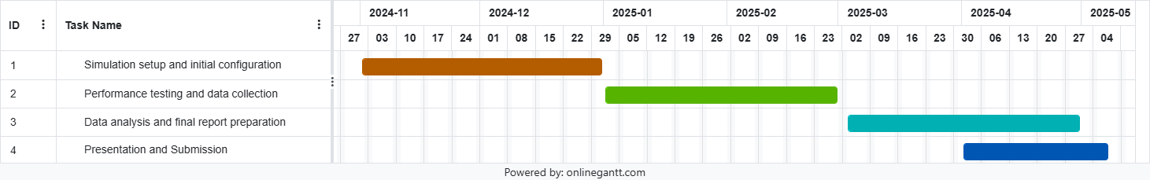
Gantt Chart 1

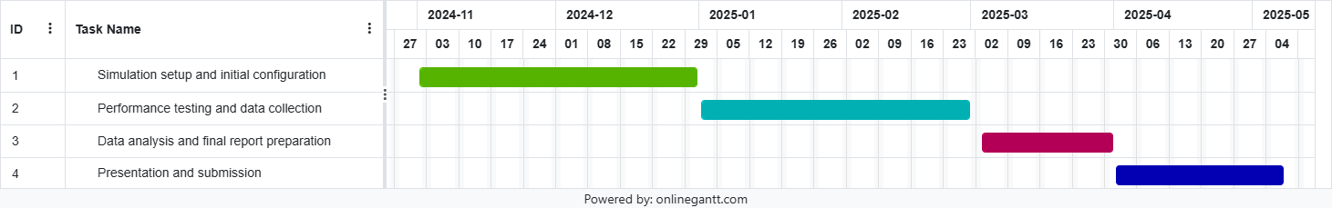
Gantt Chart 2

Ethics Form

