
UNIVERSITY OF WALES TRINITY SAINT DAVID

Learning in the Digital Era
Module Code: ACCA4025
Student Details
Student Name: Uns Rashid
Student ID Number: 2504612@student.uwtsd.ac.uk
Programme: CertHE Computing Skill for Workplace
Module Information
Module: Learning in the Digital-Era
Lecturers: Dr Mobolanle Bello, Dr Martin Svejda
Internal Verifier: Sadhana Jha

Table of Contents
Cover and Content Page (http://691ae0146f78e.site123.me) – E-portfolio Link 3
Task 1 – Summary and Referencing in IEEE Style 5
1a) Skills that are Essential for Academic and Employment 5
1b) Reflection on Turnitin Similarity Score 6
TASK 2 – MindMap and Poster 8
2a) Team Mind-Map: Effective Teamwork in Academic and Professional Environment 8
Task 2b: Academic Poster 9
TASK 3 – Automatic Referencing Tool 10
3a) Virtual Collaboration – Summary of Topic from Unit 3 10
3b) Automatic Referencing Tool Evidence 11
TASK 4 – Creation and Review of E-portfolio 12
a) Platform used to Create E-Portfolio 12
b) E-Portfolio Illustrative Review 12

Cover and Content Page (http://691ae0146f78e.site123.me) – E-portfolio Link

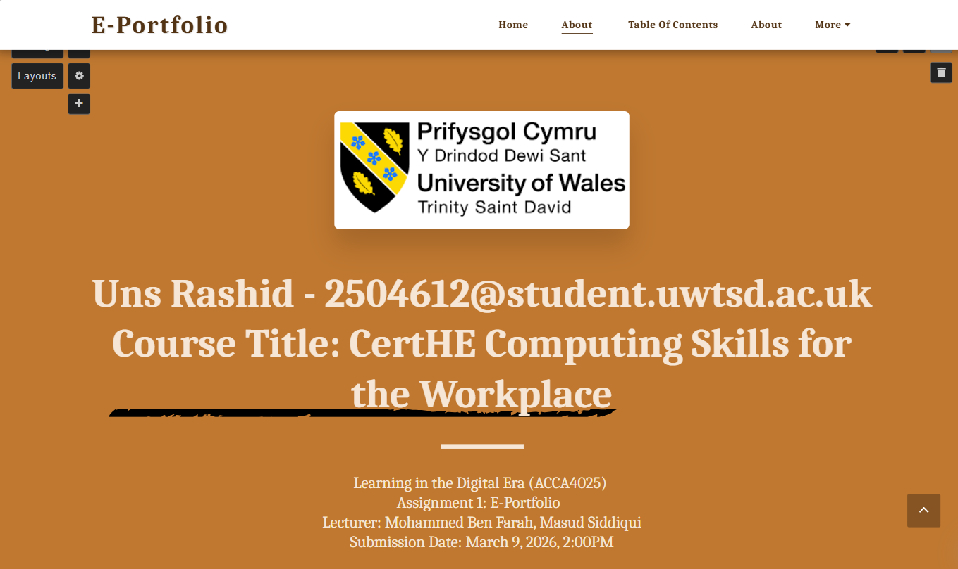
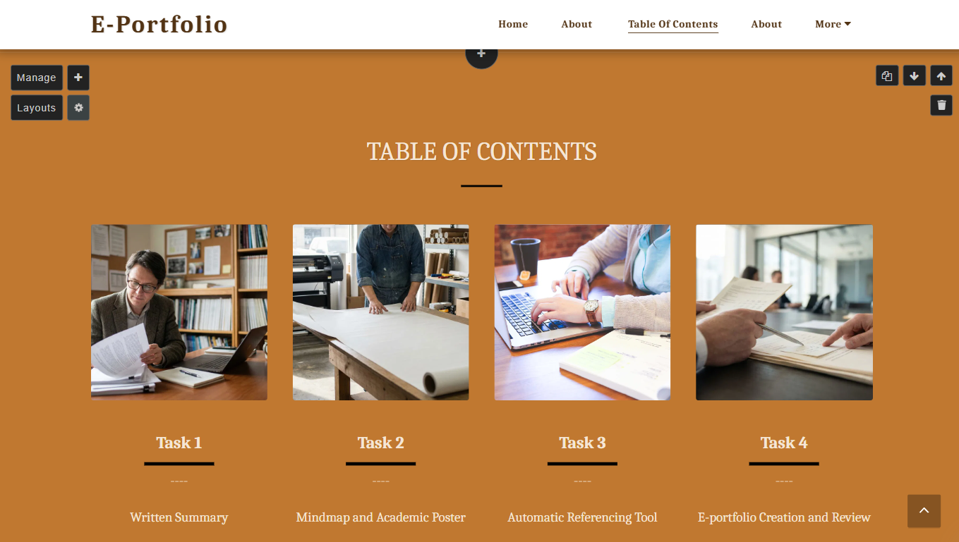
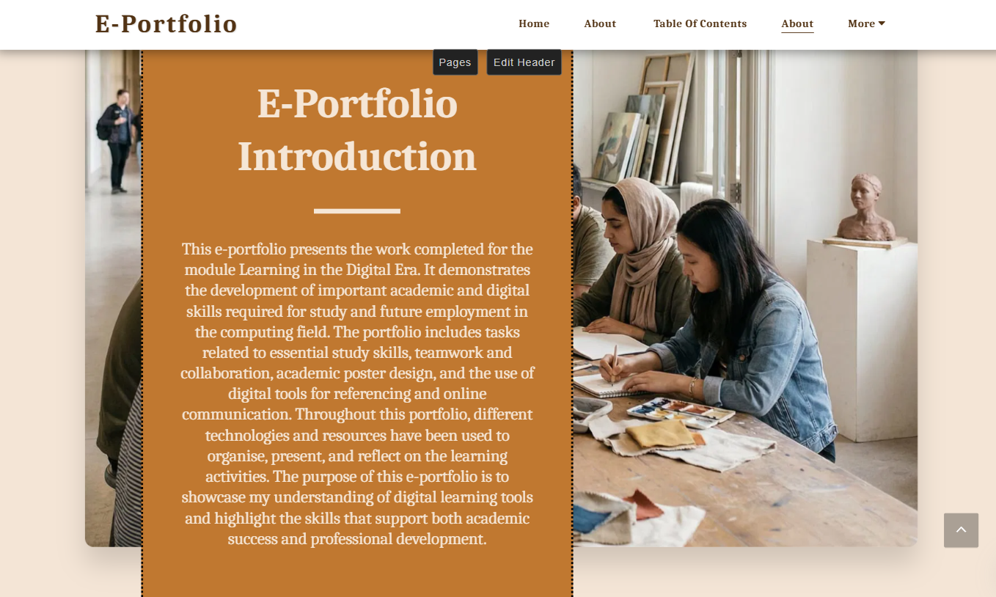

Task 1 – Summary and Referencing in IEEE Style

1a) Skills that are Essential for Academic and Employment
E-portfolio Link: (http://691ae0146f78e.site123.me)
Screenshot of E-portfolio - SITE123
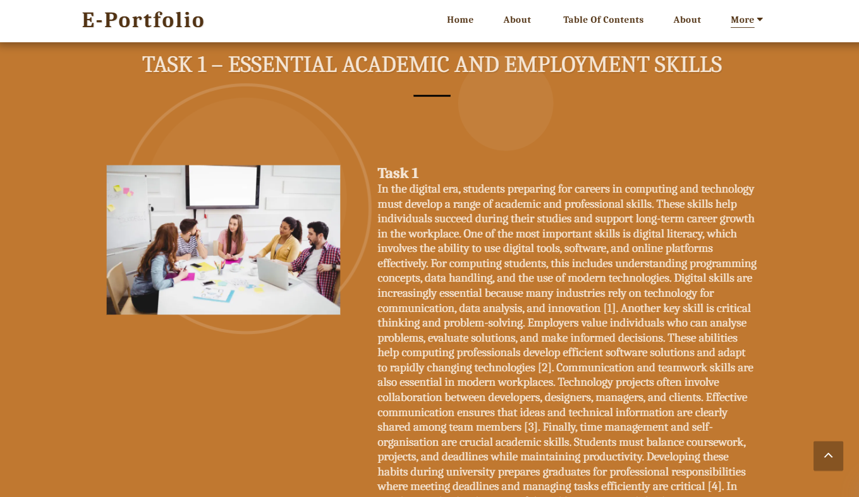
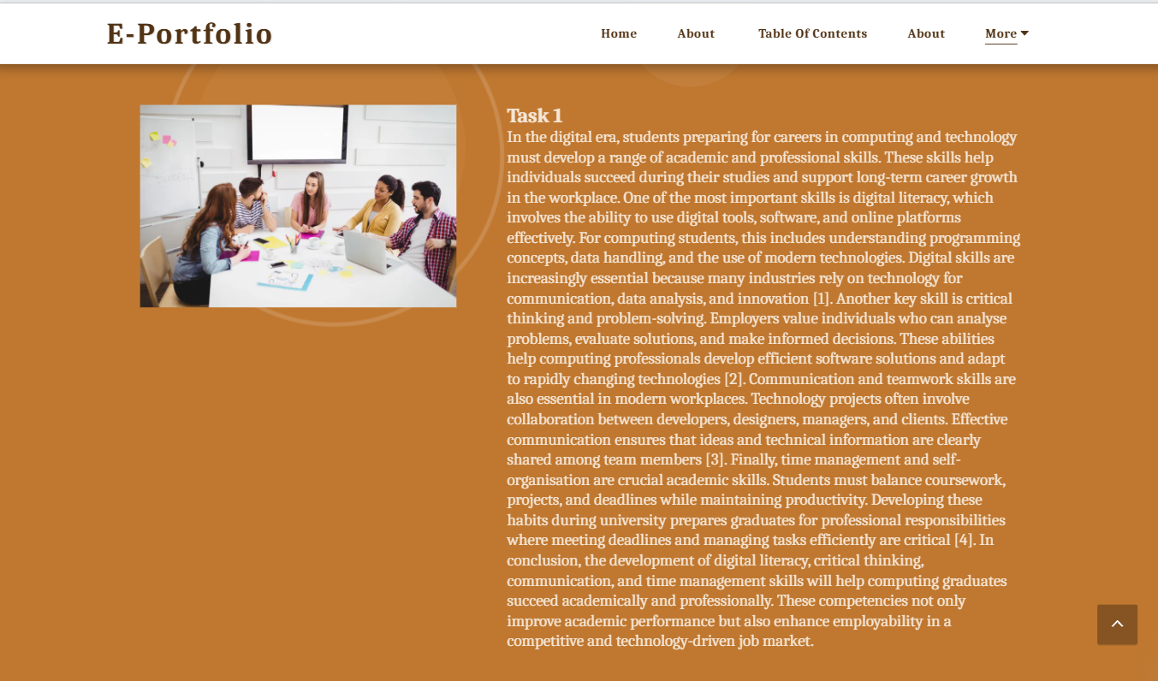

1b) Reflection on Turnitin Similarity Score
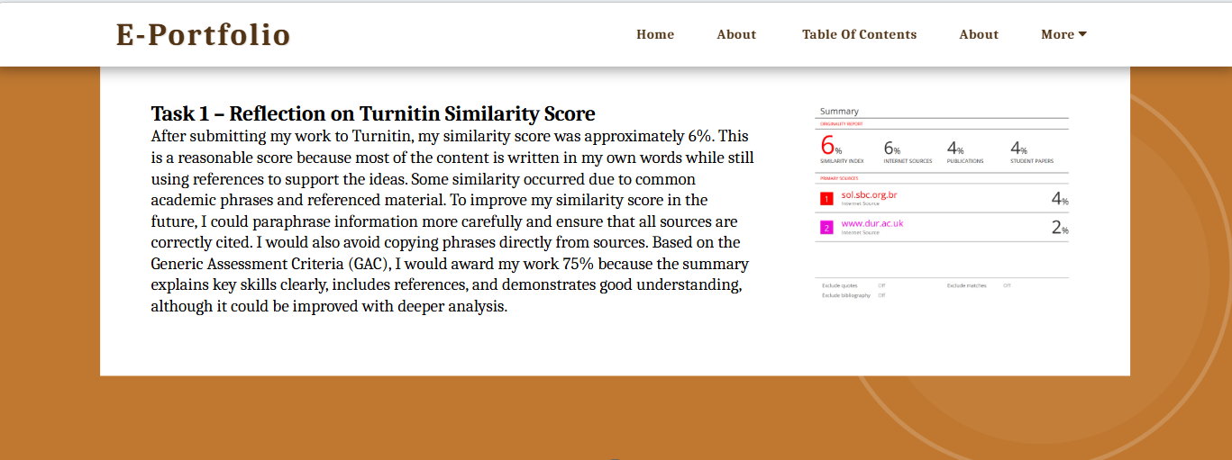
Turnitin Screenshots for Similarity
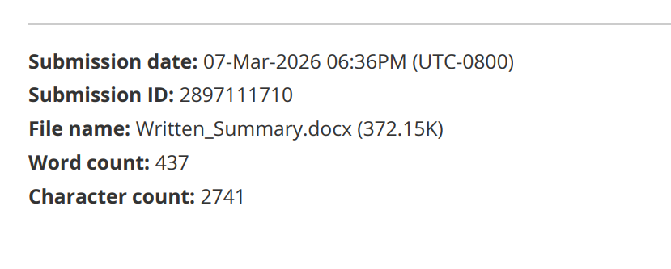
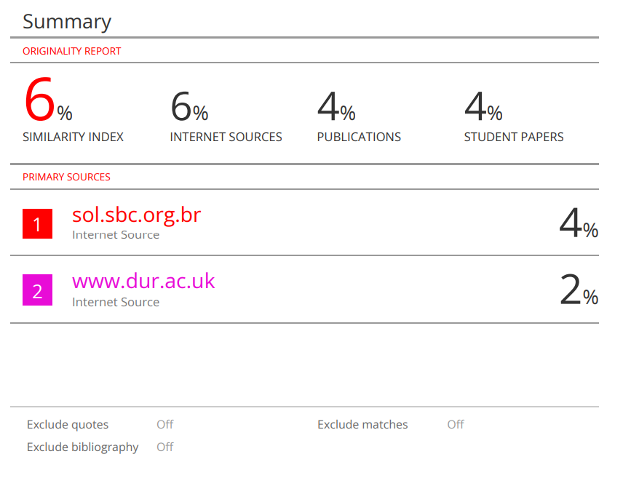

TASK 2 – MindMap and Poster

2a) Team Mind-Map: Effective Teamwork in Academic and Professional Environment
Screenshots of E-portfolio - SITE123
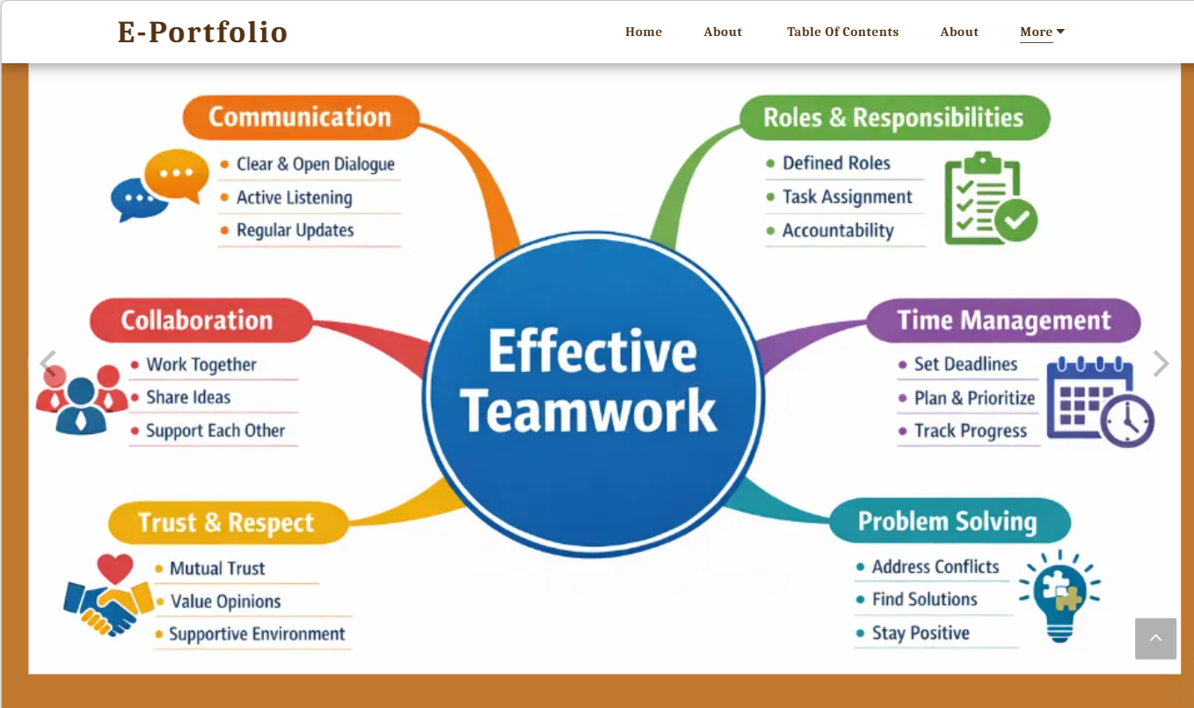

Task 2b: Academic Poster

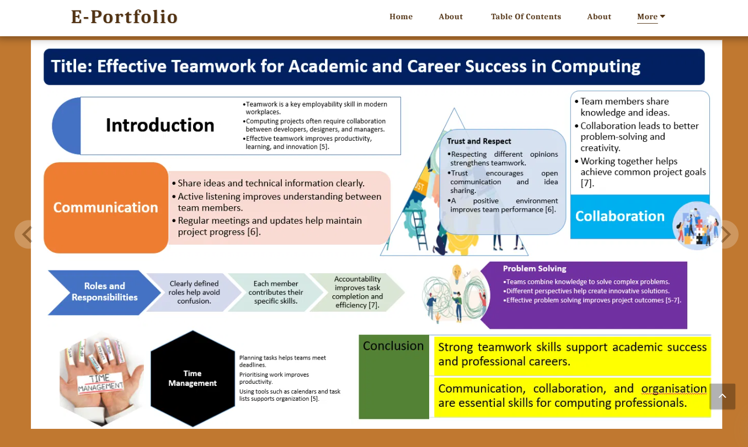

TASK 3 – Automatic Referencing Tool

3a) Virtual Collaboration – Summary of Topic from Unit 3
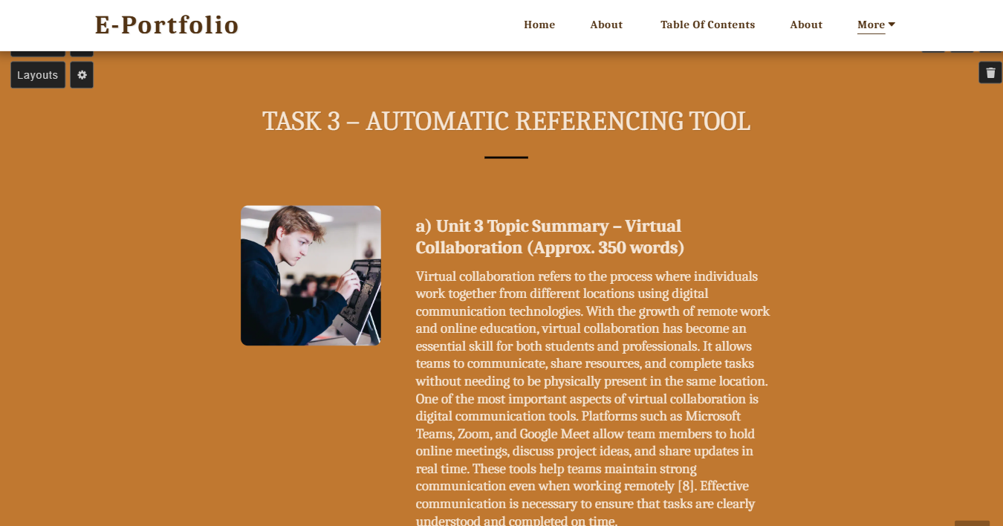
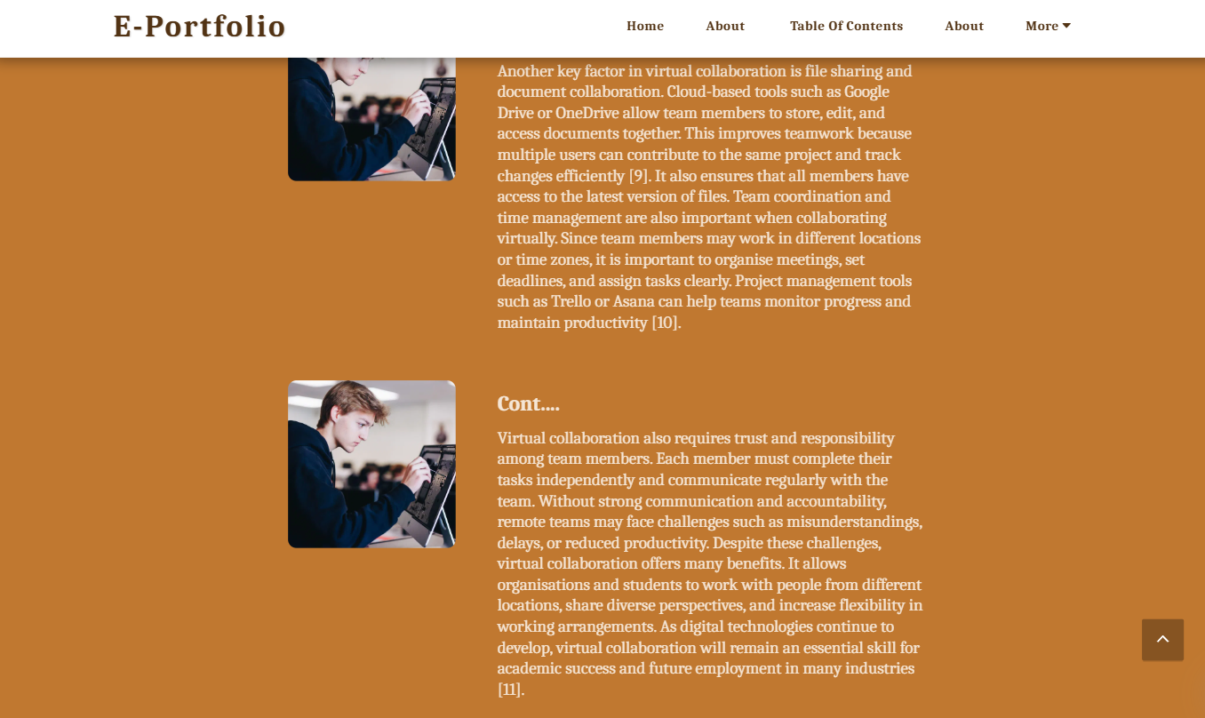

3b) Automatic Referencing Tool Evidence
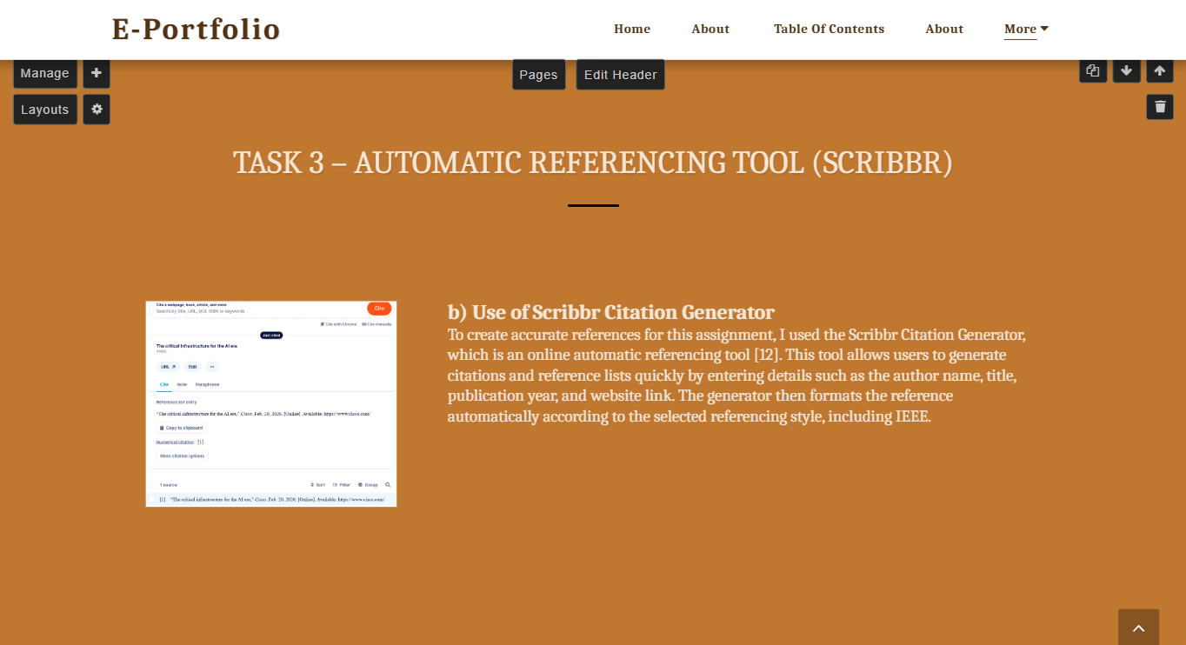
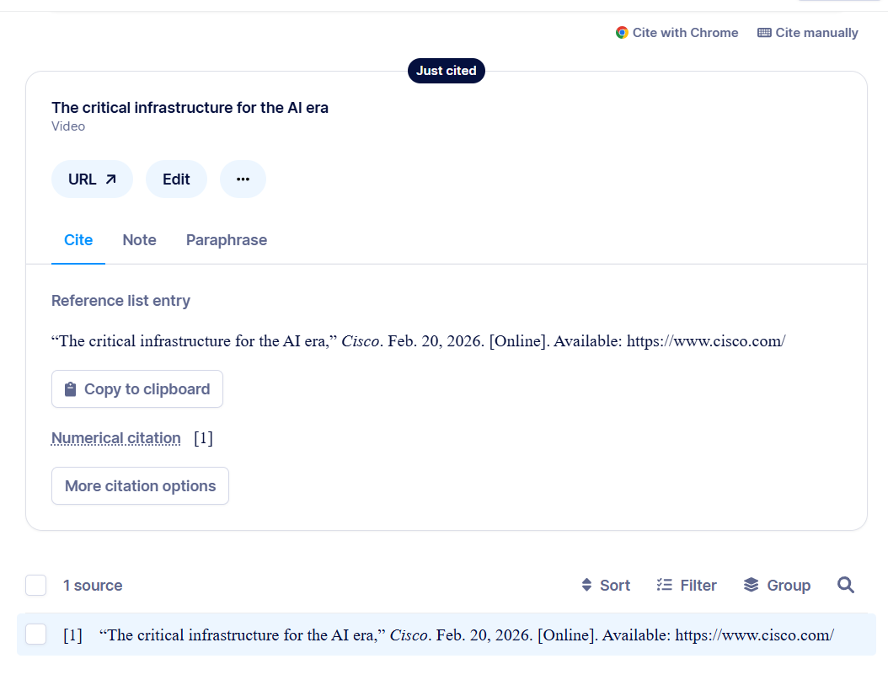

TASK 4 – Creation and Review of E-portfolio

a) Platform used to Create E-Portfolio
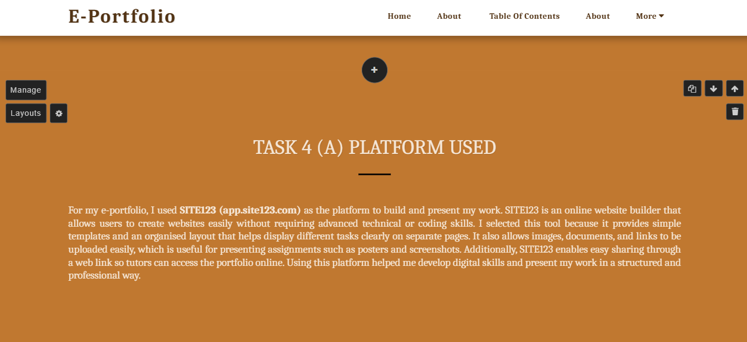

b) E-Portfolio Illustrative Review
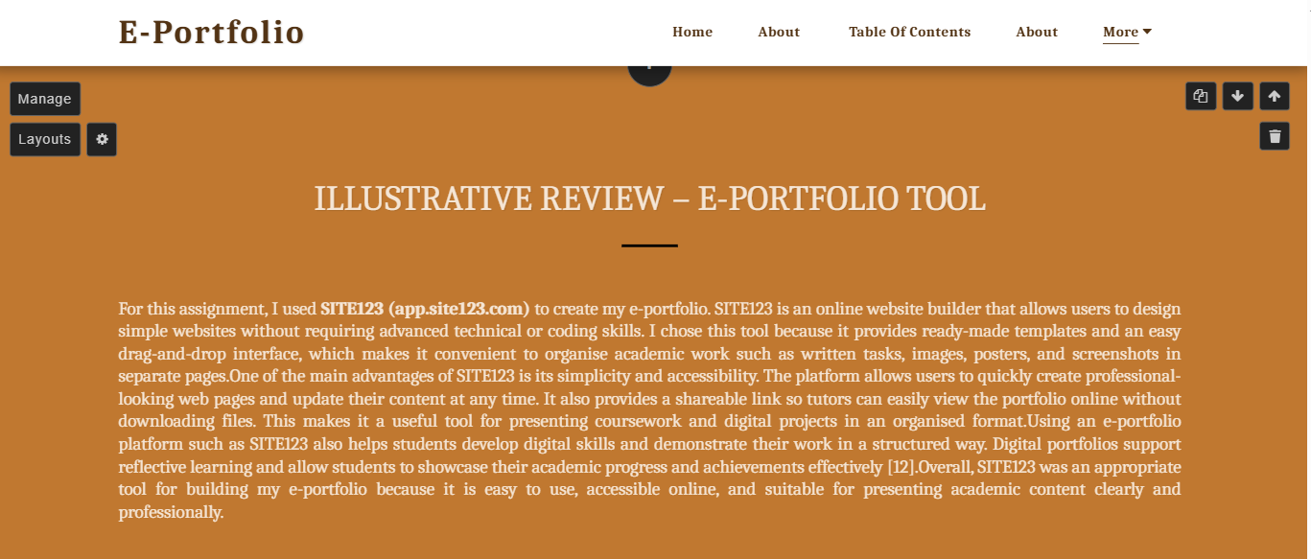
E-Portfolio Each Page’s Screenshot



