HTML & CSS Web Development
Gabor Jonas
Student Number: 1705136
Course: Web Development HND
Modul Name: Introduction to Web Development ACCA4003
Date: 2018/01/10

Table of Contents
1. Title Page
2. Table of Contents
3. Introduction 2
4. Requirements 3
4.1 Introduction 3
4.2 Site Map 3
4.3 Wireframe diagram 4
5. Implementation 4
5.1 HTML Validation 4
5.2 CSS Validation 5
7. Evaulation 5
References 5

3. Introduction
This document is a report of Web Development 1 module assignment.

4. Requirements

4.1 Introduction
GJ Motors is a fictional vehicle servicing company. The website is made for advertising its services to car owners. The intended target audience is every car owner.

4.2 Site Map
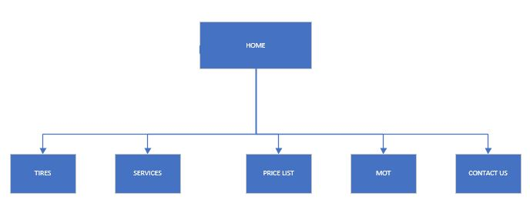

4.3 Wireframe diagram

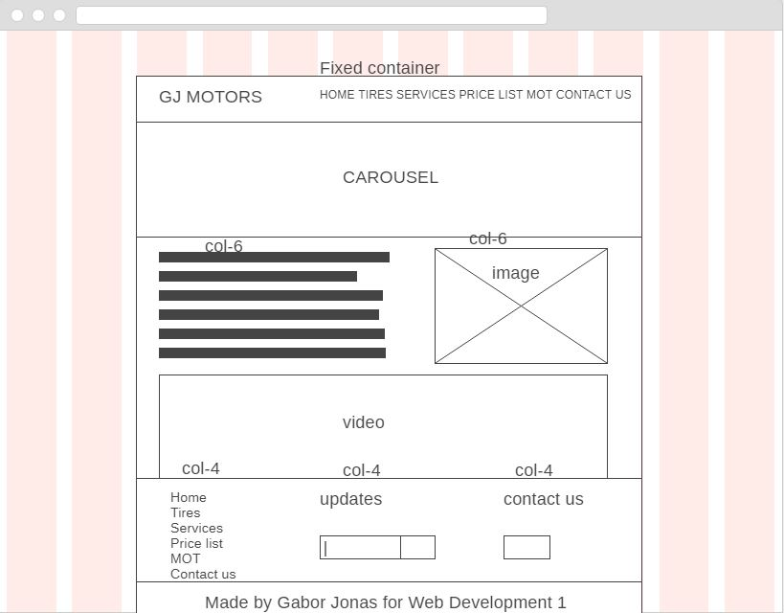

5. Implementation

5.1 HTML Validation
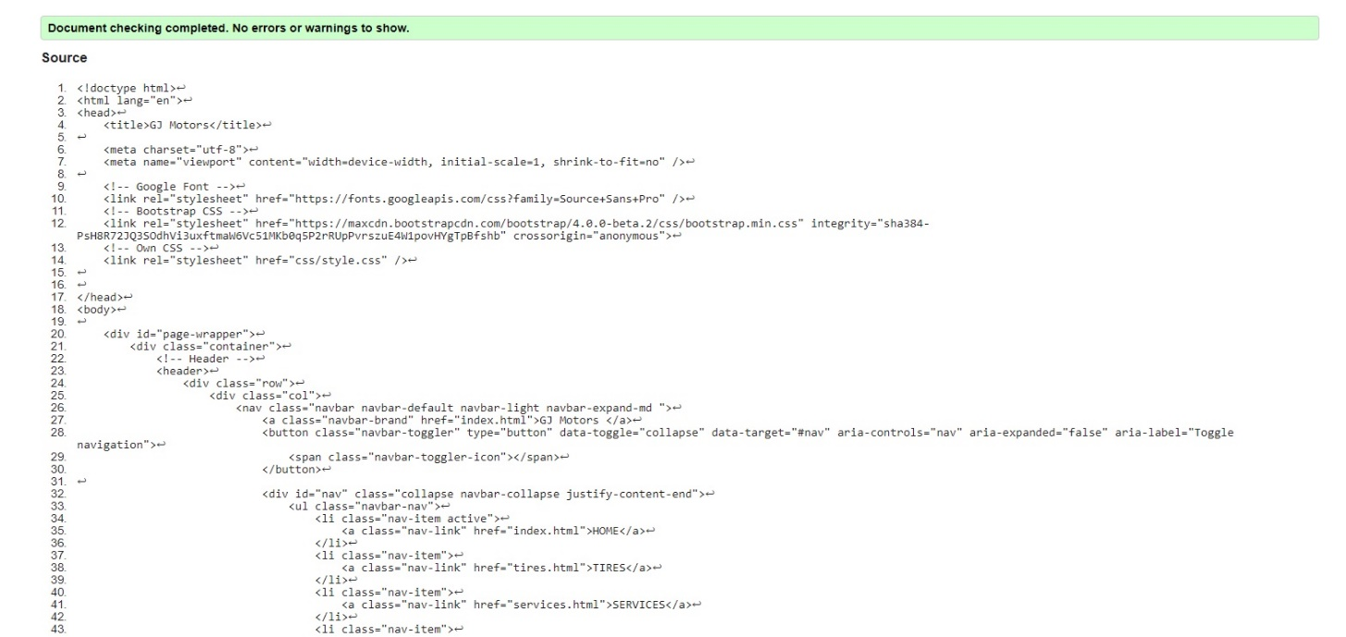

5.2 CSS Validation
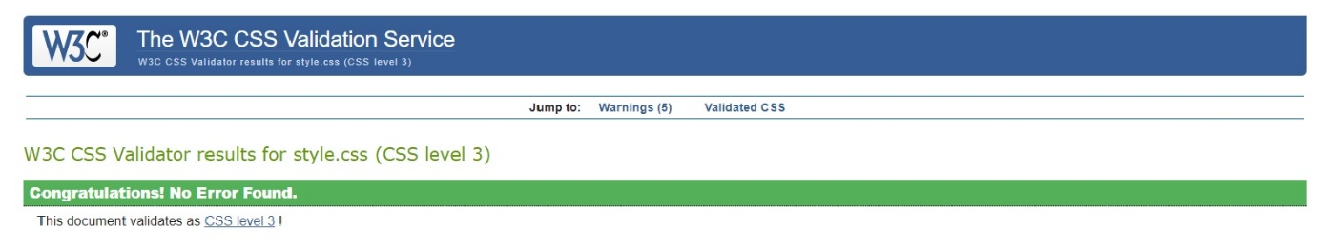

5 warnings for vendor-specific prefixes
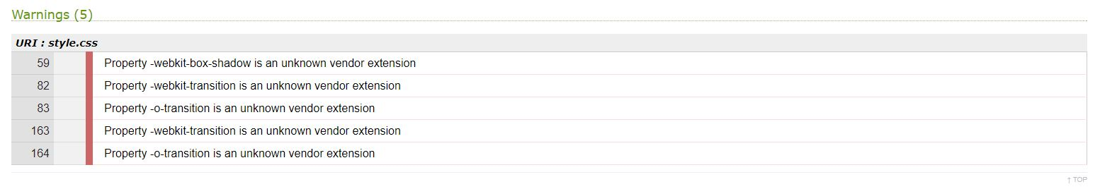

7. Evaulation

7.1 Accessibility Evaluation
- All headings are marked up
- Every image has alt with alternative text.
- Contrast ratio: high
- Text zoom available: All text gets larger, does not disappear or get cut off, text, images, other content do not overleap. All buttons forms are visible
- All forms have labels

7.2 Recomended impovements
- Bug fixing
- Better design
- More content
- Back end for booking system

References
1. w3schools. [Online] https://www.w3schools.com.
2. MDN web docs. [Online] https://developer.mozilla.org/.
3. WEBAim. [Online] https://webaim.org/.
4. Solo Learn. [Online] https://www.sololearn.com/.
5. Bootstrap. [Online] https://getbootstrap.com/.
6. Code Academy. [Online] https://www.codecademy.com/.
7. HTML5 & CSS3 For Beginners: Your Guide To Easily Learn HTML5 & CSS3 Programming in 7 Days. hely nélk. : Independently published, 2017. ISBN-10: 1521359229 ISBN-13: 978-1521359228.
8. Web Accessibility intitiative. [Online] https://www.w3.org/WAI/.

marking criteria and Student FEEDBACK

This section details the assessment criteria. The extent to which these are demonstrated by you determines your mark. The marks available for each criterion are shown. Lecturers will use the space provided to comment on the achievement of the task(s), including those areas in which you have performed well and areas that would benefit from development/improvement.

Common Assessment Criteria Applied (Assignment 1) | Marks available | Marks  awarded
1. Research-informed Literature
Extent of research and/or own reading, selection of credible sources, application of appropriate referencing conventions.
Although it is evident that you have consulted appropriate references for the implementation of the website, you have not really completed the research exercise required. (Grade mark: 40.00%) | 5 | 2
2. Knowledge and Understanding of Subject
Extent of knowledge and understanding of concepts and underlying principles associated with the discipline.
Demonstrates an excellent understanding of the standards to design and implement a website. The website has been implemented using a variety of concepts and to a very high standard, but be careful with your choice of fonts - see comments below. (Grade mark: 90.00%) | 20 | 18
3. Analysis
Analysis, evaluation and synthesis; logic, argument and judgement; analytical reflection; organisation of ideas and evidence
The evaluation is weak and does not provide a critical review of the implemented website. It simply lists a number of points. (Grade mark: 15.00%) | 20 | 3
4. Practical Application and Deployment
Deployment of methods, materials, tools and techniques; application of concepts; formulation of innovative and creative solutions to solve problems.
An excellent attempt featuring a well-thought-out website. It is evident that you have given a lot of thought to the design and content. Well done. Just a few minor things to note. Your font-choice is what is known as a decorative font. It is advisable to use decorative fonts minimally as they tend to have a low readability and create accessibility issues. See more: https://medium.com/gravitdesigner/typography-elements-everyone-needs-to-understand-5fdea82f470d. Also, the text in the slider carousel is quite small and often on a busy background image. Again, this is likely to be quite difficult to read for the user. Another minor comment: in your menu, it would have been nice if the link of the current page was highlighted in some way and the services page could do with an image or two. (Grade mark: 90.00%) | 50 | 45
5. Skills for Professional Practice
Attributes in professional practice: individual and collaborative working; deployment of appropriate media; presentation and organisation.
The report, unfortunately, is not satisfactory. This is a formal, academic report and you are expected to discuss things and not just list them. Your report is extremely sparse with a word count of 255 words. (Grade mark: 20.00%) | 5 | 1

Assignment Mark (Assessment marks are subject to ratification at the Exam Board. These comments and marks are to give feedback on module work and are for guidance only until they are confirmed. ) | Late Submission Penalties (tick if appropriate) |  | 69%
 | Up to one week late |  | 69%
 | 1st/2nd/3rd attempt? |  | 69%

