

Investigation and Implementation of Uses for the Physical Web on a University Campus
by
Liam J Ridley

Supervisor: Dr Carlene Campbell
Second Marker: Dr Kapilan Radhakrishnan

Project submitted as part of the requirements for the award of BSc (Hons) Computer Networks and Cybersecurity

April 2018
Declaration of Originality

I, Liam James Ridley, declare that I am the sole author of this Project; that all references cited have been consulted; that I have conducted all work of which this is a record, and that the finished work lies within the prescribed word limits.

This work has not previously been accepted as part of any other degree submission.

Signed: .............................................

Date: ...............................................

FORM OF CONSENT

I, Liam James Ridley, hereby consent that my Project, submitted in candidature for the B.Sc.(Hons) Computer Networks and Cybersecurity degree, if successful, may be made available for inter-library loan or photocopying (subject to the law of copyright), and that the title and abstract may be made available to outside organisations.

Signed: .............................................

Date: ...............................................

Copyright Acknowledgement

I acknowledge that the copyright of this project report, and any product developed as part of the project, belong to University of Wales Trinity Saint David, Swansea.

Contents

Abstract 6
1. Introduction / Background to the Proposed Research 7
1.1. Background to the Subject Area 7
1.2. Purpose of the Research Project 8
1.3. The Industry/Organisation Under Investigation 9
1.4. Aim of the Project 9
1.5. Objectives 9
1.5. Expected Outcome/Deliverables 9
1.6. Structure of the Report 10
2. Critical Review of Existing Literature 12
2.1. Introduction 12
2.2. The Review 12
2.2.1. Area one – How the Physical Web Can Be Used 13
2.2.2. Area two – Hardware Used to Implement the Physical Web 14
2.2.3. Area Three – Software Used to Implement the Physical Web 17
2.2.4. Area Four - Security Considerations 18
2.3. Related works 19
2.4 Conclusion 21
3. Research Methodology 23
3.1. Introduction 23
3.2. Research Overview 23
3.2.1. Research Process 23
3.2.2. Research Philosophy 24
3.2.3. Research Methodologies 25
3.2.4. Data Collection 25
3.3. Research Design 26
3.3.1. Research Deliverables 27
3.4. Resources Used During Implementation 28
3.5. Conclusion 28
4. Design and Implementation 30
4.1. Introduction 30
4.2. Project Formulation 30
4.3. Design 32
4.3.1. Location Mapping Designs 32
4.3.2. Location Based-Information Designs 34
4.4. Implementation 35
4.4.1 Location Mapping Within A Classroom 35
4.4.2 Location Based Information – Classroom 37
4.4.3 Location Mapping in A Hallway 39
4.4.4 Location Based Information – Floor 3 43
4.4.5 Location Based Information – Reception 44
4.5. Conclusion 45
5. Testing and Evaluation 46
5.1. Introduction 46
5.2. Location Mapping Implementations 46
5.2.1. Testing 46
5.2.2. Evaluation 47
5.3. Location-Based Information Implementations 48
5.3.1. Testing 48
5.3.2. Evaluation 49
5.4. Conclusion 50
6. Conclusion 51
6.1. Introduction 51
6.2. Summary 51
6.3. Conclusion 52
6.4. Areas of Future Research 54
7. Reflections 55
7.1. Introduction 55
7.2. Analysing the Aims and Objectives 55
7.3. What Could Be Done Differently? 56
7.4. Project Management 56
References 58
Appendix 62

List of Figures

Figure 1: BLE beacon in operation. 15
Figure 2: Estimote IOS application [40]. 18
Figure 3: Bus tracking model presented in [45]. 20
Figure 4: Algorithm for the code required to turn a microcontroller into a BLE beacon [4]. 21
Figure 5: Hutter-Hennink Qualitative Research Cycle [51]. 25
Figure 6: Research design. 27
Figure 7: Beacon configuration page of the Estimote app. 31
Figure 8: Configuration of the beacon’s broadcast distance. 32
Figure 9: Floorplan of room MH509 showing position of beacons. 33
Figure 10: Floor plan of the fifth floor of UWTSD Mount Pleasant main building. 34
Figure 11: Beacon positioning on floor 3. 34
Figure 12: Mount Pleasant reception layout. 35
Figure 13: Picture showing beacon positioning within room MH509. 36
Figure 14: Main steps of creating the room layout. 36
Figure 15: Screenshots from a video of the map system being tested. 37
Figure 16: Process of modifying the URL to be sent. 38
Figure 17: Settings determining distance of URL broadcast. 38
Figure 18: Settings for the three other beacons. 39
Figure 19: IOS and Android devices receiving URLs from the beacons. 39
Figure 20: Positioning of the beacons in the floor 5 hallway. 40
Figure 21: Steps required to setup the room. 41
Figure 22: Screenshots of the testing of mapping system. 41
Figure 23: Screenshots showing which URLs are received by the mobile devices, before modifying settings. 42
Figure 24: Settings for the two URL broadcasting beacons, alongside screenshots of the two mobile devices receiving the URLs. 42
Figure 25: Image showing the positioning of the beacon in relation to the entryway. 43
Figure 26: Screenshot of the beacon configuration alongside the two mobile devices receiving the URL. 43
Figure 27: Image showing the placements of the beacons, both placed on opposite sides of the room. 44
Figure 28: Settings for both beacons, along with screenshots of the two mobile devices. 44
Figure 29: Beacon settings before being modified. 46
Figure 30: Settings after modification. 47
Figure 31: Initial Gantt chart 62
Figure 32: Final Gantt Chart 63
Figure 33: Project log book 64
Figure 34: Project meeting 1 65
Figure 35: Project meeting 2 66
Figure 36: Project meeting 3 67
Figure 37: Project meeting 4 68
Figure 38: Project meeting 5 69

List of Tables

Table 1: Comparison of the iBeacon and Eddystone BLE beacon platform. 15
Table 2: Example of a research model criteria checklist. 24

Abstract

The aim of this project is to investigate and implement uses for the physical web around a university campus. Some of the objectives include; To conduct research into the physical web and how it can be used, to critique and discuss existing research around the physical web, implement some of the research around a university campus, to suggest whether the designs should be implemented on a larger scale, and to increase both the authors and the readers knowledge of the physical web. A literature review outlines information regarding the physical web, how it can be used, and how it can be implemented. The author adopts an inductive research style. The project makes use of Bluetooth Low-Energy (BLE) beacons, using Google’s Eddystone beacon platform, to broadcast URLs which provide location-based information, and to also create a small scale indoor-positioning system. Both an IOS and Android device have been used to test the receipt of the URLs, with the IOS receiving all the URLs and the Android device not receiving some of them, however this has been put down to the hardware of the device. The IOS device was also used to create and test the indoor positioning-system. The system was functional, however some minor problems such as delay, meant it did not work to optimal performance. The report concludes that an indoor positioning system, using only BLE beacons should not be implemented on a larger scale around the campus, while the URL broadcasting system should be. The conclusion chapter also discusses some potential future research such as; using WIFI for indoor-positioning and Raspberry Pi devices for BLE beacons.

1. Introduction / Background to the Proposed Research

The Physical Web [1] is an emerging internet of things (IOT) [2] technology that uses Bluetooth Low-Energy (BLE) [3] beacons to transmit URLs to an application on a mobile device. The URLs that are broadcasted can; provide context-based and location-based information, complete tasks such as unlocking doors [4], provide unique user-based information and more. The Physical web is a flexible technology, which has potential for many different uses in many different settings, for example, at bus stops to provide information regarding certain buses and routes, or car parks to monitor the number of available spaces [5]. A setting, in which the Physical Web could be used, which hasn’t been thoroughly investigated is on a University Campus, therefore, the purpose of this project is to investigate potential uses for this technology on a university campus, and to implement and evaluate these uses. The physical web is a concept that has been heavily driven and promoted by Google, through its Eddystone beacon platform, and Physical web application [1].

1.1. Background to the Subject Area

The Physical Web is a new and emerging technology that uses Bluetooth low-energy (BLE) beacons to transmit URLs to mobile devices. The basis of the Physical Web is for everyday objects to be connected together, and to be able to transmit data [2]. The idea of this is to make objects interactive, to have the ability to complete different tasks [6]. The physical web can use different transmission techniques such as; QR-codes or Bluetooth low-energy (BLE) beacons, however the most popular of these techniques is BLE, which is used in this project, the reasoning behind this will be discussed in chapter two. The beacons broadcast URLs, so that content can be accessed through a single application using web pages, rather than through multiple individual apps [7]. The idea of this is to make processes quicker due to everything being in one place, whether that is one application such as Google’s physical web app for android, or a browser such as chrome for IOS and other devices. The URLs that are being transmitted in this project provide the following functionality; providing location-based information such as lecture resources and social media links. Another use for beacons which has been implemented in this project is an indoor location mapping system.
The Physical Web is a young concept, which means that research can be considered limited. A large amount of research has been presented in conference proceedings, however there is still a lot of useful research available from other sources such as journal articles, and videos online. Due to the young age of this technology, a popular topic of research is finding uses for the Physical Web, as is the basis of this project. An example of this research is provided by Namiot and Sneps-Sneppe [5], who suggest ways in which the Physical Web can be used in smart cities.
Another popular topic of research is regarding methods of broadcasting the URLs. An example of a report is by Namiot and Sneps-Snepps, who state that ‘Wireless tags are one of the most often used approaches for physical objects markup. Wireless tags can support standard protocols like Bluetooth, Bluetooth Low energy (BLE) and Wi-Fi. The above-mentioned protocols are supported by almost all modern mobile phones.’ [5]. This research is useful as it covers methods of transmission that suit different needs. A paper written by Chandel, Ahmed, Arora and Ghose, explains how BLE beacons work, and the uses they have, such as ‘They are being extensively researched in context-aware applications, as those for shopping malls for feeding the customers with relevant promotions from a nearby store.’ [8].
Some of the current research is based on finding and reducing potential issues with the technology. A report by Lee, Im, Lee, et al., outlines what happens with too many beacons in one place, ‘Because of overlap and attenuation among beacons in small area, we predict that interference is occurred.’ [7].
An important topic of research is the overall goal of the Physical Web. Is it designed to replace an existing technology, such as mobile applications? or is it intended to work alongside these technologies? A report by Kibira and Chong argues that the Physical Web is not intended to be a replacement, they state ‘[The] Physical web will not replace rather enable interaction with the object in case of built-in applications. Since physical web is an open standard, a new era of IoT services will be emerged in WoO platform.’ [9].
This project is based on using the Physical Web on a university campus. There is some research based on this topic. For example, a report called Case Study: Impact of the Physical Web and BLE Beacons, written by Bhattacharya, Canul, and Knight, from the University of Hawaii, Maui College. As stated by the authors ‘A current work-in-progress at the University of Maui College is developing a campus-wide prototype of beacon technology using the Eddystone-URL protocol’ [10]. However, the report heavily focuses on the security issues that come with using beacons, whereas this project discuses and illustrates how the physical web can be used and how it can help people in education.

1.2. Purpose of the Research Project

The purpose of this project is to investigate and implement different ways of using the Physical Web, on a university campus. Some of these uses can range from using the Physical Web during lectures, to having beacons around the campus, providing different information. The Physical Web is growing in popularity, meaning there is more of a demand to find out its capabilities, and how it can be used to benefit different areas of life. As ‘smart’ buildings, and even ‘smart’ campuses, become more popular, the Physical Web can play a part in turning existing buildings and campuses into ‘smart’ campuses.
There is already some research into using the Physical Web in educational settings, however, much of the research is based on the principles of BLE beacons and the physical web. Few reports go into detail regarding how the Physical Web can be used. This suggests that there is room for a project such as this to be created.

1.3. The Industry/Organisation Under Investigation

The experiments will be conducted at the University of Wales Trinity Saint David (UWTSD), Mount Pleasant campus. Currently, the university does not make use of the Physical Web at its Mount Pleasant campus. At the time of this project, UWTSD is in the process of building a new campus. This would be a perfect time to implement a new and emerging technology such as the physical web. This project presents the benefits of using the physical web, such as; saving time in classrooms by broadcasting resources required for the lecture, broadcasting a map and directions to pupils so they don’t get lost on the new campus, providing useful information and resources to visitors. The benefits of the physical web can be found in greater detail within chapter two.
Although this project has been implemented at a university, the concept is relevant to most levels of education, such as Secondary and College. It can also be relevant for other industries; however, the focus is on the education industry.

1.4. Aim of the Project

The overall aim of this project is to investigate and implement different uses for the physical web on a university campus.

1.5. Objectives

The objectives that are to be met throughout the process of creating this project are as follows;
- To conduct research into the physical web to find out how it works and how it can be used in different settings.
- To effectively discuss and critique the research currently available regarding the physical web.
- To discuss why there is a demand for a project such as this, and how it could be of benefit to the target audience.
- To implement some research gathered, around the university campus.
- Evaluate and critique the effectiveness of the implementations to discover whether it is worth implementing them on a larger scale around a university.
- To create a conclusion based on the results produced.
- To further the both the readers and authors understanding of the physical web.

1.5. Expected Outcome/Deliverables

The expected outcome of this project is to have a conclusion based on observations and data from different experiments. The experiments are implementations of the physical web in different environments and with different purposes. The conclusion suggests whether it is worth implementing the physical web on a larger scale.
The project has been presented so that should someone be interested in the physical web, and want to implement it, they are able to read through and have all the information they need such as; what hardware and software they need, how much it will cost, how it is set up, etc. All settings used during the experiments have been documented, with reasoning for using those settings, along with the environments in which the experiments have taken place, such as the size of the room, any obstructions in the room, etc.

1.6. Structure of the Report

This report covers four main areas; the first area covers research into the physical web, including a literature review into the current available literature, any research into devices or software will also be featured in this section. The second area covers the planning and methodology stage, including how the physical aspects of the project have been implemented, and stating any resources that are required for the implementation stage. The Third area is the implementation stage. Here the research that has been compiled and the methodology that has been laid out will be implemented, with any results being briefly noted. The fourth and final area will cover the analysis of the results from the implementation stage, and any conclusions that can be made from the results. The report is split up into several chapters. Below is a list of each chapter, and what can be found within each of those chapters;
- Chapter one – This is the introductory chapter which contains a brief introduction to the physical web, background to the research topic, the overall aim of the project and the objectives that the project hopes to meet.
- Chapter two – A critical review of the existing literature will be found within this chapter. Also, the devices that have been used for this project have been presented, with reasoning for using them, along with the software used in the project.
- Chapter three – This chapter contains the methodology used when conducting research for this project. The chapter outlines; the methods of data collection, the philosophy used by the author when conducting the research, and the methods of deduction when choosing literature use.
- Chapter four – Chapter four outlines the designs to be implemented to conduct the experiment, along with the actual implementations. This chapter discusses how the implementations were done, the settings used, any issues that arose during implementations, with photos of the implementation process.
- Chapter five – This is the testing and evaluation chapter. This chapter discusses the testing of the implementations, any issues that arose during implementation and how those issues may have occurred along with how they can be solved. This chapter evaluates the results produced by the implementations and prepares the information for the conclusion.
- Chapter six – This is the conclusion chapter. Here, the contents of the body of the report are summarised, with the conclusion from each chapter being brought together and summarised, along with any potential future research that could be conducted after the report.
- Chapter seven – Chapter seven is the reflection chapter. This chapter is used to gauge the success of the project, were the objectives met? Is there anything that did not work? Could anything of been done to avoid these issues? What could have been done differently?

2. Critical Review of Existing Literature

2.1. Introduction

The Physical Web is a relatively new concept, meaning that the literature currently available focuses mainly on the basics of the physical web. As the focus of this project is ‘how the physical web can be used’, the author believes that it is important that this review covers literature as close to this topic as possible, however, some papers with different focuses have also be used. The review looks at different pieces of literature, such as conference proceedings, journal articles, etc, and critiques different examples of literature, stating both good and bad points, and how/if that piece of literature relates to this project or justifies this projects existence. A large majority of the literature in this review has been sourced from IEEE’s Xplore Digital Library [11].
The purpose of this literature review is to assess the literature currently available regarding the physical web, and to justify why this project is important and how it can be useful. It is important to note that, although the topic of this report is the ‘physical web’, research from a closely related topic the ‘Internet of Things (IoT)’, has been included in this review, and may also be used as an umbrella term to cover both IoT and the physical web. The reason for this is because both topics share many similarities, such as; both make use of Bluetooth technology, IoT also aims to make everyday objects interconnected [12]-[13]. Some researchers may also blend both the physical web and IoT together into one report.
This review covers three main areas of literature regarding the physical web;
- The first area covers literature regarding how the physical web can be implemented in different scenarios, some of the different scenarios include; education [10], smart cities [5], etc. The reason why the literature within this area covers many different scenarios is due to a small amount of research regarding the physical web in educational settings, as is the central topic of this project.
- The second area covers how the physical web can be implemented using technology such as BLE beacons and further literature regarding BLE beacons. The devices that have been used for this project will be defined in this area.
- The third area covers the software that has been used to configure the beacons and setup the physical web.
- The fourth area covers the considerations that need to be considered, regarding the security of the BLE beacons that are used in this project.

2.2. The Review

Before researching the areas defined in the previous section, it is important that both the author and the reader understands what the physical web is and why it can be of benefit to people. While conducting research for this section, the author kept in mind the question what is the physical web? The physical web is a concept that utilises BLE beacons to transmit URLs to an application on a mobile device. These URLs lead to web pages that allow the user to perform different functions, such as finding information, or controlling objects [4].
One of the ideas of this technology is to eliminate the need for individual applications, instead having the URL act as the application, and have them all in one central application. The intention being to save storage space on devices, and to potentially make device performance faster [14].
Another intention behind the physical web is to make everyday objects interactive and internet connected [9] [12]-[13]. These objects can then provide context or location-based information, for example; if you walk up to a map of a city, there will be a URL sent to your smart device providing an electronic copy of the map, or if you walk into a bus stop, you will be sent a URL providing route information and timetables for the buses that use that bus stop [5].

2.2.1. Area one – How the Physical Web Can Be Used

Due to the young age of the physical web concept, a popular topic of research is how the physical web can be used. In this area, different sectors/industries have been investigated, the reason for this is because there is a lack of literature available regarding the physical web in an educational setting. This is a good justification for why there is a need for a project like this. Although there are some differences between how the physical web is used in an educational setting and in other settings, such as manufacturing, the literature can still be very useful as it can provide insight into how it works, and how it can be beneficial.
An area growing rapidly in popularity is smart cities. The idea of a smart city to have as many amenities within the city connected to the internet and remotely monitored as possible [5]. These amenities include; traffic control [15], car parks, bus stops, etc. In a smart car park for example, the physical web may be implemented, this would provide you with both context and location-based information. BLE Beacons would send URLs to tell you which floor you are on, or where you parked your car, and more. This shows the flexibility of the physical web, and how it can be adapted to different environments. A big consideration in smart cities is the impact that using sensors and other technology can have on the environment. Patra [16] suggests that implementing IoT in cities can lead to cost-savings, and more energy efficiency, although the author does not include studies to back-up either point within the report. However there is research available to suggest that smart cities can help with sustainability and the environment [17]-[18]. This point relates back to this project since environmental concerns are very important in modern technology. As stated in chapter one of this project, the University of Wales Trinity Saint David are building a new campus, which will undoubtedly have many eco-friendly and sustainable features included. If a technology such as the physical web is to be implemented on a campus such as this, it is crucial that it meets this criterion.
A concept that shares similarities with the physical web is the smart building concept [19]. Smart buildings utilize sensors to monitor the environment within a building. The readings from the sensors are then compared to pre-determined levels, which then triggers automated devices depending on the reading, for example air conditioning is turned on if the temperature is too high [20]. Some of the similarities include; the use of Bluetooth devices to transmit data, devices connected to the internet to allow remote management and monitoring. A use for the physical web within a smart building is by creating a ‘smart vending machine’. A smart vending machine allows a user to walk up to the machine click a link on their device which takes them to a webpage, allowing the user to select and purchase something from the vending machine, which then dispenses the purchased item [21]-[22]. This is another good example of how the physical web has such a broad range of potential uses. An issue that would need to be further investigated for smart vending machines is the cost of implementing the technology, and whether the technology would be useful enough to everyday users.
A use for the physical web which is growing rapidly in popularity is indoor location tracking. GPS is the most popular method of location tracking and wayfinding while outside of a building. However as GPS signals are weakened while indoors [23], this makes it unsuitable for use inside buildings. This is where BLE beacons come into play. BLE beacons can be highly accurate for indoor location tracking. An advantage of using BLE beacons is that they can be placed in locations that are difficult for WIFI access points to be placed [24], which is the alternate method for indoor location tracking, they also consume a lot less energy than access points, with a small battery lasting up to two years in some cases. For this project, a mapping system has been set up in one classroom and a hallway using BLE beacons to demonstrate how the system can be implemented.
The physical web has already been implemented in multiple other industries. One of these industries is retail. In retail BLE beacons are used within stores to broadcast exclusive discounts to customers, daily deals and information to draw people into the store [25]. The beacons are also used within stores and large shopping centres to provide a mapping system to help customers find their way around. Not only is the physical web used in retail, but it can also be used in healthcare. A report written by Fagin, Sposaro and Tyson, suggests Bluetooth sensors can be used to track elderly patients suffering with dementia and other conditions who are living alone [26], this system would track their movements at home and locate them if they wander outside of their home, using GPS.

2.2.2. Area two – Hardware Used to Implement the Physical Web

This area looks at the hardware required to implement the physical web. This project uses Bluetooth Low-Energy (BLE) beacons to transmit the URLs which will provide location-based information, and to dictate the position of a user within a university building using a real-time map. BLE beacons are a low energy, low consumption source of data broadcasts [27]. The fact that BLE beacons have low power consumption is one of the reasons why they are used in this project, as it extends the lifespan of the beacon, which reduces cost and work load. The beacons work by sending out packets, normally every 2-5 seconds, which contains information such as web URLs, which are used within the physical web. This information is received by a mobile device which then notifies the user. Figure 1 below provides an example of beacon transmission.
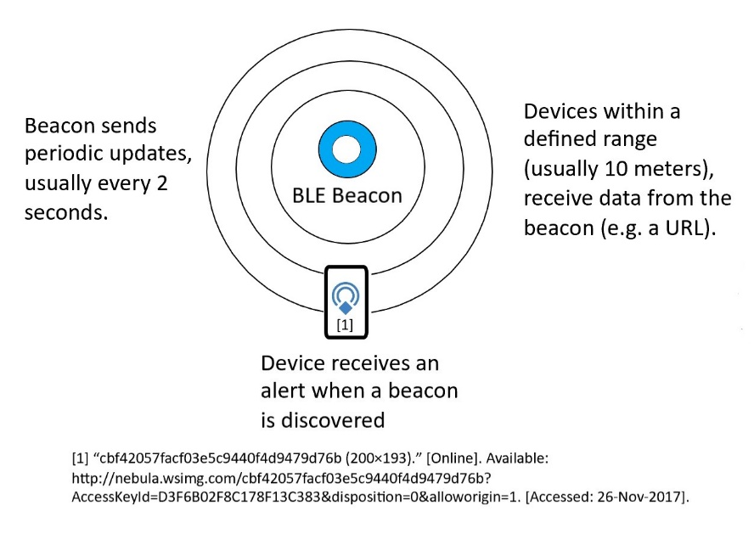
Figure 1: BLE beacon in operation.
There are currently two major development platforms for physical web beacons, one of the platforms being Apple’s iBeacon platform which was released at the Apple World Wide Development Conference in 2013 [28], and the other being Google’s Eddystone platform which was released in 2015 [29]-[30]. This project uses Google’s Eddystone platform, a major factor in this decision is that Eddystone is an open-source platform that is compatible on both Android and IOS devices, whereas iBeacon is an Apple proprietary product that is designed to work on Apple products, not on other products. On a university campus, different students will use different mobile phones, so it is important that the beacon platform is compatible and accessible to as many students as possible. Table one below highlights some of the differences between Eddystone and iBeacon.
Table 1: Comparison of the iBeacon and Eddystone BLE beacon platform.
 | Eddystone | iBeacon
Profile | Open-source platform. Available on both IOS and Android devices. | Apple proprietary software. Mainly supported on IOS, however it is possible to implement on Android.
Ease of Use | Slightly more complicated to configure than iBeacon. Each beacon requires parameters to be set such as broadcast distance, URL, etc. | Easy to configure, step by step process.
Packet Types | URL, Unique ID number (UID), and Sensor Telemetry (TML). | Unique ID number (UUID) comprising of major and minor digits.
Security | Built-in feature called Ephemeral Identifiers (EIDs). This is an ID number that automatically changes at different times, meaning that only authorised devices can read the signal. | No built-in security. Signal can be intercepted by and IOS device.
Source: Beaconstac blog [31].
As stated, this project uses the Eddystone beacon platform. Eddystone was launched by Google, a major driving force behind the physical web concept. Due to Eddystone being open-source, there are many different companies creating their own physical web beacons. Two companies with very popular beacons are Estimote [32] and iBKS by Accent Systems [33]. These are the two companies that the author looked at when deciding on which beacons to purchase.
Some of the advantages of Estimote include; they are the larger of the two companies, their beacons have built in motion, light and temperature sensors, they have a battery life of two years, the beacons have a range of up to 70 meters, they come with a software development kit, they have dedicated location beacons which can automatically map a room using UWB technology. Some of the disadvantages of Estimote beacons include; a set of four UWB location beacons can cost up to £140, and they are a US based company meaning shipping costs can be expensive and waiting time for delivery is longer. Advantages of using the IBKS beacons from Accent Systems include; Up to three years battery life, faster shipping than Estimote beacons, easy battery replacement, comes with IBKS application to configure the beacons. The disadvantages of the IBKS beacons are as follows; the company is not as widely used as Estimote, it doesn’t provide as much software support, the beacons are not waterproof meaning you cannot use them outside, however you can purchase waterproofing kits separately, and there is no built-in location mapping technology meaning more configuration is required.
After comparing the two beacons, the decision was made to use the Estimote UWB location beacons, mainly because they are a bigger company with more support and resources available to help with the project, and due to the location mapping capabilities, that they provide. The location beacons are also capable of broadcasting URLs at the same time as the location mapping capabilities. This means the beacon has been used to broadcast location-based information via URLs in different locations around the university campus as well.
Two smart mobile devices will be used to configure and to test the beacons. One device will be an Apple mobile phone, and the second will be an Android mobile phone. Each device will be monitored during the testing phase and the performance of each device will be compared to whether the performance differs depending on the device being used.
Before discussing the software that has been used in this project, it is important to note that there are alternative pieces of hardware to use in the physical web. A well-known alternative is Near Field Communication (NFC). NFC tags produce a magnetic field, which when an NFC enabled device is brought into the field, sends data or completes an action [34]. Unlike BLE beacons, NFC tags do not require a source of power, this can save money, and time as maintenance will not be required as often [35]. However, the range of the NFC tags are so short that you would need to almost tap your phone on the tag to interact with it. For this reason, it would not be suitable for the scenario of this project as it would be unrealistic for every student to tap their device on a reader to find information. Another issue with this technology is that not all devices are NFC enabled, although Hartmann and Quirnn [35] claim that over 50% of smart phones, at the time of them writing their report, have NFC capabilities, this figure is not backed up by a source. Apple have strictly controlled the way NFC is used on their devices, limiting it only to their contactless payment technology Apple Pay. This would greatly restrict the amount of people who would be able to use the physical web within the university if NFC was to be used.

2.2.3. Area Three – Software Used to Implement the Physical Web

This area looks at the software that is required to implement the physical web. The software that is required are; Operating Systems for the mobile devices taking part in the experiment, software to configure the beacons, and software to read and interpret the data sent by the beacons.
The two operating systems that have been used in this project is Apple’s IOS 11 operating system for mobile phones, and Google’s Android 7.0 operating system. It is important to note that Apple’s operating system is proprietary, meaning that only Apple devices run this operating system, however, the Android operating system is open-source, meaning that different mobile phone manufacturers place different features on top of Android. This means that performance can differ depending on which android device is used as the software can have a big effect on device performance. This project uses both IOS and Android to ensure that as many devices as possible can use the physical web. It is also useful as both operating systems can be compared to see if one performs more efficiently than the other. Both IOS and Android have their advantages when it comes to the physical web. One of the main advantages that Android devices have over IOS is that there is a dedicated application provided by google to allow you to configure BLE beacons, or to discover other beacons, whereas there is no official physical web app on the IOS platform, instead using third-party applications to discover Eddystone beacons. Another advantage of using Android is that it is an open-source platform which allows for simple application development [36]. However, IOS is considered a more ‘polished’ operating system, this means that applications are more reliable and perform better, this could be a result of Apple’s strict control over their app store.
The software that is used to configure the beacons is provided by the beacon manufacturer Estimote. The Estimote application allows you to set the parameters of the beacon such as broadcast distance, and the URL that is being transmitted [37]. This application is available on both IOS and Android devices. One of the major advantages of using the Estimote app is that it allows you to secure your beacons with passwords, so settings cannot be accessed or changed by everyone. Another advantage is that you can test your beacons to ensure they are working correctly. The Estimote application for IOS allows you to turn the IOS device into a virtual beacon, a feature that is useful during the implementation stage. To discover the Eddystone beacons on the android platform, the official Google ‘Physical Web’ app [38] has been used, however on IOS a third-party app also called the ‘Physical Web’ [39] has been used. Both apps function in the same way and have similar GUIs (Graphical User Interface).
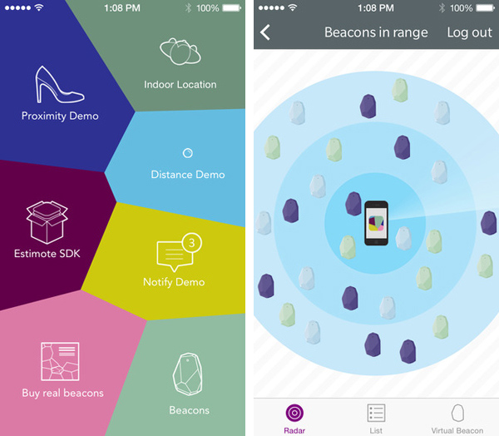
Figure 2: Estimote IOS application [40].
Estimote also provide a second application called ‘Indoor’ on IOS [39], this is the app that has been used to configure the indoor mapping system. The app is not available on android which means that to use the mapping system on android, a third-party app would need to be used, however, for this project, the mapping system has only been used on IOS.

2.2.4. Area Four - Security Considerations

This area investigates the security concerns and solutions regarding BLE beacons. As with any internet-connected device, there are always security concerns. One of the major security concerns around BLE beacons is spoofing. Spoofing involves an attacker mimicking an existing device to trick other devices into thinking that they are the legitimate device, thus allowing the illegitimate device to transmit malicious data to other devices [41]. There has been much research based on the prevention of these attacks [42]-[43], one model for preventing a spoofing attack is presented by Oliff, Filippoupolitis, and Loukas, they suggest that when a device receives information from a beacon such as a beacon identifier, the device sends that information to a server which then authenticates that information to ensure its integrity [44]. The authors suggest that this can lead to faster performance for the device as the amount of memory used is reduced, however, for this project, the implementation of a separate server will not be possible due to limitations in the location of the implementation.
Another security threat to BLE beacons is device hijacking, this is when someone gains access to the device configuration and modifies it to broadcast malicious information. However, this threat can be prevented by implementing basic security measures such as setting up complex passwords on the devices and ensuring devices are physically placed out of sight to stop tampering.

2.3. Related works

This section will look at some of the works of literature that have had an influence on this project. The works that have been discussed have topics that are like that of this project.
The first piece of literature that has provided some inspiration to this project is called ‘On physical web models’ and was written by Sneps-Sneppe and Namiot [6]. This paper covers different topics within the physical web such as; the types of technology that can be used to implement it and how the beacons work. The authors’ insight into the different technology that can be used by the physical web was useful when deciding which technology to implement in this project. Another point that was of use was the authors’ description of how the Eddystone beacon platform works. This helped the author of this project learn the more technical side of the physical web, which was needed when it came to the implementation stage. However, there are key differences between this paper, and the paper cited previously. One of these differences is that the authors believe that using push notifications to mobile devices, if they device comes into the range of a beacon, is harmful. The authors suggest that it is possible that a trojan virus could be installed via the notification. The author of this paper believes that if the correct security is set up on the beacons such as passwords and encryption, this threat would not be viable, also push notifications can be a useful part of the user experience, as the users may not know a beacon is there, in which case a push notification will let them know of a beacon in their proximity. Another difference is that the topic of the paper is a broad outline of the physical web and how it works, it does not suggest ways in which it could be used.
The second piece of literature that was influential on this project is called ‘A smart bus tracking system based on location-aware services and QR codes’ and is written by Eken and Sayar [45]. This paper is based around the idea of smart bus stops, and suggests a method in which a user, using their mobile device, scans a QR-code within the bus stop to find out route information, schedules and live updates for the bus they are waiting for, the model presented can be found in figure 3. Although there many differences between the cited paper and this project, the cited paper has been a source of inspiration since the central idea of both projects is the same, users should be able to look at their mobile devices and have up-to-date context and location-based information at the palm of their hand. As stated, Eken and Sayar suggest a user scans a QR-code to find this information, while this method may be an appropriate application for their project, for this project, it would not be realistic for each user to scan a code to find the information that they require. Due to the cited paper being released in 2014, it is possible that the BLE beacon technology was not as widely known at the time, which could have been a factor in the decision to use QR-codes.
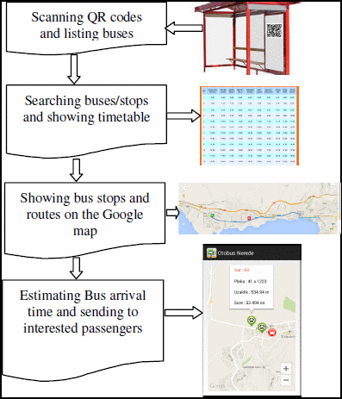
Figure 3: Bus tracking model presented in [45].

The third piece of literature that has been useful when creating this project is called ‘Implementing the physical web using Bluetooth low energy based beacons and a mobile app’ and is written by Rajpoot, Kumar, and Singh [4]. This paper gives a broad outline of how the physical web works, the main points in the paper being; What is the physical web? what are beacons? How can these beacons be implemented? and more. The paper describes how BLE beacons work and how they work which was useful during implementation. This paper proved to be useful when learning the basics behind the physical web, as the authors provide a clear and concise explanation of the physical web. Another good point about the paper is the fact that the authors have made a consideration of the security around the physical web, a point which many people will be concerned about. Another useful point regarding this paper is that the author describes how beacons can be created from existing microcontrollers such as Raspberry Pi or Arduino, this was useful when deciding which type of beacon to use during implementation of the project, however the author of this paper decided that using dedicated BLE beacons would be better suited to this project. Figure 4 provides an example of an algorithm for the code that needs to be written to set up a microcontroller as a BLE beacon. However, the paper doesn’t provide any real examples, or provide any examples of the physical web being implemented, only the theory behind it and what can be used to implement it. This is one of the major differences between the cited paper and this project and is another example of why there is room for a project such as this to exist. Another potential issue with the paper is that there is no real conclusion, which can make the paper less meaningful as it seems as if there is no result coming from the paper.
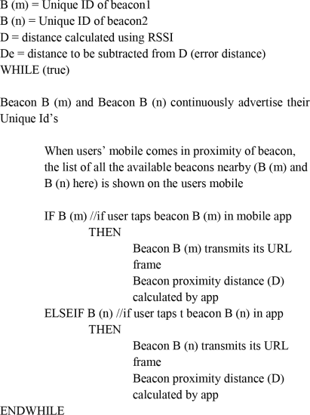
Figure 4: Algorithm for the code required to turn a microcontroller into a BLE beacon [4].

2.4 Conclusion

To summarise, this chapter has delved into the literature currently available regarding the topic of this paper, the physical web. A broad range of literature has been discussed, such as uses for the physical web, to the hardware and software required for implementation, to the theory behind the physical web.
Section 2.2.1 showcased how flexible the physical web is by providing different examples of implementations, such as; smart buildings, smart car parks, traffic control within smart cities, mapping system, etc. The lack of literature regarding the physical web within a university campus would suggest that there is a clear gap which a project such as this could fill.
Section 2.2.2 discussed the hardware that forms the backbone of the physical web. BLE beacons were introduced and explained, along with reasoning for why they are being used in this project, some of the reasons including; ease of configuration, and flexible broadcast range. Two BLE beacon platforms were discussed, iBeacon and Eddystone, with table 1 explaining the features of both. The section also mentioned the beacon brand that will be used for the mapping system (Estimote), along with the benefits of the beacons they make, and lesser known beacon was discussed. Finally, the section ended by providing information on alternative technology for the physical web, the highlighted technology being NFC.
Section 2.2.3 discussed the software that is being used during the implementation of the project. Firstly, the two operating systems for the mobile devices used during the implementation and testing stage are presented, IOS and Android, with descriptions of how both OS’ work. Within this section, the software used to discover and use the physical web beacons can be found, for example the physical web app on Android or and IOS, along with the software used to configure and monitor the beacons, the Estimote app on Android and IOS.
Section 2.2.4 discussed some of the security threats to BLE beacons such as spoofing and hijacking, however solutions were presented such as adding authentication servers and even basic security such as complex passwords.
Section 2.3 discussed the pieces of literature that were influential on this project. One of the reports written by Eken and Sayar [45], which discussed the concept of a smart bus stop, which uses context and location based information, which this project also uses.
At the start of the literature review, objectives were set which are as follows; to discuss literature as close to the topic of this report as possible, to critique pieces of literature, to justify the existence of this project. It is the opinion of the author that these objectives have been met. Literature close to the topic of this report has been discussed, along with a wide range of other literature that related to the topic in some way. Some of the literature presented has been critiqued, with both good and bad points brought to attention. And finally, the lack of available literature regarding the physical web being physically implemented in a university campus means that there is room for this project to exist.
The next chapter, chapter three, relates back to this chapter. Chapter three is titled ‘Research Methodology’ and discusses the methodology used during the research stage, along with the research philosophy adopted by the author of this project. Aims and objectives for the research process have also been discussed and the methods of data collection have been provided, along with an evaluation of whether the aims and objectives were met.

3. Research Methodology

3.1. Introduction

The purpose of this chapter is to highlight the research methodology used during the creation of this project. This chapter covers three main areas; the first area is the overview of the research, this chapter discusses the research process, along with the philosophy taken by the author, the methods of research, and the method of data collection. The second area is the research design, this area highlights the approach taken while conducting research, along with the deliverables from the research. The third area discusses the methods used when choosing which resources were required to implement this project.

3.2. Research Overview

The purpose of this section is to provide an overview of the process of conducting research for this project. Although the previous chapter covered a level of research, from the literature review, research is a process which happens through every stage of writing a project. This research overview will allow readers to gain an understanding of the process of gathering research from the authors perspective. Figure 6 below provides the flow of research for this project.

3.2.1. Research Process

The aim of the research in this project is to discover and implement ways of using the physical web in the setting of a University campus. It is the intention of the author that the research gathered during this project will provide a basis on which to build, when it comes to implementing the physical side of the project. During the process of collecting research, the author assumed an inductive research approach. Inductive research looks at existing research and patterns, and assesses how that research or those patterns can be applied to the context they have defined [46]-[47]. An example of inductive research in this project can be found within section 2.2.1 of the literature review, this section looks at existing research regarding how the physical web can be used, this research can then be implemented in the implementation stage of the project. However, it can be said that there are some traces of deductive research within the project also. Some researchers suggest that qualitative data is best suited to inductive research [48], however this will be covered within section 3.2.2.
The previous paragraph stated the purpose of the research. Looking at the research that is gathered, the settings in which the physical web has been implemented can be compared to the setting of this project, a university campus, with these settings being compared, it allows the author to determine whether the way in which the physical web is used in the research can be replicated on the university campus in this project. Table 2 below outlines an example of the comparison process between the research and the project subject.
Table 2: Example of a research model criteria checklist.
Project Criteria | Research Model
Does the model make use of context-based information? | Yes
Does the model make use of location-based information? | No
Does the model make use of BLE-Beacons? | Yes
Is the model designed for use with mobile devices? | Yes

3.2.2. Research Philosophy

A research philosophy is a belief about how research relating to a specific subject should be collected [49]. As discussed in the previous section, the author of this project has assumed an inductive style of research, which indicates that much of the research collected has been qualitative data. Qualitative research is a type of research that involves gaining insight and knowledge into a subject through observation of individual cases [50]. This type of research is best suited to this project as the type of data being collected is either experimental or provides the basis for an experiment to be conducted. For example, much of the research suggests ways in which the physical web can be used, the research provides individual examples of the uses. Quantitative data is also an important part of this project. Quantitative data looks at sets of data gathered from one experiment which is repeated multiple times and makes conclusions from those results, such as averages and percentages. Quantitative data is important to this project as this project is an experimental project.
When deciding on a research philosophy, it is useful to choose a research model to follow. A research model provides a framework for conducting research, it is a kind of formula to follow. The model that the author followed is called the ‘Hutter-Hennink Qualitative research cycle’ [51]. As shown in Figure 5, the cycle is split into three stages. Stage one is the design cycle, this stage involves; developing a research question, reviewing the literature available around that question, developing a framework for the study and deciding on the best approach to collect data. The second stage is called the ‘ethnographic’ stage, this stage involves; designing the research instrument such as resources to be used, collecting data, and making inductive inferences, this stage is closely linked to the first stage. And finally, the last stage is called the analytic stage, this stage involves; developing a set of guidelines to follow, describe and compare research, categorise research and create concepts based on the research, and to develop theories based on your findings. The author believes that this is a model that suits this project very well, a factor in this being that the model is a cycle. Research is a critical part of a project and is something that is done throughout every stage of the project, the model presented above shows that research never stops, it is a constant cycle that stops, only when the project is finished.

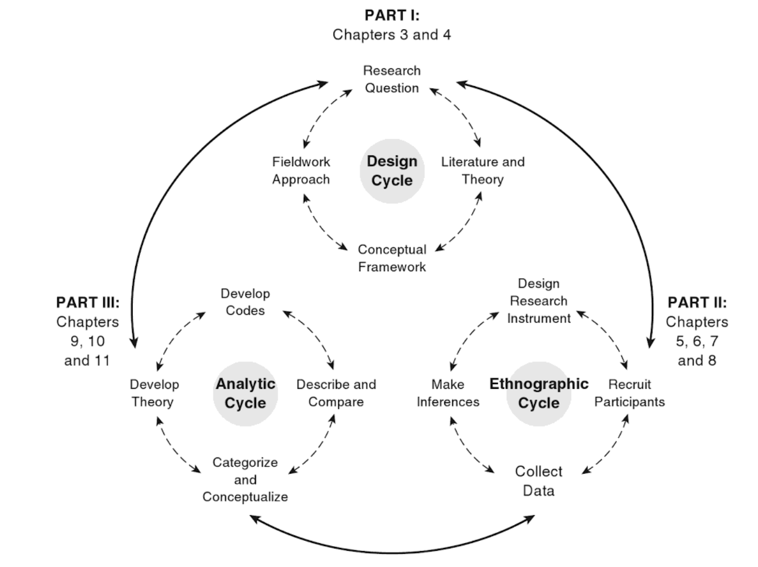
Figure 5: Hutter-Hennink Qualitative Research Cycle [51].

3.2.3. Research Methodologies

This project makes use of different types of research methodologies. One of these methodologies is called action research. Action research is a type of research that is initiated when trying to solve a specific problem, the aim of action research is to improve the skills of the person conducting the research [52]. Action research is a very hands-on style of research and is used normally when trying to solve a physical problem [53]. This is a style that is useful to this project as this project presents a physical model. The style is useful to the author as it allows the author to find solutions to problems while physically implementing the project and to learn new skills while developing existing ones.
Another research methodology used in this project is called empirical research. Empirical research is based on observed results from actual tests, rather than theories [54]. This type of research relates to this project as the author has made use of papers that are based around working models. This type of research allows the author and the reader to gain insight into how well the models work and how they can be implemented in this scenario.

3.2.4. Data Collection

This section outlines some of the different methods that have been used to collect data in this project. This section has been split into two sections, the first section covering data coming from primary sources, and the second section covering data coming from secondary sources. These terms have been described within their respective sections.
Primary research is the process of gathering new data that hasn’t been collected before. This data is usually unique to the project. This research is usually conducted in the form of interviews, questionnaires, etc. Although this project doesn’t use interviews or questionnaires, the data collected from the experiments in chapter four can be considered primary research, this is because the data being collected is unique to the project. This is called observation. Notes should be taken during experiments, along with the results from the observations. The data and notes can then be used to make assertions or back-up points made within the research and conclusion.
Secondary research involves looking at research that already exists, for example, journal articles, conference proceedings, experiments that have already been conducted. Chapter two of this project, the literature review, is a prime example of secondary research being conducted. Secondary research is used throughout the project, it is used to help explain different points, and to build up knowledge on certain subjects, such as during implementations.

3.3. Research Design

A research design is a plan that is designed to ensure that the research you gather is as unambiguous and, as closely related to the research topic, as possible [55]. Figure 6 below provides the research design used for this project. The design makes use of a waterfall style, moving from one step to another, however it also makes use of a cycle design at certain points. The waterfall aspect provides a clear and orderly process to follow, and the cycle aspect adds thoroughness and a time saving aspect, as you don’t have to start the process all over again if you need to re-visit certain parts of the process. As shown in the model the first step is to start with secondary research, this provides a good basis to go from as it allows the author to build up a good level of knowledge before moving on to the rest of the design. The secondary research stage then flows into the literature review, as a literature review is solely based on existing literature. The next stage is to implement the research gathered, this stage comes after the literature review, as the review can act as a kind of filter when deciding what literature to find inspiration from when implementing the physical model. This stage then moves down into the analysis of the results. In this design, the analysis links back up to the secondary research stage, the reason for this is because the results gathered in the implementation stage will be compared to existing results in other projects. The analysis stage also links to the primary research stage, as any results gathered by the implementation in this project are primary research. The final stage is the conclusion stage. This stage links back to the primary research stage as this research will be used when drawing a conclusion.
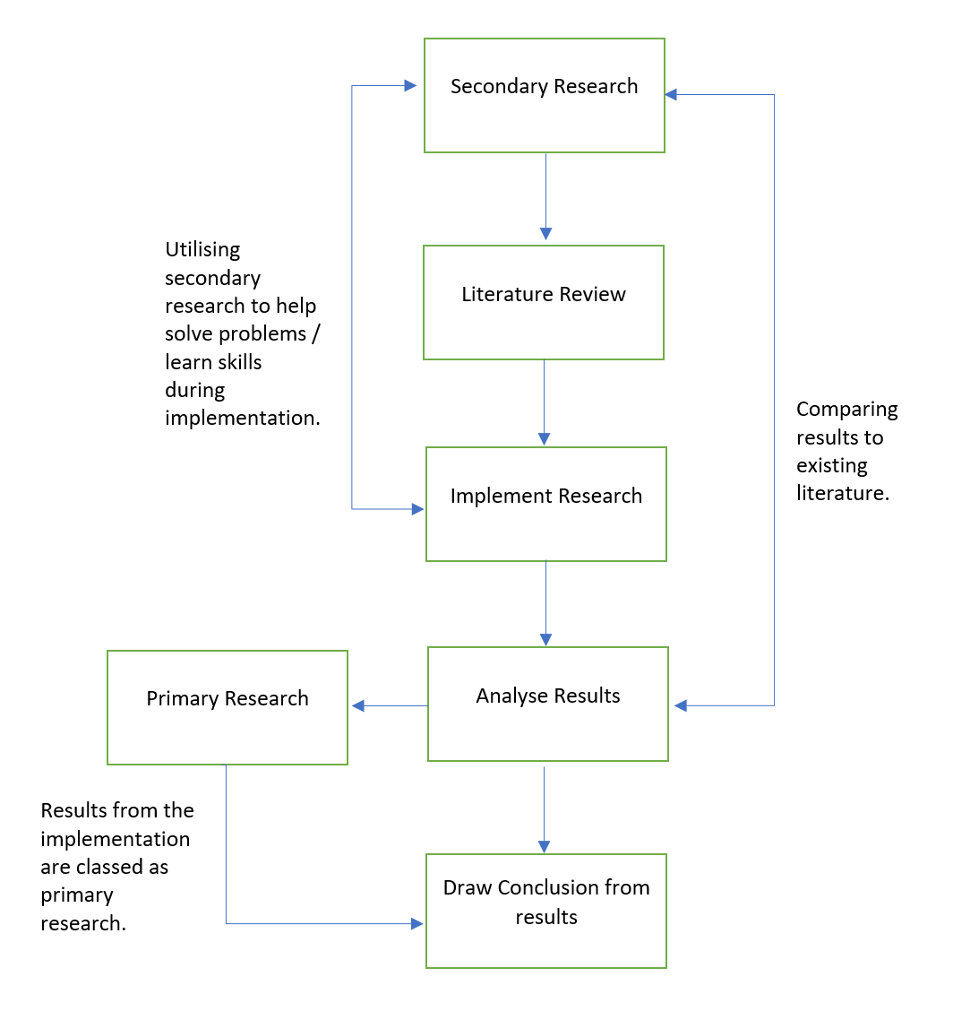
Figure 6: Research design.

3.3.1. Research Deliverables

Deliverables are the outputs that will come from the research. This project generates two types of outputs, the first type of output are primary outputs, these come from the physical implementation of the project. The second type of output are secondary outputs, these come from existing literature, and include examples of implementations from other projects.
The primary outputs from this project come from the primary research, which in turn comes from the implementation stage. This provides context as to how the outputs, that are about to be discussed, relate to the research design presented in figure 4. The first output to come from the implementation stage is the success rate of devices communicating with the beacons and can be found within the testing and evaluation chapter, chapter five. Another output is screenshots and photographs showing the location-based information concept and the location-mapping system. This output will be found within chapter four. The next output will be screenshots showing the settings used on the BLE-beacons during implementation, this will be found within chapter four.
The secondary outputs from this project come from the secondary research. One of the main outputs of this research are ideas on how to use the physical web. These ideas assist in deciding how the physical web should be used within the implementation stage. This output can be found within the literature review in chapter two. The next output that can be provided by secondary sources is hardware settings to use during implementation. This is useful because it helps the author overcome any problems during the implementation stage and would be found within chapter four of this report. Another output is what devices are going to be used, and from which manufacturer. This will be found within the literature review in chapter two. These outputs all relate to the research design in figure 4.

3.4. Resources Used During Implementation

This section covers the methods used to research and decide on the resources that were required to implement this project. The two types of resources needed to implement the project are hardware and software.
The first step in finding the hardware required for this project was to look at existing literature. The literature tells you what type of hardware is required, how that hardware can be used, and how it is configured. This research can be found within section 2.2.2. It was decided that BLE beacons should be used to broadcast URLs, with the advantages stated in the previously mentioned section. The next step was to research who manufactures BLE beacons and which one to use. This was done by conducting searches online for different manufacturers and noting down the features of the beacons from each manufacturer and their advantages and disadvantages. It was decided that the UWB Location beacons by Estimote would be used, as detailed in section 2.2.2. For users to access the physical web they need a mobile device, either an Apple IOS device or an Android mobile device can be used, but for this project, one of each has been used.
The second set of resources required is software. This first step was to research which beacon platform to use. The two major beacon platforms are iBeacon from Apple and Eddystone from Google. In section 2.2.2, a table (table 1) was created to compare the features of the two platforms and to decide on which of the two platforms should be used. It was decided that Eddystone would be used due to the wider compatibility. Because of the use of Eddystone, it was decided that Google’s Physical Web application would be used to get the most effective results from the beacon, however to configure the beacons, it was decided that the application provided by Estimote would be used as it is designed specifically to work with Estimote beacons. The software research can be found in greater detail within section 2.2.3.

3.5. Conclusion

This section has explored the different research methodology used during the creation of this report. Section 3.1 introduced the chapter. Section 3.2 discussed the research overview. This section was split into four sub-sections. Section 3.2.1 outlined the research process, the aim of the research portion of the project was presented, along with intention of the author while conducting the research. The section continues by introducing the idea of inductive research which the author assumed during the research process, providing examples of the use of inductive research during the project. Section 3.2.1 finished by providing an example of a checklist that is used to decide the suitability of the research gathered, in relation to this project. Section 3.2.2 began by discussing research philosophies. Qualitative and Quantitative research are two research philosophies used by the author, with examples of their use being provided. Section 3.2.2 continued by presenting a research model, as illustrated in figure 5. The model was explained and the reasoning behind why it is used can be found within the section, along with a sentence explaining the importance of a cycle style model. The next section, 3.2.3, describes two types of research methodologies, action research which aims to improve the knowledge of the researcher, and Empirical research, which is based on observational results from physical experiments. The final sub-section of section 3.2, 3.2.4, discusses the process of collecting data from research. The section suggests two sources of data collection, a primary section in which research comes from results from the implementation stage of this project, and a secondary section in which research comes from existing literature and projects.
Section 3.3 provides a research design which has been followed through the design stage, this model can be found in figure 6. The research design makes use of a waterfall model, however with some aspects of a cyclic model included. The different stages of the model are described in detail. A sub-section within section 3.3 discusses the outcomes that can be expected from the research. Some of these outputs include outputs from primary research, such as; settings used during implementation, screenshots and photos of the working model. Another set of outputs comes from secondary research, such as; settings used by other researchers implementing models of their own, and how they have made use of the physical web within their models.
Overall, this chapter is designed to provide the reader with an insight into how the author of this project conducted research and decided which research would be pertinent to the project. The author hopes that this chapter helps with a smooth transition into the next chapter.
Chapter four of this report provides the design and the actual implementation of the physical aspect of this report. Research gained during chapters two and three will be put into practice in this chapter. Screenshots and documentation will be made throughout the chapter to ensure the reader understands the implementation process.

4. Design and Implementation

4.1. Introduction

The purpose of this chapter is to present and discuss the designs of the physical implementations in this project. This chapter also looks at the process of implementing the designs, outlining; what settings have been used, any problems faced during implementation, how these problems were fixed, if there were any modifications made to the designs while implementing, etc.

4.2. Project Formulation

Before discussing the problems that need to be solved, it is useful to first highlight the different physical aspects of the project, such as what the beacons will be used for.
The first use for the beacons in this project is to provide location-based information. This means that depending on where the beacon is positioned on the campus, different information will be broadcasted, for example, in the main reception building of the campus, general information that relates to students and staff from all different subject areas is broadcasted, such as the UWTSD website, UWTSD social media links, etc, where as a beacon placed in the School Of Applied Computing department must broadcast URLs related to that specific department. For this project, a set of four beacons are being used, each beacon is capable of broadcasting more than one URL, however this greatly impacts battery life, which is a problem that will be discussed separately. The beacon URL can easily be modified using either a third-party application or using the official Estimote app, which is what has been used in this project. This means that during implementation, a beacon URL can quickly be changed depending on the requirements of the design. As shown in figure 7 below, the Estimote app allows you to connect directly to the BLE beacon, from here you can then modify the URL that will be broadcasted, along with the distance that the beacon should broadcast to.
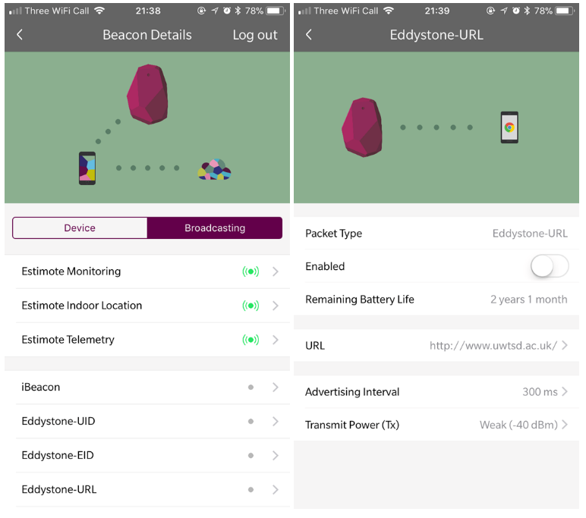
Figure 7: Beacon configuration page of the Estimote app.

Another problem as briefly highlighted in the previous paragraph is that if more than one URL is broadcasted from a beacon, the battery life is greatly reduced, this means that the beacon should only broadcast one URL at a time. However, in this project, a set of four beacons are being used to create an indoor location system. As a room requires at least four beacons to create a floor plan of the room and to locate the user within the room, it means that four URLs can be broadcasted at one time in the room.
One of the main uses for the BLE beacons in this project is for the indoor location mapping system. Each room requires four of the Eddystone UWB location beacons, one in each corner of the room. A problem that this can cause is that to accurately map out, for example, an entire floor of a building, dozens of beacons may be required as you need at least four per room, this is something that is not within the budget of this project, so to get around this issue, one room at a time will be used as an example. One classroom will be used to test the system, this will be room MH509 at the UWTSD Mount Pleasant campus, and the main corridor of the floor on which the classroom is based, will also be used.
The final problem that has been identified is that different rooms are different sizes, this can affect both the location aspect of the project and the information side of the project. As the same beacons have been used in different rooms and areas of the campus, regular reconfiguration is required, however the Estimote beacons make this reconfiguration very simple. As shown in figure 8 below, the distance for which the beacons broadcast can be easily modified using the transmission power setting, the app provides a slider control which also tells you using metres and feet, the distance that the beacon broadcasts to. As far as the location aspect is concerned, the Estimote UWB Location beacons using the Estimote Indoor application for Apple IOS devices, automatically maps the room for you when the beacons are placed, the beacons can work out how far away from each other they are to provide accurate measurements for the room they are in.
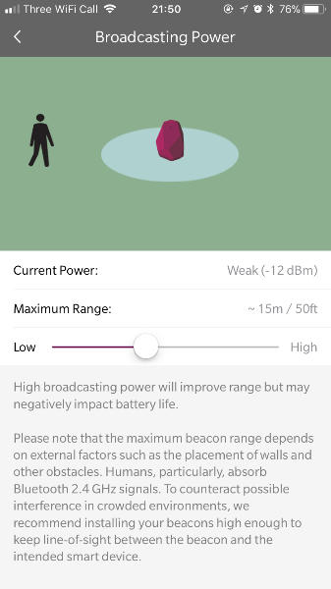
Figure 8: Configuration of the beacon’s broadcast distance.

4.3. Design

The next stage of this chapter is to present and discuss the designs that have been created to help with the implementation of the project. This section has been split into two sub-sections, with 4.3.1 outlining the designs for the location tracking aspect of the project, and 4.3.2 outlining the designs for the location-based information aspect.

4.3.1. Location Mapping Designs

The first set of designs to discuss are for the location-mapping aspect of the project. It had been decided that due to the number of beacons available during the project (four), the system would be tested one room at a time, as one beacon is placed in each corner of the room.
The first room that was used as part of the design was room MH509 on the fifth floor of the main building at UWTSD Mount Pleasant Campus. This room was chosen because it is a very common example of a classroom at the university, meaning the design could be replicated for other rooms within the campus. As the floorplan is automatically created by the beacons, along with the dimensions of the room, the dimensions in figure 9 are not accurate. Figure 9 shows the positioning of the beacons within room MH509, with one beacon being placed in each corner of the room. The reason for this is because the Estimote, the company that builds the beacons, recommends that this is done, also having a beacon in each corner of the room means more accurate results, and guaranteed coverage for the area of the room. Estimote also recommends that the beacons are placed on the wall at chest height while setting up the room, however, as there is a server rack in the room, the beacons may need to be placed higher on the wall, to avoid interference, however this is only required if the server rack is powered. As the user walks around the room, their position on the map changes, as represented by the red dot in figure 9 below. The beacon sends out signals which are received by the mobile device, with a response sent to the beacon to signal that the device is near it.
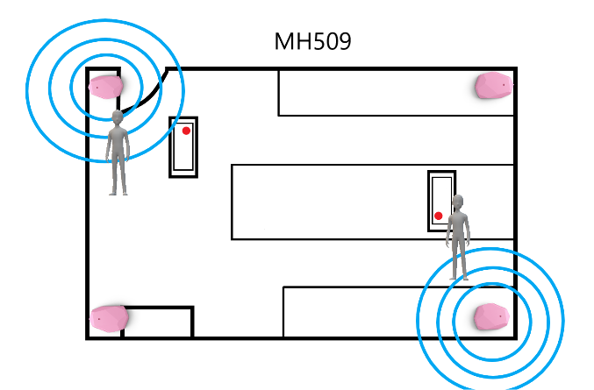
Figure 9: Floorplan of room MH509 showing position of beacons.

The next design is of the corridor on the fifth floor of the main building of the UWTSD Mount Pleasant campus. The corridor was chosen as a testing space as it is a long open space and provides a good basis for replication across the campus, not only this but when implementing a location mapping model in a real world scenario, only corridors are normally mapped, as the user normally only needs to know how to get to a room rather than where they are within the room. For the design and to provide context as to where on the floor the user is, an entire replica floor plan has been created of the fifth floor, however during implementation, only the hallway has been mapped. As shown below in figure 10, the blue lines in between the beacons represents the beacons communicating with one another to map out the floor. The design also shows how, as the user moves through the corridor, their position on the map, which is generated on the mobile device, changes. Two of the beacons, one in opposite corners of the corridor will be broadcasting URLs, one to the UWTSD School of Applied Computing (SOAC) moodle homepage, and one to the UWTSD Applied Computing twitter page. A potential problem that has been taken into consideration during implementation is the distance between the beacons, and whether that would affect the mapping process, this has been discussed further in the implementation section and within chapter five.
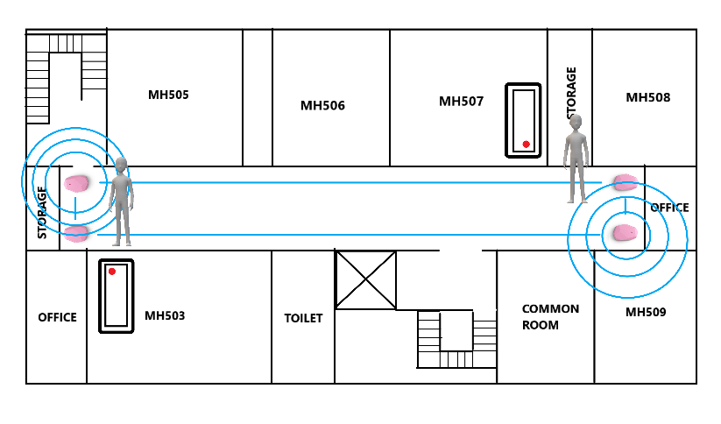
Figure 10: Floor plan of the fifth floor of UWTSD Mount Pleasant main building.

4.3.2. Location Based-Information Designs

These next set of designs are based around the principle of location-based information. The aim of location-based information is that when you walk into different locations within the university, you will be provided with different information. For this project, the concept of location-based information has been tested in three different scenarios.
The first scenario that has been designed is to have a beacon placed on one of the floors of the Mount Pleasant campus that belong to UWTSD SOAC. This is the third floor of the main building. As shown in figure 11 below, the beacon will be placed by the entrance to the floor and will broadcast a URL leading to the SOAC moodle homepage. The beacon will be placed on the wall around chest height, as recommended by the beacon manufacturer Estimote. The distance that the beacon will broadcast to has been modified and tested during the implementation stage. The URL can be easily modified within the Estimote app, as explained in section 4.2. A potential limitation of the beacon is the distance it can broadcast, and whether the signal can be broadcasted to the entire floor, this has been explained in the implementation section. Figure 11 shows the positioning of the beacon and how it may broadcast, while also highlighting the potential issue that has been raised.
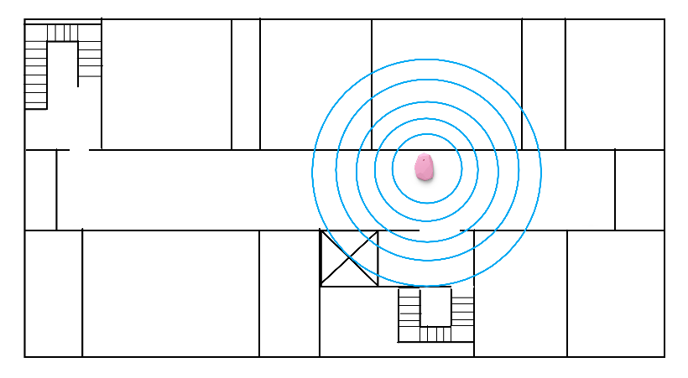
Figure 11: Beacon positioning on floor 3.
The second scenario is the use of a beacon within a classroom. This has been designed to be implemented in room MH509. This room is used to teach a number of modules to year 1, 2, and 3 students, so within this room, the beacons that have been used to map the classroom in a previous design in section 4.3.1, have also be used to broadcast URLs that lead to moodle pages for the different modules, to show how the beacons can be used to provide quick and easy access to class materials. Figure 9 above, shows the design of the room and the placement of the beacons, while the potential issues in the room have been discussed within section 4.3.1.
The third scenario is to place the beacons in the reception area of the main building of the mount pleasant campus. Two beacons will be placed in the reception area, one beacon broadcasts a URL leading to the University’s main website, and the other beacon broadcasts a URL leading to the UWTSD quick links page, so visitors can easily find information that they need. Figure 12 below shows the layout of the reception area, along with the position of the beacon. As shown in the figure, the two beacons are placed around the middle of the room, on opposite sides from each other, this is to ensure even coverage for the signal, around the room. The blue lines represent the signal and how much of the room the signal covers, however this is something that can be modified, this is shown within the implementation section.
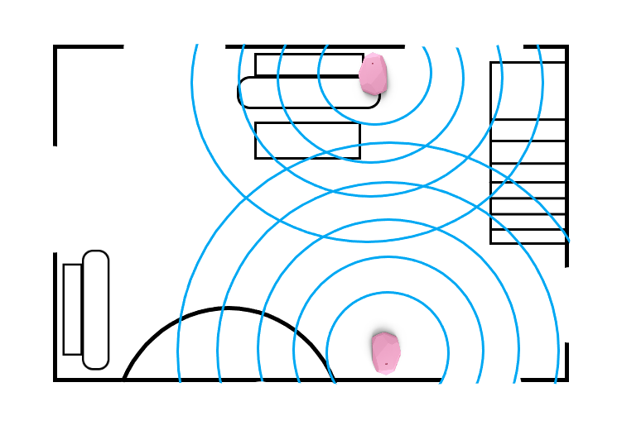
Figure 12: Mount Pleasant reception layout.

4.4. Implementation

The next stage is to implement the designs presented in section 4.3. This section will detail the implementation process, including; the positioning of the beacons, the settings that were used on the beacons, how long it took to set the beacons up, any issues faced during implementation, and whether the implementations differed from the designs they were based on.
It is important to note that the four beacons being used in the implementations have assigned names relating to the colour of the beacon; the yellow beacon is called ‘Lemon’, the pink beacon is called ‘Candy’, the white beacon is called ‘Coconut’, and the purple beacon is called ‘Beetroot’.

4.4.1 Location Mapping Within A Classroom

The first design to be implemented was the indoor location system in room MH509. As shown in figure 9 above, four beacons were placed in the room, one in each corner of the room, with each beacon being placed around chest height. It was suggested in the design that due to networking equipment being in the room, that one of the beacons may need to be placed higher due to potential interference, however the beacon was placed at chest height, as the networking equipment was switched off. The beacon positioning can be seen in figure 13 below. Each beacon has a sticky back which allows it to be placed on the wall easily.

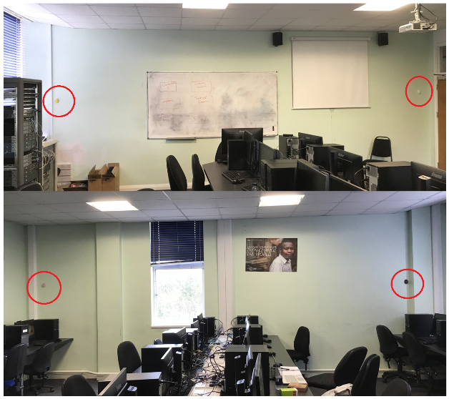
Figure 13: Picture showing beacon positioning within room MH509.
After placing the beacons, the next step was to go through the setup process using the Estimote Location application on IOS. The application walks you through the entire set up process, breaking it up into steps. This can be seen in figure 14 below. The most important step is to walk around the room, from beacon to beacon, this allows the app to register the distance between the beacons and establish the shape of the room. The app then calculates the results of that step to create the layout of the room. During implementation, the calculation stage had to be repeated multiple times due to an error occurring, however it was found that there was an incorrect setting on the beacons. To enable communication between the beacons, each beacon can be added to the same mesh network, enabling this setting solved the error. After changing this setting, the calculations were completed, and the floor plan created, this has been discussed further in the testing and evaluation chapter, chapter 5.
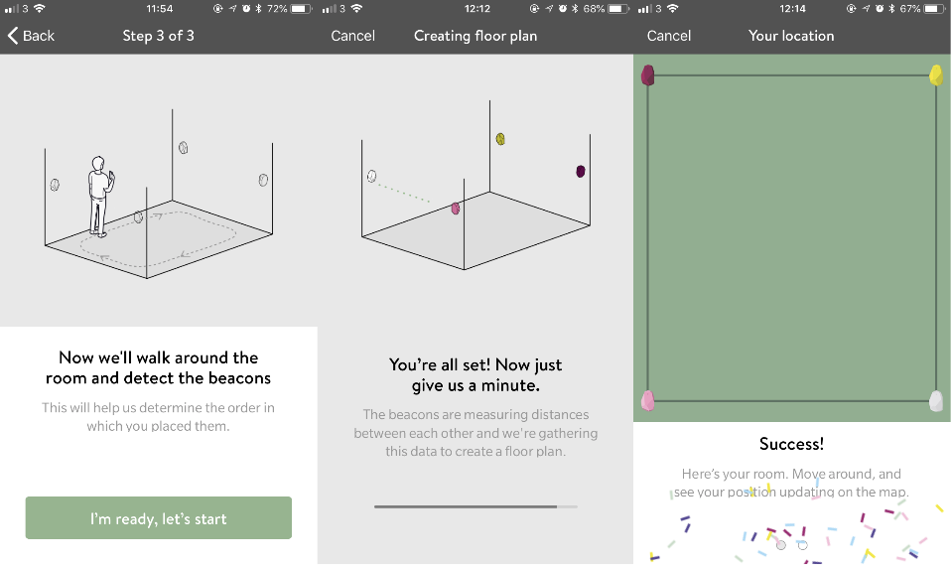
Figure 14: Main steps of creating the room layout.

With the map created, it was now time to see if it works. Figure 15 below shows screenshots of the map created in the app. As the user walks around the room, the figure on screen moves with them to indicate their position in the room. A useful feature of the Estimote Indoor app is that you can see a real time view of where you are through the camera, meaning you can see both the map and the real world at the same time. During testing there were a few issues that arose, such as inaccurate positioning, however, this has been discussed further in the testing and evaluation chapter.
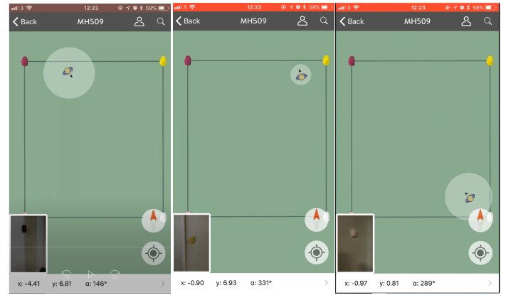
Figure 15: Screenshots from a video of the map system being tested.

4.4.2 Location Based Information – Classroom

The next design to be implemented was the location-based information design within the MH509 classroom. As detailed in the design, as there were four beacons being used for the mapping system, four different URLs could be broadcasted in the classroom. It was decided that one beacon would broadcast a URL to the Computer Networks ‘Advanced Cybersecurity’ moodle page, one beacon would lead to the UWTSD website homepage, one beacon would lead to the UWTSD Applied Computing twitter page, and the last beacon would lead to the Computer Networks ‘Network and Data Centre Management (NDCM)’ moodle page.
To enable the beacons to broadcast the URLs, the Estimote beacon application for IOS was used, this app allows you to modify all aspects of the beacons. The Estimote Cloud website can also be used to modify the settings of the beacons, with either the Estimote beacon application or the Estimote Deployment app being used to connect to the beacons to change the requested settings. As shown in figure 16 below, the first beacon that was setup was the ‘Lemon’ beacon. The Eddystone-URL setting was enabled to allow the URL to be broadcast. Within the Eddystone-URL settings the URL can be modified, along with the transmission power which dictates how far the signal is sent. The URL was modified using Google’s URL shortener feature [56], this was used as the URL to the Advanced Cybersecurity moodle page was too long for the beacon. After setting the URL it was time to check if the URL was being broadcasted, this was done using the Physical Web app on IOS and Android, to ensure that both mobile platforms received the signal. In this case, only the IOS device received the URL, the android device did not, this has been discussed further in the Testing and Evaluation chapter.
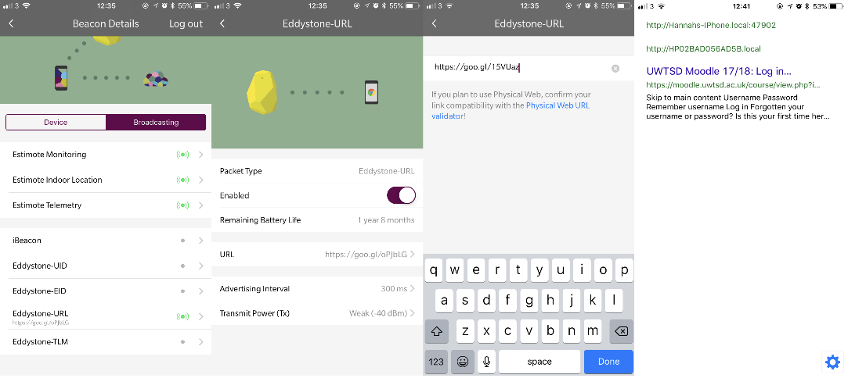
Figure 16: Process of modifying the URL to be sent.

With the beacon broadcasting the URL it was time to find the best setting for the transmission power, this was to ensure the signal could be picked up all around the room. The default setting for the transmission power was -40 dBm, this translates to a maximum range of 1 metre or 3ft, as the room is much bigger than that, the setting had to be changed. First, the setting was changed to -16 dBm (range of 7m / 22ft), however, this did not cover the whole room, this was discovered by walking to the opposite corner of the room to see if the physical web app picked up the signal. Because of this, the next setting used was -12 dBm (range of 15m / 22ft), after setting this signal strength, the signal covered the entire room. The settings used are shown in figure 17 below.
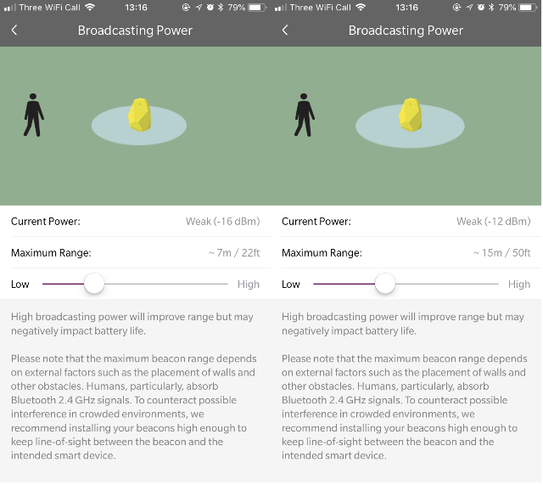
Figure 17: Settings determining distance of URL broadcast.

Using the same methods highlighted above, the three other beacons were also setup. Eddystone-URL was enabled on the other three beacons, with the ‘Beetroot’ beacon being assigned the UWTSD website URL, the ‘Candy’ beacon was assigned the Computer Networks ‘NDCM’ URL in the form of a shortened URL, and the ‘Coconut’ beacon being assigned the UWTSD Applied Computing URL in the form of a shortened URL. Before setting the transmission power, the two mobile devices were tested to see if they receive the URLs from the beacons. Only the IOS device received all four signals. The android device only received two signals, the UWTSD Applied Computing twitter URL and the ‘NDCM’ moodle URL, the reason for the Android device not receiving all the signals has been put down to the hardware of the device, this has been discussed further in chapter five. After checking whether the devices received the URLs, the transmission distance was changed, the default setting for each beacon was -40 dBm, however the distance setting was changed to -12 dBm, as it was discovered previously that this setting ensured the signal covers the whole room. The settings used on the three beacons can be found in figure 18 below, while figure 19 shows the IOS device receiving all four URLs and the Android device receiving the two URLs.
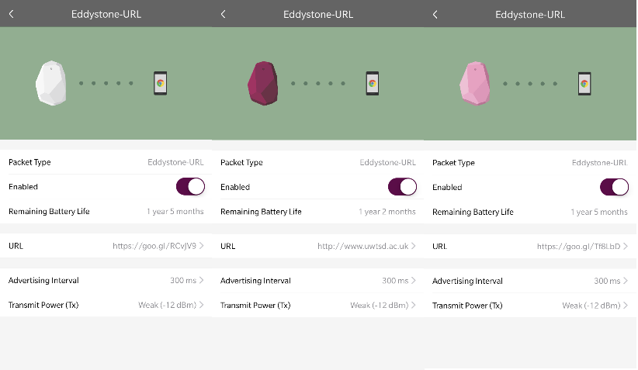
Figure 18: Settings for the three other beacons.

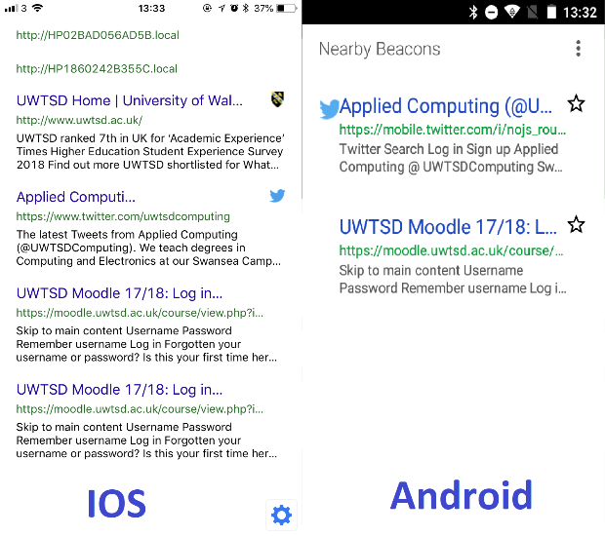
Figure 19: IOS and Android devices receiving URLs from the beacons.

4.4.3 Location Mapping in A Hallway

The next implementation is the Location mapping system in a hallway. As previously stated, the most common way of mapping an indoor location is to map the hallways/corridors, rather than individual rooms, this is because people use the location system to find how to get to a room, rather than to see where they are within a room.
The first step of this implementation was to begin the setup process on the Estimote Indoor app, once the beacons had been detected, it was time to place the beacons in the hallway, placing one beacon in each corner of the hallway, at around chest height, this can be seen in figure 20 below. Once the beacons had been placed, the setup process continued on the Indoor app, asking the user to walk from beacon to beacon so that the app can calculate the positioning of the beacons and the distance between them. The recalculation process had to be repeated multiple times as an error sometimes occurred when attempting the calculation, this was due to the long distance between the beacons, however the calculations were completed after placing the mobile device directly in the middle of the hallway so that it could communicate with the four beacons evenly. These steps can be seen in figure 21 below.
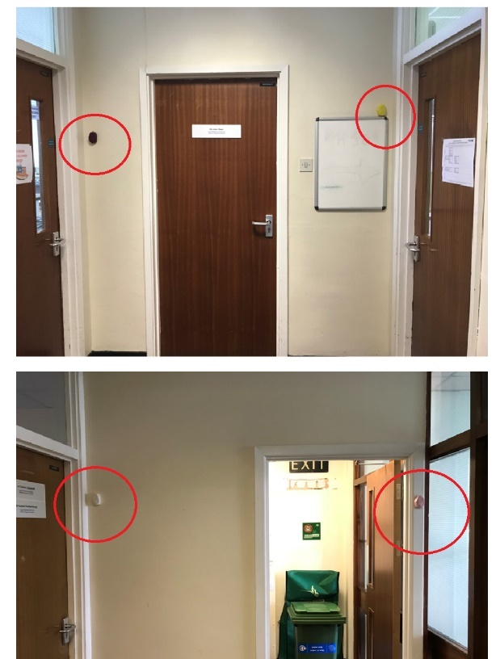
Figure 20: Positioning of the beacons in the floor 5 hallway.

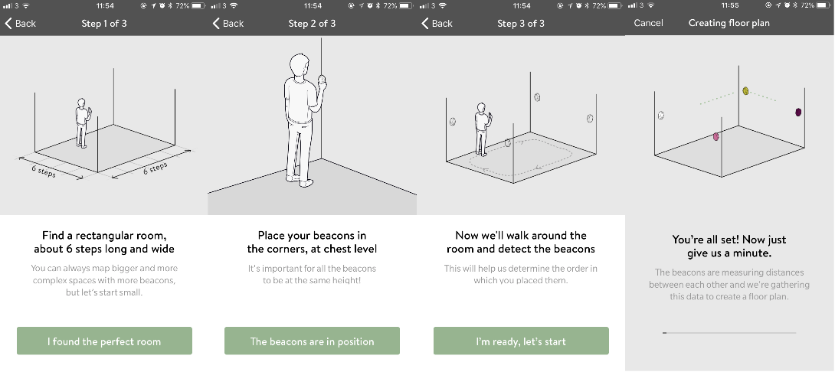
Figure 21: Steps required to setup the room.
After the calculations were completed, the app provided the layout of the corridor. As shown in figure 22 below, the layout created by the app is not an accurate representation of the actual corridor, which can be seen in the design in figure 10 above. The layout created makes the hallway very thin. The reason for this could be because the beacons are too close together, however, this is something that cannot be helped due to the width of the room, this has been discussed further in chapter five. Although the layout is not accurate, the mapping system does recognise the user moving up and down the corridor, which can be seen in figure 22, however, as shown in the third screenshot, the movement is not completely accurate, and was choppy while testing, this could be due to the distance between the beacons being too great. This has been discussed further in chapter 5.
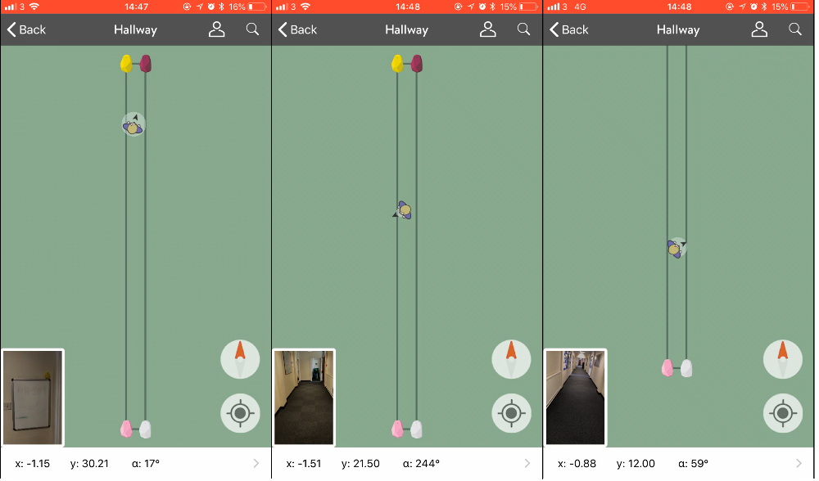
Figure 22: Screenshots of the testing of mapping system.

Two of the beacons being used for the mapping system were also set up to broadcast URLs. The ‘Candy’ beacon broadcasted a URL leading to the SOAC moodle homepage, while the ‘Beetroot’ beacon broadcasted a URL leading to the Applied Computing twitter page. Due to the length of the corridor, the distance that the beacon needed to broadcast is far greater than the classroom scenario. The first step was to disable the Eddystone-URL feature on both the ‘Lemon’ and ‘Coconut’ beacons, this is because they are not broadcasting URLs and turning the feature off saves battery. Next, the ‘Candy’ beacon was modified to broadcast the SOAC moodle homepage URL, using a shortened URL, while the ‘Beetroot’ beacon was modified to broadcast the Applied Computing twitter URL, using a shortened URL. Both the IOS and Android device were then tested to see if they could receive the URL, as shown in figure 23 below, the IOS device could pick up both signals when within range, however the android device could only pick up the SOAC moodle homepage URL, this is a recurring trend which suggests a problem with the mobile device, however, this has been discussed further in chapter five. Next it was time to choose the transmission power to dictate the distance to send the signal. At first, a setting of -8 dBm was used for both beacons, this provided a range of 30m/100ft. During testing this setting did not cover the whole floor area, both beacons only covered around half of the hallway with the centre of the hallway being a ‘black-spot’. Because of this, the setting was changed to 0 dBm which provided a range of 50m/160ft, this ensured that both beacons covered the whole hallway, however it does mean there is a negative effect on the battery life of the beacons, this has been discussed further in chapter five. The settings for each beacon can be found in figure 24 below.
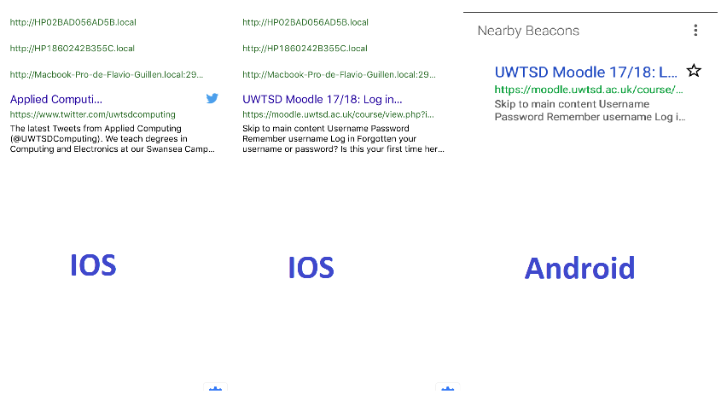
Figure 23: Screenshots showing which URLs are received by the mobile devices, before modifying settings.

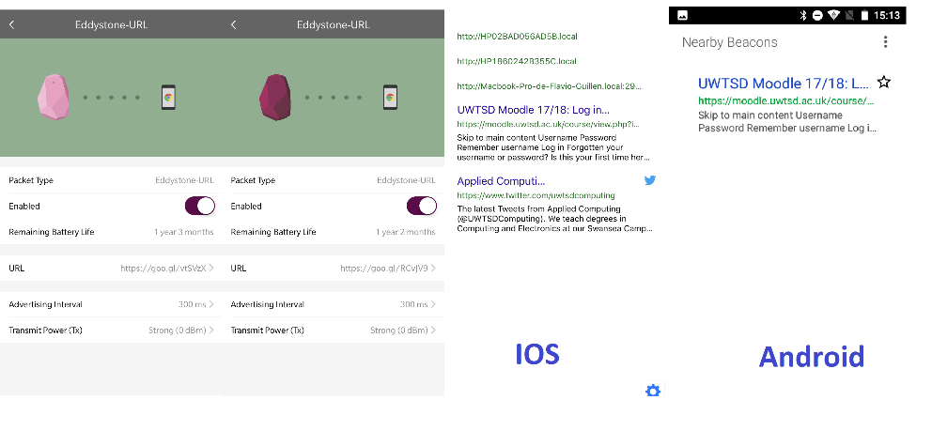
Figure 24: Settings for the two URL broadcasting beacons, alongside screenshots of the two mobile devices receiving the URLs.

4.4.4 Location Based Information – Floor 3

The fourth design to be implemented is the location-based information concept on the third floor of the main building of UWTSD’s Mount Pleasant campus. The third, fourth and fifth floors all belong to the UWTSD SOAC, so the idea of placing a beacon on the third floor is to broadcast information relating to SOAC. In this implementation, one beacon was placed at the entrance to the hallway, around chest height, as shown in figure 25 below. The beacon was next configured with a URL leading to the SOAC moodle homepage, using a shortened URL. Due to the beacon not needing to broadcast the URL to the entire floor, only the entrance area, a setting of -12 dBm was used which provides a range of 15m/22ft. Both the IOS and Android device received the URL, as shown in figure 26 below.

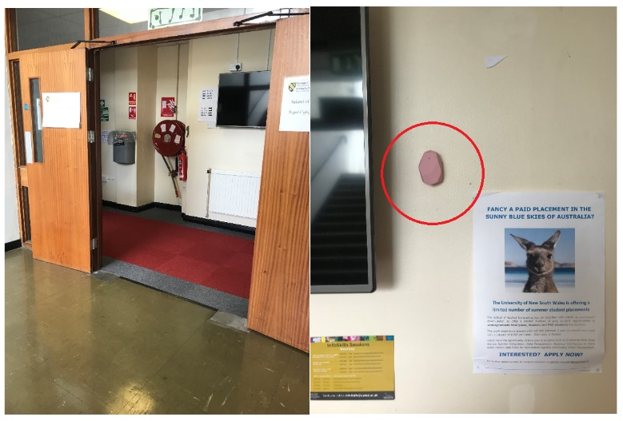
Figure 25: Image showing the positioning of the beacon in relation to the entryway.

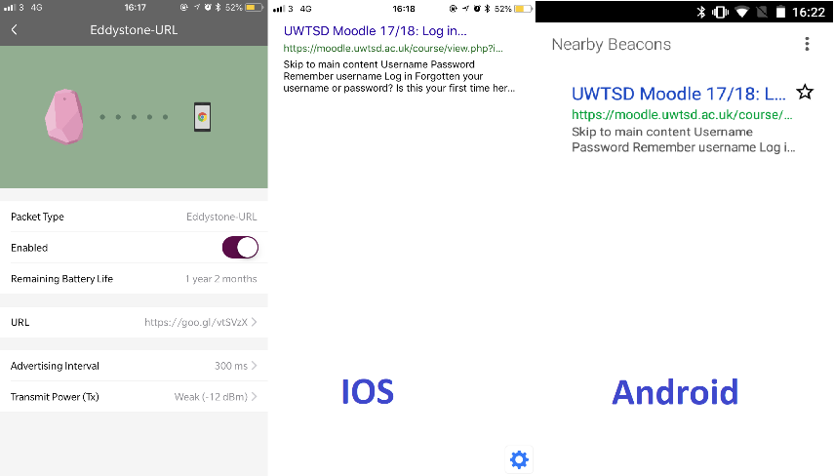
Figure 26: Screenshot of the beacon configuration alongside the two mobile devices receiving the URL.

4.4.5 Location Based Information – Reception

The final implementation was to place two beacons in the reception area of UWTSD’s Mount Pleasant campus, to broadcast location-based information. As shown in figure 27 below, the beacons are placed on opposite sides of the room, both at chest height. The first step was to ensure that the Eddystone-URL feature was enabled on the two beacons, ‘Beetroot’ and ‘Lemon’. The next step was to modify the URLs being broadcasted, ‘Lemon’ was setup to broadcast a URL leading to the UWTSD quick links website, using a shortened URL, and the ‘Beetroot’ beacon was setup to broadcast a URL leading to the UWTSD main website. With the URLs set, it was time to change the transmission power of the beacons. For both beacons, the -12 dBm setting was used, this covers the whole of the reception area. These settings can be found in figure 28 below. Only the IOS device received the URLs being broadcasted, the Android device did not receive the URLs, this contributes to a continuing pattern with this device, which has been discussed further in chapter five.
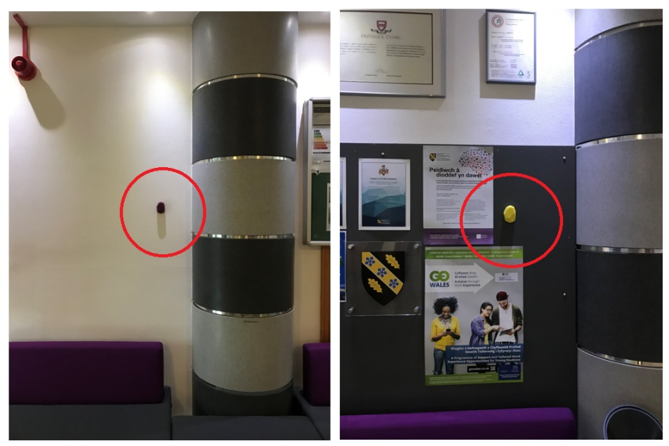
Figure 27: Image showing the placements of the beacons, both placed on opposite sides of the room.
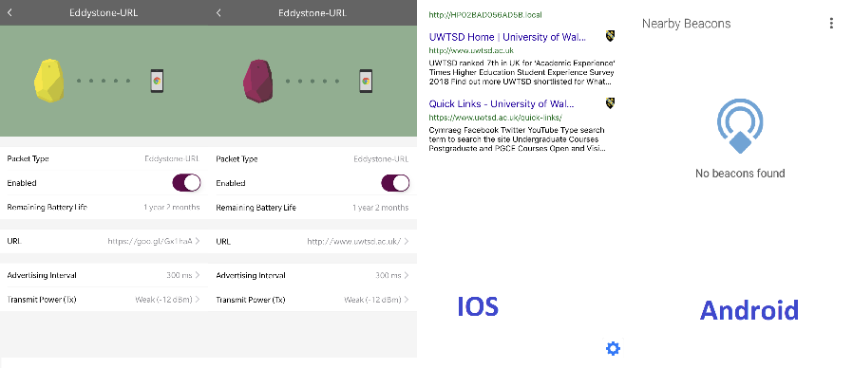
Figure 28: Settings for both beacons, along with screenshots of the two mobile devices.

4.5. Conclusion

In conclusion, this chapter has presented a set of designs to be implemented around different parts of the university building, with each design offering different functionality. These designs were then implemented with images showing how the beacons were placed and how they were configured. A couple of issues arose during implementation, some were solved during the implementation stage such as the location issue in section 4.4.1 however other issues such as the location issue in section 4.4.3, or the repeating issue of the Android device not picking up the Eddystone-URL signals, have been discussed further in chapter five. Chapter five discusses the testing of the implementations, and presents an evaluation of the implementations, such as reasoning for issues arising, and how they can be resolved, or whether anything could have been done differently.

5. Testing and Evaluation

5.1. Introduction

The purpose of this chapter is to go through the testing stage of the implementation. Discussing anything that was repeated, if there were any errors that occurred during implementation, what could have caused those errors and how or if they could be resolved. This chapter also evaluates the implementations, discussing their effectiveness.

5.2. Location Mapping Implementations

5.2.1. Testing

The location mapping implementations were setup in two locations, one in room MH509, and one in the fifth-floor hallway. The steps for implementing the mapping systems can be found within section 4.4. In these scenarios, only the IOS device was used as the Estimote Indoor application is only available on IOS.

MH509
When implementing the location system in MH509, the calculation stage, as seen in figure 14 above, had to be repeated multiple times. This was due to an error message which stated that the beacons were unable to communicate with one another. The first step in finding the cause of the error was to check the beacon settings. While checking the settings, it was discovered that two of the beacons were assigned to a ‘mesh’ network called 509-location, while the other two beacons were not part of the same network, this meant that the beacons in the mesh could only talk to each other, this is shown below in figure 29. To solve this issue, the beacons were assigned to the same network so that they could all communicate with one another, as shown below in figure 30. After doing this, the calculations could be completed, and the map was created.
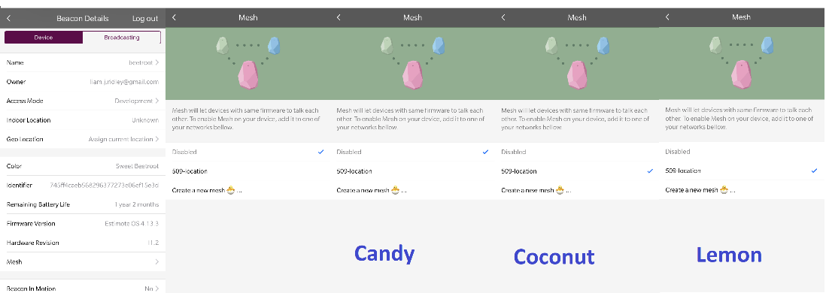
Figure 29: Beacon settings before being modified.
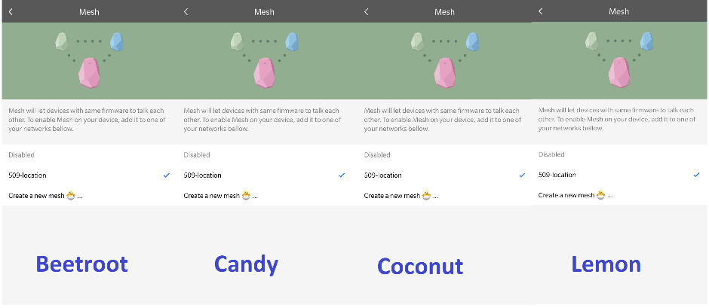
Figure 30: Settings after modification.
The next issue that arose during implementation is a jitter and a delay while moving around the room. As the user moved around the room, the figure representing the user on screen would jump around, although it would catch up and show an accurate position, the delay means that the user would have to walk slowly to allow the app to catch up. The app was closed and reloaded, however this did not make it smoother. A suggestion as to why this issue occurred is due to the beacons being development beacons. The beacons are part of a development kit, and have only been available for a short time, this could mean that there are still bug fixes to be released by the manufacturer. The mapping system can be implemented into a custom application using a Software Development Kit (SDK) provided by the beacon manufacturer, however, creating a custom application was out of the scope of this project. Due to time constraints, this issue remained unresolved.

Fifth-floor hallway
The next mapping system was implemented on the fifth-floor hallway. The first issue that arose during this implementation is the floor plan created by the beacons. As shown above in figure 22, the width of the map created is considerably smaller than the actual hallway, this is due to the beacons beacon’s being placed too close together, this is something that could not have been avoided, and a lack of beacons. Using four beacons to map a room is usually intended for rectangular shaped rooms, rather than hallways, however due to monetary constraints on the project, only four beacons could be used. Although the floor plan is inaccurate, the map was functional, although similarly to the previous mapping system, the movement on the map was jittery and delayed, this could be due to the distance between the beacons, making communication between the beacons more difficult.

5.2.2. Evaluation

Overall, the mapping systems created in both scenarios were functional but suffered from errors which made the experience of using the system less appealing. The stuttering and delay meant that real-time position accuracy was not very high, and the user had to stop and wait for the figure on the map to catch up to them. Some of the main improvements that could be made to this system include, adding more beacons to make mapping more accurate, creating a custom application so that performance of the map can be optimised, and to use beacons which are not in the developmental stage. Things that could be changed in the implementations have been discussed in greater detail within section 7.3. However, based on the results from the implementations, mapping-system is not ready to be implemented on a larger-scale, this has been discussed further in section 6.3.

5.3. Location-Based Information Implementations

5.3.1. Testing

The concept of location-based information was implemented in four different scenarios, with each scenario broadcasting a different number of URLs. For these scenarios, both the IOS and Android devices were tested to see whether they received the URLs.

Room MH509
The first scenario that makes use of location-based information is in room MH509. As stated in section 4.4.2, four beacons were already in place due to the mapping system, meaning that four URLs could be broadcasted within the room. The IOS device was able to receive all the URLs being broadcasted, at any position in the room, however the Android device only received two of the four URLs, this can be seen above in figure 19. To try and solve this problem, the Bluetooth setting was turned off and then turned back on again, but this did not solve the problem, then the Physical Web application that was being used on the android device to receive the URLs, was uninstalled and then re-installed, however this did not solve the issue. The settings being used on the beacons that were broadcasting the URLs, which were received by the android device, were the same settings used on the other beacons, which suggests that there the issue lies with the Android device. The hardware inside the Android device is not as powerful as the hardware inside of the IOS which could mean that the Android device being used is not powerful enough to process the same information as the IOS device.
To ensure reliability of the beacons and the mobile devices, the Physical Web app on both the IOS and android device were closed then opened again to ensure the app can pick the URLs up each time. In this scenario, the IOS picked up the URLs every time, with the Android device still only picking up the two beacons.

Fifth-floor hallway
The next scenario to use location-based information is on the fifth-floor hallway, similarly to the previous scenario, there were four beacons already in place in the hallway from the location mapping system. However, in this scenario, only two beacons were used to broadcast URLs. Like the previous scenario, the IOS device was able to receive URLs from all the broadcasting beacons, while the Android device only received one of the URLs. This shows a continuing pattern of the Android device, or the application on the android device, not working correctly. The Physical Web application was uninstalled and re-installed, and a new URL detecting app was installed, Google’s ‘Nearby’ app [57], however the ‘Nearby’ app again only picked up the one URL. This suggests that the device hardware is where the problem lies.
Like the previous scenario, the mobile apps were closed and re-opened again multiple times to ensure reliability. The IOS device received the URLs each time, while the Android device only picked up the one URL each time.

Floor 3
The third scenario to use location-based information is the third floor of UWTSD Mount Pleasant’s main building. Floor three to five of the building is allocated to SOAC, so it is important that a URL relating to SOAC is broadcasted. In this scenario, one beacon was used, which linked to the SOAC moodle homepage, as that page contains useful information for members of SOAC. Both the IOS and the Android device were able to pick up the URL being broadcasted. Looking back at the previous trend from the android device, and the results produced from this implementation suggests that the device is only capable of receiving two URLs at once, sometimes even just one, this can be put down to the hardware capabilities of the mobile device being used during implementation and testing.
The same method of testing has been used in this scenario, to close and re-open the Physical Web apps multiple times, to see whether the mobile devices receive a URL each time. Both the IOS and Android device received a URL each time.

Reception
The final scenario that used location-based information is the reception area of the Mount Pleasant campus. Two beacons were used in this scenario to broadcast the URLs. Only the IOS device received the URLs, the Android device did not receive any, as shown above in figure 28. The Physical web app was closed and reloaded multiple times, however the app would not detect the URLs during any of the attempts. The IOS device was also tested in this way and received the URLs every time.

5.3.2. Evaluation

After looking at each scenario, there is a clear pattern showing that the Android device used in this project is not capable of picking up the URLs like the IOS device can. The Android device used in these scenarios has less hardware capabilities than the IOS device which has had a large impact on the devices performance during implementation. The result of this is that it is difficult to gauge whether the IOS device is more suited to receiving beacon signals, as an Android device with similar hardware capabilities should be tested, however, due to monetary constraints on the project, this was not possible. Also, the use of such a high transmission range in the fifth-floor hallway means that the battery life of two of the beacons would be significantly affected. Although the Android device did not perform as expected, as the beacons use the Eddystone platform which is an Android native platform, the IOS device shows that the location-based information concept does work, and can provide useful information, on-demand. If this experiment was to be repeated, a more capable Android device would be used. Things that could be changed in the implementations have been discussed in greater detail within section 7.3. The results from the testing stage feed into the conclusion formed in section 6.3.

5.4. Conclusion

This chapter has looked at each implementation scenario, discussing; any issues that arose during the implementation such as devices not working correctly, what could have been the cause of those issues, such as low hardware capabilities, and how these issues were dealt with, if they could have been dealt with. This chapter has also discussed the method of testing the different scenarios, such as; repeating the implementation and closing apps and re-opening them to see if they work the same way each time.
An evaluation has also been provided for each set of implementations, discussing what was wrong with the implementations, and what could have been done differently. The evaluation was useful as it was able to discover the pattern of the Android device not functioning optimally, which helps when looking at what can be changed to improve the implementations.
The next chapter, chapter six, is the conclusion chapter. Here, the contents of the body of the report are summarised, with the conclusion from each chapter being brought together and summarised, along with any potential future research that could be conducted after the report.

6. Conclusion

6.1. Introduction

The purpose of this chapter is to present a summary of what has been done throughout the project, and to form a conclusion based on the outputs of the report. Conclusions from each chapter will be brought together, and a final conclusion will be drawn to discuss how successful the project was. Finally, potential areas of future research will be discussed at the end of the chapter.

6.2. Summary

This section will provide a summary of the contents of the main body of the report. Each chapter will be summarised, with links being made back to each one.
Chapter one, the introduction chapter, is designed to provide background information into the concepts that have been used such as, what is the physical web? What are Bluetooth Low-Energy (BLE) beacons? How can they be used? And how will they be used in this project? Chapter one also discusses the purpose and the aim of the project, which is to investigate and implement different uses for the physical web on a university campus. An important factor of the report is that people should be able to read through it and replicate it in another scenario. Also covered in this chapter are the objectives to be met throughout the project such as ‘To effectively discuss and critique the research currently available regarding the physical web’ and ‘Evaluate and critique the effectiveness of the implementations to discover whether it is worth implementing them on a larger scale around a university’. Finally, the chapter finishes with the expected outcomes of the report, which is to have a conclusion based on experiments and observations, and the structure of the report.
Chapter two, the literature review, is responsible for compiling and presenting the research gathered that relates to this project. The literature review covers four areas of research; Area one covers uses for the physical web such as; indoor positioning, in retail to broadcast different offers and deals from the store, and within healthcare for patient tracking. The second area covers the different hardware that can be used to implement the physical web, such as; Bluetooth Low-Energy beacons, RFID tags, different mobile devices and their platforms, and two different beacon platforms, Google Eddystone and Apple iBeacon. Area three covers the software that can be used to implement the physical web, such as; Google’s Android mobile operating system, Apple’s IOS mobile operating system, Estimote beacon software to manage the BLE beacons, etc. And area four covers the security considerations for this project, such as; encryption, beacon security, and preventing beacon spoofing. The research concludes by discussing three works related to this project, such as; a smart bus-tracking system used to create smart bus stops to see where your bus is along with projected times, and another related work called ‘On Physical Web Models’ which covers some of the uses for the physical web and how it can be implemented.
Chapter three is the research methodology chapter. This chapter covers; the research process, the philosophy adopted by the author such as an inductive research style and both qualitative and quantitative data. Under the research overview, the chapter outlines the research methodologies such as action research and empirical research and covers the different data collection methods which include; primary research methods (observations, experiments), and secondary research (journal articles, conference proceedings, online videos). The last part of the chapter covers the research deliverables, which are the outputs from the report, these include primary outputs (screenshots showing implementation settings, results from the implementations, and secondary outputs (from the research process). And the chapter ends by discussing the hardware and software resources to be used during implementation.
Chapter four is the design and implementation chapter. The chapter begins with the problem formulation section. This section is designed to highlight any potential problems that may be faced during implementation, and how they could be avoided, some of which include potential signal interference, and reconfiguration for the different implementation environments. The next part of the chapter presents the designs created for the implementations. There are five designs, two of which cover a location mapping system, and three which cover a location-based information system. Within each design section, a drawing of the design is presented showing the layout of the environment and the positioning of the beacons, and example of this can be seen above in figure 9. The final part of the chapter is to discuss the implementations of the designs previously created. The implementation section features five subheadings, one for each design. Within each sub-section, the implementation process is detailed with step-by-step instructions, the settings used are discussed, and problems faced are noted ready to be discussed in chapter five. The sub-sections also discuss whether the implementations differed from the designs.
Chapter five is the testing and evaluation stage. Here, each implementation is tested to ensure that the system is functional, or to repeat the implementations with different settings to see what results that have on the outcome. The evaluation stage is one of the most important stages. Here, each implementation is discussed, highlighting details such as; were the tests successful? Did any errors occur? How could they be fixed? Were they fixed? One of the re-occurring issues during the testing phase was the Android mobile device not receiving some of the URLs from the beacons, it was found that the mobile phone hardware is not powerful enough to process all the information from the beacons.

6.3. Conclusion

This project has been able to meet the project aim that was set at the beginning, to ‘investigate and implement different uses for the physical web on a university campus’. The report has provided many different outputs. The literature review in chapter two was able to provide plenty of information into how physical web can be implemented and how it can be used, the main outputs of this research being; the location-mapping concept and broadcasting location-based information, research into the Estimote beacons and Eddystone beacon platform, all which have been used in this project. Chapter two also highlights the gap in research into the physical web on a university campus that this report can fill. Chapter three provides insight into the research process undertaken for this project, highlighting the philosophies and methodologies used by the author, and how that helped the author find information pertinent to this project. Chapter four, the implementation chapter is designed to show how the physical web can be implemented using a step by step process, including the settings used for each device and how the software can be used. These steps can be replicated in a different scenario. The main output of this chapter is to provide the implementations, and results of those implementations, ready for the testing and evaluation stage in chapter five. Chapter five, the testing and evaluation chapter is responsible for ensuring that the implementations are functional, and that any problems that arose during implementation have been discussed, with actual or potential solutions to the problems. An example of this is a problem that occurred in section 4.2.1, the location-mapping system did not work at first however, after checking the settings, the problem was fixed and the system started working, however another problem that occurred during multiple implementations, the android device not receiving all of the URLs, could not be fixed due to it being down to the hardware capabilities of the mobile device. The main output of chapter five was the information required to put together the final conclusion as seen below.
Overall, the project has been able to meet its original aim, and the objectives set at the start, although this will be discussed further in chapter seven. After seeing the results of the implementations and evaluating those results, a decision can be made on whether the implementations featured should be implemented on a larger scale. It is of the authors opinion that the location-mapping system, using BLE beacons, should not be implemented on a University campus. The main reason for this is due to scalability. University campuses usually cover large areas, so you would require hundreds of beacons to accurately map the campus and ensure good performance. The beacons used in this project did not perform optimally, even in a small classroom, which indicates that they should not be used on a larger scale. Another reason is due to cost, with a set of four beacons costing up to £140, it would be very expensive to implement on a large scale. The final reason is due to the battery life of the beacons. The battery life varies depending on their usage and their settings, however, with an average battery life of 2 years, it would be difficult and expensive to maintain a network of location-mapping beacons. Although, the author does think that mapping-systems would be extremely useful using a different technology such as WIFI, which will be discussed further in the future works section. Using BLE beacons to broadcast location and context-based information is something that the author believes should be implemented on a larger scale. Although the system did not work correctly on the Android device used in this project, the system did work fully on the IOS device and would work on a more capable Android device. Using beacons to broadcast URLs is easy to maintain, easy to set-up, and can provide useful information on-demand.

6.4. Areas of Future Research

During the research stage of this project, many different areas of research were discovered which were not within the scope of the project. One of the main areas is to use WIFI for indoor-mapping, rather than BLE beacons. This includes using WIFI access points to determine your location within the network, then to represent this on a map. One of the main benefits of using WIFI for indoor positioning is that the network is already there for the existing WIFI infrastructure, you just need to create the map and the algorithms to setup the system, and example of a company that specialises in WIFI indoor positioning is called MazeMap [58], they use both WIFI triangulation, and BLE technology to create their wayfinding systems.
Another potential area for future research is the use of Raspberry PI’s to create BLE Bluetooth beacons [59]. The new Raspberry Pi models, Raspberry Pi 3 Model B [60], come with a BLE chip built in, meaning all that is needed is the code to create a working Bluetooth beacon. This could potentially be a lot more cost effective than using battery powered BLE beacons as the raspberry Pi is mains powered.
The next area of potential future research is to implement BLE beacons within a retail environment. The basic idea of this has already been discussed in the literature review, in section 2.2.1. A source has been cited which describes how stores can use BLE beacons [25]. Due to the authors experience in the retail industry, this research is of great interest.

7. Reflections

7.1. Introduction

The purpose of this chapter is to look back through the report to gauge how successful it was. Some of the questions that have been used to measure this are; Have the aims and objectives been met? To what extent? Have there been any shortcomings? What could be done to rectify these? This chapter also covers the conduct and progress of the author throughout the process of creating the report.

7.2. Analysing the Aims and Objectives

The first step is to see if the aim of the project has been met. The aim, found in section 1.4 states ‘…to investigate and implement different uses for the physical web on a university campus’. The aim of the project has been met, as different uses for the physical web have been researched in section 2.2.1 of the report, and two of these uses, indoor location-mapping and location-based information have been implemented in section 4.4. Next, each individual objective will be discussed with an evaluation of how successfully they were met, the list of objectives can be found in section 1.5.
The first objective states ‘To conduct research into the physical web to find out how it works and how it can be used in different settings’. This objective has been met within the literature review in Chapter two of the report. Extensive research has been conducted into the background of the physical web can be found in sections’ 1.1 and 2.2, while research into how the physical web can be used can be found in section 2.2.1. Sections’ 2.2.2 and 2.2.3 outline what is required to make the physical web work.
Objective two reads ‘To effectively discuss and critique the research currently available regarding the physical web’. A discussion and critique of the research gathered for this project can be found in the literature review, chapter two. A good example of this can be found in sections’ 2.2.2 and 2.2.3 as two different platforms are compared and critiqued against one another along with different hardware and software, with one being chosen from each to be used in the project. Literature has been critiqued within the related works section, section 2.3, where each piece of literature was compared back to this project.
The third objective states ‘To discuss why there is a demand for a project such as this, and how it could be of benefit to the target audience’. This objective has been met within the literature review. Section 2.4. states how a lack of literature available into the physical web would suggest there is room for a project like this to exist.
Objective four reads ‘To implement some research gathered, around the university campus’. This objective has been met within chapter 4. Section 4.4.1 to 4.4.5 shows location-mapping and location-based information being implemented in a classroom, corridor, entry way, and a reception area.
Objective five reads ‘Evaluate and critique the effectiveness of the implementations to discover whether it is worth implementing them on a larger scale around a university’. This objective has been met in sections 5.2, 5.3, and 6.3. Sections 5.2 and 5.3 discuss the implementations and evaluate them, discussing how effective they were, and how well they worked. Section 6.3, the conclusion section discusses whether the implementations were worth being implemented on a larger scale, it was suggested that the location-mapping system, using Bluetooth technology, should not be implemented on a large scale, while the location-based information systems should be implemented on a larger scale.
Objective six states ‘To create a conclusion based on the results produced’. This objective has been met in section 6.2. and details how successful the implementations were and if they should be implemented further.
The final objective, objective seven states ‘To further the both the readers and authors understanding of the physical web’. Only half of this objective has been met so far, and that is to further the authors understanding of the physical web. Whether the readers understanding has been furthered is for each individual reader to decide.

7.3. What Could Be Done Differently?

When creating a project of this scope, there will always be things that could have been done differently. One of the major things that would be done differently is to change the Android mobile device that was used. In this project, an inexpensive Android phone that cost around £40 was used, however the hardware was not up to the standards of the IOS device that was used, meaning that performance of the implementations was impacted, and didn’t work correctly. Having a back-up Android device was not included in the contingency plan, which is something that should have been included.
Another part of the project that could have been done differently is to use different BLE beacons. This project used Estimote UWB Location beacons. These beacons were newly released at the time of implementation and were still in development stage. This could have been a contributing factor to the location-mapping system not working optimally. More established and stable beacons could have been used instead.
Overall, writing this report has allowed the author to learn many new things, from learning about what the physical web is and how it can be used, to increasing the authors level of discipline while writing. It has also helped the author learn to put more thought into planning before the project, in-case things do not go as intended.

7.4. Project Management

Due to the length of and the amount of work involved in this project, it is crucial that the project is managed correctly. One of the best examples of this is time management. Good time management means you have a clear plan and structure, which allows time for any overlapping tasks, or any delays that may occur. Figure 31 below, found in the appendix, shows the Gantt chart created for this project at the beginning of the project. The Gantt chart covers different tasks to be completed along with dates to work on the task. As shown, the Gantt chart is extremely basic, with not enough detail put into each task.
Figure 32, as found in the appendix, shows the final gantt chart, after modifications have been made to it throughout the process of the project. As shown, there is a considerable difference between the two charts. The new chart is extremely detailed, outlining each individual task, along with the dates for them to be completed. Each chapter is split into sections, with each section having time at the end of the chapter for corrections. A research task has also been added that spans the entirety of the project to represent the constant need for new research. The dates have also seen considerable changes, such as chapter being completed on different dates.
It is also important to keep a log of the project progress. At first, the log, as seen in figure 33 in the appendix, starts off by noting every time the project was worked on, down to the day and time used, along with the resources used during each section. However, from February onwards, a weekly summary was instead created. This was done rather than noting down days that repeated themselves. It also made it easier to update the project gantt chart.
Holding regular meetings with the project supervisor was also important. This is because the supervisor has a lot of experience with these types of projects and can give out useful advice during the process of creating the report. It also allows both the supervisor and the author to judge the authors’ progress and find any areas to improve. As shown in figures 34-38, which can be found in the appendix, five meetings were held from the end of October 2017 to April 2018, with supervision forms written to assess progress on the report and any suggested improvements to be made.

References

[1] “The Physical Web.” [Online]. Available: https://google.github.io/physical-web/. [Accessed: 07-Nov-2017].
[2] M. Ruta, S. Ieva, G. Loseto, and E. Di Sciascio, “From the Physical Web to the Physical Semantic Web: knowledge discovery in the Internet of Things,” in Tenth International Conference on Mobile Ubiquitous Computing, Systems, Services and Technologies, 2016.
[3] M.-E. Ionascu and M. Marcu, “Energy Profiling for Different Bluetooth Low Energy Designs,” in IDAACS’2017, 2017, pp. 1032–1036.
[4] S. Rajpoot, S. Kumar, and P. Singh, “Implementing the physical web using Bluetooth low energy based beacons and a mobile app,” in 2016 International Conference on Innovation and Challenges in Cyber Security (ICICCS-INBUSH), 2016, pp. 327–329.
[5] D. Namiot and M. Sneps-Sneppe, “The Physical Web in Smart Cities,” in 2015 Advances in Wireless and Optical Communications (RTUWO), 2015, pp. 46–49.
[6] M. Sneps-Sneppe and D. Namiot, “On physical web models,” in 2016 International Siberian Conference on Control and Communications (SIBCON), 2016, pp. 1–6.
[7] B. Lee, S. Im, S. Lee, B. Kim, B. Roh, and Y.-B. Ko, “The beacon identification using low pass filter for Physical Web based IoT services,” in 2015 IEEE Pacific Rim Conference on Communications, Computers and Signal Processing (PACRIM), 2015, pp. 354–358.
[8] V. Chandel, N. Ahmed, S. Arora, and A. Ghose, “InLoc: An end-to-end robust indoor localization and routing solution using mobile phones and BLE beacons,” in 2016 International Conference on Indoor Positioning and Indoor Navigation (IPIN), 2016, pp. 1–8.
[9] M. G. Kibria and Ilyoung Chong, “Knowledge based open IoT service provisioning through cooperation between physical web and WoO,” in 2015 Seventh International Conference on Ubiquitous and Future Networks, 2015, pp. 395–400.
[10] D. Bhattacharya, M. Canul, and S. Knight, “Case Study: Impact of the Physical Web and BLE Beacons,” in Proceedings of the 50th Hawaii International Conference on System Sciences | 2017, 2017.
[11] IEEE, “IEEE Xplore Digital Library.” [Online]. Available: http://ieeexplore.ieee.org/Xplore/home.jsp. [Accessed: 25-Nov-2017].
[12] D. Gracanin, M. Handosa, H. G. Elmongui, and K. Matkovic, “An approach to user interactions with IoT-enabled spaces,” in 2017 14th International Conference on Telecommunications (ConTEL), 2017, pp. 139–146.
[13] S. W. Kum, S. H. Kim, Y. R. Jeon, J. Moon, and T. B. Lim, “Design and implementation of IoT planner: Device interaction service for IoT,” in International Conference on Ubiquitous and Future Networks, ICUFN, 2016, vol. 2016–Augus, pp. 441–443.
[14] S. Zhao, L. Yu, and B. Cheng, “An Event-Driven Service Provisioning Mechanism for IoT (Internet of Things) System Interaction,” IEEE Access, vol. 4, pp. 5038–5051, 2016.
[15] S. N. Mahalank, K. B. Malagund, and R. M. Banakar, “Device to device interaction analysis in IoT based Smart Traffic Management System: An experimental approach,” in 2016 Symposium on Colossal Data Analysis and Networking, CDAN 2016, 2016, pp. 1–6.
[16] M. K. Patra, “An architecture model for smart city using Cognitive Internet of Things(CIoT),” in 2017 Second International Conference on Electrical, Computer and Communication Technologies (ICECCT), 2017, pp. 1–6.
[17] F. A. S. da Silva and C. A. de F. S. da C. Rodrigues, “Computational Sustainability for Smart City Design,” in 2017 International Conference on Intelligent Environments (IE), 2017, pp. 60–67.
[18] A. Capponi, C. Fiandrino, D. Kliazovich, and S. Giordano, “Energy Efficient Data Collection in Opportunistic Mobile Crowdsensing Architectures for Smart Cities,” in INFOCOM17 SmartCity Workshop, 2017, pp. 307–312.
[19] C. Marche, M. Nitti, and V. Pilloni, “Energy efficiency in smart building: A comfort aware approach based on Social Internet of Things,” in GIoTS 2017 - Global Internet of Things Summit, Proceedings, 2017, pp. 1–6.
[20] S. Dharur, C. Hota, and K. Swaminathan, “Energy efficient IoT framework for Smart Buildings,” in 2017 International Conference on I-SMAC (IoT in Social, Mobile, Analytics and Cloud) (I-SMAC), 2017, pp. 793–800.
[21] H. Namie and A. Yasuda, “Positioning-Based ICT Infrastructure Platform - Smart vending machine - Smart v,” in 2014 IEEE 3rd Global Conference on Consumer Electronics, GCCE 2014, 2014, pp. 446–447.
[22] P. Babu, “8 Ways Eddystone and the Physical Web can Make your Daily Life Easier | Beaconstac,” beaconstac. [Online]. Available: https://blog.beaconstac.com/2016/03/8-ways-eddystone-and-the-physical-web-can-make-your-daily-life-easier/. [Accessed: 26-Nov-2017].
[23] J. H. Huh and K. Seo, “An indoor location-based control system using bluetooth beacons for IoT systems,” Sensors, vol. 17, no. 12, 2017.
[24] P. Kriz, F. Maly, and T. Kozel, “Improving Indoor Localization Using Bluetooth Low Energy Beacons,” Mob. Inf. Syst., vol. 2016, pp. 1–11, Apr. 2016.
[25] M. Da Silva, “Proximity Marketing: How to Attract More Shoppers With Beacon Technolo,” Shopify, 2017. [Online]. Available: https://www.shopify.com/retail/the-ultimate-guide-to-using-beacon-technology-for-retail-stores. [Accessed: 02-Mar-2018].
[26] B. Fagin, F. Sposaro, and G. Tyson, “Indoor tracking of geriatric patients using bluetooth,” First AMA IEEE Med. Technol. Conf. Individ. Healthc., 2010.
[27] Y.-Y. Ting and F. J. Lin, “A comparison and evaluation of different BLE connection methods for wearable devices,” in 2017 IEEE Conference on Standards for Communications and Networking (CSCN), 2017, pp. 240–245.
[28] Apple, “WWDC 2013 Keynote - WWDC 2013 - Videos - Apple Developer,” WWDC , 2013. [Online]. Available: https://developer.apple.com/videos/play/wwdc2013/100/. [Accessed: 26-Nov-2017].
[29] Google, “Platform Overview | Beacons | Google Developers.” [Online]. Available: https://developers.google.com/beacons/overview. [Accessed: 26-Nov-2017].
[30] A. De Blas and L. Diego, “Improving trilateration for indoors localization using BLE beacons,” 2017 2nd Int. Multidiscip. Conf. Comput. Energy Sci., pp. 1–6, 2017.
[31] S. Mittal, “iBeacon vs Eddystone - what works for you? | Beaconstac,” Beaconstac, 2016. [Online]. Available: https://blog.beaconstac.com/2016/01/ibeacon-vs-eddystone/. [Accessed: 26-Nov-2017].
[32] Estimote, “Estimote products.” [Online]. Available: https://estimote.com/products/. [Accessed: 26-Nov-2017].
[33] Accent Systems, “iBKS 105 | Accent Systems.” [Online]. Available: https://accent-systems.com/product/ibks-105/. [Accessed: 26-Nov-2017].
[34] P. Vagdevi, D. Nagaraj, and G. V. Prasad, “Home: IOT based home automation using NFC,” in 2017 International Conference on I-SMAC (IoT in Social, Mobile, Analytics and Cloud) (I-SMAC), 2017, pp. 861–865.
[35] K. Hartmann and A. Quirnn, “How useful are BLE beacons for mobile guides?,” in 2016 5th International Conference on Wireless Networks and Embedded Systems, WECON 2016, 2017, pp. 1–10.
[36] H. A. Tran, Q. T. Ngo, and V. Tong, “A new fall detection system on Android smartphone: Application to a SDN-based IoT system,” in 2017 9th International Conference on Knowledge and Systems Engineering (KSE), 2017, pp. 1–6.
[37] Apple, “Estimote on the App Store.” [Online]. Available: https://itunes.apple.com/gb/app/estimote/id686915066?mt=8. [Accessed: 27-Nov-2017].
[38] “Physical Web – Android Apps on Google Play.” [Online]. Available: https://play.google.com/store/apps/details?id=physical_web.org.physicalweb&hl=en_GB. [Accessed: 13-Mar-2018].
[39] “Physical Web on the App Store.” [Online]. Available: https://itunes.apple.com/gb/app/physical-web/id927653608?mt=8. [Accessed: 13-Mar-2018].
[40] V. Doljenkova and G. Tung, “Beacons: Exploring Location-Based Technology in Museums | The Metropolitan Museum of Art,” 2015. [Online]. Available: https://www.metmuseum.org/blogs/digital-underground/2015/beacons. [Accessed: 27-Nov-2017].
[41] B. Chatfield and R. J. Haddad, “RSSI-based spoofing detection in smart grid IEEE 802.11 home area networks,” in 2017 IEEE Power & Energy Society Innovative Smart Grid Technologies Conference (ISGT), 2017, pp. 1–5.
[42] P. Zhang, S. G. Nagarajan, and I. Nevat, “Secure Location of Things (SLOT): Mitigating Localization Spoofing Attacks in the Internet of Things,” IEEE Internet Things J., vol. 4, no. 6, pp. 2199–2206, Dec. 2017.
[43] P. D. Martin, M. Rushanan, T. Tantillo, C. U. Lehmann, and A. D. Rubin, “Applications of Secure Location Sensing in Healthcare.”
[44] W. Oliff, A. Filippoupolitis, and G. Loukas, “Evaluating the impact of malicious spoofing attacks on Bluetooth low energy based occupancy detection systems,” in 2017 IEEE 15th International Conference on Software Engineering Research, Management and Applications (SERA), 2017, pp. 379–385.
[45] S. Eken and A. Sayar, “A smart bus tracking system based on location-aware services and QR codes,” in INISTA 2014 - IEEE International Symposium on Innovations in Intelligent Systems and Applications, Proceedings, 2014, pp. 299–303.
[46] A. Crossman and N. L. Cole, “Deductive vs Inductive Reasoning - An Overview,” ThoughtCo, 2017. [Online]. Available: https://www.thoughtco.com/deductive-vs-inductive-reasoning-3026549. [Accessed: 30-Nov-2017].
[47] M. Saunders, P. Lewis, and A. Thornhill, Research Methods for Business Students, 5th ed., vol. 5th. Pearson Education, 2009.
[48] N. Gilbert and P. Stoneman, Researching social life., 4th ed. Sage, 2016.
[49] P. Mason, Researching tourism, leisure and hospitality for your dissertation. Goodfellow Publishers, 2014.
[50] F. M. Jablin and L. Putnam, The new handbook of organizational communication : advances in theory, research, and methods. Sage Publications, 2005.
[51] M. M. Hennink, I. Hutter, and A. Bailey, Qualitative research methods. SAGE, 2011.
[52] R. Sagor, Guiding School Improvement with Action Research. ASCD, 2000.
[53] M. Denscombe, The Good Research Guide for small-scale social research project, 4th ed. Mcgraw-Hill Open University Press, 2010.
[54] E. Cahoy, “Library Guides: Empirical Research in Education and the Behavioral/Social Sciences: What is Empirical Research?” [Online]. Available: http://guides.libraries.psu.edu/emp. [Accessed: 04-Dec-2017].
[55] B. Kirshenblatt-Gimblett, “WHAT IS RESEARCH DESIGN? 1 THE CONTEXT OF DESIGN.” [Online]. Available: https://www.nyu.edu/classes/bkg/methods/005847ch1.pdf. [Accessed: 04-Dec-2017].
[56] “Google URL Shortener.” [Online]. Available: https://goo.gl/. [Accessed: 18-Apr-2018].
[57] “Nearby | Google Developers.” [Online]. Available: https://developers.google.com/nearby/. [Accessed: 19-Apr-2018].
[58] “MazeMap Indoor Maps and Wayfinding.” [Online]. Available: https://www.mazemap.com/. [Accessed: 23-Apr-2018].
[59] E. Evenchick, “Turn Your RPi 3 Into a BLE Beacon | Hackaday,” 2016. [Online]. Available: https://hackaday.com/2016/03/27/turn-your-rpi-3-into-a-ble-beacon/. [Accessed: 23-Apr-2018].
[60] “Raspberry Pi 3 Model B - Raspberry Pi.” [Online]. Available: https://www.raspberrypi.org/products/raspberry-pi-3-model-b/. [Accessed: 23-Apr-2018].

Appendix

Figure 31: Initial Gantt chart

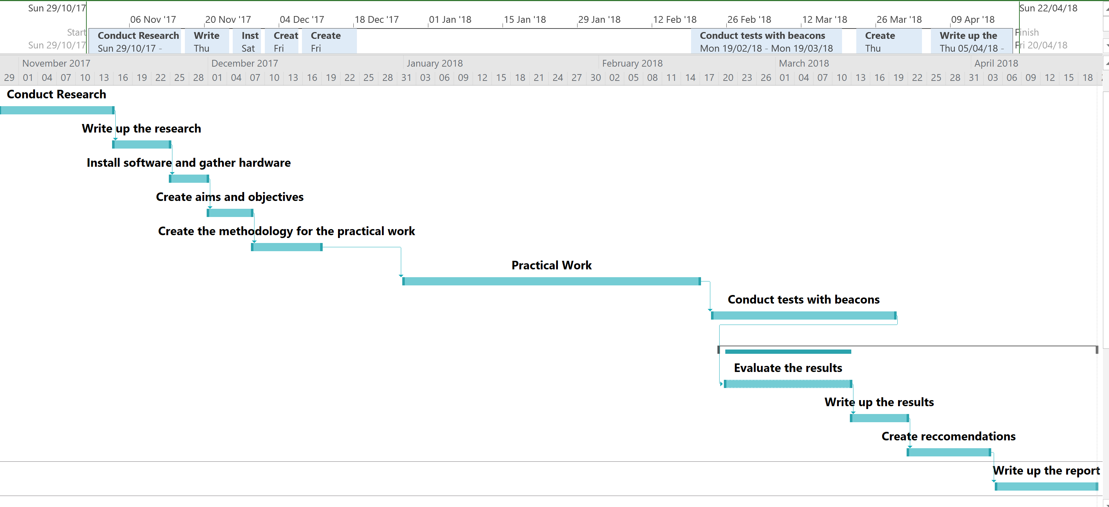

Figure 32: Final Gantt Chart


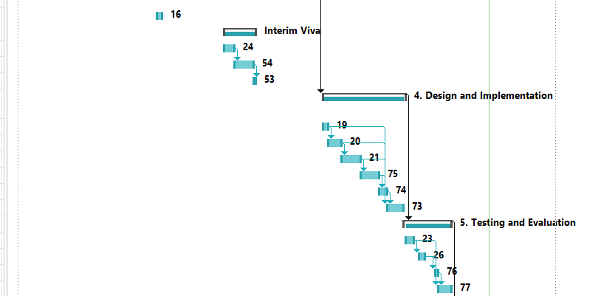
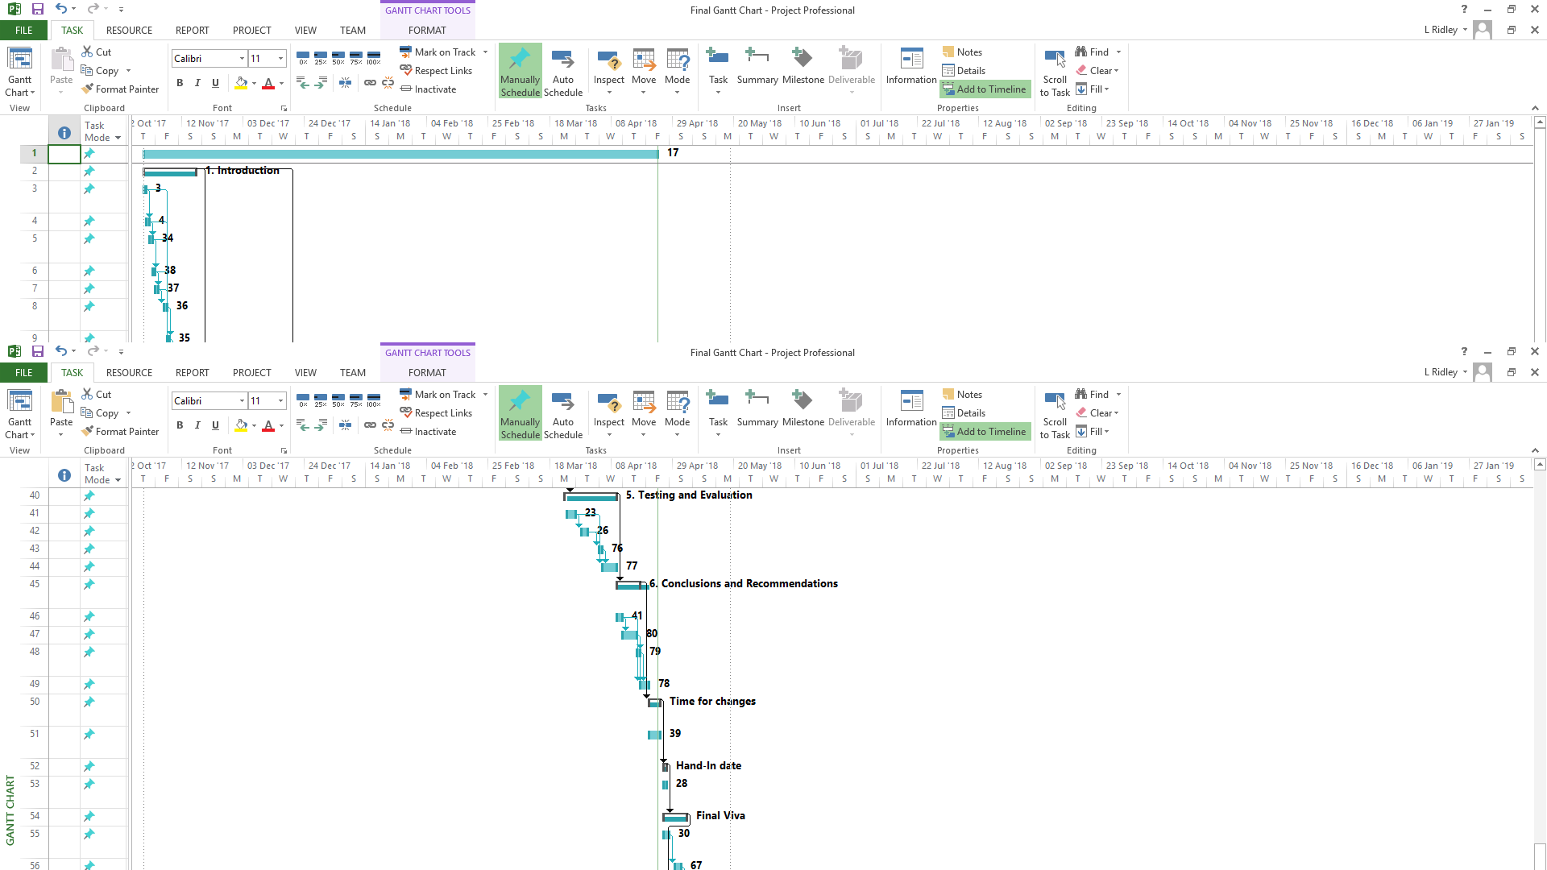

Figure 33: Project log book



Figure 34: Project meeting 1


Figure 35: Project meeting 2


Figure 36: Project meeting 3


Figure 37: Project meeting 4


Figure 38: Project meeting 5


