LCBB6003

Leadership and Management Theory and Practice

Student: Georgi Dimitrov
Student ID: 1917423

Table of Contents
Introduction 3
Chosen Organization 4
Models or Theories of Management and Leadership 5
Assessment of Mark & Spencer's top executives, Stuart Machin and Katie Bickerstaffe, using theories and models 8
Improvement of new leadership and management theories 11
Conclusion 12
References 13
Action Plan 14

Introduction
The fundamental idea supporting the notions of management and leadership, as well as the theories surrounding them, have traditionally been major objects of attention for a broad range of scientific and amounts of published material. An important part of being a leader is setting a good example for the employees and guiding them in the right direction. A person's virtues are beneficial when they show people what they are capable of accomplishing without any effort on their part. It is impossible to run a company smoothly without first addressing management and leadership philosophies. Management refers to the act of assembling a group of people and the minimum necessary infrastructure to direct a company toward its goals. Success is attributed to the management actions taken. We wrap up this study by discussing the typical setting and drivers that have an impact on managerial and leadership philosophies. Marks & Spencer is used as a chosen company in the associated study.

Chosen Organization
A British retailer that also sells food and household goods, Marks & Spencer is really a household name in many homes. It has been called London, England home since 1884 (Le Thuy, and Oe, 2020). Marks & Spencer looks to managerial and leadership ideas to help them achieve harmony between business and staff needs and wants (Gill, 2012). Organizational success is owed in large part to the leadership tenets adopted by the firm. Savings can be achieved by better bargaining with manufacturers. Making better use of the theory's benefits, the production and business strategy are enhanced as well. They are useful for keeping an eye on workers and figuring out how to boost their strengths (Ahmed, 2016).

Figure 1: Marks & Spencer (Gill, 2012).

Models or Theories of Management and Leadership
Management theories not only aid in the social and emotional growth of their employees, but also work to boost morale and productivity (Hussain, HAQUE, and Baloch, 2019). They'll be able to get better at making important decisions and accomplishing their objectives with their assistance (Sarker, and Khan, 2013). Productivity level, work performance, and the attainment of set goals are all areas in which these theories have been put into practice (Puni, Ofei, and Okoe, 2014). Management tenets provide a roadmap for the company's future success. They adapt an individual's behaviour and continued attempts to the needs of a group working toward a mutual goal (Nanjundeswaraswamy, and Swamy, 2014). When a business applies a successful leadership style, its employees will be able to articulate the company's goals and objectives and see the big picture. These ideas are what established a leader apart from the rest. Similarly, these theories specify how leaders can develop their abilities and traits. The theories enable the leader in motivating and bouncing up and down his or her adherents. An organization might benefit from their expertise. There are some broad categories of managerial and leadership theories, each with its own potential implementation.
- Classical Theory of Management: This approach to management is grounded in the composition of companies and offers suggestions for improving their operations. It has less concentrated control to plan and execute as per company needs (Carroll, and Gillen, 2019). This establishes a command structure that benefits both the company and its workers (Puni, Ofei, and Okoe, 2014). The benefits include the fact that by that time, a comprehensive framework of management had been established, as well as the development of a few key ideas that would later be useful in guiding subsequent academic inquiry (Amanchukwu, Stanley, and Ololube, 2015). Constraints of the period were associated with the formality of organizations; issues of public welfare, fair treatment of employees, and adequate compensation were overshadowed.
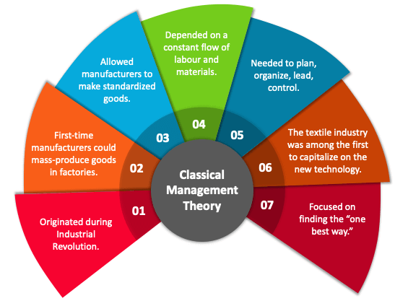
Figure 2: Theory of Classical Management (Carroll, and Gillen, 2019).
- Theory of Human Relations: The theory of human relations analyzes the elements and motivations for human conduct, much like the classical models before it explained the framework of a firm (Woodside, 2010). Components of both motivation and leadership are included in this framework. Observed benefits include personnel putting forth real attempts in data collection; team members feeling valued; being motivated by a sense of desire and position within the group; the ability of unstructured teams to describe employee performance; and the necessity for managers and supervisors to focus on the interpersonal requirements of their staff.
- Theory of Parenting: Through paternalistic leadership, a strong leader takes on the role of a matriarch or father figure with whom subordinates are obligated to show respect and loyalty. A paternalistic boss creates a homey workplace where everyone gets along. Paternalistic CEOs are extremely concerned with the welfare of their staff and the company as a whole (Barnett, 2017). The leaders of paternalistic organizations make choices for their subordinates without consulting them. They let workers know that now the decision-makers are knowledgeable and have a valid reason for making the choices they are (Puni, Ofei, and Okoe, 2014). Workers should trust their superiors' decisions and not second-guess them.
- Theory of Neo-Human Relation: The researchers behind this hypothesis, as such socio psychologists introduced a number of convoluted ideas (Sarker, and Khan, 2013). For instance, Maslow prioritizes workers' bottom-up needs that clarify why they come first in the hierarchy. This theory aids management teams in satisfying employee requirements. The theory's major downside is that it provides an explanation for all of humanity's complicated and challenging life circumstances (Nanjundeswaraswamy, and Swamy, 2014). Based on Herzberg's theory, positive workplace experiences can be directly traced to addressing the causes of negative ones. Motivating factors such as accomplishment, public acclaim, hard work, professional responsibility, and employee empowerment were identified.
- Democratic model or theory: One model of leadership that promotes the inclusion of all members of an organization in making decisions is called democratic leadership, or collective leadership. With this kind of leadership, both the supervisors and their staff members weigh on every key decision (Carroll, and Gillen, 2019). Everyone in the group has an equal opportunity to contribute ideas and work together to solve a problem, despite the fact that leaders ultimately have the final say. And therefore it is also known as shared or participatory leadership. Democratically sound leaders recognize they can't get anything done without the need for a reliable workforce (Amanchukwu, Stanley, and Ololube, 2015). Throughout most cases, a collective leadership model is preferred since it fosters a more cooperative atmosphere (Hussain, HAQUE, and Baloch, 2019). In addition, effective democratic leadership requires the ability to guide followers to success through the cultivation of an environment of mutual trust and cooperative effort without giving up any of one's own responsibilities.
- Model of full-range leadership: The Full Range Leadership Model (FRLM) is an all-encompassing theory of leadership that accounts for the variety of participation levels that might result in varying degrees of effective management. The notion that both transformational and transactional leadership are incompatible is abandoned by this model of leadership (Barnett, 2017). According to their account, a single leader can effectively employ all five approaches (Puni, Ofei, and Okoe, 2014). Based on this theory of leadership, there are two dimensions along which any type of leadership may be comprehended: the leader's engagement and the team's performance.
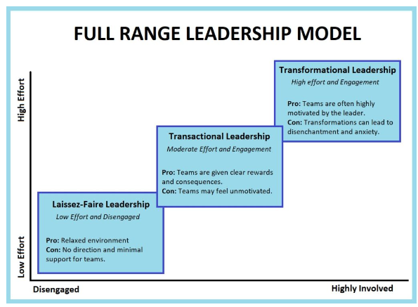
Figure 3: Model of FLRM (Barnett, 2017)

Assessment of Mark & Spencer's top executives, Stuart Machin and Katie Bickerstaffe, using theories and models
Marks & Spencer has adopted a new institutional framework with the goal of "flattening" the firm's hierarchies. Mark & Spencer's Katie Bickerstaffe and Stuart Machin will need to experiment with a range of management styles before settling on the most effective one. In recent years, the company's board and upper levels have learned more about democracy or consultative methods of management. Yet, with consultative leadership, leaders must make crucial choices after soliciting input from subordinates. Katie Bickerstaffe and Stuart Machin, the firm's directors, are working to establish a management structure based on strong leadership and cooperative efforts (Ahmed, 2016).
Workers having a say in how they do their jobs, such as democratic leadership, is one method to boost morale and productivity. Before adopting plans or making important choices, upper-level managers frequently seek input from lower-level workers. Stuart Machin will keep his overall portfolio of activities, which comprises food service leadership, management, real estate, retail expansion, and technologies (Le Thuy, and Oe, 2020). In addition to joining the PLC Panel, he will be in charge of human resources and business relations. Stuart Machin employed a number of tried-and-true management techniques, including a focus on personal attributes and an ethical approach to work. The management ought to exude confidence in both her own ability to influence the team and inspire others through her own infectious energy and optimism (Ahmed, 2016).
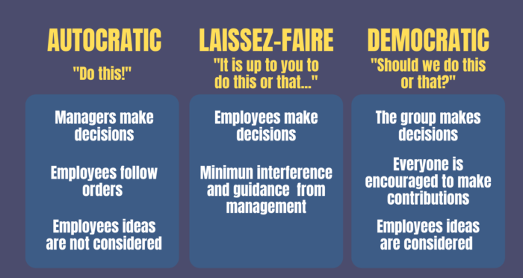
Figure 4: Leadership Styles (Nanjundeswaraswamy, and Swamy, 2014)
Among many other achievements, Stuart Machin has increased the proportion of the apparel and home goods industry that is conducted online. Such a scenario also fits within the parameters of the situational contingencies theory, which helps the management of a company choose executives’ best suited to steer the company toward success. As Fielder's contingency notion indicates that potentially a participant's organizational competence is dictated by her attitude and may be changed once situations have moved, it may be applied to my administration (Nanjundeswaraswamy, and Swamy, 2014). Just as I had always taken a collaborative approach to leadership in a democratic framework, so too had I done so in all other contexts. To become an effective manager, I will then focus on expanding such spheres of authority and acting as a dictatorial commander in difficult situations. Marks & Spencer Ltd. applies cutting-edge management philosophy to the present situation of rising manufacturing costs. Marks & Spencer is recognized for its collaborative method of conducting business, but the company has also been known to employ elements of the democratic managerial style.
This company has a wide range of management approaches, and employees at different levels of the organization are given different options. Those at the top are dictatorial, giving orders down the production floor as well as to logisticians. Those at the top who have no supervisors beneath them must employ authoritarian leadership because their subordinates lack skills in the area; individuals in the centre can take a more relaxed approach due to their positions in the organization and understand how to make the most of a laissez-faire approach; however, the owners can always be keeping tabs on their every move, and any major decisions will be subject to a democratic vote (Nanjundeswaraswamy, and Swamy, 2014). To improve my leadership skills, I would put them to use by carrying out the steps outlined within my plan of action. In addition, I plan to be using my understanding of the organization's governance to carry out my duties and the duties of others in to achieve my personal and professional goals. Stuart Machin's situation illustrates the application of the distinctive assumption to the study of the personal traits, professional competencies, and behavioural patterns that are considered necessary inside a leader.
The capacity to make modifications and increase productivity for my team was bolstered by this theory. The term "widely dispersed management" is used to describe the practice of leveraging top-level expertise inside an organization to open up new paths for change and broaden its skill set (Amanchukwu, Stanley, and Ololube, N.P., 2015).

Improvement of new leadership and management theories
M&S is moving into the next round of its "Creating the Future" restructuring initiative (Le Thuy, and Oe, 2020). The board believes that the company has made significant advances underneath the current management team and that maintaining the same approach and leadership will be beneficial moving forward. Listed below are some of the more recent innovations in their styles of management and leadership elaborated upon in light of the challenges they face in today's highly competitive business environment:
- Increasing pressure to strive for success and others: Managers and supervisors in today's rapidly evolving society are investing in their own growth and that of their staff. Past work environments were very different from today's modern workplace (Hussain, HAQUE, and Baloch, 2019). Marks & Spencer has noticed a decline in employee retention, and the company recognizes that it must work harder to maintain its current staff if it is to maintain or increase its customer base and revenue (Ahmed, 2016).
- Job portability and flexibility: Every business has at least the theoretical possibility of having at least some employees who work in remote locations or have schedule flexibility (Carroll, and Gillen, 2019). Marks & Spencer is able to run efficiently and on time due to technological advances such as the internet and social media interaction (Gill, 2012). When an employee is unable to be present at work but is capable of doing other tasks, they divide their time between the two as needed.
- Getting closer to the "Talent Cliff": As the firm prepares to take the strategy of hiring new workers and enrolling people in a number of initiatives, it must produce its largest workforce by the deadline (Nanjundeswaraswamy, and Swamy, 2014). Marks & Spencer provides its dedicated workers with opportunities to learn new skills and become more proficient in their chosen fields.
- Putting more emphasis on cultivating "soft skills": Leaders need to develop their transferable skills in order to effectively guide teams comprised of individuals with specialized knowledge and experience in many different areas (Woodside, 2010). Marks & Spencer invests in its leaders by providing them with education and training designed to improve their soft skills, which in turn increases their possibilities, job satisfaction, and productivity (Le Thuy, and Oe, 2020).

Conclusion
Having established the context for theories of leadership and management this study continues with a discussion of their significance and a representative analysis of those theories, presented chronologically. Innovative management and leadership concepts are also discussed, along with their advancement and implementation to Marks & Spencer's top executives. This task concludes with a comprehensive review of all relevant theories of managerial and leadership as they apply to Marks & Spencer.

References
Ahmed, U., (2016) Marks & Spencer: A Global Expansion to Acquire Lost Momentum? In Market Entry in China (pp. 61-72). Springer, Cham.
Amanchukwu, R.N., Stanley, G.J. and Ololube, N.P., (2015) A review of leadership theories, principles and styles and their relevance to educational management. Management, 5(1), pp.6-14.
Barnett, D., (2017) Leadership and job satisfaction: Adjunct faculty at a for-profit university. International Journal of Psychology and Educational Studies, 4(3), pp.53-63.
Carroll, S.J. and Gillen, D.J., (2019) Are the classical management functions useful in describing managerial work? In Managerial Work (pp. 291-304). Routledge.
Gill, R., (2012). Leadership and Strategy at Marks & Spencer. In SAGE Business Cases. SAGE Publications Ltd.
Hussain, N., HAQUE, A.U. and Baloch, A., (2019) Management theories: The contribution of contemporary management theorists in tackling contemporary management challenges. Yaşar Üniversitesi E-Dergisi, 14, pp.156-169.
Le Thuy, L. and Oe, H., (2020) An Exploratory Discussion of a British Apparel Brand in Relation to New Markets: Developing Actionable Recommendations Based on Network, Relationship, and Collaboration Perspectives. Budapest International Research and Critics Institute (BIRCI-Journal): Humanities and Social Sciences, 3(3), pp.1660-1675.
Nanjundeswaraswamy, T.S. and Swamy, D.R., (2014) Leadership styles. Advances in management, 7(2), p.57.
Puni, A., Ofei, S.B. and Okoe, A., (2014) The effect of leadership styles on firm performance in Ghana. International Journal of Marketing Studies, 6(1), p.177.
Sarker, S.I. and Khan, M.R.A., (2013) Classical and neoclassical approaches of management: An overview. IOSR Journal of Business and Management, 14(6), pp.1-5.
Woodside, A.G., (2010) Case study research: Theory, methods and practice. Emerald Group Publishing.

Action Plan
Areas for development | Learning and Development in Action | Developmental Resources | Required Time Frame | Assessment of Results
Competence in handling responsibilities and roles | My own evaluations have shown that my ability to delegate duties is lacking.  In order to hone this skill, I plan to adopt an "assimilation style" of knowledge and take my inspiration from those in authority. | For this reason, I plan on learning everything I can about assigning responsibility to a group using means such as online case reports, articles, publications, and lectures. | Six Months | In order to determine where we can make progress, we'll consult with our supervisors.
Being able to make wise choices | I plan to get better at making decisions by collecting feedback from my coworkers and boss. | Learn from the past choices made by great leaders by analyzing their reasoning and logic. | Three months | It is possible to determine outcomes by analyzing the individual's attitude and the results of the activities they were assigned to do.
Ability to think critically | This ability can be strengthened by participating in competitions, analyzing top performers, and considering different viewpoints when doing the work at hand. | This talent will be strengthened with the help of people with varying learning environments.  Examining real-world examples of effective leadership is a great way to enhance analytical skills. | Two months | The views of employees will be addressed.
Engagement centred behaviour | Taking an interest in group members and giving them responsibility. | Learning from the examples of successful business leaders. | Three months | The actions of workers will reveal exactly where improvements should be implemented.

