  Component One: Student Journal (learning log) 750 words +/- 10%  Contribution to Overall Module Assessment: 25% | Student No: | 2212615
 | Module Title: | Operating Hotel Facilities
 | Module Code: | BMIH4006
 | Lecturer: | Natalie Brailsford
My placement within the housekeeping department at Premier Inn Stevenage was nothing short of rewarding. My experience taught me the necessary soft and hard skills required to work in housekeeping. These skills included detailed cleaning, time management, organizing, communication, and intrapersonal skills (Thébaud et al. 2021). I will be using the Gibbs Model of Reflection (Wain et al. 2017) to look back upon my placement. The Gibbs model focuses on all domains and these will effectively help cover all necessary domains within my placement.

Description
In my placement at the housekeeping department at Premier Inn, I was responsible for a variety of tasks that ranged from making sure the rooms are kept clean to ensuring guest satisfaction. A typical day in my placement included room cleaning where after the guests had checked out, I vacuumed the entire room, topped up the amenities, changed the duvets and linens and reporting any possible issues within the room itself to the concerned department (Nimri et al. 2020). Moreover, I was also responsible for addressing the present guest’s requests related to housekeeping and these ranged from minor room adjustments to providing extra amenities or toiletries. I interacted with different housekeeping colleagues throughout to ensure all rooms were kept spotless and subsequently communicated with the front desk in order to ensure that operations ran smoothly and guests remained satisfied (Sianipar and Cicilia 2023).

Feelings
Initially, I had felt like this placement would not amount to anything beneficial since it was just maintaining rooms. This quickly changed within a few days as I began to understand all the necessary skills and the keen eye for detail that is required for within the housekeeping department (Bhatnagar and Nim 2019). I started to get overwhelmed with the tasks mounting on my shoulders but with time I learnt how to adjust accordingly. The physical demands of this placement took a toll on me as well. There was constantly something going on and you were required to be on your feet throughout. Moreover, increased amounts of guest check-ins did not help cater as this only raised stress levels (Sanon et al. 2018). It wasn’t all doom and gloom. Even with the significant amount of tasks, I was able to check them off eventually and the positive affirmations from the guests only increased my motivation to work in this department. Secondly, completing these tasks brought about a sense of joy and accomplishment within myself as I could now effectively manage my time and complete the tasks given to me. Lastly, these overwhelming experiences brought about an environment of teamwork where there were multiple colleagues willing to assist in their spare time. It truly raised the morale of the whole group.

Evaluation
There were many positives that I had brought with me through this placement. For starters, my attention to detail was well above average. I was able to ensure a spotless room and make it look perfectly presentable for the guests. One of the guests specifically thanked me for noticing a small stain on one of the towels and this emphasized the need for attention to detail. Moreover, I was able to interact with guests courteously despite the stress on my shoulders. Guest satisfaction was always a priority and I ensured that they felt that way.
While there were positives, there were some areas where I believe I was lacking. The physical exertion of this role was something I couldn’t fully cope with. Maintaining high levels of energy proved to be quite a challenge and I would find myself taking small breaks throughout my shift in order to re-calibrate. Moreover, my ability to come up with contingency plans was also short-sighted. There were times where effective problem solving was required due to an equipment malfunction or a complex guest request and I would falter in my ability to take those on.

Analysis
One of the main reasons for my attention to detail was the way I had spent my childhood. During my teenage years, I was rewarded for ensuring my room was kept clean and this ultimately translated to my strong attention to detail and the positive affirmation linked with it (Brockhaus et al. 2017). My time management skills also helped me remain efficient by prioritizing tasks based on their urgency rather than the order they came in. This helped me ease off a load of stress as the most urgent tasks would be dealt with first.
The physical stamina is one skill or strength I believe is the most important to work in such a department as it effects almost all other domains such as your motivation and if you’re fatigued you might overlook some important details.

Conclusion
This placement helped me realize the importance of physical stamina that is required. It certainly was a rewarding experience as I took home with me valuable memories and valuable skills that will assist me almost every task I perform in the future. Receiving positive reviews and affirmations from the guest certainly added to the performance as their satisfaction only motivated me to do better. This enriching experience taught me the valuable skills required to work in the hospitality industry.

Action Plan
An action plan I would like to detail for myself is to work on my physical stamina and swift thinking. I plan to achieve these through enrolling myself in a gym and attending various workshops to not only improve my existing skills but also build new ones.

References

Bhatnagar, E. and Nim, D., 2019. Impact of housekeeping services and practices on customer satisfaction and repeat business. Prabandhan: Indian Journal of Management, 12(8), pp.46-57.
Brockhaus, S., Amos, C., Fawcett, A.M., Knemeyer, A.M. and Fawcett, S.E., 2017. Please Clap! How customer service quality perception affects the authenticity of sustainability initiatives. Journal of Marketing Theory and Practice, 25(4), pp.396-420.
Nimri, R., Kensbock, S., Bailey, J., Jennings, G. and Patiar, A., 2020. Realizing dignity in housekeeping work: Evidence of five star hotels. Journal of Human Resources in Hospitality & Tourism, 19(3), pp.368-387.
Sanon, M.A., Shaver BSN, J., Militzer MA, M., Seng PhD, C.N.M. and Marjorie, C., 2018. Blood pressure and job domains among hotel housekeepers. Journal of Health Disparities Research and Practice, 11(2), p.7.
Sianipar, R. and Cicilia, R.L., 2023. Procedure Housekeeping. Penerbit NEM.
Thébaud, S., Kornrich, S. and Ruppanner, L., 2021. Good housekeeping, great expectations: Gender and housework norms. Sociological Methods & Research, 50(3), pp.1186-1214.
Wain, A., 2017. Learning through reflection. British Journal of Midwifery, 25(10), pp.662-666

Component Two: Housekeeping cleaning checklist
Contribution to Overall Module Assessment: 25%

Check List
Tasks | ✓/✘
- Replace bed linens, pillowcase, and towels with fresh linens.
- Remove the clutter or obstruction near the entrance.
- Allow fresh air to circulate by opening windows if room design and weather permits.
- Dust all surfaces including furniture and electronics.
- Wipe surfaces with appropriate cleaning solutions.
- Disinfect commonly touched surface such as light switches, door handles and remote controls.
- Clean all the glasses in the room.
- Vacuum carpets and rugs. Sweep and mop hard floors.
- Disinfect and clean the toilet. Refill toiletries, toilet paper, and hand soap.
- Ensure bins are clean and odor-free.
- Conduct a final walkthrough to ensure cleanliness and organization.
- Double-check that all amenities are replenished and the room is ready.

Discussion
It requires quite hard work and attention to ensure that all the rooms at Premier Inn Stevenage. In order to ensure the fulfilment of the given checklist and effective supervision, I will ensure that staff is provided with consistent training and guidelines. The hotel can be able to keep the brand standard with the use of effective measures for team effectiveness and enhancement. As Premier Inn Stevenage is known for its cleanliness and high standards, it is important to focus on the brand identity. It is important for staff to learn and apply the cleaning procedure of the hotel and execute tasks of housekeeping accordingly. With the help of regular audits and inspections, it is possible for the hotel housekeeping to detect areas for improvement and reinforce accountability (Benson et al., 2023). In addition to this, the use of advanced technology like AI powdered systems will help team to improve efficiency and accuracy of tasks. Hence, I will ensure that rooms are cleaned aligned with the standard of hotel by automating processes and scheduling tasks.
Team effectiveness is critically important in balancing the reputation and standards of the hotel (Hanandeh et al., 2020). Likewise, for Premier Inn Stevenage team effectiveness is important. Clear communication helps shared accountability and respect among team members. Team-building and training workshops develop a unified work environment. For the changing demands of customer, cross-training initiatives strengthen versatility of the team members and enable adaptability. Providing sufficient resources, encouraging work-life balance and supportive leadership motivate the employees and boost the morale.
As checklist is the effective tool in aligning the standards of Premier Inn Stevenage hotel, I believe that the comprehensive checklist will serve as an important role to guide housekeeping staff in performing their tasks and maintain standards. I consider the checklist effective as it will reduce the errors and offer same level of care attention. Also, the checklist will provide clear guidelines to the staff members about how to fulfil guests’ demands and specific brand standards. In addition to this, the checklist will facilitate continuous improvement and quality assurance (Ammar et al., 2021). With the help of clear audits and inspections, it will be possible for staff members to ensure comprehensive cleaning procedure and effectiveness.

References
Al-Omari, G., Hanandeh, R., Al-Somaidaee, M., Jarrah, M. and Alnajdawi, S., 2020. Work-life balance and its impact on employee satisfaction on five star hotels. Management Science Letters, 10(4), pp.871-880.
Benson, C., Obasi, I.C., Akinwande, D.V. and Ile, C., 2023. The impact of interventions on health, safety and environment in the process industry. Heliyon, 10(1).
Ammar, M., Haleem, A., Javaid, M., Walia, R. and Bahl, S., 2021. Improving material quality management and manufacturing organizations system through Industry 4.0 technologies. Materials Today: Proceedings, 45, pp.5089
Component Three : Presentation

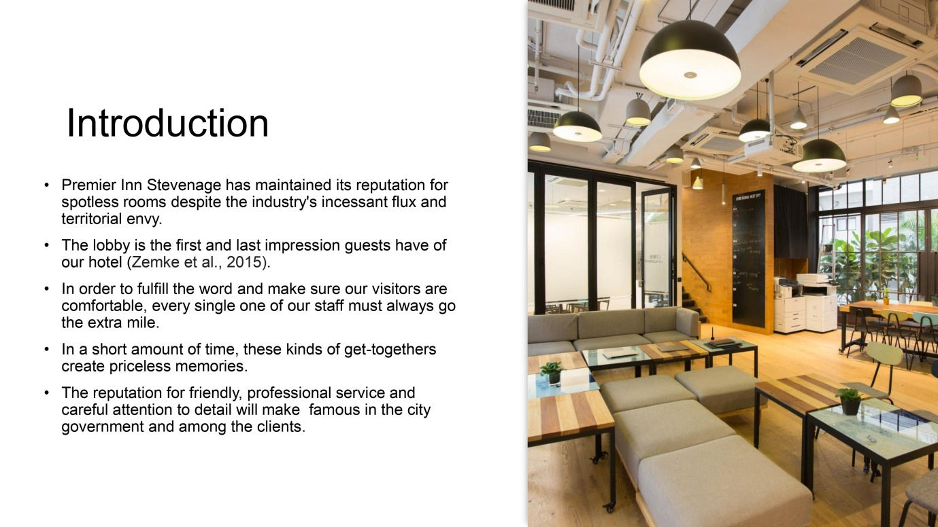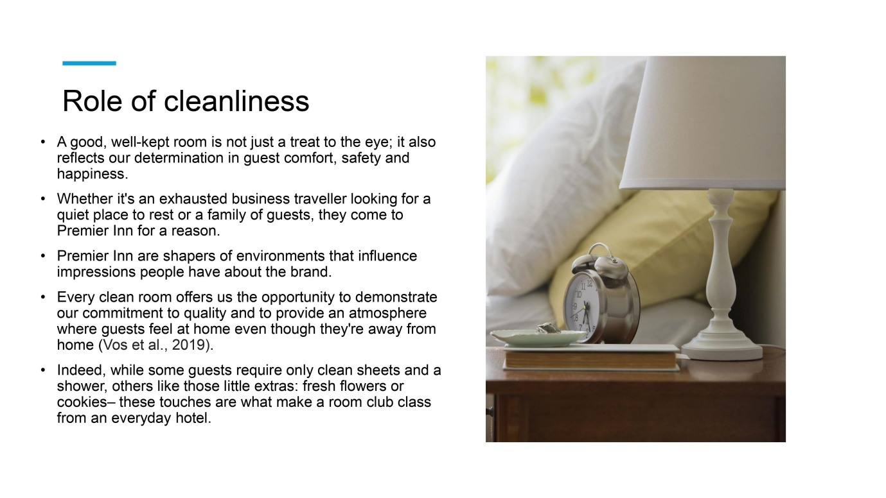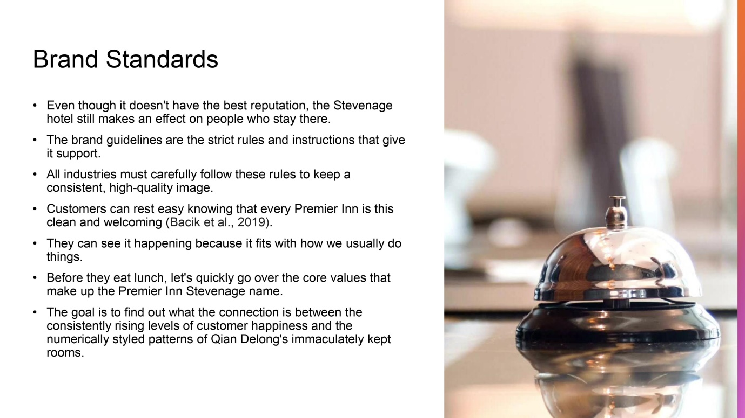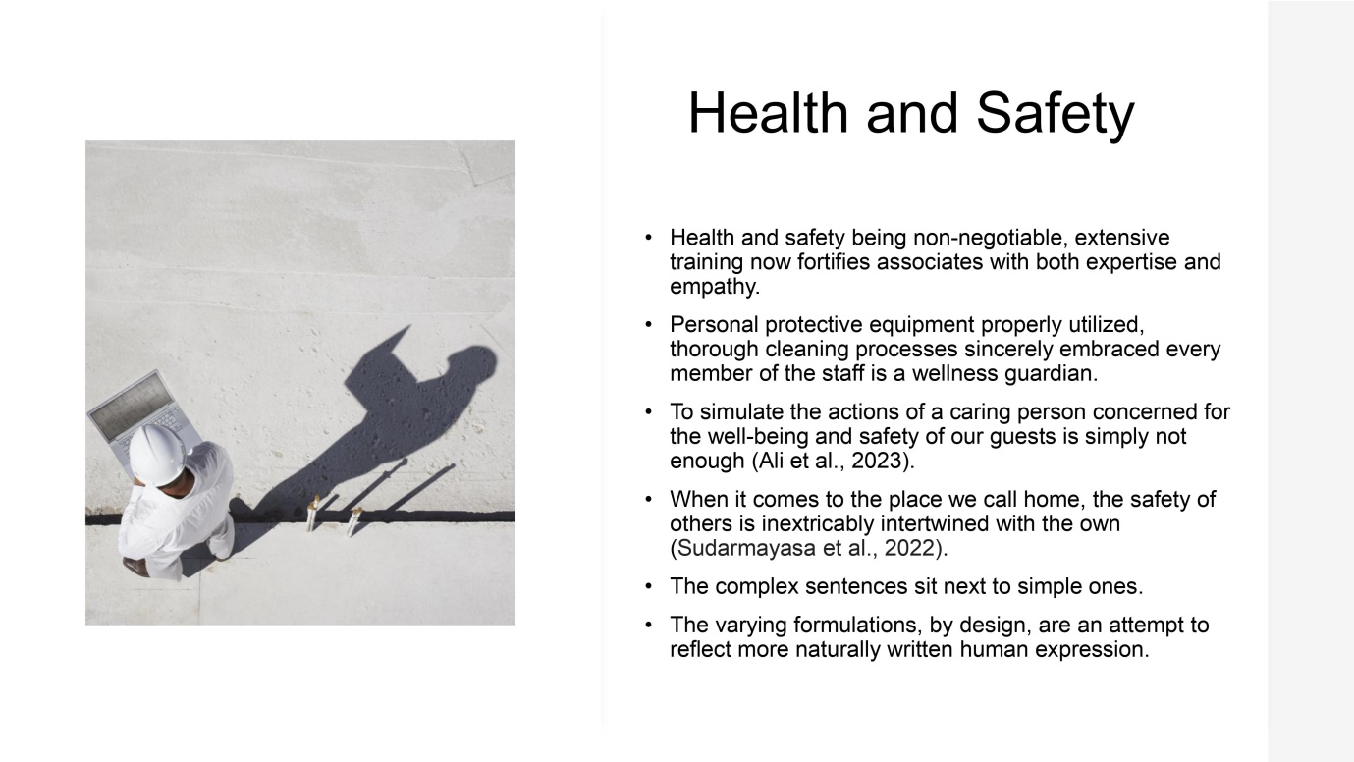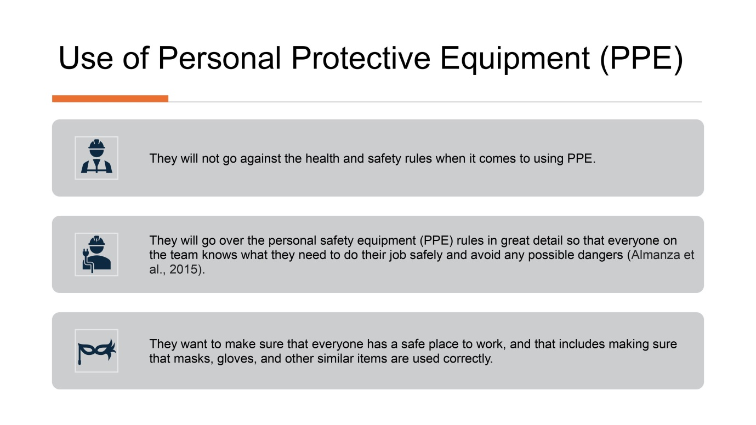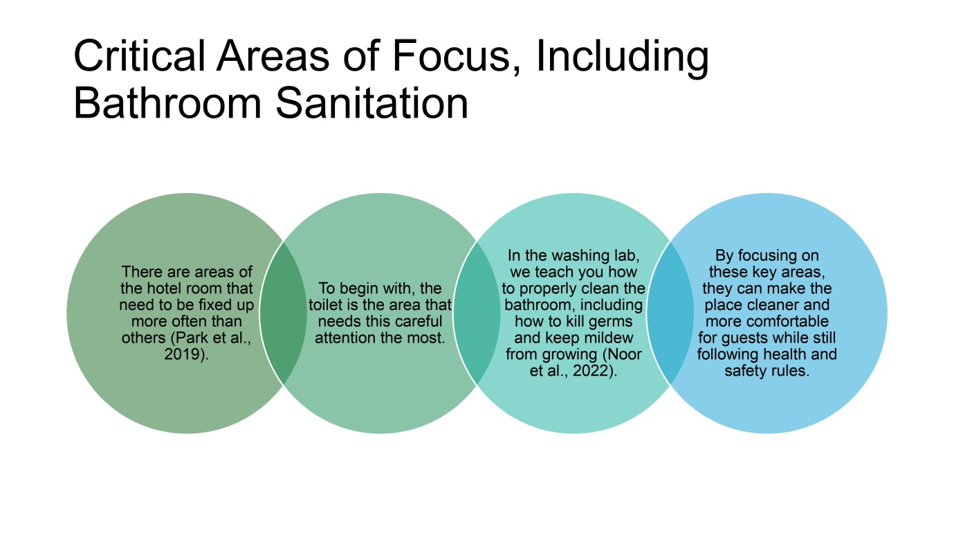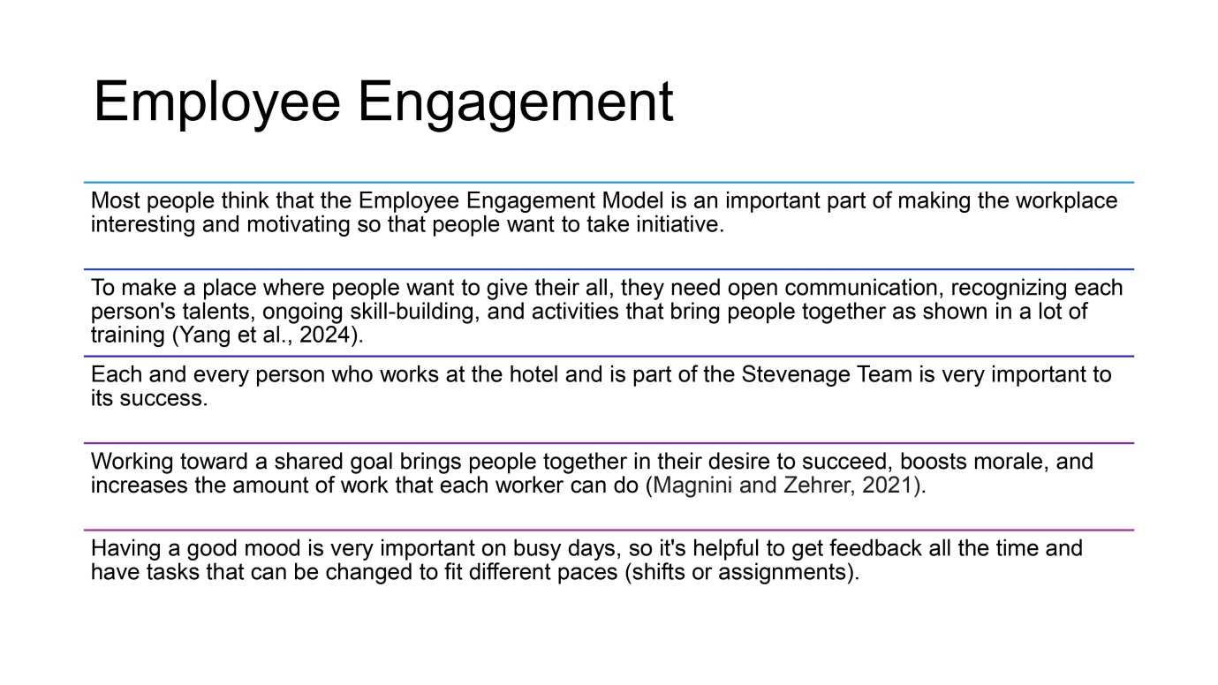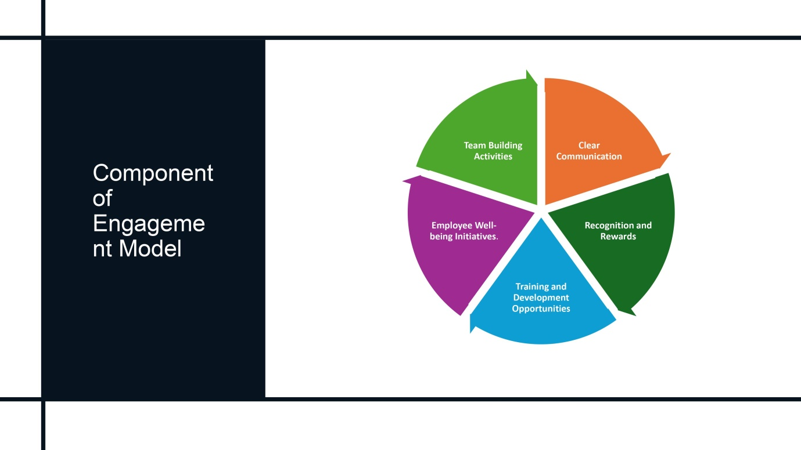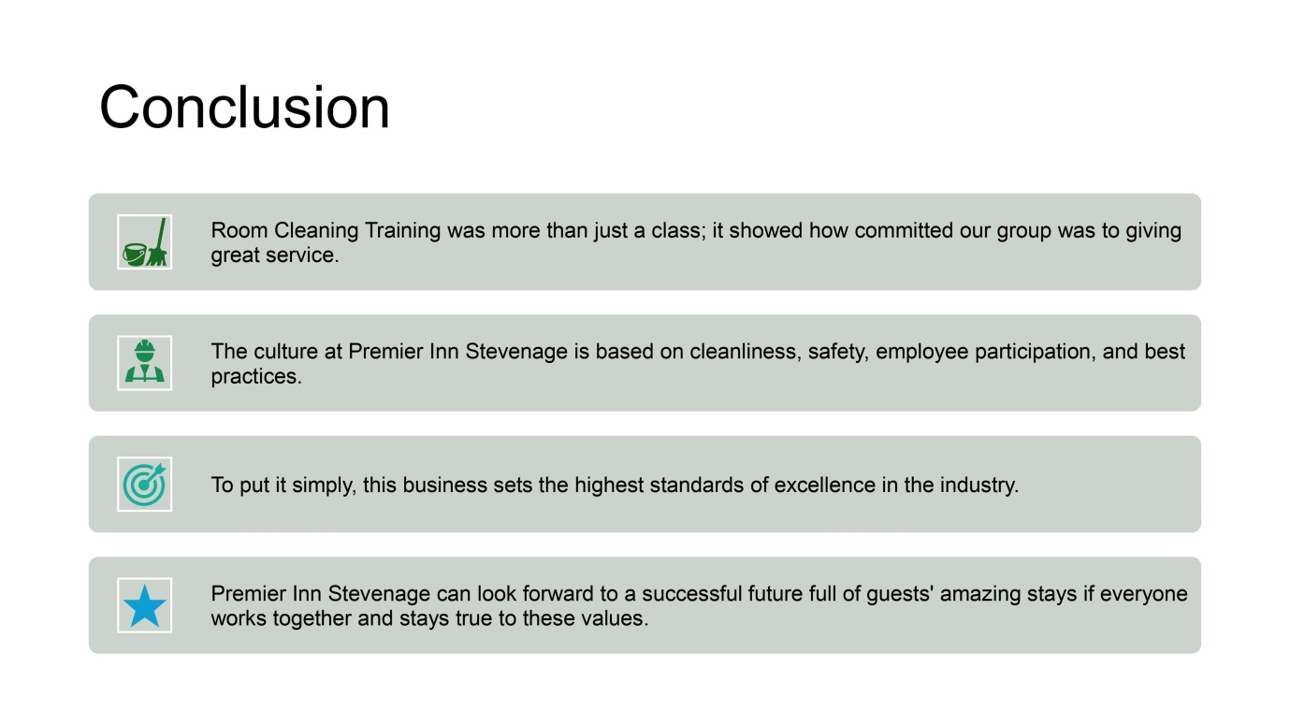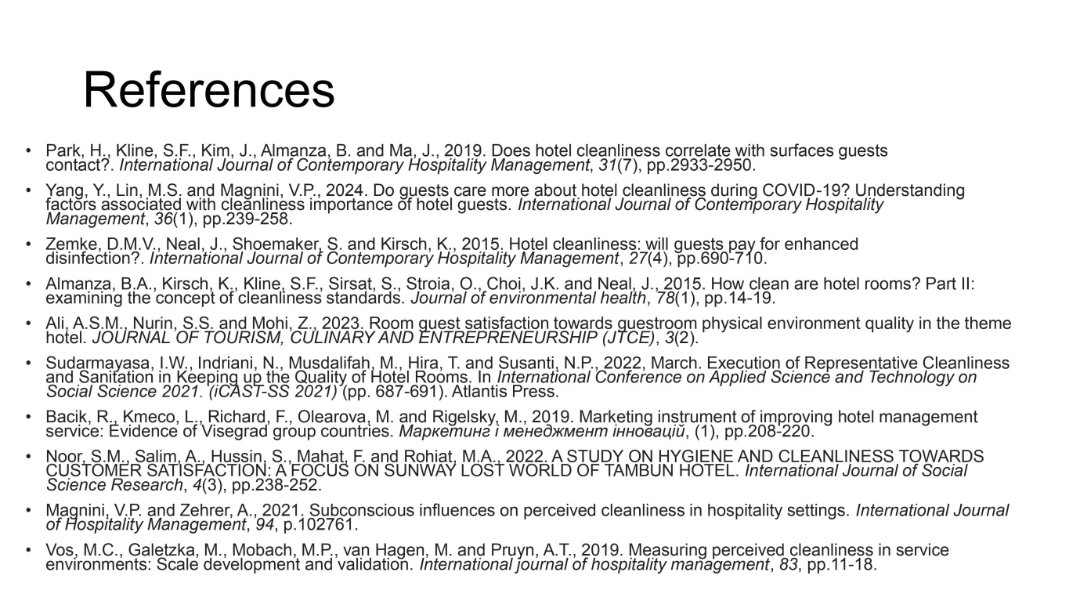
References
- Ali, A.S.M., Nurin, S.S. and Mohi, Z., 2023. Room guest satisfaction towards guestroom physical environment quality in the theme hotel. JOURNAL OF TOURISM, CULINARY AND ENTREPRENEURSHIP (JTCE), 3(2).
- Almanza, B.A., Kirsch, K., Kline, S.F., Sirsat, S., Stroia, O., Choi, J.K. and Neal, J., 2015. How clean are hotel rooms? Part II: examining the concept of cleanliness standards. Journal of environmental health, 78(1), pp.14-19.
- Bacik, R., Kmeco, L., Richard, F., Olearova, M. and Rigelsky, M., 2019. Marketing instrument of improving hotel management service: Evidence of Visegrad group countries. Маркетинг і менеджмент інновацій, (1), pp.208-220.
- Magnini, V.P. and Zehrer, A., 2021. Subconscious influences on perceived cleanliness in hospitality settings. International Journal of Hospitality Management, 94, p.102761.
- Noor, S.M., Salim, A., Hussin, S., Mahat, F. and Rohiat, M.A., 2022. A STUDY ON HYGIENE AND CLEANLINESS TOWARDS CUSTOMER SATISFACTION: A FOCUS ON SUNWAY LOST WORLD OF TAMBUN HOTEL. International Journal of Social Science Research, 4(3), pp.238-252.
- Park, H., Kline, S.F., Kim, J., Almanza, B. and Ma, J., 2019. Does hotel cleanliness correlate with surfaces guests contact?. International Journal of Contemporary Hospitality Management, 31(7), pp.2933-2950.
- Sudarmayasa, I.W., Indriani, N., Musdalifah, M., Hira, T. and Susanti, N.P., 2022, March. Execution of Representative Cleanliness and Sanitation in Keeping up the Quality of Hotel Rooms. In International Conference on Applied Science and Technology on Social Science 2021. (iCAST-SS 2021) (pp. 687-691). Atlantis Press.
- Vos, M.C., Galetzka, M., Mobach, M.P., van Hagen, M. and Pruyn, A.T., 2019. Measuring perceived cleanliness in service environments: Scale development and validation. International journal of hospitality management, 83, pp.11-18.
- Yang, Y., Lin, M.S. and Magnini, V.P., 2024. Do guests care more about hotel cleanliness during COVID-19? Understanding factors associated with cleanliness importance of hotel guests. International Journal of Contemporary Hospitality Management, 36(1), pp.239-258.
- Zemke, D.M.V., Neal, J., Shoemaker, S. and Kirsch, K., 2015. Hotel cleanliness: will guests pay for enhanced disinfection?. International Journal of Contemporary Hospitality Management, 27(4), pp.690-710.

