

Master of Business Administration
International Business
Module Code and title:
LCMB7026 International Marketing: Principles and Practices

Assignment title:
Assessment Component 1: Individual Report
Lecturer:
Tushara Balendran
Student Name: Md Forhad Hossen Rony
Student ID: 2433472
Words: 5603

Submission Date: 24th April 2026
Table of Contents
Section 1 6
1.0 Introduction 6
2.0 Background 7
2.1 Zara Operation in the UK 7
2.2 Zara Operation in the UAE 7
3.0 PESTLE Analysis of Macro Environment 8
3.1 Political Factors 8
3.2 Economic Factors 8
3.3 Social Factors 9
3.4 Technological Factors 9
3.5 Legal Factors 10
3.6 Environmental Factors 10
4.0 Socio-Cultural Factors Hofstede Dimension Model 11
4.1 Power Distance 11
4.2 Collectivism vs Individualism 12
4.3 Masculinity vs Femininity 12
4.4 Uncertainty Avoidance 13
4.5 Long-Term Orientation 13
4.6 Indulgence vs Restraint 13
4.7 Advantages of the Hofstede Model 15
4.8 Disadvantages of the Hofstede Model 15
5.0 Segmentation, Targeting, and Positioning (STP) 16
5.1 Segmentation Strategy 16
5.2 Targeting Strategy 17
5.3 Positioning Strategy 17
5.4 Similarities and Differences of STP 18
6.0 Marketing Mix (7Ps) Comparison 19
6.1 Product 19
6.2 Price 20
6.3 Place 21
6.4 Promotion 21
6.5 People 22
6.6 Process 22
6.7 Physical Evidence 22
7.0 Ansoff Strategy: Brand Directional Development Strategy 24
7.1 Market Penetration 24
7.2 Product Development 25
7.3 Market Development 25
7.4 Diversification 25
8.0 Ethical Issues 25
9.0 Recommendations 26
9.1 Recommendations for the UK 26
9.1.1 Enhance Building Circular Economies in the UK 26
9.2 Optimise the Supply Chain in the UK 26
9.3 Enhance Green Materials Utilisation 26
9.2 Recommendations for the UAE 27
9.2.1 Grow Small Muran Denim lines in the UAE 27
9.2.2 Create Arabic-Language Online Marketing Campaigns 27
9.2.3 Digital Innovation and Sustainable Supply Chains 27
Section 2 28
10.0 Gibbs’ Reflective Cycle 28
10.1 Description 28
10.2 Feelings 29
10.3 Evaluation 29
10.4 Analysis 29
10.5 Conclusion 29
10.6 Action Plan 30
11.0 Conclusion 31
12.0 References 32

Table of Figure
Figure 1: ZARA (Kumar, V., 2024) 6
Figure 2: PESTLE Analysis (Yeganeh, H., 2025) 8
Figure 3: Hofstede Cultural Dimension Model (Edyvean, H., 2025) 11
Figure 4: Cultural Factors ranking for both countries (Bilgihan and Ricci, 2024) 14
Figure 5: (STP) Analysis (Chavan, R.B., 2023) 16
Figure 6: Zara's Position in the UK (Cho et al., 2023) 17
Figure 7: 7Ps of Marketing Mix (Bilgihan and Ricci, 2024) 19
Figure 8: Zara’s Product (Chavan, 2023) 20
Figure 9: Stores in both countries (Qomaro et al., 2024) 21
Figure 10: Zara websites of both countries (Rees, 2022) 23
Figure 11: Ansoff Strategy (Asiah et al., 2022) 24
Figure 12: Gibbs’ Reflective Cycle (Yeganeh, H., 2025) 28

Section 1

1.0 Introduction
International marketing is the process of analysing marketing strategies, planning and putting them into practice across national boundaries and balancing between global standardisation and local adaptation (Rees, 2021). This report is a critical analysis of the international marketing of Zara in the United Kingdom (UK) and the United Arab Emirates (UAE). It offers a comparative macro-environment analysis based on the PESTLE model, assesses cultural divergence based on the Hofstede model of cultural dimensions, and segmentation, targeting, positioning (STP) and an extended marketing mix (7Ps). Moreover, it addresses the directional development strategy of Zara through the Ansoff Matrix in one of the chosen markets, analyses both ethical and non-ethical marketing steps, gives recommendations on specific countries and closes with a reflective experience with the help of the Gibbs Reflective Cycle.
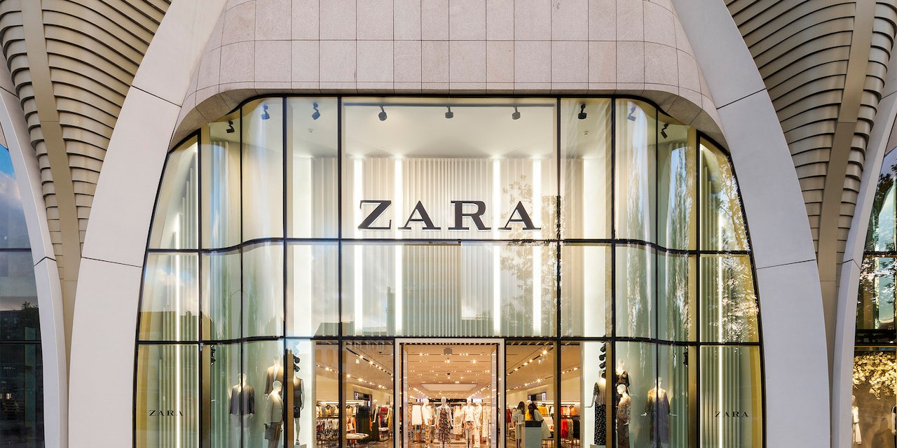
Figure 1: ZARA (Kumar, V., 2024)

2.0 Background
Zara is a fast-fashion retailer based in Spain and is owned by a larger company known as Inditex Group, and is generally recognised as one of the first companies to adopt the fast-fashion model. Its vertically integrated supply chain, quick design-to-store, and responsiveness to trends enable it to be able to launch new collections in weeks (Edyvean, 2025). Late in the 1980s, Zara went global, and in 1998, it entered the UK market and subsequently the UAE market via franchise agreements like Alshaya Group.

2.1 Zara Operation in the UK
The United Kingdom is a well-established and competitive fashion retail market with a high level of consumer purchasing power, a good e-commerce network, and growing sustainability consciousness (Dalirazar and Sabzi, 2023). British buyers are sensitive to prices but fashion-conscious, particularly over the past few years, with inflation and the uncertainty of the economy.

2.2 Zara Operation in the UAE
On the contrary, the UAE is a high-income, multicultural, and retail-based economy (Abi Saleh, 2025). Malls are important social and business centers and consumers are highly brand-conscious and show a preference to high end retailing. Fashion consumption is also influenced by cultural norms, which are determined by the Islamic tradition and especially the dress codes that are considered modest.

3.0 PESTLE Analysis of Macro Environment

Figure 2: PESTLE Analysis (Yeganeh, H., 2025)

3.1 Political Factors
The political situation is one factor that greatly affects the operational efficiency and cost structure of Zara, both in the United Kingdom and the United Arab Emirates. The UK has a stable democratic system where there is clear governance, and this offers the international retailer predictability (Eierle et al., 2022). The UAE, on the contrary, is a politically stable federal monarchy that actively encourages foreign direct investment and retail growth. The favourable environment for international brands is provided by low corporate taxation and the free zone, which is business-friendly. Therefore, both markets are politically stable, but the flexibility of operation is relatively higher in the UAE. However, overall situation for both countries is favorable for business.

3.2 Economic Factors
The economy has a direct influence on the consumer's buying power and demand for discretionary goods like fashion clothing. The recent inflationary pressures and cost-of-living rise in the UK have limited the spending of households, especially middle-income earners. On the other hand, the UAE enjoys high GDP per capita, high employment rates and massive inflows of tourism, especially in Dubai and Abu Dhabi cities (Dalirazar and Sabzi, 2023). The retail culture of the country is luxury-based, which favors high-end shopping experience in big malls. The demand for trendy apparel is maintained by the high disposable income of expatriates and local consumers. Economic conditions are both favourable and unfavourable, with good economies by assisting in GDP and GNP improvement and sales, but inflation in the UK capable of decreasing consumer spending.

3.3 Social Factors
In both markets, consumer behaviour and taste in fashion are determined by social and cultural attributes. The UK is a highly individualistic country with a diverse culture and on the increasing awareness of the environment. British consumers tend to perceive clothes as a way of self-expression and are sensitive to the changes in fashion trends. Conversely, the UAE is a multi-ethnic society that is shaped by Islamic culture and collectivism (Dalirazar and Sabzi, 2023). Although the expatriates are bringing diversity in fashion, the cultural beliefs put more focus on modesty, especially among women. In terms of fashion, the two markets are rather similar, yet in the UK, fashion is less important, and it is more personal and sustainable, which is more of a priority in the UAE, where brands and modesty are valued more. The social trends are favourable with both markets being very strong in their demand of fast fashion and their changing lifestyle preferences.

3.4 Technological Factors
In both countries, technological infrastructure greatly contributes to the use of the omnichannel strategy by Zara. The UK has a well-established digital economy in which connection to broadband will permeate, and the logistical network is highly developed, with the wide adoption of logistical networks and e-commerce platforms, which are widely established. Similarly, smartphones are well penetrated, and social media is favourable in the UAE. Digital payment systems and mobile commerce are quite widespread, particularly among young consumers (Eierle et al., 2022). However, despite the application of technology, shopping malls remain the key to the shopping experience in the UAE, which merges leisure with consumption. Zara, therefore, has a balanced online expansion and the flagship mall stores. Overall, the two countries have favourable environments in terms of technology, yet the reliance of consumers on the physical retail experience remains in the UAE. The technological aspects are very favourable, with new e-commerce and digital presence contributing to Zara omnichannel strategy.

3.5 Legal Factors
The legislations specify the requirements of compliance, labour, and advertisement rules that shape the operations of Zara. The harsh labour laws, consumer laws and environmental laws in the UK oblige retailers to be very open in their supply chains and treat workers fairly. The case of the Modern Slavery Act will compel businesses to disclose efforts made by them to remove forced labour in their global supply chains. Lack of execution would result in reputational and monetary fines (Esteve et al., 2022). Advertisements and promotional messages must, however, be carried out in line with the cultural and religious norms, and those that do not resonate with the societal ideals should not be employed. The labour laws are regulated and not criticised openly as in the UK. There is a slight negative in the legal factors, as labour laws and regulations have tightened making compliance costly. Thus, Zara will have a more intensive control over the regulator in the UK, and in the UAE, cultural sensibility and commercial licensure will be at the centre of compliance.

3.6 Environmental Factors
The global fashion industry has paid more attention to environmental issues. Sustainability issues are very potent in the UK because consumer activism, the media and regulation are very commanding. The problems of textile waste, carbon emissions, and ethical sourcing contribute significantly to the process of purchasing (Rees, 2021). The environmental commitments and sustainable collections of the company are specifically applicable in this market. On the other hand, the UAE is slowly integrating sustainability into the national development priorities, such as green buildings and environmental sensitisation programs. Although environmental awareness is on the rise in the UAE, it is not as strong a force of pressure as in the UK. Thus, the British market is significantly stronger and more demanding in terms of environmental forces. The environmental conditions are not favourable as the increase in sustainability demands is straining Zara to engage more in environmentally friendly practices.

4.0 Socio-Cultural Factors Hofstede Dimension Model
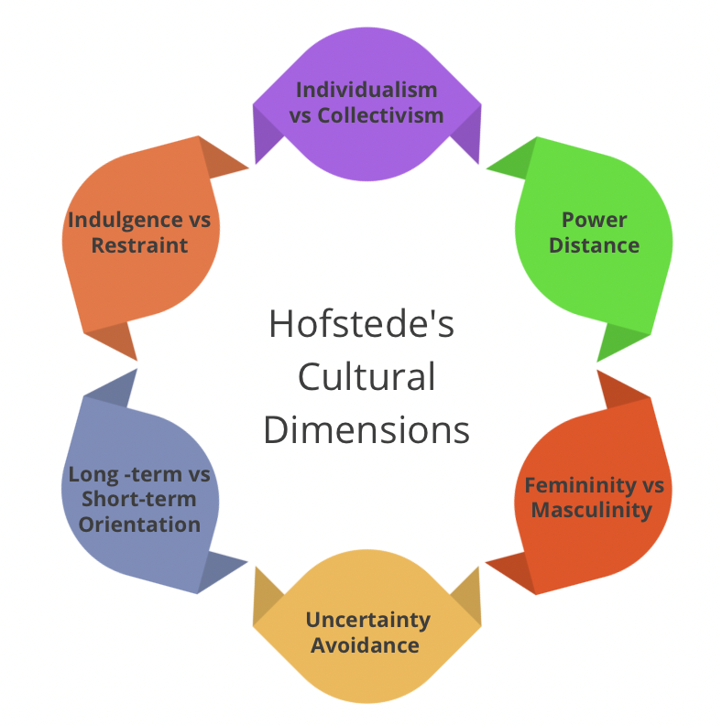
Figure 3: Hofstede Cultural Dimension Model (Edyvean, H., 2025)
The Cultural Dimensions Model by Hofstede gives a structured approach towards comparing cultures of each nation and comprehending the effects of cultural values in shaping consumer behaviour and marketing tactics (Yeganeh, 2025). The model establishes six dimensions, i.e. Power Distance, Individualism versus Collectivism, Masculinity versus Femininity, Uncertainty Avoidance, Long-Term Orientation, and Indulgence versus Restraint. When this framework is implemented to United Kingdom and the United Arab Emirates, there are major cultural differences that have a direct effect on the marketing approach of Zara.

4.1 Power Distance
Power distance is the degree of acknowledgement by the less powerful members of a society of the uneven allocation of power. The UK represents a comparatively low power distance, which means that it is egalitarian, has flatter organisational hierarchies, and does not hide communication between the management and employees. This is translated in consumer behaviour as informal brand communication and preference for accessibility, as opposed to status-based consumption (Minkov and Kaasa, 2022). On the contrary, the UAE has a higher power distance, which is respect for authority, hierarchy, and social stature. This cultural attribute affects purchasing behaviour since customers can relate luxurious shopping conditions and brand products to social status. In turn, the location of Zara in the luxury shopping malls in cities like Dubai makes the brand perception better. Marketing communication in the UAE can also be seen to be more aspirational and status-related in contrast to the UK.

4.2 Collectivism vs Individualism
Individualism is a measure of the level of individualism whereby individuals consider their own interests more than those of the group. The UK is rated as a highly individualistic country, which implies that consumers appreciate their independence, personal identity, and self-expression. Fashion has been applied in many cases to express individuality and uniqueness. Creativity and independence are common to the advertising and social media campaigns in the UK (Yeganeh, 2025). Though being multicultural, the UAE demonstrates a somewhat greater degree of collectivist behaviour that is conditioned by the family patterns and cultural customs. Thus, Zara modifies some designs, like long sleeves and not so revealing lines, according to the cultural demands. The marketing messages are often less hostile and rather culturally sensitive and socially oriented compared with the marketing messages used in the UK.

4.3 Masculinity vs Femininity
The masculinity dimension is how much society values competitiveness, achievement, and material success over cooperation and quality of life. The UK exhibits moderately masculine traits, in which achievement and performance are highly prized but accompanied by a lifestyle factor. This translates to demand for fashionable and useful wear in the area of fashion consumption (Komisarof and Akaliyski, 2025). There are also masculine characteristics of the culture in the UAE, especially the focus on success, luxury, and conspicuous status symbols. Luxury retailing settings and brand fashion tend to indicate social success. The high-end store designs that Zara has in the UAE malls support this cultural expectation. Although the two markets appreciate fashion, in the UAE, fashion can be used more as a symbol of social and economic achievement than in the UK.

4.4 Uncertainty Avoidance
Uncertainty avoidance is used to explain the level of comfort of a society with uncertainty and risk. The UK shows a relatively low to moderate uncertainty avoidance, which implies that consumers are mostly receptive to experimentation and change. This is much congruent with the model of fast-fashion that Zara operates because new designs are launched regularly, and customers are enticed to adopt new trends without investing in them. British consumers are generally responsive to innovations in styles and seasonal trends (Escandon-Barbosa et al., 2022). UAE demonstrates somewhat more uncertainty avoidance, which is conditioned by the traditional norms and organised social demands. Even though consumers like fashion trends, more stress is put on the appropriateness and reliability of the culture. Although the unconventional fashion piece might capture the attention of the expatriate groups, the collections that are aimed at the local consumers would have to conform closely to the prevailing cultural norms.

4.5 Long-Term Orientation
The orientation of long-term measures the extent to which societies are oriented to future rewards as opposed to short-term results. The UK has a comparatively pragmatic orientation, which is a balance of tradition and adaptability. With increasing environmental consciousness, consumers can look at sustainability and long-term value as important factors in their purchasing decisions. Sustainable efforts and green collections of Zara are becoming more and more topical here (Bilgihan and Ricci, 2024). The UAE is more inclined towards a normative orientation, which is based on continuity and cultural tradition. In the case of Zara, this will entail brand consistency and cultural fit. The UAE market is particularly sensitive to the long-term brand reputation and trust as a means of keeping customers loyal.

4.6 Indulgence vs Restraint
The level of free satisfaction of desires by societies is defined as indulgence. The UK has a fairly high score in the indulgence, which implies that consumers have leisure, lifestyle consumption, and discretionary spending. Fashion shopping is considered to be a pleasant and self-rewarding activity. The UAE is more moderate in terms of doing whatever pleases it or acting responsibly. As the high-income consumer is involved in the luxury consumption, the social norms and religious values promote moderation and modesty (Asiah et al., 2022). Zara should therefore strike a balance between fashionability and sensitivity with culture. The style in the UAE can be associated with both the wasteful purchasing capacity and design thriftiness.
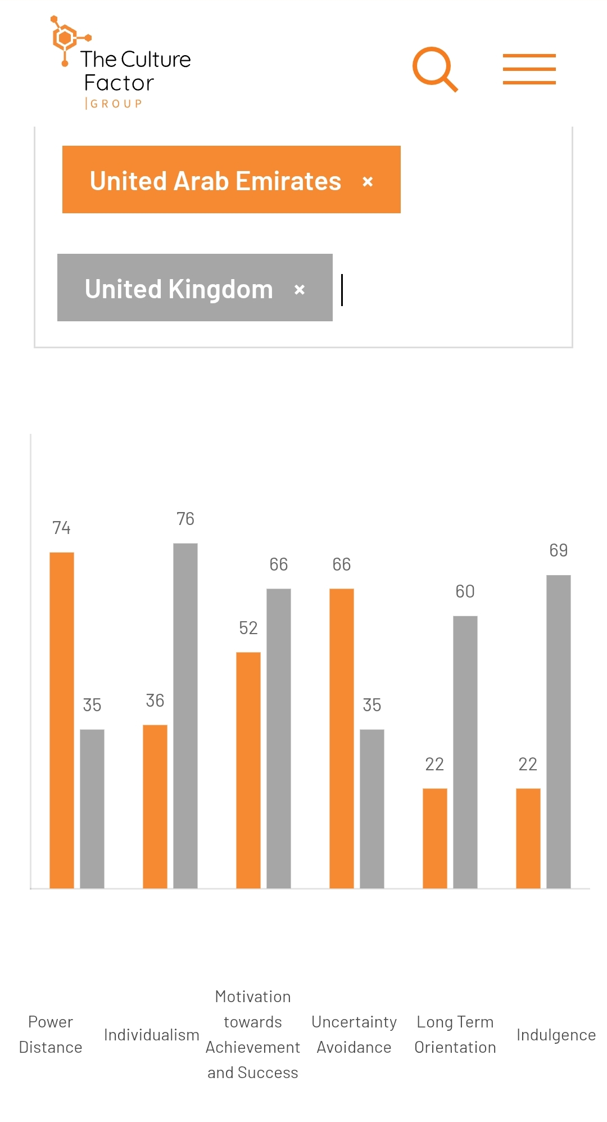
Figure 4: Cultural Factors ranking for both countries (Bilgihan and Ricci, 2024)

4.7 Advantages of the Hofstede Model
The model aids international marketers in comprehending the effects of cultural variations on consumer behaviour, consumer decisions to make, and their preferences in communication. In the case of an international company like Zara and H&M, the model of Hofstede can be used to inform marketing strategies since it can help to identify the role of cultural values in defining the expectations of customers in various markets (Chatterjee et al., 2022). The framework enables businesses to determine the similarities and differences between countries, which facilitates the formulation of viable international marketing strategies. Knowing the cultural dimensions like individualism, uncertainty avoidance, and indulgence, companies should be in a position to tailor their promotion message, branding strategy, and customer experiences to cultural conditions.

4.8 Disadvantages of the Hofstede Model
The model provided by Hofstede has several shortcomings as well. The structure is founded on past information and might not be a complete reflection of contemporary globalised societies, where cultural values are ever-changing (Chen, 2025). What has been eroded is the cultural boundary between nations due to the expansions of globalisation, technological advancement and international communication.

5.0 Segmentation, Targeting, and Positioning (STP)
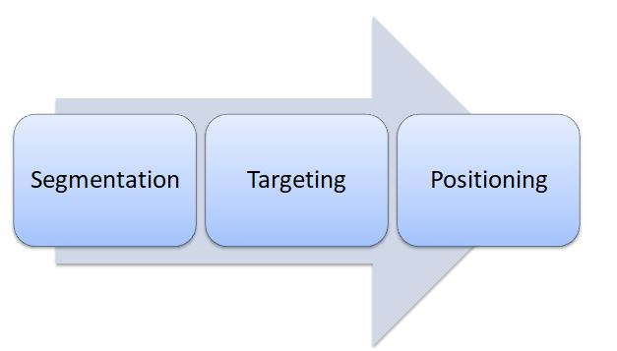
Figure 5: (STP) Analysis (Chavan, R.B., 2023)

5.1 Segmentation Strategy
In the United Kingdom and the United Arab Emirates, Zara uses a combination of demographic, psychographic, and behavioural variables to segment the market using multi-variable segmentation (Ferreira et al., 2024). Psychographically, Zara narrows down on trend-responsive people who are fashion-conscious and are becoming more interested in the sustainability issue. UK consumers use behavioural factors which show their frequent purchase behaviour due to seasonal factors and promotional cycles.
The demographic segmentation in the UAE involves expatriates with high income, the local Emirati consumers, and the youthful fashion-oriented shoppers. The focus of psychographic segmentation is the focus on brand-sensitive people with the desire to be prestigious and up-to-date without violating cultural traditions (Shahid et al., 2024). Consumer behaviour-wise, shopping is mostly done in upmarket malls and the experience in-store. Segmentation, therefore, in the two markets is alike in terms of age and lifestyle profiles but is very different in terms of incomes, expectations in the culture and shopping settings.

5.2 Targeting Strategy
Zara has a differentiated targeting approach in both markets, retaining its global fast-fashion identity. Targeting in the UK is mainly done to price-sensitive but trendy consumers who need fashionable clothes at affordable prices. The sustainability-oriented segments are being appealed to with more environmentally-friendly collections and responsible sourcing communication. Zara in the UAE also focuses on high-end and aspirational customers who prefer world-renowned brands in high-end retail stores (Qomaro et al., 2024). The company also focuses on culturally sensitive consumers by providing simple fashion modifications. Even though the target audience of the two countries, in general, is the customers who are fashion-conscious and young, the UAE market is more sensitive to cultural values and high-quality retail expectations.

5.3 Positioning Strategy
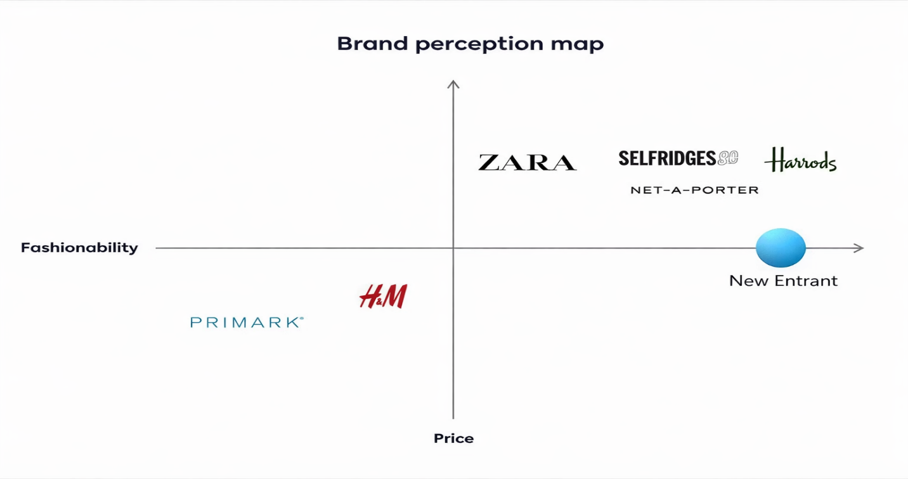
Figure 6: Zara's Position in the UK (Cho et al., 2023)
Zara brands itself as a fashionable, stylish, and relatively cheap, fast-fashion company that is able to provide designs that are influenced by the runways swiftly. The brand in the UK is a high-fashion, moderate-price brand between the discount retailers and the luxury brands. The customers view Zara as a fashionable brand that is reasonably priced. In the UAE, a core positioning is the same, but the brand perception might seem rather high quality because of the positioning of the stores in high-end malls and relatively high levels of prices because of the costs of importation and operational costs (Pereira et al., 2022). Thus, the fast-fashion manufacturer of the brand is the same in both countries, but there is a difference in the perceived prestige, the atmosphere of the store, and the positioning of prices.

5.4 Similarities and Differences of STP
STP is a marketing model that helps to recognise and cater to particular groups of customers. The three components are comparable as they are interrelated steps that are designed to enhance the effectiveness of marketing and the focus on customers. In the case of Zara, Segmentation is the division of the market into groups, selecting the most appealing ones, and positioning is the perception of a brand. Their major distinction is their functions, where segmentation is analytical, targeting is evaluative and selective, and positioning is strategic and communication-oriented (Bagnato et al., 2023). They also work together to make sure that businesses provide customised value propositions and achieve competitive advantage.

6.0 Marketing Mix (7Ps) Comparison
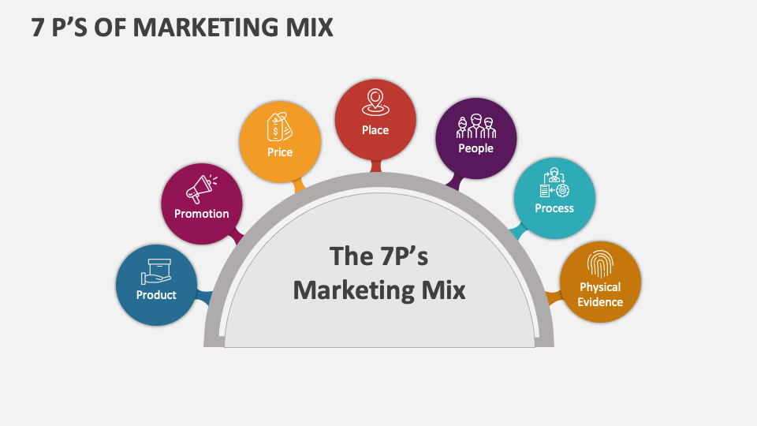
Figure 7: 7Ps of Marketing Mix (Bilgihan and Ricci, 2024)

6.1 Product
The product strategy of Zara in the UK focuses on fast movement of trends, seasonal and sustainable trends, including eco-friendly clothes. It is devoted to diversity, quickness, and conformity to the Western fashion ideals. In the UAE, product adaptation involves small fashion details, e.g. long hemlines and conservative fashion, whereas the global design elements are retained (Bilgihan and Ricci, 2024). Their difference is in the cultural design modification; their similarity is in the responsiveness to fast-fashion.
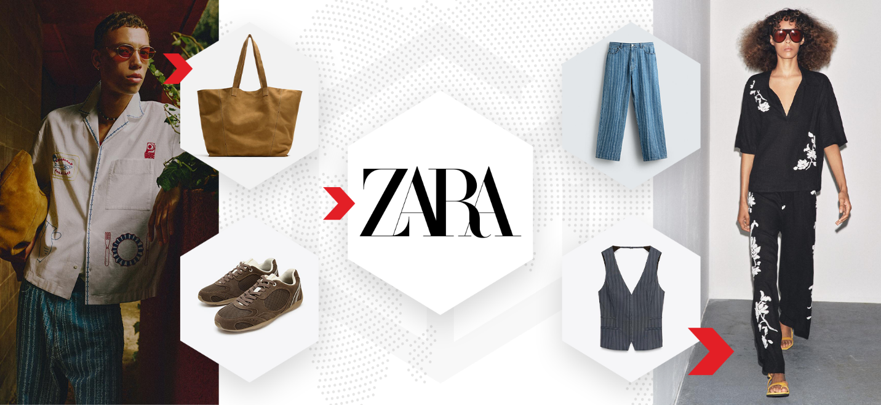
Figure 8: Zara’s Product (Chavan, 2023)
Marketing mix width is the difference or diversity of marketing activities and aspects that a company employs in each of the elements of the marketing mix (7ps). It demonstrates the extent to which a company extends its coverage of various issues including product lines, pricing strategies, distribution channels and promotional tools (Nurhayaty, 2022). To illustrate, a firm that has extensive coverage in its marketing mix can have various product lines, application of different pricing strategies, both online and offline strategy, and different promotional strategies. The degree of detail, intensity and specialisation of individual component of the marketing mix is known as marketing mix depth. An example of a deep product strategy is the availability of many versions, features and customisation of a single product range. Likewise, deep promotion can be related to personalised marketing campaigns and advanced digital targeting.

6.2 Price
The UK pricing is competitive and focused on appealing to the middle-income consumers. Zara finds the middle ground between cheap and perceived value. However, UAE prices are a little higher because of import tax, logistics and high-end location in the mall (Asiah et al., 2022). As a result, the perception of price in the UAE is more in line with the premium market than in the UK market.

6.3 Place
Zara uses flagship stores alongside intensive e-commerce platforms in the UK, which is backed by a well-developed click-and-collection service. The most important priorities are accessibility and digital convenience (Mentes and Omarli, 2023). However, direct channel distribution and retail strategy are the right option in the UK, and the UAE is based on the physical presence in the large and luxurious shopping malls, which is complemented by the rising online channels. The Mall culture is fundamental in consumer behaviour in the UAE.
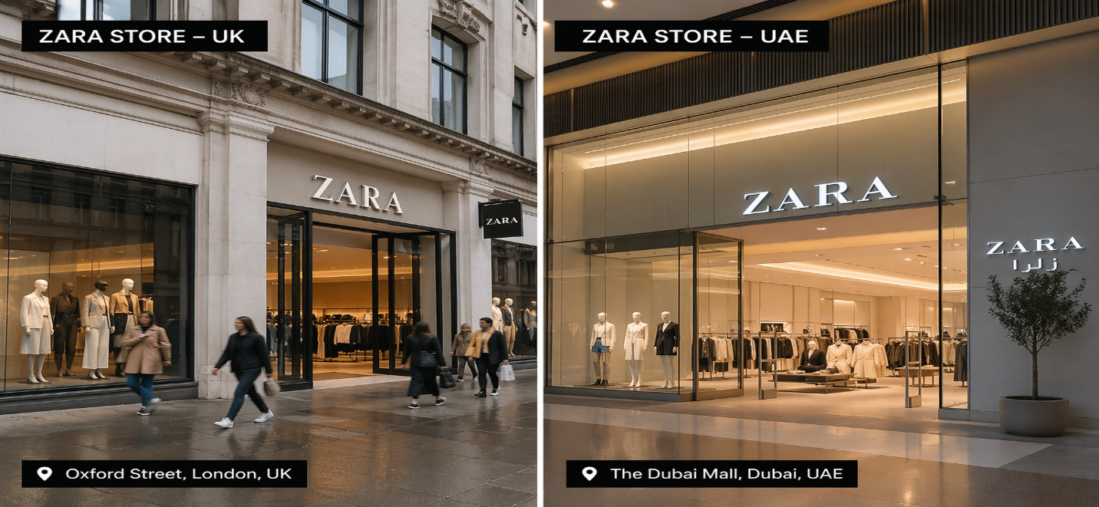
Figure 9: Stores in both countries (Qomaro et al., 2024)

6.4 Promotion
Integrated Marketing Communications (IMC) is a strategy that keeps all the marketing communication tools advertising, PR, online marketing, and sales promotion, in a regular state of coordination to communicate a clear, unified, and persuasive message to the target audience in all of the media. In both markets, Zara has little to no use of traditional methods of advertisement and much to do with visual displays, store layout, and social media presence. The UK has a higher level of visibility of digital engagement and sustainability messaging ((Nengsih et al., 2024). In the UAE, there is a stronger presence of influencer marketing, a high-quality mall placement, and aspirational imagery. The tone of the promotion is different to meet cultural and lifestyle expectations.

6.5 People
Customer service in the UK is based on efficiency, convenient self-service and simplified checkout procedures. Service expectations are more demanding in the context of the high-end retail stores in the UAE, which results in a more personalised customer experience (Bilgihan and Ricci, 2024). The presentation of the staff and the manner of service delivery are, hence, a little more formal in the UAE. UK and UAE are not disclosed in annual reports; however, they show over 105,000 global employees as of 2025.

6.6 Process
The operational practices in the two countries focus on the vertically integrated supply chain of Zara and the turnover of inventory. Digital returns and automated systems are more effective in the UK (Nengsih et al., 2024). The processes are also efficient in the UAE, but they are more focused on the management of the in-store experience because of the dominance of malls in retail. Zara's customer complaints process centers on resolving issues through their official digital channels, primarily the Help Center on their website or app, rather than in-store for online order issues. Customers are advised to contact Zara through "Contact" section on the site to initiate a case review.

6.7 Physical Evidence
The minimalist design of the global stores of Zara is similar across the markets, which strengthens brand identity. Nevertheless, there are usually bigger and more spacious UAE stores that follow the luxury mall design. The stores in the UK are up to date and are mostly found in busy commercial streets, that are busy and their layouts are functional (Nengsih et al., 2024). Therefore, as branding is constant, retail ambience is different.
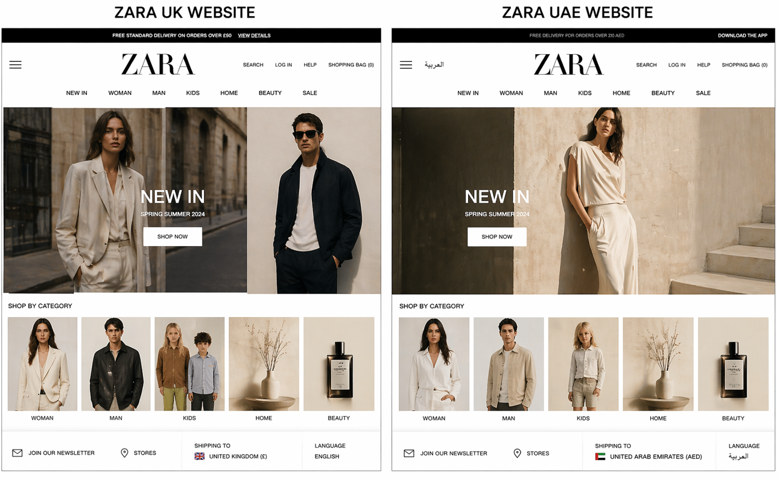
Figure 10: Zara websites of both countries (Rees, 2022)
6.8 Advantages and Disadvantages of Marketing Mix
The marketing mix allows ZARA to broaden its brand across countries and allows localisation at the level of products, involvement of the joint ventures' production process in UAE, and omnichannel selling in the United Kingdom, thus increasing relevance and responsiveness (Herring, 2023). Experiential and online promotion campaigns also strengthen brand equity and speed up the penetration of battery-electric cars.
The added complexity of managing a diverse set of SKUs and the large network of dealerships swells the cost structures (Horatiu Boeriu, 2025). Local new-energy-vehicle entrants in UAE lead to aggressive competition that would squeeze margins and cause quick adaptations to price and feature offerings (IEA, 2025). At the same time, regulatory and tax reforms, including the United Kingdom rules regarding the company cars and Chinese data/protection rules, drive continuous adjustment and can undermine the effectiveness of standardised offers.

7.0 Ansoff Strategy: Brand Directional Development Strategy
A Directional development strategy refers to a method of engaging in strategic planning that is directed by evolution and unified organisational goals and objectives (Ferreira and Sá, 2024). Directional development strategy is the direction that an organisation develops to grow market share, its product or competition. Ansoff Matrix gives four strategic growth options, and these are market penetration, product development, market development and diversification.
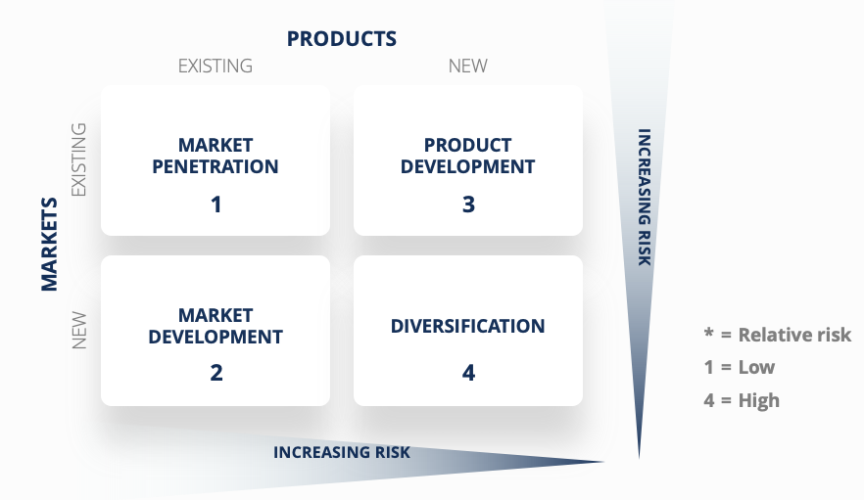
Figure 11: Ansoff Strategy (Asiah et al., 2022)

7.1 Market Penetration
Zara has been intensifying its penetration within the United Arab Emirates market by adding more stores to high-traffic shopping malls and promoting its presence in the stores. Diversification of flagship outlets in the best retail locations, like the Dubai Mall, enhances brand exposure (Pereira et al., 2022). Furthermore, the online stores can be used to enhance the experience of the physical shop by introducing the concept of click-and-collection counters along with specific online marketing and promotions, which would allow Zara to connect further with its already established customer groups and make them shop more often.

7.2 Product Development
The development of products in the UAE is manifested by launching modest fashion lines that are customised to meet the local culture. Zara uses global designs and localises them by using longer hemlines, higher necklines and slimmer figures to match the expectations of the region (Qomaro et al., 2024). Exclusive capsule collections and changes of the seasons tailor-made to the needs of Middle Eastern customers enable the brand to satisfy the local culture, but it does not lose its globally reputable fast-fashion image.

7.3 Market Development
Zara is developing its market through its retail presence; it is extending the reach of its retail outlets outside the major urban centres like Dubai and Abu Dhabi to other emirates like Sharjah and Al Ain. This geographic growth makes them reach more consumer groups and less depend on several metropolitan markets (Bilgihan and Ricci, 2024). The expansive distribution networks and the coverage of the online delivery of goods nationwide allow Zara to increase its overall market coverage in the UAE.

7.4 Diversification
The diversification is still comparatively low with the introduction of sustainable capsule collections and green product lines to the UAE market. Such initiatives enlarge the range of products offered by Zara as they include not only fast-fashion products but also sustainable materials and sustainable production. Though it is not a completely new product category, these sustainability-oriented lines are a testament to gradual strategic development and responsiveness to the concerns of the emerging global environmental concern (Albrecht et al., 2023). Comprehensively, market penetration and product development will be the main growth drivers of Zara in the UAE. The company takes advantage of its strong brand name as it uses it to adjust its products to the local culture and retail conditions so that it can maintain its competitive stance in the high-end market.

8.0 Ethical Issues
Some of the ethical business practices that have been shown by Zara in the UK market include the adoption of sustainable apparel lines and enhancing supply chain accountability. The firm has undertaken to adopt more environmentally friendly fabrics and minimise environmental degradation. Nevertheless, the model of fast fashion still has ethical issues as it promotes excessive consumption and environmental pollution (Shahid et al., 2024). Also, reputational issues have been raised by allegations of labour practices in the supplier factories. Although the transparency and compliance levels have gone up at Zara, the ethical issues related to fast fashion globally continue to exist.

9.0 Recommendations

9.1 Recommendations for the UK

9.1.1 Enhance Building Circular Economies in the UK
Zara ought to increase recycling initiatives of clothes, resale outlets, and clothes repairs in the United Kingdom. The issue of textile waste and environmental effects is growing in concern among British consumers. Through the implementation of in-store collection options, partnerships with resellers of second-hand clothing, and incentives to send used clothing back, Zara will be able to strengthen its positioning as sustainable and be ready to address the increased demand for responsible and circular models of fashion consumption.

9.2 Optimise the Supply Chain in the UK
Zara ought to be more transparent about the activities of its suppliers, labour relations, and environmental practices in the UK market. With robust regulatory systems and publicity, it can be expected that with greater transparency, brand credibility, reputational risk, and alignment with the expectations of environmentally and socially conscious British consumers can be enhanced.

9.3 Enhance Green Materials Utilisation
In both markets, Zara needs to hasten the shift towards organic, recycled and low-impact fabrics. The addition of sustainable lines to the products and labelling green products would make the brand stand out. This approach can be used to respond to sustainability-based buying choices in the UK and improve the corporate responsibility perception in the United Arab Emirates. More investment in sustainable innovation would help achieve environmental objectives in the long-term and build brand equity.

9.2 Recommendations for the UAE

9.2.1 Grow Small Muran Denim lines in the UAE
Within the UAE market, Zara ought to continue designing culturally in line with costume fashion collections, such as region-related designs, and seasonal lines of capsules. The provision of longer silhouettes, traditional tailoring and customised local collections would help to build on the local relevance. The balance between the global fashion trend and local cultural sensitivity will help Zara increase customer loyalty among the Emirati and culturally aware expatriate clients and keep its contemporary fast-fashion label.

9.2.2 Create Arabic-Language Online Marketing Campaigns
Zara needs to invest in online content apps, social media campaigns, and mobile app interfaces to the UAE market, in Arabic. Local communication would show respect for the culture and enhance customer interaction. By teaming up with local influencers and promo themes that resonate with the culture, brand resonance can be boosted. Greater localisation increases the level of emotional connection with consumers and helps to compete with positioning in the high-end retail environment of the UAE.

9.2.3 Digital Innovation and Sustainable Supply Chains
Zara should also keep up with innovative digital solutions like AI-based inventory control, custom online experience, and the integration of omnichannel in the UAE. At the same time, enhanced sustainable supply chain operations will enhance operational efficiency and minimise the environmental impact. Integration of technological innovation and sustainability leadership will allow Zara to be competitive and sustainable in the changing global retailing conditions.

Section 2

10.0 Gibbs’ Reflective Cycle
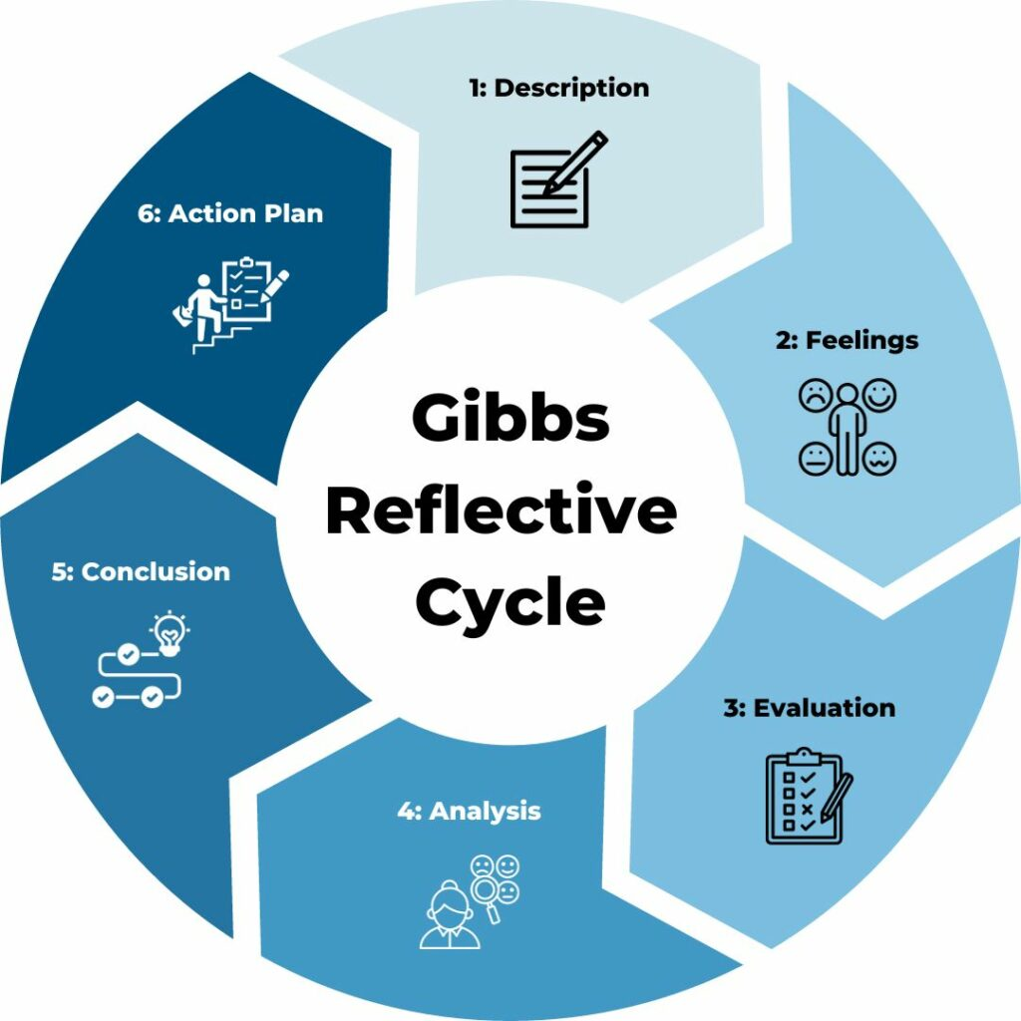
Figure 12: Gibbs’ Reflective Cycle (Yeganeh, H., 2025)

10.1 Description
I have used a systematic research process in writing this international marketing report on Zara in the United Kingdom and the United Arab Emirates. To develop a solid theoretical and contextual base, I collected articles that were published in academic journals, industry reports, and reliable sources found online. To be systematic with analysis, I used some of the most important frameworks, including PESTLE, Hofstede Cultural Dimensions, STP, the 7Ps marketing mix, and the Ansoff Matrix. It involved making a comparative assessment between two cultural and economic settings.

10.2 Feelings
At the outset of the research process, I was a bit confused about the analysis level that one has to do at the postgraduate level, especially when comparing two international markets. The differences between the political system, consumer behaviour and social values made cross-cultural analysis seem to be intricate. Nevertheless, later, when I advanced, I realised that it was an intellectual and rewarding task. The application of theoretical frameworks to the actual business situations enhanced my confidence and motivation. I was also more interested when I started distinguishing significant similarities and differences between the two markets.

10.3 Evaluation
Considering the process in general, the systematic application of academic models brought about a lot of clarity and organisation of my report. The use of theories, including PESTLE and STP, allowed me to avoid writing descriptively and engage in analytical comparison. My capability to relate theory and real-life business cases was one of the positive sides. Nevertheless, I realise that there are areas that might have contained additional serious arguments and modern scholarly sources to enhance the assessment further.

10.4 Analysis
This further reflection taught me that international marketing achievement relies on the degree of global standardisation and local adaptation. The case of Zara clearly shows that although the company needs a consistent global brand, cultural and environmental variations should be noted with a strategic adjustment. The realisation allowed me to get an insight into the practical constraints of purely theoretical models. I also realised that cultural models, though useful, have to be supplemented with up-to-date market data to prevent excessive simplification. The critical thinking stage enhanced my critical thinking and comparison skills.

10.5 Conclusion
Conclusively, the research and writing process improved my critical thinking, analytical thinking and synthesising of complex information. I was able to get a better vision of how the macro-environmental and cultural factors shape the international marketing decisions. The guided reflection process served to discover my strengths and weaknesses in the academic work. All in all, this assignment helped me gain knowledge and experience that were beneficial in my professional and academic growth.

10.6 Action Plan
In subsequent research and assignments, I will seek to be more proactive in interacting with recent peer-reviewed journal articles to maximise academic rigour. I will concentrate more on the inclusiveness of more critical attitudes as opposed to more descriptive comparisons. I will also learn to manage time better to enable more in-depth consideration of conflicting opinions. Acquisition of these skills will improve the quality of my postgraduate-level analysis and equip me with the complex professional decision-making situations.

11.0 Conclusion
Conclusively, Zara's marketing concept in the United Kingdom and the United Arab Emirates reveals a moderation in the standardisation of its marketing internationally and adaptation to the local market. The essence of fast-fashion identity will be the same, but the macro-environmental environment, cultural differences, and economic conditions will require strategic adjustments. Sustainability and online efficiency are needed in the UK market, and premium retail experiences and culturally suitable fashions are valued in the UAE. The expansion strategy of Zara in the UAE presents strong penetration of the market, as well as product development, but ethical issues associated with fast fashion are urgent. Sustainable innovation, cultural sensitivity, and strategic responsiveness will be the keys to long-term success in both markets because of the changing consumer expectations.

12.0 References
Albrecht, M.G., Green, M. and Hoffman, L., 2023. Principles of marketing. OpenStax.
Asiah, S.N., Soe'oed, R. and Sjamsir, H., 2022, December. The implementation of the 7Ps education marketing mix in early childhood education institutions. In Educational Studies: Conference Series (Vol. 2, No. 2, pp. 233-244).
Bilgihan, A. and Ricci, P. (2024) “The new era of hotel marketing: integrating cutting-edge technologies with core marketing principles,” Journal of hospitality and tourism technology, 15(1), pp. 123–137. Available at: https://doi.org/10.1108/JHTT-04-2023-0095.
Chavan, R.B., 2023. Latest Trends in Textile and Fashion Designing (no date) “Analysis of Fashion Industry Business Environment.” Available at: https://doi.org/10.32474/lttfd.2018.02.000144.
Cho, H.E. et al. (2023) “Achieving superior performance in international markets: the roles of organizational agility and absorptive capacity,” The Journal of business & industrial marketing, 38(4), pp. 736–750. Available at: https://doi.org/10.1108/JBIM-09-2021-0425.
Dalirazar, S. and Sabzi, Z. (2023) “Strategic analysis of barriers and solutions to development of sustainable buildings using PESTLE technique,” International journal of construction management, 23(1), pp. 167–181. Available at: https://doi.org/10.1080/15623599.2020.1854931.
Edyvean, H., 2025. Macro-environment analysis and fashion lifestyle trends. In Fashion Trends and Forecasting (pp. 47-66). Routledge.
Eierle, B. et al. (2022) “External Factors and the Pricing of Audit Services: A Systematic Review of the Archival Literature Using a PESTLE Analysis,” Auditing : a journal of practice and theory, 41(3), pp. 95–119. Available at: https://doi.org/10.2308/AJPT-2019-510.

Escandon-Barbosa, D., Ramirez, A. and Salas-Paramo, J. (2022) “The Effect of Cultural Orientations on Country Innovation Performance: Hofstede Cultural Dimensions Revisited?,” Sustainability, 14(10), p. 5851. Available at: https://doi.org/10.3390/su14105851.
Esteve, C.A., Torres, A. and Bernabeu, A.M.G., 2022. Market Assessment Bahrain, Israel, Jordan, Kuwait, Palestine, Qatar, Saudi Arabia and the United Arab Emirates.
Gursoy, D., Buttle, F. and Bowie, D., 2022. Hospitality marketing: Principles and practices. Routledge.
Jain, R., Jain, S. and Jain, S., 2022. Analysing and exploring the effectiveness of each element of the 7Ps of marketing mix. International Journal of All Research Education and Scientific Methods (IJARESM), 10(1), pp.2455-6211.
Komisarof, A. and Akaliyski, P. (2025) “New developments in Hofstede’s Individualism-Collectivism: A guide for scholars, educators, trainers, and other practitioners,” International journal of intercultural relations, 107. Available at: https://doi.org/10.1016/j.ijintrel.2025.102200.
Kumar, V., 2024. International marketing research: A transformative approach. Springer Nature. Available at: https://doi.org/10.1007/978-3-031-54650-1
Mentes, M. and Omarli, S., 2023. Marketing in the metaverse: evaluation through the 7P marketing mix. Journal of Hunan University Natural Sciences, 50(3), pp.137-153.
Menzies, J. et al. (2024) “Artificial intelligence for international business: Its use, challenges, and suggestions for future research and practice,” Thunderbird international business review, 66(2), pp. 185–200. Available at: https://doi.org/10.1002/tie.22370.
Minkov, M. and Kaasa, A. (2022) “Do dimensions of culture exist objectively? A validation of the revised Minkov-Hofstede model of culture with World Values Survey items and scores for 102 countries,” Journal of international management, 28(4). Available at: https://doi.org/10.1016/j.intman.2022.100971.
Nengsih, S. et al. (2024) “Analysis of The Influence of the 7p Marketing Mix on Consumer Loyalty Shipping Services Company,” Jurnal ilmiah manajemen dan bisnis, 10(1), p. 138. Available at: https://doi.org/10.22441/jimb.v10i1.20008.
Oliveira, J.S. et al. (2023) “Decision-making in international marketing: past, present and future,” International marketing review, 40(3), pp. 413–428. Available at: https://doi.org/10.1108/IMR-11-2022-0249.
Pereira Ferraz Soares Ferreira, A.P. and Marques, M.B.P. de S.M. (2024) “The Importance of the Ansoff Matrix for the Study of the Information Services Market,” Canadian journal of information and library science, 47(2), pp. 78–84. Available at: https://doi.org/10.5206/cjils-rcsib.v47i2.17432.
Qomaro, G.W., Nasrulloh, N. and Salleh, A.Z., 2024. Leveraging The Ansoff Matrix for Strategic Growth in Packaged Food Micro-Enterprises. Dinar: Jurnal Ekonomi dan Keuangan Islam, 11(1), pp.51-66.
Rees, M., 2022. Analysing the External Environment for Fashion Ventures. In Fashion Entrepreneurship (pp. 51-72). Routledge.
Shahid, Z.A. et al. (2024) “Signaling theory and its relevance in international marketing: a systematic review and future research agenda,” International marketing review, 41(2), pp. 514–561. Available at: https://doi.org/10.1108/IMR-04-2022-0092.
Yeganeh, H. (2025) “Hofstede, GLOBE, Schwartz and Inglehart’s cultural dimensions: a critical examination and assessment,” European business review, 37(6), pp. 1073–1090. Available at: https://doi.org/10.1108/EBR-05-2025-0144.

