Using the following link go to Cisco’s website:

https://www.netacad.com/



Go to the Course tab and click on “Packet Tracer”


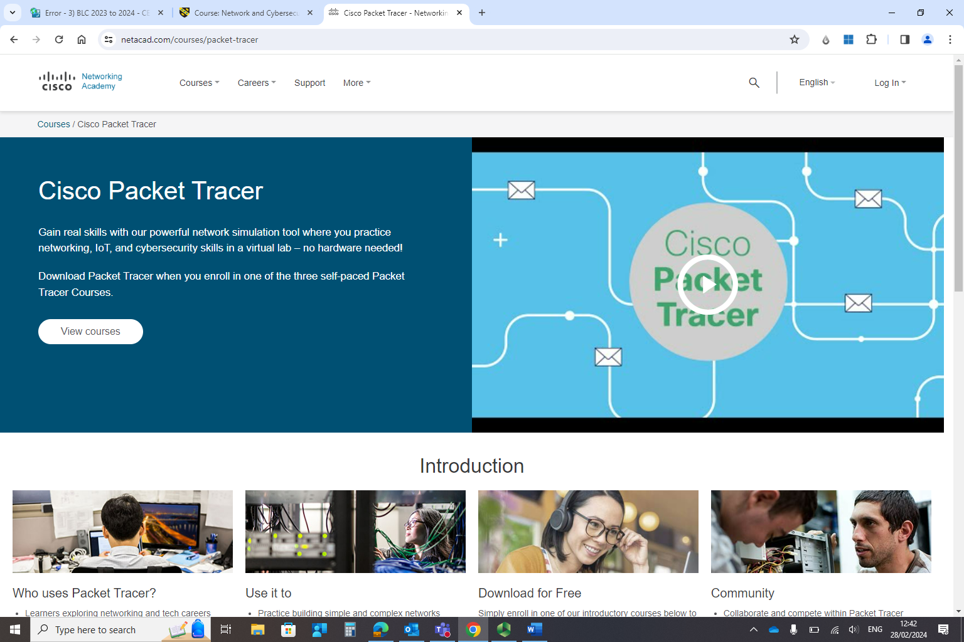
On the page, scroll down to the course link:
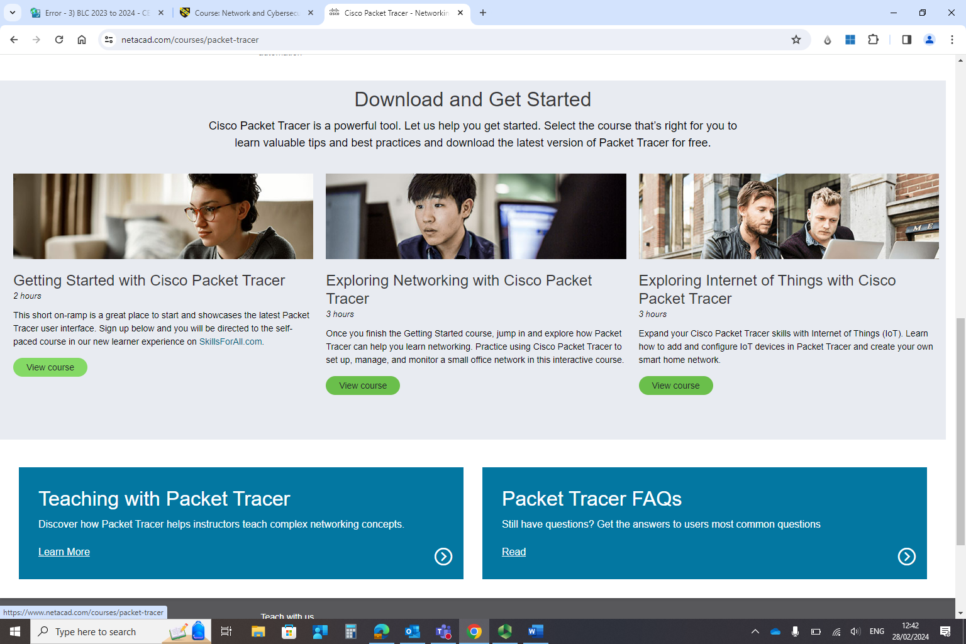

Click on the “Getting started with Cisco Packet Tracer” Course – Duration 2 hrs.


Click on skills for all

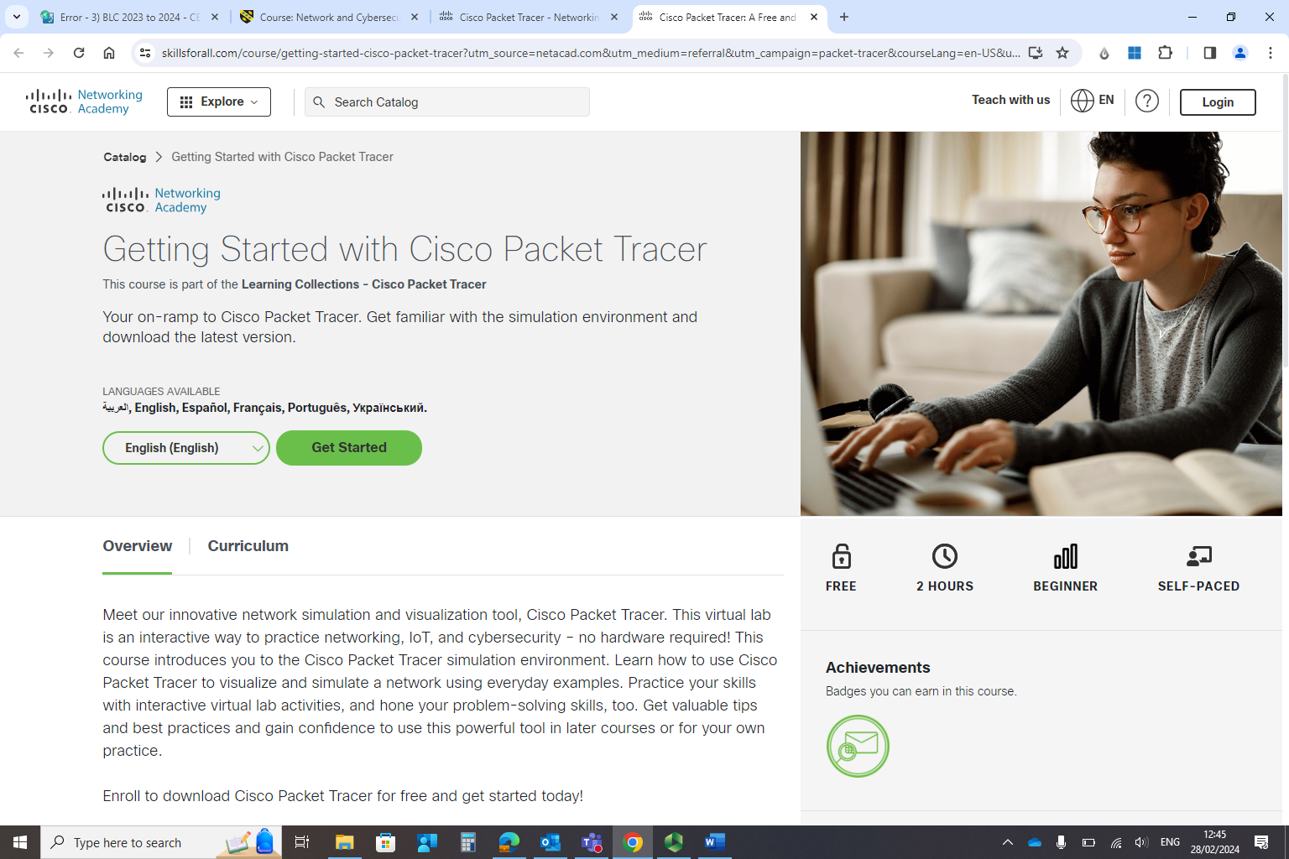
Click on “Get started”



Login to your account if you have already created one, else sign up.
Once, login is successful, you will be able to access the course.
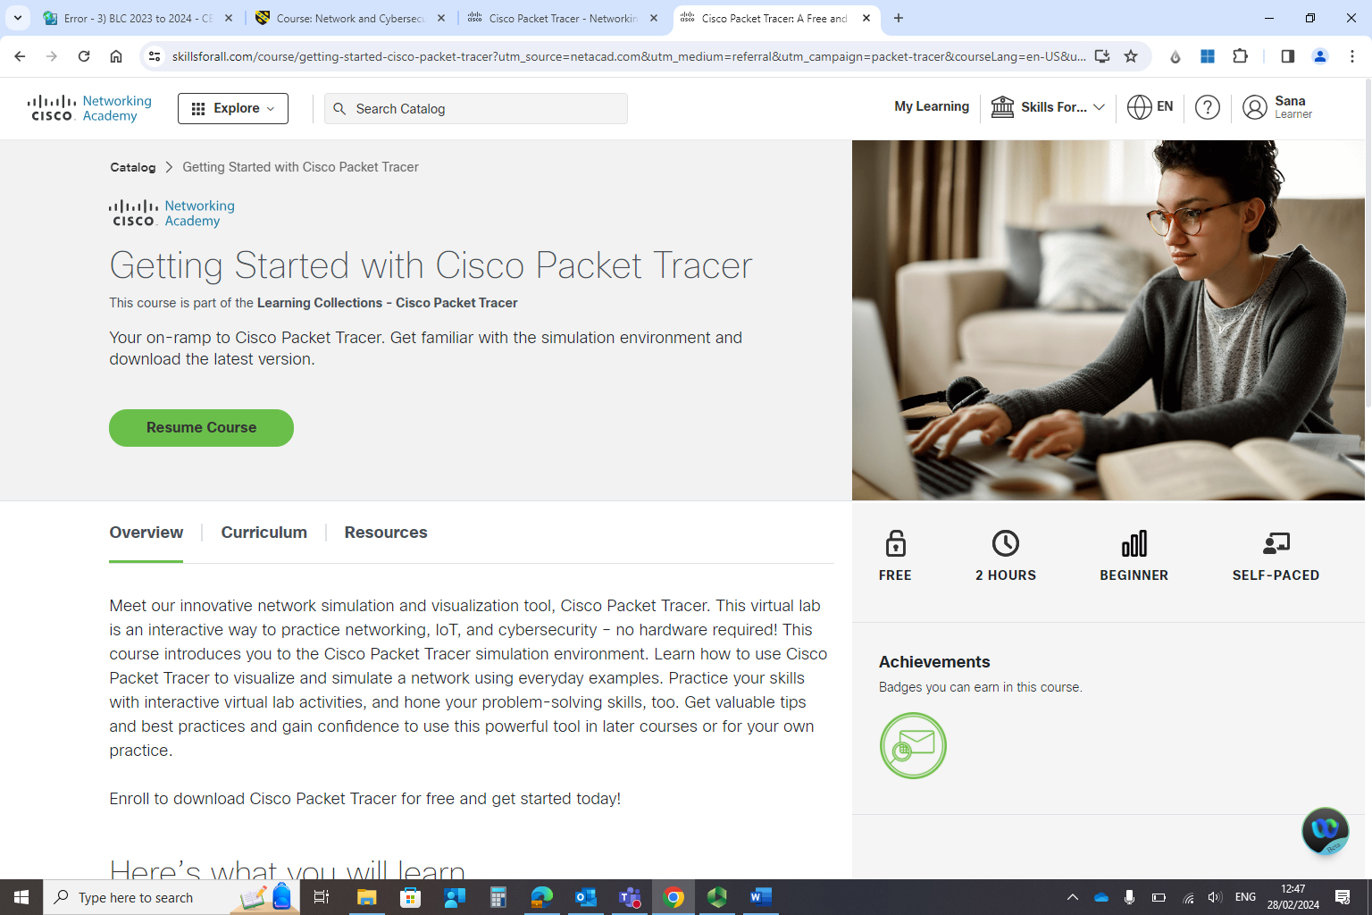
Start/resume the course. The course can be completed at your convenience in multiple attempts. It is not necessary to complete it in one go.
Once completed, you will have the course completion details/confirmation on your profile. Take a screen shot and attach it in your assignment/report/assessment component 1.



