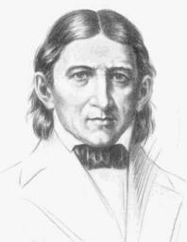
Friedrich Froebel

The Man who Invented Childhood?
Charlotte Teed, December 2022
(Free-images.com, 2017)
How many times have you asked your child what they did in school today and get the reply "Oh, we just played all day"? As infuriating as that can be, have you realised that playing all day is a great way to learn (Welsh Assembly Government, 2008)? We can thank Friedrich Froebel for this (Ainsworth, 2022). Born in Germany (known then as Prussia), Frobel lost his Mum at nine months old and experienced a neglected childhood until he was adopted by his uncle (Britannica, 2022). Receiving a good education and trying several jobs, he wasn’t content until took a job as a teacher (Britannica, 2022). Froebel was excited by Pestalozzian pedagogy but nursed ambitions for improvement (Britannica, 2022). By 1818, Froebel was running his own flourishing school (Britannica, 2022). The Education of Man, written by him in 1826, was the first time that play was recognised as being beneficial for children (Britannica, 2022). Before this, children had been perceived an entity needing to be moulded into a successful adult and childhood wasn’t a thing (The British Association for Early Childhood Education, 2022) . Growing up was regimented and learning methods were predominantly copying from text, memorising, and repetition (The Victorian School, 2021).
So, what’s the big deal?
Froebel’s principles were pretty ‘out there’ for his time. In a world of disciplinarians’ and corporal punishment, a child led school must have been, in my opinion, unthinkable. The use of nursery rhymes, wooden blocks, and shapes (Froebel’s gifts) as learning tools, absurd! Indeed, when we read the translator’s preface in the English version of Froebel’s famous work, W.M Hailmann writes that government official, Superintendent Zech, is sent to inspect Froebel’s school on at least two occasions and finds nothing wrong (Froebel, 1903, pp. 20-22). In fact, he is delightfully astonished at the ‘perfect harmony’ and notes that pupils are called by their Christian names to avoid any ‘privileges of rank or birth’ (Froebel, 1903, pp. xii-xiii). This indicates that pupils were previously using their rank and surname which is very formal and not very nurturing, especially if a toddler outranked his teacher! Froebel was all about nurture. In ‘The Education of Man, he writes affectionately, referring to ‘the little one’, he even advocates ‘striving to remove the cause of sorrow’ when a child is weeping (Froebel, 1903, pp. 20-22). A very unusually gentle man in a country fresh from revolution and a patriarchal society (Britannica, 2022).
Froebel’s Gifts
These toys were used in the earliest Kindergartens (Britannica, 2022). Inspired by Froebel’s own interest in geometry and mathematics, there are similarities in today’s shape sorters and wooden blocks (LeBlanc, 2012)
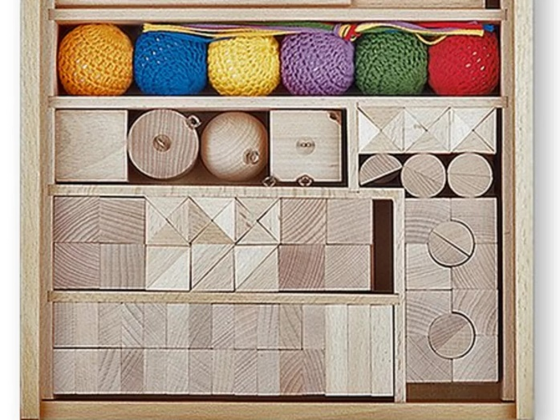 (FROBEL Australia Limited, 2000)

Froebel’s Principles
- Childhood is an integral part of growing up. It shouldn’t be bypassed to mould the child into the adult he will become.
- Consider the whole child. Mental, physical, psychological, and spiritual.
- Learning is linked to everything, not just one part.
- Self-directed activity leading to self-satisfaction
- Self-Discipline
- Each developmental stage has openings for learning
- Building on what they already know
- Promoting sense of self and reflection
- The importance and quality of interaction with surrounding people, including parents and friends
- Three factors of quality education. The child, knowledge and understanding gained by the child, and the context that learning takes place in.
(The British Association for Early Childhood Education, 2022)

These ideas were ludicrously modern for the time as far as I am concerned. These are the principles in summary.
Children are treated as individuals who should have the freedom to play.
An appropriate adult to guide them and provide them with the tools to develop their own self-expression.
They should be encouraged to be self-reliant, both mentally and physically.
They need nourishing, with healthy food, spirituality and encouraged to delve into subjects which interest them naturally and at their own pace.
He also encouraged outdoor play.
(The British Association for Early Childhood Education, 2022).
It’s taken nearly 200 years for modern education to start looking at childhood and education in a holistic way as Froebel did but I’m afraid his ending is quite tragic. Due to political unrest at the time kindergartens were labelled as socialist institutions. In a passionate letter written by Froebel to the King of Prussia, he implores the King not to politicise the schools but, all kindergartens were closed in 1851 regardless (Liebschner, 2002). Froebel died a year later, and the kindergarten movement continued again nearly ten years later and continues to influence early years education worldwide (Britannica, 2022).
If you enjoyed reading this subscribe here theoverthinkingteacher.com
Click here to find out more https://www.froebel.org.uk/

References
Britannica, 2022. Friedrich Froebel. [Online]
Available at: https://www.britannica.com/biography/Friedrich-Froebel
[Accessed 14 December 2022].
Britannica, 2022. Prussia / The French Revolution and Napoleonic period. [Online]
Available at: https://www.britannica.com/place/Prussia/The-French-Revolutionary-and-Napoleonic-period
[Accessed 14 December 2022].
Donaldson, P. G., 2015. Successful Futures, Independant Reviee of Curriculum ans Assessment Arrangements in Wales, Cardiff: Welsh Government.
Free-images.com, 2017. Friedrich-Froebel. [Art] (Free-images.com).
FROBEL Australia Limited, 2000. Frobel's Gifts, Sydney: FROEBEL Australia Limited.
Froebel, F., 1903. The Education of Man. New York: D.Appleton and Company.
LeBlanc, M., 2012. Friedrich Froebel, His life and influence on education. [Online]
Available at: https://www.communityplaythings.co.uk/learning-library/articles/friedrich-froebel
[Accessed 29 December 2022].
Liebschner, J., 2002. Prussion ban of kindergarten, s.l.: friedrichfroebel.com.
The British Association for Early Childhood Education, 2022. Friedrich Froebel. [Online]
Available at: https://early-education.org.uk/friedrich-froebel/
[Accessed 13 December 2022].
The Victorian School, 2021. Going to School in Victorian Times. [Online]
Available at: http://www.victorianschool.co.uk/schoolday.php
Wales Online, 2015. The Donaldson Report: An at-a-glance-guide, s.l.: Wales Online.
Welsh Assembly Government, 2008. Teaching Pedagogy. [Online]
Available at: https://hwb.gov.wales/api/storage/8f0b360f-f1f6-4bec-b11a-df88168007f9/learning-and-teaching-pedagogy.pdf

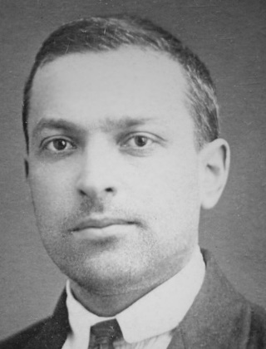
Older siblings are useful after all!

Vygotsky Who?
Charlotte Teed, December 2022 (Industry, 2014)
Lev Vygotsky. A Russian psychologist. You may not have heard of him, but your children are taught using his theories every day. Born in 1896, Vygotsky lived in turbulent times (Britannica, 2022). From 1917, Russia was amid revolution, the economy was failing, the Tsar and his family, murdered, and living was hard (Britannica, 2022). In 1913, he won a place at Moscow University through a ballot as the university had an annual number of Jewish places to fill (The Early Years and Childcare Service, 2021). A prolific writer, he penned six books in ten years (Cherry, 2022). No mean feat for someone who died young, and a testament to the theories that he contrived in that they are still used and widely discussed today (Britannica, 2022). He believed that gaining knowledge is a social process and the quality of interaction helps children and young people to develop and hone their skills (Ainsworth, 2022). Many could argue that his theories were influenced by the turmoil that surrounded him in Communist Russia, he would have had ample opportunity to see how surroundings effect the development of character, values, symbolism, and language (McQueen, 2013, pp. 185-198)

So why haven’t I heard of him?
The world’s leading psychologists were publishing their theories regarding behaviour and pedagogy as they were writing (Cherry, 2022). Whereas, due to the authoritarian state in Russia at the time, Vygotsky’s work was either internalized within the country or censored due to being a threat to Communism (Britannica, 2022). Much of his work is still being translated today and he is considered the father of Social Development Theory (Cherry, 2022) (Study Queries, 2022).

What can he tell us?
Up to the age of two, Vygotsky believed that thoughts are externalized and that internal speech which could develop into reasoning comes later (McCleod, 2022).In his view, learning was a social activity (McLeod, 2019). He found that learners gain skills and build on their own knowledge from a More Knowledgeable Other or MKO (McLeod, 2019). This could be a peer, parent or even a You Tube video (McLeod, 2019). By sharing prior knowledge and experience, the MKO assists the learner, like a baby copying a facial expression (McLeod, 2019). We do this throughout our lives without even noticing, for example, when approaching an unfamiliar carpark ticket machine, we will watch someone else pay to familiarize ourselves with the procedure. The idea is that everyone builds on their prior knowledge consciously or unconsciously, we know that we must pay for our ticket, we know that we can do this using our bank card from reading a sign, we don’t know whether a physical ticket is needed, or whether we input our car registration. This is the Zone of Proximal Development, where we need more information to refine our knowledge of this task which will provide us with the building blocks to become adept and develop the idea further (McLeod, 2019).
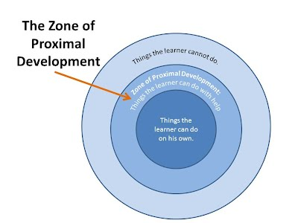 (Education Theories in Museums, 2022)
In 1976, Bruner, Wood and Ross coined the term ‘scaffolding’ to describe this process and the word is now connected with this part of Vygotsky’s work (Bruner, 1976, p. 2). Succinctly, children learn more when those around them are educated as those motions, methods, and reasonings are adopted and taught as they grow, teachers then identify those gaps and fill them as the child develops and is able to develop and discuss their own ideas in schools colleges and university (McCleod, 2022). Yes, it takes a community to raise a child
So, the next time you argue with an older sibling, remember, a lot of what you know and have learned along the way is thanks to them!

If you enjoyed reading this subscribe here theoverthinkingteacher.com
If you would like to read more on Vygotsky, click here https://www.simplypsychology.org/vygotsky.html

References
Ainsworth, S., 2022. Principles of Learning and Teaching: 2. Swansea: unpublished.
Britannica, 2022. L.S Vygotsky. [Online]
Available at: https://www.britannica.com/biography/L-S-Vygotsky
[Accessed 21 December 2022].
Britannica, 2022. Russian Revolution. [Online]
Available at: https://www.britannica.com/event/Russian-Revolution
[Accessed 21 December 2022].
Bruner, W. &. R., 1976. The Role of Tutoring in Problem Solving. J. Child Psychol. Psychiat, Volume 17, pp. 88-100.
Cherry, K., 2022. Lev Vygotsky's life and theories. [Online]
Available at: https://www.verywellmind.com/lev-vygotsky-biography-2795533
[Accessed 21 December 2022].
Education Theories in Museums, 2022. Lev Vygotsky, s.l.: Education Theories in Museums.
Industry, e., 2014. Instructional Design Models and Theories: The Sociocultural Learning Theory. [Art] (eLearning Industry).
McCleod, S., 2022. Vygotsky's Sociocultural Theory of Cognitive Development. [Online]
Available at: https://www.simplypsychology.org/vygotsky.html
[Accessed 2023].
McLeod, D. S., 2019. The Zone of Proximal Development and Scafolding. [Online]
Available at: https://www.simplypsychology.org/Zone-of-Proximal-Development.html
[Accessed 21 December 2022].
McQueen, K., 2013. Beyond Bounds? The terrorist teachers of Lev Vygotsky.. History of Education Review, 42(2), pp. pp. 185-198.
Study Queries, 2022. Piaget vs Vygotsky: Theories, Similarities, Differences & More. [Online]
Available at: https://studyqueries.com/piaget-vs-vygotsky/
[Accessed 3 January 2023].
The Early Years and Childcare Service, 2021. Exploring Pedagogy - Introducing Lev Vygotsky. [Online]
Available at: https://www.theeducationpeople.org/blog/exploring-pedagogy-introducing-lev-vygotsky/#:~:text=Vygotsky%20was%20home-schooled%20up%20to%20the%20age%20of,He%20initially%20studied%20medicine%20before%20transferring%20to%20law.
[Accessed 21 December 2022].

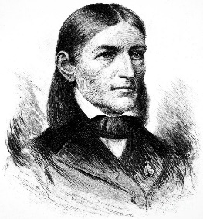
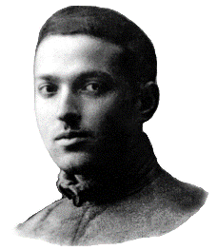
A Tale of Two Theorists
A comparison of Froebel & Vygotsky
By Charlotte Teed
(Granger, 2012) (Gallery, 2023)
Are you sitting comfortably? Then let me take you on a journey. Two educational theorists, Friedrich Froebel, and Lev Vygotsky. Born in the 18th Century, Froebel is considered the man who pioneered early years education (Britannica, 2022) and Vygotsky, born in the 19th Century, considered an expert in sociocultural theory (Cherry, 2022). Although born in different centuries, they both developed a passion for understanding how children learn.
At the beginning of his career, Froebel trained at one of Pestalozzi’s institutes which gave him a good basis for his future schools, that being child-led, moralistic and with involvement in nature, but he wanted to create something more holistic, that encapsulated a child’s unconscious mind to develop using practical, physical, and creative methods (Marenholtz-Buelow, 1887). Froebel wanted to provide skills and inventiveness early on to allow for the child’s natural talent to develop and blossom when the time came, the ‘consciousness of the mature mind’ (Marenholtz-Buelow, 1887). This ties in quite nicely with one of Vygotsky’s theories, that of scaffolding. Also, a constructivist, Vygotsky viewed early childhood learning as social and included that children learn from the people around them, a more knowledgeable other, or MKO and what they learn is then built upon and developed further (Cherry, 2022). Vygotsky said
“Learning is more than the acquisition of the ability to think. It is the acquisition of many specialised abilities for thinking about a variety of things” (Vygotsky, 1978).
And Froebel agreed, expressing that, internalised consciousness had developed, so then could the conscious (Marenholtz-Buelow, 1887). (Minesota, 2019)
Frobel was a devout Christian and viewed everything as God’s creation, he saw it as God’s purpose to introduce a love of nature to children and valued the promotion of play and exploration outside (Froebel Trust, 2022). Vygotsky, on the other hand, was more about the method of learning and socialisation, and when you consider the fact that he conjectured environments and people influenced this then I would conclude that he would agree with Froebel (Vygotsky, 1978). Both were advocates of children learning at their own pace (Marenholtz-Buelow, 1887) (Cherry, 2022).
Froebel & Vygotsky, Comparative Theories
Froebel | Vygotsky
Thought that children think differently to adults | Children were not ‘clay to be moulded’
Learning is linked to everything | Learning is a social activity
Interaction with others and the quality of it influences development | MKO fills in gaps of learning
Teachers and parents should guide the child, providing coaching when the child is ready | MKO to assist the child to scaffold and build on pre-existing ideas
(Cherry, 2022) (Froebel Trust, 2022) (Vygotsky, 1978) (Marenholtz-Buelow, 1887)
Although we see many similarities here, they also had different views. Froebel was happy to let his pupils guide their own play / learning and asked his teachers to only intervene when an interest was shown organically (Cherry, 2022). He was hands on and participated in his pedagogy. (Marenholtz-Buelow, 1887). There is no evidence to suggest that Vygotsky ran any educational establishments for his work.

Socialist Problems
Now, it wouldn’t be right to finish this comparison without mentioning one crucial similarity for both Froebel and Vygotsky. Friedrich Froebel created a formidable reputation for himself until his nephew, Karl Froebel included the kindergarten in a brochure which was condemned as socialist propaganda (Liebschner, 2002). Despite writing a letter pleading with the Prussian King not to politicise the kindergarten, they were closed down as socialist establishments in 1851 due to the employment of women and the inclusive ethos that it stood for (Liebschner, 2002) (Britannica, 2022). Unfortunately, Froebel died before seeing them reinstated in 1861 (Britannica, 2022). He was age 70 (Britannica, 2022). Vygotsky on the other hand, died young, at 38 (Cherry, 2022). He lived his life through countless uprisings including the Bolshevik revolution which brought property seizures, famine and firing squads (Dr Zhivago, 1965). The horror of this dark era in Russian history is encapsulated in Boris Pasternack’s novel, Doctor Zhivago. Indicative of the constraints of Communist Russia in Vygotsky’s time, especially considering his Jewish faith, Pasternack’s work was written in secret, refused publication, and smuggled out of Russia (BBC, 2022). Similarly, Vygotsky’s work was suppressed by the communist state and some of it is still being translated to English (Cherry, 2022).
In the next Blog we will see how both theorists’ work is used in the classrooms of our primary and secondary schools.
If you enjoyed reading this subscribe here theoverthinkingteacher.com
To read more on these theorists, click here https://www.verywellmind.com/lev-vygotsky-biography-2795533 , https://www.britannica.com/biography/Friedrich-Froebel

References
BBC, 2022. Simon Schama's History of Now. s.l.:BBC.
Britannica, 2022. Friedrich Froebel. [Online]
Available at: https://www.britannica.com/biography/Friedrich-Froebel
[Accessed 14 December 2022].
Cherry, K., 2022. Lev Vygotsky's Life and Theories. [Online]
Available at: https://www.verywellmind.com/lev-vygotsky-biography-2795533
[Accessed 4 January 2023].
Dr Zhivago. 1965. [Film] Directed by David Lean. s.l.: Metro-Goldwyn-Mayer.
Froebel Trust, 2022. Children and Nature. [Online]
Available at: https://www.froebel.org.uk/training-and-resources/children-and-nature
[Accessed January 2023].
Liebschner, J., 2002. Prussion ban of kindergarten, s.l.: friedrichfroebel.com.
Marenholtz-Buelow, B. v., 1887. Pestalozzi and Froebel. In: Reminicences of Froebel. Boston: Lee and Shepard, p. 64.
Minesota, C., 2019. What parents need to know abput insect bites and stings. [Art] (Children's Minesota).
Vygotsky, L., 1978. Mind in Society. London: Harvard University Press.

The Overthinking Teacher:
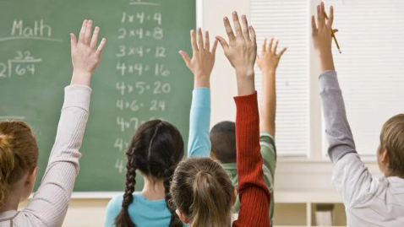
Let’s bring theory into it!
By Charlotte Teed

(Sun, 2022)
Before starting my PGCE course or teachers training as some may call it, I had no idea of the philosophy or theories behind the teaching strategies that are used. Having been a Teaching Assistant for 10 years, I thought that the training would consist mostly of getting to know the curriculum, the creation of schemes of work and managing behaviour. Little did I know that it’s all about the delivery and style in capturing and growing your audience, the whole pedagogy.
There are many great educational theorists out there, Carl Rogers and his person-centred approach (Rogers, 1951), and Maslow and his Hierarchy of Needs (Maslow, 1943). But in this blog, I will be concentrating on Friedrich Froebel and Lev Vygotsky.

(Granger, 2012)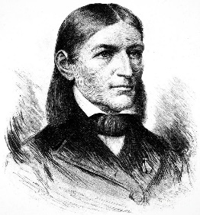Froebel
Friedrich Froebel (1782-1852) is considered the grandfather of early years education, he was the man who first realised that play was an important way that children learned (Froebel, 1903). Wales’s Foundation Phase pedagogy lists a variety of play and child led activities in their framework today (Welsh Government, 2015, p. 15). It was considered by Froebel to be a child’s way of making sense of the world (Marenholtz-Buelow, 1887). Now that we appreciate this more fully, primary school education incorporates this by allocating play during lesson time and gives pupils the choice of what they would like to play, rotating the ‘games’ on offer per half term and relating to the current topic being explored. For example, if the focus is healthy eating, then a café / kitchen area may be created with the opportunity for pupils to take it to the next level by creating menus and dealing with money when they are ready. This ties in with Froebel’s Principle of allowing the child to develop at their own pace (The British Association for Early Childhood Education, 2022). An advocate for being in touch with the great outdoors, Froebel thought it was vitally important for children to interact and immerse themselves in nature (Froebel Trust, 2022). Again, Wales have adopted this and promote outdoor activities and play for 3-7 year olds, they even provide guidance on what resources to use for teachers who are new to it (Welsh Assembly Government, 2009) as not only can it help promote a less sedentary lifestyle, it can incorporate risk taking, numeracy, physical and creative development, and worldly knowledge (Welsh Assembly Government, 2009). Being around nature is beneficial for health and wellbeing too, in Japan they practice forest bathing or shirin-yoku which has proven to reduce the risk of disease (Sherwood, 2019). It looks like Froebel was on to something, and way ahead of his time!
Vygotsky 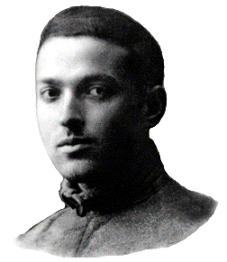 (Gallery, 2023)
Vygotsky theorised that children’s development is influenced greatly by who is around them (McCleod, 2022) and they learn socially using a More Knowledgeable Other (MKO) (McCleod, 2022). This is evidenced by children who are affected by an unstable homelife and children who experience ACES (Adverse Childhood Experiences). This negative influence at home often leaves a child unable to learn adequately due to distractions and an inability to concentrate (Public Health Network Cymru, 2017). MKO’s are teacher’s best friends as children tend to be more receptive to help from friends (Richardson, 2011) so by seating a more IT literate friend next to one who is less so, the pupil becomes the MKO for the less IT savvy friend. It is worth mentioning too, that Vygotsky was aware that adults are the role models to children view the world so if teachers and figures of authority are seen negatively by care givers, it is likely that the child will adopt this attitude (McCleod, 2022). This is the reason that home-school links are so important.
Both theorists could be described as revolutionary for their time and the curriculum in our schools is changing to adapt to our shifting world to make learning more relevant, so hold on tight, take a breath and………………. teach.
If you enjoyed reading this subscribe here theoverthinkingteacher.com
Learn more about educational theorists here https://elearninginfographics.com/6-education-theorists-teachers-know-infographic/

References
Froebel Trust, 2022. Children and Nature. [Online]
Available at: https://www.froebel.org.uk/training-and-resources/children-and-nature
[Accessed January 2023].
Froebel, F., 1903. The Education of Man. New York: D.Appleton and Company.
Gallery, L. V. I., 2023. Lev Vygotsky Image Gallery. [Art] (Lev Vygotsky Image Gallery).
Granger, 2012. Friedrich Froebel (1782-1852). [Art] (fineartamerica).
Marenholtz-Buelow, B. v., 1887. Pestalozzi and Froebel. In: Reminicences of Froebel. Boston: Lee and Shepard, p. 64.
Maslow, A., 1943. Motivation and Personality. s.l.:Harper & Row, Publishers, inc.
McCleod, S., 2022. Vygotsky's Sociocultural Theory of Cognitive Development. [Online]
Available at: https://www.simplypsychology.org/vygotsky.html
[Accessed 2023].
Public Health Network Cymru, 2017. Adverse Childhood Experiences (ACES), s.l.: YouTube.
Richardson, H., 2011. Pupils' can help teach each other to read and do maths'. [Online]
Available at: https://www.bbc.co.uk/news/education-14896716
[Accessed 2022].
Rogers, C., 1951. Play Therapy. In: L. Carmichael, ed. Client Centered Therapy. London: Constable and Company Limited, pp. 235-277.
Sherwood, H., 2019. Geting back to nature: how forest bathing can make us feel better, s.l.: The Observer.
Sun, H., 2022. Teachers look for new careers. [Art] (Herald Sun).
The British Association for Early Childhood Education, 2022. Friedrich Froebel. [Online]
Available at: https://early-education.org.uk/friedrich-froebel/
[Accessed 13 December 2022].
The Early Years and Childcare Service, 2021. Exploring Pedagogy - Introducing Lev Vygotsky. [Online]
Available at: https://www.theeducationpeople.org/blog/exploring-pedagogy-introducing-lev-vygotsky/#:~:text=Vygotsky%20was%20home-schooled%20up%20to%20the%20age%20of,He%20initially%20studied%20medicine%20before%20transferring%20to%20law.
[Accessed 21 December 2022].
Welsh Assembly Government, 2009. Foundation Phase Outdoor Learning Handbook. [Online]
Available at: https://hwb.gov.wales/storage/fcb8539c-9be7-4883-8542-35d7b54b56f2/foundation-phase-outdoor-learning-handbook.pdf
Welsh Government, 2015. Foundation Phase Framework. [Online]
Available at: https://www.earlyyears.wales/sites/default/files/foundation-phase-framework.pdf
[Accessed 2023].

