BA Business Management
Data Handling and Business Intelligence
LCBB5000
Study about coffee consumption in 2023

Lecturer Abdallah Naser
Student Adriana Maria Dobozi
Student number 2233019

Table of contents

1. Introduction…………………………………………………………………………….3
2. Study about coffee consumption and effects in 2023………………………….4
3. Functions usage of mean value, median value, mode, standard deviation, variance, if, correlation and scatterplot………………………………………………..7
4. Conclusion……………………………………………………………………............24
6. Advantages and disadvantages of using SPSS, Excel………………………..25
7. The meaning and the importance of Data Mining Cycle………………………26
8. Reference list………………………………………………………………………....28

1. Introduction

One of the most popular drinks in the world, coffee is still a major topic of study for health professionals. 2023 has seen fresh discoveries regarding the complex impacts of coffee drinking on human health. Coffee has historically been praised for its energising qualities and probable health advantages, but it has also drawn criticism for potential drawbacks. More in-depth research on these topics has recently been conducted, looking at the immediate and long-term impacts of coffee on a range of health outcomes. Scholars have investigated its impact on metabolic processes, longevity, mental health, and cardiovascular health.
The results of 2023 highlight the intricacy of coffee's impacts, indicating that a mix of genetic factors, consumption habits, and personal health problems may have an impact. This growing amount of research is essential because it helps healthcare professionals and consumers make educated decisions about coffee consumption.
Coffee has been a popular beverage for centuries and is now drunk all over the world. By 2023, millions of individuals still include drinking coffee in their daily routines. This paper looks at coffee consumption trends, health impacts, and socioeconomic effects in 2023. By doing this, it offers a summary of the state of coffee culture today and how it affects society.

2. Study about coffee consumption and effects in 2023

Trends in Coffee Consumption in 2023

Patterns of Global Consumption
Coffee consumption has been increasing in 2023, and the global market is growing in both emerging markets and classic coffee-drinking countries. While customers in North America and Europe continue to be largest, there has been notable growth in Asia, especially in China and India. The International Coffee Organisation (ICO) reports that rising urbanisation and the spread of coffee culture in non-traditional areas contributed to a 1.5% increase in global coffee consumption over the previous year (International Coffee Organisation, 2023).
The demand for premium, ethically sourced coffee has led to significant expansion in the speciality coffee sector. The emergence of artisanal coffee shops and an increased emphasis on sustainable procedures are indicative of this trend. Over 60% of coffee consumed in large markets like the United States is now speciality coffee, according to the Speciality Coffee Association (Speciality Coffee Association, 2023).

Innovations in Technology
Patterns of coffee consumption have also been greatly influenced by technological developments. In response to consumer desire for convenience and personalisation, smart coffee makers, subscription services, and customised coffee experiences have proliferated. Premium coffee is now more widely available because to these advances, which has increased consumption overall.
The health benefits of coffee use include improved mental and cognitive function.
The benefits of coffee for mental and cognitive health have been the subject of numerous studies. Regular coffee drinking has been associated with enhanced cognitive function, alertness, and concentration. According to a Harvard University meta-analysis published in 2022, moderate coffee consumption—three to four cups per day—is linked to a 17% decreased risk of depression.

Advantages for Physical Health

Antioxidants, which are abundant in coffee, are essential in defending the body against oxidative stress and inflammation. According to research, those who consume coffee are less likely to develop a number of chronic illnesses. For example, a 2023 study that was published in the Journal of the American Medical Association (JAMA) discovered that coffee drinking lowers the risk of type 2 diabetes, cardiovascular disease, and several cancers (JAMA, 2023).

Possible Hazards to Health

Sleep disturbance and nervousness
Even while coffee has many health benefits, drinking too much of it might have negative effects. High caffeine consumption is known to make sensitive people more anxious and to interfere with their sleep. More than 400 milligrams of caffeine (about four cups of coffee) can cause insomnia, restlessness, and other health problems, according to the Mayo Clinic (Mayo Clinic, 2023).

Effect on the health of the bones
Additionally, there is evidence to suggest that consuming too much coffee may be detrimental to bone health. According to a 2023 study published in Osteoporosis International, a high coffee intake may result in lower bone mineral density, which may raise the risk of osteoporosis.

Coffee Consumption's Socio-Economic Repercussions

Coffee is a major global employer, contributing significantly to global economic growth. Projections show that the worldwide coffee market will continue to increase, with a projected value of $102 billion in 2023 (Statista, 2023). The industry's growth has boosted economic development, especially in nations that produce coffee, by generating jobs in growing, processing, distribution, and retail.

Commerce and Equitable Trade Policies
One important aspect of the world economy is the commerce in coffee. On the other hand, the industry faces difficulties with fair trade standards and profit sharing. Coffee growers are guaranteed fair compensation and sustainable practices by organisations such as Rainforest Alliance and Fair Trade International. In order to solve the economic inequities in the coffee supply chain, several initiatives are essential.

Impact on Society and Culture
Coffee Culture and Society

Community development and social relationships are significantly impacted by coffee culture. Coffee shops act as gathering places for people, encouraging relationships and offering areas for work and leisure. 2023 will see the continuation of the third wave coffee movement's influence on consumer expectations and societal standards, with an emphasis on quality, sustainability, and coffee's artistic qualities.

Environmental Issues
Concern over how coffee production affects the environment is growing. Growing coffee can result in enormous water use, soil deterioration, and deforestation. Organic farming and shade-grown coffee are two examples of sustainable coffee production methods that are becoming more and more popular in an effort to lessen these consequences. These procedures guarantee the long-term sustainability of coffee growing in addition to protecting the environment.

3. Functions usage of mean value, median value, mode, standard deviation, variance, if, correlation and scatterplot

I am working as a data analyst in a well-known centre.
A research study was made to analyse the daily coffee consumption habits of a selected group of individuals. This data, an excel sheet named student performance has collected relevant data over a relevant period of time to ensure that data is as accurate as possible. This data shows information regarding daily coffee intake cups, health index and diagnostic results.
Our centre is working with Microsoft Excel for processing the information. Another mining data software recently acquired is SPSS. In the next pages, the data given will be analysed using different functions.

Mean value for reading score:

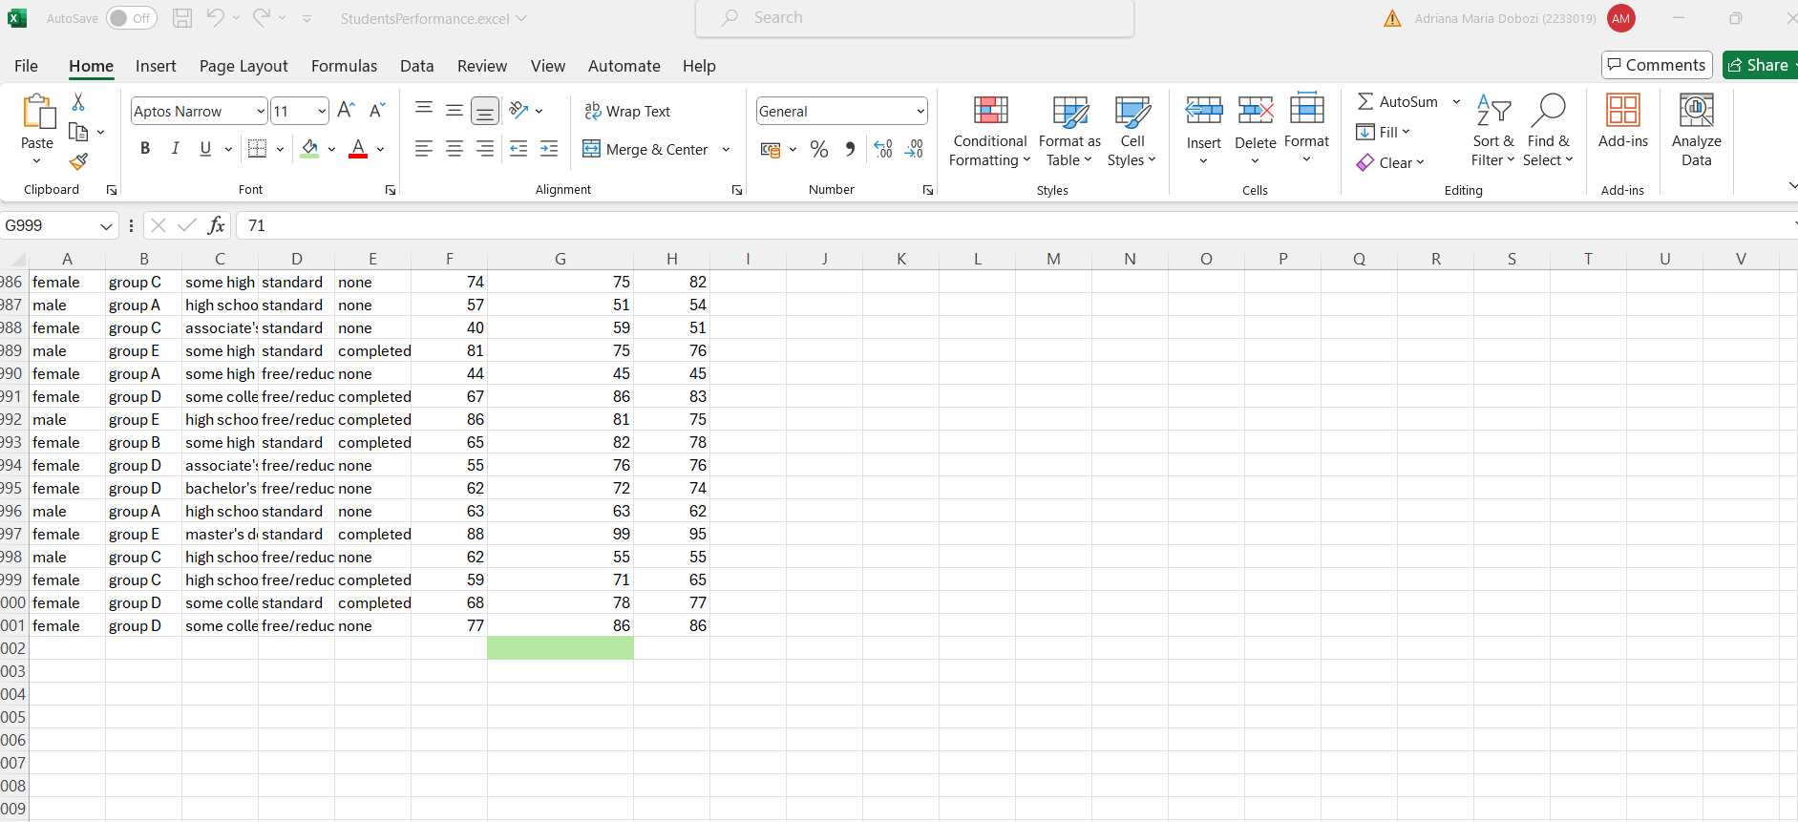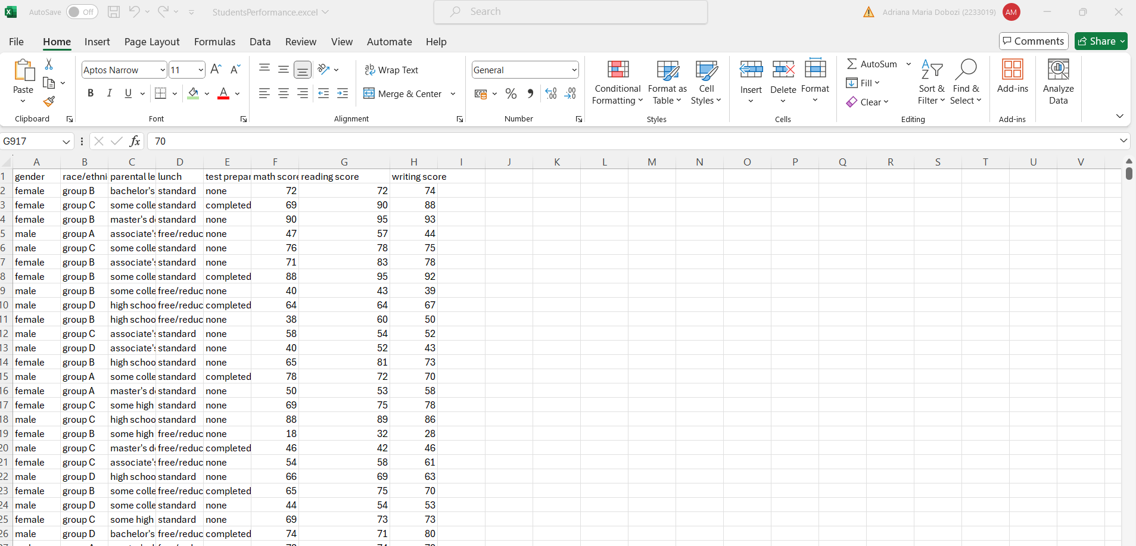
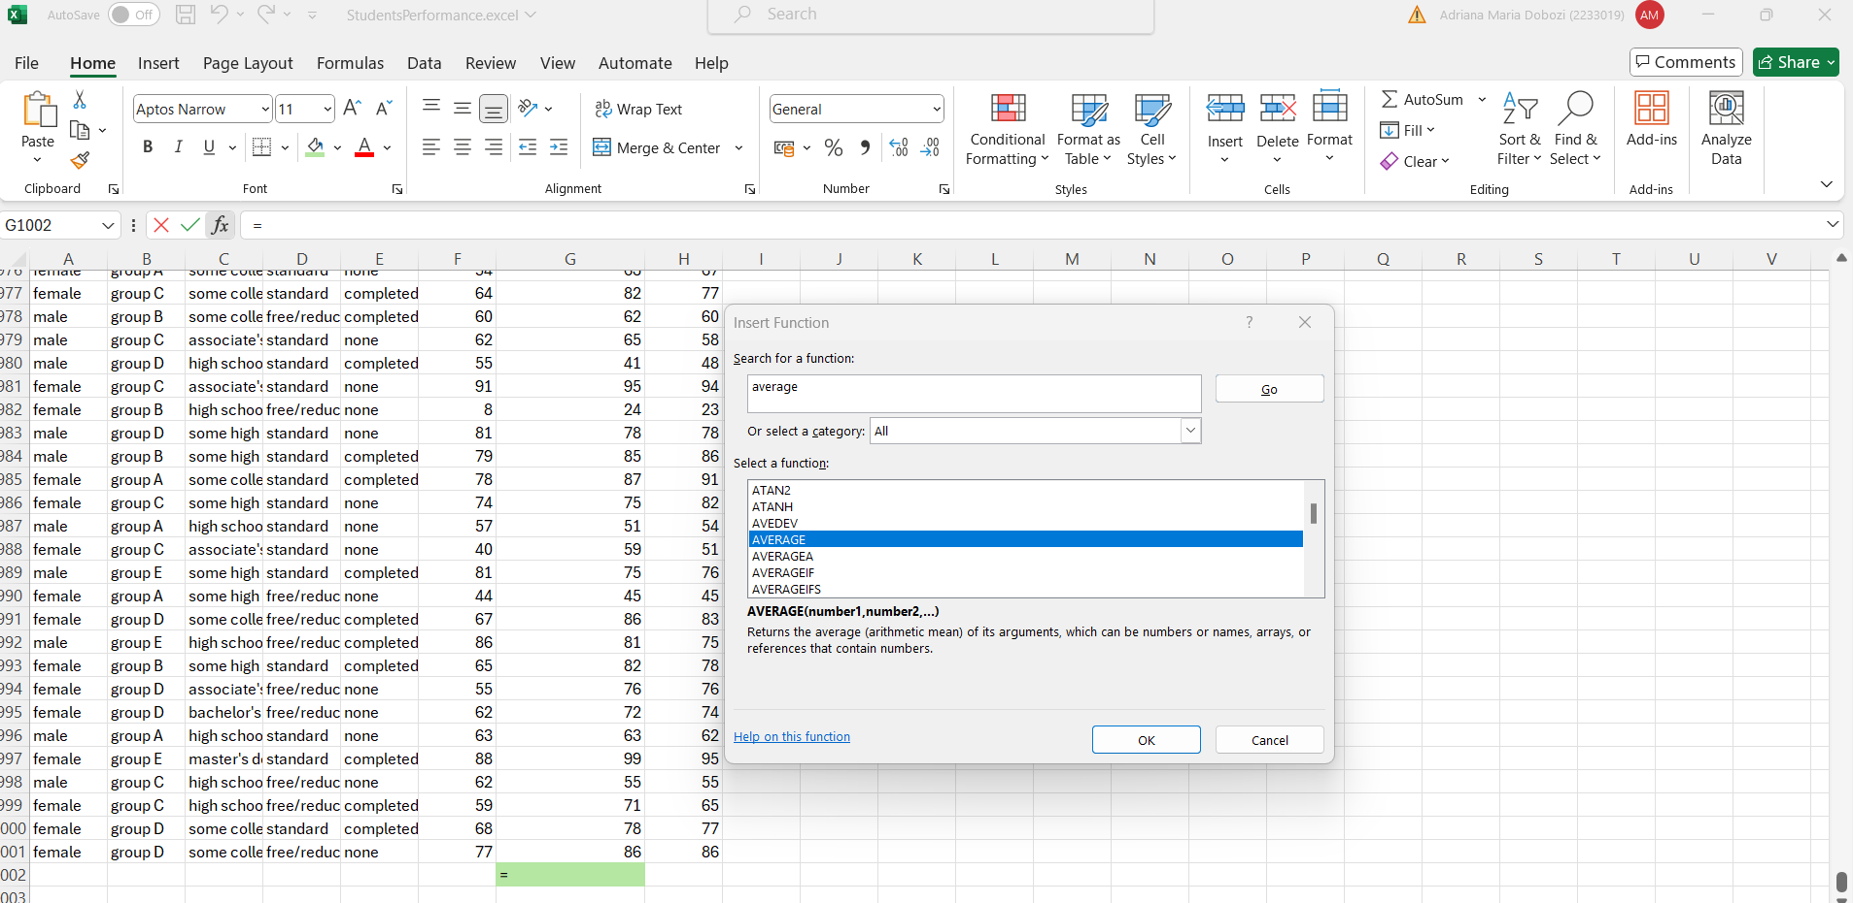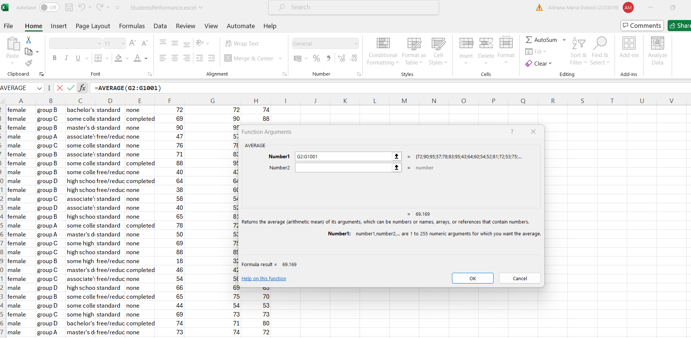

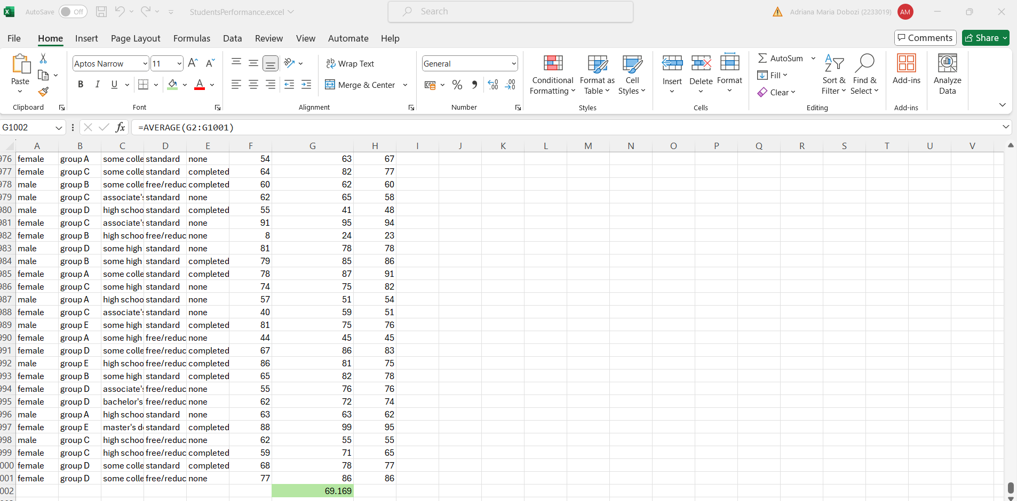
I selected the final cell of the column, I selected the function, I clicked ok, I inserted the required column, again ok and the result finally appeared.

The median value for reading score

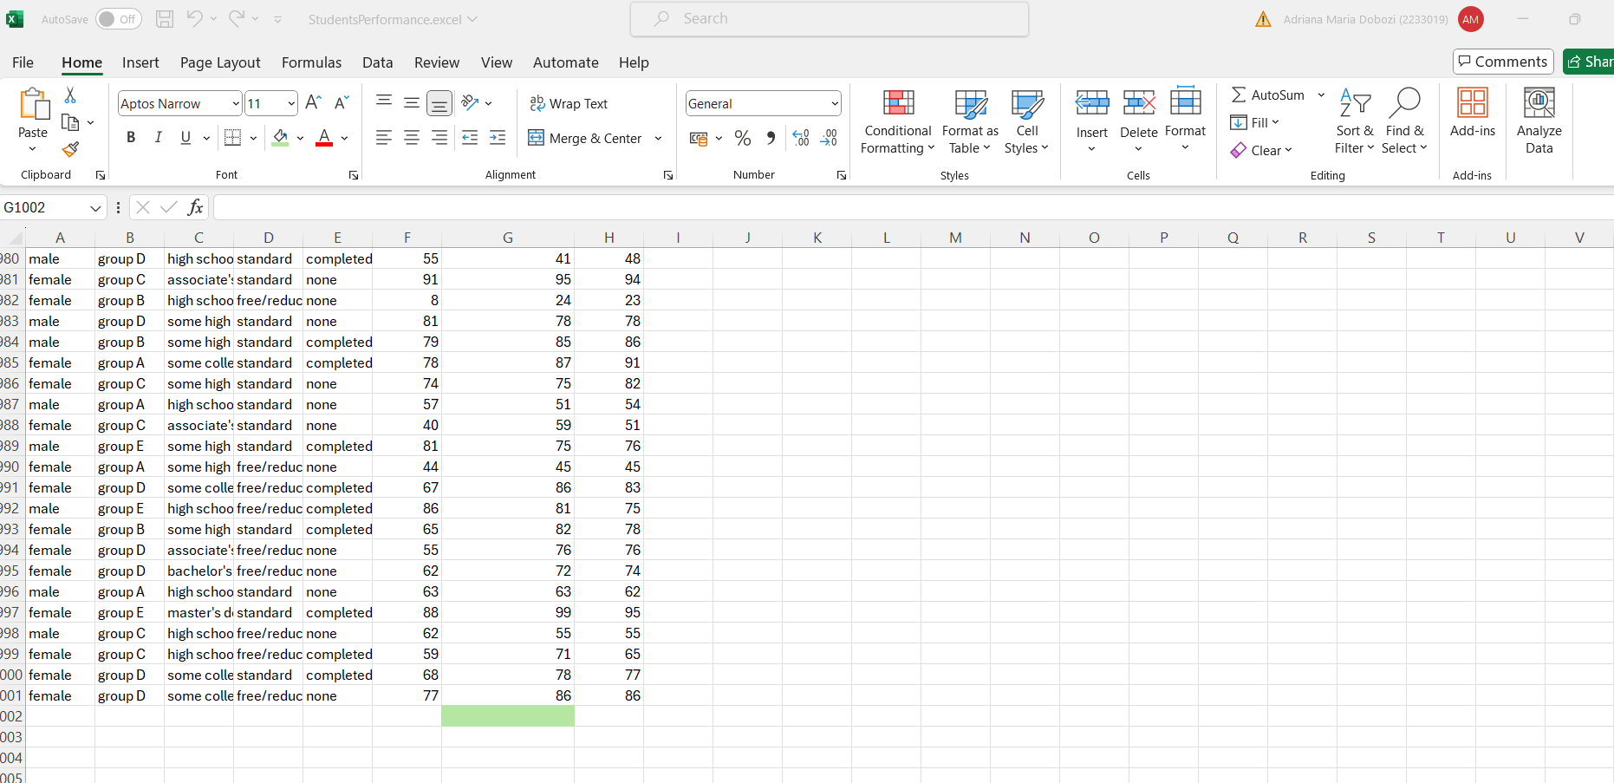
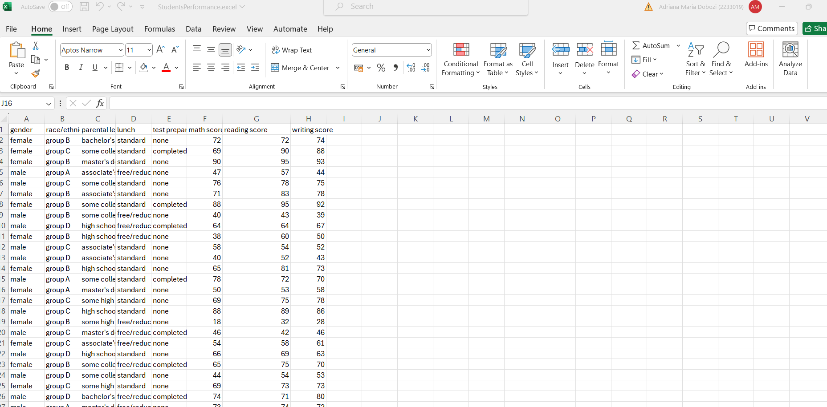

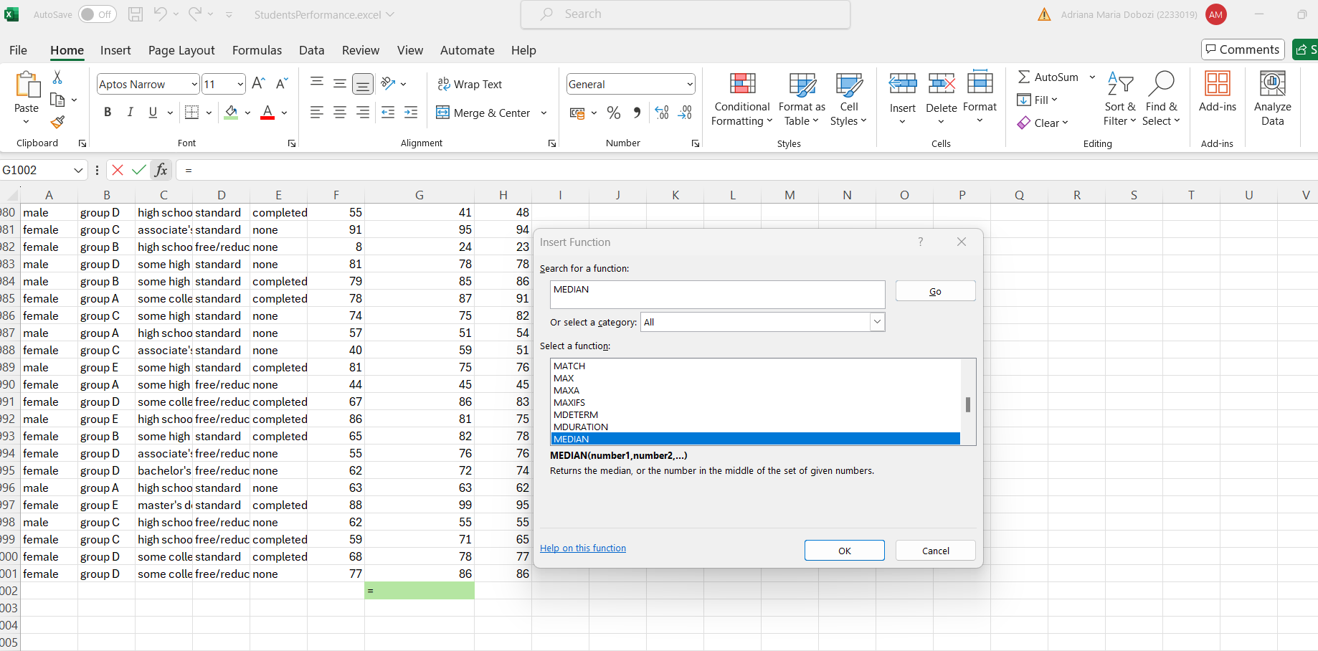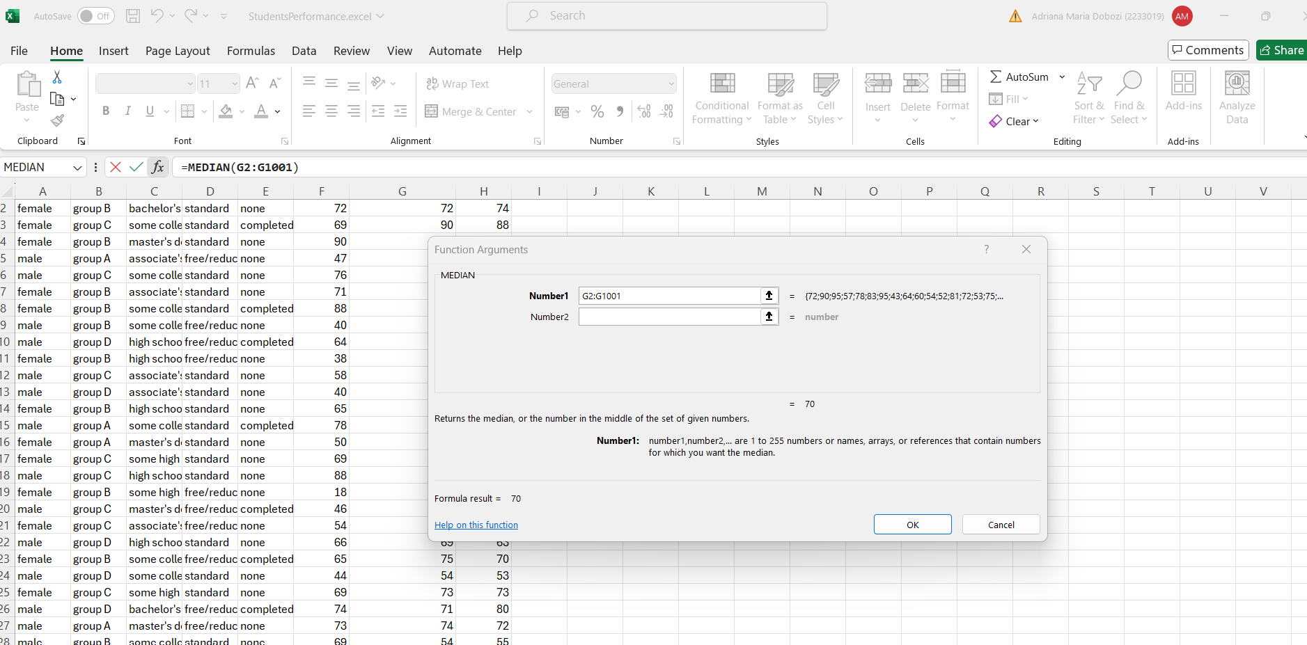
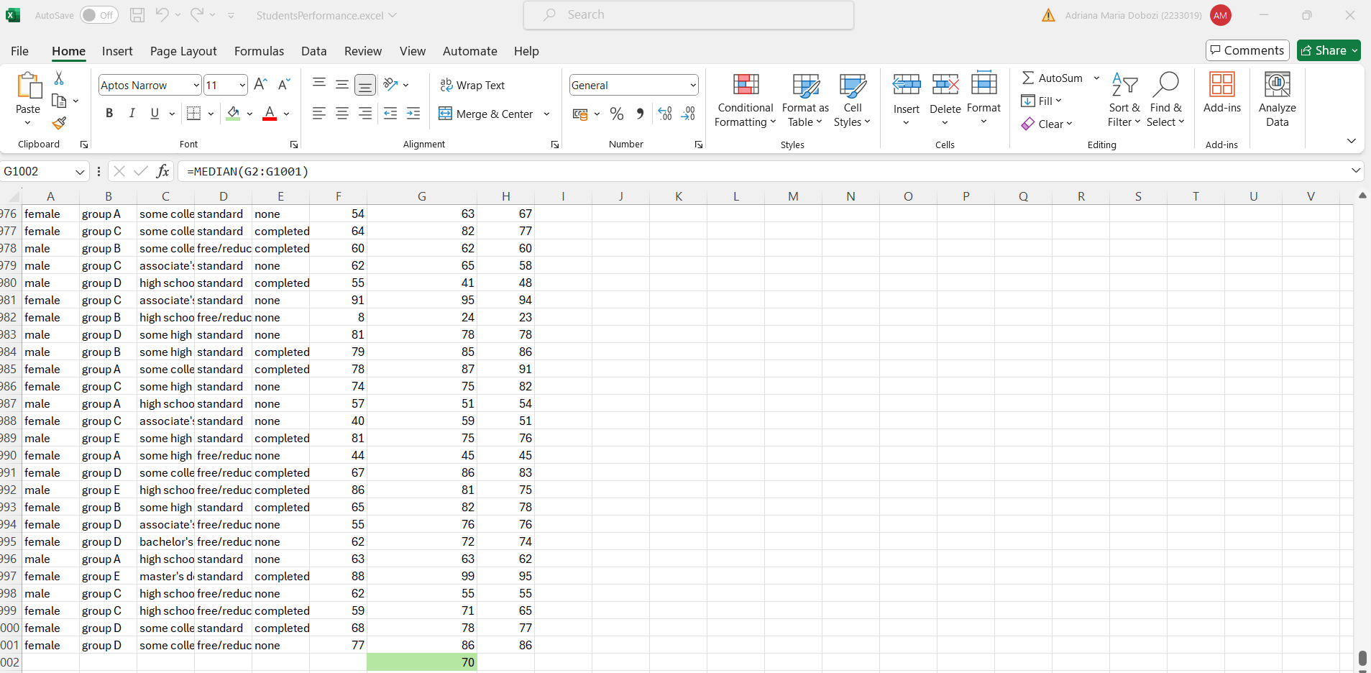

I selected the final cell of the column, I selected the function, I clicked ok, I inserted the required column, again ok and the result finally appeared.

The mode of reading score

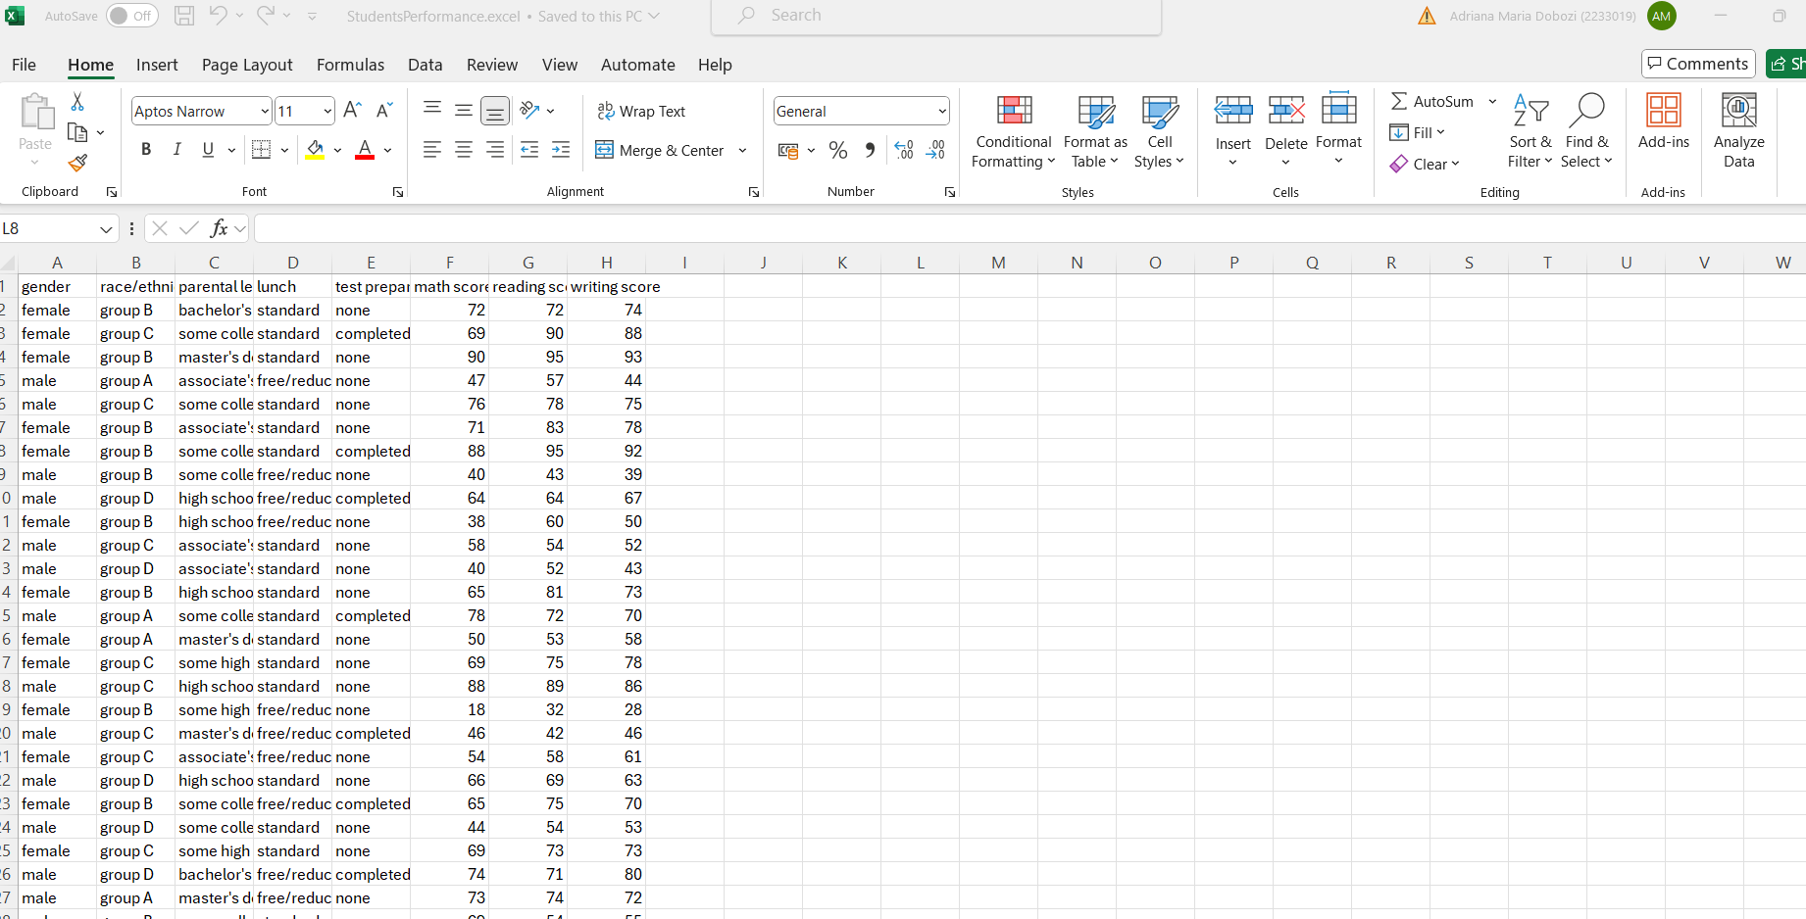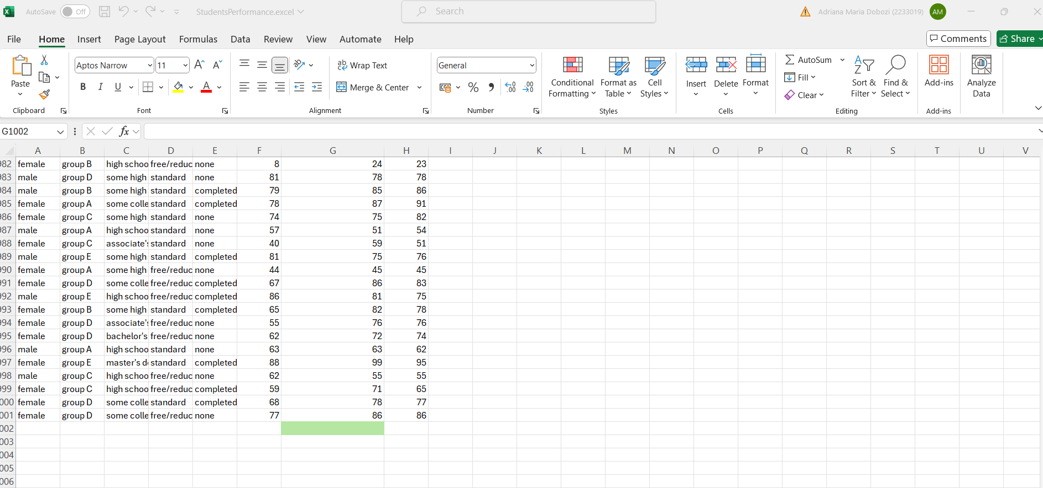
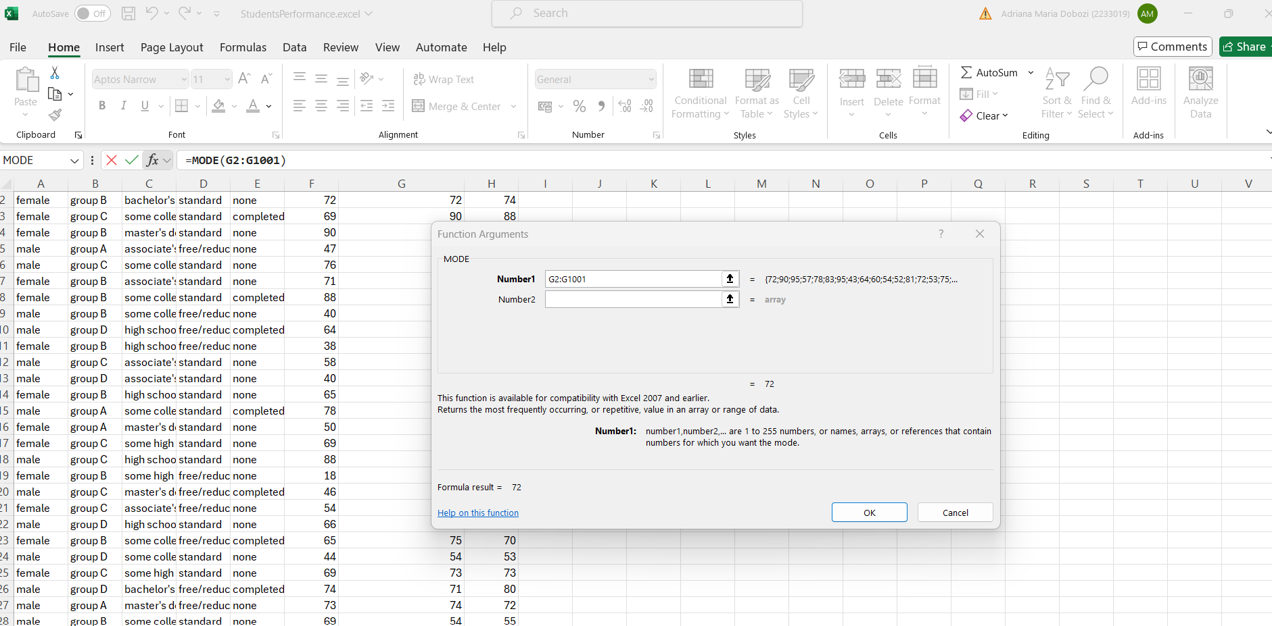

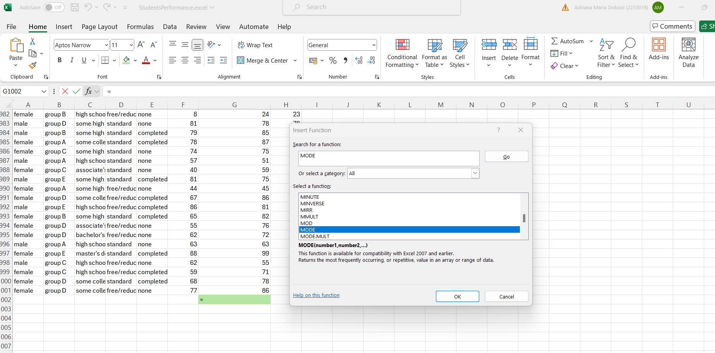
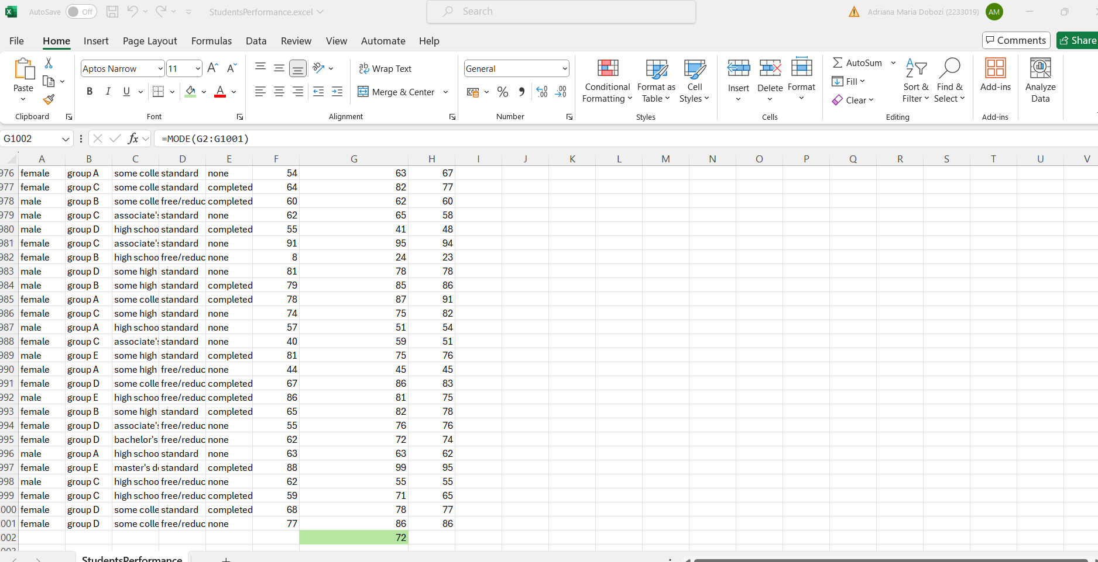
I selected the final cell of the column, I selected the function, I clicked ok, I inserted the required column, again ok and the result finally appeared.

The standard deviation for writing score

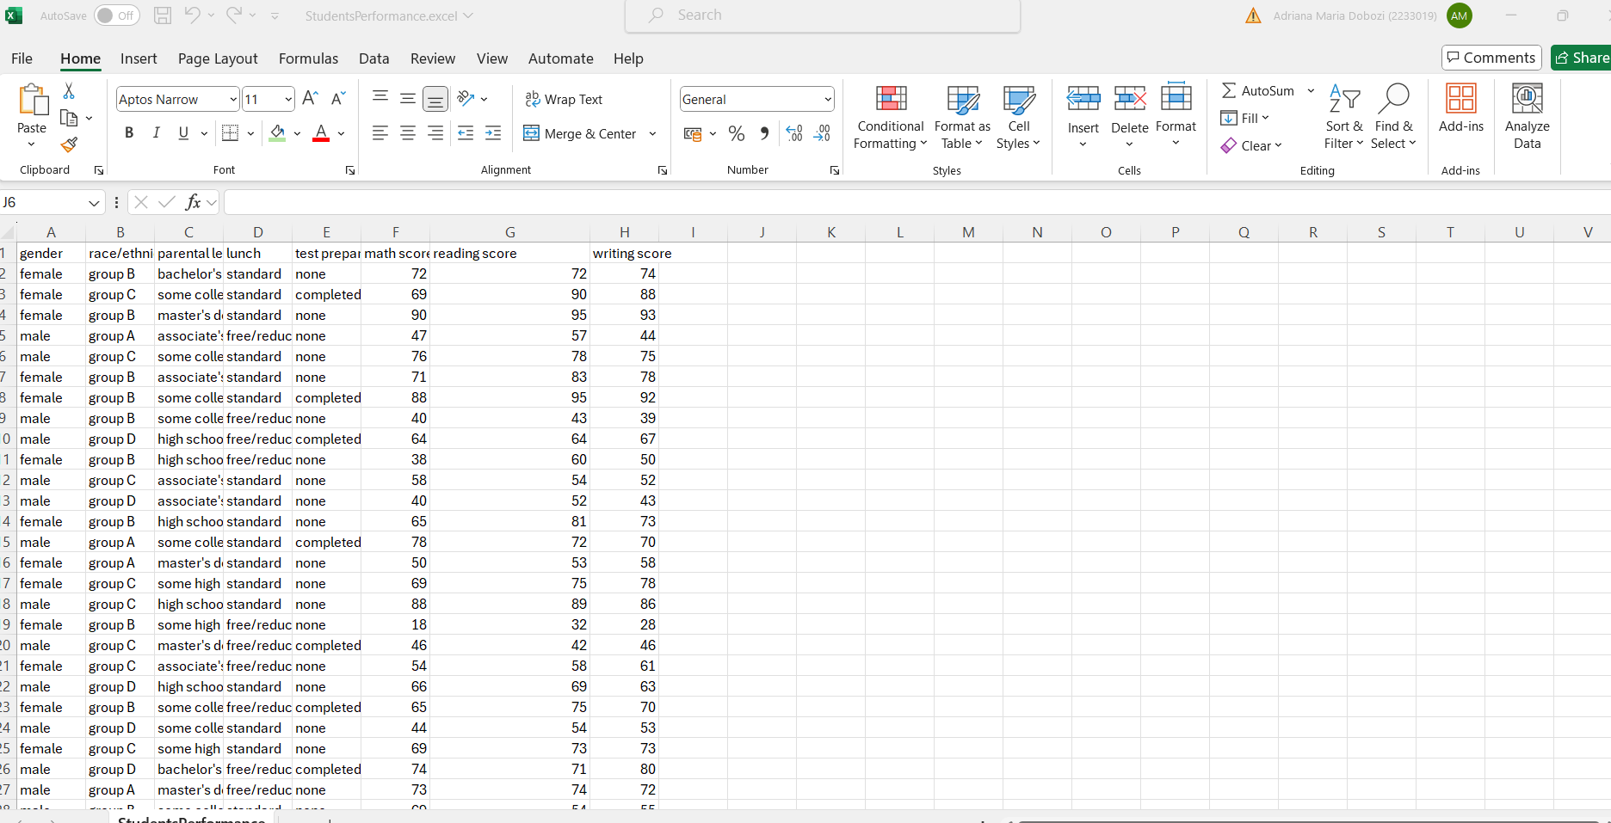

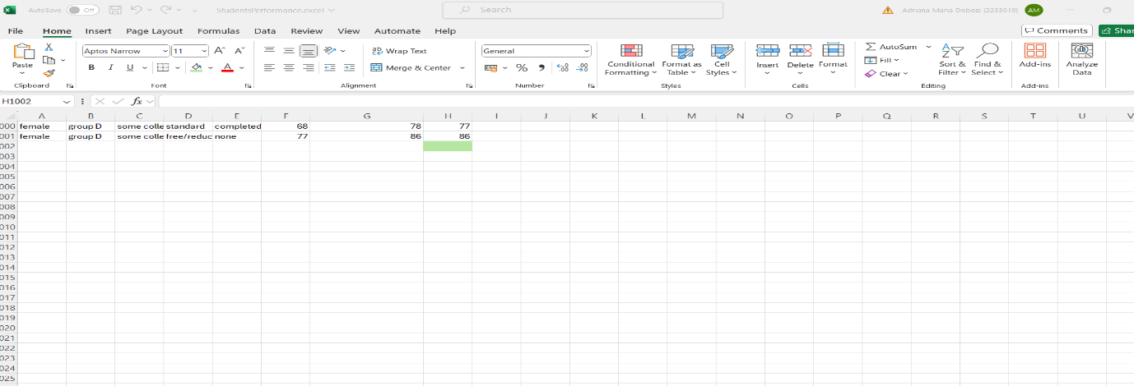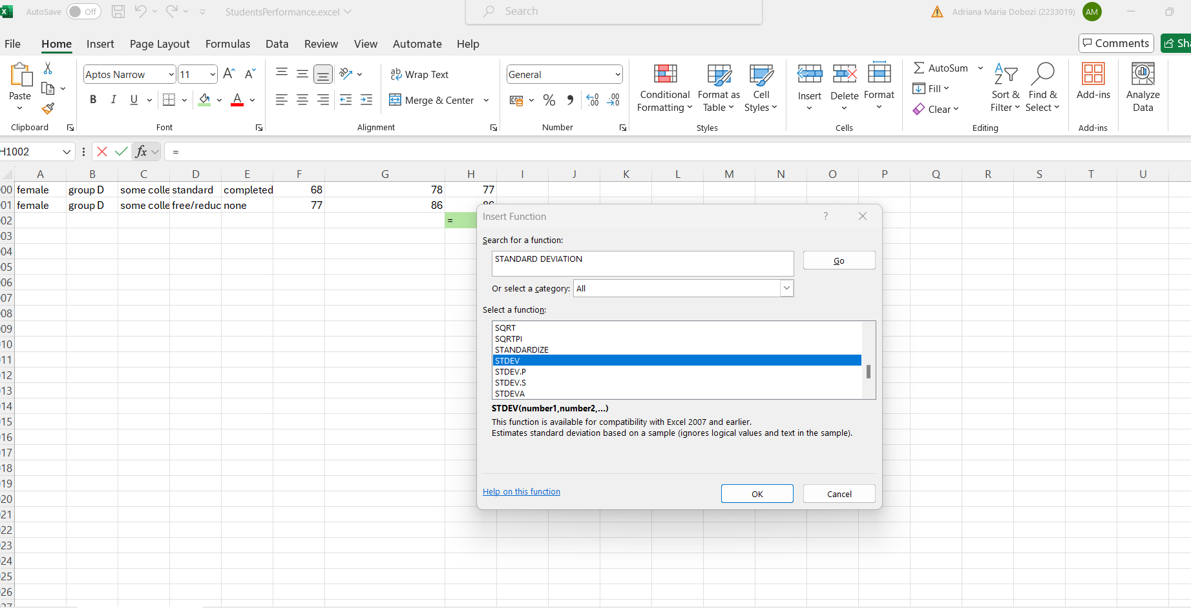

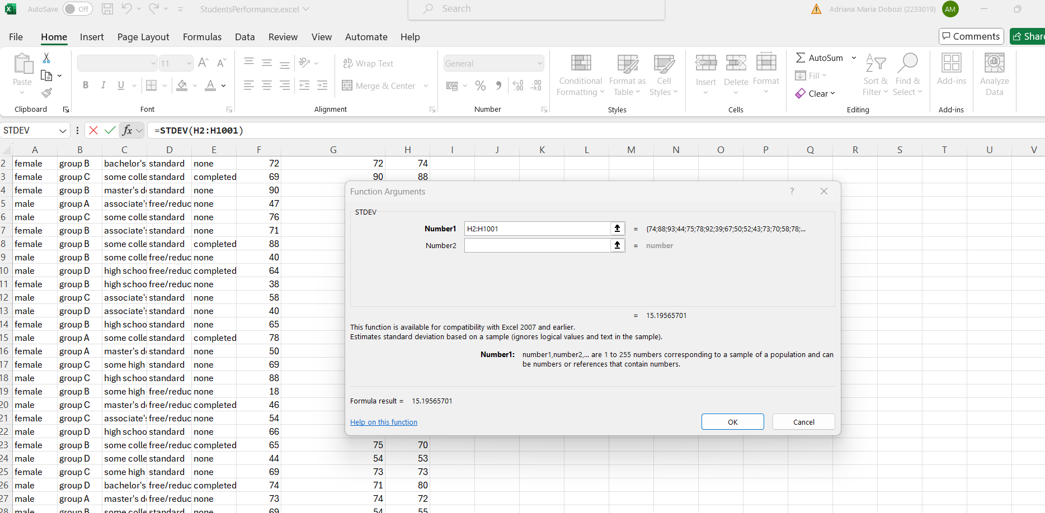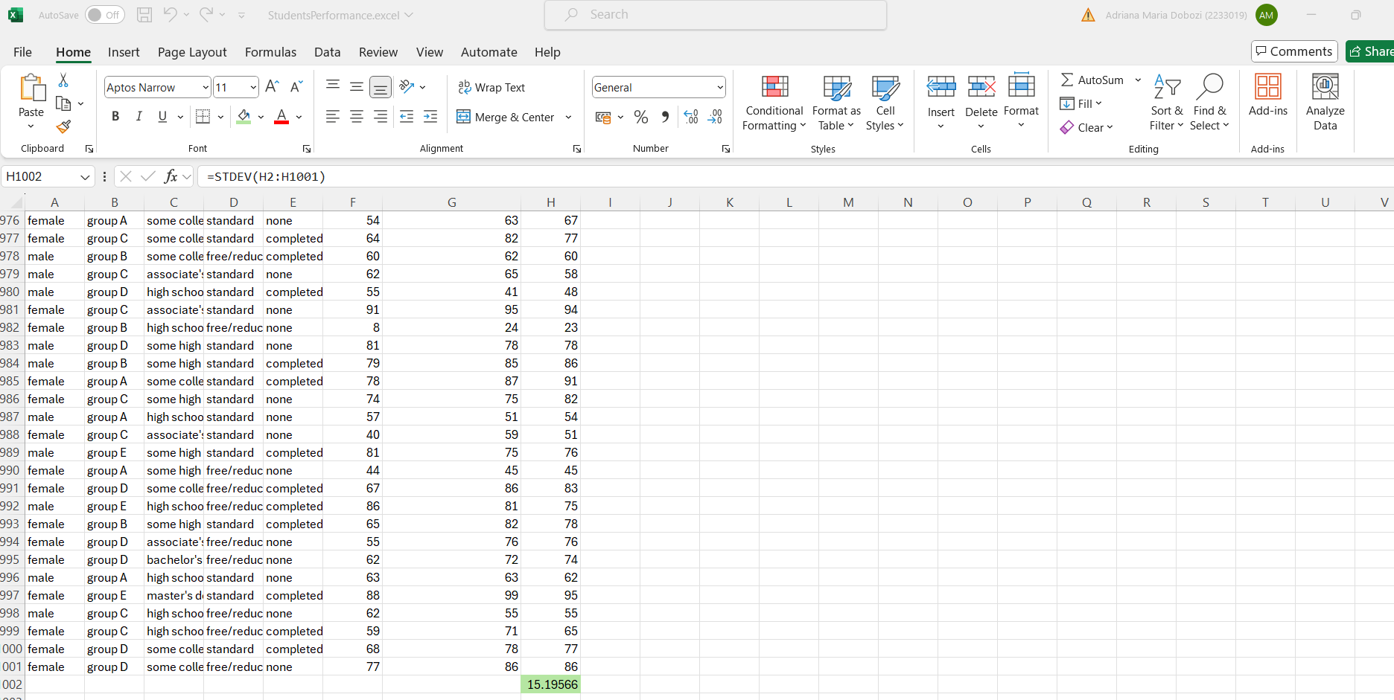

I selected the final cell of the column, I selected the function, I clicked ok, I inserted the required column, again ok and the result finally appeared.

The larger variance

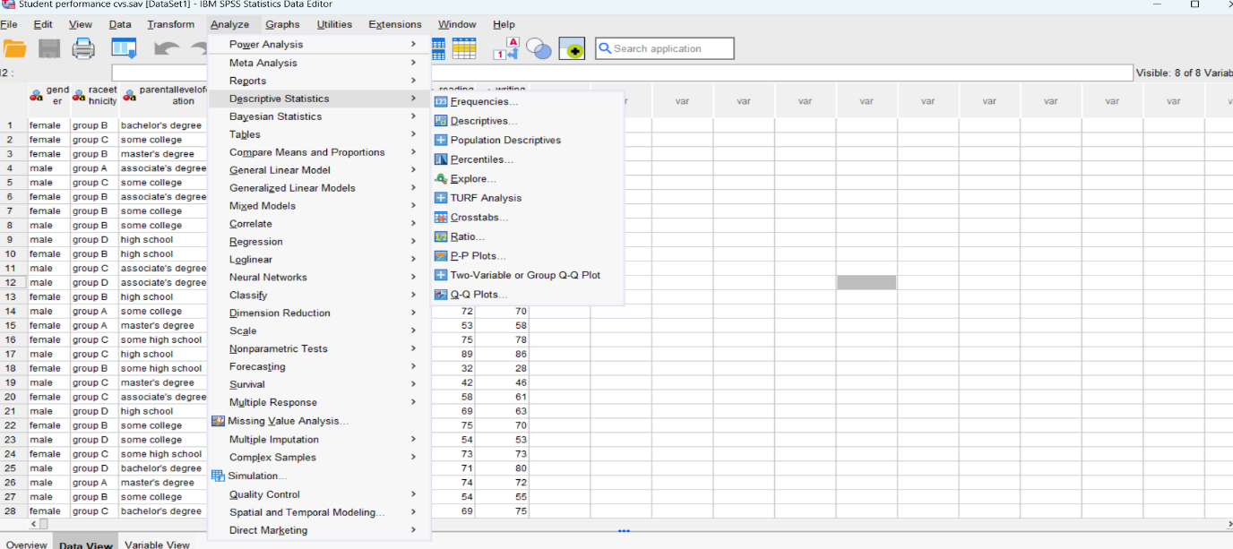
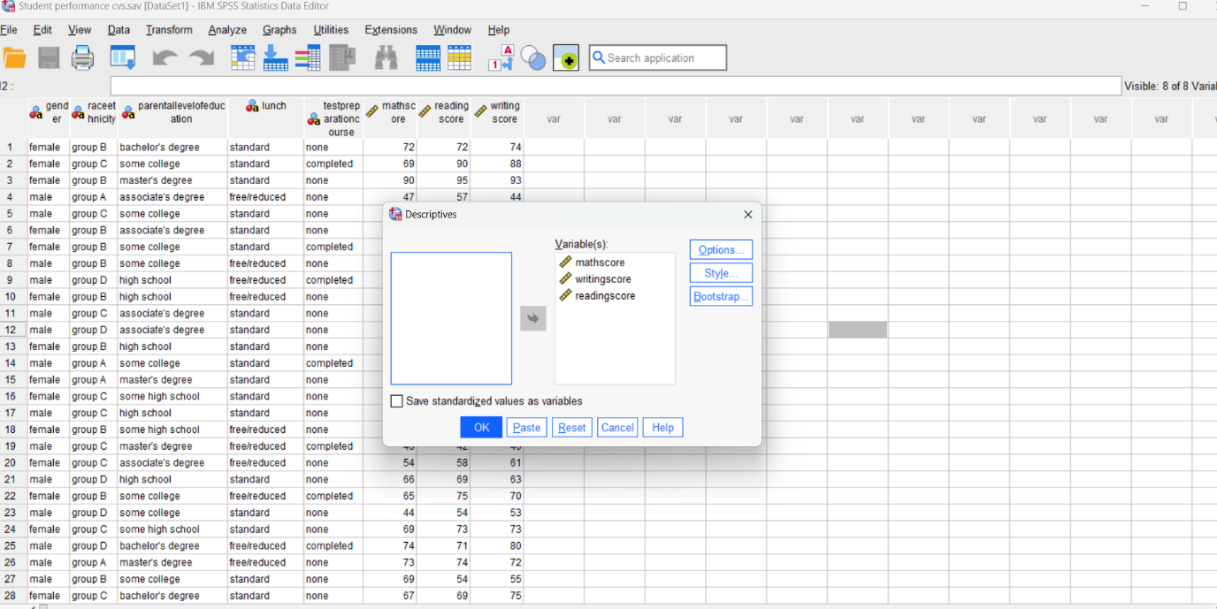
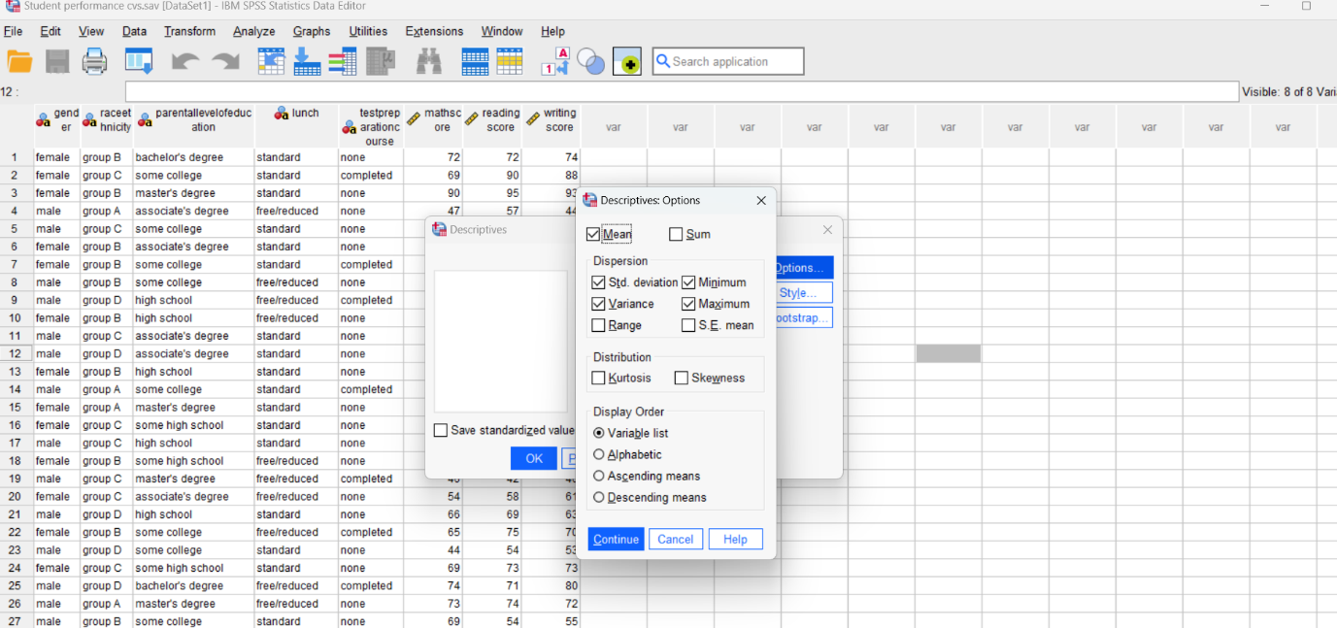
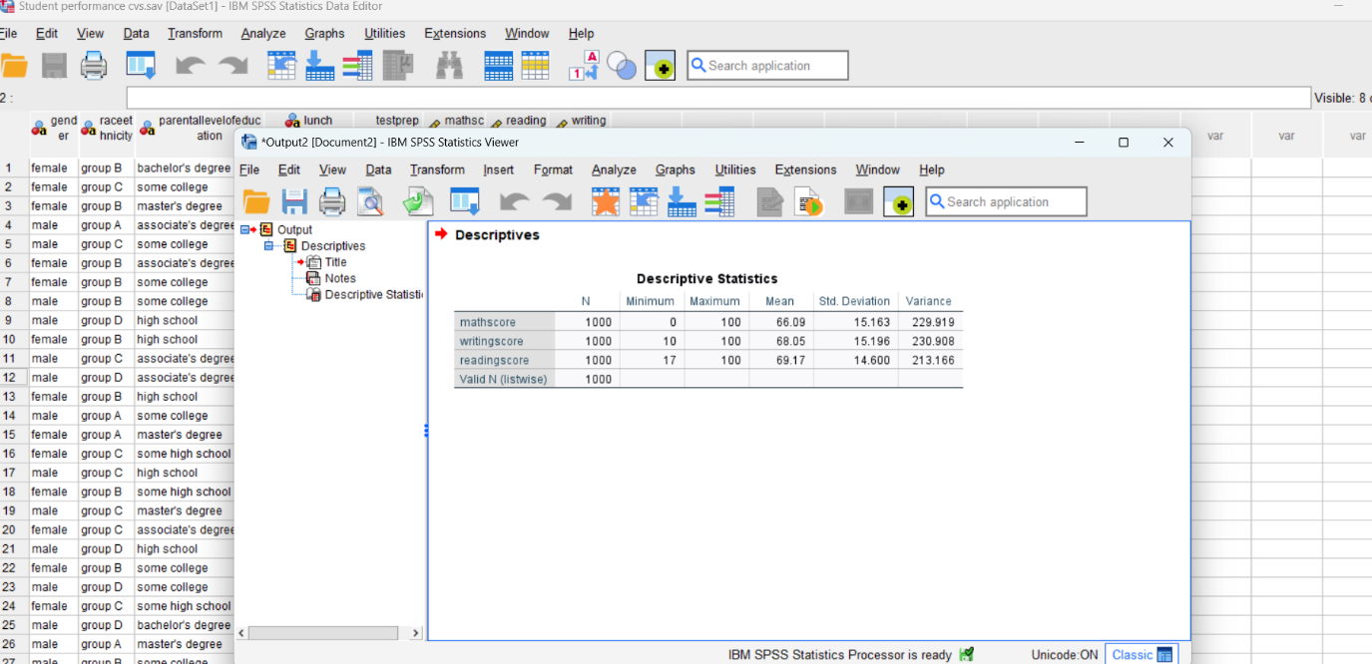

The writing score has a larger variance.
This time the SPSS was used, I opened it in data view mode, went to analyze, descriptive statistics, descriptives, on the variables should be our data, the I went to options, ticked standard deviation and variance, continue and finally reached the result.

The larger standard deviation

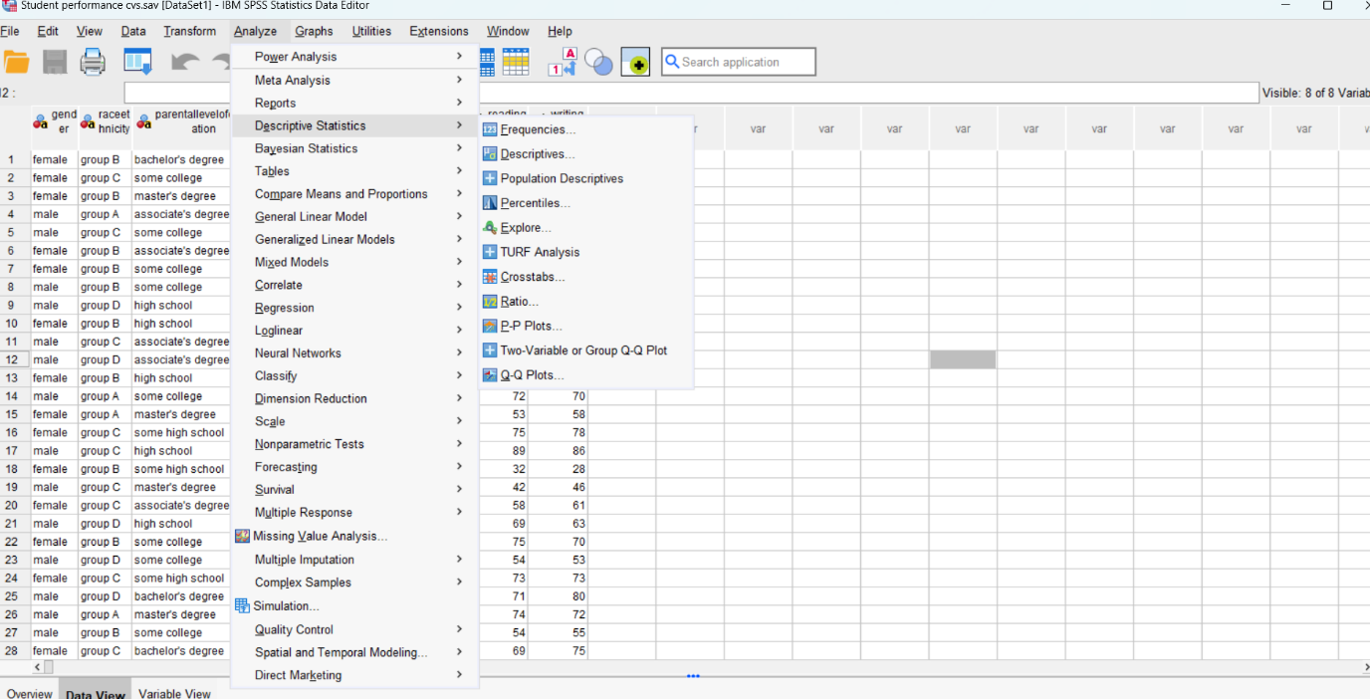

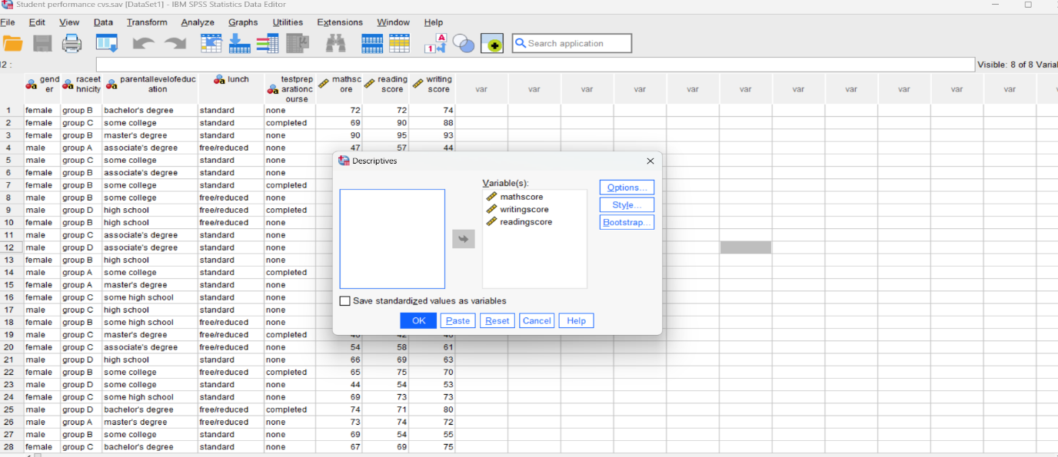
The writing score has a larger standard deviation.
This time the SPSS was used, I opened it in data view mode, went to analyze, descriptive statistics, descriptives, on the variables should be our data, the I went to options, ticked standard deviation and variance, continue and finally reached the result.

If function

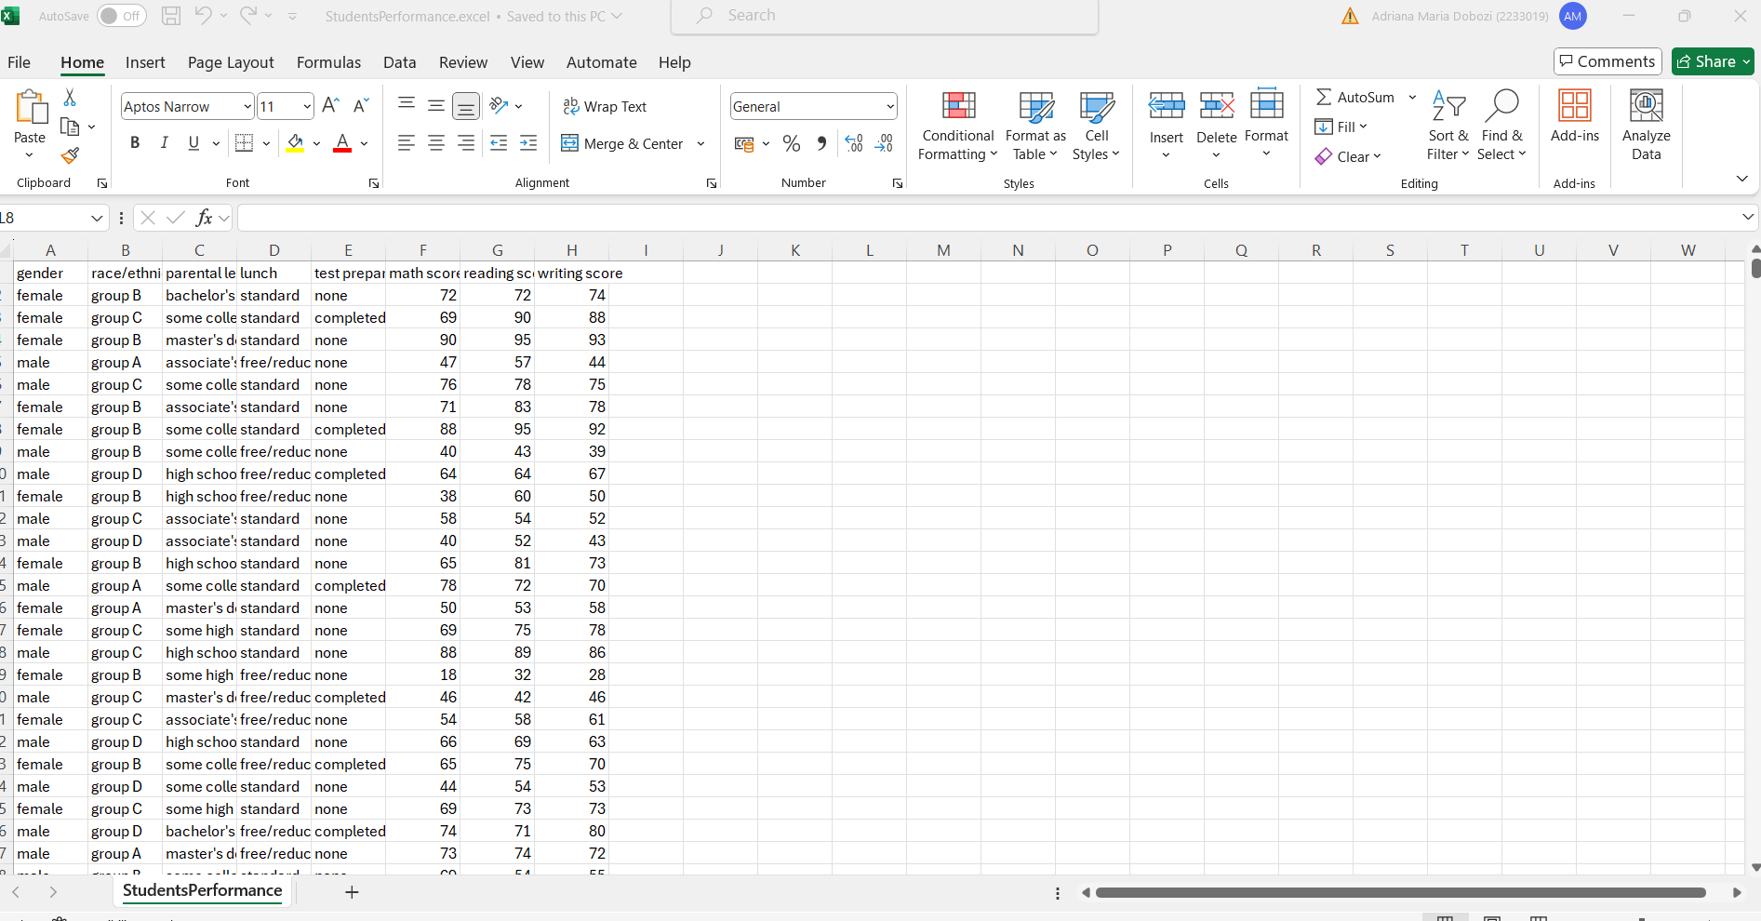
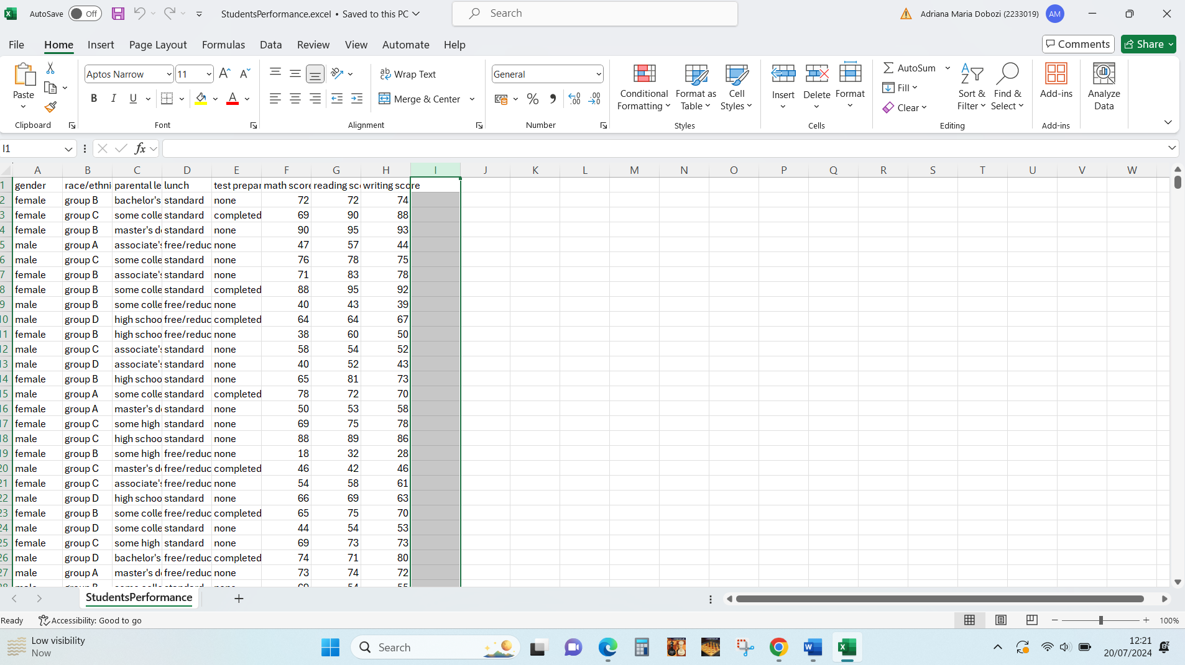

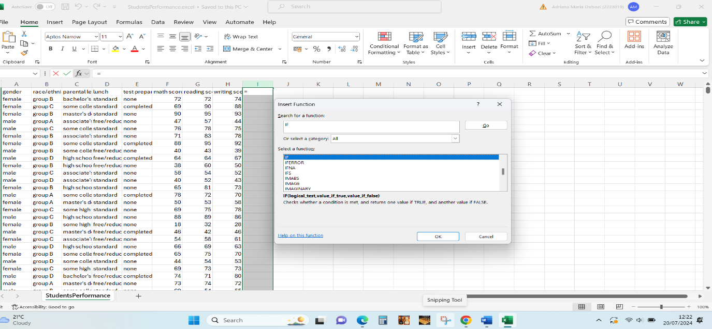
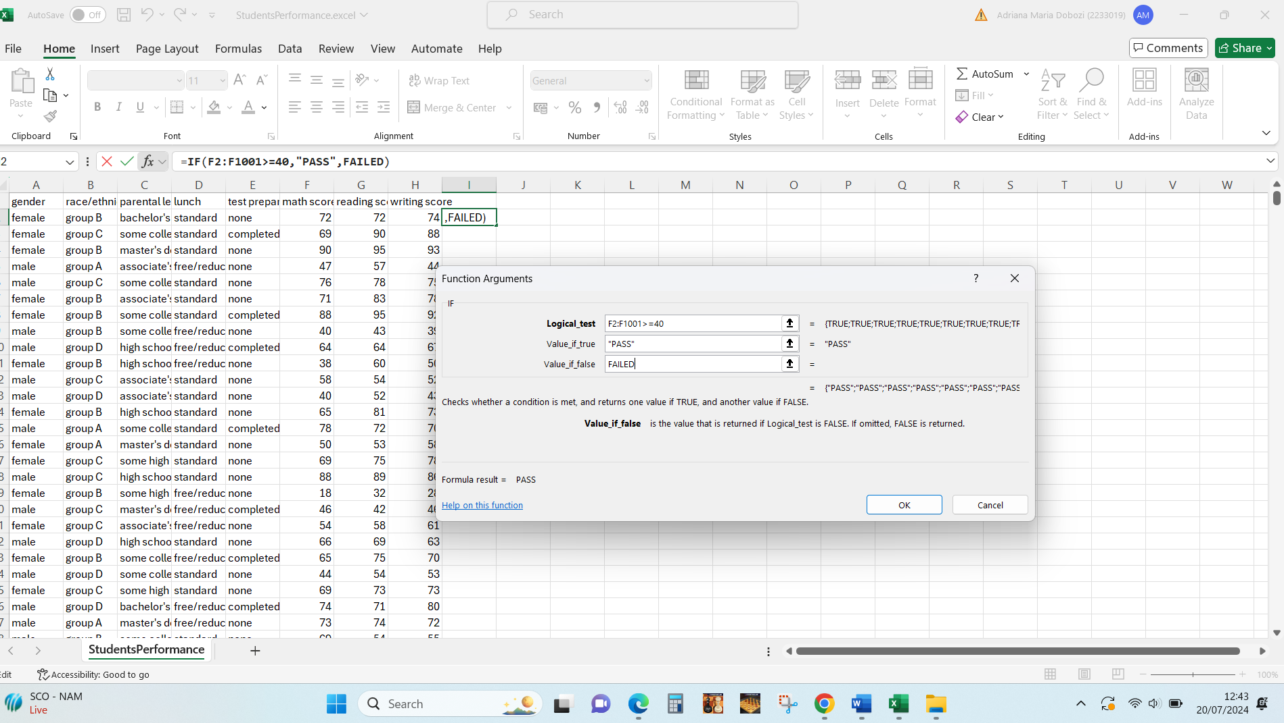
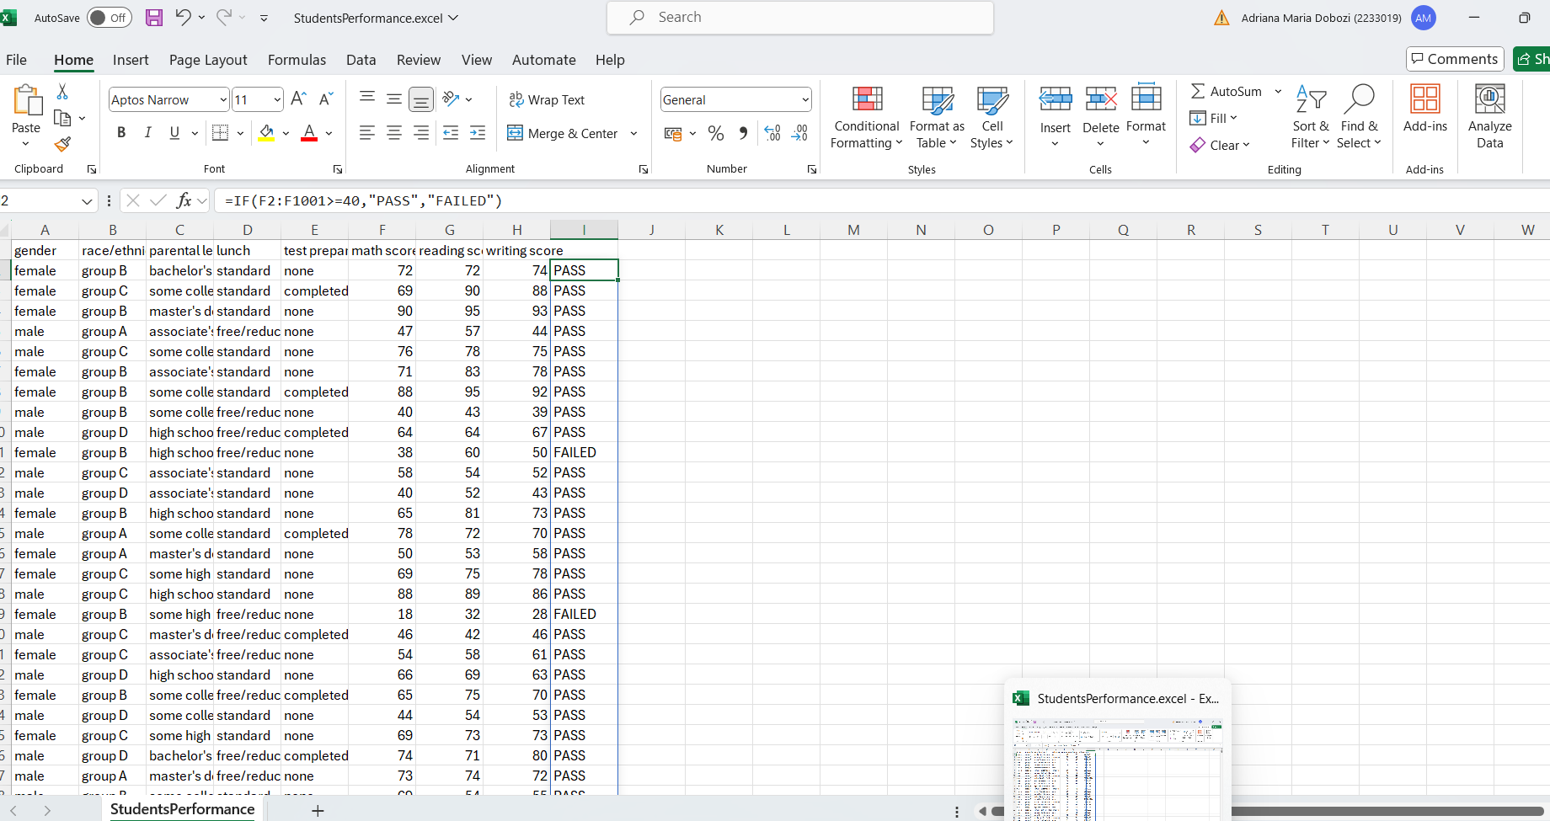
I selected the column, I selected the function, I clicked ok, I inserted for logical test the formula: who has 40 or more, passes the exam, again ok and the result finally appeared

Correlation between reading and writing score

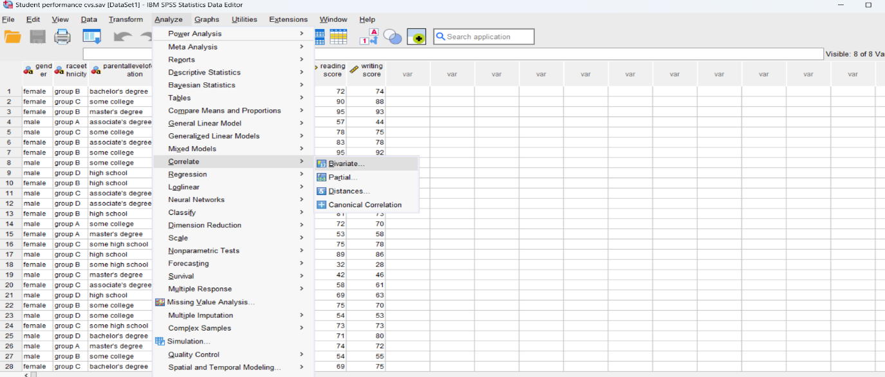
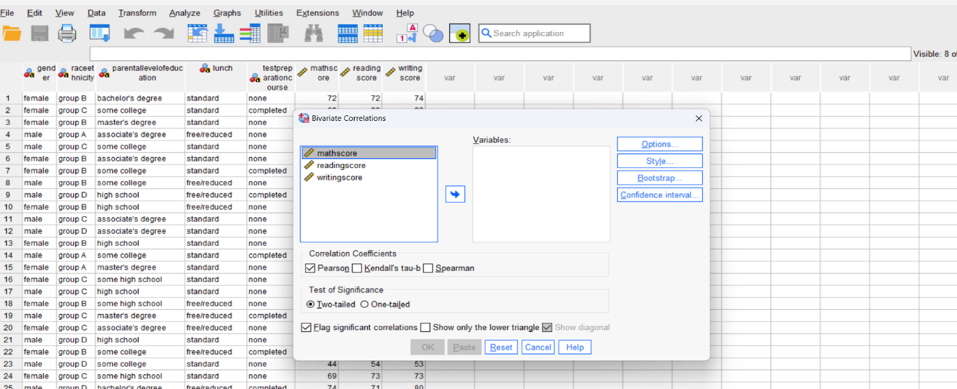
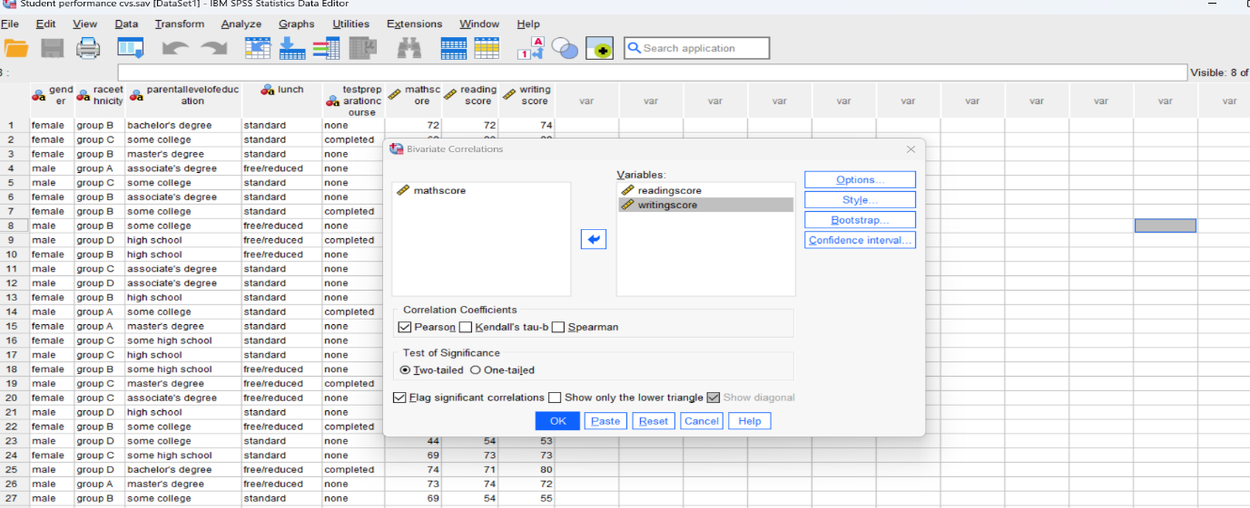
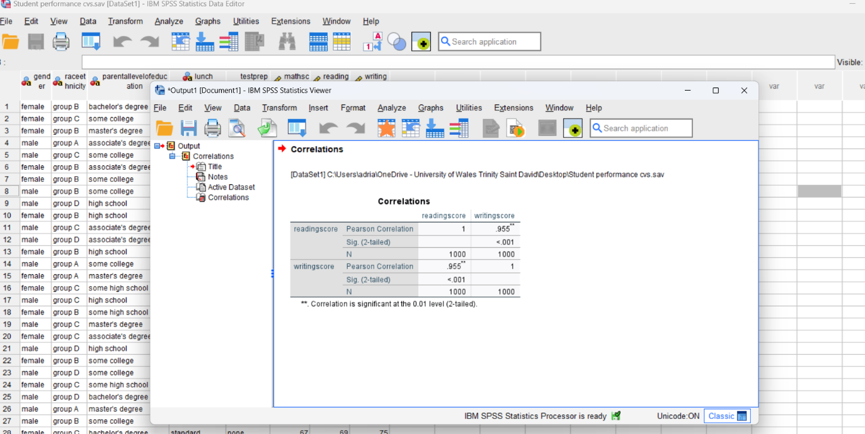

This time the SPSS was used, I opened it in data view mode, went to analyze, correlate, bivariate, moved the reading score and writing score to variables, ok and finally reached the result.

Scatter dot between reading and writing score

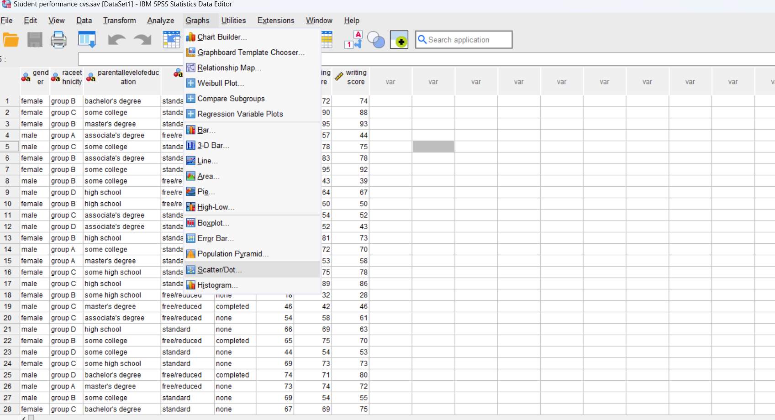

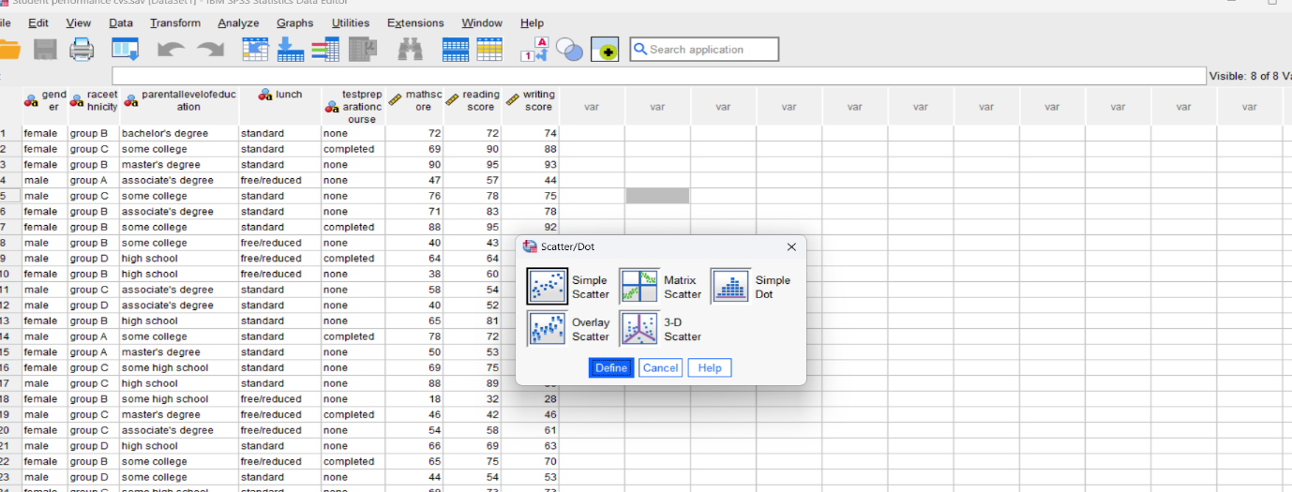
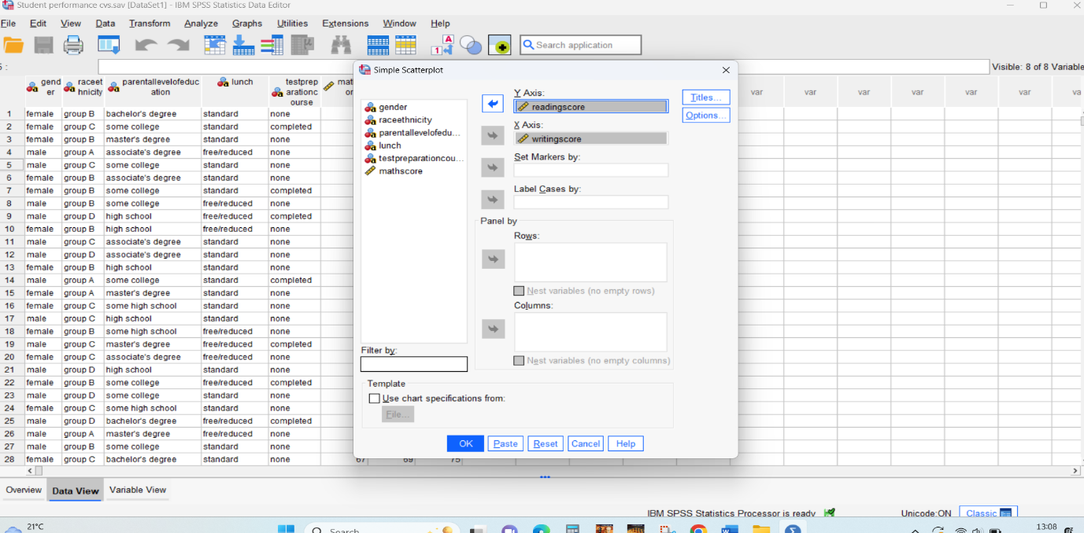
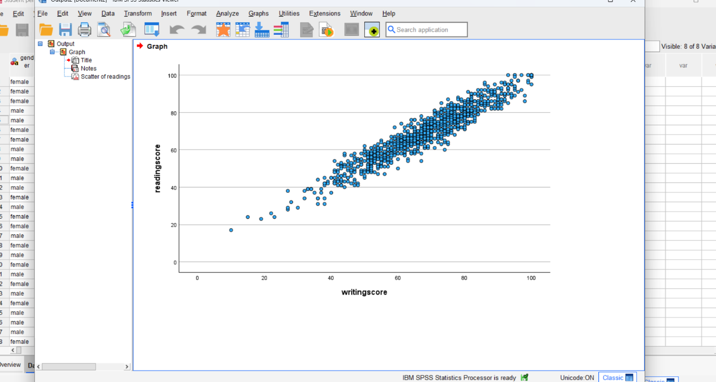

This time the SPSS was used, I opened it in data view mode, went to graphs, scatter dot, simple scatter, define, on Y axis I put reading score, on X axis writing score, ok, and reached the graph.

4. Conclusion

The 2023 research has made a substantial contribution to our understanding of the health impacts of coffee. Coffee still contains important antioxidants and drinking it has been linked to a lower risk of developing several diseases, but there are some drawbacks. Research suggests that a moderate amount of coffee can increase mental clarity, lower the risk of some chronic illnesses, and improve metabolic health.
On the other hand, overindulgence may have negative consequences such as elevated anxiety, insomnia, and heart problems in those who are vulnerable. The relationship between coffee consumption and unique health profiles implies the need for tailored advice. Coffee's health consequences are complicated, and as science works to understand them, it's becoming more and more obvious that moderation and customisation are essential. These 2023 insights offer a comprehensive viewpoint that can influence dietary recommendations and individual behaviours, ensuring that coffee enjoyment is balanced with health-related considerations.
Increased worldwide demand, a move towards speciality coffee, and technological developments that improve the coffee experience will all contribute to the growth of coffee consumption in 2023. While there are many health benefits associated with regular coffee use, excessive consumption might have negative effects. With continuous initiatives to promote fair trade and ecological practices, the coffee business has a substantial impact on the world economy and social systems. Given the continued importance of coffee in daily life, it is critical to weigh its advantages against conscious usage and a dedication to sustainability.

6. Advantages and disadvantages of using SPSS, Excel

Benefits of the Statistical Package for the Social Sciences, or SPSS:
Specialised in Statistical Analysis: Because SPSS was created especially for intricate statistical analyses, data analysis jobs may be completed with great efficiency. For instance, SPSS can easily manage several tests like ANOVA, regression, and factor analysis in psychological research (Pallant, 2020).
User-Friendly Interface: Even someone with little experience with statistics may easily use SPSS's simple, menu-driven interface. When compared to programming-based tools such as R or another software well-known Python, this lowers the learning curve (Field, 2017).
Rich Support and Documentation: There is a sizable user community and a wealth of tutorials and documentation included with the product. This guarantees that users will have no trouble locating resources and assistance when they need them (Bryman and Cramer, 2011).
Data Management Capabilities: SPSS is excellent at handling missing data and handling big datasets. Data manipulation, case selection, and file reshaping are among its functions that are essential for getting ready data for different studies and analysis (Norušis, 2012).
Drawbacks: Cost: The high cost of SPSS might be a major deterrent for small organisations or lone researchers. When compared to other programs like Excel or free alternatives like R, licensing costs may be unaffordable (Landau and Everitt, 2004).
Restricted Flexibility: Although SPSS is an excellent tool for traditional statistical methods, it may not be as adaptable for unique or non-standard studies. Compared to programming languages that offer greater options, advanced users may find it restricted (Pallant, 2020).
Performance with huge Datasets: Although SPSS performs better than Excel when handling huge datasets, it can still have problems with very large data files, which might cause crashes or other performance problems (Field, 2017).
Benefits of Excel: Cost and Accessibility: Since Excel is widely available and frequently included in the Microsoft Office suite, it is an affordable for customers (Walkenbach, 2018).
Ease of Use: Many people are familiar with Excel's interface, and it's simple to pick up the essential features. This it is usable for computations and basic data processing jobs (Frye, 2015).
Excel's versatility allows it to be used for a multitude of activities outside statistical research, including scheduling, budgeting, and data visualisation. Because of this, it can be used for both corporate and academic purposes (Winston, 2019).
Integration with Other Software: Excel's seamless integration with a range of data sources and other Microsoft Office applications makes data import and exporting simple (Walkenbach, 2018).
Drawbacks: Restricted Statistical Capabilities: Excel lacks the sophisticated statistical features found in specialised software like SPSS, although it is still capable of performing basic statistical studies. For instance, using Excel to do intricate processes is difficult (Frye, 2015).
Excel is prone to errors due to its flexibility, particularly when working with complex formulas or huge datasets. Errors in formula setup and manual data entry raise the possibility of affecting the results of analyses (Winston, 2019).
Performance Problems: Excel may have trouble processing very big datasets, which can cause crashes or sluggish performance. For projects with a lot of data, this could be a problem because it is not designed to handle large amounts of data (Frye, 2015).

7. The meaning and the importance of Data Mining Cycle

The Cycle of Data Mining
The practice of extracting knowledge and patterns from massive volumes of data is called data mining. In order to methodically extract valuable information and insights from datasets, the data mining cycle is essential. Usually, there are multiple stages in this cycle.
Understanding the issue and establishing the goals of the data mining project are part of this first phase. For instance, in order to enhance sales tactics, a retail business may wish to find trends in the purchase behaviour of its customers. (Han, Pei, and Kamber, 2012).
Data Collection: A variety of sources provide pertinent data that is compiled. This might contain information on online behaviour, consumer demographics, and transaction records from the retail example. A full and pertinent dataset is guaranteed by efficient data gathering
(Fayyad, Piatetsky-Shapiro, and Smyth, 1996).
Data Preparation: To address missing values, outliers, and noise, data is cleaned and pre-processed. Because it directly affects the calibre of the data mining results, this stage is crucial. The data is prepared using methods including aggregation, transformation, and normalisation (Han et al. 2012).
Data Exploration: To discover the underlying patterns and correlations in the data, exploratory data analysis, or EDA, is carried out. Trends and anomalies can be found with the aid of summary statistics and visualisation tools. Trends in sales data may be shown via
EDA (Tukey, 1977).
Data Modelling: In order to create models, this step entails choosing and utilising the proper data mining algorithms. Depending on the issue, different techniques are applied, including association rule learning, clustering, regression, and classification. To forecast client attrition, for instance, a classification model may be developed (Han et al. 2012).
Evaluation: Metrics such as F1 score, accuracy, precision, and recall are used to assess the models. This phase guarantees that the models are trustworthy and achieve the goals specified during the problem definition phase. Common procedures include testing on different datasets and also about the well-known pattern term cross-validation (Fayyad et al. 1996).
Deployment: The finished models are put to use in a real-world setting by being placed in a production environment. To customise marketing efforts, the model in the retail example might be included into a CRM system (Han et al. 2012).
Maintenance and Monitoring: To guarantee that the models continue to work over time, ongoing monitoring is necessary. Model upgrades may be necessary due to modifications in external factors or data patterns. Frequent upkeep of the model (Fayyad et al. 1996).
Systematic Approach: According to Han et al. (2012), adhering to a structured cycle guarantees that every step is carried out carefully which means certain patterns.
Data Quality: According to Tukey (1977), maintaining excellent data quality is essential for precise and insightful analysis. This can be achieved by placing an emphasis on data preparation and exploration.
Model Accuracy: Appropriate assessment and validation of models guarantee their accuracy and dependability while making decisions. This lowers the possibility of mistakes and increases the validity of the learnt lessons from the past experiences (Fayyad et al. 1996).
Adaptability: Consistent maintenance and monitoring enable models to adjust to shifting external circumstances and data patterns, guaranteeing their long-term viability (Han et al. 2012).
When it comes to data analysis, SPSS and Excel each have advantages and disadvantages. Large datasets and sophisticated statistical analysis are ideal uses for SPSS, while it has certain cost and flexibility constraints. Although Excel is more user-friendly and adaptable, it is less effective at managing intricate statistical processes and substantial amounts of data.
The data mining cycle is a methodical process for gleaning insightful information from data. It covers all phases, from problem formulation to implementation and upkeep, guaranteeing methodical implementation, high-quality data, precise modelling, and flexibility. For data mining initiatives to be successful, it is essential to comprehend and adhere to this cycle since it produces more dependable and useful findings.

8. Reference list

Bryman, A., and Cramer, D. (2011). Quantitative Data Analysis with IBM SPSS 17, 18 and 19. Routledge.
Fair Trade International. (2023). Annual Impact Report. Retrieved from https://www.fairtrade.net/
Fayyad, U., Piatetsky-Shapiro, G., & Smyth, P. (1996). From Data Mining to Knowledge Discovery in Databases. AI Magazine, 17(3), 37-54.
Field, A. (2017). Discovering Statistics Using IBM SPSS Statistics. Sage.
Frye, C. (2015). Excel Data Analysis: Your visual blueprint for analysing data, charts, and PivotTables. Wiley.
Han, J., Kamber, M., and Pei, J. (2012). Data Mining: Concepts and Techniques. Morgan Kaufmann.
Harvard University. (2022). Coffee Consumption and Mental Health: A Meta-Analysis. Retrieved from https://www.harvard.edu/
International Coffee Organization. (2023). Global Coffee Consumption Report. Retrieved from https://www.ico.org/
Journal of the American Medical Association. (2023). Coffee Consumption and Chronic Disease Risk. JAMA, 329(1), 45-56. Retrieved from https://www.jamanetwork.com/
Landau, S., and Everitt, B. S. (2004). A Handbook of Statistical Analyses using SPSS. Chapman and Hall/CRC.
Mayo Clinic. (2023). Caffeine: How much is too much? Retrieved from https://www.mayoclinic.org/
Norušis, M. J. (2012). IBM SPSS Statistics 19 Guide to Data Analysis. Prentice Hall.
Osteoporosis International. (2023). Caffeine and Bone Health: New Insights. Osteoporosis Int, 34(2), 213-222. Retrieved from https://www.springer.com/journal/198
Pallant, J. (2020). SPSS Survival Manual: A Step by Step Guide to Data Analysis using IBM SPSS. Routledge.
Rainforest Alliance. (2023). Sustainable Coffee Farming Practices. Retrieved from https://www.rainforest-alliance.org/
Specialty Coffee Association. (2023). State of the Specialty Coffee Industry Report. Retrieved from https://www.scaa.org/
Statista. (2023). Global Coffee Market Value. Retrieved from https://www.statista.com/

