Thomas Nica
2122261
Philippa Fitzgerald

Title: Feasibility Plan for an International Meeting
[Assignment 1]
https://uowtsd-my.sharepoint.com/:v:/g/personal/2122261_student_uwtsd_ac_uk/EW_qVEyiECFOj6zEzrAsaa4Bthf-Y6lEW_506GpuXjZrVg?referrer=Teams.TEAMS-ELECTRON&referrerScenario=MeetingChicletGetLink.view.view

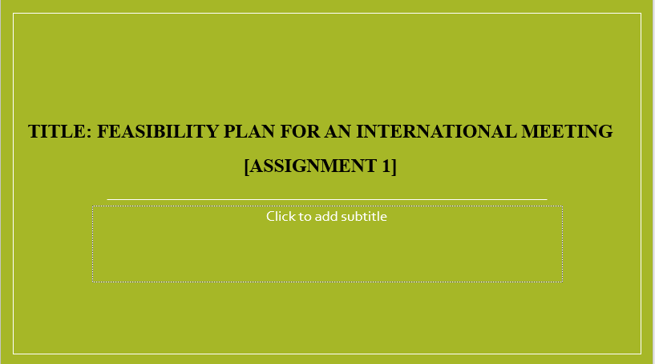

Introduction (Overview of the event and the event idea)
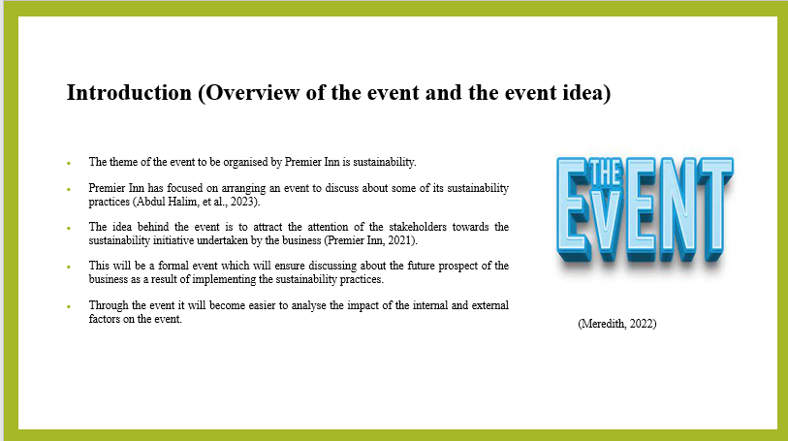

Situational Analysis and Research (Market Factors)
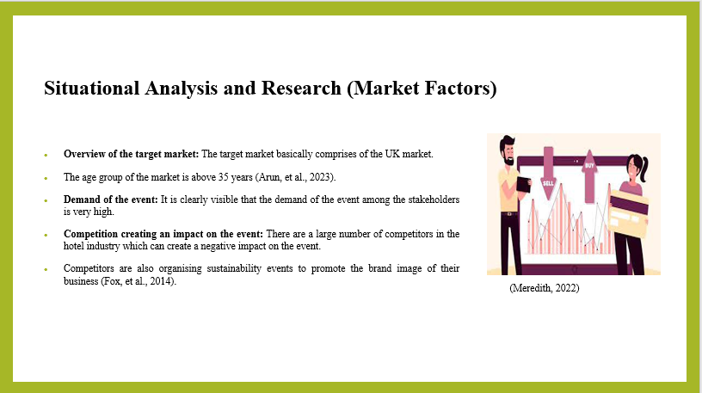

Situational Analysis and Research (Operational Factor)
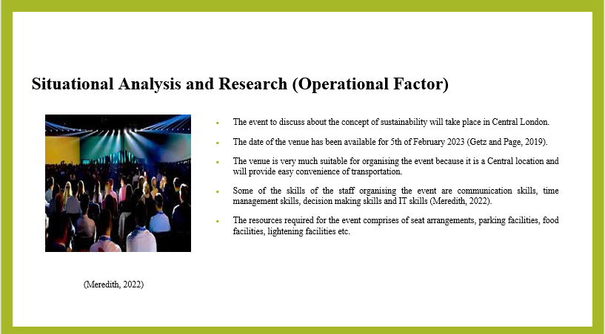.

Situational Analysis and Research (Financial Factors)
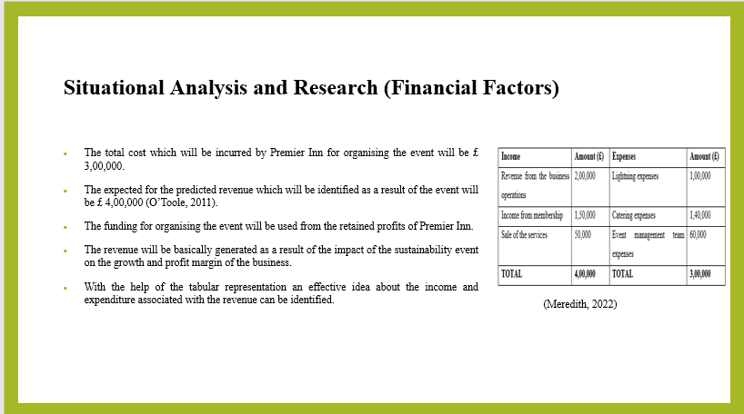

SWOT Analysis
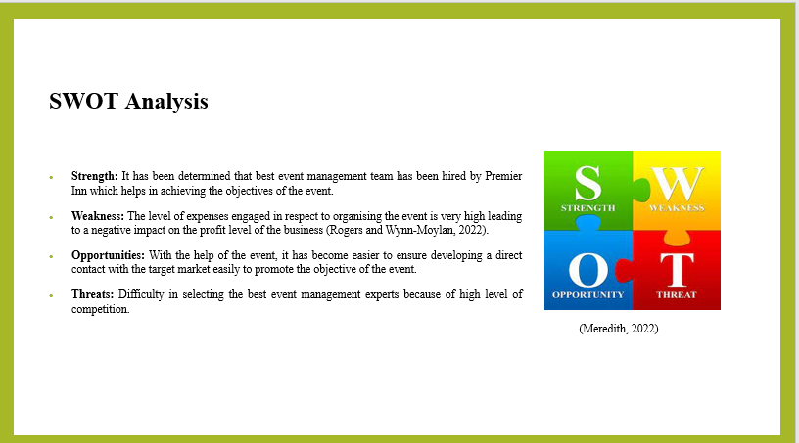

PESTLE Analysis
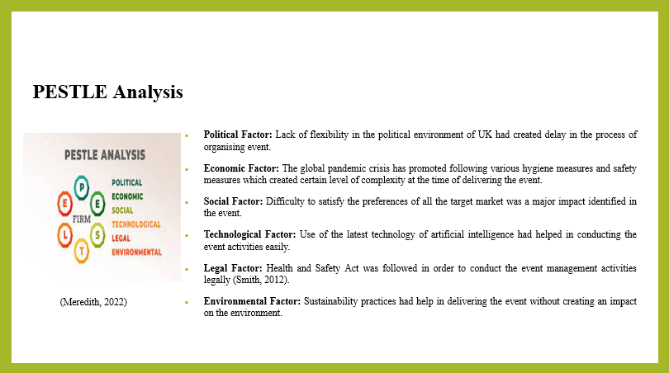

Conclusion
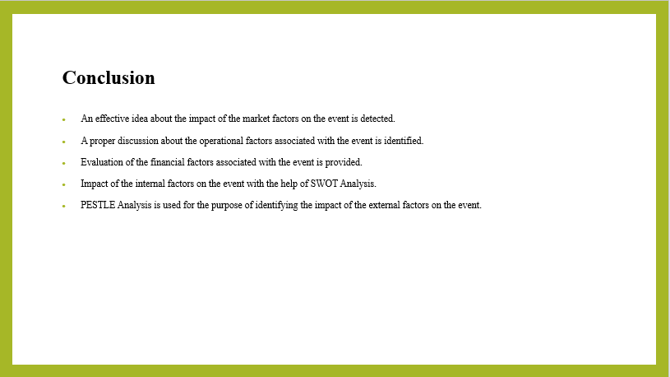

References


