Title Page:
The Overreliance of Technological Automation as an Organizational Issue. Using IBIS hotel as a case study
Name: Oluwatosin Osoba
Student Number: 2013493
Module Name: Hotel Placement Research Project
Module Number: BMIH6008
Supervisor name: Maggie-Lan Zhang
Date: 15/11/2024

AI Acknowledgement
I acknowledge the use of Grammarly (https://www.grammarly.com/) on 14 November 2024 to check my work using the prompt(s):
1. Please check the following text for readability, grammar, and syn
I confirm that I have not presented any AI-generated text as my work. I confirm I have copies of my drafts, notes, and other resources I used before and after the use of AI tools, which I may be asked to provide in evidence

Executive Summary (or Abstract)
The focus of this research is to examine the overreliance on automation as an organizational issue at IBIS Hotel, focusing on its impact on organizational performance, customer service, and employee relations. As automation technologies become increasingly integrated into the operations of the hospitality industry, hotels like IBIS are exploring how these technologies can streamline operations, reduce costs, and enhance guest experiences. However, this shift towards automation also presents challenges related to the loss of personalized service, workforce displacement, and cybersecurity concerns.
The study highlights the advantages and disadvantages of automation at IBIS Hotel. The advantage is the provision of enhanced convenience and efficiency for guests, leading to operational cost savings. These technological innovations also allow IBIS to maintain its competitive edge in a rapidly changing industry. On the other hand, the research identifies critical issues that arise from automation, particularly the reduction of face-to-face customer interactions, which many guests value for a more personalized service experience. Additionally, the displacement of traditional job roles due to automation raises concerns about employee morale and job security.
Through the analysis of IBIS Hotel’s current practices, the study emphasizes the need for a balanced approach to automation. While automation is an essential tool for improving operational efficiency, the human element in hospitality must not be overlooked. The research also calls for a strategic approach to workforce development, suggesting that training and reskilling programs should be implemented to help employees adapt to new technologies and remain valuable contributors to the hotel’s operations. Furthermore, the study underscores the importance of cybersecurity as IBIS Hotel continues to expand its use of digital tools, advocating for robust data protection measures to safeguard guest information.
In conclusion, the research suggests that IBIS Hotel should adopt a hybrid model that blends automation with human interaction, ensuring that technology enhances rather than replaces personalized service. By addressing the challenges of automation and leveraging its potential for efficiency and customer satisfaction, IBIS can strengthen its position in the competitive hospitality market while maintaining a high standard of service. The recommendations proposed aim to foster a more sustainable and customer-centered approach to automation in the hospitality sector.

Contents (Table of Contents)

Title Page: 1
AI Acknowledgement 2
Executive Summary (or Abstract) 3
Contents (Table of Contents) 5
Introduction 6
Literature Review 7
Methods 11
Case Study Discussion 13
Theme Exploration 24
Conclusion and Recommendation 32
Reflective account 36
References 41

Introduction
The 21st century has witnessed significant growth in the adoption of technology in virtually all sectors and industries; one of these industries is the hospitality sector. The hotel industry is growing its dependency on automation in their sector. It ranges from the first point of contact with the organization to service delivery and automated check-ins. Christou (2024) added that artificial intelligence has now been incorporated to improve the quality of customer services, efficiency, and cost savings through its adoption. However, there has been overdependence and overuse of this technology, which is largely at the expense of human labor (Mandic et al., 2023).
A critical look at the adoption of this technology using one of the prominent hotel industries (IBIS Hotel) can help to answer questions such as: How has the reliance on technology, rather than manual labor, shaped the hotel industry, and what are the effects? How have technology and autonomy transformed hotel operations and service quality? IBIS Hotel is a global hotel chain that can be used as a case study of the hotel industry, which is characterized by technologically driven operations (IBIS, 2024). This research addresses the case of the overreliance on technological automation as an organizational issue. Using IBIS Hotel as a case study
Research Aims
The research aims to explore how the overreliance on automation may affect the organizational performance of hotels, using IBIS Hotel as a case study.
Objectives:
The objectives of this research are to;
- Investigate how the implementation of technology has contributed to an increase in reliance on automation in the hotel industry.
- Assess the effects of this reliance on the performance of the hotel industry.
- Propose recommendations to address challenges related to overreliance on automation.

Literature Review
Technological Automation in the Hotel Industry
Automation in the hotel industry ranges from guest control of room temperature and other features at Marriot International hotels through voice command (Carson, 2019) to automated check-in and check-out systems. Hilton hotels now have robots taking over hotel deliveries (Mateer, 2023). Guest service and interaction is more of technological automation than human interaction; while Kazandzhieva et al. (2017) stated that it had improved efficiency and reduced cost, Ivanaov (2019) argued that the overall guest experience has not been effectively improved, the study claims it has only magnified a virtual reality, which in turn might create a psychological effect on the guest. IBIS Hotel, as a technology-driven hotel, has also embraced automation in its operation over the years; Tankha (2024) stated that IBIS Hotel has also embraced automation in its room management, check-in and check-out, and guest services. IBIS hotel is considered suitable for this study because of its global presence and diverse operation, and the researcher also has direct contact with this hotel while serving.

Theoretical Perspectives on Technology and Automation in Hospitality:
There are various theoretical perspectives on the adoption of technology in the hospitality sector, especially their drive towards automation. Marangunic and Granic (2015) argued that these models, such as the Technological Acceptance Model, support a strategic response to the recent market pressure that forces hotels to meet rising demands from customers regarding convenience; this demand is making technological adoption and automation almost inevitable. However, Mandic et al. (2023) stated that as beneficial as this automation is, integrity and guest experience may be at stake.
Certain human roles are essential to improve guest experiences, engagement, and satisfaction (Christou, 2024); personal interaction with guests is one of the things automation might not effectively achieve. Jabeen et al. (2022) stated that giving technology the full operation process could cause friction since quality service in the hospitality sector has an attribute of being attentive to guests' needs; the sector is thus faced with the need to balance cost-effectiveness and improve guest experience.

Impact of Automation on Organizational Performance
Implementation of various automation technologies comes with various benefits; with respect to organizations, their operations have been streamlined, and labor costs have also been reduced since the automated system has to replace certain employees (Abbasi et al., 2023). Thillaivasan and Wickramasinghe (2020) added that these automation systems also afford the organization the opportunity to gather data about their guest and improve their services. However, some critics consider this as a breach of privacy, as details of guests and their experiences should be held as private information. Kirimi (2015) added that systems failure is one of the major challenges that organizations face when adopting technology and its systems. Automation has side effects on both guests and the employees of the organization, making them the major target for assessing the effect of overreliance on automation. Kirimi (2015) added that organizations are always concerned with the bright side of automation. Still, the rate of employee retention has increased due to the adoption of these automated services in the hospitality sector. There has been a huge shift from an organization that is employee- and guest-focused to one that is focused on technology and guest experience alone.

Organizational Motivations for Prioritizing Technology Over Human Labor
It is important to know why the attention of organizations has shifted from employee or human labor to technology and automation. Burke and Ng (2006) stated that most organizations are profit-focused; if improving guest experience would maximize their profit, that is their main focus, while they parade the facts that the guest experience is their utmost priority; their major drive is profitability. Cascio and Montealegre (2016) added that this also affords the organization a 24/7 kind of guest service at a reduced cost. Another motivation observed in the literature is that organizations embrace the automation proposed by technology due to competitive pressure and industry trends (Cascio and Montealegre, 2016); it has served as a competitive advantage and edge in organizations within the hospitality sector. However, there are ethical and social concerns associated with the adoption of technology. The overreliance on this technology has been found to create a huge gap in employee rights and retention.

Recommendations for Managing Overreliance on Automation
Therefore, there is a need for a balanced approach when adopting technology and automation systems in the hospitality industry. Spektor et al. (2023) suggest the combination of human and automation systems made available by technology to improve guest services and experience in the sector since human elements are important to create a memorable guest experience. Ivanov et al. (2022) suggest that re-skilling and engaging employees can help them adapt to this changing demand. It would also provide strategies to adapt and maximize the advantages offered by automation in the hospitality sector rather than dispose of them.
For IBIS Hotel, Roy and Pagaldiviti (2023) suggest that practical measures that would enhance the technical and interpersonal skills of employees should be engaged. Vinnakota et al. (2022) also added that a strategic review of automated processes can be given to the employee to ensure that critical guest interactions remain personal. Creating such balance would not only improve service quality but also bolster operational resilience and create a more flexible and responsive environment that takes advantage of human and technological strengths (Spektor et al. (2023)).

Gaps in Literature and Implications for Future Research
The gap observed in the literature is that there is limited research on the long-term effects of automation; Kirimi (2015) stated that previous studies seem to focus on the present benefits offered by automation and technology, but the long-term effects on employee satisfaction have not been loosely examined. Additionally, Mandic et al. (2023) added that most studies have associated automation in the hospitality sector with efficiency gains; only a few studies have focused on how this automation influences the organizational culture as the years go by. It is also important to note that few studies have compared the effect of this automation across various hotels, making it difficult to achieve a generalization on the subject of automation in the hospitality sector. If two or more hotels are considered as a case study, an average perception could evolve regarding the adoption of automation in the sector. This implies that a case study of IBIS Hotel cannot be used to make a generalized conclusion about the effect of automation on all global organizations within this sector. Further research could also look into the effect of automation on employee engagement and guest experiences, which is closely aligned with the objectives of this study, which is to examine the effects of technological dependence on organizational performance.

Methods
For this study, which is largely focused on the effect of overreliance on technological automation in the hotel industry, using IBIS Hotel as a case study, the need to explore broader context on the subject matter led to the choice of qualitative research design an approach for the study, with special focus on case study approach. Although there are quantitative approaches and metrics to solve this, employee and management behavior will be prioritized.
Research Strategy and Case Study Methodology
Harwati (2019) describes the case study approach as an approach that focuses on and examines a single subject, which, in this case, might be an organization, person, event, or community. This focus is used to represent a broader issue. Aaltio and Heilmann (2010) added that this approach is largely used in social sciences and also in business for themes that might not be easier to examine using a quantitative approach. Looking closely at this study, the overreliance of the hotel sector on technology is not easily measured through specific metrics. Still, it can be beneficial to gain an in-depth insight into issues relating to overreliance. Gutterman and Fetter (2018) compared this approach to mixed methods and found that the case study approach can help to view the cause and effect of this technology adoption, which is in line with the research question and objective of the study. Since IBIS hotel is an internationally recognized hotel and has been around the sector for a while, Harrison et al. (2017) suggest that this approach would help to ground theory in real-world practice. However, Hyett et al. (2014) stated that this approach may have some elements of bias based on the researcher’s interpretation; the researcher’s perception of the overreliance on the automation benefits generated by technology might distort the validity of the result.
In addition, IBIS Hotel and other hotels might face similar challenges or even have unique challenges, which might have led to the evolution of certain strategies that might not be applicable elsewhere. Harwati (2019) then concludes that it would be difficult to make certain generalizations using the findings of the study that adopts the case study approach. To address this, this study adopts netnography to complement the observation insight that is available in the case study approach.
Netnography
As stated earlier, the limitation posed by the case study approach will be complemented using netnography, which is an online version of ethnography. This approach will use the Netnography interactions and reviews related to IBIS Hotel on digital platforms to make decisions. Through the analysis of customer reviews and the perception of the employees, there will be an inclusive analysis of how the public, aside from the researcher, views automation. This would help add and create a form of validation for every finding that would be generated from the case study analysis of IBIS hotel.
The major limitation of using the case study approach is generalizability (Widdowson, 2011). This is mainly because findings from IBIS Hotel may not be fully applicable to other hotels within the sector due to contextual differences. Additionally, Dumez (2015) stated that observational data is easily susceptible to researcher bias; the study hopes to adopt a reflective journal to document personal interpretations and biases throughout the research process to help handle such challenges.

Case Study Discussion
Overview of IBIS
IBIS Hotel is one of the popular economy hotel chains. It was first opened in 1974 in a French town known as Bordeaux (IBIS, 2024). The hotel has a global reach and presence in 70 countries, with about 1200 hotels globally (IBIS, 2024). Since the hotel started in France, the majority of its chain has existed there, although it has spread across the UK starting from the 1980s. One of the central commitments of IBIS is to leverage technology to enhance guest experience and streamline processes. IBIS underwent rebranding in 2011 to create IBIS styles and IBIS Budget with the goal of creating a unified identity (Hennessy and Gunawan, 2015). IBIS offers online check-in and mobile key systems that save the guest the stress of meeting up with the front desk and the queues that are regular characteristics of this section (IBIS, 2024). Some IBIS hotels also have self-service kiosks and automated check-out systems (Ishraq and Zakara, 2023); IBIS hotels also use data analytics to understand the preferences of guests and to personalize the guest experience. IBIS's mission statement is to ensure that their service is delivered efficiently and to offer modern hospitality service with affordability and comfort (IBIS,2024). This mission statement would also position IBIS Hotel as a leader in the budget hotel segment.
Turnover and Revenue at IBIS
IBIS Hotel is one of the hotel chains under Accor Group, and because of this, their revenue information is not publicly available, but a close look at the overall performance of Accor can grant insights into their performance. The revenue trend shown in the figure shows that there has been an increase from 1.62 billion euros in revenue since 2020 to 5.06 billion in 2023. The Economic Times (2021) showed that IBIS hotel invest in automation and technology in their hotel chain to improve customer services and experience.
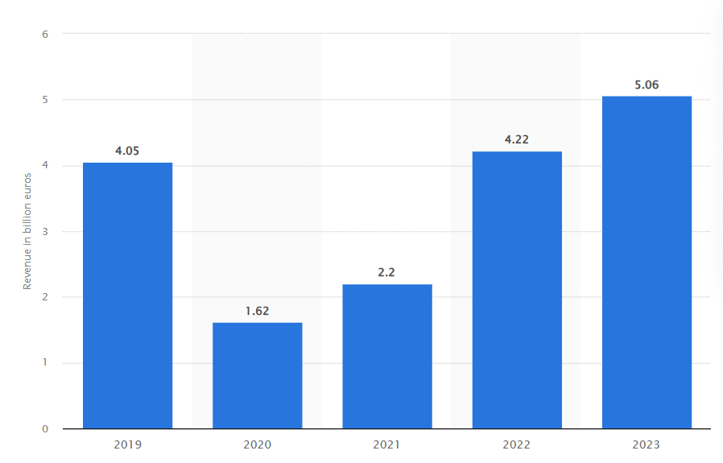
Figure: Revenue of Accor Group worldwide from 2019 to 2023 (in billion euros) (Statista, 2024)
Staffing and Workforce
At IBIS Hotel, the workforce and staff are largely grouped into front desk staff, housekeeping, management personnel, and maintenance staff. Ivanov and Webster (2019) suggest that this traditional workforce and staffing have been threatened by automation instead of integration; it has only led to the displacement of the workforce. IBIS hotel is not left with largely operational managers, housekeeping teams, and technical support staff as the surviving workforce staff, whose role is to oversee the automated system. Yimazdogan (2024) concluded that automation had a dual impact, which is both positive and negative in the hospitality sector.
Global Presence and Branch Network
Globally, IBIS hotels have created a network of hotel chains in over 70 countries, with about 1,200 hotel units (IBIS, 2024). IBIS is one of the largest brands in this sector and is expected also to lead the adoption of innovation and automation technology in their services. Starting from Paris, IBIS is strategically located in London, Newyork, Beijing, and Sydney, indicating a form of global coverage. One of the branches in London, where the researcher served, is the “ibis budget London Barking” shown in the figure 2; their target markets is largely grouped into business and leisure tavelers (All.com, 2024). IBIS brand emphasis is automation and convenience. However, Ivanov and Webster (2019) stated that these are largely from the organizations perspective and could not be the case in their interaction with employee and guest.
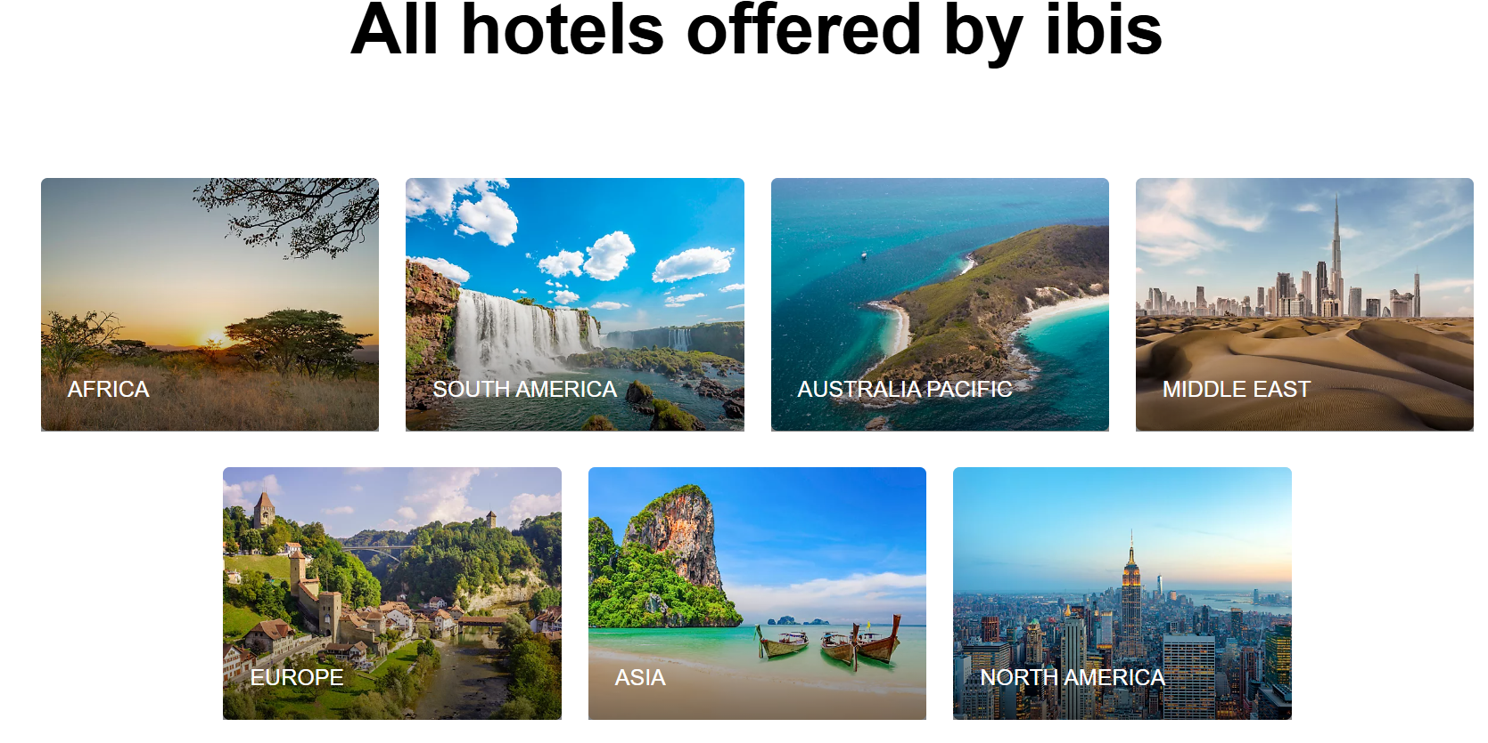
Figure 1: IBIS hotel coverage globally (IBIS, 2024)
One major attributes of IBIS hotel is that it is largely located in urban areas or near transportation hub, where guest who embrace the use of technology and the ones with flare for travelling might have direct contact with such services. For example, the IBIS branch near Charles de Gaulle Airport in Paris provides seamless access for international travelers, while the London City branch is ideally situated for exploring the city’s attractions as shown in figure.
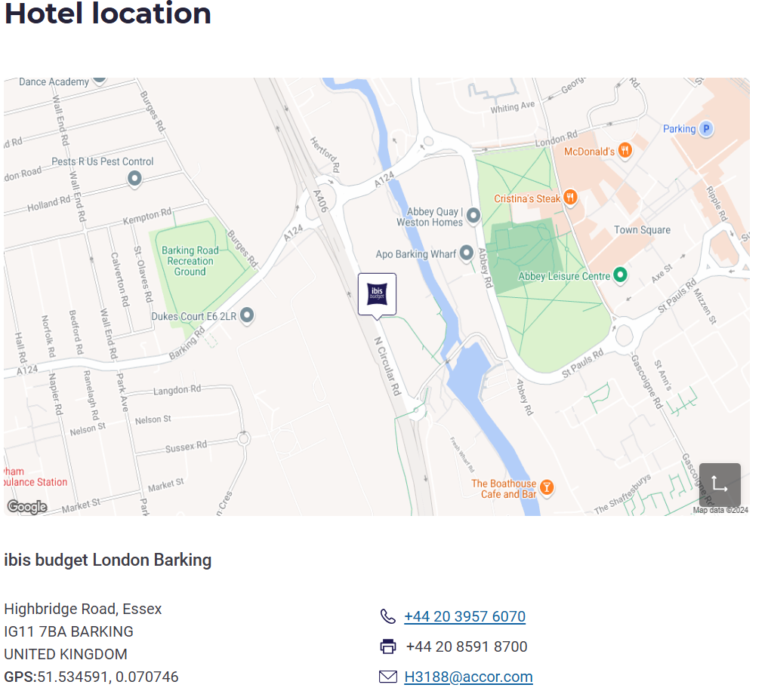
Figure 2: IBIS budget London Barking hotel (All.com, 2024)
As seen in the figure, the maps IBIS globally show a network across all continents. This also shows that there is a high concentration of branches in Europe, the Americas, and Asia-Pacific regions, emphasizing their accessibility and widespread appeal.
Cultural and Geographical Context
One special thing about IBIS is that in their service, they are sensitive to the varying cultural differences that exist across diverse regions. Bavik (2016) describes Europe’s culture as characterized by minimalist comfort and efficiency focus, which target budget-conscious travelers. Hall (2014) stated that Asians are more attracted to local cuisines and design elements that align with their culture. Tajeddini and Trueman (2012) stated that IBIS hotels in African branches emphasize vibrant designs and local hospitality traditions to create a unique guest experience. This shows that geographic factors can influence operations in the hospitality sector; for instance, IBIS hotels in tropical regions feature climate-controlled spaces to enhance comfort, while urban branches prioritize proximity to public transport.
SWOT ANALYSIS
The SWOT Analysis of IBIS showed the strengths, weaknesses, opportunities, and threats that are associated with automation in the hospitality sector. The result is shown in the table 1. below

Table 1: SWOT Analysis For Ibis Hotel
Strength  - Strategic adoption of Automation  - String Brand Reputation  - Cost Effectiveness | Weakness  - The challenge with personalized service  - Guest dissatisfaction with automation  - Lack of human contact and intuition
Opportunity  - Emerging markets like Africa or Asia  - The advent of artificial intelligence  - Collaboration with local business | Threat  - Risk of technical failure  - Cybersecurity breach  - Compettitive pressure
Strength
As a leading hotel brand in the hospitality sector, Obelenyte (2018) stated that the strategic use of automation is more or less a strength for IBIS as an organization since it is characterized by cost-effectiveness and operational efficiency. Abbellanet-Miranda (2022) stated that another strength of IBIS lies in the fact that it is a brand of Accor, which is a global business. Although its association with Accor boosts its brand's credibility and global presence, Residata et al. (2023) stated that this may subject IBIS to the challenges of aligning with a larger corporate strategy, potentially limiting flexibility in meeting local market needs. The cost-effectiveness benefits offered by this customisation are also a great strength, but focusing on affordability alone can lead to less innovation by the brand. Obelenyte (2018) stated that this would constrain the organization to only focus on budget-friendly solutions.
Weakness
Ishraq (2023) stated that the weakness that is largely associated with IBIS and adopting the automation process is that human interaction with guests will be affected since personalized services are more prevalent in the automation system; another weakness is that IBIS risks alienating less tech-savvy demographics, such as older travelers or those unfamiliar with digital platforms, thereby narrowing its customer base. Losing customers and also losing a sense of human touch in guest services are crucial issues and limitations that IBIS must consider if they want to thrive in the sector.
Opportunity
Affordable hospitality is on the rise, and this is fast expanding into regions like Africa and Asia; this is a potential opportunity for the IBIS to build a strong customer base. The adoption of artificial intelligence is also an opportunity to provide personalized and informed services to guests. Obelenyte (2018) states that collaborating with local businesses can help create valuable experiences for guests and also add unique cultural values. This opportunity can help to address the weakness associated with automation and position IBIS as a leader in budget-conscious yet personalized hospitality.
Threat
Cybersecurity and data breaches are concerns and potential threats to the adoption of automation in the hospitality sector. A single breach case can threaten the reputation of the hotel. Technical failure associated with automation can also be a threat, although this could be handled through regular updating and maintenance of the system. Feedback mechanisms can help detect and address the problems posed by these systems.
PEST Analysis
Political: Labor practices and data privacy are governed by certain regulatory frameworks; the GDPR regulatory framework in Europe is an example of political factors that ensure the security and ethical usage of guest data (Soskova, 2016). The challenge of selling user data is one of the concerns addressed by this regulatory framework. There are labor regulations that regulate the usage of technology; these labor practices target solving the challenge posed by automation to human employment and the workforce. Policies such as tax incentives are in place to motivate industry to embrace technological infrastructure while working within the legal framework.
Economic: Economic advantages such as reduced labor costs and improved operational efficiency are the advantages that automation offers to the automation industry (Soskova, 2016). The services and applications it provides enable cost savings while enhancing guest satisfaction. Salvador (2013) added that these cost benefits are especially critical in times of economic instability, allowing IBIS to maintain affordability for its target market. However, Soskova (2016) argued that the initial investment in advanced automation technologies and the ongoing costs of system upgrades and maintenance could strain resources, particularly in regions with slower economic growth. Ponomareva (2016) then suggests that IBIS must strategically balance automation’s cost-saving potential with its financial capacity to ensure long-term profitability.
Social: Socially, the rapidly changing expectation of customers presents both opportunities and challenges for IBIS. The a need to satisfy two important groups of demography, with one being modern travelers, particularly younger, tech-savvy guests, who appreciate the convenience and efficiency provided by automation (Yang, 2023). However, Ponomareva (2016) stated that this emphasis on technology risks the second group of customers who value the human touch in hospitality, such as personalized greetings and empathetic service. This second group is largely older travelers or those from cultures where hospitality is synonymous with warm, interpersonal interactions. To address this, Alekseevic (2024) suggests that IBIS must strike a balance by integrating technology with personalized service to cater to diverse customer preferences; this would ensure inclusion in the face of diversity.
Technological: Hargreaves (2015) stated that emerging trends such as artificial intelligence (AI) Internet of Things (IoT)-enabled smart rooms, and predictive analytics will shape the strategy of IBIS and also offer opportunities for personalized guest experiences and operational efficiency. For example, Riley (2019) stated that AI-powered chatbots can provide 24/7 customer support, while de Gusmao (2014) stated that IoT technology allows guests to customize their stays through voice or mobile commands. However, Riley (2019) stated that staying competitive in this dynamic landscape requires continuous innovation and investment. Yang (2023) added that IBIS must also address challenges such as system failures, cybersecurity threats, and the obsolescence of older technologies to maintain its technological edge and safeguard its reputation.
Competitors Analysis
Price vs. Quality Comparison
IBIS positions itself as a budget-friendly hotel chain, offering essential comfort at affordable rates. Cheng (2019) stated that IBIS pricing is competitive compared to other midscale brands like Holiday Inn Express and Premier Inn. Gheribi and Bonadonna (2019) suggest that while competitors may provide slightly more personalized services or premium amenities, IBIS focuses on delivering consistency and reliability at a lower cost. Nurtirtawaty et al. (2021) added that this balance of price and quality makes IBIS an attractive option for cost-conscious travelers seeking modern, efficient accommodations.
Unique Selling Points
IBIS’s embrace of cutting-edge technology is a significant differentiator in the budget hospitality market (Cheng, 2019). Unlike many competitors, IBIS integrates automation seamlessly without compromising its affordability. Additionally, its global network under the Accor umbrella ensures brand recognition and trust. Riley (2019) added that through a consistent guest experience across locations, while leveraging smart technologies, IBIS can stand out as a leader in offering cost-effective yet technologically advanced hospitality solutions, appealing to both business and leisure travelers (Cheng, 2019).
Netnography Analysis
The overall review of Ibis Hotel on TrsutPilot (2024) shows an average review of 2.0-star ratings from guests, with about 64% of one-star ratings. Radojevic et al. (2017) stated that poor ratings in hotels could be due to room-related issues, service quality, amenities and facilities, and other factors.
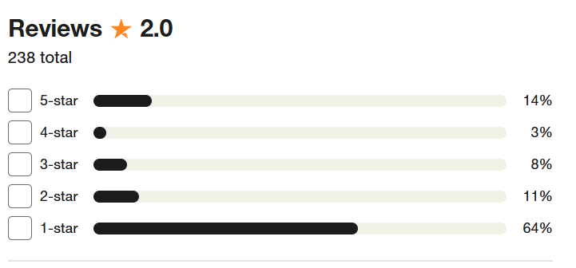
Figure 2: Ibis Hotel customer review (TrustbPilot, 2024)
A sample of the numerous reviews from the Ibis Hotel, as shown in the figure, and the complaint made by a guest shows that the Ibis Hotel adopted automation for check-in. Still, technical failure can lead to this kind of review; a monitored automated system by an employee can alleviate and reduce such cases. The same case is shown in Figure 3, which shows the effect of automation and reliance on technology.
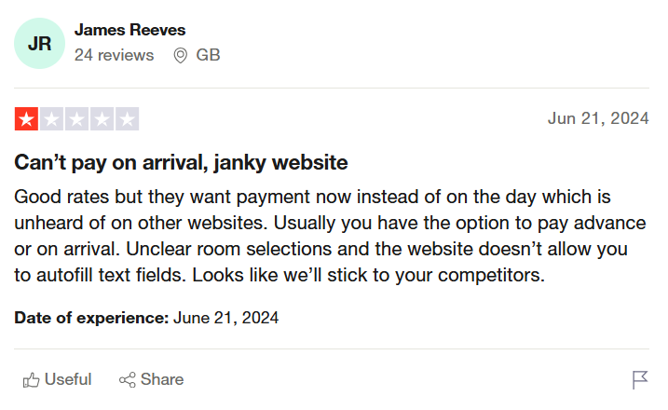
Figure 3: Complaint on automation by guest (TrustbPilot, 2024)
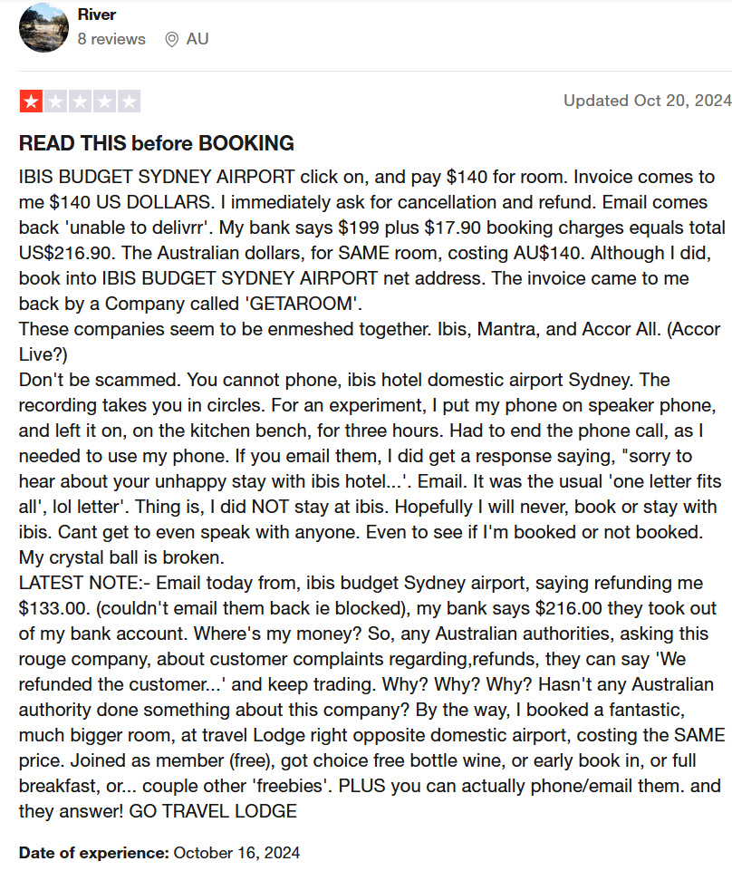
Figure 4: Complaint on technology reliance (TrustbPilot, 2024)
From an employee’s perspective, Glassdoor (2024) shows that about 273 employee ratings show a 3.8-star review and about 68% of the employees would recommend IBIS to anyone.
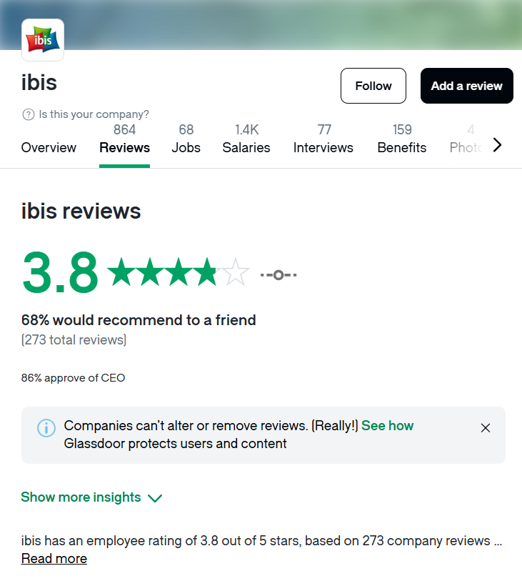
Figure 5: Employee review of IBIS hotel (Glassdoor, 2024)

Theme Exploration
The hospitality industry is increasingly embracing technological automation because they need to streamline their operations processes; the sector wants to enhance the experience of their guest and also improve efficiency (Wang, 2024). Automation provides numerous advantages, including cost-effectiveness and personalized services. However, overreliance on automation poses critical challenges, including loss of human touch, guest dissatisfaction, and cybersecurity vulnerabilities (Ivanov & Webster, 2019). This analysis critically examines the placement hotel, IBIS, to evaluate how overreliance on technological automation impacts organizational performance. The study will use literature and use to draw academic insights and practical evidence from IBIS Hotel, using maps, reviews, and financial data of the hotel. This section explores areas for improvement to balance technological integration and human interaction effectively. The section also makes recommendations on how this improvement can be adopted and applied.
Theoretical Exploration of Overreliance on Automation
Automation has proven to be efficient in the hospitality sector and has been praised for its efficiency in providing cost savings and operational flexibility. Muslim and Itoh (2019) state that this is a form of competitive edge for hotels in the 21st century and has been found to help minimize the human errors and flaws that are resident in the sector. Obelenyte (2018) highlights that automation improves service delivery by reducing human errors and labor costs, positioning organizations competitively. Similarly, Salvador (2013) notes that data analytics, IoT, and AI-driven tools enable personalized guest experiences, thereby catering to tech-savvy customers. Individual and accurate attention can thus be given to the guest, largely based on their previous preferences and choices that have been recorded and analyzed by this automation system.
However, Ponomareva (2016) cautions that automation often alienates non-tech-savvy demographics, such as older travelers; this demography is not really motivated by the technological awe that automation presents. Rather, they are more concerned with the human experience and service based on interaction; this demography may perceive the services offered by the automated system as impersonal. Additionally, Ishraq and Zakara (2023) identify the risks of guest dissatisfaction and organizational rigidity when automation is over-prioritized. The challenges associated with technology and automation may communicate wrong ethics and hinder the industry's culture and goal of providing personalized and empathetic services.
From a workforce perspective, the role that automation played in the hospitality sector has been found to have both negative and positive effects, but regarding the workforce, automation has been found to displace employees; most workers that human components have handled are now being replaced by machine, robots, and systems that evolve from automation. This has led to reduced job satisfaction and operational challenges. The employee now works with the fear of being replaced, whether sooner or later, by the automation system. Ivanov and Webster (2019) argue that the lack of human intuition and personal connection in automated systems often undermines guest satisfaction, a crucial element in the hospitality industry. Overreliance also increases vulnerability to technical failures and cybersecurity breaches, threatening brand reputation and operational continuity (Yang, 2023). Once a single system fails, the entire process is disrupted and may be on hold for a longer period until it is resolved, which is not the case with human components. Instead of displacing employees, Lyons and Stokes (2012) suggest that organizations should prioritize employee reskilling and integration strategies to ensure a human-technology synergy that preserves the industry’s personal touch. Once they have achieved this, they should also invest in robust cybersecurity frameworks, and contingency planning is essential to safeguard operational integrity. Except these measures are put in place, Obelentyte (2018) suggests that the overreliance on automation risks undermining the hospitality sector's foundational emphasis on personalized and reliable service delivery.

Practical Context: Automation at IBIS Hotel
IBIS Hotel has embraced automation as a strategy in their organization to allow the enhancement of operational efficiency and improve the experience of their guest in the hotel. Guests can now enjoy services such as online check-ins, mobile key systems, self-service kiosks, automated check-outs, etc. These services have helped to optimize the processes and attend to the needs of tech-savvy travelers (IBIS, 2024). Time management is not effectively achieved, and guests can now bypass traditional front desk interactions. For instance, Srivastava et al. (2021) stated that guests can check in or out independently using kiosks or mobile applications, while mobile key systems allow direct room access via smartphones. Sandberg et al. (2016) added that the hotel’s loyalty program and booking integrations, such as with Expedia and Booking.com, further demonstrate its commitment to leveraging digital tools for seamless service delivery.
Part of the services at IBIS is that guests can use luggage storage without charges; this shows flexibility and convenience characteristics. This can be done before or after check-out, and the automated system efficiently manages reservations, room assignments, and housekeeping schedules. Srivastava et al. (2021) also added that breakfast pre-booking and dynamic pricing strategies, including free meals for children under five, appeal to a wide customer base. Despite these advancements, Sandberg et al. (2016) argued that IBIS faces significant challenges, particularly in maintaining its hallmark of personalized service and addressing operational risks.
Challenges face at IBIS.
Automation at IBIS Hotel, while efficient, has introduced notable challenges that affect both guest satisfaction and workforce dynamics. A primary concern is the loss of personalized service, as automation cannot replicate human empathy and adaptability. Ishraq (2023) highlights that systems like self-service kiosks often struggle to address unique guest needs. This is corroborated by TrustPilot reviews, where guests frequently express frustration with impersonal interactions and unmonitored kiosks. For example, technical failures during check-in have led to long delays, undermining the guest experience and the hotel’s reputation.
Employee displacement and morale are other pressing issue. Automation has reduced the need for traditional roles, such as front desk staff, shifting responsibilities to operational management, and technical support (Ivanov & Webster, 2019). While this transition lowers labor costs, it fosters job insecurity and disengagement among staff. Glassdoor reviews reveal mixed sentiments, with some employees appreciating streamlined workflows but others lamenting the erosion of interpersonal service roles that defined their professional identity.
Finally, the hotel is increasingly vulnerable to cybersecurity and technical risks. Reliance on digital systems exposes IBIS to potential breaches that could compromise guest data and tarnish its reputation. Trustpilot reviews detailed instances of technical glitches, such as failed key systems, causing inconvenience and dissatisfaction. Without robust mitigation strategies, these vulnerabilities pose significant threats to operational continuity and guest trust.
Impact on performance
The overreliance on automation at IBIS Hotel has profound implications for its organizational performance. Guest retention, a critical metric of success in the hospitality sector, is jeopardized by dissatisfaction stemming from impersonal and inconsistent service delivery (Jabeen et al., 2022). Reviews on platforms like Trustpilot reflect growing frustration among guests, which can lead to negative word-of-mouth and reduced repeat bookings (Ivanov, 2019).
Employee morale is another casualty. The transition to automation often sidelines staff, creating a workplace environment marked by job insecurity and limited interpersonal engagement (Raina, 2023). This disengagement not only affects service quality but also challenges IBIS’s ability to retain skilled employees in a competitive labor market (Kelly et al., 2019).
Moreover, the brand’s reputation is at risk due to the dual threat of technical failures and cybersecurity breaches (Kelly et al. 2019). While automation enhances operational efficiency, system glitches and vulnerabilities expose IBIS to reputational damage (Ivanov et al., 2022). For instance, delays caused by kiosk malfunctions or unauthorized access to guest data can erode trust and deter potential customers (Touni, 2020).
Critically, IBIS must balance automation with personalized service and robust risk management strategies (Touni, 2020). Investing in staff training, maintaining human oversight, and fortifying digital security measures can mitigate these challenges, ensuring that automation does not compromise the guest experience or brand reputation (Webster & Cain, 2024; Buhalis et al., 2024).
Areas for Development and Improvements
Enhancing Human Interaction
While automation streamlines operations, Jabeen et al. (2022) stated that it cannot replace the personal touch central to hospitality. Implementing hybrid service models, where staff are available to oversee self-service kiosks and assist during technical issues, can address gaps in guest experience. Ivanov et al. (2022) stated that this ensures that guests who value interpersonal engagement, such as older travelers, feel accommodated. Bavik (2016) underscores the effectiveness of combining automation with human interaction to cater to diverse preferences. Additionally, Webster and Cain (2024)positioning roving staff in high-traffic areas like lobbies can ensure timely support while fostering a welcoming atmosphere.
Personalized Automation
Leveraging AI and machine learning can enhance IBIS’s ability to deliver personalized guest experiences without compromising efficiency (Raina, 2023). Buhalis et al. (2024) added that predictive analytics can tailor recommendations for room preferences or dining options based on past stays, while chatbots with advanced natural language processing can provide empathetic, real-time responses. Zahidi et al. (2024) stated that these technologies enable IBIS to bridge the gap between automation and personalization, ensuring every guest feels valued.
Workforce Development
To thrive alongside automation, IBIS must invest in comprehensive employee retraining programs. Equipping staff with skills to manage and complement automated systems fosters adaptability and job satisfaction. Yang (2023) emphasizes that such initiatives not only improve employee morale but also enhance overall service quality. For example, training programs in technical troubleshooting or data analysis can empower staff to take on dynamic, technology-driven roles.
Cybersecurity Measures
Strengthening cybersecurity is critical to safeguarding sensitive guest data and ensuring system reliability. Regular security audits, timely software updates, and advanced encryption protocols can minimize vulnerabilities. Additionally, training staff to recognize phishing and other cyber threats can fortify defenses against human error (Soskova, 2016). Implementing multi-factor authentication and real-time monitoring systems further enhances IBIS’s resilience to cyber risks.
Feedback Mechanisms
Proactive feedback systems are essential for refining automation. Real-time guest feedback gathered through surveys or app-based prompts can help identify pain points in automated processes. Insights from this feedback can inform updates to kiosks, mobile apps, and other technologies, ensuring alignment with guest expectations. As Alekseevic (2024) notes, continuous feedback loops allow hotels to adapt quickly to changing demands, enhancing guest satisfaction and fostering loyalty.
While IBIS Hotel's reliance on automation has revolutionized its operations, it is important to examine the need for balance in the adoption of automation and the interference it causes to the human components of the hospitality sector. The way ahead is to integrate both human-centered approaches with advanced technologies. The suggestion is that if IBIS wants to enhance guest satisfaction and improve employee engagement if they would mitigate risks associated with overreliance on automation, they need to maintain a balance between the two important components. This study draws insight from academic literature and practical evidence; the findings show that it is clear that the future of IBIS lies in its ability to harmonize technological efficiency with the timeless appeal of personalized hospitality.

Conclusion and Recommendation
In conclusion, the research into the overreliance on automation at IBIS Hotel reveals critical insights into how automation impacts the hospitality industry, particularly concerning customer service, employee relations, and organizational performance. The growing trend of automation in the hospitality sector, while offering operational efficiency and cost-effectiveness, also brings significant challenges that need to be addressed thoughtfully to maintain a balance between technology and human interaction. IBIS, as a prominent example of a hotel chain integrating automation into its operations, presents a fascinating case study that illustrates both the advantages and drawbacks of this technological shift (Ivanov & Webster, 2019; Hennessy & Gunawan, 2015).
Automation has revolutionized the way IBIS operates, with services like online check-ins, mobile key systems, and self-service kiosks providing convenience for guests and streamlining hotel operations (IBIS, 2024). The operational benefits of automation cannot be overstated, as it reduces human error, minimizes labor costs, and increases guest satisfaction in terms of efficiency (Soskova, 2016). Moreover, the global reach of IBIS, which spans over 70 countries, showcases its success in implementing automation in various cultural and geographic contexts, demonstrating the scalability of these technologies in different markets (IBIS, 2024). The hotel chain's commitment to technological innovation has undoubtedly bolstered its reputation as a cost-effective yet modern accommodation option, aligning with the growing demand for self-service and contactless experiences in the hospitality industry (Yang, 2023).
However, this overreliance on automation has also resulted in several challenges. One of the primary issues that emerged from this study is the potential loss of personalized service. As automation becomes the predominant mode of interaction between the hotel and its guests, there is a noticeable reduction in the human touch that many travelers value (Ponomareva, 2016). Personalized service, often seen as the cornerstone of hospitality, has been increasingly compromised by the efficiency-driven mindset that automation fosters (Alekseevic, 2024). Guest reviews, especially those found on platforms like TrustPilot, reflect dissatisfaction with the lack of human interaction, particularly among older or less tech-savvy travelers (TrustPilot, 2024). This issue is not exclusive to IBIS but rather a widespread challenge in the industry, where the drive for technological efficiency sometimes overshadows the essential human elements of hospitality (Riley, 2019).
Another significant concern that emerged is the impact on the workforce. As automation technologies become more embedded in daily operations, there is a growing risk of workforce displacement (Ivanov & Webster, 2019). The traditional roles of front desk staff, housekeepers, and service personnel are being replaced or reduced, leaving only those who can monitor and troubleshoot the automated systems (Ishraq & Zakara, 2023). While automation can enhance operational efficiency, it also raises ethical questions about the future of employment within the hospitality sector (Obelenyte, 2018). The fear of job losses, especially for those in lower-skilled roles, has sparked debates about the need for retraining and reskilling programs (Yimazdogan, 2024). Ensuring that employees can adapt to the changing landscape of hospitality work is essential for maintaining employee morale and engagement (Alekseevic, 2024).
From a strategic standpoint, IBIS faces challenges related to the integration of technology with the cultural expectations of different demographics. While younger, tech-savvy travelers appreciate the convenience and efficiency that automation offers, older guests may feel alienated by the lack of personal interaction (Ponomareva, 2016). This demographic divide presents a challenge for IBIS, as the hotel must cater to both groups without alienating them (Soskova, 2016). In this context, finding a balance between automated services and human touch becomes critical (Alekseevic, 2024). Some form of hybrid model, where automation enhances rather than replaces personalized service, could address these concerns and provide a more inclusive experience for all guests (Riley, 2019).
Cybersecurity concerns are also a key area of vulnerability for IBIS and the broader hospitality industry. As more guest data is stored and processed through automated systems, the risks associated with data breaches and cyberattacks become more pronounced (Yang, 2023). With the increasing reliance on mobile check-ins, digital keys, and automated payment systems, IBIS must prioritize cybersecurity to safeguard guest information and protect its brand reputation (Salvador, 2013). Regular updates, robust encryption methods, and employee training on data protection are essential measures to mitigate these risks (Ponomareva, 2016).
Looking forward, I see several avenues for improvement and development for IBIS. First, enhancing the integration of human interaction with automation could provide a solution to the personalization issue (Alekseevic, 2024). For example, frontline staff could be trained to use technology more effectively while still maintaining a human connection with guests (Ivanov & Webster, 2019). Additionally, AI-powered tools could be used to tailor guest experiences without compromising the efficiency benefits of automation (Yang, 2023). Ensuring that technology serves the guest experience in a personalized way rather than merely as a means of streamlining operations could help retain the human element in the service offering (Riley, 2019).
Moreover, focusing on workforce development through training and reskilling programs is essential (Yimazdogan, 2024). IBIS should invest in equipping its employees with the skills needed to manage and support automated systems (Ishraq & Zakara, 2023). This approach will not only enhance employee satisfaction but also improve the overall guest experience by ensuring that staff can troubleshoot and offer assistance when technology fails (Obelenyte, 2018). Furthermore, the implementation of feedback mechanisms that allow guests to voice their opinions on the automated services they experience could provide valuable insights into areas for improvement (Hargreaves, 2015). Real-time feedback can guide IBIS in adapting its automation strategy to meet better the needs of its diverse clientele (Cheng, 2019).
Ultimately, IBIS Hotel has the potential to be a leader in the hospitality industry by adopting a more balanced approach to automation (Soskova, 2016). By addressing the concerns related to personalization, workforce displacement, and cybersecurity, IBIS can ensure that automation serves both operational efficiency and customer satisfaction (Obelenyte, 2018). The key is to use technology as an enabler of better service, not as a replacement for human interaction (Ivanov & Webster, 2019). With the right strategies in place, IBIS can navigate the challenges of automation while preserving the essence of hospitality that guests value (Riley, 2019).
In summary, while the overreliance on automation presents several risks and challenges, it also offers tremendous potential for growth and innovation within the hospitality industry. IBIS Hotel, with its forward-thinking approach to technology, is well-positioned to lead the way in striking a balance between efficiency and personalized service (Yang, 2023). By addressing the key issues highlighted in this research and adapting to the evolving needs of guests and employees, IBIS can maintain its competitive edge in an increasingly automated world (TrustPilot, 2024).

Reflective account
One significant experience while shadowing my supervisor at IBIS was observing the automation of inventory management. Ivanov and Webster (2023) highlight that automation plays a key role in increasing efficiency within food and beverage operations. However, my own experience across different hotels reveals that automation still heavily relies on human input. Ebrahim et al. (2022) cautioned that human errors and technological glitches can disrupt services in automated systems, which I experienced when monitoring stock levels and placing timely orders to ensure consistent guest satisfaction. This highlights the need for human oversight in automated processes.

Another notable experience was learning food preparation techniques, particularly pastry baking. Dais et al. (2018) emphasize that temperature control and hygiene are critical factors in ensuring food safety and a positive dining experience. The challenge, however, is the cost and requirements of maintaining such high standards. As Dopson and Hayes (2019) note, the initial investment in advanced cooking devices, which ensure precise cooking times and temperatures, may be financially burdensome for many hotels, though they justify the investment in luxurious hotels that charge premium prices for high-quality services.
Guest interaction was another essential aspect of the experience. IBIS’s policies emphasize the importance of exceptional communication skills in interacting with guests. Bisui et al. (2022) recognize that language barriers can sometimes impede these interactions, though I did not experience this at IBIS. The ability to effectively listen to and address dietary preferences and restrictions is crucial in delivering excellent service. Griritlioglu et al. (2014) also point out the challenges in the industry related to diversity and inclusion, requiring managers to have expertise in food and beverage management, which I observed during my time at IBIS.
In addition to communication, I developed a deeper understanding of the role of teamwork in the food and beverage department. Okeiyi et al. (1994) argue that work-based skills, including conflict resolution and empathy, are essential for successful teamwork, while technical skills ensure the efficient application of systems and tools. Davis et al. (2018) suggest that teamwork can be enhanced by using technological tools, especially in larger organizations. Giritlioglu et al. (2014) further emphasize that conventional hotels tend to integrate both work-based skills and technical knowledge to improve team collaboration.
Finally, task management skills were honed through observing my supervisor's approach to inventory checks and staff coordination. Hayes et al. (2017) advocate for the use of technical knowledge to optimize task efficiency, though Sigala (2005) highlights challenges such as human error and security issues in automated systems. Effective maintenance and regular updates of technology, as noted by AbuKhalifeh and Som (2012), are essential to prevent technological disruptions.
Reflection on Organizational Issue
An important organizational issue I encountered during my time at IBIS was the over-reliance on automation in inventory management. While automation significantly improves operational efficiency, it is vulnerable to errors. Ivanov and Webster (2023) argue that automation in food and beverage operations, though beneficial, is not immune to human errors and technological failures. My experience with monitoring stock levels reinforced this concern, as automation failures can disrupt the service and overall hotel operations. Ebrahim et al. (2022) further emphasize that technological glitches can have a domino effect on guest service and departmental performance.
To address this issue, IBIS could benefit from a hybrid approach, integrating automated inventory systems with manual checks by staff. Okeiyi et al. (1994) suggest that combining automation with human oversight can enhance accuracy and efficiency. Regular staff training on automation-related errors and troubleshooting could strengthen adaptability and improve problem-solving skills, as recommended by Hayes et al. (2017). Furthermore, regular updates and maintenance of automated systems could mitigate the risk of glitches, a point emphasized by AbuKhalifeh and Som (2012) and Sigala (2005). Adopting this balanced approach will allow IBIS to maximize the benefits of automation while addressing its limitations.
Future Action Plan
Building on my experience at IBIS, I have identified several areas for improvement in both my personal development and professional skills:
- Enhance Communication Skills: I plan to engage in language courses and workshops to improve my ability to communicate with guests and coordinate with team members.
- Team Building and Conflict Resolution: I aim to participate in team-building training and conflict resolution workshops to improve collaboration and foster a more harmonious work environment.
- Hybrid Inventory Management: I will learn how to balance automated systems with manual checks to enhance inventory management processes.
- Developing Adaptability and Initiative: Continuous professional development will be crucial for enhancing my adaptability and proactive problem-solving abilities in the hospitality sector.
- Build Skills in Diversity and Inclusion: I plan to improve my understanding of diversity and inclusion, ensuring that all guests feel valued and well-served regardless of background or preferences.
By pursuing these actions, I aim to enhance my skill set and contribute to the growth and success of the hospitality industry.

References
Aaltio, I. and Heilmann, P., 2010. Case study as a methodological approach: From locality to understanding the essence. Encyclopedia of case study research, pp.66-76.
Abbasi, M., Shah, S.A.S. and Khaskhelly, F.Z., 2023. Measuring the Level of Automation and its Impact on Organizational Performance and Employees’ Job Performance. Journal of Entrepreneurship, Management, and Innovation, 5(4), pp.601-621.
Abellanet Miranda, C., 2022. Multinational firms in the tourism sector: Accor Hotels.
Accor (2024) Financial report (online) Available at: https://group.accor.com/en/finance/results-and-publications/financial-result (Accessed on: 26 October 2024)
All.com (2024) Ibis budget London Banking (online) Available at : https://all.accor.com/hotel/3188/index.en.shtml (accessed on: 26 October 2024)
AbuKhalifeh, A. N., & Som, A. P. M. (2012). Service quality management in hotel industry:a conceptual framework for food and beverage departments. International Journal of Business and Management, 7(14), 135-141.
Bisui, R., Uniyal, M. C., & Sharma, N. (2022, May). A systematic review of papers on guest satisfaction practices in food & beverage service department and its impact on customer satisfaction and retention. In AIP Conference Proceedings (Vol. 2393, No. 1). AIP Publishing.
Bavik, A., 2016. Developing a new hospitality industry organizational culture scale. International Journal of Hospitality Management, 58, pp.44-55.
Burke, R.J. and Ng, E., 2006. The changing nature of work and organizations: Implications for human resource management. Human resource management review, 16(2), pp.86-94.
Buhalis, D., Efthymiou, L., Uzunboylu, N. and Thrassou, A., 2024. Charting the progress of technology adoption in tourism and hospitality in the era of industry 4.0. EuroMed Journal of Business, 19(1), pp.1-20.
Calo, A., Summers, A., Broughton, E. and Stout, J., Strategic Assessment of Boston Beer Company, Inc. and Strategic Recommendations for Sustainable Competitive Advantage.
Carson D. (2019) Marriott International Committees to Continued Innovation in Hotels Guest-facing Technologies (online) Available at: https://hoteltechnologynews.com/2019/07/marriott-international-commits-to-continued-innovation-in-hotel-guest-facing-technologies/#:~:text=As%20part%20of%20its%20effort,smart%20room%E2%80%9D%20wherein%20all%20devices (Accessed on: 10November 2024)
Cascio, W.F. and Montealegre, R., 2016. How technology is changing work and organizations. Annual review of organizational psychology and organizational behavior, 3(1), pp.349-375.
Christou, P.A., 2024. Artificial intelligence overdependence in tourism. Current Issues in Tourism, pp.1-4.
de Gusmão, G.P.L., 2014. The Internationalization of Vila Galé to the South of Brazil (Master's thesis, Universidade NOVA de Lisboa (Portugal)).
Cheng, J., 2019. Research and Suggestions on Declining Market Shares of Ibis Budget Hotels. Open Journal of Social Sciences, 8(1), pp.253-261.
Dumez, H., 2015. What is a case, and what is a case study?. Bulletin of Sociological Methodology/Bulletin de méthodologie sociologique, 127(1), pp.43-57.
Davis, B., Lockwood, A., Pantelidis, I. S., & Alcott, P. (2018). Food and beverage management. Routledge.
Dopson, L. R., & Hayes, D. K. (2019). Food and beverage cost control. John Wiley & Sons.
Ebrahim, K., & Gad El Rab, M. (2022). The impact of applying electronic management systems (EMS) on food and beverage cost in five-star hotels in Cairo. International Journal of Heritage, Tourism and Hospitality, 16(1), 61-73.
Eschenbrenner, B., Zlatic, A., Bechtel, M., Collins, B., Straley, C. and Gubbels, G., 2023. Marriott International: A Managerial Strategic Audit.
Glassdoor (2024) Ibis (online) Available at: https://www.glassdoor.com/Reviews/ibis-Reviews-E1443740.htm (Accessed on: 25 October 2024)
George, R., 2021. Tourism and Hospitality Marketing Planning. In Marketing Tourism and Hospitality: Concepts and Cases (pp. 149-182). Cham: Springer International Publishing.
Gheribi, E. and Bonadonna, A., 2019. The international hotels groups on the polish market–competition strategies of selected examples. CALITATEA-ACCES LA SUCCES, 20(171), pp.49-55.
Giritlioglu, I., Jones, E., & Avcikurt, C. (2014). Measuring food and beverage service quality in spa hotels: A case study in Balıkesir, Turkey. International Journal of Contemporary Hospitality Management, 26(2), 183-204.
Hayes, D. K., Ninemeier, J. D., & Miller, A. A. (2017). Hotel operations management. Pearson.
Hemmington, N., & King, C. (2000). Key dimensions of outsourcing hotel food and beverage services. International Journal of Contemporary Hospitality Management, 12(4), 256-261.
Hall, C.M. and Page, S.J., 2014. The geography of tourism and recreation: Environment, place and space. Routledge.
Hanson, P., 2022. Airbnb Strategic Audit.
Hargreaves, C.A., 2015. A comparative analysis of hotel ratings and reviews: an application in Singapore. American Journal of Marketing Research, 1(3), pp.118-129.
Hennessy, G. and Gunawan, S., 2015. A Company Profile for Ibis Surabaya City Center Hotel. Kata Kita: Journal of Language, Literature, and Teaching, 3(3), pp.20-25.
Harwati, L.N., 2019. Ethnographic and case study approaches: Philosophical and methodological analysis. International Journal of Education and Literacy Studies, 7(2), pp.150-155.
Hyett, N., Kenny, A. and Dickson-Swift, V., 2014. Methodology or method? A critical review of qualitative case study reports. International journal of qualitative studies on health and well-being, 9(1), p.23606.
IBIS (2024) Knownf Me, Knowing You (online) Available at: https://ibis.accor.com/en/about-us.html (Accessed on: 27 October 2024)
IBIS (2024) All hotels offered by ibis (online) Available at: https://ibis.accor.com/en/destination/world/hotels-world-monde.html (Accessed on: 27 October 2024)
Ivanov, S., & Webster, C. (2023). Restaurants and robots: public preferences for robot food and beverage services. Journal of Tourism Futures, 9(2), 229-239.
Ishraq, S. and Zakaria, A.K.M., 2023. IBIS Hotel's Cultural Pragmatics, Marketing Strategies and Critical Discourse Analysis.
Jabeen, F., Al Zaidi, S. and Al Dhaheri, M.H., 2022. Automation and artificial intelligence in hospitality and tourism. Tourism Review, 77(4), pp.1043-1061.
Kazandzhieva, V., Ilieva, G. and Filipova, H., 2017. The impact of technological innovations on hospitality service. Contemporary Tourism-Traditions and Innovations, Sofia University.
Kelly, P., Lawlor, J. and Mulvey, M., 2019. Self-service technologies in the travel, tourism, and hospitality sectors: Principles and practice. In Robots, artificial intelligence, and service automation in travel, tourism and hospitality (pp. 57-78). Emerald Publishing Limited.
Krstić, B., Kahrović, E., & Stanišić, T. (2015). Business process management in hotel industry: A proposed framework for operating processes. Ekonomika, 61(4), 21-34.
Mandić, D., Panić, A. and Šain, M.Č., 2023, December. Automated service delivery in hotels: balancing efficiency and human interaction for optimal guest satisfaction. In International Scientific Conference on Economy, Management and Information Technologies (Vol. 1, No. 1, pp. 167-174).
Marangunić, N. and Granić, A., 2015. Technology acceptance model: a literature review from 1986 to 2013. Universal access in the information society, 14, pp.81-95.
Mateer N.(2019) Hotel Tech-in: The robot butlers taking over hotel deliveries (online) Available at: https://www.hoteldive.com/news/hotel-tech-in-robot-deliveries/689438/ (Accessed on 6 November 2024)
Muslim, H. and Itoh, M., 2019. A theoretical framework for designing human-centered automotive automation systems. Cognition, Technology & Work, 21(4), pp.685-697.
Nurtirtawaty, I.G.A.S., Murni, N.G.N.S., Bagiastuti, N.K. and Ruki, M., 2021. Digital marketing strategy through mobile application to increase room sales At Ibis Styles Bali Legian Hotel. Journal of Applied Sciences in Travel and Hospitality, 4(2), pp.93-100.
IBIS(2024) Knowing Me and Knowing You (online) available at: https://ibis.accor.com/en/about-us.html (Accessed on: 10 October 2024)
IBIS(2024) Welcome to the ibis family (online) available at: https://ibis.accor.com/en.html (Accessed on: 10 October 2024)
Ivanov, S., 2019. Ultimate transformation: how will automation technologies disrupt the travel, tourism and hospitality industries?. Zeitschrift für Tourismuswissenschaft, 11(1), pp.25-43.
Ivanov, S.H., Webster, C., Stoilova, E. and Slobodskoy, D., 2022. Biosecurity, crisis management, automation technologies and economic performance of travel, tourism and hospitality companies–A conceptual framework. Tourism Economics, 28(1), pp.3-26.
Ivanov, S. and Webster, C., 2019. Conceptual framework of the use of robots, artificial intelligence and service automation in travel, tourism, and hospitality companies. Robots, artificial intelligence, and service automation in travel, tourism and hospitality, pp.7-37.
Ivanov, S., 2019. Ultimate transformation: how will automation technologies disrupt the travel, tourism and hospitality industries?. Zeitschrift für Tourismuswissenschaft, 11(1), pp.25-43.
Jabeen, F., Al Zaidi, S. and Al Dhaheri, M.H., 2022. Automation and artificial intelligence in hospitality and tourism. Tourism Review, 77(4), pp.1043-1061.
Kirimi, P.W., 2015. Influence of automation of revenue collection processes on Organizational performance: a case of county government of Meru, Kenya (Doctoral dissertation, University of Nairobi).
Lyons, J.B. and Stokes, C.K., 2012. Human–human reliance in the context of automation. Human factors, 54(1), pp.112-121.
Obelenytė, R., 2018. Impact of Social Media on Marketing Activities on case of Hotel Ibis Kaunas Centre.
Okeiyi, E., Finley, D., & Postel, R. T. (1994). Food and beverage management competencies: Educator, industry, and student perspectives. Hospitality & Tourism Educator, 6(4), 37-40.
Özdemir, A. İ., Çolak, A., & Shmilli, J. (2019). Business process management in hotels: with a focus on delivering quality guest service. Quality & Quantity, 53(5), 2305-2322.
PRUENGPANYANONT, M.E. and TEERAKAPIBAL, S., 2022. Business plan for budget pet-friendly hotel (Doctoral dissertation, Thammasat University).
Ponomareva, T., 2016. Means of attracting European customers to Baltiya Hotel in Saint Petersburg, Russia.
Radojevic, T., Stanisic, N. and Stanic, N., 2017. Inside the rating scores: A multilevel analysis of the factors influencing customer satisfaction in the hotel industry. Cornell Hospitality Quarterly, 58(2), pp.134-164.
Rachmawati, M., Handayani, E. and Kuswanto, Y., 2020. The Effect of Service Quality, Consumer Relations Management on Customer Satisfaction and Implications for Customer Loyalty at Ibis Pasteur Bandung Hotel.
Raina, A., 2023. Artificial Intelligence Automation and Job Insecurities in the Hospitality Industry: An Employees and Management Perspective. In International Handbook of Skill, Education, Learning, and Research Development in Tourism and Hospitality (pp. 1-14). Singapore: Springer Nature Singapore.
Residata, W., Ningrum, N.F.K., Rahmi, S.N.A., Dylan, M.A., Nurcahyo, R., Wibowo, N., Kristiningrum, E. and Setyoko, A.T., 2023. Comparative Analysis for Strategy Implementation in Indonesia's Hotel Business Sector During Covid-19. In E3S Web of Conferences (Vol. 465, p. 02015). EDP Sciences.
Riley, H., 2019. Business expansion plan & feasibility study for Davis Ogilvie.
Riley, M. (2005). Food and beverage management: A review of change. International Journal of Contemporary Hospitality Management, 17(1), 88-93.
Sigala, M. (2005). Integrating customer relationship management in hotel operations: managerial and operational implications. International Journal of Hospitality Management, 24(3), 391-413.
Roy, B.K. and Pagaldiviti, S.R., 2023. Advancements in arena technology: Enhancing customer experience and employee adaptation in the tourism and hospitality industry. Smart Tourism, 4(1), p.2330.
Sannindra, A.E., Tarigan, E. and Nugraha, R.N., 2022. Analysis of Service Quality To Customer Satisfaction At Ibis Senen Hotel Jakarta. Jurnal Manajemen Pelayanan Hotel, 6(2), pp.358-367.
Salvador, J.R.A., 2013. Internationalization Strategy: Dom Pedro Hotel Group-São Paulo (Master's thesis, Universidade NOVA de Lisboa (Portugal)).
Sandberg, M., Gerth, R., Lu, W., Jansson, G., Mukkavaara, J. and Olofsson, T., 2016. Design automation in construction: An overview. In 33rd CIB W78 Conference 2016, Oct. 31st–Nov. 2nd 2016, Brisbane, Australia.
Spektor, F., Fox, S.E., Awumey, E., Begleiter, B., Kulkarni, C., Stringam, B., Riordan, C.A., Rho, H.J., Akridge, H. and Forlizzi, J., 2023. Charting the Automation of Hospitality: An Interdisciplinary Literature Review Examining the Evolution of Frontline Service work in the Face of Algorithmic Management. Proceedings of the ACM on Human-Computer Interaction, 7(CSCW1), pp.1-20.
Statista (2024) Revenue of Accor Group worldwide from 2019 to 2023 (in billion euros) (online) Available at https://www.statista.com/statistics/266261/revenue-of-the-accor-group/ (Accessed on: 26 October 2024)
Šošková, K., 2016. A Competitiveness Analysis of NH Hotel Olomouc.
Srivastava, A., Divya, V.K., Bhagwath, A. and PVD, K., 2021. Data Analysis and Automation-An Overview. Int. Data Sci. Anal., no. EasyChair, (6080), p.23.
Tankha S.(2024) There’s something for everyone at ibis (online) Available at: https://bwhotelier.com/article/%E2%80%98there%E2%80%99s-something-for-everyone-at-ibis%E2%80%99-536481 (Accessed on: 25 October 2024)
Tajeddini, K. and Trueman, M., 2012. Managing Swiss Hospitality: How cultural antecedents of innovation and customer-oriented value systems can influence performance in the hotel industry. International Journal of Hospitality Management, 31(4), pp.1119-1129.
The Economic Times (2021) Ibis to invest over Rs 500 cr to add 685 keys across 4 hotels by FY24 (online) Available at: https://economictimes.indiatimes.com/industry/services/hotels-/-restaurants/ibis-to-invest-over-rs-500-cr-to-add-685-keys-across-4-hotels-by-fy24/articleshow/87104933.cms?from=mdr (Accessed on: 24 October 2024)
Thillaivasan, D. and Wickramasinghe, C.N., 2020. Conceptualizing the impact of AI and automation on leadership, human capital and organizational performance. Journal of Business and Technology, 4(1-2), pp.1-19.
Touni, R., 2020. The application of robots, artificial intelligence, and service automation in the Egyptian tourism and hospitality sector (Possibilities, Obstacles, Pros, and Cons). Journal of Association of Arab Universities for Tourism and Hospitality, 19(3), pp.269-290.
Trustpilot (2024) Ibishotels (online) Available at: https://www.trustpilot.com/review/ibishotels.com (Accessed on: 24 October 2024)
Vinnakota, S., Mohan, M.D., Boda, J., Sekuini, J., Mustafa, M. and Madala, H., 2022. Leveraging artificial intelligence in the hospitality industry: opportunities and challenges. Asian Journal of Social Science and Management Technology, 5(3), pp.201-261.
Vorobjovas-Pinta, O. and Pearce, J., 2024. COVID-19 Disruption at Mullaloo Wharf Apartment Hotel: Choosing a Strategic Route to Success. In Case Based Research in Tourism, Travel, and Hospitality: Rethinking Theory and Practice (pp. 37-60). Singapore: Springer Nature Singapore.
Wang, P.Q., 2024. Personalizing guest experience with generative AI in the hotel industry: there's more to it than meets a Kiwi’s eye. Current Issues in Tourism, pp.1-18.
Webster, C. and Cain, L., 2024. Regulation, Automated Technologies, and Competitiveness in the Hospitality Industry. Journal of Hospitality & Tourism Research, p.10963480241229233.
Widdowson, M., 2011. Case study research methodology. International Journal of Transactional Analysis Research & Practice, 2(1), pp.25-34.
Yang, Z., 2023, March. Current Situation of the Tourism Industry in Queensland, Australia under the Epidemic Based on Pestel analysis. In Proceedings of the 4th Management Science Informatization and Economic Innovation Development Conference, MSIEID 2022, December 9-11, 2022, Chongqing, China.
Zahidi, F., Kaluvilla, B.B. and Mulla, T., 2024. Embracing the new era: Artificial intelligence and its multifaceted impact on the hospitality industry. Journal of Open Innovation: Technology, Market, and Complexity, 10(4), p.100390.

