University of Wales Trinity Saint David
Wales Institute of Science and Art


Application of CAE processes

Structural & Fluid analysis ACHA 6010

Word count: 3230

Ewan Evans
2200899
Date submitted: 15/12/2024
Contents
1. Introduction 1
2. Validation of FEA tests 1
a. Gravity 1
b. Simplified test case of a cantilever beam 3
c. Bimetallic strip 6
3. Limitations of FEA 8
a. Processing time 8
b. Geometry 8
c. Numerical calculations 8
d. Representation of real life supports 8
4. Methodology 9
a. Engineering data 9
b. Rigid dynamics 10
c. Thermal loadings 10
d. Static structural 11
5. Baseline 12
6. Material selection 15
7. Design alterations 17
a. Weight saving 18
b. Adding of material 19
8. Additional methods of improving results in FEA 20
a. Topology 20
b. Fatigue 20
9. Conclusion 21
10. References 22
11. Appendix 22
a. 0062 – Gravity loading deformation calculations 22
b. 0016 – Elastic bending – continuous load deformation calculations 24
c. 0078 - Bimetallic strip deformation calculations 24

Introduction
This report investigates the general process and the reliability of using ANSYS’s FEA (finite element analysis). FEA is used for recreating real world influences that are applied to a structure to measure stress, strain and more. In this report it will investigate the assembly of an engine with a specific look into the piston and how it deals with stress and deformation. As well as this the overall reliability and accuracy of FEA.

Validation of FEA tests
Before starting the investigation, it is key to test the validity of FEA. Validation ensures that the FEA data can be compared to the real world scenarios and therefore any data gathered from the simulation can be relied upon when carrying out tests on complex models. These tests will take studies completed by Dlubal Software company where they compare their software with analytical calculations, which will then be compared to this investigations ANSYS results.

Gravity
Gravity is a force that will always be applied to the piston. Therefore, using it as a validation due to it being a known force within the system is ideal. The size of the deflection and stress will not be significant due to gravity not being a strong force.
Table 1 - 0062 - Gravity loading data input (0062 Dlubal software 2016)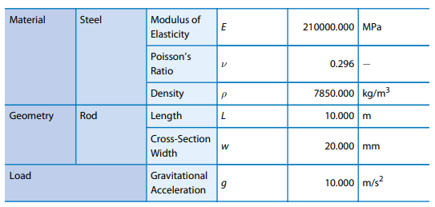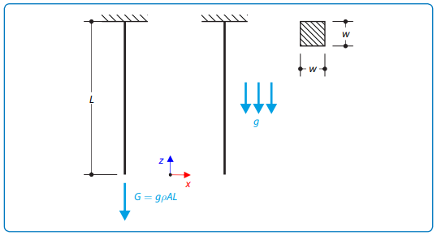
Figure 1 - 0062 – Gravity loading diagram (0078 Dlubal Software)
$$A=w^{2}$$
$$A={0.02}^{2}$$
$$A=0.0004m^{2}$$
$$ω= ρ*g*A$$
In this case gravity is used as 10$m/s^{2}$, due to Dlubal using 10$m/s^{2}$ in their calculations
$$ω=7850*10*0.0004$$
$$ω=31.4$$
$$σ= \frac{ω*L}{A}$$
$$σ= \frac{31.4*10}{0.0004}$$
$$σ= 0.785x{10}^{6}$$

The analytical maximum deflection of the beam is 0.019mm (Dlubal Software) (Calculation in appendix).

Figure 2 – Gravity mesh size influence on max deflection and stress
As shown above, there is no significant deformation when changing mesh size, whereas there is a large deviation in the stress of the beam. Therefore, when comparing these values to the analytical results, a test mesh size between 0.01 and 0.019 would obtain the closest results to the analytical values. It should be known that no bigger mesh sizes could be used due to the width of the material being that size.

Table 2 - Deviation in results for gravity test
 | Investigation FEA tests | Analytical values | Dlubal software
Max deflection (mm) | 0.018688 | 0.019 | 0.019
Stress (Pa) | $$0.851x{10}^{6}$$ | $$0.785x{10}^{6}$$ | N/A

Simplified test case of a cantilever beam

The example test case used within FEA to solve complex problems over large areas is the ‘0016 – Elastic Bending -continuous Load’ (0016 Dlubal Software 2016) as shown in the figure below.

Table 3 - 0016 -Elastic bending data input (0016 Dlubal softwear 2016)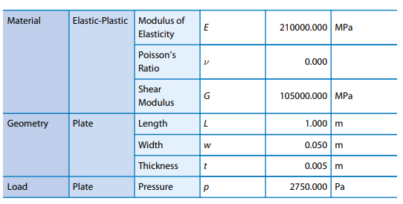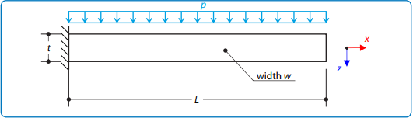
Figure 3 - 0016 - Elastic bending diagram (0016 Dlubal software 2016)
This example was chosen as it shows a universal loading, whilst being a cantilever beam. This is similar to what loads a piston will receive as it will have a pressure applied from above, whilst the conrod and gudgeon pin act as the support for the cantilever beam.
$$I= \frac{wt^{3}}{12}$$
$$I=\frac{0.05*{0.005}^{3}}{12}$$
$$I=5.2083{x10}^{-10}{ m}^{4}$$

$$ω=\frac{8* EI* δmax}{L^{4}}$$
$$ω=\frac{8* 0.21x{10}^{12}*5.2083x{10}^{-10}* 0.157143}{1^{4}}$$
$$ω=137.5N/m$$

$$M= \frac{ω*L^{2}}{2}$$
$$M=\frac{137.5*1^{2}}{2}$$
$$Mmax=68.75N$$

$$Z=\frac{w{*t}^{2}}{6}$$
$$Z=\frac{0.05*{0.005}^{2}}{6}$$
$$Z=2.083x{10}^{-7} m^{3}$$

$$σ=\frac{Mmax}{Z}$$
$$σ=\frac{68.75}{2.0833x{10}^{-7}}$$
$$σ=3.300053x{10}^{8}Pa$$

Maximum bending moment = 157.143mm (Dlubal Software) (Calculation in appendix)

Mesh sizes have an influence on the accuracy of the data and will be discussed in more detail further on. The effect on results is shown below:

Figure 4 - mesh size effect on the stress and the max deflection of the cantilever beam

It can be seen that the change in mesh size has an influence on only the stress of the component. Therefore, the mesh size should be taken into consideration to improve accuracy. In this case the mesh size should be approximately 0.005m. Ansys has a feature, where it includes numbers up to 4 decimal places and therefore cannot be as precise as desired. A mesh size below 0.0025 gives a stress value which reaches the rounding threshold as it gives a value of 3.3006x10^8.
Table 4 - results of real world to simulations
 | Investigation FEA tests | Analytical values | Dlubal software
Max deflection (m) | 0.15715 | 0.157143 | 0.175130
Stress (Pa) | $$3.3x{10}^{8}$$ | $$3.300053x{10}^{8}$$ | N/A

Bimetallic strip
The bimetallic strip is a good way to look at the influence of thermal loads on a metallic strip, which is similar to the loads that will be experienced by a piston. The example used is the ‘0078 - bimetallic strip’ (0078 Dlubal Software 2018) as shown in the figure below.
Table 5 – 0078 - Bimetallic strip data input (0078 Dlubal Software)
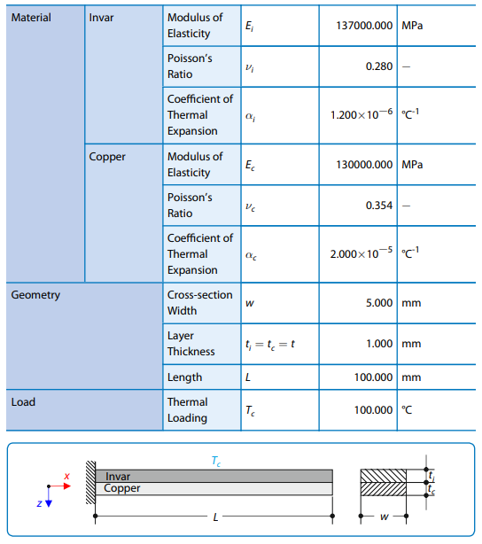
Figure 5 – 0078 - Bimetallic strip diagram (0078 Dlubal Software)
It is complex to calculate the stress of the stress with the bimetallic strip due to the complexity of calculating stress when a thermal load is being applied. Therefore, the analytical validation of the bimetallic strip can only be compared to the deflection of the beam.
The analytical maximum deflection of the beam is 7.049mm (Dlubal Software) (Calculation in appendix).

Figure 6 - mesh size effect on the stress and the max deflection of the bimetallic strip

As shown above the influence of mesh sizing is much more significant in this test compared to other tests. It is clear that the poorest mesh sizing is not at the largest size. This is often due to the mesh sizes larger than this being too big and altering the shape of the geometry, whilst the points afterwards have captured the shape and are trying to give a more localised region of improvement, increasing its accuracy. Leading on from this the best mesh size to be used when looking at the data is the smallest mesh size possible. However, it should be taken into consideration the processing time of the simulation.

Table 6 - results of the real world to simulations
 | Investigation FEA tests | Analytical values | Dlubal software
Max deflection (m) | 0.0071203 | 0.007049 | 0.007064

Limitations of FEA
There are several factors that affect the results of FEA and some limitations to the FEA process that result in differences between real world and simulation results.

Processing time
The biggest impact on the results and FEA process is the high levels of processing time and computer memory needed to solve the geometry. Frequently throughout this investigation running too finite mesh size tends to relate exponentially with the time it takes for a run to take. Therefore, when completing simulations the mesh size needs to be as small as possible to get the most accurate results, whilst being large enough so that the computers can solve the FEA process. This is why companies that design components using FEA have computers with high processing capabilities.

Geometry
A geometry that best replicates the real world model is key, as small details can make significant differences when it comes to FEA. As well as this poorly made geometry through the use of CAD can show details that don’t exist in the real world. Also, CAD designs can often be made in a way that is not ideal for use in FEA, especially when multiple edges come close to one another.
Although including small details is important, if they are known beforehand to have little to no influence on the outcome, then removing these details will reduce the likelihood of errors within the simulation and decrease processing time.

Numerical calculations
FEA uses numerical calculations to predict the changes in the geometry when loads are being applied, thus the analytical calculations will not be exactly like the real world scenario. Therefore, when looking at FEA values it needs to be understood that they cannot be 100% accurate. As well as this FEA is less accurate than the analytical methods when on simple geometry.

Representation of real life supports
In this FEA investigation the component being investigated must have a support to ensure that it acts as it would in the real world. The location of these fixed supports will impact how the loads transfer around the component. This location is quite influential as shown below due to the deviation in stress and deformation of the piston.
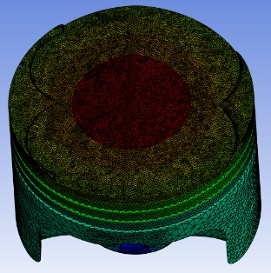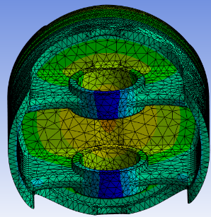  Figure 7 - Piston stress with no fixed support | 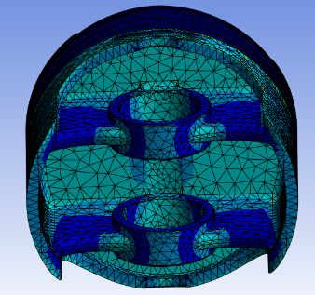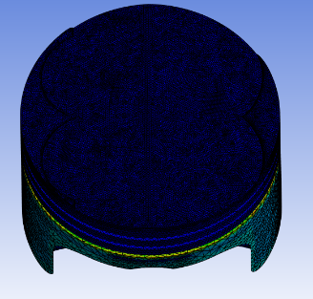  Figure 8 - Piston deformation with no fixed support
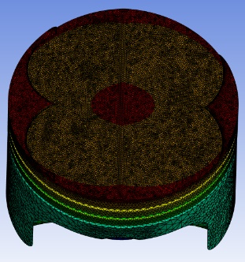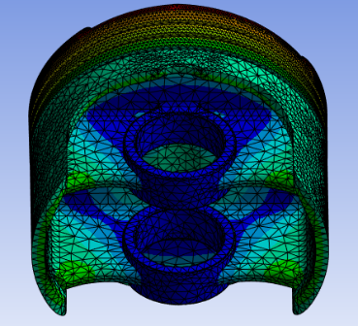  Figure 9 - Piston stress with fixed support through gudgeon pin | 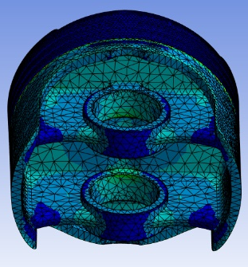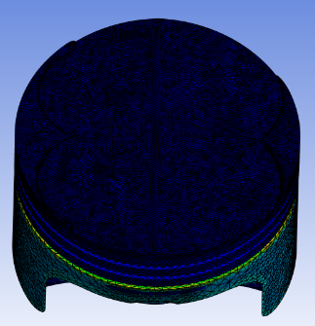  Figure 10 - Piston deformation with fixed support though gudegeon pin

Methodology
Methodology is used to set up parameters that are used throughout the assignment to ensure that the results are comparable. Within these tests there are 4 main regions to a run, as well as further studies that can be completed when looking at specific details.

Engineering data
Throughout the test the engineering needs to remain the same to ensure that the materials properties remain constant. The material being used within the test is T6- 6061 Aluminium. This is due to aluminium being a frequently used material for piston design. The properties were gathered from ANSYS Granta and then imported into the engineering data base. Some properties are shown below

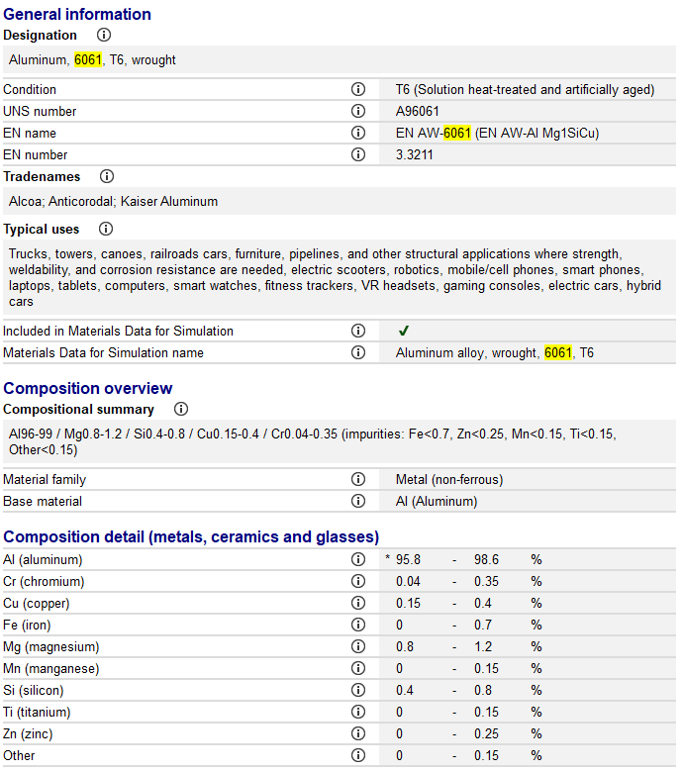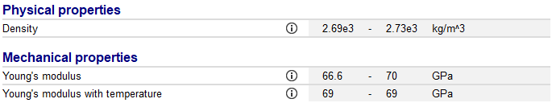 | 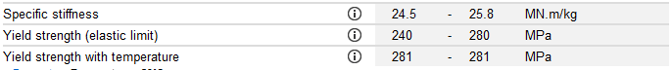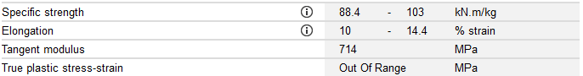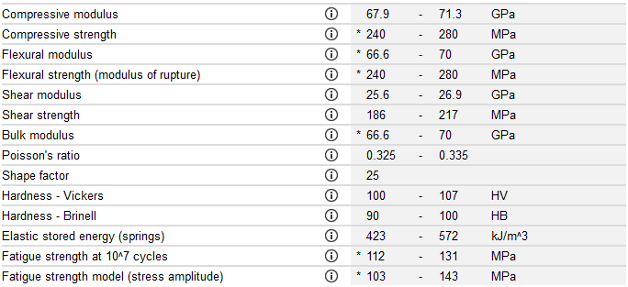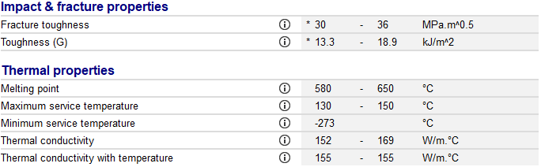

Figure 11 - Granta T6 - 6061 Aluminium basic properties (GRANTA 2022)

Rigid dynamics
Movement and joints of components need to remain the same to make sure that no unexpected forces are being applied to the component. When looking at the movement of the component it should be taken that the rate at which the crankshaft revolves should be at its maximum RPM as this will be where maximum performance and stress is placed on the component. In this case the max RPM of this engine will be 7000.

Thermal loadings
The thermal loads being applied to the component need to remain constant to ensure no deviation of the stress and deformation of the components. Also, the input values need to be comparable to the real-world values. The figure and table below show how the thermal loads being applied to the piston and the location of where they are being applied.
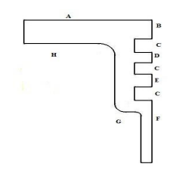
Figure 12 - thermal piston locations (Manish Kumar, 2017)

Table 7 - thermal conditions of piston (Manish Kumar, 2017)
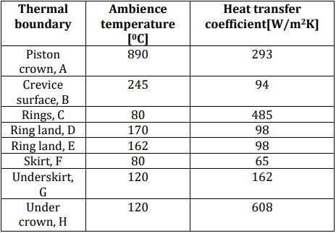

Static structural
Mesh size of components can lead to inaccuracy in data as mentioned earlier. With the validation tests, it has shown that in general a smaller mesh size is most accurate due to the largest deviation coming from the thermal loading. Therefore, a mesh size of 0.0005m for the crown and 0.001 for the side of the crown as that is where the highest temperatures area, resulting in more accurate results. The rest of the piston uses a mesh size of 0.002 to still have accuracy, while not significantly impact the time taken to solve.
Forces that are being applied to the piston need to be taken into account and remain constant. Simple constants are that gravity will always be applied and that there will be a fixed support by the gudgeon pin. The rest of the forces being applied to the components come from the piston motion loads generated in the rigid dynamics section where the maximum points are taken. Also, a pressure will be applied to the surface of the crown to mimic a real piston. The chosen value is 49.2 bar, this is so that the results can be compared to the trends of an external study (H. Adil, S. Gerguri, J. Durodola, N. Fellows, F. Bonatesta, F. Audebert, 2019) on piston. Normally inertial relief and weak spring would be used but these create errors when gathering the results and unfortunately had to be turned off.

Baseline
Having a baseline to compare all future designs is a good way to go about the improvement of components as well as identifying areas of improvements. Using all the parameters above, there are some differences when comparing my results to external studies as the geometry is different as well as different constraints being applied. There are some key similarities and differences between this investigation compared to the external paper on a similar piston design as shown below.

Table 8 - Baseline comparison between baseline and external study
Investigation Baseline | External study
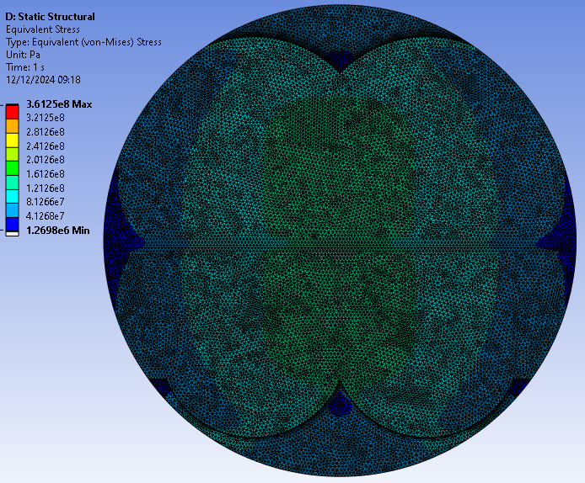  Figure 13 - Baseline run upper surface stress | 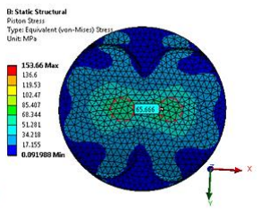  Figure 14 - stress of external investigation upper surface (H. Adil, S. Gerguri,J. Durodola,N. Fellows, F. Bonatesta, F. Audebert, 2019)
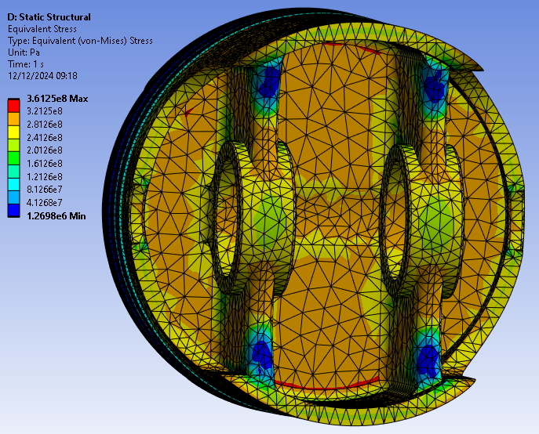  Figure 15 - Stress of external investigation upper surface (H. Adil, S. Gerguri,J. Durodola,N. Fellows, F. Bonatesta, F. Audebert, 2019) | 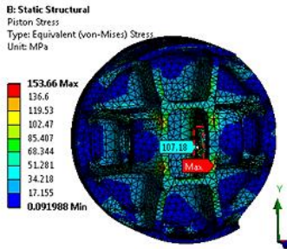  Figure 16 - Stress of external investigation upper surface (H. Adil, S. Gerguri,J. Durodola,N. Fellows, F. Bonatesta, F. Audebert, 2019)
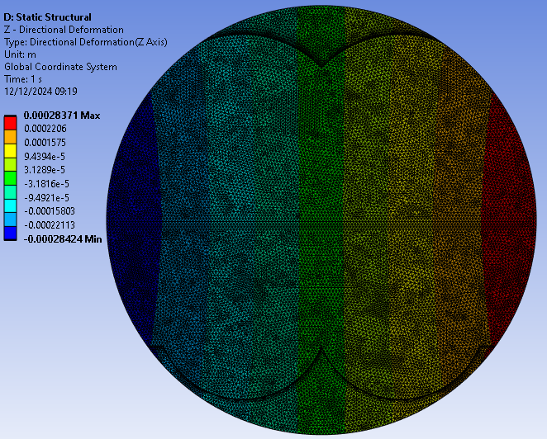  Figure 17 – Baseline deformation in the opposite direction of the conrods rotation | 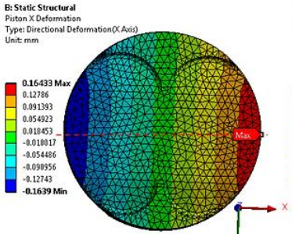  Figure 18 - Deformation in the opposite direction of the conrods rotation (H. Adil, S. Gerguri,J. Durodola,N. Fellows, F. Bonatesta, F. Audebert, 2019)
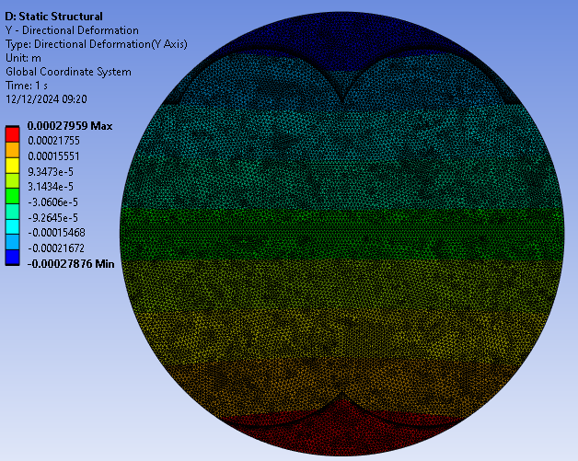  Figure 19 – Baseline deformation in direction of the conrods rotation | 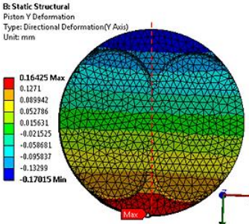  Figure 20 – deformation in direction of the conrods rotation (H. Adil, S. Gerguri,J. Durodola,N. Fellows, F. Bonatesta, F. Audebert, 2019)
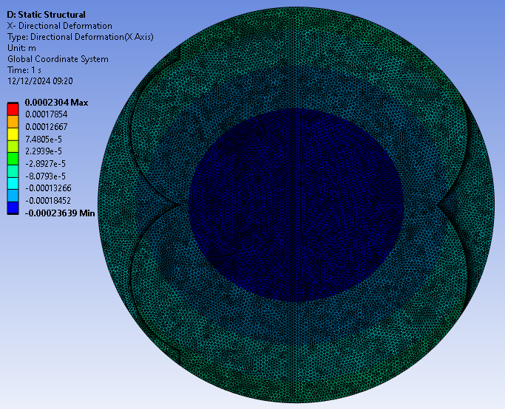  Figure 21 - Baseline deformation downwards of the piston | 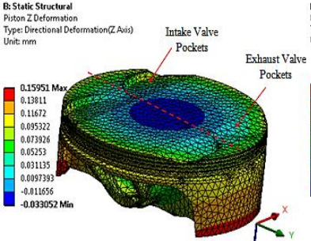  Figure 22 - deformation downwards of the piston (H. Adil, S. Gerguri,J. Durodola,N. Fellows, F. Bonatesta, F. Audebert, 2019)

The general crown of the piston has a lot of similar trends in the distribution of stress and deformation of the crown. Whereas the underside of the piston has quite a large difference between the two tests. This is likely due to the temperatures being applied to the underside deviating significantly as shown in the figure below.
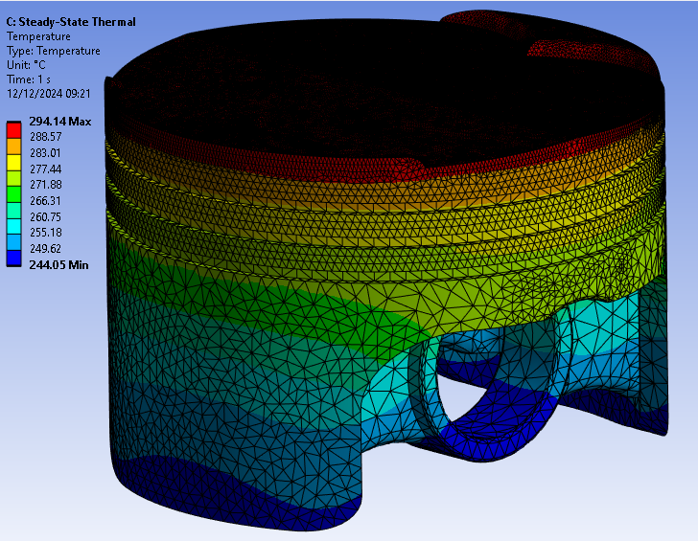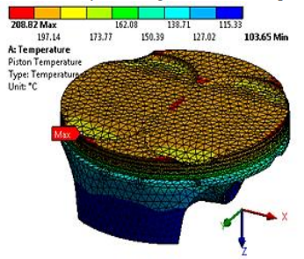
Figure 23 - Baseline piston temperatures Figure 24 - Temperature of external study(H. Adil, S. Gerguri,J. Durodola,N. Fellows, F. Bonatesta, F. Audebert, 2019)
The overall distribution of the contours looks similar, whereas when looking at the skirt and underside of the piston’s values, there is some key differences between the numerical values. This difference in thermal conditions is likely the cause of the significant deviation as a component that has half the thermal temperatures will likely see around half the stress as shown in figures 15&16.
Other than the thermal temperatures impact causing a deviance to the underside, the rest of the data is quite comparable and therefore validates the baseline piston.

Material selection
Material selection is a key concept when it comes to the design of components, especially pistons, due to the high amount of inertia and pressure being applied, whilst also needing to dissipate temperatures quickly. The materials were chosen by looking at Grantas in built system, where a graph of different materials was reviewed for its characteristics (materials that were severally unrealistic were removed e.g. Wood) as shown in figure25.
Specific heat capacity (J/kg°C) vs. Density (kg/m^3)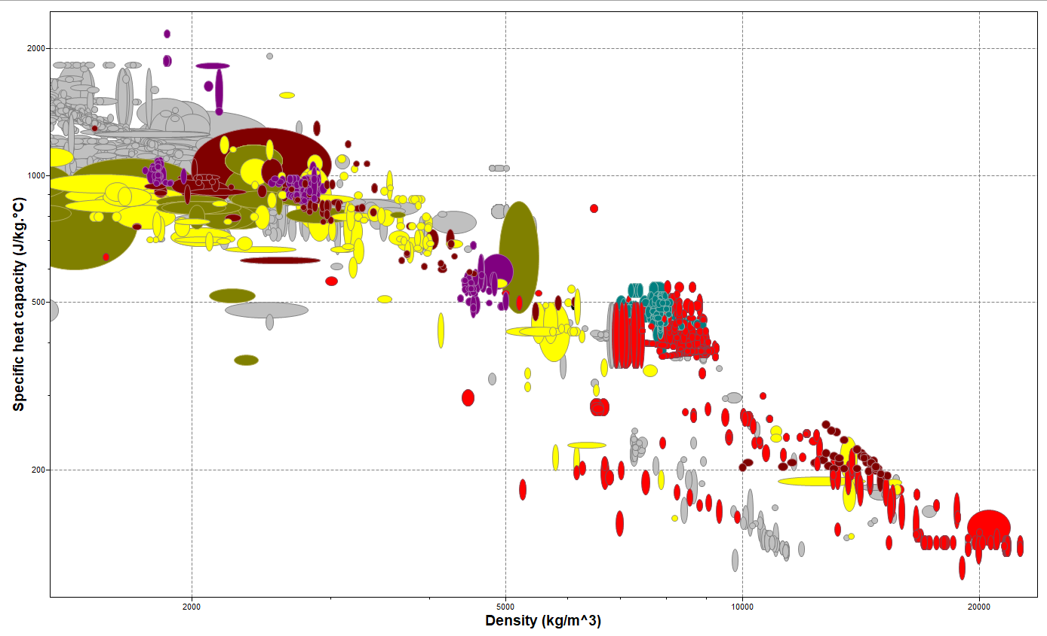
Figure 25 - Material selection option graph based upon its Specific heat capacity and density (GRANTA,2022)
Two of the materials were chosen was aluminium based due to it being commonly used for pistons. Whilst a titanium based material is a plausible material to be used and has been tested in engines before.

Table 9 - Material change table
Material | Stress |  | Deformation | Temperatures
T6 6061 Aluminium |  | 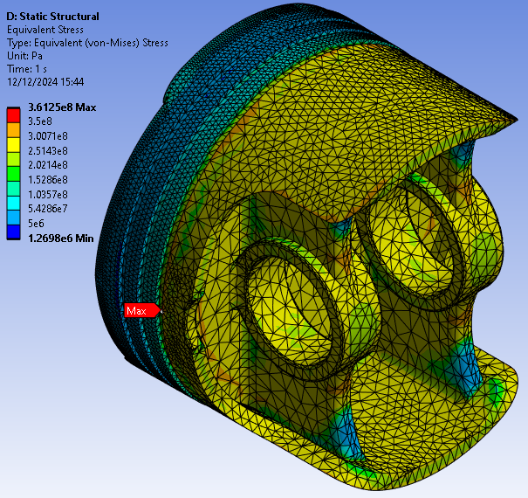  Figure 26 - T6 6061 stress | 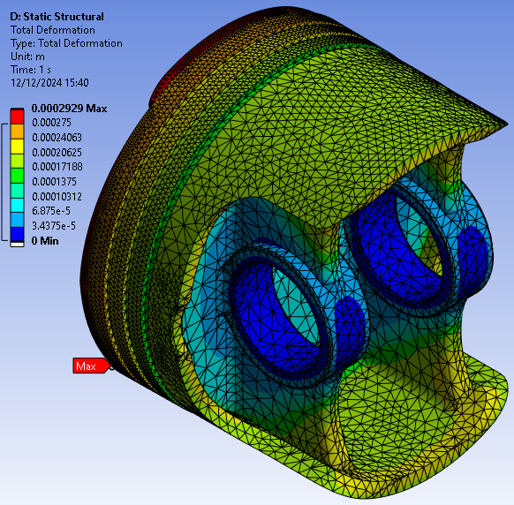  Figure 28 - T6 6061 deformation | 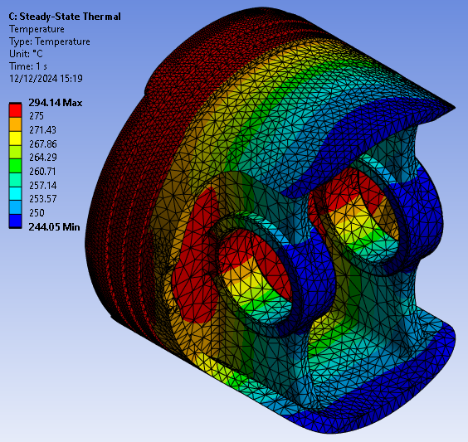  Figure 29 - T6 6061 temperatures
T7451 7040 Aluminium |  | 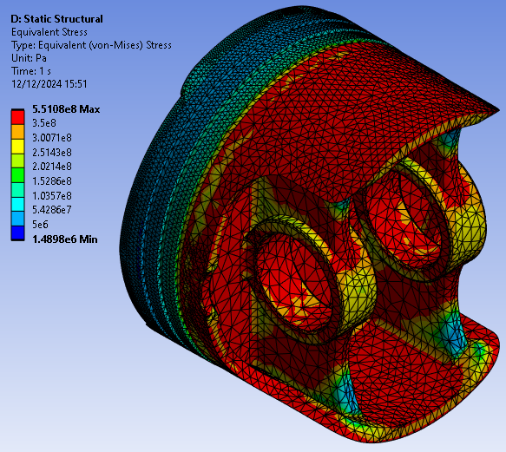  Figure 30 - Aluminium 7040 T7451 stress | 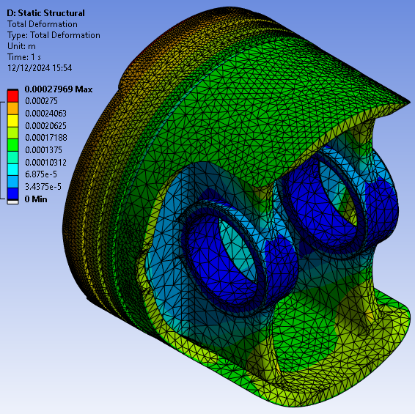  Figure 30 - Aluminium 7040 T7451 deformation | 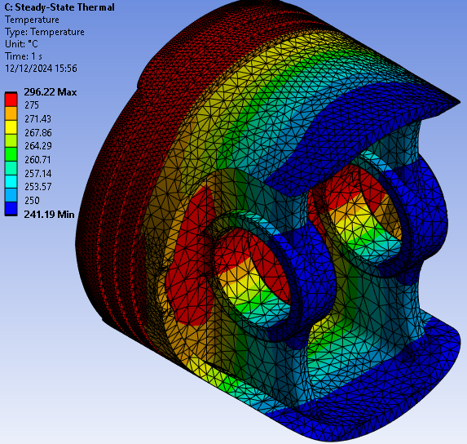  Figure 31 - Aluminium 7040 T751 temperatures
Ti-6Al-4V Titanium |  | 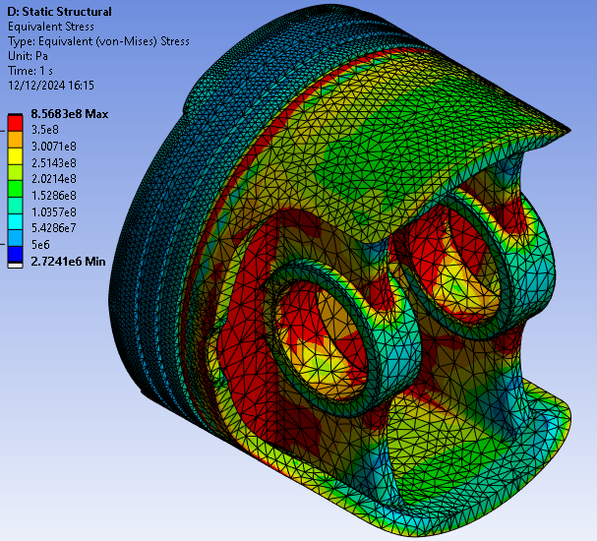  Figure 32 - Titanium Ti-6AL-4V stress | 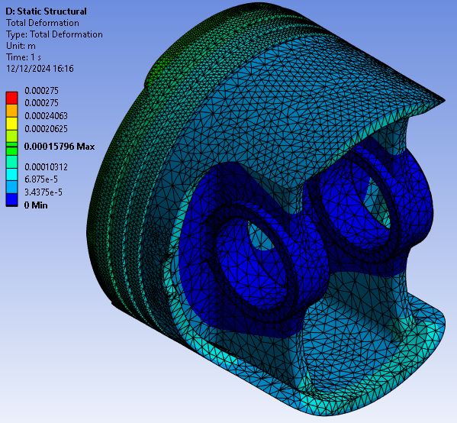  Figure 33 - Titanium Ti-6AL-4V deformation | 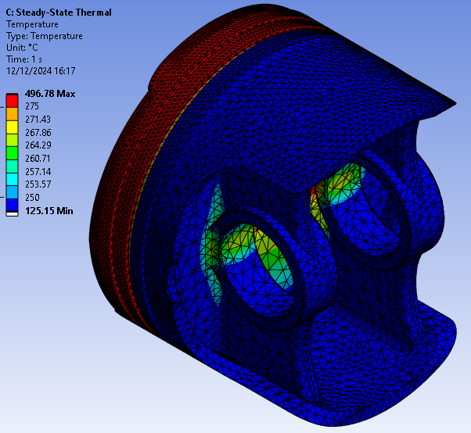  Figure 34 - Titanium Ti-6AL-4V deformation

Looking at the table above it is clear that material choice has a significant impact on the distribution of different contours, due to the contour values being set to the same scale to make them more comparable. When comparing values, it should be known that the stress and deformation of the component may be able to hold much greater loads due to its young modulus value. Also, the deviation in its temperature as well as its peak temperature needs to be investigated in relation to the components characteristics. This is due to the atmospheric temperature and film coefficient in relation to its density and specific heat capacity as shown in the formula below
$$Q=m*c* ∆T$$
Equation 1 - Heat energy equation
Even though a material may show the best values, the viability of the material being used may just be unrealistic. This is generally due to the cost of making and gathering the materials being too significant, as well as the ethics behind how they are made.

Design alterations
Using the baseline results and continuing with the use of the same boundary conditions and material being used, areas of weaknesses can be improved. This generally works by adding or removing material when an alternative material is not available. Also if a final material has been chosen, it is done by changing the shape of part of a component. This can be done by adding a fillet to decrease the stress the component sees at a joint. The removal of material can increase the overall strength of a material.
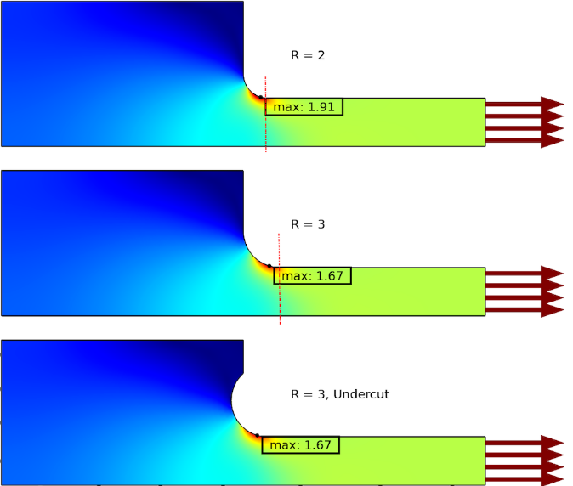
Figure 35 - impact of fillets on its stress (Henrik Sӧnnerlind)
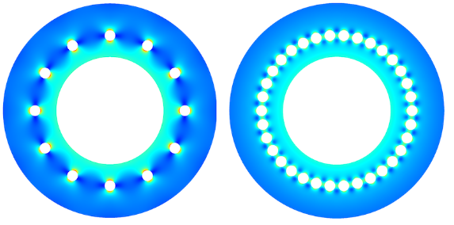
Figure 36 - impact of removal on its stress (Henrik S,20124)
Therefore, using the baseline, areas of weakness can be identified. It should be known that some areas of weakness were not chosen due to issues with the functionality of the piston. An example of this would be the length of the skirt of the piston as it needs to make sure that it doesn’t interfere with any of the other components in the system as shown below.
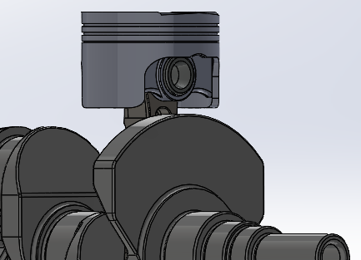
Figure 37 - Piston at bottom dead centre in CAD

Weight saving
Weight saving is a key aspect of all forms of vehicle design. Especially with pistons as reducing the weight reduces the amount of force required to move the piston the same distance. It should be known that this weight saving should not significantly impact the functionality of the component. Therefore, removing some material off the underside connection between the gudgeon pin connection points and the pistons skirt could save some weight whilst not drastically hindering its deformation or stress.
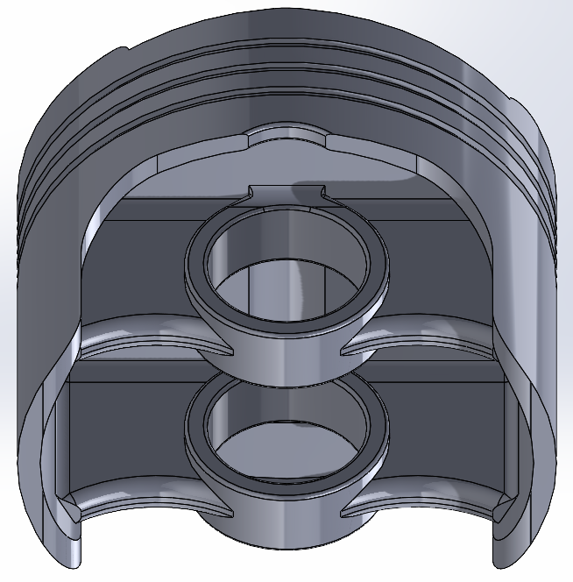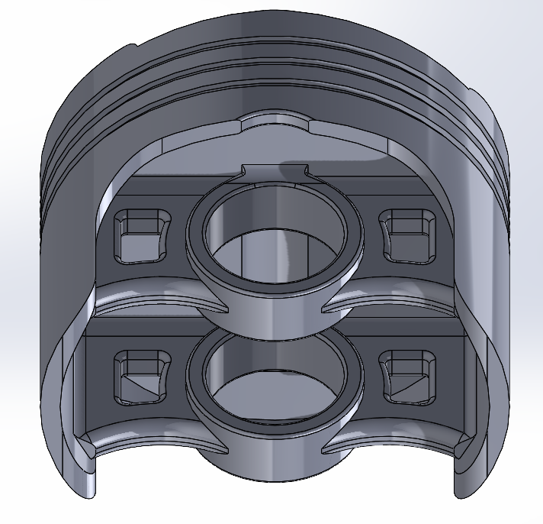
Figure 38 - Baseline piston Figure 39 – Piston with holes in CAD
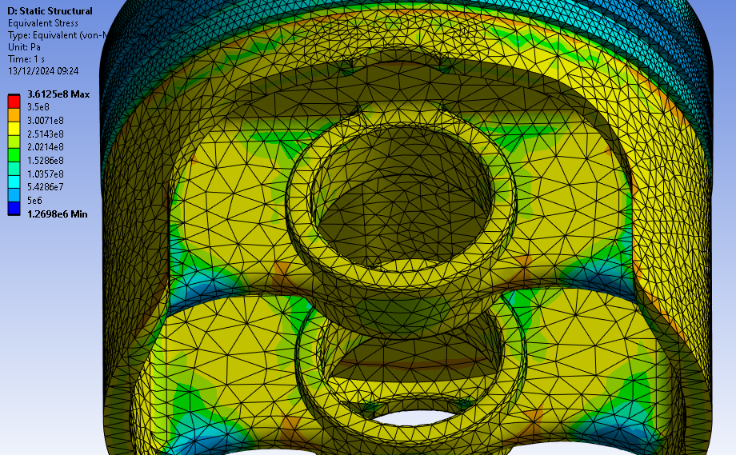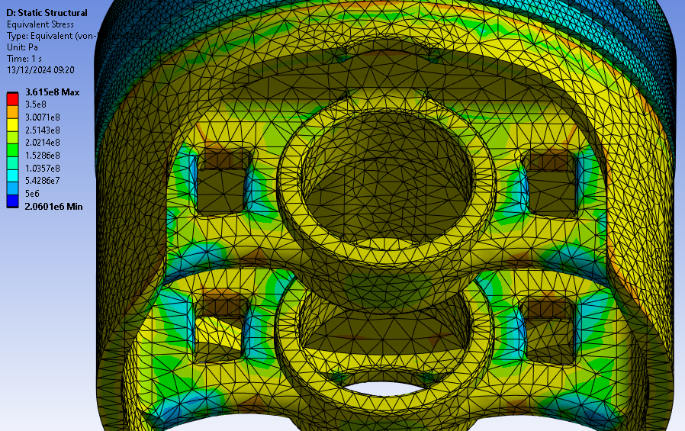
Figure 40 - Stress contours of baseline piston Figure 41 -stress contours of holes added piston
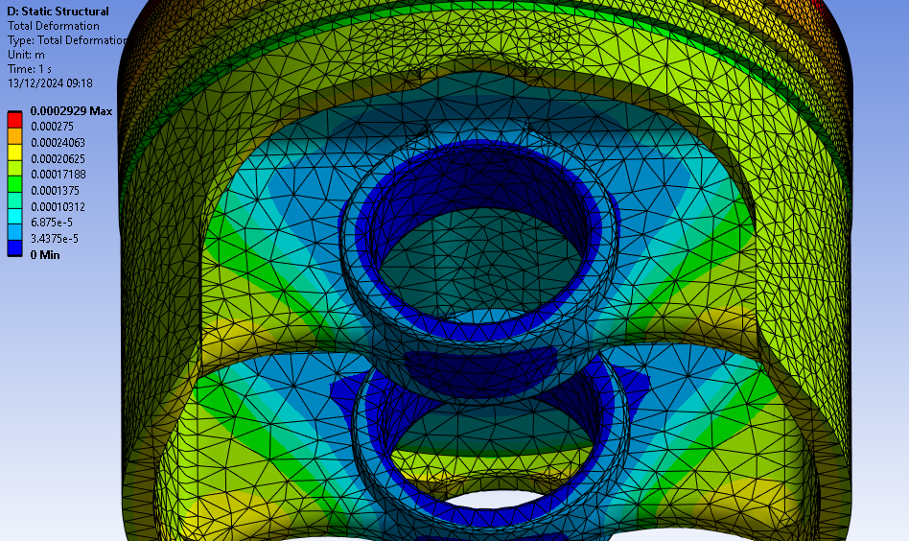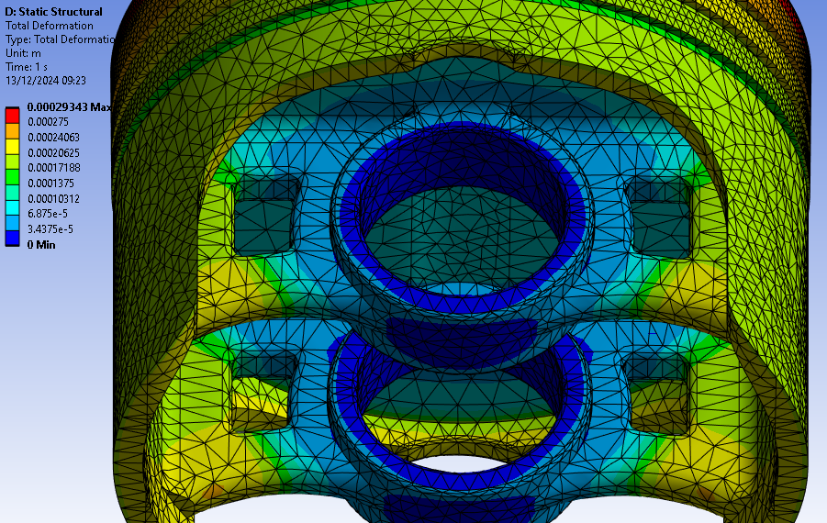
Figure 42 - Deformation contours of baseline piston Figure 43 - Deformation contours of holes added piston
Looking at the results, the reduction in material has no significant impact on the deflection of the component. Also, the stress is generally at a manageable rate due to the only high-pressure regions coming from the underside of the holes, as shown in figure 41.

Adding of material
Adding material can affect the distribution of the loads being applied to a section of the piston. In this case material was added to the lower side of the oil ring and then extruded to half the height of the rings gap. This was to increase the area that the force is applied to. The results seem to show an improvement and lower stress in this area, as shown below. Now ideally this gap would want to be removed or decreased as much as possible, but due to the importance of an oil ring there still needs to be gap for the oil ring to fit into as it is a key aspect of the functionality of the piston.
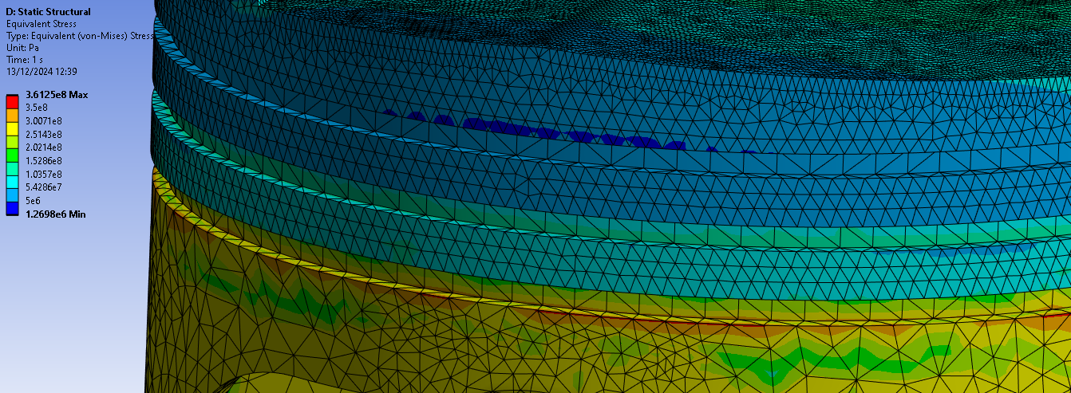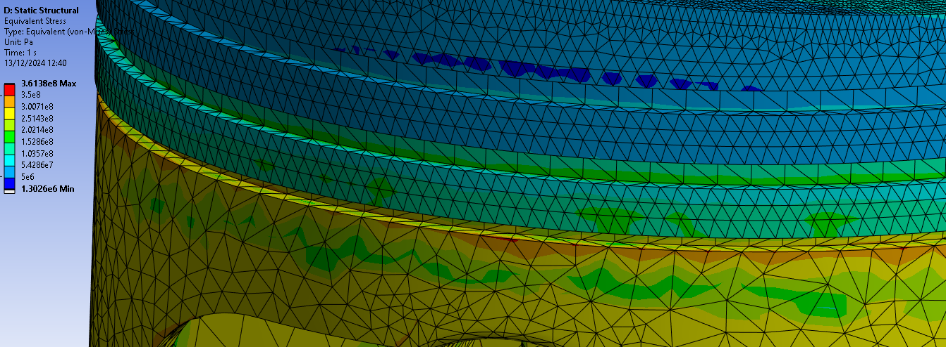
Figure 44 - Stress at the oil ring (Baseline) Figure 45 – Stress at the oil ring (reduced size)

Additional methods of improving results in FEA
It should be noted that the studies below used structural steel as there is not enough detail on T6 6061 Aluminium properties for these areas of improvement.

Topology
Instead of manually looking into areas of improvements, the use of topology (structural optimisation) can be used to display areas of material that can be removed. Using this, the design of the piston can be altered to incorporate areas where mass can be removed whilst causing the least stress of a component. It is key to specify, which components can deviate from the original position as some parts are key to the functionality of the item.
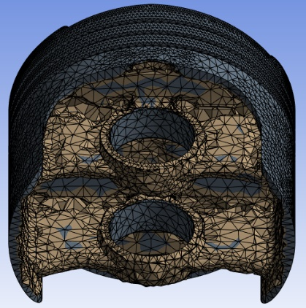  Figure 46 - 5% density reduction | 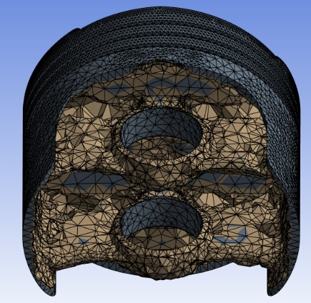  Figure 47 - 15% density reduction | 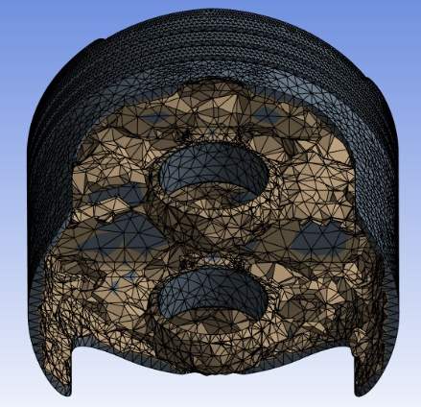  Figure 48 - 25% density reduction

Fatigue
When designing components, it is key to investigate the life cycle of the component. This can be completed in FEA by applying the known constraints. FEA then incorporates this into the materials properties and calculates the number of repetitions until it fails. Also, a safety factor can be looked at, how much margin for error there is on a component.
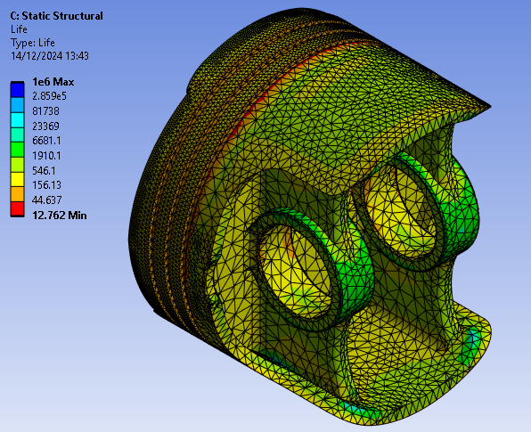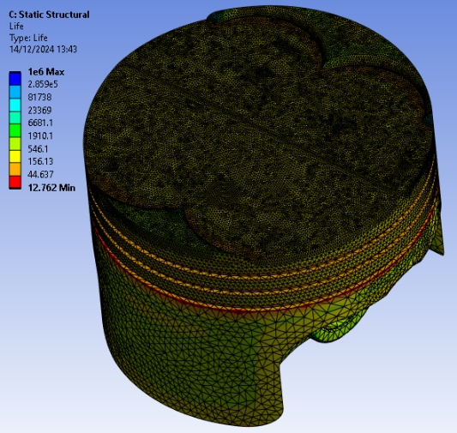
Figure 49 - Life cycle lower surfaces Figure 50 - Life cycle upper surfaces
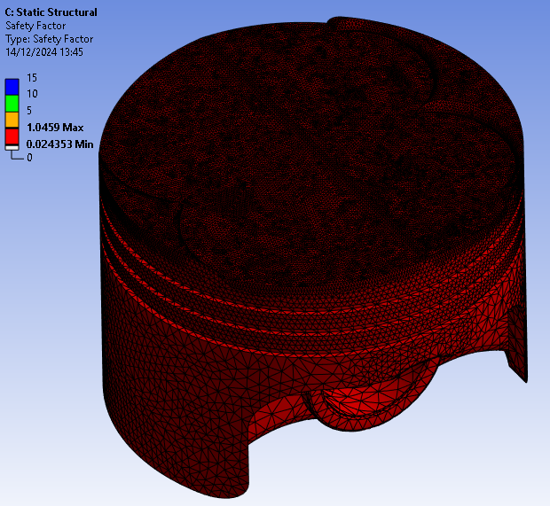
Figure 51 - Piston safety factor
As shown in the figures above, the piston has a low life cycle. Also, the margin for safety of the piston is practically 0. Below is an example of a cycle using some basic constraints on a conrod.
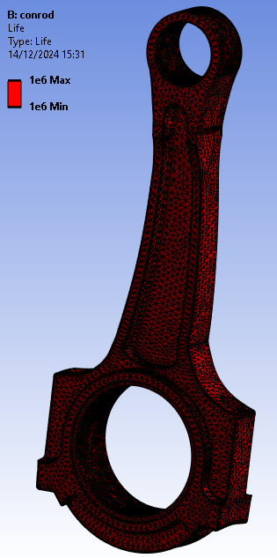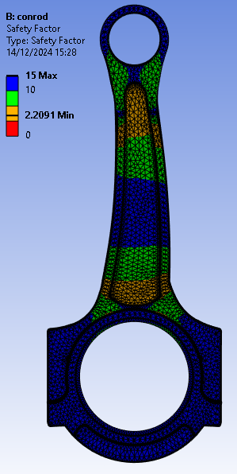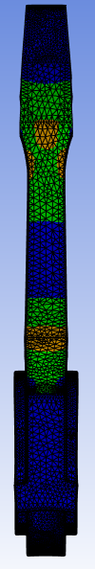
Figure 52 - Life of a conrod Figure 53 - Safety factor of the conrod

Conclusion
FEA is a highly useful tool when looking at complex geometry that will experience a variety of loads and constraints. It should be taken into account that the results from FEA will not be 100% accurate and that adding a buffer to the loads being applied would be a good idea. The combination of multiple different factors that change the stress and strain of the piston is highly beneficial and gives a good representation of how it will behave outside of FEA.

References
Cantilever with uniform load. 2016. DLUBAL: https://www.dlubal.com/en/downloads-and-information/examples-and-tutorials/verification-examples/000016 DLUBAL. (accessed 2/12/2024)
ADIL, H., GERGURI, S., DURODOLA, J., FELLOWS, N., BONATESTA, F. and AUDEBERT, F., Comparative Study and Evaluation of Two Different Finite Element Models for Piston Design. (accessed 10 /12/2024)
DLUBAL, n.d. Verification examples. (accessed 2/12/2024)
DLUBAL, 2018. Bimetallic Strip. DLUBAL: https://www.dlubal.com/en/downloads-and-information/examples-and-tutorials/verification-examples/000078 DLUBAL. (accessed 9/12/2024)
DLUBAL, 2016. Gravity Loading. DLUBAL: https://www.dlubal.com/en/downloads-and-information/examples-and-tutorials/verification-examples/000062 DLUBAL. (accessed 9/12/2024)
HENRIK SONNERLIND, 2020. Making structures strong by removing material. https://www.comsol.com/blogs/making-structures-stronger-by-removing-material (accessed 13/12/2024)
KUMAR, M., A Finite Element Thermo-Mechanical Stress Analysis of IC Engine Piston. IRJET. (accessed 10/12/2024)
KUROWSKI, P.M., 2001. 2001-01-0773 Analysis Tools for Design Engineers. SAE international: Design generator Inc. (accessed 14/12/2024)
R.FISHER, H.B., F.Sinfield, 2021. Comparison of analytical, empirical and finite - element modeling of weld metal cooling as function of plate orientation, thickness and heat input. Manafacturing processes, 62, pp. https://www.sciencedirect.com/science/article/pii/S1526612520308550#:~:text=FEA%20more%20accurate%20in%20joints%20where%20classic%20method%20assumptions%20break%20down. 471–482. (accessed 14/12/2024)

Appendix

0062 – Gravity loading deformation calculations
Analytical methods of gravity loading using their calculation for max deflection (0062 Dlubal software 2016)
$$\frac{dσ_{z}}{dz}+f_{z}=0$$

$$σ_{z}=Eε_{z}$$

$$G=gρAL=134N$$

$$\frac{dσ_{z}}{dz}= \frac{d(Eε_{z})}{dz}=\frac{Edε_{z}}{dz}=0$$
$$ε_{z}=\frac{du_{z}}{dz}$$

$$\frac{d^{2}u_{z}}{dz}=0$$

$$u_{z}\left(z\right)=C_{1}z+C_{2}, C_{1} ϵR, C_{2} ϵR$$

$$\frac{du_{z}}{dz}= ε_{z}=\frac{G}{EA}$$
$$u_{z\left(L\right)=0 }$$

$$C_{1}=\frac{G}{EA}$$
$$C_{2}=-\frac{GL}{EA}$$

$$u_{z} \left(z\right)=\frac{G}{EA}\left(L-z\right)$$
$$u_{z max}=\frac{GL}{EA}= -0.037mm$$

$$f_{z}=ρ*g$$

$$\frac{d^{2}u_{z}}{dz^{2}}= - \frac{ρ*g}{E}$$

$$u_{z}\left(z\right)= - \frac{ρ*g}{2*E}z^{2}+C_{1}x+C_{2}, C_{1} ϵR, C_{2} ϵR$$

$$\frac{du_{z}(0)}{dz}=0$$
$$u_{z}\left(L\right)=0$$

$$C_{1}=0$$
$$C_{2}= - \frac{ρ*g}{2*E} L^{2}$$

$$u_{z}\left(z\right)= \frac{ρ*g}{2*E}\left(L^{2}-z^{2}\right)$$
$$u_{z }\left(z\right)= \frac{ρ*g*L^{2}}{2*E}= -0.019mm$$

0016 – Elastic bending – continuous load deformation calculations
Analytical methods of elastic bending using their calculation for max deflection (0016 Dlubal software 2016)

$$M= EIy*\frac{d^{2}*u_{z}}{dx^{2}}$$
$$I_{y}=\frac{w*t^{3}}{12}$$
$$U_{z}\left(x\right)= \frac{qx^{2}(6L^{2}-4Lx+x^{2})}{24{EI}_{y}}$$
$$U_{z}\max{= \frac{qL^{4}}{8EI_{y}}= \frac{3pL^{4}}{2Ew^{2}t}}=157.143mm$$

0078 - Bimetallic strip deformation calculations
Analytical methods of bimetallic strip using their calculation for max deflection (0078 Dlubal Software)
$$K1=4+6\frac{tc}{ti}+4 {(\frac{tc}{ti})}^{2}+\frac{Ec}{Ei}{(\frac{tc}{ti})}^{3}+\frac{Ei*ti}{Ec*tc}$$
$$Uzmax= \frac{6\left(αi-αc\right)\left(ti+tc\right)Tc}{{ts}^{2}*K1}*\frac{L2}{2}≈7.049$$

