Premier Inn

Student number: 2123070

Student name: Beniamin Solomon Munteanu

Date: 03/03/2023

Table of Contents
Introduction 2
Situation Analysis 2
5 C’s 2
Company: SWOT analysis 2
Customers: Segmentation and Targeting/ Customer profile's' 3
Competitors: 4
Collaborators/Partnerships: 4
Climate: PESTLE (Macro analysis) 5
Objectives: Smart Target 6
Strategy 6
Tactics: Marketing Mix 6
Action 8
Control 9
Conclusion 9
Reference list 11

Introduction

The parent business Whitbread Plc, founded in 1987 via the purchase of the earlier brand Premier Lodge, includes Premier Inn Hotels. With more than 814 hotels and more than 82,000 rooms across the UK and abroad, Premier Inn is one of the fastest-growing hotel brands in the country. Also, it has the most outstanding market share (8.9%) in the UK's hotel and hospitality sector (Farah, 2021). There are restaurants in every hotel building, not to mention a varied and extensive selection of foods and beverages at reasonable costs (Rashid, 2018). The hotel rooms include restrooms, Televisions, and Wi-Fi internet connections. This report aims to pinpoint a problem or marketing opportunity and develop a communications plan for the selected hotel considering the present situation. Also, to provide the company with fresh direction, we will analyze the micro and macro environments.

Situation Analysis
Premier Inn aims to provide high-quality services to all its guests, both within and outside of the United Kingdom (Ghandour, Bilal and Mudassar, 2015). Its key selling point is the assurance of a restful night's sleep at the hotel. The consumer relationships and market that premier Hotel has access to determine their level of success. Some elements that directly impact a company's performance are the administration, consumers, rivals, and market pricing.

5 C’s

Company: SWOT analysis
Strengths | Weaknesses
- The best place to live  - Great first impression within.  - Reflects the brand portfolio of Whitbread PLC (Berry, 2022)  - Worth  - Strong presence  - Accessible structures | - A low-value image  - Absence of initiative  - Peak hour  - Noisy environment  - Outdated, outdated exterior  - Customer pay more on services that the competitor provides for free (Wifi, parking)  - A dearth of vacationers
Opportunities | Threats
- Trade agreements  - Price matching  - Additional amenities for business travelers  - Non-commercial loyalty programs  - Market encroachment  - Product creation  - Technology benefit  - Packages offered by airlines  - Twitter and digital marketing should be promoted more.  - Partnerships | - recession  - Renting apartments and rooms has become popular.  - a few customers' unfavorable opinions or reputations  - New entrants  - Roughly similar pricing and services  - The cheapest hotel is often considered to be Travelodge.

Customers: Segmentation and Targeting/ Customer profile's'
Segmentation:
Sex, education, gender, income, employment, religion, race, and nationality are among the demographic characteristics segmented by Premier Inn. Their geographic division includes cities, states, countries, regions, neighborhoods, and zip codes. Premier Inn's hotel chain often uses geographic segmentation to break up the market. The Premier Inn physiographic segmentation considers lifestyle, social level, personality, values, and other elements (Rahman, 2021). The Premier Inn hotel divides guests based on socioeconomic class, including economic and business.

Targeting:
To operate their entire sales and marketing initiatives, Hotel Premiers Inn segments and targets their prospective clients. In other portions of their company strategy, they will mention it (Freeman, 2020).

Competitors:
Several businesses compete with Premier Inn. These rivals often provide similar services to what Premier Inn offers—for instance, the quality of the meals, the lodging options, and the customer service. Travelodge Hotels Ltd, Days Inn Worldwide Inc. and ACCOR are now the rivals (Comparably, 2022). Like Premier Inn, these businesses provide comparable products. This causes Premier Inn to compete for consumers, which lowers its revenues. Famous in the United Kingdom, Travelodge seriously threatens Premier Inn. For instance, compared to Premier Inn, Travelodge provides complimentary meals to children under 16 and rooms and meals at lower rates. Large families are drawn to the rooms due to their spaciousness. These hotels are located throughout the United Kingdom and beyond, so this is a fantastic competition. The hotel chain Days Inn Global Inc. is similar in that it has overseas operations in addition to its US headquarters. Among its services are lodging and other facilities. As both Premier Inn locations provide online booking, this presents another hurdle for the hotel chain. Similarly, ACCOR is an international hotel chain providing guests with lodging services. This poses a significant issue for Premier Inn as well.

Collaborators/Partnerships:

Premier Inn offers connection via online booking tools and cost management systems to a wide range of Travel Management Organizations and hotel booking agencies. These businesses include ATPI, Clarity Tours, Click Travel, Grade Dawes Group, INNTEL, and Roomex, among others. Travel management firms may access Premier Inn's features, updates, pricing, and availability thanks to their collaboration with some technological partners. Moreover, Premier Inn has partnerships with over 800 hotels in the UK and abroad.

Climate: PESTLE (Macro analysis)

Political

Politics Premier Inns may be found in Qatar, the United Kingdom (UK), Ireland, Germany, and the United Arab Emirates (UAE). While these countries all have stable internal politics, there are differences in the legal systems and rules that apply to the hotel business (Premier Inn, 2021).

Economical

In countries like the UK, Ireland, and Germany, labor expenses are often expensive from an economic perspective (Charlton, 2020). If Premier Inn had operations in other countries, particularly developing ones, it would have benefitted from cheaper labor and rent expenses. The hotel industry is significantly impacted by a country's economic situation. It is commonly known that lockdowns had a negative influence on the UK and Germany. The growing rate of inflation affects Premier Inn in the same way that it affects all other hotels.

Social
Budget motel Premier Inn prioritizes its guests' needs. It therefore targets customers who often look for great deals with friends on trips etc.

Technological
Yet, it is important to realize that developing new technologies and maintaining old ones do not come cheap, but Premier Inn needs to move toward more innovative ways for customers easiness.

Legal
Many laws and rules, such as those controlling minimum wages, health and safety, and standards for planning and building, are applicable to Premier Inn. Any limits that are breached incur the risk of visitors, employees, and governmental entities suing.

Environmental
Some of the environmental factors that affect the business include the carbon emissions and waste created by Premier Inn, the condition of the neighborhood where its hotels are situated, and the amount of foot traffic it generates.

Objectives: Smart Target
Premier Inn's fundamental objectives are as follows:
- To make sure that consumers are engaged with the brand
- To simplify the procedures so that clients may book rooms more quickly and easily
- To provide clients with services online
- To provide a welcoming atmosphere for all customers

Strategy
The number of hotels operated by Premier Inn will rise internationally. By focusing on worldwide expansion in particular limited markets with a certainty of long-term profits, it plays to its strengths. In order to secure profit-making and joint ventures, it is attempting to expand its market in Germany and the Middle East, where it will operate. The hotel is also planning to stop offering its services in South East Asia and India.

Tactics: Marketing Mix

Product

Premier Inn offers a variety of lodging alternatives for various visitor types. The three common room categories are single, double, and accessible.

Price

They provide customers a range of options. The hotel generally employs a value pricing strategy with the intention of delivering its customers exceptional value (George, 2021b).

Place
Over 800 Premier Inn hotels are in the United Kingdom, Ireland, the United Arab Emirates, Qatar, and Germany. While guests may make phone reservations, Premier Inn recommends online bookings. Third parties like Booking.com, Lastminute.com, and others may also be used to do this.

Promotion

In 2022, it intends to invest £20 million in marketing, putting a particular emphasis on expanding its digital reach. There are more than 325,000 fans of the Premier Inn page on Facebook. But, just over 22,000 individuals regularly check its Instagram account. This shows how important it is for the hotel to increase its online presence on more social media platforms.

Action
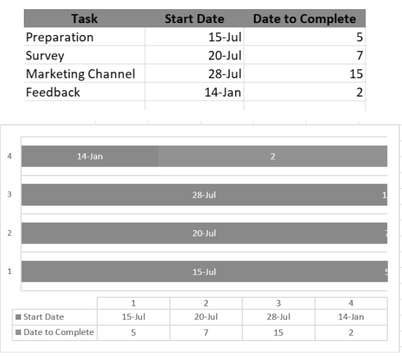
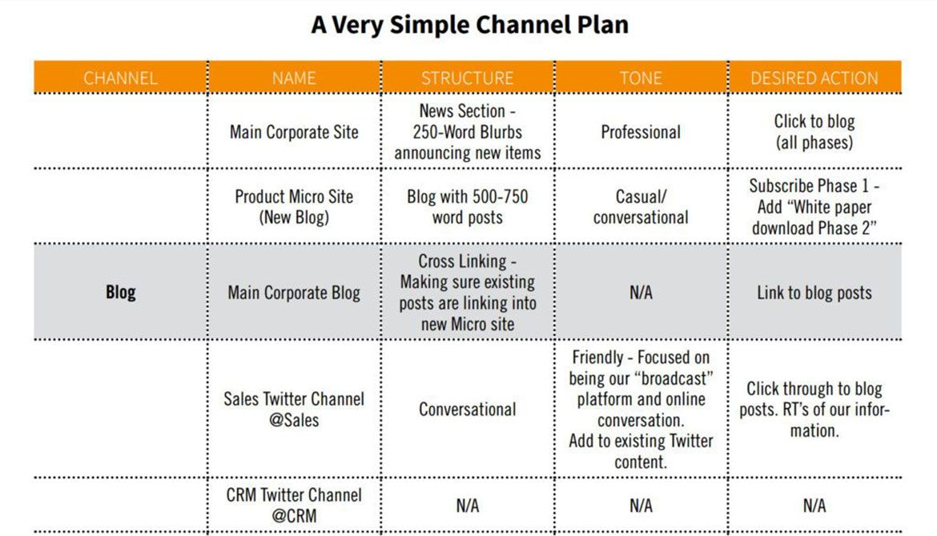

Control
A product's unique selling proposition (USP) is the quality or benefit that sets it apart from similarly priced competitors in the market (Jobber, 2020). Small-batch processing could be used for one product instead of, say, one of its competitors. When a company offers a service rather than a physical product, it may determine that its USP is the fact that it travels to the customer rather than relying on them to come to the firm. The words "USP" and "unique selling position statement" are also acceptable alternatives.
Methods for measuring
The customer is ready to order the services again.
Businesses that are in competition provide better services.
The same steps that the competitors perform are also taken.

Conclusion
Premier Inn, which provides world-class services to clients, is the most fantastic hotel in the UK. It based its products on the promise of a restful night's sleep. If a client is unhappy with the services they get, the management will refund their money. A hotel there relies on satisfied guests. As a result of extending its services outside the UK, Premier Inn contributes to the country's economy. The management must consider the pricing issue when accommodating a large group.

Reference list
Berry, C.T.P. (2022). Equity research - Whitbread PLC. [online] www.repository.utl.pt. Available at: https://www.repository.utl.pt/handle/10400.5/27132 [Accessed 2 Mar. 2023].
Charlton, E. (2020). Where labour costs the most (and least) in the European Union. [online] World Economic Forum. Available at: https://www.weforum.org/agenda/2019/05/chart-labour-costs-in-european-union/.
Comparably. (2022). Premier Inn Competitors. [online] Available at: https://www.comparably.com/companies/premier-inn/competitors.
Farah, Y. (2021). Premier Inn owner Whitbread grows market share during lockdown | Shares Magazine. [online] www.sharesmagazine.co.uk. Available at: https://www.sharesmagazine.co.uk/news/shares/premier-inn-owner-whitbread-grows-market-share-during-lockdown#:~:text=In%20a%20third%20quarter%20trading%20update%20for%20the [Accessed 2 Mar. 2023].
Freeman, J. (2020). On Determining the Value of Online Customer Satisfaction Ratings – A Case‐based Appraisal. Data Analysis and Applications 3, pp.195–214. doi:https://doi.org/10.1002/9781119721871.ch10.
George, R. (2021a). Market Segmentation, Targeting, and Positioning. Marketing Tourism and Hospitality, pp.221–246. doi:https://doi.org/10.1007/978-3-030-64111-5_7.
George, R. (2021b). Tourism and Hospitality Products, Branding, and Pricing. Marketing Tourism and Hospitality, pp.249–283. doi:https://doi.org/10.1007/978-3-030-64111-5_8.
Ghandour, R., Bilal, J. and Mudassar, H. (2015). Relationship between Service Quality, Customer Retention and the role of Social Media- Case study Premier Inn Hotel (UK). Journal of Organizational Studies and Innovation, [online] 2(4), pp.1–12. Available at: https://westminsterresearch.westminster.ac.uk/item/v37qz/relationship-between-service-quality-customer-retention-and-the-role-of-social-media-case-study-premier-inn-hotel-uk.
Premier Inn (2021). Premier Inn Home. [online] Premier Inn. Available at: https://www.premierinn.com/gb/en/home.html.
Rahman, M. (2021). Marketing mix of Premier Inn. [online] howandwhat. Available at: https://www.howandwhat.net/marketing-mix-premier-inn/.
Rashid, N.A. (2018). ‘Factors Determining Profitability’: A Study on Whitbread PLC Hotel in United Kingdom. [online] papers.ssrn.com. Available at: https://papers.ssrn.com/sol3/papers.cfm?abstract_id=3181638.

