Leah Edwards – 2006230
Assignment due by – December 4th, 2020
UK Tourism and Leisure Industry

Introduction
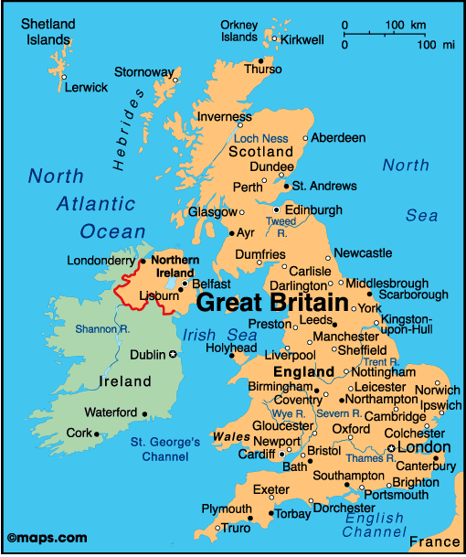 (Infoplease.com,2020)
The United Kingdom is a country in Europe made up of 4 geographical regions, England, Scotland, Wales, and Northern Ireland. The UK is the tenth most visited country in the world (weforum.org,2020) and in 2019 the country welcomed over 39.2 million international tourists, with the leading visiting groups being the USA and France (Condorferries.co.uk,2020).
Tourism is the fastest growing industry in the UK and provides more than 3.8 million jobs. Surveys suggest that 63% of tourists travel for holiday purposes, whilst the other main reasons for visiting are for educational/business purposes. Currently, the industry is worth £106 billion, however by 2025, it is expected that this figure will more than double to £257 billion relying on a surge of tourist numbers and events (VisitBritain.org,2020).
As well as welcoming international tourists, domestic tourism is also very popular in the UK and many records suggest that there was a figure of 118.6 million domestic travels made in the year 2018 (Common Library.Parliament.uk,2020). This number is also expected to grow in the following years due to Coronavirus, which has resulted in more people opting to stay local for breaks rather than go abroad. The Uk has plenty to offer, respectively it is a destination known best for its golden beaches/seaside resorts, historic landmarks, sports, and heritage. The Uk is full of amazing travel hotspots and has a huge range of tourist attractions. An example of these destinations includes London, which is the UK’s most visited city with over 27 million tourists each year as well as Manchester and Edinburgh. These cities have many appealing attractions that attract visitors such as Big Ben, The Tower of London, Edinburgh castle and the North Coast 500.Other popular destinations include the Brecon Beacons and Snowdonia in Wales. There is more to the UK than just landscapes as the area is full of great nightlife in areas like London and Bristol, shopping outlets and amazing theme parks such as Alton towers. Sports also play a huge aspect to the tourism industry in the Uk and many tourists travel to watch sports matches in places such as Wembley stadium.

A general outlook of tourism and leisure in the whole of the UK
As mentioned, The UK has four main contributing countries, all these countries contribute majorly to the UK’s tourism sector and economy. Each of them has many popular attractions and tourism hotspots that bring in thousands of tourists each year.
The UK welcomes thousands of tourists each year, these include both international and domestic travellers. The leading country with the highest annual visitor count is England, with 37.9 million tourists visiting in 2018 alone. During that year, £2.9 billion was spent by overseas visitors (condorferries.co.uk,2020. ) Followed by Scotland, with 15.5 million visitors in 2018. Where tourists spent £5 billion and an estimate of £10.5 billion to the value of the wider economy (www.scottish-enterprise.com 2020.)
There are a wide range of tourism hotspots across the UK, popular examples include Westminster, London, Edinburgh, Snowdonia, and Brecon Beacons. A few popular places located in London: The British Museum, Tower of London, and the London eye. Popular areas in Brecon beacons are: Pen Y Fan, Black Mountains, and the National Show caves Centre. Another popular location includes Cardiff, that has a historic background with attractions, such as Saint Fagan's.

Wales
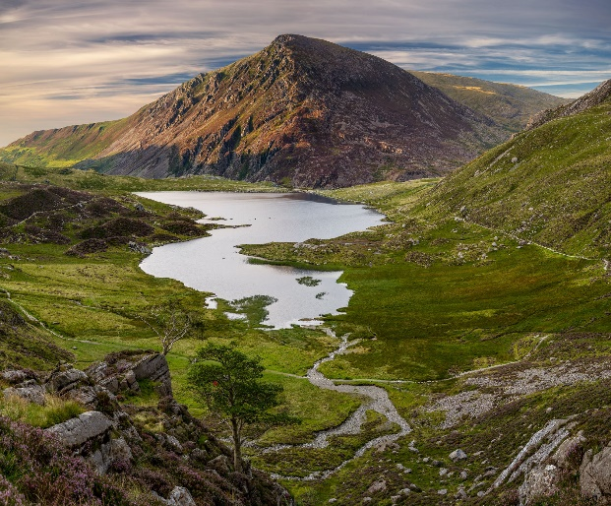
(Nationalgeographic.com,2020)

Wales is widely known for being a country of nature, with its history and heritage, beaches, landmarks, mountains, sports, and cultural traditions.
A few popular areas in Wales include Pembroke, North-Wales, and Cardiff.
Popular attractions include Cardiff Bay, Conwy castle, Pembrokeshire Coast National Park, Principality Stadium, Gwyrch Castle, and the Wales Millennium centre. Although there are hundreds of areas in Wales that people love to visit, these were found to be the most popular and high customer demand throughout the whole of Wales. Each year Wales welcomes around 1,023,000 international tourists bringing in £515 million to the economy (Gov.Wales.co.uk,2020). There are a number of domestic travel organisations in Wales such as Bluestone resort that bring in revenue and increase both domestic and international visitor numbers in the UK, in recent years Bluestone has planned to become Britain’s favourite short break destination revenuing close to £25 million (Insidermedia.com,2018).

Numbers and Types of Visitors Generated
Annually Wales attracts around 10 million visitors, as mentioned 1 million of which are international travellers (Businesswales.gov,2019). As a whole the UK’s annual tourism figure is just about 40 million visitors a year also accounting 3.8% to Global international tourism receipts (Condorferries.co.uk,2020). These figures suggest that Wales contributes around 25% (1/4) to the UK’s overall annual tourist figure. Up until late 2019 Wales was seeing an increase in tourism rates until coronavirus hit which has severely impacted industry growth and decreased travelling rates due to the restrictions, although the exact number of lost tourists has not yet been calculated the welsh economy has announced its suffering with many operators speaking out about how they have lost up to 100% of business during the pandemic (Walesonline.co.uk,2020). The tourism industry has been one of the hardest hit industries during the last year, yet Wales are hopeful that the country will be able to bounce back in the following years.

Tourist types and Target tourism groups
In recent years, the attraction of travelling to Wales for those aged 55+ has decreased whilst the younger generations aged 16-34s interests have grown (Gov.Wales.co.uk,2016). Wales has seen a change in demand regarding these figures as the main tourism group wales are wanting to attract Is now the younger generation. Whilst Wales still cater and aim to attract a range of tourism groups and all types of people, they have used their tourism surveys to acknowledge the main interests of their target market which is currently Adventure, Activity and Discovery tourism. A large majority of their younger target market claimed they were most interested in visiting for the outdoor or sports type activities that Wales had to offer which has helped Wales start to plan to prioritise this market by improving its adventure and activity products (Gov.Wales.co.uk,2020).

Key Locations and Destinations
Wales has many loved destinations that attract a range of tourists with different interests, two places in particular seem to draw in more international tourists than others. These include Cardiff and Pembrokeshire.

Cardiff:
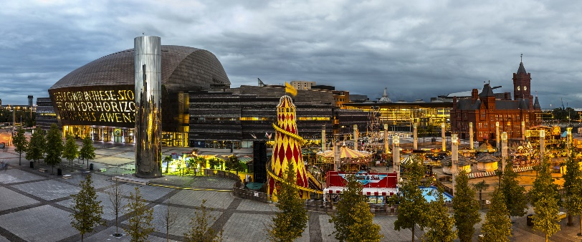
(VisitBritain.com,2020)
Cardiff is Wales’ Capital City, boasting more than 21 million visitors a year, 466,000 of which are international tourists (www.cardiffnewsroom.co.uk,2017). Cardiff is best known for its nature around the sports and music industry, home of the principality stadium the city offers a range of sports events such as rugby matches , music concerts and events and conferences. The capital with its reputation of music and sports has become a destination impacted by social influence looking at (Moutinho ,1993) theory social media may have had an impact on the appeal to Cardiff as a destination as it is the capital of Wales which is the birth place of many famous singers and actors such as Tom Jones and Catherine Zeta Jones and is also the location where many films and series such as Dr who have been filmed.Cardiff is a destination with many hospitality providers such as the Marriott hotel chain , multiple lesuire and shopping facilities such as Cardiff bay and Merlins shopping walk. The capital brings in a number of tourists each year including international tourists who have an interest in heritage and history as it is one of the most historic places in Wales with attractions such as Cardiff castle and Saint gag and.

Pembrokeshire:
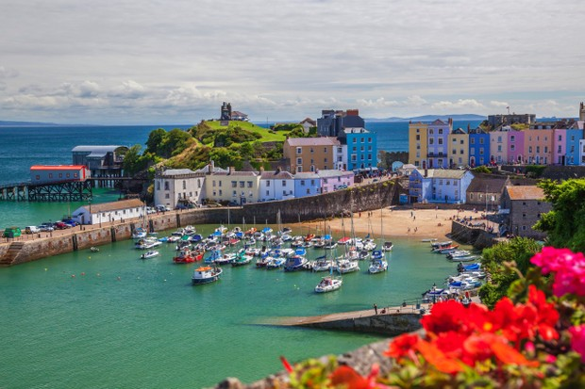
(Countryfile.com,2020)
Pembrokeshire Is another hotspot that bring in millions of tourists each year, Tenby alone welcome more than 2 and a half million tourists in each year (Walesonline.co.uk,2020) with 50% of which coming from outside Wales for events such as the Iron Man. Pembrokeshire has much to offer including unique experiences that draw in a range of visitors, looking at (Maslow,1943) theory of hierarchy of needs there may be an appeal to travelling to areas such as Pembrokeshire as people generally have more of a desire for new experiences as it improves their “self-acquisition”, which Pembrokeshire can fulfil as there are many attractions such as Zip world velocity 2, Bounce below and Skyride 2 that give visitors a unique and one of a kind experience using the natural area to their advantage basing these fun adventure and adrenaline attractions off the Brecon beacon scenery. Pembrokeshire is home to many loved attractions such as the 5 star Bluestone resort, The Pembrokeshire coastal path and Tenby. Pembrokeshire is an area of Wales that has many attractions that attract a range of visitors especially families and activities seekers from hiking and cycling trails, to mountain summits, Sandy beaches, castles, theme parks and hospitality, Pembrokeshire has much to offer for all kinds of tourists and has an existing appeal on the international market.

However, there are many other areas in Wales such as North Wales which are popular amongst visitors for attractions such as Conwy Castle and now famous for Gawrych Castle which is where I’m a celebrity 2020 is taking place due to coronavirus giving the country the recognition that it deserves and creating an appeal to tourists who are fans of the show.

Major Stakeholders and Core Industry operations
One of the main reason’s tourists visit Wales is for the scenic and unique landscapes found throughout the country. The welsh Government, the National trust, and many public sector societies such as the Brecon Beacon park society are all major stakeholders for tourism in Wales. These organisations all own or share ownership of public attractions such as Snowdonia National Park and the Brecon beacons. To name just one of Wales core industry operators WhenwhereWales is one of the countries many tourism operators specialising in sightseeing tours across the country in hotspots such as Cardiff, Tenby, and The Brecon beacons (wherewhenwales.com,2020).

Main issues and concerns
One of the current main issues and concerns that could continue impacting the travel and tourism industry and could have many negative effects on future Tourism in Wales due to the decrease of Business operations is the Coronavirus pandemic. The pandemic has caused a major drop in tourism worldwide as the restrictions such as social distancing that have been put in order have made it unsafe and nearly impossible to travel to certain places. Coronavirus is feared to of set back the global travel and tourism industry 20 years with its economic damage expecting to cost $1 trillion and putting more than 120 million jobs at risk (Weforum.org,2020). It may take years for the tourism industry to start making back profits and rebuilding itself and some destinations may struggle more than others to bring back their tourism, already causing 1,512,255 deaths worldwide (Worldometers, info,2020) Coronavirus could potentially create a long-lasting fear of travelling especially internationally which could decrease interest in international holidays with people opting to holiday domestically instead. If the restrictions are to carry on for a longer duration it could result in countries such as the UK going into a recession which would severely impact Wales.

Conclusion
To conclude, Wales seems to be making a positive change in attracting its new acknowledged target market to the country. Aiming to bring in a range of both Domestic and International visitors Wales has planned to prioritise improving its Discovery and Activity tourism products including offering more sports and cultural events and activities such as marathons/triathlons like Iron man and surfing events. Whilst the Coronavirus Pandemic does bring uncertainty to global tourism interests as the industry is unsure how organisations will be able to operate worldwide whilst restrictions are still in place, Wales are doing their best to plan towards the future to attract visitors back into the country once it is safe to travel again. ‘Most push factors to a destination include desire to escape, rest and relaxation, prestige, health and fitness, adventure and social interactions , whilst pull factors emerge from the attractiveness of a destination including beaches and cultural attractions (Uysal and Jurowski,1994) looking at this theory, although the world may be on stand still, due to the pandemic, Wales could have an advantage over other countries, to bring back revenue and tourist rates, whilst also having a positive future in the international market, as the country has many aspects such as beautiful beaches, adventure trails and cultural attractions which not many countries worldwide have to offer to the extent that Wales do, which could help Wales increase its International tourism market and could create a more rapid international demand for holidays across Wales .

Bibliography:

BusinessWales.Gov,(2019),’Wales- Year of Discovery’, Online, available: https://businesswales.gov.wales/tourism/sites/tourism/files/documents/YOD_2019_Business_Guide_Departures_English_Web.pdf

Cardiffnewsroom.co.uk, (2017),’Cardiff boasts record visitor numbers as industry experts prepare for Cardiff tourism summit 2018’, Online, available:
https://www.cardiffnewsroom.co.uk/releases/c25/18168.html

CommonsLibrary.Parliament.uk,(2020).’Home sweet Home: How popular is domestic tourism in the UK, [Online}, Available: https://commonslibrary.parliament.uk/home-sweet-home-how-popular-is-domestic-tourism-in-great-britain/#:~:text=In%202018%2C%20there%20were%20118.6,million%20were%20made%20to%20Scotland.

Condorferries.co.uk. (2020),’ Uk tourism statistics 2020’, [Online], Available: https://www.condorferries.co.uk/uk-tourism-statistics#:~:text=The%20industry%20supports%203.8%20million,in%202017%20with%2039.2%20million!

Countryfile.com,(2020),’Best walks in Pembrokeshire coast national park’, Online, available: https://www.countryfile.com/go-outdoors/walks/best-hikes-in-pembrokeshire/

Gov.wales.co.uk, (2020),’Wales tourism Performance report January to December 2019’, Online, available: https://gov.wales/sites/default/files/statistics-and-research/2020-06/wales-tourism-performance-january-to-december-2019-208.pdf

Gov.Wales.co.uk,(2016’,’wales tourism survey’, Online, available: https://gov.wales/sites/default/files/statistics-and-research/2019-05/wales-visitor-survey-2016-uk-day-visitors.pdf

Gov.Wales.co.uk,(2020),’Welcome to Wales 2020-2025- Priorities for the visitor economy’, Online, available: https://gov.wales/sites/default/files/publications/2020-01/welcome-to-wales-priorities-for-the-visitor-economy-2020-to-2025.pdf

Infoplease.com,(2020),’United Kingdom map’, Online, available: https://www.infoplease.com/atlas/europe/united-kingdom-map

Insidermedia.com, (2018),’Revenues and Visitor numbers at Bluestone Resort’, Online, available: https://www.insidermedia.com/news/wales/revenues-and-visitor-numbers-up-at-bluestone-resort
Uysal, Muzaffer, Jurowski, Claudia, (1994).’Testing the push and pull factors ‘pages Volume 21 -844-846, Annuals of Tourism Research.

Nationalgeographical.com,(2020),’Why hiking in Wales is one of our best trips for 2020’,online,available: https://www.nationalgeographic.com/magazine/2020/01/why-hiking-wales-is-one-of-our-best-trips-for-2020/

VisitBritain.org, (2020), ‘ Britain’s visitor economy facts’, [Online}, Available: https://www.visitbritain.org/visitor-economy-facts

VisitBritain.com,(2020),’Cardiff’, Online, available: https://www.visitbritain.com/gb/en/business/wales/cardiff

Walesonline.co.uk,(2020),’We are a bottomless pit’, Online, available: https://www.walesonline.co.uk/news/wales-news/we-bottomless-pit-tourism-seasonal-18040372

Walesonline.co.uk, (2020),’The jewel of Wales tourism industry’online,available: https://www.walesonline.co.uk/news/wales-news/jewel-wales-tourism-industry-no-18407228

Weforum.org, (2020), ‘Chart of the day: These countries normally have the highest international
tourist numbers’, [ online], Available: https://www.weforum.org/agenda/2020/06/most-visited-countries-world-tourism- organization/#:~:text=France%20is%20the%20world's%20number,Italy%20complete%20the%20top%20five.

Weforum.org,(2020),’Covid-19 could set the global tourism industry back 20 years’online,available: https://www.weforum.org/agenda/2020/09/pandemic-covid19-tourism-sector-tourism/

WherewhenWales.com, (2020).’welcome to Wales’, Online, available: https://www.wherewhenwales.com/

Worldometres.info,(2020),’COVID-19- Coronavirus Pandemic’, Online, available: https://www.worldometers.info/coronavirus/

