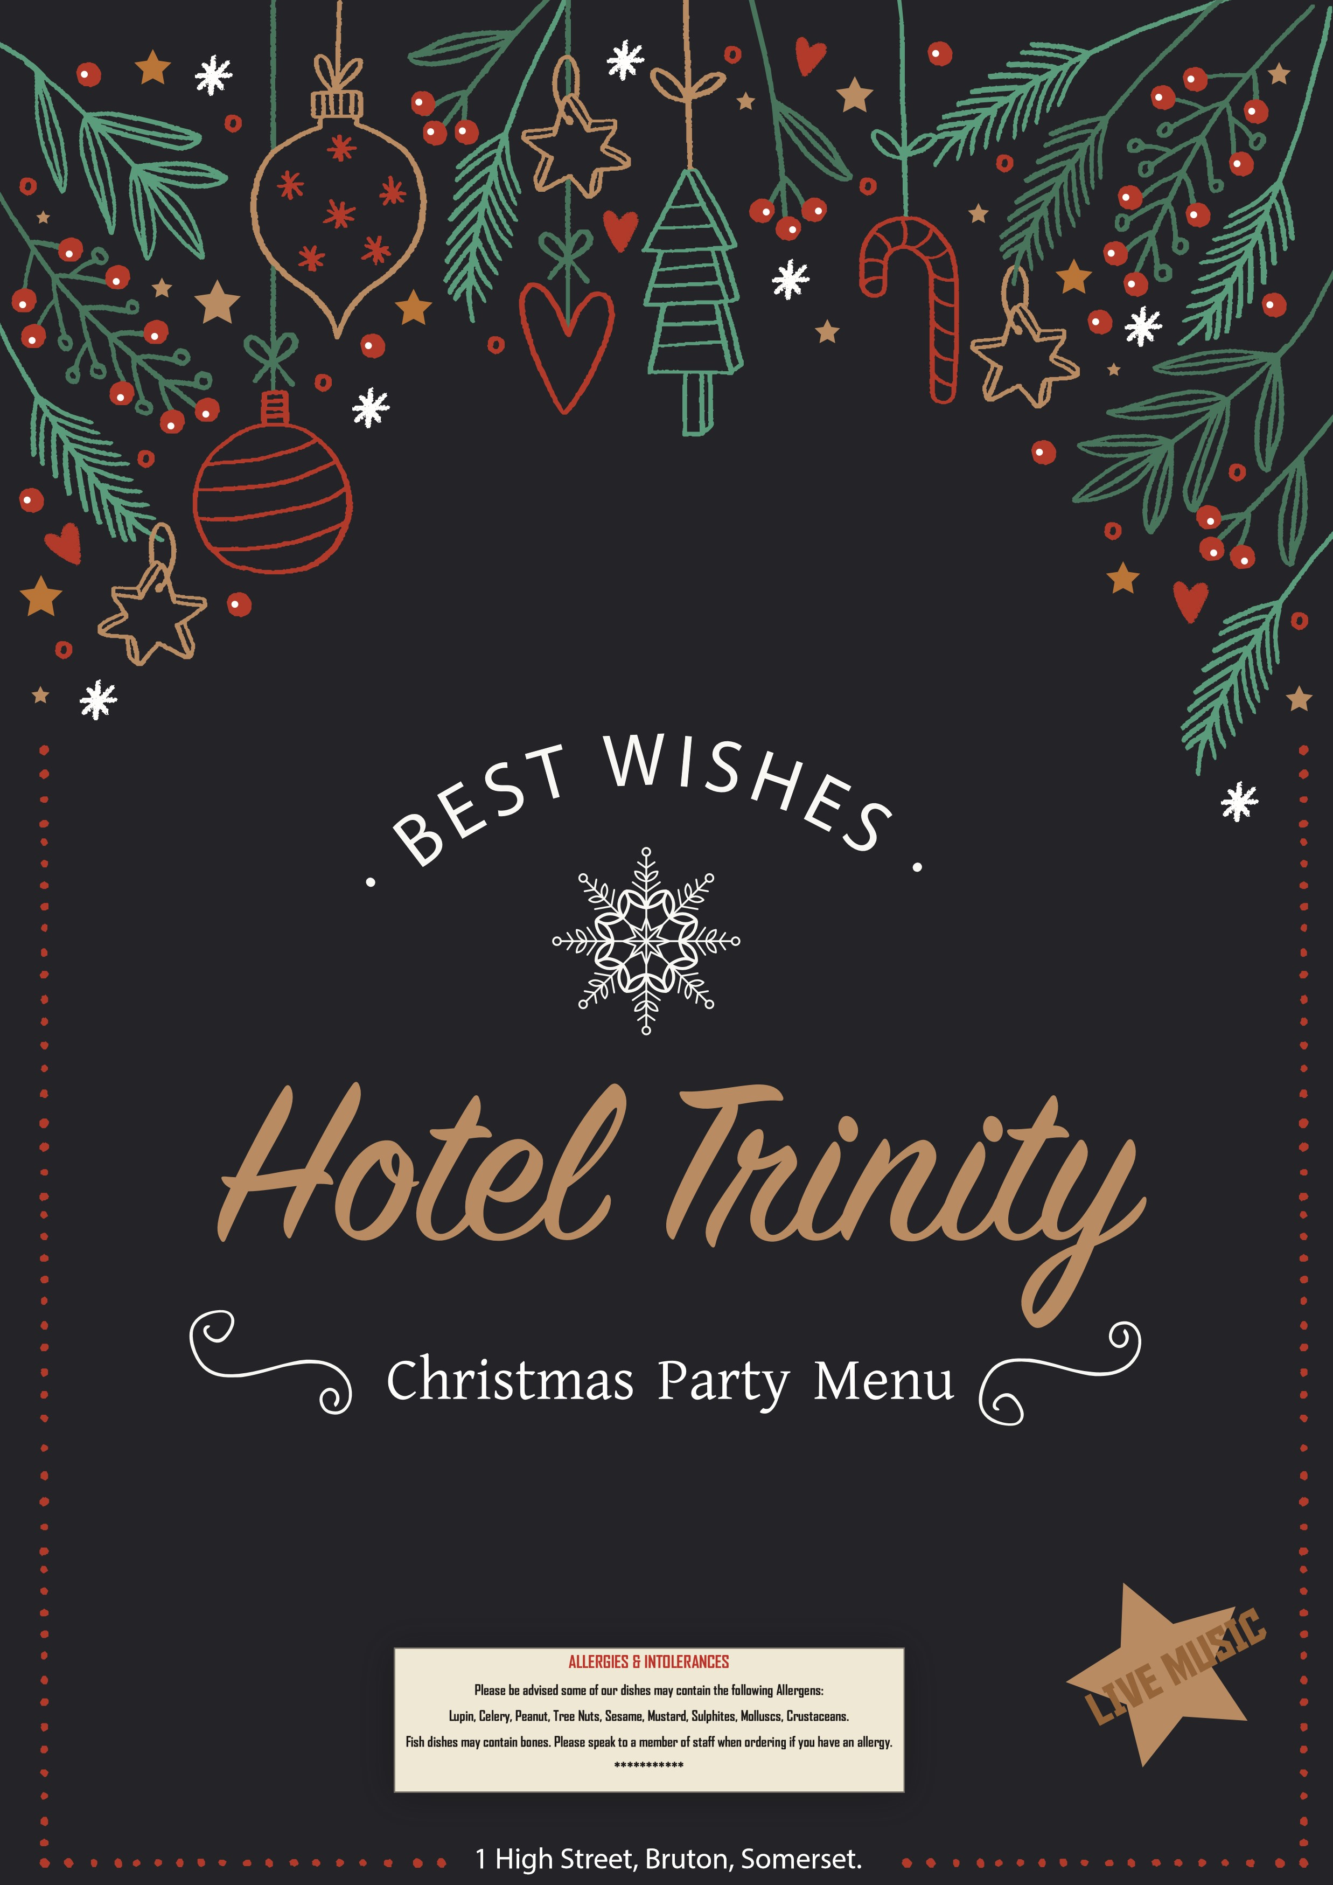

Hotel Trinity
_{Christmas Party Menu}

Starters
Smoked Salmon . . . . £20 Prawn Cocktail .. . . . . . £15
Mousse with cream cheese Marie rose sauce
Soup with Butter . . . . v £15 Smoked Mackerel Pate £25
Carrot and coriander Garlic & rosemary pate
Chicken Liver . . . . . . . . £15 Roasted Parsnip . . . . . . £10
Garlic & rosemary pate Local bakers bread and butter

Mains
Roast Turkey Breast . . £20 Vegetable Lasagne .. . . £10
Cranberry sauce Fresh vegetables
Roast Beef . . . . . . . . . . £30 Roasted Loin of Cod. . . £20
Yorkshire pudding and trimmings Parsleu mashed, crayfish sauce
Delice of Salmon . . . . £35 Walnut Topped Pork . . £35
Hollandaise Sauce Boulangere potatoes gravy

Desserts Beverages
Pudding . . . . . . . . . . £10 Negroni Sparklers . .. . £20
Raspberry Trifle . . . £10 Spiced Chai. . . . . . . . . . £10 Orange Tart . . . . . . . £15 Hot Coffee . . . . . . . . . . £15

Pre-Order Required
Above all are served with seasonal vegetbles
1 High Street, Bruton, Somerset.

