
Evidence Based Practice BMPD5017

Name: Kirsty Thomas
Student Number: 2014376
University of Wales Trinity Saind David
Word count
Task 1 – 3,150 words
Task 2 – 1,085 words
CIPD membership No: 88280669

Contents page
Introduction ……………………………………………………………………………. 3
What is evidence-based practice? ……………………………………….…. 4 - 6
Analysis Tools that can be used for decision-making ……………….. 6 - 7
Critical thinking ………………………………………………………….……….…… 7 - 8
Decision Making process ………………………………………….………..…. 8 - 10
Ethical Framework …………………………………………………….………… 10 - 12
Different ways organisations measure financial and non-financial performance…………………………………………………………………………... 12 - 13
Measuring the impact and value of people practices ……….……… 13 - 14
Task 2 – Analysis of data
Table 1 ……………………………………………………………………………………… 14 – 19
Table 2 ……………………………………………………………………………………… 20 - 21
Reference list ………………………………………………………………………..

Introduction
This report will evaluate the concept of evidence-based practice and how it can be applied to critical thinking it will also include analysis tools and methods that can be applied to diagnose organisational issues such as SWOT and PESTLE analysis. The report includes the importance of critical thinking such as finding evidence that supports our decisions and choices and a range of decision-making processes. Three ethical perspectives have been identified and an explanation of how these can be used to inform and influence moral decision-making. It also includes different ways an organisation measures financial and non-financial performances with its advantages and disadvantages. The report also explains how people practice add value in an organisation and includes two methods that can be used to measure the impact of people practice such as ROI.

  - What is evidence-based practice?
According to Eric et al. (2014) the core principle of evidence-based practice is that the most credible evidence should be combined with critical thinking to guide high quality decisions. All leadership professionals use evidence in their decisions, however not everyone would use the evidence to its advantage and see the quality of it. Due to many people failing to see the quality in the evidence, bad decisions are made which result in poor outcomes. The goal is to make improvements based on the decisions made, the strategy is for making decisions and help practitioners to assess how much they can trust the available information. It can also help find additional evidence that could improve decision making.
According to CIPD (2013) there are four sources of evidence to use before making important decisions, professionals should consider using these steps shown in figure 1. It is important to find evidence from scientific literature to be able to build a strong foundation for decision making. Gather evidence from the organisations such as costs, investments, performance as this helps identify the issue and what needs to be resolved. Gathering evidence from stakeholders is important as internal and external stakeholder can be affected from the decisions made, a professional will need to look at any possible consequences. Using all four sources of evidence can better decision making although there will be some limitations.
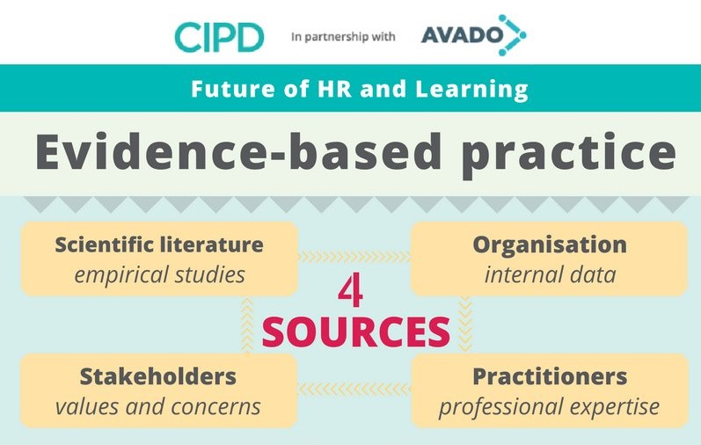

(Figure 1) 4 Sources of evidence (Galli, 2014)
When considering the four sources of evidence which allows a professional to search for the available evidence it is important to combine all evidence that have been found, CIPD created 6 steps which will help this. (see figure 2)
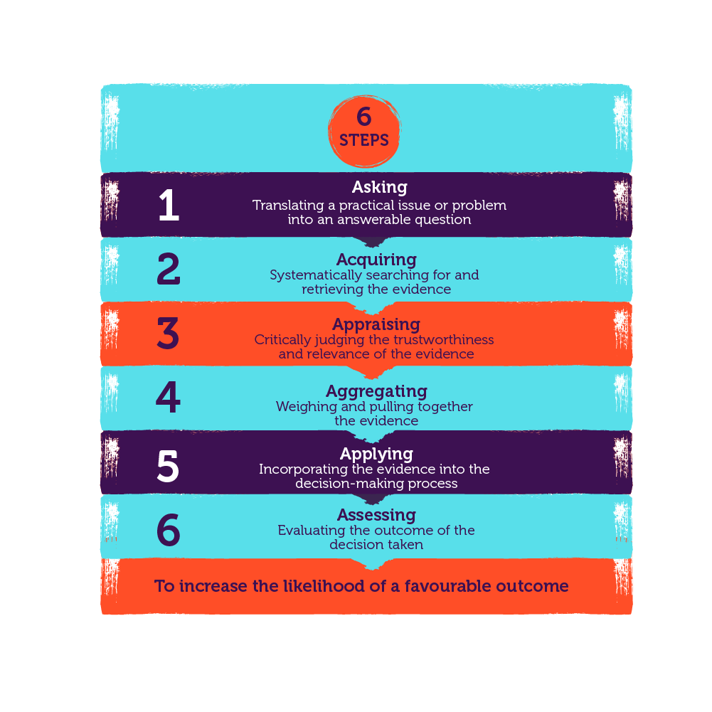

(Figure 2) CIPD 6 steps evidence-based practice infographic (CIPD, 2023)
By following these 6 simple steps it can allow the organisation to ensure the evidence found is good quality and where was the evidence found and how was it gathered? Also taking into consideration if the evidence is the best available and can it be used to reach a decision? A professional should be critical about the relevance and is it possible that it could be biased in any way (CIPD, 2023).
Why is evidence-based practice important?
Evidence-based practice can help make sure that the decision-making process is based on fact and not fads, outdated knowledge, or natural bias. It can create helpful knowledge along with positive impact in a workplace (CIPD 2023). It is also important to find solutions to any problems faced which requires decision making (Uzonwanne, 2016). Although Evidence-Based Practice has been around for many years especially for professionals such as nursing with many research available to them, however this wasn’t the case for management. This caused implications in management practice and a loss of essential evidence to improve any issues in their practice (Barends, et al. 2017). Evidence-bases practice can be applied to make sound decisions for organizations to stay above other companies. HR can reach the organization goals by applying an evidence-based mindset. By gathering important data HR can assess any issues that have happened in the past to make sure that this doesn't happen again and can assess any strengths, opportunities, threats, and weaknesses (Boatman, no date).
1.2 Analysis Tools that can be used for decision-making.
An organization must design a plan to define goals and objectives to grow into a large, unique organisation that can compete more successfully with its rivals. When a strategy is put into practise, it helps an organisation visualise where it is going, what needs to change, and how to get ready for uncontrollable changes. This enables them to determine the organization’s strengths and flaws (Kenton, 2023).
There are many strategic tools such as Bowman’s clock, Michael Porter’s four generic strategies, SWOT analysis and Henery Mintzberg developed the 5 Ps of strategy.
According to Stead and Stead (2008. P. 66) by using strategic planning, it will help the organisation vision their goals and reach their mission. It allows the organisation to look at their future opportunities, strengths, weaknesses and threats, strategic planning is something that will continuously change to the organisations values and implement business policy.
PESTLE is a strategic tool that any organisation can use in decision making to minimise any threats and issues ahead but also to view any opportunities and what can benefit the organisation. A professional must have an understanding that changes could happen that will be impossible to control, and they should be prepared to adapt for any future changes to their plans such as the pandemic businesses faced recently made businesses rethink their decision and how they will need to develop as a business under new circumstances (CIPD, 2023). With any strategic tools there will be advantages and disadvantages (See figure 3).

Advantages | Disadvantages
- It’s easy to use and gives clear information and facts.  - Allows a business to look further into the future and developments.  - Limit any risks and threats.  - Allows a business to see their opportunities | - Data could have come from assumptions that later turned out to be incorrect.  - Due to changes and for it to be effective, the analysis will need to be done regularly.  - Using too much data can result in ‘paralysis by analysis’.
(figure 3) Table of advantages and disadvantages of using PESTEL (CIPD, 2023)

Methods that can be used for decision making.
Different methods can be used when it comes to decision making and gathering evidence such as job analysis, observations, or work sampling. This can be gathering data from people to participate in the research a professional carry out. Ballie and Gill (2018) mentioned that qualitative research is used to collect people’s experiences, behaviours, feelings, and their thoughts, by carrying out interviews or focus groups. A researcher can gather some questions to ask the participants that will reach the objectives, the interviewer can record the interviews to be able to explore this later. The researcher can take the thematic approach and create themes with the data gathered and base their evidence and decision making on the interview/focus group taken.
Another method would be Surveys, where you can target many people to take part again it’s collecting data to analyse the response, this will allow professional to make decisions based on data from others (Chris, 2022).
  - Critical thinking
Critical thinking is being able to gather information and analyze it to form a judgement. Being able to think critically you will be able to find credible sources only and analyse arguments and give your thoughts. Being able to critically think can help a person find whether the source is free from research bias and find evidence to support the findings. When finding a source, look who the author is and if they are an expert, is their argument good enough and when did they mention this? Is their argument backed up with evidence and what is their point of view? These are also questions to ask yourself when writing, making sure you have evidence to all your arguments and is it clear enough? (Ryan, 2022). CIPD (2019) defines critical thinking in their podcast as “Critical thinking is the ability to think well and to critically reflect on the ideas, opinions and argument of others”.
  - Decision Making process.
As a manager decision making is important, there are approaches to help the process. Good decision-making abilities will help you avoid making unhelpful or biased assumptions, recognise the levels of uncertainty and risk involved, and determine whether these are acceptable under the circumstances. They will also enable you to understand what information you will need and how to use it to inform your decision. There are tools available to help the decision-making process such as Kepner and Tregoes, Stakeholder analysis, force field analysis, De Bono’s Six Thinking Hats, Deming’s PDCS Cycle “the Deming Wheel” and Tannenbaum and Schmidt Leadership continuum (CMI, 2020).
De Bono’s Six Thinking Hats
MindTools (2023) states that using the Six Thinking Hats method, you can examine a subject from six different angles. It pushes you and your team past any innate positions and encourages you to consider many viewpoints. You can thoroughly analyse each one without having to defend your position or make rash judgements on what is right or wrong. (Please see figure 4 for each thinking process).
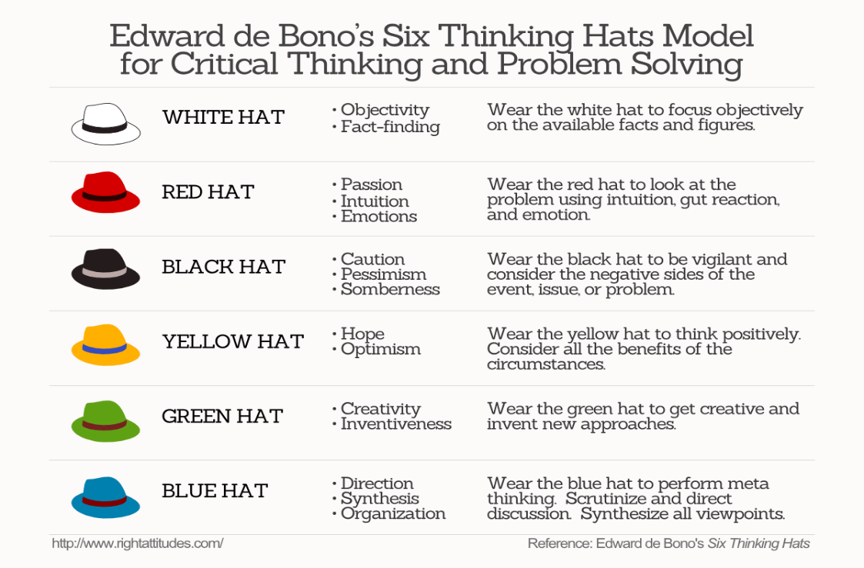

(Figure 4) De Bono’s Six Thinking Hats Model (Strait, 2018)
By using this method, it allows better thinking skills, it allows you to consider every aspect for better understanding and improves creativity (MindTools, 2023).
The Kepner-Tregoe Approach
Setting goals, investigating, and prioritising alternatives, examining the advantages and disadvantages of the top alternative, and selecting the ultimate best choice are all steps in the Kepner-Tregoe Matrix technique. It then challenges you to come up with solutions to any issues that might arise because of your choice (MindTools, 2023).
The four steps
- Situation Appraisal – identify the issue and the priorities.
- Problem Analysis – describe the issue or problem by determining and assessing the causes.
- Decision Analysis – making a final decision after identifying, assessing, and risk assessing potential solutions.
- Potential Problem Analysis – Determine the contingencies and preventive measures required to minimise the risk for final decision.
This can apply to decision making and to give an overview of what to achieve and its objectives. It can be applied to establish strategic requirements and operational objectives. It can be used to view things such as limits and resources you need (MindTools, 2023).
Stakeholder analysis
The term “stakeholder analysis" often refers to a variety of methods or tools used to recognise and comprehend the requirements and expectations of significant interest both inside and outside the project environment. To effectively plan a project, it helps to have a thorough understanding of the characteristics, interrelationships, and interactions between project supporters and opponents. A stakeholder analysis is seen as the first step to strategic planning. The method presented here forces project managers to recognise and promote the interest of the important groups. Knowing that they exist and what level of influence a stakeholder may exert can be a huge help to the team (Smith 2000). You can visualise how closely you should manage each stakeholder, how frequently you should communicate with them, and how to keep them happy and/or informed by using a stakeholder map. Stakeholders would be grouped in a stakeholder map after defining a few key criteria, built quadrants for the dimensions you wanted to optimise (Hoory and Bottorff, 2022). (Please see figure 5)
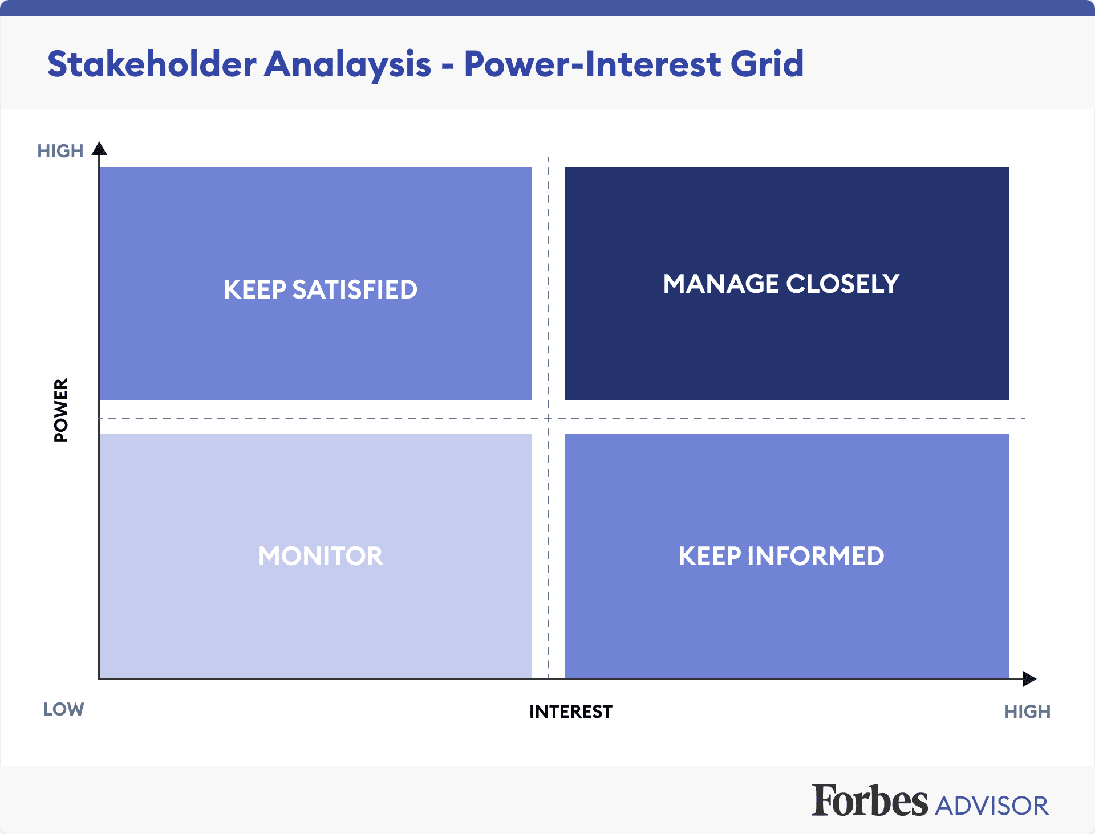

(Figure 5) Stakeholder analysis map (Hoory and Bottorff, 2022)
  - Ethical Framework
Following the code of ethics means doing what’s right, its setting an example, being fair and giving what people deserve and following rules. It’s about rights within a workplace. There are different ethical perspectives that can be used to inform and influence moral decision making.
Deontological theory – Deontology means the choices that we make and asses what kind of person we should be and the kind of person we are. It’s knowing right from wrong. Deontology is used for people to follow rules and to do what’s asked for them and to follow the company’s values (Larry and Moore, 2020). “Deontological ethics is a moral philosophy where the usual ethical definition of right or wrong is based on a series of rules to follow instead of the consequences which occur from such a decision (Connectus, 2023)”.
Strengths of Deontology - Deontology allows an individual to be responsible for their own actions and it’s their responsibility to be ethical and to avoid actions that could cost this, it establishes a foundation for human rights. There will be confusion until such information is established if someone based their morality on the decision’s outcome. That implies that until the results are clear, every decision a person makes has the potential to be right or wrong. Deontological ethics adopts an alternative stance. This moral theory provides clarity since it maintains focus on the act itself (Connectus, 2023).
Weakness of Deontology – The term suggest that you should always do what’s right no matter what. It suggests that everyone has an obligation to always act morally. Your attention ought to be on the steps you took rather than the outcome you attained. It also does not consider self-defence ideas (Connectus, 2023).
Theory of justice – Theory of justice is to address the issue of fairness in society. Everyone should be treated equally no matter their age, sex, ethnicity, or income level. There are two principles of justice which is ‘Principle of Eual Liberty’ and ‘Principle of Equality’. Equal Liberty is giving people equal rights which includes democratic rights as well as freedom of conscience, expression, and association. Principle of Equality means everyone has equal rights to any position regardless of their sex, background, or their beliefs (Peterdy, 2023).
Eight Ethical Lenses
CIPD (2022) states that ethical practice is important as it provides good reputation and good customer relations, and an open culture will improve morale. Their ethical decision-making focuses on eight different perspectives that should be considered when making decisions.
- Fairness – everyone should come to agreement on a particular decision.
- Merit – equal opportunities
- Markets – job roles and rewards to be fair following market exchanges.
- Democracy – Everyone to be involved in decision making and have an opportunity to speak and share thoughts and idea.
- Well-being – Promote well-being in a workplace, their health matters.
- Rights and duties – Employee rights.
- Character – Treating others with respect and being the best version of ourselves.
- Handing down – Asses the workplace and look after what a person has been given and will hand down in future (CIPD, 2015, P. 6).
The Eight Ethical Lenses method aims to help decision making in a workplace environment as offered by philosophical ethics. It focuses on different perspectives on work dilemmas rather than what is right or wrong (CIPD, 2015, P. 6).
3.1 Different ways organisations measure financial and non-financial performance.
Non-financial performance – Companies employ non-financial measures of performance to assess their performance and success without taking financial measurements into account. Instead of looking at success or failure in terms of monetary values they concentrate on various commercial domains and assess their prospects. One example would be ‘Innovation’ this allows a company to bring new innovative ideas and to create new services or new products to penetrate markets. A company examines how many new product lines they developed or how well its new offerings do over a given time frame. These two measures evaluate how well the business has performed overall in terms of providing customers with new product offers and bringing value. Other examples include customer experience, take rate and brand preference. (Indeed, 2023).
Advantages of non-financial performance – This allows a company to analyze their strengths and weaknesses also their opportunities and any possible risks they might face.
Disadvantage – Focusing to much on non-financial performance could take a lot of time and resources which could risk a company to spend to much that could outweigh the benefits (Indeed, 2023).

Financial performance – This allows a company to analyze their financial health and to see how the business is performing. This also allows the company to adjust goals and plan for future. One example would be Gross profit margin which is a profitability ratio, it measures the portion of revenue that remails after deducting cost of goods sold. Operating costs, interest, and taxes are not included in the cost of goods sold, which only includes the direct cost of production. Gross profit margin represents the profitability of a product or item line exclusive of overhead (Stobierski, 2020). There are other ways to measure a company's profitability such as net profit margin, working capital, current ratio, and quick ratio.
Advantage of gross margin ratio – Businesses can spot trends in their expenses and income and modify their business models accordingly.
Disadvantage – In terms of earnings or losses, the gross margin ratio may be off since it does not account for all operating expenses of a business (Accountinguide, 2023).

3.2 Measuring the impact and value of people practices.

HR has many challenges one being adding value to the organisation, HR is responsible for understanding what management, employees and future employees need. As a team HR would need to meet their expectations to be able to run the organisation and to also reach their goals (Sondhi, 2018). According to Dijk (no date) good people management is of course to add value for the employees and organisation, this results in minimizing costs and maximizing human potential the same time. Value creation can be determined by an employee’s sense of purpose or by amount of money earned. High quality living and sustainability could be the values generated for society. Organisations incorporate their desired outcomes into their mission and strategy (Dijk, no date).

There are methods and tools to be used to measure the impact and value of people practice one being Cost-benefit analysis. When evaluating and comparing various options or courses of action to determine which is the best course of action, CBA is most frequently used at the beginning of the project. It can also be used to assess a program’s overall impact in measurable and profitable terms. The activities overall expenses are added up and compared to its total benefits by CBA. The method is predicated on the idea that all programme expenses and gains, including both real and intangible advantages to companies and individuals outside those directly affected, may be valued monetarily. Therefore, one of the main benefits of using CBA is that is forced individuals to methodically and explicitly weigh the several elements that affect their strategic choices (Better Evaluation, 2022).

ROI is another method that is used which means Return of Investment. ROI is the ratio of an investment’s net income to its net costs of financing; it is shown as a percentage of the total. For example, if you purchase a property in New York for £600,000 and you sell the property for £900,000 three years later. ROI formula can be used to calculate return on investment:
(£900,000 - £600,000) / (£600,000) = ROI x 100% = 0.5 x 100% = 50%
Which means the property provides a 50% return on your investment (Jedynak and Barrantes, 2023).

Task 2 – Analysis of data
Table 1

Qualitative research is used to capture information and knowledge from others that share their thoughts and experiences. This is useful for the researcher who would prefer to collect data through interviews or focus groups once the phenomenon is chosen (Sullivan, 2012, P. 1). For the researcher to be able to analyse the data and findings, a thematic analysis approach is taken to look for patterns appropriate to the questions (Ibrahim, 2012, P. 40). Quantitative approach is taken to collect data by asking the public to take part in a survey to help the researcher once the phenomenon is chosen, surveys can be created through Microsoft forms (USCLibaries, 2023).

Percentage of gender

Gender | Total | Percentage
Female | 118 | 45%
Male | 140 | 54%
Non-binary | 2 | 1%
 | 260

The table and chart above have provided us with percentage of gender in the organisation. It shows that 54% of employees are male, 45% are female and 1% are non-binary. An organisation can create tables and charts to analyse gender diversity ratio this allows the company to view how diverse they are as an organisation or by teams/departments. It is important for an organisation to have a fair ratio of women, men, or non-binary people (HiBob, 2023). Although in the chart above there isn’t much of a difference in percentage between men and women, there is a low percentage of non-binary people. However, the organisation shows that they support all genders by employing all different genders as shown above.

Percentage of Ethnicity

Row Labels | Count of Ethnicity
Asian - Bangladesh | 0.77%
Housing | 0.38%
IT | 0.38%
Black - Other | 0.38%
Finance | 0.38%
Chinese | 0.77%
Customer Services | 0.38%
People Services | 0.38%
Indian | 1.54%
Community Engagement and Partnerships | 0.38%
Directors | 0.38%
Finance | 0.38%
Governance | 0.38%
Mixed - Other | 0.38%
Community Engagement and Partnerships | 0.38%
Pakistani | 1.15%
Customer Services | 0.77%
Property Team | 0.38%
White and Black Caribbean | 1.15%
Community Engagement and Partnerships | 0.38%
Housing | 0.38%
Supported Housing | 0.38%
White British | 91.15%
Business Services | 2.69%
Community Engagement and Partnerships | 1.54%
Customer Services | 4.62%
Directors | 1.54%
Facilities | 0.77%
Finance | 3.08%
Governance | 0.77%
Green Spaces | 4.23%
Housing | 6.15%
Income Team | 6.54%
IT | 3.08%
Lettings | 3.85%
Marketing | 1.54%
People Services | 3.85%
Property Team | 37.69%
Regeneration | 1.92%
Supported Housing | 3.85%
Tenancy Team | 3.46%
White Irish | 0.77%
Business Services | 0.38%
Income Team | 0.38%
White Other | 1.92%
Business Services | 0.38%
Green Spaces | 0.38%
Income Team | 0.38%
Tenancy Team | 0.77%
(blank) | 0.00%
(blank) | 0.00%
Grand Total | 100.00%
The table above presents a count of ethnicity in each department within the organisation. Every person deserves the same opportunities regardless of their ethnic background and colour. According to CIPD (2023), There was a serious lack of black and ethnic people employed in the UK. Black and ethnic minority have also experienced discrimination due to their ethnicity. Organisations risks a loss of a skilled team due to discrimination of employing people from different background and individuals will miss out on opportunities. The above chart shows the minority of people are White British therefore the organisation should look at levels of ethnic diversity within the organisation and the barriers to career progression. They can make sure that race equality is a part of the organisation values and future (CIPD, 2023).

Percentage of disability in the organisation as a whole and teams

The pie chart above displays a percentage of disability data within the organisation. 92% of the people are not disabled and 8% have a disability. The bar chart below displays a disability analysis within each department. Teams such as Supported Housing and Regeneration do not have any employees with a disability, however eleven teams in total have employees who have a disability. It is important that the organisation can adapt to employees and provide a safe working place to suit people with different disabilities. CIPD (2023, P. 4) stated in their disability workforce report that there are many benefits for an organisation to publishing disability workforce as it builds a good external reputation and it also shows equal right, fairness, and their values. An organisation requires must put adjustments into place to support employees who are considered disabled, this could be making reasonable adjustments such as giving them extra time when it comes to assessments or tasks, putting ramps in place if a person can not use stairs. Employees might need to attend more hospital/doctors’ appointments due to certain illnesses (CIPD, 2023). However not all disability is visible, employees have disabilities such as autism, depression, or diabetes. It’s important that non-visible disabilities receive fair treatment and reasonable adjustments are required. Employees might need some quiet working space or being able to work from home on certain days (CIPD, 2023).
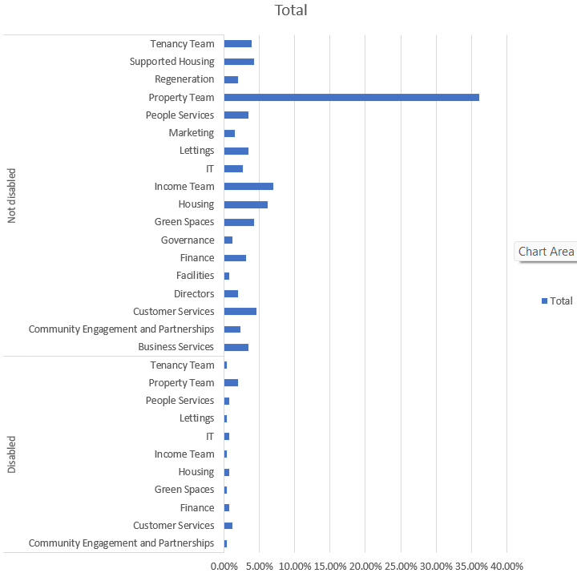

Salary difference across genders

The chart above provides the salary difference across genders and overall average salary paid by the organisation, non-binary people are considerably low in comparison to male & female salary. However, there is not much of a difference between male and female salary. According to CIPD (2023) gender pay gap is a measure of disadvantage in the labour market or workforce when comparing the average hourly pay rates of men and women. Therefore, although money is a role, there are other consideration as well, like occupational segregation. Reports on the gender pay gap focus more on what women make in comparison to males than they do on who gets what.

Table 2
Employee feedback from a survey

Fully agree.
Strongly disagree.

The table above shows that 38% of employees fully agree that they enjoy working from home some days of the week, leaving 18% of employees voting that they strongly disagree with this statement. However, the below table presents how employee’s feels regarding completing targets from hybrid working. 48% of employees strongly disagreed that this allows them to meet targets. CIPD (2021) mentions that hybrid working offers benefits to employees such as a better work-life balance and allowing employees to save on money due to less commuting to work. Allowing employees to work from home can also cost the organisation due to employees feeling isolated and lack of engagement with others (Pwc, 2020). This can result in employees leaving the company. However, if employees don’t feel like their hitting targets by hybrid working, the organisation should support the employees by communicating with them frequently, keep managing their performance and assess if they perform better being in the office or working from home. Management team could hold group meetings to discuss the issue and could possibly interview each employee that disagrees with the statement above to come up with a strategy.
Strongly disagree.
Fully agree.

