

Assignment 2
Group Report

Module Code: LCBB4006
Module Name: Academic Skills
Lecturer: Dr Lizeta Demetriou

Student Name: Adelina Stanciu
Student ID: 2245080
Student Name: Ionut Agrigoroaei
Student ID: 2247225
Student Name: Catalin Tabaras
Student ID: 2247295
Student Name: Paul Vornicescu
Student ID: 2246785

Student Name: Razvan Mucenic
Student ID: 2120426
Table of Contents
1.0 Introduction (Adelina Stanciu) 1
2.0 Time Management (Catalin Tabaras) 2
2.1 Definition of Time Management 2
2.2 Importance of Time Management Skills for Professional Success 2
2.3 Importance of Time Management Skills for Academic Success 3
3.0 Teamwork (Ionut Agrigoroaei) 4
3.1 Definition of Teamwork 4
3.2 Importance of Teamwork Skills for Professional Success 4
3.3 Importance of Teamwork Skills for Academic Success 5
4.0 Paraphrasing and Summarising (Razvan Mucenic) 6
4.1 Definition of Paraphrasing and Summarising 6
4.2 Importance of Paraphrasing and Summarising Skills for Professional Success 7
4.3 Importance of Paraphrasing and Summarising Skills for Academic Success 7
5.0 Analytical and Critical Thinking (Paul Vornicescu) 9
5.1 Definition of Analytical and Critical Thinking 9
5.2 Importance of Analytical and Critical Thinking Skills for Professional Success 10
5.3 Importance of Analytical and Critical Thinking Skills for Academic Success 10
6.0 Conclusion (Adelina Stanciu) 12
7.0 References (Team) 13

List of Figures
Figure 1: Time Management Skills (Prada et al., 2022) 2
Figure 2: Teamwork (Paul and Elder, 2019) 8
Figure 3: Paraphrasing and Summarising (Johnson, 2016) 11
Figure 4: The Importance of Critical Thinking (Braun and Clarke, 2022) 14

1.0 Introduction
Academic skills refer to a broad set of competencies that give students and professionals the ability to flourish in their academic endeavours as well as other areas of their lives. These abilities involve a wide range of competencies, from the effective management of one's time to the use of analytical and critical thinking in many contexts involving the solution of problems (Paul and Elder, 2019). They play an essential part in the process of promoting learning, encouraging self-development, and getting individuals ready to meet the problems of the future. The possession of fundamental academic skills and the continued development of those talents are of the utmost importance in the pursuit of academic achievement and eventual professional success. However, study skills can be practiced over time according to Cottrell (2019), and the author gives practical solutions on how to become better on the four concepts.
The purpose of this paper is to investigate the idea of academic skills, emphasise their significance, and investigate the relative importance that they hold for both academic and professional efforts (Trought, 2017). Four essential academic abilities have been examined in this paper that include time management, teamwork, paraphrasing and summarising, and analytical and critical thinking. The goal is to shed light on the relative relevance of these talents in both the academic and professional realms. The subsequent sections go deeper into each of these talents and investigate their relevance, benefits, and actual application in the real world. In addition, examples of actions taken from real life will be offered to demonstrate how the acquisition of this knowledge and its subsequent application can be beneficial not only for students but also for professionals.

2.0 Time Management

2.1 Definition of Time Management

Figure 1: Time Management Skills (Prada et al., 2022)
Time management refers to the practice of making effective use of available time to finish responsibilities, arrange activities in a prioritised order, and accomplish objectives in a way that is methodical and well-organized, as defined by Aeon et al. (2021). The authors’ study demonstrates that proper time management enhances individual and team productivity reduces work-related tension, and boosts job satisfaction Planning, establishing realistic deadlines, and allocating time for diverse activities are the three pillars of effective time management, which together assure success and productivity.

2.2 Importance of Time Management Skills for Professional Success
Meeting the Deadlines for Tasks
Managing time effectively in a professional setup allows for the timely establishment of tasks. For instance, an employee working in a business context who is responsible for a crucial project needs to be able to efficiently manage their time to achieve stringent deadlines (Gonzalez and Melo 2019). An individual can improve their professional reputation and contribute to the general success of the team by ensuring that the project is finished on time. This can be accomplished by establishing defined milestones, allocating time for research and preparation, and carrying out the project.
Striking a Work-Life Balance
Just like the academic setup, proper management of time enables individuals for striking a balance between their professional work and personal life. For instance, one who holds a demanding executive position often has to balance several obligations, both professional and personal (Guffey and Loewy, 2022). They can allot time for work-related responsibilities, family obligations, self-care activities, and leisure activities because they have effective management of their time. The executive improves their health, lowers their stress levels, and increases their overall productivity in the workplace by striking a healthy balance between their professional and personal lives.

2.3 Importance of Time Management Skills for Academic Success
Timely Preparation for Presentations, Tests and Other Examinations
Time management skills support a strong performance in academic life by ensuring timely preparation for tests and presentations. For instance, a college student who is getting ready for final examinations needs to be able to effectively organise their study time to adequately cover all of their disciplines (Wong and Saunders, 2020). The student improves their learning process and their chances of being successful in school by developing a study routine, devoting more time to the more difficult subject matter and taking frequent, brief breaks to refresh themselves.
Timely Completion of Assigned Projects and Assignments
Time management skills also help students to complete their projects and assignments on due time. For instance, a graduate student who is working on a thesis project is responsible for successfully managing their time to reach the deadline for submission (Adams and Blair, 2019). The student can secure the timely completion of the thesis and the subsequent academic accomplishment and recognition that comes with it by first dividing the project into several smaller assignments, then setting intermediate deadlines, and finally adhering to the timetable. The authors Adams and Blair (2019), investigate in their paper the relationship between a student’s time management and academic performance and demonstrate that effective time management correlates positively with enhanced academic performance.

3.0 Teamwork

3.1 Definition of Teamwork
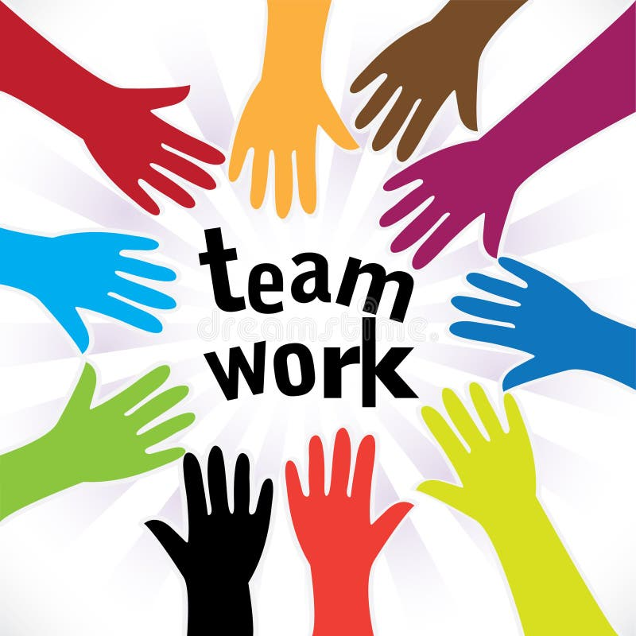
Figure 3: Teamwork (Paul and Elder, 2019)
Teamwork is when individuals come together to form a cohesive unit to cooperatively address obstacles, find solutions to issues, and achieve common goals (Prada et al., 2022). It involves clear and effective communication, attentive listening, mutual respect, and the capacity to make positive contributions towards a shared goal, among other things. Through their work, Prada et al. emphasised how collaboration improves academic achievement, problem-solving skills, and the capacity to collaborate in future professional environments while investigating the relationship between student collaboration and academic performance.

3.2 Importance of Teamwork Skills for Professional Success
Effective Establishment of Project Work
Teamwork skills are considered to be extremely critical for professional success. Organizations are constantly moving toward a team and project-based structure. For instance, when working on a difficult project in a professional setting, members of a team need to demonstrate strong collaboration abilities to effectively distribute tasks, communicate progress, and coordinate their efforts (Gonzalez and Melo 2019). In their paper, the two authors investigate the dynamics of teamwork and collaboration in organisational settings. Ther research investigates factors such as communication patterns, team cohesion, and leadership that contribute to effective collaboration.
Because of the fluid way in which they collaborate, the team can effectively deliver projects within the timescales that have been stipulated, so enhancing the organization's reputation for dependability and expertise.
Providing Better Service to the Customers
Providing better service to the customers requires a collaborative effort from all the members of the service-delivery team. Effective collaboration in customer-facing professions, such as sales or support teams, is essential to delivering a satisfying experience to end users (Stemmle, 2019). When members of a team can effectively communicate with one another and support one another, they are better able to answer questions and issues raised by customers, which in turn leads to higher levels of customer satisfaction and loyalty.

3.3 Importance of Teamwork Skills for Academic Success
Completion of Group Projects through Collaboration
Students are often instructed to involve in group activities just like in the case of this very assignment. Instructors assign group projects and assignments where students must learn to collaborate for ensuring an optimum outcome. Students need to be able to work well together to succeed in academic environments that involve group projects (Rutherford, 2018). Students can generate high-quality projects that demonstrate a variety of viewpoints and levels of competence when they utilise skills related to teamwork, such as effective communication, task allocation, and conflict resolution.
Productive Discussions in the Classroom
The mindset to indulge in group discussions to learn from others can lead to productive outcomes. Students are best able to learn from one another's perspectives and ideas when they participate actively in classroom conversations and actively contribute to those debates (Hopkins and Reid, 2018). It is beneficial to student’s academic development and the overall learning experience when students build upon each other's ideas, recognise the validity of differing points of view, and listen attentively to one another.

4.0 Paraphrasing and Summarising

4.1 Definition of Paraphrasing and Summarising
Paraphrasing: Paraphrasing is the art of restating the meaning of the original text or concept in one's own words while ensuring that the intended message is still communicated accurately is an example of the practice known as paraphrasing (Rettinger and Gallant, 2022). It gives people the ability to articulate ideas derived from a source without explicitly replicating the source's phrasing, which helps promote clarity and helps prevent plagiarism.

Figure 4: Paraphrasing and Summarising (Johnson, 2016)
Summarising: Summarising is the process of creating a succinct and condensed version of a lengthy text, capturing the key points and essential concepts of the material being summarised, is known as summarising (Jose, 2021). It requires isolating the most important information and presenting it in a logical order so that readers can comprehend the primary material in a short amount of time.
Johnson (2016) also discusses the fundamentals of academic writing including paraphrasing. His study highlights students' difficulties using external information and suggests ways to improve and also emphasises paraphrasing and summarising for academic integrity and critical thinking. Summarising is an essential skill that students must master for processing huge amounts of information.

4.2 Importance of Paraphrasing and Summarising Skills for Professional Success
Enhancing the Quality of Business Report
In a business environment, personnel may be required to make references to a variety of reports and research papers and incorporate information from those sources into their work. They can integrate pertinent results from a variety of sources in a smooth manner through the use of paraphrasing, thereby customising the material to meet their particular requirements (Akbar, 2020). The author also regards paraphrasing as a critical tool for enhancing the quality of academic writing in his paper. Paraphrasing improves connections and teamwork in both professional and personal communication, according to the study. To facilitate effective decision-making and strategic planning, professionals can benefit from the process of summarising by presenting executives or clients with complex facts in a concise manner.
Streamlining Communications at the Workplace
Streamlining communication and increasing client satisfaction can be accomplished by providing a concise summary of lengthy conversations or proposals, which also helps clients focus on the most important components. In positions that require interaction with customers, paraphrasing ensures that communication with customers is both clear and accurate (Kronvall and Jansson, 2022). Professionals can display active listening and develop a better understanding of clients by restating the client's questions or concerns in more straightforward language.

4.3 Importance of Paraphrasing and Summarising Skills for Academic Success
Betterment of Academic Writing
When writing for academic purposes, it is essential to paraphrase to incorporate data and ideas derived from scholarly sources while preserving one's academic honesty. Students can demonstrate their understanding of difficult subjects and contribute to the existing body of knowledge in their profession by practising the skill of paraphrasing (Sousa and Rocha, 2019). Students can demonstrate their ability to effectively distil essential information through the use of summarising, which supports them in the presentation of thorough literature reviews.
Increasing the Effectiveness of Presentations
Students can explain difficult concepts in their terms and with greater comprehension for their audiences when they paraphrase before giving academic presentations (Rettinger and Gallant, 2022). When presenting extensive research findings or lengthy papers, summarising them so that the focus is on the most important takeaways and points helps to keep the audience engaged.

5.0 Analytical and Critical Thinking

5.1 Definition of Analytical and Critical Thinking
Analytical Thinking: Thinking analytically entails disassembling difficult problems or scenarios into their parts, analysing how these parts relate to one another, and looking for patterns or connections among them (Trought, 2017). Logical reasoning and the ability to evaluate information objectively are both required.
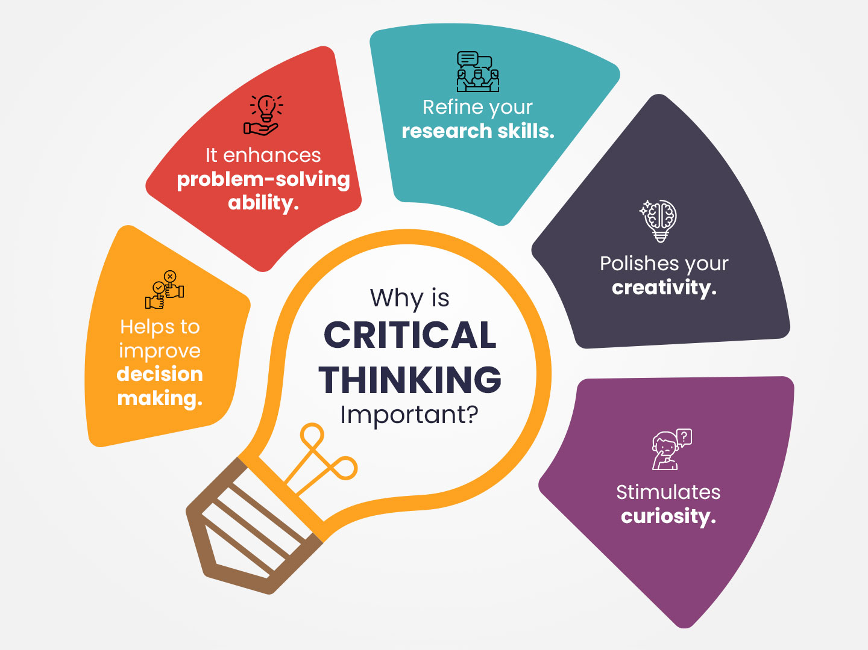
Figure 5: The Importance of Critical Thinking (Braun and Clarke, 2022)
Critical Thinking: Thinking Critically is assessing Information, Arguments, or Evidence in a Rational and Systematic Manner Critical thinking is assessing information, arguments, or evidence logically and systematically (Publisher, 2020). It is necessary to challenge preconceived notions, take into account many points of view, and arrive at well-informed judgements or conclusions.
In their paper, Braun and Clarke (2022) investigate the influence of analytical reasoning on the decision-making process of individuals, demonstrating how individuals with strong analytical reasoning skills make more effective and well-informed decisions in a variety of domains.

5.2 Importance of Analytical and Critical Thinking Skills for Professional Success
Enhanced Analysis of Data
In the world of business, professionals are frequently confronted with enormous amounts of data. They can organise this data, evaluate it, and derive valuable insights from it if they think analytically and apply that thinking (Paul and Elder, 2019). The ability to think critically enables individuals to evaluate the relevance, accuracy, and potential ramifications of the data, which in turn helps with data-driven decision-making and strategic planning.
Approaching a Challenge as a Group and Problem-Solving
In projects that are carried out in teams, having strong analytical and critical thinking skills is vital for locating problems, determining their core causes, and coming up with creative answers to those problems (Paperback, 2019). Professionals that bring these capabilities to their team can negotiate difficult difficulties cooperatively, which results in problem-solving that is both innovative and efficient.

5.3 Importance of Analytical and Critical Thinking Skills for Academic Success
Becoming Better at Academic Writing
The ability to critically examine the soundness of arguments, as well as synthesise information from a variety of sources, is essential to achieving success in academic pursuits (Byerly, 2017). Students that perform exceptionally well in analytical and critical thinking can generate well-researched essays and papers that exhibit a profound level of comprehension and independent reasoning.
Inquiries in the Field of Science
In the field of scientific study, analytical thinking is extremely helpful in the design of experiments, the collection of data, and the formation of definitive conclusions. The ability to think critically not only ensures the validity of the research findings but also helps in the identification of potential biases or restrictions, which ultimately leads to research outputs that are robust and believable (Elder and Paul. 2019). Through their book, the authors Paul and Elder (2019) study the efficacy of curriculum interventions designed to improve higher education students' critical thinking skills. The study demonstrates that targeted interventions can considerably enhance students' critical thinking skills, resulting in improved academic performance and problem-solving abilities.

6.0 Conclusion
This paper has shown how different academic skills shape successful academic and professional careers. These qualities help people grow personally and intellectually and succeed in life. Time management enabled people to maximise productivity, maintain a healthy work-life balance, and succeed in academic and professional endeavours. Academic and professional honesty depended on referencing. Crediting sources maintains ethics and boosts legitimacy. Proper referencing promotes information exchange and collaboration by showing respect for other researchers. Teamwork was essential for academic and professional group efforts. Teamwork improves problem-solving, creativity, and workplace cohesion by using multiple perspectives and expertise. Finally, analytical and critical thinking helped people solve complex problems, evaluate evidence, and make educated judgements. By recognising the value of these skills in academic and professional settings, people can maximise their potential and enrich their lives and the world.

7.0 References
Adams, R. V., & Blair, E. (2019) Impact of time management behaviors on undergraduate engineering students’ performance. Sage Open, 9(1), 2158244018824506.
Aeon, B., Faber, A., & Panaccio, A. (2021) Does time management work? A meta-analysis. PloS one, 16(1), e0245066.
Akbar, M. T. (2020) Students’ Paraphrasing in the Literature Review Section of Research Proposal. Jambura Journal of English Teaching and Literature, 1(1), 1-15.
Braun, V., & Clarke, V. (2022) Conceptual and design thinking for thematic analysis. Qualitative Psychology, 9(1), 3.
Byerly, T.R. (2017) Introducing logic and critical thinking: The Skills of Reasoning and the Virtues of Inquiry. Baker Academic.
Cottrell, S. (2019) The study skills handbook . 5th ed. London :, Red Globe Press.
Elder, L. and Paul, R. (2019) The Thinker’s Guide to Analytic Thinking: How to Take Thinking Apart and What to Look for When You Do. Rowman & Littlefield.
Gonzalez, R. V. D., & Melo, T. M. (2019) Analyzing dynamic capability in teamwork. Journal of Knowledge Management, 23(6), 1196-1217.
Guffey, M. E., & Loewy, D. (2022) Essentials of business communication. Cengage Learning.
Holmes, K. (2017) What employers want: The Employability Skills Handbook. Crimson Publishing.
Hopkins, D. and Reid, T. (2018) The Academic Skills Handbook: Your Guide to Success in Writing, Thinking and Communicating at University. SAGE.
Johnson, A. P. (2016) Academic writing: Process and product. Rowman & Littlefield.
Jose, A.S. (2021) The importance of academic integrity. GRIN Verlag.
Paperback, T. (2019) We are one team: Blank Lined Journal Thank Gift for Team, Teamwork, New Employee, Coworkers, Boss, Bulk Gift Ideas.
Paul, R., & Elder, L. (2019) The miniature guide to critical thinking concepts and tools. Rowman & Littlefield.
Prada, E. D., Mareque, M., & Pino-Juste, M. (2022) Teamwork skills in higher education: is university training contributing to their mastery? Psicologia: Reflexao e Critica, 35.
Publisher, G.-W. (2020) Soft skills for the workplace. Goodheart-Wilcox Publisher.
Rettinger, D.A. and Gallant, T.B. (2022) Cheating academic integrity: Lessons from 30 Years of Research. John Wiley & Sons.
Rutherford, A. (2018) Models for critical thinking: A Fundamental Guide to Effective Decision Making, Deep Analysis, Intelligent Reasoning, and Independent Thinking. Independently Published.
Rutherford, A. (2019) The systems thinker - Analytical skills: Level Up Your Decision Making, Problem Solving, and Deduction Skills. Notice The Details Others Miss.
Stemmle, D. (2019) Time management secrets for college students: The Underground Playbook for Managing School, Work, and Fun.
Trought, F. (2017) Brilliant employability skills: How to stand out from the crowd in the graduate job market. Pearson UK.
Wong, M. A., & Saunders, L. (Eds.). (2020) Reference and information services: An introduction. ABC-CLIO.

