Ransomware: The CryptoWall Trojan
Jordan Hayston
OME (Ordnance, Munitions and Explosives)
Faculty of Architecture, Computing and Engineering (FACE)
08/11/2019

Declaration
The work of this report completed under the supervision of Gareth Jones. I declare that this report is the product of my own work and is not being submitted for any other degree etc.
Signature

Abstract
This report investigates and explores ransomware, specifically the CryptoWall Trojan. The report includes information on what CryptoWall is, how it works, and how to protect against it. The aim of the investigation is to understand ransomware and the implications of it infecting your PC or network.

Contents
Introduction 1
Trojans and Viruses 2
What is a virus? 2
What is a Trojan? 2
How viruses infect your computer 2
Ransomware 3
What is ransomware? 3
What to do if infected 3
The CryptoWall Trojan 4
What is CryptoWall? 4
How you can get infected 4
Affected files 5
How to remove the CryptoWall Trojan 6
Payment 6
Avoiding the CryptoWall Trojan 7
Antivirus and Antimalware 7
Routine system backup 7
Avoiding suspicious websites and links 7
Bibliography 8

Introduction
This report briefly covers the CryptoWall Virus, with the context of aiming to protect sensitive information which may be damaged or lost due to the increasing threat of cyber crime. The purpose of the report is to give an understanding of the threats of ransomware attacks and the steps that can be taken in order to prevent them from happening. It also covers what to do in the event of a CryptoWall attack.

Trojans and Viruses

What is a virus?
A computer virus is often described as malicious software that can find its way onto your computer or network in order to hijack the system. The attackers’ intentions are to spread the virus, taking control of the victims’ personal data. [1]

What is a Trojan?
A Trojan is a type of virus which hides itself within a piece of software, which can seem completely legitimate. The intention of this is to bypass any security software which might be installed on the computer, and also to trick the user into thinking that the software they are downloading is genuine. [2]

How viruses infect your computer
The most commonly made mistakes occur when the user does not pay attention to the information on their screen. For example, some web pages can contain a substantial number of adverts and pop-up windows. In this case, some of the pop-up windows may advertise free software or misinform the user, stating that their computer is infected with a virus.
Furthermore, when a user is installing a program, there may be additional software included which is not noticed due to not reading the information in the setup window. This software is optional; however, the check box is usually already ticked until the user unticks it. [3]

Ransomware

What is ransomware?
Ransomware is a type of virus or malicious software which targets computer systems and users’ data in order to extort them for money. When ransomware infects a system, the attacker can threaten to do several things unless a substantial fee is paid. A common example is the encryption of data; the attacker encrypts the victims’ data and then demands money in exchange for the decryption key. If the fee is not paid, the decryption key is destroyed, meaning that the data is incomprehensible. In some cases, even if the fee is paid by the victim, the attacker will still destroy the decryption key. It is for this exact reason that it is vital to understand the implications of this kind of malicious software, and how to prevent it from infecting computer systems. [4]

What to do if infected
The first step in dealing with ransomware is to disconnect the infected machines from any network that can give it access to other computers. This will stop the spreading of the virus.
Once the machine is isolated, the user should then attempt to find out which type of ransomware they have. If they cannot access their files and documents, it is likely that they have encrypting ransomware. However, sometimes the warning message is fake, and the user can escape this by using the task manager to close the browser.
The following steps regard the encrypting ransomware:
The next step relies on backup data. If a computer system is regularly backed up, then the simplest way to deal with the attack is to check the backup to ensure that it has not already been infected. Depending on the state of the backup, it will be possible to completely wipe the computer and then reinstate a somewhat up to date version of the data. This will not be possible if the backup is also infected, unless the user has an even older version of the backup that they wish to use.
If a user does not regularly backup their computer, it is worth considering paying the ransom fee. Most large companies advise against paying anything to the attacker; however, if it is to recover valuable personal files or photos, and the fee is in the low hundreds, then it is a feasible option. Very rarely, the attacker will not hand over the decryption key, but in many cases they do. [5]

The CryptoWall Trojan

What is CryptoWall?
The CryptoWall Trojan is a type of ransomware, which not only encrypts a user’s files, but it also embeds itself within their computer’s operating system (OS). This allows it to begin running once your computer is turned on. Furthermore, the CryptoWall Trojan searches the user’s system for any passwords and digital currency wallets whilst deleting certain files, making it severely more difficult to restore the documents. [6]

How you can get infected
Much like other types of virus, common ways of becoming infected include phishing emails and false advertisements. [6]
Phishing emails are a type of online scam where the information sent appears to be from a legitimate business or company regarding a user’s personal data. These emails often include link which takes the user to a convincing website, and the information that they provide will go directly to the criminals behind the scam. The information requested is usually bank details or national insurance numbers. [7]
The malicious adverts that can appear on uncertified websites could infect a user’s computer with or without interaction. The attackers can purchase or even hack displayed advertisements and embed harmful code within them. This code can either run in the background once the user is on the website or run once the user has clicked into it. Once the code is running, it will download the virus in the background without the user noticing. [6]

Affected files
The image below shows most of the file types that the CryptoWall Trojan affects.
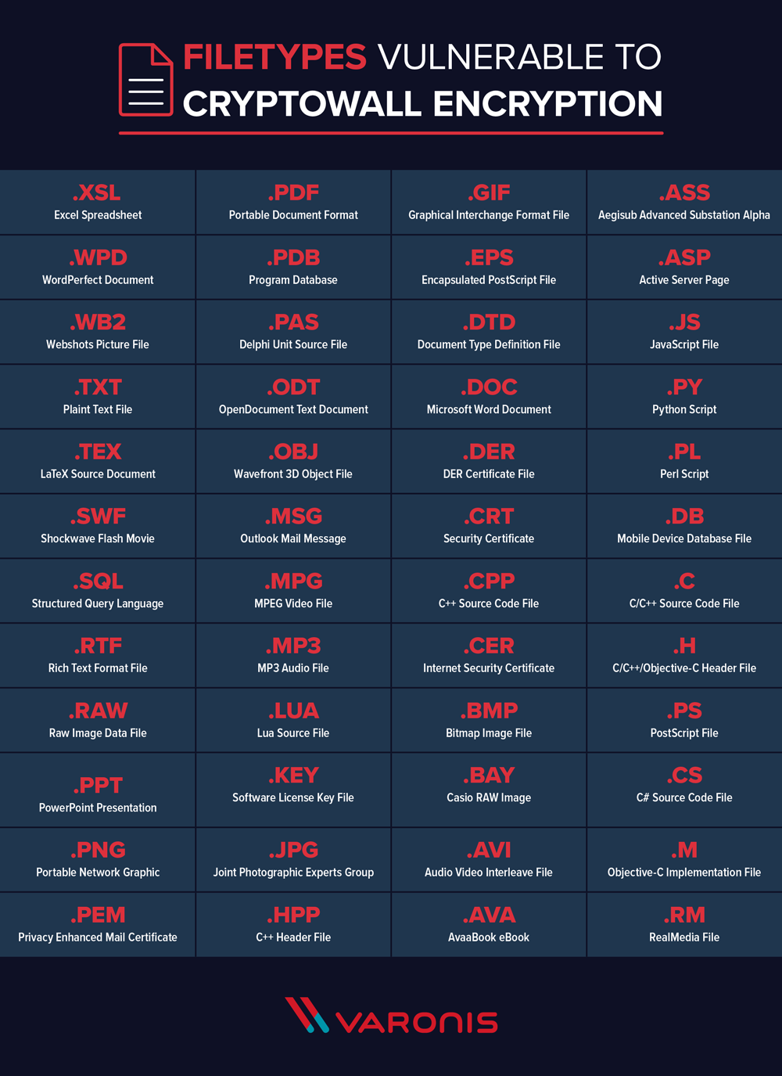
Figure 1: Files affected by CryptoWall
Source: [6] J. Petters, “Varonis,” 6 January 2018. [Online]. Available: https://www.varonis.com/blog/cryptowall/.

How to remove the CryptoWall Trojan
The most effective method of removing the CryptoWall Trojan virus from an infected computer is to run certified and trusted anti-malware software. This type of software will detect and eradicate all traces of CryptoWall. It is important to note that this will not decrypt the affected files. [8]

Payment
Upon receiving the CryptoWall Trojan’s prompt, the user is usually given a short period of time (24-48 hours) to produce a large sum of money in order to decrypt their files. The money demanded is often around $1000 paid in Bitcoin. It is paid in digital currency so that there is no possibility of it being traced back to the attacker.
As previously stated, most large companies advise against paying the ransom fee. The reason behind this is to discourage the attackers, in hope that the amount of cyber crime will reduce. Furthermore, this is supported by the fact that ‘only 19% of users that pay the ransom get their files back.’
In conclusion, it will most likely not be worth while paying the ransom fee due to the very low chance of recovering the encrypted files. [6]

Avoiding the CryptoWall Trojan

Antivirus and Antimalware
The most effective way of dealing with malware before it has infected a computer is to have antivirus and antimalware software installed. These types of software can routinely scan and detect any suspicious looking programs on your computer and remove them effectively. They also stop the majority of malware or viruses being installed in the first place. It is important to keep these kinds of programs up to date to ensure that there are no security flaws leaving the computer vulnerable to attack.

Routine system backup
It is good practice to have a regularly scheduled backup of all computers and associated machines. With this system in place, it will be much easier to recover files and documents that may be affected by any malicious software. This can be done by either backing up the data to an external drive or using an online backup service.

Avoiding suspicious websites and links
It is important for a user to ensure that the sites they are using are safe and secure. There are several ways this can be done; Google has a site diagnostic system which can provide a safety report on any website. This is a useful tool for those who are unsure if a site is safe. Furthermore, an ad-blocker can be installed to browsers which will target and eliminate any advertisements displayed on web pages. [9]

Bibliography

[1] | J. Fruhlinger, “CSO Online,” 16 July 2019. [Online]. Available: https://www.csoonline.com/article/3406446/what-is-a-computer-virus-how-they-spread-and-5-signs-youve-been-infected.html.
[2] | D. Walker, “IT Pro,” 14 August 2019. [Online]. Available: https://www.itpro.co.uk/security/30081/what-is-a-trojan-virus.
[3] | “Computer Hope,” 08 February 2019. [Online]. Available: https://www.computerhope.com/issues/ch001045.htm.
[4] | “Force Point,” [Online]. Available: https://www.forcepoint.com/cyber-edu/ransomware.
[5] | P. Wagenseil, “Tom's guide,” 30 June 2017. [Online]. Available: https://www.tomsguide.com/us/ransomware-what-to-do-next,news-25107.html.
[6] | J. Petters, “Varonis,” 6 January 2018. [Online]. Available: https://www.varonis.com/blog/cryptowall/.
[7] | “Webroot,” [Online]. Available: https://www.webroot.com/nz/en/resources/tips-articles/what-is-phishing.
[8] | S. Pilici, “Malware tips,” 13 November 2015. [Online]. Available: https://malwaretips.com/blogs/remove-cryptowall-4-0-virus/.
[9] | “GCF Global,” [Online]. Available: https://edu.gcfglobal.org/en/internetsafety/how-to-avoid-malware/1/.

