Module Name: Academic Skills
Module Code: LCLM4001_Lon
Student’s Name: Beata Beresova
Student’s ID: 2414536
Lecturer’s Name: Tim Hopkins

Table of Contents
INTRODUCTION…………………………………………...…………..……...……..3
PARAPHRASING SKILLS 3
What? 3
So what? 3
Now what? 3
ACADEMIC WRITING SKILLS 4
What? 4
So what? 4
Now what? 4
SUMMARISING SKILLS 5
What? 5
So what? 5
Now what? 5
REFERENCES 6

In this report I would like to reflect on my academic skills, which I have gained during the classes I have been attending, which is mainly paraphrasing, academic writing and summarising, I will be writing about my whole journey, the challenges about I have faced and how I have improved in the group and individually too , using Driscoll’s model.

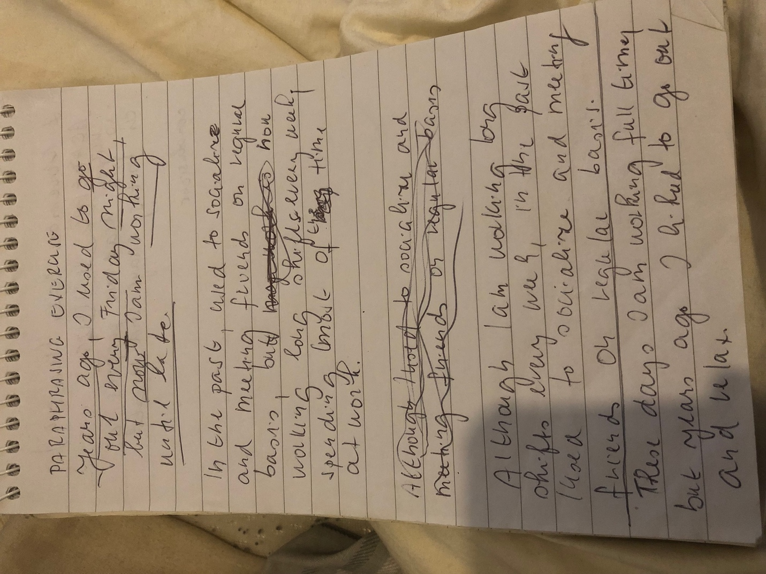
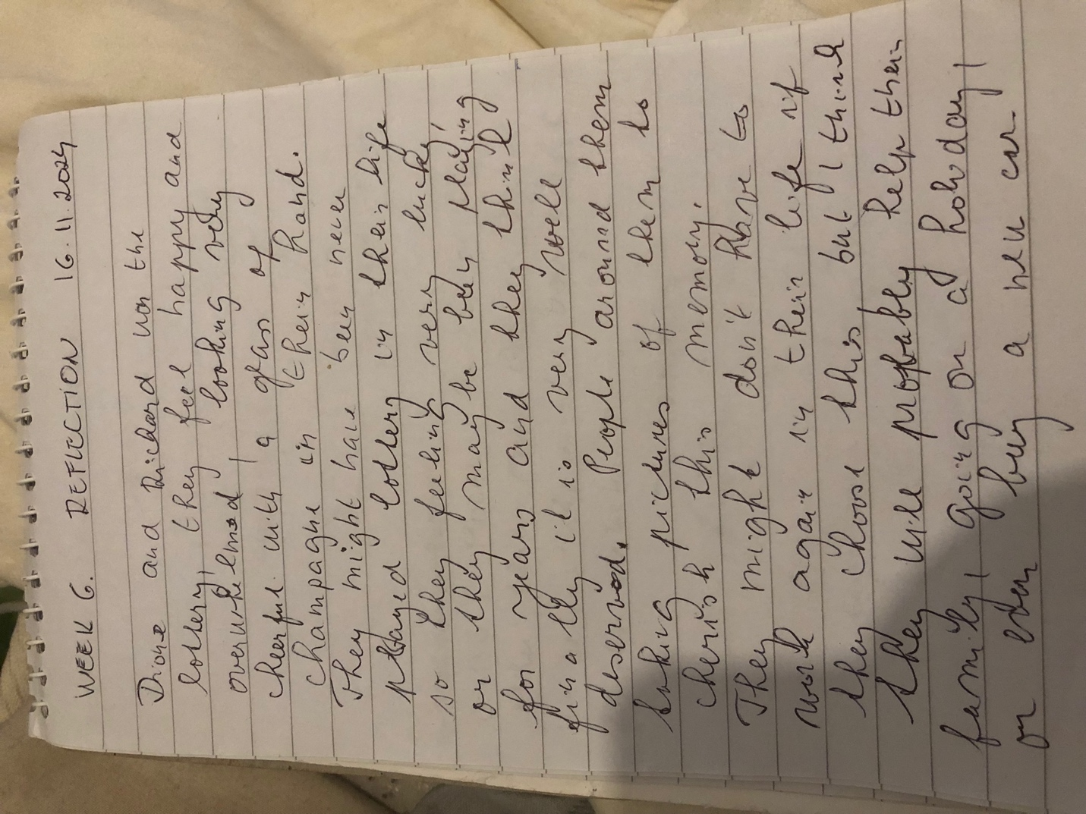
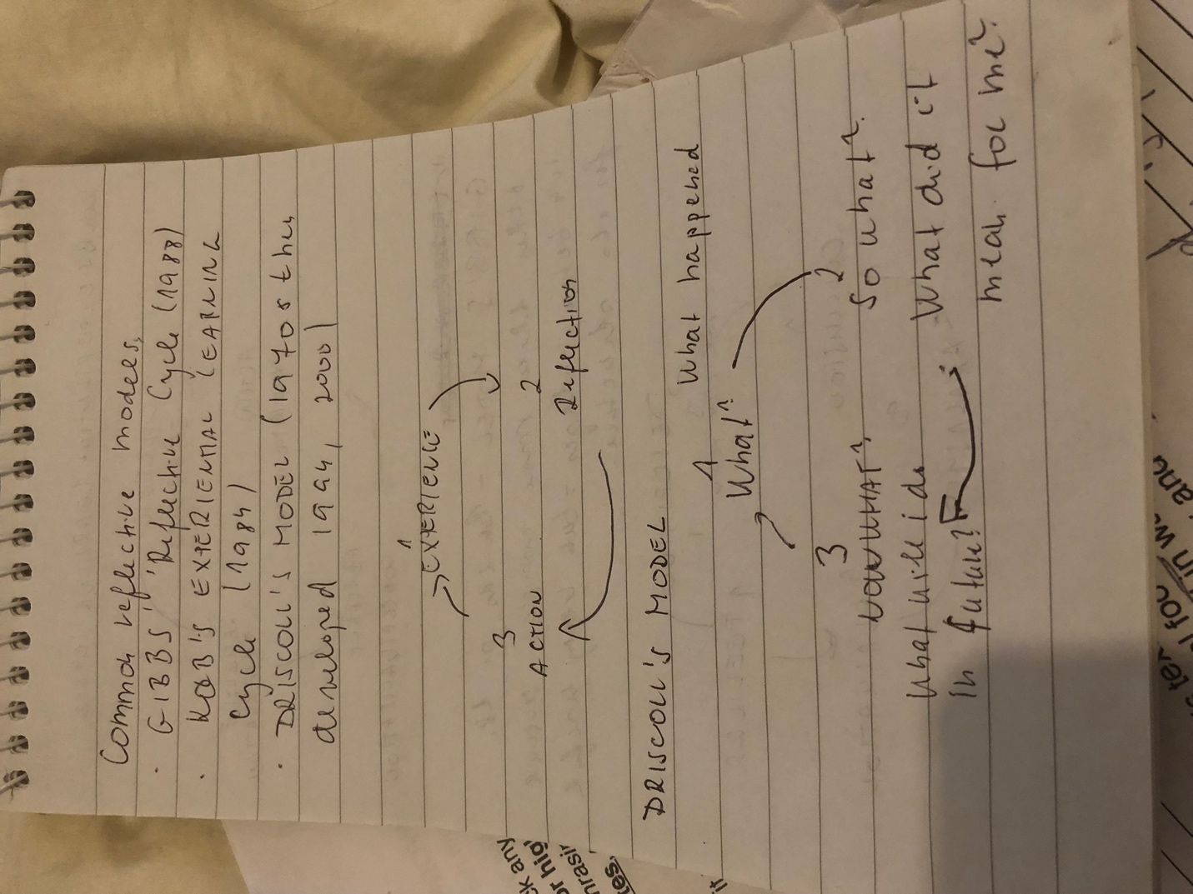

PARAPHRASING SKILLS

What?
While doing the project, I got to know that my paraphrasing skills tends to be a little weak. Paraphrasing skills refers to expressing someone else’s thinking process and ideas in your personal words. I realised that I am not able to paraphrase appropriately that can hinder the process of project making (Miranda, 2022). While doing the project, I faced the problem of paraphrasing the ideas from the primary sources in my own language. It becomes essential for me to properly acknowledge the primary source in order to avoid any kind of plague in the work. It also became very difficult for me to find the proper balance among being loyal to the source and also being original in the expression. It was not a good experience for me because of my lack of paraphrasing skills.

So what?
At this particular moment, with the help of my team members I am feeling a little relieved. I got very lucky that I had one of the best teams that helped me in understanding each and everything about how to paraphrase the appropriate data and information (Ruslan, 2020). As the paraphrasing skills tends to be crucial in the educational life, learning this skill will make me more effective in the long run. This week, while conducting the project, I realised that I am getting better at it in terms of paraphrasing the correct primary source. My team members really helped me in each step of the project, which made me much reliable and asked me about my queries constantly in order to complete the project in a better way possible.

Now what?
At this specific moment, I am very grateful to my team members that helped me to be effective in the paraphrasing skills. Now I am much efficient in paraphrasing from the appropriate primary source of data and information (Pratama, 2022). My experience was good only because of my team members that made me realised the importance of paraphrasing in an appropriate manner. While doing the project in the future, the paraphrasing skills will help me to complete the project in an effective way without any errors or mistakes in relevance with the paraphrasing of the primary source of data and information. I will now focus on finding the appropriate data in order to better prepare myself for doing the paraphrasing in a successful manner.

ACADEMIC WRITING SKILLS

What?
While conducting the project, one of the major skills I developed was the academic writing skills. Academic writing skills refers to the specific style of the expression. I realised that my academic writing skills are good but not that effective (Algburi, 2022). My grammar tends to be quite efficient but I lack having the clear focus on the assigned topic. I was feeling a less confident, which eventually hindered my process of learning. While doing the project, I was not able to understand the word structure that also made my team management skills less effective. I had a neither bad nor good experience while conducting the project.

So what?
I am feeling bad because of my lack of academic writing skills. I reacted in a positive way and listened to my team members as well as teachers at every point of time. I am quite grateful for my teachers, as with the help of their constant guidance and support from my team members, I was able to develop a proper word structure that eventually enhanced my academic writing skills. Academic writing skills will help me to stand out in front of my team members in my educational life. My team members helped me at each point of the project and helped me to clearly define the word structure. I was feeling confident about my grammatical skills that made me effective in my team. I also learned that having an effective team is also crucial for the project to be fruitful as well as successful.

Now what?
At the end of the project, I am feeling quite productive because of my teachers as well as my team members. They helped me at every step possible and made me realised the importance of the academic writing skills in my educational life (Li, 2022). I am grateful for their help and this will thus make me effective while writing any kind of project in the future. I will now remember each mistakes and errors that I made while conducting this project and will try to evade it in each way possible in the upcoming future. I will focus on my word structure in order to complete the assigned project with proper academic writing skills and abilities. I also learned that asking for the help at any given point of time is crucial to remain successful in the life both personally as well as professionally.

SUMMARISING SKILLS

What?
While doing the project, I learned the significance of summarising the project in an efficient manner tends to be quite crucial. Summarising refers to taking a long paragraph or passage from the various sentences and restating the required ideas in our personal language (Coullie, 2020). While conducting the project, I realised that I possess an efficient summarising skills. It means that I am able to appropriately define the information of the project in a short and simple way, while evaluating all the necessary data and information. Having efficient summarising skills made me quite reliable towards my team members as it tends to be an important skill in the educational life. In the academic work, the paraphrasing skills as well as the summarising skills are quite essential in order to be successful.

So what?
I am feeling quite good as well as responsible that my team members are able to rely on me. I also helped one of my team members on how to carefully and appropriately summarise the given data in efficient manner. This will made me stand out in front of my team members and my teachers also praised me in front of my whole class. I will try to do much better in terms of summarising for all my projects currently as well as the projects that I will work on in the future. With the help of so many individual and group projects, I am able to summarise in a much better way than before, which eventually helped me to be effective in the class among my team members. I also helped my team members in each step possible and also involved them in various questions about how to summarise a topic in a better manner. My team members were also feeling quite effective as I helped them at each and every way.

Now what?
I am feeling very happy and relieved, as I was able to summarise our project in an effective way. I also helped my team members in each and every way possible and they felt quite grateful for my constant help towards the benefit of the team (Harrison, 2020). With my as well as my teachers support, we were able to conduct the project in a successful manner that also made our team stand out in front of all the class. I will try to be more focused and will also prepare in a much better way to make my team members feel proud.

REFERENCES
Books and Journals
Algburi, E.A. and Razali, A.B., (2022). Role of Feedback on English Academic Writing Skills of Tertiary Level Iraqi English as a Foreign Language (EFL) Students: A Review of Literature. Journal of Academic Research in Progressive Education and Development, 11(1), pp.689-702.
Coullie, J.L., (2020). Teaching strategies for lecturers and tutors to assist non-English mother tongue tertiary students: Summarising, paraphrasing and vocabulary enrichment. South African Journal of Higher Education, 34(1), pp.37-56.
Harrison, C., (2020). Information skills. In Teaching English (pp. 105-115). Routledge.
Li, J. and Mak, L., (2022). The effects of using an online collaboration tool on college students’ learning of academic writing skills. System, 105, p.102712.
Miranda, D., (2022). The impact of paraphrasing tools on students paraphrasing skills (Doctoral dissertation, UIn Ar-Raniry).
Pratama, Y. and Prawesti, A., (2022). AN ANALYSIS OF STUDENTS’WRITING SKILLS IN PARAPHRASING: A CASE STUDY OF THE 5TH-SEMESTER DIPLOMA STUDENTS OF ENGLISH LANGUAGE AND CULTURE DEPARTMENT OF DARMA PERSADA UNIVERSITY. Getsempena English Education Journal, 9(1), pp.13-28.
Ruslan and .et.al., (2020). Paraphrasing Technique To Develop Skill for English Writing Among Indonesian College Students of English. Sys Rev Pharm, 11(11), pp.291-297.

