

Management Ethics
Critical Discussion of CSR Theory

Name: Haroon Teria

Student number: 1704624

Module: management ethics (M5X00803)

Lecturer: Dr: Caroline Jawad

Introduction
The Fairtrade Organisation was established in 1989. Since its creation, over 400 members across 70 countries around the world have gained membership of the organisation. Membership includes over 330 Fairtrade Enterprises, as well as a broader movement of 70 organisations and networks that support them. The World Fairtrade Organization (WFTO) verifies the commitment of its members to Fairtrade through peer reviews and audits in the future according to the World Fairtrade Organization (2018). However, the Corporate Social Responsibility (CSR) aims to highlight the responsibilities of an organisation towards the society and the environment. In this regard, it is essential that the decisions taken within an organisation are ethical by considering the impact made on society and the environment. This means that these organisations are expected to integrate various concerns into the decision-making process in an appropriate manner (Hohnen, 2007). An issue that is encountered worldwide is the topic of sustainable agriculture which aims to meet requirements for satisfying human need for food. This should therefore mean that the environmental impact made by organizations are examined whilst farmers are also able to maintain a good quality of life and sustain food resources.
The CSR and unethical practices
Despite new technological approaches are employed, however, the expertise of farmers is always required. It is therefore essential that the business is profitable for farmers over the long run while taking into consideration the health and wellbeing of farmers. This should include the wages, health and safety and the working conditions (MDR, 2011).For example, the Nestle company was accused of using children’s labour in its cocoa supply chain. This practice has been deemed to be unethical, but they didn’t end child slavery as it’s cheaper than employing qualified people (Baby Milk Action – IBFAN-UK., 2018). Over the past years, powerful firms and businesses ignored the rights of farmers and their level of life. This has forced individuals around the world to establish organisations in order to protect the environment as well as the rights of farmers. On the other hand, food is no longer raised in sustainable farms. This means that the production of food has started to be dominated by advanced technologies that do not take into consideration the effects on the environment. This can be attributed to the large demand on food and the reliance on chemicals and equipment that affect the natural resources such as water, soil and human health. This means that modern agriculture does not have detrimental effects on the environment and does not loses its social responsibility towards humans and nature (Agriculture, 2018). Overall, unethical practice can take two forms: the behaviour against farm workers and the behaviour against the environment and natural resources.
The CSR Theory Solutions
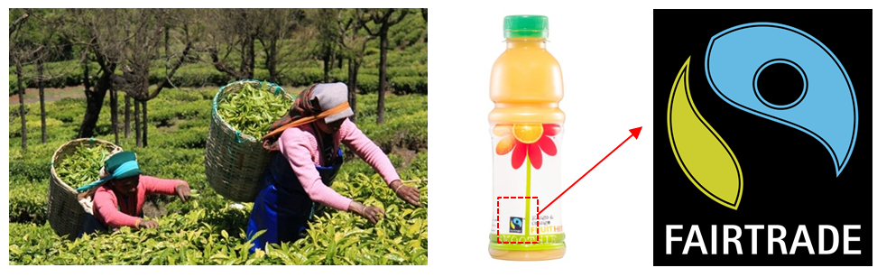
In terms of the rights of farmers some groups such as the Fairtrade organisation started to work towards improving the standard of living of farm workers, Figure 1. Moreover, it works to protect the stability of farming jobs and make it less vulnerable to price volatility. Such organisations enable farmers to have more power in decision making and become more effective in matters related to the sustainability of their jobs. It is therefore important to take the social responsibility towards farmers in this regard (Fairtrade, 2018). Moreover, the social responsibility includes the production of food and the responsibility to make food healthy free from chemicals and ingredients that might affect humans and the natural resources. It is crucial to grow up plants ‘without using toxic chemical pesticides or synthetic fertilisers or modified seeds’ (Agriculture, 2018). By using less water and less fossil fuels, there will be a lower level of financial risks and may potentially be more attractive to investors (Sustainability, 2012). It is reported that the use of heavy machinery damages the soil and results in poor crops and pollution (Agriculture_Machinery, 2018). When looking at using the chemical pesticides, it is not only the harm of using them but rather the production process by which they are produced which harms the environment. Moreover, the transport of these chemicals and the machinery used for these pesticides affect the environment, consume energy and causes global warming, acidification and smog that affect the human health and the environment (Caffrey, 2013). For this reason, the reliance on fossil fuels to operate the machinery used in agriculture should seek more sustainable resources such as solar power as it will be discussed later in the report.

Figure 1: The ‘Fairtrade’ products are favoured as they protect the rights of farm workers.
The solution to such unethical practises towards humans and the environment should be the responsibility of governments by taking actions against those who apply unethical practices and those who do not apply the principles of social responsibility. In the UK for instance, workers’ rights are protected, including minimum wage regulations, annual leave and sick pay. Night pay and regular breaks are also included if the work involves more than a certain number of hours (Gov.UK, 2018). The minimum wages in the UK set by the government for farm workers are summarised in Table 1 (Minimum_Wages, 2018).

Table 1: The minimum wages of farm workers by the UK government (Minimum_Wages, 2018).
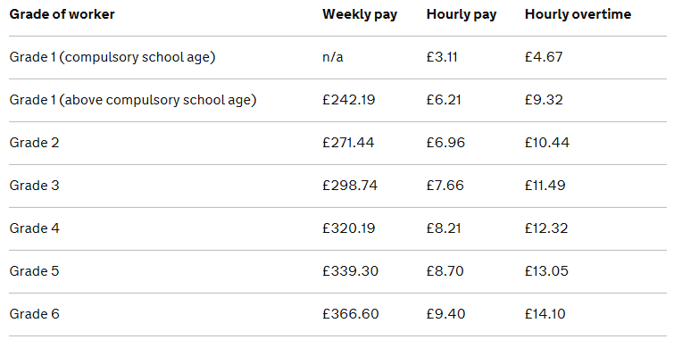

Additionally, the government has guaranteed annual leave for farm workers by creating a calculator that provides an exact number of days per year for paid holiday, Figure 3. This is based on the working hours per day and therefore per year. In other words, workers can check their entitlement for holidays before they are told by their employers to ensure that their rights are protected (Paid_Leave, 2018). The government has also guaranteed the paid sick leave for farmers who fall ill when working. For this purpose, the government has created a statutory sick pay (SSP) of £92.05 per week. In other circumstances, sick leave is paid by the employer for 28 weeks if needed. If this is not paid, the employer may face prosecution (SSP, 2018).
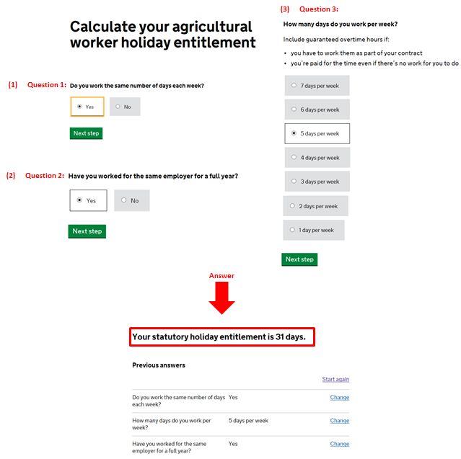
Figure 2: The calculator set by the government to estimate the annual leave for workers.

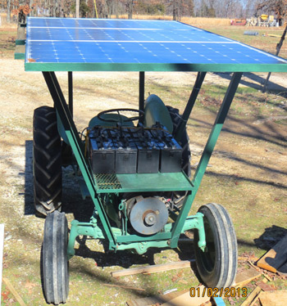

Similarly, the community can put more pressure such that fruit and vegetables are only purchased from Fairtrade farms in the UK and abroad. This means that the community can only deal with suppliers who support the vision of the Fairtrade organisation to ensure that farm workers are treated fairly. The Fairtrade organisation has created a database that is available to identify farm owners and countries that support its activities. It is reported that there are around 1.65 million farmers in 1,226 enterprises across the Fairtrade organisations in 74 countries globally (Fairtrade_World, 2018). On the other hand, the government can employ strategies and tightening regulations on using chemicals and synthetic fertilisers such that the crops are healthy and free of any toxic effects. Generally, machinery uses are minimal so that farmers can sustain work in the fields. It is also encouraged to use the principle of crops rotation which means growing a certain fruits or vegetables on a different part of the land every year. This reduces the chances of diseases related to a certain type of products as well as improve the quality and fertility of the soil (Crops_Rotation, 2018). Several sustainable farms exist, and this includes, for instance the Polly bell Organic’ farm in the UK which relies upon renewable sources of energy such as sunlight which thus also reduces harms caused to the environment by chemicals for example (Polly_Bell, 2018). Several other attempts have been made to make the process more sustainable. This includes using solar energy for harvesting machines that are battery-powered from sunlight which reduces the reliance on fossil fuel. This means that technology can still be used to help farmers while taking into consideration the ethical behaviour towards the environment (Kosare, 2017), (Solar_Tractor, 2018).

Figure 3: The use of fossil fuel for agricultural machinery affects the environment (left) while the use of solar power saves the environment (right).

Critical Reflection on Practice
Before I wrote this report, I was not fully aware of the CSR theory and its importance in our communities. It has now become important for me to follow the CSR theory in every single activity I do in my life and in my community. For instance, when I dispose any waste, I should ask myself about the consequences of this on nature and humans. For instance, I should not dispose toxic waste anywhere, these need to be recycled somehow and given to the authorised parties such as the council. Moreover, when I buy any products from the super market, I should think about how this product has been made and whether or not it involved any unethical practices. The Fairtrade products will be the most important things that I can also help with since this will reflect on the fair treatment of farmers and bring them profitability. The boycott of products that employ young children is an ideal solution that I will adopt to support the principles of CSR. I have to admit that some of my personal practices did not consider the CSR strategy as this is something of which most people are not aware. I am sure that if I am given the chance to write the assignment and contribute more in the future, I will do better, and I will also include my personal experiences into that as it is something ethical, we should all think about. From now on, I will convey this message to my friends, family and the community such that they become aware of the fact that when we buy certain products, we should think about how these are made, by who and whether it employed ethical/unethical practices against humans and the environment. This includes food, furniture and any consumables we normally use in our daily lives. This will, eventually, reflect on the unethical businesses and force them to change their strategies and improve their practices when dealing with humans and the environment.
Figure 4: Stand up against child labour and choose a ‘Fairtrade’ product.
Conclusions
It is essential to apply the corporate social responsibility principles to the agricultural industry so that the rights of workers, working conditions are protected as well as the environmental resources and human health. This can be done by dealing with suppliers who respect these principles ad show ethical behaviour towards humans and the environment. It is important to think about profitability of the business while taking into consideration the social responsibility towards the community and the environment. Once this is implemented, other suppliers will try to improve the working conditions of the farm workers and this becomes effective if a leadership to boycott products of those who disgrace the rights of farmers and the requirements of the environment is established. There is a long list of products where campaigners applied the boycott principles especially those who illegally employ young children and stop them from going to school (Boycott_Unfair_Trade, 2018). Once this boycott action takes place globally, the world will become aware of these rights and will therefore try the best to follow the principles of the CSR in our communities. It is always expected that some business will be against the CSR solutions, however, when they encounter a community support and demand, they will eventually accept the fact that there is no place in the community for those who do not respect humans and protect the environment.

References
Agriculture_Machinery, 2018. Heavy agricultural machinery damages the soil. [Online]
Available at: https://www.forskningsradet.no/en/Newsarticle/Heavy_agricultural_machinery_damages_the_soil/1253966195787
[Accessed 1 11 2018].
Agriculture, 2018. Sustainable Agriculture - The Basics. [Online]
Available at: http://www.sustainabletable.org/246/sustainable-agriculture-the-basics
[Accessed 1 11 2018].
Agriculture, 2018. Sustainable Agriculture - The Basics. [Online]
Available at: http://www.sustainabletable.org/246/sustainable-agriculture-the-basics
[Accessed 1 11 2018].
Baby Milk Action – IBFAN-UK., 2018. Baby Milk Action – IBFAN-UK.. [Online]
Available at: http://www.babymilkaction.org/nestle-fairtrade
[Accessed 16 November 2018].
Boycott_Unfair_Trade, 2018. Stop the Exploitation of African Children: Boycott Non-Fairtrade Cadbury Products. [Online]
Available at: https://www.change.org/p/cadbury-stop-exploitation-of-african-children-boycott-non-fairtrade-cadbury-products
[Accessed 1 11 2018].
Caffrey, K., 2013. Conducting an Agricultural Life Cycle Assessment: Challenges and Perspectives. The Scientific World Journal.
Crops_Rotation, 2018. Crop rotation. [Online]
Available at: https://www.rhs.org.uk/advice/profile?PID=124
[Accessed 1 11 2018].
Fairtrade_World, 2018. Where Fairtrade works. [Online]
Available at: https://www.fairtrade.org.uk/What-is-Fairtrade/Where-Fairtrade-works
[Accessed 1 11 2018].
Fairtrade, 2018. The Fairtrade Foundation. [Online]
Available at: https://www.fairtrade.org.uk/What-is-Fairtrade/Fairtrade-and-sustainability
[Accessed 1 11 2018].
Gov.UK, 2018. Agricultural workers' rights. [Online]
Available at: https://www.gov.uk/agricultural-workers-rights
[Accessed 1 11 2018].
Hohnen, P., 2007. Corporate Social Responsibility - An Implementation Guide for Business. Canada: International Institute for Sustainable Development.
Kosare, S., 2017. Review Paper on Solar power operated Sugarcane Harvesting Machine. International Research Journal of Engineering and Technology, 4(3).
MDR, 2011. Sustainability Agriculture, Social Responsibility and Dairy Farming. Michigan Dairy Review.
Minimum_Wages, 2018. Agricultural workers' rights. [Online]
Available at: https://www.gov.uk/agricultural-workers-rights/pay-and-overtime
[Accessed 1 11 2018].
Paid_Leave, 2018. Calculate your agricultural worker holiday entitlement. [Online]
Available at: https://www.gov.uk/calculate-agricultural-holiday-entitlement
[Accessed 1 11 2018].
Polly_Bell, 2018. POLLYBELL ORGANIC FARM. [Online]
Available at: https://www.pollybell.co.uk/
[Accessed 1 11 2018].
Solar_Tractor, 2018. Solar-Powered Tractor. [Online]
Available at: https://www.motherearthnews.com/green-transportation/our-solar-powered-tractor-zbcz1307
[Accessed 1 11 2018].
SSP, 2018. Statutory Sick Pay (SSP). [Online]
Available at: https://www.gov.uk/statutory-sick-pay
[Accessed 1 11 2018].
Sustainability, 2012. Sustainable Agriculture, s.l.: UNDP - International Guidebook on Environmental Finance Tools: A Sector Approach.
World Fair Trade Organization, 2018. W F T O working Togther For A Fairer World. [Online]
Available at: https://wfto.com/about-us
[Accessed 7 November 2018].

