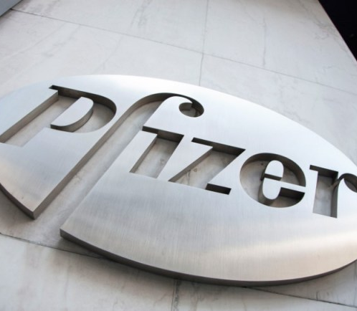
Strategic Management – Charlene Morgan - 1906685
Does Pfizer have the right strategy for today’s challenging environment?
Charlene Morgan (1906685) | 6/24/22 | BMSW6104_Swansea

Executive Summary

There are many ways in which Pfizer uses strategic Management in its organisation, which will be discussed in this report. When implementing new innovative ideas, negotiating financial terms, establishing brand recognition, or implementing the final strategies of an organization, it is essential to have a plan.
Providing an overview of Pfizer’s background, theorists can provide insight into the company's strengths and weaknesses. It is imperative to understand that advantages and disadvantages are related to the company's philosophies, plans, and future. In Pfizer's decision-making process, stakeholders play an important role, and using their ideas can help transform the company for the long term.

Contents Page

Executive Summary | 1
Contents Page | 2
Introduction | 3
Background | 4
Positioning Schools | 5
Pfizer’s Strategy Plan | 6
Profit & Loss | 7
Shareholders | 8
Strategic Models | 9
Advantages and disadvantages to the organisation and its stakeholders | 13
Conclusion | 15
References | 16

1.0 Introduction

This Strategic Management Report has been requested by the Managing Director of Pfizer and is to be submitted on 24th June 2022. In this report, several strategic management topics will be examined, such as an overview of the development in the past 5 years, profit and loss, market share and additional financial stakeholders.
A strategic analysis will be performed utilizing various models, such as SWOT, PESTLE 5 FORCES, etc. Furthermore, market forces and growth will also be highlighted, as well as how strategic planning shows where the organization could be pulled in various directions and if that is effective.
In order to support all of the above mentioned, research will be undertaken using various resources, such as online websites, videos, textbooks, and journals.

Background
(Pfizer, 2021) has had a long-standing relationship with the UK for almost 68 years. For decades they remain resilient in identifying new and better methods for preventing and treating diseases with the addition of enhancing the health and wellbeing of people worldwide.
(Pfizer, 2019) Values and culture are at the heart of any organisation however, there is one keyword that represents the four core areas that define this, ‘how’. In order to accomplish these objectives, the following steps will be actioned:
- Courage
- Excellence
- Equity
- Joy

Brown, (2021) states values within a company must focus on a concept which refers to the financial values as well as the non-financial values of a company. An effective management of any current project will allow it to be handled with the upmost care.
Despite today's technological advances, the company's mission statement remains relevant (Visionary Team, 2020) and uncovers the significant reason behind the organisations success:
“to become the world’s most valued company to all of these people.”
(Pfizer – Mission Statement)
In short, it focuses on the accomplishments the organization wishes to achieve, it also aims to meet the needs of each individual patient.
The development of drugs and clinical products are at the centre of what Pfizer does, which links with the focus of its vision statement:
“Innovate to bring therapies to patients that significantly improve their lives.”
(Pfizer – Vision Statement)

Positioning Schools

Examining Mintzbergs framework on ‘Schools in Strategic Thinking’ Pfizer comes under the umbrella of a few schools, the first one being Entrepreneurial this is because Jecanz, (2022) speaks about how this particular school has a total of five main points to consider. These are:
- Intuition
- Judgement
- Wisdom
- Experience
- Insight
It is important for a leader to reveal all of these when making decisions. Strategic plans can be influenced by this factor. Jecanz, (2022) digs deeper by stating that Mintzberg very much describes this school as “deliberate and emergent” this shows innovation and how the experience and adaptability of the business revolves around the leader. Pfizer Inc (2022) innovates through changing lives, progress generates through the teams work ethic, and gives a sense of personal growth and a feel good factor when a new product is formulated. Keeping in line with the vision statement it is known that sharing different ideas and collaborating with colleagues will allow to show a true reflection of outstanding achievement and learn new expertise. Another school Pfizer sits comfortably in is the positioning element, it helps to look back at what Pfizer truly means by examining the mission statement and what truth and values lie behind it, a framework analysis named SWOT can identify by reviewing and evaluating these achievements. If gaps are apparent, then this is the tool to take advantage of. Executive Leadership Training (2021) explains the starting point for the positioning school are economics, industrial organisation and military history. This process looks at the fixed data, which is then submitted to an analysis to feed it to the strategy design. Gordon (2022) proclaims that taking into consideration for Michael Porters five forces strategy will drive competitive advantage using generic strategy enhancing the marketplace. To aid in this process Porter projected a value chain which allows the company’s operational activities. As a result, differentiation or cost structure can provide a competitive advantage.

Pfizer’s Strategy Plan
Pfizer UK (2020) follows a complex strategic plan in any work conducted to create and develop vaccines. A long and complicated process must be followed to be 100% right before distribution, it is the company's responsibility to protect the health of others. Pfizer (2021) ensures a focus to keep on delivering the COVID-19 vaccine worldwide throughout 2022, and to stay true to word when it comes to quantity and as part of its commitment to low- and middle-income countries, the company plans to provide 2 billion doses. Part of Pfizer’s principles is recognizing that people who are on low income cannot afford healthcare, therefore pricing strategies or affordable plans will be put in place to combat these issues. When research, materials, stakeholders, commitment of teamwork are all readily available, then innovative ideas become reality, this goes without saying results and recognition are credited. Pfizer went from eleventh to fourth place against other competitors and were highly recommended in the research and development (R&D) stage planning.
Yet Pfizer Inc (2022) make it known that their process is quite simple, when building potential relationship or partner focused coalitions. An evaluation of potential opportunities will be conducted by the Business Development team and scientific and commercial experts. Then given the chance there can be the opportunity to speak about deals, negotiating terms and receiving approvals. It only goes through 4 main steps to come to a conclusion:
- Initial Review
- Due Diligence
- The Deal
- Implementation & Integration

Whilst there are many ways of strategic planning, Pfizer’s latest encounters still remain true to their mission statement and vision. Arthur (2022), elaborates in more detail how Pfizer sets to benefit from continuing to move forward with mRNA R&D and manufacturing. Since the pandemic has been a crucial part to Pfizer’s success and main core of the business, it now wants to remain vigilant on other external companies working on the best tech and working alongside internal individuals with greater expertise. To do this Pfizer will draw upon:
- Experience - expanding the portfolio of the vaccine and propelling in tech and new developments.
- Vaccine development – Invest in core franchise
- New therapeutic areas – to expand in larger areas such as inflammation and immunology

Profit & Loss

Bowman, (2007) affirms creating value should be the primary objective of a profit-seeking firm's strategy. The value creation process is characterized by five different types of activity. If a firm expands its scope beyond a single product, matters relating to "corporatization" will arise. For the past 5 years, (Pfizer, 2022) has gone through dramatic changes, in 2020 they provided over £5.9 million in charitable donations, which carried through to patient organisations, community and academic institutions, and contributions to professional associations. Pfizer’s investment in research and development in 2021 was over £266 million, and participated in 102 collaborations with universities, pharmaceutical companies, and businesses. This investment has helped with sharing knowledge, skills and knowhow with scientists, academics and clinicians to help develop the health and lives of people all over the world.

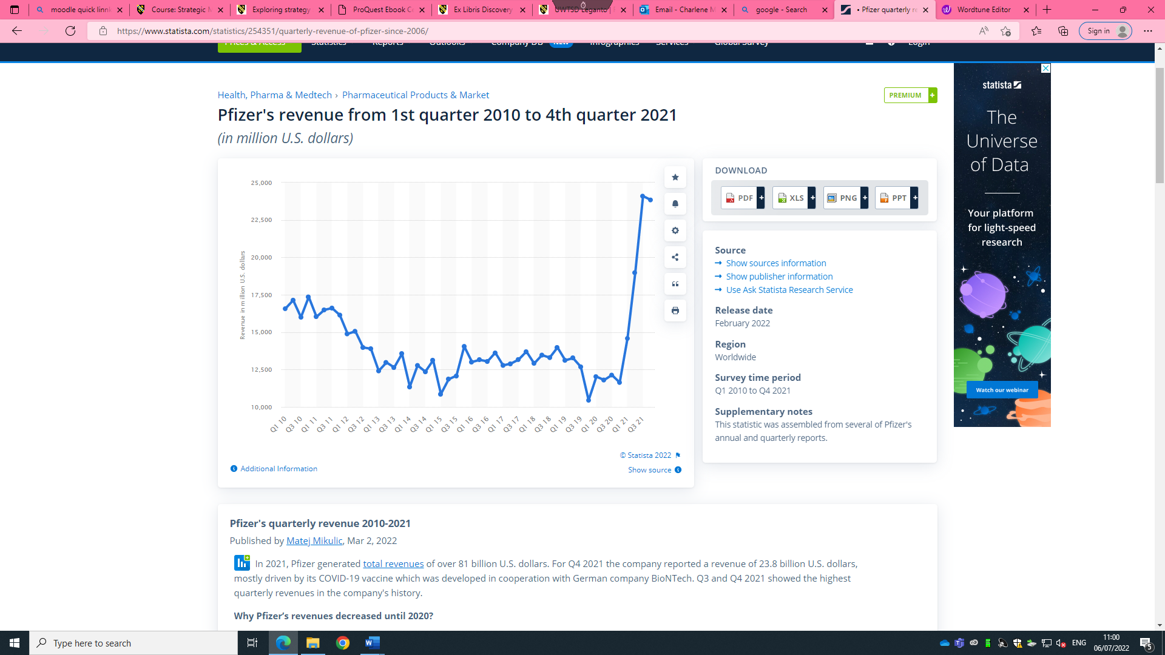
(Table 1)

The company earned the highest quarterly revenues in its history during the third and fourth quarters of 2021, this total revenue was over 81 billion U.S dollars this was undoubtedly caused by the new covid 19 vaccine. However, before this soar of financial rise it was at one of its lowest peaks in 2020, this caused a 10 billion decrease in revenue sales. Mikulic, (2022) explains one reason for the decline was competition from generic drugs that entered the market when key patents expired. At the end of 2011, Pfizer lost market exclusivity for Lipitor, resulting in a significant decline in revenues. Also revising the company’s product range, several of Pfizer's business segments, including its animal health division and Upjohn, were struck off in 2013, which had a detrimental effect on revenues. To develop new, innovative medicines, Pfizer needs to invest in research and development (R&D).
Marketline (2022) states the costly flaws Pfizer has had to go through that have effectively put the company in comprising positions. As well as product recalls, Pfizer has incurred a significant amount of litigation over the years.

Shareholders
In the corporate world, executive leaders are those who deal with financial, strategic, and operational decisions. Pfizer (2022) establishes 13 main figures in their organization to oversee these functions. One being the Dr Albert Bourla (Chief Executive Officer and Chairman).
According to Johnston, (2021) Pfizer sits amongst six investors to help accommodate and propel its business for the better these include, 3 Individual Insider Shareholders Frank A. D'amelio, John Douglas Young and Mikael Dolsten with them 3 Institutional Shareholders Vanguard Group Inc., BlackRock Inc. (BLK), and State Street Corp. (STT). The largest shareholder to date is Vanguard Group Inc. investing in 456.2 million shares of Pfizer, representing 8.1% of total shares, the other end of the scale from an institutional perspective are State Street owns 278.6 million shares of Pfizer, indicating 5.0% of total shares. Considering that between these three shareholders alone total shares have accumulated to 65 – 66% worth of procession.
Many questions were raised at Pfizer’s shareholders meeting (2022) asking only the vital issues that may have impact on investors themselves. Even though all were answered, there was room to divulge into more pressing matters unfortunately due to technical matters this could not be released. However, there is no denying the fact that this does illustrate how involved the shareholders are on an annual basis and how important it is for the future of the company to prosper. The three main key areas of discussion were:
- Diversity, Equity, Inclusion – job opportunities, fair playing field
- Covid 19 Vaccine & Treatments – negative impact – media, costs, other countries
- Partnerships & Vendors – Honesty about other investors

Strategic Models
The purpose of strategic management is to plan, monitor, analyse, and assess all the necessities that will enable an organization to achieve its objectives and goals in the most effective manner, Tucci (2022) goes on to say organizations must continually evaluate their success strategies in response to changes in their business environments.

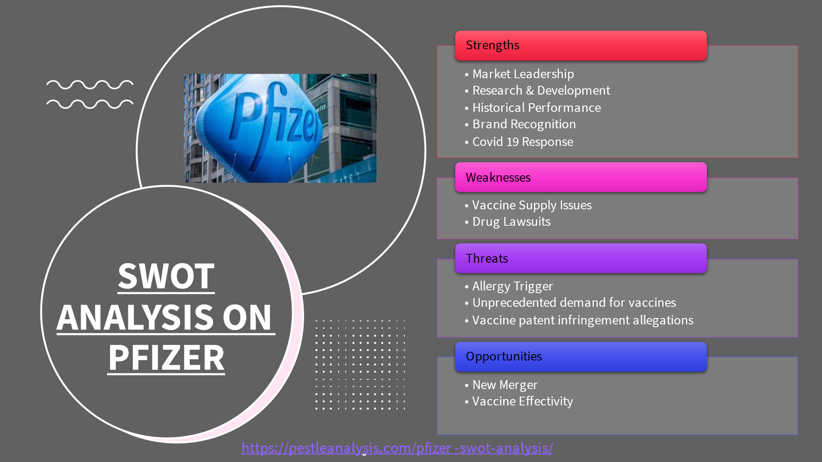
(Table 2)
A SWOT analysis is a key tool to develop a strategic plan. If a team can utilise all the knowledge from internal and external methods, it shall start to show all pros and cons of the organisation. In (Table 2) there is an opportunity to start seeking out a new merger, as part of Pfizer's recent acquisition of Mylan M.V. its Upjohn division was combined which left the company less diversified. But, to increase the growth of the pipeline of new drug candidates, it was decided to separate the slower-growing Upjohn business. Yet, if Pfizer were to look at the weakness and pull out the issue of vaccine supply issues, this would of not of led to not being able to meet the deadline of distributing the product. An error of judgement was noted by the congress, which plans were dissected and later revealed that they could mass-produce the vaccine immediately as soon as approval was given because billions of dollars were to Pfizer in federal funding. In order to of steered away from a carless move, Pfizer should have tested thoroughly before allowing such a distribution to take hold, if suppliers where not ready to ship out then delays, questions, and media attention would not of been raised. This could have had a negative reputation to the organisation and would not have stood up to Pfizer’s mission statement or even the core values.

Lees, G and Technical Information Service (2008) creates an understanding of the integral part of the strategic management process is the determination of the strategic position. In turn, it facilitates the making and implementation of strategic decisions. A company's strategic position can be viewed as consisting of three key elements, each of which has a substantial impact on the organization's future direction:
- External Environment
- Resources and competences
- Culture and ethical values and stakeholder influences
These can be credited by sectioning off each area, by creating and implementing a successful strategy. Organizations may be able to gain competitive advantage through the use of their unique collection of resources and abilities in a manner that is hard to duplicate by their competitors.
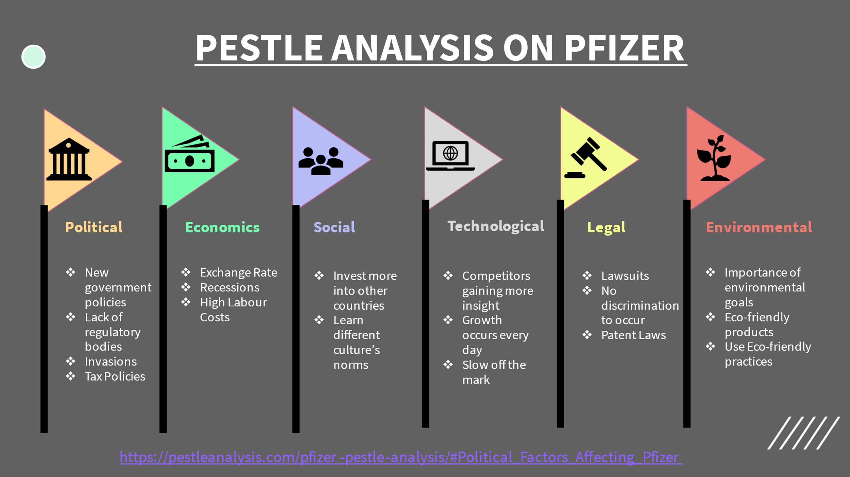
(Table 3)
PESTLE (Table 3) creates a tool that can provide a person with a comprehensive view of the external environment is very beneficial. It can be hard to control government changes under the political umbrella, for Pfizer to be successful in other countries, it must weigh risks in this area. With the uncertainty of ongoing invasions in Russia Pfizer has had to acknowledge that they shall no longer invest with such a country and with that this has put a halt on generating any more revenue in the future. An economic flaw that has Pfizer’s hands tied, is the cost of products rising, putting highly priced goods onto the market may seem unfair and not affordable to everyone’s needs, yet without the supply of labour and it is becoming so costly with one’s wages increasing Pfizer will be forced to increase the cost of contribution. Revenue may be faced with an all-time low.

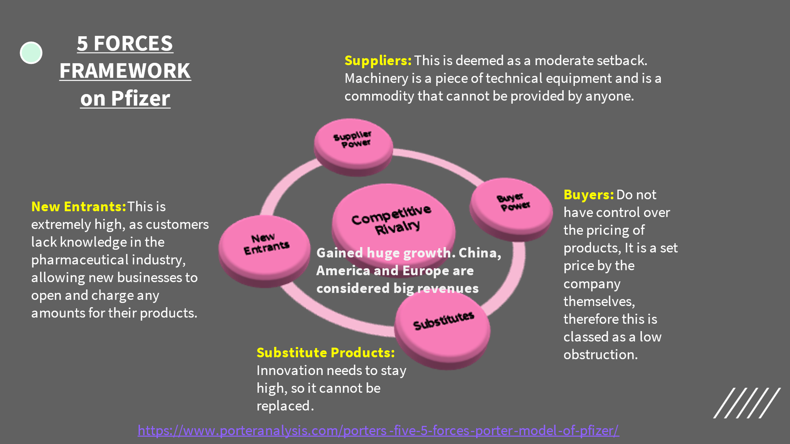
(Table 4)
Five Forces Analysis (Table 4) can be quite similar to PESTLE and be considered as an external framework although there is a distinguished difference between Macro environment (one way effect) and Task environment (interact with each other internally). Allowing to demonstrate how Pfizer can ultimately show long term profit potential. New entrants are where Pfizer must keep their fingers on the pulse in order to stay above the rest, when a product loses market exclusivity, other companies can legally manufacture and sell a generic alternative at a lower price. Pfizer must channel their technological flaws and keep up to date, with what competitors are bringing to the forefront of their pharmaceutical companies. There is a great advantage to this, as consumers really do not have the knowledge and know-how as to what is the best medical treatment and at what price. Pfizer can play this to their strengths.

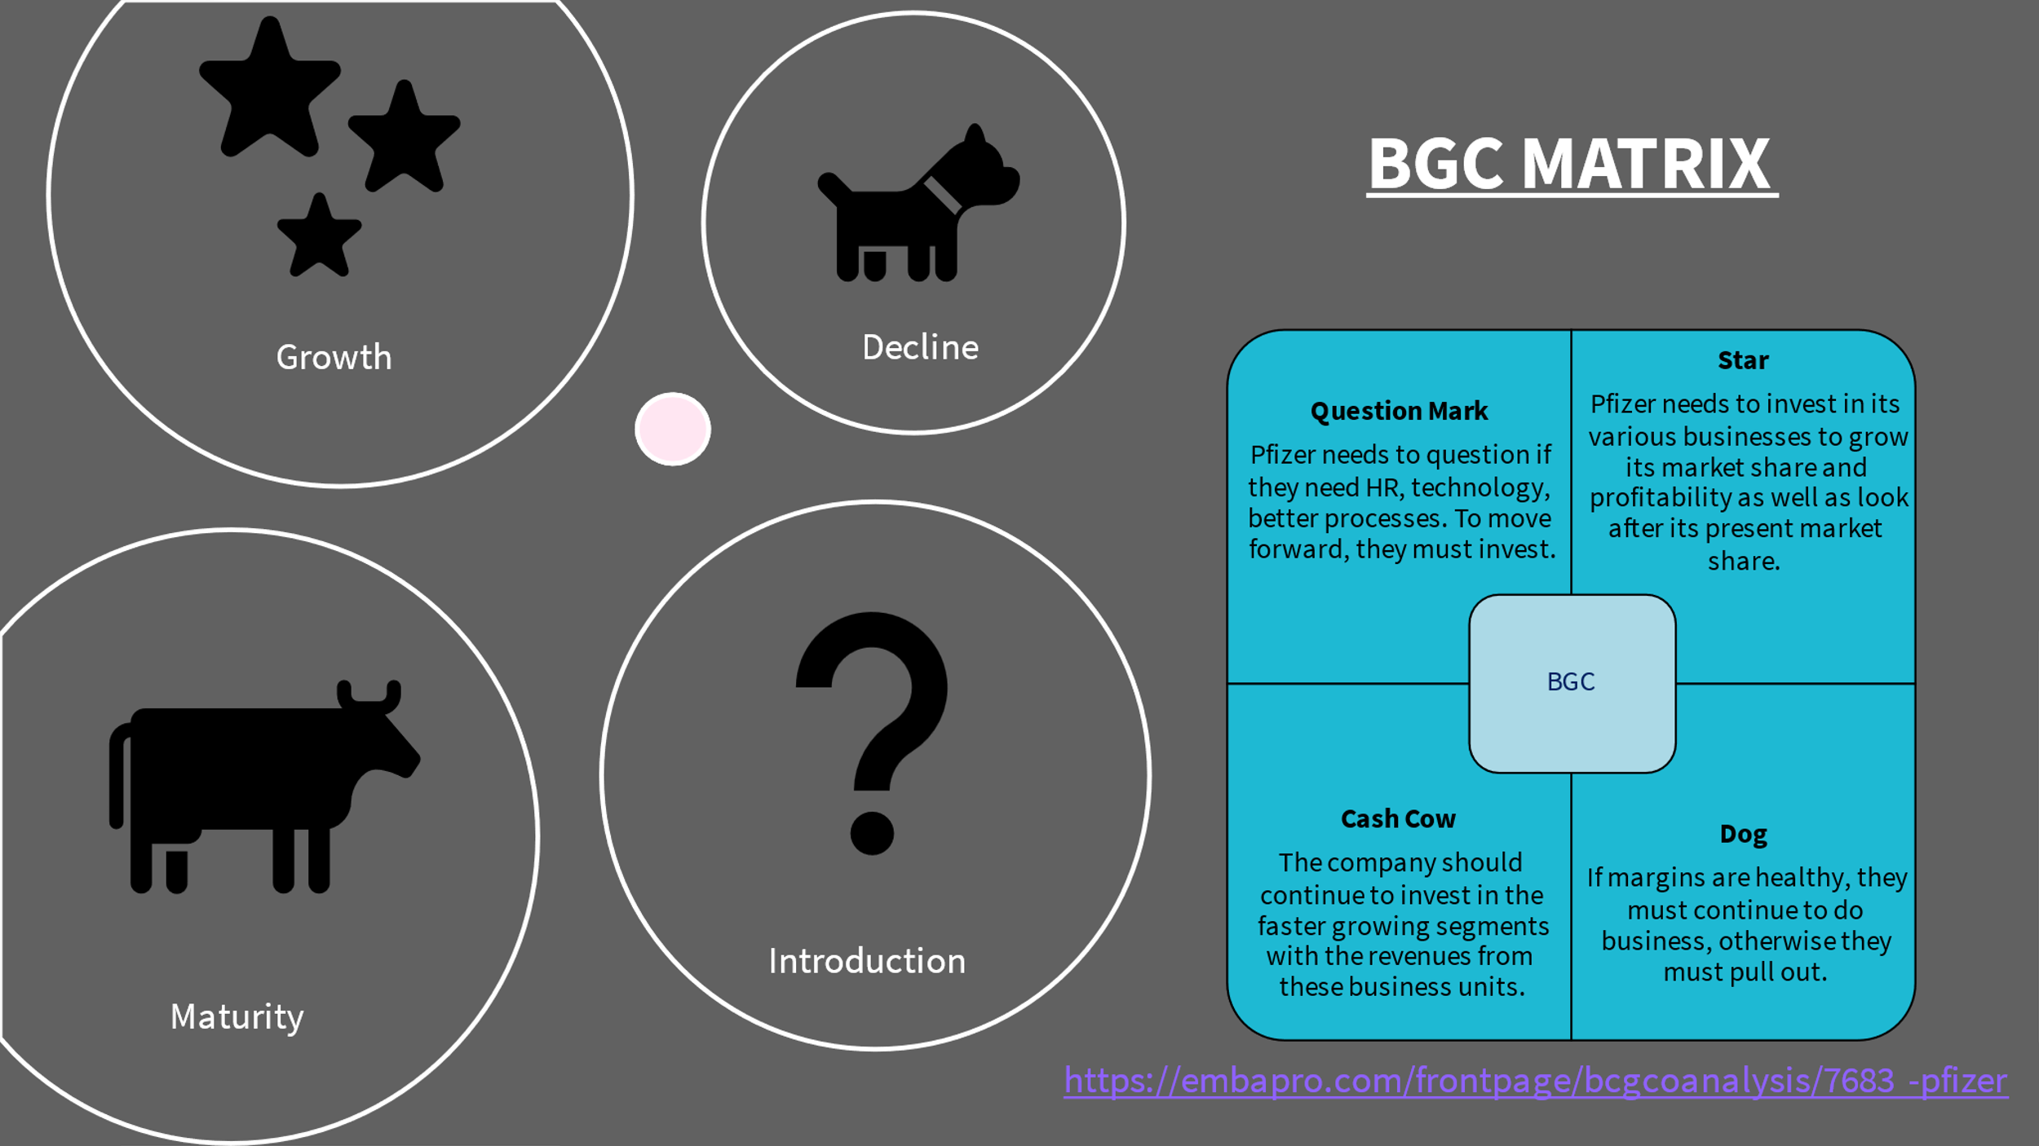
(Table 6)
(Table 6) Boston Consultant Group (BGC) is used to analyse strategic business units (SBU’s) where Pfizer can make investment decisions on a corporate level. Here the star of this framework has really shone for Pfizer since the introduction of the Covid 19 vaccine, this has allowed profit margins to soar and to remain this way. However, there will always be room for a question mark to maintain standards and elite status, Pfizer must invest in certain areas in the business such as technology knowhow, it is well-known you cannot move forward without technological skills it is the heart of many business advantages, by investing in the latest tech it can help to gain more insight and knowledge against other competitors and growth can be established every day because of this. If Pfizer does not see a reason to invest in such an important commodity, then the business will never really rise to its full potential and will remain stagnant, with failure to follow.
Madsen, (2017) argues the BGC matrix remains one of the most valued frameworks of all time, the technique is still widely used by practitioners in the area of corporate portfolio planning even with the threat of new individuals trying to put new techniques together the matrix will still apply and indeed stay crucial.
(Whittington et al. 2020, p. 229) embraces business models as a very popular tool to have within companies, models consist of a definition of value propositions for consumers and other contributors, the organisation can help to produce value as well as the revenues and cost structures associated with them.

Advantages and disadvantages to the organisation and its stakeholders

Throughout the strategy process, (Faulkner and Bowman 1995, p. 3-4) argues that even though there is focus getting a plan right, managers often lose sight in which way a proposal should be devised, therefore often resulting in failure. There is no straight path, when businesses are dealing with outside consultants, or if an order from corporate level (top – down approach) demands a plan of action, this can ultimately put a discouragement feeling amongst the team. Emphasis on a mission statement shall provide a means of direction that a company must face, in other words stay true to the company’s values and what they stand for. Communication must stay at the forefront of any new changes brought into the organisation and allow to generate new and innovative ideas for the company to stay a cut above the rest and keep pushing forward, to generate revenue, promised values and culture and to keep the brand the admired.
Pfizer (2018) say that it is important for them to engage with their stakeholders so that it can carry out and improve global business operations. An advantage of this is to keep them informing and authenticating our decision-making processes, these stakeholders also provide guidance and insights that can assist in responsibly managing the business. A massive turnaround for Pfizer and its shareholders was beyond comparison in their annual report. Pfizer (2021) very own CEO Albert Boula reveals in great delight, that goals had been reached and beyond in terms of revenue, vaccines reaching more patients, investments were increased and they were able to initiate more pivotal clinical studies than ever before. Keeping in line to current need of the COVID-19 vaccine the market share was able to constantly grow, demonstrating 70% of all doses distributed across the U.S. and EU as of March 5, 2022.
(Morden, 2007, p.34) explains how financial performance is vital to any organisation. In the view of anyone who may have financed money time and effort into the chosen company their only viewpoint may only included return of investment and can include many other avenues from the perspective of banks, livelihoods and the government will anticipate taxpayers money in order to keep public domains such as schools and hospitals to keep running.
As a generic overview of why stakeholders are not entirely the best reason to have on board is the lack of only looking after themselves, a tunnel vision approach may only help oneself and may not have the business acumen to support a company they no nothing about, but to only finance, an extra point by UpCounsel Technologies, Inc. (2022) include standing in the way of progress, when change is introduced it can make stakeholders wary. When communication and technology advance, individuals, corporations, and even nations are forming relationships in a different manner. Lastly and the most important is fear of failure, by impeding on plan can cause chaos, which leads to a collapse of ideas or shifts direction in order to gain control. Pfizer is at a complete advantage of having shareholders as its company would not be able to thrive through the times of decline revenue, with the following investments been given, Pfizer has been able to give back and show clarity in there ever growth and strategic plans, making way for popular demand in developing medicines and vaccinations.
Conover, (2021) reveals in the pharmaceutical industry, Pfizer has established one of the largest economies of scale due to its size. Its broad range of patent protected drugs (new and old) as left an impression to be desired for by its competitors. Combined with Mylan's recent acquisition of Pfizer's off-patent division Upjohn, Pfizer's remaining innovative division should experience speedier growth.

3.0 Conclusion
Although Pfizer will remain one of the largest pharmaceutical companies in the world, to maintain their position, they must continue to focus on progressing their forward thinking into developing drug-related medicines and getting them right from the beginning. Taking care of people's health is a responsibility that cannot be taken lightly. In an extraordinary turn of events, during the pandemic, Pfizer has been able to really propel their name in brand recognition, revenue has taken their profits to sky rocketing results, and has allowed for new innovative ideas to come forth.
Strategic planning cannot happen without, learning from skilled theorists, having an extraordinary workforce who create new and inventive ideas throughout great communication skills and having the support from fantastic leadership.
In order to maintain momentum, Pfizer should keep their mission statement at the forefront of their minds. In times of uncertainty, the world really does rely on the minds of incredible, talented and entrepreneurial people to keep pushing the boundaries for successful strategic planning. After all, how do we keep planning if there is no one to plan for?

“Strategic planning is worthless - unless there is first a strategic vision.”
- John Naisbitt – (1988)
- BrainyQuote (2022)

Reference List

Adamkasi (2019) Porters (5) Forces (Porter Model) of Pfizer Available at: https://www.porteranalysis.com/porters-five-5-forces-porter-model-of-pfizer/ (Accessed: 13 June 2022).

Arthur, R. (2022) Pfizer sets out strategy to win in mRNA Available at: https://www.biopharma-reporter.com/Article/2022/02/10/Pfizer-sets-out-strategy-to-win-in-mRNA (Accessed: 9 July 2022).

Bowman, C. and Ambrosini, V. (2007) ‘Firm value creation and levels of strategy’, Management Decision, 45(3), pp. 360. Available at: DOI:10.1108/00251740710745007

BrainyQuote (2022) John Naisbitt Quotes Available at: https://www.brainyquote.com/authors/john-naisbitt-quotes (Accessed: 12 July 2022).

Brown, L. (2021) What is Business Value and How It is Measured? Available at: https://www.invensislearning.com/blog/what-is-business-value/ (Accessed: 6 July 2022).

Conover, D. (2021) Why Pfizer Has a Wide Moat Available at: https://www.morningstar.co.uk/uk/news/217357/why-pfizer-has-a-wide-moat.aspx (Accessed: 5 July 2022).

EMPA Pro (2022) What is BCG / Growth Share Matrix? Introduction to BCG Matrix Available at: https://embapro.com/frontpage/bcgcoanalysis/7683-pfizer (Accessed: 13 June 2022).

Executive Leadership Training (2021) Thinking Schools / Strategy Mintzberg / Scholz [Video]. Available at: https://www.youtube.com/watch?v=KpjzlVkXlSM (Accessed: 11 July 2022).

Faulkner, D. & Bowman, C. (1995) The essence of competitive strategy. Hertfordshire: Prentice Hall.

Gordon, J. (2022) Positioning School (Strategy) – Explained Available at: https://thebusinessprofessor.com/en_US/business-management-amp-operations-strategy-entrepreneurship-amp-innovation/positioning-school-strategy-explained (Accessed: 11 July 2022).

Jecanz, S. (2022) School of Thought on the Strategic Management Part A [Video]. Available at: https://www.youtube.com/watch?v=7pw3W2JApNU (Accessed: 9 July 2022).

Johnston, M. (2021) Top Pfizer Shareholders Available at: https://www.investopedia.com/articles/company-insights/082316/top-10-shareholders-pfizer-pfe.asp#:~:text=The%20top%20shareholders%20of%20Pfizer,(STT). (Accessed: 6 July 2022).

Lees, G. and Technical Information Service (2008) Strategic Position Available at: https://www.cimaglobal.com/Documents/ImportedDocuments/cid_tg_strategic_position_mar08.pdf.pdf (Accessed: 9 July 2022).

Madsen, D.Ø. (2017) ‘Not dead yet: the rise, fall and persistence of the BCG Matrix’, Problems and Perspectives in Management, 15(1), pp. 19.

Marketline (2022) Value Chain Analysis Available at: https://advantage-marketline-com.ezproxy.uwtsd.ac.uk/Analysis/details/pfizer-inc-value-chain-analysis-147704 (Accessed: 11 July 2022).

Mikulic, M. (2022) Pfizer's revenue from 1st quarter 2010 to 4th quarter 2021 Available at: https://www.statista.com/statistics/254351/quarterly-revenue-of-pfizer-since-2006/ (Accessed: 5 July 2022).

Momin, A. (2022) Pfizer PESTLE Analysis 2022 Available at: https://pestleanalysis.com/pfizer-pestle-analysis/#Political_Factors_Affecting_Pfizer (Accessed: 10 June 2022).

Morden, T. (2007) Principles of strategic management. Hampshire: Ashgate.
Pestle Analysis Contributor (2021) Pfizer SWOT Analysis 2021: How COVID-19 Vaccine Affects its Performance Available at: https://pestleanalysis.com/pfizer-swot-analysis/ (Accessed: 10 June 2022).

Pfizer (2018) We Are Putting the Science of Engaging Stakeholders to Work Every Day to Benefit Patients and the Global Health Community Available at: https://www.pfizer.com/sites/default/files/investors/financial_reports/annual_reports/2018/our-business/sustainable-policies-practices/stakeholder-engagements/index.html (Accessed: 7 July 2022).

Pfizer (2019) Annual report 2019. Available at: https://www.pfizer.com/sites/default/files/investors/financial_reports/annual_reports/2019/assets/pfizer-2019-annual-review.pdf (Accessed: 5 May 2022).

Pfizer (2021) Our History and Achievements in The UK Available at: https://www.pfizer.co.uk/our-science/pfizer-uk/our-history (Accessed: 5 May 2022).

Pfizer (2021) Two Billion Doses by the End of 2022: Pfizer’s Commitment to Equitable Access Available at: https://insights.pfizer.com/two-billion-doses-by-the-end-of-2022-pfizers-commitment-to-equitable-access/ (Accessed: 7 July 2022).

Pfizer (2022) A Year In Review Available at: https://www.pfizer.com/sites/default/files/investors/financial_reports/annual_reports/2021/files/Pfizer_Annual_Review.pdf (Accessed: 7 July 2022).

Pfizer (2022) Executive Leadership Available at: https://www.pfizer.com/about/people/executives#:~:text=William%20Erhart%20is%20named%20the,George%2C%20becomes%20senior%20vice%20president. (Accessed: 11 July 2022).

Pfizer (2022) Pfizer in the UK Available at: https://www.pfizer.co.uk/our-science/pfizer-uk (Accessed: 5 May 2022).

Pfizer (2022) Pfizer’s Annual Meeting of Shareholders – April 28, 2022 Available at: https://s28.q4cdn.com/781576035/files/doc_downloads/event-announcement/2022/06/Pfizer-Post-Annual-Meeting-Q-A-6-6-22-Final.pdf (Accessed: 18 July 2022).

Pfizer Inc (2022) Innovation Available at: https://www.pfizer.com/about/careers/en-ir/innovation (Accessed: 11 July 2022).

Pfizer Inc. (2022) Our Process. Available at: https://www.pfizer.com/partnering/our_process (Accessed 9 July 2022).

Tucci, L. (2022) Strategic Management Available at: https://www.techtarget.com/searchcio/definition/strategic-management (Accessed: 5 July 2022).

UpCounsel Technologies, Inc. (2022) Advantages and Disadvantages of Stakeholders: Everything You Need to Know Available at: https://www.upcounsel.com/advantages-and-disadvantages-of-stakeholders (Accessed: 7 July 2022).

Visionary Team (2020) Pfizer Mission, Vision, Values, and Strategies Explained Available at: https://visionarybusinessperson.com/pfizer-mission-vision-values-strategies/ (Accessed: 6 May 2022).

Whittington, R. et al. (2020) Exploring strategy text and cases. 12th ed. Harlow : Pearson.

