Reflective report

The 3 academic skills I have chosen to write a reflective report on are note-taking skills, finding information / research skills and paraphrasing skills.

In week 2 we learned about different note-taking methods. These included Linear notes, the Cornell Method, diagrammatic, and tabular styles. [See Appendix 1 for example of class work].
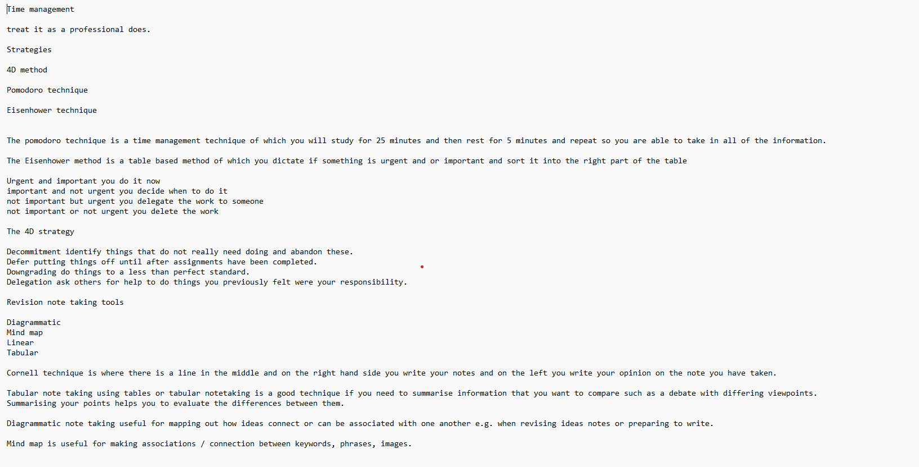
Before learning note-taking skills I found it difficult to summarise the information I have been given in a way that will be useful to quickly return to and remember whatever the topic was on.
I have found note-taking skills extremely useful regarding doing and completing work at university as I am able to split information into different sections or in an easily readable format.
Doing this has made me feel more confident when approaching a task where I shall be needing to use and refer to notes to finish my task. I believe that it has made life easier for me because of techniques and strategies such as the ‘4D Method, Pomodoro technique and the Eisenhower technique’.
For example, the Pomodoro technique consists of being on top of time management where you will study for 25 minutes and then rest for 5 minutes so you can take in all the information presented to you. I think this is particularly useful to me as my attention is not held for the longest of times; by using this technique I have been able to remember all the information presented to me. Another technique which I think has made note taking easier and useful to me is the ‘Cornell technique’, which consists of a page which has been separated by a straight line down the middle and on the right-hand side you write your notes and on the left side of the page you are meant to write your opinion on the notes you taken. This has made taking notes much easier because I can look back at whatever I have written when I may need to refer to my notes and I already have an opinion on something it allows me to finish my work quicker and at a higher level as I can now do some further thinking on how to build upon whatever point I may need to answer.
The note-taking technique has been beneficial to me, but it could be improved.
I might work on going into a bit more detail in my notetaking as I tend to keep things simple as it easy to find what I am looking for in my notes, however by going into depth I reckon I will be able to create a much higher level of work.

In week 3 we also learned about finding information / research skills these included being able to reference correctly specifically Harvard referencing. [ See Appendix 2 for example of class work]. 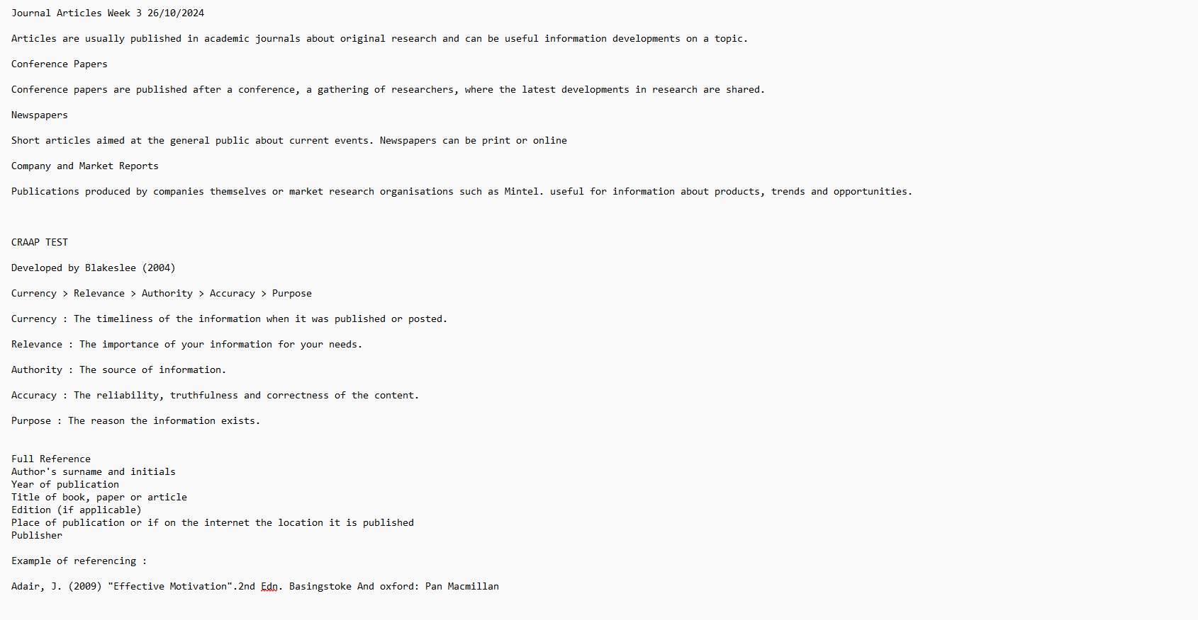

Before I learnt how to reference correctly, I wouldn’t have been able to get enough marks on anything or validate any information as it provides a level of certainty to the work you are presenting.

I have found what I have learnt useful in the sense that I know specifically what information to make sure I keep an eye out for in anything I deem useful and would like to quote in my work.

Learning about techniques such as the CRAAP test has made me a lot more understanding of how to present work at a higher education level. I also understand the relevance of the order of referencing such as the timeliness of the of the information when it was published or posted being first and then; the important, the source, the reliability and truthfulness of the content and the reason the information exists. This all helps determine whether a source is reliable or credible. It also helps avoid plagiarism which is copying and presenting someone else's work which would most likely result in getting marked down or not receiving any marks as it is cheating. You must also be sure to avoid plagiarism as it can possibly hint at students and peers to have colluded together which may not be the case, all which I have learnt referencing is important to avoid such problems when trying to produce work.

What I learnt in week 3 will be useful my entire university experience as I will need to constantly reference things in the correct manner.
I will continue to use Harvard referencing as I would not want to produce any non-credible work.
Thirdly in week 4 we learnt about paraphrasing which is to express the meaning of something using different words, especially to achieve greater clarity. Using different techniques we are able to achieve the clarity we so desire. [ See Appendix 3 for example of class work].
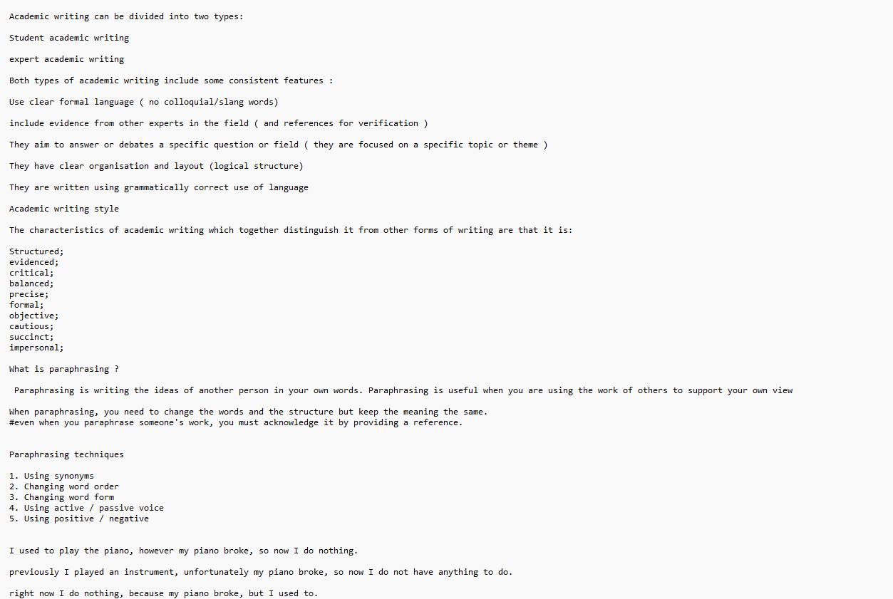

Before I learnt paraphrasing and the different techniques to do so I believe I used to drag my work out more than necessary and now I can shorten the work, so it is more readable and simple for the reader to process all the relevant information.

After having learnt paraphrasing, I have seen it’s importance as I can now rearrange what I have said to be less repetitive throughout my work and if my work is too long in an essay such as this one I can use such skills to shorten my word count and still convey the same message.

Learning this has made my work be able to be a much higher standard and easier to manage overall. I have learnt different paraphrasing techniques such as using synonyms which are words or phrases which mean near or exactly the same thing. I can look at my work and go over it before completing and see if any of the words I have used can be switched for a choice of higher vocabulary or even simpler dependent on who you are showcasing the work to. I also learnt about changing the word order which can change the dynamic of a sentence as a whole by shifting the focus to a different part of the idea of the sentence. When going over my work If I feel as if a specific part of the sentence which the focus on hasn’t got much emphasis, I can now rearrange it to do so.
Changing the word form and using active / passive voice’s were some other skills we learnt as well as using positive and negative to change the meaning of things.

In conclusion paraphrasing has been extremely useful to me in furthering the quality of my work, however I feel like I could always improve my paraphrasing abilities as I could have a better understanding of sentence structure and all there is to it to truly paraphrase at the best of my ability.

To work on my paraphrasing work I might try to expand my vocabulary to replace words with words which could be considered at a higher level. I could also learn more about changing a words form which is changing a word from a verb to a noun or a noun to adjective for example there is a lot of ways in which you can do so which requires a greater understanding of the English language.

Reference list

Association for Learning Development in Higher Education (2021) What is academic writing? Available at: https://aldinhe.ac.uk/teaching-learning/what-is-academic-writing/) (Accessed15 December 2024 }

EAP Foundation (2013) ‘Academic Writing – what is it?’
https://www.eapfoundation.com/writing/what/ (Accessed15 December 2024 )

