  Component One:  What are the key skills required when working in the housekeeping team? 750 words (+/- 10%)  Contribution to Overall Module Assessment: 25% | Student No: | 2209327
 | Module Title: | Hotel Placement – Operating Hotel Facilities
 | Module Code: | BMIH4006
 | Lecturer: | Lisa-Marie Bassler
The efforts of housekeepers play a significant role in maintaining the cleanliness of public and private facilities. Being able to pay great attention to detail and keep the house in order is one of the most important traits of a good housekeeper. Housekeeping-specific skills are essential for success in this line of work (Jones and Siag, 2009). The specific set of abilities a housekeeper will require will depend on their job description and workplace environment. My experience as a cleaning staff member at the Premier Inn Hotel in Hanley, Stoke-on-Trent, has taught me the fundamentals of this profession. While working as a housekeeper, I have picked up the following skillset: technical knowledge; attention to detail; time management; teamwork; and strong communication skills.
Housekeeping staff members should be well-versed in various cleaning methods, familiar with various cleaning products and their proper use, and adept at operating various pieces of cleaning equipment (Sherman, 2011). To maintain a high standard of cleanliness and hygiene for guests, I have learned the value of employing effective cleaning procedures. Knowing how to make beds, clean bathrooms, and remove stains from various surfaces. Housekeeping requires meticulous attention to detail to guarantee that each room is cleaned and kept to the highest standards.
Working at Premier Inn has shown me how easily a mistake may ruin a guest's experience. There might be various small gestures and steps that can enhance the guest experience, which ultimately becomes good for the hotel. As a result, I have trained my eyes to quickly identify spots that need further cleaning, vacuuming, or attention to the presentation of amenities. Housekeeping requires excellent time management skills due to the urgency of completing duties within strict deadlines without compromising quality. My life experiences have taught me to set priorities, organise my workflow, and give each space the attention it deserves. Due to this, I have kept my productivity high, always finished on time, and avoided missing any deadlines. The housekeeping staff functions as a unit, and their success depends on their ability to work together effectively.
Communicating effectively is crucial for effective task coordination, troubleshooting, and problem resolution (Nimri et al., 2020). Open and honest communication between team members and their superiors is the key to a successful workflow and swift problem-solving.

Applying theoretical knowledge in the industry
I will be applying theoretical knowledge while working in the industry because in order to improve performance and create outstanding guest experiences, it is crucial for those working in the hospitality business to apply theoretical knowledge.
- When I have a firm grasp of the various cleaning procedures and how they may be used, I can select the most appropriate strategy for every cleaning job.
- As a result of my familiarity with hygiene and sanitation standards, I can keep the area free of risks and to the delight of my guests.
- Putting into practice the theories I have learnt about time management will increase efficiency, better distribute my time, and finish cleaning tasks on schedule.

Importance of the topic
Housekeeping crew members' ability to perform essential duties effectively is a hot topic in hospitality. The quality of housekeeping is a major factor in determining the level of guest satisfaction. Guests' comfort, security, and overall impression of a hotel depend on its cleanliness and upkeep. The success of a hotel depends on its housekeeping department. Keeping rooms tidy and in good condition is crucial to guest happiness (Bhatnagar and Dheeraj, 2019). Housekeeping is responsible for making sure that guests have a clean, well-organised, and fully stocked room during their stay. The group is responsible for keeping track of and replenishing linens, cleaning products, and equipment stocks. The cleanliness of a hotel is essential to maintaining the high standards upon which its reputation rests. The housekeeping staff plays a crucial role in the hotel's brand reputation by maintaining guest rooms in pristine condition. More customers and a stronger standing in the competitive hospitality business are the results of a well-respected hotel. Housekeeping also helps the hotel's standing because guests consider cleanliness and hygiene while deciding whether to stay there again (Pongsiri, 2012). It is an essential part of the hotel sector, and by highlighting the necessary abilities, businesses can guarantee excellent service, make guests happy, and stay ahead of the competition. Working as a cleaning staff member at the Premier Inn Hotel in Hanley, Stoke-on-Trent has provided me with invaluable hands-on experience and taught me the value of theoretical knowledge in providing first-rate service. Hence, the housekeeping team is crucial to the hotel's reputation and management.
Word Count | 759

Component Two:
Contribution to Overall Module Assessment: 25%
In this scenario – You have just been promoted to team leader for a floor within the hotel. A guest complains that on their arrival, their room had not been properly cleaned. Create an action plan and answer the following questions.

Problem | Why did it happen? | What are you going to do? | How will you prevent this from happening in the future? | What measures would you introduce to improve team effectiveness?
 | The room may have been missed or neglected due to a misunderstanding between the front desk and housekeeping. | I will apologise to the guest on behalf of the hotel for the trouble they have had and promise to look into their issues as soon as possible. | If it happens again, then I will plan to provide more training for the staff, and I will also investigate whose fault it is. If it occurs to be the fault of one person, then I will improve their work through meetings and training sessions. | I will ensure everyone on the team knows what they should be doing. I am going to help them improve by setting specific goals and providing frequent feedback on their progress towards those goals.
 | It is possible that the housekeeping workers should have cleaned something thoroughly since they were pressed for time. | I will check the room myself to ensure the guest's claim is true, and then I will clean it immediately. Make the necessary arrangements if a room change or emergency cleaning is required. | I want to create detailed checklists for cleaning each room to ensure that everything is noticed. Inspect frequently to ensure standards are being met, and fix any problems immediately. | I intend to put money into ongoing training and development programs for the team. Some examples of such opportunities are workshops, seminars, and cross-training programs.
 | The tools and supplies needed to clean the space properly may have run out or broken down. For instance, a lack of cleaning supplies could have prevented the housekeeping team from giving each room a thorough scrub. | I will note the guest's name, room number, and the nature of the complaint so that I may follow up with them later. | I aim to foster an environment where all team members feel comfortable speaking out and taking responsibility. I will set up a method where employees may anonymously share any issues, they are having on the job so that I can quickly respond and offer assistance. | I will do what I can to balance work hours and employee availability. My plan will be to keep team members from feeling overwhelmed by giving them enough time to do their work properly.
 | The person on the team cleaning the room may have yet to receive adequate instruction or fallen short of the requirements. | I will try to find out the reason, the person responsible for it, and I will provide a warning to them to not happen such situation again. | I will do my best to improve lines of communication between the front desk and housekeeping so that they can keep each other updated on the status of guest rooms and any special cleaning requirements they may have. | It is crucial to foster a welcoming and supportive workplace where everyone can contribute and feel appreciated. Therefore, I will promote teamwork, reward success, and offer chances for progression.
 | It is possible that the housekeeping team needed to be more timely due to a high number of guests or an insufficient number of employees. Therefore, they may have needed more time to clean each room fully, resulting in missed areas or incomplete chores. | I will do my best to update the guest on the status of the problem's resolution and make amends with suitable compensation or goodwill gestures, such as a free meal or an upgrade, if necessary. | If, after the training sessions and meetings, the issue still occurs and there are complaints from the guests regarding the same problem, then the hotel may fire the housekeeper too. | I intend to canvass team members for input on operational practices routinely. I will actively seek out feedback from them and act on their suggestions for enhancements.

Component Three:
Contribution to Overall Module Assessment: 50%
Your task is to create and prepare a presentation following the detailed scenario provided below.

As the floor housekeeping manager and given the recent guest complaints you need to put together a basic training presentation for your colleagues within the housekeeping team to get the best out of them, ensure that brand standard is being achieved and that Health and Safety procedures are also being followed.

A hotel's housekeeping staff is tasked with keeping the hotel's guest rooms, common areas, and kitchens clean and sanitary for guests (Verma et al., 2020). When it comes to visitor satisfaction, cleanliness, and overall satisfaction with their stay, few departments are as important as housekeeping. This training provides an overall view of some basic responsibilities and skills that the housekeeping team at the Hotel Trinity needs to understand and adapt to overcome the guest's complaints and reduce them in the future.
Training Notes:
Importance of housekeeping
In the hospitality sector, housekeeping is crucial, especially in hotels where cleanliness, comfort, and visitor happiness are priorities. It is impossible to exaggerate how crucial housekeeping is to a hotel's overall experience and reputation. The maintenance of the hotel's reputation and brand image is crucial. Customers link a well-run, respectable institution with cleanliness and high standards (Wood et al., 2005). A hotel gains a good image by regularly maintaining cleanliness and upholding brand standards through its housekeeping services, which leads to a rise in bookings, customer happiness, and, eventually, financial success. It is important to emphasise the significance of housekeeping in hotels. It guarantees cleanliness, provides comfort for visitors, and enhances the hotel's general reputation. A committed and effective housekeeping crew supports the brand's standards, improves visitor experiences, and is essential to the hospitality sector's success.

Training Notes:
Brand standards
It is necessary to be aware of the brand standards to keep the hotel's cleanliness up-to-date and to develop a positive reputation. It would help if you adopted the following strategies regarding this:
Pay attention to the little things that go into providing excellent customer service. Ensure everything is in working condition, including carefully cleaning the rooms, making the beds, arranging the amenities, and cleaning the rooms (Dev et al., 2017).
Wear the official housekeeping uniform and your name badge, and maintain professional personal grooming. A tidy and clean look enhances the hotel's reputation and helps to uphold brand standards.
Be proactive in looking for chances for lifelong learning and development. Keep up with business trends, fresh cleaning methods, and new technological developments. Participate in training events, workshops, and webinars to improve your knowledge and abilities.
Pay attention to advise and constructive criticism, and take advantage of the chance for improvement. Enhance your abilities and performance consistently to meet brand requirements and satisfy customers.

Training Notes:
Health and safety procedures
To safeguard the well-being of both visitors and employees, hotels must adhere to strict health and safety regulations. All aspects of the hotel, including guest rooms, public areas, and back-of-house spaces, have strict cleaning procedures in place. This includes employing the proper cleaning supplies and equipment, sanitising high-touch surfaces, and maintaining cleanliness in public toilets (Chan et al., 2019). It is important to take the time to comprehend the hotel's health and safety policies fully. Review the training materials, go to the orientation meetings, and if you have any questions, ask your managers or supervisors for clarification. As a member of the housekeeping crew, you may greatly influence maintaining brand standards by adhering to these guidelines, helping the hotel succeed, and guaranteeing a positive visitor experience.

Training Notes:
Collaboration and communication
It would help if you comprehended that guaranteeing visitors' needs comes first and that excellent teamwork and communication are essential to delivering a great experience. Help the crew realise how their efforts directly affect the guests' happiness. Daily briefings are required to convey priorities, updates, and any particular guest requests or concerns (Kadry, 2017). During these sessions, we promote free discussion and information exchange, allowing team members to express questions or seek clarification. You will also have access to cross-training opportunities, where team members may educate and support one another in all facets of housekeeping. This encourages teamwork, diversifies skill sets, and enables greater job coverage during busy times or employee shortages.
Training Notes:

Time management
Time management plays a crucial role for the housekeeping team. The successful completion of housekeeping activities within the allotted time constraints is ensured by effective time management. This enables the crew to uphold the hotel's standards for cleanliness in terms of the guest rooms and public spaces (Pai, 2020). Visitors anticipate fast cleaning and preparation of their rooms. The cleaning staff can deliver a great guest experience and prevent delays or inconveniences by efficiently managing their time to guarantee that guest rooms are ready for check-in. They feel more accomplished and less stressed when they can successfully manage their time. As a result, there is an improvement in productivity and a favourable work atmosphere. This also improves team morale.
Training Notes:
Attention to detail.
Guests have high standards for a comfortable and spotless stay. The room's cleanliness, linens, amenities, and decoration are all carefully considered. This kind of attention to detail is what leads to happy customers who are more likely to recommend your business to others. The housekeeping staff of a hotel may make or break its reputation. Guests will have a favourable impression of the hotel if care has been taken to ensure a pleasant experience in every aspect of their stay (Nimri et al., 2020). It helps establish credibility for the company, which may result in more repeat business and favourable word of mouth. Paying close attention to detail is essential for keeping the space clean and risk-free for visitors. Accidents may be avoided, and guests' comfort can be maximised by following thorough cleaning and disinfection routines, inspecting for potential risks and maintenance difficulties, and arranging furniture and amenities as best as possible.
Training Notes:
Service recovery and guest interaction
In order to successfully handle and resolve any issues or complaints expressed by visitors, service recovery is essential. When a visitor has a bad experience, the staff can offer outstanding service recovery. In turn, this improves guests' experiences, which leads to higher ratings and more return business. Guests who believe their issues were acknowledged and addressed expeditiously are more inclined to book another stay at the hotel (Wu et al., 2018). Guest retention is directly tied to the cleaning staff's capacity to communicate with guests with empathy, compassion, and professionalism. To enhance their services, operations, and overall guest experience, the team can benefit by actively listening to guest problems, recommendations, and preferences. The hotel may better adapt to guests' ever-evolving needs and preferences by using this feedback-driven strategy.
Training Notes:
Engagement model
The renowned research and consulting company Gallup created the Q12 model for employee engagement. 12 questions in the Q12 model assess things like trust in management, chances for advancement, and employee contentment with their current roles (Gupta and Sharma, 2016). Organisations can use the Q12 model as a framework to evaluate employee engagement levels and pinpoint development opportunities. Organisations can learn more about the successes and failures of their employee engagement initiatives by analysing employee responses to these 12 questions. They can then practice specific ways to improve employee engagement, which will boost output, satisfaction, and overall corporate performance.
Training Notes:
Industry example
The Ritz-Carlton Hotel Company is leading the way in the hospitality sector regarding employee engagement practices. They implemented the proven framework for employee engagement, the Q12 model from Gallup. The Ritz-Carlton Hotel Company has adopted the Q12 model and incorporated its principles into the company's way of doing business. Their dedication to their staff is clear to both customers and workers alike in the high quality of their services. Empowering staff, creating unique customer experiences, and encouraging constant growth are all important tenets of the Gold Standards. Leaders at Ritz-Carlton take an interest in their staff, celebrating their successes and facilitating their professional development (Hoffman, 2019). High levels of staff loyalty and passion for providing excellent service have emerged from this focus on employee engagement. Understanding the significance of staff engagement in achieving service excellence may be done by connecting the Q12 model to the best practice example of The Ritz-Carlton Hotel Company. They may apply what they have learned from the Ritz-Carlton to their work to create a more engaged workforce and better customer service.

References
Almanza, B.A., Kirsch, K., Kline, S.F., Sirsat, S., Stroia, O., Choi, J.K. and Neal, J., (2015). How clean are hotel rooms? Part II: examining the concept of cleanliness standards. Journal of environmental health, 78(1), pp.14-19.
Bhatnagar, E. and Dheeraj, N., (2019). Impact of housekeeping services and practices on customer satisfaction and repeat business. Prabandhan: Indian Journal of Management, 12(8), pp.46-57.
Chan, J., Gao, Y.L. and McGinley, S., (2021). Updates in service standards in hotels: how COVID-19 changed operations. International Journal of Contemporary Hospitality Management, 33(5), pp.1668-1687.
Choi, J., (2019). Is cleanliness really a reason for consumers to revisit a hotel?. Journal of Environmental Health, 82(5), pp.16-22.
Dev, C.S., Hamilton, R. and Rust, R., (2017). Hotel brand standards: How to pick the right amenities for your property.
Gupta, N. and Sharma, V., (2016). Exploring employee engagement—A way to better business performance. Global Business Review, 17(3_suppl), pp.45S-63S.
Hoffman, J. (2019) Employee engagement: Ritz-Carlton’s secret to providing world-class service and increasing customer loyalty, PSA Insurance and Financial Services. Available at: https://www.psafinancial.com/2018/05/employee-engagement-ritz-carltons-secret-world-class-service-customer-loyalty/ (Accessed: 12 June 2023).
Jones, P. and Siag, A., (2009). A re-examination of the factors that influence productivity in hotels: A study of the housekeeping function. Tourism and Hospitality Research, 9(3), pp.224-234.
Kadry, S., Bagdasaryan, A. and Kadhum, M., (2017), April. Simulation and analysis of staff scheduling in hospitality management. In 2017 7th International Conference on Modeling, Simulation, and Applied Optimization (ICMSAO) (pp. 1-6). IEEE.
Mattila, A.S. and O'Neill, J.W., (2003). Relationships between hotel room pricing, occupancy, and guest satisfaction: A longitudinal case of a midscale hotel in the United States. Journal of Hospitality & Tourism Research, 27(3), pp.328-341.
Nimri, R., Kensbock, S., Bailey, J., Jennings, G. and Patiar, A., (2020). Realizing dignity in housekeeping work: Evidence of five star hotels. Journal of Human Resources in Hospitality & Tourism, 19(3), pp.368-387.
Nimri, R., Kensbock, S., Bailey, J., Jennings, G. and Patiar, A., (2020). Realizing dignity in housekeeping work: Evidence of five star hotels. Journal of Human Resources in Hospitality & Tourism, 19(3), pp.368-387.
Pai, A., Manjunath, M., Kowshik, C.S., Ayedee, N., Malarout, N. and Naik, N., (2020). SOFT SKILLS AS A KEY COMPETENCY FOR THE FUTURE LEADERS OF THE HOSPITALITY INDUSTRY. PalArch's Journal of Archaeology of Egypt/Egyptology, 17(9), pp.4341-4355.
Pongsiri, K., (2012). Housekeeping, Human Resources: Competency ServiceStandard Management for Hotel Business in ASEAN. International Journal of e-Education, e-Business, e-Management and e-Learning, 2(5), p.343.
Ramanathan, U. and Ramanathan, R., (2011). Guests' perceptions on factors influencing customer loyalty: An analysis for UK hotels. International Journal of Contemporary Hospitality Management.
Sherman, R., (2011). Beyond interaction: customer influence on housekeeping and room service work in hotels. Work, Employment and Society, 25(1), pp.19-33.
Verma, P., Singh, M. and Aggarwal, N., (2020), June. The Effect of Next–Level Housekeeping via Technology on the Perceptions of the Hospitality Aspirants. In 2020 8th International Conference on Reliability, Infocom Technologies and Optimization (Trends and Future Directions)(ICRITO) (pp. 1150-1156). IEEE.
Wood, D.F., Moreo, P.J. and Sammons, G., (2005). Hotel housekeeping operational audit: A questionnaire approach. International journal of hospitality & tourism administration, 6(3), pp.1-10.
Wu, W.Y., Qomariyah, A., Sa, N.T.T. and Liao, Y., (2018). The integration between service value and service recovery in the hospitality industry: An application of QFD and ANP. International Journal of Hospitality Management, 75, pp.48-57.
Zemke, D.M.V., Neal, J., Shoemaker, S. and Kirsch, K., (2015). Hotel cleanliness: will guests pay for enhanced disinfection?. International Journal of Contemporary Hospitality Management, 27(4), pp.690-710.



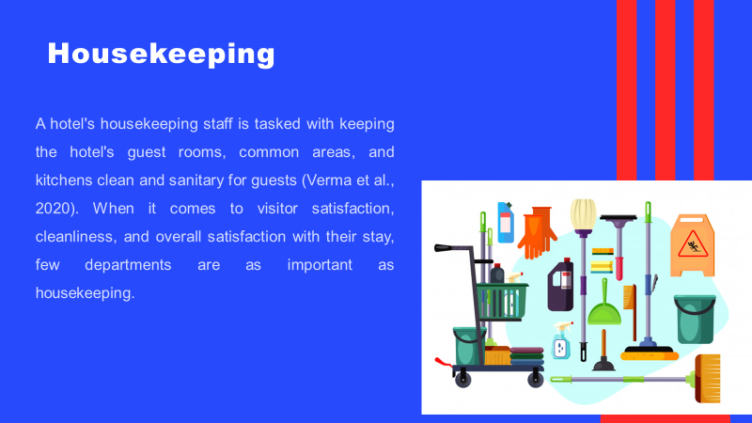
This training provides an overall view of some basic responsibilities and skills that the housekeeping team at the Hotel Trinity needs to understand and adapt to overcome the guest's complaints and reduce them in the future.
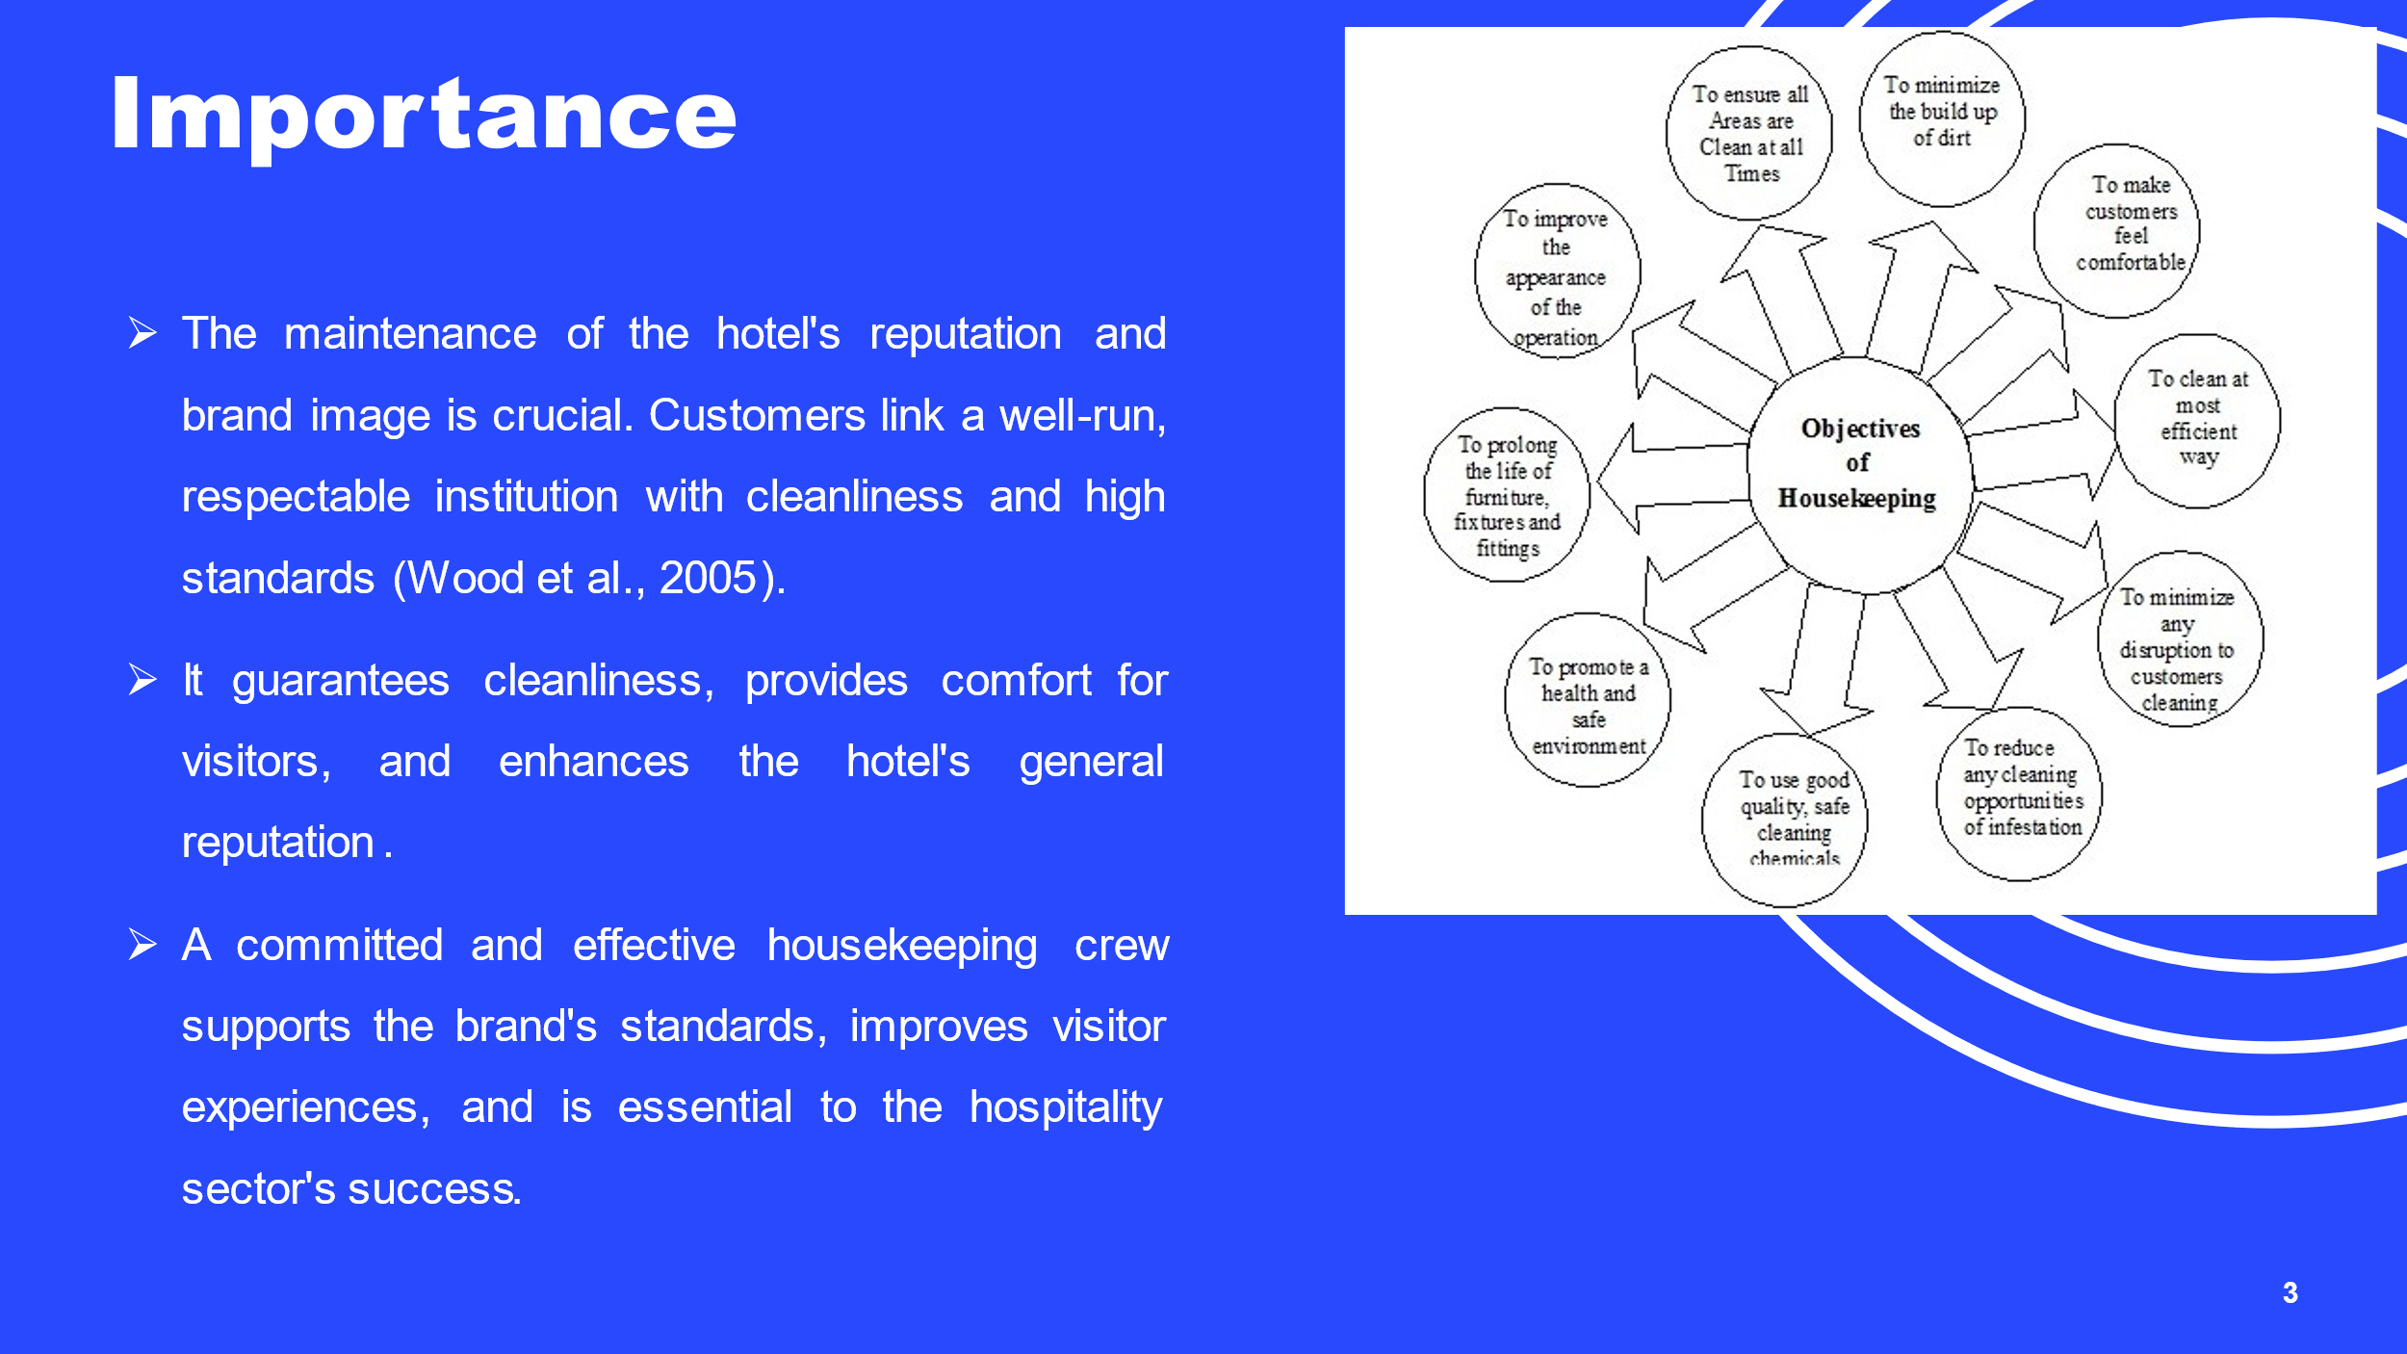
In the hospitality sector, housekeeping is crucial, especially in hotels where cleanliness, comfort, and visitor happiness are priorities. It is impossible to exaggerate how crucial housekeeping is to a hotel's overall experience and reputation. A hotel gains a good image by regularly maintaining cleanliness and upholding brand standards through its housekeeping services, which leads to a rise in bookings, customer happiness, and, eventually, financial success. It is important to emphasise the significance of housekeeping in hotels.
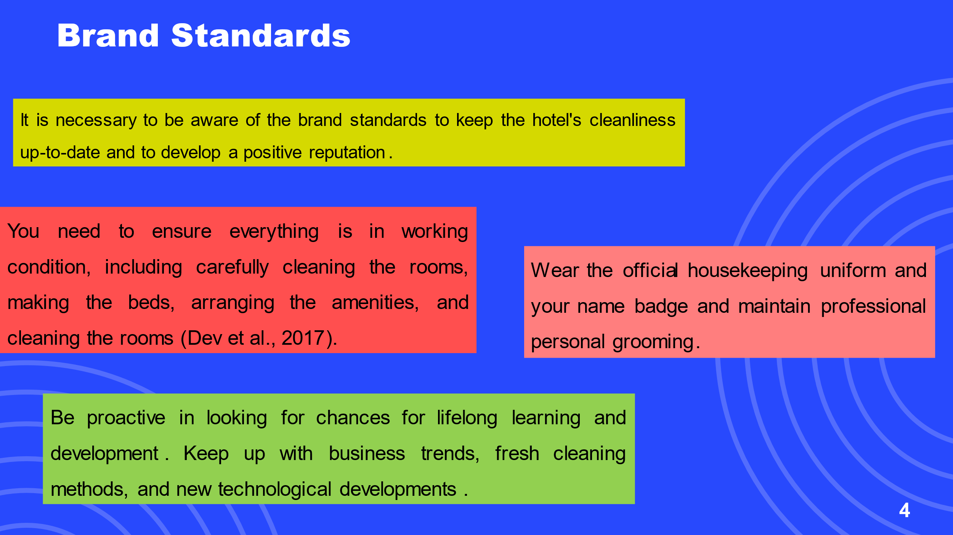
It would help if you adopted the following strategies regarding this: Pay attention to the little things that go into providing excellent customer service.
A tidy and clean look enhances the hotel's reputation and helps to uphold brand standards.
Pay attention to advise and constructive criticism, and take advantage of the chance for improvement. Enhance your abilities and performance consistently to meet brand requirements and satisfy customers.
Participate in training events, workshops, and webinars to improve your knowledge and abilities.

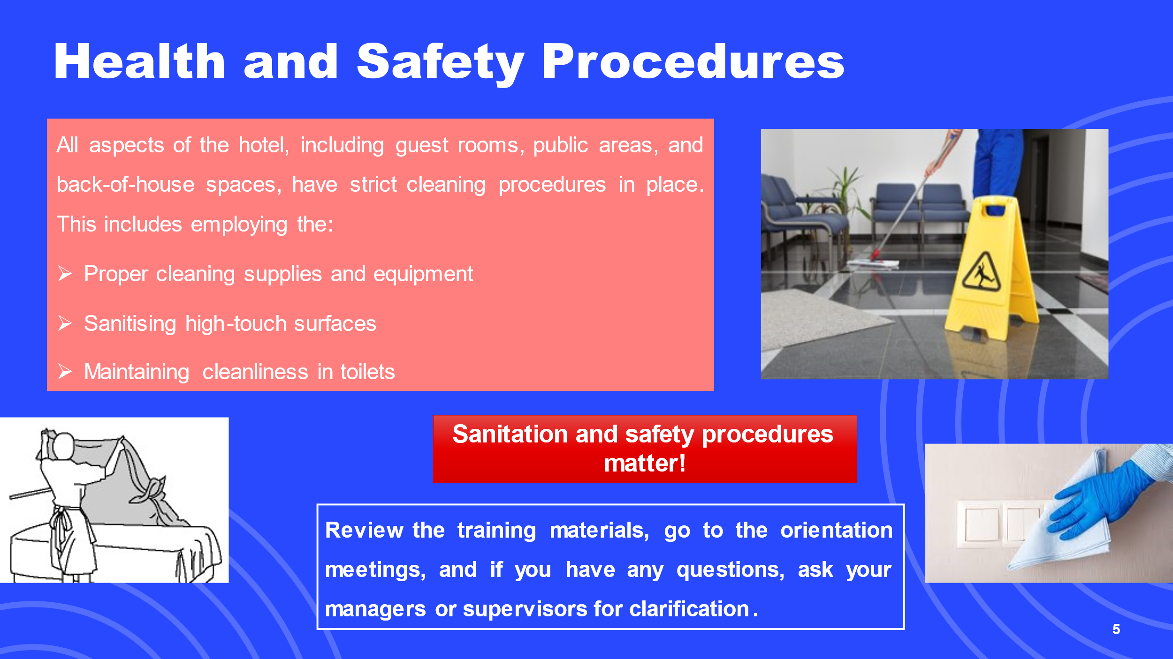
To safeguard the well-being of both visitors and employees, hotels must adhere to strict health and safety regulations.
It is important to take the time to comprehend the hotel's health and safety policies fully.
As a member of the housekeeping crew, you may greatly influence maintaining brand standards by adhering to these guidelines, helping the hotel succeed, and guaranteeing a positive visitor experience.
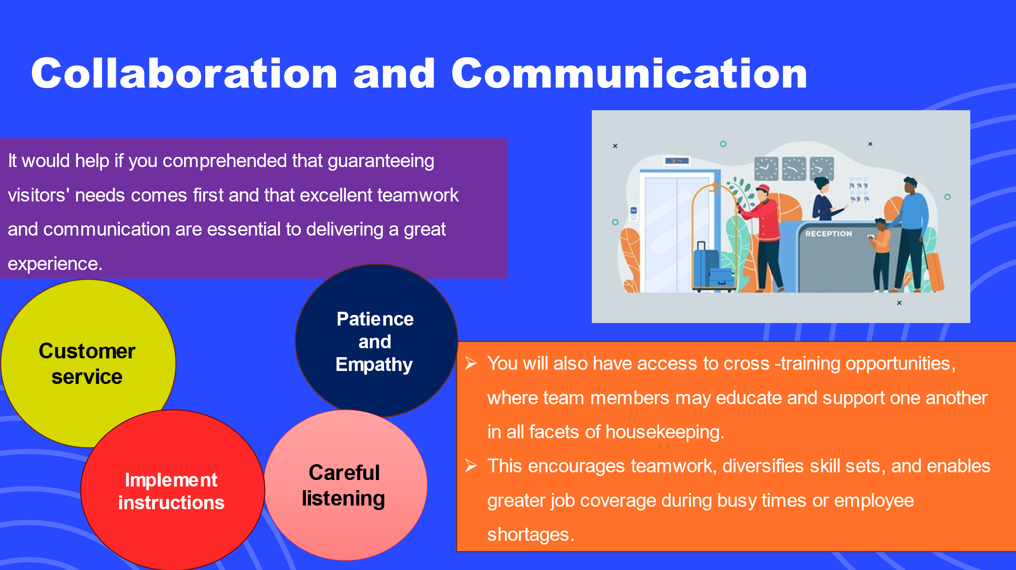
Help the crew realise how their efforts directly affect the guests' happiness. Daily briefings are required to convey priorities, updates, and any particular guest requests or concerns (Kadry, 2017). During these sessions, we promote free discussion and information exchange, allowing team members to express questions or seek clarification.

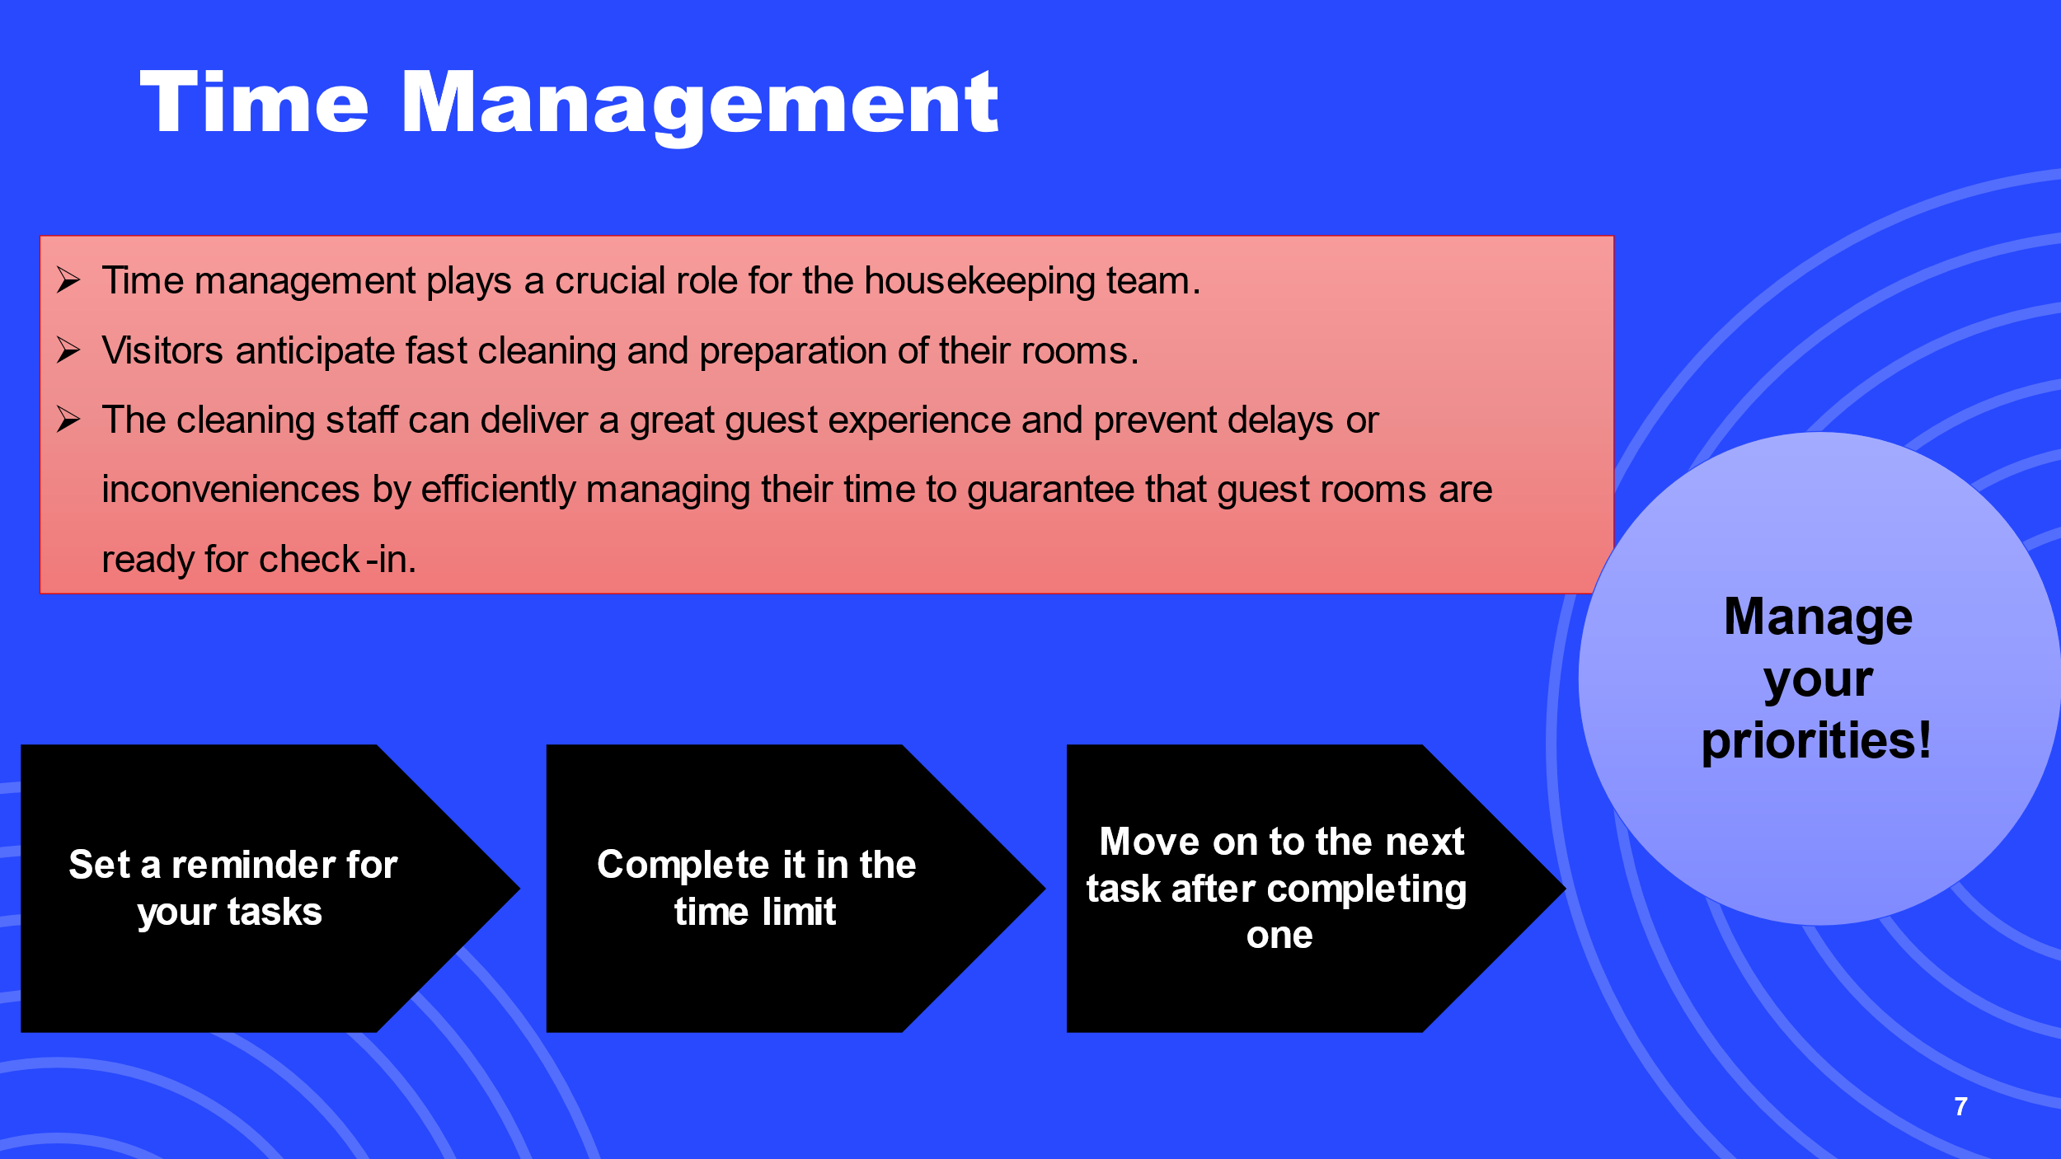
The successful completion of housekeeping activities within the allotted time constraints is ensured by effective time management. This enables the crew to uphold the hotel's standards for cleanliness in terms of the guest rooms and public spaces (Pai, 2020).
They feel more accomplished and less stressed when they can successfully manage their time. As a result, there is an improvement in productivity and a favourable work atmosphere. This also improves team morale.
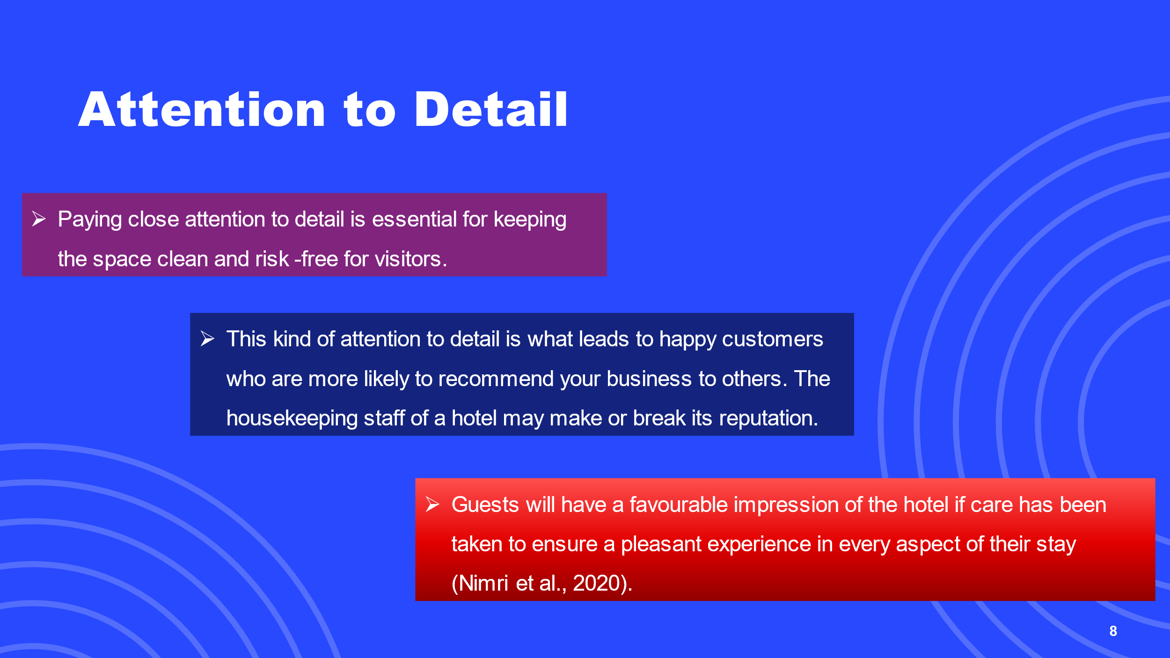
Guests have high standards for a comfortable and spotless stay. The room's cleanliness, linens, amenities, and decoration are all carefully considered.
It helps establish credibility for the company, which may result in more repeat business and favourable word of mouth.
Accidents may be avoided, and guests' comfort can be maximised by following thorough cleaning and disinfection routines, inspecting for potential risks and maintenance difficulties, and arranging furniture and amenities as best as possible.
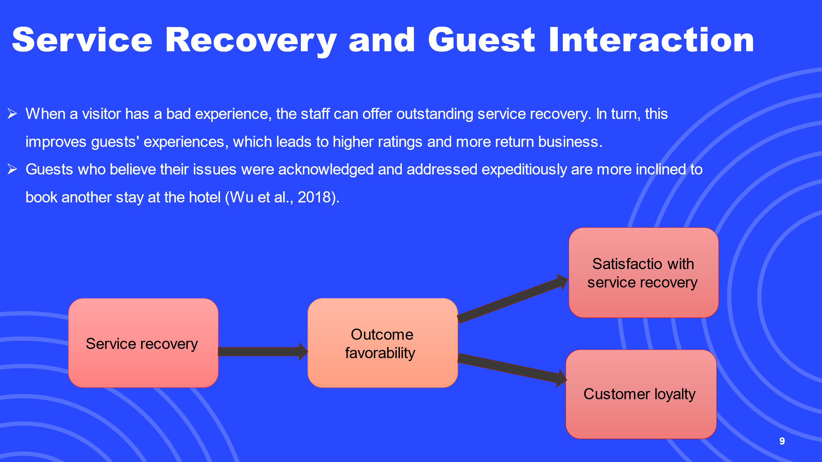
In order to successfully handle and resolve any issues or complaints expressed by visitors, service recovery is essential.
Guest retention is directly tied to the cleaning staff's capacity to communicate with guests with empathy, compassion, and professionalism.
The hotel may better adapt to guests' ever-evolving needs and preferences by using this feedback-driven strategy.
To enhance their services, operations, and overall guest experience, the team can benefit by actively listening to guest problems, recommendations, and preferences.

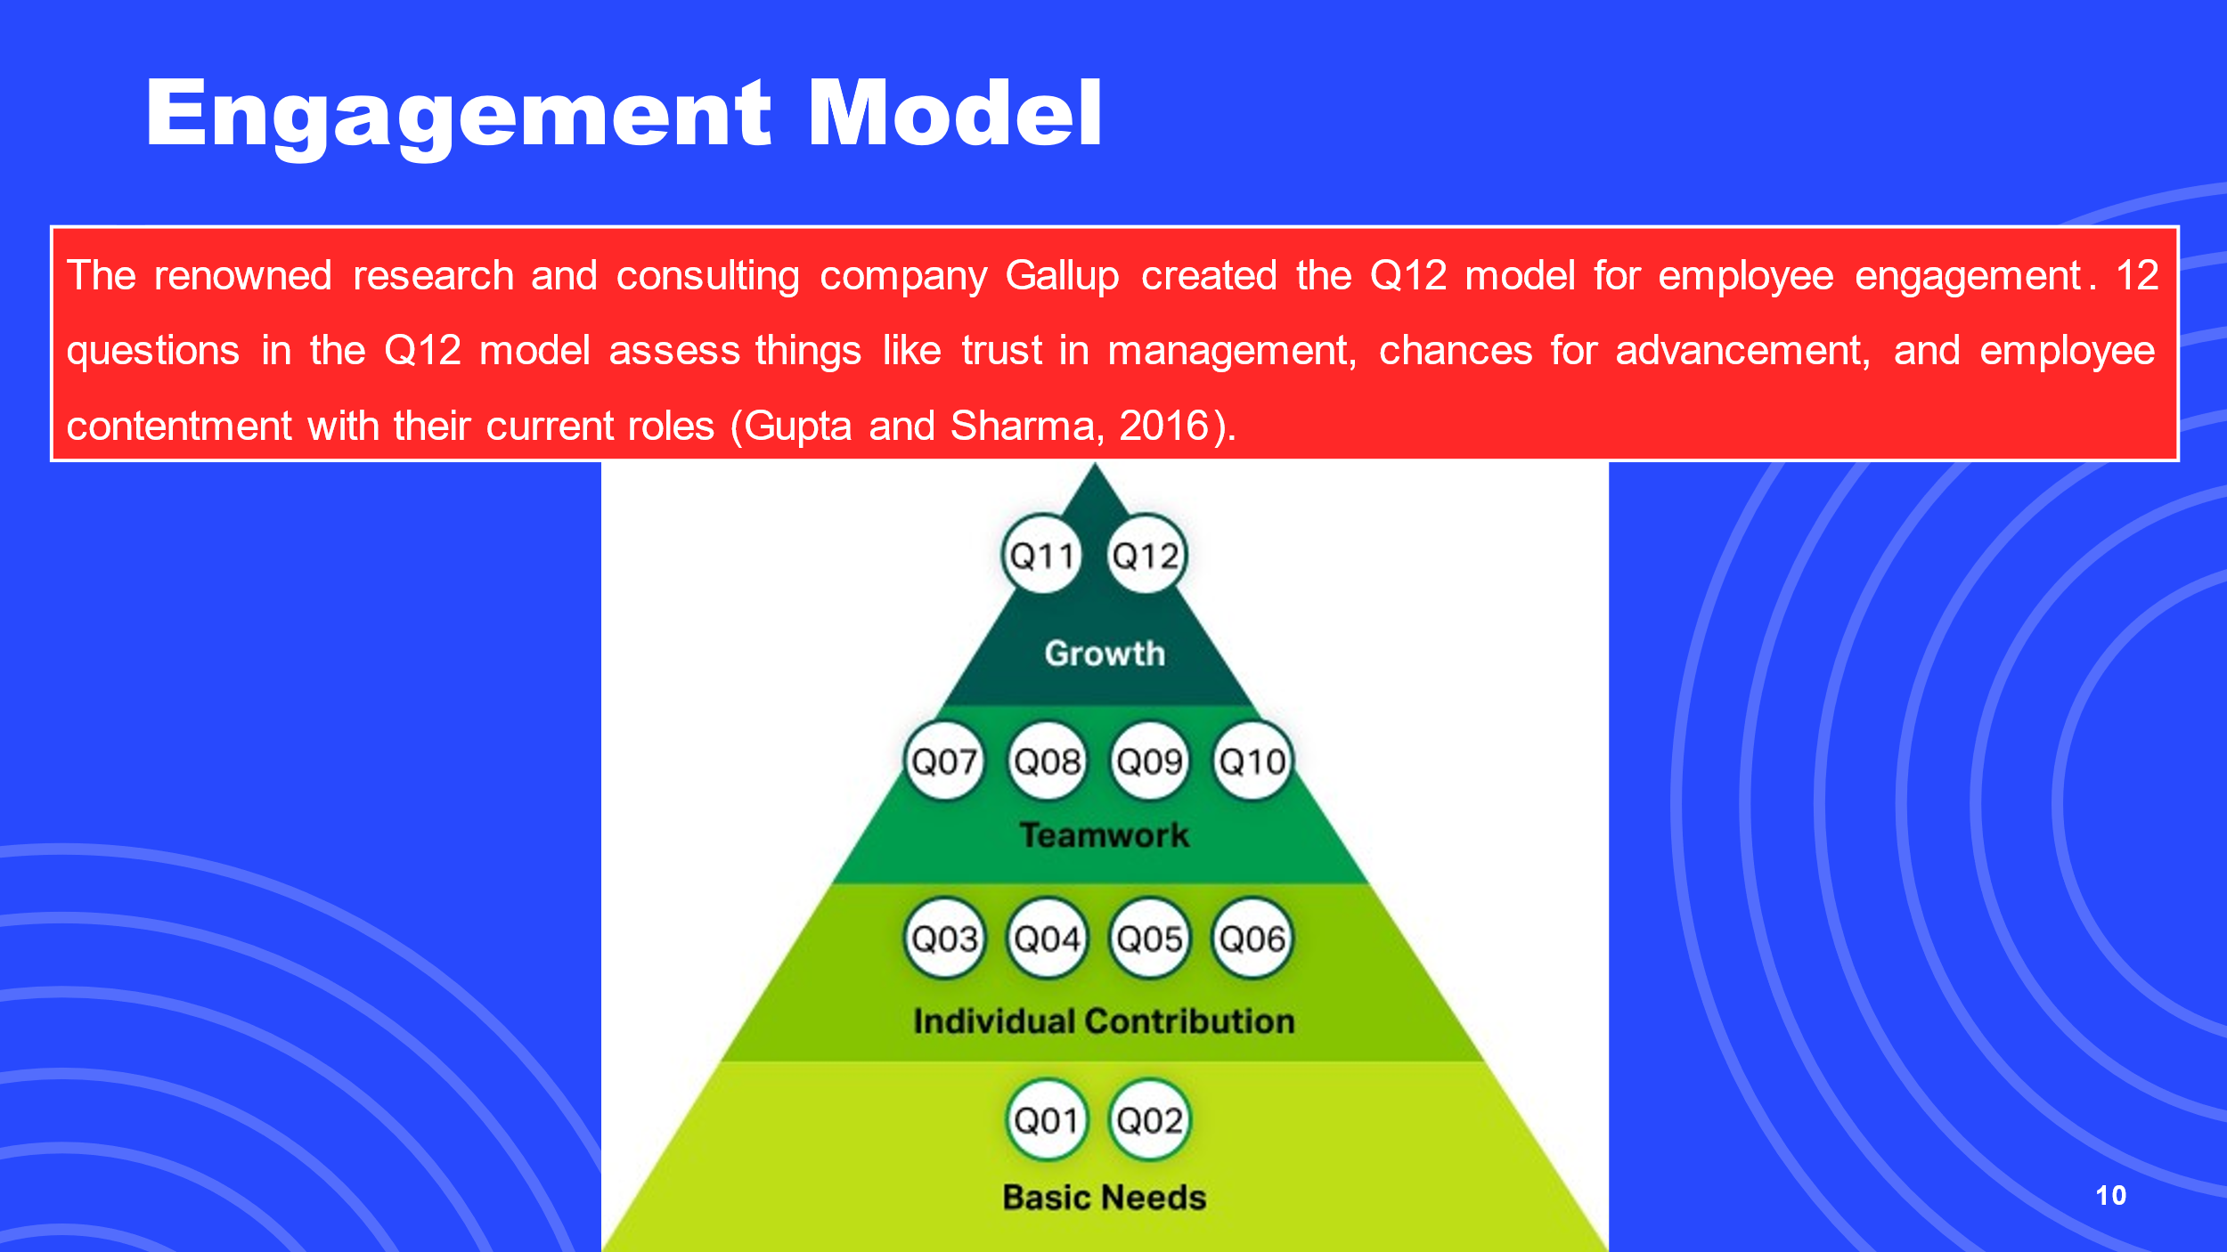
Organisations can use the Q12 model as a framework to evaluate employee engagement levels and pinpoint development opportunities. Organisations can learn more about the successes and failures of their employee engagement initiatives by analysing employee responses to these 12 questions. They can then practice specific ways to improve employee engagement, which will boost output, satisfaction, and overall corporate performance.



