Name: ILIYA RADICHEV
Module: Marketing Fundamentals
Student Number: 2023563
Module Code- LCBB4004

Assessment 1: Marketing Fundamentals Analysis and Evaluation

Table of Contents
Introduction 3
Thesis statement 3
The stages and process of marketing 3
Strategic marketing analysis 4
Marketing implementation 4
Marketing-mix planning 5
Marketing control 6
The crucial contribution of marketing environment and situational analysis models 6
Pestle Model 7
STP analysis of Sainsbury 8
Segmentation 9
Targeting 9
Positioning 10
Conclusion 10
References 12

Introduction
Marketing is the most significant part of a business and the development of proper marketing in an organization helps to improve the future opportunity of a company effectively. External environment plays the most effective role in marketing and the crucial external environment also increases the marketing environment of an organization. This study has shade light on crucial stages and processes of marketing and it also develops effective models and theories to analyze the significance of the marketing environment.

Thesis statement
Marketing environment is the most significant part of an organization and that also influence the business growth and assist to improve the sales rate of the company.

The stages and process of marketing
Marketing procedure influences the sales rate of a company and marketing has a total of four stages which play the most crucial role to enhance the sales rate of an organization. Those crucial elements area:
- Strategic marketing analysis,
- Marketing implementation,
- Marketing-mix planning,
- Marketing control
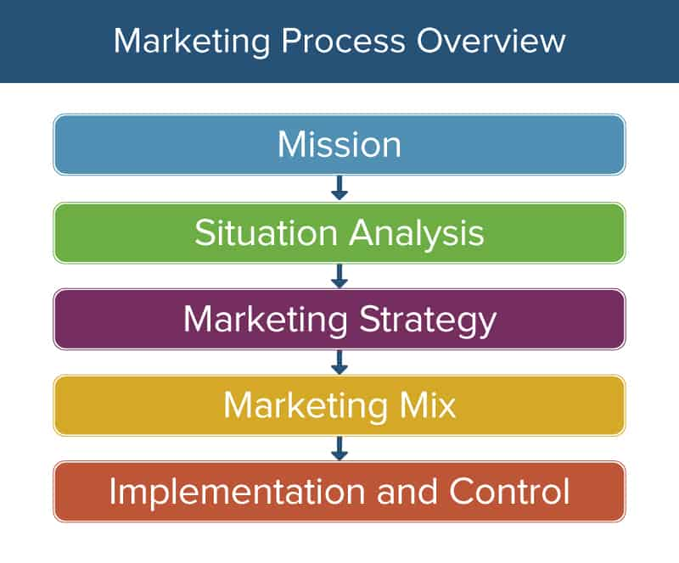
Figure 1: Marketing process
(Source: Seturi and Urotadze, 2017)

Strategic marketing analysis
Strategic marketing analysis is the most crucial element of marketing procedure and it has been found that strategic marketing analysis help to understand the market condition. Development of STP analysis significant role analyses strategic marketing of an organization (Varadarajan, 2019). In the case of Sainsbury Company, it has been found that this company has also developed strategic marketing analysis in the company which helps to minimize their investment risk and help to identify potential opportunities and future threats effectively. Strength of the competitors is also easily analyzed through developing strategic marketing analysis tools in the organization.

Marketing implementation
Marketing implementation is the most significant stage because this stage help to execute the crucial marketing plan through the help of team members. There are several types of theories and models that an organization develops to execute the marketing plan effectively. As per the view of Seturi and Urotadze, (2017), marketing implementation in an organization answers customer engagement rate as well as also develops the revenue rate of a company. In the case of Sainsbury, it has been found that after the development of a unique and effective marketing plan in the company the revenue rate has developed remarkably. It has portrayed the development of marketing plan and execution that unique theory and model help organization effectively.

Marketing-mix planning
The marketing mix is one of the most significant elements of marketing procedure and the development of marketing mix planning in the Sainsbury Company assists to develop a unique and effective strategy. Development of marketing mix planning in the Sainsbury company, help them to improve their brand image effectively (Thabit and Raewf, 2018). 4ps is one of the most effective parts of the study and through analyzing the product, place, price, and crucial promotional strategy Sainsbury can easily develop a unique and significant marketing strategy for the organization.
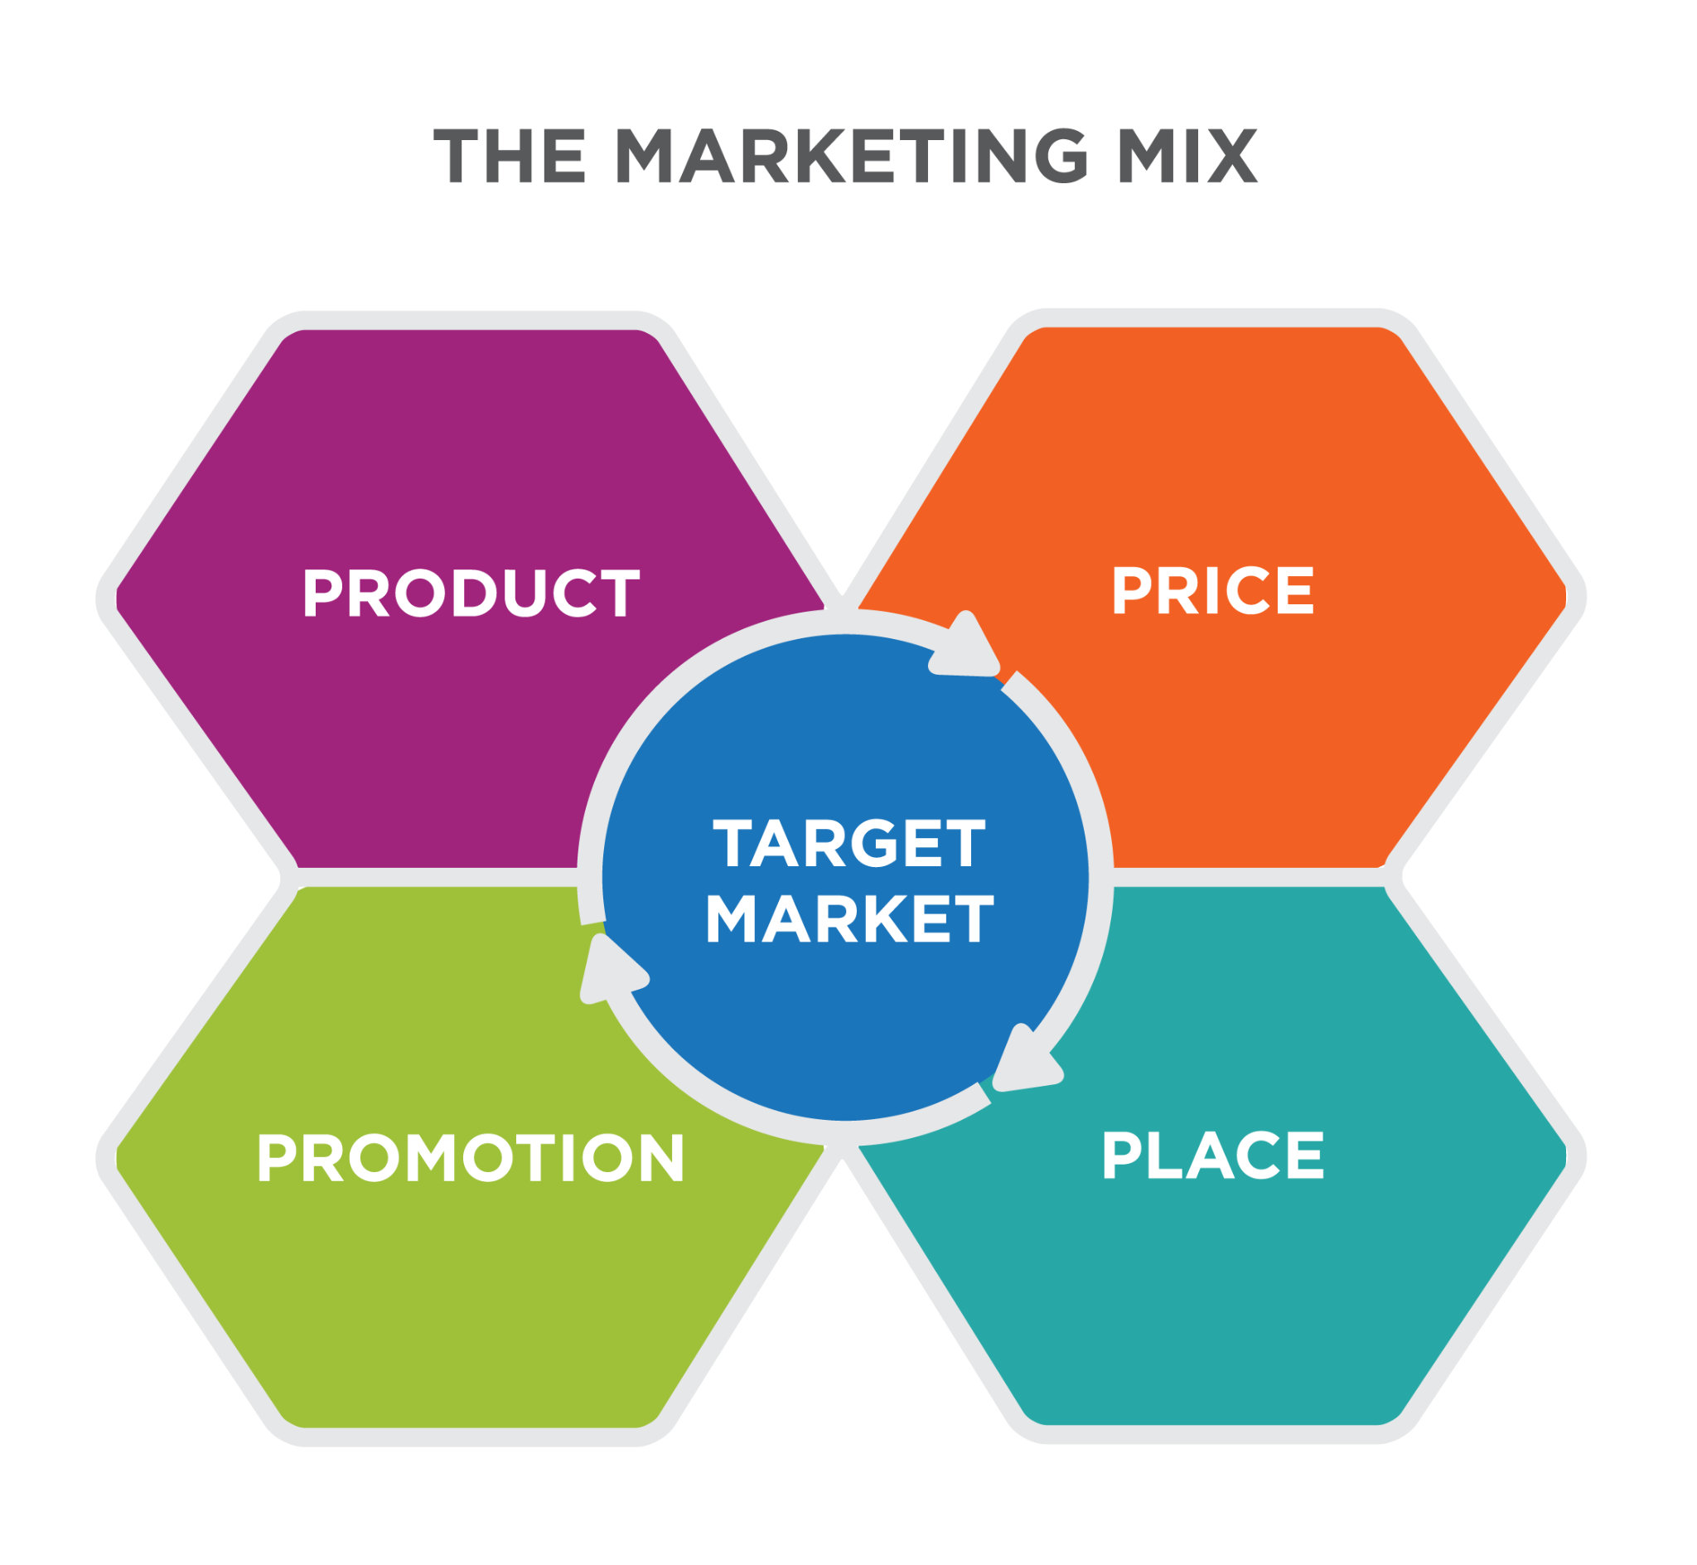
Figure 2: Marketing-mix planning
(Source: Thabit and Raewf, 2018)
This figure has highlighted the four crucial parts of the marketing mix and marketing mix play the most effective and significant role to improve the brand image of Sainsbury in the global market effectively.

Marketing control
The marketing plan profoundly monitors the crucial marketing plan and aids to identify the effective issues through the monitoring procedure. Measurement and significant evaluation of the marketing play assist to develop the marketing control effectively. It improves the significant performance of the marketing department and it also improves the marketing operation effectively. The development of a marketing control system in the Sainsbury Company decreases the work pressure from the marketing manager and the quality of the marketing strategy has also been developed.

The crucial contribution of marketing environment and situational analysis models
The marketing environment is another important element of the business and marketing environment of an organization that influences the future opportunity and helps to identify the future threat of a business. The marketing environment of an organization also helps to develop any new services and products in the market because a negative marketing environment can decline the revenue and sales rate of an organization (Petrunia et al. 2019). On the other hand, based on the marketing environment, an organization can implement a unique and effective strategy to capture the whole market and it also helps to increase the revenue rate of a company. It has been found that in the time of covid-19 M&S company has faced major challenges because of the negative environment of the UK and that decrease their revenue and sales rate immensely.
The development of the most significant environment analysis model also helped organizations to understand the marketing environment and through the help of marketing analysis and organizations can be aware of future threats and challenges (Ruziev, 2021). On the other side analysis of the marketing, the environment can develop future opportunities for the company and help them to achieve their ultimate goal and objectives. This area situation analysis model has been also developed to analyze the marketing environment of Sainsbury.
In this area, porter's five forces and develop to analyze the situation of the UK market for this model also portrait the market condition of the UK. It also portrayed several types of challenges and opportunities that the market-facing in recent times.

Pestle Model
Political | - Stable government  - Constitutional monarchy and parliamentary democracy have been structured.
Economical | - The GDP rate of the UK in 2020 was 1.96 trillion British pounds (statista.com, 2021).  - The corporate tax rate of the UK is 19%.
Social | - In 2021 UK population has been reached at 68 million approximately (Worldometers.info, 2021).  - The percentage of the educated population is significantly high.
Technological | - AI technology significantly uses in every business sector of the UK.  - The UK is one of the most technologically advanced countries.
Legal | - The UK has implemented The Employment Act 1996 on workplaces.  - Equality Act 2010 of UK also decreases discrimination from workplaces.
Environmental | - The environmental sustainable policy has been developed in the UK  - Carbon emission has been decreased effectively.
Table 1: PESTLE analysis
(Source: cipd.co.uk, 2021)

The pestle analysis helps to portray the condition of the UK market and based on this market analysis it can easily develop a unique and effective marketing strategy to capture the UK market effectively. However, it has been also recognized that the UK has advanced technology and the implementation of unique and effective technology in the Sainsbury Company can help them to create competitive advantages which help to bring future opportunities to the company. However, the pestle analysis is also country and that also helps the company to implement strategy and change management and portrays the economic and social condition of the UK market. Hence, this model works as a situational model and can highlight the current situation of the UK effectively.

STP analysis of Sainsbury
STP is one of the most significant analytical strategies that help to analyze the segmentation target and position of an organization in the competitive market. In this area to analyze the STP of Sainsbury, the STP analysis tool has been implemented in this area.
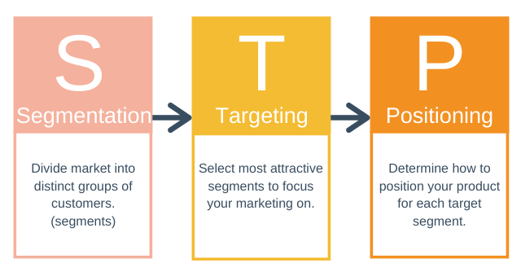
Figure 3: STP model
(Source: Wuryandani et al. 2018)

Segmentation
Segmentation aids to develop the target group of a company and there are four types of segmentation and based on this segmentation, organizations develop unique market strategies.

Geographic | Demographic | Psychographic | Behavioral
UK | 15-65 | Determined, easy going | Active user
Urban and rural density | Male and female | Regular | Variety, cost advantages
- | Housewife, employed | contended conformers | Positive and Sceptical attitude
- | Middle and low-income category | Traditionalists | Regular occasions
Table 2: Segmentation table of Sainsbury
(Source: sainsburys.co.uk, 2021)
This table has highlighted the condition of the Sainsbury Company and please help the company to implement a unique and effective strategy to capture the UK market UK. It also helps to create the target market for the company that also improves the comparative advantages of Sainsbury.

Targeting
The target market is the most important part because the target market helps to improve the advertisement strategy and helps to attract a considerable number of consumers to the company. In the case of Sainsbury, it has been found that the main target of this company is the family unit and mainly the mother (sainsburys.co.uk, 2021). Based on the target market, Sainsbury has developed unique and effective advertisements on several television channels and they also use the marketing mix to attract their significant segmentation

Positioning
Positioning is another important part of the study and it helps to portray the position of Sainsbury in the UK market. A positioning map is a unique tool that seems very have developed to understand their position in the competitive market (sainsburys.co.uk, 2021). The position in map highlights the effective competitor of the company and based on the position Sainsbury can easily develop an effective marketing strategy
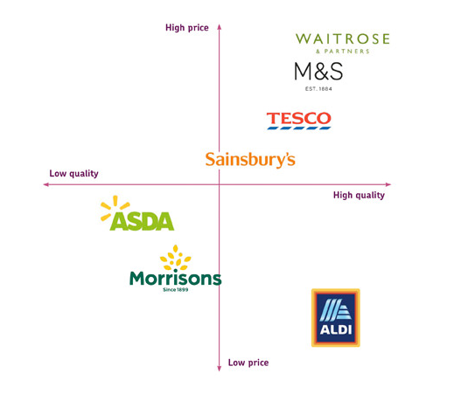
Figure 4: Positioning map
(Source: alderandalder.co.uk, 2021)
This figure has portrait the position of Sainsbury in the UK market full stop moreover this figure also highlights all the competitors of Sainsbury in the UK market and the product quality and price today is depicted in this figure.

Conclusion
Thus it can be concluded that marketing is the most important part of an organization and the development of proper theory and model help in this area effectively. This has highlighted the crucial marketing model and portrayed the significance of the marketing environment in an organization.

References
alderandalder.co.uk (2021), knowing your market position is important, available at: https://www.alderandalder.co.uk/knowing-your-market-position-is-important/ [Accessed on: 24/06/2021]
cipd.co.uk (2021), Pestle analysis, available at: https://www.cipd.co.uk/knowledge/strategy/organisational-development/pestle-analysis-factsheet#gref [Accessed on: 24/06/2021]
Petrunia, Y., Chentsov, V., Życzyński, N. and Petrunia, V., 2019. Marketing environment and marketing management of universities in Ukraine: national and regional dominants. Innovative Marketing, 15(1), pp.1-12.
Ruziev, S.S., 2021. Analysis of the marketing environment and communication in tourism business. ACADEMICIA: An International Multidisciplinary Research Journal, 11(5), pp.370-375.
sainsburys.co.uk (2021), about us, available at: https://www.sainsburys.co.uk/ [Accessed on: 24/06/2021]
Seturi, M. and Urotadze, E., 2017. About Marketing Process Model and Relationship Marketing. In Proceedings of International Workshop „Model-Based Governance for Smart Organizational Future (pp. 169-171).
Statista.com (2021), United Kingdom: Real gross domestic product (GDP) growth rate from 2016 to 2026, Available at: https://www.statista.com/statistics/263613/gross-domestic-product-gdp-growth-rate-in-the-united-kingdom/ [Accessed on: 24/06/2021]
Thabit, T. and Raewf, M., 2018. The evaluation of marketing mix elements: A case study. International Journal of Social Sciences & Educational Studies, 4(4).
Varadarajan, R., 2019. Theoretical underpinnings of research in strategic marketing: a commentary. Journal of the academy of marketing science, 47(1), pp.30-36.
Worldometers.info (2021), UK Population, available at: https://www.worldometers.info/world-population/uk-population/ [Accessed on: 24/06/2021]
Wuryandani, S., Ismoyowati, D. and Nugrahini, A.D., 2018. STP analysis in marketing pigmented rice as functional food. KnE Life Sciences, pp.128-135.

