  The global business environment  BA Business Management; Module Code: LCBB4005 | Module Leader: Alfred Mensah and Nadeem Mirza  Student ID: 2123043  Zlatina Zlatkova

Table of Contents
Introduction 2
Evaluation 2
SWOT analysis 4
Porter’s strategic Economical Models 5
Porter’s five forces model 6
Conclusion 6
References 8

Introduction
The Global Business environment has been moved mainly by the automobile industry for the past decades, importing and exporting vehicles from the country of production to the market built by demanding certain features customers. Cars have been invented way back in 1885-1886, the first example presented on the market by Karl Benz was called “Motorwagen”. Later back at the beginning of the 20th century Benz merged his manufactory with Gottlieb Daimler’s and developed the factory, manufacturing today’s one of the most popular and demanded car brands – Mercedes Benz. Benz has been an influential brand in the automobile industry since it was founded and has been a major market leader since that time. The brand is one of the reasons the term “German quality” exists in the automobile market and has been expanding on the global market widely, promoting not only the proven quality but comfort and style of the vehicles they are producing. Mercedes models keep developing by this day, however, the changes in the market demand can potentially damage the success of the so-beloved brand. Following the changes and exploring the potential future threats by applying Porter’s five forces and value chain, could assist in drawing the near to farther future of the company. By developing SWOT and PESTLE analysis, the oldest car brand can be evaluated and show whether its future could be bright as its start.

Evaluation
Benz invented the first vehicle that was horseless and gas-powered carriages, after graduating with a mechanical engineering degree (l. Cox, 2022). The initial investment for Benz’s factory was made by his wife and her dowery – an investment that led to the invention of the future and founding not only of the Benz brand but also of the entire motor vehicle industry. The Global Business environment that has been created throughout the past 100 years upholds major parts of the automotive industry, as the type of companies taking part in these industries is focused on the higher sales reaching international levels of customer demands. Mercedes Benz as a company has been present on the market since the industry has been developed, and following today’s rates, it is still in the top 5 of the world’s vehicle brands on the market. Remaining dominant in the market for nearly a hundred years is a sign of complete balance between the internal and external environment of a business. The internal environment of every business contains certain factors that influence its well-being: finances, personnel, and equipment. The Benz car brand had a certain period that was completely dominant on the market, without any rivalry to obstruct its ultimate success, therefore the company was capable to remain stable and allow itself to make mistakes at the beginning, developing prices suitable for them without competing and evaluating the non-existent competitive market. In this case, the management of the company could plan further developments and expansion without thoughts under consideration. However, throughout the years, the market shifted in many different directions as many more car brands have been developed. Therefore, the competition was already a major factor in the company’s future expansion and development. To this day Mercedes-Benz is a major part of the import-export business within the Global Business Environment. However, following the decrease in interest in gas-fueled vehicles, The Benz company has faced some difficulties in regard to completely satisfying the automobile demand. The vehicles they produce are considered high quality and luxury, aiming to the complete financial fit customers who could afford the extra price for extra comfort. One of the main reasons the company is meeting difficulties within customer demand is the expense of maintaining the vehicle, as well as the variance in export and import costs. The factory of the brand is based in Germany, which makes the distribution to Europe easier (apart from the UK, because of the change in import tax rates after Brexit), however, at the same time, some of the poorest countries with the highest percentage of poverty are based in Europe, which decreases the demand of exclusive vehicles on the market. Mercedes being part of the Global Business Environment contributes to the vehicle industry with new and developed technology and creates jobs by operating and expanding the work of the factory as well as multiple showrooms available all around the world. Apart from those contributions, the brand is bringing a significant amount of investment capital from the export to other countries, to Germany. The brand’s biggest strength is the fact that it is a sign of the invention of the industry, which made it more popular and allowed it to develop its technologies further and quicker than other brands. There is a high chance of probability that if the vehicle market was basing its trade methods on liberalization, the cars would have been even more accessible and affordable.
Even being one of the market leaders, Mercedes-Benz is facing major changes on it, like the increased demand for electric vehicles (provided by Toyota, Tesla, BMW, etc.) which uphold many positive impacts on the consumers and the planet. As lately the “cleaner air” and “cleaner planet” movements have been prioritized by people as well as entire countries, brands like Mercedes which operate with gas-fueled motors will meet struggles in satisfying the market demands. Liberalization on the trade market might slower the transition to completely green energy, however, the company should consider developing new technologies in addition to blending with the changing market.
Maintaining a business on a global level could introduce some challenges to it, like language barriers, cultural differences, difficulties in managing global teams (showroom employees), currency exchange, and inflation (which might affect the sales if prices start to increase). However, not every brand within the automobile industry is facing struggles like this, especially one that has been developing for nearly 100 years.
Mercedes-Benz’s strategy is representing the actions taken by the general managing team, aiming for profitability and profit growth of the company. One of the strategic actions the company has taken is creating profitable partnerships with different car brands as well as developing sub-brands. The Mercedes Benz Group gathers brands like Mercedes-Benz USA; Smart, Daimler India Commercial Vehicles; etc. The grouping of the brands has created a platform for the production of different vehicles that are more affordable, still representing the company’s quality standards and reaching variance of markets – the luxury market, the affordable market, and the business market (Evo Bus {logistics and transportation}). The merging of those companies increased the revenue of Mercedes-Benz and increased its sustainability in the market.

SWOT analysis
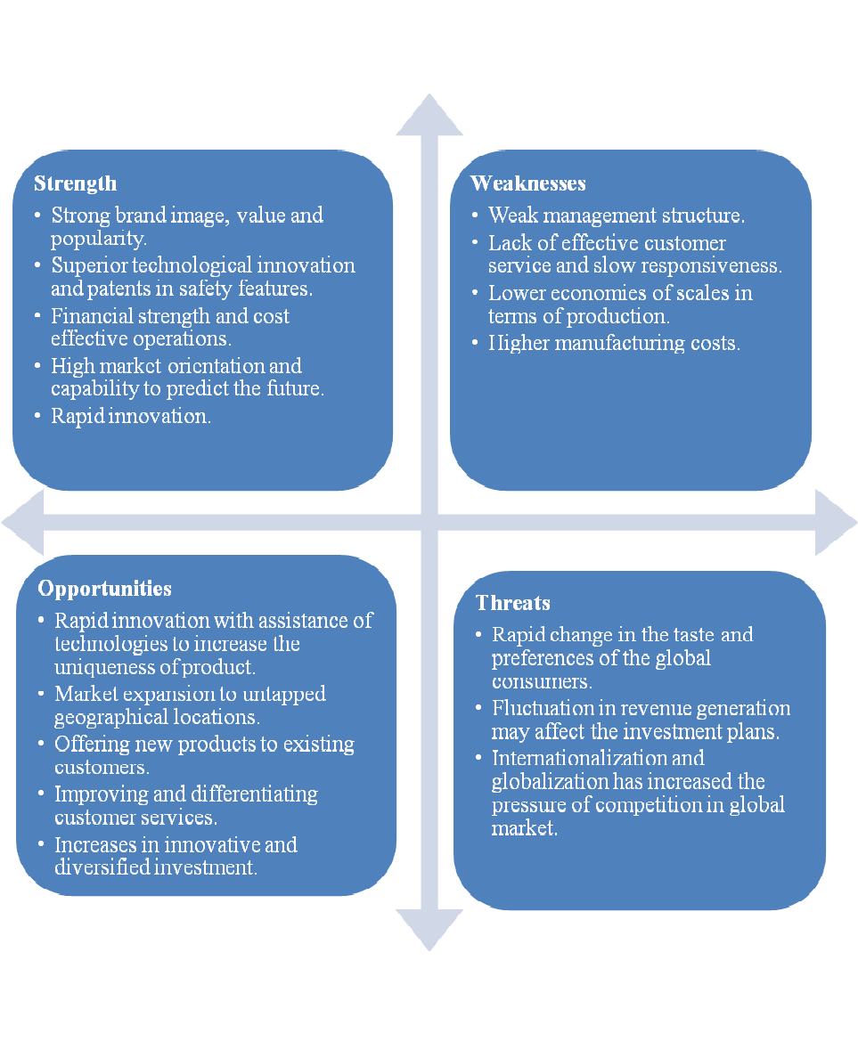
Addressing the SWOT analysis made on the major brand of the Mercedes-Benz Group the company has limitless advantages, that sustain its dominance in the market, allowing it to remain and lead it furthermore. However, the company has shown poor management and customer service qualities that are not always replaceable with the great quality of the vehicles. The changes within the economy of countries and the global inflation that we are facing nowadays are potentially threatening the prosperity of the company on the market. The increased gas prices are affecting the market for gas-fueled vehicles drastically. The development of more car brands, the globalization of the world, and the liberalization of the market are leading to rapid changes in demands and making the competition for market dominance unbearable for most businesses.

Porter’s strategic Economical Models
The Strategic economical models developed by Michael Porter are aiming to explain how the market rivalry works and what is its influence on businesses. It explains how one country could be better than another, in addition, to being more inventive within a certain industry. Porter’s Dimond model represents four major influential factors that influence businesses’ development and success. Adding two additional factors that might or might not influence its working-development process.
- Factor conditions – Those can vary between basic and advanced ones, as the basic represent the raw materials necessary to produce any product on the market, like metals, oil, etc. The advanced forces are human resources and their research capabilities, as people are the ones refining the raw materials in the product which has been presented on the market. An example of the importance of advanced forces is Mr. Benz, who was thought the theory of mechanical engineering and by the learned basics, he had upgraded the theory, developing entirely new inventions for the global market.
- Demand conditions – Predicting the potential demands the consumer market might have. Moving the timeline to 2017, when Mercedes-Benz Group was created, following the changes in customer demands, by merging into a group with other car manufacturers, Mercedes has increased its revenue and confirmed its sustainability in the market, by providing cheaper versions of the same quality and expanding their product range.
- related and supporting industries could be called subcontractors. Those are the suppliers for the company providing the necessary for the production of the final product. Component manufacturers (the upholstery company that takes care of the seats used in the vehicles). Distributors are mainly logistic companies that import and export vehicles around the globe or merchandise companies (showrooms) which bring the demanded products closer to the market.
- As mentioned, the varying components of Porter’s Diamond Model are two. The first one is the Government, operating within the country the company is looking to import or export to. The government could stimulate the early demand allowing a business to plan ahead their action and build a strategy towards fulfilling the market demand. Another way of taking a major part in a business’ development a government might take is to include studies related to the industry, in addition, to creating qualified personnel for it. An example is again Mr. Benz, who got a degree in mechanical engineering from Germany, and invented an entirely new business sector for the world and at the same time contributed towards the increase of GDP and brought to its borders large amounts of investment capital from different countries.

Porter’s five forces model
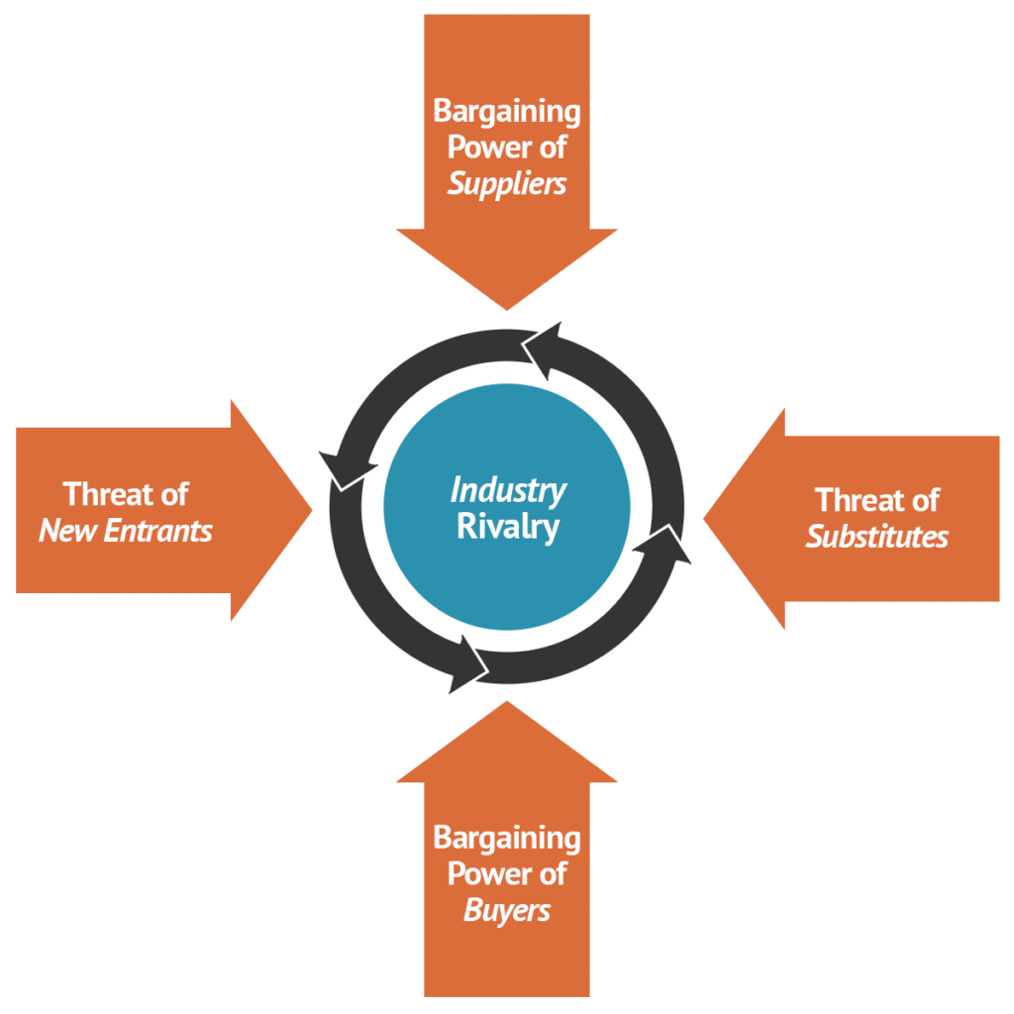
This model has been developed to measure the intensity of competition on the market within a certain range of products within an industry, allowing the managers of the business to evaluate whether the product could or could not reach high levels of profitability in long term or even market dominance.

Conclusion
Mercedes-Benz is a vehicle manufacturing company that placed the beginning of the vehicle industry. Throughout the years the company has developed different strategies to remain on the top of the market and proved that the evaluation of opportunities and threats always will have an impact on one business’ development. The company’s success has relied on its strong brand recognition, however, there are some negative outcomes in regard to the quality of management and customer service which have an impact on the company. The price range that Mercedes- Benz is aiming to remain at, has been higher than the average affordable prices available on the market, however, the company developed a strategy to respond to the market’s demand by creating the Mercedes-Benz Group. This group contains multiple vehicle manufacturing brands that have increased the revenue of the company and at the same time supported it by providing the customers variety of vehicles and expanding the brand it’s product range.

References
Brinkman, J., Navarro, I. and Harper, D., 2014. Unlocking the Business Environment. 1st ed. Taylor and Francis.
Corpbiz. 2022. International Business Environment (IBE) - Corpbiz Advisors. [online] Available at: <https://corpbiz.io/learning/international-business-environment-ibe/amp/> [Accessed 3 May 2022].
Cox, L., 2022. Who Invented the Car?. [online] livescience.com. Available at: <https://www.livescience.com/37538-who-invented-the-car.html#section-karl-benz-car-pioneer> [Accessed 1 May 2022].
Group.mercedes-benz.com. 2022. History of Mercedes Benz. [online] Available at: <https://group.mercedes-benz.com/company/tradition/company-history/1885-1886.html#:~:text=On%20January%2029%2C%201886%2C%20Carl,1.> [Accessed 3 May 2022].
Grundy, T., 2006. Understanding Michael Porter The Essential Guide to Competition and Strategy. John Wiley & Sons, Ltd.
Guy, F., 2009. The Global Environment of Business. Oxford University Press, pp.8-34.
Investopedia. 2022. Trade Liberalization Explained. [online] Available at: <https://www.investopedia.com/terms/t/trade-liberalization.asp> [Accessed 2 May 2022].
Magretta, J., 2012. Understanding Michael Porter. Boston, Mass.: Harvard Business Review Press, pp.85-93.
Malmgren, I., 2016. Quantifying the Societal Benefits of Electric Vehicles. 1st ed. [ebook] Available at: <https://www.mdpi.com/2032-6653/8/4/996/pdf> [Accessed 1 May 2022].
Otter, D. and Whetherly, P., 2011. The Business Environment : Themes and Issues. 2nd ed. Oxford University Press, pp.3; 204-228; 32-62.
Pettus, M. and Helms, M., 2008. Government Inclusion in Porter’s Diamond: The Case of Argentina. [online] Hbs.edu. Available at: <https://www.hbs.edu/ris/Publication%20Files/20170524%20Strategy%20Keynote_%20v4_full_final_2814963a-c8ca-457d-8ee6-69e8b57921ea.pdf> [Accessed 2 May 2022].
Sathre, R. and Gustavsson, L., 2021. A lifecycle comparison of natural resource use and climate impact of biofuel and electric cars. Energy, 237, p.121546.
Satryo, C., 2022. Free Trade Intervention: Political-Economic Intervention on Global Business Environment. [online] Available at: <https://apmba.ub.ac.id/index.php/apmba/article/view/295> [Accessed 2 May 2022].
Srinivasan, S., 2012. Understanding Michael Porter: The Essential Guide to Competition and Strategy. Journal of Education and Vocational Research, 3(3), pp.80-81.

