Document of Intent
In this group collaboration mission, I am mainly responsible for scene model production and animation. And I do auxiliary work on special effects and lighting and rendering. So, my roles in the group are modeler, animator, technical developer, special effects, rendering. The reason I wanted to take on these responsibilities is that I was recently studying UE5, and I believe that the advanced technology I learned will make our team more efficient in completing this project.

Main Role: Animation Model Rendering

Minor Role: VFX

Alternate Role: Post-Editing Scene Construction

I am very passionate about animation, and now I am occasionally taking online courses with animators, and I have some research on the curve control of animation, production techniques. He has also worked as an animator in an animation company and has participated in the production of animation promos for Onmyoji and Honor of Kings. I believe that my technology can help team members even more. It can also improve the productivity and production quality of animation.

In terms of models, since the renderer may use UE5 for rendering, I will play the role of model making, because I have some understanding of the PBR production method and the software bridging process of UE5, so I can help the team to do this work more efficiently.

In terms of rendering, I have done research on the rendering flow of UE5, as well as PPV effects. So it can help the group to better achieve the visual effects that the director wants.

In VFX, in my course on software research, I covered some research on Unreal Engine physics systems. I believe I can help the team members.

In post-editing, I now work as an editor for an advertising agency. So, I can provide some practical color grading suggestions to the team members.

In terms of scene construction, I haven't done any in-depth research on the artistic aspects of map editing, but I can guide the team to use Unreal Engine's map editor.

Technical R&D

In terms of animation, I will shoot a lot of reference videos. When I play the role, I can better understand the appearance and movement of the character. The reference video can also help me make better animations.

The model making method I chose is the PBR production process. First, I'll make low polygons in maya, and then I'll import low polygons into Zbrush for more elaborate sculpting. Since the rendering of the film may use the Nanoite technology in UE5, I need to keep the low-poly subdivision mesh in Zbrush sculpting, which allows me to edit high-poly UVs more efficiently. Nanite is Unreal Engine 5's virtualized geometry system that uses a new internal mesh format and rendering technology to render pixel-level details as well as massive amounts of objects. It intelligently handles only the details you can feel. In addition, Nanite uses a highly compressed data format and supports fine-grained streaming with automatic levels of detail. Using this technique allows me to save a lot of time during the topology model and baking normal phases.
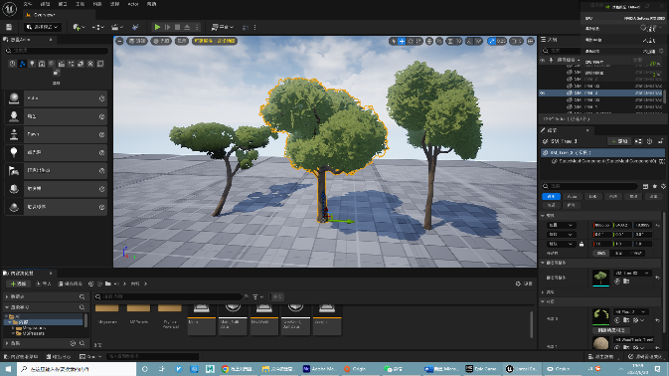
Next, I need to do texture drawing, editing with the shader. First, I map each polygon in substance. I then imported the texture into the Unreal5 engine to write a stylized shader. I spent a lot of time working on stylized renderings for UE5 during the early technical research process. I made several instance materials for this project.
Renderings
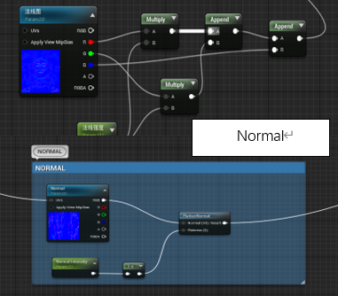
In the design vegetation material. For stylized rendering, I tried a variety of different codes to write the shader. Those methods all have the same problem, normal stickers affect the rendering of vegetation, and default Normals make rendered objects very realistic, which is not what I want. I tried to use the product node directly to modify the normal intensity, but the rendering effect is not ideal, because the normal map rendering principle is to modify the coordinates of the shadow at the vertex according to the value of the three colors of RGB. So once the product node is used, the position of each coordinate is changed, resulting in a catastro phic rendering effect. After several attempts, I found that after separating the RGB of the normal graph, it was a good idea to use the product nodes alone to modify the R and G channels, and then add them to the B channels. After I communicated with my friends, I learned that there was a better solution.
Flatten normal This node is a very good normal strength control code. It also worked best after I tried it many times.

VFX：
I also encountered a more complex problem, that is, the physical effects of plants. In our team's expectations, how to make the plants flutter with the wind was a big problem, because there was a lot of vegetation in the wheat field where the characters were located, and if those plants did not have physical effects, the picture would lose its vitality. We discussed several scenarios, such as using skeletal animation to make those grasses, or solving the cloth in Maya and then exporting the animation guides in the Unreal engine. After consulting Unreal Engine's official documentation, I found that local motion of vegetation can be simulated by pixel depth offsets in material Blueprints. Unreal Engine also has a feature called Global Vegetation Wind. This feature can simulate real vegetation physics with very little hardware load.
Since only 4 computers in the group can be used for material understanding and rendering, we chose the latter two methods to simulate the effect of vegetation drift. 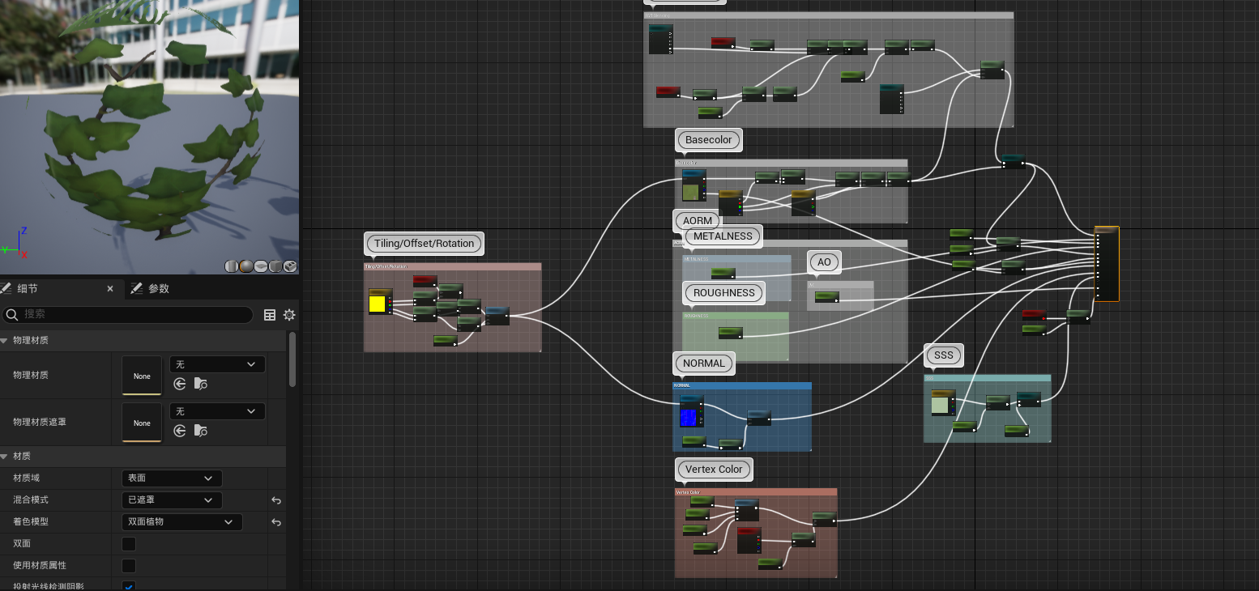
This is the final instance Material code. It contains stylized rendering effects for each node and physical flutter effects for plants.

