An investigation into the impact of influencer marketing on consumer behaviour in the FMCG sector: A study on Unilever UK

Declaration

Master’s Degrees by Examination and Dissertation
Declaration Form.
1. This work has not previously been accepted in substance for any degree and is not being concurrently submitted in candidature for any degree.
Signed…Ziya Eram Feroz Daula……………………………………
Date ……13/10/2023……………………………………..

2. This dissertation is being submitted in partial fulfilment of the requirements for the degree of Master in Business Administration.
Signed …Ziya Eram Feroz Daula …………………………………
Date ……13/10/2023……………………………………..
3. This dissertation is the result of my own independent work/investigation, except where otherwise stated.
Other sources are acknowledged by footnotes giving explicit references.
A bibliography is appended.
Signed candidate: … Ziya Eram Feroz Daula ………………………
Date:…13/10/2023………………………………………………

4. I hereby give consent for my dissertation, if accepted, to be available for photocopying, inter- library loan, and for deposit in the University’s digital repository
Signed (candidate)…… Ziya Eram Feroz Daula……………………
Date…13/10/2023……………………………………..
Supervisor’s Declaration.
I am satisfied that this work is the result of the student’s own efforts.
Signed:…Dr Jaya Gopalkrishnan…………………………………………………………………..
Date: …17/10/2023…………………………………………………………………………...

University of Wales: Trinity Saint David

E-Thesis Deposit Agreement

Details of the Work
I would like to deposit the following item in the digital repository maintained by the University, and/or in any other repository authorized for use by the University:

Title …………………………………………………………………………………………
…………………………………………………………………………………………

This item is a product of my own research endeavours and is covered by the agreement below in which the item is referred to as “the Work”. It is identical in content to that deposited in the Learning Resources Centre, subject to point 4 below.

I agree that the University of Wales: Trinity Saint David may electronically store, copy or translate the Work to any approved medium or format for the purpose of future preservation and accessibility. The University is not under any obligation to reproduce or display the Work in the same formats or resolutions in which it was originally deposited.

UW: TSD Digital Repository
I understand that work deposited in the digital repository will be accessible to a wide variety of people and institutions, including automated agents and search engines via the World Wide Web.

I understand that once the Work is deposited, the item and its metadata may be incorporated into public access catalogues or services, such as national databases of electronic theses.

I agree as follows:
- That I am the author or have the authority of the author/s to make this agreement and do hereby give the University of Wales: Trinity Saint David the right to make available the Work in the way described above.
- That the electronic copy of the Work deposited in the digital repository and covered by this agreement, is identical in content to the paper copy of the Work.
- That I have exercised reasonable care to ensure that the Work is original, and to the best of my knowledge, does not breach any laws including those relating to defamation, libel and copyright.
- That I have, in instances where the intellectual property of other authors or copyright holders is included in the Work, gained explicit permission for the inclusion of that material in the Work, and in the electronic form of the Work as accessed through the open access digital repository, or that I have identified and removed that material for which adequate permission has not been obtained and which will be inaccessible via the digital repository
- That University of Wales: Trinity Saint David does not hold any obligation to take legal action on behalf of the Depositor, or other rights holders, in the event of a breach of intellectual property rights, or any other right, in the material deposited.
- That I undertake to indemnify the University of Wales: Trinity Saint David against all actions, suits, proceedings, claims, demands and costs occasioned by the University in consequence of any breach of this agreement

Signature …Ziya Eram Feroz Daula …………………………………………………….

Date …13/10/2023

……………

Acknowledgements
I would like to express my gratitude towards everyone who contributed to the success of this research project. First, I significantly thank my supervisor who provided feedback on the research which led to the rectification of the weak areas of the dissertation. Then I appreciate the efforts made by the consumers of Unilever in the UK while participating in the online survey and responding to the questionnaire shared with them. I also thank my friends and colleagues who motivated me during the project and filled me with confidence to conduct the research.
Abstract
The digital marketing methods used by business organisations also include influencer marketing which is based on the partnership with influencers and its impact on the consumers of the organisations in their respective target markets. The lack of primary data evaluation identified from the literature led to the rationale for this study which aimed at evaluating the impact of influencer marketing on consumer behaviour while focusing on Unilever, UK. A quantitative methodology was implemented during this research so that precise outcomes are obtained and the data was collected from 60 consumers of Unilever in the UK. A close-ended questionnaire was utilised for data collection during an online survey on the online platform Google Forms. The linear regression analysis method was implemented for analysing the collected data and testing the four hypotheses developed after the literature review. The findings of this research revealed that a significant impact is made by influencer marketing of Unilever, UK on the behaviour of consumers due to better promotion through advertisements by the influencers, better product awareness and the information about the salesforce and service quality. It is recommended that Unilever should opt for partnerships with influencers who have many followers on social media and who have expertise in FMCG products so that a better impact can be made on consumer behaviour.
Table of Contents

1.1 Introduction……………………………………………………………………………….13
1.2 Background 13
1.3 Rationale 15
1.4 Research Significance 16
1.5 Research Gap 16
1.6 Research Aim and Objectives 17
Aim 17
Objectives 17
1.7 Research questions 17
1.8 Chapter overview 17
1.9 Summary 18
Chapter 2: Literature review 19
2.1 Introduction 19
2.2 Concept of influencer marketing 19
2.3 Influence of influencer marketing on consumer behaviour 22
2.4 Influencer marketing practices of retail firms 24
2.5 Theories and models of consumer behaviour 27
2.6 Research gap 29
2.7 Conceptual framework 29
2.8 Conclusion 31
Chapter 3: Research Methodology 32
3.1 Introduction 32
3.2 Research Philosophy 33
3.3 Research approach 33
3.4 Methodological choice 33
3.5 Research strategy 34
3.6 Time horizon 34
3.7 Techniques and procedures 35
3.8 Limitation of research 41
3.9 Ethical considerations 42
3.10 Conclusion 42
Chapter 4: Data analysis, findings and discussion 43
4.1 Introduction 43
4.2 Analysis of demographic questions 43
4.3 Reliability test 45
4.4 Linear Regression analysis 46
4.4.1 Analysis for testing hypothesis 1 48
4.4.2 Analysis for testing hypothesis 2 52
4.4.3 Analysis for testing hypothesis 3 56
4.5 Discussion 59
4.6 Conclusion 62
Chapter 5. Conclusion and recommendations 63
5.1 Introduction 63
5.2 Realisation for the accomplishment of research aim and objectives 63
5.3 Research implications 64
5.4 Limitations of the study 65
5.5 Recommendations for future research 66
5.6 Conclusion 67
References 69
Appendix 76

Table of Figures
Figure 1: Influencer marketing 20
Figure 2: Impact of influencer marketing 22
Figure 3: Reasoned action theory 27
Figure 4: Conceptual framework 30
Figure 5 Research onion 32
Figure 6 Pie chart representing the responses for the first demographic factor 43
Figure 7 Pie chart representing the responses for the second demographic factor 44
Figure 8 Pie chart representing the responses for the third demographic factor 44
Figure 9 Pie chart representing the responses for the first scale item on purchase decision 46
Figure 10 Pie chart representing the responses for the second scale item on purchase decision 47
Figure 11 Pie chart representing the responses for the third scale item on purchase decision 47
Figure 12 Pie chart representing the responses for the first scale item on product awareness 48
Figure 13 Pie chart representing the responses for the second scale item on product awareness 48
Figure 14 Pie chart representing the responses for the third scale item on product awareness 49
Figure 15 Scatter plot depicting the relationship between product awareness and purchase decision 51
Figure 16 Pie chart representing the responses for the first scale item on advertisements 52
Figure 17 Pie chart representing the responses for the second scale item on advertisements 52
Figure 18 Pie chart representing the responses for the third scale item on advertisements 53
Figure 19 Scatter plot depicting the relationship between advertisements and purchase decision 55
Figure 20 Pie chart representing the responses for the first scale item on service quality and salesforce 56
Figure 21 Pie chart representing the responses for the second scale item on service quality and salesforce 56
Figure 22 Pie chart representing the responses for the third scale item on service quality and salesforce 57
Figure 23 Scatter plot depicting the relationship between service quality and salesforce and purchase decision 59

List of Tables
Table 1 Values of Cronbach's alpha 43
Table 2 Results of the first regression analysis 47
Table 3 Results of the second regression analysis 51
Table 4 Results of the third regression analysis 55

Chapter 1: Introduction

1.1 Introduction
Research is referred to the means of creating base of knowledge using past studies in innovative generating new concepts, methods and detail understanding. It is also the systematic investigation related to sources and the study of materials to reach new conclusions and incorporate innovative facts. In addition to this, influencer marketing is the type of marketing which allows companies to work together with individuals having a high figure of followers so in order to increase the brand exposure (Vrontis, et al. 2021). Organizations can ask the individual who has a large following to publish the content on media pages which promotes services and products provided by the firm.

1.2 Background
Influencer marketing (IM) is refereed as the marketing form from which businesses communicate for collaborating with the influencers having high number of following by publishing the content on different social media pages which focuses on promoting the services and products of the brand. IM facilitates the brand in increasing its exposure (Campbell, and Farrell, 2020). In the present times, individuals often follow the people they trust on the platforms of social media and when they see someone, they chase advertising of that particular brand, which develops an inherent trust among them for the company and this results in boosting the conversion rate of the organization. Influencer marketing is considered beneficial for the company because it helps them establish trust and credibility.
Many companies are not able to sell their services and products because they are not able to establish credibility. It is significant for the companies to appear for selling products and service in the easier manner. Through partnering with influencers who have trusted and loyal followers can help the firm quickly boost its credibility. The next key benefit of implementing influencer marketing is that it is cost-effective (Belanche, et al. 2021). When companies decide to use influencer marketing, they generate a high return on their investments if they form partnerships with the appropriate people. IM also facilitates attracting quality leaders for the companies. The campaigns run by influencers on their platforms of social media companies can reach individuals who are interested in the services and products offered by the firm. With this, companies can easily increase their rate of conversion.
Boosting the awareness of the brand is also regarded as one of the key benefits which firms get by using IM. This is so because by doing partnerships with the influencers, services and products of the brand are in front of thousands or hundreds of people (Ye, et al. 2021). Even many influencers have their followers, so through this, many individuals become aware of the products and services offered by particular brands. IM also helps the brand grow its audiences or increase its base of customers. Consumer behavior is basically defined as the study related to groups, organization or individuals and all their task and activities which are linked through the disposal, use and purchase of goods offered by the company.
It also includes how the preference, attitudes and emotions of the consumer affect their behavior of buying. In other words, consumer behavior means the decisions and actions which individuals make at the time of using or purchasing any product. The behavior of consumers towards any good or service includes the initial decision of buying the product, using it and also whether they will continue to buy that product or service in the future or not. Customer behavior is considered significant for companies because it facilitates them in understanding the desires, needs and wants of the consumers and then creates the products accordingly (Martínez-López, et al. 2020). This helps the firm increase its sales and profitability. It has been identified that the impact of IM is positive on the behavior of customers. IM has a positive impact on consumer behavior because it facilitates fostering trust, increasing awareness of the brand and engaging the customer with the help of relatable content on social media platforms and this also offers them social proof related to the services and products of the brand.
IM play an imperative role in shaping the decisions of the customers related to purchasing the products. In the modern era, it is developing as the strong strategy for companies in order to build personal connect with their potential or targeted audience. This is regarded as an effective way of marketing because influencers in the market currently have power of influencing the consumer behavior by way of relatable and authentic content (Jin, Muqaddam, and Ryu, 2019). Influencer marketing has positive impact on the consumer behavior because it helps in building the authenticity and trust of the customers. Influencers are regarded as trustworthy by their follower because of the personal nature of the content posted by them on their social media platforms. At times, when influencers promote the services and products of the company, customers are more prone to observe it as reliable and authentic. This results in fostering a positive connection between consumer and organisation, which leads to augment in their brand loyalty.
Secondly, the impact of IM is also positive on the behavior of consumers because it improves the awareness of the brand. IM mainly focuses on amplifying the exposure and reach of the brand. Through collaborating or partnering with influencers who have engaged and relevant audiences, companies can effectively gain visibility among the targeted customers who are not able to reach the brand through traditional channels or traditional advertising (Chopra, Avhad, and Jaju, 2021). An increase in the awareness of the brand has a direct impact on the behavior of customers and also facilitates customers in making a purchase decision. The impact of IM is also positive on the behavior of customers because they are likely to buy a product and take services which are recommended by the influencer they trust and follow.
The post shared by influencers on the platforms of social media facilitates development of an emotional connection, which can drive the customers to prioritize the products which are recommended by the influencers, and ultimately, this results in increasing profitability, sales and the consumer base of the company (Trivedi, and Sama, 2020). IM is regarded as a dominant force in the digital age of modern marketing, which influences the behaviour of the customer in multiple ways. Influencer marketing also helps the firm in gaining a competitive edge over the competitors.

1.3 Rationale
The rationale of the study is to find the impact of influencer marketing on consumer behaviour in the FMCG sector, with a particular focus on Unilever UK key rationale is to address an problem that FMCG companies are facing. Currently, use of influencer marketing is considered to promote fast-moving consumer goods (FMCG) by corporations such as Unilever but they are not able to determine its effectiveness in respect to its influence on consumer behaviour (Majeed, et al. 2021). This research tries for addressing the gap and covers the details regarding impact and current practices of Unilever UK. Another rationale is to have learning on current influencer marketing practices adopted by businesses so that for future better strategies related recommendations can be considered. In an era of digitization and the rise of social media and influencer marketing is dominating the market (Ismagilova, et al. 2020). The research studies have explored its effect on consumer behaviour but there is gap of learning on the effectiveness of influencer marketing and way practices are allowing having growth. For addressing such aspects the present study is done carefully.

1.4 Research Significance
The significance of conducting this research is that it provides an investigation into the collision of influencer marketing on the behaviour of consumers in the FMCG sector, which is based on Unilever UK. This research gives a deep understanding related to influencer marketing and the benefits and opportunities which companies get by doing this. This study helps in obtaining knowledge regarding the importance of influencer marketing in the modern era. Conducting this research is essential for it facilitates in increasing the academic and professional growth of the one. Through this, various strategies have been identified that assist in increasing the brand awareness, trust, credibility and loyalty of the customers (Lee, and Kim, 2020). With the help of this research, companies are able to gain a deep understanding related to practices of influencer marketing in retail firms and also its influence on consumer behaviour. This study is significant because IM is an effective tool which helps in engaging potential individuals and shapes their perceptions accordingly. By this study, a leader can gain multiple knowledge which can help in promoting its products and services in future and this results in increasing its growth and development.

1.5 Research Gap
The current study addresses the previous studies research gapsand presented learning influencer marketing effectiveness in the FMCG sector, with a focus on Unilever UK. The research presents details on influencer marketing and its precise impact on consumer behaviour to address gap in the literature. However, there are few areas of influencer marketing that still needs to be investigated (Reitsamer, and Brunner-Sperdin, 2021). Research covers Unilever UK's practices but does not provide a comprehensive analysis of all possible influencer marketing strategies. Also, the long-term sustainability and ethical implications of influencer marketing in the FMCG sector are not covered that still needs to be identified and further research is required on its relation with consumer behaviour.

1.6 Research Aim and Objectives

Aim
The research aims to analyse the impact of influencer marketing on consumer behaviour in the FMCG sector: A study on Unilever UK.

Objectives
- To understand the concept of influencer marketing.
- To evaluate impact of Unilever UK influencer marketing on consumer behaviour.
- To identify influencer marketing practices adopted by Unilever UK for affecting consumer behaviour.
- To recommend ways for improving effectiveness of influencer marketing within Unilever UK.

1.7 Research questions
- What is the concept of influencer marketing?
- How Unilever UK influencer marketing impacts consumer behaviour?
- What are key influencer marketing practices that are adopted by Unilever UK?
- How effectiveness of influencer marketing within Unilever UK can be improved?

1.8 Chapter overview
Chapter 1: Introduction – This chapter in the research is the chapter which introduces the overview and background of the topic is discussed. The key objectives, the aim and the questions of the research are determined in first chapter along with the key rationale, significance and research gap.
Chapter 2: Literature review – The next chapter in the study is literature review that comprise of information from secondary sources related to the topic. This chapter comprise of key information collected from various published articles and journals that are summarized in thematic manner to present the overall findings in the past surrounding the topic of the research. The theoretical findings and analysis has been presented in this chapter by researching about key theories and models relevant to the topic or subject in the present study.
Chapter 3: Research methodology – This chapter mainly comprise of key strategy, approach, design and methodology which is employed to conduct research for the present study. The chapter comprise of key elements of research onion such as research philosophy, sampling methods, data analysis, data collection method, research design method and strategy.
Chapter 4: Data analysis – This chapter analysis the data collected in the research has been done in this chapter using secondary data analysis method. This chapter is important aspect for the study to derive insights and findings from the research. The thematic analysis is the tool selected for the present research for data analysis.
Chapter 5: Conclusion and recommendations- In conclusion chapter, the summary of the research is presented in systematic manner by matching with the objectives of the research. Later, several recommendations are presented in the research in this chapter. The key limitation of the research and the suggestions for improving the research outcomes in the future is also presented in this chapter at the last.

1.9 Summary
It can be summarized that influencer’s marketing has been emerged as one of recent trend in the field of marketing to promote and raise the awareness of the brand on different social media channels. The key rational within the current study is to determining and addressing the key problems that are faced by the FMCG sector companies in terms of employing influencer’s marketing tactics to improve its brand image and awareness in the market. It is summarized that because the consumer behaviour is mainly influenced by the use of influencer marketing tactics by the company, the analysis of the efficiency of the influencer marketing is important for the researchers.

Chapter 2: Literature review

2.1 Introduction
In the current chapter, research deals with different writing of the existing authors and scholars who have stated something related to the topic. The critical evaluation of the different idea of influencer marketing is to be added within the section, which means that a proper definition of the term, along with its impact, is to be stated. In addition to this, there is also an explanation of the influencer marketing impact on the behaviour of customers. The various influencers marketing practice within the FMGC sector of the UK is also to be added. Lastly, the theories and models of consumer behaviour need to be added within the following section.

2.2 Concept of influencer marketing
As per Chopra, et al. (2021), the concept of influence marketing is explained as the process of doing collaboration between social media users and brand in order to promote the products and facilities provided by the organization. Influencer marketing is the most effective marketing strategies which help the brand in selling their products as well as influencing customers regarding the products and services sold by the company in the market. The term influencer marketing is a kind of social media marketing which consideration is given to the well-known influencers for promoting and marketing the goods and services offered by the firm. It has been analyzed that influencer marketing is an effective marketing approach which has been used effectively by every single business organizations. Haenlein, et al. (2020) cited that the influencers use various strategies and approaches for reaching to more customers as well as for influencing customers for their goods and services. From consideration of influencer marketing, the famous brand is able to make a strong online presence in the market. This has a foremost influence on the development and growth of the business firms. Influencer marketing can also be consider as type of word of mouth marketing which enhances the awareness of the product and services in front of the customers. The key purpose of influencer marketing is to surge the sales and profitability of the brand with the help of famous and well-known brands.
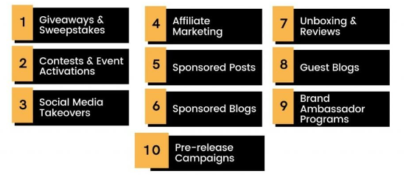
Figure 1: Influencer marketing
(Source: Engaiodigital, 2023)
Makrides, et al. (2020) identified that influencer marketing is an important approach which leads in convening customers with the help of attractive and creative videos and posts related to the products and services offered by the firm. Influencer marketing uses famous individuals as an influencer who collaborates with the top leading brands such as Unilever Plc. This is a kind of marketing approach which has been used by Unilever Plc for getting connected with their targeted and potential customers. In the competitive business environment, the concept of influencer marketing is playing fundamental role in order to increase brand awareness resulting in increasing growth and productivity of the organizations in the market which is targeted. In the concept of influencer marketing approaches, the brands uses highly innovative and creative content for engaging and connecting with the customers at a local as well as global level. The famous influencer uses collaborative approach for promoting the goods and services provided by the selected brand and this result in increasing the sales and profitability of the organization in the market.
Stoldt, et al. (2019) cited that in the influencer marketing, the brand uses platforms of te social media in order to reach more customers while enhancing the overall revenues and the business efficiency in the market which is targeted. With this, it is also been evaluated that influencer on the social media channels is useful for offering quality and effective services to the consumer and this makes customers more valued and appreciated. The influencers get connected with the customers on social media platforms for understanding their needs and requirements. There is a major impact of influencers marketing on the buying behaviour of purchaser and hence can leads in enhancing the sales and productivity of the chosen firm. In the influencers marketing, the brand do partnership with the top leading and famous influencers and allow them for promoting and selling their products on various social media platforms.
Belanche, et al. (2020) states that the concept of influencer marketing is a strategy used by Unilever Plc for getting on their targeted audience and this also helps in building a social proof and grows the overall profitability of the firm in the market place. When the consumers see the products and services being shared by the people they know and trust, changes the buying decision of the customers. It has been identified that seventy one percent of the consumers are lean towards buying the goods when it is recommended by their trusted and famous influencers. There are multiple benefits of using influencer marketing for the brand and it help them in gaining multiple competitive benefits and advantages. With the help of influencer marketing, the selected brand is creating content which features their products and services and hence increase the awareness of the brand which is very beneficial for the growth of the firm. This is one of the most effective ways for creating a hype around a new products and services. Unilever Plc uses social media channels such as YouTube, Instagram and Facebook for promoting products and uses creative content for increasing the sales of the business.
Shen, (2021) said that the approaches and strategies used in influencer marketing also results in taping into new and emerging markets and reach to more potential customers in the market. By increase the reach of the customers, the overall sales and profitability of the firm gets enhanced and which leads in increasing the ROI of the selected business organizations. This is also a very cost effective approach which help brand in using less money for promoting, advertising as well as for selling their products to the targeted and potential customers. Unilever Plc is also using best practices in influencer marketing and uses celebrities and famous personalities for brand promotion. Camoiras-Rodriguez, and Varela, (2020) stated that with the help of influencer marketing, the brand uses effective approaches for asking queries and feedback about the product and services. The brand uses influencer marketing is used for sourcing feedback and reviews on the new goods provided by the company.
Rossato, and Castellani, (2020) cited that influencer marketing is an effective approach which has been used by the leading brands for establish a good relationship and bond between then brand and customers. It has been identified that long term relationships with the customers are very benefits because they helps in increasing the credibility and trust with the influencer audience when their followers see that they can continuously work with them. Influencer marketing helps the chosen brand in gaining more visibility when influencer recommending different products of different the brand this automatically enhances the awareness of the brand. All these features and benefits of influencer marketing boost the overall revenue and profitability of the firm and also able to gain multiple kind of competitive position in the market place.

2.3 Influence of influencer marketing on consumer behaviour
As per the view point of Belanche, et al. (2021), the term influencers marketing have a foremost influence on the behaviour of consumers. The concept of influencers marketing uses effective approaches for influencing and attracting customers and hence which results in changing the purchasing decision of the customers. When, the famous and well known influencers on the social media platforms uses influencer marketing approaches then this can change the perception and behaviour of customers. This makes customers more informed and involved with the brand and hence which results in higher sales and more revenues. With the help of influence marketing, the brand gets connected with the targeted and potential customers at a global level and which influences more customers and increase the customer base of the firm. The brand uses effective and innovative influencer marketing approaches for analyzing and understanding the needs and requirements of the customer so that more growths as well as competitive benefits can be achieved. For influencing more customers, the business firm uses creative and attractive content so that customers feel more connected and involved with the brand.
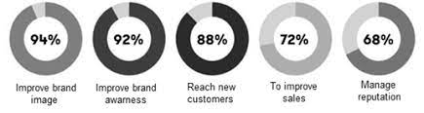
Figure 2: Impact of influencer marketing
(Source: Černikovaitė, 2019)
Tarka, et al. (2022) examined that by considering the needs and wants of the customers, the brand is able to enhance the customer service and which leads in changing the customer behaviour. It has been analyzed that changing the customer’s behaviour have a major impact on the overall long term growth of the firm. By taking these strategies into the account, the business firm gaining trust and loyalty of the customers having solid impact on the attitude and purchasing decision of the business firm. Influencer marketing is also used by the brands for convincing customers by creating innovative and attractive content and which leads in changing the purchasing behaviour of the consumers. The main aim of influencers is to attract the potential customers with the help to effective approaches and this also leads in attracting and influencing customers very easily and effectively. Influencer marketing also focuses on asking feedback and reviews to the consumers so as to analyze the requirements of the customer.
Dhir, et al. (2021) mentioned that this makes customer feels more valued and connect with the brand increasing consumer engagement. These factors are directly connected with the profits of the company in market targeted. The concept of influencer marketing is basically a customer centric approach which focuses on the demand of the customer and makes customers more involved. The brand awareness can be boosted by influencer marketing further it is cost efficient. The brand uses famous personalities and influencers which are highly active on media platforms though consistent posting in the form of videos, images or stories. For changing the purchasing decision of the customers it is further require overcoming competition by taking influencer marketing in the consideration. It has been evaluated that the influencers marketing is also well known for providing personalized form of services to the customers increasing their trust and loyalty towards the brand. This also increase the customer based of the firm and allow the brand to gain multiple competitive advantages. Effective influencer marketing helps in building trus and authenticity which assists in convincing customers for making the purchase.
According to Barta, et al. (2023), influencer marketing is one of the most effective approach which helps in influencing customer purchasing behaviour. The famous and well -known influence have the ability of selling the products and services to the followers in a way which helps them in connecting with via trust and credibility. Influencer marketing is an effective approach which leads in constructing of the emotional connection among the clients and brand. It has been identified that the influencers uses effective approaches and strategies for promoting the products and services and which leads in grabbing the attention of the customers. By leveraging the power of social media and influencer marketing, influencer is able to change the behaviour of consumers with the help of halo effect. The concept of influencer marketing majorly works on two different concepts and which are trust and credibility. Influencers also promote the products and services and also guide the customer for choosing the right and most effective products.
Yokoyama, et al. (2022) said that the brand uses influencer marketing for standing out from their competitors and offer valuable and effective services to their customers. It has been identified that the influencer are considered as the trust experts in multiple fields and have gained trust of the different demographic segment which can be unlisted by the company for increasing profitability of the business organizations. In the Unilever Plc, the marketing strategies have been also enhanced with the help of influencer marketing. The brand is able to understand the needs and requirements of the customer and which lead in changing the customer behaviour. In the recent years, influencer marketing is emerged as a dominant strategy and it is very crucial for the brand to enhance long term growth initiatives and come ahead of the competition in the target market. The primary objective of influencer marketing is to foster relationships and connecting between the customers and brand and which making customers feel more valued and involved in the firm.
Agmeka, et al. (2019) cited that for succeeding in the area, the brands are focusing on cultivating long term relationships with the customers whose value and interest align with their own. There are multiple benefits of using influencer marketing and the overall sales and productivity of the firm gets enhanced with the help of effective influencer marketing approaches. The concept of influencer marketing also plays a very important role in increasing the brand awareness in the local as well as global market. This is a very appealing way which provides organic, positive endorsements and many others factors are there. It has been identified that an influencer approach is very subtle because the content used by the business organizations looks and feels like their usual posts and thus it results in increasing the brand awareness. This also makes customers more informed and aware about the latest products and services offered by the firm and hence which leads in making customers more influenced and involved at the workplace.

2.4 Influencer marketing practices of retail firms
Saura, (2021) cited that , the main aim of influencer mar eking which is used by the top leading firm is to uses new media platform in order to promote and sale products and services in the market. It has been analyzed that the FMCG firms are using influencer marketing is embarked as new marketing strategy by various companies and this is having a significant impact on the expansion of the business firms. Influencer marketing is a very effective approach which allows the brand to reach to more customers at the global level and hence enhance the overall sales and productivity of the firm in the market place. With the help of influencer marketing, the firms are directly impacting the buying decisions of the customers. There are multiple strategies which have been used by the FMCG Company in influencing marketing. These strategies also enhance the growth and success rate of the firm. It has been identified that influencer marketing strategies and best practices also results in increasing the revenue growth and profit margin. This helps the firms in gaining multiple competitive benefits and advantages and hence makes the firm more productive in the target market place. All these strategies also provide effective strategies play significant role in enhancing growth and performance of the companies in the market.
Shrivastava, et al. (2021) said that one of the most common strategies which have been used by Unilever Plc in the influencer marketing is connecting with niche audience. The brand are using social media platform for reaching to more potential customers. The posts and videos uploaded by the influencers are very creative and helps in attracting the potential customers. With the help of this attractive content, the brand gets connected with the customers and hence gains better and potential customers. All these factors gain the trust and loyalty of the customers.
It has been analyzed that when the firms saw their most favourite actor using social media as a tool for advertising the products offered by the firm then this leads in gaining the trust and credibility of the customers. This has a major impact on the growth and overall sales of the firm. By getting connected with the customer, the brand can evaluate the requirements of the customer and hence the overall sale of the firm gets enhanced. For this, the brand also pig for customized form of services to the customers and this enhances the customer service. All these aspects lead in enhancing the productivity and performance of the business and allow the firm to achieve the goal and objectives more effectively.
According to Martínez-López, et al. (2020), the next and significant strategy which has been used by Unilever Plc is to focuses less on the products and more on the ethics and ethos. It has been analyzed that Unilever brand majorly focuses on using their business for driving positive social impact. This brand uses influencer marketing as a most effective approach and also adapt to the customer demand. The brand enhances the awareness of the product along with the ethics, ethos and belief of the business organizations. This brand is solely dependent on its products and services for grabbing the attention of the customers and who share values to the entire world. This is a shift in the marketing strategies and which lead in increasing the overall profits margin and sales of the business firm. This is a very simple strategy which involves the influencer to follow the ethos and beliefs of the brand such as the products placements are very subtle and effective. This also leads in harassing the power of the brand and gain more competitive benefits in the target market place.
Rundin, and Colliander, (2021) mentioned that, the FMCG firms i.e. Unilever Plc also provide discount and coupon codes to the influencers. This is one of the most effective and attractive practice which has been used by the company for convincing customers. This leads in attracting and grabbing the attention of customers. Offering discount codes to the customers helps in gaining larger base of the consumer that can have siginciant impact on the sales and profitability of the firm. The firm provide coupon and discount codes to their followers so that their followers can buy the products and services offered by them. This also helps the brand in monitoring and tracing the sales with the help of this network. Discount codes also provide more flexibility to the customers and which also help the brand in gaining the trust as well as the loyalty of the customers. The next strategy which has been used by the FMCG firms related to influencers marketing is creating contests for the customers. This is also an effective approach which has been used by the top leading FMCG brand for attracting and influencing customers. Unilever Plc also focuses on creating contest in which they offer prize money and other reward points to the customers.
Helberger, et al. (2020) analyzed that Gamification is a significant approach used by the selected brand to among more effective conversation between the brand and people who can become your future and potential customers. Therefore , having a fun and appealing game and contests for the customers is very relevant for the business and the brand also chooses a prize for the winner such as discount and offer free products. It has been analyzed that the influencers also promote their contests on their official social media pages. This strategy also enhances the brand image and value of the firm in the market which is targeted.
Additionally, the next and effective strategy that has been used by the Unilever Plc is launching the products and services with the help of influencer. The brand collaborates with the famous and well known influences for promoting and launching new products into the market. The brand also chooses brand ambassador for promoting the products and services in enhancing the performance of the firm in the market place. All these factors have a major influenceon the productivity of the firm. The firms also rely on effective approaches related to influencer marketing and for gaining a competitive position in the market.

2.5 Theories and models of consumer behaviour
As per Majeed, et al. (2021), consumer behaviour theories and models are described as the analysis of the market's decision-making and purchasing attitudes and habits based on which businesses carry out marketing activities to sell their products and services. Theories have helped marketing executives forecast the factors that influence consumers that will lead to buying the company offerings. Market researchers have identified several factors, such as socio-economic, political and environmental factors, that impact customer buying habits. However, Reitsamer, and Brunner-Sperdin, (2021) argues that a critical element that plays a major role in influencing consumer behaviour is income in the hands of customers available for disbursement. People significantly base their buying decisions on purchasing power and willingness to spend money, considering their personal preferences and budget restrictions.
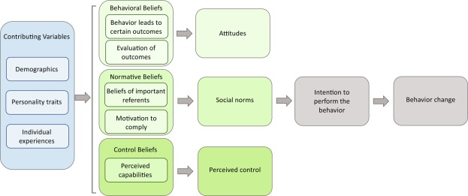
Figure 3: Reasoned action theory
(Source: Akther and Nur, 2022)
Based on these factors, Ismagilova, et al. (2020) lays down several theories on consumer behaviour, one of which is the 'reasoned action theory’. The theory suggests that consumers make decisions based on expected public reaction to a specific behaviour portrayed. Such behavioural pattern is formed by communicating with other consumers in the market and their assumption of purchasing a certain product or service.
Contrary to the above, the ‘social cognitive theory’, as explained by Otaye-Ebede, et al. (2020), studies consumer behaviour that relies on information-based decision-making. Under this theory, behaviour is not influenced by actions, emotions, ideologies and perceptions of others. Overwalle, et al. (2020) recognizes the 'theory of planned behaviour', which can be considered to be on the same lines as the former theory, which lays down that consumers rely on their rationality and intention as a deciding factor. A key behavioural theory, as recognized by Jiang, and Pu, (2021), wherein all the variables are integrated and studied, is the ‘integrated model of behavioural prediction’. This theory combines factors such as attitude towards a specific behaviour depiction, information-oriented approach and intention-based characteristics mixed with public influence on purchasing habits.
Based on these theories, several models have been developed on consumer behaviour over a period of time. Pereira, (2021) describes a traditional model called the 'learning model', according to which consumers purchase a company's products and services with the intention of meeting personal needs. These needs are understood to develop in ascending order, beginning with psychological requirements that end with meeting self-actualization goals. In addition, Chopra, et al. (2021) speaks of the ‘psychoanalytical model’ by which consumers strive to satisfy compelling desires that may stem from a conscious or subconscious drive to acquire a product or service.
While several models describe consumer purchasing patterns and trends based on societal influences and economic constraints, Yeo, et al. (2022) identifies the ‘Engel-Kollat-Blackwell Model’ (EKB). This model outlines the various stages of decision-making on the basis of which consumers perform purchases, such as awareness, information processing, evaluation, purchase follow-up and result analysis. Moreover, Stoldt, et al. (2019) lays down the ‘black box model’ according to which consumers are characterized as critical thinkers who consider the external and internal factors before considering purchase.
While there are other models that suggest that consumers adopt rational and systematic decision-making patterns that analyze problems and solutions, Yi, et al. (2023) argues that consumers do not always undertake extensive decision-making processes. Rather, customers are subject to impulsive purchasing trends as laid down by the ‘impulse buying model', which was considered contrary to the aforementioned models.

2.6 Research gap
The gap that the following study is fulfilling relates to the impact of influencer marketing on consumer behaviour within the FMGC sector of the UK. The study mainly collects information that helps to find out the different influencer marketing practices that the FMGC sector is using for attracting customers and impacting their buying behaviour as well. There are other trends that the FMGC sector is following, including setting up partnerships with influencers. By using and implementing these practices, the company is able to attract a higher number of customers thus, thus impacting their buying behaviour. There is another gap that the current study is addressing, which relates to analysing the impact and influencer marketing use on the buying behaviour of customers. There were past studies that showed the impact of this new marketing startegy and revenue of the company. So, the current research is filling the gap by identifying the impact of influencer marketing on the buying behaviour of customers in the FMCG sector.

2.7 Conceptual framework
Product awareness
Advertisement
Service quality and sales force
Purchase decision
Independent variable
Dependent variable

Figure 4: Conceptual framework
(Source: Created by author)

The above conceptual framework depicts the different variable of the research which is to be used for drawing the questionnaire. Three independent variables are included in the conceptual framework for studying the impact of influencer marketing on consumer behaviour in the FMCG industry and the classification of variables can be as service quality, advertisement, and product awareness. These independent variables are elements that can influence the dependent variable, which is the client purchase decision-making process. Service quality represents the level of satisfaction consumers receive from the services associated with a product (Stoldt, et al. 2019). The effectiveness of influencer marketing tactics in explaining the product's attributes and benefits is indicated by the advertisement.
Product awareness refers to consumers' comprehension and familiarity with FMCG products promoted by influencers. These independent variables are clearly linked to the dependent variable which was purchase decision making (Camoiras-Rodriguez, and Varela, 2020). Beneficial service quality perceptions, effective influencer advertising, and enhanced product awareness are all expected to have a beneficial impact on customers' purchase decisions in the FMCG industry. Understanding of variables is considered as key aspects of study and allows having subsequent analysis in context to topic.
Based on the conceptual framework, the following hypotheses have been developed which will be tested in the research.
H₁ – Product awareness from influencer marketing significantly impacts the purchase decisions and eventually the behaviour of consumers of Unilever in the UK.
H₂ – Advertising done by influencers significantly impacts the purchase decisions and eventually the behaviour of consumers of Unilever in the UK.
H₃ – Service quality and sales force information provided by influencers significantly impact the purchase decisions and eventually the behaviour of consumers of Unilever in the UK.

2.8 Conclusion
It could be analysed that influencer marketing is the new trend in the field, which brings together the company and the most popular users of platforms in social as a way of promoting the brand in the market. The customers' buying behaviour in the current social media environment is affected by influencers whom they are following. So, the products that influencers are praising or promoting are likely to get higher attraction from the customer side. The customers are thus expected to purchase the products only after reviewing the feedback of social media influencers. Therefore, this is impacting customer buying behaviour, especially within the FMCG sector.

Chapter 3: Research Methodology

3.1 Introduction
The purpose of this chapter is to adopt the research methods that are essential to achieve each research objective. A research methodology provides various elements such as data collection method, research approach, data analysis method and strategy so that a problem statement is mitigated (Flick, 2015). In the present study, the research onion framework provided in Figure 5 is adopted so that these elements can be selected. The philosophy of the study is adopted first which is followed by the consideration of the research approach as well as the methodological choice. The adoption of an adequate strategy is further done which is related to the method of data collection. A discussion on the research time horizon is considered in this chapter which is the next layer of the research onion framework. Furthermore, the data collection technique is discussed followed by the data analysis technique which is collectively considered with the sample size of the research and the method of sampling used to reach the participants. Research ethics are further adopted in this chapter for performing the study ethically.
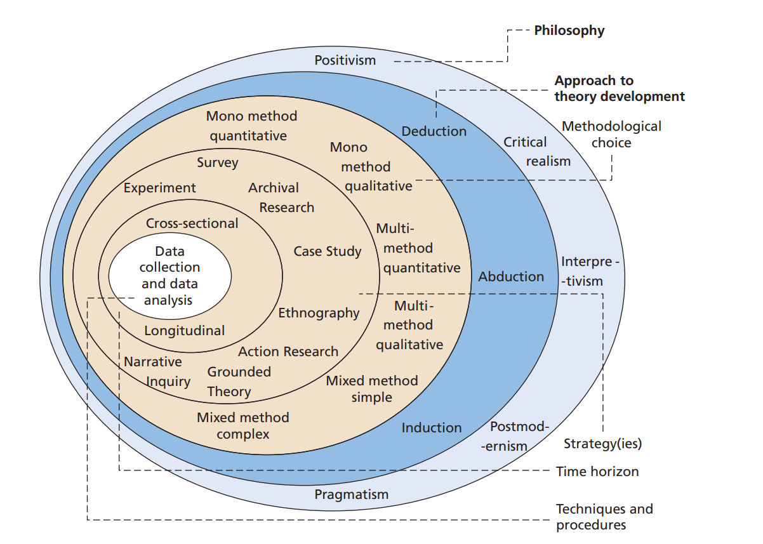
Figure 5 Research onion
Source: (Saunders, Lewis and Thornhill, 2019)

3.2 Research Philosophy
The set of principles which are adopted in a study and are considered by the researcher for the collection and analysis of data along with the belief related to reality (Tamminen and Poucher, 2020). A number of options are provided by the research onion that can be utilised in the present study. Positivism philosophy refers to the belief that the overall reality related to a phenomenon has an objective characteristic and the knowledge is actually present beyond what is currently known. On the other hand, an interpretivism philosophy refers to the subjective type of reality and believes that various factors impact this reality and the human behaviour associated with it (Alharahsheh and Pius, 2020). The present investigation adopts the philosophy of positivism because objective reality is taken into account so that an accurate interpretation can be done. It is also determined that the data i.e., the opinions of customers of Unilever is present beyond what is currently known which is the existing literature. So, an adequate exploration of consumer behaviour and its alteration due to influencer marketing of Unilever will be done from the implementation of the positivism philosophy.

3.3 Research approach
The second element that should be considered while dealing with research methodology is the approach of the study as it provides the type of reasoning implemented for the interpretation of the collected data (Thomas, 2022). It is necessary that the philosophy of this research is aligned with the approach for which the selection should be done from the abduction, deduction and induction approaches provided by the research onion. The induction approach refers to the development of a theory which is associated with the phenomenon being analysed whereas a deduction approach is based on testing a particular piece of information or hypothesis (Woiceshyn and Daellenbach, 2018). So, the latter one i.e., deduction is adopted in this research because hypotheses testing will be done so that the relationship between independent and dependent variables can be determined. Another rationale is that the objective type of data is considered in this approach for the collection and analysis of close-ended data.

3.4 Methodological choice
A further analysis of the research onion leads to the choice of methodology of the study in which the data type is selected. The collection and analysis related to the reality of the research are directly dependent on the mono, mixed or multi-methodological choices provided by the research onion. From these choices, the mono-method quantitative choice is adopted in this research because numerical results based on this choice are provided by the quantitative methodology (Queirós, Faria and Almeida, 2017). Furthermore, the multi-method or the mixed method is omitted so that the study can be completed in the available time. In addition, the accuracy offered by the quantitative methodology is related to the deduction research approach. This is beneficial to analyse the impact of influencer marketing on consumer behaviour when conducting research on Unilever, UK.

3.5 Research strategy
The strategy element of the research is now considered while exploring the next layer in research onion. Guidance towards data collection and the exploration of a phenomenon is directly based on the research strategy (Melnikovas, 2018). The number of options such as archival research, survey, case study, action research, etc. exists in the research onion which should be considered. The primary nature provides the rationale for selecting the strategy of the survey and this will be conducted online on the platform Google Survey because of its reliability to collect data online. Furthermore, the link to the survey can be easily shared with the survey participants which is the reason for this selection. Close-ended data is gathered in a survey as it aims to gather the required information in less amount of time (Vaske, 2019). So, this is a benefit of the survey strategy which has been another reason for selecting this and thus should be determined as the foremost consideration for guiding the data collection method.

3.6 Time horizon
The predecessor of data collection and analysis is the time horizon of the research which is concerned with the overall time frame and the pattern in which data collection should be done. Only one process of collecting data is present in the cross-sectional time horizon which is opposed to the longitudinal time horizon in which various approaches and steps are implemented to gather the required information (Sahay, 2016). When considering the present investigation, it is essential to adopt the cross-sectional time horizon because the survey is planned to be conducted only once to gather data from the participants. This is appropriate so that the research gets completed in the available time and no delays are present due to intervals which might have been there in the consideration of the longitudinal time horizon. So, the cross-sectional time horizon is effective in the current study.

3.7 Techniques and procedures
3.7.1 Research sample
The first element that should be considered in the last layer is the sample size of the research as well as the method used to reach the sample because of the need to conduct a primary investigation (Taherdoost, 2016). In the current study, the sample contains 60 consumers of Unilever in the UK who are active on the internet. These are chosen because they can provide data about how influencer marketing done by Unilever impacts consumer behaviour in the UK. However, the sample cannot be reached in the absence of a sampling approach. The benefit of the elimination of any target population bias is provided by the random sampling method in a primary investigation (Emerson, 2015). Another reason is the presence of a large number of FMCG customers in the UK which provides the benefit of using the random sampling method. Therefore, the current study also adopts this technique for reaching the relevant participants without any bias. The participants will be contacted by email and social media platforms and a link to the survey will be shared.
3.7.2 Data collection method
A primary investigation requires the adoption of a technique in which either qualitative data using focus groups or interviews or quantitative data is collected using a questionnaire (Mazhar et al., 2021). The selection of the mono-method quantitative choice for this study provides the rationale to select the second method i.e., the questionnaire in which close-ended questions are present for collecting objective data from the participants. Questionnaires are suitable for surveys because they aim to collect more data in less time due to the objective questions asked of the participants. The below questionnaire thus involves these types of questions that are based on the independent and dependent research variables along with some demographic questions.
Questionnaire
Demographic Questions
Question 1. What is your gender?
a) Male
b) Female
c) Prefer not to say
Question 2. How old are you?
a) 18-25
b) 26-35
c) 36-45
d) 46 and above
Question 3. For how many years have you been purchasing products from Unilever in the UK?
a) 0-2
b) 2-5
c) 5-10
d) More than 10
Measurement items based on the Likert Scale
Product awareness
1. I believe that influencers on the internet provide reliable information about products of Unilever.
a) Strongly disagree
b) Somewhat disagree
c) Neutral
d) Somewhat agree
e) Strongly agree
2. I think my awareness about the products and services provided by Unilever has increased from the promotions done by influencers.
a) Strongly disagree
b) Somewhat disagree
c) Neutral
d) Somewhat agree
e) Strongly agree
3. In my opinion, social media influencers have expertise in the peculiar characteristics of the products provided by Unilever.
a) Strongly disagree
b) Somewhat disagree
c) Neutral
d) Somewhat agree
e) Strongly agree
Advertisements
4. I think there have been more advertisements done by influencers for Unilever as compared to former times.
a) Strongly disagree
b) Somewhat disagree
c) Neutral
d) Somewhat agree
e) Strongly agree
5. In my opinion, consumers of Unilever such as myself are more attracted towards the promotions by celebrities.
a) Strongly disagree
b) Somewhat disagree
c) Neutral
d) Somewhat agree
e) Strongly agree
6. I prefer buying a Unilever product after watching an advertisement containing a positive review from an influencer about the respective product.
a) Strongly disagree
b) Somewhat disagree
c) Neutral
d) Somewhat agree
e) Strongly agree
Service quality and salesforce
7. I believe that more information about the service quality of Unilever is communicated by influencers during their reviews on the internet.
a) Strongly disagree
b) Somewhat disagree
c) Neutral
d) Somewhat agree
e) Strongly agree
8. In my opinion, support to the salesforce of Unilever is provided by influencer marketing implemented by the company.
a) Strongly disagree
b) Somewhat disagree
c) Neutral
d) Somewhat agree
e) Strongly agree
9. I think that more sales are achieved by Unilever in the UK due to the product reviews of prominent people on platforms such as social media.
a) Strongly disagree
b) Somewhat disagree
c) Neutral
d) Somewhat agree
e) Strongly agree
Purchase decision
10. My preference for buying a certain product from Unilever changes after I watch a product promotion on the internet done by an influencer.
a) Strongly disagree
b) Somewhat disagree
c) Neutral
d) Somewhat agree
e) Strongly agree
11. I believe that the opinions of influencers are considered by people before deciding to purchase any product of Unilever.
a) Strongly disagree
b) Somewhat disagree
c) Neutral
d) Somewhat agree
e) Strongly agree
12. In my opinion, consumer behaviour has been significantly affected after Unilever started using influencer marketing.
a) Strongly disagree
b) Somewhat disagree
c) Neutral
d) Somewhat agree
e) Strongly agree
3.7.3 Data analysis method
The technique to analyse the collected information is based on data type because descriptive analysis or content analysis is done when qualitative data is collected whereas statistical analysis is required in the case of quantitative data (Wickham and Wickham, 2016). So, statistical analysis is relevant because the present research is a quantitative one and there is a need to analyse the close-ended data gathered from the participants. Linear regression analysis is used to test hypotheses by measuring the relationships between independent and dependent predictors present in the research model (Montgomery, Peck and Vining, 2021). So, this analysis will be done using SPSS (Statistical Package for Social Sciences) so that the hypotheses can be tested and the findings can be obtained.

3.8 Limitation of research
The degradation of the reliability of the results provided by an investigation happens when there are limitations related to the methods used to address the research problem (Theofanidis and Fountouki, 2018). So, it is necessary that the limitations of this study are realised while taking into account the methodology adopted above in this chapter. It is identified that there is a lack of qualitative data collection because the focus is only on quantitative or close-ended data related to the research area. Although precision and accuracy are important characteristics linked to the quantitative data, comprehensive results would not be there due to the lack of qualitative data.

3.9 Ethical considerations
Research ethics are important when collecting data from human participants because of the security and confidentiality required in data handling (Dooly, Moore and Vallejo, 2017). This is also true for the present investigation and thus the cloud storage secured by a strong password will be used so that confidentiality is maintained. This will be accessible only to the investigator and for anonymity, the questionnaire has omitted the consideration of any personal questions which could reveal the participants’ identity. For secure disposal, the completion of the research will mark the time of deleting the collected data. Furthermore, the informed consent of participants has been gained through a participant information sheet and a consent form.

3.10 Conclusion
This chapter has successfully selected the research methods appropriate for meeting the objectives. With the consideration of research onion, the positivism philosophy is selected which will help in analysing the information present outside the scope of the existing knowledge and hypothesis testing will be adequately done using the deductive approach. Furthermore, the mono-method quantitative methodological choice has been adopted for the collection of quantitative data using the close-ended questionnaire and the survey strategy. The gathering of data in an adequate time will be done through a cross-sectional time horizon and the regression analysis will be done using SPSS to analyse the collected responses of 60 consumers of Unilever in the UK who are active on the internet. While collecting and storing the data, the ethics of anonymity, informed consent and confidentiality will be considered as discussed above.

Chapter 4: Data analysis, findings and discussion

4.1 Introduction
The interpretation of the results attained by this research is done in this chapter by performing data analysis and obtaining the research findings. The survey on Google Forms has been conducted among the research participants and it is essential to analyse the responses provided by them to the questionnaire. In this chapter, the responses to the demographic questions present in the questionnaire are first provided followed by the reliability test to check the reliability of the questions. Furthermore, the three research hypotheses developed in chapter 2 are tested using the method of linear regression analysis. A discussion is then provided which has the purpose of determining the reliability of the results by comparing them with the literature.

4.2 Analysis of demographic questions
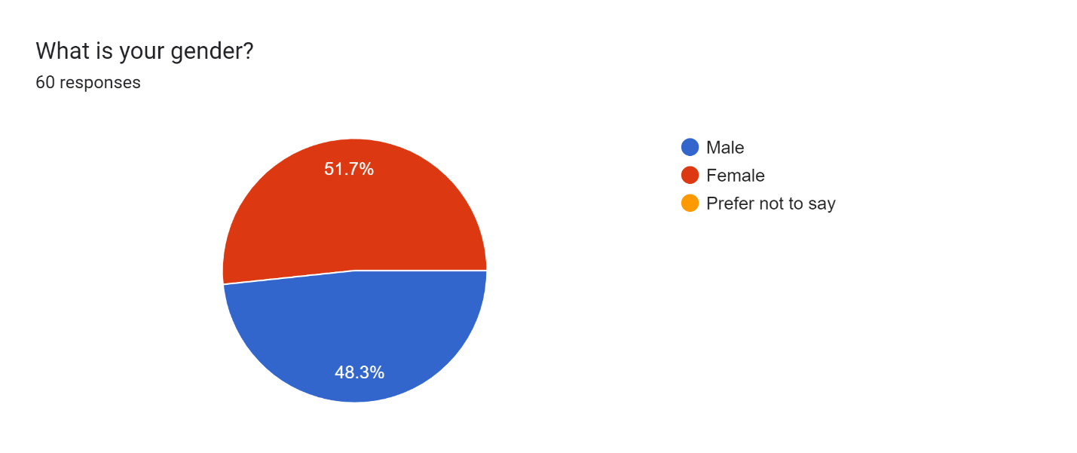
Figure 6 Pie chart representing the responses for the first demographic factor
Source: Google Forms
The data was collected from 60 consumers in the UK who are active on the internet and buy products from Unilever. The interpretation of the responses based on the first question reveals that 48.3% i.e., 29 participants were males and the remaining 51.7% i.e., 31 participants were females. Gender bias refers to the dependency of the responses in a survey towards a particular gender which can negatively impact the reliability of the collected data (Andrade, 2020). It is interpreted from the above results that the opinions of both male and female consumers in the UK have been collected which makes the findings valid and highlights the absence of any gender bias.
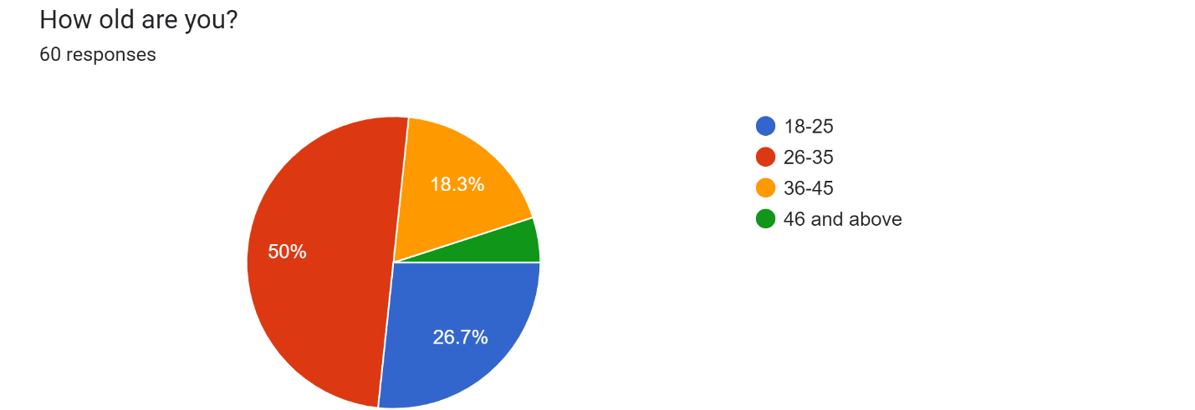
Figure 7 Pie chart representing the responses for the second demographic factor
Source: Google Forms
The analysis further leads to the second demographic factor which is the age of the participants collected during the survey. It is interpreted from the pie chart given above that the majority of the participants belonged to the age group of 26-35 as this option was selected by 30 out of 60 participants. This was followed by the responses towards the age group of 18-25 and 36-45. Therefore, it is evident that the results are not biased concerning participants’ age and thus are reliable.
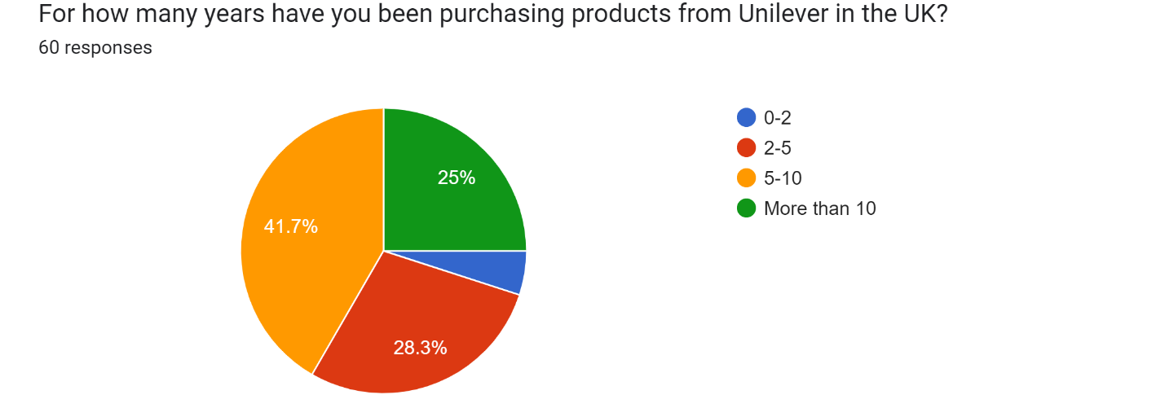
Figure 8 Pie chart representing the responses for the third demographic factor
Source: Google Forms
The last factor related to the demographics of the participants was the number of years for which they have been buying products from Unilever in the UK. This was essential to determine their experience with the promotions done by the company on the internet including influencer marketing. The analysis of the responses from the pie chart shown in Figure 8 signifies that the highest number of participants had a purchase experience of 5 to 10 years whereas the second highest i.e., 28.3% had an experience of 2 to 5 years. Some responses are also obtained for the other options which highlights that data has been gathered from people who have been buying products of Unilever for many years.

4.3 Reliability test
The reliability test is conducted for the scale items present in a measurement scale with the evaluation of the value of Cronbach’s alpha which is a measure that indicates reliability when greater than 0.7 value (Chan and Idris, 2017). In the present research, the Likert Scale was used to develop the questionnaire so that a statistical test can be conducted on the collected data. Various scale items were developed based on the independent and dependent variables. The scale items for the independent variable ‘product awareness’ are denoted by PA1, PA2 and PA3; ‘Advertisements’ are denoted by A1, A2 and A3; ‘Service quality and salesforce’ are denoted by SQS1, SQS2 and SQS3. Furthermore, the measurement scale items for the dependent variable ‘purchase decision’ are denoted by PD1, PD2 and PD3 respectively. To conduct the reliability test, SPSS v.26.0 was used and the value of Cronbach’s alpha was calculated. It is interpreted from Table 1 that all the values for the measurement scale items are greater than 0.7 which denotes significant reliability.
Table 1 Values of Cronbach's alpha
 | Cronbach's Alpha
PA1 | .967
PA2 | .968
PA3 | .968
A1 | .969
A2 | .968
A3 | .968
SQS1 | .967
SQS2 | .969
SQS3 | .967
PD1 | .968
PD2 | .969
PD3 | .971
Source: SPSS

4.4 Linear Regression analysis
The linear relationship between two or more predictors or variables along with the variation in one variable due to variation in another is measured by linear regression analysis (Pal et al., 2019). It is an effective statistical analysis method which provides insights into the relationship between research variables and is therefore a valuable procedure in the present study. SPPS v.26.0 was used to conduct this analysis by first converting the responses of the participants into numerical values i.e., ‘Strongly agree’ into 5, ‘somewhat agree’ into 4 and so on up to ‘strongly disagree’ i.e., 1. The average of responses of every three scale items was calculated because every variable had three scale items. Furthermore, the accuracy of 95 entities out of 100 is indicated by the 95% confidence level when conducting regression analysis (Wan, Liu and Bretz, 2022). So, this level was selected while analysis the data through linear regression. The responses to the scale items regarding the dependent variable given below were first considered for the y values.
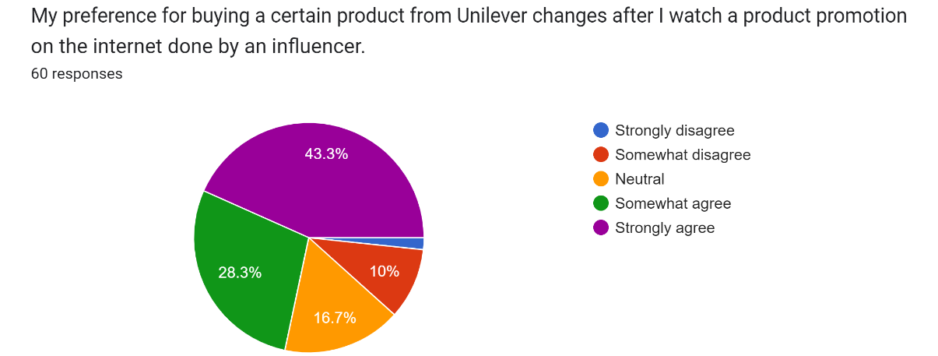
Figure 9 Pie chart representing the responses for the first scale item on purchase decision
Source: Google Forms
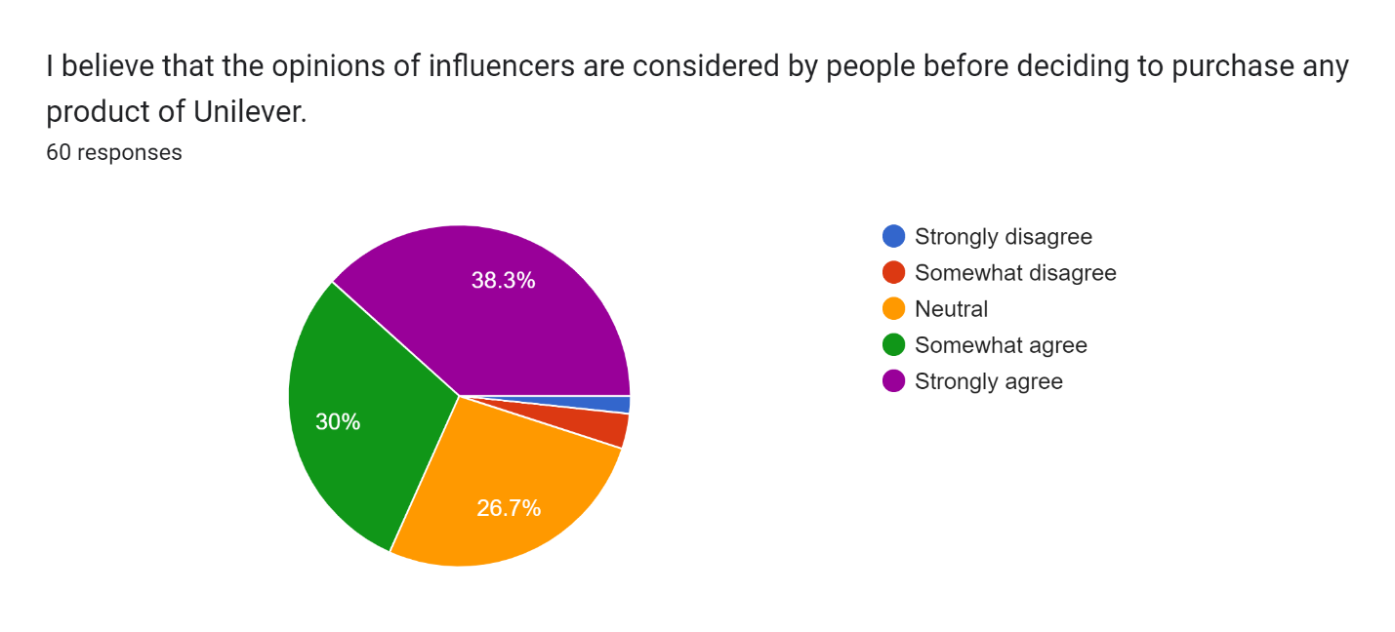
Figure 10 Pie chart representing the responses for the second scale item on purchase decision
Source: Google Forms
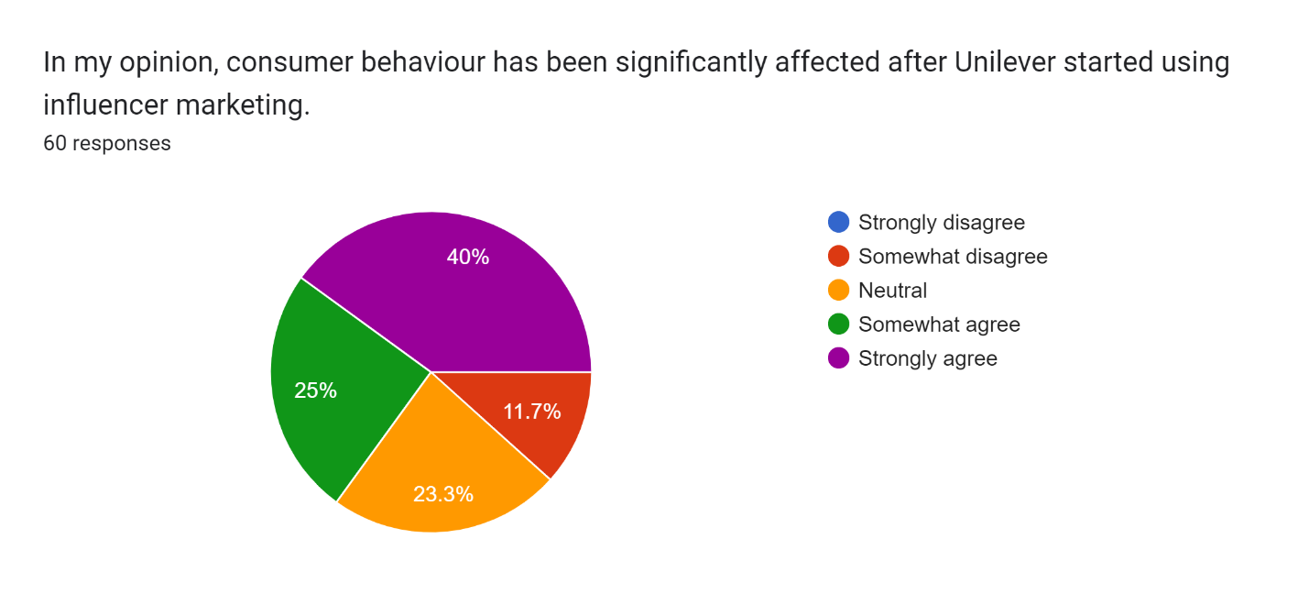
Figure 11 Pie chart representing the responses for the third scale item on purchase decision
Source: Google Forms
The responses of the participants for the above three scale items shown in Figures 9, 10 and 11 were put into the y value because they are based on the dependent variable purchase decision.

4.4.1 Analysis for testing hypothesis 1
The first research hypothesis is based on the impact of product awareness from influencer marketing on consumer purchasing decisions. In the measurement scale, the first three scale items were based on product awareness regarding which the collected data is represented below.
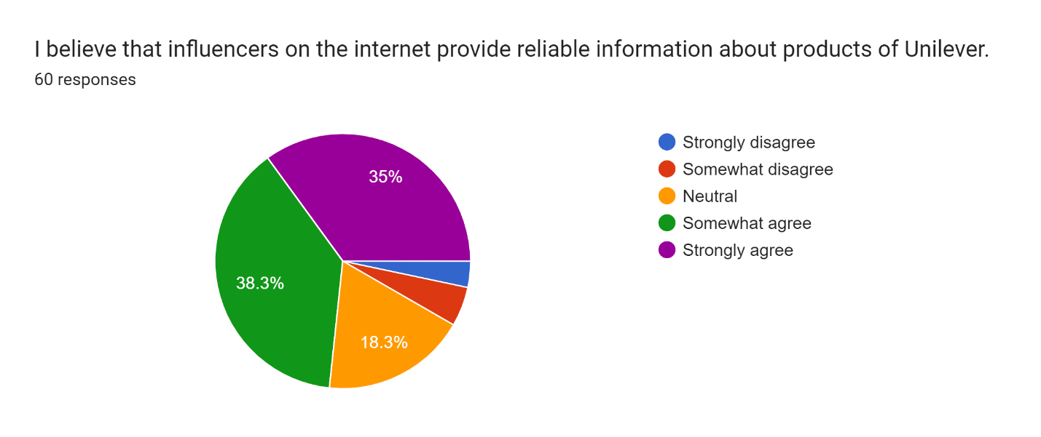
Figure 12 Pie chart representing the responses for the first scale item on product awareness
Source: Google Forms
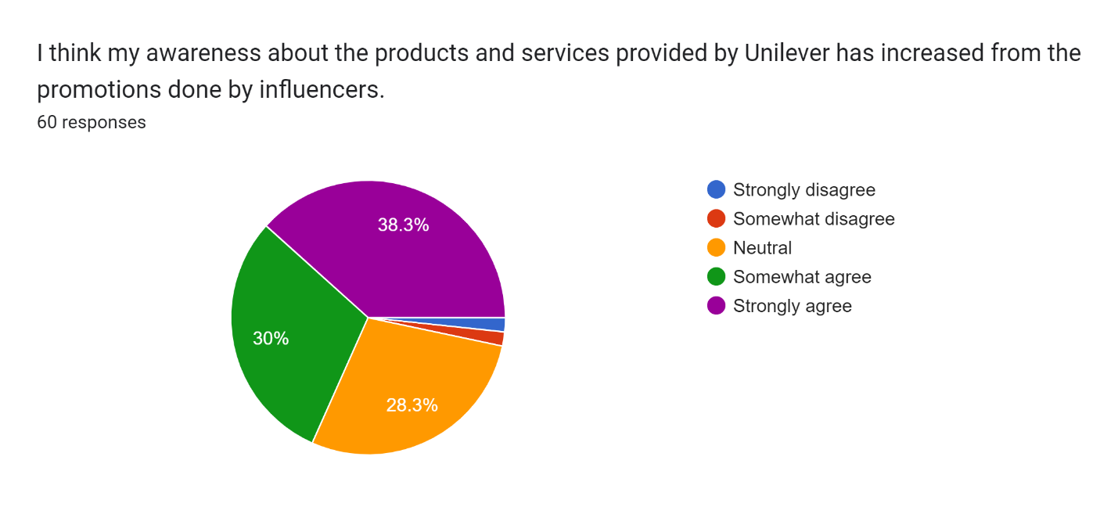
Figure 13 Pie chart representing the responses for the second scale item on product awareness
Source: Google Forms
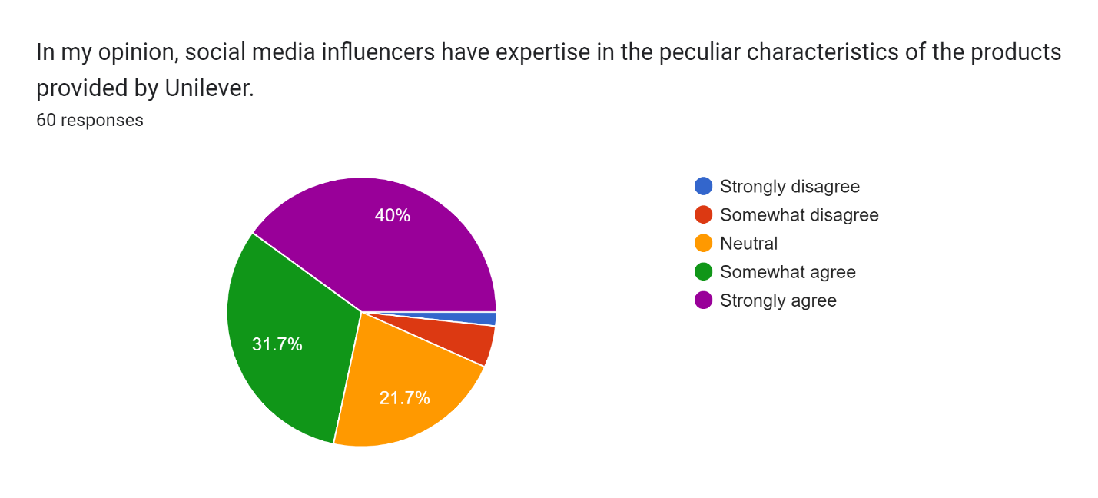
Figure 14 Pie chart representing the responses for the third scale item on product awareness
Source: Google Forms
It is evident from the above pie charts that most of the participants agree with the benefit of product awareness that comes from influencer marketing. For testing the first hypothesis, the above data was considered the value of x which was put into SPSS to obtain the outcomes for linear regression as given below.
Table 2 Results of the first regression analysis
Model Summary^{b}
Model | R | R Square | Adjusted R Square | Std. Error of the Estimate
1 | .854ª | .729 | .724 | .487
a. Predictors: (Constant), Productawareness
b. Dependent Variable: Purchasedecision

ANOVAª
Model |  | Sum of Squares | df | Mean Square | F | Sig.
1 | Regression | 36.995 | 1 | 36.995 | 155.872 | .000^{b}
1 | Residual | 13.766 | 58 | .237
1 | Total | 50.761 | 59
a. Dependent Variable: Purchasedecision
b. Predictors: (Constant), Productawareness

Coefficientsª
Model |  | Unstandardized Coefficients |  | Standardized Coefficients | t | Sig.
 |  | B | Std. Error | Beta | t | Sig.
1 | (Constant) | .511 | .285 |  | 1.791 | .079
1 | Productawareness | .867 | .069 | .854 | 12.485 | .000
a. Dependent Variable: Purchasedecision
Source: SPSS
Interpretation
The results obtained for the first linear regression analysis as shown above comprise a total of three elements which include the model summary for regression statistics, ANOVA coefficients and regression coefficients. The first entity in statistics given above is the value of R which provides the relationship between the predictor and the dependent variable and is also known as the correlation coefficient (Fox and Weisberg, 2018). This is 0.854 as shown in Table 2 which indicates the 85.4% relationship between product awareness and purchase decision. On the other hand, the changes or variations that come in the dependent variable due to the predictor are provided by R square and its adjusted version i.e., adjusted R square (Gelman et al., 2019). It is essential to determine which value to consider and the presence of only one predictor provides the significance of R square which is 0.729 as obtained in the above table. So, it is evident that purchase decision varies by 72.9% when there is a variation in product awareness derived from influencer marketing. In addition, the standard error should be less than 1 in regression analysis so that the reliability of the collected observations can be determined (Daoud, 2017). The above table provides the 0.487 value of standard error of the estimate which clearly indicates reliability.
The ANOVA coefficients provide the value of statistical significance which is present when the significance F value is less than 0.005 (Ahlgren and Walberg, 2017). In Table 2, this value is 0.000 that can be represented as F(1,58) = 155.872, p < 0.005. It is evident that the value is less than 0.005 which provides the statistical significance for the relationship between x and y. In addition, the third component of the results includes the regression coefficients which are used to make a visual representation using the slope and intercept (Schroeder, Sjoquist and Stephan, 2016). The results obtained in the above table provide the slope of 0.511 and the intercept of 0.867 which leads to the linear regression equation y = 0.511x + 0.867. This equation is represented by the scatter plot shown in Figure 15 which indicates the alignment of the observations for the predictor with that of the dependent variable. The standard error related to this change in y due to x is also very low because of the value 0.069 obtained in the above results. The t-statistics value in linear regression analysis is responsible for conducting a test between the alternate and the null hypothesis and the alternate or default hypothesis is true when the value is greater than 1 (Darlington and Hayes, 2016). So, the 12.485 value in Table 2 indicates that H₁ is true.
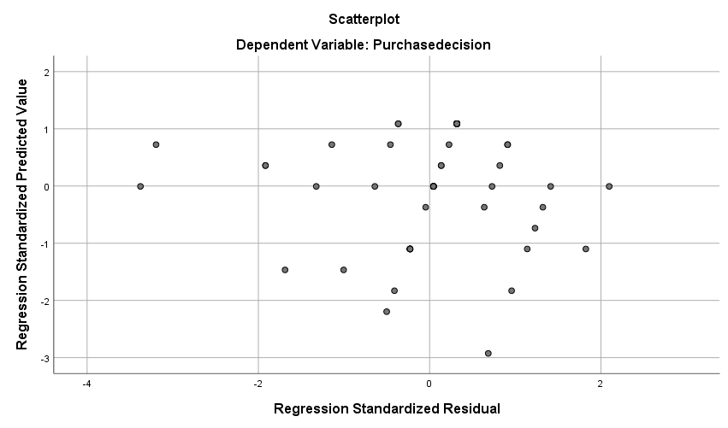
Figure 15 Scatter plot depicting the relationship between product awareness and purchase decision
Source: SPSS

4.4.2 Analysis for testing hypothesis 2
The second hypothesis is based on the relationship between the dependent variable purchase decision and the independent variable advertisements. The fourth, fifth and sixth scale items represent this variable the collected responses for which are given below.
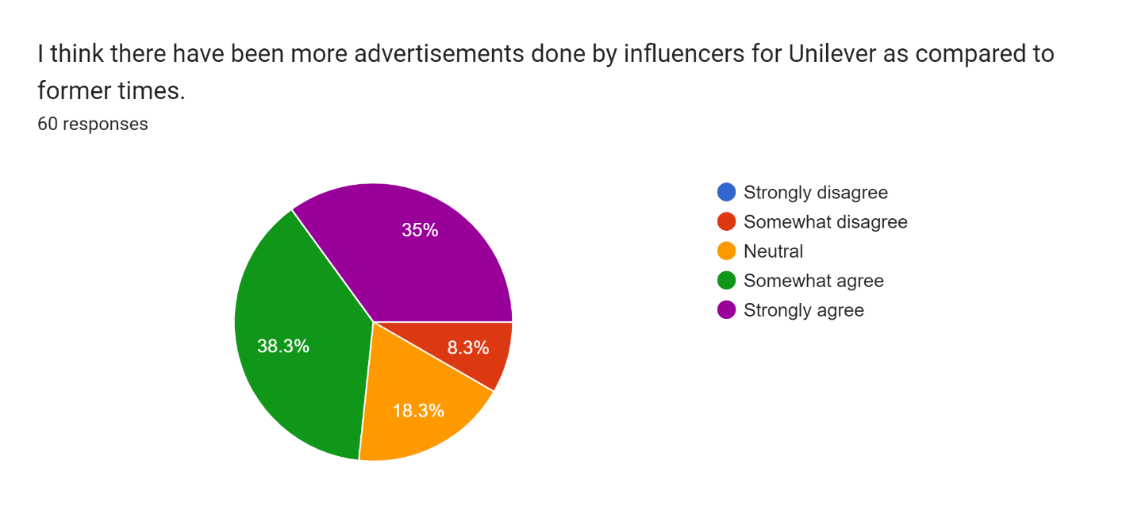
Figure 16 Pie chart representing the responses for the first scale item on advertisements
Source: Google Forms
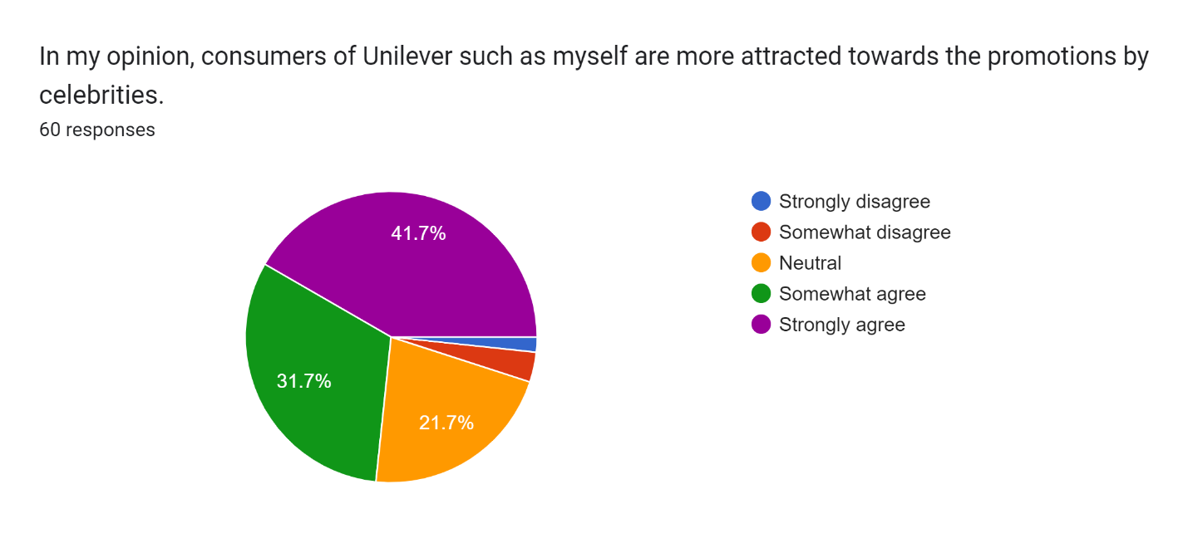
Figure 17 Pie chart representing the responses for the second scale item on advertisements
Source: Google Forms
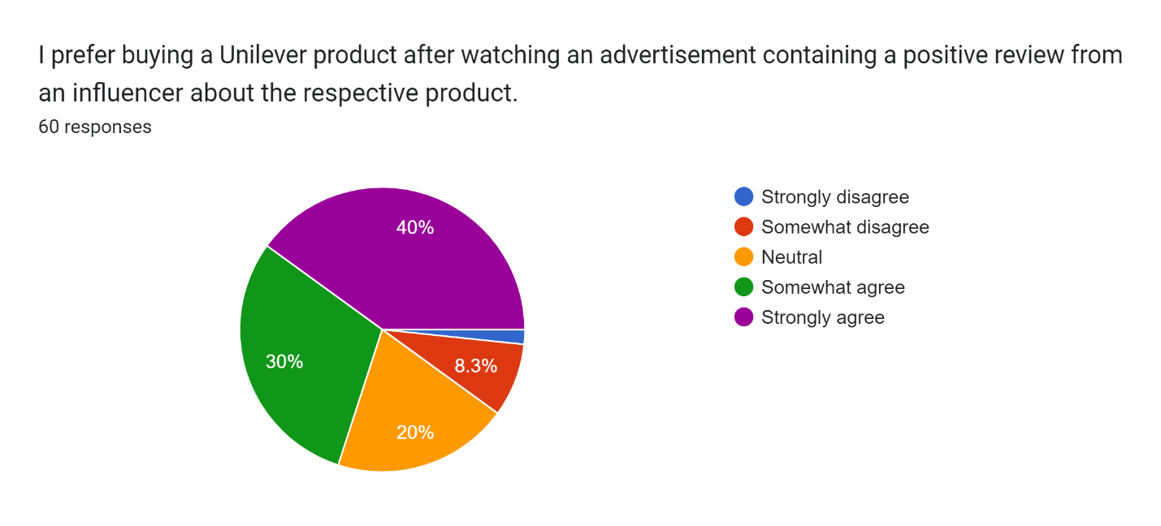
Figure 18 Pie chart representing the responses for the third scale item on advertisements
Source: Google Forms
For testing the second hypothesis, the above data was considered as the value of x so that the impact of advertisements through influencer marketing on the purchase decisions of customers in Unilever in the UK can be determined. The value of y is the same in this case as in the previous analysis because of the same dependent variable and after ensuring the 95% confidence level, the below results were obtained.
Table 3 Results of the second regression analysis
Model Summary^{b}
Model | R | R Square | Adjusted R Square | Std. Error of the Estimate
1 | .862ª | .743 | .738 | .474
a. Predictors: (Constant), Advertisements
b. Dependent Variable: Purchasedecision

ANOVAª
Model |  | Sum of Squares | df | Mean Square | F | Sig.
1 | Regression | 37.705 | 1 | 37.705 | 167.503 | .000^{b}
1 | Residual | 13.056 | 58 | .225
1 | Total | 50.761 | 59
a. Dependent Variable: Purchasedecision
b. Predictors: (Constant), Advertisements

Coefficientsª
Model |  | Unstandardized Coefficients |  | Standardized Coefficients | t | Sig.
 |  | B | Std. Error | Beta | t | Sig.
1 | (Constant) | .384 | .285 |  | 1.348 | .183
1 | Advertisements | .895 | .069 | .862 | 12.942 | .000
a. Dependent Variable: Purchasedecision
Source: SPSS
Interpretation
The commencement of the analysis is with the first element of regression coefficients which is R. A 0.862 value is present in the above table which highlights the 86.2% relationship between x and y. Furthermore, R square is known as the coefficient of determination as it determines the variation in the dependent variable due to the predictor present in the research model (Chicco, Warrens and Jurman, 2021). From the results in the above table, a 74.3% variation in the purchase decision due to advertising done by influencers for Unilever is evident because of the 0.743 value. In addition to this, the adjusted R square element is not considered due to the presence of only one predictor in the research model. The reliability of the results is also obtained because of the low standard error of 0.474. So, all 60 observations attained from participants’ responses have provided reliable findings of linear regression.
The interpretation of the ANOVA coefficients is majorly related to the value of significance F because of the lack of contribution given by the sum of squares and their individual values when it comes to linear regression (Brook and Arnold, 2018). Therefore, the significance F value is 0.000 which is less than 0.005 and is represented as F(1,58) = 167.503, p < 0.005. A statistical significance in the relationship between x and y becomes evident from these results. In addition to this, the change in the dependent variable due to the predictor is highlighted by the unstandardised coefficients. The slope and intercept obtained while testing the second hypothesis are shown in Table 3 and provide the linear regression equation y = 0.384x + 0.895. A visual representation of this equation is provided in the scatter plot shown in Figure 19. It is also interpreted that the variation is valid because of the very low 0.69 standard error obtained while calculating the coefficients as mentioned in the above table. Furthermore, the default or alternate hypothesis H₂ is found true because of the 12.942 value which is significantly higher than 1. The interpretation of the results of the second linear regression analysis thus concludes that purchase decisions and eventually the behaviour of consumers of Unilever in the UK are significantly impacted by advertising done by influencers.
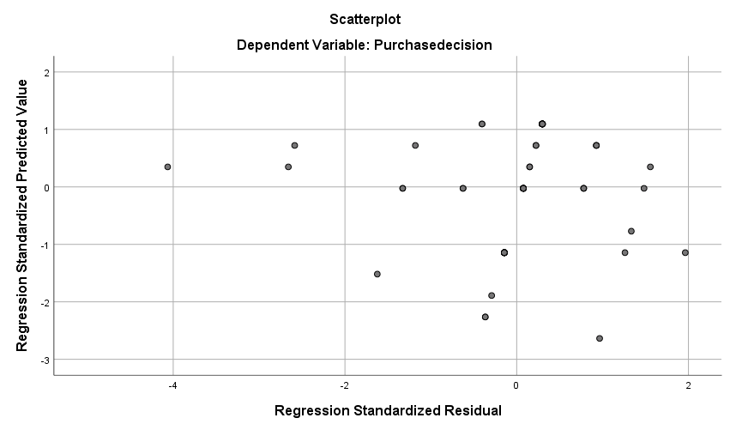
Figure 19 Scatter plot depicting the relationship between advertisements and purchase decision
Source: SPSS

4.4.3 Analysis for testing hypothesis 3
The factors of service quality and salesforce were the consideration of the third research hypothesis developed in chapter 2. The seventh, eighth and ninth scale items in the measurement scale were based on these factors for which the collected data is given below.
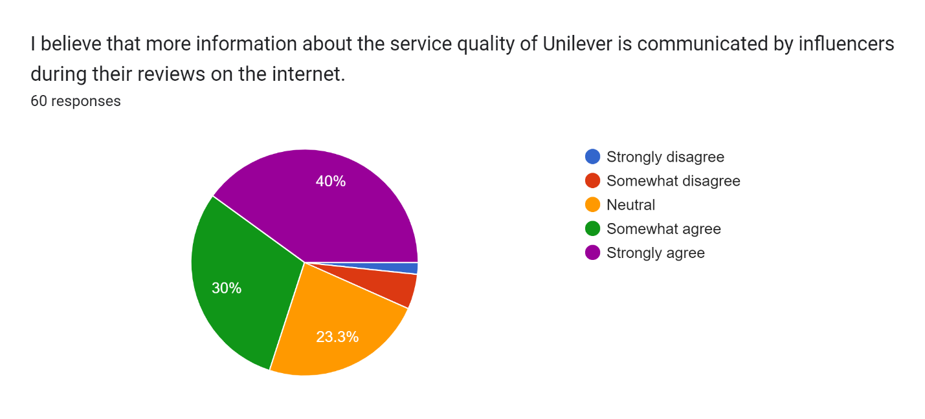
Figure 20 Pie chart representing the responses for the first scale item on service quality and salesforce
Source: Google Forms
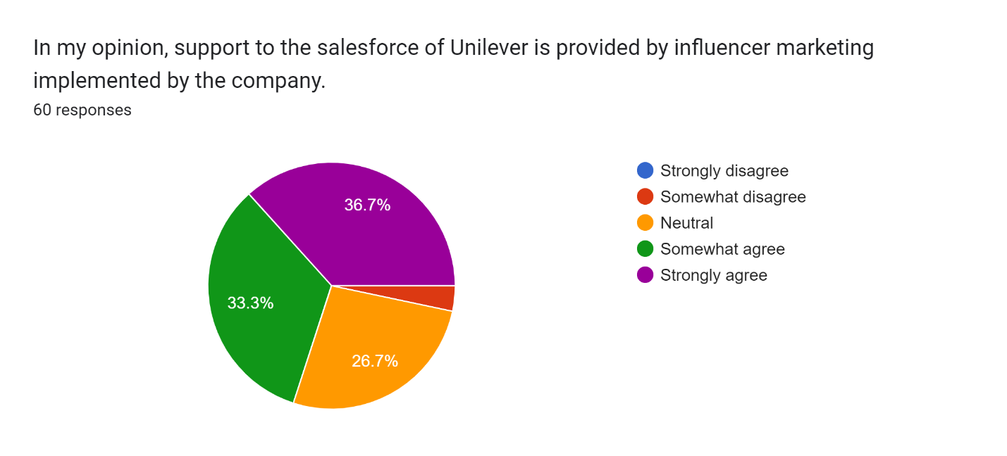
Figure 21 Pie chart representing the responses for the second scale item on service quality and salesforce
Source: Google Forms
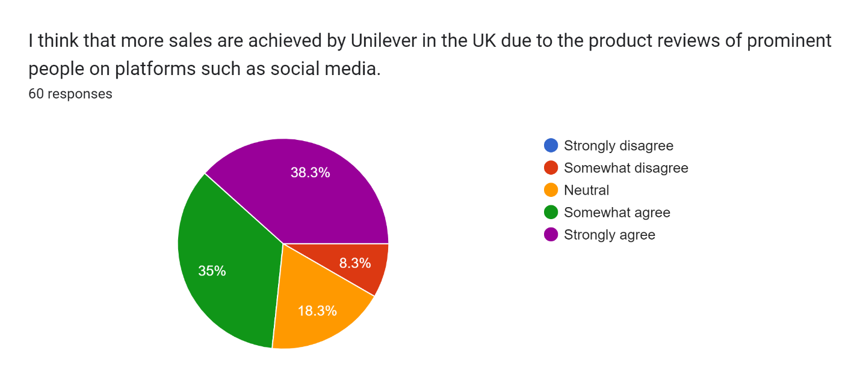
Figure 22 Pie chart representing the responses for the third scale item on service quality and salesforce
Source: Google Forms
A significant agreement of consumers in the UK has been obtained in the above results which are now considered for the x values because service quality and salesforce collectively is an independent variable which is taken into account for testing the third hypothesis. The results obtained in this attempt are provided below.
Table 4 Results of the third regression analysis
Model Summary^{b}
Model | R | R Square | Adjusted R Square | Std. Error of the Estimate
1 | .871ª | .758 | .754 | .460
a. Predictors: (Constant), Servicequalityandsalesforce
b. Dependent Variable: Purchasedecision

ANOVAª
Model |  | Sum of Squares | df | Mean Square | F | Sig.
1 | Regression | 38.497 | 1 | 38.497 | 182.067 | .000^{b}
1 | Residual | 12.264 | 58 | .211
1 | Total | 50.761 | 59
a. Dependent Variable: Purchasedecision
b. Predictors: (Constant), Servicequalityandsalesforce

Coefficientsª
Model |  | Unstandardized Coefficients |  | Standardized Coefficients | t | Sig.
 |  | B | Std. Error | Beta | t | Sig.
1 | (Constant) | .274 | .281 |  | .975 | .333
1 | Servicequalityandsalesforce | .921 | .068 | .871 | 13.493 | .000
a. Dependent Variable: Purchasedecision
Source: SPSS
Interpretation
The last hypothesis should be tested by first considering the model summary in which an 87.1% relationship is obtained between the predictor and the dependent variable. This is due to the 0.871 value of R present among regression statistics. Furthermore, the 0.758 value of R square is also reliable as it indicates a 75.8% variation in the y values when there is a variation in the x values. An alignment of these results with the standard error is identified because of the low error of 0.46 mentioned in Table 4. The validity of the 60 observations thus becomes evident from this low value of error and it is now essential to interpret the ANOVA values which indicate the Significance F value 0.000. Therefore, F(1,58) = 182.067, p < 0.005 highlights a statistical significance in the relationship between x and y. When it comes to regression coefficients, a greater change in y with the change in x is indicated by the slope and intercept values in Table 4 which make up the equation y = 0.274x + 0.921 represented visually in Figure 23. The standard error is also low at 0.068 and the true characteristic of the hypothesis has been interpreted from the high t-stat value which is 13.493.
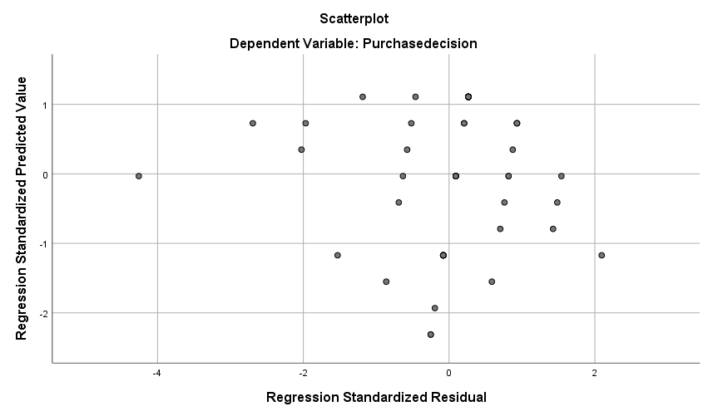
Figure 23 Scatter plot depicting the relationship between service quality and salesforce and purchase decision
Source: SPSS

4.5 Discussion
The discussion of research findings is now required to assess their insights with the reviewed literature so that similarities and differences between the results and the findings of other authors can be determined. The effectiveness of influencer marketing was analysed by Chopra et al. (2021) in their study which revealed that customers are majorly influenced by this marketing technique which helps the brand promote its products and services. Well-known influencers play a critical role in the advertisements of the propositions of a brand and thus are preferred in digital marketing methods. It is also evident from the results of the present study that a significant impact is made by influencers on the behaviour of consumers. Therefore, the above information provided by Chopra et al. (2021) is confirmed by this research. Furthermore, Belanche, et al. (2020) argue that better product awareness is provided after the utilisation of influencer marketing because of the communication of the influencer with the audience which contains the information about the product being promoted. The acquisition of this information thus becomes beneficial for the consumers as they know the advantages and shortcomings associated with the product. The true nature of the first hypothesis in the present study also signifies the importance of influencer marketing with respect to product awareness. Therefore, the findings of this research confirm the arguments given by Belanche, et al. (2020).
In addition, the purchasing decisions of customers and a change in these decisions were evaluated by Tarka, et al. (2022) in their study. The authors provided the insight that not only the attitudes of the customers but also decisions towards the purchase of certain products are changed after they watch the product promotions done by influencers on the internet. This is because of the prominence of influencers among the customers. With respect to Unilever, UK, the benefit of this marketing method towards consumer purchasing decisions has been identified from the research findings. The second hypothesis of this research is found true which provides the insight that the arguments of Tarka, et al. (2022) are confirmed by the obtained results. In addition, the importance of an emotional connection was determined by Barta, et al. (2023) who argue that a brand can make such a connection with the target customers through the implementation of influencer marketing. The image of the influencer among the audience becomes effective for the brand in making a positive impact while promoting the products and services offered by it. The attention of customers is acquired after the same offerings are advertised through partnerships with people famous in the same industry. However, there was no finding related to emotional connection in the present research and thus the results of Barta, et al. (2023) are not confirmed by this study.
The consideration of social media when it comes to influencer marketing is also important and was evaluated by Stoldt, et al. (2019) while exploring this subject matter. The authors were able to reveal that the promotion of the services provided by a brand can be done effectively by partnering with influencers. The recommendations of influencers become beneficial in making the customers realise the service quality provided by the brand. Concerning Unilever, UK, this has been identified after the third hypothesis was found true from the linear regression analysis. It is evident from the findings that influencer marketing positively impacts consumer behaviour through the effective promotion of the service quality of the brand. Therefore, the arguments of Stoldt, et al. (2019) are validated by this research. On the other hand, Rossato, and Castellani, (2020) argue that awareness regarding the brand increases among the customers after the reviews of the products are done by influencers. This is due to not only trust but also the credibility perceived by the target audience for the opinions of famous people on the internet about the products and services provided by the being promoted. The benefits as well as features of the product that can be effective for the customers are instantly recognised by them after the promotion done by influencers. A significant contribution of this marketing method to product awareness and its impact on consumer behaviour is identified in this research which validates the arguments of Rossato, and Castellani, (2020).
Yokoyama, et al. (2022), in their exploration, revealed that the expertise of influencers in the products and services that they are promoting contributes to the acquisition of better behaviour from the target customers. Support for other marketing strategies is provided by this benefit of influencer marketing derived from the expertise of influencers. However, the factor of influencers’ expertise has not been considered in the current research findings. Although the impact on consumer behaviour has been determined in the results, there is no specific insight into the expertise factor and thus the insights of Yokoyama, et al. (2022) are neither confirmed nor rejected by this research. In the FMCG sector, an exploration was done by Saura (2021) who found that an effective approach is provided by influencer marketing to the companies operating in this sector. The productivity of the firms is increased from the greater sales obtained after the implementation of this marketing method. This is due to the success of the FMCG brands in positively impacting the behaviour of consumers. In the FMCG sector of the UK, the potential of influencer marketing has been identified in the present research with respect to the company Unilever which confirms the arguments of Saura (2021).
When it comes to theoretical consideration, Otaye-Ebede, et al. (2020) argued that consumer behaviour is positively impacted when the decision-making is information-based. Such information is about each characteristic related to the products and services offered by a brand. It is determined by the authors that the perceptions of others are also considered by the consumers and thus the prominence of influencers among others makes them purchase the promoted products. This makes the decisions information-based and eventually contributes to the behaviour of consumers towards the brand. This has also been determined in the present study which thus substantiates the arguments of Otaye-Ebede, et al. (2020). In addition, Shrivastava, et al. (2021) argued that connection with the niche audience is made by a brand after the adoption of influencer marketing as the digital marketing method. The purchasing decisions are impacted positively by the advertising done by the brand after partnering with influencers. This has been determined in the present investigation from the true nature of the second hypothesis which validates the insights provided by Shrivastava, et al. (2021).

4.6 Conclusion
The analysis of the data collected during the online survey has been effectively done in this chapter from the implementation of linear regression analysis. The reliability test revealed that the measurement scale was reliable and thus collected valid data from the research participants. Furthermore, the hypotheses testing revealed that all four research hypotheses are true and the aspects related to influencer marketing such as service quality and sales force, advertising and product awareness significantly impact consumer purchasing decisions leading to a better behaviour of consumers of Unilever, UK. An alignment of these findings with the existing literature has also been identified in the discussion.

Chapter 5. Conclusion and recommendations

5.1 Introduction
The purpose of this chapter is to validate the research findings with the four research objectives and the overall aim of the study. This is done with the comparison of the insights obtained from data analysis with the initial objectives that is followed by the discussion of research implications in this chapter. These implications provide the contribution provided by the results to the research area. Furthermore, a discussion is also provided for the limitations concerned with this study so that the areas that need attention concerning the research methodology are identified adequately. This chapter also provides recommendations for future research.

5.2 Realisation for the accomplishment of research aim and objectives
The aim of this study was to analyse the impact of influencer marketing on consumer behaviour in the FMCG sector by conducting a study on Unilever UK. This aim has been achieved by the collection and evaluation of primary data from 60 consumers of Unilever UK about how their behaviour is impacted by the influencer marketing implemented by this FMCG company. It is identified that a positive impact is there due to the prominence of influencers among consumers in the UK which makes them give attention to the reviews of influencers about the products and services provided by Unilever. The first objective of this research was to understand the concept of influencer marketing and the review of the literature has contributed to a better understanding of this concept. It is determined that the expertise of influencers and their level of following allow brands to effectively target the niche audience. When it comes to the FMCG sector, brands find themselves able to make good relationships with customers after the promotion of products with the help of online influencers. Therefore, such an importance has led to a reliable understanding of influencer marketing.
The second research objective was to evaluate the impact of Unilever UK influencer marketing on consumer behaviour. The findings of this study have led to the evaluation of this impact from the true nature of all the hypotheses found after statistical data analysis. It is determined that a positive impact was made on consumer behaviour by Unilever after the partnership with influencers for promoting the products and services of the company. Furthermore, the third objective was to identify influencer marketing practices adopted by Unilever UK to affect consumer behaviour. This has also been identified from the literature as well as the primary data as it is determined that attention towards product awareness is given by the company and the expertise of influencers is utilised for obtaining a better impact on their shopping behaviour. Advertising is also effectively done through influencer marketing and the practice of promoting the salesforce and service quality is also adopted by Unilever UK. The fourth and last objective of this research was to recommend ways to improve the effectiveness of influencer marketing within Unilever UK. It is recommended that Unilever UK should opt for partnerships with only those influencers who have expertise in FMCG products and services. This will help in establishing trust among the target customers and making a good brand-audience relationship with them. Another recommendation is that the promotion of products and services should be done by contacting influencers who have an extensive number of followers on digital platforms such as social media applications.

5.3 Research implications
The epilogue of an academic investigation includes a discussion on the contribution provided by the findings which refer to its implications towards practice, theory, policy and literature (Moeller, Tomblin and OcHL, 2015). The present research has the literature implication that the gap identified in the second chapter after a critical evaluation is now addressed. The lack of primary research has been addressed after collecting and analysing information from consumers of Unilever in the UK. So, original data has been contributed to the literature which is not only beneficial for a better understanding of the impact of influencer marketing but is also useful for other researchers who opt to explore this area in the future.
The policy implications of a study are concerned with the contribution towards the reforms of existing policies and the implementation of new ones (Bell and Waters, 2018). This is also true in the existing context because the findings can be used by policymakers at Unilever, UK to reform the marketing policies. They can address the areas of such policies through the consideration of the research findings. Furthermore, they can adopt new policies based on the recommendations provided while accomplishing the last objective of this research. It is evident that the findings have led to significant policy implications for the FMCG sector.
Furthermore, the theoretical implications related to this research are based on the contribution of the findings towards an effective understanding of the theories concerned with the area being explored. For instance, the theory of reasoned action proposes that the intention of a consumer to perform a particular behaviour is derived from social norms, attitudes, behavioural beliefs and other contributing variables (Montano and Kasprzyk, 2015). These can be better understood after realising the impact of influencer marketing towards these elements and eventually contributing to the purchase intention of consumers. Another theory discussed during the literature review is social cognitive theory based on information-based decision-making and it is evident from the findings of the study that the decisions of customers are derived from the information provided by influencers.
The last implication is towards practice because practical steps can be taken by Unilever, UK for positively impacting consumer behaviour by influencer marketing after utilising the insights revealed in this research. The first contribution is that product awareness can be enhanced by partnering with influencers who have expertise in the benefits of the products. Moreover, they should consider the aspect of following into practice because a better result can be obtained after partnering with influencers who have a great level of following. So, practical steps can be taken by Unilever, UK after leveraging the research findings.

5.4 Limitations of the study
The reliability associated with the results obtained in research is negatively impacted by the limitations based on the utilised methodology (Greener, 2018). It is thus essential to determine the limitations present in the methods used in the current research. The first limitation is concerned with the dependency on statistical outcomes from the adoption of the quantitative methodology. Only numerical findings were obtained without the collection of detailed opinions of research participants. The data collection instrument of a questionnaire led to the collection of objective responses from the participants based on the options provided to them which highlights a restriction towards their detailed opinions and is a limitation that needs to be addressed in the future.
A weak area of the methodology towards the sample size has also been identified in the present study because the data was collected from only 60 consumers in the UK. The sample size of a primary study highlights the extent to which information is collected (Ahmad and Halim, 2017). So, a limited extent is identified with respect to this research because of the small sample size containing only 60 participants. More information about the impact of influencer marketing on consumer behaviour would have been collected by reaching more consumers of Unilever in the UK. There might be some difference in the opinions of other people as compared to the ones contacted during the research.
The third limitation is concerned with the focus of the investigation because the findings were only related to the influencer marketing implemented by Unilever, UK. Generalisability in research refers to the extent of applicability of the findings to a general context instead of being useful to only a specific area (Murad et al., 2018). So, a lack of generalisability is present in the current research because the insights are only applicable to Unilever, UK. There could be a difference in the opinions of Unilever outside the UK or the customers of other FMCG brands which also implement influencer marketing. However, the lack of generalised results restricts in analysis of any such differences in the collected data.
Furthermore, the characteristics of a research sample are based on the sampling method used to approach the participants while considering their eligibility (Oribhabor and Anyanwu, 2019). It is identified that the characteristics of the sample included the age of participants above 18 and being consumers of Unilever in the UK. However, the findings might differ when the opinions of marketers of Unilever are considered. There was a lack of data collection from either the marketers or the influencers of Unilever so that their perspectives towards the impact on consumer behaviour would be determined. This limitation related to the characteristics of the research sample needs to be addressed in the future.

5.5 Recommendations for future research
The scope of the current investigation should be extended by investigators in the future who aspire to further explore the area of influencer marketing in the FMCG sector or any other sector. It is recommended that they should opt for qualitative methods so that detailed information from the participants can be collected. Interviews come in data collection techniques of qualitative studies and have the potential to analyse the opinions of the participants comprehensively (Roulston and Choi, 2018). So, this technique should be used by researchers in the future so that the restriction of this research regarding the collection of only objective data through a quantitative methodology can be addressed.
An effort towards the sample size should also be made by investigators in the future so that the limitation concerning the small sample size is mitigated. They should opt for contacting more than 60 participants while initiating the data collection process. This will increase the extent to which information about influencer marketing is gathered for evaluation. It is also realised that the number of factors identified in the research area can increase after more people are contacted by the researchers. There can be a difference in the findings of this study and the ones obtained in the future due to the presence of an additional number of participants. The increment in sample size will therefore positively impact the reliability of the exploration.
The third suggestion for researchers is that they should work on the factor of generalisability while conducting a study on influencer marketing. It is determined that the narrowed findings obtained in the current research should be addressed by finding data outside the UK when it comes to Unilever or collecting data about other companies operating in the FMCG sector. This will help in providing generalised findings regarding the subject matter which can be applied by marketers in this industry for a better implementation of influencer marketing. The generalisation should be done in a way that would extend the scope present in the research conducted above. The implementation of the insights can also be done by other FMCG companies from the utilisation of such generalised results.
In addition, the last recommendation is that sample characteristics should be redefined by researchers in the future while opting for primary data collection. The data should not only be gathered from the customers of FMCG companies but also from their marketers so that their opinions are also considered about the impact made by influencer marketing. Furthermore, influencers in this sector should be reached to analyse their opinion about how consumer behaviour is affected by their reviews of FMCG products. This will help in analysing the alignment of the opinions of customers collected in the present study with the ones provided by influencers and marketers.

5.6 Conclusion
This chapter concludes that the findings of the research have been able to accomplish the research objectives and the overall aim of the investigation. It is evident that the results provided by data analysis have led to the identification of the impact of influencer marketing on consumer behaviour when it comes to Unilever, UK. Various implications have been provided by the research that can be beneficial towards the literature associated with the research and the practices implemented by Unilever while opting for influencer marketing. A better understanding of the research theory and the policy implementations has been determined from the implications. However, there is a prevalence of limitations such as the small sample size and the lack of qualitative research data along with the lack of generalisability which should be addressed in the future by other researchers using the recommendations provided in this chapter.

References
Agmeka, F., Wathoni, R.N. and Santoso, A.S. (2019) ‘The influence of discount framing towards brand reputation and brand image on purchase intention and actual behaviour in e-commerce’, Procedia Computer Science, 161, pp.851-858.
Ahlgren, A. and Walberg, H.J. (2017) ‘Generalized regression analysis’, Research design: The logic of social inquiry, p.285.
Ahmad, H. and Halim, H. (2017) ‘Determining sample size for research activities’, Selangor Business Review, pp.20-34.
Akther, T. and Nur, T. (2022) ‘A model of factors influencing COVID-19 vaccine acceptance: A synthesis of the theory of reasoned action, conspiracy theory belief, awareness, perceived usefulness, and perceived ease of use’, PLoS One, 17(1), p.e0261869.
Alharahsheh, H.H. and Pius, A. (2020) ‘A review of key paradigms: Positivism VS interpretivism’, Global Academic Journal of Humanities and Social Sciences, 2(3), pp.39-43.
Andrade, C. (2020) ‘The limitations of online surveys’, Indian journal of psychological medicine, 42(6), pp.575-576.
Barta, S., Belanche, D., Fernández, A. and Flavián, M. (2023) ‘Influencer marketing on TikTok: The effectiveness of humor and followers’ hedonic experience’, Journal of Retailing and Consumer Services, 70, p.103149.
Belanche, D., Casaló, L.V., Flavián, M. and Ibáñez-Sánchez, S. (2021) ‘Understanding influencer marketing: The role of congruence between influencers, products and consumers’, Journal of Business Research, 132, pp.186-195.
Belanche, D., Flavián, M. and Ibáñez-Sánchez, S. (2020) ‘Followers’ reactions to influencers’ Instagram posts’, Spanish Journal of Marketing-ESIC, 24(1), pp.37-54.
Bell, J. and Waters, S. (2018) Ebook: doing your research project: a guide for first-time researchers. McGraw-hill education (UK).
Brook, R.J. and Arnold, G.C. (2018) Applied regression analysis and experimental design. CRC Press.
Camoiras-Rodriguez, Z. and Varela, C. (2020) ‘The influence of consumer personality traits on mobile shopping intention’, Spanish journal of marketing-ESIC, 24(3), pp.331-353.
Campbell, C. and Farrell, J.R. (2020) ‘More than meets the eye: The functional components underlying influencer marketing’, Business horizons, 63(4), pp.469-479.
Černikovaitė, M. (2019) ‘The impact of Influencer marketing on consumer buying behavior in social networks’, Contemporary Issues in Business, Management and Economics Engineering, pp.805-812.
Chan, L.L. and Idris, N. (2017) ‘Validity and reliability of the instrument using exploratory factor analysis and Cronbach’s alpha’, International Journal of Academic Research in Business and Social Sciences, 7(10), pp.400-410.
Chicco, D., Warrens, M.J. and Jurman, G. (2021) ‘The coefficient of determination R-squared is more informative than SMAPE, MAE, MAPE, MSE and RMSE in regression analysis evaluation’, PeerJ Computer Science, 7, p.e623.
Chopra, A., Avhad, V. and Jaju, A.S. (2021) ‘Influencer marketing: An exploratory study to identify antecedents of consumer behavior of millennial’, Business Perspectives and Research, 9(1), pp.77-91.
Daoud, J.I. (2017) ‘Multicollinearity and regression analysis’, In Journal of Physics: Conference Series (Vol. 949, No. 1, p. 012009). IOP Publishing.
Darlington, R.B. and Hayes, A.F. (2016) Regression analysis and linear models: Concepts, applications, and implementation. Guilford Publications.
Dhir, A., Sadiq, M., Talwar, S., Sakashita, M. and Kaur, P. (2021) ‘Why do retail consumers buy green apparel? A knowledge-attitude-behaviour-context perspective’, Journal of Retailing and Consumer Services, 59, p.102398.
Dooly, M., Moore, E. and Vallejo, C. (2017) Research ethics, Research-publishing.
Emerson, R.W. (2015) ‘Convenience sampling, random sampling, and snowball sampling: How does sampling affect the validity of research?’, Journal of Visual Impairment & Blindness, 109(2), pp.164-168.
Engaiodigital. (2023) Influencer marketing. [Online]. <Available through: https://engaiodigital.com/influencer-marketing-campaign-types/>. [Accessed on: 28th Sep, 2023]
Flick, U. (2015) Introducing research methodology: A beginner's guide to doing a research project. Sage.
Fox, J. and Weisberg, S. (2018) An R companion to applied regression. Sage publications.
Gelman, A., Goodrich, B., Gabry, J. and Vehtari, A. (2019) ‘R-squared for Bayesian regression models’, The American Statistician.
Greener, S. (2018) ‘Research limitations: the need for honesty and common sense’, Interactive Learning Environments, 26(5), pp.567-568.
Haenlein, M., Anadol, E., Farnsworth, T., Hugo, H., Hunichen, J. and Welte, D. (2020) ‘Navigating the New Era of Influencer Marketing: How to be Successful on Instagram, TikTok, & Co.’, California management review, 63(1), pp.5-25.
Helberger, N., Huh, J., Milne, G., Strycharz, J. and Sundaram, H. (2020) ‘Macro and exogenous factors in computational advertising: Key issues and new research directions’, Journal of Advertising, 49(4), pp.377-393.
Ismagilova, E., Slade, E.L., Rana, N.P. and Dwivedi, Y.K. (2020) ‘The effect of electronic word of mouth communications on intention to buy: A meta-analysis’, Information Systems Frontiers, 22, pp.1203-1226.
Jiang, S. and Pu, R. (2021) ‘Reconceptualizing and modeling sustainable consumption behavior: A synthesis of qualitative evidence from online education industry’, Innovative Marketing, 17(3), p.144.
Jin, S.V., Muqaddam, A. and Ryu, E. (2019) ‘Instafamous and social media influencer marketing’, Marketing Intelligence & Planning, 37(5), pp.567-579.
Lee, S. and Kim, E. (2020) ‘Influencer marketing on Instagram: How sponsorship disclosure, influencer credibility, and brand credibility impact the effectiveness of Instagram promotional post’, Journal of Global Fashion Marketing, 11(3), pp.232-249.
Majeed, M., Owusu-Ansah, M. and Ashmond, A.A. (2021) ‘The influence of social media on purchase intention: The mediating role of brand equity’, Cogent Business & Management, 8(1), p.1944008.
Makrides, A., Vrontis, D. and Christofi, M. (2020) ‘The gold rush of digital marketing: assessing prospects of building brand awareness overseas’, Business Perspectives and Research, 8(1), pp.4-20.
Martínez-López, F.J., Anaya-Sánchez, R., Fernández Giordano, M. and Lopez-Lopez, D. (2020) ‘Behind influencer marketing: key marketing decisions and their effects on followers’ responses’, Journal of Marketing Management, 36(7-8), pp.579-607.
Mazhar, S.A., Anjum, R., Anwar, A.I. and Khan, A.A. (2021) ‘Methods of data collection: A fundamental tool of research’, Journal of Integrated Community Health (ISSN 2319-9113), 10(1), pp.6-10.
Melnikovas, A. (2018) ‘Towards an Explicit Research Methodology: Adapting Research Onion Model for Futures Studies’, Journal of futures Studies, 23(2).
Moeller, M.P., Tomblin, J.B. and OcHL. (2015) ‘Epilogue: Conclusions and implications for research and practice’, Ear and hearing, 36, pp.92S-98S.
Montano, D.E. and Kasprzyk, D. (2015) ‘Theory of reasoned action, theory of planned behavior, and the integrated behavioral model’, Health behavior: Theory, research and practice, 70(4), p.231.
Montgomery, D.C., Peck, E.A. and Vining, G.G. (2021) Introduction to linear regression analysis. John Wiley & Sons.
Murad, M.H., Katabi, A., Benkhadra, R. and Montori, V.M. (2018) ‘External validity, generalisability, applicability and directness: a brief primer’, BMJ evidence-based medicine, 23(1), p.17.
Oribhabor, C.B. and Anyanwu, C.A. (2019) ‘Research sampling and sample size determination: a practical application’, Journal of Educational Research (Fudjer), 2(1), pp.47-57.
Otaye-Ebede, L., Shaffakat, S. and Foster, S. (2020) ‘A multilevel model examining the relationships between workplace spirituality, ethical climate and outcomes: A social cognitive theory perspective’, Journal of Business Ethics, 166(3), pp.611-626.
Pal, M., Bharati, P., Pal, M. and Bharati, P. (2019) ‘Introduction to correlation and linear regression analysis’, Applications of regression techniques, pp.1-18.
Pereira, J.F.P. (2021) Can we sense shift in consumer behaviour in Portuguese retail companies due to the pandemic? (Doctoral dissertation, ISCTE-Instituto Universitario de Lisboa (Portugal)).
Queirós, A., Faria, D. and Almeida, F. (2017) ‘Strengths and limitations of qualitative and quantitative research methods’, European journal of education studies.
Reitsamer, B.F. and Brunner-Sperdin, A. (2021) ‘It’s all about the brand: place brand credibility, place attachment, and consumer loyalty’, Journal of Brand Management, 28, pp.291-301.
Rossato, C. and Castellani, P. (2020) ‘The contribution of digitalisation to business longevity from a competitiveness perspective’, The TQM Journal, 32(4), pp.617-645.
Roulston, K. and Choi, M. (2018) ‘Qualitative interviews’, The SAGE handbook of qualitative data collection, pp.233-249.
Rundin, K. and Colliander, J. (2021) ‘Multifaceted influencers: Toward a new typology for influencer roles in advertising’, Journal of Advertising, 50(5), pp.548-564.
Sahay, A. (2016) ‘’Peeling Saunder's research onion’, Research Gate, Art, 3(2), pp.1-5.
Saunders, M., Lewis, P. and Thornhill, A. (2019) Research methods for business students. 8th ed. Pearson.
Saura, J.R. (2021) ‘Using data sciences in digital marketing: Framework, methods, and performance metrics’, Journal of Innovation & Knowledge, 6(2), pp.92-102.
Schroeder, L.D., Sjoquist, D.L. and Stephan, P.E. (2016) Understanding regression analysis: An introductory guide (Vol. 57). Sage Publications.
Shen, Z. (2021) ‘A persuasive eWOM model for increasing consumer engagement on social media: evidence from Irish fashion micro-influencers’, Journal of Research in Interactive Marketing, 15(2), pp.181-199.
Shrivastava, A., Jain, G., Kamble, S.S. and Belhadi, A. (2021) ‘Sustainability through online renting clothing: Circular fashion fueled by instagram micro-celebrities’, Journal of Cleaner Production, 278, p.123772.
Stoldt, R., Wellman, M., Ekdale, B. and Tully, M. (2019) ‘Professionalizing and profiting: The rise of intermediaries in the social media influencer industry’, Social Media+ Society, 5(1), p.2056305119832587.
Taherdoost, H. (2016) ‘Sampling methods in research methodology; how to choose a sampling technique for research’, How to choose a sampling technique for research (April 10, 2016).
Tamminen, K.A. and Poucher, Z.A. (2020) ‘Research philosophies’, In The Routledge international encyclopedia of sport and exercise psychology (pp. 535-549). Routledge.
Tarka, P., Kukar-Kinney, M. and Harnish, R.J. (2022) ‘Consumers’ personality and compulsive buying behavior: The role of hedonistic shopping experiences and gender in mediating-moderating relationships’, Journal of Retailing and Consumer Services, 64, p.102802.
Theofanidis, D. and Fountouki, A. (2018) ‘Limitations and delimitations in the research process’, Perioperative Nursing-Quarterly scientific, online official journal of GORNA, 7(3 September-December 2018), pp.155-163.
Thomas, G. (2022) ‘How to do your research project: A guide for students’, How to do your research project, pp.1-100.
Trivedi, J. and Sama, R. (2020) ‘The effect of influencer marketing on consumers’ brand admiration and online purchase intentions: An emerging market perspective’, Journal of Internet Commerce, 19(1), pp.103-124.
Van Overwalle, F., Manto, M., Cattaneo, Z., Clausi, S., Ferrari, C., Gabrieli, J.D., Guell, X., Heleven, E., Lupo, M., Ma, Q. and Michelutti, M. (2020) ‘Consensus paper: cerebellum and social cognition’, The Cerebellum, 19, pp.833-868.
Vaske, J.J. (2019) Survey research and analysis. Sagamore-Venture. 1807 North Federal Drive, Urbana, IL 61801.
Vrontis, D., Makrides, A., Christofi, M. and Thrassou, A. (2021) ‘Social media influencer marketing: A systematic review, integrative framework and future research agenda’, International Journal of Consumer Studies, 45(4), pp.617-644.
Wan, F., Liu, W. and Bretz, F. (2022) ‘Confidence Sets for a level set in linear regression’, arXiv preprint arXiv:2207.04300.
Wickham, H. and Wickham, H. (2016) Data analysis (pp. 189-201). Springer International Publishing.
Woiceshyn, J. and Daellenbach, U. (2018) ‘Evaluating inductive vs deductive research in management studies: Implications for authors, editors, and reviewers’, Qualitative research in organizations and management: An International Journal, 13(2), pp.183-195.
Ye, G., Hudders, L., De Jans, S. and De Veirman, M. (2021) ‘The value of influencer marketing for business: A bibliometric analysis and managerial implications’, Journal of Advertising, 50(2), pp.160-178.
Yeo, S.F., Tan, C.L., Kumar, A., Tan, K.H. and Wong, J.K. (2022) ‘Investigating the impact of AI-powered technologies on Instagrammers’ purchase decisions in digitalization era–A study of the fashion and apparel industry’, Technological Forecasting and Social Change, 177, p.121551.
Yi, Q., Khan, J., Su, Y., Tong, J. and Zhao, S. (2023) ‘Impulse buying tendency in live-stream commerce: The role of viewing frequency and anticipated emotions influencing scarcity-induced purchase decision’, Journal of Retailing and Consumer Services, 75, p.103534.
Yokoyama, N., Azuma, N. and Kim, W. (2022) ‘Moderating effect of customer's retail format perception on customer satisfaction formation: An empirical study of mini-supermarkets in an urban retail market setting’, Journal of Retailing and Consumer Services, 66, p.102935.

Appendix
University of Wales: Trinity Saint David
E-Thesis Deposit Agreement

Details of the Work
I would like to deposit the following item in the digital repository maintained by the University, and/or in any other repository authorized for use by the University:

Title: An investigation into the impact of influencer marketing on consumer behaviour in the FMCG sector: A study on Unilever UK

This item is a product of my own research endeavours and is covered by the agreement below in which the item is referred to as “the Work”. It is identical in content to that deposited in the Learning Resources Centre, subject to point 4 below.

I agree that the University of Wales: Trinity Saint David may electronically store, copy or translate the Work to any approved medium or format for the purpose of future preservation and accessibility. The University is not under any obligation to reproduce or display the Work in the same formats or resolutions in which it was originally deposited.

UW: TSD Digital Repository
I understand that work deposited in the digital repository will be accessible to a wide variety of people and institutions, including automated agents and search engines via the World Wide Web.

I understand that once the Work is deposited, the item and its metadata may be incorporated into public access catalogues or services, such as national databases of electronic theses.
I agree as follows:

That I am the author or have the authority of the author/s to make this agreement and do hereby give the University of Wales: Trinity Saint David the right to make available the Work in the way described above.
That the electronic copy of the Work deposited in the digital repository and covered by this agreement, is identical in content to the paper copy of the Work.
That I have exercised reasonable care to ensure that the Work is original, and to the best of my knowledge, does not breach any laws including those relating to defamation, libel and copyright.
That I have, in instances where the intellectual property of other authors or copyright holders is included in the Work, gained explicit permission for the inclusion of that material in the Work, and in the electronic form of the Work as accessed through the open access digital repository, or that I have identified and removed that material for which adequate permission has not been obtained and which will be inaccessible via the digital repository
That University of Wales: Trinity Saint David does not hold any obligation to take legal action on behalf of the Depositor, or other rights holders, in the event of a breach of intellectual property rights, or any other right, in the material deposited.
That I undertake to indemnify the University of Wales: Trinity Saint David against all actions, suits, proceedings, claims, demands and costs occasioned by the University in consequence of any breach of this agreement

Signature …Ziya Eram Feroz Daula …………………………………………………….
Date …13/10/2023

