University of Wales – Trinity Saint David
Skills for the Workplace (Level 4)

Student: Elizabeta Trapkovska
Student ID: 1920978

Module title: Problem Solving and Decision Making (BMSW4004_LON)

Term 3 (February 2021)

Task 2 - Write a report of 2,000 words, in which you apply recognized problem-solving tools and techniques to identify and propose solutions to a work-based problem, to include an evaluation of possible solutions. Discuss and agree with your lecturer a suitable problem to be solved which may be drawn from your current or past work experiences or an agreed situation

Modules' Lecturer: Yajesh Kumar

Table of Contents
Introduction 3
Identifying of complicated problems 3
Problem-solving tools 4
PESTLE analysis 4
Fishbone diagram of Cera Care 5
Swot analysis 7
Solution to problems 8
Alternate solution generation 9
PMI technique 10
Implementation 11
Monitoring and controlling 11
Communicating with stakeholders 11
Recommendation 12
Conclusion 13
References 14

Introduction
Cera Care is known to be a famous London-based home care company that is technology-enabled. Cera care enables families to organize and govern home care for people who are of old age and elderly relatives. Apart from this, it utilizes a digital platform for matching individuals seeking in-home aid with carers. Cera Care delivers distinct sorts of elderly care which includes live-in care, palliative care, respite care, post-discharge care, and dementia care (Jacobs et al., 2018). The company faces several issues some of which are technology-related the corporation was impeached for misrepresenting certain partnerships which were with the (NHS) National Health Service as well as clinical commissioning groups. The issue started with posting fake reviews of the services. These reviews were posted on Facebook and Trustpilot. After the allegations, Cera Care eliminated mentions of their partnerships that were not appropriate or up to date from their website.

Identifying complicated problems
The healthcare scenario across the world illustrates an opposing landscape. Since at one edge there are refined medical devices, well-equipped hospitals, qualified medical professionals, on the flip side, there is the soaring expense of medical care as well as an aging population that is trying desperately to fit within the complexities of the future. However, Cera Care lacks the advanced architecture as well as data management systems for managing the data which is collected from numerous sources (Jacobs et al., 2018). The issue is the usage of relational databases that cannot effectively administer the unstructured information obtained from numerous sources, which implies the significance of the data they are receiving is not absolute.
The soaring cost for Cera as a healthcare company directly influences the revenue as the raised cost discourages the firm’s patients in several ways, from taking lab testing to performing conventional follow-ups after the visit, which eventually result in poor elderly care outcomes.

Problem-solving tools

PESTLE analysis
Political
The healthcare companies like Cera are influenced by several components encompassing tax legislation changes, insurance mandates, as well as consumer protection. Political components encompass political instability, tax rates, economic recession, and unemployment (Visconti et al., 2017). Governmental modifications can influence the public as well as the services provided by Cera which the company is entitled to, particularly with amending healthcare plans and bills (López, 2017).

Economic Environment
Economic environment pertains to the economic components that possess a bearing over the operations of a business. Within 2019, the UK has boosted the 4.4% of Minimum Wage Rate and it led to an upward transition in the labor cost. Cera will be influenced by numerous economic components, particularly inflation, unemployment, as well as interest rates. All of these modifications can change the way the public is eligible to pay their wealth, impacting policy spending (Phan, 2021). Besides, the rising unemployment ratio has diminished the quality of the services. Though economic components are not in control of Cera, their consequences on performance as well as on marketing mix could be profound (Visconti et al., 2017).

Social Environment
Cera relies upon comprehending the modifications in public values and demographics. Specific communities could share beliefs, fears, and cultural norms. In case the caregiver professional of Cera is not aware of the conditions while they provide service to the public, then it can cause issues. Further, Cera professionals are required to remain on their toes for the new trends (López, 2017). People are furthermore coming to be more health-conscious. Cera must take into consideration dietary plans for elderly people and other people who need care (Phan, 2021).

Technological Environment
Since The data breaches are increasing day by day health care companies like Cera are at risk. Connected medical devices along with a greater necessity to maintain the records of the people who visit the company or the patient information entice the scrutiny of malicious hackers (Visconti et al., 2017). Understanding, handling, and ensuring that all interactions in home care are effectively made is a little difficult because of the lack of advanced technological adaptations (Phan, 2021).

Legal factor
The modification in the policies of the government directly influences the undertakings of the corporation. It requires fulfilling both the provincial regulations for continuing with steady procedures (López, 2017). For illustration, Cera care must take into consideration the labor laws for the employees working in the corporation. A fair pay according to the fair wage act must be provided to the employees working in the corporation.

Environmental Factors
Cera Care has initiated several initiatives for helping to enhance the environment as well as for creating a society that is more sustainable. Cera has undertaken the Reduce, Remove, Reuse and Recycle agenda. The corporation has attempted numerous endeavors to reduce and remove each of the non-recyclable plastic used in health care equipment. However, the company has also failed at a few of them (Visconti et al., 2017).

Fishbone diagram of Cera Care
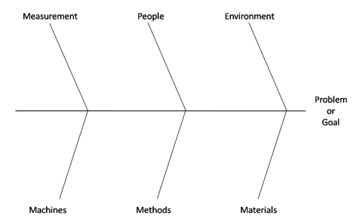

Cera care uses the Cause and effect diagrams on the documents of quality control like concession sheets wherein a fishbone diagram should be completed each time there is a defective material relating to the medications and other equipment used for health care and elderly care within Cera care home. This diagram would further be assessed on a regular time interval for bringing the improvements and modifications within the services building. After Developing The cause-and-effect diagram Cera Care home creates a future state wherein the firm specifies where it wants its corporations to expand (Coccia, 2020). Cera wants to eliminate their issues of technology and irregularity in their services. By mapping the procedure, Cera home care identifies its areas for development. By glancing at ranking order, the firm observes additional areas for improvements. Utilizing cause and effect diagrams Cera discerns what has worked for the company as well as what has not. At the final state Cera reviews and applies each of the strategies which the firm has evaluated for enhancing the satisfaction of the people (Loredana, 2017).
Swot analysis
Strength
Cera Care widened to Leeds, Birmingham, and Manchester, besides developing care businesses within Nottingham and Huddersfield. As part of the company's expansion plans, Cera capitalized £10 million for expanding to 14 towns around the UK, as well as launching a primary recruitment campaign for the social care division by social media (Vlados, 2019). The fundamental strategy which has been acquired by the corporation is the services and product customization as per the demands of the patients (Williams and Sir, 2017). Cera ranked ‘Good’ By the (CQC) Care Quality Commission around London and Nottingham branches, with a 0.005% grievances rate, and 9.5/10
Weaknesses
Various partnerships with NHS have led to financial loss for Cera as well as damage to the company’s brand image. The company has also faced monetary loss at the time of recession (Williams and Sir, 2017). The company faces enormous challenges while the funding as well as provision of social care.
Opportunities
The company has an opportunity for expansion and for that, it needs the employees who are fresh as well as possess innovative thinking for expansion. Moreover, the corporation also has the opportunity of fund-raising by being more innovative and having creative thinking as compared to other health care organisations. The company also has the opportunity of adopting advanced technology for providing better services (Gürel and Tat, 2017). This geographic diversification would assist the corporation in enhancing their economy of scale, and minimising their systemic risk exposure (Vlados, 2019).

Threats
The advent of a widespread financial crisis has led to a contraction within the economy of the UK which has an adverse effect on Cera. Cera engagement within the UK market can thus have a destructive effect on their financial standings (Williams and Sir, 2017). The reduction in revenue and the surge in unemployment in the UK have influenced the brand image because of untrained employees and poor technology as compared to other health care companies (Vlados, 2019).

Solution to problems
To solve the above-mentioned issues of Cera, the corporation must utilize a hybrid toolkit of management; a strategy of administration that incorporates the strength and stability of the Six Sigma approach of management along with Total Quality Management strengths. Within this technique, the corporation will be compelled to establish certain benchmarks for operations which must be retained at every time within the organization by always spotting the potential health problems before they could develop into anything serious (Funke et al., 2018). To assure that the bars are set higher than the competitors and attained, the administration of Cera must impose specific operating system methods for training and development of the new employees. The corporation must continuously rebuild and restructure its mission and vision; creating a strategic mission pertains to thinking strategically about the needs of the patients and how the firm could do better (Sivalingam, 2018).
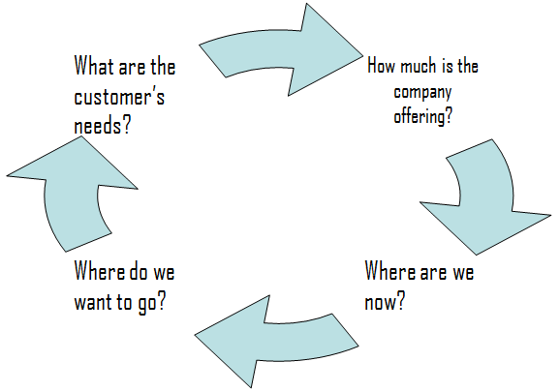

Alternate solution generation
Occasionally, the corporation must be taking external and internal business analysis for Problem-solving in the organisation. The internal business examination strives to demonstrate the strengths of the corporation, how nicely it is accumulating with the set criteria, and ascertaining any area which requires improvement. While undertaking internal examination, the administrators must guarantee that the bars they have established are adapted effectively and efficiently (Sivalingam, 2018). By TQM, the corporation will be competent in giving 100% care to the new consumers on a similar day as of their inquiry, whenever required or requested, reflecting exceptional speed as well as agility within Cera’s service along with the onboarding procedures. Besides, it would be competent to exceed other corporations to evolve as the globe's biggest health care home. Moreover, for a corporation to continuously enhance its procedures and achieve the set objectives as well as outperform the expectations which the customers have from the corporation and hence the firm must keep re-examining its policies (Lagorio and Pinto, 2020).

PMI technique
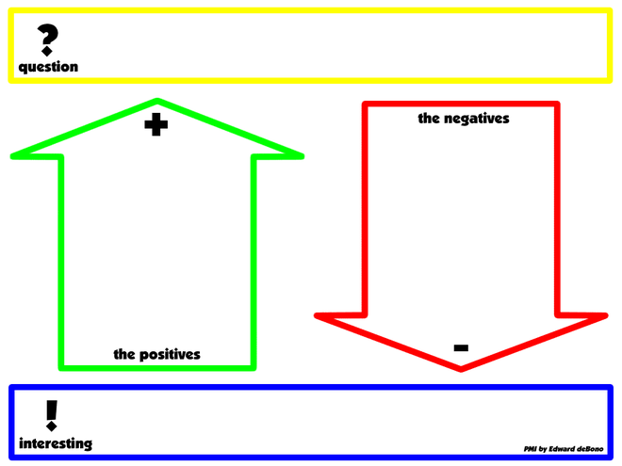
Plus:
- Cera must include a hybrid system
- New technology must be initiated such as an enhanced version of the company’s app which would be easy to use for the patient's upcoming visits and schedule. It must-have modern features like leaving audio messages to the care team for timely action (Peng et al., 2020).
- New policies must be developed
Minus:
- Losing the customers might hinder the fundraising
- The company tends to repeat the same mistake again and again
- Issues in follow-ups of client’s health concerns
Interesting:
- To have efficiency in the operations, the corporation must strengthen their internal control as well as review its contracting policies (Peng et al., 2020).
- Cera secured places within the NHS Shared Business Services Framework, Newham NHS framework of DPS, Nottingham NHS framework of DPS, and partnerships with Assist, Active Four Seasons, Tunstall.

Implementation
To guarantee that the network works adequately, the administration of Cera must incorporate a gap examination mechanism which is a part of equipment utilized by executives for deciding which strategies and tactics to utilize the follow-ups with the patients in the organisation and undertaking the timely measures (Sivalingam, 2018). Besides, it is a method utilized to correlate a business vision and conception with its goals and strategies. It assists in specifying a discrepancy within the performance which assists in specifying relevant strategies for filling the discrepancy and solving the problem. The Methods identified for solving the problems could be implemented effectively and efficiently for the betterment of the organisation and the overall health of the patients or the elderly people (Amankwah-Amoah and Osabutey, 2020).

Monitoring and controlling
For monitoring and controlling, Cera must oversee all the problem-solving tools which are being implemented. Cera must proceed with the system which is hybrid for detecting as well as solving issues, the administration must comprehend that each outlet within the UK has its unique and extraordinary problems which could be solved or tackled by unique management methods (Amankwah-Amoah and Osabutey, 2020). They must be open to acquiring new strategies to varied outlets. monitoring of these new strategies must be undertaken constantly for minimising the issues. Controlling the issues in Cera could be done by comparing the actual performance of the organisation with the planned one and eliminating the differences for better operations (Iqbal and Keay, 2019).

Communicating with stakeholders
The fundamental internal stakeholders at Cera are managers, employees, executive and board committees, fundraisers, and shareholders. The fundamental external stakeholders at Cera are customers, competitors, creditors, local communities, pressure groups, and the government (Iqbal and Keay, 2019). Engaging as well as collaborating with the stakeholders and fundraisers assists Cera in comprehending their evolving priorities along with assisting in addressing the extensively relevant sustainability issues.

Recommendation
A recommendation for Cera will be to strengthen their consumer penetration and enhance the test sensor which was aimed to utilize the data obtained by sensors and aware caregivers of any modification in patterns that could symbolize a deterioration in patients’ fitness and health, enabling them to acknowledge faster and consequently lessen avoidable stays at the hospital. (Amankwah-Amoah and Osabutey, 2020).
Conclusion
To sum up, Cera is a health care corporation which is confronting strategic problems; The main issues of the company include some technical issues, partnerships, as well as problems relating to customer satisfaction and employee training. To guarantee that the corporation stays competitive amidst transforming business environments, the administration must acquire a hybrid system of management. Besides, the system would encourage the corporation in identifying the weak points as well as to solve them before these issues become significant threats for the corporation.

References
Amankwah-Amoah, J. and Osabutey, E.L.,(2020) New challenges and opportunities in the global marketplace: learning from developed-country multinationals’ failures, International Studies of Management & Organization, 50(1), pp.43-56.
Coccia, M.,(2020) Fishbone diagram for technological analysis and foresight. International Journal of Foresight and Innovation Policy, 14(2-4), pp.225-247.
Funke, J., Fischer, A. and Holt, D.V.,(2018) Competencies for complexity: problem solving in the twenty-first century, In Assessment and teaching of 21st century skills (pp. 41-53). Springer, Cham.
Gürel, E. and Tat, M.(2017) SWOT analysis: a theoretical review, Journal of International Social Research, 10(51).
Iqbal, T. and Keay, A.(2019) An evaluation of sustainability in large British companies, Common Law World Review, 48(1-2), pp.39-63.
Jacobs, C., Brieler, J., Salas, J., Betancourt, R. and Cronholm, P.(2018) Integrated behavioral health care in family medicine residencies a CERA survey, Family medicine, 50(5), pp.380-384.
López López, N. (2017) Different ways to assure the continuity of the business.
Loredana, E.M.(2017) The analysis of causes and effects of a phenomenon by means of the “fishbone” diagram, Analele Universităţii Constantin Brâncuşi Din Târgu Jiu: Seria Economie, 1(5), pp.97-103.
Peng, Z., Huang, M., Zhong, Y., Chen, L., and Liu, G.(2020) ‘A new method for interoperability and conformance checking of product manufacturing information’, Computers & Electrical Engineering, 85, p.106650.
Phan, S. (2021) The effect of PESTLE factors on development of e-commerce. International Journal of Data and Network Science, 5(1), pp.37-42.
Sivalingam, R. (2018) Strategic Management. Industry Analysis, Strategic Drift and Re-Strategizing. GRIN Verlag.
Visconti, R.M., Doś, A. and Gurgun, A.P.(2017) Public–private partnerships for sustainable healthcare in emerging economies. In The Emerald Handbook of Public–Private Partnerships in Developing and Emerging Economies. Emerald Publishing Limited.
.
Vlados, C. (2019) On a correlative and evolutionary SWOT analysis. Journal of Strategy and Management.
Williams, C. and Sir, R.(2017) Complexity Of Modern Management.

APPENDIX


