A review on the effectiveness of stop searches for preventing, detecting and deterring crime.

Student: Lauren Cosway
Student Number: 1920610

BSc (Hons) Professional Policing Practice

Acknowledgements

This dissertation is primarily the work of the author who takes full responsibility for the views expressed within it. However, without the help and understanding of certain individuals, the task of writing it would have been a lot more difficult.
I would like to express my sincere appreciation to my dissertation supervisor, Rhiannon Sandy, for all her help, support and advice throughout the final year. I would also like to thank all the university staff who have provided information and support throughout.

Declaration

This work has not previously been accepted in substance for any degree and is not being concurrently submitted in candidature for any degree.
Signed: L.Cosway
Date: 28/12/2022

STATEMENT 1
This dissertation is being submitted in partial fulfilment of the requirements for the degree of BA.
Signed: L.Cosway
Date: 28/12/2022

STATEMENT 2
This dissertation is the result of my own independent work/investigation, except where otherwise stated.
Other sources are acknowledged by footnotes giving explicit references. A bibliography is appended.
Signed: L.Cosway
Date: 28/12/2022

STATEMENT 3
I hereby give consent for my dissertation, if accepted, to be available for photocopying and for interlibrary loan, and for the title and summary to be made available to outside organisations.
Signed: L.Cosway
Date: 28/12/2022

STATEMENT 4
I hereby give consent for my dissertation, if accepted, to be available on the university’s IT system to those who have consent to use the system.
Signed: L.Cosway
Date: 28/12/2022

Abstract

This dissertation is an analysis of the effectiveness of stop searches for preventing, detecting and deterring crime within the UK.
The aim of this dissertation was to investigate whether stop and search is an effective police method for preventing, detecting and deterring crime by researching into the public perception and opinions of serving police officers within South Wales Police.
An in-depth analysis of the history surrounding stop and searches was carried out with an insight into the legislation used by police officers. In order to obtain the views, opinions and experiences of serving police officers within South Wales Police, a survey was distributed, and the findings were analyse with officers in agreement to the effectiveness of stop and searches.

Contents Table

- Acknowledgements……………………………………………………………………………………..…………..2

- Declaration……………………………………………………………………………………………………………….3

- Abstract……………………………………………………………………………………………………………………4

- Introduction / Objectives………………………………………………………………………………………….6

- Literature Review……………………………………………………………………………………………………..7

- Methodology………………………………………………………………………………………………………….12

- Analysis of Results…………………………….……………………………………………………………………15

- Conclusion……………………………………………..………………………………………………………………20

- Recommendations…………………………………………………………………………………………………23

- Bibliography……………………………………………………………..……………………………………………24

- Appendix One – Questionnaire……………………………………………………………………………..27

- Appendix Two – Questionnaire Results…………………………………………………………………32

Introduction

The purpose of this research is to determine whether stop and searches are effective in the prevention and detection of crime.
This dissertation looks at the history of stop and searches in the UK and explains how the powers and laws surrounding stop and searches changed following the Brixton Riots which occurred in 1981.
The dissertation will explore the different powers a police officer can use in relation to stop search and the reasonable grounds needed for the search to be legal. It will also explore the additional uses of stop and search by police officers in detecting further criminal activities.

This subject was chosen as stop and search is something which is conducted by police officers regularly. However, there is very little research explaining the effectiveness of this despite the many positive outcomes from the stop and searches conducted.

Objectives

The objectives for this research project are to review whether stop and search is an effective tool for police officers to use in preventing, detecting and deterring crime.
The objectives for this research project will allow to:
- Explore the police powers in relation to stop and search.

- Explain the history behind stop and search and the change in legislative laws surrounding it.

- Conduct an analysis of a survey on stop and search from serving police officers.

- Evaluate whether stop and search is an effective tool in preventing, detecting and deterring crime.

Literature Review

This literature review looks at the history of stop and searches in UK police forces and the reasons which enforced a change in the legislation surrounding it.

Stop and searches are commonly used by police officers in order to conduct a search of a person, vehicle or a premises in order to locate a specific item.

The Police and Crime Commissioner (2022) of South Wales states that stop and search powers are an important tool for the police to assist in reducing crime and criminal activity. It can be used to enable the police to detect and tackle crimes that may have already occurred, and it may also prevent future offending. This will increase the public confidence in the police as it shows the police are using their powers in a way to reduce, prevent and detect crime.

Stop and search powers have been part of British policing since the Victorian era. However, the use has continuously evolved through case-law, changed to guidance and legislation. Whitfield, J., (2009) explains that stop and search powers pre 1980s were formed from the Vagrancy act 1824 and were known as ‘sus laws’ as they allowed police officers to search any person, they suspected of being disorderly or a ‘rogue and vagabond’.
Keeling, P., (2017) explains that the searches resulted in black, Asian and minority ethnic (BAME) young men perceived the stop and searches to be target towards themselves and felt that they were being treated unfairly by police forces.

Due to the perception that men within the black, Asian and minority ethnic groups felt they were unfairly treated which resulted in a reduction of public confidence in the police. HMICFRS (2021) discussed how the relations between the police and members of ethnic minorities were badly damaged due to the use of stop and search powers from the ‘sus law’ as they were not always applied appropriately and fairly.

Brixton Riots

Between April 10-12, 1981, the first and most serious riots of the 20th century in England took place as stated by Brenton, F., (2010) and follows on to explain that the riots were confrontations between lack British youths and white British police. The riots started after a police operation took place to address the crime rate within Brixton, London. This operation resulted in a significant number of black youths being stop and searched which in turn, infuriated the local population and created tensions between the communities and the police.
The riots started on Friday 10th April 1981, as two police officers attempted to help an injured young black man into their car. Their actions were misinterpreted by a group of young black men, as they assumed the officers’ actions to be harassment. This subsequently resulted in the group attacking the vehicle with more people adding to the group, creating a large crowd. The crowd became hostile and threw bottles through police vehicles’ windscreens.
The police continued to patrol the streets of Brixton, with reinforcement units assisting. The riots continued into Saturday 11th April 1981, as two police officers searched and arrested a young black taxi driver, due to this, missiles were thrown at the police vehicle. Benton (2010) stated this was the worst day of the rioting and the rioters were mostly young black men however, by this date, they were now joined by young white men. As the rioting continued, looting began, bricks, bottles and petrol bombs were thrown, fires were set to both police and private cars and police vans were overturned. The riots continued into Sunday 12th April 1981 and the riots resulted in 122 police officers and three members of public injured, 165 persons arrested, 61 police vehicles and 26 other vehicles were damaged.

Lord Scarman’s Report

Following the Brixton Riots, Lord Scarman announced an inquiry into the disturbance and his report was issued on November 25th, 1981.
Lord Scarman’s investigation into the Brixton Riots 1981 identified the overuse of stop and search powers particularly against ethnic minority communities which developed in a breakdown of relations between the police and the public. Keeling, P., (2017) described this ultimately resulted in lack of confidence and respect for the police and tension raised due to the stop and search powers being used against BAME community members.

The Police Foundation (2012), discusses how the Scarman Report acknowledged that stop and searches were necessary to combat street crime, however expressed concerns over the use of the ‘sus laws’. This resulted in a recommendation for the replacement of ‘sus laws’ with a new legislation for stop and search. The Police and Criminal Evidence Act 1984 was subsequently created which included powers of stop and search on an individual or vehicle.

Police and Criminal Evidence Act 1984

In 1984, a new legislation Police and Criminal Evidence Act 1984 (PACE) was introduced. This legislation was set in place after the confrontation between the police and BAME communities. The Police and Criminal Evidence Act is an important piece of legislation which was introduced to establish a balance between police powers and the rights of the public. Miller, J. (2019) explains that the Act created a Code of Practice for police behaviour which officers must abide to in an attempt to restore the public’s confidence in the police following on from the Scarman report which found disproportionate use of stop and search powers against black people. This meant that there was a need for accountability by the police in these situations.

Within PACE, there are currently 8 Codes of Practice, which cover the different powers and rights of detainees from A-H. This is to ensure fairness, accountability and respect each individual who the police engage with.

Home Office (2022), sets out the policy in relation to Code A of PACE. The code has been revised throughout the years since the introduction of PACE to ensure that it is up to date, and that the powers are used fairly, responsibly and for respect for each person being searched without unlawful discrimination.
Home Office (2013) explains that Code A is the exercise of power used by police officers to search a person or a vehicle without first making an arrest and it included the need for a police officer to make a record of a search or encounter.
Code A sets out the reasonable grounds and that any stop and search encounter under Section 1 PACE and Section 23 Misuse of Drugs Act 1971, will require a reasonable ground in order for the search to be lawful.
The Act sets out its powers for stop and search under section 1. The Police and Criminal Evidence Act (1984) states that a constable may stop and search a person or vehicle where they have reasonable grounds to suspect that they will locate prohibited items. The items include offensive weapons such as knives, stolen articles, or any item that could be used to commit crime.

College of Policing (2016) explains that within Section 1 of PACE and officer who is conducting the stop and search must have reasonable grounds to suspect that they will locate the item or items they are searching for.

Prior to commencing the stop and search, a police officer must use the acronym ‘GO WISELY’ in compliance with Code A of PACE. According to Gould (2020) if the ‘GO WISELY’ procedure is not followed, then the search of the person or vehicle is likely to be unlawful.

GO WISEY is used to explain the grounds, objectives and power in which the search is being conducted under. The officer will need to identify themselves, their station and explain that the person is detained for the purpose of a search with the entitlement of a copy to the search. This ensures the search is justified, proportionate, legal and the officers are accountable for the search.

The Macpherson Report (1999- 2012)
Following on from the Stephen Lawrence murder which took place on 22 April 1993, Sir William Macpherson began an inquiry which concluded that Metropolitan Police was institutionally racist. A report from the House of Commons (2021) explains the findings from the Macpherson report and states that it was highly critical of the police actions during the investigation into the murder. The report made recommendations in relation to stop and search as it concluded them to be disproportionate and it highlighted that discrimination was a major factor which was based on the perception and experience of BAME communities. Although, the findings concluded that stop and search powers needed change, Macpherson explained that it has a useful and important role to play in the prevention and detection of criminal activity.
(Nickolls & Allen, 2022) clarify that Macpherson called for greater scrutiny in how stop and searches were conducted, although they did agree that within the report, he acknowledged they are required to assist the police in preventing and detecting crime. Nicholls & Allen (2022) go on to describe the conclusions of the result which resulted in recommendations that all stop and search encounters should be recorded and monitored. Therefore, Code A of PACE was amended, and further guidance was provided to police in relation to the reasonable grounds for a stop and search.
In conclusion to Sir Macpherson’s report, the findings and conclusions are similar to that of Lord Scarman inquest. Both findings show that the disproportionate use of stop and searches against the BAME communities and that changes needed to be implemented in order to adjust the way in which stop and search powers were utilised.

Misuse of Drugs Act 1971 – Section 23 (2)
Section 23 (2) of the Misuse of Drugs Act 1971 (MDA) states if a constable has reasonable grounds to suspect a person is in possession of a controlled drug, they may detain the person for a purpose of a search, conduct a search of a person or vehicle in which the constable suspects that the drug may be located and to seize any item found in the course of the search as evidence of an offence under this Act, Bryant, et al (2019).
Both section 1 PACE and section 23 MDA requires a constable to have reasonable grounds for the search to be conducted lawfully. The smell of Cannabis alone to be used reasonable grounds is prove controversial according to Shiner, et al (2018) and explain that the guidance was supported by analysis which revealed that references to the smell of Cannabis used in officer’s grounds, did not increase the likelihood of an arrest or out of court disposal.
(HMICFRS, 2021) discusses how stop and searches are predominantly used to search for drugs, whether that be possession or supply of drugs, however they suggest that more searches are conducted for possession rather than the more serious offence of supply.

PEEL: Police legitimacy (2017)
Within the national overview document set out by HMICFRS (2021), it describes the effectiveness of the use of stop and searches. The review explains how the purpose of a stop and search is to allay as well as confirm an officers’ suspicions without having to exercise their power of arrest which could prevent an unnecessary arrest. In order to best measure the effectiveness of stop and searches, is to locate the item search for on the person, or within the vehicle. This indicated that the grounds for the officer’s suspicions were likely to be robust.
If stop and searches are correctly monitored by police forces, the public confidence will improve as they will gain an understanding that the searches have been conducted fairly and lawfully in compliance with the correct legislation, policies and procedures.

Statistics
The Home Office (2022) published a review of the figures relating to stop and searches conducted within UK police forces for the year ending March 2022. The information has been gathered from British police forces excluding Greater Manchester Police. The findings show that under section 1 PACE and associated legislation, 526,024 searches were conducted with 66,772 leading to arrest. The Home Office reported that 71% of the stop and search outcomes were recorded as needing no further action. This data is found to be similar to the previous year ending March 2021, however the amount of stop and search encounters had decreased by 25%.
Furthermore, Police UK (2022) completed research into the statistics of stop and searches conducted within South Wales Police indicated that there were 1,181 searches recorded between June 2022 and August 2022. Out of those searches, 59.36% related to controlled drugs with only 8.13% leading to arrest.
HMIC (2013) requested YouGov to inspect the power of stop and search from the perception of the public within each of the 43 police forces in England and Wales. The majority of the public were positive about the effects of stop and search with 78% agreeing that stop and search helps catch criminals and 75% agreeing that it assists in the prevention of crime. The research gathered from YouGov showed that stop and search is considered to be helpful in the prevention of drug dealing but taking drugs and weapons of the street. 85% of over 55s age group agree that stop and search has a positive effect and is helpful to catch criminals compared to 70% of 18 to 24s age group. With only 62% of black, minority and ethnic groups agreeing that stop and search is effective and helpful in the prevention of crime compared to 77% of white British.

Criminal Justice and Public Order Act 1994
The Criminal Justice and Public Order Act 1994, sets out the stop and search power under section 60. This power states that if a police officer of or above the rank of Inspector may give authorisation for stop and searches to be conducted on any person within a specified place for up to 24hours if the reasonable believe that an incident may take place involving serious violence in anticipation of or after violence. If authorisation has been granted, a constable may stop any person or vehicle for the purpose of a search without the need for reasonable grounds (Bryant, et al., 2019).
Agnew-Pauley, W. & Akintoye, B (2021) argue that stop and search encounters disproportionately affect black communities as they believe that black a minority groups are more likely to be unfairly targeted by police.
Additionally, the Home Secretary, Priti Patel, announced in 2022 that the restrictions which were set in 2014 on stop and searches under Section 60 Criminal Justice and Public Order Act 1994, would be lifted in line with the legislation set out in 1994. The restrictions limited when police officers could use the vital power and decreased the confidence in deploying it, Home Office (2022)
Priti Patel (2022) stated the following:
“I stand wholeheartedly behind the police so that they can build on their work to drive down knife crime by making it easier for officers to use these powers to seize more weapons, arrest more suspects and save more lives.”
Methodology

Introduction

This chapter outlines the methods used in this study to determine whether stop and search is an effective method for preventing, detecting and deterring crime. Although the research aims to determine whether stop and searches are an effective method for preventing, detecting and deterring crime, it will also examine the other police powers used for stop and search including those relating to the items located on the person.

The research is based on information on stop and searches obtained from current serving police officers who work within South Wales Police, using a survey containing questions regarding stop and search powers, outcomes, reasonable grounds and the effectiveness.
According to McCombes (2022) a methodology discusses and explains the data collection and analysis methods which have been used as part of the research.

Data collection

Both qualitative and quantitative research data will be collated to gain a better insight into the experiences serving police officers have had whilst conducting a stop and search during their role.

Qualitative research involves collating and analysing text data to be able to understand the concepts, experiences or opinions of the participants. It allows the researcher to gather a more in-depth insight into the data collated, Bhandari (2022). This research approach will show how each individual officer perceives the question and will show a range of different answers in a text format rather than multiple choice. The approach used within the qualitative search will come from phenomenological research.
Yüksel & Yildirim (2015) wrote the main purpose of phenomenological research is to seek reality from individuals through feelings and experiences. Whereas Delve & Limpaecher (2022) explain that phenomenological research is a qualitative approach that seeks to understand the essence of a phenomenon. This approach investigates the lived experiences of individuals while suspending the researchers’ preconceived assumptions.

The online survey is designed with open and closed questions along with multiple choice questions. According to Cleave (2017), having open ended questions within a survey allows the respondents to include information which gives the researcher more useful, contextual feedback. They allow for a better understanding of the respondent’s true feelings and attitudes about the survey subject, in this case, stop searches. Whereas closed questions do not give the respondent the choice to give their opinions due to the question and answer limitations.

The survey contains a variety of questioning styles in order to achieve an in depth understanding of how stop and searches are conducted within South Wales Police.
Although the survey is only aimed at serving police officers within South Wales Police, the survey will ascertain whether those officers believe that conducting stop and searches is an effective method in preventing, detecting and deterring crime. The responses will be opinion based as the participants will be providing their reasoning to whether they believe that stop and search powers are an effective method but there will also be some personal experience questions whereby officers will need to explain how they have conducted the search and the reasons for that search.

The aim was to receive 30 responses to the survey, however more responses improve the data quality. The limitation for this survey is that it was only distributed to police officers within South Wales Police due to the time frame, it was not practicable to send to a number of different neighbouring forces as the responses may not have been received in a timely manner in order to conduct the research and analysis.

Ethics

The survey allowed the participants to complete anonymously, confidentially and on a voluntary basis. The survey did not include any personal information and will not be shared with any other person. The information gathered will only be used for this research and the participants will remain anonymous throughout.

Data Analysis

The method selected to obtain the information is in the format of an online survey distributed to police officers within South Wales Police. This form gathered information from serving police officers from several different departments and roles in order to gain an insight to how they conduct stop and searches and the statics relating to this.

An online survey was used due to the busy schedules of serving police officers currently, along with low resources. It was anticipated that the participants to this survey may be less than expected as I am fully aware of the pressures, workloads and commitments police officers are under recently.

The online survey was the easiest and quickest method in order to gain more responses as officers could complete the survey at their own convenient time, when possible, around their own work commitments.

Once all surveys have been collated, the responses have been formed into charts and graphs which will make it more visible and easier to see the responses. Due to using questions whereby the participant will need to freely write their answers, these questions will be displayed as they are received in order to ensure no answers are missed.

Conclusion

To conclude, a survey has been used to gain an insight into the feelings and opinions of serving police officers. It will enable the researcher to gather information into the use of stop and searches and how they are conducted within South Wales Police.

The survey will form an understanding of the perception from police officers who use stop and search as part of their role within the police. Using the different types of questioning styles will ensure the answers will be personal to each officer completing the survey and will therefore provide more information. The answers will remain anonymous and confidential and are for the use of this research project only.

Analysis of Results

The analysis of survey data is the process of drawing conclusions from what information has been gathered (Frampton, 2020). The data has been collated from an online survey distributed to serving police officers within South Wales Police.
In total, 39 participants completed the survey, 38 of which were working within Mid. Glamorgan and one from Swansea and Neath, Port Talbot.
The participants work within a number of different departments, with the most responses coming from Response Officers.
The survey was based on stop and searches in order to get an understanding of how serving police officers conduct them. The first question asked participants whether they conduct stop and searches as part of their role within South Wales Police.
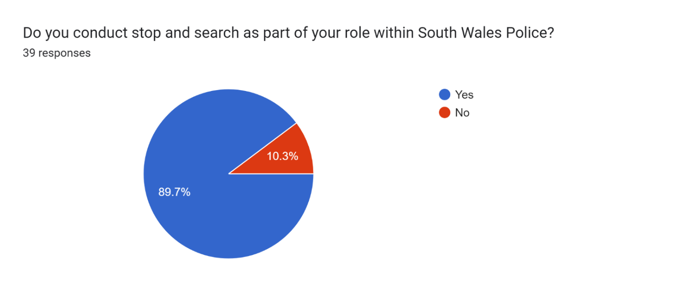
Figure 1: Do you conduct stop and search as part of your role within South Wales Police?

The results from this question are shown in the form of Figure 1.
35 participants answered yes to conducting stop and search as part of their role (89.7%) and only four out of the 39 participants answered no (10.3%).
This shows that stop and searches are conducted by most serving officers and the small percentage of officers who may have answered no may work within a department such as management, public protection or within the interviewing hub as identified through other questions within the survey (see Figure 2 below).

Figure 2: What department do you work on?
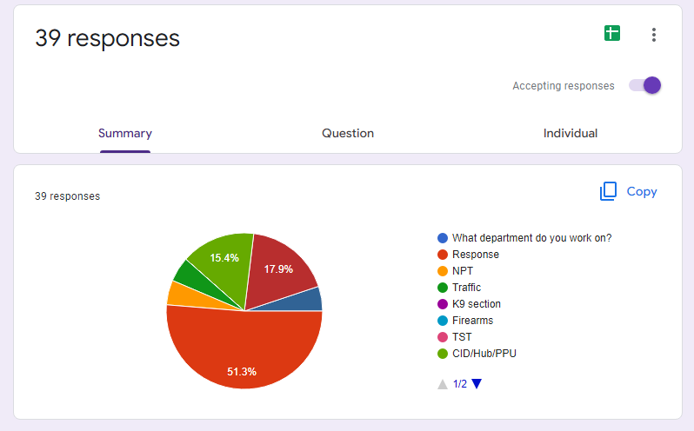

This shows that stop and searches are conducted by most serving officers with the highest percentage being Response Officers. The small percentage of officers who may have answered no may work within a department such as management
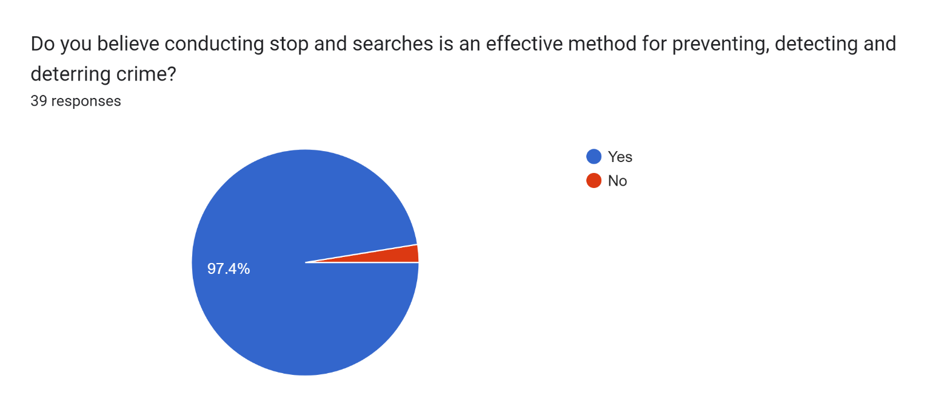
Figure 3: Do you believe conducting stop and searches is an effective method for preventing, detecting and deterring crime?

Out of the 39 participants, 38 of which answered yes to the above questions and one answered no. Participants were asked to explain their answer. One said that:
“It is a very valuable tool for preventing and detecting crime, it can help in identifying offenders, before a crime occurs as well as following a report of crime. The very nature of Stop Search, being in a public place means that it is also effective in reassuring the public that police are enforcing the rule of law and addressing problems in public spaces. It also sends a message to other nominals that may see police activity.”
The general consensus was similar with the majority of officers agreeing that conducting stop and searches is an effective method for preventing, detecting and deterring crime.
Stop and search is often viewed as a valuable tool in the fight against crime. A requirement of the police service is to show the public evidence that their use of these powers is fair, lawful and appropriate in order to risk losing the trust of the communities in which they serve, HMICFRS (2021).
There are many responses which are agreeing with the fact that stop and searches are an effective method in preventing and detecting crime, however, one participant said that:
“I think it helps to detect crime, but not prevent it.”
If police officers are pro-active in using the stop and search powers effectively and proportionately it will show members of the public that officers are actively detecting crime in order to prevent it further occurring, this can assist in persons being in fear of being caught and ultimately receiving prosecution. According to Nickolls & Allen (2022), stop and search is more effective at detection, however, most searches which are conducted result in no items located.
Figure 4: Which powers do you use for the search?
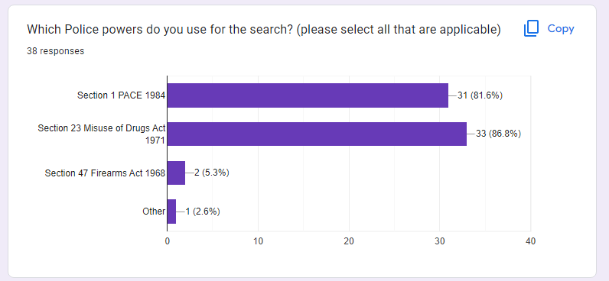

Although, there was 39 participants in the survey, only 28 persons answered this question.
The most commonly used powers used to conduct a stop and search by officers within South Wales Police was Section 1 of the Police and Criminal Evidence Act 1984 (PACE) with 81.6% and the Misuse of Drugs Act 1971 (MDA) with 88.6%.
Within the legislation relating to those powers, officers require reasonable grounds for conducting the search. The survey asked the question relating to the reasonable grounds used for stop and search under Section 1 PACE which received 32 responses. Examples are shown below.
‘Attended a call for a person possibly carrying a weapon and was passed a description. Identified a person matching the description passed and therefore have conducted a stop search.’
‘Persons matching a description following a burglary found within the area late at night, avoiding police contact. When stop checked persons had no reasons to be within the area as they lived a while away and was always looking for a reason to walk away.’
‘Previously I have conducted searches for items of stolen property. I have received credible evidence that includes witnesses providing descriptions of offenders that included unique description of clothing. Persons matching description have been searched within a reasonable timeframe of the offence being committed.’
From analysing the responses to this question, the answers were similar in relation to the person matching a description which was identified by a witness or CCTV. The information provided in relation to a description of an offender gathers intelligence and can provide a reasonable suspicion that the item will be located on the person.
A further question was asked relating to the reasonable grounds for conducting stop and search under Section 23 of the Misuse of Drugs Act 1971. Out of 39 participants, 33 answered this question. I have selected a few of the responses below.
‘Male seen acting suspicious where another male has approached his vehicle and has been handed a small package and left immediately after concealing the item within his pocket.’
‘Person or persons observed exchanging items for money and upon sighting police proceeded to avoid or make off from officers in an attempt to avoid police.’
‘Persons sighted and officers have witnessed what they believe to be a drug exchange with a package being handed over and money exchanged. Officers have approached person involved who have immediately tried to discard items in their pockets. Persons have been stopped and searched where drugs have been located and then arrested.’
The overall reasons were similar and in relation to witnesses which led officers to believe there was a drug exchange. However, two participants responded with the following:
‘Mostly this would be when you come across a person or persons in a remote area in a vehicle or park area where you can smell cannabis or there is clear evidence of drug taking, such as joint butts, silver foil, needles etc.
Persons that have had drugs appear usually nervous and avoid eye contact etc, they seem jittery and unpredictable.’
‘Male located in area known for high volume of drug dealing, male smelling of cannabis and tried to evade police by walking away and fidgeting in his pockets.’
Although the smell of cannabis alone cannot be a reasonable ground for a stop and search under section 23 Misuse of Drugs Act 1971 (MDA), the other facts identified within the responses can add to the suspicion providing reasonable grounds in line with Code A PACE. College of Policing (2019) states that under section 23 (2) of the MDA and in accordance with Code A of PACE, there is no reference as to whether the smell of cannabis alone provides reasonable grounds, however it is up to the individual officer to ensure that the smell of cannabis can be justified.

Conclusion
Introduction

The previous chapters within this dissertation have directed the research through the introduction, research and planning. With the most recent chapter being analysis and finding which were collated through a survey distributed to serving police officers using quantitate and qualitative questioning.
Each chapter has achieved the objectives set out in the introduction and this chapter will seek to achieve the final objective, which is: Evaluate whether stop and searches are effective in preventing, detecting and deterring crime.

This chapter will also provide a conclusion surrounding whether stop and searches are effective at preventing, detecting and deterring criminal activity.

Achievement of Objectives

Explore the police powers in relation to stop searches:
The police powers in relation to stop searches were successfully explored within the Literature Review chapter.

Explain the history behind stop and searches and the change in legislative laws surrounding it:
The history behind stop and searches provides an important role in the reasons why legislative laws were amended and changed. This objective was successfully achieved within the Literature Review chapter whereby there is an explanation on the history surrounding stop and searches and the laws which have been set in place for police officers to abide to whilst exercising this power.

Analysis of a survey on stop and searches from serving police officers:
An analysis of the survey which was distributed to serving police officers within South Wales Police was successfully achieved within the Analysis of Results chapter. Appendix 1 & 2 at the end of this research project show the survey and answers provided to assist with the analysis.
Evaluate whether stop and searches are effective in preventing, detecting and deterring crime:
The final objective will be achieved within this section of the Conclusion.

Main Findings

Many of the findings for this research project were established in the literature analysed as this provided the insight to stop and search powers, the history and the changes implemented due to historic events.

There are several historical events where contributed factors involved the use of stop and search powers, the way in which they were conducted and the unfair treatment of the BAME communities which resulted in tensions between the communities and police and ultimately ended with riots. The introduction of Code A of PACE assisted in the recording of stop and searches, which help the public view the figures, analyse the data and build confidence back between the communities and police. The data will show whether the stop and searches conducted were effective, and whether they have resulted in prosecution, this will show that the police are effectively using this power to prevent, detect and deter crime.

Whilst there is controversy surrounding black and ethnic minorities, the police have the power to stop and search a person using section 1 PACE and section 23 Misuse of Drugs Act if they suspect a person to be carrying an unlawful item, where the officer has reasonable grounds to suspect. The main finding from the historic events, was that of the Brixton Riots which occurred in 1981 and subsequently resulted in an introduction of a new legislation for stop and search powers, which was PACE. The introduction of this legislation was in replacement of the ‘sus laws’ which contributed to the reasoning behind the Brixton Riots.

As explained within the literature review, the PEEL police legitimacy described the effectiveness of stop and searches to allay as well as confirm an officers’ suspicions without the need to arrest. Although PEEL described stop and searches to be effective, the public have their own views and opinions due to the perception they perceive. HMIC (2013) commissioned YouGov to investigate the police powers of stop and search to gain and understanding of the public perception of this power. The survey concluded with a majority of the public from England and Wales understood the purpose of stop and search and are positive about the effect it has to assist in the reduction of crime in their areas. Though, minority groups have a tendency to be more cautions of the effectiveness of stop and search powers.
The analysis of the results from the survey provides an insight to the views, opinions and personal experience of police officers within South Wales Police. Although this survey was only distributed to serving police officers within South Wales Police, an alteration would be considered, if the research project were to be conducted again. This would be to distribute the survey out to neighbouring police forces and compare the findings from each force which would provide an awareness into the use of stop and search powers generally. The results showed that the participants were in agreement that stop and search was an effective method for detecting and deterring crime, however, the effectiveness in prevention is arguable.

Whilst stop and search can assist in detecting criminal activities, therefore deterring the crime, it can only be used as a temporarily preventive measure as there is no evidence to say that the offender may commit the offence on a different occasion in the future.

McCandless, R. et al. (2016) explain that the Home Secretary launched a public consultation on stop and search in July 2013 which resulted over 5,000 responses. Amongst those who responded, 61% agreed that stop and search powers were effective in preventing and detecting crime.

To conclude on this research project, there is no study to confirm whether stop and search is an effective method for preventing, detecting or deterring crime and a lot of the research found that it is mainly opinion based, with persons of BAME communities having the perception of being unfairly treated.
The public perception can differ in different areas and of different ethnic backgrounds, however, the perception of serving police officers, believe that stop and searches are an effective method in preventing, detecting and deterring crime. This may be due to their own personal experiences from conducting stop and searches, as shown in the survey conducted in this research project.
Police officers have a role to serve and protect, this means preventing, detecting and deterring criminal activities and ensuring the communities they serve are safe and free from crime. So, by having the power of stop and search, supported by legislation, police officers can exercise this power to ensure the communities are free from harm by seizing prohibited items found within the search.
The Home Office undertakes annual data reviews into British police forces’ stop and search figures, as explained within the literature review chapter. The public can therefore freely access and review this information. This can restore public confidence in the police, to show that they are lawfully exercising the power to reduce crime and build trust between the police and the communities they serve.

Recommendations

From conducting this research project, the researcher has improved their understanding surrounding the history or stop and search, the changes in legislative laws and the views and opinions of the public with a view to BAME communities feeling unfairly treated.
Recommendation can be made to police forces to implement into training of new police officers to provide a greater understanding into the history behind stop and search as this provides the reasoning to the introduction of PACE.
Another recommendation would be for CODE A of PACE to confirm whether the ‘smell of cannabis’ alone can be used as a reasonable ground for conducting a search under section 23 Misuse of Drugs Act 1971, as the guidance is not clear in this area. Whilst there is research to suggest it can be used as a reasonable ground to suspect, there is no clear understanding whether that alone without any other grounds can be justified.
The Independent Office for Police Conduct sets out a recommendation to the Home Office to review what constitutes reasonable grounds for suspicion of cannabis possession. With a review to consider where the smell of cannabis alone provides a reasonable ground for stop and search and whether any changes are required to Code A PACE (IOPC, 2022).
The recommendations are based on the research from this project and can assist in the learning and understanding for police officers in relation to stop and search.

Bibliography

Agnew-Pauley, W. & Akintoye, B. (2021) Stop and search disproportionately affects black communities – yet police powers are being extended. [RSS] 3 August. Available at: https://theconversation.com/stop-and-search-disproportionately-affects-black-communities-yet-police-powers-are-being-extended-165477 (Accessed 19 12 2022).
Brenton, F., (2010). Brixton Riots April 10-12, 1981 (13 June). Available at: https://www.blackpast.org/global-african-history/brixton-riots-april-10-12-1981/ (Accessed 18 11 2022).
Bryant, R. et al. (2019) Blackstone's Handbook for Policing Students. Fourteenth ed. Oxford: Oxford University Press.
Cleave, P. (2017) The Pros and cons of using open ended questions. Available at: https://www.smartsurvey.co.uk/blog/the-pros-and-cons-of-using-open-ended-questions (Accessed 10 12 2022).
College of Policing, (2016). Fair.Available at: https://www.college.police.uk/app/stop-and-search/fair (Accessed 10 12 2022).
College of Policing, (2019). Legal Basis. Available at: https://www.college.police.uk/app/stop-and-search/legal/legal-basis (Accessed 18 12 2022).
Delve. Ho, L., & Limpaecher, A.(2022). What is Phenomenological Research Design? Essential Guide to Coding Qualitative Data. Available at: https://delvetool.com/blog/phenomenology (Accessed on 12 12 2022)
Frampton, S. (2020). A Beginner’s Guide to Survey Data Analysis and Data Collection, 24 April. Available at: https://www.chattermill.com/blog/survey-data-analysis (Accessed 25 11 2022).
Gould, I. (2020). The GOWISELY Procedure and Unlawful Stop and Search, 14 September. Available at: https://iaingould.co.uk/2020/09/14/the-gowisely-procedure-and-unlawful-stop-and-search/ (Accessed 12 10 2022).
HMICFRS, (2021). Disproportionate use of Police powers: A spotlight on stop and search and the use of force. Available at: https://www.justiceinspectorates.gov.uk/hmicfrs/wp-content/uploads/disproportionate-use-of-police-powers-spotlight-on-stop-search-and-use-of-force.pdf (Accessed 18 10 2022).
Home Office, (2013). Police and Criminal Evidence Act 1984 (PACE) codes of practice.
Available at: https://www.gov.uk/guidance/police-and-criminal-evidence-act-1984-pace-codes-of-practice (Accessed 10 12 2022).
Home Office, (2022). Code A revised. Available at: https://www.gov.uk/government/publications/pace-code-a-2015/code-a-revised-accessible (Accessed 19 12 2022).
Home Office, (2022). Home Secretary backs police to increase stop and search [RSS] 16 May. Available at: https://www.gov.uk/government/news/home-secretary-backs-police-to-increase-stop-and-search (Accessed 10 10 2022).
Home Office, 2022. Police powers and procedures: Stop and search and arrests, England and Wales, year ending 31 March 2022. Available at: https://www.gov.uk/government/statistics/police-powers-and-procedures-stop-and-search-and-arrests-england-and-wales-year-ending-31-march-2022/police-powers-and-procedures-stop-and-search-and-arrests-england-and-wales-year-ending-31-march-2022 (Accessed 10 12 2022).
House of Commons, (2021). The Macpherson Report: Twenty-two years on. Available at: https://publications.parliament.uk/pa/cm5802/cmselect/cmhaff/139/13903.htm#:~:text=The%20Macpherson%20report%20found%20that,both%20individual%20and%20institutional%20level. (Accessed 18 12 2022).
IOPC, (2022). National Stop and Search learning report, April 2022. Available at: https://www.policeconduct.gov.uk/national-stop-and-search-learning-report-april-2022#recc-4
(Accessed 27 12 2022).
Miller, J., (2019). The Police and Criminal Evidence Act 1984 (PACE) [RSS] 21 August. Available at: https://www.motoroffence.co.uk/the-police-and-criminal-evidence-act-1984-pace/ (Accessed 18 10 2022).
Keeling, P., (2017). No respect: Young BAME men, the police and stop and search Available at: https://criminaljusticealliance.org/wp-content/uploads/No-Respect-290617.pdf Accessed 29 10 2022).
McCandless, R. et al. (2016) Do initiatives involving substantial increases in stop and search reduce crime? Assessing the impact of Operation BLUNT 2: March 2016. Available at: https://assets.publishing.service.gov.uk/government/uploads/system/uploads/attachment_data/file/508661/stop-search-operation-blunt-2.pdf (Accessed 20 12 2022)
McCombes, S., (2022). What Is a Research Methodology? Available at: https://www.scribbr.co.uk/thesis-dissertation/methodology/ Accessed 10 11 2022).
Nickolls, L. & Allen, G., (2022). Police powers: stop and search. Available at: https://researchbriefings.files.parliament.uk/documents/SN03878/SN03878.pdf (Accessed 11 11 2022)
Nickolls, L. & Allen, G., (2022). Police powers: stop and search. Available at: https://commonslibrary.parliament.uk/research-briefings/sn03878/#:~:text=Impact%20of%20stop%20and%20search&text=There%20is%20little%20evidence%20to,result%20in%20officers%20finding%20nothing. (Accessed 20 11 2022).
Patel, P., (2022). Home Secretary backs police to increase stop and search [RSS] 16 May. Available at: https://www.gov.uk/government/news/home-secretary-backs-police-to-increase-stop-and-search (Accessed 10 10 2022).
Shiner, M., et al., (2018). The Colour of Injustice: Race’, drugs and law enforcement in England and Wales. Available at: https://www.lse.ac.uk/united-states/Assets/Documents/The-Colour-of-Injustice.pdf (Accessed 18 11 2022).
Police UK, (2022). Stop and search in South Wales Police. Available at: https://www.police.uk/pu/your-area/south-wales-police/performance/stop-and-search/?tc=W05000898 (Accessed 10 12 2022).
The Police Foundation, (2012). The briefing. Available at: https://www.police-foundation.org.uk/2017/wp-content/uploads/2017/08/stop_and_search_briefing.pdf (Accessed 11 10 2022).
Whitfield, J., (2009). Stop and search: what can we learn from history? 12 August. Available at: https://www.historyextra.com/period/modern/stop-and-search-what-can-we-learn-from-history/ (Accessed 18 11 2022).
YouGov (2013). Stop and Search Report. HMIC. Available IMPACT Programme Main Document Template L only (justiceinspectorates.gov.uk) (Accessed 12 12 2022)

Appendix One – Questionnaire

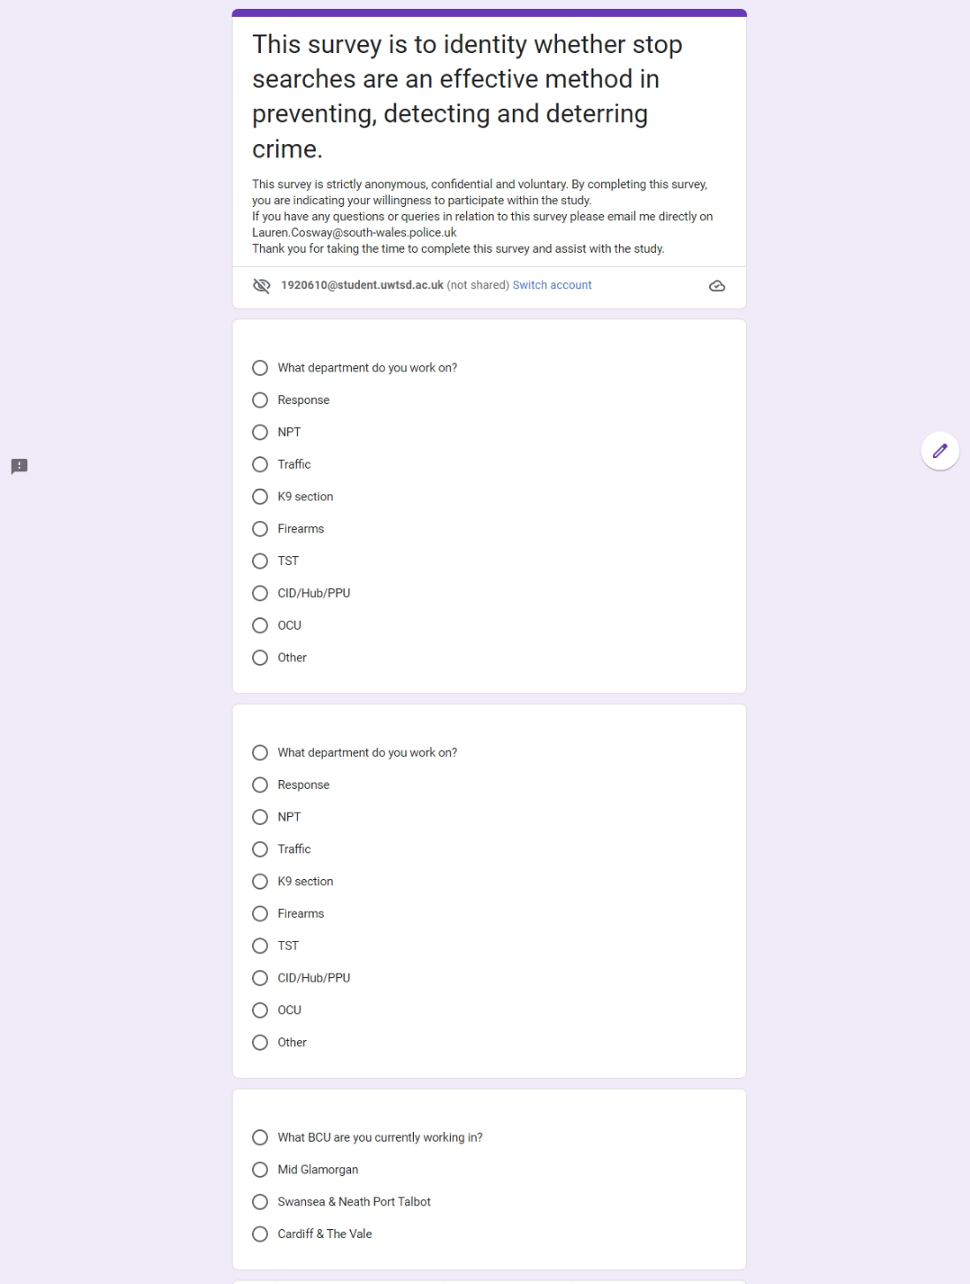

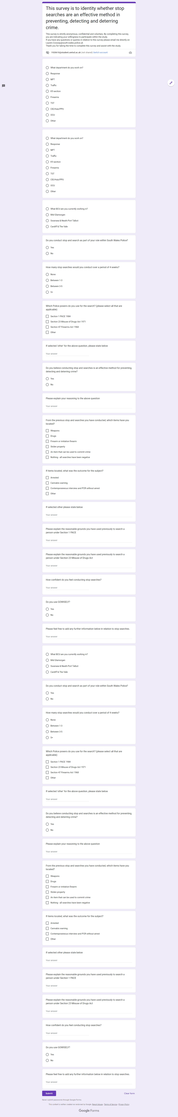

Appendix Two – Questionnaire Results



