Name: Safina Bibi
Student Number: 2243482
Module Code: BMHP6030
Assignment Title: Component 2 Written Assignment (Report)
Lecturer: Phillip Jones

Contents Page

Introduction…………………………………………………………….3
Section 1: SDG 3 - Good Health and Wellbeing……………………4-6

Recommendations……………………………………………………..6-7

Section 2: SDG 11 – Sustainable Cities and Communities………..7-9

Local Evaluation and Recommendations…………………………….9-10
Conclusion………………………………………………………………10-11
References………………………………………………………………12-16

Introduction
The United Nations (UN) is an international organisation established in 1945 to promote human rights, peace, security and sustainable development through global cooperation. In 2015, the UN adopted the 2030 Agenda for Sustainable Development (SD) after recognising continuing social, economic, environmental and public health challenges. This framework comprises 17 Sustainable Development Goals (SDGs) (Figure 1) and 169 targets designed to promote prosperity, protect the environment and improve wellbeing by 2030 (UN, 2015). According to the World Health Organization (WHO) (2024), achieving SD requires coordinated action across multiple sectors because health is influenced by both healthcare services and the environments in which people live and work.
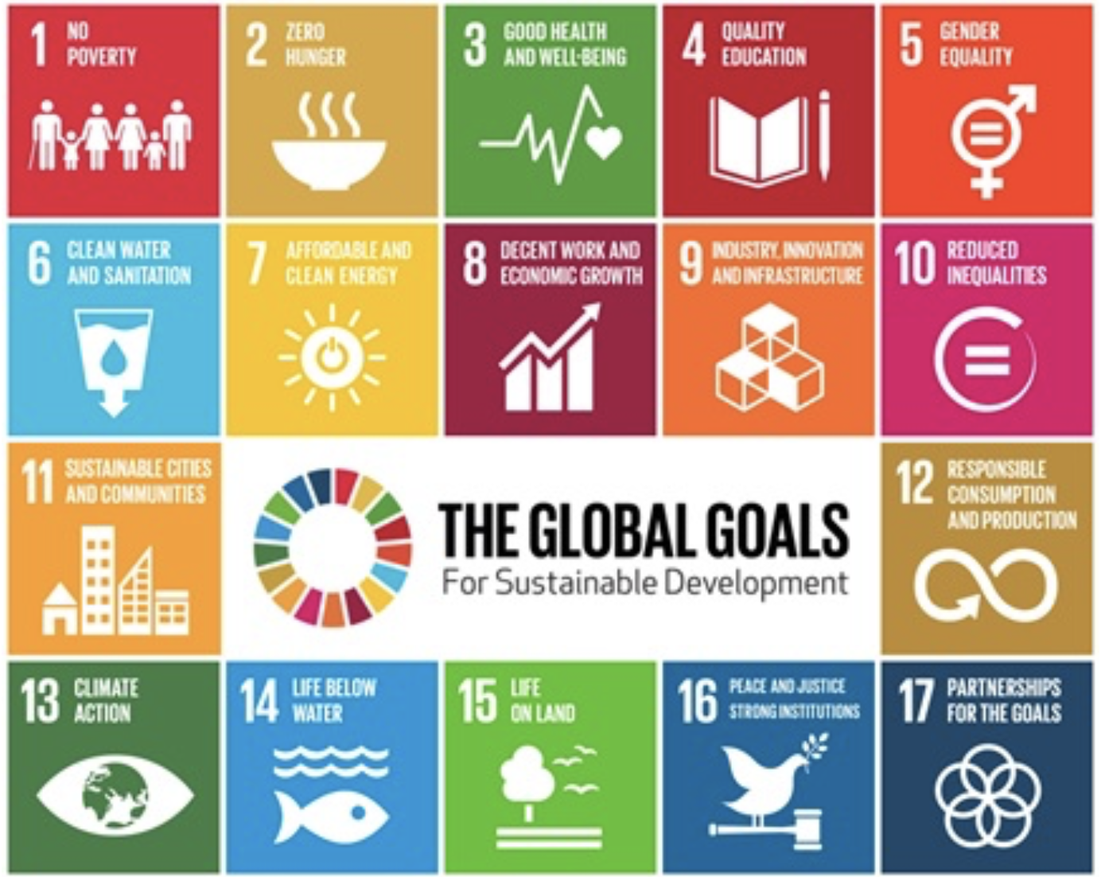
Figure 1. SDGs (Everett, 2017)

This report critically examines SDG 3 Good Health and Wellbeing (GHW) and SDG 11 Sustainable Cities and Communities (SCC), highlighting their interrelated role in improving health and wellbeing at global, national and local levels. It critically evaluates current policies, strategies and initiatives, considering both their achievements and the challenges that limit their implementation. Real-world examples and relevant theories are used to demonstrate how sustainable urban environments can improve population health. The report concludes with evidence-based recommendations to strengthen future policy and practice and promote healthier, more inclusive and sustainable communities (UN, 2015).

Section 1: SDG 3 - GHW
According to the WHO (1948), the enjoyment of the highest attainable standard of health is a fundamental human right. Despite advances in medicine and public health, many countries continue to face major health challenges, including non-communicable diseases, infectious diseases, mental health conditions and persistent health inequalities (Rad, 2025). In response, the UN adopted the 2030 Agenda for SD in 2015, introducing 17 SDGs to promote social, economic and environmental sustainability. SDG 3 (Figure 2) (GHW) aims to ensure healthy lives and promote wellbeing for all by reducing premature mortality, preventing disease, improving maternal and child health and achieving universal health coverage (UN, 2015).
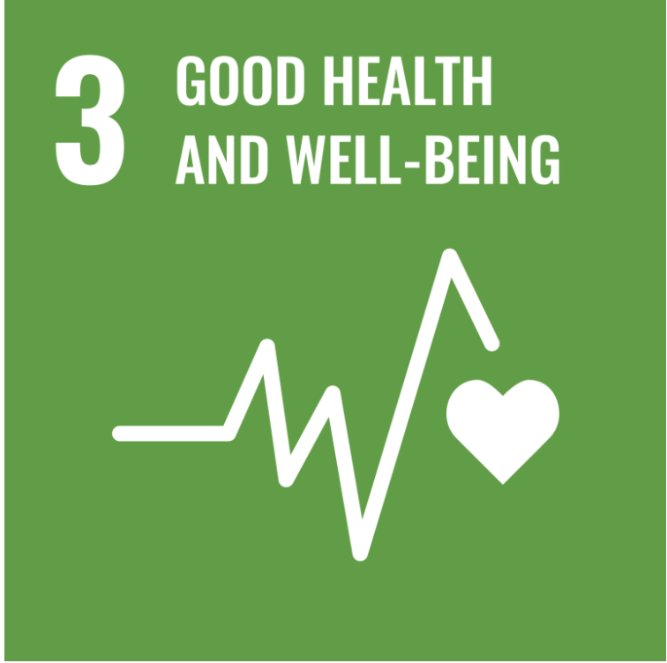
Figure 2. (United Nations, 2025)
According to the WHO (2020), achieving SDG 3 requires more than accessible healthcare services, as health is strongly influenced by wider social, economic and environmental factors. Housing, education, employment, transport, air quality and access to green spaces all contribute to health and wellbeing. Consequently, improving health outcomes requires cross-sector collaboration rather than relying solely on healthcare systems. This integrated approach also highlights the close relationship between SDG 3 and SDG 11, recognising that healthier urban environments contribute to healthier populations (WHO, 2020).
This approach reflects the Social Determinants of Health model developed by Dahlgren and Whitehead (1991) (Figure 3), which recognises that health is shaped by wider social, economic and environmental conditions rather than healthcare services alone. In practice, this model underpins initiatives such as the WHO Healthy Cities Programme and the Marmot City approach, which improve population health by addressing wider determinants of wellbeing (Dahlgren and Whitehead, 1991).

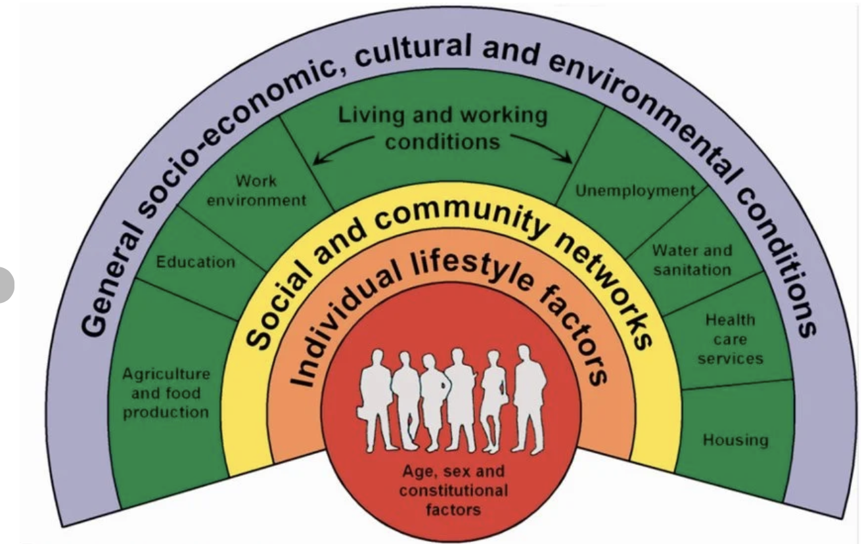
Figure 3. (Dahlgren and Whitehead, 1991)
Globally, the WHO Healthy Cities Programme (2026) is recognised as a leading initiative supporting SDG 3 by encouraging governments to integrate health into urban planning (UP), environmental policy and community development. The programme promotes health equity and cross-sector collaboration to address wider determinants of health. Danielli et al., (2023) suggested that Healthy Cities initiatives improve population health by prioritising prevention over treatment. However, they also highlighted that political commitment, governance and financial resources continue to influence implementation (Danielli et al., 2023). Therefore, although global initiatives provide an important strategic framework, their success depends on effective implementation at national and local levels.

Following the global commitment to SDG 3, the United Kingdom (UK) introduced national strategies focusing on prevention, early intervention and integrated care. According to NHS England (2019), the NHS Long Term Plan aims to strengthen primary and community healthcare by increasing collaboration between healthcare providers, local authorities and voluntary organisations. The plan promotes integrated, person-centred care and greater investment in preventative healthcare to reduce health inequalities and improve long-term population health (NHS England, 2019). However, successful implementation depends on sustained funding, workforce capacity and effective collaboration across the health and social care sector (NHS England, 2019).

The Chief Medical Officer (2024) highlighted that health outcomes are shaped by wider determinants, including housing, transport, air quality, access to healthy food and opportunities for physical activity, emphasising that improving population health requires coordinated action beyond healthcare services. The report suggested that collaboration between public health organisations, local authorities and UPs is essential to creating healthier and more equitable communities (Chief Medical Officer, 2024). Similarly, Lee et al., (2024) suggested that place-based approaches led by local authorities can address wider determinants by strengthening cross-sector collaboration and reducing health inequalities. Nevertheless, rising demand for healthcare services, financial pressures and persistent socioeconomic inequalities continue to present significant challenges to improving population health across the UK.
At a local level, Leeds City Council (2023) adopted the Marmot City approach to address wider determinants of health by improving housing, education, employment and community wellbeing. The initiative recognises that health is influenced by the social and environmental conditions in which people are born, live and work rather than healthcare services alone (Leeds City Council, 2023). It also promotes collaboration between local government, healthcare providers and community organisations to create healthier lives (Leeds City Council, 2023). Although the initiative demonstrates commitment to reducing health inequalities, its long-term success depends on sustained funding, community engagement and ongoing evaluation to improve population health.

Recommendations
To achieve SDG 3, greater investment in preventative public health should become a national priority. According to the Office for Health Improvement and Disparities (2022), reducing preventable illness requires sustained action on wider determinants of health, including housing, education, employment and healthy lifestyles. Strengthening community-based preventative services and routinely monitoring their effectiveness can improve population health while reducing long-term pressure on healthcare systems (Office for Health Improvement and Disparities, 2022).
According to Marmot et al., (2020), reducing health inequalities requires sustained investment in wider determinants of health rather than relying on short-term healthcare interventions. Future policies should strengthen collaboration between local authorities, healthcare providers and community organisations to improve housing, employment, education and access to healthy environments. This approach would create healthier, more resilient communities while supporting the long-term achievement of SDG 3 (Marmot et al., 2020).
According to Lewis et al., (2022), effective population health management requires strong collaboration across health, social care and local government. Future policy should strengthen integrated care systems and support evidence-based decision-making to ensure services respond effectively to local population needs. Although financial pressures and rising demand remain significant challenges, sustained investment in prevention and partnership working is more likely to improve long-term population health than reactive models of care (Lewis et al., 2022).

Section 2: SDG 11 – SCC
SDG 11 (Figure 4) aims to make cities and human settlements inclusive, safe, resilient and sustainable (UN, 2025). The UN established SDG 11 in response to rapid global urbanisation and increasing pressures on housing, transport, infrastructure and the environment. More than 55% of the world's population lives in urban areas, with this figure projected to reach nearly 68% by 2050, highlighting the importance of sustainable urban development (UN, 2018). SDG 11 promotes affordable housing, accessible public transport, sustainable UP and safe public spaces to improve quality of life while reducing environmental impacts. According to UN-Habitat (2024), well-planned cities promote economic growth, social inclusion and environmental sustainability while improving health and wellbeing through access to essential services and green infrastructure.
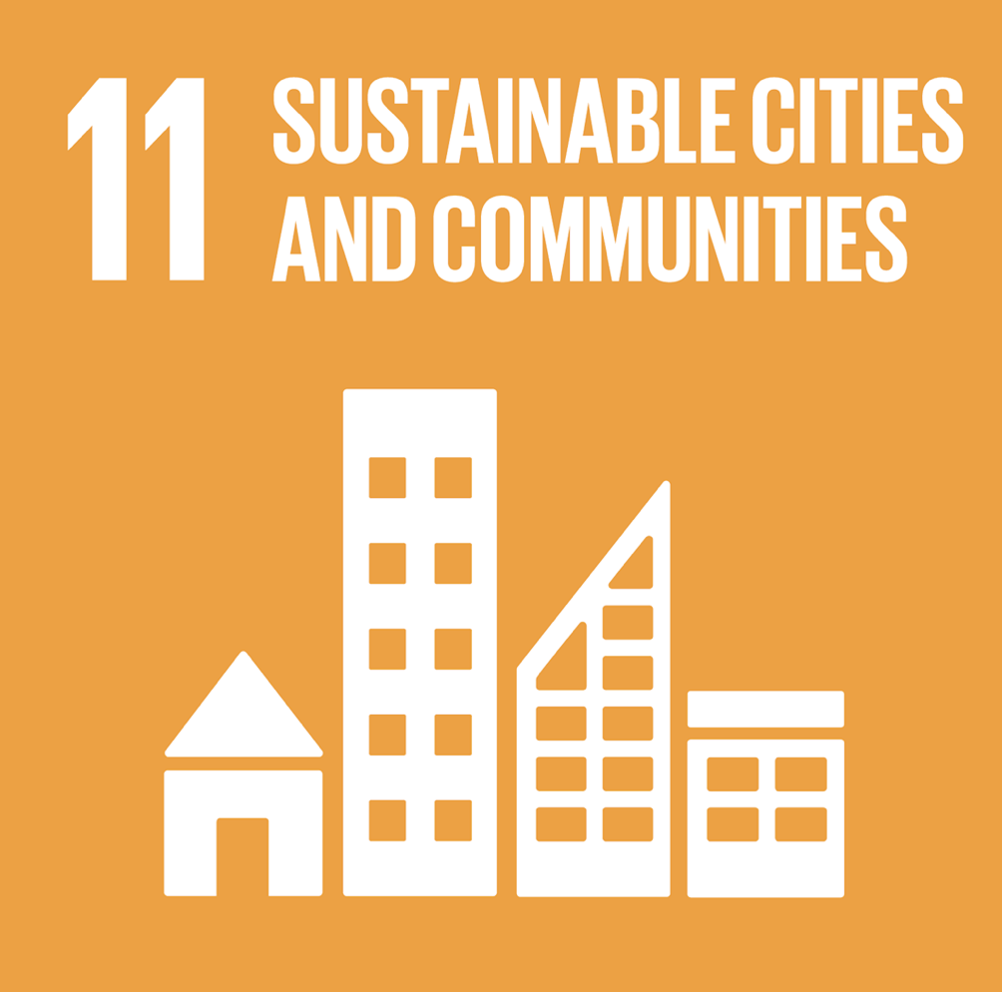
Figure 4. (United Nations, 2025).
Sustainable urban development has become a global priority as governments respond to climate change, population growth and socioeconomic inequalities. UN-Habitat (2024) highlighted that investment in affordable housing, sustainable transport and accessible public spaces is essential for creating inclusive, resilient communities. The organisation also suggested that integrated UP can reduce inequalities and improve quality of life through equitable access to infrastructure (UN-Habitat, 2024). Despite global commitments to SDG 11, many cities continue to face financial constraints and governance challenges that limit implementation (Dehrashid et al., 2026).
Recent research highlights the relationship between urban design and population health. Boeing et al., (2022) suggested that walkable neighbourhoods, connected street networks and accessible public transport promote physical activity, reduce reliance on private vehicles and support healthier lifestyles. Similarly, Cerin et al., (2022) found that communities with better access to destinations and public transport were more likely to meet recommended physical activity guidelines. However, Almulhim et al., (2024) argued that progress towards SDG 11 remains uneven because many cities face inadequate infrastructure, financial constraints and governance challenges. These findings suggest that achieving SDG 11 requires sustained investment, strong leadership and equitable UP to create healthier communities.
This approach reflects Bronfenbrenner's Ecological Systems Theory (1979) (Figure 5), which acknowledges that individuals are influenced by their physical and social environments. In practice, this theory supports sustainable UP by demonstrating how well-designed neighbourhoods, accessible transport and green spaces encourage healthier behaviours and improve community wellbeing.
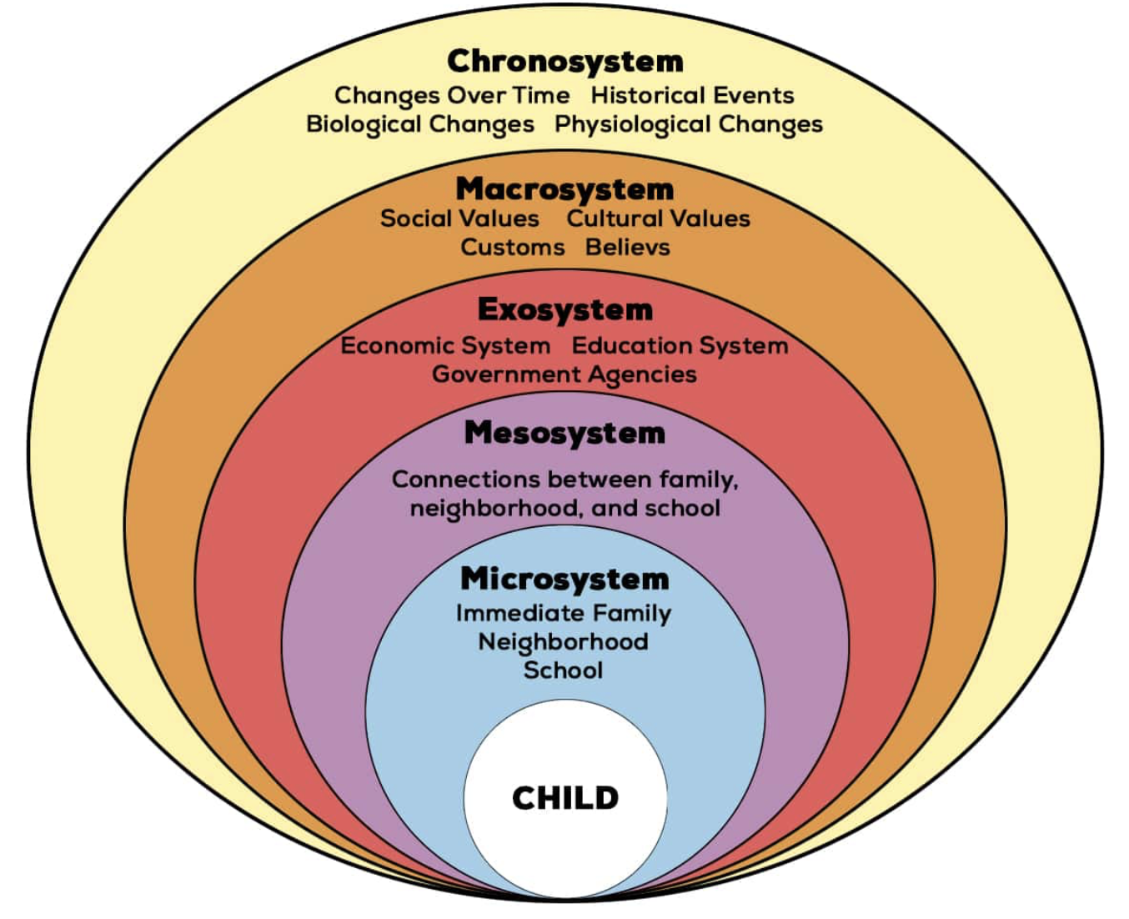
Figure 5. (Bronfenbrenner, 1979)

The UK has incorporated SDG 11 principles into national planning policies to create healthier, more resilient communities. According to the Ministry of Housing, Communities and Local Government (2024), the National Planning Policy Framework promotes SD through well-designed places, environmental protection and improved access to housing, public transport and green infrastructure. The framework emphasises planning decisions that support healthy, inclusive communities while balancing economic, social and environmental priorities. However, housing shortages and regional inequalities remain significant barriers to sustainable urban development.

According to the Office for National Statistics (ONS) (2023), approximately 94.6% of people in England and Wales lived in built-up areas at the time of the 2021 Census, highlighting the importance of long-term planning for growing urban populations. As demand for housing, infrastructure and public services increases, sustained investment is essential to ensure urban development remains environmentally sustainable while improving residents' quality of life ((ONS, 2023).

According to NICE (2018), the built environment plays an important role in promoting physical activity and wellbeing. The guidance emphasises the importance of walkable neighbourhoods, cycling infrastructure and accessible public spaces to encourage healthier lifestyles and reduce health inequalities. However, implementation varies across the UK because of differences in funding, infrastructure and local planning priorities (NICE, 2018). Consequently, consistent policy implementation is needed to ensure all communities benefit equally.

Local Evaluation and Recommendations
At the local level, several UK cities have introduced initiatives aligned with SDG 11 by promoting sustainable transport, improving public spaces and encouraging active travel. Greater Manchester Combined Authority (2026) provides a strong example through the Bee Network, an integrated transport system designed to improve connectivity while encouraging people to walk, cycle and use public transport. This approach supports national ambitions to increase active travel and create healthier communities (Department for Transport, 2021). However, delivering active travel projects requires integrated governance, long-term investment and coordination across all levels of government to achieve lasting success (Greenwood et al., 2024).
However, Sport England (2026) highlighted that inequalities in access to safe walking and cycling routes remain a significant barrier to participation, particularly in disadvantaged areas. Consequently, differences in local funding, infrastructure and planning priorities continue to affect the effectiveness of sustainable transport initiatives, limiting their potential to improve health outcomes and quality of life (Greenwood et al., 2024).
According to research, sustainable UP can improve physical and mental health by increasing access to public transport, green infrastructure and well-designed neighbourhoods that encourage physical activity and social interaction. Nieuwenhuijsen (2021) suggested that healthier urban environments reduce environmental risks while promoting physical activity. Similarly, Twohig-Bennett and Jones (2018) found that greater access to green spaces improves physical and mental health outcomes. However, Cerin et al., (2022) stated that inequalities in housing quality, transport provision and access to green infrastructure continue to limit these benefits for many disadvantaged communities.
Future progress towards SDG 11 will require stronger collaboration between national government, local authorities, UPs and public health professionals. According to Sharifi (2021), sustainable urban development requires integrated planning and coordinated policies addressing environmental, social and economic priorities simultaneously. Similarly, Kramer et al., (2024) suggested that effective urban governance requires collaborative, place-based approaches to create sustainable and equitable cities. Furthermore, Gergis (2024) highlighted that collaborative governance and stakeholder participation are essential for implementing sustainable urban mobility initiatives. Collectively, these measures would strengthen progress towards SDG 11 while supporting SDG 3 by reducing health inequalities and creating safer, healthier and more sustainable communities.
Conclusion
This report critically examined the contribution of SDG 3 (GHW) and SDG 11 (SCC) to improving health and wellbeing at global, national and local levels. The findings demonstrate that achieving long-term improvements in population health requires action beyond healthcare services, recognising the importance of wider social, economic and environmental determinants of health (WHO, 2020). While international frameworks and national policies provide important foundations for SD, their success ultimately depends on effective local implementation, sustained investment and cross-sector collaboration (UN, 2015).

The report also emphasised the close relationship between SDG 3 and SDG 11, demonstrating how well-planned urban environments, accessible public transport, green infrastructure and preventative public health programmes can work together to reduce health inequalities and improve quality of life. However, persistent challenges, including financial pressures, regional inequalities and inconsistent policy implementation, continue to limit progress. Therefore, stronger collaboration between governments, healthcare organisations, UPs and local communities will be essential to achieving healthier, more inclusive and sustainable communities while supporting the long-term objectives of the SDGs (UN-Habitat, 2024).

References

Active Travel England. (2024) Active Travel England: annual report and accounts 2023 to 2024. Available at: https://assets.publishing.service.gov.uk/media/66ab445a49b9c0597fdb091b/ate-annual-report-23-24.pdf (Accessed: 10 July 2026).

Almulhim, A.I., Sharifi, A., Aina, Y.A., Ahmad, S., Mora, L., Leal Filho, W. and Abubakar, I.R. (2024) 'Charting sustainable urban development through a systematic review of SDG11 research', Nature Cities, 1(10), pp. 677–685. Available at: https://doi.org/10.1038/s44284-024-00117-6 (Accessed: 10 July 2026).

Boeing, G., Higgs, C., Liu, S., Giles-Corti, B., Sallis, J.F., Cerin, E., Hinckson, E., Mavoa, S., Adams, M.A., Badland, H. and Salvo, D. (2022) 'Using open data and open-source software to develop spatial indicators of urban design and transport features for achieving healthy and sustainable cities', The Lancet Global Health, 10(6), pp. e907–e918.

Bronfenbrenner, U. (1979) The Ecology of Human Development: Experiments by Nature and Design. Cambridge, MA: Harvard University Press.

Cerin, E., Sallis, J.F., Salvo, D., Hinckson, E., Conway, T.L., Owen, N., van Dyck, D., Mavoa, S., Adams, M.A., Christiansen, L.B. (2022) 'Determining thresholds for spatial urban design and transport features that support walking to create healthy and sustainable cities', The Lancet Global Health, 10(6), pp. e895–e906.

Chief Medical Officer. (2024) Chief Medical Officer's annual report 2024: Health in Cities – Executive summary and recommendations. London: Department of Health and Social Care. Available at: https://assets.publishing.service.gov.uk/media/67581cf2f72b1d96e06bbfb2/cmo-annual-report-2024-health-in-cities-executive-summary-and-recommendations.pdf (Accessed: 10 July 2026).

Danielli, S., Ashrafian, H. and Darzi, A. (2023) ‘Healthy city: global systematic scoping review of city initiatives to improve health with policy recommendations’, BMC Public Health, 23(1), Article 1277. Available at: https://doi.org/10.1186/s12889-023-15908-0 (Accessed: 10 July 2026).
Dahlgren, G. and Whitehead, M. (1991) Policies and strategies to promote social equity in health. Stockholm: Institute for Futures Studies.

Department for Transport. (2021) Gear Change: one-year-on review. London: Department for Transport. Available at: https://assets.publishing.service.gov.uk/media/6107b4b4d3bf7f0449a82017/gear-change-one-year-on.pdf (Accessed: 10 July 2026).

Dehrashid, P.A., Mansourian, H. and Sharifi, A. (2026) ‘Healthy cities as catalysts for sustainable development: A systematic review of co-benefits, trade-offs, and solutions to the SDGs’, Progress in Planning, 203, article 101032.

Everett, G. (2017) What are the Sustainable Development Goals? Office for National Statistics Blog, 9 November. Available at: https://blog.ons.gov.uk/2017/11/09/what-are-the-sustainable-development-goals/ (Accessed: 13 July 2026).

Greater Manchester Combined Authority (2026) The Bee Network. Available at: https://www.greatermanchester-ca.gov.uk/what-we-do/transport/the-bee-network (Accessed: 10 July 2026).

Greenwood, D., Gerhards, J., Aldred, R. and Fadel, M. (2024) ‘Scales of governance, polycentricity and the case of active travel infrastructure in West London’, Public Policy and Administration, 0(0), pp. 1–21. Available at: https://doi.org/10.1177/09520767241306560 (Accessed: 10 July 2026).

Gergis, F.H. (2024) ‘Collaborative forms of governance in sustainable urban mobility schemes at the sub-governmental levels: a scoping literature review’, International Journal of Urban Sustainable Development, 16(1), pp. 343–359.

Kramer, J., Silverton, S. and Späth, P. (2024) ‘Urban governance arrangements for sustainability and justice – linking theory with experience’, Urban Transformations, 6, Article 6. Available at: https://doi.org/10.1186/s42854-024-00064-4 (Accessed: 10 July 2026).

Lewis, T., Buck, D. and Wenzel, L. (2022) Equity and endurance: how can we tackle health inequalities this time?London: The King's Fund. Available at: https://www.kingsfund.org.uk/insight-and-analysis/long-reads/how-can-we-tackle-health-inequalities (Accessed: 10 July 2026).
Leeds City Council (2023) New partnership aims to deliver a fairer and healthier Leeds. Available at: https://news.leeds.gov.uk/news/new-partnership-aims-to-deliver-a-fairer-and-healthier-leeds (Accessed: 10 July 2026).

Lee, C., Buswell, M., Coker, J., Buckner, S., Cowan, A. and Lhussier, M. (2024) ‘Addressing health inequalities in times of austerity: implementation of a place-based approach in multitiered local government’, Perspectives in Public Health, 144(3), pp. 153–161.
Marmot, M., Allen, J., Boyce, T., Goldblatt, P. and Morrison, J. (2020) Health Equity in England: The Marmot Review 10 Years On. London: Institute of Health Equity. Available at: https://www.health.org.uk/reports-and-analysis/reports/health-equity-in-england-the-marmot-review-10-years-on-0?gad_source=1&gad_campaignid=13881943804&gbraid=0AAAAADunFmQmtA_MYoNNk9078sSW_THyv&gclid=Cj0KCQjwsMLSBhD9ARIsAIpUTDq2PM5C6igItO4TFfgtm0YNjqzm6xT5aiLb8irkgqpBi4_JrYxsfUcaAmV-EALw_wcB (Accessed: 10 July 2026).
Ministry of Housing, Communities and Local Government. (2024) National Planning Policy Framework. London: Ministry of Housing, Communities and Local Government. Available at: https://assets.publishing.service.gov.uk/media/67aafe8f3b41f783cca46251/NPPF_December_2024.pdf (Accessed: 10 July 2026).
Nieuwenhuijsen, M.J. (2021) ‘New urban models for more sustainable, liveable and healthier cities post COVID-19: reducing air pollution, noise and heat island effects and increasing green space and physical activity’, Environment International, 157, p. 106850.

National Institute for Health and Care Excellence. (2018) Physical activity and the environment (NG90). London: National Institute for Health and Care Excellence. Available at: https://www.nice.org.uk/guidance/ng90 (Accessed: 10 July 2026).

NHS England. (2019) The NHS Long Term Plan. Available at: https://www.england.nhs.uk/2019/01/long-term-plan/ (Accessed: 10 July 2026).

Office for Health Improvement and Disparities (2022) Health disparities and health inequalities: applying All Our Health. London: Department of Health and Social Care.
Available at: https://www.gov.uk/government/publications/health-disparities-and-health-inequalities-applying-all-our-health/health-disparities-and-health-inequalities-applying-all-our-health (Accessed: 10 July 2026).
Rad, J. (2025) ‘Health inequities: a persistent global challenge from past to future’, International Journal for Equity in Health, 24(1), p. 148. Available at: https://link.springer.com/article/10.1186/s12939-025-02526-y (Accessed: 8 July 2026).

Sport England. (2026) Active Lives Adult Survey November 2024–25 Report. Available at: https://sportengland-production-files.s3.eu-west-2.amazonaws.com/s3fs-public/2026-04/Active%20Lives%20Adult%20Survey%20November%202024-25%20Report_.pdf?VersionId=eNbVPPXI6E4LS5ozt489Yr_FnGdH84zQ (Accessed: 14 July 2026).

Sharifi, A. (2021) ‘Co-benefits and synergies between urban climate change mitigation and adaptation measures: A literature review’, Science of the Total Environment, 750, 141642.

Twohig-Bennett, C. and Jones, A. (2018) ‘The health benefits of the great outdoors: A systematic review and meta-analysis of greenspace exposure and health outcomes’, Environmental Research, 166, pp. 628–637.

United Nations (2015) Transforming our world: the 2030 Agenda for Sustainable Development. Resolution adopted by the General Assembly on 25 September 2015, A/RES/70/1. Available at: https://sdgs.un.org/2030agenda (Accessed: 10 July 2026).

United Nations. (2025) Goal 11: Sustainable cities and communities. Sustainable Development Goals. Available at: https://sdgs.un.org/goals/goal11 (Accessed: 9 July 2026).

United Nations. (2018) 68% of the world population projected to live in urban areas by 2050, says UN. Available at: https://www.un.org/sustainabledevelopment/blog/2018/05/68-of-the-world-population-projected-to-live-in-urban-areas-by-2050-says-un/ (Accessed: 8 July 2026).

United Nations Human Settlements Programme (UN-Habitat). (2024) World Cities Report 2024: Cities and climate action. Nairobi: UN-Habitat. Available at: https://unhabitat.org/sites/default/files/2024/11/wcr2024_-_full_report.pdf (Accessed: 8 June 2026).

United Nations. (2025) The Sustainable Development Goals Report 2025. New York: United Nations. Available at: https://unstats.un.org/sdgs/report/2025/ (Accessed: 13 July 2026).

UN-Habitat. (2024) World Cities Report 2024: Cities and Climate Action. Nairobi: United Nations Human Settlements Programme (UN-Habitat). Available at: https://unhabitat.org/sites/default/files/2024/11/wcr2024_-_full_report.pdf (Accessed: 10 July 2026).

World Health Organization. (1948) Constitution of the World Health Organization. Geneva: World Health Organization. Available at: https://apps.who.int/gb/bd/pdf/bd47/en/constitution-en.pdf (Accessed: 10 July 2026).

World Health Organization. (2024) Urban Health Initiative. Geneva: World Health Organization. Available at: https://www.who.int/initiatives/urban-health-initiative (Accessed: 10 July 2026).

World Health Organization. (2020) Healthy Cities Effective Approach to a Rapidly Changing World. Geneva: World Health Organization. Available at: https://iris.who.int/server/api/core/bitstreams/2e4092fb-4753-4e44-85f1-3ce83b74ad05/content (Accessed: 9 July 2026).

World Health Organization. (2026) Healthy Cities. Available at: https://www.who.int/teams/health-promotion/enhanced-wellbeing/ninth-global-conference/healthy-cities (Accessed: 9 July 2026).

