Part 1:

Abstract:

This report presents an experiment on measuring the attenuation coefficient of ultrasonic waves in two different material samples: a mild steel block and a metal wheel hub spacer. The attenuation coefficient shows the energy loss of an ultrasonic beam as it travels through a material. The experiment used a zero-degree 5MHz probe and an ultrasonic flaw detector to measure the amplitude of the reflected waves at different depths. Three amplitude measurements E1, E2 and E3 were taken. The attenuation coefficient was then calculated using the time of flight equation and the average of the ratios of E2/E1 and E3/E1. The results showed that the attenuation coefficient of metal spacer was higher than that of the mild steel block. However, the measurement process was prone to human error and lack of frequency variation. The report suggests that more accurate and reliable methods are needed to determine the attenuation coefficient of materials using ultrasonic waves.

Apparatus:

For our assignment, we were given 2 material samples to work with in the lab. The two material samples are a mild steel rectangular block and a metal wheel hub spacer.
During the lab session, we were also given an ultrasonic flaw detector, a zero-degree 5MHz probe as well as some hair gel as apparatus. I have created a 3D-model drawing to illustrate the 2 material samples. (A metal Spacer & mild steel rectangular block)

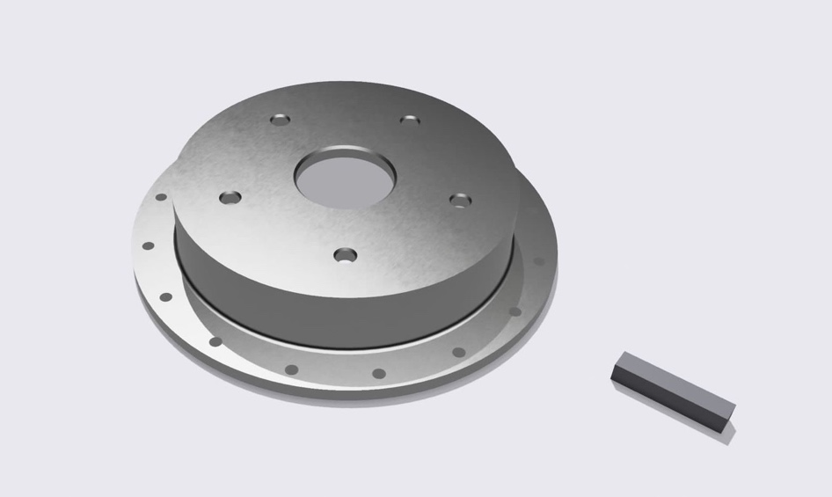

Introduction:

The use of ultrasonic flaw detector is crucial in the NDT industry to inspect defects such as cracks, porosity hidden under the layer of the material. It has the advantage where the detection process can be done fairly quickly. It works by sending a pulse of ultrasound from a transducer into the material through a detection probe and receiving the reflected echoes from any discontinuities or boundaries. The echoes are displayed on the screen as a waveform, which is the E1, E2 and E3 amplitude values in our lab experiment, these waves can then be analysed to identify and locate the flaws, as well as finding the attenuation coefficient. The attenuation coefficient is a parameter that indicates how much the ultrasonic beam loses energy as it travels through a material and can be used to evaluate the quality and integrity of the material (Sampath et al., 2021). In the following lab experiment, we would learn that the α value, which refers to the attenuation coefficient highly depends on both the material properties and the ultrasonic beam characteristics, such as frequency and divergence. A higher α value indicates more scattering and absorption of the ultrasound signal, which means there’s inhomogeneity in the material, likely caused by defects and porosity. Whereas a lower α value indicates a uniform and sound material with fewer or finer flaws (Bell & Carroll, 2019).

Methodology:
For our assignment, we were required to connect the zero-degree 5MHz probe to the ultrasonic flaw detector, and set the frequency and range on the detector to measure the E1, E2 and E3 values of the two material samples.
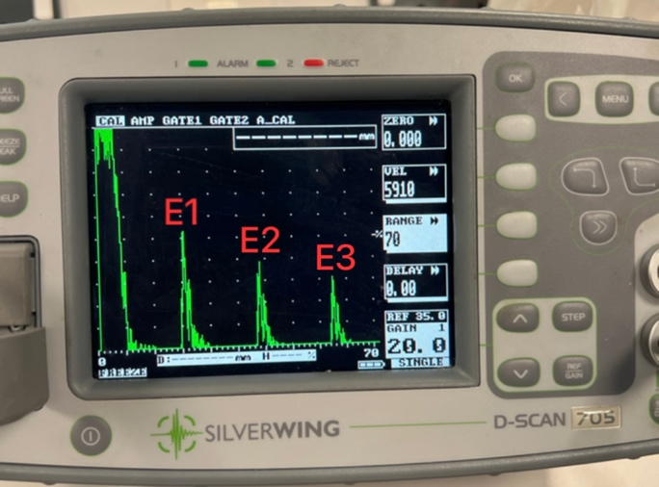
The procedure of the measuring process was quite complicated and technical, along with some of the procedures being very easily influenced by human error. First of all, the ultrasonic flaw detector needs to be set at specific range in order for it to display the correct proportion of the graphs on the display. If this was not being set correctly, the graph could not show all E1, E2 and E3 values. We had to experiment this a few times before getting the range somehow correct for our measurement, and the range has to be re-calibrated back-to-back with the 2 different material samples we had. The second step of the procedure was to apply a hair styling gel on top of the area that we intended to place our detector probe on. This step was arguably the most problematic as the shape and values of the graph fluctuates depending on the amount of gel we applied and the pressure that was exerted from the detection probe onto the material sample. On top of that, the freeze frame button had to also be pressed while holding the probe measuring a reading. I would doubt the reliability and repeatability of this procedure to give an accurate and similar reading every time we measure. This could be seen in one of the data collected for the mild steel rectangular block where the values deviated very far from the other two sets of measurements.

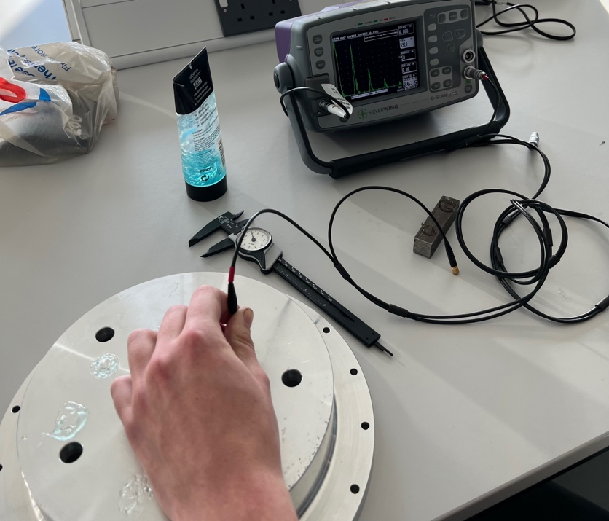
(Picture of the process of taking amplitude measurements using the detection probe)

Measurements and Graph of raw measurements:
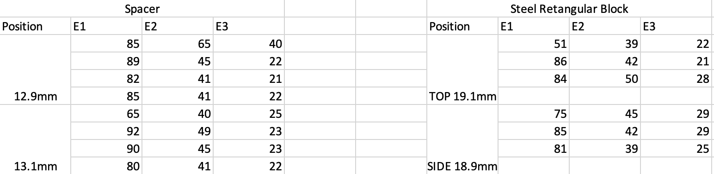
On the left of the excel spreadsheet shows the measurements of E1 to E3 amplitude of the metal spacer. 12.9mm indicates the thickness measured from the top part of the inner ring. Subsequently, 13.1mm indicates the thickness of the outer ring.
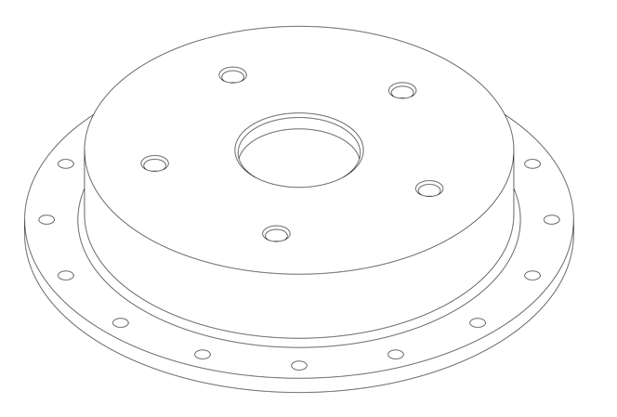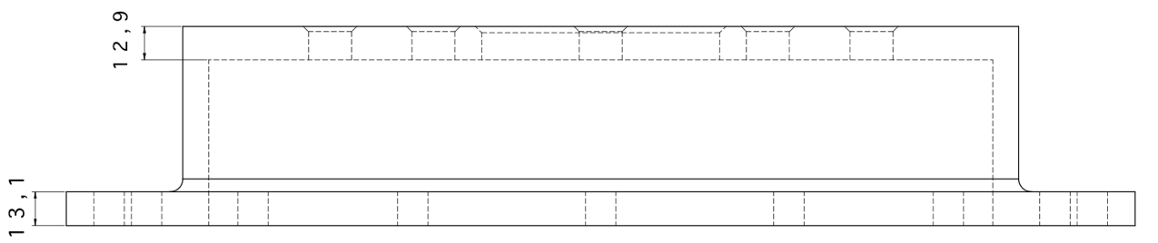
For the steel rectangular block, thickness from the top of the block measures to be 19.1mm, and 18.9mm when measured from the side.
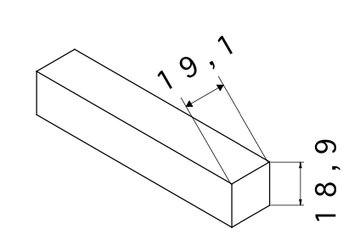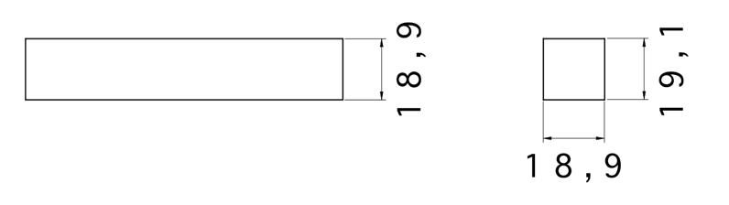
Calculations:
In order to determine the material attenuation coefficient values for both examples using the time of flight method, the following equations were used;
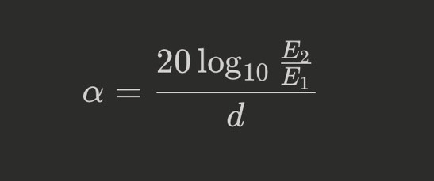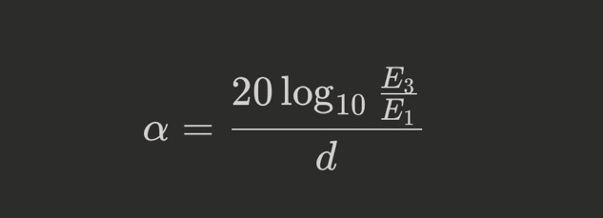

For the distance on the E2 and E1 equation, the distance (indicated by the letter d) needs to be 2* thickness, while on the E3 and E1 equation, the distance needs to be 4* thickness. To list the steps of a calculation example from one of the measurements on the inner ring of the spacer would be:
E1=89, E2=45, E3=22 and the thickness = 12.9mm, by plugging in the numbers into the equation;
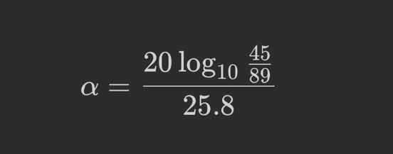
The attenuation coefficient α for E2/E1 would be equal to -0.229 dB/mm. Subsequently, to get the attenuation coefficient from E3/E1 would follow the same steps, but the thickness distance (d) would be 4*12.9mm, which is 51.6mm, by plugging the numbers into the same equation again;
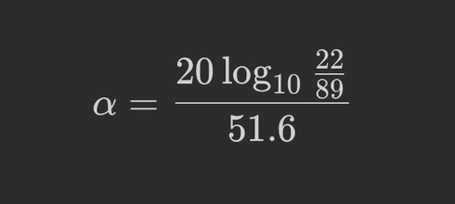
which then gives α the value of -0.235 dB/mm. By taking an average from the attenuation coefficient values of E2/E1 and E3/E1 would give a final value of 0.232 dB/mm.

Results and Discussions:
Using the above method, the values of attenuation coefficient is given in the following table:
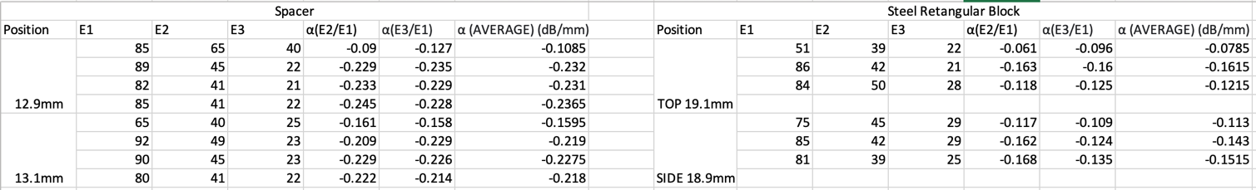
Looking at the results drawn on the spreadsheet, we could see the attenuation coefficient was higher on the metal spacer than that of the mild steel rectangular block. However, we could see a pattern of E1, E2 and E3 data deviation on the first attempts at measuring the amplitude values, I would attribute this to be down to human error as mentioned in the methodology. Looking back at the measurement collection process in the lab session, situations such as the hair gel not being applied smoothly on the surface could also very likely affected the accuracy of the initial amplitude values as the subsequent data appeared to be more closed and in range together. Those initial attempts of data collected should arguably be excluded from being taken into average.

Conclusion:

Looking at the experiments, there were many factors that contribute to the accuracy of the attenuation coefficient values to the two materials. In terms of human error, I would attribute the factors to be down to uneven spread of hair gel over the material layer and inconsistent pressure being applied when pushing the ultrasonic probe against the material while pushing the freeze frame button on the ultrasonic flaw detector. Moreover, we have tested only at one frequency of ultrasonic attenuation in the lab session, I would argue that’s not enough. Testing at a variety of different frequencies is important for ultrasonic flaw detectors because the frequency of the sound waves affects the resolution and penetration of the inspection. Higher frequency transducers can resolve smaller flaws due to the shorter wavelength while lower frequency ones has the ability to penetrate further in a given material because attenuation decreases with frequency (Anderson, 2015). Thus, doing so could certainly help better determine the two material’s α attenuation coefficient values.

Part 2:
Abstract:

This report evaluates the sizing accuracy of 10 operators who measured 21 defects. Using linear regression, the study estimates the expected defect size for different skill levels and compares them with the true value. By plotting scatterplot graphs and showing the difference in trendlines, it shows the relationship between the operators’ measurements and the true size visually. The results reveal a significant variation and a systematic bias in the measurements of the operators. The study discusses the possible sources and implications of these errors, such as the calibration of the equipment, the training and experience of the operators, and the measurement techniques. Finally, it concludes that operator 1 is the most consistent but also the most affected by calibration error in the equipment, while operator 10 is the least accurate. The study suggests that further research is needed to improve the reliability and validity of the defect measurements.

Introduction:

For our assignment, we were given an excel spreadsheet with 21 defect measurements from 10 different operators. In order to determine the accuracy of each operator, statistical methods such as linear regression has to be used. Linear regression is an important statistical analysis technique for determining sizing accuracy, especially in a smaller data group like what we are dealing with. It allows us to measure the degree of correlation and causation between the defect measurements and the technician’s skill level (Field, 2018). By applying the linear regression technique into this data, we can estimate the expected defect measurement for different skill levels, thus evaluate how close they are to the true value (Cohen et al., 2013). By using the excel function to plotting a trendline, we can more clearly show the variance in between the true value and the technicians’ data, using this function also allows us to come up and test hypothesis about the relationship between the variables, like the reasoning behind the inaccuracy.

In order to assess the sizing accuracy of each operator and their methodology and equipment, I have opted to plot scatterplot graphs from all 21 defect measurements from the 10 operators. The X axis on the scatterplot represents the 21 defect measurements and the Y axis represents the defect measurement values. 10 scatterplot graphs were plotted representing the 10 operators. Each scatterplot graph was comprised of the data from the corresponding operator and the true size. On each graph, the plots and trendline highlighted in red and blue represents the true size and the data from the operator respectively. By comparing the blue and red trendline, not only that we can closely inspect the accuracy of the measured defect data by inspecting how close the two lines are, but we can also see trend of the accuracy, which can be useful in determining the methodology and equipment accurateness.

Methodology:

In order to assess the accuracy of the different operators. I have initially thought of different methods at the beginning, one of which being by comparing the dataset with normal distribution. This method requires finding the mean and standard deviation and also 95% confidence interval and potential more points for the X axis of the histogram. However, I have decided against using this method as this method would require me to plot 21 graphs for their probability density functions.

As the requirement of the task is to assess the sizing accuracy of the individual operators, I would argue that the focus should be on the individual performance, making the proposed method more suitable.

Measurements and Graphs of raw measurements:

According to the 10 plotted scatterplot graphs, I would group the 10 technicians in 5 different groups based on their similarities and patterns in their sizing accuracy.

Group 1 consists of only OP1;
Group 2 consists of OP2 and OP7;
Group 3 consists of OP3 and OP4;
Group 4 consists of OP5, OP6, OP8 and OP9;
Group 5 consists of only OP10.

I would describe Group 1, which refers to only technician 1 to having the most consistent data out of all the other technicians, however the data is consistently off from the true size. This is shown by the trendline in the scatterplot. We can see the 2 trendlines in the scatterplot appeared to be parallel in the graph, which indicates the difference in the technician’s data and the true size to be of similar pattern, however consistently off by a certain margin by about 0.8 units in average. Based on the results shown by the graph, I would argue the probable cause of the error is due to the incorrect parameters settings of the equipment used to measure the defects.
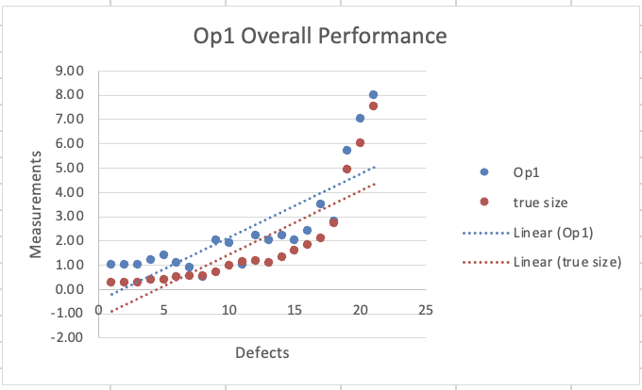
Group 2, which consists of technician 2 and 7. The accuracy trend of their data can be described as being gradually more accurate as the number of defect measurements increase. This is quite common in many lab measurements where on smaller values, the accuracy is actually harder to get right, however as the values get larger, the accuracy improves. This could be down to factors such as the equipment’s level of accuracy on smaller values. However, technician 2’s overall data measurement is closer to the true values when compared to technician 7.
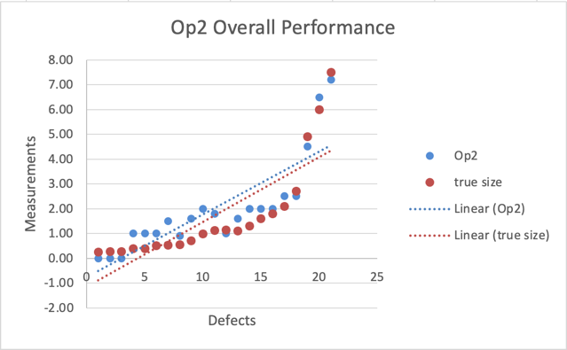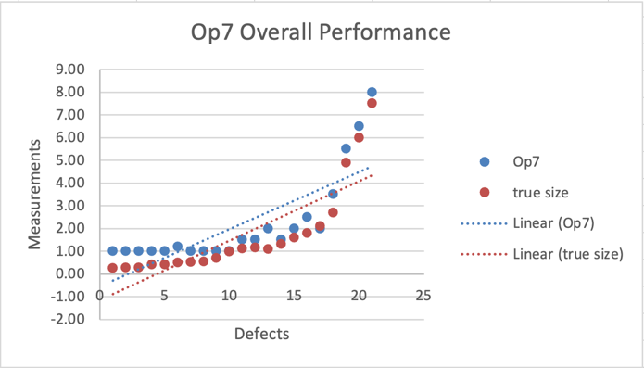
Group 3, which consists of technician 3 and 4 is a more extreme version of Group 2. The accuracy of their data gets very close to the true value while the initial measurement is further from than the ones from group 2.
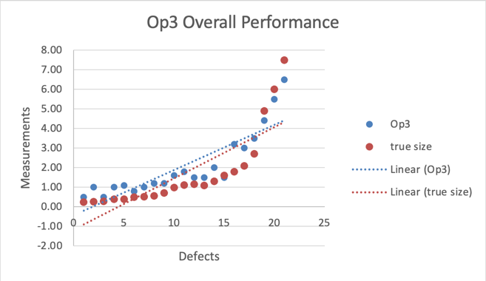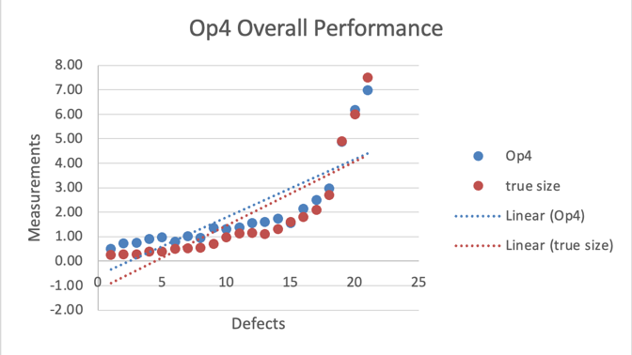
Group 4 consists of the most number of technicians, which are technician 5,6,8 and 9. The pattern of their data trendlines was also very confusing. In the initial phase, there’s a significant deviation from the true data, this can be attributed to a systematic error or bias from the measuring equipment or from the operator’s human error, likely down to factors such as incorrect calibration or the measurement error. The intersection in the middle with the true value indicates a momentary alignment in between the operators’ data and the true value, a likely explanation for this could be due to a correction phase from the operators who realised there’s a significant error in the initial phase and tried to correct it. The subsequent deviation would indicate that although adjustment correction was being attempted, it wasn’t sustained, leading to a divergence again. I would attribute this pattern of discrepancy to be of inconsistencies by the technicians.
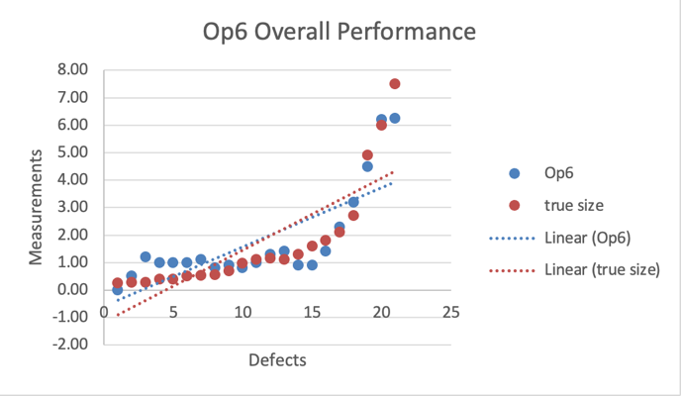
Group 5, which refers to only technician 10. I would describe this operator to be the least accurate out of all operators. For the start, the initial phase of the defect measurement is already off by a significant margin. It also doesn’t seem like the technician attempted any correction in the middle phase. Although the measurement did seem to be getting closer to the true value at the final phase, the data trendline of technician 10 didn’t seem to provide a clear pattern to show any form of accuracy.
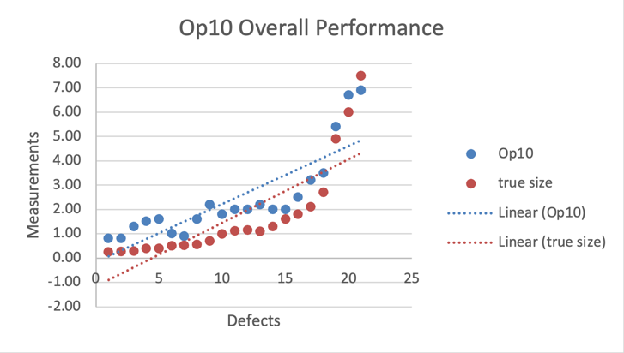

Results:
By combining all the data of the operators, a graph that consists of all the trendlines of the operators can be plotted against the true data, as shown below:

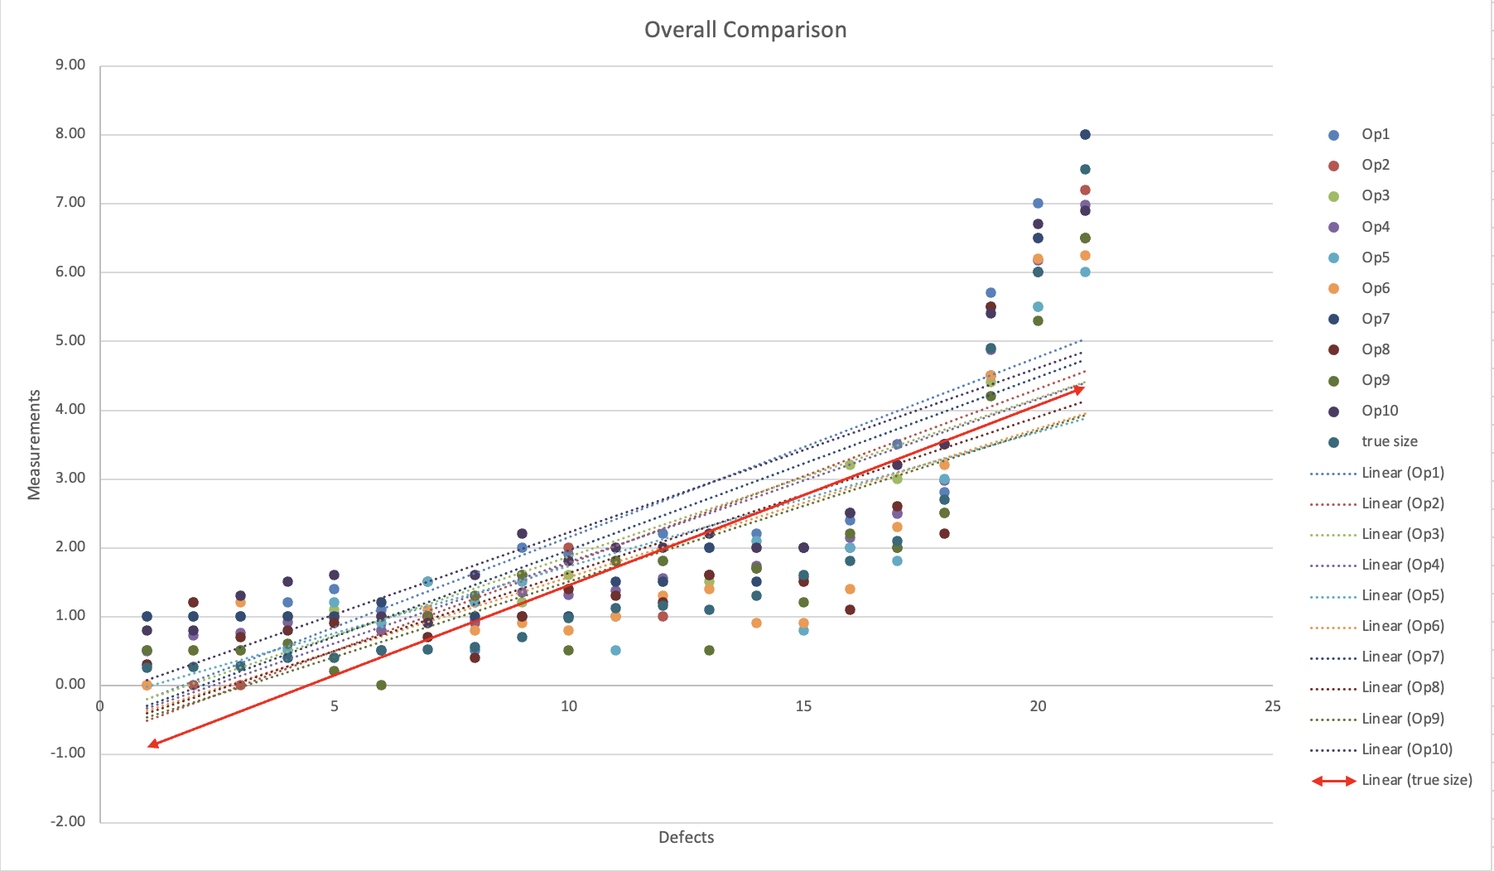

Conclusion:
Looking at the graphs, it is hard to pin-point whether which of the operators has the most accurate data, however looking at the characteristics of each operator’s trendline, it shows there was a significant variation in the accuracy of the individual operators, as well as a systematic bias in the overall measurements. By visually inspecting the relationship between the operators’ measurements and the true size, the conclusion could be made that Operator 1 holds the most consistent data out of all the other operators, but its data accuracy is also most affected by calibration error of the equipment. The operators from Group 2 shows an initial deviation from true size, which could be down to systematic error, however as more data is collected, the measurements become more accurate. The improvement could be due to adjustments made in measurement techniques or increased precision that the equipment provides as the measurement value gets bigger. Group 4’s operators are an example of the result of the equipment’s incorrect or over calibration, resulting in a temporary alignment of the data in the middle phase, but then deviates from the true value again. To conclude, the accuracy of the individual operators could be influenced by several factors, such as the calibration of the equipment, the training and experience of the operators. Possible errors might be down to the equipment not being calibrated before the experiment, resulting in a systematic overestimation for all 10 operators in the first phase of the detection.

References:

Anderson, M. (2015) The basics of ultrasonic flaw detection, The Basics of Ultrasonic Flaw Detection. Available at: https://www.qualitydigest.com/inside/metrology-article/basics-ultrasonic-flaw-detection-091415.html (Accessed: 08 January 2024).
Bell, D. and Carroll, D. (2019) ‘Attenuation (ultrasound)’, Radiopaedia.org [Preprint]. doi:10.53347/rid-67529.
Cohen, P., West, S.G. and Aiken, L.S. (2013) in Applied multiple regression/correlation analysis for the Behavioral Sciences. Mahwah, NJ: Routledge, p. 117.
Field, A. (2018) Discovering statistics using IBM SPSS statistics: North American edition. Los Angeles ; London ; New Delhi ; Singapore ; Washington DC ; Melbourne: SAGE.
Sampath, S. et al. (2021) ‘Evaluation of material degradation using phased array ultrasonic technique with full matrix capture’, Engineering Failure Analysis, 120, p. 105118. doi:10.1016/j.engfailanal.2020.105118.

