Assessing the Environmental Impact on the Bristol Airport Re-development

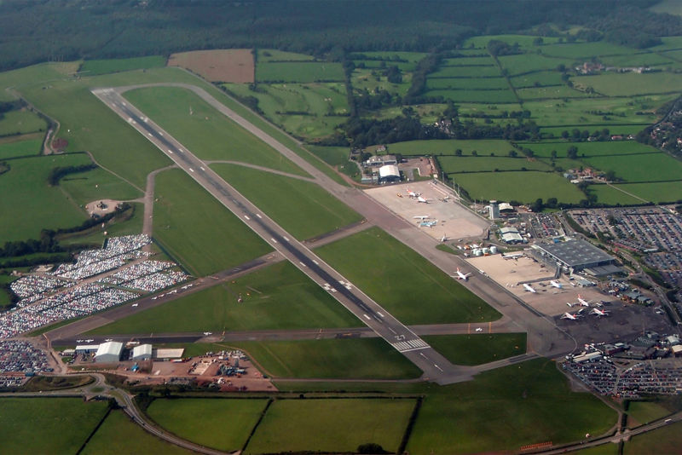

By Marie West (1702919)

Contents
1.0 Introduction 1
1.1 Bristol Airport 2
1.2 Regulations 4
1.2.1 The Future of Air Transport (2003) 4
1.2.2 The Town and Country Planning (England and Wales) Regulations (2000) 5
1.2.3 The Air Quality Strategy for England and Wales (AQS) (2000) 5
1.2.4 International Civil Aviation Organisation (ICAO) (2000) 6
1.3 Development Proposal 7
1.4 Environmental Impacts 10
1.4.1 Air Quality 10
1.4.2 Archaeology and Culture Heritage 11
1.4.3 Biodiversity 11
1.4.4 Community 12
1.4.5 Geology and Land Quality 12
1.4.6 Landscape and Visual 13
1.4.7 Noise 13
1.4.8 Transport 13
1.4.9Water resources and Quality 14
2.0 Conclusion 15
3.0 Reference 17

List of Figures

  - Bristol International Airport Master Plan 2006-2030 development plans……9
  - Bristol International Airport Master Plan 2006-2030 development plan in detail………………………………………………………………………………………………………...9
  - Estimated NOχ, CO, HC’s, PM₁₀ and SO₂ for 2020………………………………………10
  - Bristol Airport. Google Earth (2020)………………………………………………………...16

1.0 Introduction

When deciding to build a new development there is a multi -staged process that must take place before construction can even begin.

Each stage has many steps. The main stages

Each stage has many steps. The main stage is the inception, this involves
the question, is it necessary to build?
If the answer is yes, then the following steps are taken to move the project forward,
- Architect appointment, brief on the planned development, what type of building? and appointments with consultants.
- Feasibility, this stage will contain an Environmental Impact Assessment (EIA), an outline of the plan, can it be achieved ?,
- Health and safety with a site visit, a report of findings, preliminary enquiries, a decision to continue with the project.
- Outline the proposals, first the layout of the building, second a structural design, third services of requirement, fourth alternative proposals and lastly estimated costs.
- Scheme design, first a detailed plan is needed, secondly a brief specification, then a model is made, once the model is made the cost of the project is then re-evaluated.

Once these stages have been given the go ahead a detailed design is made, production information is given, bills of quantities are done, then tender action is carried out, project planning is carried out, operations on site are started, completion of the project and final feedback is completed on the site.

However, for this assessment the point of interest is the Environmental Impact Assessment (EIA). The United Kingdom Government give the definition of a environmental impact assessment as:

‘The aim of Environmental Impact Assessment is to protect the environment by ensuring that a local planning authority when deciding whether to grant planning permission for a project, which is likely to have significant effects on the environment, does so in the full knowledge of the likely significant effects, and takes this into account in the decision making process. The regulations set out a procedure for identifying those projects which should be subject to an Environmental Impact Assessment, and for assessing, consulting, and coming to a decision on those projects which are likely to have significant environmental effects.

The aim of Environmental Impact Assessment is also to ensure that the public are given early and effective opportunities to participate in the decision-making procedures.’ (Government, 2014)

The Environmental Impact Assessment that will be used is Entce’s assessment on the Bristol International Airport Master Plan 2006 to 2030.
The goal of this assessment is to identify areas that have been neglected, suggest improvements on how to improve the environment and how to protect the Community.

  - Bristol Airport

Bristol Airport can be found at Lulsgate Bottom, North of Somerset (Bristol Live, 2020). The site of the airport was once a RAF airfield. In 1975 the Lulsgate airport was built to replace the Whitchurch airport; once the Lulsgate airport was built it was known as Bristol International Airport from 1997 to 2010 (Bristol Live, 2020). Then in 2016 it became the 9th busiest United Kingdom airport, seeing over 7.6 million customers (Bristol Live, 2020). The passenger numbers continued to grow with 8.6 million passengers passing through the airport in 2018; with this growth the additional aircraft companies began to fly from Bristol allowing more flights to be scheduled and other locations to be visited (Bristol Airport, 2019).

This airport is a large space and this reflects in the number of employees it has. The Bristol airport itself employs 400 staff but 3,000 people work on site with over 50 organisations from government agencies such as Border force and commercial airlines (Bristol Airport, 2020).

With this size airport in the area, it is of no surprise that the estimated annual tourism economy in Bath and Bristol is £2.3 billion (Baker, 2019). However, with the planned expansion it is thought to boost by another £380 million in the mid 2020’s and have another 4,000 employees (Baker, 2019).

All was looking well for the airport until the unpredicted turns of event with Covid19. Due to the virus, airports all over the world have been affected with international airports, like Bristol Airport, have seen a sharp decline in plane traffic, some airports have even completely closed their terminals (Gittens, 2020). With these events happening globally it is expected to have economical repercussion not only in the airport industry but in every sector.
As mention in section 1.0, the environmental impact assessment that will be used for the foundations of this report is the Bristol International Airport Master Plan 2006 to 2030; before continuing with this paper however the regulations that the airport had to follow by it fist needs to be established.

1.2 Regulations

Due to the year, 2005, in which this Master Plan was designed ,in it falls under regulations that were made at that time; so, the regulations and legislation this Master Plan must follow were ones from 2005 even though we are in 2020. Along with regulations for construction from 2006 it also must follow regulations from other sectors like the Department of transport.
There are several regulations and legislations that need to be complied with, for example:
- The Future of Air Transport (2003)
- The Town and Country Planning (England and Wales) Regulations (2000)
- The Air Quality Strategy for England and Wales (AQS) (2000)
- International Civil Aviation Organisation (ICAO) (2000)

1.2.1 The Future of Air Transport (2003)
“The challenge we face is to deal with the pressures caused by the increasing need to travel whilst at the same time meeting our commitment to protect the environment in which we live”. (Department for Transport, 2003: p.7)

This regulation has many sections that discusses problems that could occur with air transport, environment impacts and how each area in the UK should handle air travel going forward. It outlines what should be considered and done with each area. For example, they make refence to air quality to the local area and how nitrogen dioxide (NO₂) and particulates (PM₁₀) can effect the area significantly; but the European Union (EU) set limitation levels to how much pollution can be emitted, to be in accordance with the EU the Department for Transport said a few thing but one of the regulations made was that airports had to reduce ‘airside’ emissions through technological and operational improvements by airlines and the airports themselves (Transport, 2003). When building an airport this regulation must be considered.

1.2.2 The Town and Country Planning (England and Wales) Regulations (2000)

This regulation is where the Environmental Impact Assessment (EIA) falls under. The definition of what an environmental Impact Assessment is can be found in section 1.0.

In the 2000 case of Berkeley v Secretary of State for the Environment was taken to court because the Secretary of State for the Environment had accepted the planning permission of rebuilding a football club on the banks of the River Thames; this would mean the re-modelling of the river with an effect on the rivers habitat (Environmental Law Alliance Worldwide, 2015). This application was accepted without the Secretary of State for the Environment requesting to see the EIA and this is why Berkeley took the Secretary to court; although the Judge dismissed the case as the EIA showed that there would be no impact to the river habitat he did state he dismissed the case as the outcome would have been the same if the EIA had been read. After this case the House of Lords remind the public and government bodies that EIA are of great importance when land use is be planned (Brady, 2005).

This just further strengthens why EIA are important in the planning process when it comes to construction.

1.2.3 The Air Quality Strategy for England and Wales (AQS) (2000)

This Strategy is very important when looking into building an airport as airplanes can cause air and noise pollution. The strategy outlines a plan going forward on how to improve air quality, what the standard of air quality is expected and how this can be achieved, a framework to tack fine particles and to identify possible new national policy that measure further health benefits which will aid in meeting the strategy’s objectives (APIS, 2016).

If we look at the strategy for Nitrogen Dioxide (NO₂) as planes emit this; this NO₂ strategy applies to the whole of the UK, the objective is 200 microgram per cubic meter (𝜇𝘨𝘮¯³) not to be exceeded more the 18 times a year, the concertation is to be measured by 1 hour average, this is to be achieved by 31st of December 2005 (APIS, 2016)

1.2.4 International Civil Aviation Organisation (ICAO) (2000)

Although the International Civil Aviation Organisation (ICAO) is not a regulation it is important to mention them as they were put in place by the United Nations (UN) to govern and administrate Convention on International Civil Aviation (ICAO, 2020).

The ICAO job is to come together to agree on international civil aviation Standards and Recommend Practices (SARPS), policies that support safe, efficient, secure, economically sustainable and environmentally responsible practices in civil aviation; SARPS are then take by the Members of ICAO to their local civil aviation sector and the changes are made, this in turn allows over 100,000 flights daily to operate safely around the world (ICAO, 2020).

When building an airport this organisation will aid in best practice and safety.

For the Bristol International Airport Master Plan 2006 to 2030 planning permission to be successful, these regulations would have to be used while still following the up to date policies.

1.3 Development Proposal
In 2018, a planning application was submitted to the North Somerset Council to increase the airport size, as it is expected to have more passengers by mid-2020’s and this is more than their current capacity (Bristol Airport, 2019). The Master Plan predicted by 2030 they would be seeing 10-12 million passengers visiting the airport (Bristol Airport, 2005) however, this increase is now predicted to happen in the mid 2020’s (Bristol Airport, 2019) which with a 10 million passenger increase in two years is feasible.

The planning application included new infrastructure, improvements to existing terminal, road facilities improvement and operational changes to allow the airport to be able meet the demand of air travel, the maximum that the airport can currently hold is 10 million passengers so new development is needed (Bristol Airport, 2019).

This information and development are more recent then the Master Plan but should be noted and kept in mind as it shows you how successful this development of the Bristol International Airport has been.

The Master Plan first lays out how much the airport of use at the current time (2005) and how much it is expected to be used by 2030 (Bristol Airport, 2005). It states that in 2005 it had 52 different businesses inside the airport with 2,650 people employed, if the planning permission is granted then by 2015 there will be 3,802 job and 5,686 jobs by 2030; this is not even mentioning the economically benefit of having an international airport in the South West (Bristol Airport, 2005).

The 2005 facilities could only hold a capacity of 6 million passenger a year with the anticipated growth of passengers by 2015 (Bristol Airport, 2005) a new development was needed. The development of the airport will be done in two phases with accommodation growth from 2005 to 2015 as the passengers is expected to be 9 million per annum by 2015 (Bristol Airport, 2005).

A extension to the east and west sides of the terminal building already there will allow it to double in size, this design will be done in a way which will allow the current terminal to remain and the extension to emphasis sustainable construction, the aircraft parking would also increase from 18 to 30 (Bristol Airport, 2005).

The car parking infrastructure on the north side of the airport was also brought to attention in the consultation and suggestions made for this to be increased (Bristol Airport, 2005). In the Master Plan the construction of a multi-storey and single-storey cark park near the north side parking area with green roofs was included to improve parking problems and to aid with environmental benefits (Bristol Airport, 2005). An extension on the south side car parking is also required but to a lesser extent.

Some of the other proposals were to have allocated land inside the airport borders for an enlarged fuel depot, the fire station and new administration buildings to be relocated (Bristol Airport, 2005). There was also a need for an on-site hotel for air crew, staff, and passengers to stay (Bristol Airport, 2005).

Moving forward the Master Plan considers the environmental, economic, and social impacts of the expansion (Bristol Airport, 2005). The most important part of the Master Plan for this assessment is the Environmental impact and what they will do to cause the least damage.

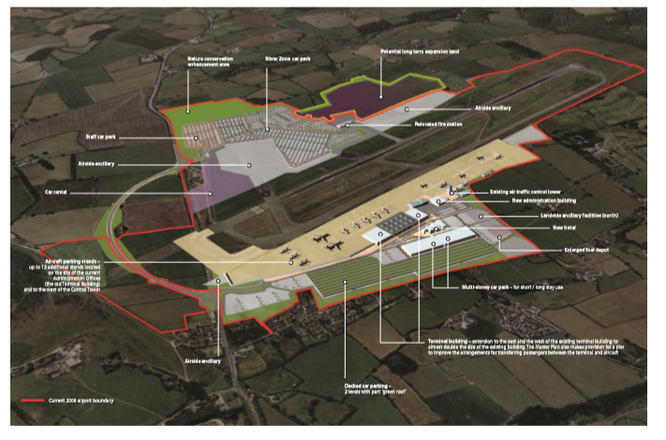
Figure 1.1 Bristol International Airport Master Plan 2006-2030 development plans.
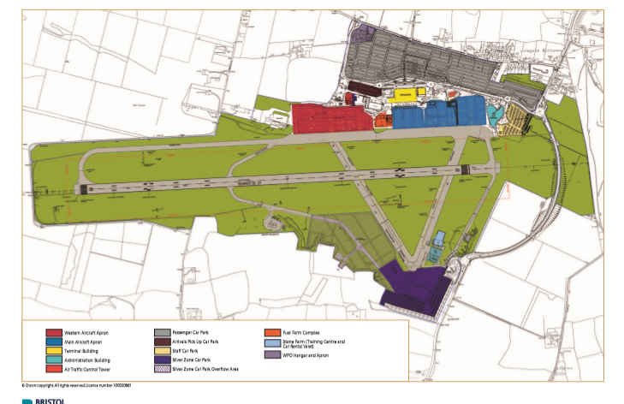
Figure 1.2 Bristol International Airport Master Plan 2006-2030 development plan in detail.

1.4 Environmental Impacts

While the Master Plan was in consultation there were a few environmental issues brought to light. These issues were, public transport, surface assess, air pollution, climate change, noise, night flights, landscape and visual impact and economic benefits (Bristol Airport, 2005). The ones with the most concerns were then addressed in the Master Plan. The Environmental Impact Assessment was carried out by Entec. After the Environmental Impact Assessment is complete Environmental Statement (ES) is produced which describes and evaluates the possible effects to the environment because of the proposed development and what these effects can mean (Entec, 2005).

1.4.1 Air Quality

The RASCO study suggested that the extension of the Bristol Airport would have minimal impact and no further studies were needed. However, the Environmental Appraisal by Entec suggested further studies would be required. A detailed study showed that nitrogen (NOχ), carbon monoxide (CO, non-methane volatile organic compounds or hydrocarbons (HC’s), sulphur dioxide (SO2) and particulate matter (PM₁₀) were all calculated from airplane activity. Aeroplanes are one of the biggest emitters of NOχ, CO, HC’s and PM₁₀; figure 1.3 shows the estimated emission for 2020 from 2004. With this information Entec found that air quality would not decrease with the increased flights or operations with the expansion (Entec, 2005).

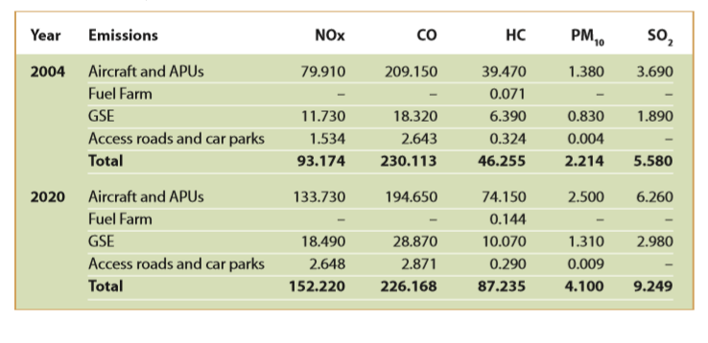
Figure 1.3 Estimated NOχ, CO, HC’s, PM₁₀ and SO₂ for 2020.

Suggestion were offered to minimise emissions, some areas with traffic management via free-flowing traffic, speed limits and road designs, dense vegetation screens and barriers etc.

1.4.2 Archaeology and Culture Heritage

There were no identifying features or locations of interest found within the development area; although there were old documents that stated differently when the Entce archaeologist visited the site none were found (Entce, 2005). No further action was suggested.

1.4.3 Biodiversity

This part the Entce assessment was carried out following the guidelines of the Institute of Ecology and Environmental Management (IEEM).

There were many Sites of Special Scientific Interest (SSSI), Lulsgate Quarry, King’s Wood, Urchin Wood, Hartcliff Rocks Quarry, Brockley Hall Stables and Goblin Combe around the new development but not on the development site. North Somerset and Mendips SAC were brought to attention as the house horseshoe bats and lesser horseshoe bats which are endangered, these were also not on sites of the development (Entce, 2005).

All the habitats and endangered or rare species were not found in the development site, however there was concern regarding the habitats and species to the south of the airport as they might be disturbed or displaced, unable to get to for foraging or breeding sites (Entce, 2005).

The suggestions to minimise decline in biodiversity was that mature trees and hedgerows will be left, any new plants should be native to the area and more so when this planting is near natural vegetation or existing hedgerow, trees or shrubs (Entce).

The Master Plan says that they will follow Entecs plan as well as improving the south end car park where they will plant more to encourage the bats; they mention that they will also have green roofs on the north side car park to encourage more biodiversity (Bristol Airport, 2005).

1.4.4 Community

Entce found there were many things that could affect the community such as, construction disturbance through air quality, noise or traffic; effects of tourism on the local communities, effect on physical and mental health of the community. No suggestions were made for this area.

The local Bristol Community have spoken out against the extension application for 2018. The author was unable to find any complaints from 2004/2005, when this proposal was first put in place.

1.4.5 Geology and Land Quality

It is acknowledged that human health could be affected due the old lead mining, zinc mining and limestone underlies that were found; there could be effects from contaminants from development works transferred to biodiversity, surface water and groundwater. The recommendations are personal protective equipment (PPE) for workers on the site during development as this will minimise risk to workers and the pathway moved from the proposed south car park (Entce, 2005).

The adoption of standard pollution prevention measures and best practice methods will be used so geology and land quality is expected to have no significant effects (Bristol Airport, 2005).

1.4.6 Landscape and Visual

There are areas around the development are AONB site (Mendip Hills and Black Down), reconfiguration of existing landscape and increased lighting because of the airport (Entce, 2005). The were no recommendations for these problems.

Existing planting will be changed on the north side, green roofs on two storey car parks, lightweight roof on car parks to reduce light pollution, planting scheme for the southern boundary, new lighting will be put in to place to reduce light glare (Bristol Airport, 2005).

1.4.7 Noise

Noise from the development, airborne noise, night air traffic noise, noise due to increased air traffic during the day and increased noise from car traffic due to new car parks were also picked up as possible impacts to the area (Entce, 2005). “No additional mitigation is thought to be necessary, as other receptors are not anticipated to experience noise levels above the onset of community annoyance threshold” (Entce, 2055: p.84.)

The airport suggestion to combat these issues was to have the most modern and quietest available technology while monitoring noise and flight paths; any aircrafts that breach this will have penalties (Bristol Airport, 2005).
These proposed improvements to aircrafts will affect no more people than it does at present and aircrafts on the ground will reduce the current noise levels (Bristol Airport, 2005).

1.4.8 Transport

Increased vehicular activity could lead to road safety and potential risk of accidents and increased future traffic are all possible impacts for the environment (Entce, 2005). If a traffic management strategy were put into place construction traffic could be minimised, this will need to be done with the local highway’s authority (Entce, 2005)

A new road, shuttle bus, car share schemes and a routing strategy for peak times are recommend for improvement to the transport problem (Bristol Airport, 2005).

1.4.9 Water resources and Quality

Groundwater and surface water could have potential contamination problems due to construction and aircrafts (Etce, 2005). A pollution prevention and management plan will need to be considered for the construction phase, update and review correction drain systems to minimise potentional pollution transfer to groundwater, used SuDS on new and old car park (Entce, 2005).

Appropriate design and management of current drainage systems as well as Sustainable Drainage system will be put in place to avoid contamination to water or change in water quality (Bristol Airport, 2005).

2.0 Conclusion

This Master Plan and EIA fall under old regulation and old science. Although the EIA and Master Plan were rather forward thinking for 2005.

However, the EIA did seem to be lacking in areas, a few sections have data missing which meant that they could not make informed, if any recommendations to make the development as environmentally friendly as possible. The Master Plan seemed to focus more on how the extension could help the local and national economy, which is important and should be considered, but it should not be the only reason for this project to be considered or approval given.

Although the author could not find opposed arguments for the 2005 extension from the local community, she was able to find a Facebook page and a few other websites which were opposed to the idea and possibility of another extension in 2018. So, it is believable that there were local people who opposed the 2005 extension.

As of 10th February 2020, the North Somerset Council rejected the extension application of 2018. The Leader of North Somerset Council Stated:

“What the Committee has considered is that the detrimental effect of the expansion of the Airport on this area and the wider impact on the environment outweighs the narrower benefits to Airport expansion. I know some people will be upset by this decision and I am sure that we can reconsider it in future when the airline industry has decarbonised and the public transport links to the airport are far stronger.” (Davies, 2020: p.1.)

It also appears that some of the environmental things that they stated in the Master Plan they planned to do they have not, for example they said that green roofs would be put in place when using Google Earth Pro to examine the airport it is clear that there are no green roofs, this can be seen in figure 2.1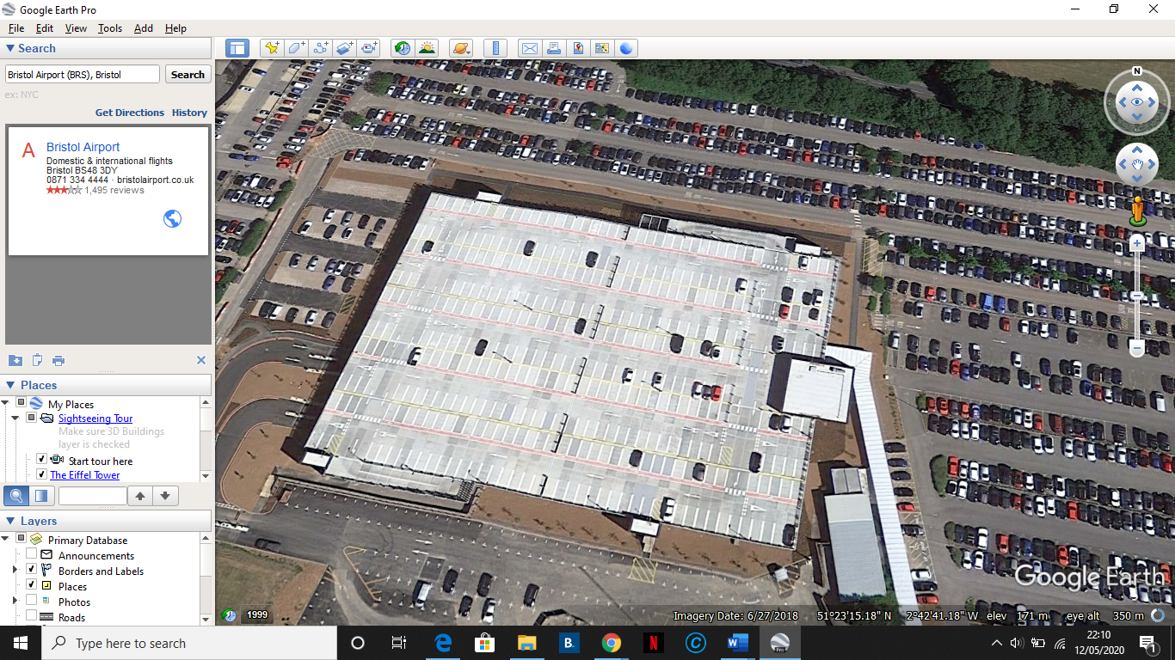Figure 2.1 Bristol Airport. Google Earth (2020)
Overall a better job could have been done by Entce and Bristol Airport seemed more interested in the economics.

3.0 Reference

APIS, 2016. The Air Quality Strategy For England, Scotland, Wales And Northern Ireland | Air Pollution Information System. [online] Apis.ac.uk. Available at: <http://www.apis.ac.uk/overview/regulations/overview_uk_naqs.htm> [Accessed 12 May 2020].
Baker, H., 2019. Bristol Airport says expansion could 'boost' tourism economy by hundreds of millions of pounds. Business Live, [online] p.1. Available at: <https://www.business-live.co.uk/economic-development/bristol-airport-expansion-tourism-economy-17392245> [Accessed 12 May 2020].
Brady, J., 2005. Environmental Management In Organizations. [online] Google Books. Available at: <https://books.google.co.uk/books?id=HSzFuHokEkEC&pg=PA54&lpg=PA54&dq=The+Town+and+Country+Planning+(England+and+Wales)+Regulations+(2000)+summary&source=bl&ots=rGBUEKgNcV&sig=ACfU3U3H6Jf9x6OcWnSGEe12_qUWoeQbtw&hl=en&sa=X&ved=2ahUKEwju4un4tK7pAhVUeMAKHadbCG04ChDoATACegQIChAB#v=onepage&q=The%20Town%20and%20Country%20Planning%20(England%20and%20Wales)%20Regulations%20(2000)%20summay&f=false> [Accessed 12 May 2020].
Bristol Airport, 2005. Bristol International Airport Master Plan 2006 To 2030. [ebook] Bristol: Bristol International, pp.1, 81-103. Available at: <https://moodle.uwtsd.ac.uk/pluginfile.php/143974/mod_resource/content/1/BRISTOL%20AIRPORT%20EIA%20%28ENTEC%29.pdf> [Accessed 12 May 2020].
Bristol Airport, 2019. Bristol Airport Reports Record Year. [online] Bristolairport.co.uk. Available at: <https://www.bristolairport.co.uk/about-us/news-and-media/news-and-media-centre/2019/1/bristol-airport-reports-a-record-year> [Accessed 12 May 2020].
Bristol Airport, 2020. Our People. [online] Bristolairport.co.uk. Available at: <https://www.bristolairport.co.uk/about-us/who-we-are/our-people> [Accessed 12 May 2020].
Bristol Live, 2020. Bristol International Airport. Bristol Live, [online] p.1. Available at: <https://www.bristolpost.co.uk/all-about/bristol-airport> [Accessed 12 May 2020].
Davies, D., 2020. Stop Bristol Airport Expansion. [online] Stop Bristol Airport Expansion. Available at: <https://www.stopbristolairportexpansion.org/> [Accessed 12 May 2020].
Department for Transport, 2003. The Future Of Air Transport. [ebook] London: UK Government, pp.7, 38. Available at: <https://assets.publishing.service.gov.uk/government/uploads/system/uploads/attachment_data/file/685595/6046.pdf> [Accessed 12 May 2020].
Entce, 2005. Environmental Impact Assessment Of The Expansion Of Bristol International Airport. [ebook] Bristol: Entec Uk Limited, pp.19-97, 103. Available at: <https://moodle.uwtsd.ac.uk/pluginfile.php/143974/mod_resource/content/1/BRISTOL%20AIRPORT%20EIA%20%28ENTEC%29.pdf> [Accessed 12 May 2020].
Environmental Law Alliance Worldwide, 2015. U.K. -- Berkeley V. Secretary Of State For The Environment(2000.06.06)(Enforcement Of EIA`S) | ELAW. [online] Elaw.org. Available at: <https://elaw.org/content/uk-berkeley-v-secretary-state-environment20000606enforcement-eias> [Accessed 12 May 2020].
Gittens, A., 2020. COVID-19 : An existential threat to the global airport business. [Blog] ACI World Blog, Available at: <https://blog.aci.aero/covid-19-an-existential-threat-to-the-global-airport-business/> [Accessed 12 May 2020].
ICAO, 2020. About ICAO. [online] Icao.int. Available at: <https://www.icao.int/about-icao/Pages/default.aspx> [Accessed 12 May 2020].
UK Government, 2014. Environmental Impact Assessment. [online] GOV.UK. Available at: <https://www.gov.uk/guidance/environmental-impact-assessment#contents> [Accessed 30 April 2020].

