  LOCATION Swansea | BARRY BRADSHAW  Student ID 1909431  LLEOLIAD abertawe
LEVEL 4 / Foundation yr | LEFEL 4
EXAMINATION PERIOD | CYFNOD ARHOLIADAU
May 2022 | Mai 2022

MODULE CODE: ACCA4021
Introduction to Computer Systems

48/80 = 60%
TIME: 2 Hours
answer all questions

Instructions for students:

This is a timed on-line exam.
As it is ‘open book’ ensure you show all calculations/methods used in your answers.
Create a single word document in which you should answer your questions. If you need to produce any diagrams or sketches, you can do this with whatever method suits you best – e.g. use a sketching program, or manually draw it on a piece of paper, then use your phone to take a picture of it. Then Copy/paste any images into your word document.
Upload your finished word document to the link provided on moodle within the specified time limit. It is also suggested you also immediately email the document to your tutor as a backup or in the case of any moodle issues.

ANSWER ALL FIVE QUESTIONS
(total marks available = 80, final mark is multiplied by 1.25 to obtain a %)

QUESTION ONE (20 marks total)

- Provide the name for each of the following symbols (5 marks)

- 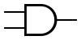 ---------------AND-----------------
- 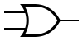 ----------------OR----------------
- 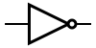 ---------------NOT-----------------
-  ---------------XOR-----------------
-  ---------------NAND-----------------

- Give a representation of the truth table for an AND gate given the inputs A and B (5 marks)

Input… Output
A . B A AND B
0 0 0
0 1 0
1 0 0
1 1 1

- Indicate the output at each of the stages labelled in Figure 1. Inputs A and C are at logic level 1 (4 marks)

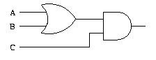
E
D
Figure 1
If A,B,C are set at …
D is at 1
E is at 1

- A domestic light can be illuminated by two different switches. Each of the switches may turn the light on independently of one another, not dissimilar to a stairs light. Represent this scenario using a logic circuit (6 marks)

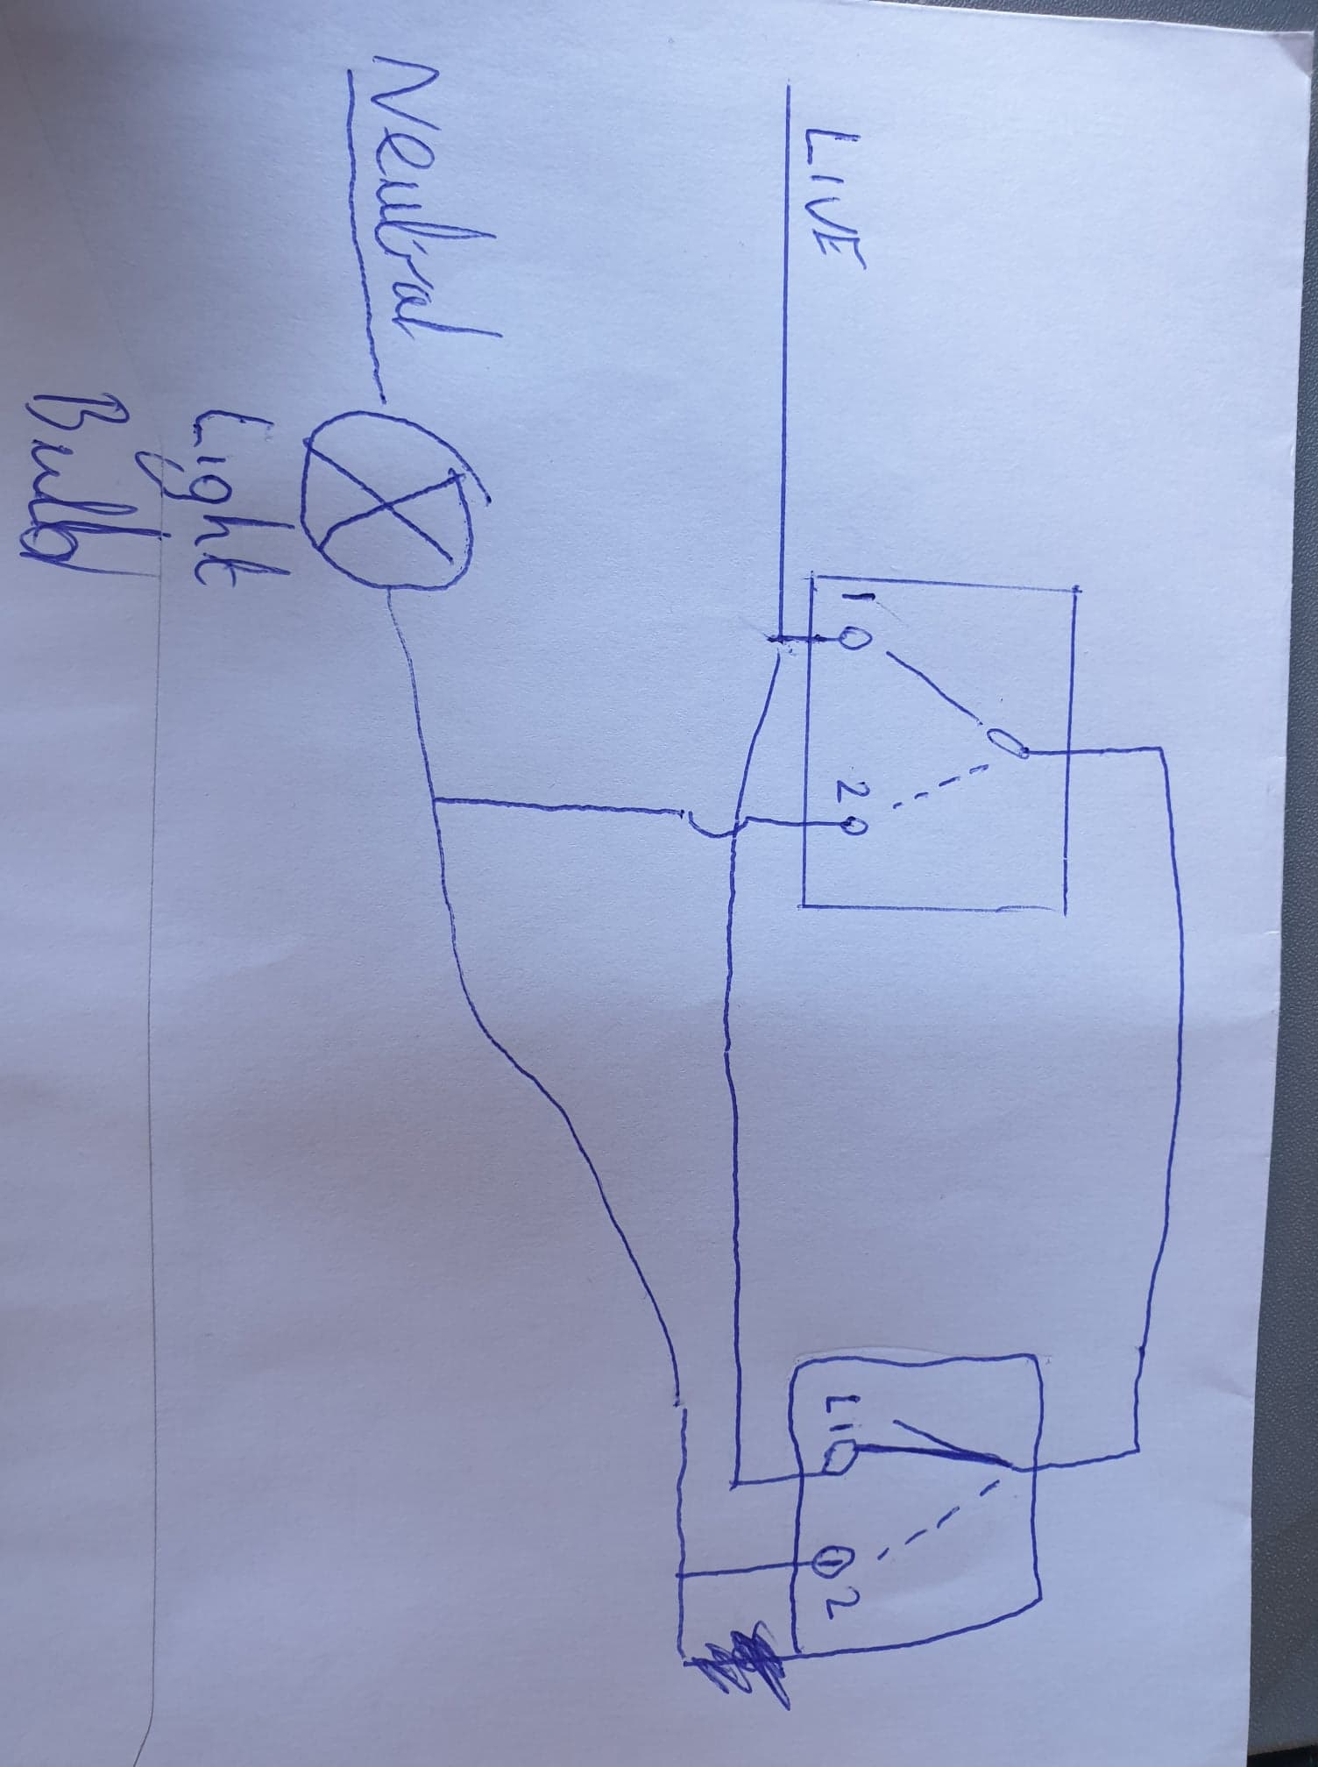

QUESTION Two (20 marks total)

Attempt all of the following. Do not simply use an Electronic Calculator and just present the final answer. Write down and show all your manual calculations in your exam book.

I used my binary to hex table
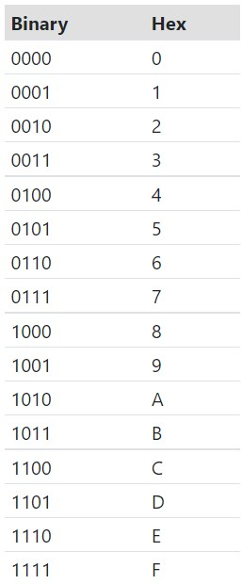
- Convert the following binary numbers to base 10 (2 marks each)

- 1101 0111 answer is D7 (using the table inserted for my answers)
- 0010 0101 answer is 25
- Convert the following hex numbers to binary (2 marks each)

- 6F answer is 0110 1111
- EA answer is 1110 1010

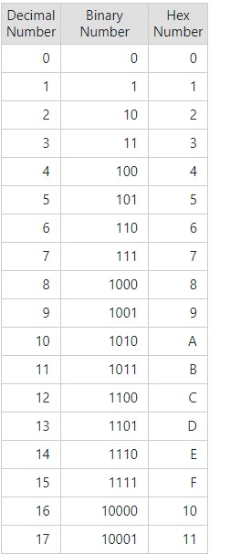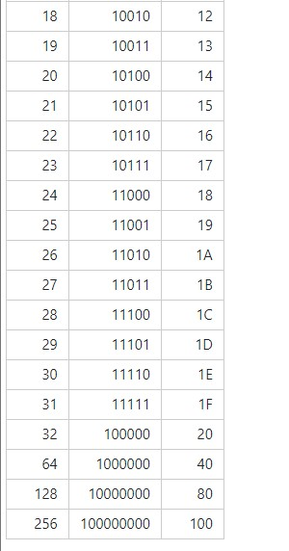
- Convert the following decimal numbers to Binary (2 marks each)

- 84 answer is 1010100 (using the table inserted for my answers)
- 246 answer is 11110110

- Convert the following Hex numbers to decimal (2 marks each)

- A1 answer is 161
- F5 answer is 245

- How many unique values can be represented by a 6- bit number ? (2 marks)

64 possible values

- Using the base 2 number system write the number of bytes in 1 Kilobyte (2 marks)

1024 bytes,

QUESTION THREE (20 marks total)

Give a typical, cost effective specification for a typical PC that could be used for 3D animations and software development. Provide details for:
- A suitable CPU,
a multi core CPU that is able to process more at one time,,

- What is a sensible amount of RAM,
For a normal PC 8GB is the new standard for RAM but 16GB to 32GB give plenty of room for memory,

- What type and size of non-volatile storage would be suitable
1Tb hard drive seems plentiful (Hdd)

- The input/output features/ports needed
keyboard mouse and mic for input maybe a drawing pad too,
Speakers, monitors for output

- The features a suitable graphics card would require.
A good GPU with plenty of cores for processing along with a good amount of GDDR memory
For all of the above areas, you should justify your choice with reasoning and where possible, explain why you chose that particular option, over the alternatives.

QUESTION FOUR (20 marks total)

a)What do the terms GPU and CPU stand for? Explain what they are used for in the context of a typical PC. (6 marks)
GPU is the graphics processing unit. A GPU is used to speed up graphics rendering.
CPU is the central processing unit which preforms actions, calculations and runs programs as in fetch, decode and execute the final steps

b) Depict the Von Neumann architecture, showing the three main busses. Also provide and explanation of the function of each bus (8 marks)

Main 3 busses are
Control unit ( directs flow of the data between CPU and other hardware/devices )
Memory unit ( RAM/Main memory directly accessible by the CPU)
An ALU ( Holds data that’s being processed and also the results of any calculations )

c)In the context of different programming languages, what is the difference between a Compiled language and an interpreted language. Give one example of each. (6 marks)

Compiled language C, C++
Compiled language is expressed in instructions of the target computer

Interpreted language JavaScript, Python
Not directly executed on the target computer and read and executed by another program.

