Francis Barcelo (2401983)
2401983@student.uwtsd.ac.uk
20/04/2026

Soil Mechanics Laboratory Practical Portfolio
Geotechnics and Foundation Engineering (ACBA5021)

Abstract
This report evaluates the principles and the various classification methods used to identify soil and rock types to determine their mechanical, physical, and engineering properties. Three laboratory tests were conducted to investigate these characteristics, and the procedures and results are presented. The collected data are analysed and critically discussed to interpret the behaviour of the materials and assess the significance and reliability of the experimental results.

Table of Contents
1 Introduction 3
2 The Sieve Analysis (Textural Classification) Test 4
2.1 Introduction 4
2.2 Methodology 4
2.2.1 Sieve Analysis Procedure 6
2.3 Results 10
2.4 Analysis 12
2.4.1 Limitations 14
2.5 Conclusions 16
3 The Atterberg Limits Test 17
3.1 Introduction 17
3.2 Methodology 17
3.2.1 Liquid Limit Procedure 20
3.2.2 Plastic Limit Procedure 23
3.3 Results 28
3.4 Analysis 31
3.4.1 Limitations 32
3.5 Conclusion 35
4 The Constant Head Permeameter Test 36
4.1 Introduction 36
4.2 Methodology 37
4.3 Constant Head Permeameter Procedure 41
4.4 Results 42
4.4.1 Test 1 43
4.4.2 Test 2 44
4.5 Analysis 45
4.5.1 Limitations 47
4.6 Conclusions 49
5 Overall Conclusion 50
6 References 51

Introduction
The mechanism of Engineering Soil is an essential role in Civil Engineering by enabling the analysis and understanding of the behaviour of soils and rocks under applied loads. Accurate classification and testing of earth materials are vital in ensuring the safety, stability, and longevity of a structure. Laboratory testing provides valuable data that can be used to assess material properties and predict ground behaviour during construction, which can reduce the risk of structural issues such as excessive settlement or failure. This report contains three laboratory tests undertaken to evaluate the physical and mechanical characteristics of the selected soil samples. The procedures, results, and calculations are presented which is followed by a critical analysis and discussion of the findings to assess their significance and reliability.

The Sieve Analysis (Textural Classification) Test

Introduction
Sieve analysis is a standard laboratory test used in soil mechanics to determine the particle size distribution of both coarse and fine-grained soil. The method involves passing dried soil sample through a series of progressively smaller sieves to separate the particles according to their size. The classification of soil texture relies exclusively on grain size distribution, and is categorised into three groups which are sand, silt, and clay. The texture of soil is the most important physical property, and a thorough understanding of it is essential in geotechnical engineering because particle size influence important engineering properties such as permeability and the water holding capacity of the soil. It can also determine any potential angles of failure and the suitability of soil for urban construction through its bearing capacity. This test therefore provides fundamental data used in soil analysis, foundation design and evaluation other properties such as porosity and relative density.

Methodology
Equipment | Purpose | Picture
Sieves, Pan, and Cover | A stack of standardised sieves. Sizes used 2mm-20microns (0.02mm). A pan is located at the bottom to collect fine materials passing through the last sieve, and a lid was placed on top to prevent material loss. | 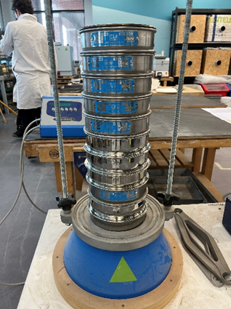  Figure 1: Stack of Sieve apparatus
Mechanical Sieve Shaker | A device that vibrates the sieve stack to promote particle movement at a given time (2 minutes). This helps ensure that particles pass through the appropriate sieves. | 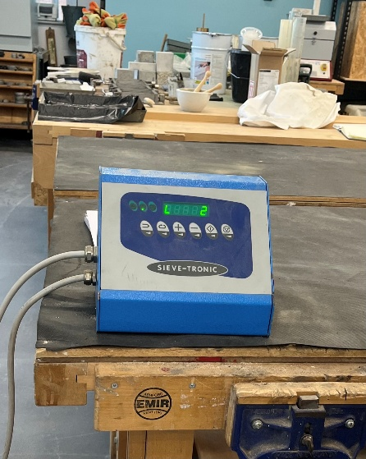  Figure 2: Mechanical Shaker used
Transportation Container and Brushes | A container covered in plastic to place sample when cleaning and weighing the sieves. Brass and Nylon brushes were used to loosen any stuck particles from the mesh. Black plastic helped ease transporting sample size to the weighing scale pan. | 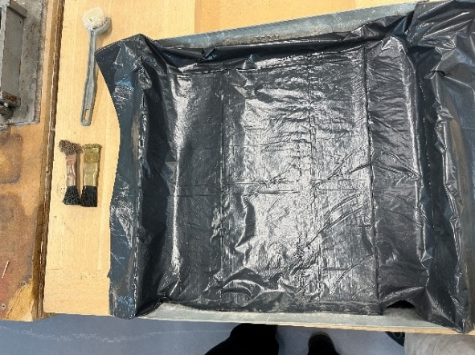  Figure 3: Transportation container and brushes used
Weighing Scale and Scale Pan | A weighing scale used to weigh the sample before to attain the original sample size, and after the sieving procedure to determine the mass retained on each sieve. | 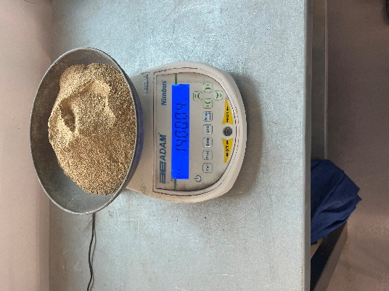  Figure 4: Weighing scale showing sample size used
Secondary Container | A secondary container was used to place all the sample size that have been weighted and analysed
Table 1: Equipment’s used in Sieve Analysis test

Sieve Analysis Procedure
1 | All equipment’s required for the test were prepared ensuring that there were no defects on the sieves as seen on Table 1.
2 | Any appropriate personal protective equipment (PPE) was put on before starting the procedure.
3 | The weight of the scale pan was calibrated using the weighing scale, this calibration was used throughout the test as seen on Figure 4.
4 | A sample size of around 1.4kg to the nearest 0.01g was recorded (see Figure 4). This was used to calculate the percentage of distribution between the three groups later.
5 | The sieves were stacked correctly in the order of the largest mesh size on the top and progressively go smaller until it reached the pan. It was then ensured that the sieves secured as seen on Figure 1.
6 | The sample size was carefully poured on top making sure that no sample were lost during this procedure as seen on Figure 5. | 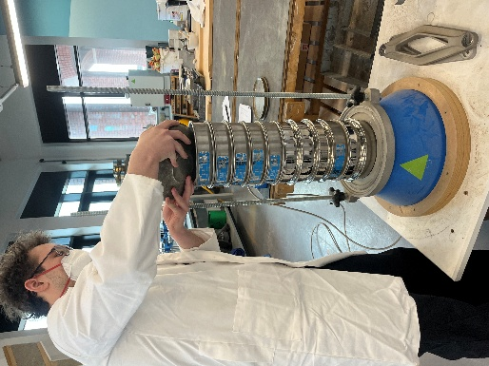  Figure 5: Group Member pouring sample into the sieve stack.
7 | The lid was placed on top and held down whilst the mechanical shaker vibrated the sample for 2 minutes. | 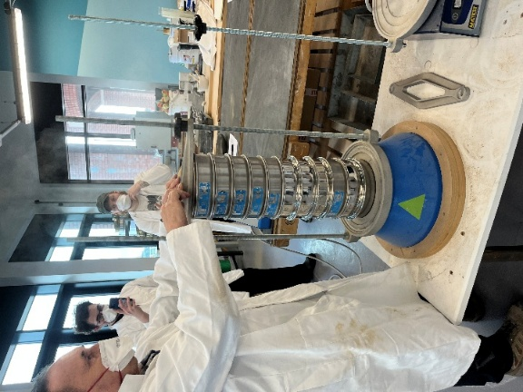  Figure 6: Group member holding down lid.
8 | After 2 minutes the machine stopped. The lid was removed, and one by one the sieves were taken off to weigh the sample size retained in each sieve.
9 | The sieve was poured into the transportation container covered in plastic as seen on Figure 3.
10 | The brushes were used to loosen up any struck particles in the mesh. This limits the amount of sample lost (See Figure3).
11 | The sample is then carefully poured into the scale pan. Using the brushes any sample stuck on the plastic is loosened and added to the scale pan. The individual weight retained on each sieve are recorded to the nearest 0.01g. The weight is recorded on a given table. Figure 7 shows one of the results attained for the sieve 63µm size. | 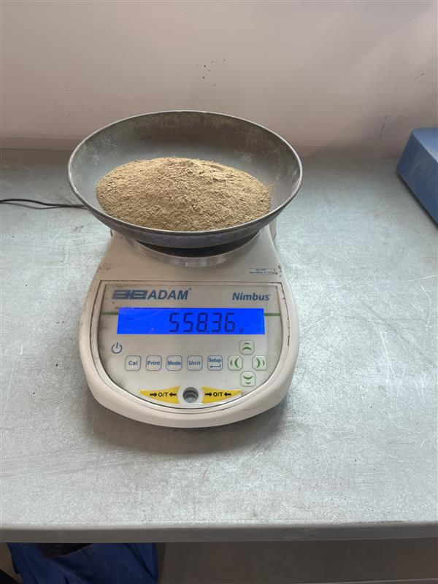  Figure 7: Results attained for the sieve 63µm size
12 | The process is then repeated for the next sieve size.
13 | The process was repeated until the weight of the pan has been weighed and recorded.
14 | The weight recorded of each sample in different sieves was then used to calculate the percentage to the nearest 0.01% for each size of aggregate retained on each sieve.
15 | All throughout the procedure it was important to be extra careful to prevent any loss of material, if there was a small discrepancy of less than 0.20% between the original weight recorded at the beginning and the sum of the weights of the various sizes recorded at the end, it was assumed that amount are the small particles passing the smallest sieve into the pan and use the original weight. If the discrepancy is greater than 0.20% it is recommended to check the weights of the various sizes or to do the procedure all over again with a new sample size to correct the error.
16 | Using our result, we plotted sieve size against percentage passing for the sample on the graph paper provided. We then used a triangular graph of Soil Texture to classify our soil sample.
Table 2: The procedure taken for the Sieve Analysis test

Results
Test 1: Particle Size Distribution for Texture
Original Sample Size = 1400.04g (all results taken to the nearest 2d.p.)
Sieve Size  (mm) | Mass  (g) | % on sieve | % Passing
2mm | 10.96 | 0.78 | 99.22
1.18mm | 19.13 | 1.37 | 97.85
600mic | 131.85 | 9.42 | 88.43
425mic | 309.40 | 22.10 | 66.33
300mic | 303.42 | 21.67 | 44.66
63mic | 558.36 | 39.88 | 4.78
53mic | 55.88 | 3.99 | 0.79
45mic | 5.08 | 0.36 | 0.43
38mic | 0.83 | 0.06 | 0.37
20mic | 0.82 | 0.06 | 0.31
PAN | 0.04 | 0.002 | 0.31
Table 3: Particle Size Distribution results
Total end Mass: 1395.77g
Percentage Lost= $\frac{1395.77}{1400.04}$ x 100 = 99.70%,
0.30% Lost

Proportion % (nearest 2d.p.)
SAND:$\frac{774.76}{1400.04}$ x 100 = 55.34% | SILT:$\frac{620.97}{1400.04}$ x 100 = 44.35% | CLAY:$\frac{0.04}{1400.04}$ x 100 = 0.00%
Table 4: Proportion Percentage of the Sample
The sieve analysis results are shown in Table 3. Result shows that most of the sample was retained in the 2mm-300µm sieves. The 63µm sieve size retained the most sample and a massive drop being retained in the 53µm-PAN can be observed
It was observed that 0.30% of the original sample size was lost throughout the test.
Particle size distribution chart
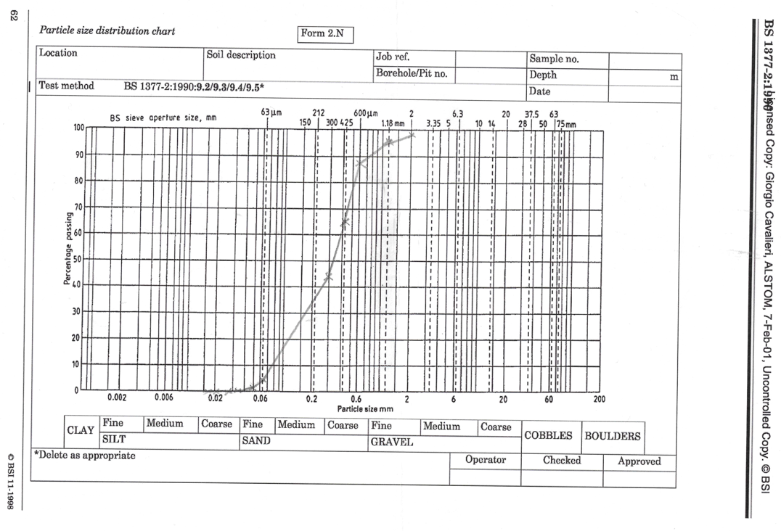
Figure 8: Particle Distribution graph (BS 1377-2:1990)
Figure 8 shows the particle distribution curve; the results attained in Table 3 creates a uniform gradation curve of the sample used.

Triangular Graph of Soil Texture

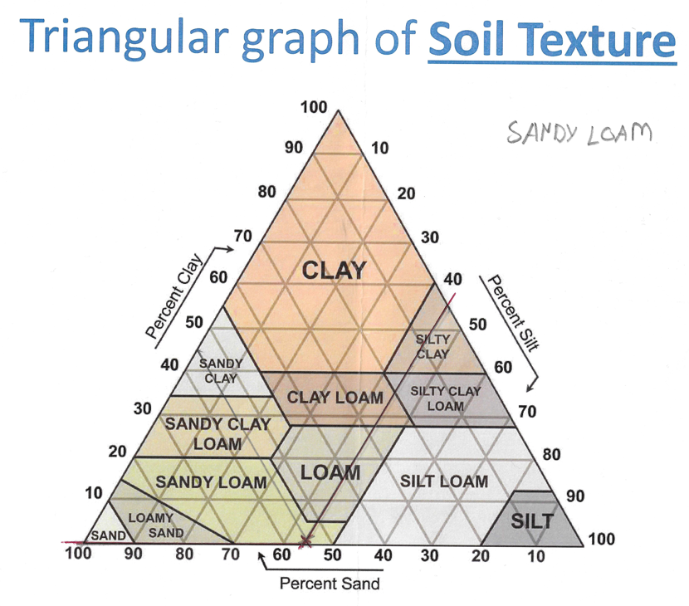
Figure 9: Triangular Graph of Soil Texture
Using the triangular graph of soil texture (see Figure 9), it indicates that the sample used is classified as Sandy Loam.

Analysis
The results indicate that the soil sample used for the experiment is predominantly composed of coarse particles, as most of the material were retained within the 2mm and 300µm sieve size range. It is also observed that the coarse particle soil was retained the most in the 600µm-300µm sieve sizes. This suggests that sediments were deposited in a moderate energy environment, as coarse particles require higher energy to move, and the silts were transported by suspension further along. This is also consistent where the result shows that the sample size consists of larger silt particles that were retained in the 63µm sieve size.
Using the sieve sizes, we were able to determine which particles are retained. From 2mm to 300µm Sand particles were retained. 63µm to 20µm silt particles were retained and in the PAN was the clays. Table 4 shows the percentage proportions. This was then put in a triangular graph of soil texture where we classified the soil sample as Sandy Loam (see Figure 9).
The classification of the sample as Sandy Loam suggests that the sediment has undergone moderate mechanical transportation, where larger particles move by rolling in moving water or wind. In contrast, the silts present in the sample indicates that they are more easily carried in suspension over longer distances. The mixture in particle sizes indicates that the transportation process had fluctuating energy levels. As a result, the presence of sandy loam suggests deposition in an environment where energy levels vary, such as a river floodplain and alluvial plains. The absence of clay indicates that very fine particles were either not present in the sample or were transported further away.
The result and the proportion percentages of the sample shown in Table 3 and 4 is supported by the uniform gradation curved obtained in Figure 8 from the sieve analysis. The uniform curve indicates that the particles are well sorted and fall within a low variability in particle size, meaning that the majority of the particles are of similar size. This further supports that the sediments were transported in a moderate energy environment. The significance of these findings is that they indicate a stable and selective transportation process which resulted in a well sorted sample. Due to the particle sizes, it suggests that the soil will have high permeability due to amount of course particles and lower cohesion due to the absence of clay. This makes the soil suitable for applications where water movement is required such as drainage. But the lack of variation in particle sizes can results in lower shear strength and stability under load due to reduced friction between particles. Overall, the results reflect deposition in an environment with consistent flow conditions and efficient sorting of sediments.
The particle size distribution obtained is consistent with findings reported in published geotechnical literature for sandy loam soils. Studies aligned with BS EN ISO 14688-2:2017 indicate that sandy loam commonly show moderate grading with limited clay content, like the distribution observed. However, some research may report a wider range of particle sizes which results in better grading compared to the relatively uniform distribution identified in this study. Overall, the close agreement with established classification suggests that the results are representative of typical sandy loam behaviour.

Limitations
Several limitations were observed throughout the test. Before starting the procedure ensure that the correct steps were followed the day before when preparing the sample. They needed to be dried oven in 120 degrees for 24 hours. This is to ensure that the experiment is least impacted by moisture.
Room temperature, body temperature, and humidity should be considered throughout the procedure. It was made sure that before starting the test that all the equipment’s have been check and maintained. Damaged sieves can have bigger holes allowing particles to be in the wrong sieves.
The weighing scale used was sensitive due to the vibration of our feet and table. It was important to try and control and calibrate the weighing scale properly. The sieve was also calibrated, too little vibration can cause incomplete separation, too much shaking can cause particle to break.
Gloves were recommended to ensure that moisture from our hands wouldn’t affect the result. Avoid touching the soil directly and try to handle the container. Small amounts of moisture from hands can introduce measurable error.
When taking sample off sieve ensure that using the appropriate equipment’s, tapping the sieve, and holding it against a light source can help show any particles stuck as seen on Figure 10. The amount of sample lost during this process needs to be controlled and can influence the final weight. | 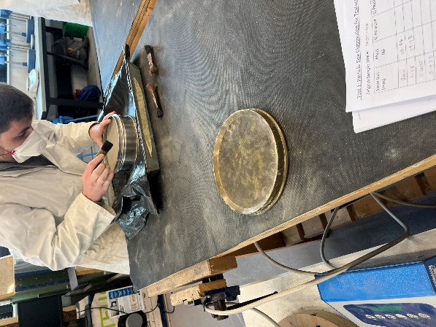  Figure 10: Group Member removing sample from sieve
A black plastic cover is used to make transportation easier. However, fines are so small that it causes static with this material which causes them to stick. Before going on to the next sieve it was important to brush of any excess fines from the plastic material and add it the sample before weighing it out as seen on Figure 11. This helped maintain the original sample size. | 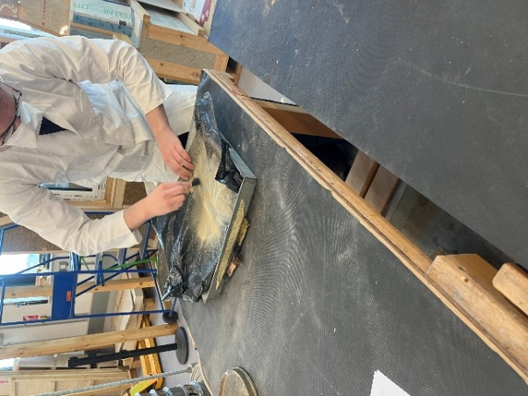  Figure 11: Group Member removing any sample stuck on plastic sheet
Additionally, the relatively small sample size may not fully represent the overall sediment composition of the area, which can limit the reliability of the results. Furthermore, the test was only done once where we can’t confirm whether the results are consistent which reduces its credibility and prone to more errors.
Table 5: Limitations observed throughout the test

Conclusions
In conclusion, the sieve analysis classified the sample as sandy loam. The uniform gradation curve indicates that the particles are well sorted and of similar size. This suggests that the deposition was under consistent, moderate energy conditions. These findings are significant as they indicate an efficient and selective transportation process, resulting in soil with low permeability with low cohesion. Overall, it reflects a stable environmental condition during deposition.

The Atterberg Limits Test

Introduction
The Atterberg Limits are fundamental parameters used in Geotechnical Engineering to help describe the behaviour of very fine-grained soils as their moisture content alternates. These limits define the moisture contents at which the soil transitions between different states of consistency. There are three primary limits which are the Liquid Limit (LL), Plastic Limit (PL), and Plasticity Index (PI). These parameters are widely used to classify soil and determine their consistency. Understanding these limits are key due to how soil can be strongly influenced by water content due to their consistency. Any change in moisture can significantly affect the soil strength, compressibility, and workability. Determining the Atterberg Limit allows engineers to get a better understanding of how the soil of a site behave under different environmental conditions and loading. The information can help predict potential issues that may occur in a site such as excessive settlement and shrinkage which can compromise the stability of a structure.

Methodology
Equipment | Purpose | Picture
Mixing Bowl | A Mixing Bowl where the soil sample is mixed in during both Liquid and Plastic Limit procedure. | 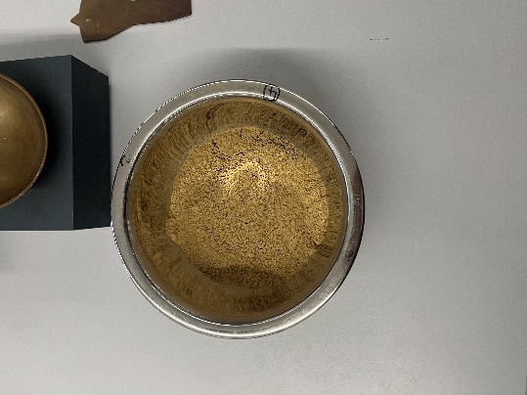  Figure 12: Mixing Bowl with sample
Spatulas and Water Container | Spatulas were used to mix the soil sample and to transport them to the Casagrande apparatus. Water container was used to increase moisture content. | 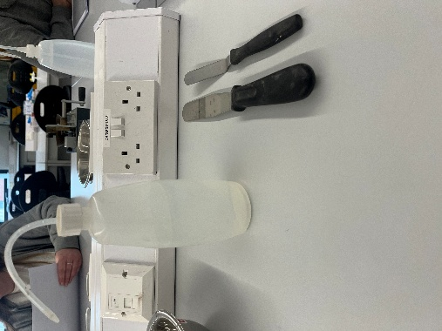  Figure 13: Spatula and water container used
Casagrande Device and Gauging Groove Tool | Casagrande Device and Gauging Groove Tool were used for the Liquid Limit Procedure. The Grooving Gauge Tool was used to create the 12mm gap and the Casagrande was used to measure how many drops it would take to close that gap. | 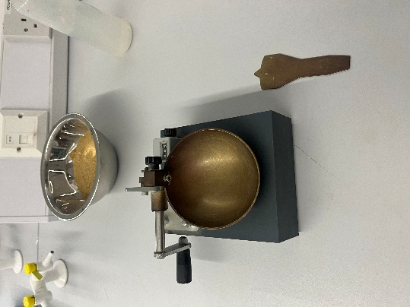  Figure 14: Casagrande apparatus and Gauging Groove Tool used
Spare Bowl with Dry Mix | Spare Bowl with dry mix was used if the sample becomes over saturated during the Liquid Limit Process. This was again used to get the required plasticity of the sample during the Plastic Limit Procedure. | 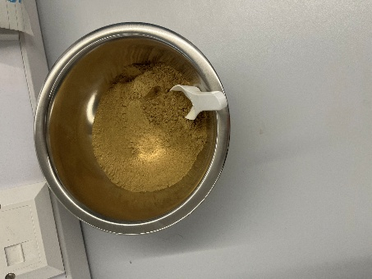  Figure 15: Spare bowl with dry mix
Containers and Oven Tray | Containers have been marked to make it easier to identify which test was which. Oven Tray was used to put all containers with sample into the oven to dry. | 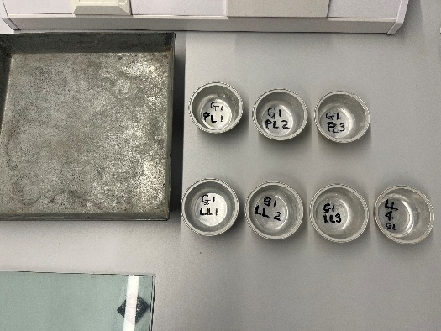  Figure 16: Containers and oven tray used
Weighing Scale | Weighing scale was used to measure the weight of the sample. Before the procedure’s started it was calibrated. | 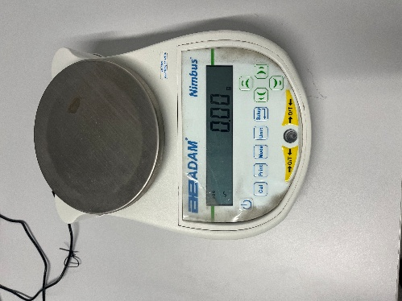  Figure 17: Weighing Scale used
Flat Glass Plate, and Wooden Rod | The flat glass plate was used to make it easier to roll the sample to the required size during the Plastic Limit Procedure. The wooden Rod was used as reference on how big the sample should be when cracking starts to appear. | 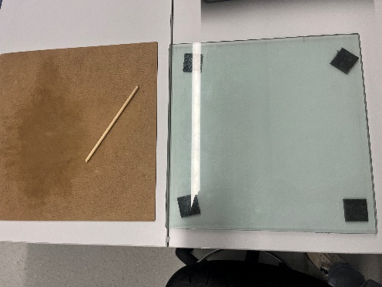  Figure 18: Glass plate and wooden rod used
Table 6: Equipment’s used for the Atterberg Limit Test

Liquid Limit Procedure
1 | Four containers were picked and marked. These were then weighted and recorded as seen on Figure 16.
2 | A sample size of 188.36g was put into a metal mixing bowl as seen on Figure 19. For the Liquid Limit Procedure small droplets of water were added into the mix whilst being thoroughly mixed with a spatula. | 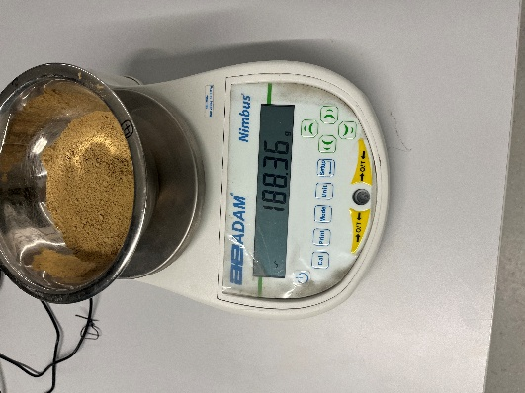  Figure 19: Sample size shown on weighing scale
3 | The consistency required for this procedure is achieved through by trial and error of adding water or dry mix into the sample size as seen on Figure 20. A sample consistency with around 30-35 drops of the Casagrande Device to close the 12mm gap was required for this procedure. | 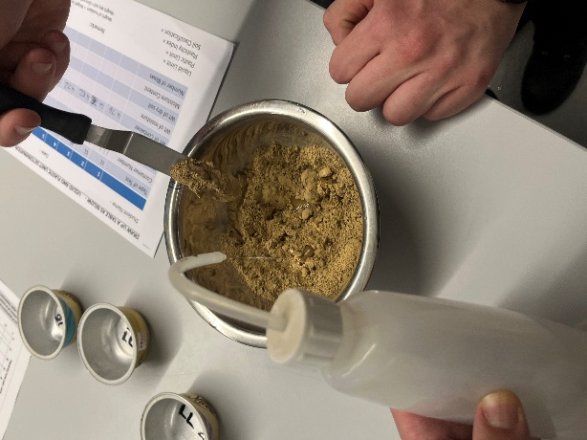  Figure 20: Mixing water to sample
4 | Once the right consistency was achieved, a small portion was added to the Casagrande cup bowl, using a spatula it was evenly spread out from one edge to the other as seen on Figure 21. Any excess sample was returned to the mixing bowl. | 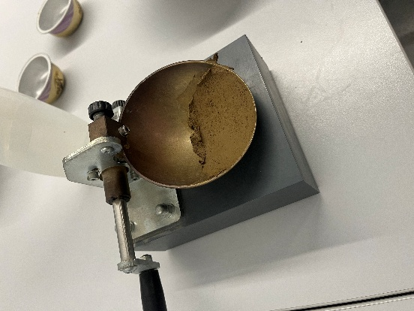  Figure 21: Mix spread out on Casagrande apparatus
5 | From back to front the gauging groove tool was used to create a gap of 12mm in the centre of the sample. This was repeated 3 times to create a consistence 12mm gap and avoid side tear as seen on Figure 22. | 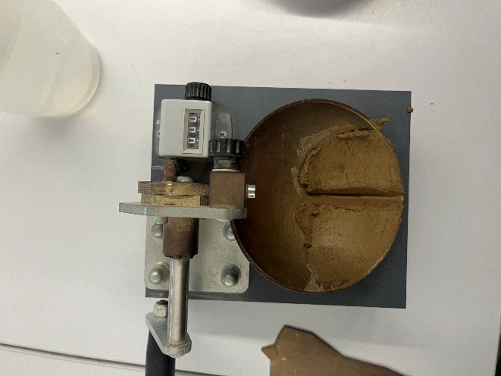  Figure 22: 12mm gap created using Gauging groove tool
6 | The Casagrande was calibrated to 0 on the drop counter as seen on Figure 22. At a rate of 3 revolutions per second, using the lever it was lifted and dropped until the 12mm gap created by the gauging tool has been closed. The number of blows is recorded when it was in the 30-35 drops range.
7 | From left to right (edge to edge) another spatula was used to gather a slice of soil which cut through the groove/gap as seen on Figure 23. | 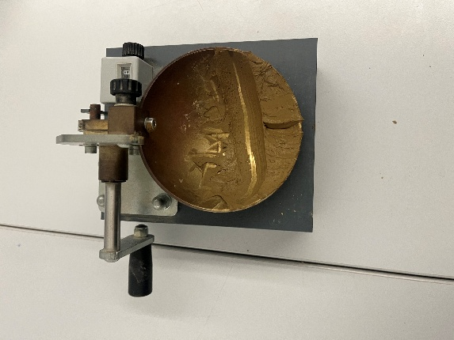  Figure 23: Sample removed using spatula
8 | This sample was placed in one of the marked containers and was recorded to attain the weight of the wet soil with the container as seen on Figure 24. | 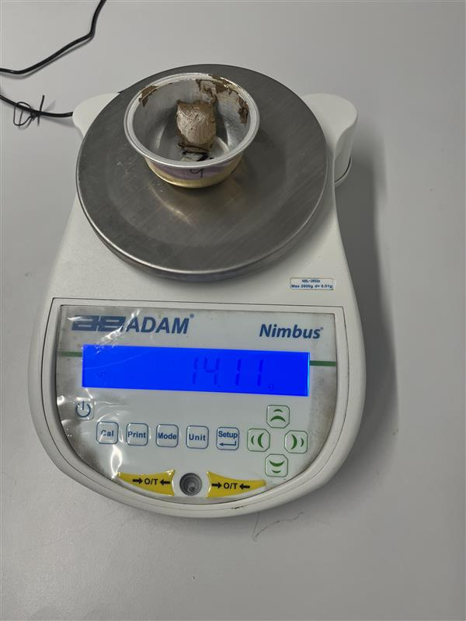  Figure 24: One of the samples (wet) being weighed
9 | The process was then repeated three more times, gradually increasing the moisture content on each sample to try and reduce the number of blows needed to close the 12mm gap. The ranges obtain was below the initial 30-35 blows, then the last two samples had a range between 20-12 and the number of blows decreases as the moisture content was increased.
10 | Putting in the oven tray it was placed on the oven to dry for 24 hours. The sample were then weighed again; this would attain the weight of the dry sample with the container as seen on Figure 25. Using the recorded result, we were able to attain the moisture contents. | 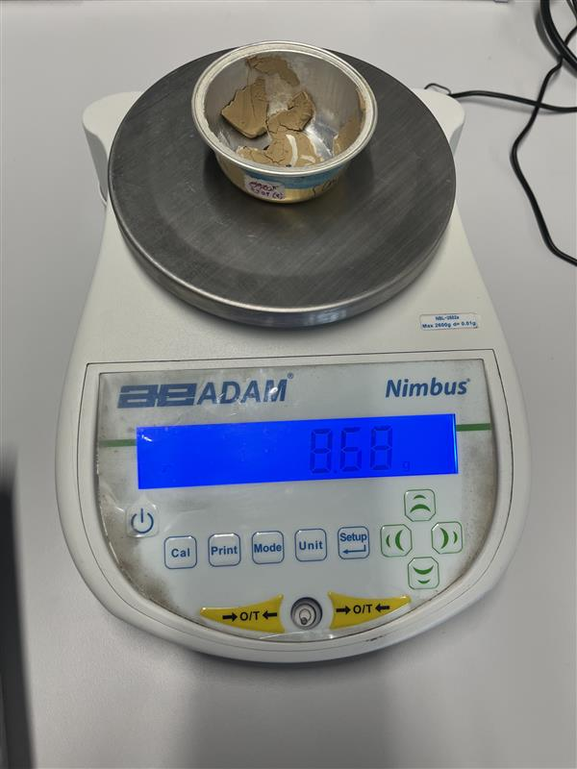  Figure 25: One of the samples (dry) being weighed.
11 | Using the result a Liquid Limit analysis graph was created to determine the moisture content percentage after 25 blows.
Table 7: The procedure taken for the Liquid Limit test

Plastic Limit Procedure
1 | Three containers were picked and marked as seen on Figure 16. These were then weighted and recorded.
2 | Using the sample size left from the Liquid Limit Procedure, the dry mix sample was added to decrease the moisture content as seen on Figure 26. Throughout this process it was thoroughly kneaded until the moisture content required is attained. | 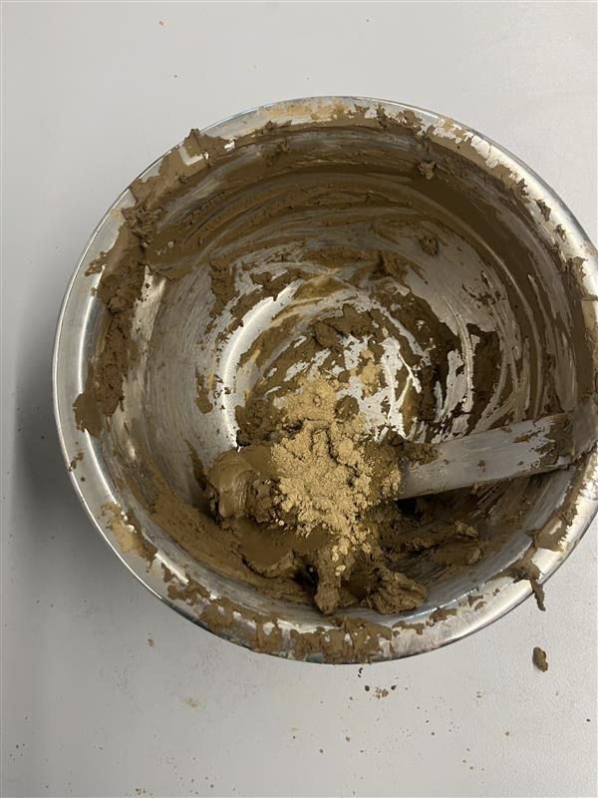  Figure 26: Dry mix added to sample
3 | A small portion of the sample was then moulded into a small ball using our fingers and the palm of our hands. This made rolling easier and with the help of the warmth of our hands it slowly dried the sample.
4 | When cracks started to appear on the sample, it was then divided into three equal parts. Each one was separated and these would be used for the 3 tests for the Plastic Limit Procedure.
5 | Using the wooden rod as a reference each ball was rolled into a thread on the glass plate of around 3mm in diameter as seem on Figure 27. The cracks should appear at the desired size. During the procedure the process of adding dry mix or water into the sample to achieve the correct consistency during the rolling process was done by trial and error. The thread should be intact and homogenous when cracks start to appear. | 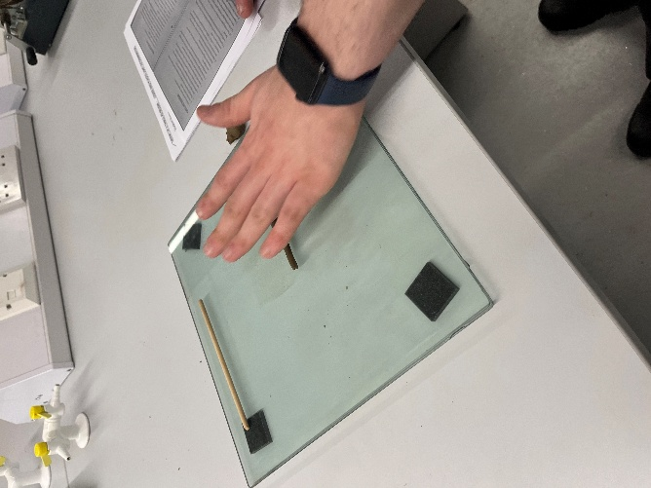  Figure 27: Sample being rolled into a thread
6 | The rolling process was done by using the palm of our hands and applying steady pressure to slowly reduce the diameter to 3mm. At the point where the thread started to crumble/crack the process was stopped and placed in one of the containers.
7 | It is key that the rolling pressure applied is maintained throughout, this ensured that the crumbling/cracking was because of the reduction of moisture when attaining the desired mix of the sample, and not directly as a result because of mechanical breakdown due to too much pressure from our hands.
8 | The crumbling point is the Plastic Limit moisture content
9 | The thread was then weighed with the container giving the wet soil with container weight as seen on Figure 28. | 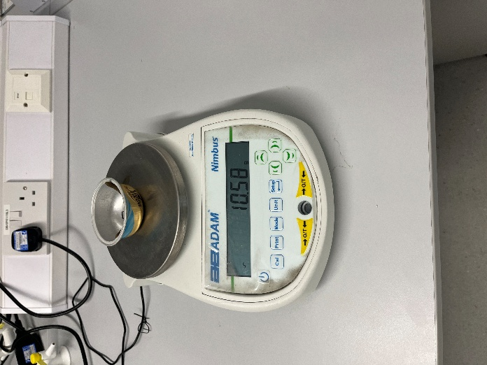  Figure 28: One of the samples (wet) being weighed
10 | The process was then repeated three more times to attain the desired three samples.
11 | The containers were placed in the oven tray and put in the oven to dry for 24 hours. | 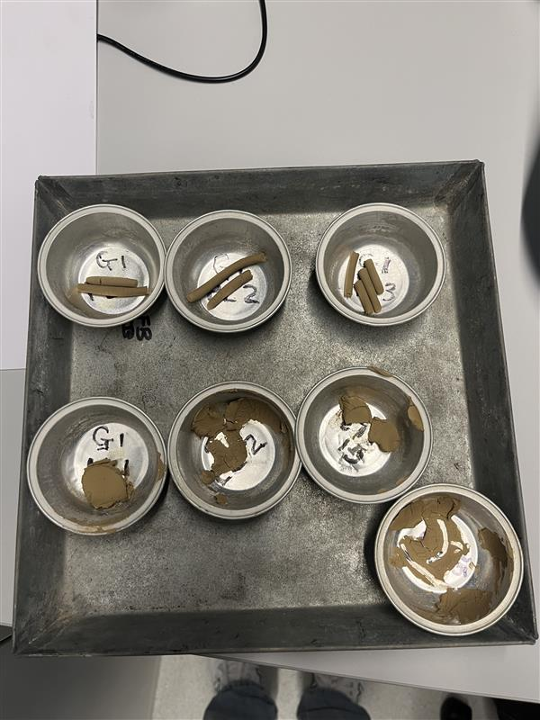  Figure 29: All samples after being dried
12 | When dry the containers were weighed once again to get the dry soil with container weight. The average was then calculated using the three weights to obtain the moisture content mean. This mean is the Plastic Limit moisture content indicator for the soil sample. | 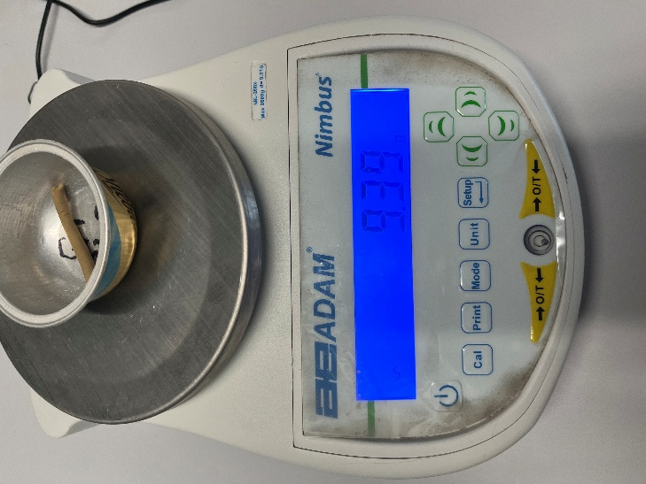  Figure 30: One of the samples (dry) being weighed
Table 8: The procedure taken for the Plastic Limit test

Results
Liquid and Plastic Limit Determination
​ | 1​ | 2​ | 3​ | 4​ | 5​ | 6​ | 7​
Type of Test​ | LL​ | LL​ | LL​ | LL​ | PL​ | PL​ | PL​
Container Number​ | ​LL 1 | LL2​ | LL3​ | LL4​ | PL1​ | PL2​ | PL3​
Wt of wet soil + cont.​ | ​14.11 | 11.37​ | 10.74​ | ​10.33 | 9.16​ | 10.58​ | 10.22​
Wt of dry soil + cont.​ | ​11.54 | ​9.57 | 9.03​ | 8.68​ | 8.28​ | 9.39​ | 9.13​
Wt of Container​ | ​4.76 | 4.76​ | 4.82​ | 4.72​ | 4.70​ | 4.75​ | 4.72​
Wt of moisture​ | ​2.57 | ​1.80 | ​1.71 | ​1.65 | 0.88​ | 0.79​ | 1.09​
Wt of dry soil​ | ​6.78 | 4.81​ | 4.21​ | 3.96​ | 3.58​ | 4.64​ | 4.41​
Moisture Content​ | ​37.91 | 37.42​ | 40.62​ | 41.67​ | 24.58​ | 25.65 | 24.72​
Number of Blows​ | ​32 | 26​ | 18​ | 12​ | ​ | ​ | ​
Equations
Weight of Set Soil | (Wt of Wet Soil + Cont.) - Container
Weight of Dry Soil | (Wt of Dry Soil + Cont.) - Container
Weight of Moisture | Weight of Wet soil - Weight of Dry Soil
Moisture content | $\frac{Weight of Moisture}{Weight of Dry Soil}$ x 100
Table 9: Results of Liquid and Plastic Limit tests
Table 10: Equations used throughout the test

Liquid Limit Analysis Graph
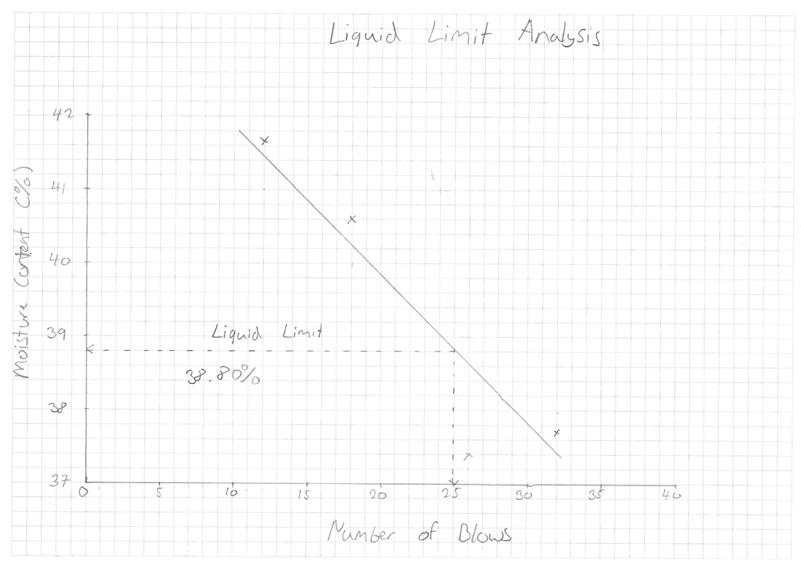
Figure 31: Graph for determining the Liquid Limit
The Liquid Limit Analysis Graph seen in Figure 31 shows that the Liquid Limit is 38.80% at 25 number of blows.

Plasticity Chart
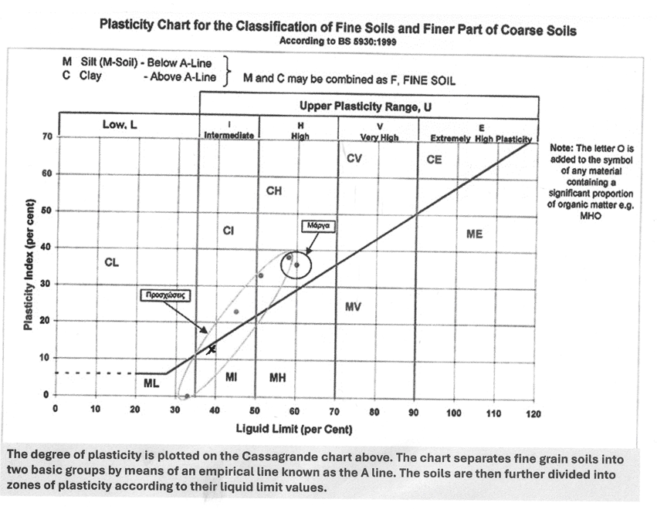
Figure 32: Plasticity Chart for soil classification (BS 5930:1999)
The Plasticity Chart seen in Figure 32 gives a soil classification of Silt of Intermediate Plasticity.
Results
Liquid Limit (LL) | 38.80%
Plastic Limit (PL) | $\frac{24.58+17.03+24.72}{3}$ = 24.98%
Plasticity Index | 38.80 – 24.98 = 13.82%
Soil Classification | Silt of Intermediate Plasticity
Table 11: All results obtained throughout both test

Analysis
The results of the Atterberg Limits test shows that the soil exhibits intermediate plasticity, as shown by a Plasticity Index of 13.82%. This value reflects the difference between the Liquid Limit of 38.80% and the Plastic Limit of 24.98% (See Table 11). Both represents the range of moisture contents over which the soil behaves plastically. Together, the values establish the range over which the sample can be deformed without cracking. A Plasticity Index within this range suggests that the soil contains a moderate proportion of fine particles that is predominantly silt sized particles, with limited clay content. As a result, the sample used shows some plastic behaviour, but significantly less than that of highly plastic clays. The small plastic range indicates that the soil transitions more quickly between stages which suggests that there is reduced cohesion and limited resistance to deformation.
The classification of the soil sample as silt of intermediate plasticity is consistent with the results obtained. According to BS EN ISO 14688-1:2017, soil within this category usually has a consistency ranging from firm to stiff depending on their moisture content. This indicates that the soil possesses moderate strength and can resist deformation under load when relatively dry but may become weaker and lose its stiffness as the moisture content increases. It also shows that silts typically exhibit lower plasticity and cohesion compared to clays due to their mineral composition and particle size. The classification of the soil as silt of intermediate plasticity is further supported by graphical analysis using the plasticity chart, where the plasticity index is plotted against the liquid limit. The soil plots just below the A-line, confirming its classification as silt rather than clay, and withing the intermediate plasticity range. However, it’s proximity to the boundary suggests the presence of minor clay content. This may result in slightly increased cohesion when compared to typical silts, while exhibiting sensitivity to moisture change.
For a Design perspective, soils classified as silts of intermediate plasticity can present challenges during the development and construction. Silt soils may appear relatively stable when dry, their strength however can decrease significantly when exposed to increased moisture content. The moderate Liquid Limit suggests that the soil has limited capacity to retain water compared to clay, but it is still able to become soft and unstable when saturated. The relatively low plasticity index indicates that the soil has limited resistance to deformation, making the soil more susceptible to erosion, settlement, or loss of strength under certain loading conditions. This behaviour must be carefully considered in applications such as foundations and any earthworks, where changes in moisture content may affect performance.
The results obtained are consistent with values reported on existing geotechnical standards and reports. According to BS 1377-2:1990, silts generally exhibit lower plasticity than clays due to their reduced clay mineral content. The results obtained in this test fall within the expected range for intermediate plasticity silts, supporting the reliability and validity of the results. However, some variations may be observed when compared to other existing research. Differences in particle size distribution, mineral composition, and sample preparation techniques can have an influence on these variations. The presence of small amounts of clay can also influence the plasticity characteristics, leading to slight deviations in classification.
The Atterberg limits test is closely linked to the sieve analysis test, as both methods contribute to soil classification but assess different aspects of soil behaviour. While sieve analysis determines the distribution of particles sizes within the soil, the Atterberg Limit test complements this by evaluating the consistency and plasticity of fines particles under varying moisture conditions. The significance of combining these tests lies in the comprehensive understanding they provide. Sieve analysis shows information on the physical composition and grading of the soil, while the Atterberg Limits test reveals its mechanical behaviour and consistency. Together, they enable more accurate classification and prediction of soil performance in engineering applications.

Limitations
Several limitations may have influenced the accuracy of the results. One factor is human error, for the Liquid Limit test it relies on the consistent operation of the Casagrande apparatus which different operators causes variations in the rate of handle rotation and the judgement of the groove closure can produce error. Similarly, the plastic limit test is dependent on manual rolling of the sample into a thread, which introduces subjectivity and may lead to slight inconsistencies between trials.
Throughout both test the room temperature was considered when determining results. With continuous cranking operator fatigue can lead to inconsistencies in the rate of rotation whilst leading to an increase in body temperature of the operation which can have an effect on the room temperature.
Moisture can have a significant effect on the sample, which is why it is important that all equipment’s are cleaned before and in-between tests. Any water spilt into the table during mixing procedure were immediately be cleaned. In the Plastic Limit test hands were cleaned and dried before rolling to avoid additional sample from previous test this can be seen on Figure 33. | 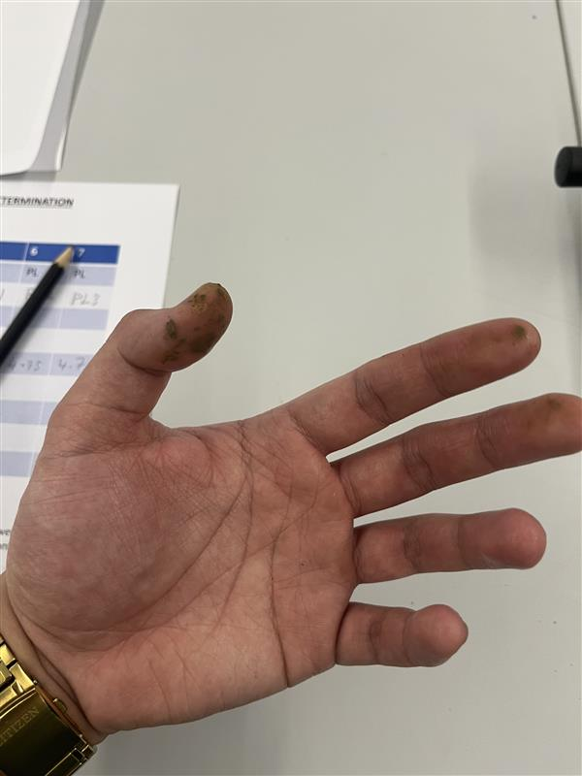  Figure 33: One of the group member’s hands showing with excess sample from previous testing.
In-between testing any equipment used to removed and transport the sample were clean and dried to avoid additional sample being mixed from previous test this can be seen on Figure 34. | 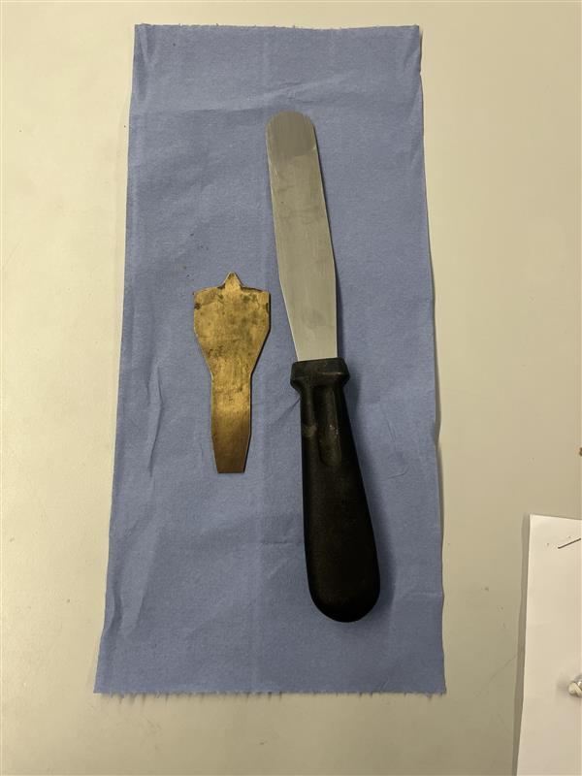  Figure 34: Dried and clean Equipment’s
During the plastic limit procedure, it is best to consider that moisture from the hands can have an effect on the sample. With the addition of extra moisture, it can change the breaking point of the sample, therefore affecting the results. This can be avoided by wearing gloves to avoid moisture exposure. Figure 35 shows that no gloves were worn during testing. | 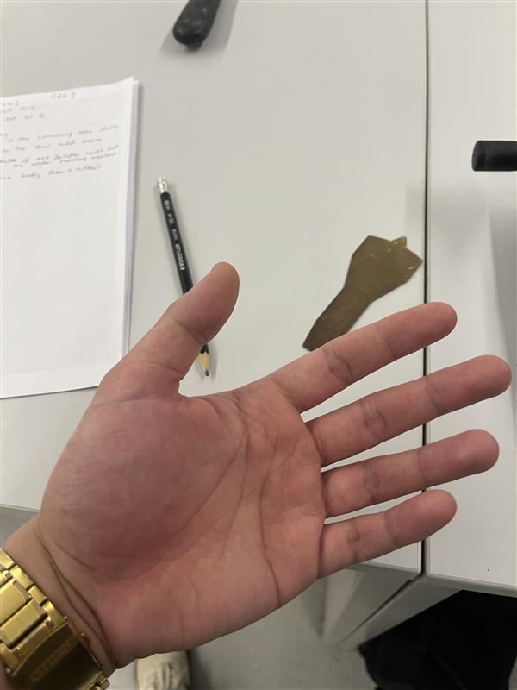  Figure 35: One of the group member’s hands
Another limitation is that both tests was conducted only once, this reduces the reliability and reproducibility of the results. By repeating the experiment, it would allow for comparison between trials and help identify any anomalies.
Table 12: Limitations observed during Atterberg Limits Test

Conclusion
In conclusion, the Atterberg Limits test determined that the soil sample has a Liquid Limit of 38.80%, a Plastic Limit of 22.11%, and a plasticity index of 16.69%, classifying it as clay of intermediate plasticity. These results shows that the soil has moderate cohesion and plasticity. Depending on moisture conditions there is potential for volume change. This soil may be viable for certain engineering applications, but it’s behaviour under certain conditions must be carefully considered in design. Overall, the test provides valuable insight into the soil’s consistency and classification.

The Constant Head Permeameter Test

Introduction
The Constant Head Permeameter test is a laboratory method that is used in Geotechnical Engineering to determine the coefficient of permeability of soil. It is used for granular soils which has higher permeability where water can flow through the voids at a measurable rate. In the procedure water is allowed to flow through the saturated soil sample under a constant head of water, and the rate of flow is measured over time. The coefficient of permeability varies between construction sites due to differences in the soil’s pore size and structure. A deep understanding of the permeability can help determine how easily water can flow through the voids of the soil. This parameter is essential for both the design such as the foundation and the safety of a construction project. Determining the permeability of the soil can help predict groundwater movement which can help ensure the stability and safety of a structure.

Methodology
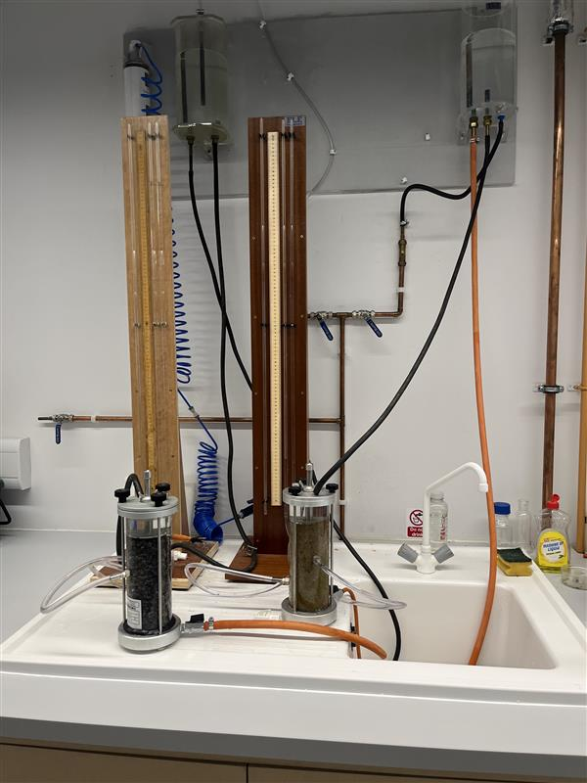
Figure 36 Constant Head Permeameter setup with soil sample
Figure 36 shows the Constant Head Permeameter setup, this image shows the various equipment’s used such as the Manometer tubes, Balancing tank, Permeameter, and the Rubber Hoses.
Table 13: Constant Head Permeameter setup

Equipment | Purpose | Pictures
Ruler/Digital Callipers | Used to measure the distance between the two pressure points and the internal diameter of the permeameter. This gives the L value and the cross-sectional area (A). | 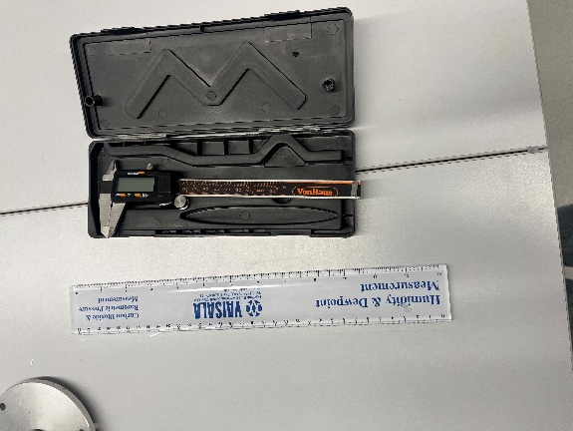  Figure 37: Rulers/Digital Callipers used
Permeameter | Permeameter apparatus holds the porous materials that will be used to measure the permeability and allows controlled water flow through it. | 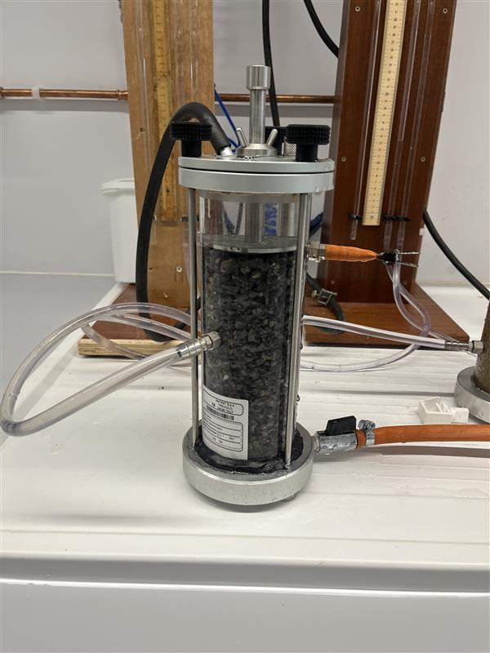  Figure 38: Permeameter Apparatus holding one of the samples used
Timer and Bucket | Timer used in-between test to measure the selected time for each test. Bucket was placed under measuring cylinders during testing to prevent spillage on floors and control Health and Safety. | 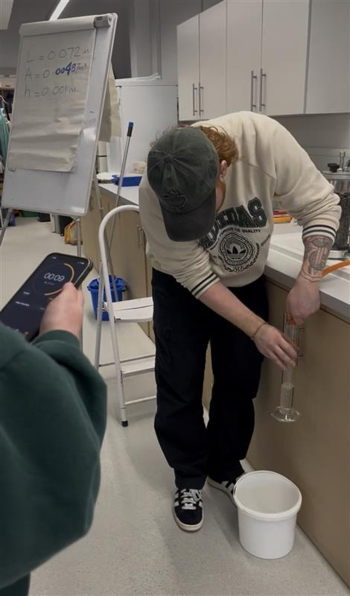  Figure 39: Group Member doing one of the tests
Manometer Tubes | The Manometer Tubes are used to measure the difference in water head (pressure) between two points. This allows the hydraulic head difference to be calculated. | 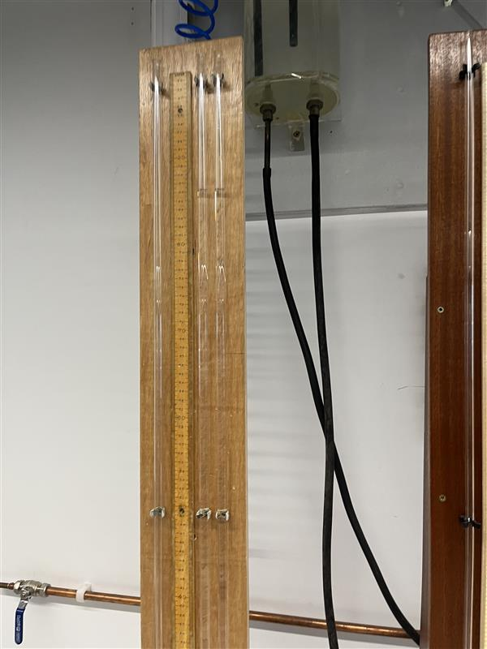  Figure 40: One of the manometer Tubes used
Rubber Hoses | Rubber Hoses are used to connect different parts of the apparatus and allow water to flow smoothly between equipment’s without leakage. | See Figure 36
Measuring Cylinders | Two different sizes of Measuring Cylinders were used to collect and measure the volume of water flowing through the soil over a specific time period. | 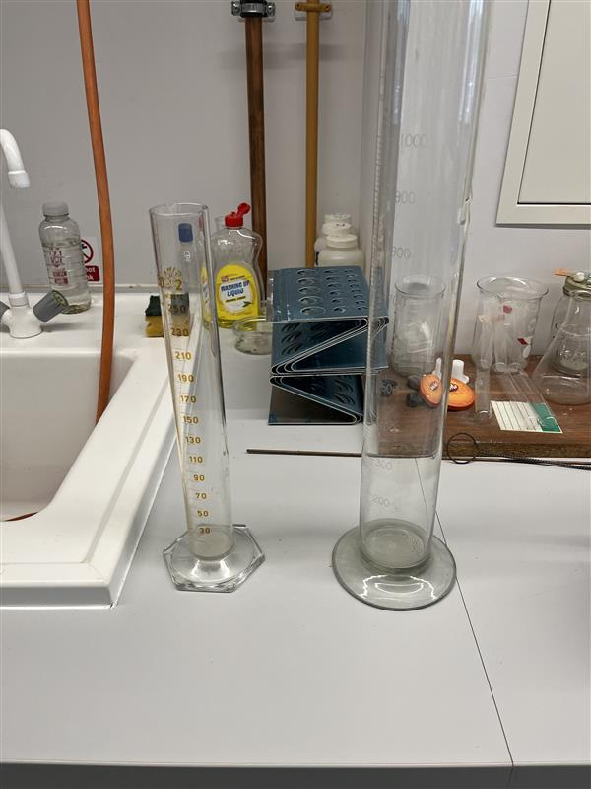  Figure 41: Measuring Cylinders used
Balancing Tank | Maintains a constant water level to ensure a steady hydraulic head throughout the test. | 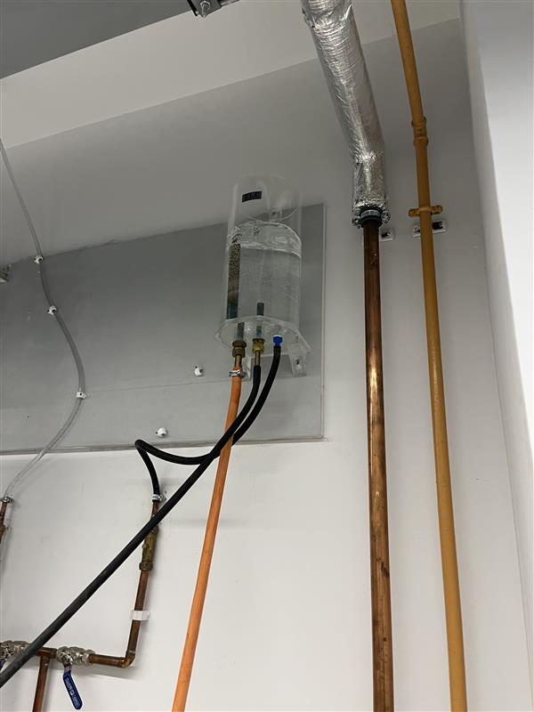  Figure 42: Balancing Tank used
Water Supply | Water supply provides continuous flow of water through the system to maintain saturation and constant head conditions. | See Figure 36
Round Wire Mesh | A round wire mesh can be found inside the permeameter allowing water to flow across the surface of the sample evenly and prevents the loss of the sample
Table 14: Equipment’s used for The Constant Head Permeameter test

Constant Head Permeameter Procedure
1 | The Constant Head Permeameter was assembled ensuring that all connections were secured (See Figure 36). The soil samples were placed onto the permeameter apparatus and was compacted to the desired density. The sample was then saturated by allowing water to flow through. This was done for a period of time to fully saturate the samples (See Figure 38). The filters were also placed at the top and bottom of the permeameter apparatus to prevent soil lost.
 | It is essential that there was a stable and constant flow of water through the soil. This ensured that there were no air bubbles presence during the experiment.
2 | With a ruler/digital calliper an empty permeameter apparatus was used to measure the length (L) between the two-pressure point, and three internal diameters were measured and averaged to calculate the cross-sectional area of flow (A) (See Figure 37).
3 | The Hydraulic Head Difference (h) was established by measuring the pressure between two points, using the manometers tubes (See Figure 40).
4 | Three different time given in seconds were selected for the first sample
 | When ready, the water outlet tube was pinched and transferred on top of the measuring cylinder whilst at the same time, the timer/stopwatch was started (See Figure 39).
5 | The amount of water collected in the measuring cylinder was measured and gave us (Q) for a set time (t)
6 | This was repeated three times, where it was observed that there was an increased in volume collection when the time period was also increased. All data was converted to M³ (x10⁻⁶).
6 | All data was collected and placed into a table and Using Darcy’s Law, we were able to determine the coefficient of permeability (K) and its average for both test
7 | This was repeated for a different sample. As the time increases, we switched to a bigger measuring cylinder to prevent overflowing.
8 | Using the Hydraulic Conductivity Chart, we were able to classify both samples.
Table 15: The procedure taken for The Constant Head Permeameter test

Results
$$K= \frac{Q × L}{A × h × t}$$

K | Coefficient of Permeability
Q | Flow over time ‘t’ (m³/s)
L | Length of the flow line (m)
A | Area of Flow (m²)
h | Hydraulic head difference (m)
t | time in seconds
Table 16: Coefficient of Permeability Equation
This equation was used to calculate the coefficient of permeability throughout the experiment.
Length of the flow line (L): 14.7 – 7.5= 7.2cm 0.072 m
Internal Diameter: $\frac{78.72 + 78.86 + 78.74}{3}$ = 78.77mm 0.0788 m
A= π x r²
r = $\frac{0.0788}{2}$ = 0.0394 m
Cross sectional area (A): π x 0.0394²= 0.00487 m²
Table 17: Calculation on how to the (L) and (A) value was determined
Three different measurements were taken for the internal diameter and averaged to improved accuracy. This average value was used to calculate the cross-sectional area of flow. All measurements were converted to meters to ensure consistency in the calculation of permeability.

Test 1
Hydraulic head difference (h): 86.1 – 86.0 = 0.1cm 0.001m
Time | Results
20 seconds | 186 x 10⁻⁶= 0.000186m³
40 seconds | 398 x 10⁻⁶= 0.000398m³
60 seconds | 595 x 10⁻⁶= 0.000595m³
Table 18: Volume of water collected in different durations for test 1
The hydraulic head difference (h) was determined as 0.001m from the measured values. The volume of water collected was recorded over three different time intervals of 20, 40, and 60 seconds, as shown in Table 18. The recorded discharge increased proportionally with time.
Coefficient of Permeability
Test 1 (20 seconds) | $K=\frac{0.000186 ×0.072}{0.00487 ×0.001 ×20}$ =0.137 m/s
Test 2 (40 seconds) | $K=\frac{0.000398 ×0.072}{0.00487 ×0.001 ×40}$ =0.147 m/s
Test 3 (60 Seconds) | $K=\frac{0.000595 ×0.072}{0.00487 ×0.001 ×60}$ = 0.147 m/s
Table 19: Coefficient of Permeability results for the 3 tests in test 1
Using Darcy’s Law, the coefficient of permeability (K) was calculated for each time interval (See Figure 19).
Average
$\frac{0.137 + 0.147 + 0.147}{3}$ = 0.144 m/s
Average permeability (K) = 1.44 x 10⁻¹ m/s
Table 20: The average result for Coefficient of Permeability for test 1
The average coefficient of permeability for Test 1 was calculated and shown in Table 20. This value represents the overall permeability of the sample tested.

Test 2
Hydraulic Head Difference (h): 83.9 – 17 = 66.9cm 0.669m
Time | Results
40 seconds | 360 x 10⁻⁶= 0.000360m³
80 seconds | 700 x 10⁻⁶= 0.000700m³
100 seconds | 905 x 10⁻⁶= 0.000905m³
Table 21: Volume of water collected in different durations for test 2
The hydraulic head difference (h) was determined as 0.669m from the measured values. The volume of water collected was recorded over three different time intervals of 40, 80, and 100 seconds, as shown in Table 21. The recorded discharge increased proportionally with time.
Coefficient of Permeability
Test 1 (40 seconds) | $K=\frac{0.000360 ×0.072}{0.00487 ×0.669 ×40}$ =1.989 x 10⁻⁴ m/s
Test 2 (80 seconds) | $K=\frac{0.000700 ×0.072}{0.00487 ×0.669 ×80}$ =1.937 x 10⁻⁴ m/s
Test 3 (100 Seconds) | $K=\frac{0.000905 ×0.072}{0.00487 ×0.669 ×100}$ = 1.9999 x 10⁻⁴ m/s
Table 22: Coefficient of Permeability results for the 3 tests in test 2
Using Darcy’s Law, the coefficient of permeability (K) was calculated for each time interval (See Figure 22).
Average
1.989 x 10⁻⁴ + 1.937 x 10⁻⁴ + 1.9999 x 10⁻⁴ = 5.9259 x 10⁻⁴ m/s
5.9259 x 10⁻⁴ $÷$ 3 = 1.97 x 10⁻⁴ m/s
Average permeability (K) = 1.97 x 10⁻⁴ m/s
Table 23: The average result for Coefficient of Permeability for test 2
The average coefficient of permeability for Test 2 was calculated and shown in Table 23. This value represents the overall permeability of the sample tested.

Hydraulic Conductivity Chart
Hydraulic Conductivity Chart
Range of Values for k (m/s)
10² | Clean Gravels
10 | Clean Gravels
1 | Clean Gravels
10⁻¹ | Clean Gravels
10⁻² | Clean Sands  Gravel-Sand Mixtures
10⁻³ | Clean Sands  Gravel-Sand Mixtures
10⁻⁴ | Clean Sands  Gravel-Sand Mixtures
10⁻⁵ | Very Fine Sands  Silts and Silty Clays
10⁻⁶ | Very Fine Sands  Silts and Silty Clays
10⁻⁷ | Clay Silts (20% clay)  Unfissured Clay
10⁻⁸ | Clay Silts (20% clay)  Unfissured Clay
10⁻⁹ | Clay Silts (20% clay)  Unfissured Clay
Table 24: Hydraulic Conductivity Chart classification chart
Classification Results
Test 1: Average permeability (K) = 1.44 x 10⁻¹ m/s | Clean Gravels
Test 2: Average Permeability (K) = 1.97 x 10⁻⁴ m/s | Clean Sands and Gravel-Sand Mixtures
Table 25: Soil classification based on hydraulic conductivity values
The calculated permeability values were compared with the hydraulic conductivity chart (Table 24), allowing the soil samples to be categorised (Table 25).

Analysis
The classification results of the soil samples based on the hydraulic conductivity chart shows two distinct permeability characteristics (See Table 25). Sample for test 1, identifies as clean gravels which exhibits very high permeability, and this is consistent with its high coefficient of permeability result. This value reflects large particle sizes and well-connected void space that allows water to flow rapidly through the soil with minimal resistance. In contrast, the sample for test 2 is classified as clean sands and gravel-sand mixtures and shows a lower coefficient of permeability. This indicates a reduced flow rates due to smaller particle sizes and less interconnected voids. However, there is not a significant discrepancy between the two results, as both samples fall within the range of course-grained materials. This suggests that both samples share similar fundamental characteristics, with difference primarily only in their permeability rather than overall behaviour.
The differences in permeability can be further explained by variations in porosity and particle arrangement. Sample for test 1 exhibits higher porosity with larger, well-connected voids that resulted in minimal resistance to water flow. In contrast sample for test 2, was more compact that had smaller voids and increased particle contact, leading to greater resistance to flow. Although the hydraulic head difference remained constant throughout the test, these variations in internal structure significantly influenced the measured permeability. This demonstrates how soil structures govern the rate of water moved rather than external test conditions. It is also important to note that the soil samples tested were disturbed samples. To minimise the effects of disturbance, the soils was placed into the permeameter in layers and compacted (tamped) to achieve a more uniform density and structure. This processed reduced large voids and improved particle contact, allowing the sample to better represent in-situ conditions within controlled environment.
From a design perspective, these differences are highly significant. Soils with very high permeability such as clean gravels are ideal for drainage applications such as groundwater control systems, where rapids removal of water is essential. In comparison, clean sands and gravel-sand mixtures provide a more controlled rate of flow, offering a balance between drainage and stability. This makes them more suitable for foundations and embankments, where excessive seepage could compromise structural integrity.
The results obtained are consistent with established findings reported in existing research and standards. According to BS1377-5:1990, coarse-grained soils such as gravels and sands typically exhibit high coefficients of permeability due to their low surface area and containing more voids. The values and classifications observed align with these expectations, supporting the reliability of the test procedure. Minor variations between test results and published values can be attributed to differences in particle shape, gradation, and sample compaction which ca all influence void ration and flow paths within the soil.
The significance of the constant head permeameter test lies in its ability to quantify the rate of water flow through soil, providing essential data for predicting seepage and drainage behaviour. Combining this with the Sieve analysis and the Atterberg Limit test, a more comprehensive understanding of Soil characteristics can be achieved. Together, these methods provide a complete assessment of soil properties at a site which supports more informed and reliable engineering decision making.

Limitations
The Constant Head Permeameter test is subject to several limitations that can influence the accuracy and reliability of the results. Prior to recording data, water was allowed to flow through the sample until full saturation was achieved. This ensured that entrapped air was removed and that soil particle settled into a stable equilibrium position. These conditions were essential for achieving steady-state flow. This ensure that the measured discharge accurately reflected the true hydraulic behaviour of the soil rather than initial particle rearrangement.
Human error is another significant factor, particularly when taking measurements such as volume and time. Inaccuracies in reading the measuring cylinder, timing the flow duration, or recording values can introduce errors when calculating permeability (See Figure 43). Similarly, when observing the hydraulic head difference, small fluctuations or misreadings of the pressure difference can affect the calculated hydraulic difference (h). | 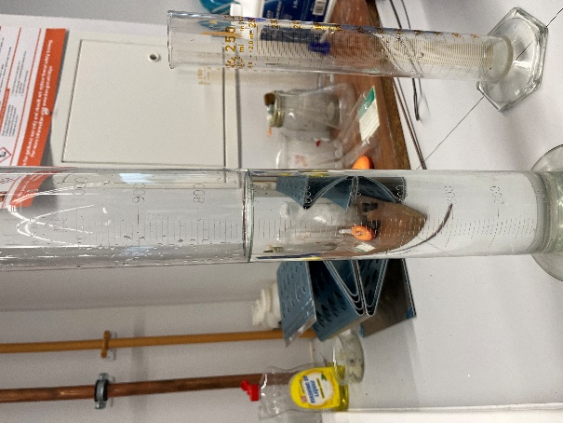  Figure 43: One of the Volume of water collected after test
Correct unit conversions are also critical. Errors in converting measurements such as centimetres to meters can significantly affect the result and can lead to unrealistic permeability values. Another limitation is the need to properly dry measuring cylinders between tests. Any residual water left in the cylinder can increase the recorded discharge, resulting in an overestimation of permeability.
Throughout in between test good communication is critical in ensuring that the correct volume is being collected at the designated time. Pinching the outlet too early before the timer has finished can lead to incorrect results have affect the estimation of permeability. This was once observed on one of the tests conducted.
Finally, the test is conducted on a relatively small and controlled soil sample, which may not fully represent in-situ conditions. Despite these limitations, the test still provides a useful approximation of both sample’s permeability when conducted carefully.
Table 26: Limitations observed during The Constant Head Permeameter test

Conclusions
In conclusion, The Constant Head Permeameter test demonstrated that both soil sample exhibit relatively high permeability which are consistent with their classification as coarse-grained particles. The first test identifies as clean gravels that showed high permeability due to large void spaces that allowed rapid water flow. Whereas, the second test classified as sand and gravel-sand mixture, exhibits lower permeability which reflects a more compact structure. Despite their difference, both samples displayed similar behaviour, with no great discrepancy in their permeability characteristics. These findings highlight influence of particle size, porosity, and soil structure on water flow. The results are significant for engineering design such as drainage and foundation stability.

Overall Conclusion
Overall, the combination of Sieve Analysis, Atterberg Limits, and The Constant Head Permeameter tests provides a comprehensive understanding of soil behaviour. Together, these tests allow for accurate classification and prediction of the soil’s performance in a site and its behaviour under certain conditions. This integrated approach is essential for site investigations, as it ensures that both the physical composition and mechanical behaviour of the soil are carefully considered. This leads to a more reliable and informed design decisions.

References
British Standard Institution (2017) BS EN ISO 14688-1:2017 Geotechnical investigation and testing - Identification and classification of soil - Part 1: Identification and Description. [online]. Available at: https://www.iso.org/standard/66345.html (Accessed on 3 February 2026)
British Standard Institution (2017) BS EN ISO 14688-2:2017 Geotechnical investigation and testing - Identification and classification of soil – Part 2 Principles for a classification. [online] Available at: https://www.iso.org/standard/66346.html (Accessed on 3 February 2026)
British Standard Institution (1990) BS 1377-2:1990 Methods of tests for soils for civil engineering purposes – classification tests. [online] Available at: https://knowledge.bsigroup.com/products/methods-of-test-for-soils-for-civil-engineering-purposes-classification-tests (Accessed on 3 February 2026)
British Standards Institution (2022) BS 1377-2:2022 Methods of test for soils for civil engineering purposes. Part 2: Classification tests and determination of geotechnical properties. [online] Available at: https://knowledge.bsigroup.com/products/methods-of-test-for-soils-for-civil-engineering-purposes-classification-tests-and-determination-of-geotechnical-properties (Accessed on 14 February 2026)
British Standard Institution (2018) BS EN ISO 17892 -12:2018 Geotechnical investigation and testing – Laboratory testing of soil – Part 12: Determination of liquid and plastic limits. [online]. Available at: https://www.iso.org/standard/72017.html (Accessed on 14 February 2026)
British Standard Institution (1990) BS 1377-5:1990 Methods of test for soils for civil engineering purposes – Compressibility, Permeability and Durability tests. [online] Available at: https://knowledge.bsigroup.com/products/methods-of-test-for-soils-for-civil-engineering-purposes-compressibility-permeability-and-durability-tests (Accessed on 14 February 2026)

