Knowledge and Information Management Skills for the Workplace

Link to video; https://web.microsoftstream.com/video/5a9c985c-3658-4a49-ae6f-a1e90ae30216

Razvan Aurelian Huminic: 1915413
Module code: BMSW5106
Lecturer: Seyed Nasirpourosgoei

Executive Summary
John Deere has mainly set new appropriate direction for global agricultural market. The company is constantly focusing upon modern farming methods such as remote sensors, drone technology, IOT and Data Analytics to improve their production activities. This report has summarized brief information about John Deere along with its technological developments. It has been indicated that John Deere is entirely dependent upon new farming technologies to make efficient use of fertilizers. The report has identified that John Deere has incorporated their IOT with farming practices to reduce input costs and enhance customer service. It also explained the impact of Data Analytics on corporate success.

Table of Content
Introduction 4
Task 1: Report 5
Information Systems within John Deere 5
Impact of Customer Relationship Management (CRM) 8
How John Deere can apply IT to tackle five forces 11
Implications of IOT and Big Data Analytics 13
Conclusion 18
Reference 18
Task 2: Presentation 21

Introduction
This report is entirely based upon the importance of information systems and its long term implications upon John Deere. It mainly illustrates the positive and negative implications of Customer Relationship Management. This report also demonstrates the importance of Big Data Analytics and IOT to manage day to day operations. It also illustrates that how John Deere can apply IT system to tackle threat of substitutes and competitive rivalry. The report also demonstrates suggestions for John Deere to improve their knowledge management.
Company Overview
John Deere is mainly regarded as sustainable leader in agricultural equipments, construction and other technology. The company has mainly employed 10,000 workers and generates huge turnover around 2 billion (Eroknin et al., 2019). The average annual income of John Deere is 3.253 billion. The company was mainly specialized in forestry, technology and turf care.
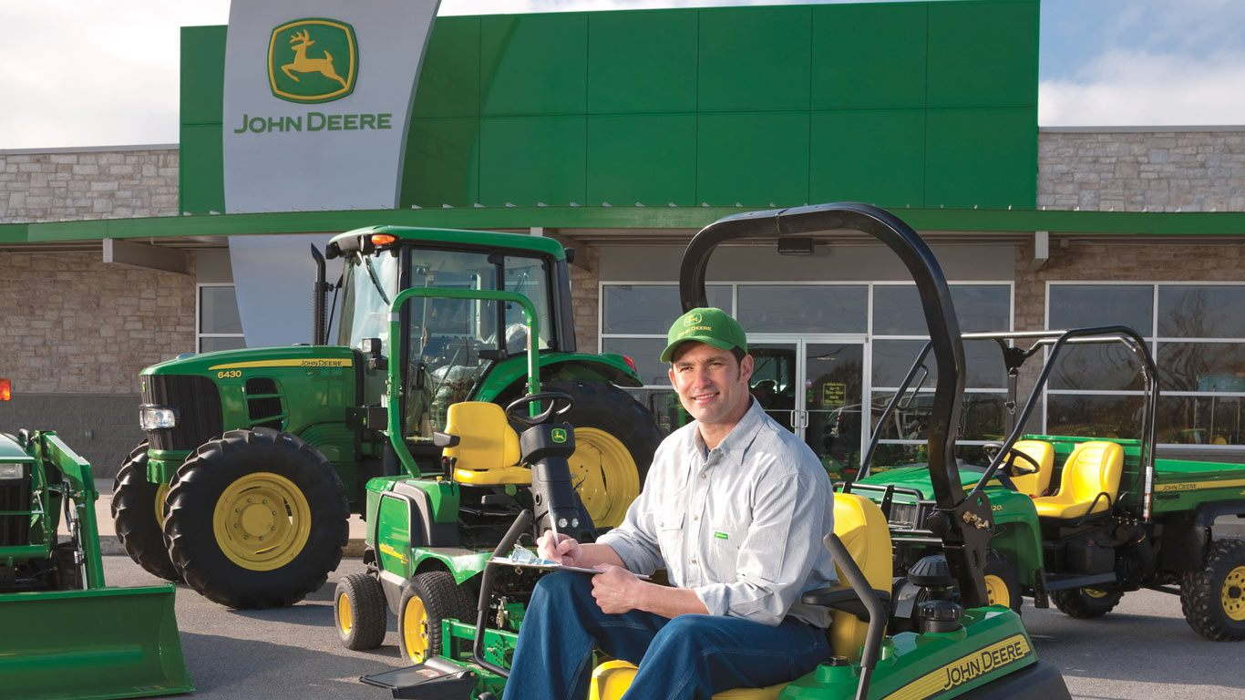
Source: (Eroknin et al., 2019)

Task 1: Report

Information Systems within John Deere
John Deere has mainly launched new web portal named My John Deere portal to offer better convenience and instructions to staff members. The company has mainly created smart landing page named My John Deere to give immediate notifications to farmers regarding warranty information, machine alerts and product improvement programs. In this way, Farmers can easily access operator’s manuals and JD parts catalogues. The company has created personalized Data Operation Centre to control machine productivity (Kopishynska et al., 2020). Apart from this, John Deere has implemented its own telematics system named JD Link to track location history of machines.
The company has also created online website named deere.com to provide relevant information to farmers regarding engine utilization, annual crop summaries and machine measurements (Kruize et al., 2016). Apart from this, John Deere mainly takes advantage of new farm management software named Harvest Profit and Apex to gain better visibility about agricultural machinery and make logical decisions. This farm management software mainly helps John Deere to protect their valuable assets and gain deep analysis about fuel consumption.
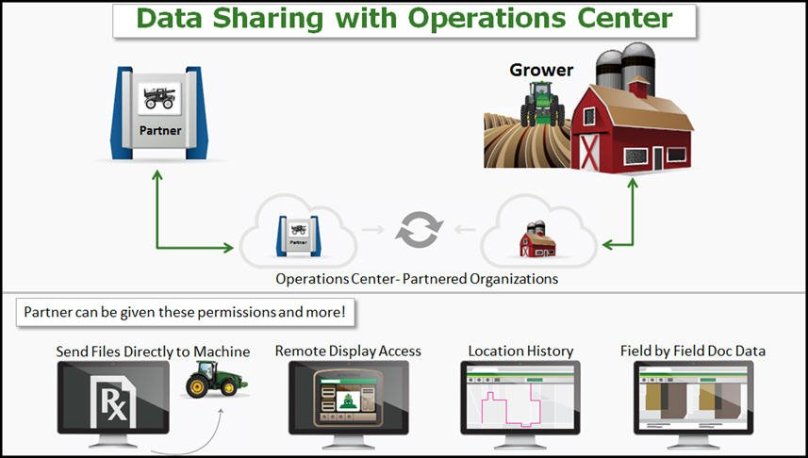
Source: (Eroknin et al., 2019)
The company also takes advantage of JD link CAN Bus technology to access service engine codes and review temperature on regular basis (Kruize et al., 2016). The company also uses different remote sensors such as Star Fire Receiver and Integrated Displays to collect large information about signal stability, geostationary satellites, and placement of seeds.
. The company has mainly launched new Mobile Weather Farm Mobile App to analyze relative humidity, wind direction and access all other agroeconomic data (Eroknin et al., 2019). The company also uses GPS system to align their crop scouting events within a specific geographical location. John Deere has also introduced new Harvest Identification Cotton (HIC) to simplify their production activities.
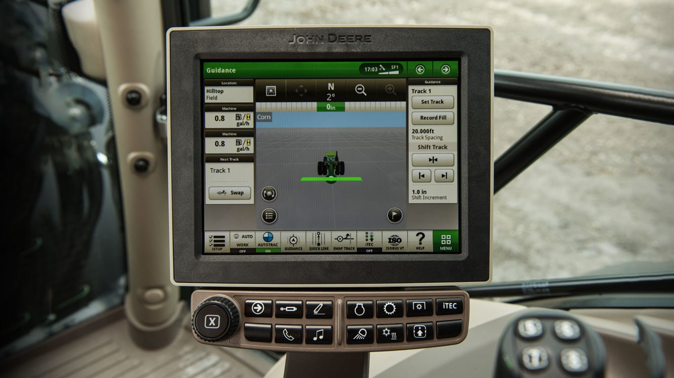

Apart from this, John Deere also post agriculture testimonial videos on their official website to help farmers in crop yields and day to day field coverage. In this way, John Deere can maintain absolute control over multiple crops, tractors and locations. The company also use take advantage of Auto Trac Turn Automation System to create certain adjustments in their agronomic decisions and manage confidential data. The company mainly focuses upon RTK network for better accuracy of interior boundaries and signal quality. Apart from this, John Deere has mainly implemented Global Satellite Based Augmentation System to gain real time accuracy about agricultural machinery, specialized crops and tracking field locations (Kopishynska et al., 2020). Through GPS, The company often support farmers in tracking their harvesting practices. These technologies mainly help John Deere to create accurate crop yield maps for farmers.

Impact of Customer Relationship Management (CRM)
CRM mainly involves different technologies and techniques used by business to create strong brand awareness among customers. The company often uses CRM software to track machine maintenance and livestock. In this way, John Deere can maintain separate Excel spreadsheets to secure customer information (Cruz et al., 2019). CRM systems mainly help John Deere to develop mutual trust and loyalty among customers.. In this way, The Company was able to gain deep information about different customer segments (Harrigan et al., 2020). For instance, John Deere often uses CRM system to introduce 1 year Silver membership rewarding program for customers. The company also sends quarterly reward digital mail to maintain strong relationship with customers. Thus, CRM offers following benefits to John Deere which are:
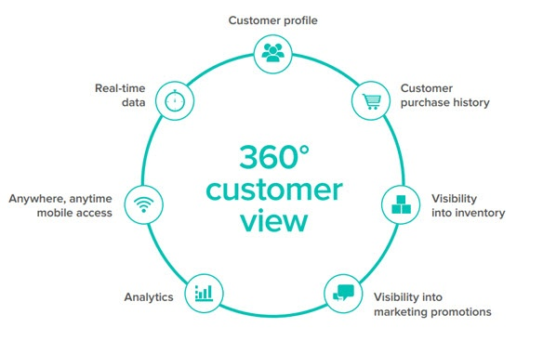
Source: (Cruz et al., 2019)

Builds Profitable Relationship: CRM systems mainly help John Deere to make strong emotional brand appeal among customers (Dalla Pozza et al., 2018). CRM systems often keep customers updated regarding upcoming gift vouchers, pricing structure and discounts
Access large information: CRM systems allow John Deere to access large information about customer purchasing habits, educational background and product requirements. For instance, John Deere can take advantage of sales history, emails and mobile apps to gather customer information (Ahani et al., 2017). Through CRM, The Company can use different performance indicators to track their field progress and crop plantation on regular basis.
Maintain consistent sales: CRM systems mainly help John Deere to maintain stable financial position. For instance, John Deere can incorporate their CRM into digital platforms to build separate call list for customers (Cruz et al., 2019). Thus, CRM is a profitable opportunity for John Deere to generate highly qualified leads.
Create exciting reward programs: John Deere often use CRM system to create innovative brand value for customers. The company often uses mobile CRM software to provide 5% discounts to customers for purchasing planters, sprayer parts and air seeders (Harrigan et al., 2020). This mainly helps John Deere to gather positive word of mouth from customers regarding field mapping, new farming practices and Turf equipments.
Drawback of CRM system
CRM systems often create certain issues in sales growth due to higher operational costs and premium upgrade packages. On the other side, CRM systems mainly involve hidden costs which often create several difficulties for business (Cruz et al., 2019). Apart from this, Adoption of wrong tools mainly leads to failure of CRM system. There are several drawbacks of CRM systems which are described below:
Lack of Leadership: Organization mainly requires mutual cooperation of all functional departments for successful CRM implementation (Ahani et al., 2017). If leaders do not have sufficient knowledge about CRM, then it has negative impact upon business operations. In the absence of proper leadership, Staff members often remain confused and frustrated regarding new CRM software.

Cause Phishing Scams: CRM service providers often pass sensitive information to third parties regarding business objectives and credit cards (Harrigan et al., 2020). While implementing CRM, Firms often face higher risk of fraud emails and phishing scams.
Lack of Proper Training: It is the biggest challenge of CRM implementation. At certain situations, Firms often spend more time upon new technologies rather than training methods. Poor training mainly contributes towards lower retention rates and decrease business productivity (Ahani et al., 2017).

How John Deere can apply IT to tackle five forces
Threat of New Entrants (Low): The agricultural machinery market is highly competitive and diversified sector across UK. The new entrants often face several barriers in agricultural industry including huge capital, professional expertise in farming practices and in depth understanding about agricultural trends. Thus, John Deere often faces lower risk from new company due to higher restrictions. At this point, John Deere can adopt geographic information system to track field location and achieve highest quality standards (Brujil, 2018).
Competitive Rivalry (High): There is intense competition in agricultural sector in terms of technological developments, pricing structure and innovation. John Deere is unable to compete with AGCO and Kubota. These competitors are mainly introducing different loyalty schemes to attract large customers. For instance, Kubota mainly offers after sale services to grab customer attention (Suglobov and Semenova, 2017). At such point, John Deere can implement IT systems to optimize their local farming practices and track field coverage on regular basis.
Threat of Substitutes (Low): John Deere mainly faces lower risk from substitutes due to its loyal customer base. John Deere can apply IT system to tackle substitute threat by introducing new agricultural equipments such as Portable Agricultural Sprayer, Remote Sensors and Tillage Planter to attract new customers. In this way, John Deere can expand their lawn equipments to create superior value for customers.
Supplier Power (Low): The main suppliers of John Deere are agro field experts, farmers, and distributors. John Deere has already established several foreign subsidiaries and factories in 30 emerging markets (Brujil, 2018). The company can take advantage of IT systems to tackle supply chain issues and manage inventory costs.

Buyer Power (Low): John Deere mainly face less threat from buyer power due to strong international presence. The company has already created diversified product portfolio including Lawn tractors, Sports Turf and construction equipments to attract large customers. Thus, John Deere could apply IT systems to gain real time insights about customer needs (Suglobov and Semenova, 2017).

Implications of IOT and Big Data Analytics
Impact of Big Data Analytics
Big Data Analytics is all about gaining crucial insights about latest marketing trends, technological developments, and consumer trends. Big Data Analytics mainly help businesses to gain crucial insights about analytical queries. Over the past few years, John Deere use big data analytics to transform entire agricultural practices. The company has mainly collaborated with data scientists to initiate smart farming practices (Ryan, 2020). Thus, Data Analytics mainly helps John Deere to collect large information about different remote sensors, temperature conditions and other topographic areas. Big Data Analytics mainly contributes towards sustainable growth of business. There are several benefits of Data Analytics which are described below:
Manage Supply Chain: Big Data Analytics mainly helps John Deere to make logical decisions regarding supply chain. It mainly helps businesses to track supply chain activities and boost sales collections. Through Data Analytics, Firms can identify several issues within critical equipments and eliminate spoilage (Matteti et al., 2021). Big Data Analytics mainly helps businesses to optimize their fleet management and cut transportation costs

Accurate Weather Forecast: John Deere mainly focuses upon Big Data Analytics on natural conditions such as soil, pesticides and weather conditions. On the other side, Firms can integrate big data analytics on different weather conditions. Thus, Big Data Analytics creates strategic alignment between big data analytics with smart farming software to manage production activities (Singh et al., 2020). For instance, John Deere can take advantage of soil data and images to improve their annual growth rates.
Improve Profit Margins: Big Data Analytics mainly helps John Deere to improve crop yields and boost profit margins. In this way, John Deere can easily access up to date weather data to manage business operations (Ryan, 2020). Thus, Big Data Analytics mainly helps John Deere to produce accurate forecasts about sales projections. In this way, John Deere can become more profitable and competitive in global marketplace
Deliver Accurate Information: Big Data Analytics mainly helps John Deere to establish huge confidence and trust among customers. In this way, John Deere mainly adopts smart agricultural facilities and offer accurate data to customers. Big Data Analytics helps John Deere to consider high quality data on temperature, humidity and chemicals (Matteti et al., 2021).
Increase Business Productivity: John Deers can utilize data analytics to stay updated with latest customer trends and gain real time insight about product demand. It mainly helps businesses to become more innovative leader in global marketplace (Ryan, 2020). Data Analytics mainly allows john Deere to monitor their health crops in real time.
Drawbacks of Big Data Analytics
Privacy Issues: Big Data Analytics is mainly concerned with different security concerns which may affect business productivity (Singh et al., 2020). At certain situations, Big Data Analytics often lead to unauthorized data collection and shows privacy errors which is the major threat to business reputation.
Lack of Support: Without professional expertise, Organization often find difficult to manage large amount of data. In such conditions, Firms are unable to transfer data from one centralized system to another (Matteti et al., 2021). Thus, Lack of Management Support mainly creates confusion and anxiety among staff members regarding data collection.
Influence of Internet of Things
At present, Internet of Things has become popular trend among business world. John Deere utilizes Internet of Things to gather relevant information about dam levels, chemical applications and soil moisture (Hassan, 2019). Thus, IOT mainly helps John Deere to automate entire irrigation system and monitor field crops on regular basis.
With the help of IOT, John Deere was able to make smart decisions based on moisture precipitation, dew detection and drainage capacity (Colakovic et al., 2018). Thus, IOT solutions mainly contribute towards better production of goods and services. IOT offers numerous benefits to business. Some of them are described below:
Improve operational efficiency: John Deere often use IOT devices to monitor crop plantation, irrigation and field location. IOT mainly provides crucial insights to business for solving production issues (Chettri and Bera, 2019).
Promote eco friendly practices: IOT allows John Deere to adopt ecofriendly farming practices and increase customer retention (Ammar et al., 2018). It mainly helps businesses to adopt sustainable supply chain management and allocate efficient resources within one plant.
Cost Reductions: The main benefit of IOT devices is that it reduces operational expenditure and additional charges.. Thus, IOT devices are quite beneficial for scheduling important tasks and minimize maintenance costs (Hassan, 2019). Through IOT, John Deere was able to identify relevant issues within production activities. It also helps businesses to minimize inefficiencies within value chain.
Collect new data: John Deere often take advantage of different IOT devices to access relevant data regarding environmental conditions. For instance, John Deere often use smart sensors to analyze current state of specialized crops (Hassan, 2019).
Drawbacks of IOT devices
Ecosystem Complexity: IOT is quite a diverse and complex ecosystem that involves different software and user friendly interface (Hassan, 2019). These IOT devices are usually connected with remote sensors, complex technological standards and regulations.
Cybercrime attacks: There are different computer programs such as malware which often lead to failure of IOT devices. On the other side, IOT devices mainly contribute towards data filtering, network failures and device modifications (Colakovic et al., 2018). In such conditions, Firms are unable to access confidential information.

Recommendations to John Deere
The current COVID 19 pandemic has disrupted the entire John Deere operations. The global pandemic has contributed towards production losses and disrupted the entire supply chain activities. During COVID 19, Firms often face several problems related to storage facilities and lowers crop productivity (Hassan, 2019). During COVID 19, John Deere often face several difficulties in managing logistics operations. Thus, John Deere must focus upon new innovation projects to strengthen their knowledge management. The company must adopt following measures to become global leader in marketplace. Some of them are described below:
Use Decision Support Systems: John Deere must adopt DSS system to conduct extensive research upon smart farming practices (Ryan, 2020). This is a wider opportunity for John Deere to expand their knowledge regarding modern agricultural practices.
Conduct online field digital surveys: It is the best way to strengthen their knowledge management systems. John Deere must conduct online digital field surveys for farmers based upon crop cycle dates, crop yields and management practices (Ryan, 2020).

Conclusion
The report concluded that John Deere has mainly established online farm management software to gather relevant information regarding soil conditions and temperature. The company constantly makes certain modifications in their Operation Center to boost sales collections and gain competitive advantage. The report has identified that John Deere mainly takes advantage of mobile CRM system to build long term relationship with customers. It also illustrate that Data Analytics was quite beneficial in managing supply chain activities and boost business productivity. The report has discussed the positive as well as negative consequences of IOT systems. It has identified that IOT systems are mainly associated with different cybercrime attacks which may affect business productivity.

Reference
Ahani, A., Rahim, N.Z.A. and Nilashi, M., 2017. Forecasting social CRM adoption in SMEs: A combined SEM-neural network method. Computers in Human Behavior, 75, pp.560-578.
Ammar, M., Russello, G. and Crispo, B., 2018. Internet of Things: A survey on the security of IoT frameworks. Journal of Information Security and Applications, 38, pp.8-27.
Bruijl, G.H.T., 2018. The relevance of Porter's five forces in today's innovative and changing business environment. Available at SSRN 3192207.
Chettri, L. and Bera, R., 2019. A comprehensive survey on Internet of Things (IoT) toward 5G wireless systems. IEEE Internet of Things Journal, 7(1), pp.16-32.
Čolaković, A. and Hadžialić, M., 2018. Internet of Things (IoT): A review of enabling technologies, challenges, and open research issues. Computer Networks, 144, pp.17-39.
Cruz-Jesus, F., Pinheiro, A. and Oliveira, T., 2019. Understanding CRM adoption stages: empirical analysis building on the TOE framework. Computers in Industry, 109, pp.1-13.
Dalla Pozza, I., Goetz, O. and Sahut, J.M., 2018. Implementation effects in the relationship between CRM and its performance. Journal of Business Research, 89, pp.391-403.
Erokhin, M., Pastukhov, A. and Kazantsev, S., 2019, May. Operability assessment of drive shafts of John Deere tractors in operational parameters. In 18th International Scientific Conference Engineering for Rural Development (Vol. 18, No. 22-24, p. 28).
Harrigan, P., Miles, M.P., Fang, Y. and Roy, S.K., 2020. The role of social media in the engagement and information processes of social CRM. International Journal of Information Management, 54, p.102151.
Hassan, W.H., 2019. Current research on Internet of Things (IoT) security: A survey. Computer networks, 148, pp.283-294.
Kopishynska, O., Utkin, Y., Galych, O., Marenych, M. and Sliusar, I., 2020, May. Main Aspects of the Creation of Managing Information System at the Implementation of Precision Farming. In 2020 IEEE 11th International Conference on Dependable Systems, Services and Technologies (DESSERT) (pp. 404-410). IEEE. (Kopishynska et al., 2020)
Kruize, J.W., Wolfert, J., Scholten, H., Verdouw, C.N., Kassahun, A. and Beulens, A.J., 2016. A reference architecture for Farm Software Ecosystems. Computers and Electronics in Agriculture, 125, pp.12-28.
Mattetti, M., Maraldi, M., Lenzini, N., Fiorati, S., Sereni, E. and Molari, G., 2021. Outlining the mission profile of agricultural tractors through CAN-BUS data analytics. Computers and Electronics in Agriculture, 184, p.106078.
Ryan, M., 2020. Agricultural big data analytics and the ethics of power. Journal of Agricultural and Environmental Ethics, 33(1), pp.49-69.
Singh, R.P., Javaid, M., Haleem, A. and Suman, R., 2020. Internet of things (IoT) applications to fight against COVID-19 pandemic. Diabetes & Metabolic Syndrome: Clinical Research & Reviews, 14(4), pp.521-524.
Suglobov, A.E. and Semenova, E.I., 2017. Development of methodical approaches to the analysis of a market environment of the organization. Economics of Agriculture of Russia.

Task 2: Presentation

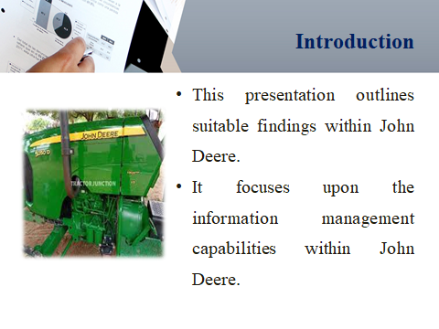
This presentation delivers concise description about John Deere. It has mainly focused upon the challenges and findings within John Deere case study. The presentation has focused upon the data driven capabilities of John Deere.
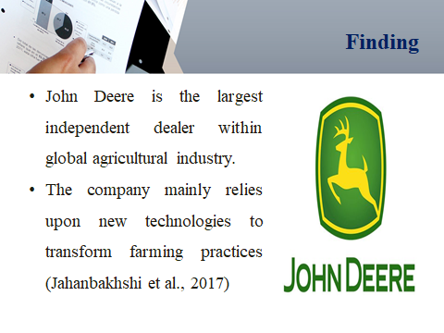
This slide has demonstrated usually covers key points within John Deere case study. The results indicate that John Deere has occupied dominant position in global agricultural industry. The company has mainly produced diverse product portfolio for customers including dump truckers, corn pickers, construction equipment and financial services. The findings indicate that John Deere’s competitive advantage mainly lies within its outstanding operations (Eroknin et al., 2017). Over the past few years, The company is constantly investing upon new technologies to bring positive change in agricultural sector. The company is entirely dependent upon 5 technologies which are remote sensing displays, Internet of Things and GPS to serve itself as innovator in marketplace.
The company is usually coming up with new smart and self driving vehicles to improve farming practices. The engineers of John Deere have created special GPS system to track field location. The company also uses satellite imagery to examine different grasslands, lawns, crop fields and temperature conditions (Pham and Stack, 2018). The findings indicate that John Deere is constantly trying to create sustainable future for agricultural industry. The company is constantly focusing upon Data Analytics to offer high resolution data to farmers regarding soil variation and changing weather conditions. The company mainly conducts extensive research upon new farming practices to support local farmers. Apart from this, John Deere is constantly focusing upon remote sensing technology to gain crucial insights about satellite vegetation data, soil conditions and weather. The company is already coming up with new farming equipments to build sustainable competitive advantage and maximize profit. The company has mainly adopted efficient CRM system to optimize user experience and make suitable predictions regarding crop yields. The company also pays much attention towards Machine Vision Platform and efficient IT infrastructure to gain customer appreciation (Jahanbakhshi et al., 2017). The findings also indicate that John Deere face low risk from new entrants due to higher market restrictions. The company is constantly utilizing different IOT devices to build smart agricultural practices. The results indicate that John Deere is constantly upon IOT industrial network to create data driven culture for farmers. The company is constantly focusing upon new agricultural technologies to use hybrid seeds and optimize their field.
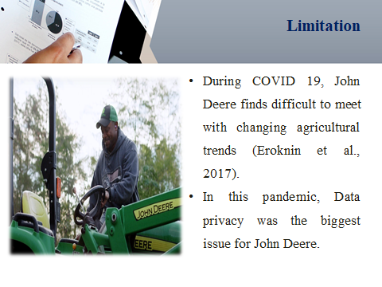
This slide mainly demonstrates certain limitations for John Deere. In this pandemic, The Company is struggling to adapt itself with changing agricultural trends due to fewer resources (Eroknin et al., 2017). The company often faces several difficulties in optimizing their algorithm. During COVID 19, John Deere has faced several challenges related to data privacy. The company often stores majority of their confidential data in cloud systems. On the other side, Hackers are already coming up with new software to steal business information from cloud computing.

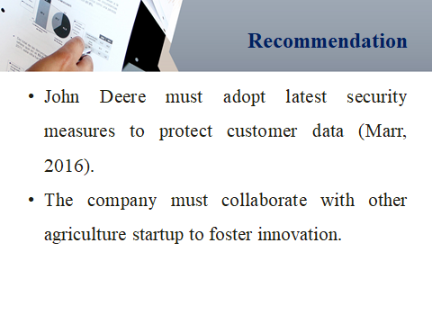
This slide mainly offers suitable recommendation for John Deere to improve product innovation. The company must adopt different security measures to manage customer information. This may help organization to maintain huge trust and commitment among customers. On the other side, John Deere must collaborate with agricultural startups to boost sales collections (Marr, 2016). The company must upgrade their storage infrastructure to improve value chain activities.
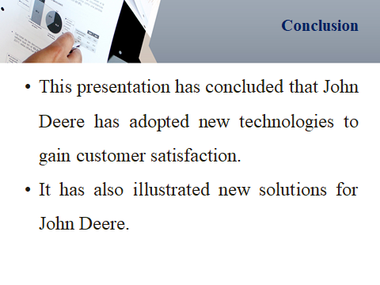
This presentation has illustrated that John Deere mainly relied upon new technologies such as Google Analytics, CRM and remote sensing technology to gain competitive advantage. The presentation offers suitable solutions to John Deere to improve business performance.


