A Personal Learning Environment
Thomas Ollason Ryan
UWTSD Business Management

A Personal Learning Environment

What is a PLE?
In his doctoral dissertation, Jarkko Suhonen of the University of Eastern Finland describes a Digital Learning Environment (DLE) as a technical solution for “supporting learning, teaching and studying activities” (Suhonen, 2005). It is clear that technology has advanced tremendously even so in the 13 short years since this writing, and so to have the means in which a learner intakes information. This change however is represented in the functionality and design of the DLE and does not change the definition of a DLE. A collection of DLE’s ranging from all digital resources used (such as computing hardware, software, operating systems and storage) begin to map out a Personal Learning Environment or PLE. These PLE’s can be essential in the management of an educational journey and how they facilitate scholarship. It is suggested that the prominence of these Learning Environments has more to do with the changing methods of education than technology but that the developments in these technologies have been an integral part of their progression (Dolence, 2014). In this writing I shall be demonstrating the significance of digital technologies on higher education learning and reflecting on my own use of digital technologies with an illustrated format of my own PLE.

Digital Technology and Learning
There is currently debate over the concept that we have entered a new epoch; “The Anthropocene”. This indicates that humans have had such a profound impression on the Earth’s Geology and eco-systems that they can trace our impact in the plastics embedded in the rocks and radioactivity in plant matter (Skibba, 2018). With such a change in our way of life to the extent it can be defined by a new period, does it make sense that our methods of schooling are much of the same as they were hundreds of years ago before the industrial revolution, 2 world wars, an arms race, a cold war and the freedom and instantaneous information the internet provides? All this change and we still go to school in the early morning, sit in a class room, face the front and get told what to learn, usually from a white man, supporting a white man’s history in the form of a national curriculum that requires specific boxes ticked to leave the school environment a success. All of this regardless of your immediate community or desired environment in the future. A century ago, schools had to innovate to develop in accordance to a population moving away from an agricultural way of life towards the age of industry. This transformation is now what is required as we enter this new epoch and continue our ascent into the age of information. In relation to the interconnectedness between business, information and culture and nations in our global marketplace “The idea of learning taking place in a self-contained classroom that is essentially separate from the highly connected world of which it is a part is likely to become outmoded to the point where it is no longer necessary” (Lesch, 2009. p. 122)
There is a growing consensus that this method of learning, defined by Sfard, (1998) as the Acquisition Metaphor, is outdated and is not a way of learning that reflects the needs of today’s learners. In a growing number of environments, there is a need for an educational method which includes the learner’s opinion and a concept of their sense of place as a community within a networked world, dubbed by Sfard (1998) as the participative metaphor. This is not to say that in many instances that the traditional teaching styles are ineffective, but as an educational system, this method seems to be failing on a large scale. For example, a recent article in The Guardian suggests that one in eight secondary schools in England are “failing” (Weale, 2018). Lesch (2009) suggests that a way of solving this would be a method which “fuses initiative and accountability outside the contemporary self-contained classroom”.

The obvious method in which this is being carried out today is through “digital learning” or “e-learning” and its successes have been in eroding geographic or time constraints, curbing excessive budgets and initiating exciting new opportunities in higher education (Wagner, Hassenein & Head, 2008). In a world where people are now learning differently and are under-stimulated by acquisition style teachings, online learning not only offers them a solution but offers opportunity in the sense of limited capacities in traditional educational environments, the costs of these establishments and the opportunity that the growth in this digital environment brings in terms of prospective employment. There are concerns regarding digital learning also. With this huge change on the consumers of this content, being the students, changes are equally expected from teachers, lecturers and instructors. Students are entering a new environment and must be ready to adapt and develop a new set of skills to enable the success in this online environment. A lot of the content, if not all, will be carried out independently, so students must be highly motivated (Huynh, Umesh & Valechich, 2003). Teo and Gay (2006) suggest that teachers must now manage the learning resources of its students as opposed to being the source of this information. Also, student and teacher alike must have a fair amount of digital competency, especially the teachers if they are the creators of the online resources (Romiszowski, 2004). Learning new skills is part of an educational development and the benefits of these changes far outweigh the potential hindrance of resisting it.

Just like the invention of the printing press by Gutenburg during the 1400’s completely transformed the way we learn and educate, the internet and the technologies that have developed alongside it have the innate possibility to enable any student to excel at something. The internet in its short existence has gone on to replicate what the standard methods of education have taken 100’s of years to realise. The development of “Web 1.0 and 2.0”, terms popularized by Tim O’Reilly, seem to reflect what Sfard’s (1998) metaphors to learning seem to suggest to us. The stasis of the early Web 1.0 sites where information is displayed using non-interactive formats as a means of transferal of information strongly represents the Acquisition metaphor. Web 2.0 seems to reflect the Participative metaphor, where content is user generated and peer reviewed and critiqued and becomes a process of using communities online to create and moderate content (O’Reilly, 2018)

The term Web 3.0 has appeared although not from O’Reilly, and seems to suggest the incorporation of the Semantic Web, a way in which tagging allows computers to read and structure information across countless databases, along with other technologies. This reflection in learning metaphor seems to be missing, the next step in learning should embody the changes that Web 3.0 delivers and help us understand the importance of an education mindful of its learners, it’s community and social responsibility, aware of the whole world, it’s problems and opportunity and utilizes technology to connect with this abundance of information and wealth of scholars. This metaphor could be called the “Collaboration Metaphor”.

My PLE
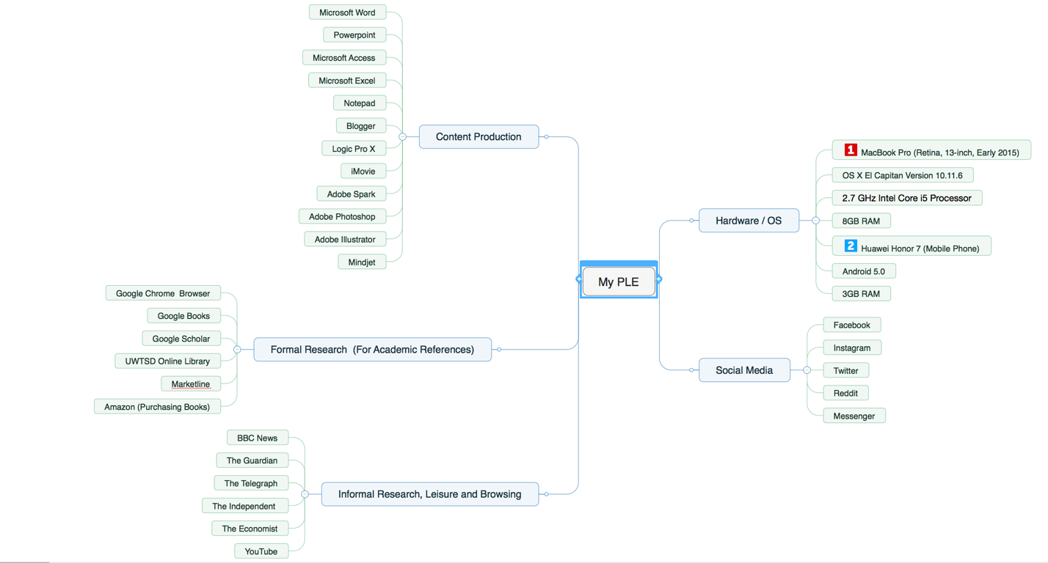

My Use of Technologies
The clear majority of my PLE exists within the two devices I currently use. One being a MacBook Pro, a very reliable computer that runs smoothly with OSx El Capitan. Its RAM is more than adequate meaning that I can run various software simultaneously and not sacrifice speed or performance. It can also process higher intensity applications such as editing suites and music production software due to the power of the 2.7GHz Intel Core Processor. The other device which I use is a Huawei Honor 7, a Chinese mobile phone and although on the cheaper side of the market, I have found it to be just as quick as the iPhone or Samsung models. This is an android device so compatibility between the devices would be increased if they were both running the same OS. I believe it is crucial that the devices you use are sufficient to power your scholarly ambitions, reliability and speed means little or no time troubleshooting, allowing you to focus and allocate all your time to your intended task.

A lot of my time when writing and creating content academically is spent on internet research, therefor a reliable browser is needed. In my experience Google Chrome offers the smoothest experience, the least compatibility issues, and a good library of external plugins such as pop up blockers and VPN services to streamline the learning experience. Just as important are the types of resources you intend to reference. I tend to use Google Books and Google Scholar for referencing, as they tend to be largely free to use, with a very large selection of academic, peer reviewed articles and books. The UWTSD online library is also a great source of scholarly material with useful features like checkboxes to only bring up peer reviewed material when using the search function. Media outlets such as newspaper companies can be useful for finding subject material and sourcing the references they have used for that subject matter, I use what are in my opinion the more credible news outlets; BBC, The Guardian, The Telegraph, The Independent and The Economist.
Social Medias can be very useful tool as they facilitate collaboration. The Messenger application, a Facebook product, has been useful for allowing all members of this course to discuss a range of issues. More leisurely intake of information is carried out on these social media platforms as I am very aware that the clear majority of the content on social media platforms is not edited or moderated for credibility. YouTube is a great resource for learning, and the credibility of the videos is often reflected in its views, its ratings or likes and comments and subscribers of the channels. It is often beneficial for some to intake information in an audio-visual format as students with dyslexia or reading difficulties can be given a chance to process information in a preferable manner.
The ways in which the information is formatted and presented in your own work is another digital tool used in my PLE. Microsoft Word is an easy to use word processing software that is the standard format for most educational institutions. We have been tasked with organising data in some modules so programs such as Access and Excel have been a great way to organise this data and present it.

My Digital Literacy
Digital literacy is now something the younger generations are being brought up on. The improvement of the technologies coincides with the understanding of the technologies. The devices in the pockets of today’s youth are more powerful than the heavy machines that dominated the desk of yesterdays study. The introduction of social medias has encouraged people to use these technologies daily and as these platforms update and incorporate new features, users are keen to learn how to use these. Thus, we are seeing a higher level of moderate digital competency in the younger generations. To fairly assess my digital literacy, it is important to mark out comparisons. I feel compared to an older generation of casual users of computers and digital technologies, my digital literacy is superior. I am confident in using the tools I have identified in my PLE and often go beyond the basic features. This being said, I am under no illusion that I am highly skilled in digital technologies. I have acquaintances who can create websites, programs and build and take apart computers using parts and in comparison, to them, I would be deemed digitally illiterate. I feel I am at a level where I can consume content and contribute with ease, however there is another level of competence which enables users to create and organise the mediums in which this data is analysed and displayed, a true understanding of the systems we use in a sense. I feel that my current level of digital literacy is competent in regards to the demands of this degree level course. I do not understand all functions of some tools such as Access and Excel but with instruction I pick it up quickly. To progress after this course, a higher level of understanding of digital technologies would be hugely beneficial. Careers in computer science are going to become more desirable and to one day study towards a masters degree in computer science would be a personal goal of mine.

In summary, it was Harold Wilson who once said “He who rejects change is the architect of decay. The only human institution which rejects progress is the cemetery.”. This man was prime minister. Twice. This man lead contributions towards gender and race equality, educational reform, social housing, keeping Britain out of the Vietnam war and ended capital punishment. He also created the Open University. His quote is a fitting symbol for our digital literacy and learning environments, it’s his idea of revolutionary change that contributed to one of, if not the most significant contribution to higher education in this country.

References

Dolence, M. (2014). Digital Learning Environments. (2014, September 08). Retrieved April 01, 2018, from https://mgdolence.com/services/academic-services/digital-learning-environments/

Huynh, M.Q., Umesh, U.N., Valachich, J. (2003). E-Learning as an Emerging Entrepreneurial Enterprise in Universities and Firms. Communications of the AIS, 12, 48-68.

O’Reilly, T., (2018) What is Web 2.0. Retrieved April 01, 2018, from http://www.oreilly.com/pub/a/web2/archive/what-is-web-20.html

Romiszowski, A. (2004). How’s the E-learning Baby? Factors Leading to Success or Failure of an Educational Technology Innovation. Educational Technology, 44(1), 5–27.

Sfard, a. (1998). On two metaphors for learning. Educational researcher, vol. 27. 2nd ed. [ebook] washington, dc: american educational research association, pp.4-13. Available at: http://www.jstor.org/stable/1176193 [accessed 10 March. 2018].

Skibba, R. (n.d.). Has humankind driven Earth into a new epoch? Retrieved April 01, 2018, from https://www.knowablemagazine.org/article/sustainability/2018/has-humankind-driven-earth-new-epoch

Suhonen, J. (2005). A formative development method for digital learning environments in sparse learning communities. Joensuu: University of Joensuu

Skibba, R. (n.d.). Has humankind driven Earth into a new epoch? Retrieved April 01, 2018, from https://www.knowablemagazine.org/article/sustainability/2018/has-humankind-driven-earth-new-epoch

Sfard, a. (1998). On two metaphors for learning. Educational researcher, vol. 27. 2nd ed. [ebook] washington, dc: american educational research association, pp.4-13. Available at: http://www.jstor.org/stable/1176193 [accessed 10 March. 2018].

Teo, C.B. and Gay, R.K.L. (2006). A Knowledge-Driven Model to Personalize e-Learning. ACM Journal of Educational Resources in Computing, 6(1), 1-15.

Wagner, N., Hassenein, K., & Head, M. (2008, July). Who is responsible for E-Learning Success in Higher Education? A Stakeholders' Analysis. Retrieved March 29, 2018, from http://www.jstor.org/stable/pdf/jeductechsoci.11.3.26.pdf?seq=1#page_scan_tab_contents

Weale, S. (2018, January 25). One in eight secondary schools in England are 'failing'. Retrieved April 01, 2018, from https://www.theguardian.com/education/2018/jan/25/one-in-eight-secondary-schools-in-england-are-failing-dfe-data-shows

