Application Development – Assignment 2
ACDA5004
Connor Ellement 1803452
Web Development

Contents
1) Introduction 2
2) Requirements 2
2.1) Description 2
2.2) Functional Requirements 2
3) Design and Implementation 3
3.1) Features 3
3.2) Screenshots 5
3.2.1) Home Page 5
3.2.2) Games Page 5
3.2.3) Create Page 7
3.2.4) Edit Page 8
3.2.5) Details Page 8
3.2.6) Reviews Page 9
3.2.7) User Page 10
3.2.8) Register Page 10
3.2.9) Log in Page 10
4) Evaluation 11
4.1) Testing 11
4.2) Conclusion 11

Introduction
For this project, the task was set to be able to design and implement a web application using ASP.NET MVC that incorporates an SQL Database that can store and manage data. The report should use MVC Controllers for the webapps controller and JavaScript for the webapps views. This project should be able to relate to a real-world business scenario.

Requirements
With any project, comes a set of requirements that must be made note of and used to plan how the project should go, and complete the implementation.

2.1) Description
For this project, a webapp related to a real-world scenario had to be created that uses an SQL Database to display, store and edit data. With this needed required scenario, a webapp under the name of “Games ‘n’ Go” was created. The purpose of Games ‘n’ Go is to be a reliable source of information and reviews for users to be able to view.

2.2) Functional Requirements
The webapp should contain a link to a database that contains a minimum of pf 3 tables, with sample test data included, along with the tables created by the .NET framework. The database should also be normalised to 3NF.
The webapp should be able to display the sample data from inside the database onto various pages on the webapps. This data also needs to be able to be manipulated and changed using the CRUD (Create, Read, Update and Delete) operations. Users of the website also need to be able to use a search bar to find specific results that they want to view from the database and that data should be displayed accurately to the users search request.
When using the forms from the webapps (Register, login, edit forms etc.) the fields should be validated to only allow specific data. This can range from simple validation like making certain fields required, to a bit more advanced validation like making a password having to be longer than a certain amount of characters, contain numbers and require a special character. Milecia from dev.to said this about form validation, “My point is that forms are everywhere. They come in different shapes and sizes and are responsible for all kinds of information. That's why it can be easy to overlook how much validation goes into creating a form.” [1].
The webapp also should be responsive so that is can be accessed of a higher range of devices such as tables and mobiles. This is becoming increasingly more important due to the vast rise of small screen devices replacing pc web browsing [2].

Design and Implementation

3.1) Features
Games ‘n’ Go has a list of various functions and features that the webapp offers. First of all, the Games ‘n’ Go offers a register and login system for users to create accounts on. Along with the register and login system, the webapp offers a member’s page for users to be able to edit their personal data on the website allowing them to change their details as needed. Having a member account is essential to the website as having one allows the user to be able to create a review to be displayed on the webapp.
On the games page, users of the webapp have the capability of using a search bar located at the top of the page that allows them to search for a game of their choice, and if that game is in the database, then it will display that game, along with other game that also may share the name, or be similar. As well as this, there is a paging feature on the website, where when the database of games gets over a specific amount, rather than displaying one long page showing every game on the database, it will split it up onto separate pages than can be swapped to and from again easily at the bottom of the page.
On the reviews page on the webapp, a piece of JavaScript was used. The reviews are displayed inside shapes to look like speech bubbles. These speech bubbles randomise and change colour from a list of specific colours every time the page is reloaded. This doesn’t add much functionality to the website, however it does add to the pleasant experience, as a writer at the IronPaper says “In a crowded market, having a website that simply serves as a brochure is no longer competitive” [3].
As one of the requirements for the website was to be able to alter and add new data to the database using the CRUD operations, there have been create, delete, edit and details buttons for each game displayed on the webapp on the games page. The ‘Edit’, ‘Details’ and ‘Delete’ options are always viewable on the website, although only the ‘Details’ button will work for a random user of the website. To use the ‘Edit’ and ‘Delete’ buttons, the user of the webapp must be an admin which is controlled in the back-end of the webapps code. Something similar occurs for the ‘Create New’ button also, as the button only displays when an admin is logged in and does not show up if a random guest of logged in customer views the game page. When using the ‘Edit’ or ‘Create’ features of the website, the appropriate form shows up allowing the admin user to add games to the database or edit existing ones. The forms also make use of a image file upload where the admin is able to upload a cover image for the appropriate game from anywhere on their personal computer and that specific image will have it’s name saved inside the database and the actual image file will get copied and moved to the image path for the Games ‘n’ Go webapp.
Upon clicking on a game that is being displayed on the games page of the webapp, the user will be shown a page with extra details that go more in-depth on the game. This more in-depth page also includes a modal trailer button where a user can click it, and a new window will appear on the screen that will show the user the trailer for that specific game from YouTube. Once open, the user can play use the functions of YouTube to play, pause, fast forward, or rewind/replay the video.
The page with the least functionality is the home page. This is because the home page does not require much (if any) back-end development to it. However, so the home page isn’t bland and boring when loaded, the users will be greeted with a animated image carousel that automatically slides through images and wallpapers from the newer games that the webapp has in its database. As well as being automatic, the user can also control the carousel using arrows on the sides of the images, or an image selector at the bottom of the images.

3.2) Screenshots

3.2.1) Home Page
Figure 1


3.2.2) Games Page
Figure 2
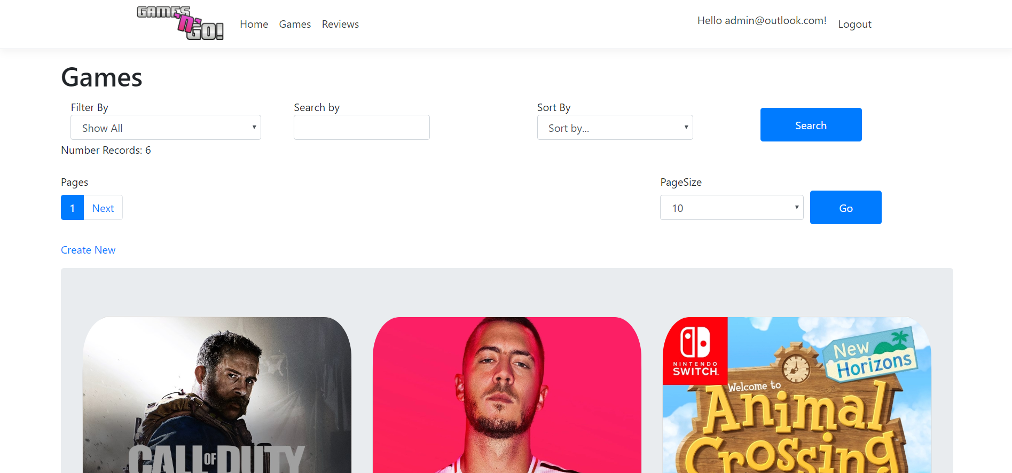
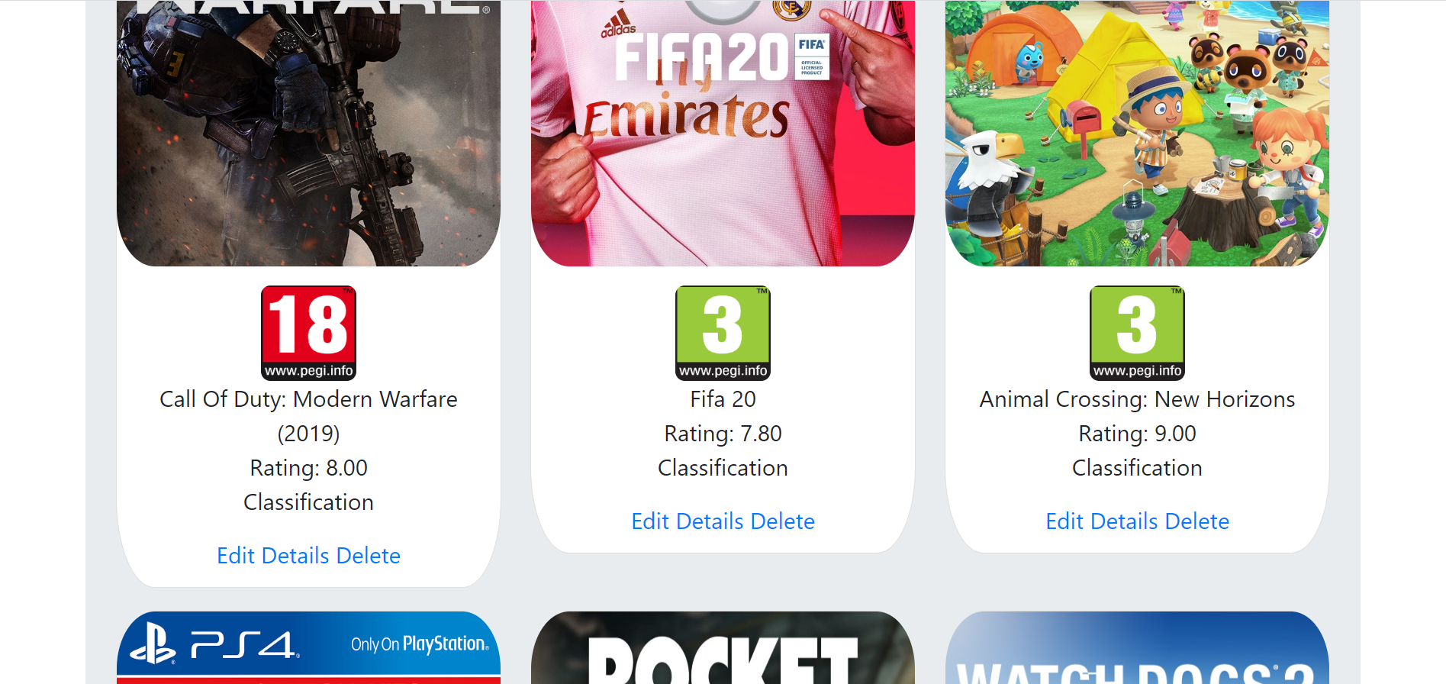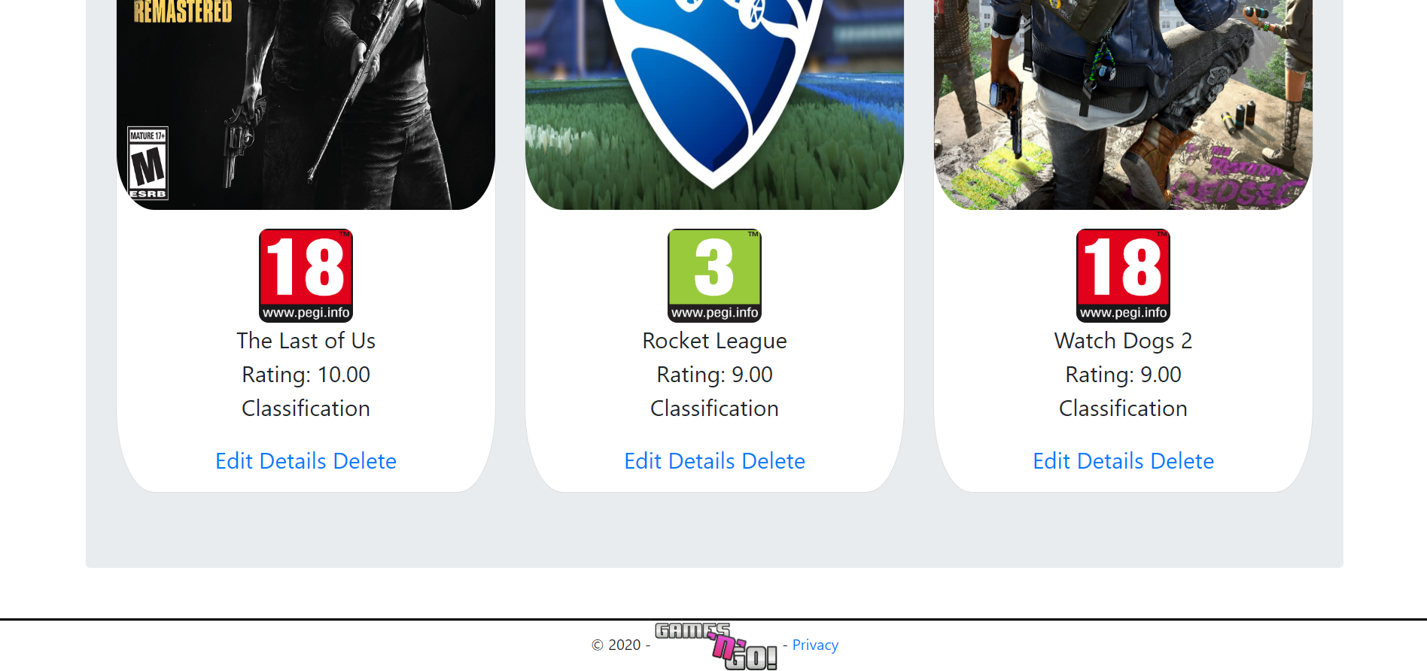

3.2.3) Create Page
Figure 3
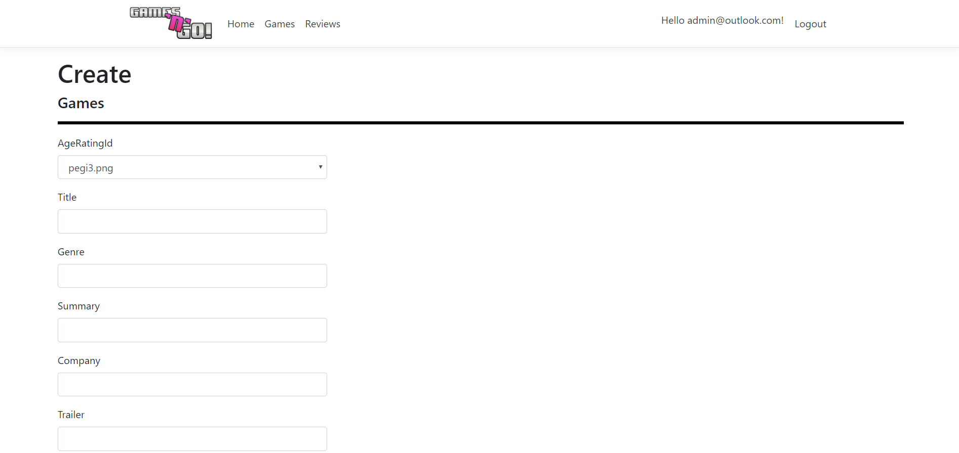
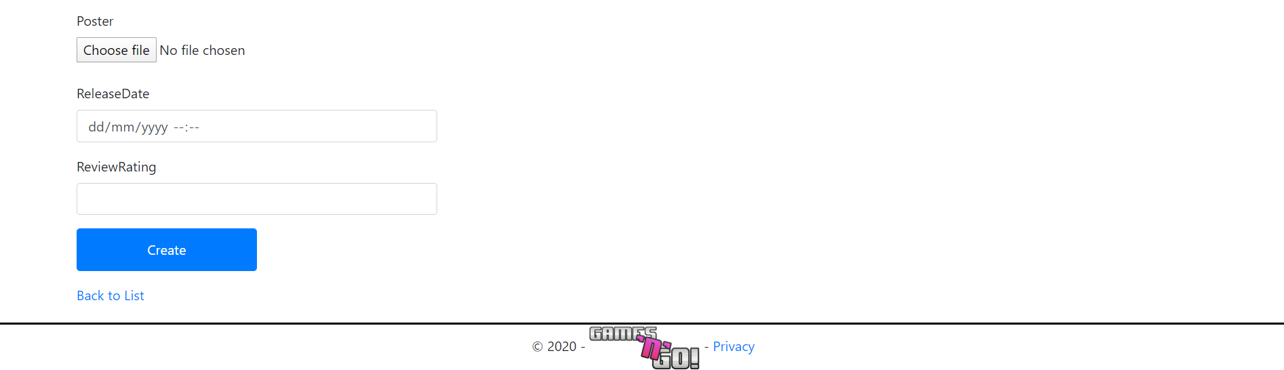

3.2.4) Edit Page
Figure 4
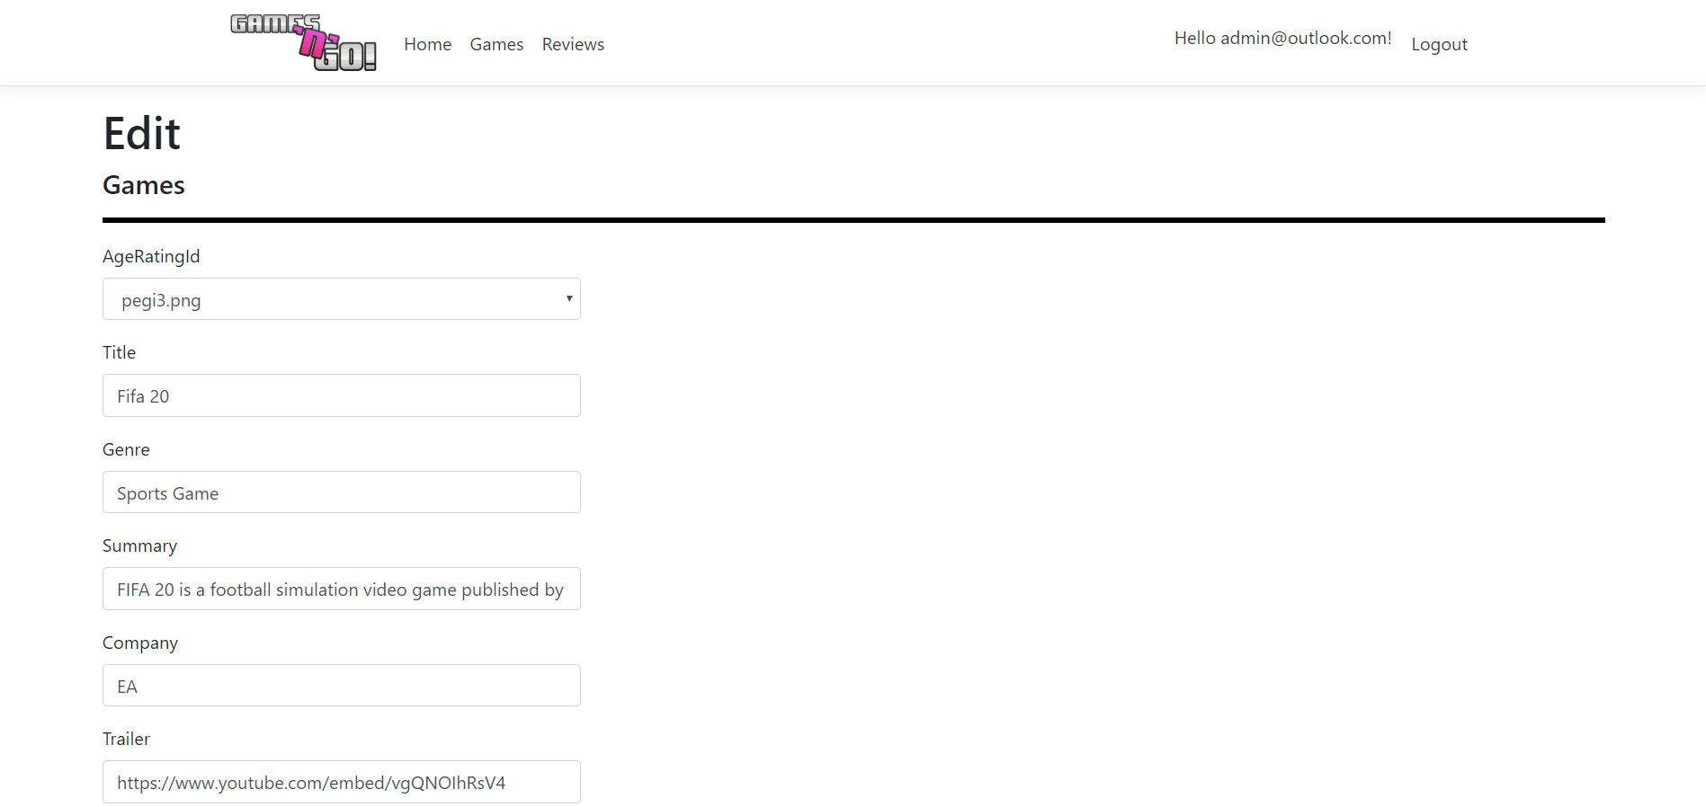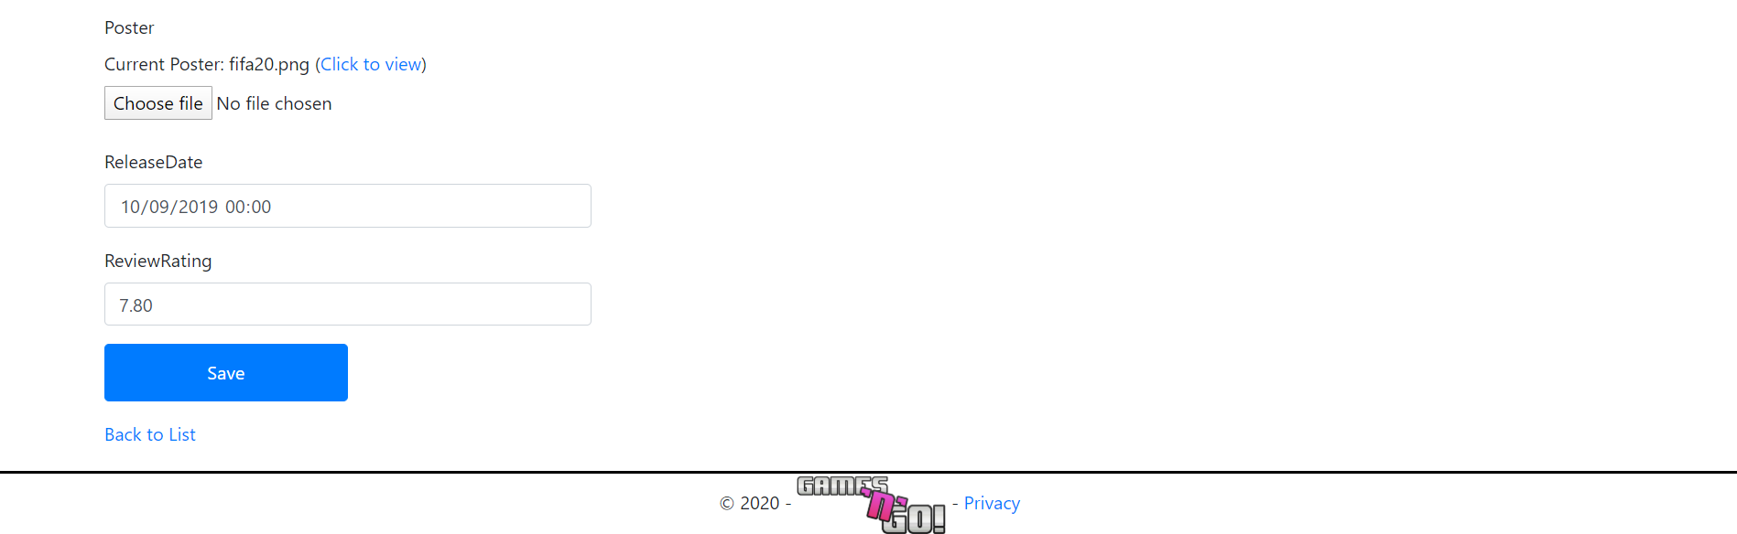

3.2.5) Details Page
Figure 5
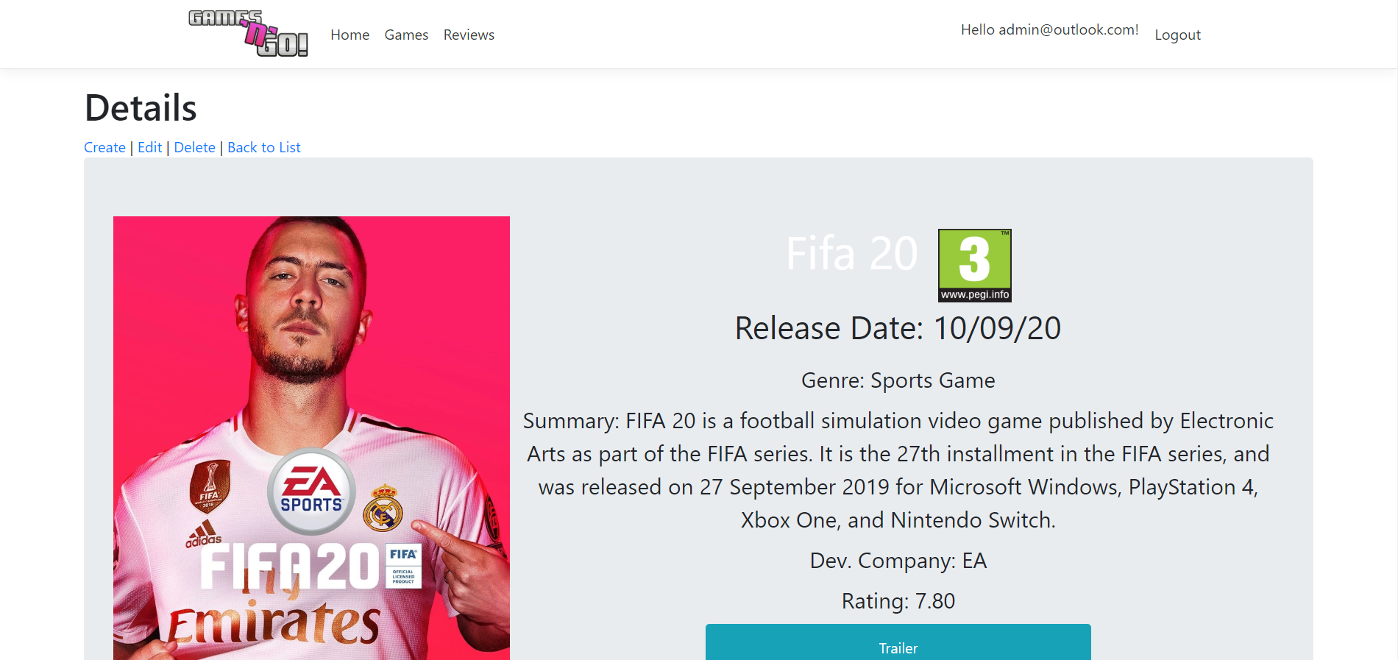
Figure 6
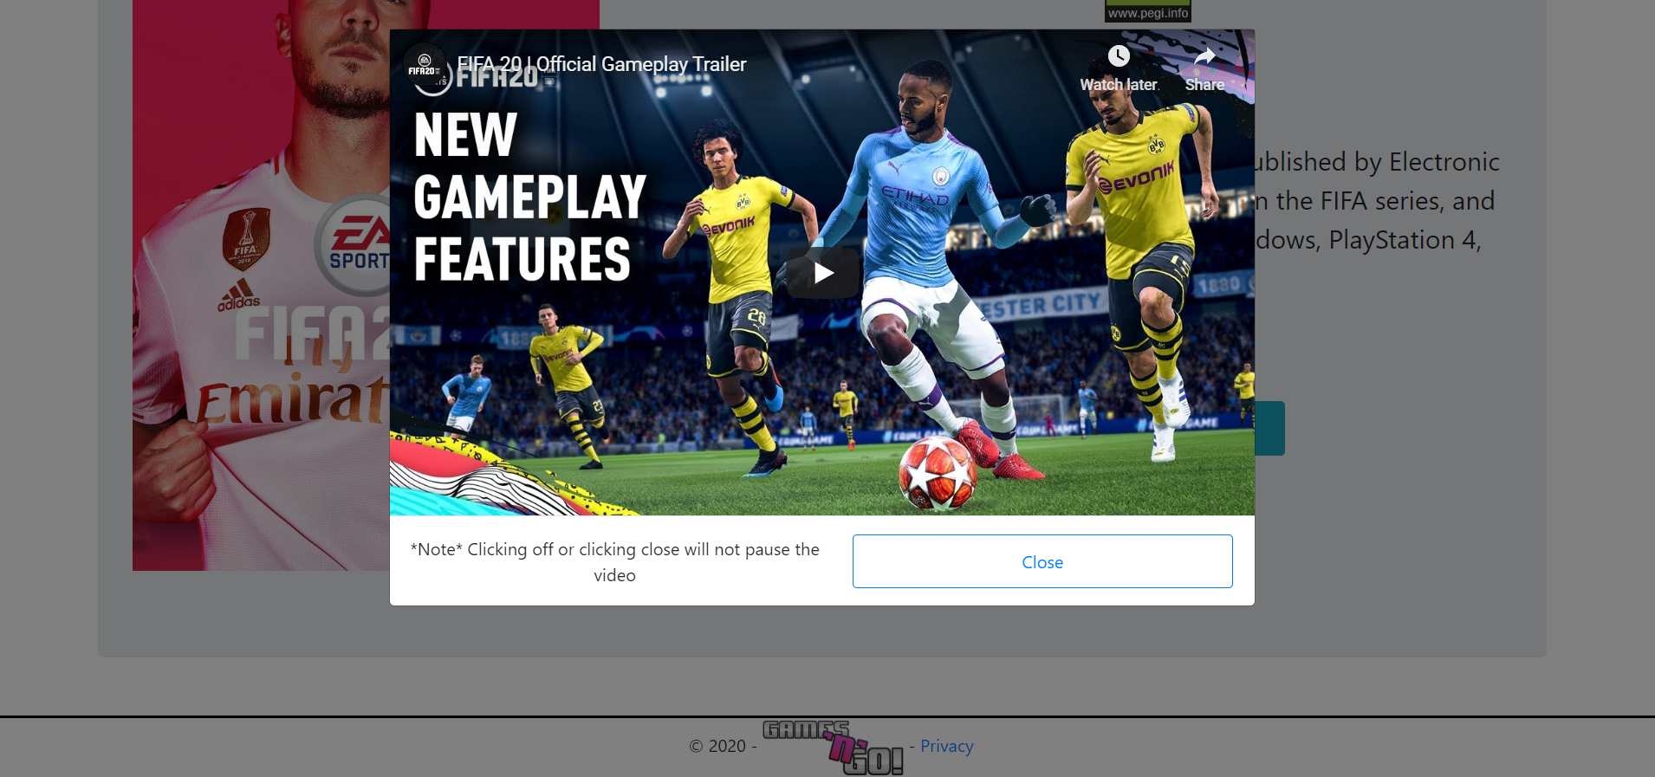

3.2.6) Reviews Page
*Multiple images of the same screenshot showing the randomising of colours*
Figure 7
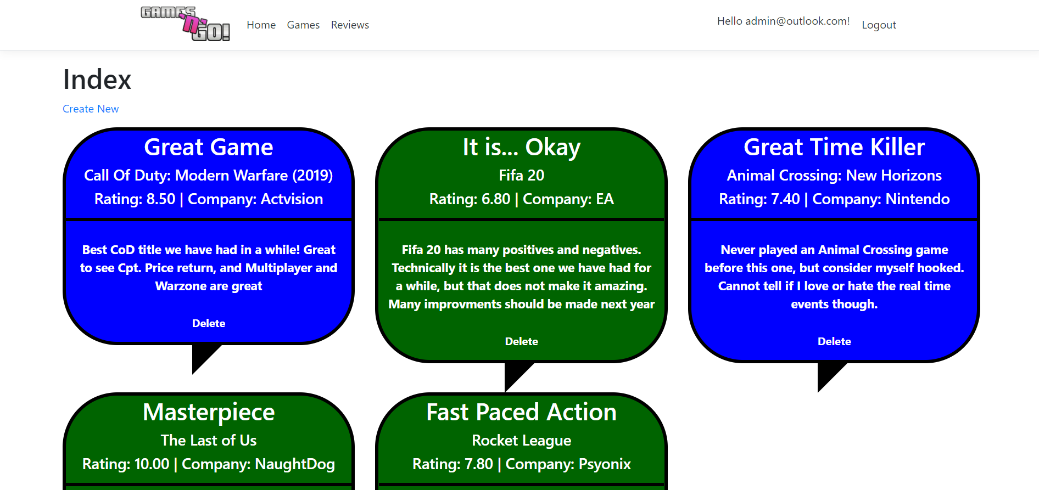
Figure 8
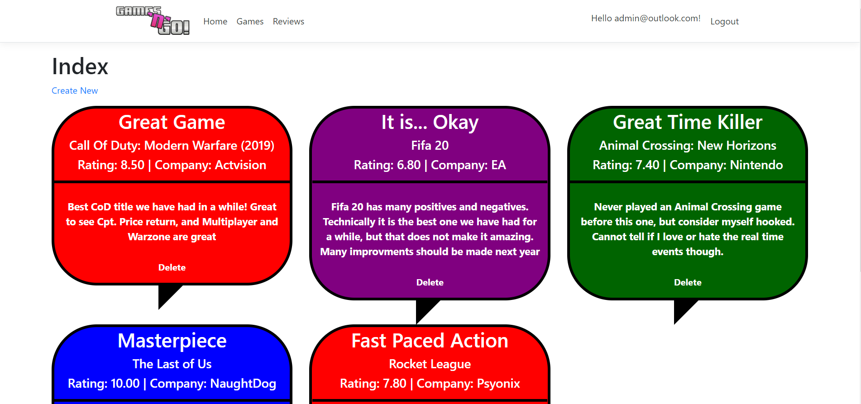

3.2.7) User Page
Figure 9
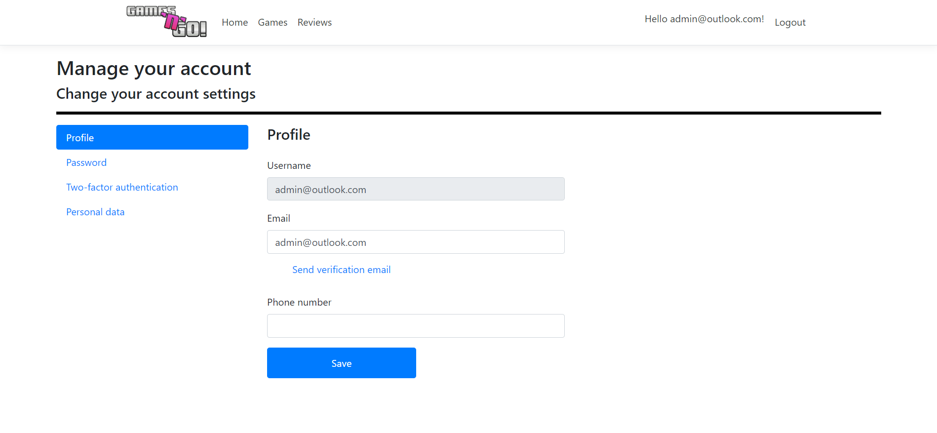

3.2.8) Register Page
Figure 10

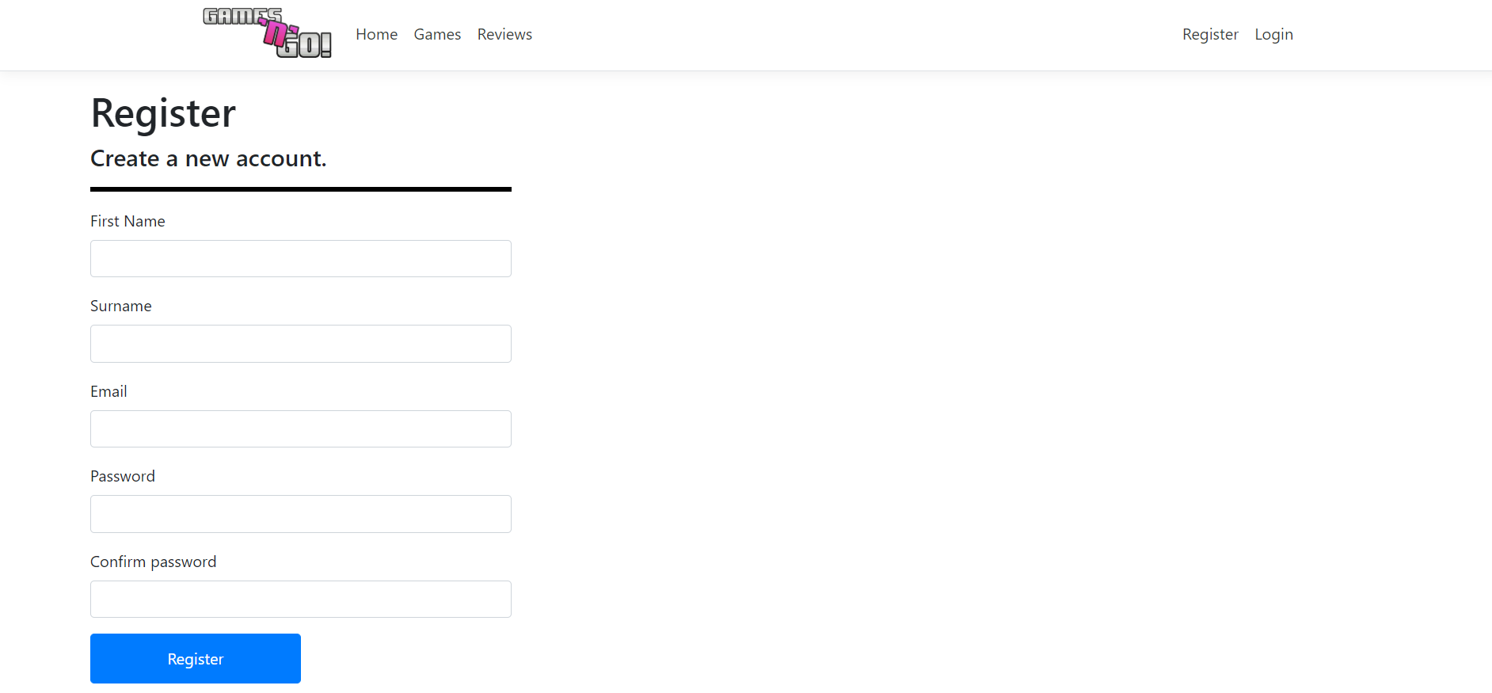

3.2.9) Log in Page
Figure 11
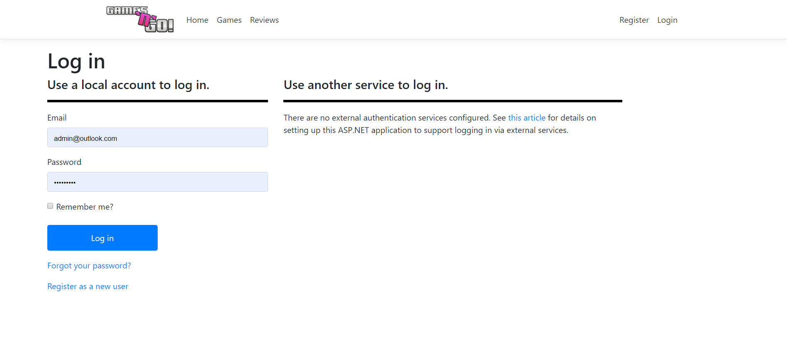

Evaluation

4.1) Testing
Test # | Description | Expected Result | Actual Result | Passed? | Figure
1 | Testing that the webapp loads | The webapp should load successfully | The webapp loaded successfully | Yes | 12
2 | Making sure the games from the database display | The games should display in a card format | The games displayed properly | Yes | 13
3 | Searching for a specific game using the filter/sort/search | The correct game to the user search should display | The correct game displayed | Yes | 14, 15
4 | Making sure there is form validation | Upon entering no register data and a too short password, errors should show | Errors showed properly | Yes | 16
5 | Adding a new game to the database | The game should get added to the database and then display on the games page | Game was added, and displayed | Yes | 17, 18
6 | Updating a games title | Making sure the game can be edited, and the display updates | Database was updated and display changed | Yes | 19, 20, 21
7 | Deleting a game | Chosen game should be deleted | Game was deleted | Yes | 22, 23
8 | Speech bubbles change colour | Speech bubbles on the reviews page should change colour on reload | Colours changed | Yes | 24, 25
9 | A non-logged in user cannot create a review | The ‘Create’ button should not show for a non-logged in user | Button did not show | Yes | 26
10 | Checking who can update the games table | Only an admin should be able to update the games table | Unauthorized user cannot update the games table | Yes | 27, 28, 29, 30

4.2) Conclusion
The task was set out at the beginning of this project to be able to design and create a functioning webapp related to a real-life scenario. This task has successfully been completed, and the webapp is fully functional as it is, and works as intended. In terms of usability, the webapp is easy to use for the users whether they be an admin, customer or a random visitor to the webapp. The webapp has a nice simplistic look to it, and makes use of cards to display the games, and speech bubbles to show reviews as they both have connotations to speech. The webapp is also responsive so a various range of devices can access it. In future however, a less simplistic approach would be taken to make sure the webapp stands out and is memorable for users. Also, a better understanding of ASPNET would be had via more researching into the topic, to have a better knowledge on the ASPNET functions and features.

Bibliography

[1] | M. McG, “Why Form Validation Is Important,” Dev.to, 26 08 2019. [Online]. Available: https://dev.to/flippedcoding/why-form-validation-is-important-37mj. [Accessed 2020 05 01].
[2] | U. R. Satyal, “A Website Design with the Mobile-first,” Helsinki Metropolia University of Applied Sciences, Helsinki, 2016.
[3] | Anonymous, “Web Design Statistics for 2017,” IronPaper, 2017.

Appendix
Screenshots from testing
Figure 12
Figure 13
Figure 14
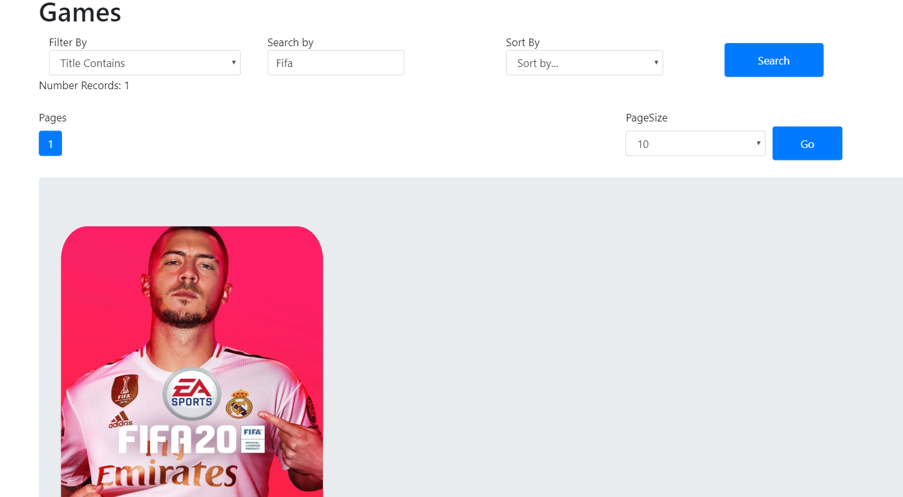
Figure 15
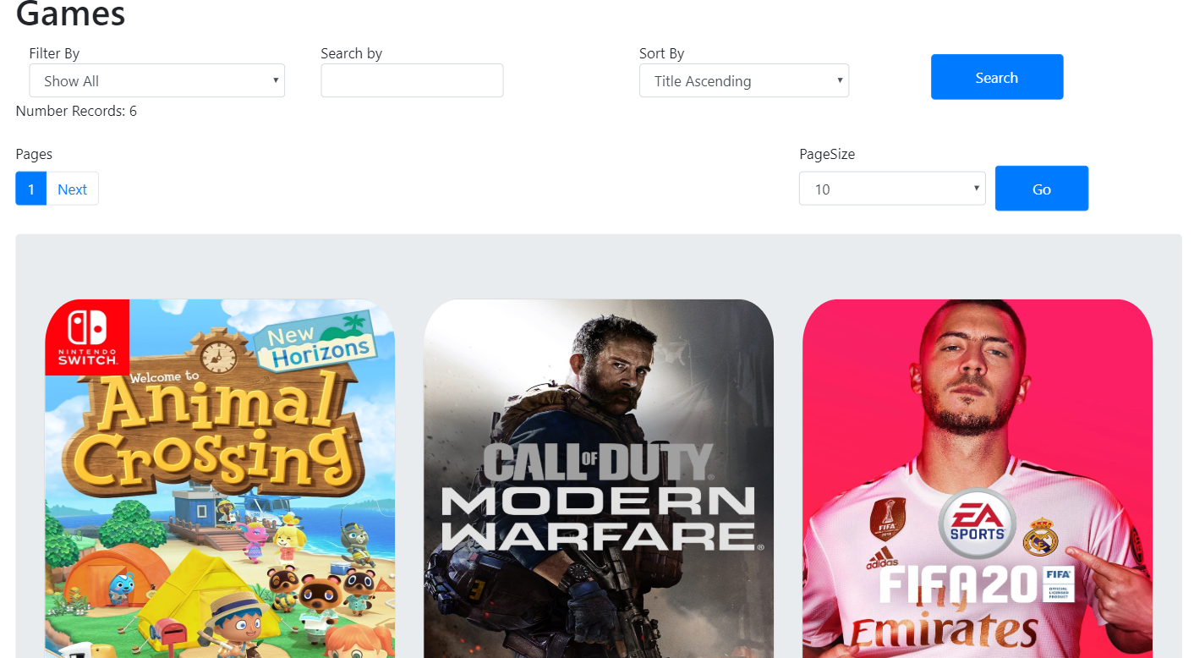
Figure 16
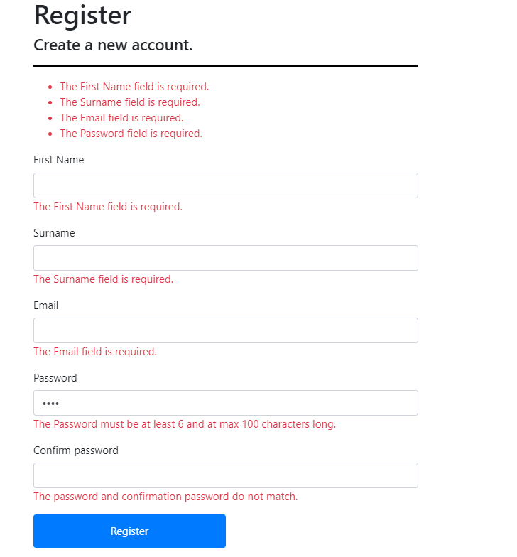
Figure 17
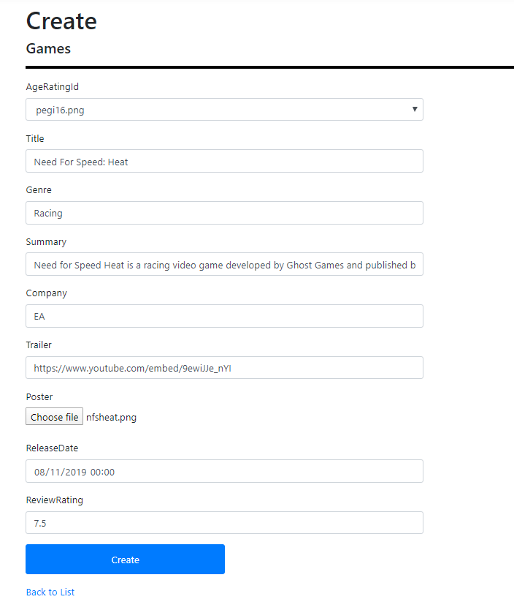
Figure 18

Figure 19 - After

Figure 20
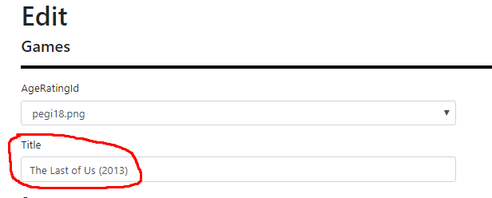
Figure 21 - After

Figure 22
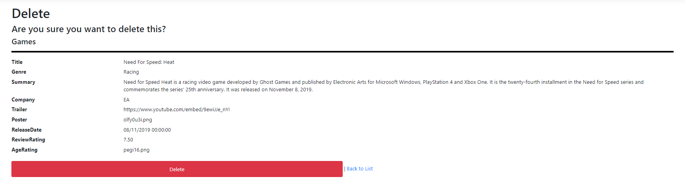

Figure 23
No longer there
Figure 24
Figure 25
Figure 26
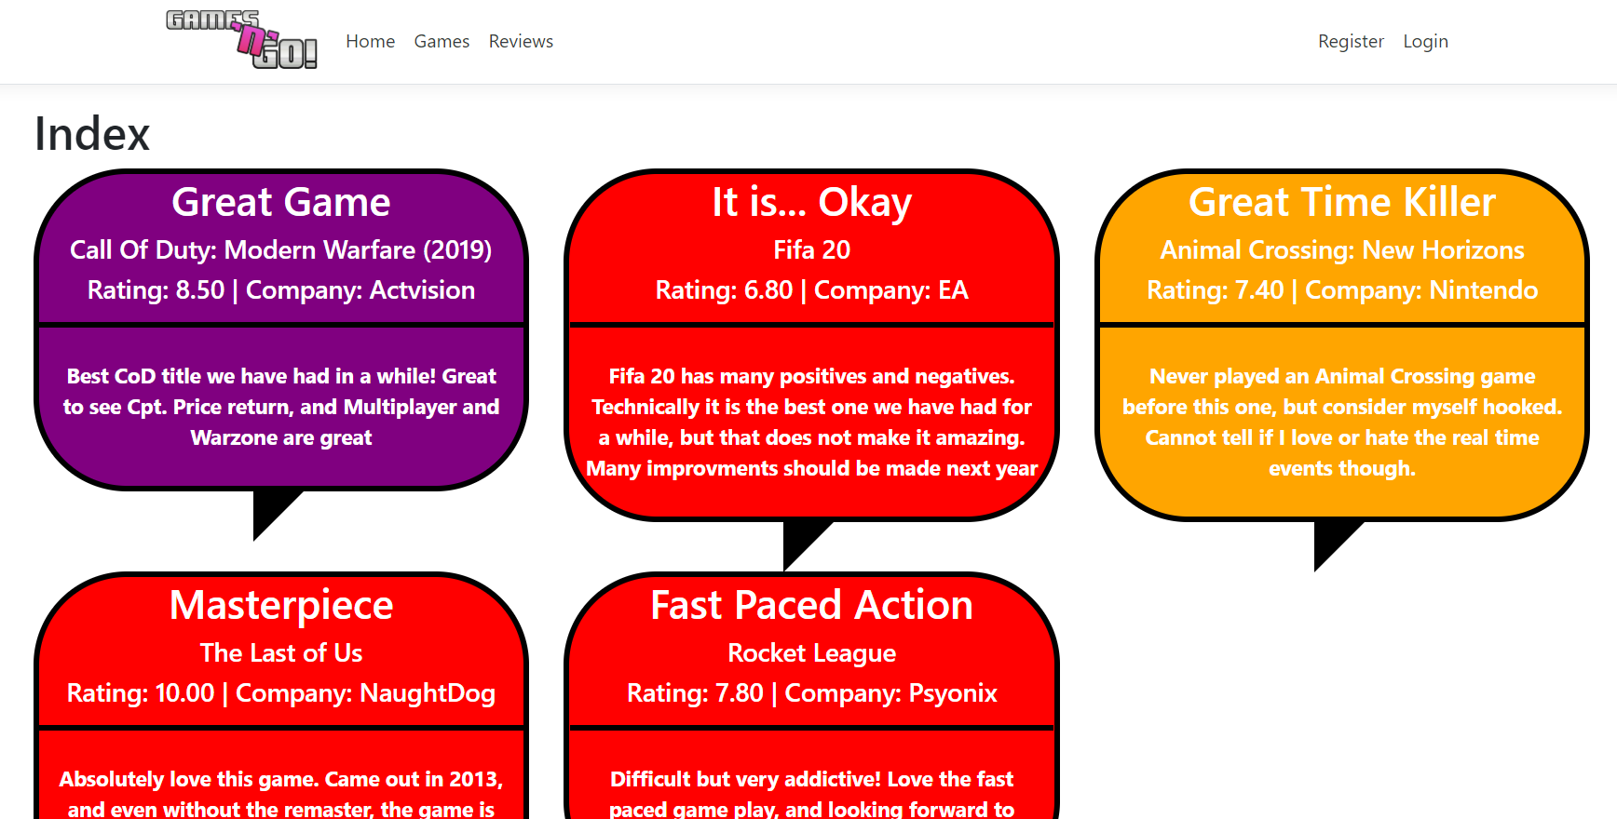
No create button
Figure 27
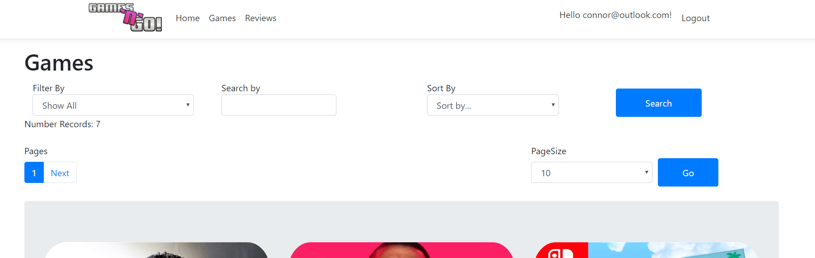
No create button
Figure 28- Clicked edit

Figure 29
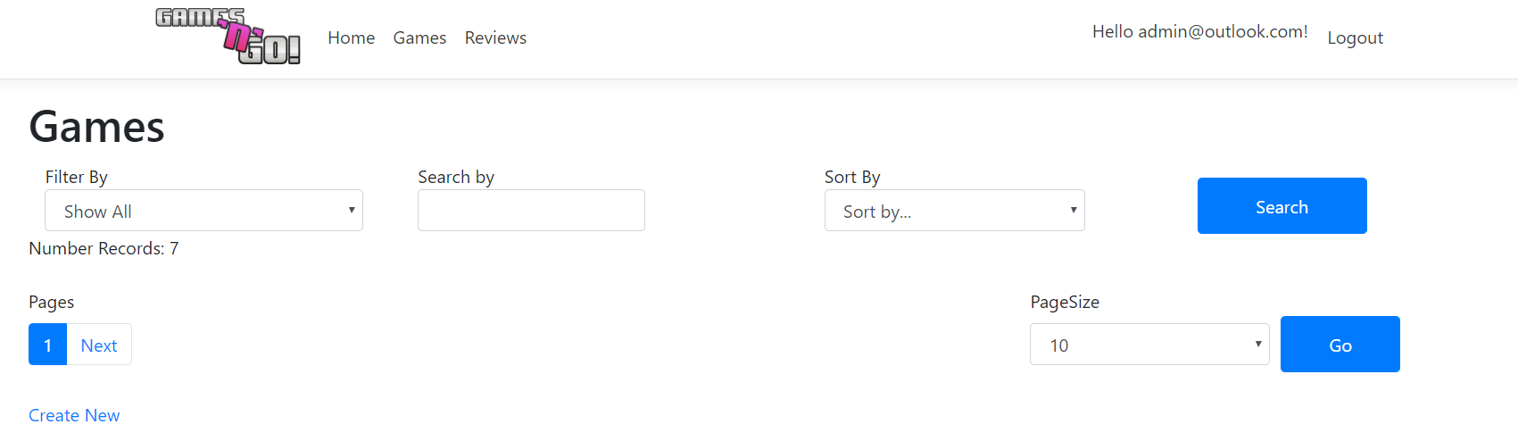
Figure 30 - Clicked edit


