BA (Hons) International Hotel Management
BMIH6005
Organisational Consultancy

Consultancy Report for Hilton London Metropole

Company name: NovaEdge Hospitality Solutions
Prepared by : Silvia Daniela Grecu
Student ID: 2245642
Contents
1. Executive Summary 3
2. Introduction 6
2.1 Background of the Hotel 6
2.2 Consultancy Company 6
2.3 The Identified Problem 6
2.4 Frameworks and Tools to Be Used 7
3. Problem Analysis 9
3.1 Overview of the Identified Issue 9
3.2 Impact on Guest Experience and Operations 10
3.3 External Factors – STEEPLED Analysis 12
3.4 Internal Capabilities – SWOT Analysis 13
3.5 Strategic Planning – TOWS Matrix 15
4. Recommendations and Change Management 16
4.1 Overview of Recommended Solutions 16
4.2 Strategic Recommendations 17
4.3 Change Management Approach (Kotter’s 8-Step Model) 21
4.4 Potential Benefits of Implementation 23
4.5 Cost Estimations 23
4.6 Success Measurement and KPIs 24
5. Action Plan 25
6. Conclusion 27
References 29

1. Executive Summary
This consulting report has been presented to Hilton London Metropole to assist in solving a critical staffing problem created after the completion of an extensive refurbishment of the hotel. The hotel has recently invested in improvements to its physical plant, but it has had challenges maintaining stable, well-qualified staff in a number of operational departments. The consequence: service delays, unhappy guests, and stressed-out staff. These obstacles threaten the hotel’s reputation and business objectives in times of peak operational load.
Tasked by Hilton London Metropole with getting to the bottom of the staffing issues and a proposed solution, NovaEdge Hospitality Solutions was appointed. A structured approach involving problem analysis, framework-based diagnosis, solution design, and implementation planning was adopted during the consulting process. The aim was to provide cost-effective, high-impact measures which could be deployed rapidly without causing a serious break in current operations.
The staffing shortage was found to have both external and internal factors. Outside factors are major shifts in the labour market with Brexit, increased cost of living for Londoners, and lifestyle developments following the pandemic. All of this has shrunk the pool of workers interested in working in hospitality, particularly in large markets. Entry-level jobs in hospitality also compete for talent against remote and hybrid positions in other sectors. It's now more difficult for places like Hilton London Metropole to recruit new employees traditionally.
The hotel itself has not adjusted to the shifts internally here. The current onboarding system is immature, and there is little formal new-hire support. There are departments where informal peer training is used, and as a result, levels of knowledge vary, and corridor cop work skill gaps exist. There is also no minor acknowledgement or small incentives for team members who do well. It is these missing pieces that lead to staff frustration, lack of motivation, and high turnover as a result. This puts more pressure on the remaining workers and creates a circle of stress, sickness, and resignation.
To delve further into the issue, the paper employed three professional tools. The STEEPLED tool was used to examine broader macro factors such as sociocultural trends, economic insecurity, and political shifts. The SWOT analysis gave an impression of the hotel’s internal strengths and weaknesses in addition to external opportunities and threats. Based on the results, the TOWS matrix was employed to combine and produce strategic suggestions. This integrative analysis contributed to the discovery of feasible actions while corresponding to the hotel's present demands.
The report offers five recommendations in light of this analysis. These are to (1) widen the recruitment pipeline through partnerships with local colleges and digital channels; (2) standardise an onboarding and peer mentoring process; (3) provide a scheme that rewards things like small monthly rewards or public praise; (4) slowly roll out a rota management system to make sure working hours are distributed fairly and that regular overtime is less common, (5) and conduct weekly team meetings to maintain an open dialogue and attentively listen to staff commentary. Particular solutions are selected not only in terms of their practicality, but also in terms of their immediate application to identified service challenges in the hotel.
The execution plan phases in the rollout of those operations over three months. Month 1: Recruitment and onboarding materials are finalised and launched. Training support will be brought in during the second month, while the reward system will be piloted and mentoring pairings set for new staff. In Month 3, the rostering tool will be launched, and team meetings will commence. Key milestones have been assigned to a responsible department, with a specified date and an estimate of the cost—the aim is not disruption, but a slow and measurable march forward.
For the people side of change, a proven model, Kotter’s 8-Step Change Model, is utilised. This makes the process technical yet cultural. The early moves are establishing a sense of urgency and the formation of a leadership team to lead the transformation. Vision communication, removing barriers, and short-term wins are not presented, albeit slowly. The plan concludes with embedding new habits into the hotel’s work culture. This model is particularly relevant in a sector such as hospitality, where team buy-in and behaviour change are key to long-term success.
It is an economically cheap strategy. The overall budget is approximately 7,000 pounds for three months. The vast majority of the spend goes towards recruitment advertising, induction tools, staff recognition, and the Rota software, which I imagine has many other benefits. The project costs are kept low by leveraging existing HR staff, team leaders, and internal office space for meetings. That makes it possible even during a time of rebuilding revenues after the pandemic.
To define success, we will use a small set of performance indicators (KPIs). Among them are employee turnover, time-to-hire, guest review scores, and staff briefing feedback. These KPIs are grounded and simple enough to monitor with tools already at the disposal of management. They will be monitored monthly and will serve as a benchmark to make rapid course adjustments should results lag behind expectations.
The plan will provide significant operational advantages if it is put into place as envisaged. The hotel will be part of a stronger and more stable team. This will mean faster and more personal service for guests. Hilton Metropolitan have an employee who is focused on supporting employees and ensuring that they feel well-trained and motivated to stick around. These enhancements, over time, are ultimately going to result in a more productive staff, fewer crashes out of service and better online reviews. The result is not a short-term quick fix, but a framework for sustained performance.
This is not an academic report. It's a consultancy-driven solution to a real business problem. The concepts are based on experience in housing, professional techniques, and practical treatment. Hilton London Metropole doesn’t have to spend millions or bring in overly complicated systems to transform its workforce. Instead, with manageable but purposeful steps, the hotel can greatly improve how it serves and, subsequently, how it keeps its talent.
In summary, Hilton London Metropole (HLM) is currently facing a critical situation that impacts its brand, guests, and staff. The plan proposed in this report provides a clear, cost-effective, and well-tested path forward. With strong leadership, proactive steps, and united commitment, the hotel can overcome its current problems and have a strong future that benefits the people and the company.

2. Introduction

2.1 Background of the Hotel
Hilton London Metropole is one of the largest hotels in central London. It is one of the brands within Hilton Portfolio (CIPD, 2025). Situated close to Paddington and Edgware Road, the hotel is within easy reach of all travellers, whether business or leisure. It contains more than 1,000 guest rooms and has large conference and banquet facilities—the organisation is therefore a significant player in London’s hospitality and events industry (MindTools, 2025). In recent years, the hotel has undergone a huge reno to update its rooms, event spaces and design. The idea was to improve and expand the experience and to grow business visitation (Prospects, 2025).
Although the renovation has enhanced the feel of the hotel, new challenges have come with it (Laig and Abocejo, 2021). These issues concern the operation and service quality of the hotel. One of the key issues raised is the staffing levels in core departments. This problem has escalated and begun to affect other aspects of the hotel’s operations. According to online reviews and guest feedback, this scarcity has already affected service times, response times, and cleanliness (Haas et al., 2019). This article addresses this problem and provides some best practices.

2.2 Consultancy Company
This report is brought to by NovaEdge Hospitality Solutions, a professional consulting company. The company focuses on hotel operations, HR and services management. It is primarily focused on assisting hotels in addressing real issues with intelligent, cost-effective solutions (Trawick and Carraher, 2023). A hotel in-the-know, NovaEdge’s team has also worked with hotels in the UK, solving staffing, quality of service and guest satisfaction problems (ManagementHelp, 2025). It is the belief of the company that by utilising data, clear analysis and industry tools, it can help hotels achieve long-term results. Hilton London Metropole asked NovaEdge to analyse its labour deficit and come up with recommendations to enhance its services and efficiency.

2.3 The Identified Problem
Hilton London Metropole became more populous after the renovation (Baron and Armstrong, 2007). However, the hotel was not sufficiently staffed to handle that level of demand. The shortage of personnel has resulted in late room service, slower check-in and check-out, and a drop in guest satisfaction levels (Benzaghta et al., 2021). The housekeeping, front desk and food and beverage departments are hardest hit (Georgiadou et al., 2019). It seems that a lot of guests have picked up on these issues, according to online mentions and public feedback. A few have told of their bad times elsewhere on sites like TripAdvisor and Google Reviews.
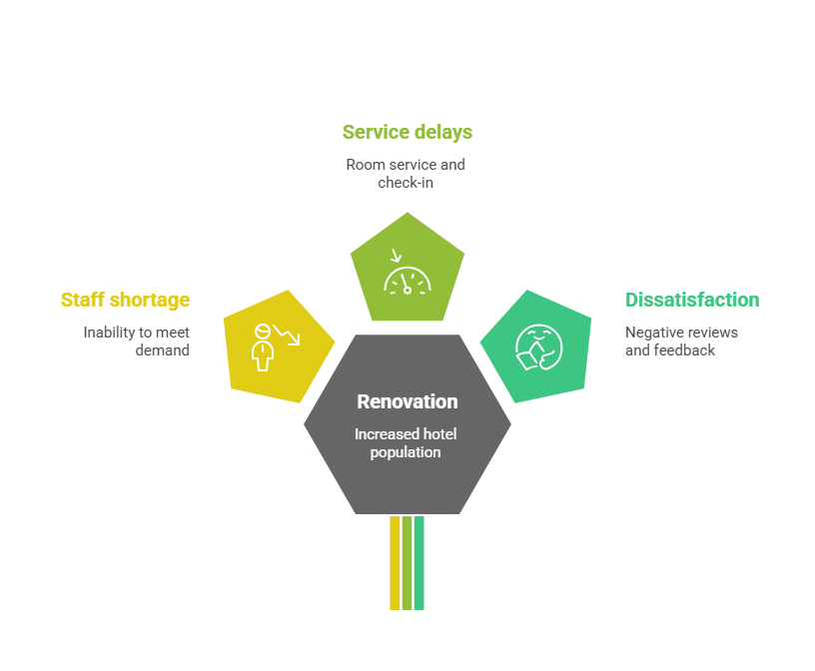
Figure 1: Major Problem of the Hilton Hotel (Source: ManagementHelp, 2025)
The hospitality industry has grown accustomed to being short-staffed (Brierley, 2006). This is due to a number of factors, such as coronavirus, Brexit, and greater operational costs (Phadermrod et al., 2019). And Hilton London Metropole isn’t the only one dealing with this problem. It has to do so quickly, but must do something to halt the problem, to protect its brand, and ensure quality of service (Burnes, 2014). The firm need a solution that addresses short-term staffing deficiencies and also sets the hotel up for success in the long run. This report will also provide detailed recommendations on the issue.

2.4 Frameworks and Tools to Be Used
Various industry tools and frameworks will be used in this report to facilitate analysis. Helpful in analysing such external factors as they impact staffing is a STEEPLED analysis (Puyt et al., 2022). These are social, legal, economic, and demographic. A SWOT analysis will reveal the hotel’s strengths and weaknesses, as well as the threats and opportunities present in the market (Buttrick, 2009). Then, the TOWS matrix will translate what is learned into strategies for both professional and personal development. Kotter's 8-Step Change Model will be employed to direct the change process (Vlados, 2019). This framework provides a systematic way to organise change and can assist the hotel in smoothly executing its strategies (Fisman and Sullivan, 2014).
These resources will help to provide rigour and evidence for all findings and recommendations. They will also assist in keeping the report organised and professional.

3. Problem Analysis

3.1 Overview of the Identified Issue
The Hilton London Metropole site has experienced considerable operational strain since a recent refurbishment (Johnson, 2005). Although the refurbishment changed the physical environment of the hotel, it failed to tackle more service-related issues. One of the more visible issues is the lack of employees in critical departments (Quezada et al., 2019). This scarcity has affected day-to-day functions and driven down guest satisfaction. It's that much more on our radar as our guest count grows (Caterer.com, 2024).
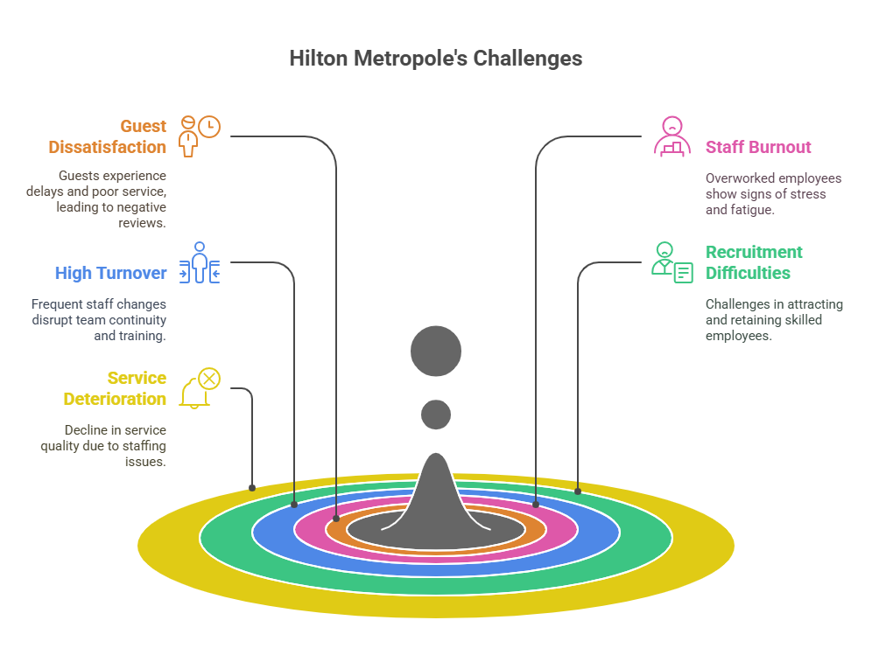
Figure 2: Hilton Metropolitan major challenges (Source: Statista, 2024)
The staffing issue is hitting vital parts of the businesses, such as the front office, housekeeping, and food and beverage. Waiting for the reception and checkout has now become a regular procedure (Suárez-Albanchez et al., 2021). There have also been reports of late room servicing and slow delivery of in-room services to some guests. These are the same concerns that have been echoed in online reviews across sites like TripAdvisor and Google. Many guests note that the staff appear overburdened and that they show signs of burnout or stress. These complaints have been repetitive over the past couple of months, indicating that there is a continuing and open issue (O'Mahoney et al., 2024).
It seems there were a few contributing factors to the shortage. The hospitality job market was turned on its head by the COVID-19 pandemic (Statista, 2024). During lockdowns, many workers left the industry and never came back. At the same time, Brexit has cut the number of foreign workers in London’s hotel sector. All these conditions have made it a challenge to keep and track skilled employees for the hotel (Halton, 2019). Recruitment has also become more difficult because of competition from other hotels and businesses.
The hotel’s location in central London adds extra nuance. Life is expensive here, but starting hotel wages are not. So, some potential workers opt to take jobs elsewhere in different industries or regions. Then there is the issue of high staff turnover and its impact on staff training and continuity in the team (Raiden and King, 2021). New staff members typically require extra assistance, which can place more work on veteran employees (The Guardian, 2024).
This cycle of stress and loss of performance only perpetuates this situation. And when staff members leave, the burden gets transferred to those who stay. At the same time, the pressure is mounting, service is deteriorating, and more and more staff are thinking of leaving (Kipping and Clark, 2012). In the long run, this is destructive to team morale and negative for the hotel’s public image. If unremedied, the hotel may, in the face of its contemporary facilities, fall subject to guest expectations.
It's not just a staffing issue. It affects service, guest satisfaction, and the hotel's value proposition. Knowing the full extent of the problem is the first step to effective solutions.

3.2 Impact on Guest Experience and Operations
Understaffing at Hilton London Metropole is definitely making a difference for the worse to the guest experience. The staff has not been able to keep up with the demands of the hotel, which has a higher guest count after the renovation (Yadav et al., 2020). They added that this has meant lower service, long lines, and excruciating waits for basic guest services. Consequently, many guests have left feeling rather undersatisfied, despite the chain's dependable amenities.
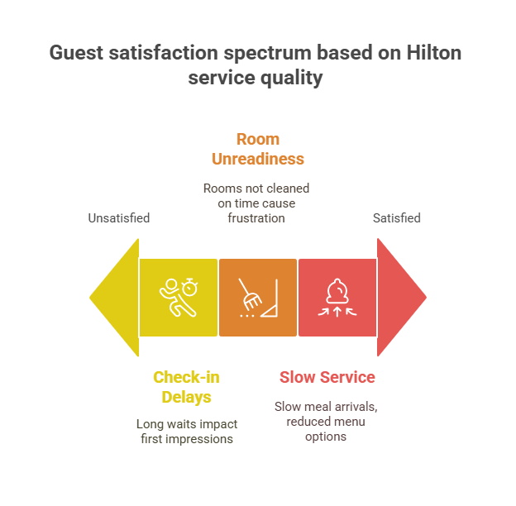
Figure 3: Guest Satisfaction based on Hilton service quality (Source: Own Design)
One of the hardest hit is the front desk. It’s common for guests to wait long hours at certain peak check-in and check-out times (Kotter, 2012). Some said they sat on hold for more than 30 minutes to talk to a receptionist. This delay will leave a bad first impression, and often, all the guests see is whether it’ll be a good stay or not. Even with the best efforts of staff, workforce shortages make smooth operations challenging.
Housekeeping has also been feeling the heat. Cleanliness and room readiness are key in the hospitality business, but with fewer staff available, many rooms are not being cleaned on time, according to Smith Travel Research (Mavridopoulou and O’Mahoney, 2020). The first guests in the door early on check-in day are sometimes told to wait even longer for their room so that they can stew in their frustration for an hour. Sometimes it is because cleaning standards have lapsed in the rush to meet check-in times (Kirkpatrick et al., 2019). It is not only uncomfortable for guests but also hygienically troublesome.
Food and beverages have experienced a similar conundrum. Restaurant understaffing has slowed meal arrivals and led to reduced menu options (Newton, 2010). This is especially noticeable at events or conferences, when many people have to be served very quickly. Breakfasts taking too long, orders overlooked, or delays in attending to requests are typical comments in guest reviews (Noordzijfe, 2014). It ruins the reputation of the hotel, especially with business people whose time is highly efficient.
It’s an insult to the entire guest experience when a guest receives poor service because there aren’t enough staff to do the job properly (Wilke, 2018). It’s obvious to guests when one is tired or stressed. This lessens the warmth and energy of the experience, which makes the service memorable (O’Mahoney, 2021). Great design and location won't make up for shoddy service. However, labour challenges that can have long-term consequences for customer satisfaction and loyalty persist.
When the quality of operations decreases, sales suffer, too. Bad reviews don't encourage return visits. Service challenges in a hotel of this scale and calibre will ultimately lead to lower visitation and lost commercial bookings.

3.3 External Factors – STEEPLED Analysis
To completely comprehend the staffing problems at Hilton London Metropole, it must be rooted within the wider external environment. Some external forces impact the hotels’ ability to attract and retain staff. A STEEPLED analysis is useful when viewing these external factors in a structured manner (Subramaniam et al., 2011). It considers Social, Technological, Economic, Environmental, Political, Legal, Ethical, and Demographic factors.
Factor | Relevance to Hilton London Metropole’s Staffing Issue
Social | Changing work preferences after the pandemic have shifted staff expectations. Many seek better work-life balance and more flexible jobs (Mathur, 2020).
Technological | Although hotel automation is growing, Hilton still depends on face-to-face service. The lack of trained staff limits the use of new systems.
Economic | The cost of living in London is high, while entry-level hotel wages remain low. This creates a gap between pay and expenses (Das, 2023).
Environmental | There is a growing demand for eco-friendly operations. However, training staff for sustainability practices requires time and resources.
Political | Brexit has reduced access to the European hospitality workforce, limiting Hilton’s recruitment pool.
Legal | UK labour laws protect employee rights but also create strict rules regarding hiring, contracts, and working hours, which can slow recruitment (Acharya and Mahapatra, 2024).
Ethical | Ethical staffing practices, such as fair pay and safe conditions, are now expected. Failure in these areas can damage brand image.
Demographic | The UK’s ageing population and fewer young workers entering hospitality reduce the number of potential recruits (Anwar et al., 2024).
Table 1: STEEPLED Analysis (Source: Own design)
Those elements play off each other and present challenges to hiring and retaining staff. In Hilton’s case, while it would like to raise wages to compete, costs and budget constraints stand in the way (Whittington et al., 2020). At the same time, even with jobs on offer, younger job-seekers might opt for more flexible or remote jobs in other sectors.
Brexit has had a lasting impact. With fewer EU workers arriving, the capital’s hotels are in direct competition for local talent. Now, Hilton competes not just against hotels but also against retail, transportation, and many others.
Understanding this outside influence can give greater credibility to future staffing plans. It also ensures that whatever the advice is, it isn’t just pie in the sky; it is also practical advice for the trading times.

3.4 Internal Capabilities – SWOT Analysis
External forces have caused some of the staffing troubles at Hilton London Metropole, but there are also internal opportunities and threats that must be considered. A SWOT analysis can help one see what the hotel is doing well and what can be improved (Whittington and Molloy, 2005). It also assesses the strengths and weaknesses connected to internal and external conditions.
Category | Key Points Related to Staffing Issues
Strengths | Strong brand name and global reputation; central London location; modernised facilities after renovation (Truong et al., 2020).
Weaknesses | Staff shortages, slow service delivery, high employee turnover, and limited internal training programs.
Opportunities | There is a growing demand for hotel services post-pandemic, and digital tools for staff management are being used (Rahmiati et al., 2024). Partnerships with local job centres are also being formed.
Threats | Competitive job market, rising living costs, and continued negative reviews are affecting bookings and staff morale.
Table 2: Internal Capabilities – SWOT Analysis (Source: Own design)
The hotel’s strengths have it well positioned to rebound from the staffing hiccup. It is quite a boon for both the guests and the employees, with its propensity to attract a win-win (Ghosh, 2023). Renovated rooms and event spaces draw high-end tightwads. These aspects can then be leveraged to position the hotel as an excellent place to work.
But the drawbacks are real. There is a high rate of staff turnover, making it difficult to maintain service continuity. Passage interviews and reviews indicate that some employees leave because of a heavy workload and lack of support (Ye et al., 2019). This results in repeated training requirements and added stress on the rest of the team.
There is room for progress. The hotel could also consider shift planning with scheduling software and sourcing job placements through local colleges or employment centres (BBC News, 2023). These moves might help diminish hiring deficits and attract younger talent.
Threats such as the high cost of living and a competitive labour market are more difficult to handle (Zarezadeh et al., 2022). However, they need to be factored in when establishing long-term staffing plans. Failure to address this issue may lead to more expensive recruitment and impede recovery (Visit London, 2025).
It indicates the direction in which an organisation should move and where it should not go. It also helps connect present difficulties to market risk exposures—another key piece of the puzzle.

3.5 Strategic Planning – TOWS Matrix
The TOWS matrix expands on the SWOT analysis by enabling insights to be converted into actions. It associates internal factors(strengths and weaknesses) with external ones (opportunities and threats) (Bonfanti et al., 2021). This approach enables more focused planning and allows the hotel to work based on what it can control and what it can’t.
The following is the TOWS matrix, which provides particular courses of action for Hilton London Metropole in solving staffing issues.
Strategy Type | Description | Strategic Actions
S–O (Strength–Opportunity) | Use strengths to take advantage of opportunities | - Use Hilton’s brand to promote roles on global job platforms  - Offer training in the new renovated spaces to attract job seekers  - Partner with local colleges for hospitality placements (Gonzalez et al., 2019)
W–O (Weakness–Opportunity) | Overcome weaknesses by using opportunities | - Improve onboarding and mentorship by using digital HR tools  - Introduce internal referral schemes to reduce turnover  - Use modern scheduling software to improve work-life balance
S–T (Strength–Threat) | Use strengths to reduce threats | - Promote the hotel’s strong reputation to retain loyal employees  - Use central location and easy transport links as recruitment incentives  - Highlight career growth opportunities within Hilton’s global network
W–T (Weakness–Threat) | Minimise weaknesses to avoid threats | - Launch wellness programs to manage staff stress and avoid burnout  - Improve internal communication to reduce misunderstandings  - Revisit compensation and benefits to compete with other industries
Table 3: TOWS Matrix – Strategic Combinations and Actions (Source: Own design)
These win-win situations help the hotel proceed with its obvious plans (Denysenko and Yuryne et al., 2021). For instance, staff development in renovated facilities can boost recruitment and retention. Referral programs not only give one reason to keep the recruitment costs down, but they also result in better-fit teams (Indeed, 2025). At the same time, encouraging an international career path for Hilton’s workforce can help retain employees for the long term.
These are risky moves, but if applied consistently, they can mitigate the likelihood of service failure. The TOWS matrix also ensures that responses to staffing challenges are not arbitrary but rather based on genuine strengths and oriented toward development.

4. Recommendations and Change Management

4.1 Overview of Recommended Solutions
Hilton London Metropole's short staffing requires targeted action. Solving the problem has produced some significant outcomes (Henschel et al., 2018). Considering the resources at its disposal, the hotel is doing this at present. They are working to improve service, alleviate pressure on existing workers, and create a lasting staffing foundation.
This is accomplished by refining the recruitment process. Jobs need to be promoted more, and online sources and local job centres need to be used (London Chamber of Commerce, 2023). That will only attract more applicants. Better job descriptions and faster interview processes can also help the hotel hire faster.
It's also key to increase staff training and development. New staff need the right sort of support when they start (Ivanov et al., 2020) . Brief, organised training will allow them to grow into the job, and continued support will help them stay longer in their careers.
Staff benefits and motivation are also matters that require attention. Small rewards, like extra bonuses, flexibility, or even the simplest reward, can raise morale (Brierley, 2006). These changes make staff feel valued and less likely to leave.
Finally, a novel shift scheduling system is proposed. It will help to share the workload and reduce stress equitably. Together, these solutions may provide both short-term and long-term relief!

4.2 Strategic Recommendations
A few straightforward measures can fix the Hilton London Metropole staff shortage. Each recommendation below addresses a different aspect of the issue. Combined, these measures constitute a workable strategy for increasing recruitment, training, morale, and team results.
Improve Recruitment Practices
- Post job applications far and wide -- including on national and global job sites and job sites specialising in the hospitality sector.
- Establish connections with local job centres and hospitality colleges to target people interested in hotel careers.
- Simplify the application process and minimise the interval between interviews and job offers.
- Promote the advantages of working at Hilton, including location, new building, and brand name.
A greater reach and faster responses can mean more candidates taking the desired jobs more quickly.
Strengthen Staff Training and Development
- Establish an organised 3- to 5-day onboarding for new employees.
- Include subjects like responsibilities of the day, customer service fundamentals, health and safety and team values.
- Offer brief weekly training in the first two months of employment. The training may focus on communication, time management, or problem-solving.
- Mentor new hires—match them with more experienced members who can guide the first few weeks.
This method allows newcomers to find their place and gain confidence fast.
Increase Staff Motivation and Retention
- Consider starting a “Staff of the Month” program with tokens or vouchers.
- Flex some duration where one can to accommodate a balance between work and life.
- Provide easy benefits — hot lunches during night shifts or the chance to cut out early after a long day.
- Encourage managers to offer personal thanks and regular feedback to their teams.
These small steps can help make staff feel appreciated and increase the likelihood of retention.
Introduce Smarter Shift Management
- Use rostering software to plan staff shifts according to current demand and hotel occupancy.
- Make sure shifts are balanced and staffed in every area, particularly during peak times.
- Distribute rotas as early as possible so staff members can plan and there are no last-minute changes.
- Watch team members’ hours so as not to burn them out, contributing to stress and errors.
Improve Internal Communication
- Convene brief weekly meetings in every department to discuss goals, troubleshoot small issues and gather feedback.
- Allow team leaders to give updates and hear concerns.
- Communicate with everyone about changes and news through noticeboards, email or even a basic app.
Clearer communication clears up confusion and builds trust throughout the hotel team.
These five strategic moves provide some practical moves that will work in both the short and long term. They result in better hiring, better work, and better staff retention. When used in combination, they can build up team strength and improve service quality.
Implementation Strategy
Week | Action Item | Responsible Person | Notes
1–2 | Prepare and publish job advertisements. | HR Manager | Use national job boards, local job centres, and college partnerships
1–2 | Contact local hospitality colleges | HR Manager | Set up internship or placement discussions
2–4 | Design and approve the onboarding training plan | Department Heads + HR | Create a 3–5 day program and a training checklist
3–6 | Deliver onboarding sessions for new staff | Trainers / Team Leaders | Use structured modules and practical sessions
5–6 | Launch weekly short training sessions | Department Supervisors | Focus on skills like communication, safety, and problem-solving
5–8 | Start a staff recognition and reward program | Line Managers | Low-cost perks like staff of the month, early leave, and small vouchers
6–9 | Introduce flexible shift options | Shift Planner / Manager | Adjust schedules with staff input
7–10 | Select and install scheduling software | Operations Manager + IT | Choose a low-cost, easy-to-use system
9–12 | Train managers to use the new shift system | Operations Manager | Short practical training session
8–12 | Begin weekly team briefings | Department Heads | 15–20 mins per week; updates + feedback
Table 4: Three-Month Implementation Schedule for Staffing Strategy (Source: Own design)
Putting the recommendations into practice needs a clear and orderly pathway. The process should be straightforward, realistic, and manageable to anyone. The hotel already has infrastructure and resources in place. These can get one started on small but significant changes right away!
First, it should bring the recruitment procedure up to date within a month. HR should draw up a brief plan for new job adverts. These can be placed on established job boards and the hotel's local employment office. The HR manager should also reach out to local hospitality colleges to plan internships or part-time jobs (Fisman and Sullivan, 2014).
Meanwhile, a preparatory training course could be formulated. This can be done in two weeks. Team leaders of each unit can join forces to create bite-sized, task-based sessions for new employees (O’Mahoney, 2021). A paper checklist can be used to monitor each individual's progress during the training. Afterwards, weekly training can be given for two more months.
In the second month, the hotel can introduce a reward and staff motivation programme. Managers could then choose one or two simple actions, such as acknowledging good work every week or providing flexible shifts. These will not take much out of the bank but can lift spirits. One can even allocate a small monthly budget towards this cause.
The hotel can introduce scheduling software in the third month. Managers should be able to plan shifts based on booking levels. A range of inexpensive instruments and devices is available that do not require specialised training (Whittington et al., 2020). If necessary, the operations manager is free to select and implement the system themselves with IT support.
And all departments should start having weekly team meetings. Meetings can run 15 to 20 minutes and contain updates, reminders and a place for feedback. Such sessions can be scheduled by the department head and factored into the weekly rota.
This timeline gives hoteliers the flexibility to spread revisions over three months. Each step follows from the last and aids staff in a seamless adjustment. A clear beginning, basic tools, and shared responsibility will make it work.

4.3 Change Management Approach (Kotter’s 8-Step Model)
This change process will require the hotel to effectively manage the transition to ensure that its staffing recommendations are met (Baydeniz and Kart, 2024). A bad rollout can lead to confusion, stress, or staff pushback. To overcome the problems mentioned above, Hilton London Metropole can adopt Kotter’s 8-Step Change Model. This approach provides staff with clear guidance for understanding and adopting the changes.
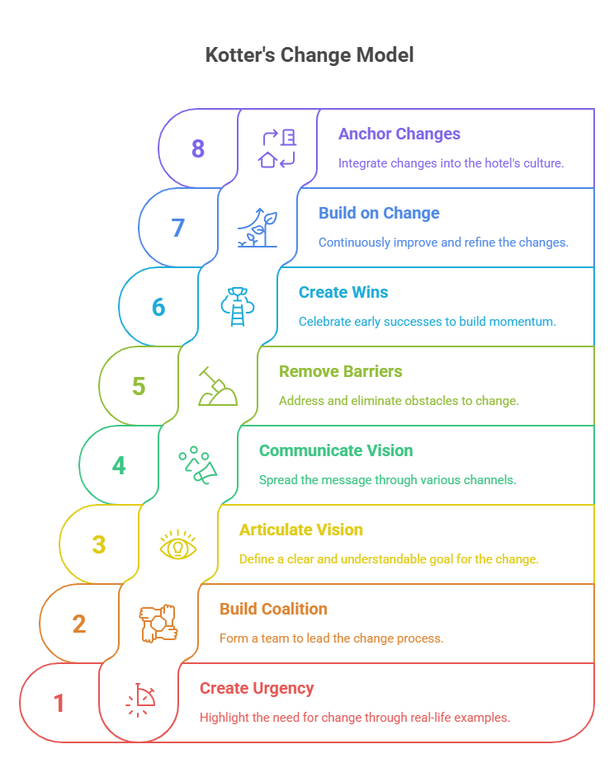
Figure 4: Kotter’s Change Model (Source: Prospects, 2025)
- Create a Sense of Urgency
The first step is to get employees to recognise that there is a problem. Managers can point to real-life examples like guest complaints and bad reviews to demonstrate how the staff shortage affects everyone (Statista, 2024). Hilton Metropolitan need to tell staff that if we don't do something, service levels will further decrease, and so will their spirits on shift.
- Build a Guiding Coalition
The hotel ought to form a small team to lead the transition. This group can consist of HR leaders, team leaders and a couple of acknowledged staff members. These are the people who will organise actions, direct people, and push the project along.
- Articulate a Clear Vision of Change
The hotel needs simple work to enforce the change. To wit, “Creating a strong and happy team to enhance the guest experience.” This goal should be easy to understand and support.
- Communicate the Vision
Spread the message in various ways. These can include staff briefings, posters in staff areas, or emails from managers. Staff are more likely to buy into these things when they hear the same message repeatedly.
- Remove Barriers
Barriers such as time, communication, and morale should be eliminated. Staff concerns should be listened to, and changes should be made, where possible. Small accommodations or extra support may make people feel more included.
- Create Short-Term Wins
Cheering some early success creates momentum. Hotels can showcase quick wins, such as new hires, better reviews or positive feedback (Kipping and Clark, 2012). A small prize, or the team’s thanks, can set off a wave of motivation.
- Build on the Change
Once the changes begin, the hotel has to keep getting better. This involves ongoing training, support and feedback. Support should be informed and directed by feedback.
- Anchor the Changes
Lastly, the changes ought to become the hotel’s culture. Daily routines should be structured along new systems, rewards, and habits. Managers need to help sustain these changes over time.

4.4 Potential Benefits of Implementation
If successfully adopted, the recommended strategies offer a variety of significant advantages for Hilton London Metropole. These improvements will resolve current staffing shortages and enhance the level of service and team morale within the hotel.
Here are the most immediate benefits: Better guest service. More trained workers = getting things done when they should be done; fewer delays. Guests will check in more quickly, their rooms will be cleaner, and the food and beverage service will be improved (Hidalgo et al., 2022). This can result in better reviews, better satisfaction scores, and more repeat bookings.
Better staff morale is another huge advantage. Workers who feel supported, rewarded, and listened to are more likely to stick around. Lower staff turnover means saving time and resources spent on recruiting and training. It also promotes a stronger work environment with good teamwork.
Improved shift planning and communications will also help relieve staff stress. Transparent schedules and reasonable workloads can foster trust between staff and managers, enhancing teamwork and performance.
Ultimately, a stronger workforce will allow the hotel to manage peak times, enhance its reputation, and perform better in the market. This transformation has value for the organisation and its people.

4.5 Cost Estimations
Activity | Description | Estimated Cost (£)
Recruitment Campaign | Job adverts, outreach to colleges, HR materials | £3,000
Staff Training & Onboarding | Basic training sessions, materials, and mentoring setup | £1,500
Reward and Motivation Program | Staff of the Month, perks, and small incentives | £1,500
Scheduling Software | License for the basic rota management system | £1,000
Total Estimated Cost | All activities over 3 months | £7,000
Table 5: Estimated Implementation Costs (3-Month Plan) (Source: Own design)
The existing interventions are feasible within a lean and demand-value budget. Most steps are related to improving existing systems rather than building new ones, which helps hold costs down while continuing to make some progress.
The recruiting costs are expected to be about £3,000. This will involve job ads, very simple marketing, and engagement with some local colleges. Staff training will cost about £1,500 for printed materials, short sessions, and perhaps a small fee for a trainer if necessary.
The incentive program requires a monthly budget of £500 for small vouchers, meal perks, or recognition awards, totalling £1,500 over three months. Digital shift planning software can be obtained for around £1,000, depending on the desired functions.
So far, the three-month implementation could cost just over £7,000. That’s a pretty good return on an investment for a hotel of this calibre. If well handled, he says, it can generate higher returns in the form of better service, higher occupancy, and less staff turnover.

4.6 Success Measurement and KPIs
Simple and practical indicators can be used to track whether the second key policy is working successfully. Key performance indicators (KPIs) will indicate whether the actions are working overtime.
A key KPI is the staff turnover rate—a decline in turnover points to better retention. Monitoring satisfaction scores and online review ratings to determine changes in the quality of service is also beneficial. The average time it takes to fill an open position could be used to evaluate one’s hiring practices.
Weekly reports from team meetings will allow managers to monitor progress. These benchmarks will drive any changes, and the hotel will be able to keep track of how well it’s doing compared to its staffing aims.

5. Action Plan
This action plan provides a sequential set of recommendations, along with the problem, solution, outcome, person responsible, timeline, cost, and success measure.
Problem | Proposed Solution | Expected Outcome | Responsible | Timeline | Estimated Cost | Measurement Method
Staff shortages in core departments | Launch a recruitment drive via job sites and colleges | Higher number of applicants and faster hiring | HR Manager | Weeks 1–3 | £3,000 | Vacancy fill rate; application volume
New hires lack confidence or support | Develop a structured 3–5 day onboarding plan | Faster adjustment and reduced early staff exits | HR + Dept. Heads | Weeks 2–4 | £1,500 | Retention after 1 month, onboarding feedback
Low staff morale and lack of recognition | Start a monthly reward and recognition program | Improved team motivation and lower absenteeism | Line Managers | Weeks 5–8 | £1,500 | Absence rate, team feedback
Unbalanced and stressful shift patterns | Introduce digital scheduling software | Fairer shifts and improved staff satisfaction | Operations Manager | Weeks 7–10 | £1,000 | Staff shift feedback; rota accuracy
Poor team communication and unclear updates | Hold weekly team briefings in all departments | Stronger teamwork and faster issue resolution | Department Supervisors | Weeks 8–12 (ongoing) | No added cost | Meeting attendance, informal feedback
Table 6: Action Plan for Addressing Staff Shortage at Hilton London Metropole (Source: Own design)
This table shows that Hilton London Metropole has a clear and calibrated route to elevating staffing levels. Every action is linked to a present need and measurable for progress. If executed as intended, this action plan will ease the staffing shortage, enhance service, and fortify the team culture.

6. Conclusion
The short-staffed situation for Hilton London Metropole has become a chronic problem for the hotel’s day-to-day business. Although the hotel has undergone major changes in its historic grandeur, the results of the Rehabilitation phase have highlighted the issue of Manual, unskilled labour, which has a negative impact on Service. Guest perception has revealed slowdowns, lower quality service, and less satisfaction. These concerns should be effectively and carefully managed in order to prevent further damage to the hotel’s reputation and operations.
It was an in-depth look into how the staffing crisis is taking its toll on several departments. Housekeeping, front desk, and food service squads are always getting slammed. The staff is frequently overworked and unable to accommodate guest expectations. We have these problems not for one reason only. External and internal factors, such as market trends, changes in laws, and team structure, all come into play. Nothing is taken, which means the same problems over and over.
A number of low-cost, practical recommendations have been suggested. Everyone directly addresses the hotel’s current issues. Solutions include better recruitment, improved training, staff incentives, digital scheduling tools, and regular team meetings. All this is simple, doable, and appropriate to the hotel as it stands.
A plan was structured to ensure the smooth implementation of these action points. Projects were split into three-month chunks so they wouldn’t get interrupted. Managers and team leaders were given clear responsibilities, along with a schedule and estimated costs. Each intervention was designed to be facilitated and manageable.
Kotter’s 8-Step Change Model was utilised to assist with implementation. This model holds change in a manner that feels firm and clear. It starts with urgency and ends with integrating the change into daily habits. This step-by-step process helps employees understand the why behind the changes and what they really mean for their work.
If the guidelines are adhered to, a number of advantages can be anticipated. These are faster service, better staff morale, and better guest satisfaction. Less focus means less pressure and more thinking about the team. Over time, that can mean more repeat visits, better reviews, and better overall performance.
Consultancy report. This consultancy report aimed to produce a clear and usable plan. It addressed actual problems and proposed straightforward, commonsense solutions. Hilton London Metropole has a lot to build on. With the right assistance and scaffolding, the hotel will be able to meet the staffing challenges and provide a more fruitful relationship for guests and staff.
Finally, the authors would like to appreciate the opportunity provided by Hilton London Metropole to contribute to this significant research. We acknowledge with gratitude the confidence in this consultancy. This partnership demonstrates how we can work together, plan appropriately, and be mindful in solving real challenges.

References
Acharya, P. and Mahapatra, S.S., 2024. EXPLORING THE IMPACT OF ARTIFICIAL INTELLIGENCE INTEGRATION ON GUEST EXPERIENCE IN THE HOTEL INDUSTRY. GeoJournal of Tourism & Geosites, 54.
Anwar, F.A., Deliana, D. and Suyamto, S., 2024. Digital Transformation in the Hospitality Industry: Improving Efficiency and Guest Experience. International Journal of Management Science and Information Technology, 4(2), pp.428-437.
Baron, A. and Armstrong, M., 2007. Human capital management. London: Kogan Page.
Baydeniz, E. and Kart, N., 2024. Factors affecting the green behaviour of hotel managers. European Journal of Tourism Research, 36, pp.3611-3611.
BBC News, 2023. The UK hospitality sector is facing staff shortages post-Brexit. [online] Available at: https://www.bbc.co.uk/news/business-65487632 [Accessed 16 Jun. 2025].
Benzaghta, M.A., Elwalda, A., Mousa, M.M., Erkan, I. and Rahman, M., 2021. SWOT analysis applications: An integrative literature review. Journal of Global Business Insights, 6(1), pp.54-72.
Bonfanti, A., Vigolo, V. and Yfantidou, G., 2021. The impact of the Covid-19 pandemic on customer experience design: The hotel managers’ perspective. International Journal of Hospitality Management, 94, p.102871.
Brierley, E., 2006. Talent on tap: Getting the best from freelancers, interims and consultants. London: Chartered Institute of Personnel and Development.
Burnes, B., 2014. Managing change. 4th ed. Great Britain: Prentice Hall.
Buttrick, R., 2009. The project work. London: Prentice Hall.
Caterer.com, 2024. Hospitality Recruitment Trends and Challenges in the UK. [online] Available at: https://www.caterer.com/advice/hiring-hospitality-trends-uk [Accessed 16 Jun. 2025].
CIPD, 2025. Chartered Institute of Personnel and Development. [online] Available at: https://www.cipd.org/uk/ [Accessed 16 Jun. 2025].
Das, M.P., 2023. Technology and Guest experience: innovations reshaping hotel management. International Journal for Multidimensional Research Perspectives, 1(3), pp.76-95.
Denysenko, M. and Yurynets, Z., 2021. Modern hotel management principles and methods for providing a quality product. Економіка та держава, (3), pp.28-33.
Fisman, R. and Sullivan, T., 2014. The org: How the office really works. London: Murray.
Georgiadou, E., Siakas, K., Berki, E., Estdale, J., Rahanu, H. and Ross, M., 2019. A STEEPLED analysis of the SPI manifesto. In Systems, Software and Services Process Improvement: 26th European Conference, EuroSPI 2019, Edinburgh, UK, September 18–20, 2019, Proceedings 26 (pp. 209-221). Springer International Publishing.
Ghosh, M., 2023. Analysing IoT automation facilities in hotel rooms: Enhancing guest experience and operational efficiency. Rajasthali Journal, 2(4), pp.54-60.
Gonzalez, R., Gasco, J. and Llopis, J., 2019. ICTs in hotel management: a research review. International Journal of Contemporary Hospitality Management, 31(9), pp.3583-3609.
Haas, M.R., Munzer, B.W., Santen, S.A., Hopson, L.R., Haas, N.L., Overbeek, D., Peterson, W.J., Cranford, J.A. and Huang, R.D., 2019. # DidacticsRevolution: Applying Kotter’s 8-Step Change Management Model to Residency Didactics. Western Journal of Emergency Medicine, 21(1), p.65.
Halton, W., 2019. Some unconscious aspects of organizational life: Contributions from psychoanalysis. In The unconscious at work (pp. 11-18). Routledge.
Henschel, U.K., Gruner, A. and Von Freyberg, B., 2018. Hotelmanagement. Walter de Gruyter GmbH & Co KG.
Hidalgo, A., Martín-Barroso, D., Nuñez-Serrano, J.A., Turrión, J. and Velázquez, F.J., 2022. Does hotel management matter to overcoming the COVID-19 crisis? The Spanish case. Tourism management, 88, p.104395.
Indeed, 2025. Hilton London Metropole employee reviews. [online] Available at: https://uk.indeed.com/cmp/Hilton/reviews [Accessed 16 Jun. 2025].
Ivanov, S., Seyitoğlu, F. and Markova, M., 2020. Hotel managers’ perceptions towards the use of robots: a mixed-methods approach. Information Technology & Tourism, 22(4), pp.505-535.
Ivkov, M., Blešić, I., Janićević, S., Kovačić, S., Miljković, Ð., Lukić, T. and Sakulski, D., 2019. Natural disasters vs hotel industry resilience: An exploratory study among hotel managers from Europe. Open Geosciences, 11(1), pp.378-390.
Johnson, M., 2005. The independent consultant’s survival guide. London: Chartered Institute of Personnel and Development.
Kipping, M. and Clark, T., 2012. The Oxford handbook of management consulting. Oxford: Oxford University Press.
Kirkpatrick, I., Sturdy, A.J., Alvarado, N.R., Blanco-Oliver, A. and Veronesi, G., 2019. The impact of management consultants on public service efficiency. Policy & Politics, 47(1), pp.77-95.
Kotter, J., 2012. Leading change. Boston: Harvard Business Review Press.
Laig, R.B.D. and Abocejo, F.T., 2021. Change management process in a mining company: Kotter’s 8-step change model. Journal of Management, Economics, and Industrial Organization, 5(3), pp.31-50.
London Chamber of Commerce, 2023. Post-Brexit labour market report: Impact on London hospitality. [online] Available at: https://www.londonchamber.co.uk/news/post-brexit-hospitality-labour [Accessed 16 Jun. 2025].
ManagementHelp, 2025. Free Management Library – Organisational Performance Tools and Models. [online] Available at: https://managementhelp.org/ [Accessed 16 Jun. 2025].
Mathur, S.,2020. Implementing Sustainable Practices in Hotel Management to Enhance Guest Experience and Operational Efficiency.
Mavridopoulou, M. and O’Mahoney, J., 2020. Elitism in strategy consulting: How institutional prestige influences recruitment. Management Consulting Journal, 3(1), pp.12–22.
MindTools, 2025. Kotter’s 8-Step Change Model – Change Management Tools from MindTools.com. [online] Available at: https://www.mindtools.com/pages/article/newPPM_82.htm [Accessed 16 Jun. 2025].
Newton, R., 2010. The management consultant: Mastering the art of consultancy. London: Financial Times Publishing.
Noordzijfe, G., 2014. Project management of hotel opening processes: Exploring better ways to manage new hotel openings. North Charleston, SC: CreateSpace.
O’Mahoney, J., 2021. How small consultancies grow: Challenging problem-based theorising. Management Consulting Journal, 4(1), pp.5–20.
O'Mahoney, J., Sturdy, A. and Galazka, A., 2024. Acquiring knowledge through management consultancy: a national culture perspective. Journal of Management & Organization, 30(6), pp.2255-2274.
Phadermrod, B., Crowder, R.M. and Wills, G.B., 2019. Importance-performance analysis based SWOT analysis. International journal of information management, 44, pp.194-203.
Prospects, 2025. Career advice and consultancy examples. [online] Available at: https://www.prospects.ac.uk/ [Accessed 16 Jun. 2025].
Puyt, R., Lie, F.B., De Graaf, F.J. and Wilderom, C.P., 2020. Origins of SWOT analysis. In Academy of management proceedings (Vol. 2020, No. 1, p. 17416). Briarcliff Manor, NY 10510: Academy of Management.
Quezada, L.E., Reinao, E.A., Palominos, P.I. and Oddershede, A.M., 2019. Measuring performance using SWOT analysis and balanced scorecard. Procedia Manufacturing, 39, pp.786-793.
Rahmiati, F., Dewi, P.G.L.G., Othman, N.A., Madden, K., Advincula, G.B. and Sitorus, Y., 2024. Exploring the effect of guest experience on guest loyalty: Mediating role of guest satisfaction. Jurnal Fokus Manajemen Bisnis, 14(2), pp.177-189.
Raiden, A. and King, A., 2021. Social value, organisational learning, and the sustainable development goals in the built environment. Resources, Conservation and Recycling, 172, p.105663.
Statista, 2024. Average salary of hotel staff in London (2020–2024). [online] Available at: https://www.statista.com/statistics/hotel-staff-salaries-london [Accessed 16 Jun. 2025].
Suárez-Albanchez, J., Blazquez-Resino, J.J., Gutierrez-Broncano, S. and Jimenez-Estevez, P., 2021. Occupational health and safety, organisational commitment, and turnover intention in the Spanish IT consultancy sector. International journal of environmental research and public health, 18(11), p.5658.
Subramaniam, N., Collier, P., Phang, M. and Burke, G., 2011. The effects of perceived business uncertainty, external consultants and risk management on organisational outcomes. Journal of Accounting & Organisational Change, 7(2), pp.132–157.
The Guardian, 2024. Why hotel workers are quitting – and not coming back. [online] Available at: https://www.theguardian.com/business/2024/hotel-workers-leaving [Accessed 16 Jun. 2025].
Trawick, S. and Carraher, T., 2023. Contextualising Kotter’s 8-step model to a sustainable digital transformation: A qualitative study from the perspective of organisational change.
TripAdvisor, 2025. Hilton London Metropole – Reviews. [online] Available at: https://www.tripadvisor.co.uk/Hotel_Review-g186338-d193104-Reviews-Hilton_London_Metropole-London_England.html [Accessed 16 Jun. 2025].
Truong, N., Dang-Pham, D., McClelland, R. and Nkhoma, M., 2020. Exploring the impact of innovativeness of hospitality service operation on customer satisfaction. Operations and Supply Chain Management: An International Journal, 13(3), pp.307-319.
Visit London, 2025. Hilton London Metropole. [online] Available at: https://www.visitlondon.com/things-to-do/place/248121-hilton-london-metropole [Accessed 16 Jun. 2025].
Vlados, C., 2019. On a correlative and evolutionary SWOT analysis. Journal of Strategy and Management, 12(3), pp.347-363.
Whittington, R. and Molloy, E., 2005. HR’s role in organisation: Shaping change. Research Report. London: Chartered Institute of Personnel and Development.
Whittington, R., Angwin, D., Regnér, P., Johnson, G. and Scholes, K., 2020. Exploring strategy: Text and cases. Harlow: Pearson Education Limited.
Wilke, G., 2018. The art of group analysis in organisations: The use of intuitive and experiential knowledge. Routledge.
Yadav, N., Shankar, R. and Singh, S.P., 2020. Impact of Industry4. 0/ICTs, Lean Six Sigma and quality management systems on organisational performance. The TQM Journal, 32(4), pp.815-835.
Ye, S., Xiao, H. and Zhou, L., 2019. Small accommodation business growth in rural areas: Effects on guest experience and financial performance. International Journal of Hospitality Management, 76, pp.29-38.
Zarezadeh, Z.Z., Rastegar, R. and Xiang, Z., 2022. Big data analytics and hotel guest experience: a critical analysis of the literature. International Journal of Contemporary Hospitality Management, 34(6), pp.2320-2336.

