
Assignment 2:

Operating Systems
CertHE Computing Skills for Workplace
Computer Architecture and Operating Systems.
ACCA4022_LON
DR. Redhwan Al-Amri (Lecturer)
(London Campus)

Student Name: Rike Raranti Siska
Student Number: 2531290
Group: 01
Date: 12 August 2026
Table of Contents
1. Key functions of general Operating Systems 3
1.1 Process and Processor Management 3
1.2 Memory Management 6
1.3 File System Management 7
1.4 Security and Protection 7
2. Use of Windows OS CLI commands 8
3. Use of Linux OS CLI commands. 12
3.1 Process Management 14
4. Use of Windows OS scripts. 16
4.1 Batch Script – Simple Calculator 16
4.2 Batch Script 2 – Password Checker 19
4.3 Script System Health Check 20
Key Features Demonstrated: 23
Use of the Windows OS Script Health Check 23
5. Use of Linux OS scripts 23
Script: Log File Analyser 24
Key Features Demonstrated 26
Conclusion 26
References 26

Introduction
Computer architecture and operating systems are essential to today's computing. Computer architecture describes how hardware parts like the CPU, memory, storage, and input/output devices collaborate to execute tasks. An operating system (OS) manages these hardware resources, offers a user interface, and facilitates efficient operation. This report covers the basics of computer architecture, the main functions of an OS, the use of Windows and Linux command-line tools and provides simple scripting examples for automation.[1]

1. Key functions of a general Operating System
A versatile operating system acts as an intermediary between users and computer hardware, overseeing system resources and software functions. Microsoft Windows is one of the most widely used operating systems globally, serving both home users and organisations. It offers a broad array of features designed to enhance productivity, communication, security, and multimedia experiences.

1.1 Process and Processor Management
Managing processes and CPU resources is a key duty of the operating system. A process is a program in execution, and the CPU carries out its instructions. The OS manages CPU time, schedules tasks, and supports the efficient operation of multiple applications. Modern systems use multitasking and scheduling to allocate CPU time, using priority levels to ensure critical tasks get enough processing power without compromising overall system performance.

Windows Task Manager offers a way to observe CPU usage, running apps, background processes, memory consumption, and general system performance. This enables users to detect issues and optimise resource management effectively.[2]

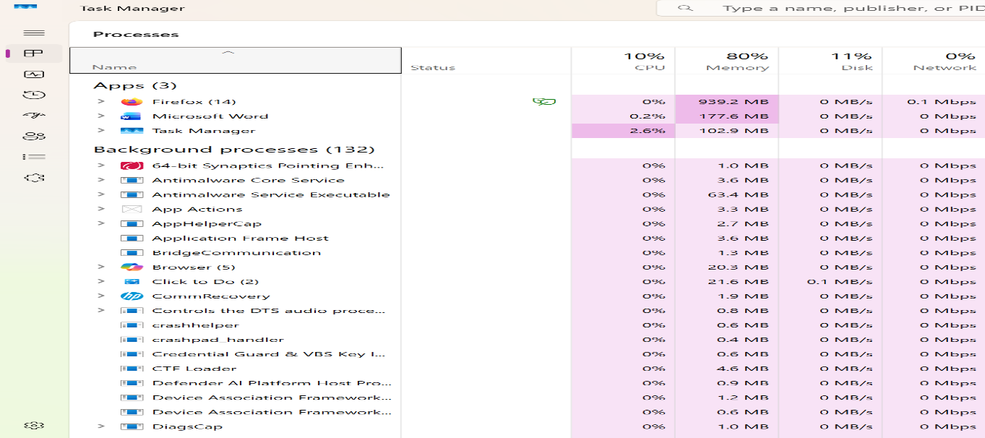
Figure 1
Windows Task Manager shows CPU usage and running processes.

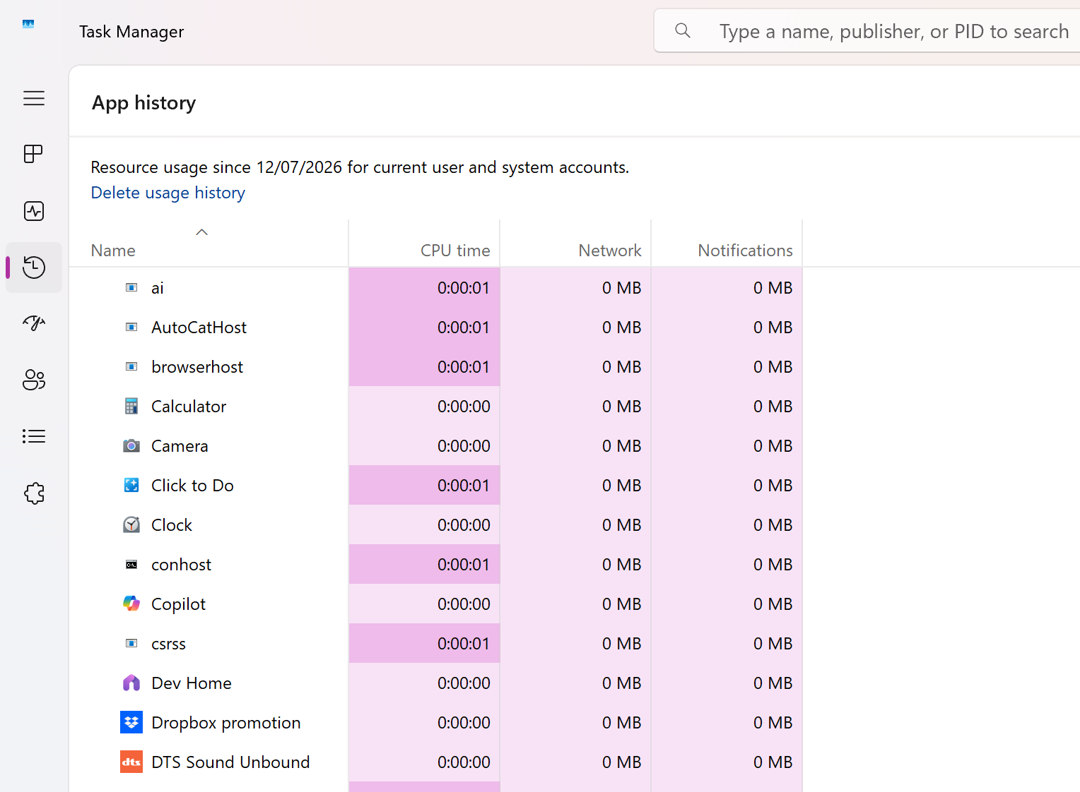
Figure 2
Task Manager - App History

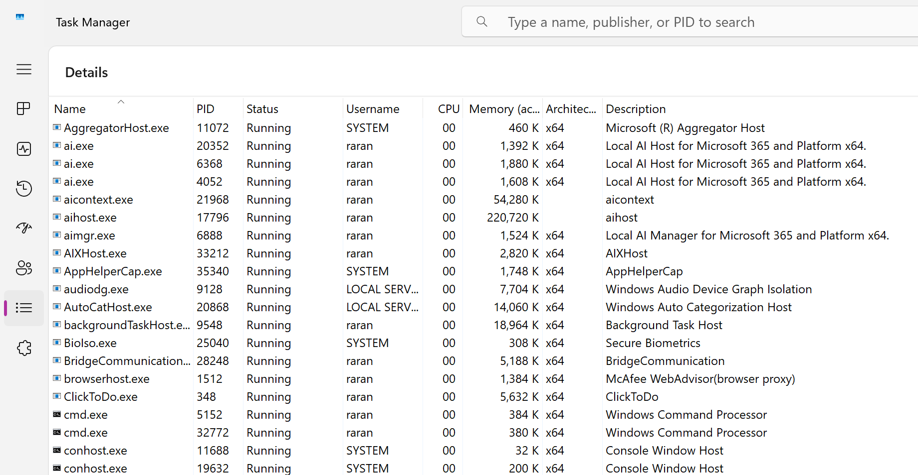
Figure 3
Task Manager, including running processes, PID, CPU, and memory

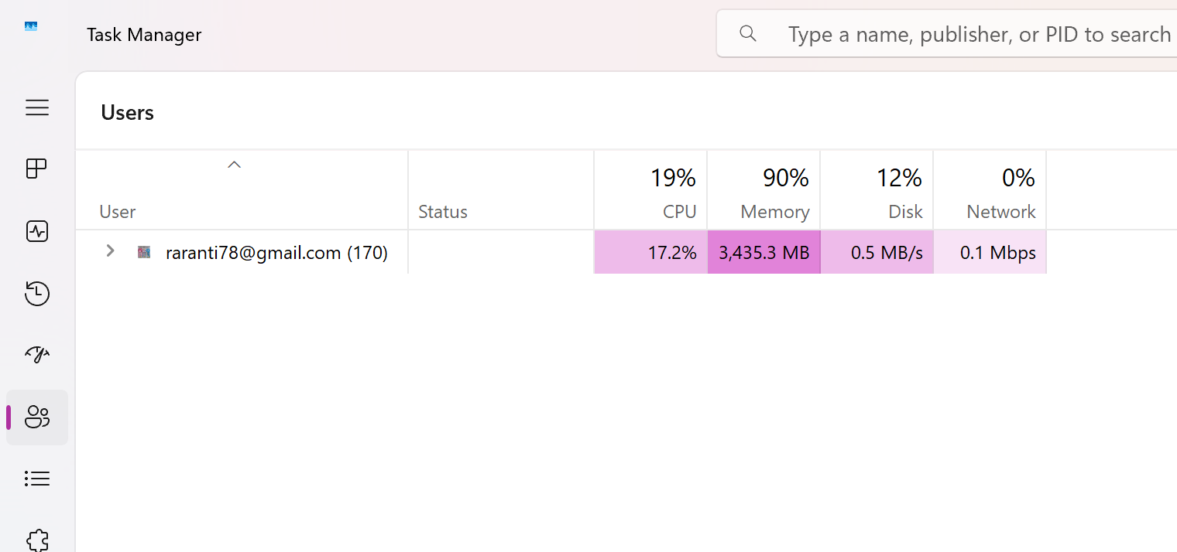
Figure 4
Task Manager - Users

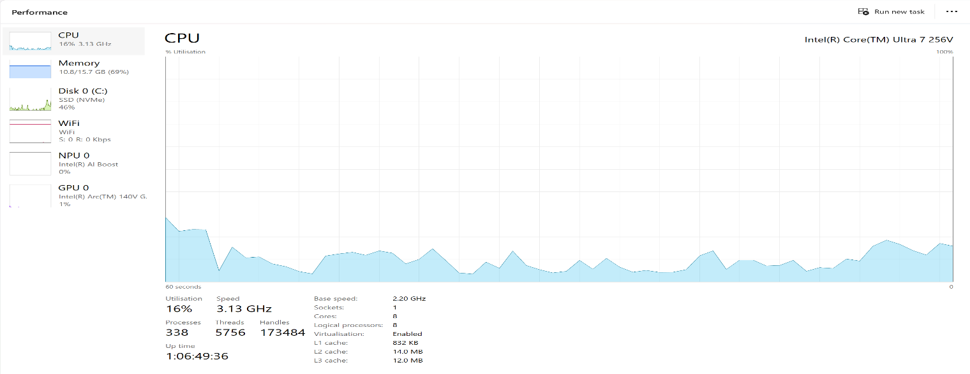
Figure 5
CPU Performance Diagram

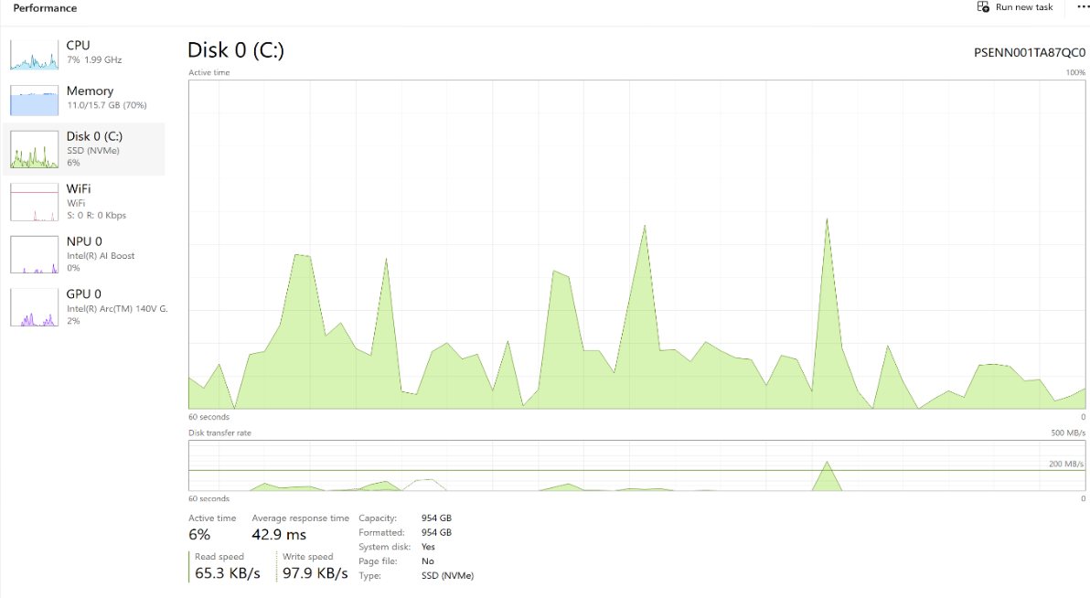
Figure 6
Disk Performance Diagram

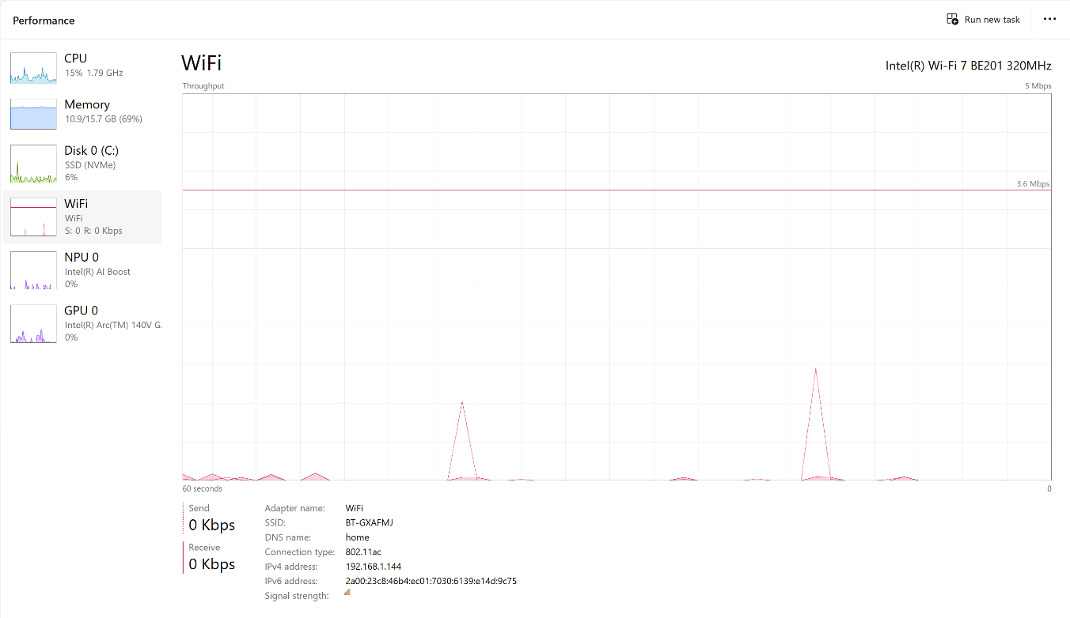
Figure 7
Wi-Fi Performance Diagram

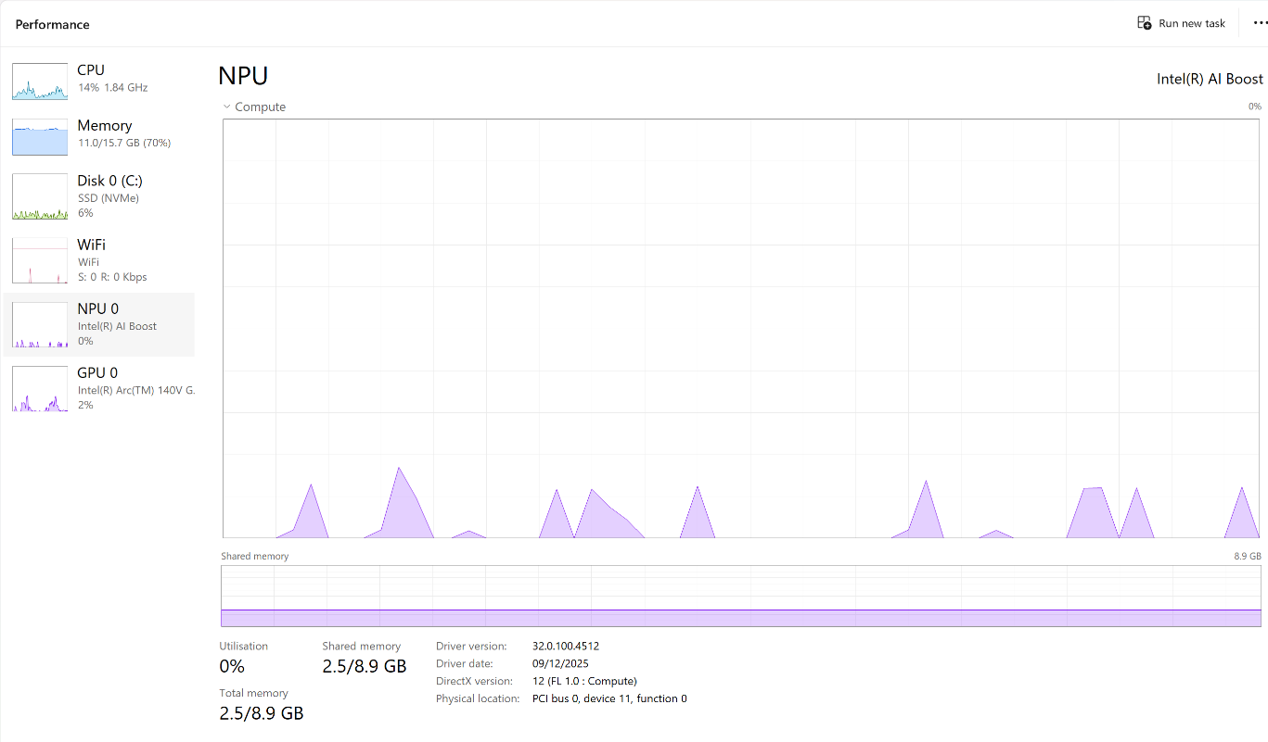
Figure 8
NPU Performance Diagram

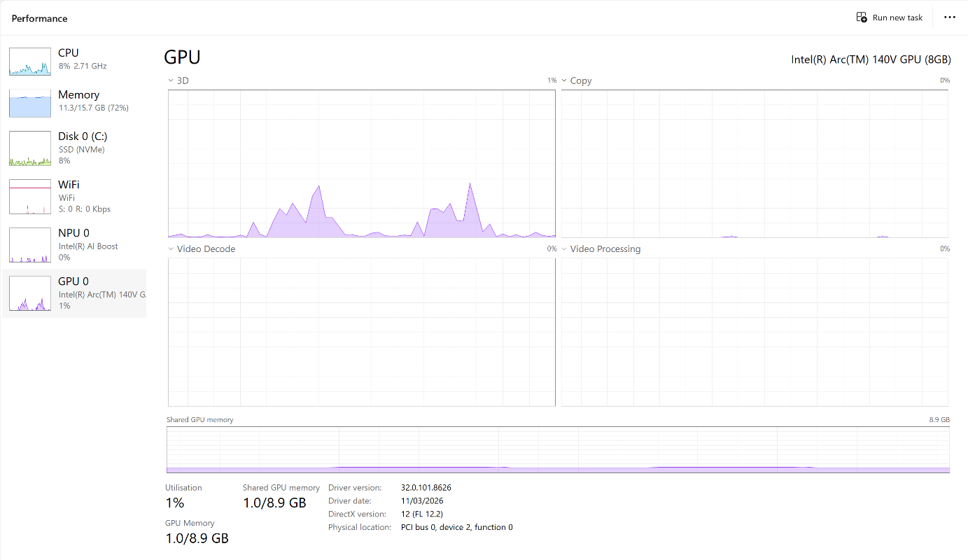
Figure 9
GPU Performance Diagram

1.2 Memory Management
Memory management is a key function of an operating system, responsible for efficiently allocating and utilizing available memory. It assigns RAM to applications and frees it when they close, enabling smooth multitasking. Microsoft Windows also employs virtual memory, merging physical RAM with hard drive or SSD space to compensate when real memory is low. Though virtual memory is slower than RAM, it enhances system stability and prevents application crashes caused by memory shortages. Good memory management boosts system performance and ensures dependable multitasking[3].

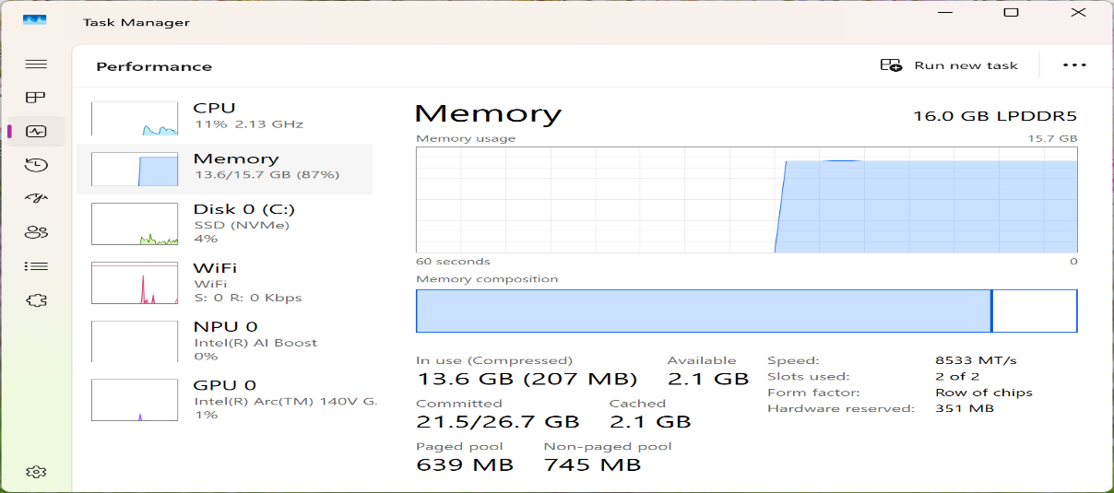
Figure 10
Windows Task Manager showing memory (RAM) usage diagram

1.3 File System Management

A file system organises, stores, and safeguards digital files for easy access and management. In Windows, File Explorer allows users to create, copy, move, rename, search, and delete files. Windows mainly uses the NTFS file system, which offers features like file permissions, encryption, and compression to improve data security and optimise storage[4].

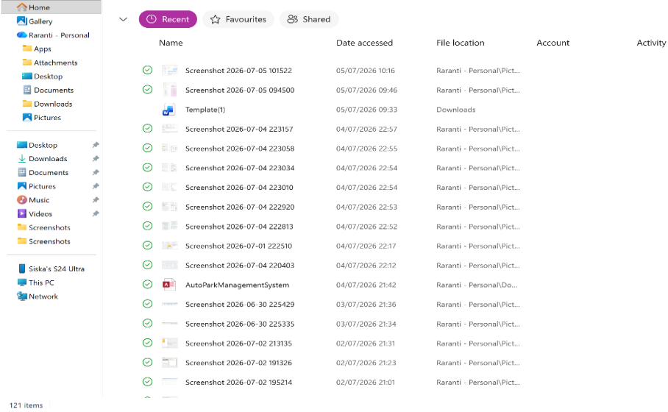
Figure 11
Windows File Explorer shows the file management system and folder structure.

1.4 Security and Protection
Security and protection are crucial roles of an operating system, preventing unauthorised access, malware, and cyber threats. Windows offers several built-in security features, including Microsoft Defender Antivirus, Windows Firewall, User Account Control (UAC), Windows Update, and BitLocker to secure both the system and user data. Users can oversee and adjust security options via the Windows Security app, which shows antivirus status, firewall configurations, and update details. These tools help protect personal data and support system stability and reliability[5]

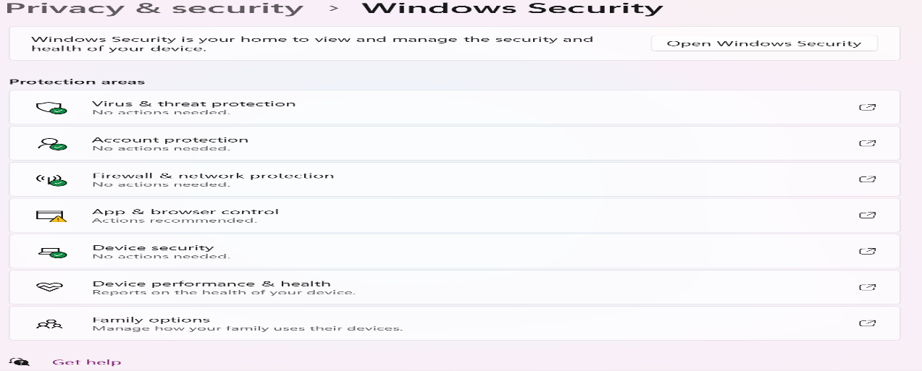
Figure 12
Windows Security shows security and protection features.

2. Use of Windows OS CLI Commands
The Windows Command-Line Interface (CLI), also known as Command Prompt (CMD), enables users to operate and manage the OS using text commands instead of a visual interface. It's frequently used for administrative tasks, file management, troubleshooting, adjusting system settings, and automating repetitive processes[6]

1- tasklist | The tasklist command shows all active processes on the computer, including details like process name, PID, session info, and memory usage.
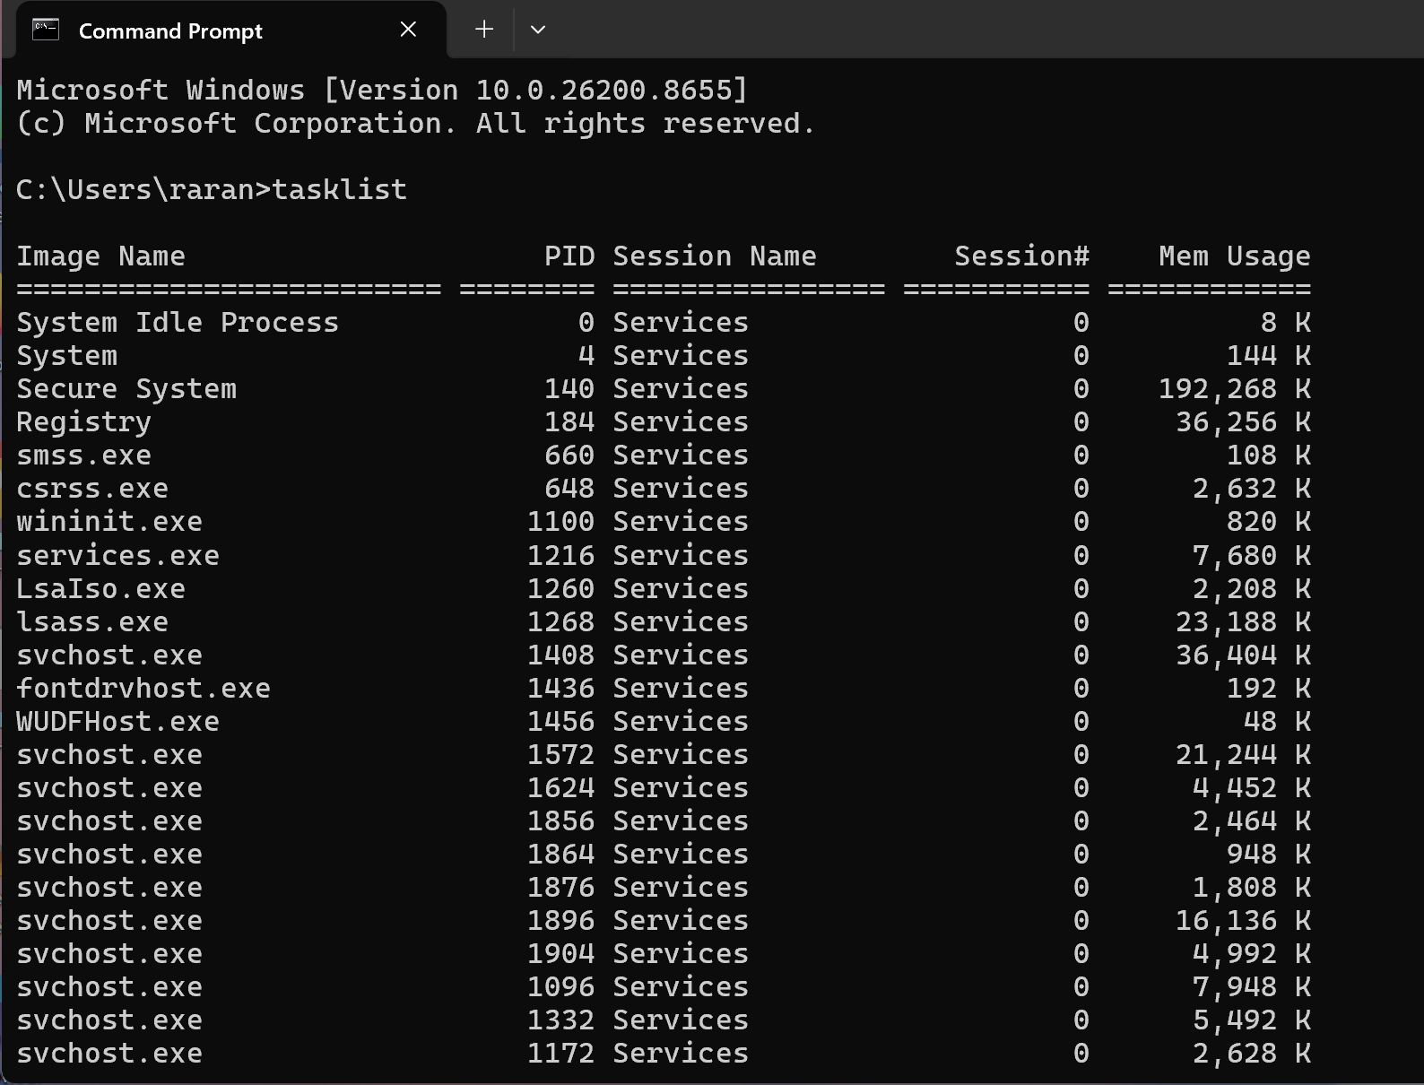
Figure 13
Command Prompt showing the TASKLIST command.

2- DIR | The DIR command shows the files and folders in the current directory, including their names, sizes, and last modification dates and times.
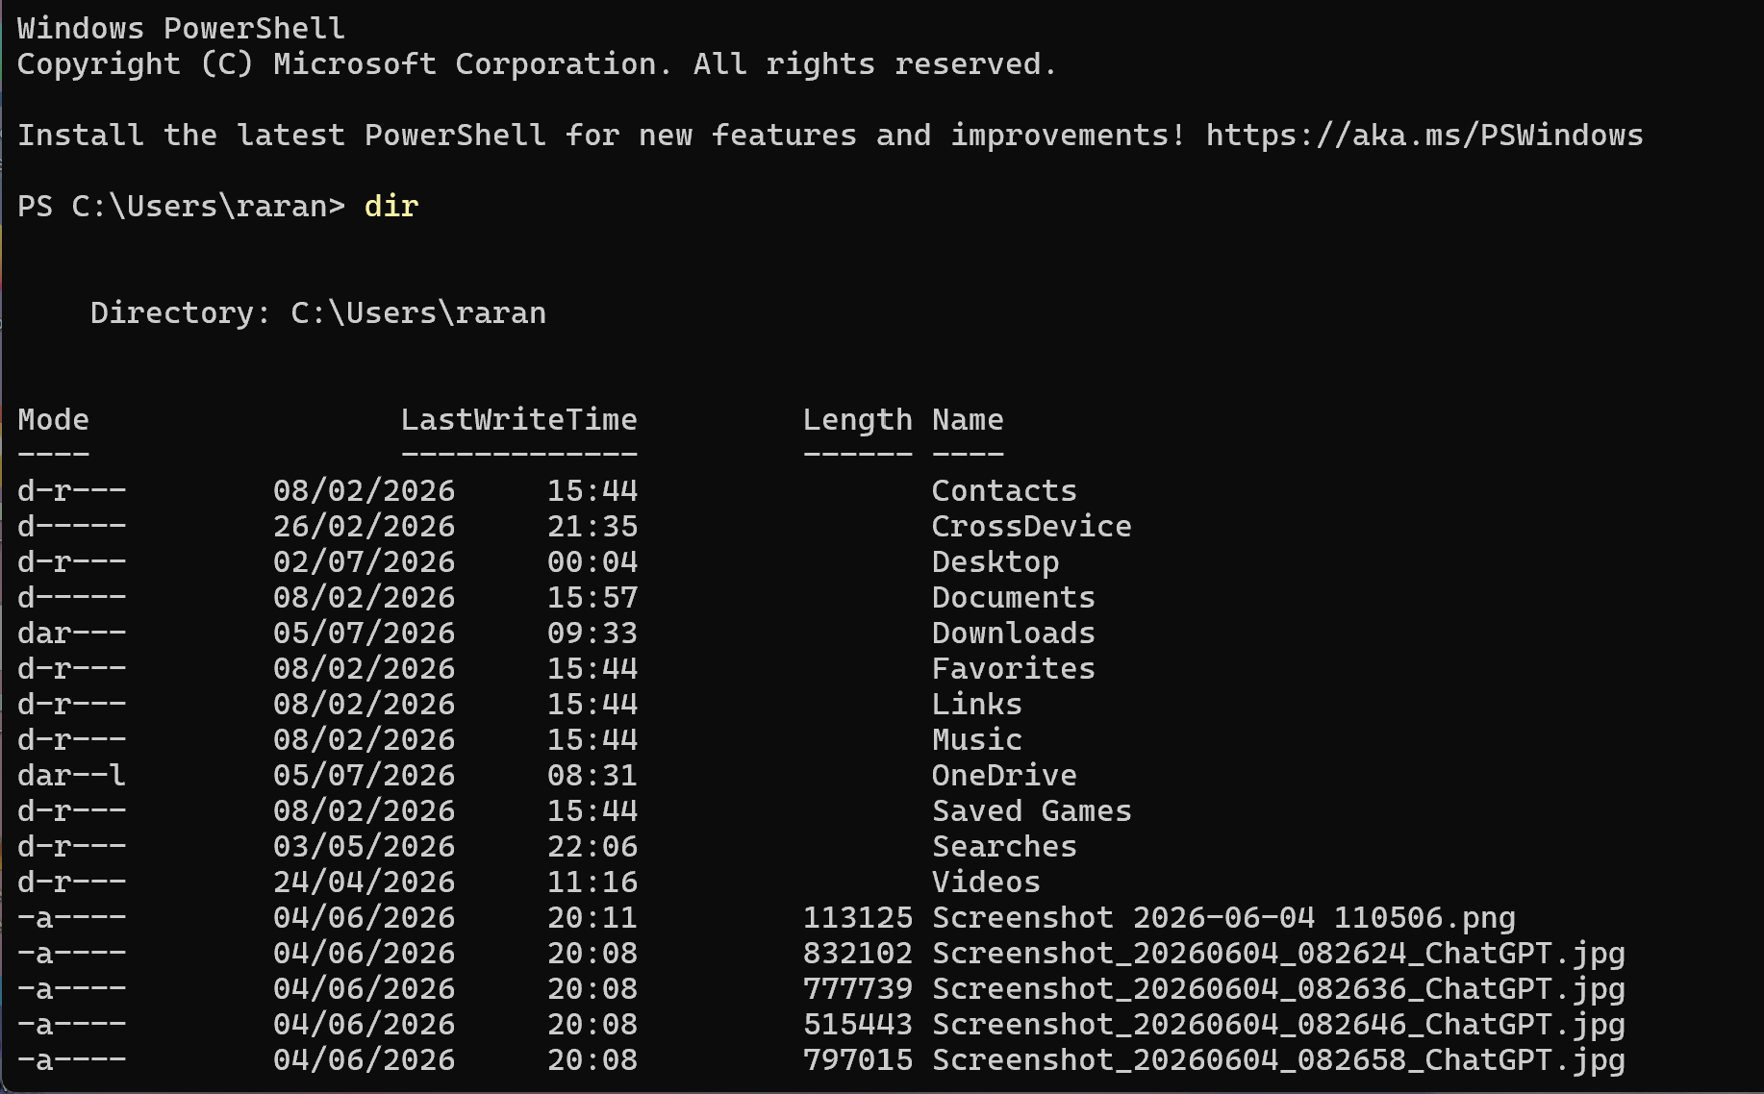
Figure 14
Command Prompt showing the DIR command.

3- SYSTEMINFO | The SYSTEMINFO command offers detailed information about the computer and operating system, including the Windows version, system manufacturer, processor, installed RAM, BIOS version, network settings, and system startup time.
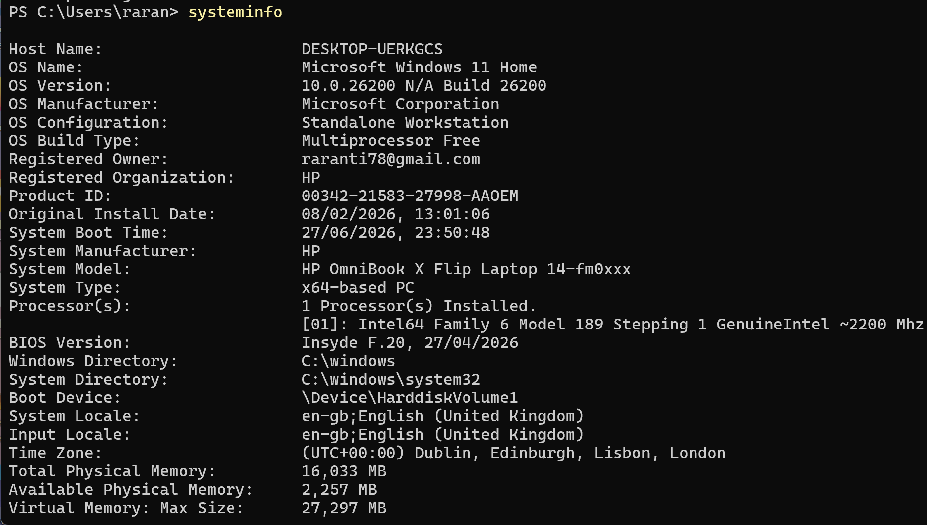
Figure 15
Command Prompt SYSTEM INFO command.

4-IPCONFIG | The IPCONFIG command shows the computer's current TCP/IP network settings, such as the IP address, subnet mask, and default gateway.
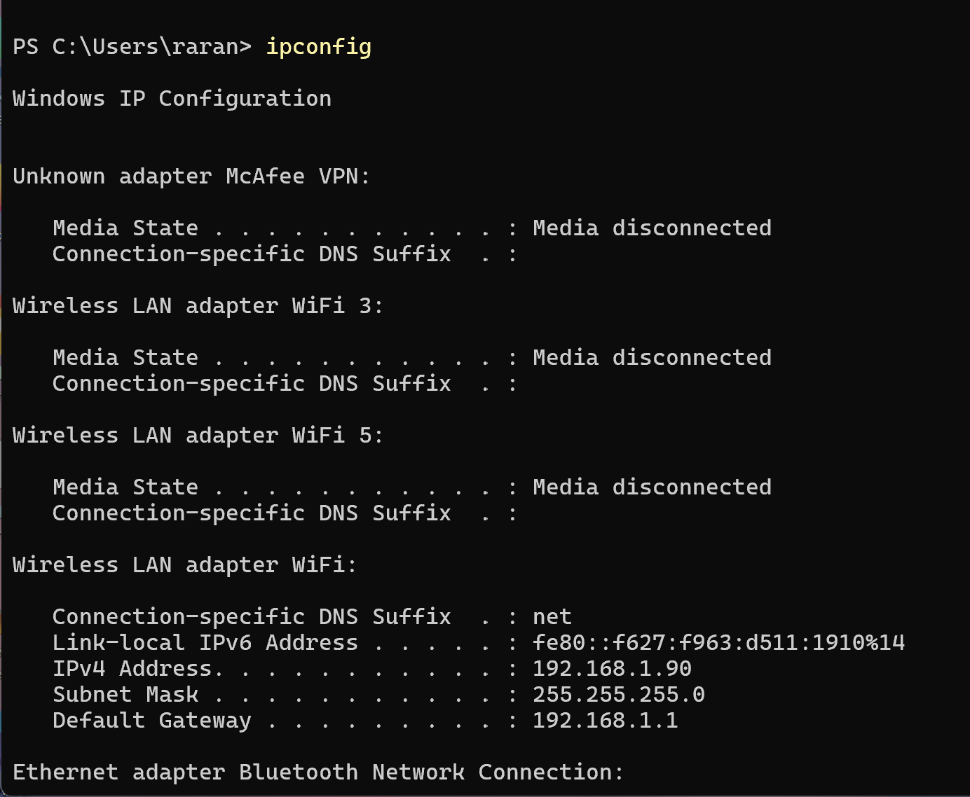
Figure 16
Command Prompt showing the IPCONFIG command.

5-PING www.google.com | The PING www.google.com command tests the connection between the local computer and Google’s server.
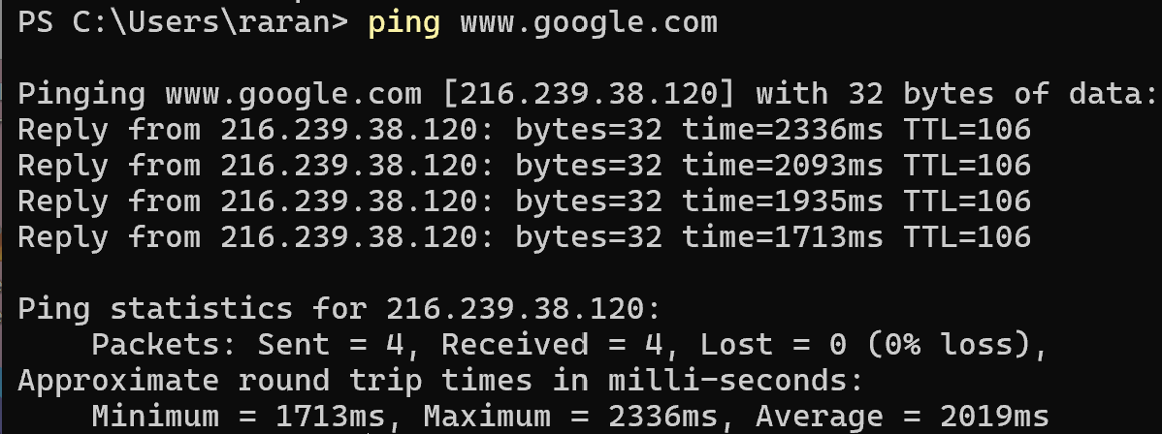
Figure 17
Command Prompt showing the PING www.google.com

6-DEL | Description: The DEL command removes one or more files from a specified location.
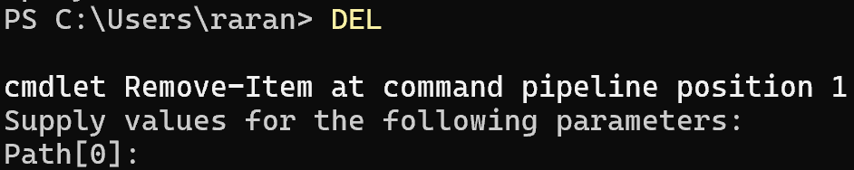
Figure 18
Command Prompt is displaying 'DEL'.

7-COPY | The COPY command transfers files between locations.
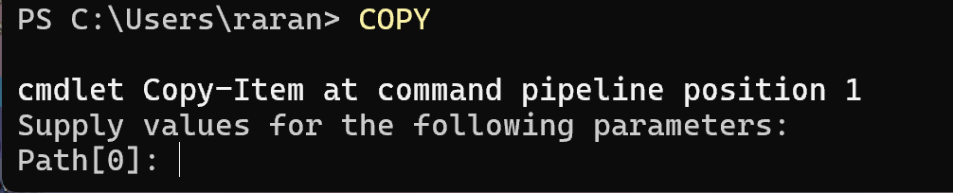

Figure 19
Command Prompt: COPY command.

8-MKDIR (or MD) | The MKDIR (or MD) command creates a new directory or folder. Since no folder name or path was specified, PowerShell will prompt for the necessary Path parameter before the directory is created.
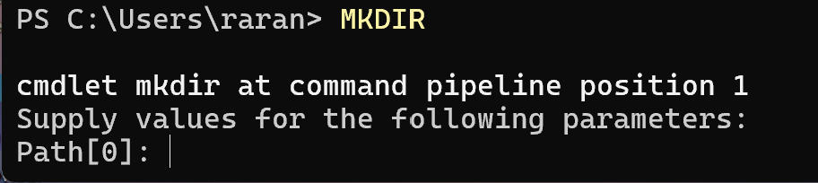
Figure 20
Command Prompt MKDIR command.

9-NET USER | The NET USE command shows a list of user accounts on the local machine. Additionally, it can be used to create, modify, delete user accounts, and reset passwords.
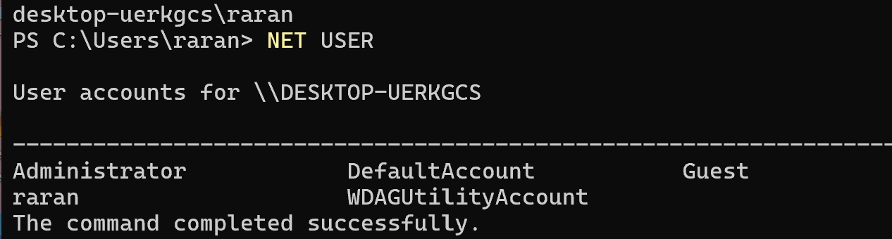
Figure 21
Command Prompt showing the NET USER command.

10-SCHTASKS | The SCHTASKS command shows all scheduled tasks on the computer, including details like task name, status, next run time, and schedule.
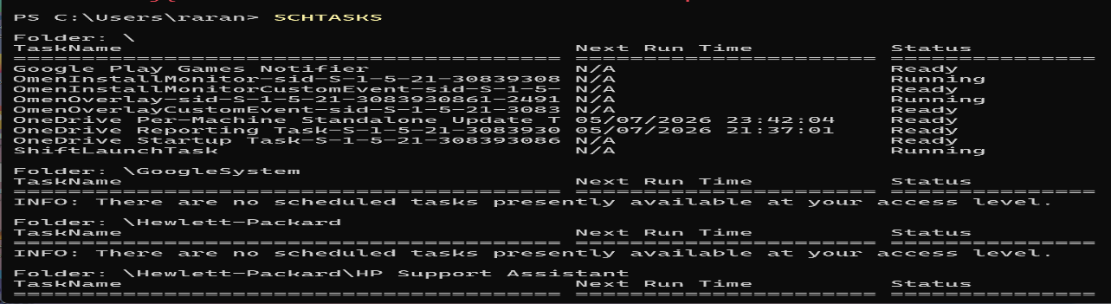
Figure 22
Command Prompt showing the SCHTASKS command.

3. Use of Linux OS CLI Commands
The Linux Command Line Interface (CLI) is a text-based platform that allows users to interact with the operating system through commands. It is widely used for managing files, monitoring system performance, configuring settings, and performing administrative tasks efficiently. This section highlights several common Linux commands along with their outputs.

No.1

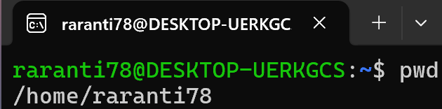
Figure 23
The pwd (Print Working Directory) command displays the full path of the current directory.

No.2

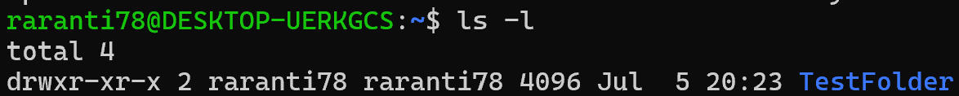
Figure 24
The ls -l command in Linux shows files and directories with detailed information such as permissions, owner, size, and last modification date.

No.3

Figure 25
The mkdir command creates a new directory.

No.4

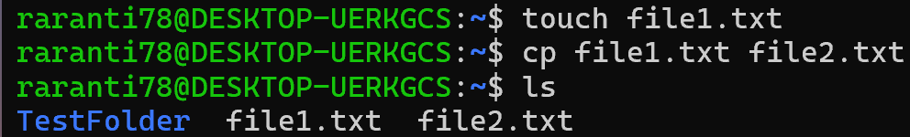
Figure 26
The touch command creates a new empty file if it doesn’t exist.
The cp command copies files between locations.
The ls command displays the files and folders in the current directory.

No.5

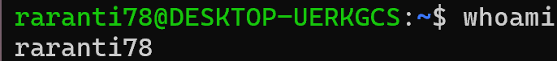
Figure 27
shows the username of the user currently logged in.

No.6

Figure 28
shows the user’s UID, GID, and group memberships.

No.7

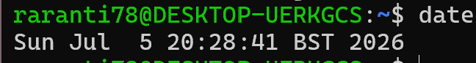
Figure 29
shows the current system date and time.

3.1 Process Management

No.1

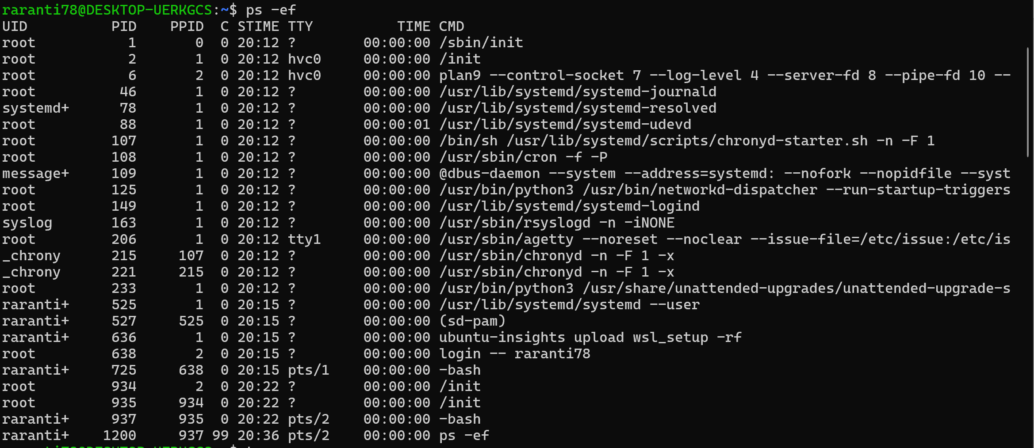
Figure 30
displays all active processes on the system.

No.2

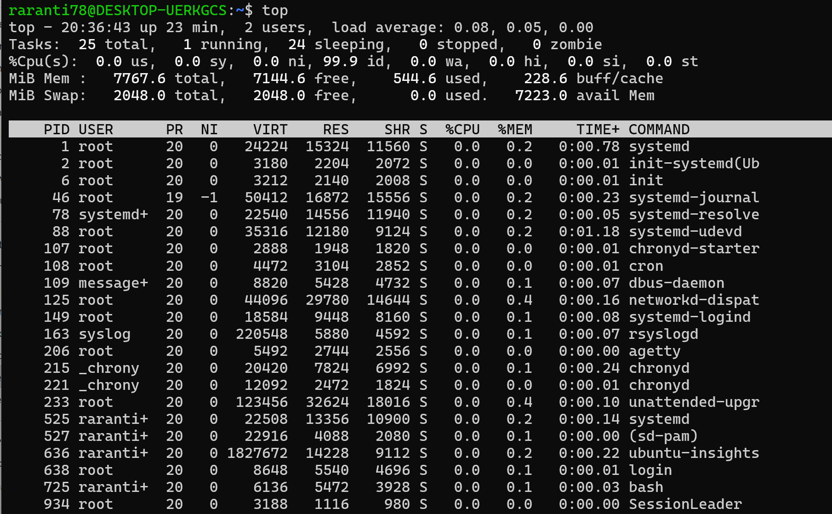
Figure 31
The top command offers a live overview of system performance, showing CPU, memory usage, and active processes.

No.3

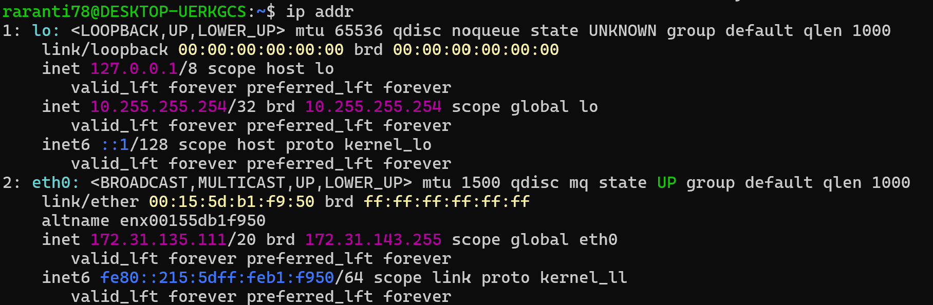
Figure 32
Displays the network interfaces and their IP address.

No.4

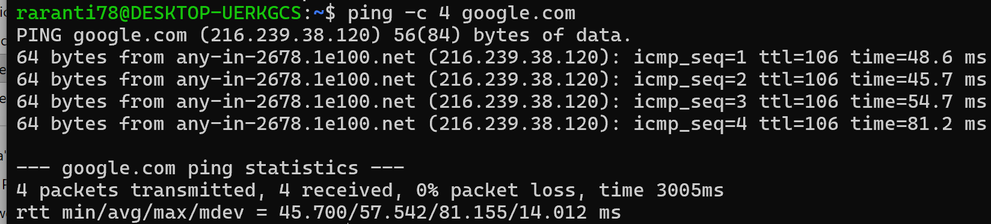
Figure 33
Shows a successful network connectivity test.

No.5

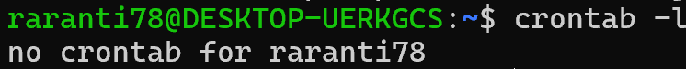
Figure 34
Shows that no cron jobs are configured.

4. Use of Windows OS scripts.

4.1 Batch Script – Simple Calculator
The Simple Calculator batch script allows the user to enter two numbers and perform basic mathematical operations, including addition, subtraction, and multiplication. It demonstrates calculations and output in Windows Batch scripting.

1. Open Notepad  2. Type the script into Notepad | What this script demonstrates  -Variable: set  -User input: set /p  -Mathematical operation: set /a  -Output: echo
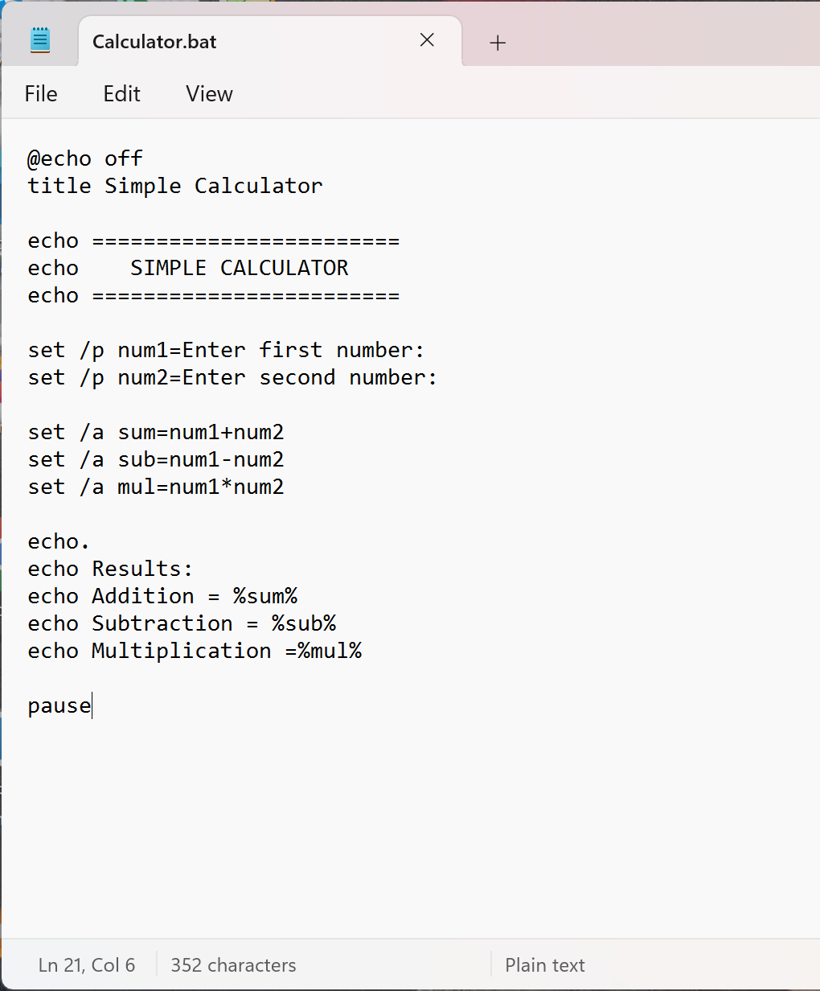
Figure 35
Simple Calculator batch script code

3. Click File -> Save As
4. Save the file as Calculator.bat
5. Save as type: All files
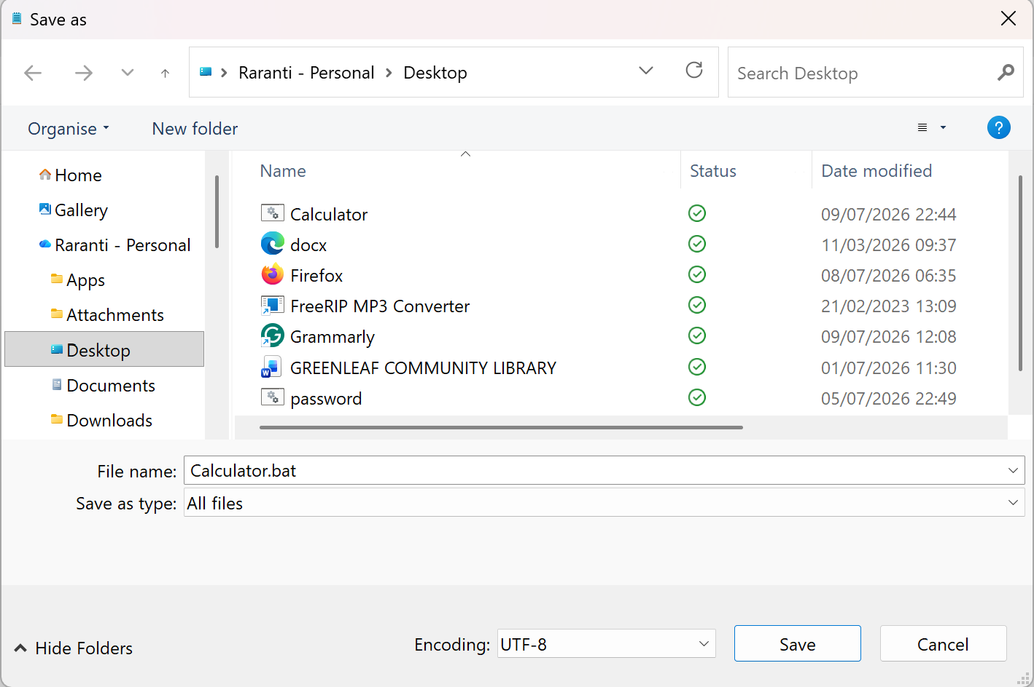
Figure 36
Saved Simple Calculator.bat file on Desktop

6. Find the saved file on the Desktop named Calculator.bat
7. Double-click to open “Calculator”
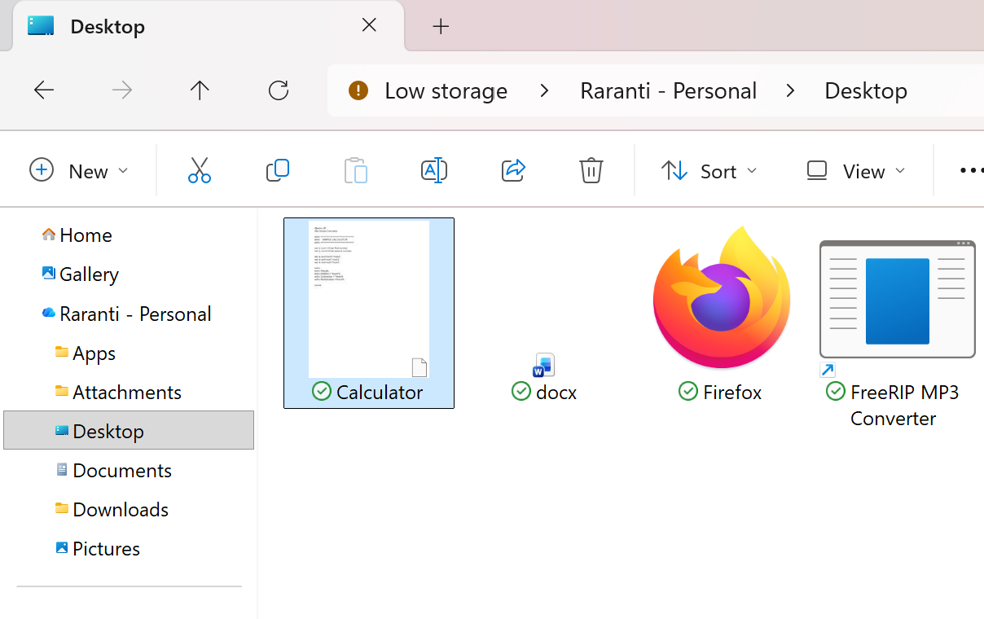
Figure 37
It shows the Simple Calculator saved and found on the Desktop.

8. A black Command Prompt window will open and display:
9. Enter the first number, then click Enter.
Enter the second number, then click Enter.
We get the result as shown.
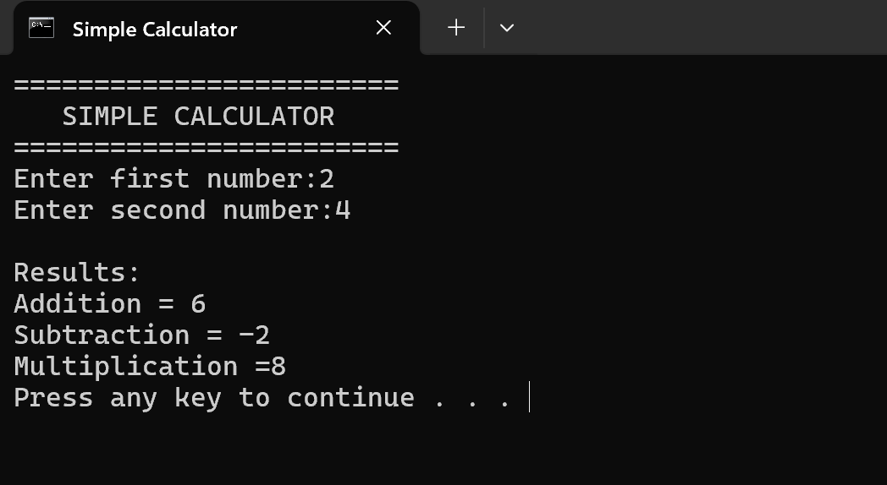
Figure 38
Simple Calculator output

4.2 Batch Script 2 – Password Checker

The password-checker batch script prompts the user to enter a password and compares it with a stored password using an IF … ELSE conditional. If the password is correct, access is granted; otherwise, access is denied. This demonstrates the use of variables, user input, and conditional logic in Windows Batch scripting.

1. Open Notepad  2. Type the script into Notepad | What this script demonstrates  -Variable  -User input  -Conditional statement (IF … ELSE)
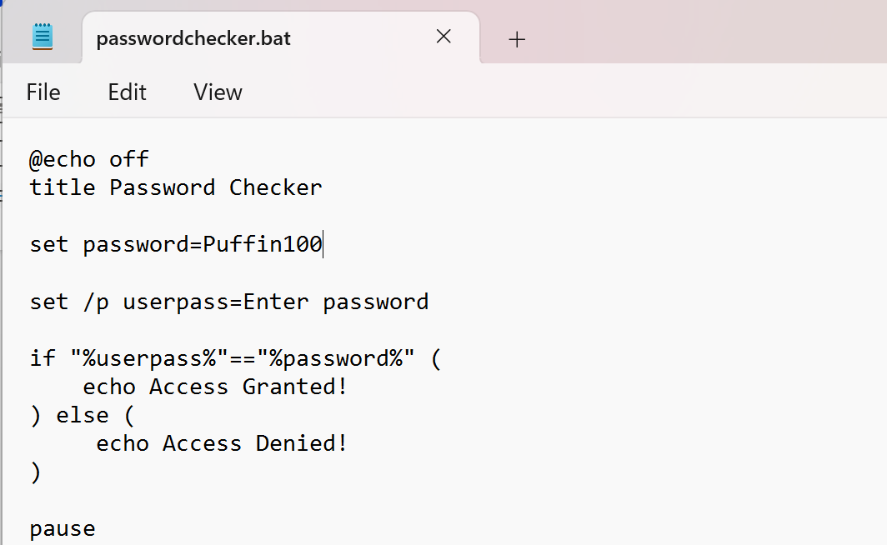
Figure 39
Password Checker Batch Script Code

3. Click File -> Save As
4. Save the file as passwordchecker.bat
5. Save as type: All files
6. Double-click to open “passwordchecker”
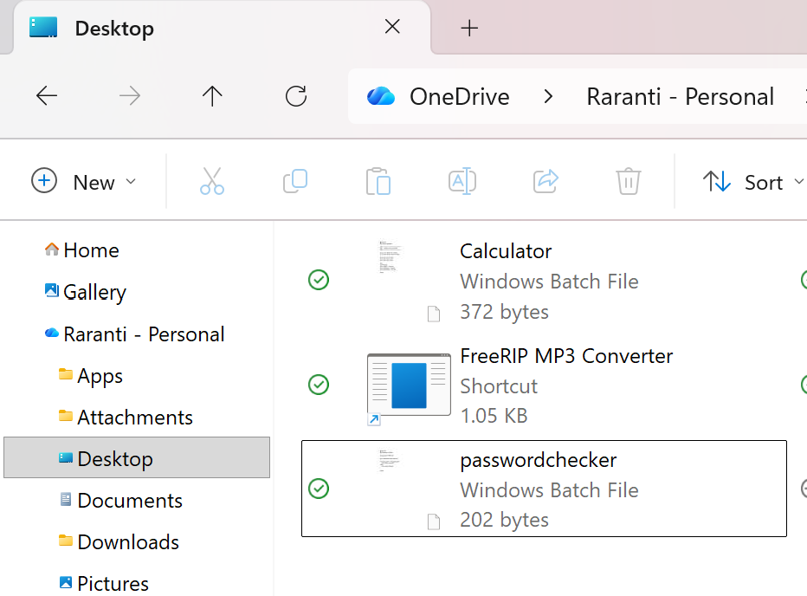
Figure 40
Saved Password Checker Batch File on Desktop

7. A black Command Prompt window will open and display:
8. Figure X: Correct password entered (Puffin100). The script shows “Access Granted” since the entered password matches the stored one.
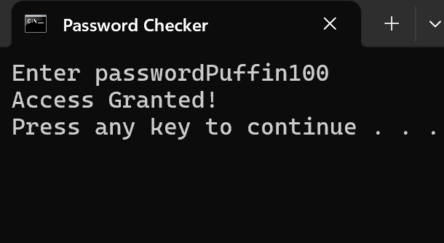
Figure 41
Successful password verification

9. Figure Y: Incorrect password entered (admin123). The script displays “Access Denied!” because the entered password does not match the stored password.
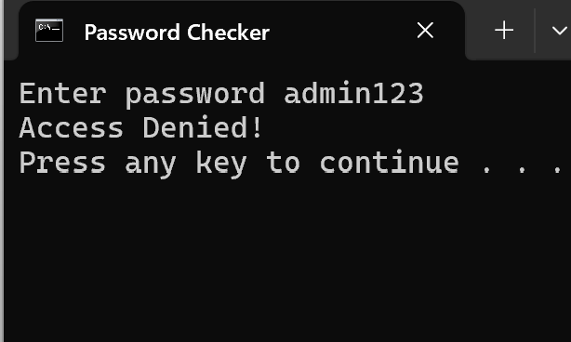
Figure 42
Failed password verification

4.3 Script System Health Check
The System Health Check batch script shows essential details about the computer, such as the computer name, operating system, available disk space, and physical memory. It simplifies regular system monitoring by executing built-in Windows command-line tools and displaying the outcomes within a single Command Prompt window.
No.1
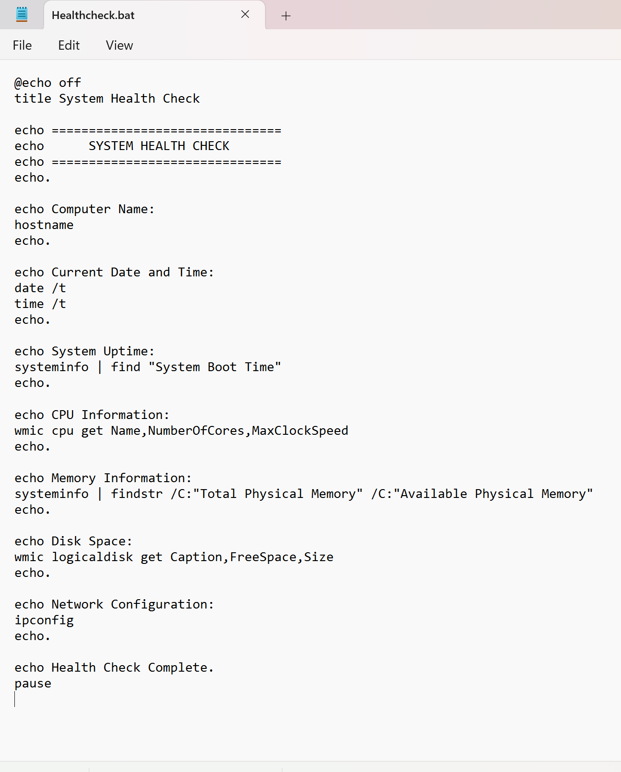
Figure 43
Health Check Batch Script Code
Brief description: Windows Health Check batch script (Healthcheck.bat) displaying system information and network configuration.

No.2

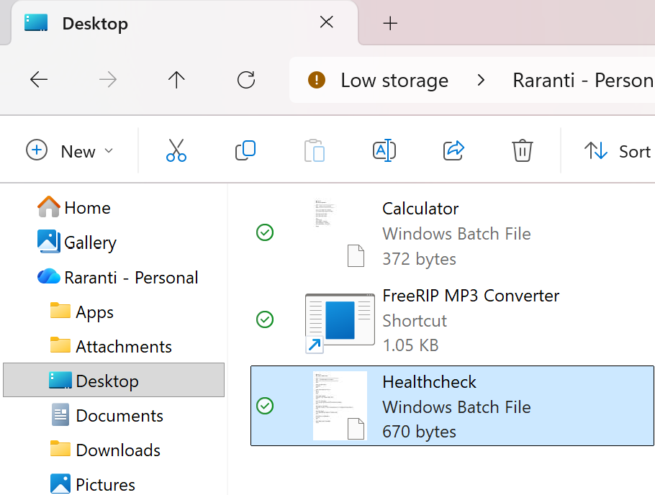
Figure 44
Saved Health Check Batch File
Brief description: It shows the Health Check batch file (Healthcheck.bat) successfully saved to the Desktop.

No.3

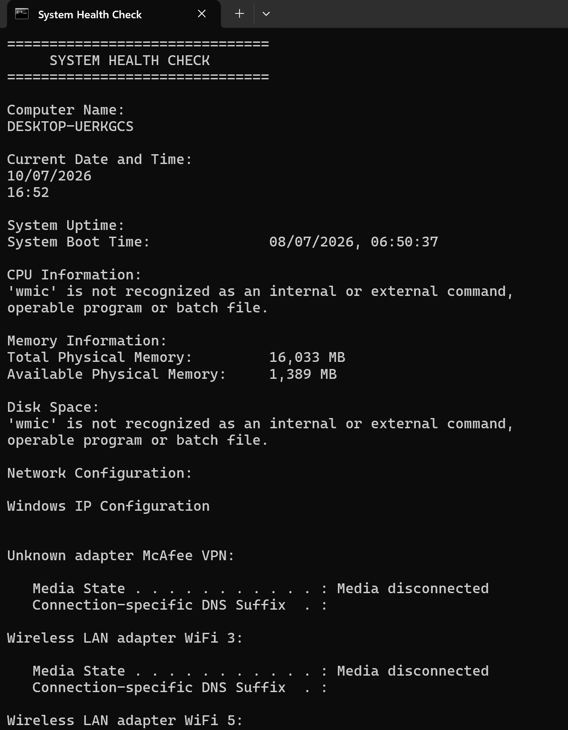
No.4

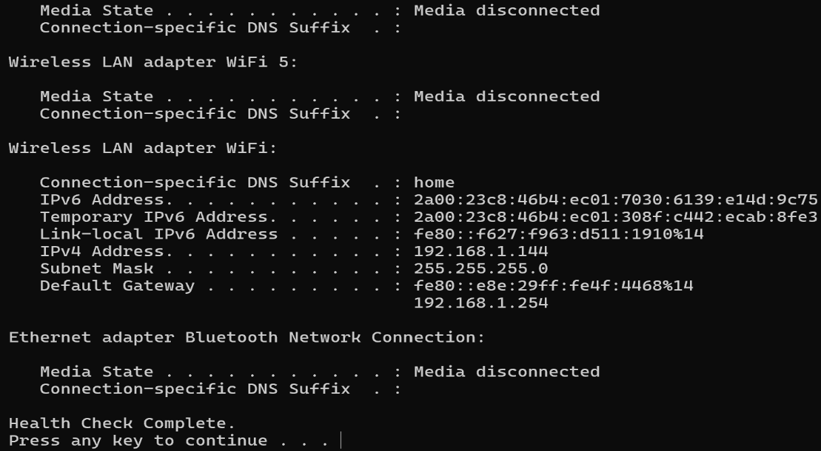
Figure 45
System Health Check Script Output
Displays the output of the Windows System Health Check script, including system information and network configuration.

Key Features Demonstrated:

Use of the Windows OS Script Health Check
The Windows Health Check batch script showcases essential Windows scripting capabilities:
- Echo commands for displaying headings and labels.
- System information retrieval covering computer name, date, time, CPU, memory, disk space, and network settings.
- Automated system checks.
- Usage of commands like hostname, date, time, systeminfo, ipconfig, and pause.
- Organised output into distinct sections.
- Batch file automation for routine system management.

These features illustrate how Windows scripting can facilitate system monitoring and quickly collect vital information about computer health.

5. Use of Linux OS scripts
Linux OS scripts, written in Bash (Bourne Again Shell), are used to automate tasks. These scripts allow multiple commands to execute from a single file, increasing efficiency and reducing manual work. Bash scripts can manage variables, user input, loops, calculations, and conditional statements for functions such as file handling, system monitoring, and process automation. In this coursework, Linux scripts were created and executed in the terminal to demonstrate automation and control flow.

No.1

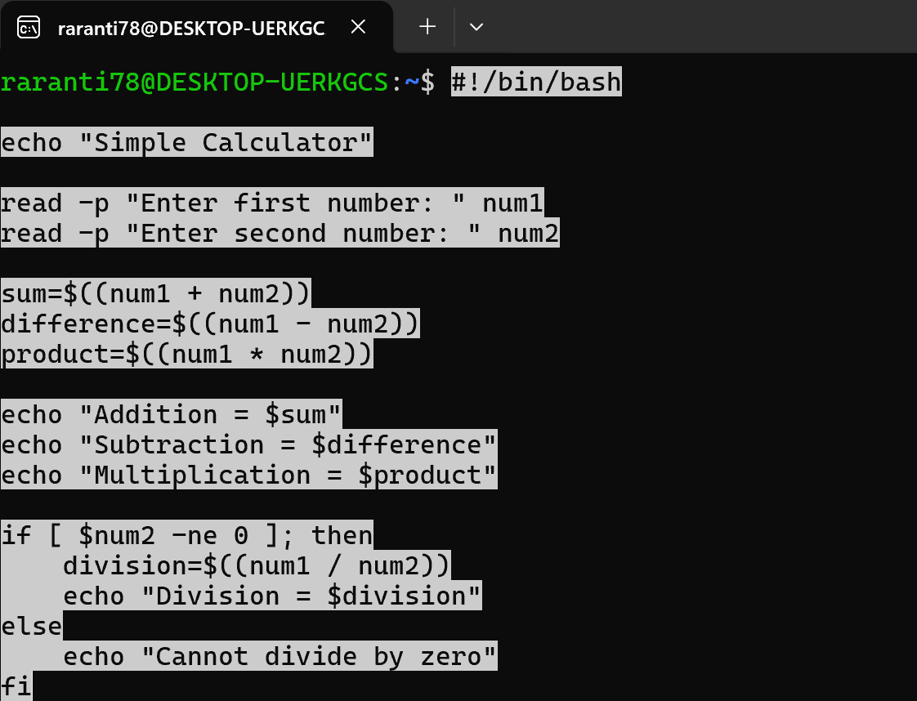
Figure 46
Displays the Simple Calculator script running commands

Explanation:
- #! /bin/bash - Indicates the script uses the Bash shell.
- echo – Outputs text to the terminal.
- read -p – Prompts the user and stores input in a variable.
- $(( )) – Performs arithmetic operations like addition, subtraction, multiplication, and division.
- echo “$variable” – Shows the value stored in a variable.
- if … then … else … fi – Evaluates a condition and runs different commands based on the outcome.
- -ne – Checks if two values are not equal.
- Variables such as sum, difference, product, and division hold the results of calculations.

No.2

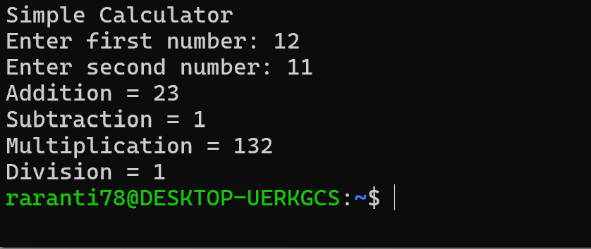
Figure 47
Simple Calculator processing

Script: Log File Analyser

The Log File Analyser is a Bash script that reads and analyses Linux log files, searching for entries like errors and warnings through variables, user input, loops, conditionals, and commands such as grep, wc, and cat. It helps users quickly identify system issues while minimising manual effort. This script showcases how Bash scripting can automate log monitoring and fundamental system administration tasks.

No.1

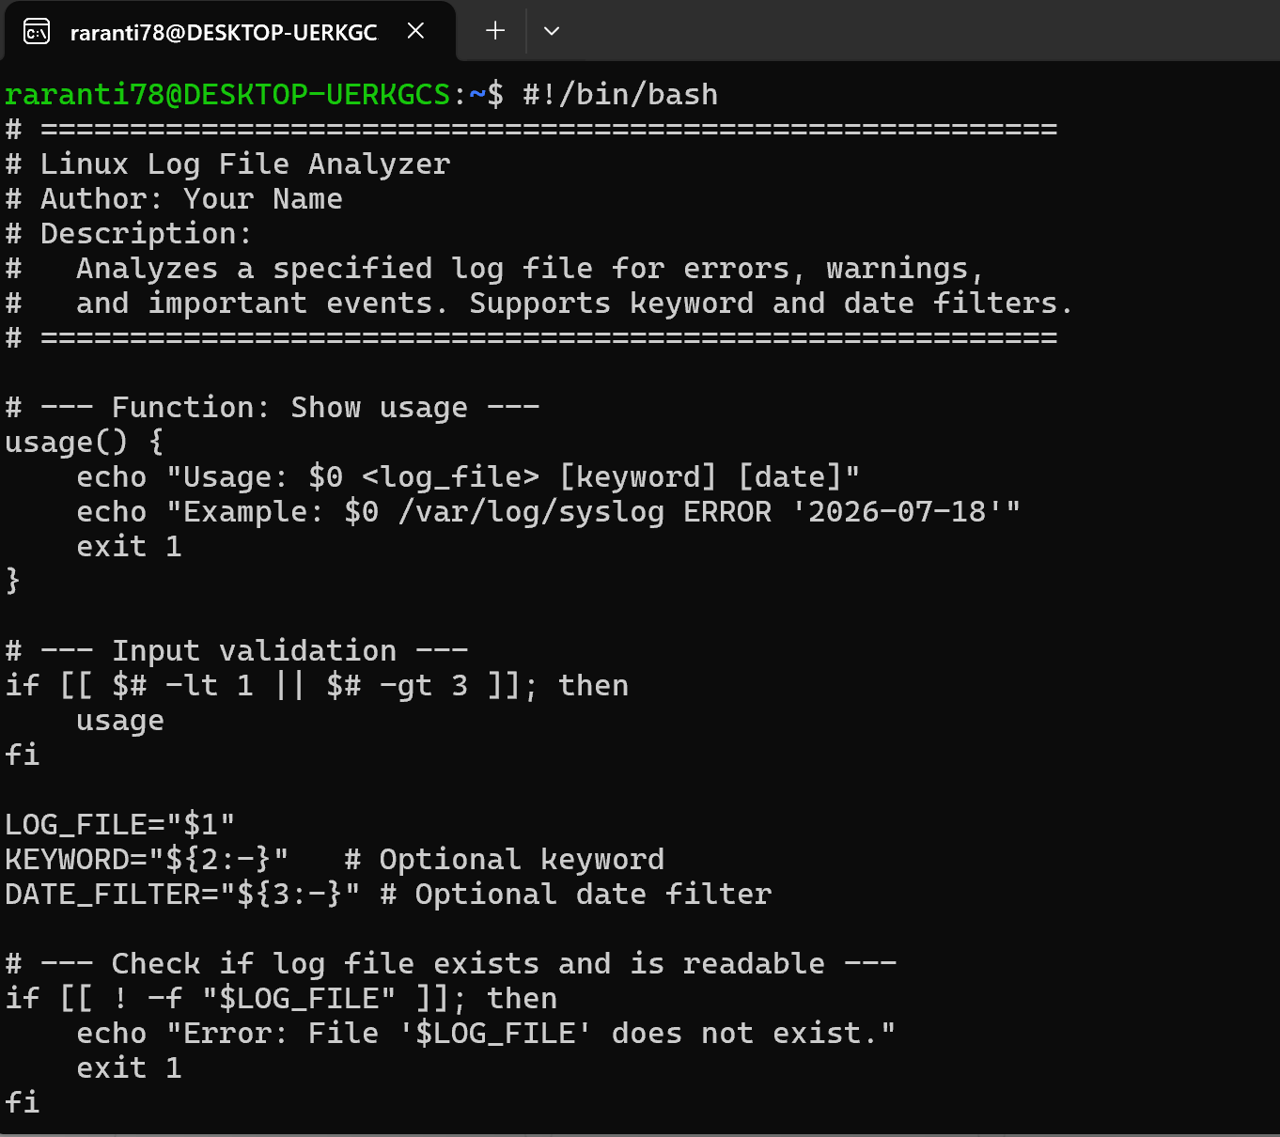
No.2
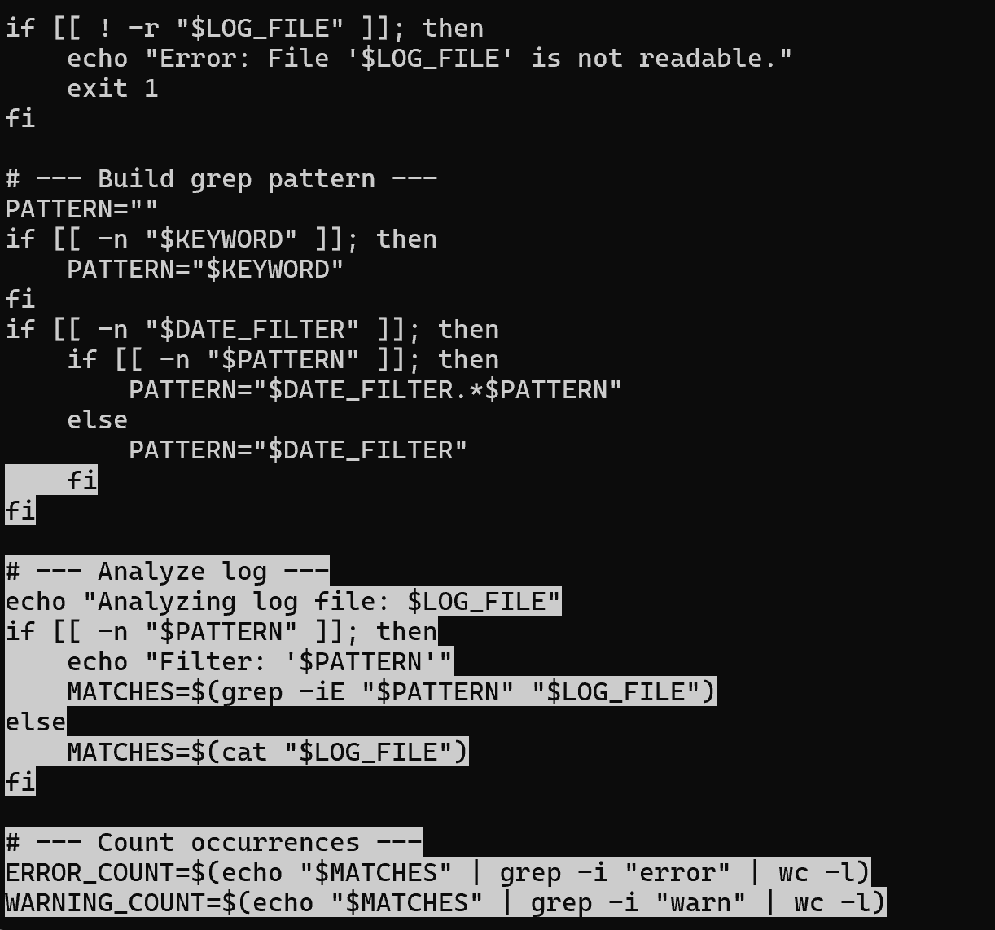
No.3
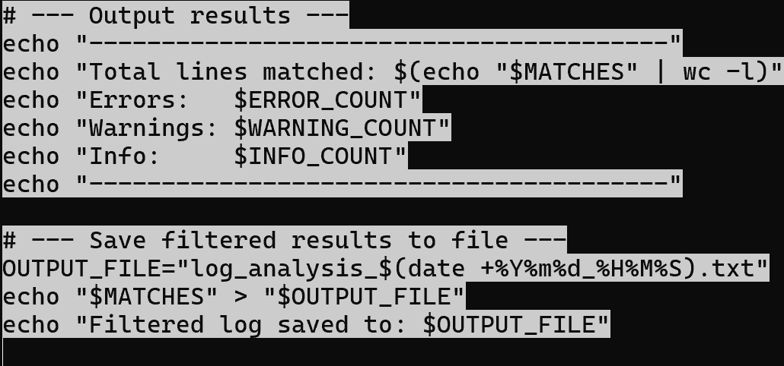
Figure 48
Bash Log File Analyser showing variables, conditions, and output.

Key Features Demonstrated

Use of Linux OS Script: Log File Analyser
- Variable – Stores the log file name and user input.
- User Input – Allows users to specify the log file.
- Conditional Statements – Check whether the log file exists before analysis.
- Loops – Process log file entries efficiently.
- Linux Commands – Uses grep, cat, and wc to search, display, and count log entries.
- Automation – Automatically analyses the log file …
- Output – Displays results clearly for easier identification of errors and warnings.

Conclusion
This report described the main roles of a general-purpose operating system, including process and memory management, file systems, and security. It also demonstrated the use of Windows and Linux command-line tools for system administration. The Windows System Health Check script gathered system information, while the Linux Log File Analyser automatically reviewed logs to spot errors and warnings. These scripts show how automation improves system monitoring and management. Overall, the report emphasized how operating systems, command-line tools, and scripting support effective computer performance and administration.

References
[1] R. Banoth and A. K. Godishala, "The Windows Operating System, Linux Overview," in Building a Secure Infrastructure: The Key Procedures for System Network Security, Springer, 2026. pp. 19–106.
[2] T. Jaeger, Operating system security, Springer Nature, 2022.
[3] J. M. Hart, Windows system programming, Pearson Education, 2010.
[4] P. Yosifovich, A. Ionescu, M. E. Russinovich and D. A. Solomon, Windows Internals: System architecture, processes, threads, memory management, and more, Part 1, Microsoft Press, 2017.
[5] V. Saxena, A. Kumar and V. Danwa, "A Review of Cloud Computing CPU Resource Optimisation: Methods, Difficulties, and Prospects", in Proceedings of the 6th International Conference on Information Management & Machine Intelligence, pp. 1–5.
[6] A. Yadin, Computer systems architecture, CRC Press, 2016.

