Academic and Employability skills

University of Wales Trinity and Saint David London Campus
BCs Cloud Computing Level 4
Student name: Ofeliya Artin Kazazyan
Student ID: 1907555
Subject: Academic and Employability skills
Lecturer: Modak Koushik
Date:27/12/2019

Table of Content:
I. Introduction
1.1 Who is writing this
1.2. Education
1.3. Work experience
1.4. Key points for my presentation
II. Skills required for Employability and Higher Education
1.1Strengths and weaknesses
1.2. How did this course help me?
III. Short-term and long-term goal
1.1. Short- term goals
1.2. Long-term goals
1.3 Self evaluation
IV. Looking after your data
1.1. Data preservation
1.2. Possible scenarios
1.3. The Rule of three
1.4. Time management
V. Conclusion & evaluation
VI. Appendices



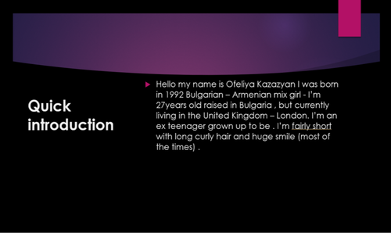
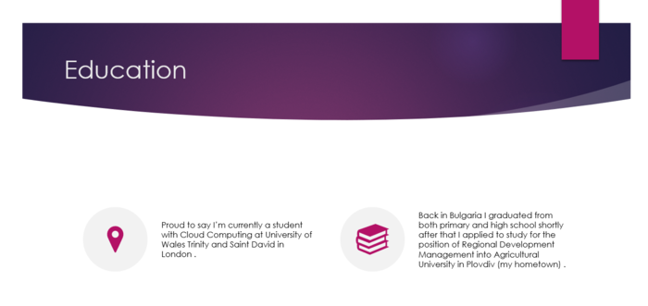
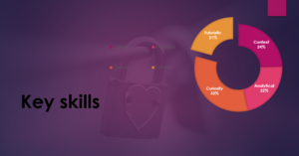

I. Introduction
1.1 Who is writing this
Hello, my name is Ofeliya Kazazyan I am 27 years old, I was born and raised in Bulgaria, my mother is Bulgarian my father is Armenian and I have two sisters older than me they both live in Bulgaria and my father I live here with my mother . I came here to try and live a better life because forget about the money / salaries for a moment from my personal experience what I can tell is that people here have better character , more positive people live here which makes me feel and think that I will be able to manage and have better opportunities but of course every opportunity comes with some kind of sacrifice just like being in university in order to progress you have to put in hard work stress and nerves but after completing your tasks you get to feel so satisfied from your achievement. And if you apply like me to study computer science for example you will have sleepless nights but at the end as I said the feeling is amazing.
1.2. Education
This is not the first time I am in university in my hometown - Plovdiv I was accepted for the position of Regional Development Management into Agricultural University where I studied one year when I decided that this is not what I really am into.
1.3Work experience
Work wise compared to most people I started working when I was around 18 years old and if you ask somebody he or she will tell you that they started working at younger age more like 14 or 15. My first job was as receptionist in Hostel named ‘Old Plovdiv’ – just like the name of my city in Bulgaria and my duties include much more than just being a receptionist I was responsible for first of course meeting and greeting clients, booking meetings , arranging couriers , keeping the reception clean and tidy at all times, answering phone calls, sorting post , report to the police clients personal information also my responsibility did not end here I was making breakfast preparation which includes serving food and hot drinks to clients , cleaning the tables and cleaning the reception with a hoover. I was working day shifts and night shifts. Later on, I decided to try out as a real estate agent for ‘Vavilon Build- LTD ‘my duties there were selling properties and homes via Plovdiv area with success through networking and prospecting. Set and manage appointments to show homes to variety of clients. To be a real estate agent you must know how to deal with lenders, home inspectors, pest control operators, help clients decide between financing options to ensure absolute satisfaction. Escrow companies and to make sure that all terms and conditions of purchase agreement were met. Keep up to date on competitive real estate knowledge through attending conversations, reviewing listings and trade journals. One of my favorite jobs was actually here in London like a teaching assistant(TA) in Bedelsford School – Kingston upon Thames for children with disabilities here are some of the responsibilities I had there as a teaching assistant supporting teachers in managing class behavior, looking after children who were upset or had bad accidents , helping children with extra support like feeding or and basic movements , reading them stories , helping teachers to plan learning activities and complete records , cleaning away materials and equipment after lessons is a must, taking part in numerous trainings – like First Aid , or tube feeding and many more , carrying out administrative tasks.
1.4. Key points for my presentation
To make a good presentation you have to know some tips like rule number one keep it simple don’t over do it, add only the important information that you want to present. Be able to grab the audience get their attention be friendly, smile to the audience and do not forget eye contact is very important too! You can try and make small jokes or even say a story if you wish to but have in mind that a good presentation should be kept short no more than like 20 minutes and also must be no more than 10 slides – sometimes less is more . Last but not lest importance is to be relaxed and to enjoy the whole experience.

II. Skills required for Employability and Higher Education
1.1 Strengths and weaknesses
Like every person I have strengths and weaknesses , some of my strengths include my timekeeping I am very punctual I do not like being late for any occasion , I love communicating and engaging with people or leadership as well , also I have the ability to identify and define problems while looking for the best solution. Adaptability is not uncommon for me as well – adapt to survive. I can add that I do have attention to detail and every little piece matter to me. One of my greatest weakness is the ability to concentrate on one task at a time. Perfectionism this one can be both positive and negative skill for me sometimes it helps me a lot of other times it just confuses me more. Finally, patience is probably my biggest weakness of all, if I can master this skill, I believe I can archive many things in life.

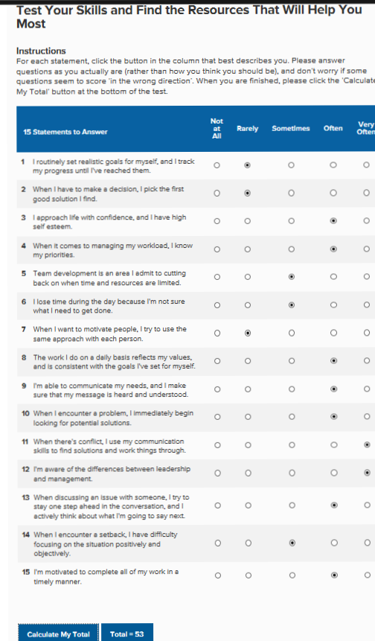
(mindtools.com, 2019)

1.2. How did this course help me?
How you present your knowledge, attitudes, skills and how you use your assets to the employers it is what matters for your employability. This course did not only help me but keeps helping me to improve my writing skills my communication skills and interpersonal skills which is the ability to explain what you mean concisely through written and spoken means. To listen and relate to other people, and to act upon key information / instructions. Problem solving skills to be able to break down into small parts, understand a problem. Self-motivation to be able to complete tasks without being pushed or forced by someone or something in your life but to do things on your own will. Deadlines and work under pressure. Team working to accomplish tasks together in a group with people from different backgrounds and disciplines. Organizational skills meeting up deadlines and targets, monitoring progress of work. (www.exeter.ac.uk, 2019) All those skills I can help me towards my study my and my work life.
- Short-term and long-term goals
1.1. Short-term goals
My short-term goal is to be able to write better reports and essays, to have better grammar to be more patient and give myself time to catch up with all the material. Another wish of mine is to be able to understand and use most of what I learn in the university. To graduate to find myself a good job and take care of myself and the people that I love.
1.2. Long-term goals
Setting a long-term goal brings people a purpose in life. It builds you to be more responsible and reliable person. My long-term goal is to be more hard working on everything I do never to say ‘NO’ on difficulties in life because that is how you learn best. I learned that making plans for my future helps me to be more focused on what I need to do instead of just wasting time because time is priceless, and nobody can give it back to you.
1.3. Self-evaluation
To be successful in future in my personal or work life and even academic life what it takes is to be persistent, to stay positive at all times, keep the stress away. Try to be more open-minded and creative and do not give up on the first obstacle that comes in your way.

IV. Looking after your data
1.1. Data preservation
In development of your files you have spent a lot of time and energy, so keep them safe. Discover how to carefully select and store what to keep. Keep your data safe make sure it will not disappear. Learn how data and backups are stored and how you can get the maximum benefit from your data by saving and sharing. Do not think that your digital data is safe only because have stored your data on multiply places it is safe because digital technology is developing rapidly and we all at risk from one or more of the problems: File formats may not be compatibly with the future software which can make them illegible or unreadable, and even if its still possible to open a record with new software, they may not be usable or durable to the degree that continuing storage media can be damaged, scratched or even destroyed, in particular if they are portable like USB stick, so that material can be lost to files or records. To Keep your data safe record the details correctly and make it comprehensible in future. Transfer data periodically to new storage devices (drivers fail with time). Maintain more than a copy of the data and storage media in different ways. Migrate data to new versions of software or use format that can be quickly inserted into different software systems. Ensure your data can be re-used in the future and take some initial steps in the development, organizing and storing of your data in order to make sure your data remain accessible and clear for the future. (www.data.cam.ac.uk, 2019)
1.2. Possible scenarios
People usually do not think of backups until the time comes, they just believe backups are working and no one cares about them. Losing data can happen to anyone but when it happens it is important to restore your data by using a backup. Backing up data is crucial part for a firm for example on a daily and weekly basis. Making sure that the data is restored from that backup is even more significant. It takes just one click to ruin your day. For instance, take a small firm with about 12 attorneys. The firm of 12 attorneys had their data backed up by a service firm but the service firm has had data backup problems. They do not always get their files backed up, but they are working on it. One employee opens an email attachment and installs a program called Cyberlocker, which is unknown to them. This software scans their device and all network drivers for documents from MC Office, JPG files, PDF files and several of their file types and encrypts the documents. All the files are still there but no one can open any of the firm’s files, move/copy them or to do anything with them without a key to unlock the files. The key is help for ransom and somebody else’s power over their data. Cyberlocker is a modern ransomware security type. The app keeps the company’s ransom files and is given 36 hours to pay 350 dollars or the equivalent in Bitcoins. If they refuse to give money people behind Cyberlocker that own the key to open all their files will be destroyed. If they do not do, they have a good data backup? Sure, perhaps not. There is no question that by having a regular testing and restoration of the data it takes time, but no data will be lost. You need regular, tested and reliable backups. (Turner, 2014)

1.3 The Rule of Three
Anyone who has been a victim because he/she failed to do backup know that backup is essential. While contemplating backups, the rule of three is a reasonable thumb rule for any data that you do not want to lose; back up the data in three different locations for each company. The three places may be different, but there should be three. Some examples might include: Backup your data in the office – local backup (disk image) or backup drive. Use a different type of media- cloud based backup system or a DVDs. Backup outside the office- a physical backup within a substitute geographical location. Or for a small office, a system could be: Data stored on the cloud is backed up to a local external drive. A cloud-based backup is backing up the same data in case it burns down for example. Offsite on weekly basis preferably nighttime an image of the local external drive is being taken.
Additional backups might be included like Database, Financials and Time and Billing. Many people think about records, spreadsheets, slides and PDF files as you think about backups. While these papers are a law firm’s lifetime, do not forget to also back up your resume, financial system and to practice management systems as well. Do these systems backups make it easy to recover the data? What could happen if you lose access to your important data today? Would you like to restore your data without any loss of it? Once a year make a test of your backup of financial/time and billing/email/practice management system once a year. You may be surprised how long it takes. (Turner, 2014)

1.4. Time management
“Time management” is the organization and planning process for dividing the time between specific activities. Good time management allows you to work faster-not harder-so that even when time is tight and stress is high, you get more done in less time. Difficulty to control your energy causes damage to your productivity and tension. It appears sometimes that the time we have is never enough but no matter that we all share same hours – 24 hours, then again, we wonder why do some people accomplish much more with their time than others? Well the answer is perfection in time management. Yet even when the time is pressuring us by using some time management techniques, we can achieve many things. Good time management requires a major change from action to outcome: being busy is not as being effective. (Often reverse is closer to the truth, ironically). End your day in frenzy, as you break your focus between so many different tasks always complete little. Good time control allows you to work intelligently – not more difficult – do more in less time. It may look like inefficient to spent time to learn about time management but the benefits from it are massive. The beneficial side you get to have less stress, greater productivity and efficiency, better professional reputation, greater chances to improve your career and life. But on the other hand, failing on time keeping can lead to undesirable consequences: High level of stress, poor work quality, deficient workflow and missed deadlines. So then immerse yourself in the main time management skills: goal, preparation and concentration. Explore social ideas and time management methods to understand the right thing for yourself. Be more effective, achieve more and work more to have successful and to be flexible at any cost. (team, 2019)
V. Conclusion and evaluation.
In conclusion no matter where are we coming from we can all thrive to concentrate on reducing our weaknesses and maximizing our strengths on daily basis also on our preferences in life to be able to make the right decisions, be more motivated in life with challenges and of course time management analyze, plan and less stress and more focus. Nowadays everybody relies on digital data itself that is why data preservation is important extremely important for example in the medicine or the law. Besides data contains so many things in our regular basis life it like entire web domains, email, games, social media and many more we can even store information in space.

References
mindtools.com 2019, Get started with the mind tools. [Online] https://www.mindtools.com/pages/article/get-started.htm [ Accessed 26th December 2019 ]
team, M. t. 2019, What is time management? [Online] https://www.mindtools.com/pages/article/newHTE_00.htm [ Accesed 26th December 2019 ]
Turner, P.(2014, . lawtechnologytoday. Backups - The Rule of Three [Online]
Available at: https://www.lawtechnologytoday.org/2014/12/backups-rule-three/ [ Accessed 26th December 2019 ]
data.cam.ac.uk. 2019. Looking after and sharing your data. [Online]
Available at: https://www.data.cam.ac.uk/data-management-guide/looking-after-and-sharing-your-data [ Accessed 27th December 2019 ]
STEMNET 2019, 01.02 Employability skills [Online] Available at: https://www.exeter.ac.uk/ambassadors/HESTEM/resources/General/STEMNET%20Employability%20skills%20guide.pdf [ Accessed 27th December 2019 ]








