

Employability and Career Development Report – Selection of In-Class Tasks Component 2

Student Name: Anna Maria Fleszar
Student ID: 2427097
Module Code: LCLM4005
Module: Employability and Career Development
Lecturer: Piyumika Gamage

Table of Contents
1. Key Skills Required for a Teaching Assistant Role 3
2. Evaluation of my own skill 4
2.1 SWOT Analysis 4
2.2 Evidence of Readiness 5
3. Employment Goals 6
4. Personal Development Plan 6
5. References 8
6 Appendices 9

Key Skills Required for a Teaching Assistant Role

To identify the important skills needed for my preferred future role as a KS1 teaching Assistant, I analyzed four job advertisements from different organizations, all of which were found on the Indeed Website. The four job advertisements analyzed for this assignment are included in the appendix for reference (see Appendix A-D). These include roles in Key Stage 1 (KS1), primary schools, nurseries, and early years settings. Although these environments are different, the advertisements revealed a few shared skill expectations as well as important differences.
Across all these roles, communication was highlighted as the most important skill. A Teaching Assistant must communicate clearly not only with children but also with teachers, parents, and colleagues. This is especially important in KS1, where children are still developing language and understanding. Another common skill was patience. Young children often need reassurance, emotional support, and help managing their behaviour. All jobs also emphasized the need for calmness and a nurturing approach. As every role requires working closely with teachers, parents, and staff, Teamwork was listed as a crucial skill needed in the education sector. Experience working with children also appeared in all of these positions. Employers value candidates who understand how children learn and behave. Behaviour management, enthusiasm, and positive attitude were also constantly mentioned.
The job advertisements also showed some differences. The level of qualification ranged. Some roles required childcare certificates or a university degree, while others accepted unqualified applicants as long as they were willing to learn. The age of the children also varied: KS1 roles focused on pupils aged 5 – 7, while the nursery role concentrated on younger children aged 3 – 4. While the EdEx job was focused on phonics, reading, and early literacy, the Lunchtime Teaching Assistant was focused more on children’s well-being and supervision. Some of the positions required supporting children with SEN, and others only mentioned that it is desirable.
All of these similarities and differences helped me to recognise the main skills I need to work on. Especially communication, behaviour management, and confidence supporting learning.

2. Evaluation of my own skill

2.1 SWOT Analysis

Looking at those skills that were required by the employers, I tried to reflect on my own qualities by completing a SWOT analysis. A SWOT analysis is a useful tool for identifying strengths, weaknesses, opportunities, and threats in relation to career planning and employability (CIPD, 2023).
My Strengths:
I am a calm, patient, and caring person, and these skills help me to build a strong, positive relationship with children. The Mock Interview exam also reminded me of my experience of Leadership during my apprenticeship in primary school in Poland, where I was asked to run an after-school German club independently. I planned activities, organized the classroom, and managed behaviour, which showed confidence, responsibility, and good organization. I have supported children of many ages, from babies to KS2, and this has strengthened my empathy and understanding of children’s needs. My background as a nanny helped me to develop emotional support skills, especially in situations like helping a distressed child who was anxious about going to school. Through patience and consistency, I helped him feel more confident.
My Weaknesses:
One of my main weaknesses that stands out when reading these four advertisements is a lack of classroom experience in UK primary schools. Another crucial skill I would need to improve is my communication skills, and this is critically important for a Teaching Assistant as it serves as a link between the students, teachers, parents, and other staff. Without mastering this important skill, I will not succeed in my dream role. I would also need to work on my confidence in behaviour management and enhance my knowledge of the KS1 curriculum, especially phonics and early reading techniques. Sometimes I can feel overwhelmed in new situations, although I have improved over time.
Opportunities:
There are many development opportunities. Volunteering in schools, learning from the teachers, and taking online Skills Development Courses are just a few ways of growth. There are also many public speaking courses in London; attending them personally will definitely enhance my ability to speak with confidence. And my current work in a school kitchen helps me to observe children’s behaviour and procedures used in a school setting.
Threats:
There may be strong competition for Teaching Assistant positions, particularly from those with more extensive experience in UK primary schools or Level 3 qualifications. Also, working and studying can be difficult, but with good organisation is manageable. Additionally, native speakers have an advantage when applying for this position due to the expectation of English fluency in supporting literacy or numeracy.

2.2 Evidence of Readiness

Through my studies and work experience, I gained a range of skills and achievements to show that I am ready for future employment. My academic progress, including ESOL qualifications and current studies for a CARTHE in Business Skills for the Workplace, demonstrates my commitment and willingness to learn to improve myself. Additionally, my work experience provides evidence of readiness. I have worked in several childcare settings, including a nanny job, two school apprenticeships, and my current role in primary school. All these positions helped me to develop important employability skills such as teamwork, communication, responsibility, and time management. Moreover, I participate in extracurricular experiences such as running a German after-school club, helping with school events, and supporting workshops at a cultural centre. These projects strengthened my leadership, creativity, confidence, and good organisational skills. The positive feedback I received from teachers, parents, and colleagues, who appreciate my calm, patient approach and ability to build strong relationships with children, showed me that I am prepared and motivated to be a good addition to any classroom team.

Employment Goals
My long-term employment goal is to progress in the education sector and complete further qualifications such as Level 3 TA training, and I am planning to dedicate 3 years to accomplish this, or become a Higher Level teaching Assistant, and that should take me 5 years.
To reach this long-term goal, I set medium-term goals that focus on developing skills and qualifications. In the next 6months to 24 months, I will take part in 4 accredited CPD courses in phonics, SEND support, and behaviour management. At the same time, I plan to attend at least 3 public speaking or communication skills courses to enhance my confidence when communicating with adults or explaining instructions clearly. One of my goals is also to observe experienced staff at least once a week and assist with small tasks.
My short-term objectives will concentrate on acquiring practical experience and preparing for employment. My goal is to work as a volunteer or part-time Teaching Assistant within 3-6 months. In the next 6 months, I also wuld l;ike to update my resume and get ready for interviews by doing at least two practice interviews. These short and medium-term objectives are crucial milestones that will help me to develop experience, confidence, and abilities required to effectively accomplish my long-term professional goal and progress in my career. To ensure my goals are realistic and achievable, I used the SMART goal framework, as they are specific, measurable, achievable, relevant, and time bound and that increasesthe chance of success (Mind Tools, 2023).

4. Personal Development Plan
To support my progress to becoming a confident KS1 Teaching Assistant, I have developed a Personal Development Plan that focuses on improving the skills required for this role. A personal development plan supports individuals in identifying development needs, setting goals, and improving employability over time (Open University, 2021). One of my priorities is to build strong communication skills, especially when speaking with adults, as this is an area I identified as a weakness. So I am planning to observe experienced teachers, take part in speaking activities, and join reading groups. My aspiration is also to complete online courses in phonics, safeguarding, and SEND awareness to consolidate my knowledge of the KS1 curriculum. Gaining more experience is another key part of my plan, so I will apply for volunteering in one of the local schools to become more confident and familiarise myself with the classroom routines and procedures. My further plan includes gaining qualifications such as Level 3 TA training or Higher Level Teaching Assistant status, so that I can develop professionally and take on more responsibilities. By following this personal development plan, I will gradually build the skills, confidence, and experience needed to succeed in my future career. By creating this plan that includes training, experience, and reflection, I can take responsibilityfor my own professional growth and preapare effectivelyfor KS1 Teaching Assistant role (CIPD, 2022)

Personal Development Plan
Objective | Time | Activities | Succes Criteria | Resources
Short - term | 3 – 6 moths | Work as a volounteer or part time TA,  Update CV and practice interview,  Observe experie  nced staff once a week | Experience gained,  Confidence improved | Primary School Teachers
Mid - term | 6 months – 2 years | Regular TA Work,  Attend 4 CPD courses,  Attend 3 public speaking courses | Classroom routine confidence,  Positive feedback | Teachers,  CPD sites,  SEND support staff
Long – term | 2 – 5 years | Complete Level 3 TA training,  Preapare for Higher Level TA ,  Ongoing CPD and communication courses | Qualification achieved,  Career progression | Training providers,  School Leaders

5. References

- CIPD (2023) SWOT analysis. Available at: https://www.cipd.org/uk/konwledge/factsheets/swot-analysis-factsheet/ (Accessed: 13 December 2025)
- MindTools (2023) SMART goals. Available at: https://www.mindtools.com/a4wo118/smart-goals (Accessed: 13 December 2025)
- Open University (2021) Personal development planning. Available at: https://help.open.ac.uk/personal-development-planning (Accessed 14 December 2025)
- CIPD (2022) Continuing professional development (CPD). Available at: https://www.cipd.org/uk/knowledge/factsheets/continuing-proffessional-development-factsheet (Accessed 14 December 2025)

Appendices

Appendix A – KS1 Teaching Assistant job Advertisement ( Teach Now)

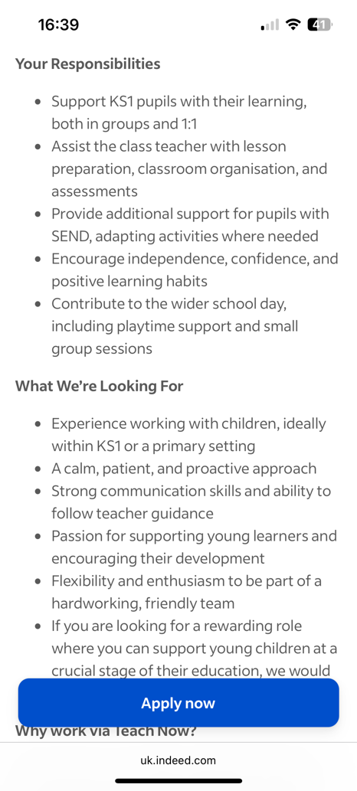
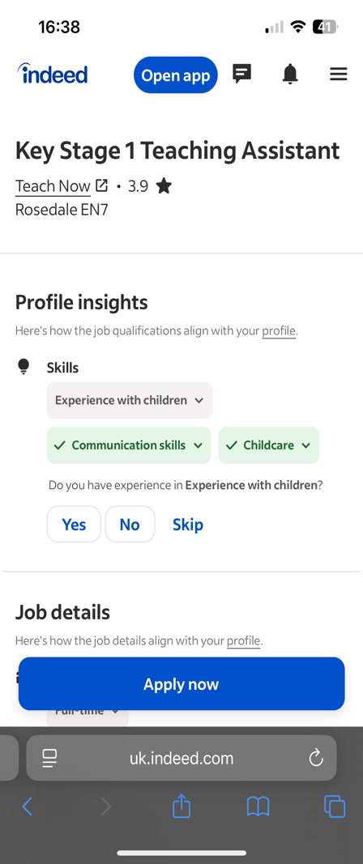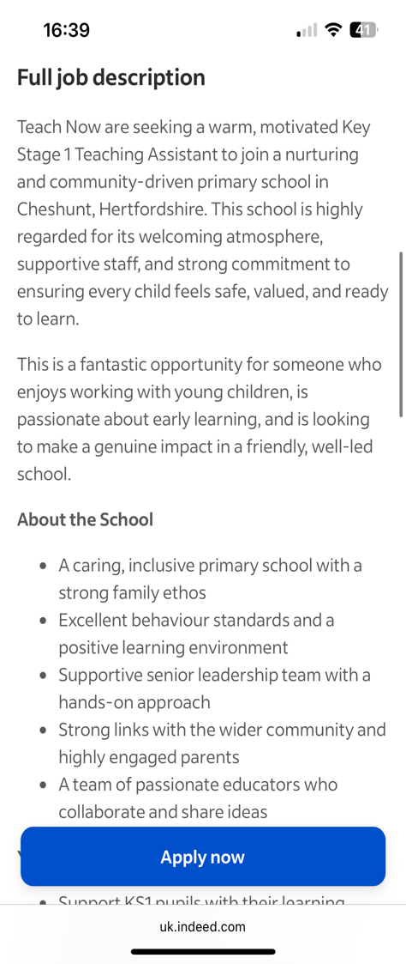

Appendix B – Primary Teaching Assistant Job Advertisement (Ribbon & Reeves)

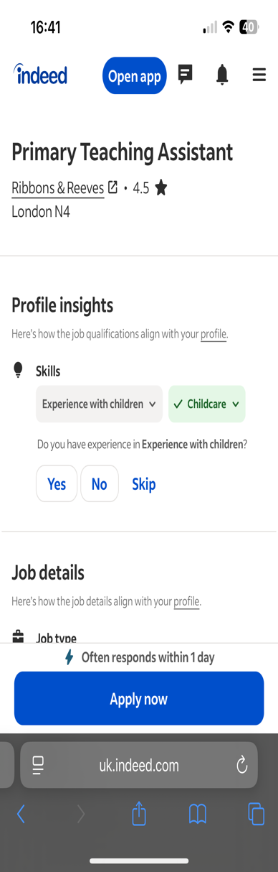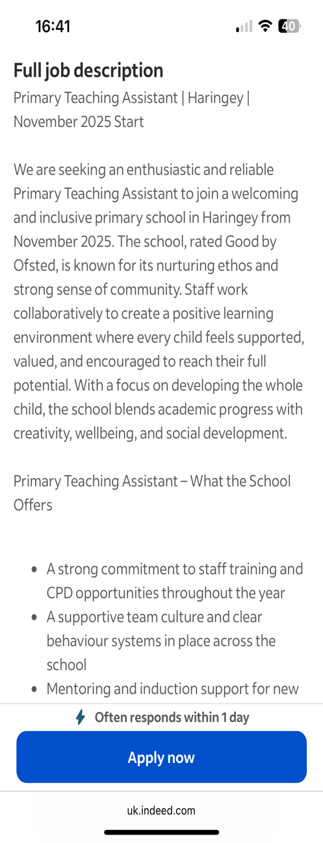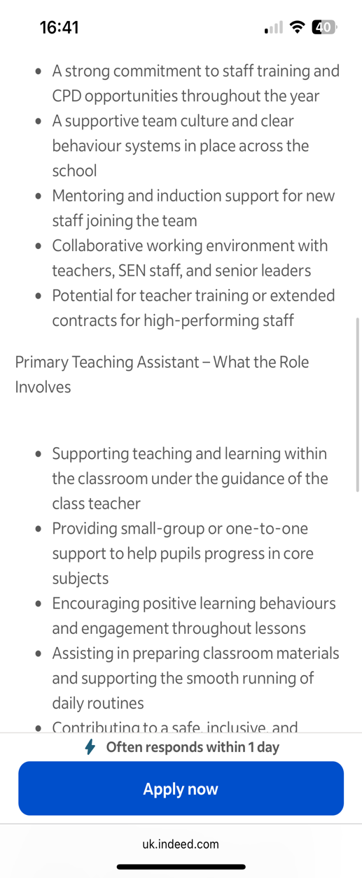

Appendix C – Lunchtime Teaching Assistant Job Advertisement ( Fennies Day Nurseries Ltd)

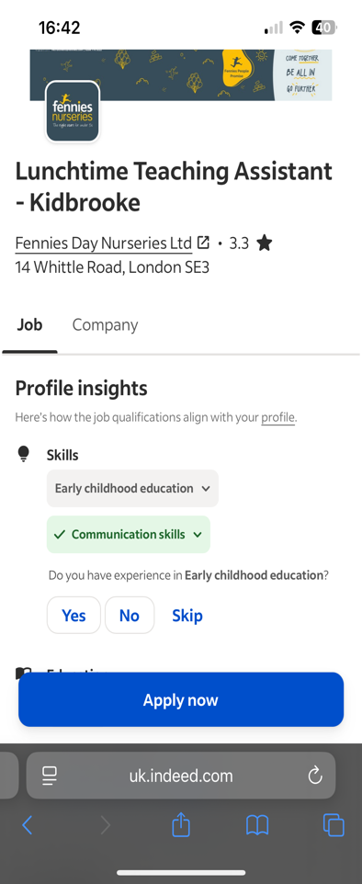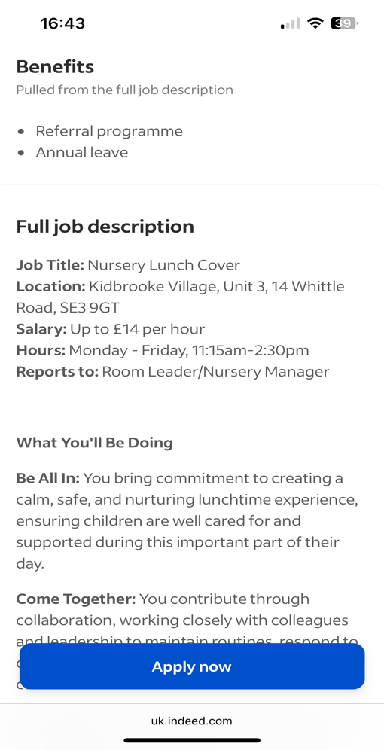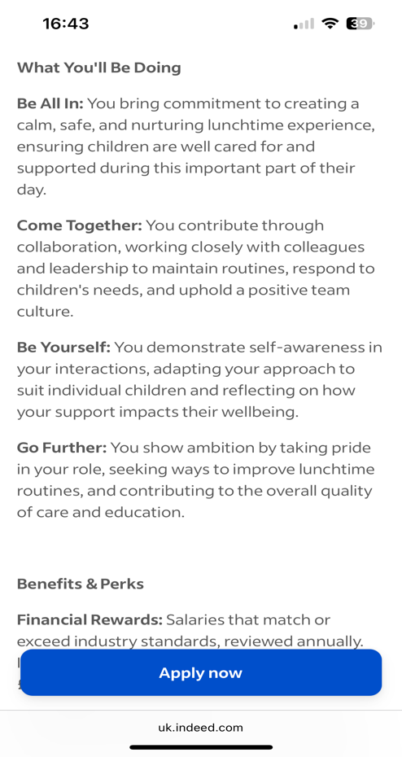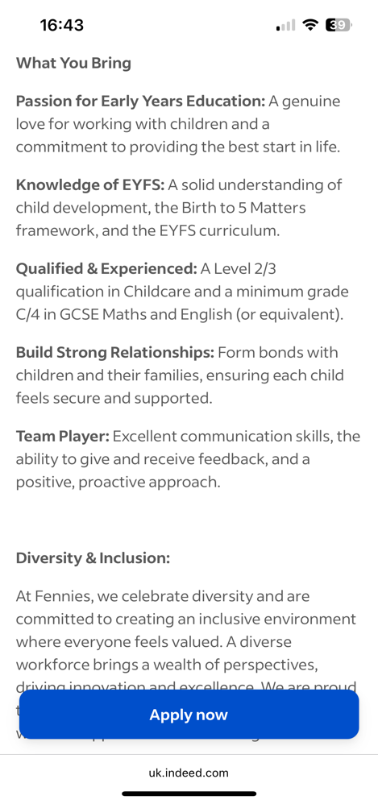
Appendix D – Unqualified Teaching Assistant Job Advertisement (EdEx)



