Civil Engineering Project Management Assignment 2.
Dylan Francis.

CONTENTS.

- INTRODUCTION.
- PURCHASING PLANT.
- LEASING PLANT.
- DEPRECIATION COMPARRISON.
- CONCLUSION.
- REFERENCES.

- INTRODUCTION.

In this second stage of the assignment I will discuss the different options of purchasing or leasing plant for construction, I will compare the advantages and disadvantages for both. I will also assess the most economical methods and provide calculations to establish the amount of depreciation.

- PURCHASING PLANT.
Pat Newman (2006) Explains how deciding to purchase plant will depend on lots of varying factors. Firstly you must consider how long do you plan on keeping the vehicle and how regularly it will be used. The main advantages to purchasing are that you will actually own the vehicle so you can decide how long you will like to keep it for and it can be sold at a fair price ensuing a reasonable percentage of the initial payment is considered, also if you prefer not to have continual out payments purchasing is the better option. The most common advantage and disadvantages when purchasing are:

Advantages of Purchasing. | Disadvantages of Purchasing
A One off lump sum payment. | The owner will have full responsibility for maintaining the vehicle and will have to pay any additional repair fees.
No monthly outgoings to cover the vehicle cost. | Some plant vehicles will depreciate in value quickly.
The vehicle is owned by the company/personnel and is up to them how frequently it is used. | If the vehicle is bought second hand there is a risk that its full history is unknown.
Company branding can be placed on the vehicle to act as promoting scheme. | Large unrealistic outright payments.
The Vehicle and be Modified to suit different jobs. | Purchasing can mean that you will fall behind with modern technology.
The Vehicle can be part exchanged when you wish to buy a new vehicle. | Pay the vehicles insurance yourself.

- LEASING PLANT.
Similarly to purchasing, leasing has its own advantages and disadvantages. Leasing is more commonly used by large building contractors as they are continually moving from site to site. The main advantage of leasing is that the plant is maintained by its original owner. Another form of leasing is (PCP) Personal contract purchase, this is when an initial down payment on the plant vehicle is paid and then followed by monthly payments which are deducted from the remaining balance, these contractors normally last for between 3-5 years and at the end of the contractor a final balloon payment is required.

(Maire Loughran N/A)

Advantages of Leasing | Disadvantages of Leasing
No Maintenance. | The vehicle is never owned by the company.
New Plant Vehicle every 3-5 years. | Large cost implications if the vehicle is returned damaged.
The vehicle can just be rented for the job duration. | The month payments can be seen as “Dead money” as it is never subtracted from the total.
Always keeping up with the latest technology by having the most modern equipment, increasing efficiency. | Large initial payments which can sometimes be thousands of pounds.
The Vehicle and be Modified to suit different jobs. | Once the vehicle is handed back at the end of its contractor another initial rental payment will need to be paid to start a new contract.
The Vehicle can be part exchanged when you wish to buy a new vehicle. | Added interest Rates
Skilled operative will usually also be hired in specialised cases.

- DEPRECIATION COMPARRISON.

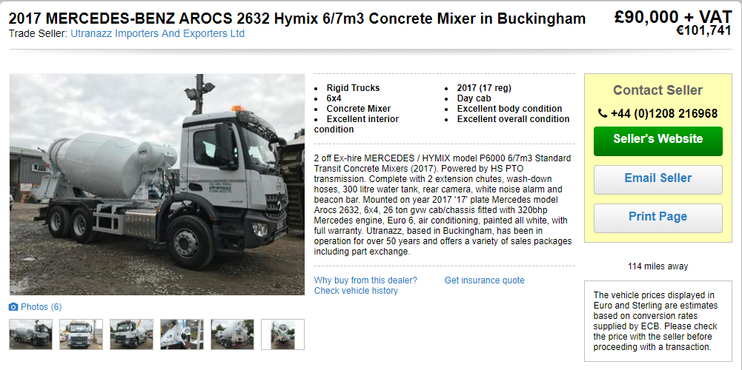
Image taken from (Auto Trader 2018)

This vehicle is the one I’ve decided to assess with regards to it decrease of asset value from new.

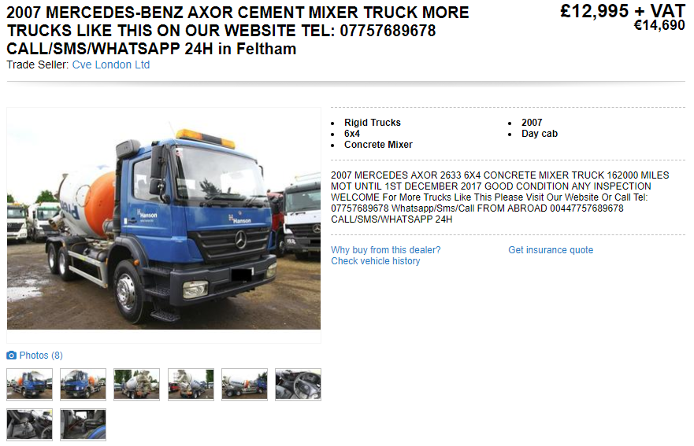
Image taken from (Auto Trader 2018)

This is a 10-year-old vehicle which shows what the salvage value would be after a 10 year period.

$$Dn=\frac{P-F}{N}$$

$$Dn=\frac{90,000-12,995=7,700.50}{10}$$

Year | Depreciation | Back Value
0 | 0 | 90,000
1 | 7,700.50 | 82,299.50
2 | 7,700.50 | 74,599.00
3 | 7,700.50 | 66,898.50
4 | 7,700.50 | 59,198.00
5 | 7,700.50 | 51,597.50
6 | 7,700.50 | 43,797.00
7 | 7,700.50 | 36,096.50
8 | 7,700.50 | 28,396.00
9 | 7,700.50 | 20,695.50
10 | 7,700.50 | 12,995.00

This chart clearly shows the line of depreciation of the concrete mixer.

- CONCLUSION.
This report has allowed me to develop an opinion on whether a company should lease or purchase a vehicle for a construction purposes. Purchasing a vehicle is a better option if the company plans to use the vehicle very regularly and on a range of different jobs, although this is a large fee initially it will pay off in the long run. The option of leasing is the better option if the company requires the vehicle for a specific job or it is likely that they will require the latest technology. Using a depreciation equation, it has proven that a concrete mixer which is one of the most common types of plant used on site depreciates by £77,005 over a 10-year period.

6.0 REFERENCES.

Pat Newman. (2006). Leasing vs Buying: Which Is Best for You? .Available: https://www.entrepreneur.com/article/169332. Last accessed February 2018.

Maire Loughran. (N/A). THE ADVANTAGES OF LEASING. Available: http://www.dummies.com/business/accounting/knowing-your-debits-from-your-credits/. Last accessed February 2018.

(Auto Trader 2018) https://www.autotrader.co.uk/

