

Operating Systems
Georgi Vangelov
Student Number: 1913380
BSc Cloud Computing
Instructor: Sunerh Fernando
Due Date

Table of Contents
Operating System 3
Introduction 3
Evolution of the Operating System 3
Types of Operating Systems 3
Functions of an Operating System 5
Command Line Interface 5
Windows Shell 6
Linux Command Line Interface 7
Windows Batch Files 7
Creating a windows batch file 7
Batch Elements 8
Linux Bash Scripts 9
Bash Commands 9
Conclusion 10
References 11

Operating System
Introduction
Operating system falls under the system software category of computer software, and it plays a major role of managing computer resources and processes. Operating systems gives a link between software and hardware and therefore, to utilise any software development or application software, an operating system must first be installed. In addition to this function, is the most significant role of the operating system that ensures user interact effectively with computer programs through provision of user interfaces [2].
Evolution of the Operating System
Since its first development in the early 1940’s Operating Systems have continued to increase and develop to become very sophisticated software, able to manage computer resources and processes effectively. Operating system’s evolution through the years are categorised into four generations, depending on the functionality and technology utilised to develop and operate them.
Operating System Generation | Period | Technology Used
First Generation | 1945 - 1955 | Vacuum Tubes and Plug boards
Second Generation | 1955 - 1965 | Transistors and Batch Systems
Third Generation | 1965 - 1980 | Integrated Circuits and Multiprogramming
Fourth Generation | 1980 – to date | Personal computers

Types of Operating Systems
Depending on the hardware software there is a lot of different types of operating systems. The most popular of all is the categories of operating system run on the microcomputers and mobile phones, since these gadgets are very popular with people. The following forms the types of operating system;

Batch Operating System
Batch operating systems allows for data processing simplification. This is achieved through task integration and combined performance. . A user always creates a batch file containing all the tasks to be performed and executes them through a command line interface [3]. In turn, the batch operating system executes the processes programmed sequentially. An example of batch operating system is the Payroll System
Multi-Tasking/Time-sharing Operating systems
This kind of an operating system allows users to utilise the same computer system, the terminal, accessed from remote locations. These operating systems include Multics and UNIX.
Real time OS
Real time operating systems is designed to perform time-critical operations, for instance launching and control of missiles would require a real time operating platform. Their design includes specific fast operation design structures. Military Software Systems and Space Software Systems are working examples of real time operating systems [6].
Distributed Operating System
Distributed systems utilise many processing machines found in various machines. This phenomenon allows for fast provision of task processing much needed in their functionality design. LOCUS is one main example of a distributed operating system.
Network Operating System
Network operating system is the principal software installed in network and system servers. The main functionality of network operating system is to manage network data, allow for network configuration, ensure network security, provide network applications and offer network functions. Examples of network operating systems include Microsoft Windows Server OS, Linux, Mac OS X, Novell NetWare, and BSD [6].
Mobile OS
The mobile OS is the principal software that runs, manages and control mobile devices resources. They are designed to operate smart phones, tablets and wearable devices such as watches. Today the Mobile OS are gaining popularity across the world due to the existence of so many mobile devices across the world that supports them. These operating systems categories include Android OS, iOS, Blackberry, watch OS, Harmony OS and many others that are used in smart phones [6].
Functions of an Operating System
- Processor Management: including task allocation and subsequently allocation of time to every process.
- Memory Management: which is allocation and deallocation of storage to computer processes.
- Device Management: all peripheral devices are controlled and managed by the computer.
- File Management: this is the file and folder management activities necessary in every kind of a computer. The function include creation, renaming, copying and cutting checking for errors and even deletion of files and folders.
- Security: provide use of password, firewall use and other antivirus capabilities.
- Error Detection: some operating systems have the capability of always tracking malicious programs and activity in a computer and providing adequate reporting for effective action.
- Job scheduling: enables multitasking and helps to schedule all the tasks in a computer.
Command Line Interface
Command Line Interface written in short as CLI allows users to communicate with the computer system by providing a character-input window. This allows to user to input a series of commands and the computer in return responds by doing the tasks requested. For instance, if one needs to change the computer’s time and date, using the windows operating system, he or she would open a command prompt and type in either ‘Time’ or ‘Date’ commands respectively. The figure below shows a CLI window with time change command executed.
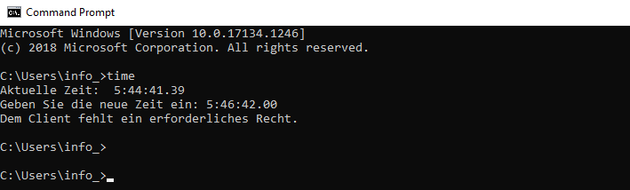
Computers respond to the CLI commands much similarly to their response to application button or icon click. These functionalities include opening files, deleting, changing date and time, starting specific programs and many other functionalities that the computer user intends to computer to perform. The CLI is built under the windows operating system, which provides both the graphical user interface and the command line [3]. Today command line interface plays a very important role, this includes major network configuration, system control functionalities among other computer operations.
Windows Shell
The main shell in Windows operating system environment is Command Prompt or the CMD.exe. To run CMD.exe application, one has to click on start and on the start menu, search CMD or command prompt and click on the resultant command prompt application. CMD window is by default a black screen allowing users to make text entries, which are normally in white colour [5]. Users utilizing the command prompt have an option of writing single line commands executed independently or multiple ones that can be executed in a sequence. Command prompt allows for the following system control tasks, which are fundamentally designed to be implemented by system administrators.
- Changing directories
- Networking configuration and trouble shooting
- Renaming special files in a computer
- Managing memory locations like forming, fragmentations etc.

Linux Command Line Interface
The Linux command line are referred to as shell, terminal, console command prompts profiles a text-based user interface to a computer running under the Linux operating system. The main function is to allow execution of simple programs that were pre-written in bash scripts and stored on the computer [1]. Pre-written bash files play a major role of helping cut down execution of specific functions of the Linux system control functions.
Windows Batch Files
Windows batch files are files with .bat extension with either single or multiple lines, which run on the command prompt environment to provide special output messages. The main function of batch files is to provide a simplified way of On Windows 10, a batch file typically has a ".bat" extension, and it is a text file, which includes; multiple commands that run-in sequence to perform various actions [4].
Creating a windows batch file
Creating a windows batch file requires one to a text editor like notepad.exe. The following is an example of a simple windows batch file creation with major steps followed.
Step 1: click on ‘Start’
Step 2: type ‘notepad’ on the search field of the windows start menu to open the required text editor
Step 3: type simple batch file text such as one shown below
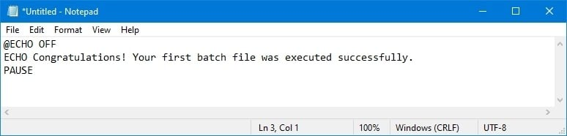Step 4: Click the File option on the notepad menu bar.
Step 5: click on the save as button to save the resultant text.
Step 6: Save the file created with an extension of .bat.
It is worth noting that batch files do not only have .bat extension, but also would use .cmd or .btm as their extensions. After completing step 6 the resultant batch file can be run by double clicking on it. Batch files can be run on a command prompt, file explorer or even on the task scheduler, which is when utilising the windows operating system sunning windows 10 version [3].
The above code outputs the following result on the terminal screen after successfully running.
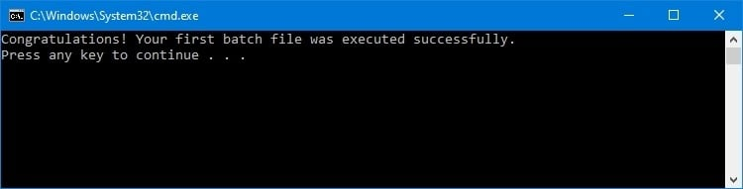

Batch Elements
@ECHO OFF — this element is written on the first line of the text editor and allows the message to be shown on a clean window by disabling the prompt display. The ‘@’ character on the element plays significant role of providing a clean output, however, its use can be omitted.
ECHO — this element helps to execute the lines of text written after them.
PAUSE — the pause command or element allows for the command prompt window or whatever environment is used to run the batch file to remain open after execution. Normally when this element is not used, the output window will always flash open and disappears immediately.
Linux Bash Scripts
Bash scripts does the same function of enabling execution of specific function in a Linux operating system just like the Bach Script do. Their main function includes execution of specific shell commands, enabling execution of many commands simultaneously, customization of system control activities in a Linux environment and enabling automation of various computer processes [3]. Any Linx user ought to know to includes write Bash scripts because this makes usage of the operating system very simple and performing various system-based executions become very easy to do.
A Bash Script file can be created using any text editor application that runs on a Linux platform such as Nano. Using various commands, that will be detailed by this paper, the user need to write the script lines carefully and save the resultant file with an extension of ‘.sh’ [3]. For instance, when one to write a bash script that outputs the following phrase, “Hello World! Welcome and feel free!” He or she has to document as shown below, then he or she should save using any name with .sh extension, like, myfirstbash.sh
#! /bin/bash
echo "Hello World! Welcome and feel free!"
Bash script files are run using a terminal.
Bash Commands
- Echo: This command is used to print a text line that must be written under double quotations. An ‘Echo’ command utilised with extensions have different usage and meaning. These functions include the following
- Echo-n – this is used to print a txt line without starting a new line
- Echo-e – this command is used to remove backslash characters on the output file.
- Echo-filename.sh – this command allows users to create new bash script files with a specified name for the file. For the command written one would opt to replace the word filename with any other name they have chosen to name their files.
- Comment Characters
# - this character is used to denote a single line comment or remark on a bash file, for example;
#! /bin/bash
# Multiply two numeric values
((product=34+10))
#Output the result
echo $product
: and ‘are used to start and end a multiple line comment in a bash script editor.
The above bash commands are just but examples of the major bash elements, which help Linux programmers to create and execute bash file. There are a whole lot of other commands that play a significant role while creating bash files.
Conclusion
Operating system is the main contributor of the major innovations in the technology field today. This includes the dynamism of programming environments that we witness today. The first operating system development platforms such as the use of command line interface have played a key role to shape the current operating systems despite having a completely different user interface platform, the graphical user interface. It is worth noting that all the operating systems types that we presently have in the market have one major similarity, the technology and models used to build and their functionality. The existing operating systems, be it Linux or windows, have the same functionalities with only a small deviation on how they are implemented [6].
References
- Both D. Using and Administering Linux.: Volume 2 Zero to SysAdmin: Advanced Topics. Apress; 2020.
- Du DX, Reisbick SA, Flannigan DJ. UEMtomaton: A Source-Available Platform to Aid in Start-up of Ultrafast Electron Microscopy Labs. Ultramicroscopy. 2021 Apr 1; 223:113235.
- Grant RH, Smith SD, Harrell SL, Younts A, Smith P. Windows-based Workflows on Linux-based Beowulf Clusters. InProceedings of the Practice and Experience on Advanced Research Computing 2018 Jul 22 (pp. 1-5).
- Musaddiq A, Zikria YB, Hahm O, Yu H, Bashir AK, Kim SW. A survey on resource management in IoT operating systems. IEEE Access. 2018 Feb 21;6:8459-82.
- Tanenbaum AS, Bos H. Modern operating systems. Pearson; 2015.
- Zhang Y, Huang Y. " Learned" Operating Systems. ACM SIGOPS Operating Systems Review. 2019 Jul 25;53(1):40-5.

