Problem Solving and Decision making

Contents
Introduction: 3
Background of the Company…………………………………………………………………..4
Analyse information on the identified problem, to help inform the decision making process:.5
Propose a range of alternative solutions to the problem: 7
Use a decision making technique to evaluate a range of solutions to identify the most appropriate option: 8
Develop a plan for implementing the solution: 9
Communicate the plan to stakeholders: 11
Assess appropriate monitoring and review techniques to ensure successful implementation of the solution: 13
Fishbone analysis of M&S leadership procedure…………………………………………….15
References: 16

Introduction:
In the modern day business environment there are multiple amounts of problems which hinder the developments of the process. Due to the greater rise in the problems of the environment of the business is affected and the efficiency of the business is lowered. Due to the lack of the business efficiency the productivity level of the business is affected and the lesser amount of revenues is generated. Thus the solving of the problems in the course of the business developments, the aspect of the problems solving must be looked upon in the utmost regard. In this following report the main problems of the business organization which has been highlighted is the lack of leadership within the business organization. The lack of leadership within the organizational structure is a significant issue which affects the working procedures of the organization. Thus by the virtue of this report a detailed discussion has been provided on the aspects of the mitigation of the leadership issues. Furthermore, the problems affection the process of decision making of the organization is also been highlighted in the process (Doz, and Kosonen, 2010). The importance of the decision making for the growth of the business propositions have been documented in this report. Moreover the impact of the problems on the decision making of the organization has also been highlighted. Discussions have been carried on developments of plans for negating the issues of leadership in a proficient manner.

Background of the Company
Mark & Spencer PLC Group is one of the major multinational retailers of UK. The head quarter of M&S is situated at Westminster, London. T was the first British retailer who has become the maker of pre tax profit owner of over £1 billion. Till 2019, it has earned revenue of £ 10.377 million. The amount of operating income of M&S is almost £ 601.5million and net income is £ 37.3 million. M&S generally consists of the stores of clothing, home ware and food hall. They have run their online delivery service from the mid of 2000 (Mark & Spencer, 2019).
In this report problems regarding leadership of M&S are going to be discussed with the proper solution on the basis of the information from the various valid sources related Mark & Spencer.

The complex problems in M&S include its scope and impact
In M&S, there can be multiple issues or challenges which can be detrimental in carrying out the business proposition. The aspect of the lack of leadership is one of the challenges is one of them. This is one of the major issues faced by all the organization across the globe. Lack or inefficient leadership within the structure of the business hinders the developments of the business. By the virtue of proper and impeccable leadership, a guidance and direction is provided to the employees inside the workplace. By the aid of this direction the tasks with significant amount of difficulties is comprehended with ease within the stipulated time frame. Incapability of the people within the workplace to lead and given direction in the workplace gives rise to the generation of the leadership issues. The problems resulting from the lack of leadership are huge. Due to the lower or less amount of leadership in the workplace the productivity of the organization is affected and the performance of the business as a whole is lowered (Chandrasekar, 2011). There can be large impact which can be resulted due to lack of leadership. The first and the foremost thing is the there can be issues of communication within the workplace which can lead to the generation of confusion and as a result the business proposition will be delayed. Lacks of leadership in M&S also portrays the factor of lesser employees motivation. Employees within the place of work are highly de-motivated to the greater level of stress and pressure. With the impetus of the competent leadership any formation of the dissatisfaction is negated within the minds of the M&S employees and they are motivated in accordance (Kray and Shirako, 2011). Lower amount of leadership in the workplace also can result in the generation of lack of responsibility amongst the staffs. Furthermore the rise of conflicts within the functional departments of the organization is generated which can shatter the working environment and hinder the development and the services facilities of the organization.
Most of the leading business organization like M&S, in the present day scenario is equipped with managers and supervisor who looks over the completion of the task and the management of the business processes. The lack of leadership skills in them leads into the incompetency of the M&S as many business aspects are hampered due to it. Lack of leadership in environment of M&S is not only a major obstacle but has its fair share of implication of the process of decision making. The important if the decision making is kept in the utmost regard by the major business organization (Oladapo, 2014). With the aid of the greater level of leadership the decision making process is boosted and plans are developed in accordance to tackle the complex business propositions. With higher emphasis in the decision making creative thinking is developed and strategic planning is done. This assists M&S to comprehend various tasks and activities to meet their business objectives in accordance. Impeccable decision making thus can be regarded as one of the important elements in escalation of the growth of the business.

Analyse information on the identified problem, to help inform the decision making process:
The aspect of the mitigation of the problems regarding lack of leadership is an important issue and must take into the account by the M&S. The aspect of leadership and the decision making process is an inter-related process. By the virtue of implementation of effective leadership the enhancement of the decision making skills is also highlighted. The decisions on the development and the creation of the strategies for the planning of the business are done with efficacy with the aid of leadership (Turban et al., 2010). Thus to enhance the decision making process the barriers and the problems faced in the leadership should be effectively found out. The role of the information in this case is indispensible and should be emphasised by the organization to know the areas which are deprived in leadership. Proper information about the aspects of leadership should be accumulated by the organization and the ways to improve the decision machining should be enacted with efficacy. The role of information is very crucial as it allows in knowing the importance of leadership in boosting the process of decisions making. The mannerism of the decisions and the processes in which the implementation of the decision are taken is known by the means of the information of the problem. The decision making step is a gradual process and various is comprised of various steps in the course of taking decisions. The information of the lack of leadership is considered by M&S. Thus the lack in the communication in the organization, lack of co-ordination in the team within the organization, lack of vision for the future, lack of planning are the vital pieces of evidences. These evidences are regarded as the information on the lack of leadership within Mark & Spencer, which are looked upon by the management of the business organization to increase their decision making skills which will eventually boost their efficiency. The accumulation of the information in regards to the inefficient leadership in the M&S is helpful in the enhancing the decision making process (Romiszowski, 2016). The amount of inefficiency in the leadership level is also known by gathering the information on the problem. Thus with the proper knowledge proper appropriate effort is also indulged in the decision making process. As the lack of leadership influences the decision making process, the consideration of the valid information of the problems is looked upon in the process of making business decisions and creation of plans for the business. The steps in the decision making process abiding the information of the inefficient leadership is showcased by the virtue of a table in the following:
Decision making steps | Information
Recognising of the issues | In order to gather the issues and what the problems are for the organization the information plays a vital part (Savery, 2015). On the basis of the information the identification and the drawback in the organizational process are sought.
Emphasising on the problem | Information of the leadership and the inefficiency of the leadership hindering the particular business process are gathered.
Developments of solutions | The solutions are based on the information so that the right and the most suitable forms of decisions are taken to increase the productivity as well as the efficiency of the business.
Development of alternatives | Accumulation of the various traits and the characteristics of leadership results in the seeking the alternatives measures for seeking solution and implementing impeccable decisions for comprehending tasks (Turban et al., 2010).
Selection of the best form of alternatives | The alternatives methods for the eradication of the problems of the leadership are looked upon and the relevant and the accurate pieces of information if collected. The information based suitability of the organization is selected which will eventually boost their growth and success in the long term.

Propose a range of alternative solutions to the problem:
In course of mitigation of the problems on the challenges of the leadership within the structure of Mark & Spencer a wide ranges of solutions should be taken into consideration. This enables the organization to look for options in case they are hit with a stumbling block in their problem solving phase. The alternative solutions are highly useful in the course of developments of the projects and are used in place of one of the primary solutions. The selection of the alternative solutions is done once the generation of the alternate solutions are carried out by the organization to mitigate the challenges on the leadership problems. Moreover the alternative which is highly beneficial for the developments of M&S in the long run and has greater amount of feasibility is highly looked upon (Wu et al., 2010). The alternate solution can be looked upon by the organization in neutralising the aspects of leadership. In the process creation of safe and sound environments for the practicing of the leadership skills should be looked upon by the business or the organization. The practice of the skills should be carried out in teams. The incorporation of the factor of trust should be supplemented within the teams indulges in the factor which will result in the growth of the leadership abilities. The learning on the grounds of leadership should be provided by the organization it and the process of feedback should be provided in the process. The aid of a mentor or a coach should be taken to accumulate the knowledge of the leadership skills by the organization. The feedback for the rest of the team members involved in the developments of the skills which will portray the loopholes and the areas of improvement in the developments of the leaders. Moreover with the development of a efficient environment for practice boost the morale of the employees and encourages them in the exchanging of the ideas amongst themselves (Cheung and Wong, 2011). With the exchange of the ideas the exchange of the knowledge takes place which develop a sense of confidence within the minds of the team members. The right form of motivation by the virtue of a mentor should be adopted by the organization in negating the issues of lack of leadership. Hiring a proficient leader not only will motivate the team member to become visionaries in the future but will eventually provide the much needed inspiration to tackle greater difficulties.

Use a decision making technique to evaluate a range of solutions to identify the most appropriate option:
In the actual business environment, making the perfect decision is highly necessary for the growth of the business. Thus, it is necessary to follow certain techniques for the effective decision. There is a systematic method of making certain decisions within M&S which is needed to be followed. These steps of the systematic approach are described below.
For making a proper decision, it is needed to make a proper constructive area. Decisions may turn complex according to the bas of problems. Thus, it is highly required for creating the environment which will help in exploring the particular situation. It includes analysing the stake holders of M&S, so that the issues could be properly understood. As the lack of leadership is one of the essential problems, it is necessary to understand the environment. Leadership is the important aspect which helps in attending the growth in a better way. it is essential for the leaders to avoid group thinking so that the effective decision can be attended (De Brouwer, 2018).
After analysing the entire environment of N&S, it is essential that the situation should be properly understood before making any kind of decision. The situation of issue in the leadership is necessary and so the investigation should be done in details. It is needed to understand the problem. This will enable in making the effective decisions.
With the proper analysing the situation, the generation of the good alternatives are essential. This will help in creating the other essential roads too. Leadership is important as it help in providing a better guidance in the competition of the work. Analysing the risks will enable in understanding the issues.
Selecting the best solutions is also the part of making an effective decision. This includes the group decision which helps in understanding and formulating the proper decisions. The decision which is made will help in including and discussing the important points. Leadership is an important part through which the work force can be properly engaged in the particular work. Thus, selection is very necessary for the effective making of the decisions (Somantri, 2019).
After selection of the best solutions, it is essential that the proper plans should be evaluated. The best solutions should be properly understood. If the execution is not made in a proper manner, then the alternative should be also implemented for the effective results form the decisions. As leadership can also face issues, thus it is essential to provide an alternative solution. This will help in making the decisions faster and will enable the leadership effective.
Once all the procedures are over and the decisions are taken, the communication should be done in a proper manner. leadership includes providing inspiration and motivation to employee and other staff members so that the efficiency of the work force could be increased.

Develop a plan for implementing the solution:
The action plan against developing the effective leadership for M&S should not be made critical. It is essential that the leaders should know what is to be done and how the things are needed to be performed. The plans which are developed by the leaders will enable in achieving the growth of the organisation. There are four steps which is included in developing a proper action plan so that the growth can be achieved in a proper manner. it includes the determining of the goals, creating a proper action plan with certain steps and a proper time lines. The third step includes verifying the entire progress with the proper review of results (Cassidy, 2016). Whereas the fourth step includes the adjustment of the plans and also if required repeating them for the better attainment of the results.
The use of the SWOT analysis can be an effective tool for better solving of the issues in the leaderships. This will enable in erasing the barriers so that proper growth can be attended. The SWOT includes the Strength, Weakness, Opportunity and Threat. The strength includes the parts of the report or a particular project where the role of leadership can gain certain advantages or benefits. Weakness includes parts of a particular report or project where the leadership can face various drawbacks. This is the place where the lack of leadership quality is seen. This can lead to decrease in the productivity of the organisation. Opportunity includes all the basic elements which can help in making the project a better one. Threats are the particular element which can create a trouble in the competition of the particular work. it is necessary for the leader to understand those threats so that the objectives are easily achieved.

 | Highly beneficial in achieving the particular objectives | Create a drawback in attending the objectives
Internal attributes of an organisation | STRENGTH | WEAKNESS
External attributes of an organisation | OPPORTUNITY | THREAT

Thus, it can be said that for the better action plan, the use of the SWOT analysis can be also an effective. This will enable the organisation in mitigating the inefficiency of the leadership.
For the development of the effective plan, Gantt chart can be used as a tool. This will help in enhancing the qualities of leadership through the various methods. Gantt chat includes the time frame and methods which will enable in preparation of the proper plans (Schwalbe, 2015). The Gantt chart is the method of supervising the tasks so that the projects which are planned should be attempted on the specific date.
Activities | Week 1 | Week 2 | Week 3 | Weeks 4 | Week 5 | Week 6 | Week 7 | Week 8 | Week 9 | Week 10 | Week 11 | Week12
Selection of topic for plan
Proper understanding of the plans
Designing the aims and objectives
Preparing the seminars
Proper selection of the other factors included in planning process
Preparing an effective communication with the subordinates
Communication with the higher executives
Collecting the additional idea for the better plan
Providing the conclusion and the recommendation
Implementing it in the work place
Attending the feedbacks of the plans

Communicate the plan to stakeholders of M&S:
It is essential that the plans which are made through the Gantt chart and SWOT table should be implemented in a proper manner. This will enable in understanding how the plans are been prepared and implemented. As considering the stake holders, it is necessary that the plan should be properly implemented. Thus, for the proper communication there are certain processes which are discussed below:
Planning: It is one of the essential processes for the effective communication. This will help in developing the proper strategy which can enable in attending the goals. The strategies which are developed might be based on the growth of the revenue, acquisition of the customers and many others. If the stake holders agree to the set strategies, the confusion gets reduces in attaining the goals. Also use of the effective plans or the road map will enable in preparing the effective plan for the growth of the organisation (Ojoet al., 2018).
Prioritization: It is one of the essential factors where the set goals are required to provided a high priority. This is the place where the proper communication enhances between the heads of the departments and the other stake holders. If the stake holders are engaged in the entire process, better results can be observed.
Execution: As the prioritisation is done, it is needed to execute the work in a proper manner. Here the views of the stake holders are needed to be considered so that the growth can be achieved. Beside this, their views are also needed to be implemented. The road map will enable in converting the plans into the proper actions. Each department should be aware about the plan and the execution process. This can also help in attending the bigger objectives. As stake holders are concern, the execution be done in their views. The role of leadership is essential in the process through with the effective communication can be executed (Kirsch, 2019).
Release: It is essential that the when the plans are set, parties and all the other stake holders should be on single side. The use of the Gantt chart will help in understanding how the goals can be achieved. This will help in educating the stake holders about the process of execution.
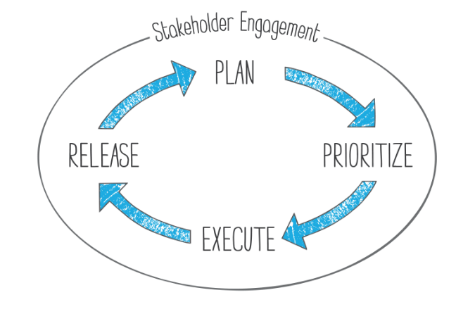
Figure 1:[Source: Kirsch, (2019)]
The proper communication will reduce the barriers and issues regarding the plans. This can be done through asking or gathering the proper information from the stake holders. As this communication grows the loop holes also reduces. It is also observed that through communicating the plans, the goals are achieved in a proper manner. The changes and modifications can also be done when it is communicated with the stake holders. Stake holders as being an essential part of the entire process, it will enable them in understanding the goals and objectives of the organisation.

Assess appropriate monitoring and review techniques to ensure successful implementation of the solution:
The most crucial and the effective step in the process of mitigating the problems of leadership in M&S is the process of evaluation and monitoring the effectiveness of the implemented solutions. In order to measure the solutions of the the problems of the leaderships the evaluation process should be prioritised by the organization in the process. As a part of the monitoring program a competent review program should be developed by the organization. By the means of the review program the tracking of the performance of the staffs of the organization should be gathered. The better performance of the employees within Mark & Spencer is a reflection of proper guidance. Monitoring the performance graphs of the workplace employees will result in the signalling the positive results of the solutions of the problems of the leadership issues. It will showcase that effective leadership has been implemented by the virtue of which the motivation is provided to the staffs along with proper direction in meeting the business objectives. Furthermore, the responsive of the employees to the solutions should also be assessed with efficacy by the organization. This would help the organization in knowing the impact and the effectiveness of the solution. The suitability of the developed solution should be properly evaluated which will portray a clear idea of the efficacy of the implemented solutions (Jeston, 2014). With greater suitability of the solution in the business environment of the organization the employees will easily get acclimatised to the changes for negating the problems. Moreover, the level of interests of the staffs and the employees in adapting to the solutions should also be gathered by the process of continuous assessment. Lack of interest from the employees in inculcation the ideas to solve the problems will eventually result in the existence of the problems as a result of which the leadership will be hard to mitigate. If the interest in the solutions is less from the employees the solutions should be developed in accordance which will match the demands of the employees and will be easily adopted in the future. The time frame in which the business propositions are carried out the functional departments of the business organization is another aspect which should be continuously assessed. This will present a clear picture of the motivational force supplemented by the aid of effective leadership in the process. Lack of leadership also results in the lack of mitigation of the risks. The risk assessment is another process of monitoring of the risks in the business environment. Evaluation of this assessment will in the knowing the impact of the solution applied for eliminating the problems of the leaderships. Monitoring the risks in a duly time frame will portray the effectiveness of the solutions. Thus it can be said with the proper execution of the monitoring program the effectiveness of the applied solutions are gathered (Morrison et al., 2019). The monitoring phase boosts the developments of the solving the problems as the solutions are adjusted in accordance with the suitability of business environment.

Fishbone Analysis
Fishbone analysis refers to a diagram that explains the cause and effect of any situation, decision, functions or anything else. Generally fishbone diagram is used by the organization to design a product and quality defect prevention which will help to identify the potential factors of causing of an overall effect. In this report, fishbone analysis also can be used to understand the overall effect of the leadership process of M&S that has been explained above.
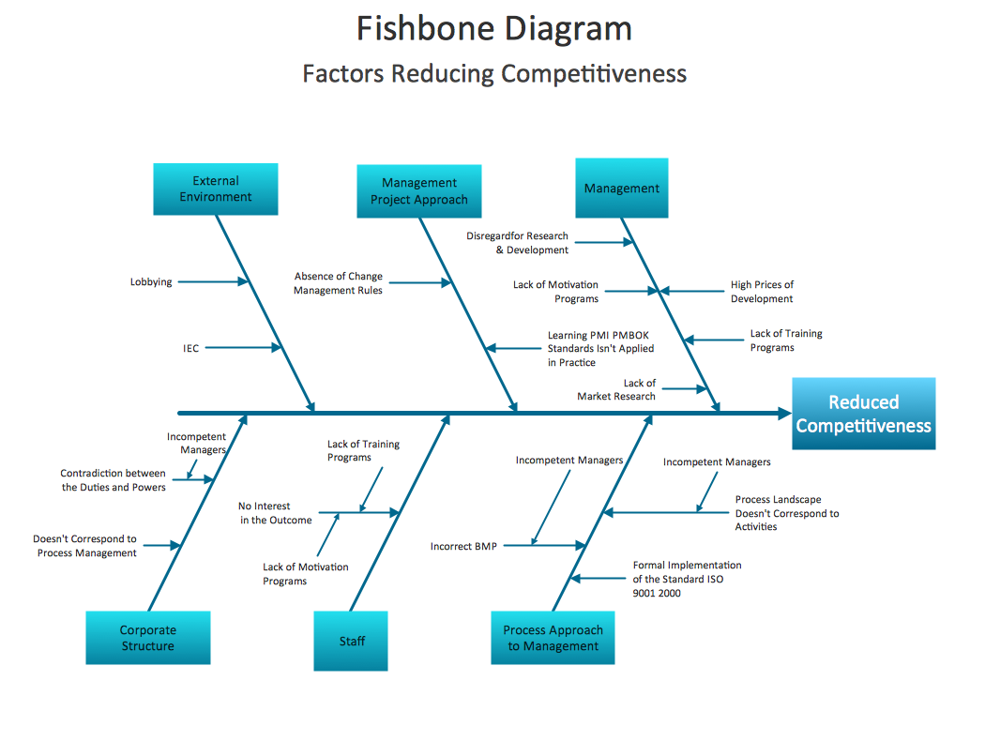
The overall diagram of fishbone analysis for the leadership procedures of M&S, finally shows that, Eternal environment such as lobbing and IEC and absent of management rules can hinder the development of human resource of the organization. On other hand, proper management system, adequate motivation for employees can turn the productivity higher than ever. Eve corporate structure is also responsible for the positive and negative effect of te leadership process on the employees. On the basis of the information above about the leadership strategy, problems and solution for M&S, it can be easily said that management of M&S is successful to implement the leadership process for their organization (Conzemius & O’Neill, 2002).

Conclusion:
Leadership is an essential part for the growth of the organisation as in the same manner in Mark & Spencer. Thus, the problems which arise in making the decisions can be erased through the help of leadership. This particular report covers a huge are on how to mitigate the problems. If there is the problem in the leadership of the organisation like M&S, this can lead to decrease in the productivity. The report properly discusses about the complex problems in the work place with their impact in the organisation. This report also covers the area like analysing the information of the particular problem of M&S which will help in reducing the issues arising in the making of the decisions. Beside these, the report also includes about prescribing the alternate methods for creating the solutions. Using the proper method for making the decisions are also discussed through the help of different techniques. Plans for neutralising the problems are also discussed so that the growth can be achieved. This is done through the help of SWOT analysis and developing a Gantt chart. Through the help of this, the goals are achieved in an easier and effective manner. Apparently, the appropriate methods and the techniques for the proper reviewing of the solutions are also discussed so that the problems can be solved and decisions can be taken in an appropriate manner.

References:

Cassidy, A. (2016). A practical guide to information systems strategic planning. Auerbach Publications.
Mark & Spencer. (2019). Observer business agenda: FTSE exit beckons for M&S as retail sector readies for bexit. [Online]. Available from: https://www.theguardian.com/business/marksspencer [Accessed 3rd September. 2019].
Chandrasekar, K. (2011). Workplace environment and its impact on organisational performance in public sector organisations. International journal of enterprise computing and business systems, 1(1), pp.1-19.
Cheung, M.F. and Wong, C.S. (2011). Transformational leadership, leader support, and employee creativity. Leadership & Organization Development Journal, 32(7), pp.656-672.
De Brouwer. P.J. (2018). Decission Making in Uncertainty.
Doz, Y.L. and Kosonen, M. (2010). Embedding strategic agility: A leadership agenda for accelerating business model renewal. Long range planning, 43(2-3), pp.370-38
Jeston. J. (2014). Business process management: practical guidelines to successful implementations. Routledge.
Kirsch. M. (2019). How to Communicate Your Roadmap to Stakeholders. [online] Productplan.com. Available at: https://www.productplan.com/communicate-roadmap-stakeholders/ [Accessed 3rd September. 2019].
Kray L.J. and Shirako, A. (2011). Stereotype threat in organizations. Stereotype threat: Theory, process, and application, 173.
Morrison G.R., Ross. S.J., Morrison. J.R. and Kalman, H.K. (2019). Designing effective instruction. Wiley.
Ojo. C., Mulvane., K., Mazzotta. M. and Berry. W. (2018). A Marketing Plan for Scientists: Building Effective Products and Connecting with Stakeholders in Meaningful Ways. Solutions (Burlington, Vt.), 9(2), p.1.
Oladapo. V. (2014). The impact of talent management on retention. Journal of business studies quarterly, 5(3), p.19.
Romiszowski. A.J. (2016). Designing instructional systems: Decision making in course planning and curriculum design. Routledge.
Savery. J.R. (2015). Overview of problem-based learning: Definitions and distinctions. Essential readings in problem-based learning: Exploring and extending the legacy of Howard S. Barrows, 9, pp.5-15.
Schwalbe. K. (2015). Information technology project management. Cengage Learning.
Somantri. M. (2019). April. Identification of the Leadership Potential of the Post Graduate Students in the Field of Educational Management. In International Conference on Educational Sciences and Teacher Profession (ICETeP 2018). Atlantis Press.
Turban. E., Sharda. R. and Delen. D., (2010). Decision support and business intelligence systems (required). Google Scholar.
Wu. J.B., Tsui. A.S. and Kinicki. A.J., (2010). Consequences of differentiated leadership in groups. Academy of Management Journal, 53(1), pp.90-106.
Conzemius, A. & O’Neill, J. (2002). SMART School Teams. Bloomington, IN: National Educational Service (NES).

