

COACHING AND MENTORSHIP SKILL FOR THE WORKPLACE.

STUDENT NAME - Olufemi Ademokoya
STUDENT NUMBER – 2125012.
MODULE CODE – BMSW6105_LON.
LECTURER’S NAME – Nishi Ramsurrun.
NAME OF INSTITUTE - UWTSD (LONDON CAMPUS)
DATE - 23/12/24.

ASSIGNMENT TOPIC – Reflection on coaching and mentoring session in the classroom.

Table of Contents
Introduction 4
Critical Evaluation of the Purpose of Coaching and Mentoring in the Workplace 4
Advantages of coaching and mentoring 6
Critical Analysis of a Specific Model of Coaching 7
Coaching skills required in workplace 9
Reflection on Practical 1 Using Gibbs’ Reflective Cycle 10
Description 10
Feelings 10
Evaluation 11
Analysis 11
Conclusion 12
Action Plan 12
Reflection on Practical 2 Using Kolb’s Experiential Learning Model 12
Concrete Experience 12
Reflective Observation 13
Abstract Conceptualization 13
Active Experimentation 13
Conclusion 14
References 16
Appendix 20
SWOT Analysis 20
Skills audit 21
Skills audit for improvement 22
Action Plan based on Coaching skills 23

Introduction
This reflective report looks at my experiences whilst trying to coach and mentor a staff member who was dissatisfied with promises of promotion and pay rise but was disappointed. I conducted two practical sessions: the first one was coaching based on the GROW Model, which was supposed to guarantee effective goal identification and options consideration, and the second was mentoring based on JOHARI Model, which allowed for gaining a different perspective on further professional advancement. Therefore, this report seeks to analyse critically the role of coaching and mentoring in the workplace and the related models of both practices.
Coaching has been most often described as a systematic and purposeful activity where a coach helps a coachee acquire specific skills or accomplish specific objectives, in most cases, based on short-term improvement alone (Orduña, 2024). On the contrary, mentoring is more complex with more of a career framework, with the mentor being expected to offer developmental support for years (Holmes, 2024). Coaching and mentoring are both effective ways of helping a learner to grow and develop, but they are different because coaching leads a learner through assignments. Thus, Rana (2024) highlighted that mentoring is more concerned with the learner as a person and his career. Furthermore, skills such as active listening, use of empathy, and the use of flexibility are essential for coaches and mentors. In this report, Gibbs’ Reflective Cycle for Practical One and Kolb’s Experiential Learning Model for Practical Two are adopted for reflection on the approach and the results.

Critical Evaluation of the Purpose of Coaching and Mentoring in the Workplace
Coaching and mentoring are two different activities used at the workplace and have their unique functions (Schnieders, 2020). Moreover, coaching is commonly concerned with skills training and performance development, occasionally arising from understanding and work experience but more frequently in line with set objectives and time frames with a view of aligning the employee with the organisational needs. Additionally, coaching also holds utility when employees transition into their organisations or need to develop attributes, enhancing a specific competency or overcoming communion performance difficulty (Milad Mafakheri et al., 2024). Caveney (2024) suggested that coaching not only improves individual performance but also makes the goals of the employees more consistent with organisational goals. Coaching helps organisations and individuals to feel more secure about their jobs and ensure meeting with organisational objectives.
In contrast, mentoring is a more general concept and is mainly aligned with career and general growth (Schnieders, 2020). Moreover, long-term mentoring is a process where two people share a bond to empower the other to grow personally or professionally, for career advancement, or to build self-confidence in one’s occupation. While coaching may be task-oriented, mentoring provides a positive atmosphere for development that is likely to enhance the career of the individual involved. The role of the mentor here involves creating commitment and encouraging planning for a career, and in most cases, the mentor works on the non-job issues that may hinder the career path (Hill et al., 2022).
However, the comparison between the two approaches is that whilst coaching tends to be organised based on serious goals and projects, mentoring is progressive for lifelong personal development. Furthermore, Gianakura (2023) highlighted that coaching seeks first-time, tangible results, whilst mentoring is linked to self-actualisation and general skills utilisation. An organisation needs to know or determine which method should be used depending on the needs and objectives of the employees. Moreover, coaching and mentoring are competencies that include aspects such as patience, emotions, interpersonal communication, and flexibility for one’s staff. Due to their application, they address the need for improvement at the micro-level as well as the engineers’ long-term development (Al Hilali et al., 2020).
Coaching and mentoring are significant enablers of engagement strategies and the retention of staff, enhancing awakening amongst employees (Bronwen, 2024). Thus, they form an enmeshed system that meets the short-term requirements for performance and development while also providing real potential for growth. When all these approaches are well aligned according to the current working position, work output, and growth needs of the employee, then the organisations have a better picture of how to go about enhancing performance as well as encouraging the employees to reach their most significant potential (López-Cabarcos et al., 2022). Therefore, this same two-pronged approach also ensures the congruency of personal and organisational goals in an effort to boost staff retention and productivity and, therefore, organisational performance.

Advantages of coaching and mentoring
Coaching | Mentoring
Increase an organisations and employee engagement thus creating a rapport and better understanding of company's objectives which should be aligned with the goals of both the individuals and company | Mentoring fosters a healthy working environment where employees feel supported leading to more job satisfaction
Helps in identifying organisational and employee gap to ensure benchmarking with other competitors | Helps an organisation to retain their employees and less staff turnover which impact of reducing cost on recruitment
Improved autonomy and leadership characteristic where individuals such as managers could delegate some responsibilities to staff and concentrate on business growth strategy | Encourage team dynamics, improve cultural barriers and boost employee's morale
Makes staff feel more confident and optimistic at work and thus improve work relationship through teamwork | Increase company profitability as staff knows what is expected from them
Table source: Author

Critical Analysis of a Specific Model of Coaching
The GROW Model, or Goal, Reality, Options, and Way Forward, was created by John Whitmore and is one of the most widely used coaching models that focuses on goal definition and action planning (Wilson, 2020). Moreover, a Goal is a discrete aim or outcome; current circumstances and challenges define reality; options evaluate potential strategies; and a Way Forward involves deciding on procedures and tactics to reach the goal.
The GROW Model is appreciated for its simplicity of structure, as well as its versatility, which is instrumental within different contexts of coaching (Nicos Paschali, 2024). The model is also focused on the goals and encourages the coachee to work to envision the path to the model’s contractual goal by segmenting the journey into stages. Similarly, this approach fosters a culture of autonomy and total personal responsibility in the process since the coachee is expected to own the goal as well as the solution. However, GROW has some drawbacks, mainly when the underlying issues of the conflict are feelings of anger or frustration or personnel dissatisfaction. Kindness, Masthoff et al. (n.d.) claimed that it cannot always effectively cover the more complex need for emotional support as the framework is comparatively more result-oriented than context-oriented.
When, during Practical 1, I had to communicate with a frustrated employee who was expecting a promotion, the GROW Model helped me focus on more realistic short-term goals. However, the limitations of such an approach were evident when the coachee was unable to ‘move on’ from disappointment to solutions, hence the importance of a more emotional coaching strategy. When emotions are incredibly involved, it might be advisable to use both a coaching and a mentoring style, as appropriate, to deal with the root causes of that approach.
The GROW Model is beneficial for the process of goal-oriented work because it implies an effective program for creating goals and achieving them (Ryan, 2024). This makes it particularly useful in performance-based environments where clear objectives can be set, and it rarely happens in exploratory environments where learning is more of a byproduct of discovery. However, the model could be extended to include emotions because they can be critical where psychological resilience or emotional well-being determines performance. When the emotional status of the employee is critical to the proposed strategy, the GROW Model has to be applied in coordination with other coaching models that focus on the emotional aspect of the given process. This integration would allow for less confusion between performance and emotions as the athlete would receive both goal and emotional support for long-term effectiveness and satisfaction (Bonifacio, 2024).

Coaching skills required in workplace
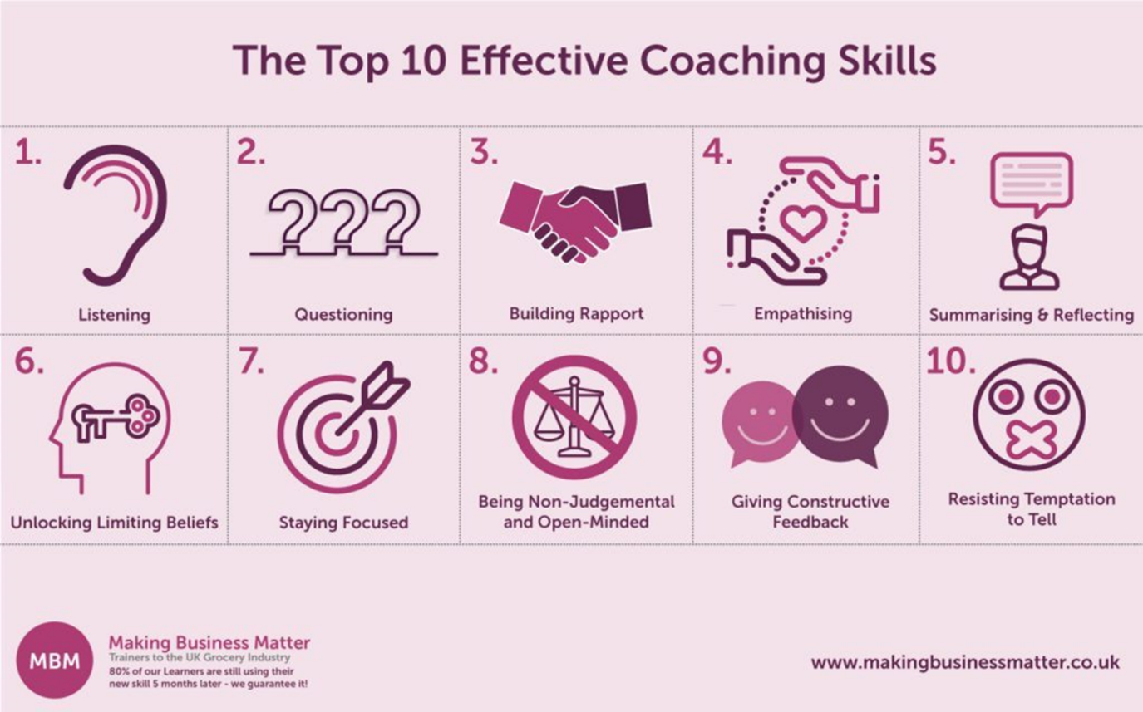
As per the business mentorship, the above shows the effectiveness of coaching skills for a coach
- Active listening helps in understanding the coachee to better help them
- Questioning techniques, the coach could use a range of questioning techniques such as open-ended questions, hypothetical questions, probing and socratic types of questioning techniques
- Building rapport is essential to create a working relation to ease the individual to trust the coach
- Empathising relates to make the coachee feels supported and valued
- Summarising and reflecting relate to catch up with what has been said and ensure both parties understood the same thing
- Unlocking limited beliefs lead to trust, confidence and empowerment of an individual to increase self esteem
- Staying focus is an important factor to consider so the coach can better understand the situation to provide support
- Being judgemental lead to accept other people opinion
- Giving constructive feedback to encourage improvement
- Resisting temptation to tell so that the other person does not feel offended

Reflection on Practical 1 Using Gibbs’ Reflective Cycle
In Practical 1, I used the Gibbs reflection model to analyse my coaching encounter with an angry employee unhappy with the job’s failure to deliver on the promises of promotions and pay increases. This model comprises six stages: Description, Feelings, Evaluation, Analysis, Conclusion, and Action Plan.

Description
During the session, I applied the GROW Model to help the employee define plans. However, sometimes, the employee's overwhelming behaviour makes it challenging to work on goal direction, another imperative aspect of coaching: emotion.

Feelings
At first, I was rather ill at ease and a definite shade of anxious to handle his rather conspicuous annoyance. Although I did understand his frustration, I could not figure out how to assist him in refocusing on a more optimistic approach without completely disregarding his feelings of disappointment.

Evaluation
The session had positive and negative aspects. While the GROW Model helped me develop the structure and frame my lines to the employee, I found that it did not effectively manage the emotional aspect of the dissatisfaction. The strengths included our communication and direction toward building a trusting partnership.

Analysis
From this coaching experience, coaching experience, I learned that in a state of heightened emotional arousal, such as anxiety, the GROW model should allow for more structure and focus more on active listening. I can only say that the general plan of GROW, discussing Goals, Reality, Options, and Will in its order, is undeniably beneficial for directing the conversation towards specific desired outcomes. However, in this case, it was apparent that emotions should be recognised and addressed as a prerequisite of coaching in high-pressure scenarios. I also learned that acknowledging the employee’s frustrations and anxieties made it relatively easy to build trust and approval, which in turn can facilitate healthy communication between the two of us without compromising our professional courtesy.
Using specific empathic listening helped me provide more tangible expectations and real-life strategies, which brought the feelings and the goals of the employee into focus. I found out that appraisal of emotions is not just a humanitarian act; it is a strategy that determines how well a coach is likely going to be understood by the employee because the coach has shown a willingness to acknowledge at least the fact that emotions do matter in the workplace. This change in strategy was applicable in returning the focus on the objectives of the session from a strict employee’s emotional perspective to build up the trust that can be engaged in setting and following realistic goals and objectives. Finally, it is possible to note that flexibility and empathy became essential in utilising the GROW Model under pressure.

Conclusion
Therefore, this experience also emphasised the fact that the coach's emotional readiness increases the effects of coaching. It would be advisable to incorporate elements of the coaching approach alongside more sympathetic nurturing in successive meetings.

Action Plan
To improve further practice, a supportive intervention together with activating goal attainment is necessary to provide more effective strategies to control emotional processes. Moreover, focusing on the target population makes it possible to enhance one’s skills in empathy-based coaching through additional training which should be started as soon as possible.

Reflection on Practical 2 Using Kolb’s Experiential Learning Model
In Practical 2, I moved from the coaching approach to the mentorship approach using Kolb’s Experiential Learning Model (1984). Kolb’s model includes four stages: These are Concrete Experience, Reflective Observation, Abstract Conceptualization and Active Experimentation.

Concrete Experience
This session involved coaching the same employee to view their current job as just a preparation for the next level. The coaching approach relied mainly on practising concrete behaviours and creating quick-fix solutions. It was an advantage of the mentoring strategy that not only let me address the ways of improving the communication with the employee but also allowed me to provide him with a more focused consultation on his career development plans. This approach provided me with a chance to explore his plans and progression, focusing not only on short-term goals but also on setting up a less aggressive and more constructively oriented conversation.

Reflective Observation
After the coaching session, the employee still looked frustrated, which meant that the largely instrumental perspective of the coaching did not meet his needs. However, during the mentoring stage, I had a chance to discuss some affairs and establish confidence and personal growth rather than performance goals of the present moment. This change made me understand that mentoring has a better structure and that the communication that is encouraged is more assertive and reflective of the career paths and objectives. The kind of development he required clearly underlined the usefulness of the mentoring approach, thus making me understand that mentoring could help ensure satisfaction and motivation among employees.

Abstract Conceptualization
This made me learn that while mentoring, one must be so involved with the trainee that one captivates them, but at the same time, one cannot be too close to the trainee. In contrast, mentoring was helpful and cheerful regarding facilitating career advancement conversations, but I also discovered that focusing too much on the challenges may not be constructive.

Active Experimentation
Consequently, in the future, when forming the next mentoring relationship, I will ensure that the mentees have an accurate perception of what can be achieved with the help of the mentor-mentee relationship. At the same time, I will try to become as supportive as possible, and if the situation is beyond simple mentoring, I will suggest that my mentees seek professional help. This approach respects overall support without crossing the professional spectrum, considering that an individual may need more than professional support.

Furthermore, I plan to incorporate a solution-oriented approach into the discussions I engage in with my mentees. I can better assist the mentees when I ask them well-focused questions to reflect on them so they can also focus on strengths and opportunities rather than dwelling on the problems. This strategy will compel them to re-focus on the objectives in a constructive manner, which will, in turn, lead to self-ria. Most importantly, the method with the use of role models and successful experiences serves to help mentees grow and engage them in pursuing their aims, fully knowing the way to achieve them.

Conclusion
It has been concluded that both concepts of coaching and mentoring complement each other in working with employees and their issues. The Gibbs’ Reflective Cycle applied to the coaching session demonstrated that frustration should ideally be tackled with patience and understanding. The GROW Model applied well here, although the emotional aspects presented deviations that needed malleability. During the mentoring, the applicability of Kolb’s Experiential Learning Model showed the importance of the distinction between emotional understanding and professional detachment to foster the construction of a valuable and sustained perspective toward self- and other improvement.
This concept has helped me learn more about the advantages of having coaching and mentoring integrated. While coaching directs its attention to tangible performance objectives and training within popular paradigms, mentoring encompasses personal growth and future personal career goals. This made it conclusive that while support can be formal and traditional, it needs to be individualised. Compliance is essential as daily encouragement, such as giving an employee a virtual pat on the back, is required to make employees feel appreciated. This way, they can allow the employee to complete his short-term goals and also feel concerned about achieving long-term goals, all in a cycle that would enhance the employee’s humanity.

References
Al Hilali, K.S., Al Mughairi, B.M., Kian, M.W. and Karim, A.M. (2020). Coaching and Mentoring. Concepts and Practices in Development of Competencies: A Theoretical Perspective. International Journal of Academic Research in Accounting, Finance and Management Sciences, 10(1), pp.41–54.
Bonifacio, R. (2024). Effective Coaching Models to Help Your Clients Grow. [online] www.shiftbase.com. Available at: https://www.shiftbase.com/glossary/coaching-models.
Bronwen (2024). The Role of Coaching in Employee Retention | Think Coaching Academy. [online] Think Coaching Academy. Available at: https://www.thinkcoachingacademy.co.za/the-role-of-coaching-in-employee-retention/?srsltid=AfmBOoqx_F5MVBoqzLNZFxu0N7YQ6IDexZfzxRnB3uwZPBDjUDujkHWY [Accessed 11 Nov. 2024].
Caveney, L. (2024). A Complete Guide to Performance Coaching - BuildEmpire. [online] BuildEmpire. Available at: https://buildempire.co.uk/performance-coaching/ [Accessed 11 Nov. 2024].
Gianakura, J. (2023). Whether you have already established a mentor connection or are seeking a mentor, you likely have some thoughts as to what you hope to accomplish with this relationship. If you are a mentor and are genuinely seeking ways to make a difference with your mentee, this discussion may add value to your mentor. [online] Linkedin.com. Available at: https://www.linkedin.com/pulse/mentoring-toward-self-actualization-joy-gianakura-allen-ed-d--tuxmc [Accessed 11 Nov. 2024].
Hill, S.E.M., Ward, W.L., Seay, A. and Buzenski, J. (2022). The Nature and Evolution of the Mentoring Relationship in Academic Health Centers. Journal of Clinical Psychology in Medical Settings, [online] 29(3), pp.557–569. doi:https://doi.org/10.1007/s10880-022-09893-6.
Holmes, H. (2024). The Benefits of Being a Mentor - Mentorloop. [online] Mentorloop Mentoring Software. Available at: https://mentorloop.com/blog/benefits-of-being-a-mentor/.
Kindness, P., Masthoff, J. and Mellish, C. (n.d.). Designing emotional support messages tailored to stressors. International Journal of Human-Computer Studies, 97, pp.1–22. doi https://doi.org/10.1016/j.ijhcs.2016.07.010.
López-Cabarcos, M.Á., Vázquez-Rodríguez, P. and Quiñoá-Piñeiro, L.M. (2022). An Approach to Employees’ Job Performance through Work Environmental Variables and Leadership Behaviours. Journal of Business Research, [online] 140(140), pp.361–369. Available at: https://www.sciencedirect.com/science/article/pii/S0148296321008110.
Milad Mafakheri, Tavakoli, A. and Gerde, K. (2024). The Role of Coaching in Enhancing Organizational Commitment and Improving Employee Performance. [online] ResearchGate. Available at: https://www.researchgate.net/publication/381852563_The_Role_of_Coaching_in_Enhancing_Organizational_Commitment_and_Improving_Employee_Performance [Accessed 11 Nov. 2024].
NICOS PASCHALI (2024). The GROW Model: A Powerful Tool for Personal and Professional Development The GROW model is a simple yet effective coaching and personal development framework. Developed in the 1980s by business coaches Graham Alexander, Alan Fine, and Sir John Whitmore, GROW has become one of the most widely used c. [online] Linkedin.com. Available at: https://www.linkedin.com/pulse/grow-model-powerful-tool-personal-professional-nicos-paschali--jbsgf [Accessed 11 Nov. 2024].
Orduña, C. (2024). Mentoring vs. Coaching: Key Differences, Benefits, and Examples. [online] Careerminds. Available at: https://careerminds.com/blog/mentoring-vs-coaching-key-differences-benefits-and-examples.
Rana, S. (2024). Sameer Rana on LinkedIn: The Value of Coaching and Mentorship in the Workplace: My Personal…. [online] Linkedin.com. Available at: https://www.linkedin.com/posts/sameerrana16_the-value-of-coaching-and-mentorship-in-the-activity-7233529984995278848-r7Pe [Accessed 11 Nov. 2024].
Ryan, E. (2024). Mastering the GROW Model: Achieve Your Goals with Ease. [online] Mentorloop Mentoring Software. Available at: https://mentorloop.com/blog/mastering-the-grow-model-achieve-your-goals-with-ease/.
Schnieders, A. (2020). Coaching vs Mentoring: What’s the Difference? [online] Chronus. Available at: https://chronus.com/blog/coaching-vs-mentoring-whats-the-difference.
Wilson, C. (2020). The GROW model. [online] Culture at Work. Available at: https://www.coachingcultureatwork.com/the-grow-model/.

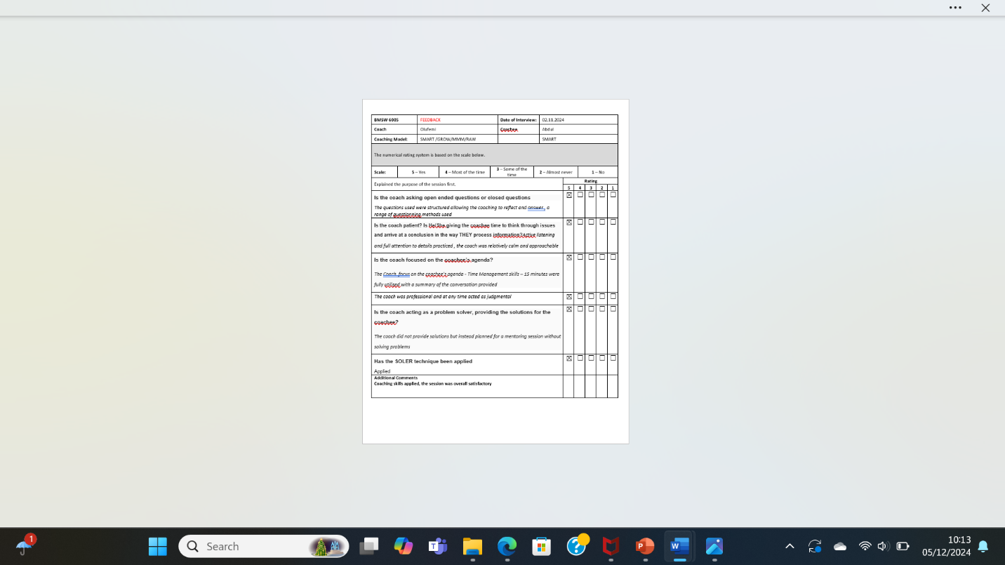

Appendix

SWOT Analysis
Strengths | Weaknesses
Ability to deal under pressure | I tend to lose focus sometimes when the subject does not interest me
Good communication skills including verbal, non-verbal and use of graphics such as charts, symbols, graphs | Need to develop my analytical skills
Effectively manage time and prioritise task | Review note taking and ways to improve writing skills
Good leadership skills such as democratic styles | Delegate tasks and responsibilities to appropriate employees
Opportunities | Threat
Better job opportunity in multinational or international context and higher salary | Fierce competition in the market
Promotions and working on international assignment | Rapid advancement of technology
Clearer understanding of different people | Inflation and other economic conditions such as unemployment

Skills audit
Skills I have | Examples
Good communication skills | My mother tongue is English I can fluently speak English with colleagues’ peers and fellow students as well as managers as work  My non-verbal communication skills include eye contact, firm handshake, good posture, body language and movement  I understand charts, graphs and symbols and easily able to interpret them as well as explain them to others
Leadership skills | I am an active leader and believe in different leadership styles  My autocratic leadership style allows me to be directive and provide clear guidance to new starters  My democratic style emphasising on people’s opinion to have a wide view of different perspectives
Time management techniques | I apply the POMODORO approach and believe in taking appropriate breaks in between tasks such as 15 minutes every 1 hour  I apply the Eisenhower technique to do important things to meet deadline  I schedule tasks which are less important and do not need immediate attention and i completely delete tasks that does not need immediate attention

Skills audit for improvement
Skills I have to improve | How?
Focus on Transformational leadership | Short courses, online videos or my MBA
Internet of Things | Courses on evolution of technology from 1.0 to 4.0
Analytical skills | Reading more books and watch online existing videos
Problem solving and conflict management | Focus on the Ishikawa fish bone theory model to understand the root of the problem

Action Plan based on Coaching skills
Development objectives | Activities required | Resources needed | Start Date | End date
Focus on Transformational leadership | Short courses, online videos or my MBA | Finance, enrollment, laptop, notes, internet connection | November 2024 | March 2025
Internet of Things | Courses on evolution of technology from 1.0 to 4.0 | Course enrolment, technological devices, books, internet facilities | December 2024 | July 2025
Analytical skills | Reading more books and watch online existing videos | Books, online resources such as websites, blogs and others | December 2024 | June 2025
Problem solving and conflict management | Focus on the Ishikawa fish bone theory model to understand the root of the problem | Books, websites | December 2024 | May 2025

